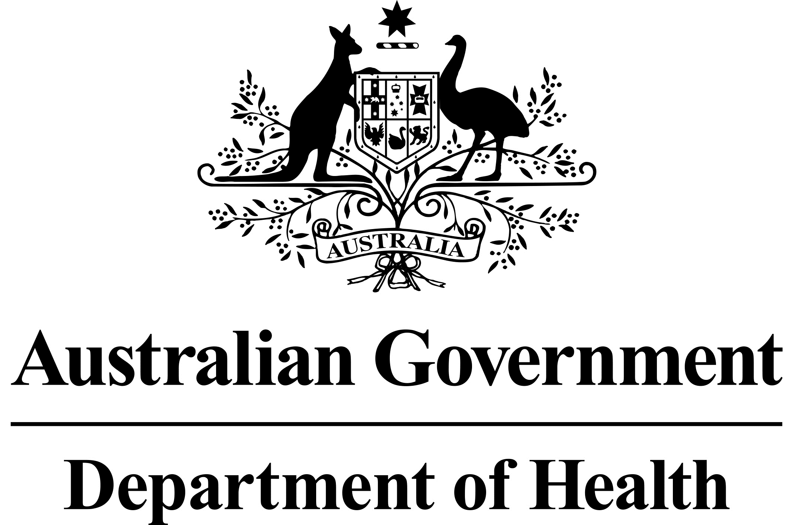

# National Dust Disease Taskforce Communique

The National Dust Disease Taskforce held its fifth meeting via videoconference on   
3 November 2020.

## Issues considered at the fifth meeting

Taskforce members discussed the progress of phase 2 consultations, noting the written submissions received to date and the progress of targeted consultation sessions held with a range of stakeholders including peak bodies, researchers, legal representatives, unions, occupational hygienists and radiologists. Consultation with industry/business groups is planned to be held by the end of 2020.

Members discussed key themes progressed to date within the scope of the Taskforce’s work, which included: banning engineered stone; need for additional regulatory controls and active enforcement, combined with improved worker education; better support for workers affected by silicosis including but not limited to improved return-to-work initiatives where appropriate, and psychological support for workers and their families; and standardised accreditation of those personnel involved in workplace monitoring.

Members also discussed refining research priorities in light of increasing knowledge about the cohort of workers suffering in Australia, including assessing effectiveness of the prevention measures implemented since the epidemic emerged in Australia, and the particular hazards associated with the mix of components of engineered stone.

To further build its understanding of the regulatory changes being introduced in jurisdictions, Taskforce members heard from WorkSafe Victoria on its proposed approach for introducing a licensing scheme to better address unsafe practices associated with the use of high silica content engineered stone.

Taskforce members discussed the development of the National Registry, and established a project Steering Committee to provide more detailed advice before the end of 2020.

Taskforce members noted the progress of its National Guidelines Working Group for doctors managing workers exposed to respirable crystalline silica.

## Next steps

The phase 2 consultation period will close on 11 November 2020.

The Taskforce will further progress the findings identified in the Taskforce’s Interim Advice, and support implementation of the early recommendations as accepted by the Australian Government.

The Taskforce agreed to meet again via videoconference in mid-February 2021.

Further information regarding the National Dust Disease Taskforce Terms of Reference and membership is available on the Department of Health’s National Dust Disease Taskforce webpage (<https://www.health.gov.au/dust>) or by emailing the National Dust Disease Taskforce Secretariat ([dust@health.gov.au](mailto:dust@health.gov.au)).