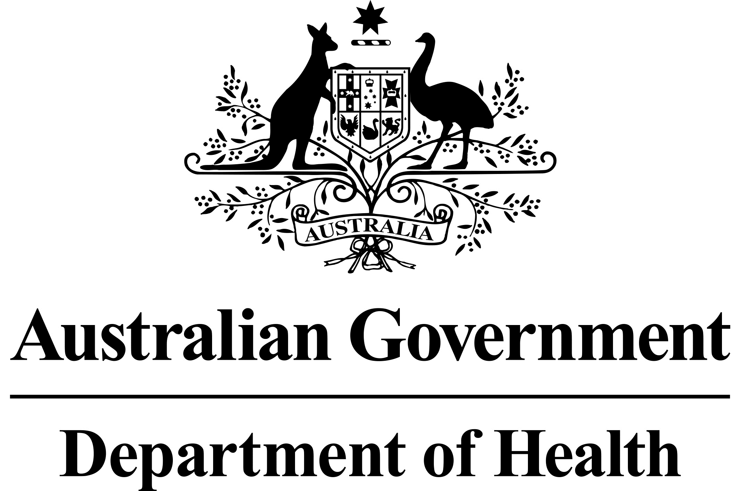

# National Dust Disease Taskforce Communique

The National Dust Disease Taskforce held its third meeting in Melbourne on   
29 November 2019.

## Issues considered at the third meeting

The Taskforce discussed the outcomes of consultation activities conducted over the previous six months including workshops held across Australia, online written submissions and targeted market research.

Members discussed issues with key stakeholders and heard from individuals affected by silicosis. The Taskforce appreciated the courage shown by these individuals in sharing their personal stories.

The discussions at the meeting informed the development of the Taskforce’s Interim Advice. The Interim Advice includes national actions that can be taken in the immediate to short-term to address specific issues related to the re-emergence of silicosis, and identifies initial findings which will be investigated further over the following twelve months to inform the Final Report.

## Next steps

The Taskforce will provide its Interim Advice to the Commonwealth Minister for Health by the end of 2019.

Further information regarding the National Dust Disease Taskforce Terms of Reference and membership is available on the Department of Health’s National Dust Disease Taskforce webpage (<https://www.health.gov.au/dust>) or by emailing the National Dust Disease Taskforce Secretariat ([dust@health.gov.au](mailto:dust@health.gov.au)).