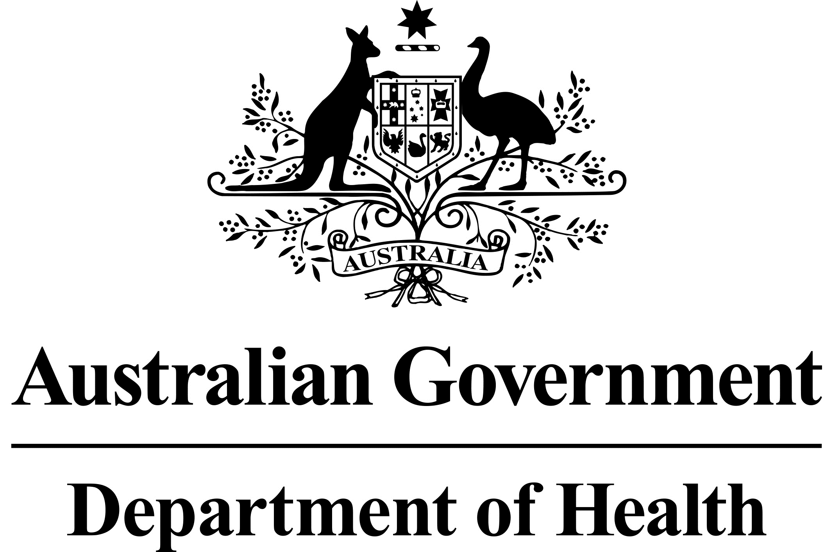

# National Dust Disease Taskforce Communique

The National Dust Disease Taskforce held its sixth meeting via videoconference on   
23 and 25 February 2021.

## Issues considered at the sixth meeting

Taskforce members discussed the outcomes of phase 2 consultations. Members noted the written submissions received and the additional targeted consultation sessions held with industry/business groups and affected individuals and their carers/support persons since their last meeting.

Members particularly appreciated the courage of the individuals in telling their stories, the insights they provided about health and safety concerns in workplaces, and the need for improved support for people who have been diagnosed with occupational dust diseases. Members agreed to publish the report from the phase 2 consultation on the National Dust Disease Taskforce’s website.

Members discussed different regulatory options and the merits of introducing a national licensing framework in the engineered stone industry with the aim of preventing new cases of workers developing silicosis.

Members agreed that a product ban on engineered stone should remain an option for consideration, particularly if strengthened regulations and enforcement activities fail to prevent new cases of silicosis in this industry, or attempts at licensing fail, noting the requirement for strong data and evidence to underpin such a decision.

Members agreed on the draft vision, strategies and priority action areas for the Final Report and for further consultation to be undertaken with key stakeholders on these sections of the Report.

Members endorsed the proposed scope of the national registry, and provided in-principle support for the proposed vision, mission, purposes, functions and high level design of the national registry.

Members provided in-principle support for proposed goals and principles to drive an enhanced national focus on prevention activities. Members noted that since the establishment of the Taskforce, substantial work has been undertaken by states and territories and Safe Work Australia from both a prevention and regulatory perspective to address the risks of working with engineered stone.

Members were provided an update on national research efforts related to silicosis. The Taskforce will also continue to explore opportunities with research experts to support national collaboration in relation to silicosis research.

Members noted the significant progress made in the development of a draft national guideline for doctors managing workers who have been exposed to respirable crystalline silica. The Taskforce noted the importance of ensuring that the guidelines are regularly updated going forward.

## Next steps

The Taskforce will consult with key stakeholders on its draft vision, strategies and priority actions, and the draft national clinical guidelines.

The Taskforce agreed to meet again in April 2021.

Further information regarding the National Dust Disease Taskforce Terms of Reference and membership is available on the Department of Health’s National Dust Disease Taskforce webpage (<https://www.health.gov.au/dust>) or by emailing the National Dust Disease Taskforce Secretariat ([dust@health.gov.au](mailto:dust@health.gov.au)).