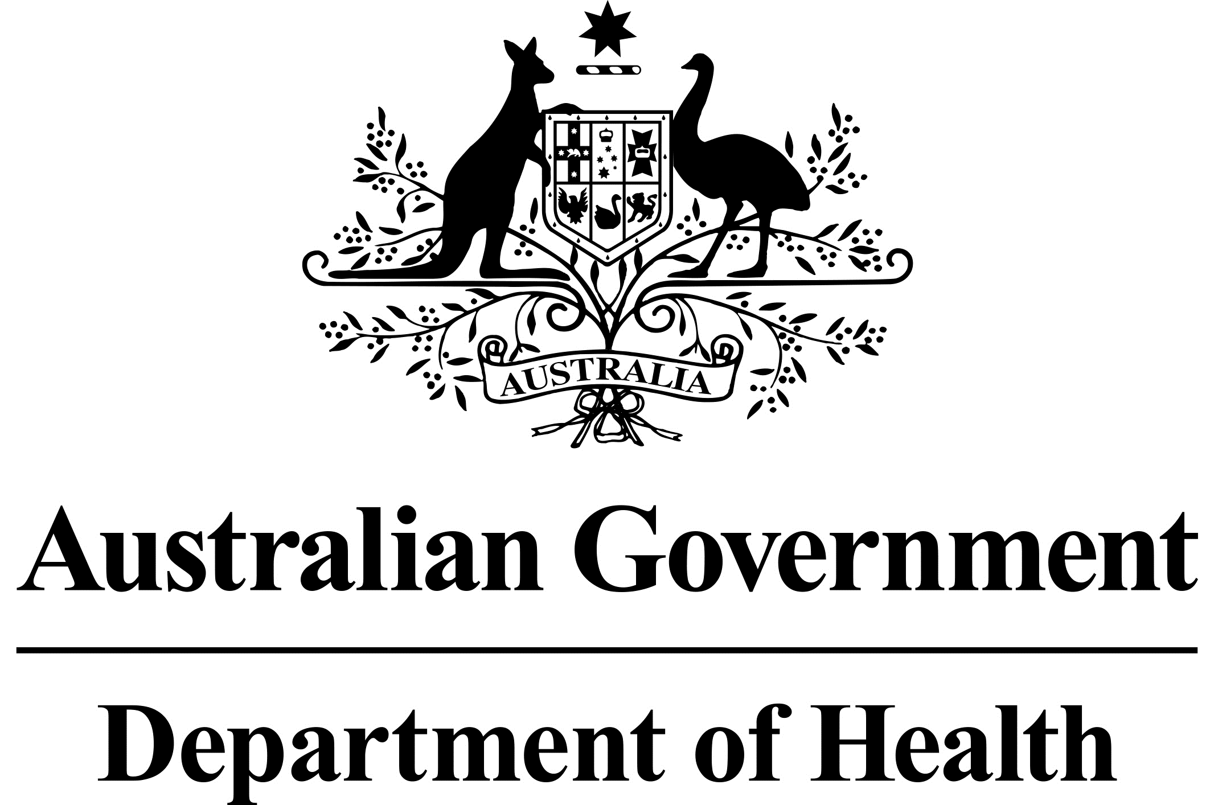

# National Dust Disease Taskforce Communique

The National Dust Disease Taskforce held its seventh meeting via videoconference on   
22 April 2021.

## Issues considered at the seventh meeting

Taskforce members focused on developing the Taskforce position in relation to a range of issues identified through its research and consultation processes as requiring further attention. This includes the adequacy of existing arrangements in relation to air monitoring for silica dust from engineered stone; key issues facing workers diagnosed with silicosis in relation to current compensation arrangements, as well as their ability to access support and assistance more generally; and possible options to improve screening of workers.

Members also discussed the importance of ensuring that a suitable governance mechanism is established to maintain the momentum generated by the Taskforce once its term comes to an end. In particular, this governance arrangement should be responsible for driving, monitoring and reporting on progress in relation to the implementation of the Taskforce’s recommendations both from its Interim Advice as well as its Final Report.

Members noted updates on the progress of activities being undertaken in response to the Taskforce’s interim recommendations. This includes further work on the development of the National Silicosis Prevention Strategy and a draft Detection and Rapid Response Protocol. Members noted that the consultation process for the draft National Clinical Guidelines (for doctors managing workers exposed to respirable crystalline silica) (the Guidelines) closes on 6 May 2021.

## Members considered a preliminary draft of the Taskforce’s Final Report, and draft set of recommendations. Members also discussed the current status of the consultation on the Vision, Strategies and Priority Areas for Action paper.

## Next steps

The Taskforce will use the feedback collected through the current consultation processes to further revise the Guidelines and the draft Final Report, noting the latter is due to be provided to the Minister for Health by 30 June 2021.

The Taskforce agreed to meet again in early June 2021.

Further information regarding the National Dust Disease Taskforce Terms of Reference and membership is available on the Department of Health’s National Dust Disease Taskforce webpage (<https://www.health.gov.au/dust>) or by emailing the National Dust Disease Taskforce Secretariat ([dust@health.gov.au](mailto:dust@health.gov.au)).