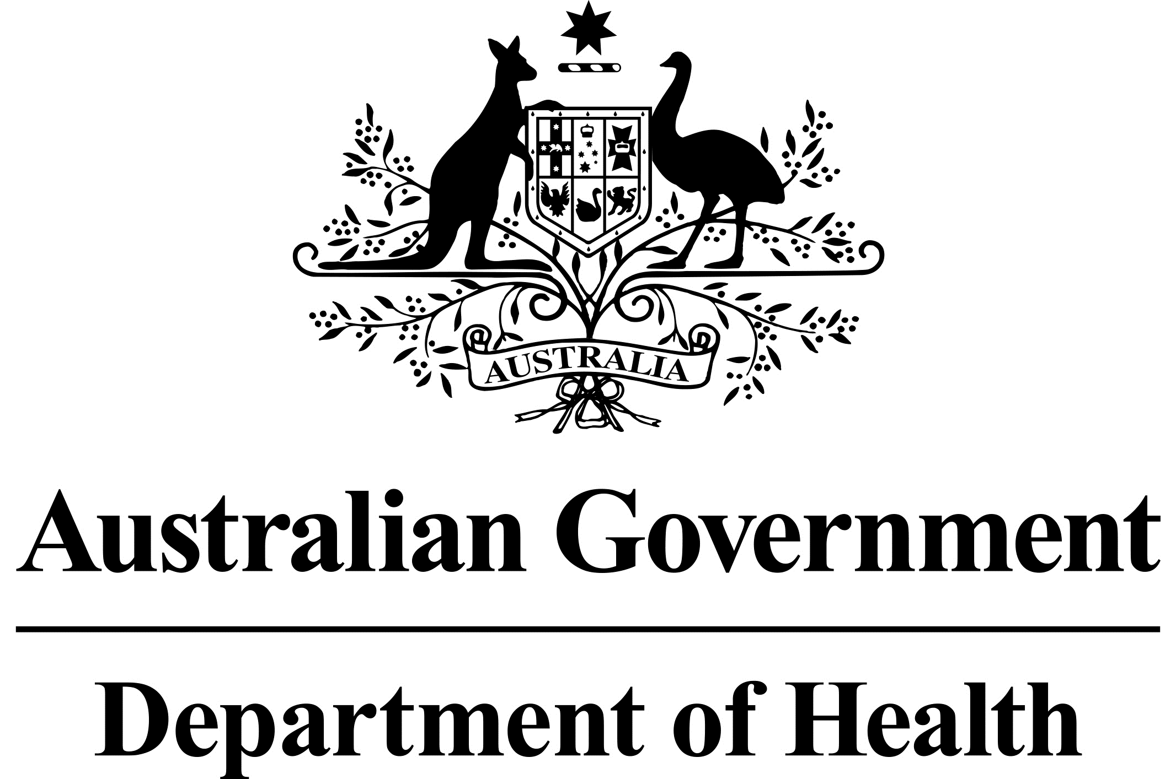

# National Dust Disease Taskforce Communique

The National Dust Disease Taskforce held their second meeting in Melbourne on   
12 September 2019.

## Issues considered at the second meeting

The second meeting further discussed the scope and nature of a National Dust Disease Register. The Taskforce considered current registries, along with lessons learnt.

The meeting continued to build the knowledge base of the Taskforce on existing policy and regulatory arrangements in Australia. This included a discussion on the supply chain applicable to engineered stone in Australia. The Taskforce discussed opportunities to enhance compliance and noted initiatives being undertaken by industry.

The meeting reaffirmed the importance of recognising and understanding the actions that have been undertaken across jurisdictions to address occupational dust disease.

The Taskforce recognised the need for the development of best practice national guidelines for the screening and monitoring of exposed workers.

The meeting further considered a research priority setting process to help identify gaps in the understanding of how to prevent, diagnose or treat accelerated silicosis and other occupational dust diseases.

The meeting noted the commencement of an open consultation process to understand the issues associated with the emerging trend of cases of accelerated silicosis further.

## Next steps

The Taskforce is due to commence open consultation with key stakeholders shortly following this meeting. Further information on how to engage with the Taskforce is provided on the Taskforce’s webpage.

The Taskforce will continue the consideration of options for a National Dust Diseases Register.

The Taskforce agreed to meet again on 29 November 2019.

Further information regarding the National Dust Disease Taskforce Terms of Reference and membership is available on the Department of Health’s National Dust Disease Taskforce webpage (<https://www.health.gov.au/dust>) or by emailing the National Dust Disease Taskforce Secretariat ([dust@health.gov.au](mailto:dust@health.gov.au)).