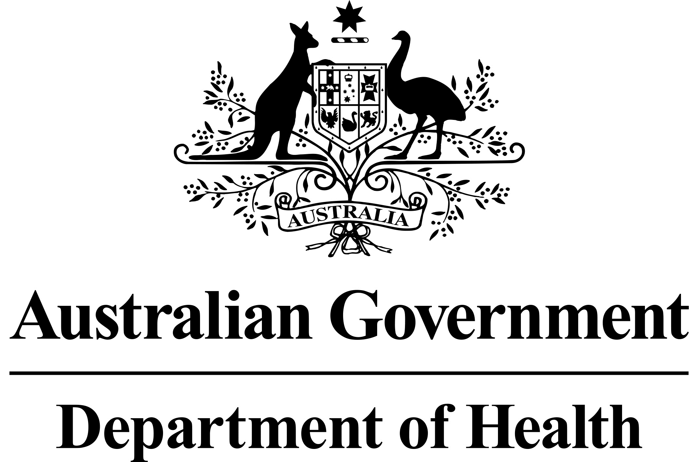

# National Dust Disease Taskforce Communique

The National Dust Disease Taskforce held its fourth meeting via videoconference on   
12 August 2020. The Taskforce welcomed its new Chair, Professor Paul Kelly, Acting Chief Medical Officer.

## Issues considered at the fourth meeting

The meeting undertook a stocktake of the progress of the work of the Taskforce following acceptance of its Interim Advice in January 2020 by the Hon Greg Hunt MP, Minister for Health.

Taskforce members discussed an approach to further investigating the Interim Advice findings and agreed to a detailed exploration of possible regulatory and non-regulatory interventions.

Taskforce members agreed on the importance of conducting a further round of targeted consultations with stakeholders over the next few months, and to an online submission process. This consultation round aims to obtain further advice on the identified key issues in the Interim Advice.

Taskforce members discussed and agreed upon next steps for implementing the early recommendations of the Interim Advice. Members recognised the importance of a collaborative and coordinated approach to progressing the recommendations, including working with representatives from Commonwealth and state/territory governments, regulators, peak bodies, non-government organisations, research institutions and industry.

## Next steps

The Taskforce is expected to conduct its final phase of consultation in the second half of 2020. Information on how to engage with the Taskforce will be provided on the Taskforce’s webpage and to those stakeholders who have registered to receive updates.

The Taskforce will continue to further investigate the findings identified in the Taskforce’s Interim Advice, and support implementation of the early recommendations.

The Taskforce agreed to meet again via videoconference in late October 2020.

Further information regarding the National Dust Disease Taskforce Terms of Reference and membership is available on the Department of Health’s National Dust Disease Taskforce webpage (<https://www.health.gov.au/dust>) or by emailing the National Dust Disease Taskforce Secretariat ([dust@health.gov.au](mailto:dust@health.gov.au)).