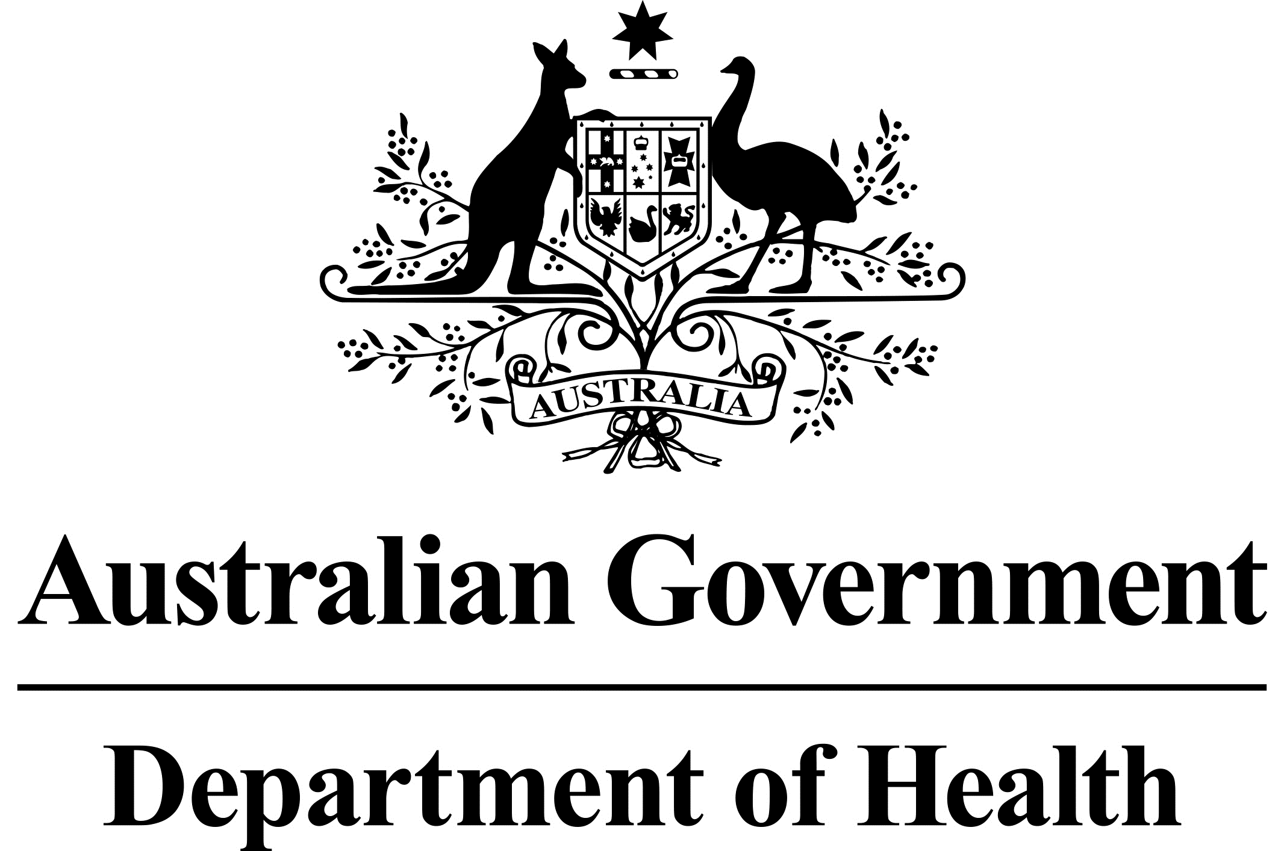

# National Dust Disease Taskforce Communique

The National Dust Disease Taskforce met for the first time in Canberra on 1 August 2019.

## Background

In July 2019, the Australian Government Department of Health established a National Dust Disease Taskforce to develop a national approach to the prevention, early identification, control and management of occupational lung diseases in Australia. This was in response to a highly concerning emergence of new cases of silicosis in regions of Australia. This preventable occupational lung disease has been affecting workers as a result of exposure to silica dust, in particular in the stone benchtop fabrication industry.

## Issues considered at the first meeting

The first meeting noted the National Dust Disease Taskforce Terms of Reference, and confirmed the Taskforce will need to prioritise the issues related to prevention, education and management of the relevant dust diseases.

The meeting confirmed the importance of recognising the roles and responsibilities of the states and territories, particularly with respect to workplace health and safety. The Taskforce acknowledges the various efforts to collaborate between jurisdictions and intends working with the relevant agencies to optimise consistency by building on the current work underway.

The meeting discussed practical actions that the Taskforce can explore that would further mitigate respirable silica dust exposure, and considered undertaking a research priority setting process to help identify areas for potential investment.

The meeting committed to examining the scope and nature of the National Dust Disease Register.

The meeting acknowledged the importance of early and effective engagement with the broad range of individuals, in particular affected workers and their family members, and organisations affected by or with an interest in occupational dust disease.

The meeting noted the need to provide early advice to the Commonwealth Minister for Health in early 2020 and a final report by the end of 2020 to Australian Health Ministers.

## Next steps

The Taskforce has commenced its preparations for broad engagement with key stakeholders. Consultation is expected to commence as soon as practical and well before the end of 2019. Further information on how to engage with the Taskforce will be provided on the Taskforce’s webpage.

The Taskforce will continue the process of cross-jurisdictional consultation and consider the options for a scoping and design necessary to establish a National Dust Diseases Register.

The Taskforce agreed to meet again on 12 September 2019 in Melbourne.

Further information regarding the National Dust Disease Taskforce Terms of Reference and membership is available on the Department of Health’s National Dust Disease Taskforce webpage (<https://www.health.gov.au/dust>) or by emailing the National Dust Disease Taskforce Secretariat ([dust@health.gov.au](mailto:dust@health.gov.au)).