

Protect yourself…



protect the people in your care

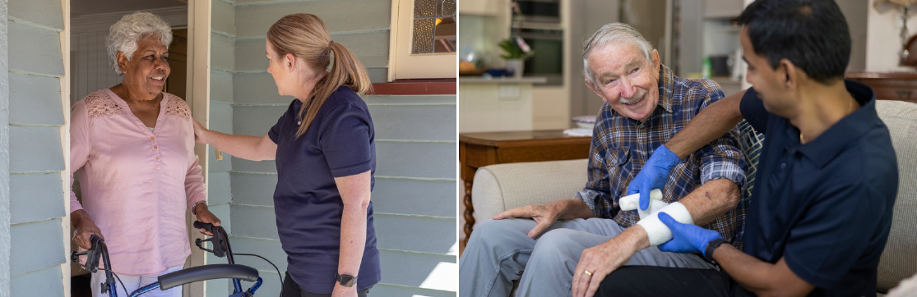

Information kit to support COVID-19 vaccination of in-home and community aged care workers

Updated July 2022

## Introduction

This information kit is a resource for all aged care providers, aged care peaks and unions to support in-home and community aged care workers to get vaccinated against COVID-19 to protect themselves and the people in their care.

In-home and community aged care workers play a critical role in enabling senior Australians to live as fully and independently as possible at home and in the community. As we transition to opening up our communities, we need to do all we can to protect those most vulnerable to the impacts of COVID-19.

This means it is more important than ever for all in-home and community aged care workers to be up-to-date with their COVID-19 vaccinations.

You also have an important role in supporting care recipients to access factual information on how they can access COVID-19 vaccination and on vaccine safety and efficacy.

The Australian Technical Advisory Group on Immunisation (ATAGI) advises that individuals aged 16 years and over are up-to-date with their COVID-19 vaccination when they have received a booster dose three months after their primary course.

ATAGI also [recommends](https://www.health.gov.au/news/atagi-updated-recommendations-for-a-winter-dose-of-covid-19-vaccine) an additional COVID-19 vaccine booster (Winter) dose for the following people who are considered to be at most risk from serious illness, hopsitalisation or death from COVID-19:

* People aged 50 years or older
* Residents of aged care or disability care services
* Aboriginal and Torres Strait Islander people aged 50 years or older
* People aged 16 -64 years:
  + who have [a medical condition](https://www.health.gov.au/resources/committee-statements/expanded-atagi-recommendations-on-winter-covid-19-booster-doses-for-people-at-increased-risk-of-severe-covid-19) that increases the risk of severe COVID-19 illness
  + living with a disability with significant or complex health needs or multiple comorbidities which increase risk of poor outcome from COVID-19.

People aged 30 – 49 years can also choose to receive an additional COVID-19 booster dose.

COVID-19 vaccination for in-home and community aged care workers is mandatory in some states and territories. State and territory public health orders define who must be vaccinated and by when, whether a primary course only or booster dose is mandatory, and limited exemptions that may apply.

Stay up to date with the latest information on [mandatory COVID-19 vaccination in aged care](https://www.health.gov.au/initiatives-and-programs/covid-19-vaccines/information-for-aged-care-providers-workers-and-residents-about-covid-19-vaccines/mandatory-covid-19-vaccination-in-aged-care).

Thank you for supporting your workers to get vaccinated, and in doing so helping to protect senior Australians in their homes.

## Communication material

A number of resources have been developed for use by in-home and community aged care providers to encourage and support their workforce to become up-to-date with their COVID-19 vaccinations.

* 1. e-Newsletter and web content
  2. Direct email to workers
  3. Key resources to share with your workforce
  4. Frequently asked questions
  5. Text message scripts
  6. Social media posts
  7. Outbound call script

### 3.1. e-Newsletter and web content

**COVID-19 vaccination for in-home and community aged care workers saves lives**

To continue to protect senior Australians at home and in the community, it is critical that those providing care in people’s homes and in the community are also up to date with their COVID-19 vaccination.

The [Australian Technical Advisory Group on Immunisation](https://www.health.gov.au/news/atagi-statement-on-defining-up-to-date-status-for-covid-19-vaccination) (ATAGI) recommends that people aged all people aged 16 years and over receive a COVID-19 vaccine booster dose to maintain an “up-to-date” status. This booster dose is recommended from 3 months after your second dose.

If you are not up to date with your COVID-19 vaccinations, it is important to get vaccinated as quickly and safely as possible.

For in-home and communication aged care workers, COVID-19 vaccination is mandatory in a number of states and territories as a condition of employment.

“It continues to be a worrying time for senior Australians. The COVID-19 pandemic is not over and many vulnerable people in our community are concerned about being exposed to the virus. For this reason, many who receive our care do not want any worker visiting their home who is not up to date with their vaccination, and it our responsibility to provide care that protects them,” <insert spokesperson>.

It is strongly encouraged that all in-home and community aged care workers get a booster dose as soon as they are eligible (at least three months after a second dose of a COVID-19 vaccine).

ATAGI [recommends](https://www.health.gov.au/news/atagi-updated-recommendations-for-a-winter-dose-of-covid-19-vaccine) an additional COVID-19 vaccine booster (Winter) dose for the following people who are considered to be at most risk from serious illness, hopsitalisation or death from COVID-19:

* People aged 50 years or older
* Residents of aged care or disability care services
* Aboriginal and Torres Strait Islander people aged 50 years or older
* People aged 16 -64 years:
  + who have [a medical condition](https://www.health.gov.au/resources/committee-statements/expanded-atagi-recommendations-on-winter-covid-19-booster-doses-for-people-at-increased-risk-of-severe-covid-19) that increases the risk of severe COVID-19 illness
  + living with a disability with significant or complex health needs or multiple comorbidities which increase risk of poor outcome from COVID-19.

ATAGI advises people aged 30 – 49 years can also choose to receive an additional COVID-19 booster dose.

It is now easier than ever before to receive your priority COVID-19 vaccination.

“Our workforce, including subcontractors and volunteers, have priority access to all four safe and effective vaccines – Pfizer, Moderna, Novavax and AstraZeneca. You can choose which vaccine you receive,” said <insert spokesperson>.

It is also important to get a booster dose as soon as you are eligible.

“You can book your appointment now at GPs and pharmacies, , and state and territory vaccination clinics,” said <insert spokesperson>.

All primary care clinics, including GPs and pharmacies are asked to prioritise aged care workers to receive a COVID-19 vaccination within 7 days.

Workers can take a [proof of employment](https://www.health.gov.au/resources/publications/covid-19-vaccination-proof-of-employment-letter-for-in-home-and-community-aged-care-workers) letter to their vaccination appointment showing they have priority access to a COVID-19 vaccination.

“It’s easy to book an appointment using the [COVID-19 Vaccine Clinic Finder](https://www.health.gov.au/resources/apps-and-tools/covid-19-vaccine-clinic-finder) to find a clinic nearby,” said <insert spokesperson>.

The dedicated Helpline on 1800 020 080 (select option 4) is also available to workers for information about vaccination or on how to book an appointment. If you have any concerns about vaccination, talk to your doctor as soon as possible.

“Vaccination is the most effective protection against hospitalisation and death from COVID-19 - for you, your family and senior Australians in our care.,” said <insert spokesperson>.

**Protect yourself, protect the people you care for:**

1. Talk to your employer now about getting your vaccination.
2. Call the dedicated Helpline on **1800 020 080** and select **option 4** if you have questions about getting your vaccination.
3. Book an appointment through the COVID-19 [Vaccine Clinic Finder](https://covid-vaccine.healthdirect.gov.au/eligibility?lang=en).
4. If you are concerned about vaccination, talk to your doctor as soon as possible.
5. [Download](https://www.servicesaustralia.gov.au/individuals/subjects/getting-help-during-coronavirus-covid-19/covid-19-vaccinations/how-get-proof) or access your proof of vaccination.

### 3.2. Content for direct email to workers

**COVID-19 vaccination for all in-home and community aged care workers**

#### What you need to know

COVID-19 vaccination remains the most effective protection against severe illness, hospitalisation and death from COVID-19. A booster dose will boost your immune response and provide an additional layer of protection.

The [Australian Technical Advisory Group on Immunisation](https://www.health.gov.au/news/atagi-statement-on-defining-up-to-date-status-for-covid-19-vaccination) (ATAGI) recommends that people aged all people aged 16 years and over receive a COVID-19 vaccine booster dose to maintain an “up-to-date” status. This booster dose is recommended from 3 months after your second dose.

ATAGI has also [recommended](https://www.health.gov.au/news/atagi-updated-recommendations-for-a-winter-dose-of-covid-19-vaccine) an additional COVID-19 vaccine booster (Winter) dose for the following people who are considered to be at most risk from serious illness, hopsitalisation or death from COVID-19:

* People aged 50 years or older
* Residents of aged care or disability care services
* Aboriginal and Torres Strait Islander people aged 50 years or older
* People aged 16 -64 years:
  + who have [a medical condition](https://www.health.gov.au/resources/committee-statements/expanded-atagi-recommendations-on-winter-covid-19-booster-doses-for-people-at-increased-risk-of-severe-covid-19) that increases the risk of severe COVID-19 illness
  + living with a disability with significant or complex health needs or multiple comorbidities which increase risk of poor outcome from COVID-19.

ATAGI advises people aged 30 – 49 years can also choose to receive an additional COVID-19 booster dose.

If you are not up to date with your COVID-19 vaccinations, it is important to get vaccinated as quickly and safely as possible.

It is strongly encouraged that all in-home and community aged care workers get a booster dose as soon as they are eligible (at least 3 months after a second dose of a COVID-19 vaccine).

If you are eligible to get your booster dose, you are encouraged to book an appointment without delay.

#### How to get your vaccination

Talk to your employer now about getting your vaccine. It’s important you don’t wait. You can easily find a COVID-19 vaccination clinic near you using the online COVID-19 [Vaccine Clinic Finder](https://covid-vaccine.healthdirect.gov.au/eligibility?lang=en).

All in-home and community aged care workers are being prioritised by state and territory vaccination clinics, GPs and pharmacies.

Workers can also get a priority booster appointment at Commonwealth [dedicated worker vaccination hubs](https://www.health.gov.au/resources/publications/covid-19-vaccination-vaccination-hubs).

When you book your appointment, identify yourself as an aged care worker and your vaccination will be scheduled as quickly as possible and usually within seven days of your request. If needed, you can take a [proof of employment letter](https://www.health.gov.au/resources/publications/covid-19-vaccination-proof-of-employment-letter-for-in-home-and-community-aged-care-workers) to your vaccination appointment showing that you have priority access to a COVID-19 vaccination.

#### Do you need help or more information?

If you have questions about getting your COVID-19 vaccination, please call the **dedicated Helpline on 1800 020 080** and **select option 4** at any time.

For interpreting services call **131450**.

If you are concerned about vaccination, please talk to your doctor as soon as possible.

Visit the [Department of Health’s website](https://www.health.gov.au/initiatives-and-programs/covid-19-vaccines/information-for-aged-care-providers-workers-and-residents-about-covid-19-vaccines/information-for-residential-aged-care-workers-about-covid-19-vaccines#support-for-residential-aged-care-workers-) for more information, including translated information and answers to frequently asked questions.

### 3.3. Key resources to share with your workforce

Download here: Fact sheet – [In-home and community aged care workers COVID-19 vaccination – are you up to date?](https://www.health.gov.au/resources/publications/covid-19-vaccination-information-for-in-home-and-community-aged-care-workers-are-you-up-to-date) – available in 20 languages

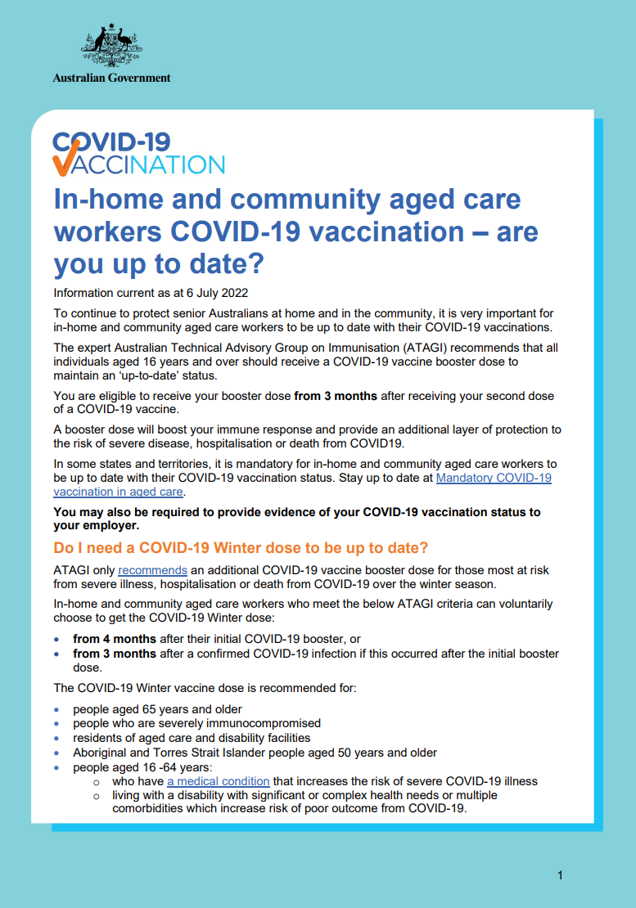

### 3.4. Frequently asked questions

**COVID-19 vaccination for in-home and community aged care workers**

#### When should I get vaccinated?

Vaccination remains the most effective protection against severe illness, hospitalisation and death from COVID-19.It is strongly encouraged to get a booster dose as soon as you are eligible. You are eligible for a booster dose if you received your second dose of a COVID-19 vaccine at least three months prior.

Depending on your state or territory of work, vaccination may also be a condition of employment. You are encouraged to speak to your employer to ensure you are meeting the requirements of public health directions that may be in force.

#### What vaccine will I get?

Four safe and effective vaccines are now available to all workers, regardless of your age – Comirnaty (Pfizer), Spikevax (Moderna), Nuvaxovid (Novavax) and Vaxzeria (AstraZeneca). The Moderna and Pfizer vaccines are also the preferred vaccines for booster doses.

#### How do I get a vaccination?

It’s never been easier to get a COVID-19 vaccination. We can support you to receive your vaccination as soon as possible.

You can find a COVID-19 vaccination clinic near you using the online [vaccine clinic finder](https://covid-vaccine.healthdirect.gov.au/eligibility?lang=en).

Priority appointments are available at:

* General practices
* Pharmacies
* Aboriginal Community Controlled Health Services
* State and territory-run mass vaccination clinics

If you have questions about getting your COVID-19 vaccination, please call the dedicated Helpline on **1800 020 080** and select **option 4** at any time.

#### Is the vaccine safe and effective?

Yes. There are currently four COVID-19 vaccines available for use in Australia and all are effective in protecting you from serious illness or death from COVID-19.

[Read more](https://www.health.gov.au/initiatives-and-programs/covid-19-vaccines/covid-19-vaccines) about the safety and effectiveness of COVID-19 vaccines.

#### Is the vaccine safe for women who are pregnant or breastfeeding?

Yes. Australian medical experts recommend the mRNA COVID-19 vaccines (Pfizer or Moderna).

Evidence shows the vaccine is safe for pregnant women and breastfeeding women.

Pregnant women are at higher risk of severe illness from COVID-19, and their babies are at higher risk of being born prematurely.

COVID-19 vaccination may provide indirect protection to babies by transferring antibodies through the placenta (for pregnant women) or through breastmilk (for breastfeeding women).

Women who are trying to become pregnant do not need to delay vaccination or avoid becoming pregnant after vaccination.

Pregnant women are encouraged to discuss the timing of their vaccination with their health professional.

More information is available here: [Pregnancy, breastfeeding and COVID-19 vaccines | Australian Government Department of Health and Aged Care](https://www.health.gov.au/initiatives-and-programs/covid-19-vaccines/who-can-get-vaccinated/pregnant-women)

#### Can I get sick from vaccination?

Most vaccines have side effects, and the COVID-19 vaccines are no different. It’s important to note that everyone’s immune system is unique.

Most side effects last no more than a couple of days and they go away without any problems.

Common reactions to vaccination include:

* pain, redness and/or swelling where you received the needle
* mild fever
* headache.

Some people will experience more significant flu-like symptoms from the vaccine, compared to other common vaccinations, and may need time away from normal activities. For the Pfizer vaccine, these symptoms are more common after the second dose.

#### How many vaccine doses do I need?

As [advised](https://www.health.gov.au/news/atagi-statement-on-defining-up-to-date-status-for-covid-19-vaccination) by the Australian Technical Advisory Group on Immunisation (ATAGI), to be considered ‘up-to-date’ with their COVID-19 vaccination a person must complete all doses recommended for their age and individual health needs. This means that everyone aged 16 years and older needs to receive a booster dose three months after their primary course of two vaccinations to maintain the best protection and an ‘up to date’ status. A third primary dose is recommended for people who are severely immunocompromised.

#### When and how do I get the booster dose?

You can book a booster dose using the online [vaccine clinic finder](https://covid-vaccine.healthdirect.gov.au/eligibility?lang=en).

Appointments are available at:

* General practices
* Pharmacies
* Aboriginal Community Controlled Health Services

If you have questions about getting your COVID-19 vaccination, please call the dedicated Helpline on **1800 020 080** and select **option 4** at any time.

#### What should I take to my appointment?

Bring the following with you to your appointment:

* proof of identity, for example, your driver's licence, passport or birth certificate
* [proof of employment](https://www.health.gov.au/resources/publications/covid-19-vaccination-proof-of-employment-letter-for-in-home-and-community-aged-care-workers) confirming you have priority access, or you can take a current work ID card or payslip
* your Medicare card, if you have one. People without a Medicare card can still access a COVID-19 vaccine.

#### Do I have to pay for the vaccine?

COVID-19 vaccines are administered free-of-charge. You do not have to have a Medicare card to access a free vaccine.

#### Why should I get vaccinated?

Vaccination remains the most effective protection against serious illness, hospitalisation or death from COVID-19 – for you, your family and the senior Australians in your care.

COVID-19 can spread quickly and widely. When enough people in the community are vaccinated, it slows down the spread of disease.

Higher vaccination rates make outbreaks much less likely, which reduces the need for things like lockdowns, border closures and travel restrictions. When you get vaccinated, you are protecting yourself, the people you care for and support, and the whole community.

#### What do I need to do after I am vaccinated?

It is important to let your employer know your COVID-19 vaccination status. This is because all in-home and community aged care providers are required to report de-identified data on their workforce COVID-19 vaccination status, including booster doses, via My Aged Care.

Your state or territory government’s public health orders will specify the proof of COVID-19 vaccination you are required to provide to your employer, if this applies to you.

A [fact sheet](https://www.health.gov.au/resources/publications/covid-19-vaccination-information-for-in-home-and-community-aged-care-workers-are-you-up-to-date) is available which provides more information about why your employer is asking you about your COVID-19 vaccination status and what types of evidence you can provide.

#### My question isn’t answered here – who can I talk to?

If you have questions about getting your COVID-19 vaccination, please call the **dedicated Helpline on 1800 020 080** and **select option 4** at any time.

If you are concerned about vaccination, please talk to your doctor as soon as possible.

Visit the [Department of Health’s website](https://www.health.gov.au/initiatives-and-programs/covid-19-vaccines/information-for-aged-care-providers-workers-and-residents-about-covid-19-vaccines/information-for-residential-aged-care-workers-about-covid-19-vaccines#support-for-residential-aged-care-workers-) for more information, including translated information and answers to frequently asked questions.

### 3.5. Text message scripts

### Key messages for distribution

| Topic | Text |
| --- | --- |
|  |  |
| Priority | Aged care workers will be prioritised for an appointment when you book through a primary care provider. Find the closest clinic now [COVID-19 Vaccine Clinic Finder | Australian Government Department of Health](https://www.health.gov.au/resources/apps-and-tools/covid-19-vaccine-clinic-finder) or call the dedicated Helpline on **1800 020 080** and select **option 4** at any time. |
| Vaccine availability | Four safe and effective COVID-19 vaccines are available in Australia. Don’t delay – get vaccinated now. Find a clinic: [COVID-19 Vaccine Clinic Finder](https://www.health.gov.au/resources/apps-and-tools/covid-19-vaccine-clinic-finder)  or call the dedicated Helpline on **1800 020 080** and select **option 4** at any time. |
| Help | Aged care workers with questions about COVID-19 vaccination, or requiring help with booking an appointment, can call the dedicated Helpline on 1800 020 080 and select option 4 at any time. Protect yourself. Protect those you care for. |
| What to take to an appointment | Remember to take to your COVID-19 vaccination appointment proof of identity, [proof of employment](https://www.health.gov.au/resources/publications/covid-19-vaccination-proof-of-employment-letter-for-in-home-and-community-aged-care-workers) and a Medicare card (if you have one). You don’t need a Medicare card to get your free vaccination. |
| Safe and effective | Australia now offers four safe and effective COVID-19 vaccines. Find a vaccination clinic near you on the [COVID-19 Vaccine Clinic Finder](https://www.health.gov.au/resources/apps-and-tools/covid-19-vaccine-clinic-finder) or call **1800 020 080** and select **option 4** at any time. |
|  |  |
|  |  |
| Health benefits | COVID-19 vaccines protect people from serious disease or death. If you haven’t been vaccinated yet, it’s important not to wait – book your vaccination now. |
| Community benefits | COVID-19 vaccines protect you, the people you care for, and your community. If you haven’t been vaccinated yet, it’s important not to wait – book an appointment now on the [COVID-19 Vaccine Clinic Finder](https://www.health.gov.au/resources/apps-and-tools/covid-19-vaccine-clinic-finder). |
| Co-worker benefits | COVID-19 vaccines protect you and your co-workers. If you haven’t been vaccinated yet, it’s important not to wait – book an appointment now via the [COVID-19 Vaccine Clinic Finder.](https://www.health.gov.au/resources/apps-and-tools/covid-19-vaccine-clinic-finder) |

### 3.6. Social media posts

|  | Text | Image |
| --- | --- | --- |
| Facebook | Aged care workers are prioritised to receive a vaccination appointment within 7 days of request when booking through a primary care clinic (like a GP or pharmacy).  Protect yourself and our most vulnerable citizens.  Book your vaccination now.  Find your closest clinic: [COVID-19 Vaccine Clinic Finder](https://www.health.gov.au/resources/apps-and-tools/covid-19-vaccine-clinic-finder)  or call the dedicated Helpline on **1800 020 080** and select **option 4** at any time.  #COVID19 #health #agedcare #vaccinate #protectyourself #ProudToProtect |  |
|  |  |  |
| Twitter | Aged care workers support some of our most vulnerable citizens. Protect yourself and those you care for. Book an appointment now: [COVID-19 Vaccine Clinic Finder](https://www.health.gov.au/resources/apps-and-tools/covid-19-vaccine-clinic-finder) #COVID19 #health #agedcare #vaccinate |  |
| Twitter | It’s never been easier to get a vaccine. Aged care workers must be vaccinated as a condition of their employment by <insert date> Book an appointment now [COVID-19 Vaccine Clinic Finder](https://www.health.gov.au/resources/apps-and-tools/covid-19-vaccine-clinic-finder) #COVID19 #health #agedcare #vaccinate |  |

### 3.7. Outbound call script

| Step | Script | Action |
| --- | --- | --- |
| 1 | Hello <worker’s name>. | Check if this is their preferred name.  Go to 2. |
| 2 | My name is <name> and I’m calling from the <name of organisation/team/location>.  I’m calling about the COVID-19 vaccine. | Go to 3. |
| 3 | Have you booked in for, or received, your booster COVID-19 vaccine dose yet? | If yes: go to 4.  If no: go to 5. |
| 4 | Thank you very much for prioritising your COVID-19 vaccine.  Do you have questions or need more information about the vaccine? | If yes: check if you can answer; refer to the Q&As for help.  If you can’t answer, advise that you will transfer them to 1800 XXX XXX  If no: go to 8. |
| 5 | We are really interested in understanding people’s choices and decisions around vaccination. May I ask why you haven’t booked your booster vaccination yet? Are there any special concerns you have that you would be happy to share and perhaps I can help? Alternatively, have you considered talking to your GP or union for advice? | Refer to the Q&As to see if you can answer/provide information.  Go to 6. |
| 6 | Aged care workers are a priority for COVID-19 booster vaccination. If you book through a primary care provider (like a GP or pharmacy) you should get an appointment within 7 days. | Go to 7. |
| 7 | You can find your nearest COVID-19 vaccination location through the [COVID-19 Vaccine Clinic Finder | Australian Government Department of Health](https://www.health.gov.au/resources/apps-and-tools/covid-19-vaccine-clinic-finder) | Go to 8. |
| 8 | If you have questions about getting your COVID-19 vaccination, you can call the dedicated Helpline on 1800 020 080 and select option 4 at any time.  If you are concerned about vaccination, please talk to your doctor as soon as possible.  You can also visit the [Department of Health’s website](https://www.health.gov.au/initiatives-and-programs/covid-19-vaccines/information-for-aged-care-providers-workers-and-residents-about-covid-19-vaccines/information-for-residential-aged-care-workers-about-covid-19-vaccines#support-for-residential-aged-care-workers-) for more information, including translated information and answers to frequently asked questions. | Go to 9. |
| 9 | Thank you for your time today. | End call. |

## Additional resources

A range of information and resources are available on the [COVID-19 Vaccination in Aged Care](https://www.health.gov.au/initiatives-and-programs/covid-19-vaccines/information-for-aged-care-providers-workers-and-residents-about-covid-19-vaccines) section of the Department of Health’s website.

### Resources to share with your workers

* [How to book your COVID-19 vaccination](https://www.health.gov.au/resources/translated/covid-19-vaccination-information-for-in-home-and-community-aged-care-workers-other-languages)
* [Proof of employment letter for priority vaccination](https://www.health.gov.au/resources/publications/covid-19-vaccination-proof-of-employment-letter-for-in-home-and-community-aged-care-workers)
* [Who can get vaccinated](https://www.health.gov.au/initiatives-and-programs/covid-19-vaccines/who-can-get-vaccinated)
* [Safety of COVID-19 vaccines](https://www.health.gov.au/initiatives-and-programs/covid-19-vaccines/approved-vaccines/safety-side-effects)
* [COVID-19 Vaccination Guide for women who are pregnant, breastfeeding or planning pregnancy](https://www.health.gov.au/resources/publications/covid-19-vaccination-shared-decision-making-guide-for-women-who-are-pregnant-breastfeeding-or-planning-pregnancy)
* [Find out the facts about COVID-19 vaccines](https://www.health.gov.au/initiatives-and-programs/covid-19-vaccines/is-it-true)
* [Aged care vaccine program](https://www.health.gov.au/initiatives-and-programs/covid-19-vaccines/information-for-aged-care-providers-workers-and-residents-about-covid-19-vaccines)

### Resources for providers

* Webinar and Q&A on [COVID-19 vaccination for in-home and community aged care providers](https://www.health.gov.au/resources/webinars/national-webinar-on-covid-19-vaccination-for-in-home-and-community-aged-care-providers)
* [Aged care vaccine program](https://www.health.gov.au/initiatives-and-programs/covid-19-vaccines/information-for-aged-care-providers-workers-and-residents-about-covid-19-vaccines)
* [Mandatory COVID-19 reporting](https://www.health.gov.au/initiatives-and-programs/covid-19-vaccines/information-for-aged-care-providers-workers-and-residents-about-covid-19-vaccines/mandatory-covid-19-vaccination-reporting)
* My Aged Care [Quick Reference Guide](https://www.health.gov.au/resources/publications/quick-reference-guide-how-to-view-add-and-update-covid-19-vaccination-data) on how to view and update your COVID-19 vaccination data.

You can also download useful resources from the Staff Vaccination Support Service website, including:

* [#ProudToProtect campaign materials](https://supporthub.agedservicesworkforce.com.au/media-and-communication/) – to help you celebrate success and reassure staff and service recipients that their safety and wellbeing is your no.1 priority  
  [Employment Relations tools and templates](https://supporthub.agedservicesworkforce.com.au/er-tools-and-templates/) - including a template vaccination policy for States where no mandate exists  
  [General Tools and resources](https://supporthub.agedservicesworkforce.com.au/general-tools-and-resources/) – to help you overcome staff objections and educate them about vaccination.