Info about the flu vaccine

# Why should I get the flu vaccine?

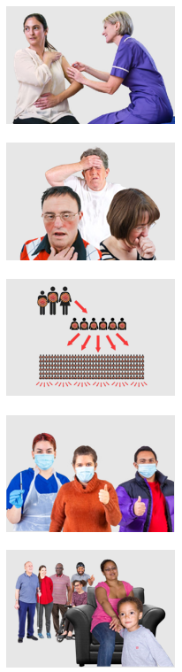There are some things to think about if you want to get a flu vaccine this year.

The flu is a type of cold that makes some people very sick.

The flu is easy to catch from others.

This year we think lots of people will get the flu.

The **flu vaccine** protects you and others from getting sick with the flu.

All people over 6 months old can get the flu vaccine.

# Side effects of the flu vaccine

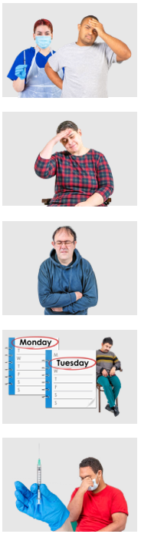A **side effect** is when you feel sick after you get a vaccine.

You may feel side effects after you get the flu vaccine.

Most side effects are often not serious.

The side effects can last 1 or 2 days.

Some side effects of the flu vaccine could be:

* Pain where you got the vaccine
* You feel tired or sore.

# When should I get the flu vaccine

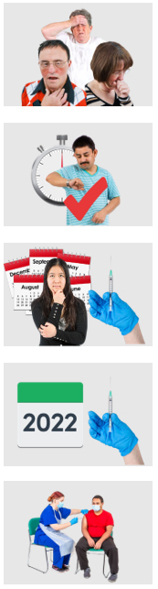Lots of people get sick from the flu in winter.

It is best to get the flu vaccine as soon as you can.

You can get the flu vaccine at any time of the year.

You only need 1 flu vaccine each year.

It is safe to get the flu vaccine on the same day as you get the COVID-19 vaccine.

# Where can I get the flu vaccine

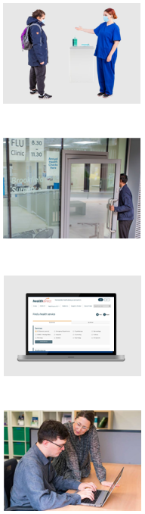You can get the flu vaccine from

* Your doctor or a chemist
* An Aboriginal health service.

You can also get the flu vaccine from a community health centre.

A **community health centre** is a place where you can get health supports.

You can use the Health Service Finder to find a place to get the flu vaccine.

The **Health Service Finder** is a website that helps you find a health service near you.

You can ask for help to use the Health Service Finder.

# Can I get the flu vaccine at home

Some doctors can come to your home to give you the flu vaccine.

You can call your doctor to ask about this.

If you live in supported accommodation your support person may get a doctor to come to your home.

**Supported accommodation** is a type of home where people with disability get supports.

You can ask your support person if a doctor can give you the flu vaccine at home.

# How much does the flu vaccine cost

The flu vaccine is free for:

* Children under 5 years old
* All people over 65 years old
* All First Nations people
* Women who are pregnant
* People who have other health problems like diabetes.

You can call the Department of Health where you live to ask if it is free for you.

The **Department of Health** looks after the health services in the place you live

# Department of Health info for each state and territory

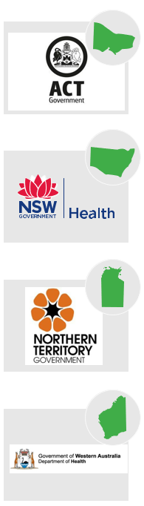Australian Capital Territory

You can call **02 5124 9800**

New South Wales

You can call **1300 066 055**

Northern Territory

You can call **08 8922 8044**

Western Australia

You can call **08 9321 1312**

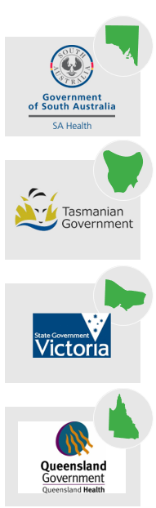South Australia

You can call **1300 232 272**

Tasmania

You can call **1800 671 738**

Victoria

You can call **1300 882 008**

Queensland

You can call **13 4325 84**

Council for Intellectual Disability made this document Easy Read. CID for short.

You need to ask CID if you want to use any pictures in this document.

You can contact CID at business@cid.org.au.