HCP and PHDB data submission user guide

Version 1.7 February 2021

**Private Hospital Data Bureau (PHDB)**

**Health Casemix Protocol (HCP) – (validation only)**

**Hospital Casemix Protocol 1 (HCP1)**

**Hospital Casemix Protocol 2 (HCP2)**

**General Treatment Dental (GTD)**

Contents

Introduction 4

Identity and Access Management (IAM) Portal 5

Log on to the Identity and Access Management (IAM) portal 5

Change your password 7

Criteria for your new password 8

Setting up password challenge questions 8

Reset forgotten password 9

Data Submission Portal (DSP) 11

Logging onto the DSP 11

File naming standards – PHIA file validation and submission 13

HCP file validation process 14

File naming standards – HCP file validation by hospitals 15

File naming standards – HCP file validation by health funds 15

Uploading a file 17

Submitting data in a ZIP file 19

Reviewing results of validation 19

Checking history of uploaded files 20

Downloading files and validation reports 22

Correcting errors 23

Additional features of manual file transfer 24

Logging out 24

Validation summary report PHDB – Hospitals 25

Validation summary report HCP – Hospitals 26

File information 26

Data file summary 26

Error summary 27

Validation summary reports – Funds 28

File information 29

Data file summary 30

Error summary 30

The validation listing report PHDB PDF 31

The validation listing report HCP PDF 32

File information 32

Error details 32

The validation listing report CSV 33

File information 33

Error details 33

What to do if your file fails 34

How to find your errors 34

Troubleshooting 35

Incorrect/forgotten password 35

Accessing the portal for the first time 35

Uploading files 35

Validation reports 36

Supported browsers 38

What browsers are supported? 38

Issues with Internet Explorer Version 10 or higher? 38

Any other requirements? 38

# Introduction

Welcome to the Australian Government Department of Health’s Enterprise Data Warehouse (EDW) Data Submission Portal (DSP) for data submissions required under the Private Health Insurance Act (PHIA).

The DSP is the most effective way to validate and submit Private Hospital Data Bureau (PHDB), Hospital Casemix Protocol (HCP), Hospital Casemix Protocol 1 (HCP1), Hospital Casemix Protocol 2 (HCP2) and General Treatment Dental (GTD) data files.

The PHIA Data Submissions User Guide is for Hospitals and Health Funds to follow for both validating data files prior to submission and then submitting those data files to the Department using the DSP. It includes instructions for uploading files for validation, submitting files, viewing a file transfer history, generating transfer reports and navigating within the DSP.

This User Guide assumes that you have already contacted the department and have obtained a username and temporary password for an account which enables access the Data Submission Portal. If you do not have a username and password please contact [hcp@health.gov.au](mailto:hcp@health.gov.au) (or ring 02 6289 8058) and request an account by giving the following details:

Name of data submitter:

Provider number of facility:

Provider (facility) name:

Email for validation reports:

If you submit data for more than one hospital and require this to be set up, please provide the provider ID for all facilities.

# Identity and Access Management (IAM) Portal

**This process will allow you to change your password, set or modify your challenge questions and update your personal details.**

To set up a new password for your account you will need to access the Identity and Access Management (IAM) portal.

Your username and temporary password are required to access this page. You should have received these in emails from the Department of Health.

## Log on to the Identity and Access Management (IAM) portal

**Step 1:** Access the [Identity and Access Management (IAM) portal](https://login.healthdata.gov.au/my.policy) at or click on the link provided in the Welcome email notification.

**Step 2:** Sometimes you may see the screen below depending on your browser settings. If so, click the ‘click here’ link.

Error screen 
Text says 
Your session could not be established 
to open a new session please click here 

**Step 3:** Indicate your agreement with the terms and conditions by clicking on the ‘Accept’

Login page 
Text in image 
 This system is for use by authorised users only. The right is reserved to monitor usage as necessary in accordance with relevant legislation and applicable policies. Unauthorised or improper use of this system may result in disciplinary action and/or civil or criminal penalties. By continuing to use this system you indicate your awareness of, and agreement to, these terms and conditions of use. DO NOT proceed with logon if you do not agree to the conditions stated in this notice.

with the options 
ACCEPT 
DECLINE

**Step 4:** Enter the username and temporary password you received in the email notification

Picture of the login.healthdata.gov.au page.
username
Password


Once you are logged on, the homepage will appear where you will be able to perform a number of different activities including changing your password.

## Change your password

**Step 1:** Select the ‘My Information’ tab from the IAM Portal

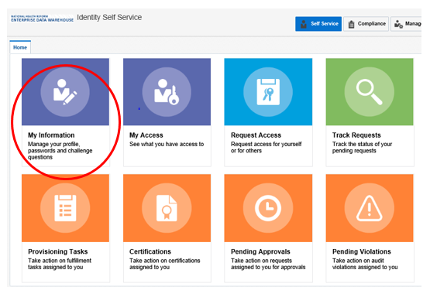

**Step 2:** Enter your temporary/old password into the ‘Old Password’ field and your new password in the listed fields. Once you have completed all three fields click ‘Apply’.

Change password page 
Old password
New password
Confirm New password

## Criteria for your new password

Passwords must:

* contain at least 2 alphabetic character(s)
* be at least 10 character(s) long
* contain at least 1 lowercase letter(s)
* contain at least 1 numeric character(s)
* contain at least 1 uppercase letter(s)
* start with an alphabetic character

Passwords must not:

* match or contain first name
* match or contain last name
* match or contain Username

## Setting up password challenge questions

**The setting of challenge questions is triggered whenever a new account holder logs into their account for the first time. The challenge questions can also be updated at any time through the Identity and Access Management (IAM) portal. These questions are used to check the user’s identity whenever a password reset is requested.**

**Step 1**: Select the ‘My Information’ tab from the IAM Portal

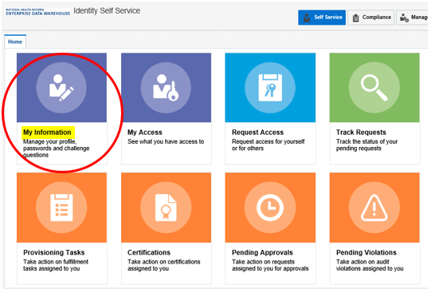

**Step 2:** Select the ‘Challenge Questions’ sub tab from the ‘My Information’ page.

Challenge questions page.
Question 1 Answer 1 
Question 2 Answer 2
Question 3 Answer 3
Question 4 Answer 4   
Question 5 Answer 5 
Question 6  Answer 6 

**Step 3:** Select questions you would like to use as your three challenge questions using the drop-down boxes.

**Step 4:** Enter the answer for each chosen question into the boxes provided.

**Step 5:** Complete all questions and responses then click ‘Apply’. A popup will appear to confirm that challenge questions have been successfully set.

## Reset forgotten password

If you ever forget your password, you are able to do a reset by entering the answers to your challenge questions, follow these steps.

**Step 1:** Navigate to [Forgotten Password](https://identity.healthdata.gov.au/identity/faces/forgotpassword?backUrl=https://identity.healthdata.gov.au/identity)

**Step 2:** Enter your username in the space provided and then click **Next**.

Forgotten password page
Enter your username 


**Step 3:** The following window will appear where you can enter the answers to your challenge questions which were set up when first setting your password.

Answer your challenge questions
What is your mothers maiden name?
what is the city of your birth?
what is  your favourite colour?


**Step 4:** Once you have filled in answers to each challenge question click the “Submit” button

**Step 5:** Once submitted an email should be sent to your email account assigning a random password which you can then use to log in.

Once you have received your temporary password, it is recommended that you change it to something more memorable to reduce the need for a future password reset.

If you have forgotten the answers or never set your security challenge questions then you will have to request a manual password reset by emailing [hcp@health.gov.au](mailto:hcp@health.gov.au) providing your username and letting us know that you require a password reset.

# Data Submission Portal (DSP)

## Logging onto the DSP

**Step 1:** Navigate to the [Data submission Portal](https://mftportal.data.health.gov.au/VLPorta)

**Step 2:** You may see the screen below depending on your browser settings. If so, click on the ‘click here’ link.

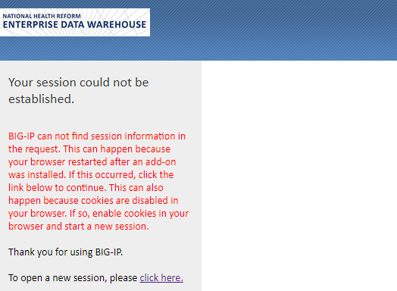

**Step 3:** Indicate your agreement with the terms and conditions by clicking on the ‘Accept’ icon

This system is for use by authorised users only. The right is reserved to monitor usage as necessary in accordance with relevant legislation and applicable policies. Unauthorised or improper use of this system may result in disciplinary action and/or civil or criminal penalties. By continuing to use this system you indicate your awareness of, and agreement to, these terms and conditions of use. DO NOT proceed with logon if you do not agree to the conditions stated in this notice.
Accept or 
Decline

**Step 4:** Enter your Username and Password and click ‘Logon’.

Please note: your Username must be entered in lowercase

Secure logon page
username 
Password


After successfully logging into the Data Submission Portal you will arrive at this page:

Welcome to the VersaLex web portal.

  --  select "Manual File Transfer" for ad hoc file transfers
  --  select "File Transfer History" to view transfer results within your HTTP user mailbox or an associated primary mailbox
  --  select "VersaLex Web Portal Help" to view general help documentation for the portal


Please contact the system administrator with any questions.

**Please note:**

The standard browser ‘forward’ and ‘back’ buttons should not be used when navigating within and between the portal base pages. Instead use the menu in the left pane to navigate between the pages.

The standard browser ‘refresh’ button should also not be used. Instead use the refresh button or icon provided on the portal view page.

## File naming standards – PHIA file validation and submission

Naming the file correctly prior to uploading PHIA files to the DSP is essential. If the file name is incorrect, the DSP will reject the file.

For Health Funds, a different file naming standard has been specified when a HCP file is uploaded for validating. See “File naming standards – HCP File Validation by Health Funds”.

PHIA data files are required to follow the relevant format listed below:

*All files are to be saved as text files (.txt), this includes files submitted within a ZIP file.*

### PHDB

***ProviderNumber***(underscore)**PHDB**(underscore)***MonthYear***

*ProviderNumber* = 8 character code used to uniquely identify the hospital who is the originating source of the data.

*MonthYear* = Month reported. Character values in the format MM(e.g. JUL="07", AUG="08") for month and YYYY (e.g. 2021) for year.

#### Example

**0123456T_PHDB_042021.txt**

### HCP1

***InsurerCode***(underscore)**HCP1**(underscore)***MonthYear***

*InsurerCode* = 3 character code used to uniquely identify the Health Fund.

*MonthYear* = Month reported. Character values in the format MM(e.g. JUL="07", AUG="08") for month and YYYY (e.g. 2021) for year.

#### Example

**ABC_HCP1_042021.txt**

### HCP2

***InsurerCode***(underscore)**HCP2**(underscore)***MonthYear***

*InsurerCode* = 3 character code used to uniquely identify the Health Fund.

*MonthYear* =Final month in quarter reported (e.g. Quarter 1 data would have March (03) as month for filename).

#### Example

**ABC_HCP2_032021.txt**

### GTD

***InsurerCode***(underscore)**GTD**(underscore)***EndofQuarterMonthYear***

*InsurerCode* = 3 character code used to uniquely identify the Health Fund.

*EndofQuarterMonthYear* = Last month of quarter reported. Character values in the format MM(e.g. MAR="03", JUN="06") for month and YYYY (e.g. 2021) for year. This has to be the last month of the relevant reporting quarter (ie 03,06,09 or 12).

#### Example

**ABC_GTD_062021.txt**

## HCP file validation process

HCP (hospital to insurer) validation using the DSP for 2020-21 data onwards is now available. Hospitals and Funds log in to the DSP and upload both HCP Episode and related ANSNAP files (separately) to validate that they comply with the required specifications.

There is no limit on the number of times this process may be undertaken. After Hospitals have corrected any errors, they will send their HCP Episode and ANSNAP data files to Funds in the usual way. Funds can also check that the HCP files received from Hospitals are valid. There are two acceptable file name formats for HCP validation, please see examples below.

**Please note that Hospitals are responsible for sending the validated HCP data files to the relevant Health Funds. The Department is not responsible for this process.**

*See sections on* *uploading files* *and* *downloading the validation reports**.*

## File naming standards – HCP file validation by hospitals

### HCP

**ProviderNumber**(underscore)**HCP**(underscore)**MonthYear**

**Or**

**ProviderNumber**(underscore)**Fundcode**(underscore)**HCP**(underscore)**MonthYear**

ProviderNumber = 8 character code used to uniquely identify the hospital who is the originating source of the data.

MonthYear = Month reported. Character values in the format MM(e.g. JUL="07", AUG="08") for month and YYYY (e.g. 2021) for year.

#### Examples

**0123456T_HCP_042021.txt**

**0123456T_ABC_HCP_042021.txt** – this one includes the fund code

### HCP – ANSNAP

**ProviderNumber**(underscore)**ANSNAP**(underscore)**MonthYear**

**Or**

**ProviderNumber**(underscore)**Fundcode**(underscore)**ANSNAP**(underscore)**MonthYear**

ProviderNumber = 8 character code used to uniquely identify the hospital who is the originating source of the data.

MonthYear = Month reported. Character values in the format MM(e.g. JUL="07", AUG="08") for month and YYYY (e.g. 2021) for year.

#### Examples

**0123456T_ANSNAP_042021.txt**

**0123456T_ABC_ANSNAP_042021.txt** – this one includes the fund code

## File naming standards – HCP file validation by health funds

These are the file naming standards which are be used by Health Funds uploading HCP files for validation using the DSP process.

Naming the file correctly prior to uploading to the DSP is essential. If the file name is incorrect, the data file will be rejected.

Different file naming standards are in use for HCP Episode files and for HCP ANSNAP files. The files must use the file naming standard prescribed:

*All files are to be saved as text files (.txt), this includes files submitted within a ZIP file.*

### HCP – Episode

**ProviderNumber**(underscore)**HCPF**(underscore)**MonthYear**

ProviderNumber = 8 character code used to uniquely identify the hospital who is the originating source of the data.

MonthYear = Month reported. Character values in the format MM(e.g. JUL="07", AUG="08") for month and YYYY (e.g. 2013) for year.

#### Example

**0123456T_HCPF_042019.txt**

### HCP – ANSNAP

**ProviderNumber**(underscore)**ANSNAPF**(underscore)**MonthYear**

ProviderNumber = 8 character code used to uniquely identify the hospital who is the originating source of the data.

MonthYear = Month reported. Character values in the format MM(e.g. JUL="07", AUG="08") for month and YYYY (e.g. 2013) for year.

#### Example

**0123456T_ANSNAPF_042019.txt**

## Uploading a file

Server Download Directory
upload files
home > outbox
Files below 

**Step 1:** To upload your files, select the ‘Manual File Transfer’ link from the menu, as shown below. If you see an error message after clicking the link, please click the ‘Manual File Transfer’ link again.

**Step 2:** In the Server Upload Directory panel, ensure that ‘./inbox’ is selected from the dropdown box.

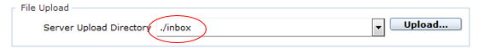

**Step 3:** Click on the ‘Upload button’ to upload files. A security warning may pop up, if this happens, tick the option to ‘Always trust content from this publisher’ and then click ‘Yes’. (This warning message should only appear the first time you launch the DSP from your browser).

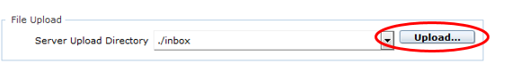

**Step 4:** A Windows File Explorer window will be displayed (as shown below). Navigate to and select the file you wish to upload and Click on the ‘Open’ button

**Please note: your file must adhere to the file naming standards listed under ‘File Naming Standards’ (p.13).**

Windows File Explorer window
the ‘Open’ button circled

**Please note**: The DSP will accept both zipped and unzipped files.

**If you are resubmitting data for a month which you have previously submitted, the contents of the previous submission will be completely overwritten by this one**

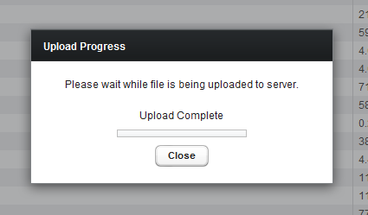

**Step 5** An ‘Upload Progress’ window will appear on your screen updating you on the progress of the upload. Once your file(s) have been uploaded the text “Upload Complete” should appear in the window. Note that the ‘progress bar’ in the window will appear as below once completed. Click the ‘Close’ button to close the window.

Once you have uploaded your file to the DSP, you will receive an email confirming its upload. The data file will then go into a queue to be validated. Your file should be validated on the same day it’s uploaded however; during peak periods it can take up to 1 business day depending on the server queue.

## Submitting data in a ZIP file

Multiple or single data files can be submitted in a ZIP file if you preferred. A ZIP file should contain no more than 20 files.

ZIP files have no required naming conventions but the file name may not contain any spaces.

## Reviewing results of validation

Once your submitted file has been validated you should receive an email stating either your file has:

* Successfully validated with no errors
* Passed validation with errors
* Failed validation

If your file has ‘passed validation with errors’ or ‘failed validation’ you will receive a validation summary report attachment with this email outlining each error and warning found within the file.

A more comprehensive error report that lists each individual error with its row number and invalid value can be downloaded directly from the DSP. These comprehensive error reports are known as ‘Validation Listing Reports’. **See section on** **Downloading files and validation reports** **for step-by-step guide to downloading these files.**

In the case of a file failing validation, please amend the errors and resubmit a corrected file to the DSP.

## Checking history of uploaded files

**This process will allow you to check that files have been uploaded, and to create a ‘Transfer Report’**

**Step 1:** To check the files you have uploaded to the EDW, select the ‘File Transfer History’ link in the menu, as shown below.

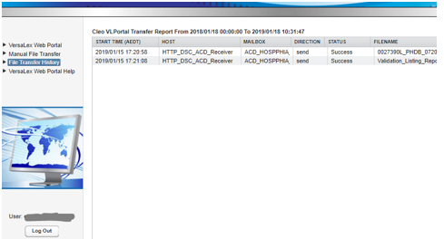

This page will display all file uploads associated with your mailbox. Initially, only the current day’s transfers will be displayed. Click on each column header to sort the table in ascending or descending order.

**Step 2:** Select the ‘Filter’ button at the bottom of the page to customise the items you wish to display in your transfer report.

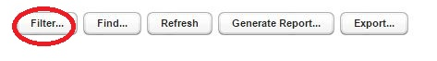

The following page will appear:

Cleo VL Portal Transfer report filter window
From 00:00
to 
Today now

**Understanding how the Transfer Report filter works:**

* ‘**From’ and ‘To’ fields:** these fields allow you to select the time range that the report will display. You may either use the drop down menus or enter specific dates (YYYY/MM/DD) and time (HH:MM) fields.
* **Include Host Mailbox(es), Status(es), Direction(s):** these fields allow you to filter based on a specific host or mailbox, status or direction.
* Click the **‘All’** button to select all the rows in that section.
* Click the **‘None’** button to deselect all the rows in that section.
* Click the **‘Continue’** button to refresh the display with the specified criteria you have chosen.
* Click the **‘Cancel’** button to cancel the operation and return to the File Transfer History display.
* Click the **‘Help’** button for a list of support documentation. This information will be displayed in a separate window.

**Step 3:** Once you have clicked the ‘Continue’ button on the Transport Report Filter, as shown in Step 2, your File Transfer History will be refreshed based on the selected filter criteria.

## Downloading files and validation reports

Once a file is uploaded and processed, the Portal can provide up to 4 different types of validation reports:

1. Validation Summary report (pdf) – Summary table of errors/warnings
2. Validation Sample report (pdf) – Sample of errors/warnings (not very useful)
3. Validation listing report (pdf) – Full List of errors/warnings
4. Validation listing report (CSV) – (Open in Excel) Full List of errors/warnings with additional information

*You have the ability to download data files that you have previously uploaded to the DSP and/or validation reports returned after validation.*

*These files can be found in your outbox located in the Portal by following the instructions below.*

**Step 1:** To download a file returned from the EDW select the ‘Manual File Transfer’ tab in the menu. Files returned will be displayed in the ‘File Download’ section. First click the ‘Refresh’ button at the bottom of the screen to ensure that the latest files are visible. Click on the ‘MODIFIED (AEST)’ column heading to sort by date (to see most recent files). To download a file, select it and click ‘Download’ at the bottom of the screen. You will have the option to open the file or show the file in your ‘Downloads’ Folder.

Outbox with validation listing report
Validation summary report
Validation listing report sample 
Validation listing report CSV highlighted 

## Correcting errors

If you have errors in the summary report, you will be able to find the individual values causing the errors in the Validation listing report.csv. This file contains more information (eg. ‘MRN’) than the PDF Validation listing report.

* For PHDB the csv file includes the Medical Record Number (MRN)
* For HCP the csv file includes the Medical Record Number (MRN)
* For HCP1 the csv file includes the Link identifier
* For HCP2 the csv file includes Patient ID
* For GTD the csv file includes Patient ID
* For ANSNAP the csv file includes the AN-SNAP Identifier

You should be able to find the errors using the MRN and correct the errors in your software system. Once errors have been rectified, please upload the amended data file, using the same file name eg 01234567A_PHDB_062019.txt. This will overwrite your previous data submission in the Portal.

**NOTE.** A CSV file is a comma-separated values file and has a .csv extension. CSV files can be used with spreadsheet programs, such as Microsoft EXCEL.

A TEXT file has no formatting and has a .txt extension. TEXT files can be used with programs such as Notepad++. (Don’t use Notepad)

## Additional features of manual file transfer

**(Located at the bottom of the Manual File Transfer screen)**

* **‘All’ –** Click this button to select all the rows in the table.
* **‘None’ –** Click this button to deselect all the rows in the table.
* **‘Refresh’ –** Click this button to update the table display in the case where the directory's contents may have changed.
* By selecting **‘Zip single selection file download’**, will zip the file you are downloading
* Click ‘VERSALEX WEB PORTAL HELP’ on top left side for more help information

## Logging out

**Once you have finished using the DSP click the ‘Log Out’ button on the left to log out.**

**If you leave your session inactive for more than a few minutes during use the system will log you out automatically.**

# Validation summary report PHDB – Hospitals

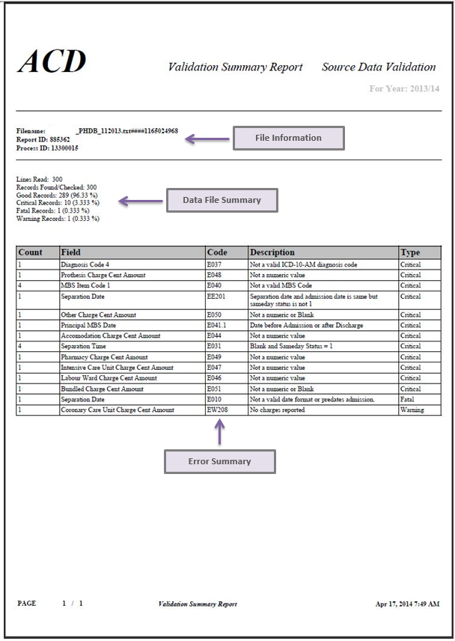

# Validation summary report HCP – Hospitals

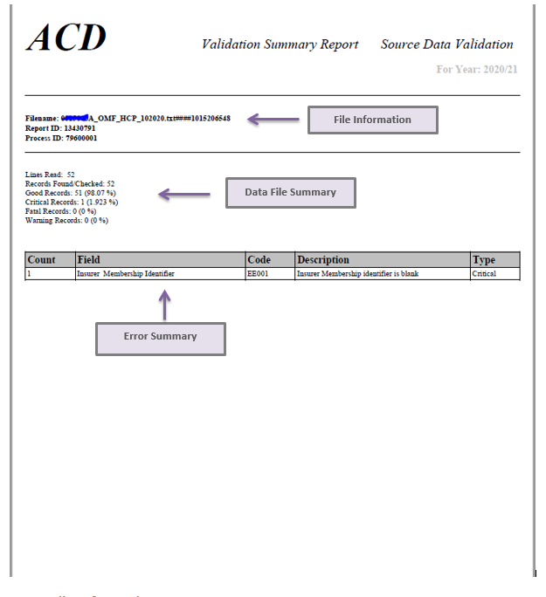

## File information

Identifies:

* the filename of the file for which the validation summary report has been produced
* the technical internal identifiers used within the Data Submission Portal.

## Data file summary

Allows you to identify:

* the number of lines read
* the number of records found/checked.
* the number and percentage of:
  + ‘Good’ records (ie records with no errors).
  + ‘Critical’ records (records with at least one critical error (which must be corrected for the file to ‘pass’. These records may also contain identified (warning) errors).
  + ‘Fatal’ records (records with at least one fatal error within the record). Fatal errors are errors which will cause the file to fail even when the error threshold percentage has not been exceeded.
  + ‘Warning’ records (records with at least one identified (warning) error and no critical errors).

## Error summary

The error summary is used to identify the types of errors (critical or identified) by field, code, description and their frequency.

You can find the Validation Summary Report attached to the failed submission email, it is also available to download directly from the Portal (see: ‘Downloading files and validation reports’).

# Validation summary reports – Funds

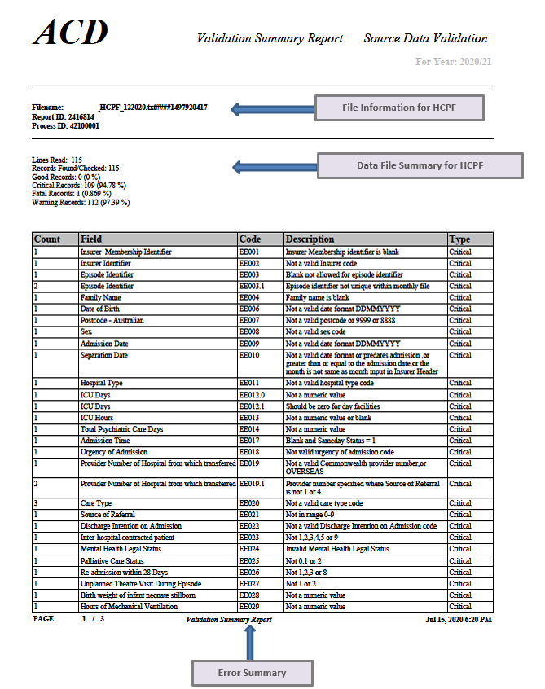

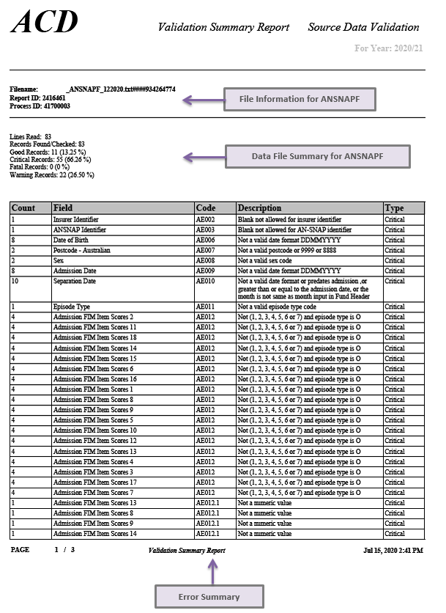

## File information

Identifies:

* the filename of the file for which the validation summary report has been produced
* the technical internal identifiers used within the Data Submission Portal.

## Data file summary

Allows you to identify:

* the number of lines read
* the number of records found/checked.
* the number and percentage of:
  + ‘Good’ records (i.e. records with no errors).
  + ‘Critical’ records (records with at least one critical error (which must be corrected for the file to ‘pass’. These records may also contain identified (warning) errors).
  + ‘Fatal’ records (records with at least one fatal error within the record). Fatal errors are errors which will cause the file to fail even when the error threshold percentage has not been exceeded.
  + ‘Warning’ records (records with at least one identified (warning) error and no critical errors).

## Error summary

The error summary is used to identify the types of errors (critical or identified) by field, code, description and their frequency.

You can find the Validation Summary Report attached to the failed submission email, it is also available to download directly from the Portal (see: ‘Downloading files and validation reports’).

# The validation listing report PHDB PDF

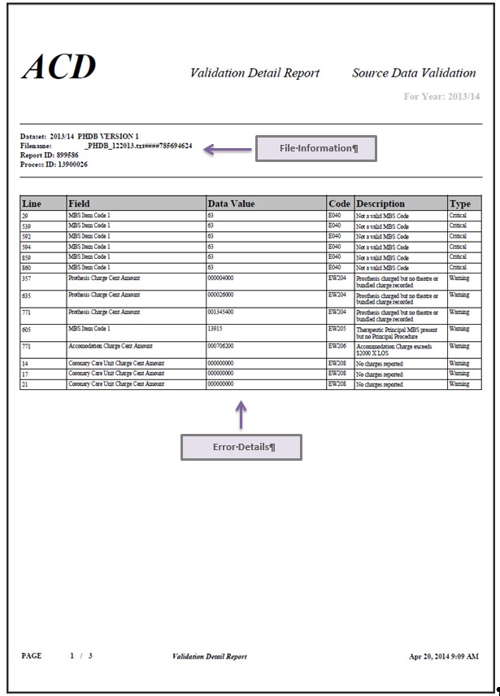

# The validation listing report HCP PDF

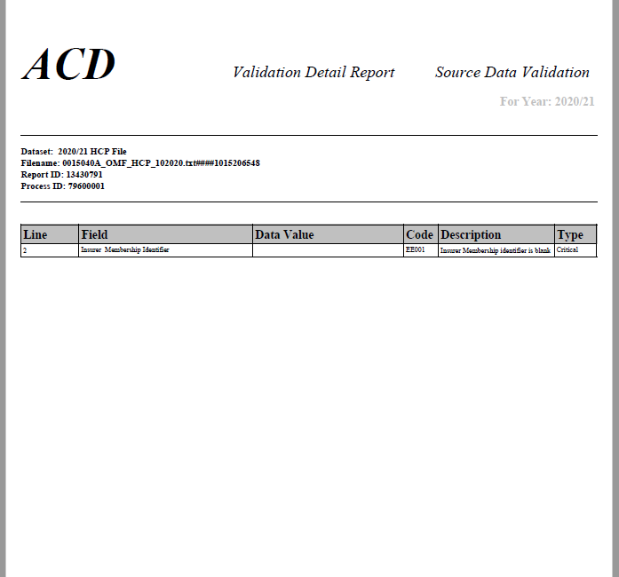

## File information

Identifies:

* the filename of the file for which the validation summary report has been produced
* the technical internal identifiers used within the Data Submission Portal.

## Error details

Error Details’ gives you a listing of each individual error/warning with the line on which it occurs and the data value which is causing the error/warning

The Validation Listing Report PDF is available to download directly from the Portal (see: ‘Downloading files and validation reports’).

# The validation listing report CSV

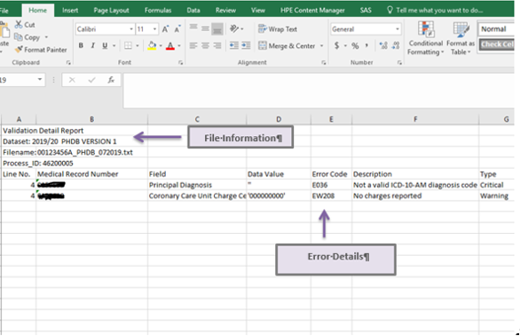

## File information

Identifies:

* the filename of the file for which the validation listing report has been produced
* the technical internal identifiers used within the Data Submission Portal.

## Error details

The CSV report gives you a listing of each individual error/warning including additional information, with the line on which it occurs and the data value which is causing the error/warning. The CSV version of the validation listing report contains the same listing of errors as in the PDF version, but in addition, includes Medical Record Number (MRN) for PHDB and HCP, AN-SNAP Identifier for ANSNAP, Link Identifier for HCP1, and Patient ID for HCP2 and GTD.

The Validation Listing Report CSV is available to download directly from the Portal (see: ‘Downloading files and validation reports’).

# What to do if your file fails

1. Use the Validation Summary Report and Validation listing Report to identify:

* the types of errors and their frequency
* where the errors have occurred
* why the errors have occurred

1. Once you have identified the errors go back to your original data file to correct them.   
   *Note all ‘fatal’ errors must be corrected for the data file to ‘PASS’.*
2. Re-submit the amended data file through the Data Submission Portal
3. If you need help you can contact the PHDB/HCP help line 02 62898058, or email the HCP/PHDB inbox [hcp@health.gov.au](mailto:hcp@health.gov.au)

**Please alert the Department of any errors that you think are being incorrectly flagged or are inconsistent with the data specifications or are impossible to address.**

## How to find your errors

Look at Validation Summary Report for general information regarding the errors

Look at the Validation Listing Report CSV for a more in-depth analysis of the errors. The Validation Listing Report is available to download through the portal, see the section of this document titled ‘Downloading files and validation reports’ for more information.

Check the data specifications for an overview of each individual edit rule.

# Troubleshooting

## Incorrect/forgotten password

### Problem:

**Password reset required**

You have forgotten your password or have had too many unsuccessful attempts at logging in and require a password reset.

### Solution:

If you have set your secure password challenge questions then navigate to [Reset Forgotten Password’](https://identity.data.health.gov.au/ForgotPassword/logonChallengeQuestions.jsp)

If you have not set your password challenge questions or do not know the answers to the questions a password reset can be requested by emailing [hcp@health.gov.au](mailto:hcp@health.gov.au), and providing us with your user name.

## Accessing the portal for the first time

### Problem:

**An error message displays when clicking ‘Manual File Transfer’ for the first time.**

### Solution:

After a long initialisation period, an error message may appear. If this happens, click on the ‘Refresh’ button. The ‘Manual File Transfer’ page should then be displayed and you will be able to upload files. Should this problem persist, please contact the EDW Service Desk at [hcp@health.gov.au](mailto:ITServiceDesk@health.gov.au).

## Uploading files

### Problem:

**‘File Transfer History’ is not showing.**

Logged in and successfully uploaded files to the DSP however, when ‘File Transfer History’ is selected from the menu, uploaded files are not displayed.

### Solution:

If this happens, click on the ‘Refresh’ button or elsewhere on the screen but not on the error message. This will cause the page to refresh and load the File Transfer History page. Should this problem persist, please contact the EDW Service Desk at [hcp@health.gov.au](mailto:ITServiceDesk@health.gov.au).

### Problem:

**Internet Explorer cannot display the page.**

The error message “Internet Explorer cannot display the page” appears as file uploading is attempted.

### Solution:

A limitation exists in some versions of Internet Explorer when uploading large files (>1 GB). The file is uploaded successfully but displays an error message or the files fail to upload but the user still receives a “Files uploaded” notification. This error does not exist for Mozilla Firefox and Google Chrome when uploading files larger than 1GB. Should this problem persist, please contact the EDW Service Desk at [hcp@health.gov.au](mailto:ITServiceDesk@health.gov.au).

## Validation reports

### Problem:

**Validation reports are not attached to the notification email received after data validation.**

Auto notification email received from the EDW DSP indicating errors in the file(s) submitted but there was no validation summary report attached to the email

### Solution:

This is a technical problem – please contact the EDW Service Desk at [hcp@health.gov.au](mailto:ITServiceDesk@health.gov.au)

### Problem:

**Validation report errors are too difficult to interpret**

Validation summary reports received but not able to make sense of errors

### Solution:

Refer to the PHIA [data specification](https://www.health.gov.au/resources/collections/hospital-data-resources#data-specifications) relevant to the data collection you are submitting.

If you are still unable to interpret your errors, please email the HCP/PHDB inbox at [hcp@health.gov.au](mailto:hcp@health.gov.au) with your query or phone the HCP/PHDB hotline on (02) 6289 8058.

### Problem:

**Only attachment received with auto notification was the validation summary report. The full range of errors was not displayed.**

The attached validation report from the auto notification email only outlines the first 50 errors and not the full range of errors.

### Solution:

A summary of the validation report, which contains the first 50 errors, will be attached to the auto notification email. If the file contains, more than 50 errors, you will need to go to your ‘Outbox’ and download them. See section 3.5 Downloading files and validation reports from the Outbox for instructions.

# Supported browsers

## What browsers are supported?

The following Browser/Versions are currently supported for DSP use:

* Internet Explorer version 10 or higher
* Google Chrome version 87 or higher
* Firefox version 2 or higher

Other browsers and browser versions may work, but are not supported.

## Issues with Internet Explorer Version 10 or higher?

If you are using Internet Explorer version 10 or higher and the DSP is not behaving as expected try running the DSP website in compatibility mode.

Instructions for how to run a website in compatibility mode are available at:<http://windows.microsoft.com/en-AU/internet-explorer/use-compatibility-view#ie=ie-11>

## Any other requirements?

When setting up your browser make sure to:

* Turn off any pop-up blockers
* Install Java runtime extensions required for the browser to work with the Web GUI Interface. (as prompted)
* Recommendation for Java Runtime Extension is version 1.6 or higher

A minimum screen resolution of 1024X768 is highly recommended.