Emergency Response Plan for Communicable Disease Incidents of National Significance
  - Australian Health Protection Principal Committee
  - CD Plan
  - September 2016

Authority
The Emergency Response Plan for Communicable Disease Incidents of National Significance (CDPLAN) was developed by the Communicable Diseases Network Australia, a standing committee of the Australian Heath Protection Principal Committee.
CDPLAN was endorsed by the Australian Health Protection Principal Committee on 11 August 2016. CDPLAN has been developed under the auspices of the National Health Emergency Response Arrangements (NatHealth Arrangements 2009).
Certificate of Amendment
The Department of Health will review the Emergency Response Plan for Communicable Disease Incidents of National Significance as appropriate.
Recommendations for amendments or suggestions for improvement may be made at any time to:
Assistant Secretary Health Emergency Management Branch
Office of Health Protection
Australian Government Department of Health
MDP 140 GPO Box 9848 Canberra ACT 2601
Phone: +61 2 6289 3030 Facsimile: +61 2 6285 3040
E-Mail: Health.Ops@Health.gov.au
Information on the current version can be obtained from the Department of Health Website DoH Website.
Table of Amendments, issue date, amended by and date.
Amendment No | Issue Date | Amended By | Date

Contents
1 Introduction 5
1.1 Origins of this plan 5
1.2 Objectives of this plan 5
1.3 Target audience 6
1.4 Structure of this plan – informed by the comprehensive approach 7
1.5 Context 7
1.6 Scope 9
1.7 Summary of what happens in Response 9
1.8 Legislation 11
2 Governance: Roles and responsibilities 13
2.1 Australian Government 13
2.2 State and territory governments 15
2.3 Coordinating mechanisms 16
2.4 Linkage to Health and Emergency Plans 20
2.5 Ethical framework to support decision making 21
2.6 An approach to vulnerable populations or at risk groups 21
3 Using this plan 23
3.1 Identification 23
3.2 Assessment 23
3.3 Declaration 24
3.4 Escalation 25
3.5 Response coordination 27
3.6 Standdown 30
4 Public health system preparedness and response 31
4.1 Australian Government Department of Health responsibilities 31
4.2 Responsibilities shared between Australian Government and state and territory governments 39
4.3 State and territory government responsibilities 43
4.4 A note on command, control and coordination in the public health response 44
5 Healthcare system preparedness and response 47
5.1 Workforce 47
5.2 Infection prevention and control 48
5.3 Clinical care pathways 49
5.4 Primary health care 50
5.5 Secondary and tertiary care 51
5.6 Pathology laboratories 52
5.7 Equipment and supplies 52
6 Financial considerations 53
7 Recovery and resilience 54
7.1 Recovery 54
7.2 Resilience 54
8 Plan administration 56
8.1 Plan testing 56
8.2 Plan review 56
9 Appendices 57
9.1 Decision instrument to support Rapid Assessment Panel 57
9.2 IHR decision instrument for notification to WHO 58
9.3 Example of incident management roles and responsibilities 59
9.4 Glossary and acronyms 61

Introduction

Origins of this plan
- The Australian Government Department of Health is responsible for planning for the management of national health emergencies. Part of this responsibility is planning how the health sector will respond to and manage communicable disease outbreaks, epidemics or pandemics that threaten to impact human health and result in increased demand for health service delivery and healthcare workers.
- The National Health Emergency Response Arrangements (NatHealth Arrangements 2009) articulate the strategic arrangements and mechanisms for the coordination of the Australian health sector in response to emergencies of national consequence, including communicable disease emergencies.
- The Australian Health Protection Principal Committee (AHPPC) – in partnership with the Australian Government Department of Health - is responsible for the NatHealth Arrangements. This responsibility is through the Australian Health Minister’s Advisory Council (AHMAC).
- This plan is a hazard specific sub-plan of the NatHealth Arrangements 2009 and is intended to sit above disease-specific emergency plans and other disease-specific plans.
- Where disease-specific plans exist, such as the Australian Health Management Plan for Pandemic Influenza (AHMPPI) and the National Polio Emergency Response Plan, these are the primary plans used in response to specific incidents.
- Where no disease-specific plan exists, this Plan is considered the primary response plan.

Objectives of this plan
The objectives of this plan are to:
- Describe the context within which the Australian Government Department of Health and state and territory government health departments will function during any national communicable disease related emergency.
- Clarify roles and responsibilities of the Commonwealth and state and territory health authorities including inter-jurisdictional committees and decision making bodies.
- Describe the mechanisms through which a communicable disease incident of national significance (CDINS) is declared, how this plan will be escalated and stood down.
- Describe preparedness and response measures that may be taken by the public health and healthcare system in anticipation of, or during a CDINS.
By ensuring that all parts of the health sector understand the systems, processes and roles described in this plan, use of this plan will:
- Ensure rapid, timely, coordinated action.
- Ensure current and authoritative information for health professionals, the public and media at all stages of the response.
- Reduce morbidity and mortality to the greatest extent possible.
- Minimise the burden on the health system and ensure health service ‘business as usual’ is protected as much as possible.
- Minimise social disruption and economic losses that may be associated with disease outbreaks or epidemics.

Target audience
This plan should be read and used by all agencies and individuals in the health sector as a high-level guide to preparing and responding in the event of a CDINS.
This plan is primarily relevant to:
- the Australian Government Department of Health;
- State and territory government health departments;
- joint Commonwealth/State/Territory health committees; and
- the health sector and healthcare providers.
The health sector includes, but is not limited to the following:
- Public and private hospitals
- Diagnostic, reference and public health pathology laboratories
- Public health unit managers
- Primary healthcare organisations and Primary Health Networks
- Primary care practitioners (General Practitioners and community pharmacists)
- Healthcare professionals including specialists and infection control practitioners
- Ambulance services
- Community health providers
- Mental health providers
- Other specialist services
- Specialist clinical networks
- Government public health practitioners including immunisation providers

Structure of this plan – informed by the comprehensive approach
- The comprehensive approach involves a continuum of strategies for risk management through stages of Prevention, Preparedness, Response and Recovery (PPRR).
- Prevention activities reduce the likelihood and/or minimize the effect of CDINS. Examples of prevention activities include: strengthening communicable disease surveillance for early detection of outbreaks to enable earlier response; intelligence gathering through international surveillance; improving immunisation rates for the National Immunisation Program (NIP) and incorporating new vaccines to the NIP where these are shown to be cost effective; and strengthening biosecurity to minimise the risk of the entry, emergence, establishment or spread of exotic pests and diseases that have the potential to cause significant harm to people, animals, plants, the environment and the economy.
- This plan focuses on Preparedness and Response.
  - Response activities are further divided into Standby, Action and Standdown
- Preparedness includes actions taken before an incident to ensure effective response and recovery. The Response phase includes measures that are taken in anticipation of, or during an incident. Measures taken specifically in anticipation of a particular incident are response measures, but can be confused with preparedness measures.
- Adapting the PPRR model to this plan is based on the premise that Australian communicable disease authorities and healthcare providers are in a constant state of preparedness and response to communicable diseases. As examples, these measures range from identifying and responding to notifiable disease cases, investigating and managing outbreaks, treating and contact tracing infectious cases of diseases such as tuberculosis, hepatitis A, or measles, writing guidelines and plans, managing surveillance systems, to coordinating through a range of national committees.
- Transitioning from routine communicable disease response to a national emergency response for a communicable disease incident is likely to represent an escalation in the scale or complexity of an existing response. Therefore the language used to describe the use of this plan during a CDINS is based on the principle of escalation, rather than activation.

Context
- Communicable disease incidents, including outbreaks, are an ongoing threat to health service delivery, health care workers and the population.
- A communicable disease is an illness due to a specific infectious agent or its toxic products that arises through transmission of that agent or its products from an infected person, animal or inanimate source to a susceptible host; either directly or indirectly through an intermediate plant or animal host, through a vector, or through contact with the inanimate environment.
- Communicable disease incidents (CDI) are different from traditional emergency management events because the scale of a CDI is usually smallest at the start and grows with time, which is the opposite of a mass trauma incident. As a result:
  - the peak of a CDI is difficult to predict and therefore the scale of response is difficult to predict;
  - the greatest impact on the scale of a CDI can be from reducing transmission early;
  - response actions may depend on the biology of each infectious organism and it can be difficult to define a set of actions before an outbreak occurs, therefore planning must remain flexible; and,
  - many actions need to be sustained above a certain level to have any effect on a CDI. These can be protracted with no clearly defined endpoint.
- Communicable disease response challenges include:
  - Decisions need to be made early with little information, when scale might be small, but response may require actions that are disruptive to society.
  - The potential for widespread transmission means that it can be difficult to contain a disease within a specific area, meaning there is usually no defined incident site which circumscribes an area of risk to health or response.
  - Sustainable response capacity (weeks to months) needs to be considered when committing resources to a course of action that may divert resources from routine communicable disease prevention and control activities.
  - Some actions for communicable disease control are not part of usual health or government activity – dispensing stockpiled medications, border screening – therefore they are not practised in everyday incident management and are not embedded within corporate knowledge of health or emergency services.
  - Implementation of public health measures requires coordination of stakeholders who do not normally work within a command structure – general practitioners, hospital doctors, public servants, business owners, academic institutions (including schools), Non-Government Organisations (NGOs) and the general public.
  - Actions to respond to communicable diseases can require the public to act (e.g. reduce contact) and this requires public confidence and trust to maximise adherence.
- Governance arrangements should facilitate a flexible, comprehensive and proportionate response and include:
  - Processes to allow early scoping of risk and recruitment of necessary personnel into an early response across government.
  - Processes for regular review to allow the response to be scaled to what is necessary and appropriate.
  - Processes to allow strategic decisions for whole of government to direct the actions of emergency, non-emergency and NGO participants.

Scope
- A Communicable Disease Incident of National Significance (CDINS) is defined as a CDI that requires implementation of national policy, interventions and public messaging, or deployment of Commonwealth or inter-jurisdictional resources to assist affected jurisdictions.
- A CDI may transition into a CDINS when a jurisdiction’s response resources are overwhelmed (either immediately or exhausted over time) or the CDI has complex political management implications above and beyond the routine jurisdictional clinical and operational management and response.
- The absolute number of people affected may vary due to combinations of transmission and clinical severity of a CDI.
- A CDINS usually involves a significant number of cases of communicable disease, with the potential to spread and affect many more people. For a very small number of diseases, a single case is considered a significant number of cases, for example poliomyelitis.
- An international outbreak or emerging disease could be a CDINS if it requires domestic preparedness and response measures to address imported cases of disease, or prevent establishment in Australia.
- Triggers to assess and declare a CDINS are described in Section 3 – Using this plan.

Summary of what happens in Response
- The Australian Government Chief Medical Officer, as Chair of the Australian Health Protection Principal Committee (AHPPC) can declare an incident to be a CDINS and escalate coordination and response measures under this plan.
When the CDPLAN is in Response stage:
- The Australian Government Department of Health convenes AHPPC and its standing committees as required, coordinates liaison with other Australian Government agencies and advises the Minister for Health of progress and actions under CDPLAN.
- State and territory departments of health will liaise with their government, the health sector and response stakeholders in their jurisdictions
- The primary links between the Australian Government and state and territory government health authorities during a response are through AHPPC and the Communicable Diseases Network Australia (CDNA).
    - AHPPC will coordinate national policy positions for response, aiming for national consistency where feasible.
    - CDNA will coordinate national technical, public health and clinical advice in response, aiming for national consistency where feasible. The Public Health Laboratory Network (PHLN) will support CDNA in developing laboratory policy and procedures.
- All jurisdictions, including the Australian Government, will implement appropriate public health measures in their jurisdiction, in accordance with nationally agreed arrangements. Mechanisms to promote nationally consistent responses include AHPPC, CDNA and other relevant standing committees.
- Jurisdictions, in partnership with healthcare providers in their jurisdictions, will implement appropriate healthcare system response measures. Mechanisms to promote nationally consistent responses include AHPPC and key infection prevention and control stakeholders and committees.

Examples of incidents that could constitute a CDINS
The following types of communicable disease incidents could be of national significance:
- Multijurisdictional involvement – any outbreak involving people from more than one state or territory, or having potential to spread to other states or territories. Examples include outbreaks involving nationally distributed or imported foods and zoonotic diseases.
- Emerging or re-emerging disease – the introduction or recognition of an exotic pathogen in Australia, e.g. rabies, or the potential introduction of an exotic disease, e.g. an outbreak of plague in a country with high levels of travel contact with Australia, particularly if the affected country or countries does not have a strong health system. This could include the detection of a case of a re-emerging infection such as polio in Australia.
- Highly virulent or infectious organism – the emergence of, or an outbreak of a known highly virulent organism in Australia may require technical expertise and collaboration, as well as coordinated national-level communications to address political and public concern.
- Outbreaks affecting national/international events – outbreaks affecting people involved in national or international events receiving intensive media coverage may be nationally significant, for example the Olympic Games. In addition, there may be widespread dispersal of infected persons nationally or internationally.
- Demonstrated failure of routine public health practice – incidents that cast doubt on nationally accepted standards of public health practice. For example, incidents associated with contaminated blood products or surgical equipment, defective vaccines, or failure of standard food safety processes.

Legislation
Key areas of legislation in the health and emergency sectors include:

The Biosecurity Act 2015
The Biosecurity Act 2015 authorises activities used to prevent the introduction and spread of target diseases into Australia. People reasonably suspected to have, or have been exposed to these diseases can be ordered to comply with a range of control activities including observation, examination, segregation and isolation. The Governor-General has the power to authorise a broad range of actions to respond to an epidemic (within the scope of the Act).

The National Health Security Act 2007
The National Health Security Act 2007 (NHS Act) authorises the exchange of public health surveillance information (including personal information) between the Commonwealth, states and territories and the World Health Organization (WHO). The National Health Security Agreement supporting the NHS Act formalises decision-making and coordinated response arrangements that have been refined in recent years to prepare for health emergencies.

International legislative obligations
The International Health Regulations 2005 (IHR) is an international public health treaty that commits signatory countries to take action to prevent, protect against, control and provide a public health response to the international spread of disease. As a signatory, Australia has a range of obligations, including reporting and maintaining certain core capacities at designated points of entry.

Therapeutic Goods Act 1989
The Therapeutic Goods Act 1989 establishes a framework for ensuring the timely availability of therapeutic goods (i.e. medicines, medical devices and biological products) that are of acceptable quality, safety and efficacy/performance. There are provisions within the legislation that operate at an individual patient level and at a program level (such as the maintenance of a National Medical Stockpile) to allow for the importation and supply of products that have not been approved for use in Australia. These products may be required to deal with an actual threat to individual and public health caused by an emergency that has occurred or to prepare to deal with a potential threat to health that may be caused by a possible future emergency.

Public Health Acts
State and Territory legislative provisions that would support a communicable disease emergency are found in the public health acts of each jurisdiction. These provisions include notification of disease, and declaration of public health alerts or emergencies. Jurisdictions also have legislative powers that enable them to implement biosecurity arrangements within their borders and that complement Commonwealth biosecurity arrangements.

Disaster and Emergency Acts
Each Australian jurisdiction has a disaster or emergency act. These Acts outline broad emergency arrangements, conveying of special powers, arrangements for declaring a state of emergency and roles and responsibilities of lead and support agencies.

Privacy Act 1988
The Privacy Act 1988 (Part VIA) enables information exchange between Commonwealth Government agencies, State and Territory Government agencies, private sector organisations, non-government organisations and others (including community health centres and local government) in an emergency or disaster for a permitted purpose.

Other legislation
Agencies in other sectors will also have relevant legislation, such as the Migration Act 1958, the Air Navigation Act 1920 and the Social Security Act 1991.

Governance: Roles and responsibilities

Australian Government

Minister for Health
The Australian Government Crisis Management Framework (AGCMF) states that the Minister for Health is the lead Minister for a domestic public health incident that requires a whole-of-government response. Examples may include an influenza pandemic or a serious infectious disease outbreak. The Health Minister will generally be the Australian Government spokesperson and will ensure that public communication objectives, particularly messages to support public safety, are achieved.
Should circumstances warrant it, the AGCMF notes that the Prime Minister may assume primary responsibility for leading some or all elements of the Government’s response. When this occurs, the Prime Minister’s Office will advise ministers which elements the Prime Minister will lead and which elements the relevant portfolio minister(s) will continue to lead. Under these circumstances, the Prime Minister is also likely to consult with the leaders of affected states and territories to ensure a coordinated national response
The Minister for Foreign Affairs and Trade is the lead Minister for responses to an international health crisis, supported by the Health Minister who is responsible for:
- Deploying Australian health resources overseas in response to an emergency, as required (in consultation with the Minister for Foreign Affairs and Trade);
- Providing advice and implementing measures to manage an international health incident which involves a threat to Australia;
- Liaising with the World Health Organization, including meeting reporting requirements under the International Health Regulations 2005 and administering the World Health Organization Act 1947 in Australia.

Department of Health
The Department of Health is the lead Agency in response to a domestic public health incident that requires a whole-of-government response.
National responsibilities: coordinating with state/territory health authorities and across the Australian Government, national risk assessment and risk communications, providing advice on border controls/ screening arrangements, advice on social distancing or population-level interventions, clinical care through the primary health and aged care sectors, deployment of the National Medical Stockpile, human biosecurity measures, public health and clinical advice, public health information, and where required deployment of Australian Medical Assistance Teams (AUSMATs).
International responsibilities: the Department is the National Focal Point for the purposes of giving effect to the 2005 International Health Regulations (IHR 2005); for liaison with WHO and State Parties at all times; and for liaison with responsible Commonwealth, State or Territory bodies in relation to public health events of national significance. Under IHR(2005), the Department is responsible for maintaining capacity for surveillance and response to public health events within Australia, notification to WHO in the event of a public health event of potential international concern, and implementation of WHO-recommended response measures if applicable. (Appendix 9.2 IHR decision instrument.)

Other Australian Government departments and agencies
A CDINS may require coordinated actions from a number of government agencies to minimise social disruption, health and economic impacts. Responsibilities of selected Australian Government agencies in the setting of a whole-of-government response to a CDINS include:

Department of Prime Minister and Cabinet
- Provide advice to the Prime Minister and to the Cabinet.
- Manage the operation of senior officials-level committees, such as the Australian Government Crisis Committee and the National Crisis Committee.
- Develop and maintain the Australian Government Crisis Management Framework.

Attorney-General’s Department
- Develop, maintain and exercise national emergency management sector arrangements.
- Facilitate provision of Australian Government Support.
- Contribute to the coordination of information and situational awareness through the Australian Government Crisis Coordination Centre.

Department of Immigration and Border Protection
- Conduct agreed regulatory functions on behalf of Commonwealth agencies at the border.
- Undertake border protection, on and off shore.
- Regulate visas for temporary entrants/visitors who have special requirements during a CDINS.
- Operate 24/7 intelligence to provide information on travellers.

Department of Agriculture and Water Resources
- Implement human biosecurity and border control activities.
- Liaise with airlines, shipping lines, airports, seaports and industry concerning communicable disease emergency activities.
- Work with state and territory governments and food and grocery sector group to support continuity and security of the food chain.

Department of Foreign Affairs and Trade
- Monitor and disseminate relevant communications from overseas posts.
- Provide assistance to Australians overseas.
- Working with Health, provide advice to travellers (Smartraveller).
- Keep the diplomatic community informed.
- Manage requests for/ offers of assistance.

State and territory governments

State and territory health departments
State and territory health departments have primary operational responsibility for responding to a CDI within their jurisdiction. Existing arrangements include public health surveillance, outbreak response, clinical care through the hospital sector, vaccination programs where applicable, health promotion, public communications, public health laboratory testing and research.
In relation to CDIs and potential CDINS, state and territory health departments are responsible for:
- Detection and reporting of CDIs to the Australian Government to support national surveillance and visibility of emerging issues.
- Implementing nationally agreed public health response measures to a CDINS within their jurisdiction.
- Administering crisis management in their own jurisdictions.
- Working with local government, business and the community to respond to and recover from a CDINS.
If required, states and territories will: manage cross-border events on a cooperative basis with neighbouring jurisdictions; deploy medical assistance to other states and territories; and contribute to overseas deployments to other countries in need.

Coordinating mechanisms

Ministerial responsibilities
Under the AGCMF, the Australian Government Minister for Health is the lead minister for the Australian Government response to a domestic public health incident that requires a whole-of-government response.

Whole of Government decision making structure
- Existing emergency arrangements are described in the AGCMF. The Australian Government Crisis Committee (AGCC) will coordinate the response across the Australian Government.
- The primary forum for coordinating the cross-government response is the National Crisis Committee (NCC). The NCC consolidates information and coordinates information exchange and advice to ministers. The NCC also coordinates ministerial decisions across the Australian Government, state and territory and local governments.

Health sector decision making structure
- The Australian Health Protection Principal Committee (AHPPC) provides overarching national leadership through cross jurisdictional collaboration on health protection matters. AHPPC is the key coordinating committee providing the link between the Australian Government, state and territory governments and emergency management agencies. In the setting of a CDINS, AHPPC’s role is to:
  - provide national leadership in managing health protection incidents and coordinating the national health response to incidents of national significance;
  - provide leadership on national policy development and implementation on emerging health threats related to communicable diseases, the environment, natural disasters and disasters related to human endeavour, including long term threats;
  - prepare national health systems for responding to emerging health threats and disasters through exercises and/or planning;
  - ensure consistent, timely and accurate communications between jurisdictions and other relevant organisations.
- AHPPC is supported by five standing committees. During a CDINS, the key standing committees and their functions are:
  - the Communicable Diseases Network Australia (CDNA) coordinates the investigation and control of multi-jurisdictional outbreaks of communicable disease; and provides leadership in coordination of national technical matters in communicable disease surveillance and response.
    - CDNA is the key technical coordinating body providing the link between technical experts in the Australian Government, state and territory governments, national centres, and food safety through OzFoodNet.
  - the Public Health Laboratory Network (PHLN) advises on public health microbiology aspects of communicable disease control; including response to outbreaks of national importance.
  - the National Health Emergency Management Standing Committee (NHEMS) - addresses the operational aspects of disaster medicine and health emergency management in an all hazards context with a focus on preparedness and response.
  - the Bloodborne Viruses and Sexually Transmissible Infection Standing Committee (BBVSS) advises on strategic policy, programs, social issues and activities related to HIV, viral hepatitis and STIs.
  - the Environmental Health Committee (Enhealth) advises on environmental health risks and supports Environmental Health Officers (EHOs) in local government and in Aboriginal and Torres Strait Island communities.
- During a CDINS that required consideration of vaccination as a prevention or control strategy, the Department of Health would be responsible for the development, implementation and evaluation of CDINS-specific immunisation. To achieve this, the Department would be supported by
  - the Australian Technical Advisory Group on Immunisation (ATAGI) which provides technical advice on immunisation issues; including strength of evidence for use of existing, new or emerging vaccines in the Australian population, and options for immunisation strategies to achieve CDINS response objectives.
  - the National Immunisation Committee which would guide the implementation of immunisation measures in the community; and
  - the Therapeutic Goods Administration (TGA) and Advisory Committee on the Safety of Vaccines (ASCOV) on matters related to vaccine safety.

Food safety sector
- Identification and response to potentially foodborne outbreaks of national significance requires collaboration between OzFoodNet, CDNA, state and territory food regulators, state and territory communicable disease control authorities, the national food safety agency (FSANZ), and national food regulators including the Bi-national Food Safety Network (BFSN) and the Department of Agriculture and Water Resources.
- OzFoodNet is a national network of epidemiologists, coordinated by Australian Government Department of Health, which is the focal point for national foodborne disease surveillance and outbreak investigation. OzFoodNet is a member of CDNA.
  - OzFoodNet’s Guidelines for the epidemiological investigation of multi-jurisdictional outbreaks that are potentially foodborne (the MJOI Guidelines) guide the coordination of national epidemiological investigation of multi-jurisdictional outbreaks (MJOs) potentially linked to contaminated food sources.
  - If a multi-jurisdictional outbreak of foodborne disease constitutes a CDINS (requiring implementation of national policy and public messaging, or deployment of Commonwealth or inter-jurisdictional resources to assist affected jurisdictions), this plan can be used to escalate the health response.
- The Bi-National Food Safety Network, responsible for coordination and information sharing/communication on food safety incidents, is made up of the Australian state and territory and New Zealand food enforcement agencies and Food Standards Australia New Zealand (FSANZ).

Therapeutic goods sector decision making structures
- The Therapeutic Goods Administration (TGA) is responsible for ensuring therapeutic goods supplied in Australia meet acceptable standards of quality, safety and efficacy. The TGA meet this responsibility through continually monitoring and evaluating the safety and efficacy profile of therapeutic products and managing any risks associated with individual products.
- Potential CDINS related to medicine, device or vaccine safety can require coordinated efforts of the TGA, supported by AHPPC and its standing committees.
  - AHPPC and particularly CDNA are involved in a response when public health authorities need to communicate with stakeholders or institute nationally enhanced surveillance or epidemiological investigation into a potential CDINS due to a contaminated product or vaccine safety.
  - The Advisory Committee on the Safety of Vaccines (ASCOV) advises the Minister for Health and the TGA on the safety, risk assessment and risk management of vaccines.

Animal and agriculture sector decision making structures (OneHealth)
- The Australian Department of Agriculture and Water Resources coordinates the response to national animal biosecurity related crises, including zoonotic disease outbreaks. In the event of an animal health emergency of a zoonotic disease, the Consultative Committee on Emergency Animal Disease (CCEAD) is the coordinating body providing the technical link between the Commonwealth, states, territories and industry for decision making during animal health emergencies. CCEAD membership comprises Australian Government and state and territory Chief Veterinary Officers, representatives from the Australian Department of Agriculture and Water Resources, the Australian Animal Health Laboratory (CSIRO) and industry bodies. Animal Health Australia is represented.
- The Emergency Animal Disease Response Agreement (EADRA) is a contractual arrangement that brings together the Australian Government, state and territory governments and livestock industry groups to increase Australia’s capacity to prepare for, and respond to, emergency animal disease (EAD) incursions. For all diseases listed in the EADRA, there is a preferred approach to an outbreak which is described in the Australian Veterinary Emergency Plan (AUSVETPLAN).
- AUSVETPLAN is a comprehensive series of manuals that sets out the various roles, responsibilities and policy guidelines for agencies and organisations involved in an EAD response. AUSVETPLAN manuals are also used for training purposes and during exercises to ensure that relevant structures and processes are in place, with appropriately qualified personnel well in advance of an EAD outbreak.
For an animal health event with real or potential human health consequences, it would be expected that the Department of Health and Department of Agriculture and Water Resources collaborate throughout the response, potentially as co-lead agencies. Whole of government coordinating mechanisms under the ACGMF, including the AGCC and NCCC are engaged as required.

Research sector
- The National Health and Medical Research Council (NHMRC) is Australia’s leading expert body promoting the development and maintenance of public and individual health standards.
- During a CDINS, the NHMRC could support Government addressing information needs through targeted calls for research.
- Existing Centres of Research Excellence (CRE), for example Preparedness Research on Infectious Disease Emergencies, and other CREs with a focus on communicable disease control could be engaged to improve health outcomes and promote/or improve translation of research outcomes into policy and/or practice during a CDINS.

Linkage to Health and Emergency Plans
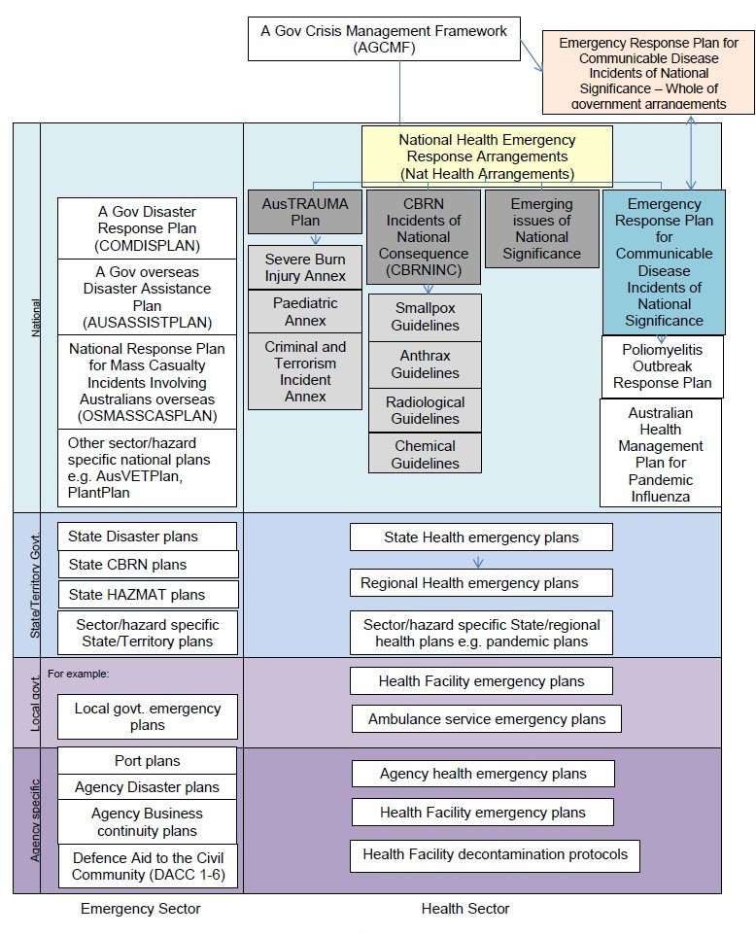

Ethical framework to support decision making
- Health decision makers and individuals will face difficult decisions during the course of a CDINS. Decisions may affect all people, and there might be tensions between the needs of individuals and those of the population.
- An ethical framework to guide the health sector response provides values to take into account when planning and implementing actions.
- An ethical framework includes:
  - Protection of the public: Ensuring that the protection of the entire population remains a primary focus.
  - Stewardship: That leaders strive to make good decisions based on best available evidence.
  - Trust: That health decision makers strive to communicate in a timely and transparent manner to the public and those within the health system.
  - Equity: Providing care in an equitable manner, recognising special needs, cultural values and religious beliefs of different members of the community. This is especially important when providing health services to vulnerable individuals, such as Aboriginal and Torres Strait Islander peoples and people who are culturally and linguistically diverse.
  - Proportionality: Ensuring that measures taken are proportional to the threat.
  - Reciprocity: Ensuring that when individuals are asked to take measures or perform duties for the benefit of society as a whole, their acts are appropriately recognised and legitimate needs associated with these acts are met where possible.
  - Provision of care: Ensuring that health care workers are able to deliver care within the limits of the situation, commensurate with good practice, and their profession’s code of ethics.
  - Individual liberty: Ensuring that the rights of the individual are upheld as much as possible.
  - Privacy and confidentiality of individuals: Privacy is important and should be protected. Under extraordinary conditions, it may be necessary for some elements to be overridden to protect others.

An approach to vulnerable populations or at risk groups
During a CDINS, there could be subgroups of the population that are disproportionally affected by the event. This could be because the disease itself causes differential impact on certain groups (worse in some), or pre-existing vulnerabilities limit access to healthcare, services, support or information. Factors affecting individual vulnerability include health status, access to healthcare, housing, income, remoteness, stage of life, and dependency on others for basic care.
Health authorities should consider and prioritise the essential needs of vulnerable people before, during and after a CDINS; and enable health service providers to readily identify, locate and communicate with vulnerable people in a CDINS.
A working definition of a vulnerable person is someone who
- Is known to be reliant on external support from agencies, service providers, caregivers or community networks due to a dependency, disability or limitation that affects their capacity to prepare for, respond to, and/or recover from an emergency.
- Cannot identify or access personal or community support networks to help them in an emergency or have exhausted their usual support networks and resources.
General principles in emergency planning for vulnerable people:
- Individuals, families and the local community have primary responsibility for their own safety, care and support relating to emergency planning, preparedness, response and recovery from an emergency. This includes health emergencies such as communicable disease incidents of national significance.
- Government agencies, special facilities, service providers and individual carers that have day-to-day responsibilities to provide guardianship, care, and/or support to vulnerable people maintain those responsibilities during and after an emergency.
- Owners and operators of special facilities have primary responsibility for emergency planning, preparedness, response (including decision making, communication and evacuation) and recovery relating to those special facilities.
- The higher the level of foreseeable vulnerability, the more comprehensive the emergency planning, preparedness, response and recovery activities are expected to be provided.
- Communicating public information requires targeted and tailored advice being provided to vulnerable people and special facilities as early as possible, and delivered in a manner that is accessible to the range of vulnerable people and in a form that can be understood by these individuals.
- The timely sharing of information is critical to readily identify, locate, communicate with and support vulnerable people in an emergency. Arrangements to share personal or sensitive information between those individuals, government agencies and NGOs that have a ‘need to know’ during an emergency, need to be established before an emergency occurs.

Using this plan

Identification
- CDIs occur every day in Australia and overseas. It is possible that at any one time there are a handful of current incidents with the potential to increase in scale and/or complexity and affect multiple jurisdictions in Australia, or an international incident spreads to Australia.
- Domestic CDIs, including outbreaks, may be recognised by state and territory health authorities, CDNA, PHLN, OzFoodNet, clinicians, microbiologists, and/or the Australian Government Department of Health through surveillance systems and networks.
- The Australian Government Department of Health, in partnership with other Australian government agencies, may identify international CDIs with potential consequences for Australia through existing surveillance and monitoring systems.
- Each state or territory health department has its own procedures for surveillance, detection and control of communicable diseases. Heads/Directors of communicable disease control participate in fortnightly meetings of the CDNA to discuss current incidents, including those with potential national implications.
- Contact between health departments, through CDNA and, where relevant, Australian Government agencies, is essential as soon as it becomes apparent that the incident has potential national implications.

Assessment
- The trigger to assess the potential for a CDI to be a CDINS is when an incident has national implications.
- Any member of AHPPC or an AHPPC standing committee can request the Australian Government Department of Health coordinate a rapid assessment of whether a CDI constitutes an actual or potential CDINS.
  - This request is made to Health Ops by email Health.Ops@Health.gov.au or by phone (+61) 2 6289 3030 (See 4.1.2 Single point of contact)
- Rapid assessment takes place through the establishment of a CDINS Assessment Panel chaired by the Assistant Secretary of the Health Emergency Management Branch in the Australian Government Department of Health and comprised of CDNA members, and relevant experts and/or other Australian Government agencies as required.
- Under the International Health Regulations (2005) (IHR (2005)), the WHO can declare an event a Public Health Emergency of International Concern (PHEIC). A PHEIC may represent a real or potential CDINS and should be considered for rapid assessment by a CDINS Assessment Panel.
- The Rapid Assessment Panel considers the potential CDINS against the triggers to declare a CDINS and/or escalate response measures (Appendix 9.1)
- The CDINS Assessment Panel can recommend to the Australian Government Chief Medical Officer (CMO) as Chair of AHPPC that the CDI is:
  - not a CDINS and existing arrangements are adequate.
  - a potential CDINS for ongoing assessment and monitoring; or
  - a CDINS requiring escalation of response measures under this plan.
- This recommendation can then support the CMO’s decision to declare a CDINS, and the panel is stood down following the recommendations.

Declaration
- The Australian Government Chief Medical Officer (CMO), as Chair of AHPPC, can declare an incident a CDINS and escalate the response as required.
- In addition to the recommendation from the CDINS Assessment Panel, the Australian Government CMO may seek additional advice from, and consult with AHPPC and its standing committees, other Australian Government or international agencies in deciding to declare a CDINS. For the purpose of this plan a person acting as the CMO has the full authority of the CMO while acting.
- As the National Focal Point, the Australian Government Department of Health will communicate with the World Health Organization under the IHR (2005). This includes notifying WHO if a CDINS meets relevant criteria under Annex II of the IHR (2005) (Appendix 9.2).
Triggers for declaring a CDINS include:
- notification by an affected jurisdiction that assistance in managing the health aspects of the CDI is required
- enhanced arrangements are required to ensure nationally consistent policy, interventions and/or communications because:
  - the number and/or severity of cases is overwhelming the capacity of the affected health system including the public health sector, and/or
  - there is a need for consistent public messaging about the incident, and/or
  - there is a need for national leadership and coordination, and/or
  - there is a Public Health Emergency of International Concern (PHEIC), or an international outbreak or incident, with implications for Australia
- recommendation from the CDINS Assessment Panel that the incident is a CDINS;
- other circumstances as deemed necessary by the AHPPC or the CMO.

Escalation
- The Australian Government CMO, as Chair of AHPPC, has the authority to escalate this plan through its stages (Preparedness, Response (Standby, Action), Standdown – Table 1) to manage a CDINS.
- Escalation represents the addition of public health measures that are appropriate to the particular incident. It does not imply a stepwise progression of all measures described in this plan. Features of the disease and/or requirements of the response will be considered in deciding to increase response measures.
- The threshold at which escalation across stages in this plan is considered might be different depending on the nature of the communicable disease and the resources of the affected jurisdiction/s.
- Assistance may be requested by a jurisdiction or jurisdictions to:
  - Enhance immediate disease control responses
  - Enhance epidemiological investigations
  - Supply or support laboratory services
  - Conduct research to inform current and future public health response.
- Forms of assistance may include: coordination; communications; consultation; provision of laboratory services; secondment of personnel to affected areas; financial assistance; and/or deployments from the National Medical Stockpile.
Table 1 Examples of triggers to escalate and standdown a response
Stage |  | Examples
Preparedness |  | Confirmation of a communicable disease incident outside Australia; or a significant CDI in one Australian jurisdiction that has low likelihood of spreading across jurisdictions and response arrangements in the affected jurisdiction are adequate.
Response | Standby | Potential CDINS – current response arrangements are adequate but:  - the number and/or severity of cases could overwhelm capacity of the affected health system including the public health sector, and/or  - public messaging about the incident and/or the response could require national coordination, and/or,  - there is a need to prepare national public health measures (surveillance, testing, guidelines, management advice) or incident investigation requires national coordination, and/or  - there is an international communicable disease incident (which may or may not be a PHEIC) with potential implications for Australia.  In Standby, priorities are to investigate, monitor and prepare. This might include measures such as continuing outbreak investigation, preparing surveillance systems or agreeing laboratory case definitions or updating current national guidelines. In Standby, health authorities and committees monitor an incident and prepare to escalate some or all of the response measures under this plan.
Response | Action | Declared CDINS – the incident requires implementation of national policy, interventions, and/or public messaging, and/or deployment of Commonwealth or inter-jurisdictional resources to assist affected jurisdictions, for some or all of the following reasons:  - the number and/or severity of cases is overwhelming the capacity of the affected health system including the public health sector, and/or  - there is a need for consistent public messaging about the incident, and/or  - there is a need for national leadership and coordination, and/or  - there is a Public Health Emergency of International Concern (PHEIC), or an international outbreak or incident, with implications for Australia.  In Action, a CDINS warrants escalation of several response measures under this plan.
Response | Standdown | End of outbreak, epidemic or emergency, services returning to normal; response can be managed within normal arrangements.

Response coordination
The Australian Constitution provides the Australian Government the statutory authority to give directions to states and territories on issues specifically included in the Constitution. In general the management of emergencies is not one of these issues. Hence the strategic coordination of national emergencies, including a CDINS, is reliant on cooperative and collaborative mechanisms with states and territories for the management of health emergencies of national consequence.
Coordination is the act of managing interdependencies between activities and involves the bringing together of many organisations to pursue a common goal and to share resources, information, expertise and decision making. There is ongoing coordination and collaboration to manage communicable disease control in Australia. AHPPC and standing committees are the primary forums in which the Australian Government and state and territory governments share resources, information, expertise and decision making. AHPPC and its standing committees meet throughout the year to prevent, plan for, respond to, and recover from health protection incidents. For example, CDNA meets every fortnight, irrespective of whether there is a CDINS or not, to share information, resources and make decisions about communicable disease control in Australia. Therefore during a CDINS, the coordination arrangements for national communicable disease control are not new, but the inter-relationships between these committees and expert groups will be enhanced and need to be brought together in a more structured way.
This plan considers two main types of events – a significant international CDI, or a domestic multijurisdictional CDI. Both types of events could transition into the other (international to domestic, domestic to international) and response coordination arrangements must be flexible.

Significant domestic events such as multi-jurisdictional outbreaks
CDNA plays a critical role in the detection, investigation and response to multi-jurisdictional outbreaks of communicable disease on an ongoing basis. In most cases, prompt detection and response measures coordinated through CDNA, supported by other standing committees, are sufficient to prevent further spread of the outbreak.
If a multijurisdictional outbreak escalates in complexity, CDNA (or any AHPPC standing committee member) can request it be assessed as a potential CDINS (see 3.2 Assessment). If AHPPC declares a CDINS, following a recommendation by the CDINS Assessment Panel the Australian Government Department of Health is responsible for coordinating the national health sector response. Coordinating mechanisms include AHPPC for national policy coordination and CDNA and other AHPPC standing committees for consolidated technical advice. The Department can request advice from external agencies, experts or regulators if necessary.
The Chief Health Officer (CHO) of each state and/or territory or their delegate or equivalent is permanently represented on the AHPPC. At the AHPPC the CHO reports on state and territory activities and represents the interests of their respective jurisdiction. The CHO has the authority to make requests for assistance to the AHPPC and to offer physical assistance on behalf of their respective state and/or territory.
As AHPPC’s principal technical advisory committee for communicable diseases, CDNA can recommend priorities for surveillance, public health management of cases and contacts, outbreak investigation, and provision of scientific and technical advice. Similarly, the Public Health Laboratory Network can recommend priorities for laboratory testing policy and procedures and advise on laboratory testing capacity. These recommendations can be agreed at AHPPC, however implementation of specific measures in each jurisdiction will be directed by the respective CHO.
Decisions concerning Australian Government actions (such as border measures or sharing information internationally) are informed by Australian Government agencies/departments, and may be informed by input from AHPPC and its standing committees as required.
A multijurisdictional outbreak that is not declared a CDINS can be managed by jurisdictions, supported by CDNA. CDNA may elect to form specific incident management investigation and control teams to achieve their objectives. National coordination will be through existing committee structures and plans, where they exist, such as suspected foodborne disease outbreaks investigated by OzFoodNet under the Guidelines for epidemiological investigation of multi-jurisdictional outbreaks of foodborne and suspected foodborne disease.
Specific considerations within each jurisdiction, including the Australian Government, will determine whether their own emergency plans, internal incident management structures and teams are engaged during a CDINS.

Significant international events
There may be circumstances where an international event – new disease or significant outbreak - presents a real or perceived risk to public health in Australia and is considered a potential CDINS, requiring ongoing assessment, monitoring and preparation to escalate response measures under this plan.
The Australian Government Department of Health, through the CMO, will take the lead in coordinating Australia’s health sector response to an international incident that is a potential CDINS. The Department’s role during an international event is to assess the risk to Australia, assess state of readiness to respond and, in consultation with AHPPC and its standing committees, identify response measures requiring national policy coordination. Measures might include specific arrangements at the border, travel advice, preparation for surveillance, contact tracing and/or case management, availability of national public health or technical guidelines, and health sector implications in the event of imported cases (e.g. designated treatment/isolation hospitals, referral processes, testing arrangements). In consultation with DFAT, measures might also include consideration of deployment of medical assistance to affected countries in the region, and providing input to travel advice for Australians.
Specific considerations within each jurisdiction, including the Australian Government, will determine whether their own emergency plans, internal incident management structures and teams are engaged during an international incident that is a potential CDINS. The implementation of the response in each jurisdiction may also be influenced by local circumstances and expectations of state or territory health ministers.
In summary, when CDPLAN is in Response stage:
- The Australian Government Department of Health convenes AHPPC and its standing committees as required, coordinates liaison with other Australian Government agencies and advises the Minister for Health of progress and actions under CDPLAN. (See Section 4.1)
- State and territory departments of health will liaise with their government, the health sector and response stakeholders in their jurisdictions. (See Section 4.2 and 4.3)
- The primary links between the Australian Government and state and territory government health authorities during a response are through AHPPC and CDNA.
  - AHPPC will coordinate national policy positions for response, aiming for national consistency where feasible.
  - CDNA will coordinate national technical, public health and clinical advice in response, aiming for national consistency where feasible. PHLN will support CDNA in developing laboratory policy and procedures.
- All jurisdictions, including the Australian Government, will decide on appropriate public health measures (outlined in Section 4) to implement a response in their jurisdiction, in accordance with nationally agreed arrangements. Mechanisms to promote nationally consistent responses include AHPPC, CDNA and other relevant standing committees. Jurisdictions, in partnership with healthcare providers in their jurisdictions, will implement appropriate healthcare system response measures. Mechanisms to promote nationally consistent responses include AHPPC and key infection prevention and control stakeholders and committees.
Figure 1 Summary of assessment, declaration and corresponding plan stages and actions.
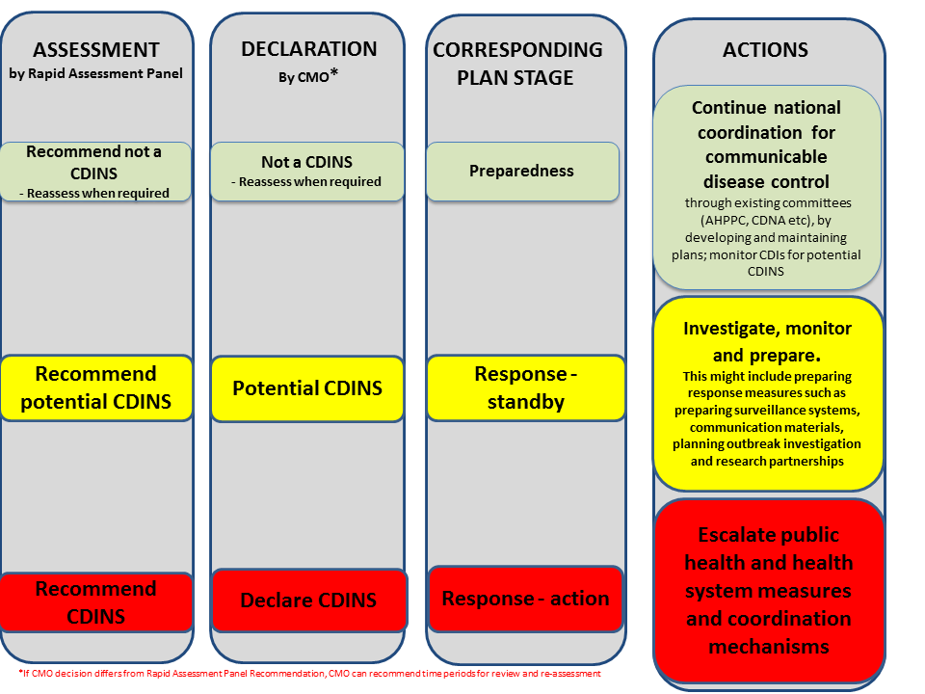

Standdown
The CMO, through AHPPC, will authorise the standdown when all actions requiring national coordination have been completed (acknowledging recovery efforts will be occurring and potentially ongoing) and there is no likelihood of any additional immediate tasking. The health response will be debriefed and an evaluation report will be made available following standdown.

Public health system preparedness and response
This section describes public health measures in preparedness and response to a CDINS.

Australian Government Department of Health responsibilities

Development and maintenance of National Health Emergency Response Arrangements (NatHealth Arrangements)
The Department of Health, in partnership with AHPPC, is responsible for maintaining the NatHealth Arrangements, which is the overarching agreement that incorporates this plan and other specific health emergency plans.

Single point of contact
For state and territory health authorities, or government agencies to notify a potential CDINS, the single point of contact is as follows:
- National Incident Room t: (+61) 2 6289 3030
- Department of Health e: Health.Ops@Health.gov.au
In the event of a national emergency response to a CDINS, additional national emergency control contact numbers will be advised.

Australian Government Health Incident Management Team (H-IMT)
During a CDINS, the Australian Government Department of Health is responsible for:
- national intelligence gathering and planning, including liaison with WHO and other international bodies for high-level advice/recommendations to national authorities
- national epidemiological reporting and situational awareness
- convening relevant technical advisory groups and other advisory groups to develop national clinical and public health advice
- disseminating national guidance for public health management and clinical response to the public health and healthcare sector
- provision of nationally consistent public messaging, through 1800 numbers, website information and access to travel advisories provided by DFAT and border control agencies
- provision of information and advice to Ministers
- liaison with other Australian Government agencies
- provision of advice to instigate and standdown border measures
- coordinating the relevant public health measures employed to meet objectives of this plan
- coordinating deployment of the National Medical Stockpile if required
- coordinating medical or epidemiological or public health response teams if required
To meet these responsibilities in the event of a CDINS, the Department of Health can establish a national health incident management team (H-IMT) under a modified Australian Inter-service Incident Management Structure (AIIMS). The H-IMT leads the national health sector response to a CDINS and comprises members from the Office of Health Protection, and other relevant divisions in the Department of Health.

Liaison between the Australian Government H-IMT/National Incident Room and state and territory Emergency Operation Centres (EOCs) or incident management teams
If a response involves the Australian Government H-IMT in the National Incident Room (NIR)* and/or state/territory health emergency operation centres, liaison between the H-IMT (NIR) and state and territory health EOCs occurs in numerous ways:
- through AHPPC as the primary link between the Australian Government H- IMT and state and territory government health incident management teams and EOCs;
- through CDNA as the link on intelligence including surveillance, clinical and public health advice, outbreak investigation; and for communication including public messaging;
- through the Incident Controller/Manager in the H-IMT with Incident Managers in state and territory EOCs;
- through functions, for example, H-IMT planning function with state/territory health planning function, or H-IMT health communications function with state/territory communication function.
*The Australian Government Department of Health maintains a single point of contact through the National Incident Room (see 4.1.2) at all times.

Communications
- Communication in routine or business as usual communicable disease control occurs between government and the health sector, across government, and between government and the public. Public communication usually requires media coordination.
- Existing mechanisms are maintained during a CDINS, sometimes requiring additional coordinating mechanisms such as the National Health Emergency Media Response Network (NHEMRN).
- The Department of Health is also responsible for reporting to and liaison with the WHO as required under the IHR (2005) and sharing information from the WHO, from surveillance and other sources with relevant stakeholders.
- Other health care stakeholders have a responsibility to provide input into decision making forums and to communicate key messages to the public.
- The Department of Health will administer the national website Health Emergency Website, to post specific information on the status of the communicable disease emergency and response, or, establish specific web pages on DoH Website to communicate national actions and information for the public.

Communication across government
- The Australian Government and state and territory governments will share information, via existing channels, about:
  - advice from international bodies, such as the WHO;
  - the status and impact of the communicable disease event in Australia and/or overseas;
  - the epidemiology, clinical and microbiological features of the disease; the implementation and impact of measures to manage the response; and
  - deployment of the National Medical Stockpile (NMS).
- The Department of Health’s National Incident Room (NIR) provides a point of communication with the Australian Government for health incidents.
- State and territory governments are responsible for reporting issues to the Single point of contact (see section 4.1.2) which might require a coordinated response and/or reporting under the IHR (2005).

Communication with the health sector
- Communication may target clinical and/or administrative aspects of health services, according to the nature of the information to be delivered.
- The Australian Government and state and territory governments are jointly responsible for sharing information with the health sector on resource availability and providing advice on case and contact management, chemoprophylaxis, vaccination, quarantine/isolation and risk assessment.
- The Australian Government Department of Health is responsible for communications with the health care sector at a national level. Existing channels include principal committees of the Australian Health Ministers Advisory Council (AHMAC), and stakeholders such as professional colleges and associations, the primary health networks and the GP Roundtable. In many cases, this will support state and territory health department communications with the health and clinical care system in their jurisdictions.
- Additionally, state and territory health departments will consolidate communication with healthcare workers and providers (both public hospitals and non-government, such as private hospitals) and include state and local level information via their own communication channels.
- The Australian Government will also disseminate relevant tailored information to aged care and other residential facilities through approved providers and regulatory processes and liaise with Australian Government education authorities concerning public health measures related to schools.

Communication with the public
The Australian Government Department of Health is responsible for health-specific communications with the public at a national level. AHPPC and its standing committees can advise on key health messages for the public at different stages of the incident. These can then be adapted by stakeholders to meet the needs of their target audience and the purpose of communications, and distributed. NHEMRN will support the distribution of messages to the public.

Media coordination
- The Australian Government Department of Health coordinates the National Health Emergency Media Response Network (NHEMRN), which comprises media liaison managers in the Australian Government, state and territory agencies, medical colleges and professional associations.
- The role of NHEMRN is to keep the public and the media informed during national health emergencies by providing consistent and coordinated media and public responses.
- NHEMRN is made up of Media Units representatives from the Department of Health and state and territory health departments; relevant Australian Government agencies, national medical colleges and associations, National Aboriginal Community Controlled Health Organisation and select parts of the private sector directly involved in emergency health management.
- Health and NHEMRN, in consultation with the AHPPC and AGD EMA, will be responsible for coordinating national media statements on the health aspects of the response to a CDINS.
- NHERMN will coordinate dissemination of these messages and adaptation for specific audiences. NHEMRN is coordinated by the Media Unit of the Department of Health.
Messaging and strategies agreed at NHEMRN teleconferences will feed into the media communications that occur at state and territory level. Coordination of public communications within jurisdictions will be in accordance with jurisdictional arrangements.
In the event that a National Terrorist Situation is declared, the media management arrangements that apply to National Terrorist Situations override the media management arrangements outlined in this plan (refer to the National Counter-Terrorism Plan and National Counter-Terrorism Handbook).

Border measures
Border measures during a CDINS may include communications to raise awareness and knowledge of travellers and border staff, and/or case identification measures to detect possible cases at the border to slow transmission, noting that border measures cannot completely prevent entry of communicable diseases into Australia.
During a public health emergency of international concern, the WHO can recommend border measures be adopted by some or all member states. The decision to institute border measures in Australia will be made jointly between the Department of Health, Department of Prime Minister and Cabinet, and Department of Immigration and Border Protection, with operational support from the Department of Agriculture and Water Resources.
Communications measures to raise the awareness and knowledge of travellers and border staff include:
- Inflight announcements and on-board announcements on ships;
- Communications materials for incoming or outgoing travellers at airports/seaports;
- Travel advice regarding high-risk places and to raise awareness of symptoms if returning from travel (through communications on the Smartraveller website and/or with travel agencies); and
- Information for border staff.
Case identification measures to detect possible cases at the border include::
- Entry screening
  - Negative / non-automatic pratique
  - Identification and assessment of travellers with illness
  - Passenger identification measures including locator documents
  - Border nurses
  - Screening of passengers on cruise ships prior to disembarkation, (where there is evidence of cases on board)
- Exit screening if requested by WHO IHR Emergency Committee
- Contact tracing and sharing information through IHR National Focal Points
Management of potential cases identified at the border:
- People reasonably suspected to have, or to have been exposed to a Listed Human Disease under the Biosecurity Act 2015, can be ordered to comply with a range of biosecurity measures that are decided based on clinical evidence. Biosecurity measures available may include travel restrictions, behaviour restrictions, and risk minimisation interventions such as examination, decontamination, vaccination or treatment, the provision of body samples, receiving medication and isolation measures.

Population level interventions – pharmaceutical and/or social distancing
Population-based interventions may be recommended to reduce the impact of the CDINS, depending on the clinical severity and transmission characteristics of the disease.

Pharmaceutical measures
The Australian Government Health Minister will decide whether to implement population level Australian Government funded pharmaceutical measures through the Australian healthcare system. These might include:
- Medications for treatment of cases
- Medications for post-exposure prophylaxis for contacts
- Medications for post-exposure prophylaxis for contacts in at risk groups
- Medications for pre-exposure prophylaxis for healthcare workers
- Candidate vaccine
- Customised vaccine
The Australian Technical Advisory Group on Immunisation (ATAGI) would provide technical advice to the Minister on relevant vaccines, the evidence for their use, and options for implementation in response to a CDINS. The National Immunisation Committee would guide implementation measures in the community.

Social distancing measures
Decisions to implement social-distancing interventions in other sectors (e.g. education or business) rest with the relevant sector, however the Department of Health can recommend certain measures through a whole-of-government decision making process. These might include:
- Proactive school closure
- Reactive school closure
- Workplace closure
- Working from home
- Cancellation of mass gatherings
- Voluntary isolation of cases
- Voluntary quarantine of contacts

National Medical Stockpile
- During a CDINS, Chief Health Officers or Chief Medical Officers (or other person as authorised by the state/territory) in state and territory governments can request access to National Medical Stockpile (NMS).
- Emergency requests to the NMS are made to the single point of contact:
  - National Incident Room t: (+61) 2 6289 3030
  - Department of Health e: Health.Ops@Health.gov.au
- The requesting state/territory will be required to fill out an NMS request form – to be supplied at the time of the request by the department.
- Requests require approval from the Australian Government CMO. Products not registered for use in Australia require approval from the Secretary of the Australian Government Department of Health.
- As a preparedness measure, some products (those requiring urgent administration) have been pre-deployed to the states/territories to ensure timely access.
- TOLL Remote Logistics has been engaged to undertake the role of Prime Vendor to the NMS. This includes inventory management and storage as well as facilitating timely deployment on behalf of the department.

Vaccine and other medications
For a novel communicable disease the development time for an effective vaccine is unknown. For pandemic influenza, it could take six months or longer before the first supplies of vaccine are available if onshore capability is not available.
Initial vaccine supplies will be limited, requiring prioritisation so that the greatest benefit can be achieved. The Australian Government Department of Health, through consultation with relevant expert committees, will establish priority groups for any available vaccine. Once vaccines are available, the Australian Government Department of Health is responsible for promoting immunisation and awareness to the public and health care professionals, and working with state and territory immunisation providers to assist in delivering the vaccination program.

Post standdown
After standdown from any emergency response, the Department of Health will initiate a review of actions taken during the emergency and outcomes of the response. The purpose of the review will be to constructively assess the actions and response and identify areas for improvement. The resulting review will be a public document. This plan will be revised, taking the review findings into account.

Responsibilities shared between Australian Government and state and territory governments

Surveillance
The various methods of surveillance that operate in Australia should provide early warning of disease spread or development. It is likely that any new communicable disease will first be detected through well-informed clinicians detecting and reporting unusual illnesses, and/or through intelligence gathering from overseas through WHO or other international agencies.
Depending on the organism causing the CDI, surveillance may require establishment of new systems, or enhancement of existing surveillance systems. Surveillance activities in preparation or in response to a CDINS may include:
- Defining and documenting surveillance objectives.
- Choosing appropriate methods to achieve objectives, for example routine notifiable disease surveillance, active case finding, enhanced surveillance of cases and contacts.
Collation and interpretation of the disease-associated dataset is a national responsibility. The decision to cease enhanced data collection will be a national recommendation, based on whether additional mechanisms have provided useful characterisation of epidemic characteristics.
Ongoing surveillance and monitoring throughout a CDINS will use multiple sources of information. Traditional surveillance systems will be the main focus, however information from the WHO, international agencies, and event-based surveillance channels will contribute to the broader health intelligence of the CDINS.
The Australian Government Department of Health, as the National Focal Point (NFP) under the IHR (2005), is responsible for liaison with WHO and the NFPs in other countries. This can include surveillance information including WHO Event Intelligence Site (EIS) notifications.

Risk assessment
Iterative risk assessment is critical to achieve a flexible, proportionate response to a CDINS and should continue throughout the stages of this plan. The risk assessment process should be documented and outcomes made available to internal and external stakeholders.
The Australian Government Department of Health will coordinate the process and documentation of risk assessment throughout a CDINS, through AHPPC and its standing committees. Outcomes of national risk assessment will inform risk management decisions, such as the escalation of certain public health response measures to address risks.

Public health laboratory testing
During an emergency, surveillance and outbreak management depend on rapid detection and identification of the causative organism or agent. Strategic decisions about outbreak response, which may lead to use of considerable resources, rely on laboratory test results.
Public health laboratory preparedness activities include supporting early detection and laboratory analysis and characterisation of pathogenic organisms, building laboratory capacity through staff training and supply of laboratory equipment, tests and reagents, ensuring efficient laboratory data sharing, and providing strategic advice to the AHPPC to identify gaps and needs in laboratory capacity.
Specific response actions might include:
- Develop and maintain the laboratory case definition to provide definitive and suggestive criteria that must be met to report a laboratory confirmed diagnosis.
- Acquire relevant testing kits, isolates and sequencing data for test development, validation and control samples, and share isolates with relevant reference centres for characterisation.
- Develop laboratory testing protocols to provide clinical specimen collection guidance; and detection methodologies, such as culture, molecular methods such as polymerase chain reaction, molecular characterisation (typing and sub-typing methods) and serology; and quality assurance considerations.
- Determine triggers for authorising laboratory testing in the early phase; transferring testing from reference laboratories to diagnostic laboratories; restricting testing to clinically relevant patients only i.e. when it is no longer necessary to test all suspect cases. Noting that testing may be restricted to laboratories with relevant levels of physical containment depending on the pathogen.
- Develop and validate organism-specific tests if needed and support the needs of laboratories to develop appropriate testing capacity or protocols.

Outbreak investigation
Outbreak investigations may be required to determine the source of the outbreak and implement control measures to prevent further disease. These might require enhanced surveillance and case follow up, descriptive and analytical outbreak studies, and applied research to understand disease transmission and severity.
CDNA is primarily responsible for coordinating the investigations of multi-jurisdictional outbreaks. Workforce surge capacity, particularly epidemiologists, will be critically important to support health departments, especially in the early stages of a CDINS, while disease parameters (transmission, clinical severity, at risk populations, response to treatment) are unknown. A potential source of surge capacity of epidemiologists in training is the Australian National University’s Master of Applied Epidemiology program. Other surge workforce categories might include: public health medical officers and nurses, laboratory epidemiologists and technicians, epidemiologists from other Departments or organisations, health communication experts and administrators. These workers could support outbreak investigation and research, but would be relevant for broader response actions during a CDINS.
To answer questions on clinical severity and transmission characteristics of a new or mutated organism that cannot be addressed through surveillance alone, applied research plays an important role. During a CDINS, rapid research activities are likely to require formal partnerships between government health departments, the National Health and Medical Research Council (NHMRC), AHPPC and standing committees and selected academic or public health institutes. This includes Centres for Research Excellence that focus on research preparedness for infectious disease emergencies. Important preparedness measures include establishing pre-agreed arrangements and protocols in advance of an actual disease outbreak.
Preparedness activities might include:
- Build national epidemiological capacity through training and routine outbreak investigations to ensure ready workforce for national emergency.
- Build national emergency research capacity through establishing pre-agreed research options and protocols, noting the need for flexibility in priority research questions depending on the incident.
Response might include:
- Coordinate and deploy epidemiologists to manage surveillance and outbreak investigation.
- Coordinate and activate emergency research networks to answer critical questions.
- Consider specialized laboratory testing of isolates (e.g. molecular typing or genetic sequencing) to characterize specimens.

National guidance for clinical and public health management
The Australian Government Department of Health, in partnership with AHPPC and its standing committees, will coordinate the development of public health guidance to support the health sector response to cases and their contacts, including healthcare workers. Expert input will be sought from existing committees and/or specific technical advisory groups.
- An established form of national guidance for public health authorities is the Series of National Guidelines (SoNG). The purpose of the SoNG is to provide nationally consistent advice and guidance to public health units in responding to a notifiable disease event.
- The Australian Government Department of Health, through relevant committees and advisory groups, will also coordinate the development of clinical care guidance, including infection prevention and control advice, and clinical care pathways, to support health service delivery in the primary, secondary and tertiary care sector during a CDINS.
  - Clinical care pathways that support the process of case and contact management are described in section 5.
  - Infection prevention and control is described in more detail in section 5.
- In the event of an emerging communicable disease, the Department of Health will work with clinical experts in developing and disseminating clinical guidelines for patient management. In some instances, these guidelines may be developed and/or adapted by specialist clinical groups responsible for different components of a patient’s care (for example infectious diseases, intensive care). Clinical management of individual patients will always be the responsibility of the treating clinicians.

State and territory government responsibilities

Major incident and emergency plans
States and territories are responsible for the preparation of major incident and emergency plans. These plans should identify how essential health services will continue to be delivered in tcontacte event of CDINS. State and territory government emergency plans are expected to cover communication with all health service providers and other relevant organisations and agencies in the jurisdiction.

Single point of contact
States and territories must maintain a communications function that ensures effective two-way information exchange through a single point of contact on a constant basis (24/7). This means that the Australian Government Department of Health and state and territory government health departments can communicate directly with each other at all times.

State/territory incident management
Each state and territory is responsible for their own incident coordination plan and incident management structure. Incident control provides overall direction of the response within the jurisdiction, and incident coordination brings together resources and agencies to ensure and effective response.
A state and territory incident management team may be required to manage the delegated responsibilities of planning, operations, logistics, public communication, investigation and intelligence relating to overall control of the incident.
The interactions between jurisdictional IMTs and associated emergency management teams will depend on specific jurisdictional arrangements.
State and territory incident controllers and/or coordinators must be able to communicate directly with their national counterparts, through the single point of contact and specific mechanisms.

Contact tracing, isolation and quarantine
Public health actions such as contact tracing can be of great importance in minimising the spread of infection during a CDINS. Actions may include the tracing of contacts of suspected, probable and confirmed cases, and isolation/quarantine of people at home or in other settings.
States and territories, in conjunction with public health services and national committees, will be responsible for planning, implementing and resourcing these actions. Contact tracing of individuals who may have been infected will be coordinated by state and territory public health authorities. In extreme circumstances, this role may be outsourced within a jurisdiction, or assistance from the Australian Government Department of Health may be requested.
The Australian Government Department of Health will liaise with border control agencies, airlines, and shipping to ensure adequate information is collected to facilitate contact tracing. In some circumstances, state and territory health authorities will liaise directly with border control representatives in their jurisdiction on operational matters.

Service prioritisation
System capacity issues and/or infection control precautions may mean that some services are reduced in volume or temporarily suspended during a CDINS, or that some facilities temporarily stop admissions or discharges.
State and territory government emergency plans should cover possible need for service reduction or suspensions and provide for flexible prioritisation, taking into account national perspectives. Planners should develop scenarios for alternative basic service provision, should it be necessary to temporarily close a facility.

Care in the community and of dependents
Some major epidemics may simultaneously affect a large proportion of the population, including health professionals. In this situation, all except the most seriously ill may need to be cared for at home or in the community by relatives or other unaffected members of the public, with advice and support from health professionals and organisations. Planning should review the potential for use of community groups and/or volunteers who could provide assistance to health professionals and organisations in severe situations.
A major epidemic may result in a number of dependents (either young or old) being effectively orphaned by the hospitalisation or death of their principal caregiver(s). Emergency planning outside of the health sector should consider how dependents could be managed in a severe CDINS.

A note on command, control and coordination in the public health response
Response arrangements in a CDINS rely on the effective coordination of functions through existing national committees. These committees have well defined roles and responsibilities and meet regularly to progress policy and monitor key issues in their area of responsibility, but may not naturally appreciate how their expert functions align with and relate to the functions of other committees and expert bodies. Coordination of a national response will require clear allocation of roles and responsibilities to these existing expert groups and a clear articulation of how these groups will work in relation to each other to deliver a consistent and effective response. Figure 2 is an example of mapping relationships of expert groups and committees under the broad construct of the Australian Inter-service Incident Management System, with the AHPPC as the overseeing/ decision making body (or the incident coordinator in the context of the nationally coordinated response).

Figure 2: Illustration of coordination of key functions during a CDINS
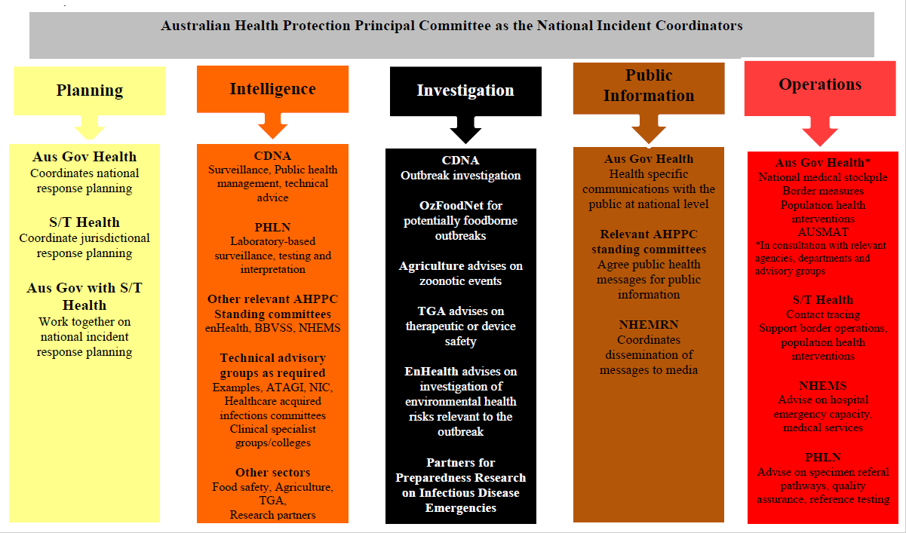

Healthcare system preparedness and response
Healthcare system preparedness will enable health service providers to provide an effective clinical response while protecting the ability to maintain other services to the greatest degree possible. In a CDINS, it may be decided to centralise patient care at selected facilities. However, given the unpredictability of communicable disease related emergencies, all healthcare providers need to consider that their services will provide at least initial care for suspected or probable patients.

Workforce

Occupational safety and health
The safety and health of healthcare workers will be pivotal to a successful response by primary and secondary/tertiary services in the event of a CDINS. In the case of an infectious disease, appropriate safety policies not only maintain staff capacity and confidence, but also reduce the risk of further disease spread through staff-to-staff, staff-to- patient and/or staff-to-family contact.
Individual health services should develop a comprehensive package of services that addresses both prevention and care, and provides support for the physical and psychological health of staff. There should be close liaison between the occupational health and infection control teams, where they exist.
The demand for large numbers of skilled staff during the very early stages of a potential or actual CDINS means there will be little time for education and training in basic competencies. Health service providers will be responsible for ensuring the ongoing competency of staff with respect to infection prevention and control, to avoid the need for significant extra training in an emergency situation.
As a preparedness measure, all health service providers should ensure that:
- all staff are trained and skilled in infection prevention and control, and maintain ongoing competency;
- infection prevention and control training programmes are regularly updated;
- a safe working environment is provided for all staff;
- all staff have access to personal protective equipment (PPE) and relevant training;
- if vaccine or pharmaceutical prophylaxis is available, policies are in place to institute vaccination of staff.
During a CDINS, all health service providers are expected to ensure that:
- a safe working environment is provided for all staff;
- staff are aware of any additional infection prevention and control requirements related to the specific organism and its mode of transmission;
- healthcare workers are monitored for symptoms prior to entering the workplace, and any recent travel history is recorded;
- there are clear processes to identify staff who will care for suspected or probable patients, and defined procedures for the exemption of pregnant or immuno-compromised staff;
- rules for staff are clearly defined (e.g. the required standdown period following travel, and the steps to be followed after caring for a communicable disease patient);
- information regarding suitable accommodation is available to staff, if quarantine from a staff member’s family is necessary;
- all staff working with suspected or probable communicable disease patients are appropriately trained and skilled and have access to the required PPE;
- there is a process for the daily assessment and comparison of staff absences from work due to illness, to provide early warning of possible staff transmission.

Infection prevention and control
Infection prevention and control training and the application of infection prevention and control procedures are critical for the ability of all health service providers to respond to a CDINS. All primary and secondary/tertiary services must be capable of implementing infection control practices to an acceptable standard, as outlined in the Australian Guidelines for the Prevention and Control of Infection in Healthcare (2010). Because the greatest risk of disease transmission is from unrecognised and undetected cases, it is imperative that health care workers practise good infection control in their everyday work, particularly the application of standard precautions.
The role of the infection control practitioner is crucial in the implementation of effective infection control. Infection control practitioners are responsible for tracking and managing health care associated infections, educating other health care workers, providing advice, and developing policies related to infection prevention and control, as well as reinforcing appropriate precautions.
The following are key requirements of primary and secondary/tertiary services with regard to infection control.
- All Local Hospital Networks (LHN) should include infection control services in their response team in the event of a CDINS.
- LHN should maintain staffing levels within their infection control services that allow for the redirection of personnel at short notice to undertake CDINS-related activities, such as widespread specific staff education.
- All services must ensure they have standard precautions policies and that these can be carried out at all times.
- Infection control practitioners must provide routine education/training on the basic principles of infection control to all hospital-based staff, including medical and allied health and support staff (e.g., orderlies, cleaners, laundry staff ).
- Provision should be made for additional specific infection prevention and control education programmes/sessions to be undertaken as necessary.

Clinical care pathways
Planning should describe a primary, secondary and tertiary sector clinical care pathway for suspected or probable patients. The clinical care pathway should provide the maximum possible protection for healthcare workers, other patients and the general public. The clinical care pathway should define:
- processes for safe triage of potentially infectious patients, wherever they present for assessment;
- processes for the safe assessment of suspected cases, away from other patients and visitors;
- transport or transfer and clinical hand-over processes for suspected or probable patients;
- temporary or definitive care area(s), where suspected or probable patients, child and/or adult, can receive the necessary ongoing care;
- processes for safe access to laboratory, radiological and other diagnostic tests;
- processes for the safe provision of cleaning, laundry, translation and other ancillary services.

Primary health care
All primary health care, ambulance, community-based services and Primary Health Networks should be able to provide evidence that standard precautions are routinely practised and that appropriate procedures are in place to manage patients who require separation from others.
During a CDINS, primary health care services are expected to:
- access updated clinical information and advice about disease characteristics and case management for affected adults and/or children, and to make this available to staff in the service as appropriate;
- display appropriate visible signage, with content based on national-level advice, advising patients and others of any restrictions or required actions (this signage may need to be in other languages in some localities);
- consider making use of answerphone systems, with appropriate and regularly updated recorded messages giving instructions to callers;
- provide appropriate PPE for clinical and non-clinical staff (see also ‘Equipment and supplies section 5.7);
- enable access to infection control training for primary health care, ambulance and community-based providers.

Secondary and tertiary care
Most LHNs are responsible for the provision of public hospital services in a defined geographical area, but in some jurisdictions a small number of LHNs provide services across a number of areas.
All LHNs should have an emergency/business continuation plan for hospital and other provider arm services, including:
- clear and agreed internal communication processes to inform operational personnel of an communicable disease- related emergency situation and the required actions;
- an agreed process for prioritising services during an communicable disease-related emergency situation and a staged approach to reducing services, such as elective surgery and/or outpatient clinics;
- agreements with private hospitals and other private providers to provide assistance if necessary;
- arrangements to provide some hospital-based services in the home or in other outreach settings.
All LHN providers should have the capacity to safely assess, isolate and provide at least short-term, hospital-level care to suspected or probable patients (child or adult) while maintaining the ability to treat others. Plans should make provision for:
- appropriate visible signage advising patients and visitors of any restrictions or required actions;
- assessment of suspected CD patients, to be undertaken in an area of the emergency department, or other area, separated from other patients and visitors;
- a defined clinical pathway for child and adult patients requiring long-term hospital care, including possible long-term ventilation (including an agreed referral pathway where it is not possible to provide this locally);
- a defined internal clinical escalation pathway, moving from use of negative pressure rooms to isolation rooms to cohort situations;
- protocols for the support and management of discharged patients recuperating and/or in need of monitoring at home. Protocols should cover arrangements for liaison with primary care providers.

Pathology laboratories
Pathology laboratories are critical to the public health system (described in Section 4.2.3) and healthcare system during a CDINS. Depending on the potential agent of concern, pathology laboratories need to have processes in place for testing or referring samples from suspected cases. This is especially important if the causative pathogen means that testing is restricted to laboratories with relevant levels of physical containment. All laboratories, especially reference or public health laboratories, which receive referred samples need to consider how to deal with increased demand for specimen processing and/or testing during a CDINS.
For newly emerging, re-emerging or rare pathogens not already covered by specimen referral protocols, physical containment and other standards, the Public Health Laboratory Network (PHLN) is responsible for issuing national advice on sample processing and referral during a CDINS. In some cases, there may be a need for local laboratories to rapidly implement new testing, with the support of reference laboratories.

Equipment and supplies
Equipment and supplies issues may include:
- unpredictability of the type and quantity of equipment and supplies required in an communicable disease-related emergency, and the perishable nature of some supplies
- lack of real-time information on equipment and supplies inventories at national, regional and local level
- extended re-supply times for PPE
- ‘hoarding’ of equipment and supplies
- difficulties with the prioritisation and distribution of equipment procured at national, regional and local levels.
To ensure that supplies and equipment are available during a health-related emergency, LHNs should consider:
- maintenance of updated detailed inventory records
- extension of basic stockholding of PPE
- co-ordination of purchasing through collaborative engagement with suppliers.

Financial considerations
All agencies in all jurisdictions involved in operations under this plan are expected, in the first instance, to absorb any costs incurred within their jurisdiction to fund delivery of response obligations under this plan. Details of expenditure should be recorded at all stages of operations by all agencies in each jurisdiction.

Recovery and resilience

Recovery
Recovery following CDINS is a shared national and jurisdictional responsibility, with the bulk of activities being delivered by jurisdictions. Recovery in terms of this plan includes:
- identification of resources deployed or consumed in the response (on replenishment of cache);
- recovery and repatriation of deployed public health or medical teams and their equipment;
- national and jurisdictional operational debriefing and development of post activation report and recommendations; and
- delivery of mental health services.
It is possible that an affected jurisdiction, which has managed a CDO without external support for the acute response, may require health support during the recovery phase. This may be accessible through CD Plan.

Resilience
Building preparedness within Australia’s health systems will contribute to the resilience and sustainability of our systems.
The resilience of individuals will be promoted by empowering them to manage their own exposure to the disease through public messaging about:
- the status of the disease in Australia and internationally;
- infection prevention and control practices;
- disease transmission;
- understanding of how to recognise the signs and symptoms of the disease and when to seek medical assistance; and
- access to support and advice, including mental health services.
To build resilience within most vulnerable populations, communications within the health sector will be used to raise awareness of at risk groups and their associated needs. Measures will also be implemented with consideration of necessary adaptations to meet the needs of these individuals and communities.
The needs and challenges of communicating with low socio-economic communities, which may have reduced access to healthcare, will also be considered.

Plan administration

Plan testing
The Australian Government Department of Health will coordinate testing of this plan through appropriate mechanisms.
The Department will coordinate exercises with the following aims: to educate participating agencies and stakeholders about processes under this plan, their roles and the roles of other agencies; and to review processes that can be improved or refined.

Plan review
The Australian Government Department of Health will coordinate periodic review and evaluation of this plan through the AHPPC. A major review will be conducted every five years. It will also be reviewed if required following activation or learnings from exercise outcomes, and operations and escalations of the plan.

Appendices

Decision instrument to support Rapid Assessment Panel
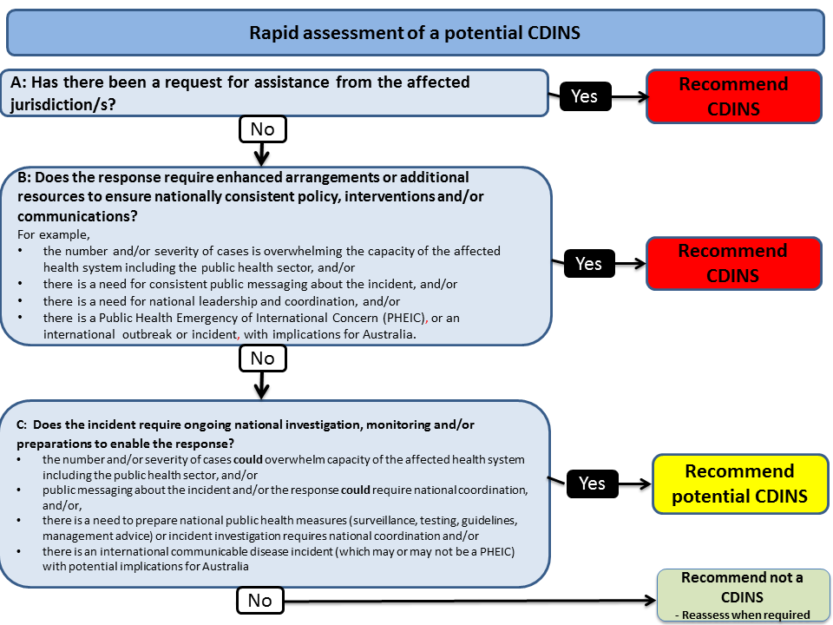

IHR decision instrument for notification to WHO
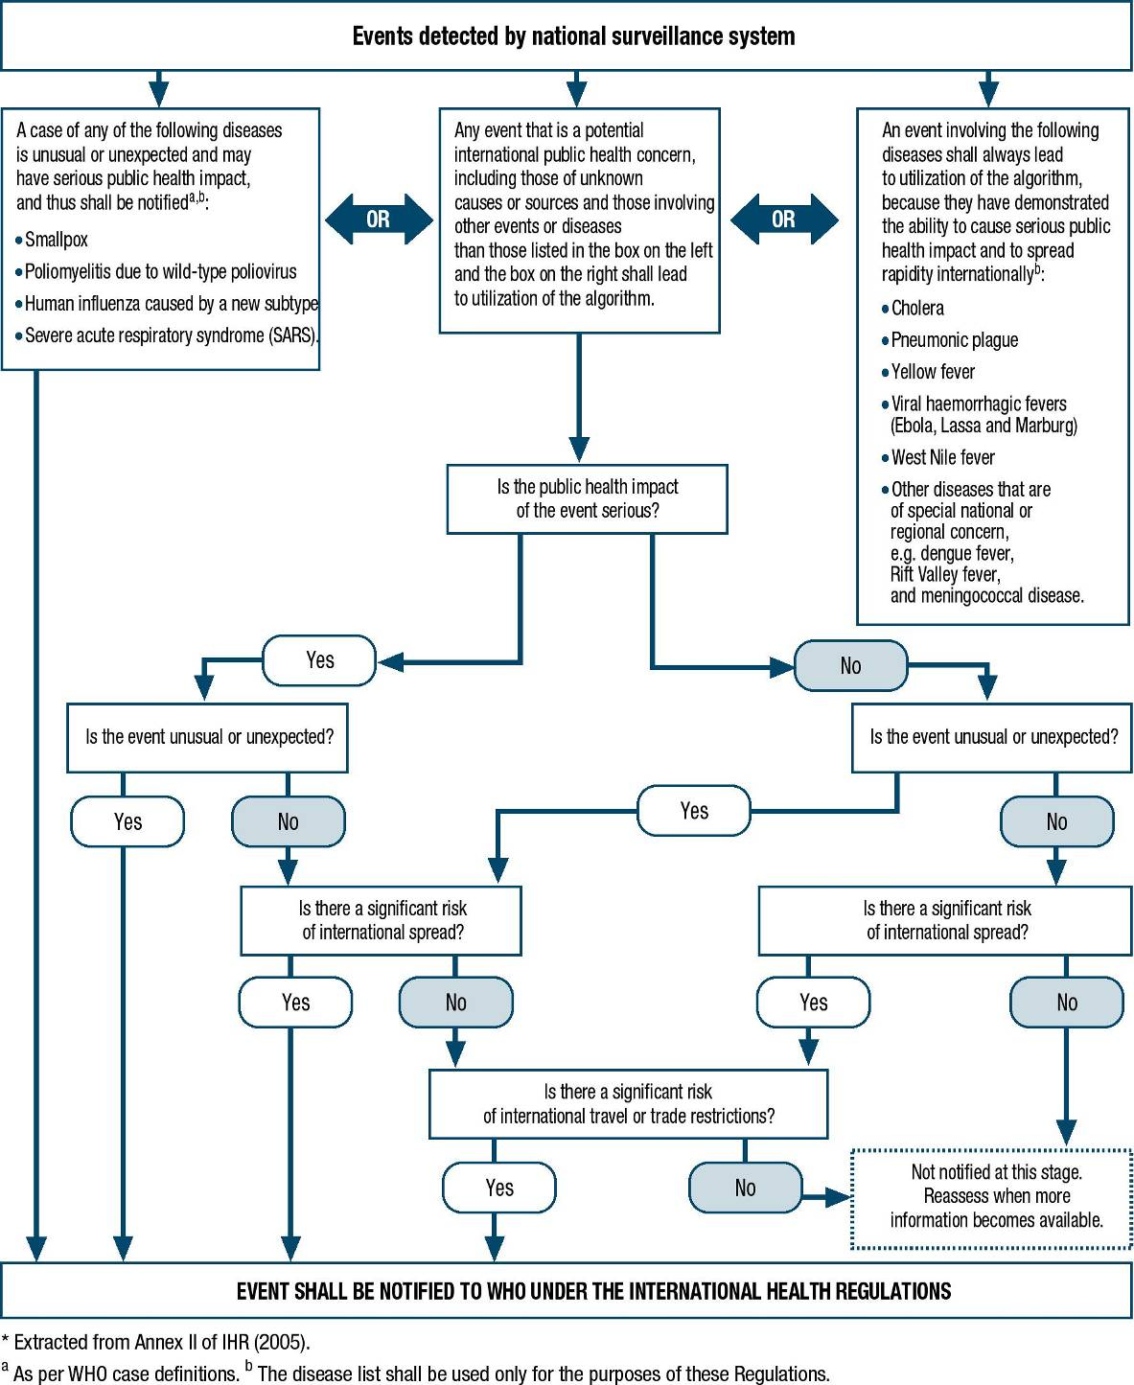

Example of incident management roles and responsibilities
Incident control provides overall direction of the response within the jurisdiction, and incident coordination brings together resources and agencies to ensure and effective response.
National Incident Management Team
The Health-Incident Management Team (H-IMT) sets the objectives and provides advice for the overall Health response.
Health Domain Coordinator
The Health Domain Coordinator will have a strategic focus and also link the department’s response to the Minister, other Australian Government agencies, and national committees, e.g. AHPPC.
NIR Coordinator
The NIR Coordinator will focus on operational issues, particularly operationalising strategic objectives. The NIR Coordinator will plan, organise, direct and control operations within the NIR.
Planning function
The planning function utilizes the intelligence gathered by the Intelligence function to prepare plans for the incident response.
Planning involves:
- Evaluating/analysing intelligence to prepare response options and plans, including the Incident Action Plan; and
- undertaking risk assessments.
Intelligence function
The intelligence function comprises:
- collecting information on the current and forecast situation;
- processing of that information into timely, accurate and relevant intelligence; and
- creating and disseminating a common operating picture.
Public information function
The public information function comprises:
- Provision of warnings and information to communities and stakeholders; and
- liaison with media, the community and stakeholders.
Logistics function
The logistics function comprises:
- Provision of support (HR, facility, services, materials) to the NIR.
Operations function
The operations function focuses on:
- the management of deployed resources.

Glossary and acronyms

Glossary
Term | Definition
Communicable | Able to be transmitted from one patient to another; contagious or infectious, although the use of communicable in communicable disease control extends to diseases that can be transmitted by other means (vectors etc).
Communicable disease | An illness due to a specific infectious agent or its toxic products that arises through transmission of that agent or its products from an infected person, animal or inanimate source to a susceptible host; either directly or indirectly through an intermediate plant or animal host, through a vector or through contact with the inanimate environment.
Communicable disease incident | An incident that results in a significant number of communicable disease cases, with the potential to continue to spread, affecting many more people. It can also refer to an unexpected communicable disease event (clusters of severe illness), spread of disease within Australia (for example geographical expansion of vector borne diseases or of a new serogroup of meningococcal disease). In the context of this plan, a communicable disease incident is an event that may require additional resources, or response measures that exceed business as usual requirements. Occasionally incidents involving safety of medicines, devices or vaccines require actions by communicable disease authorities.
Essential services | Essential services include those services which underpin the functioning of Australia’s social cohesion, economic prosperity and public safety, such as food, water, health services, energy, communications, transportation and banking.
Incident | An instance of something happening; an event or occurrence. Incident includes outbreaks under this plan.
Multijurisdictional | In more than one jurisdiction (state or territory) in Australia, for example communicable disease outbreak or incident with cases occurring in more than one jurisdiction (state or territory) in Australia.
NatHealth arrangements | The National Health Emergency Response Arrangements articulate the strategic arrangements and mechanisms for the coordination of the Australian health sector in response to emergencies of national consequence.
National | In the context of this plan, national includes the Australian Government and state and territory governments.
Outbreak | A disease outbreak is the occurrence of cases of disease in excess of what would normally be expected in a defined community, geographical area or season. An outbreak may occur in a restricted geographical area, or may extend over several jurisdictions. It may last for a few days or weeks, or for several years. A single case of a communicable disease long absent from a population, or caused by an agent (e.g. bacterium or virus) not previously recognised in that community or area, or the emergence of a previously unknown disease, may also constitute an outbreak and should be reported and investigated.

Acronyms
Acronym | Description
AGCC | The Australian Government Crisis Committee is the key mechanism for coordinating the Australian Government response to emergencies.
AGCMF | The Australian Government Crisis Management Framework sets out responsibilities for officials managing domestic and international crisis that require Australian Government assistance or coordination.
AHPPC | The Australian Health Protection Principal Committee is the principal decision coordination body for national health emergencies.
AUSMAT | Australian Medical Assistance Team.
CDI | Communicable disease incident.
CDINS | A CDINS is defined as a CDI that requires implementation of national policy and public messaging, or deployment of Commonwealth or inter-jurisdictional resources to assist affected jurisdictions.
Potential CDINS | A CDI that could become a CDINS through importation and local transmission in Australia, or through escalation in scale or complexity of a domestic CDI.
CDNA | Communicable Diseases Network Australia.
CDPLAN | Emergency Response Plan for Communicable Disease Incidents of National Significance.
DFAT | Department of Foreign Affairs and Trade.
ECC | Emergency Coordination Centre.
EOC | Emergency Operations Centre.
IDETF | An Australian Government Inter-departmental Emergency Task Force will be convened to coordinate the response to a communicable disease emergency which threatens to significantly affect Australians or Australian interests overseas.
IHR (2005) | International Health Regulations 2005 aim to help the international community prevent and respond to acute public health risks that have the potential to cross borders and threaten people worldwide. They require countries to report certain disease outbreaks and public health events to the WHO
NCC | The National Crisis Committee is the key mechanism for coordinating the WoG national response to emergencies across the Australian, State and Territory Governments.
NHEMRN | National Health Emergency Media Response Network is a health sector network used to coordinate a national government approach to interaction with the media during a health emergency.
NHEMS | National Health Emergency Management Standing Committee provides advice to AHPPC on activities to strengthen disaster health infrastructure and capacity nationally, and on national coordination of the health sector in response to disasters.
NIR | The National Incident Room is the contact point for the Department of Health during an emergency and the key resource for coordinating the Department’s role in an emergency.
PHEIC | Public Health Emergency of International Concern declared by the World Health Organisation under the International Health Regulations (2005).
PHLN | Public Health Laboratory Network provides leadership in guiding human health microbiology and laboratory practice.
SEMC | State Emergency Management Committee (names may vary according to the state or territory).
S/T | State and territory.
WHO | World Health Organization.
WoG | Whole of governments – Local, State, Territory and Australian Governments.

The Australian Government Health Minister is not required to make decisions on using the National Medical Stockpile during a CDINS (see 4.1.7).
Local Hospital Networks (LHNs) directly manage single or small groups of public hospital services and their budgets, and are directly responsible for hospital performance under the Performance and Accountability Framework outlined in Schedule D of the National Health Reform Agreement 2012. Some jurisdictions have their own local names for the areas and administrative units known nationally as Local Hospital Networks. For example, in New South Wales they are known as 'Local Health Districts', in Queensland they are known as 'Hospital and Health Services', in South Australia they are known as 'Local Health Networks', and in Tasmania they are known as 'Tasmanian Health Organisations'
Primary Health Networks are Australian Government funded consortiums across Australia (31 in total) responsible for improving the efficiency and integration of the primary health care system. PHNs work directly with GPs, other primary health care providers, secondary care providers, hospitals and the broader community to ensure improved outcomes for patients.

