COVID-19 scenario modelling for cancer screening programs

Cancer

12 May 2020

# Contents

Contents 2

Authors 2

Introduction 3

Methods 3

Simulation model 3

Scenario settings 5

The prioritisation module 6

Model runs 7

Reporting periods and population groups 8

Results 8

Screening delays 8

BreastScreen clients affected by pauses 9

Population invasive breast cancers 10

Program sensitivity 13

Tumour characteristics 13

Survival 16

BreastScreen recall rates and false positive rates 17

Discussion 18

Overview 18

Clinical outcomes 19

BreastScreen program outcomes 19

Screening capacity 19

Options for screening recovery 20

Other considerations 20

References 21

# Authors

Suggested citation: Nickson C, Procopio P, Deij S, Velentzis L, COVID-19 scenario modelling for cancer screening programs, the BreastScreen Australia Program, May 2020.

Cancer Council NSW, Cancer Research Division

# Introduction

On 3 April 2020, the Australian Department of Health commissioned Cancer Council NSW to undertake urgent and incremental preliminary modelling and analysis of potential COVID-19 impacts on cancer screening, by simulating, comparing and reporting on multiple scenarios.

Over the subsequent four weeks, Cancer Council NSW submitted a series of evolving modelling reports, organised according to the circumstances specific to the three separate national screening programs for bowel, breast and cervical cancers.

This report provides indicative results for COVID-19 impacts on the BreastScreen program. It is an update to an earlier report dated 6 May 2020.

It was a complex exercise to adapt our existing microsimulation model to evaluate pause and recovery scenarios including prioritisation of client groups during recovery. As such, results are not included for an additional scenario assuming 120% capacity from 7 months after screening resumption, because this could not be accurately modelled without further model calibration.

Instead, we have now revised and expanded results for scenarios that assume full restoration of screening capacity within 7 months of screening resumption. We also provide more detail about the modelled approach to screening capacity and uptake.

# Methods

## Simulation model

We use the Cancer Council NSW *Policy1-Breast* model, which provides a comprehensive and validated platform to evaluate the clinical benefits and harms of a wide range of screening protocols, new technologies and risk-based approaches aiming to optimise breast cancer screening.

The model applies a continuous-time, stochastic, multiple-cohort micro-simulation of breast cancer screening, diagnosis and treatment in Australia. Each individual woman in the simulation is assigned a range of attributes including lifetime breast cancer risk, breast cancer natural history up to clinical diagnosis, and life-course breast density. Breast cancer screening is then modelled as an overlay, for current and alternative BreastScreen Australia screening protocols, to evaluate the likely clinical benefits and harms of various approaches to population breast cancer screening.

Structurally, Policy1-Breast comprises a set of sub-models (Figure 1), namely: demographics; tumour (cancer risk and natural history); breast density; BreastScreen screening; screening outside the BreastScreen program and detection.

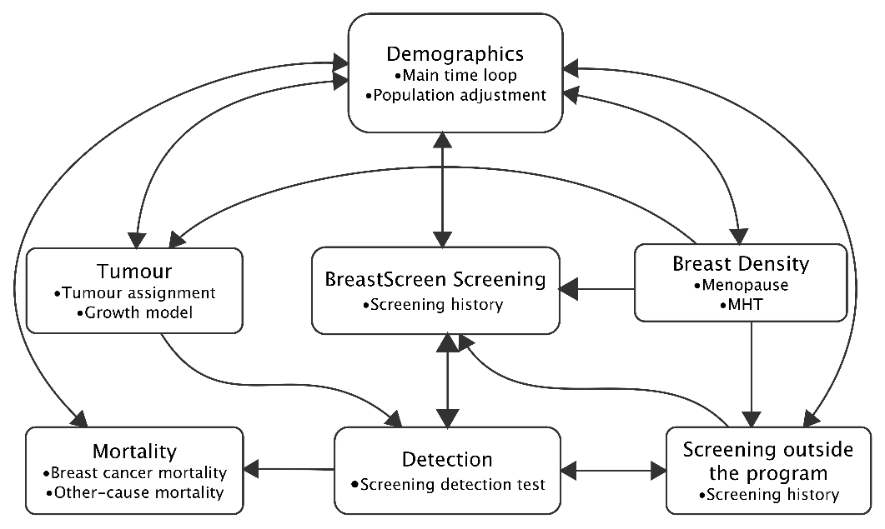

Figure 1. Schematic representation of the overall Policy1-Breast model demonstrating the relationship between sub-models. ‘Private screening’ describes opportunistic and risk-driven screening outside the program.

Individual women progress through the sub-models as shown in Figure 2. Simulated women exit the simulation either through death or by reaching the end of the modelled calendar period.

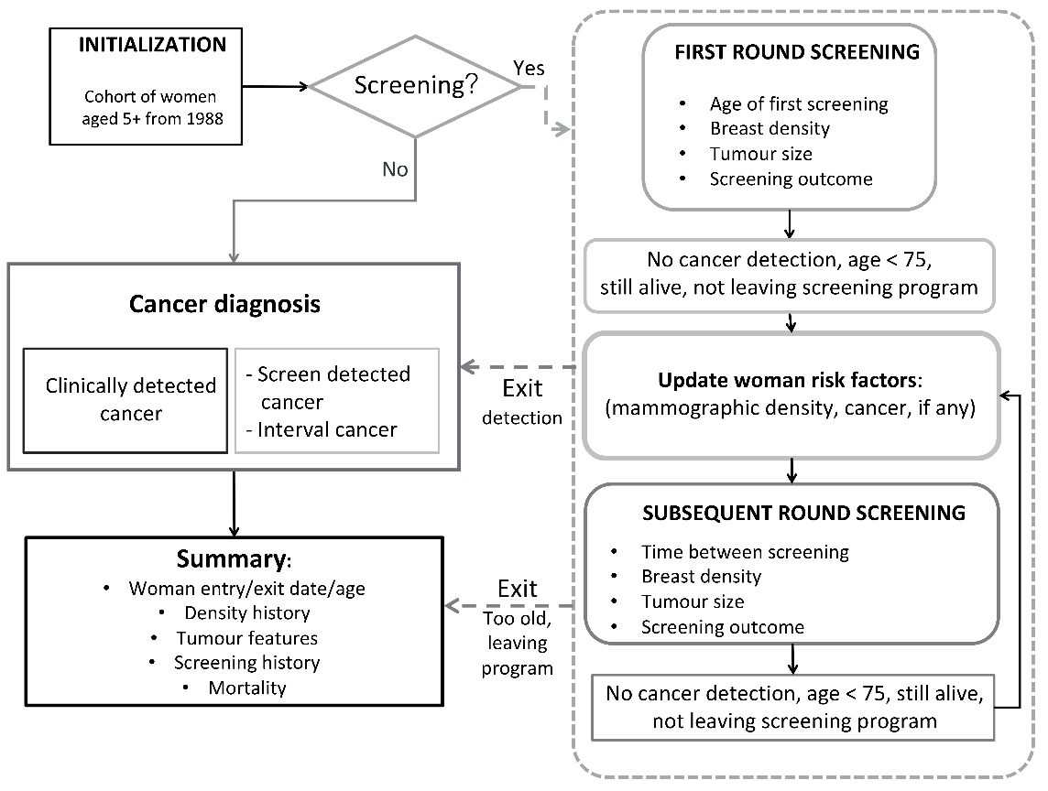

Figure 2. Progression of individual women through the model. The population is initialised for women aged 5+ starting from 1988 (the baseline cohort), and then progressed through to the age range and calendar period required for each model run, with new individuals joining the simulation to replicate births as well as a ‘migration effect’ in older age groups to maintain the observed age female population distribution by year.

For this project, Policy1-Breast has been revised so that it can be applied to capacity-driven recovery scenarios as described below. With this revision, individual clients within the simulation can be channelled into available screening appointments prioritised according to different factors, such as age or screening round.

For the scenarios modelled here, the duration of screening pause can be specified for any value (e.g. by year, month or week). This is applied as an averaging of annual rates.

Like the Policy1 models for cervical and bowel cancer [1,2], Policy1-Breast is based on detailed observed data. Selected data sources are described in Table 1.

Table 1. Data sources for key model input parameters.

|  |  |
| --- | --- |
| Sub-model | **Data Source** |
| Demographics | Female estimated resident population by 5-year age group and calendar years 1971-2018 [3] |
| Mortality | Australian national mortality rates by age and year (all causes mortality) [4]  Breast cancer deaths in women aged 50-69, by detection status [5] |
| Screening | BreastScreen Australia Monitoring Reports up to 2019 version [data from 1997 to 2017]  The *lifepool* cohort ([www.lifepool.org](http://www.lifepool.org)), including breast density measurements and linked BreastScreen and cancer registry outcomes.  A cohort of BreastScreen Victoria clients with breast density measurements from 2003-2007 and follow-up data to 2014. |
|
|

Where possible, parameter values are assigned by direct replication of observed distributions rather than modelling from summary statistics of those distributions. This is done by random sampling from observed individual or aggregate data values. These observed distributions can also be adjusted to simulate alternative scenarios while maintaining similar distribution patterns. For example, to simulate a policy of targeted annual screening, the observed distribution of time between biennial screens could be scaled by 0.5 and constrained to a minimum of 12 months, reflecting real-world scenarios of screening appointment scheduling and client adherence to recommended screening intervals.

## Scenario settings

We simulate a total of seven scenarios, namely:

* Business as usual (BAU)
* Pauses of 3, 6, and 12 months commencing 1 April 2020

For each of these scenarios we assume:

* Following pauses, capacity from month 7 is assumed to be 100% of BAU
* Opportunistic or risk-based screening outside the program is reduced by 50% during program pause (due to COVID-19 social distancing requirements), and resumes at 100% on BreastScreen service resumption.
* BreastScreen service recovery gradually increases relative to business as usual (BAU) over the first 6 months of recovery as shown in Figure 3, reflecting changes in throughput that may be driven by both service capacity and the capacity of BreastScreen clients to engage in screening. To implement these specifications, the number of screens specified as available for each week is calculated as a proportion of screens usually available under BAU.

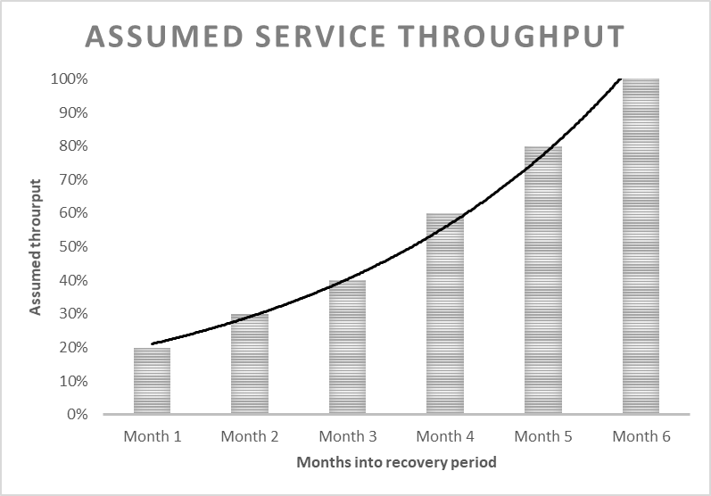

Figure 3.Gradual restoration of service throughput as modelled during the first 6 months of the recovery period.

The combined target screening capacity is shown in Figure 4. The number of modelled screens under BAU increases slightly over time, in accordance with observed trends due to the ageing population. Figures are shown relative to that trend.

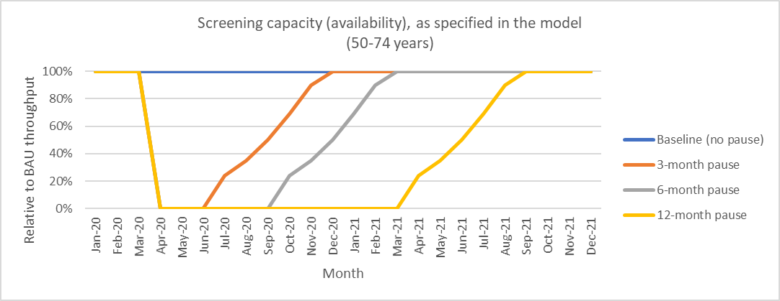

Figure 4.The combined effect of pause periods and gradual restoration of service throughput, as specified in the model.

The uptake of these available screens is then determined by a p*rioritisation module* which was rapidly developed for the purposes of this COVID-19 response project.

## The prioritisation module

The prioritisation module prioritising clients during the recovery period and assigns them to available screens following screening resumption.

Specifically, available screens are assigned as follows:

* For each week of the recovery period, clients queued for screening (either carried over from the pause or due under BAU during the recovery period) are prioritised for available screening appointments according to their screening round (first or subsequent), age, and whether their screen is due or overdue, as shown in Table 2 below. Women who usually screen annually are indirectly prioritised. The queue includes only women aged 50-74 years.
* The module aims to firstly assign clients at the top of the queue to available screening appointments for that week, and then push the remaining queue forward week by week until they are able to be assigned to an available appointment. This pushing forward is limited by a threshold using the maximum delays as described in Table 2.
* Clients resume normal screening schedules after their first recovery screen.

Table 2. Ranking of women aged 50-74 in the queue for available screens during the recovery period.

| Client group | **Rank in queue** | **Target criteria** |
| --- | --- | --- |
| A. New BreastScreen clients who become eligible for screening (i.e. reach age 50) during *screening pause*; age range 50-74. | Rank = 1, also ensuring criteria is met | Screened at a maximum of 15 months later than would have been originally scheduled. |
| B. New BreastScreen clients who become eligible for screening (i.e. reach age 50) during *screening recovery*; age range 50-74. | Rank = 2, also ensuring criteria is met | Screened at a maximum of 15 months later than would have been originally scheduled. |
| C. Existing BreastScreen clients who would have been scheduled for screening during *screening pause*; age range 50-74. | Rank = 3, also ensuring criteria is met | Screened at a maximum of 21 months later than originally scheduled. |
| D. Existing BreastScreen clients who become eligible for screening (i.e. reach age 50) during *screening recovery*; age range 50-74. | Rank = 4, also ensuring criteria is met | Screened at a maximum of 21 months later than originally scheduled. |

As specified, this module requires calibration to be optimised to match screening uptake to screening capacity. In the current simulations, capacity and uptake are comparable, but uptake is somewhat overestimated (Figure 5). This means the current modelled results may slightly underestimate the impact of screening delays (or alternatively that the model effectively assumes a more rapid recovery and a slightly higher throughput following recovery). This model component will be refined for future modelled scenarios, including examples assuming changes to longer-term screening capacity.

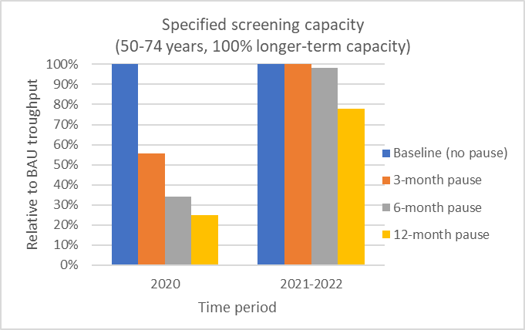 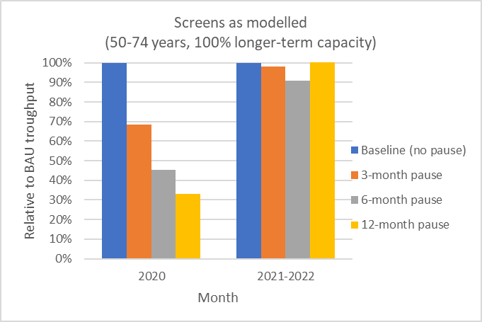

Figure 5. Target screening capacity (left) and resulting screening uptake (right) as currently modelled for the pause commencement year (2020) and the following two-year reporting period (2021-2021).

## Model runs

For each scenario, we report the average output of 10 simulations. We model Policy1-Breast projections of the whole Australian female population by age and calendar time, based on Australian Bureau of Statistics figures.

## Reporting periods and population groups

Modelled outcomes are reported for various calendar periods:

* The first 12 months after the pause commencement (1 April 2020 to 31 March 2021)
* Biennial periods 1 Jan 2020 – 31 Dec 2021, 1 Jan 2021 – 31 Dec 2022, and 1 Jan 2022 – 31 Dec 2023
* The four-year period 1 Jan 2020 to 31 Dec 2023

Outcomes are reported for women aged 50-74 years.

Outcomes are reported for the whole female Australian population and for various groups.

This includes reporting groups of women according to how they are affected by the pause, namely:

* *Women* ***directly affected*** *by the pause* describes BreastScreen clients whose screens were originally scheduled for the pause period
* *Women* ***indirectly affected*** *by the pause* describes BreastScreen clients whose screens were originally scheduled after the pause period and whose screens are delayed during the recovery period to help accommodate directly affected women.
* *Women* ***not affected*** *by the pause* describes BreastScreen clients with no delay to their screens but with screens or outcomes within the reporting periods.

# Results

## ****Screening delays****

Estimated delays in screening are determined by the duration of pause and by the modelled approach to prioritising women for screening following the pause.

For the calendar period 2020-2021, we estimate that pauses to screening would extend the median time between screens (time since the pre-pause screen for subsequent-round participants) from approximately 104 weeks under BAU to 130 weeks for a 12-month pause (Figure 6).

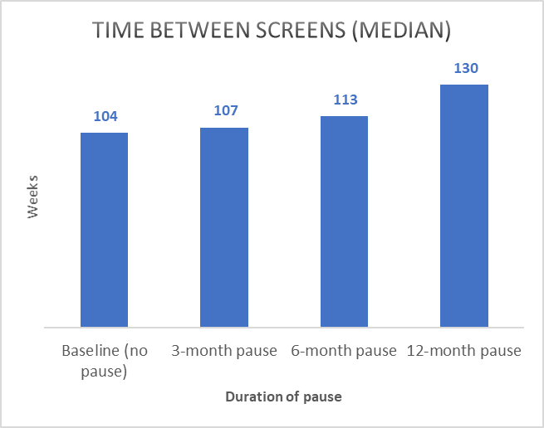

Figure 6. Estimated median time (weeks) between the pre-pause screen and the subsequent screen by duration of pause, for the period 2020-2021.

These delays to screening for subsequent round participants would be reasonably balanced between women who are directly or indirectly affected by the pause, with greater differences for longer pauses (Figure 7). For example, for subsequent-round screening participants aged 50-74, a 6-month screening pause is expected to lead to a median time since pre-pause screen of 132 weeks for *directly affected* women (women who would have usually been scheduled for a screen during the pause period), 126 weeks for *indirectly affected* women (women who would usually be scheduled for screens following the pause and whose screens are then delayed), and 104 weeks for *never affected* women (women whose screens take place on the usual schedule following the pause).

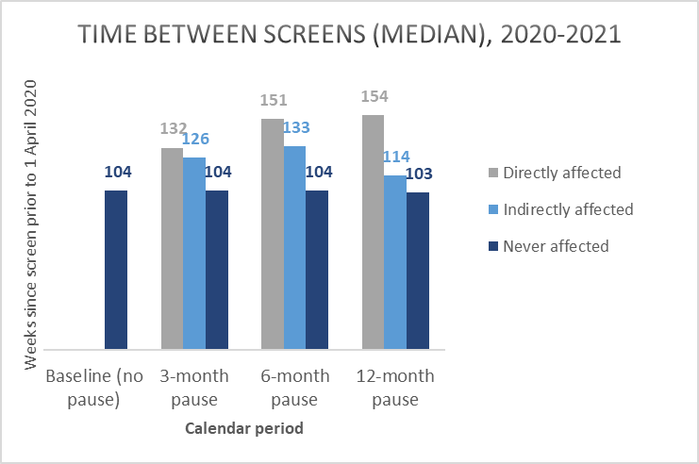

Figure 7. Estimated median time since previous screen for different pause scenarios, for women directly, indirectly affected by the pause, for the period 2020-2021.

## BreastScreen clients affected by pauses

After service resumption, BreastScreen clients aged 50-74 years are expected to include a mix of directly and indirectly affected women and women not affected by the pause. As for estimated delays in screening, these outcomes are determined by both the duration of pause and by the modelled approach to prioritising women for screening following the pause.

The estimated profile of screened women for the period 2021-2022 is shown in Figure 8 for the two-year period 2020-2021, for various pause scenarios. As expected, the proportion of *directly affected* women increases with the duration of the pause, and the proportion of *not affected* women decreases.

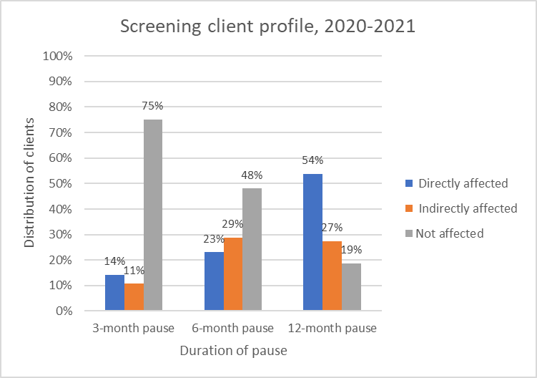

Figure 8. Estimated distribution of BreastScreen clients aged 50-74 according to how they are affected by the pause, for the two-year period 2021-2022.

By the two-year period 2022-2023, this distribution is expected to shift depending on the original duration of pause, as shown in Figure 9.

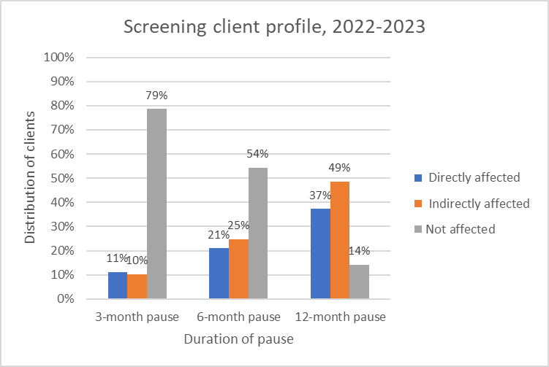

Figure 9. Estimated distribution of BreastScreen clients aged 50-74 according to how they are affected by the pause, for the two-year period 2022-2023.

## Population invasive breast cancers

At a population level, pauses in screening are expected to change the rates of invasive breast cancers, and the way that cancers are diagnosed.

**In the short term** (the first 12 months following pause commencement) we estimate an overall reduction in population-level invasive breast cancers ranging from 244 per 100,000 women (3-month pause) to 166 per 100,000 women (12-month pause) for women aged 50-74 years (Figure 10).

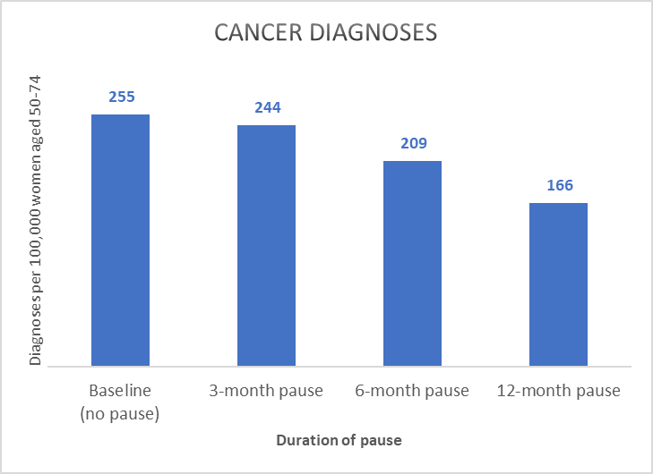

Figure 10. Estimated invasive breast cancers per 100,000 Australian women aged 50-74 years, for the first 12 months following the pause (1 April 2020 to 31 March 2021), for various pause scenarios.

The proportion of invasive breast cancers that are screen-detected within the first 12 months following pause commencement is estimated to range from 33% (3-month pause) to (logically) 0% (12-month pause) (Figure 11).

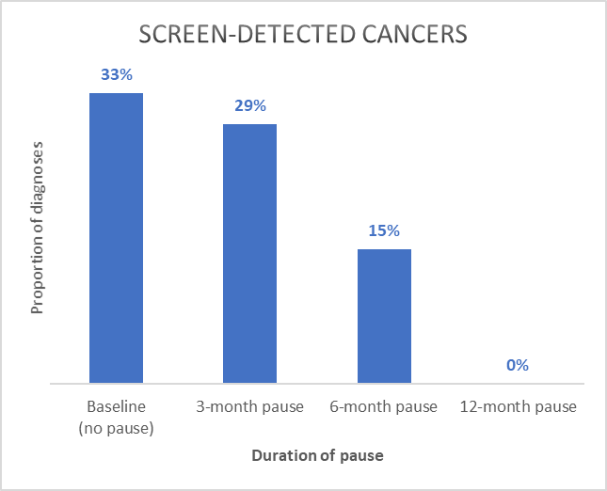

Figure 11. Estimated proportion of invasive breast cancers diagnosed by BreastScreen for the first 12 months following the pause (1 April 2020 to 31 March 2021), women aged 50-74 years.

**In the longer term,** screening pauses are expected to lead to fluctuations in population-level invasive breast cancer diagnoses among women aged 50-74 throughput the recovery period. For example, as shown in Figure 12, population level invasive breast cancers are expected to vary depending on the duration of pause, over each two-year reporting period. For example, with a 12-month pause we estimate a 10% difference between cancer diagnoses in 2020-2021 (270 per 100,000 women) and 2022-2023 (296 per 100,000 women).

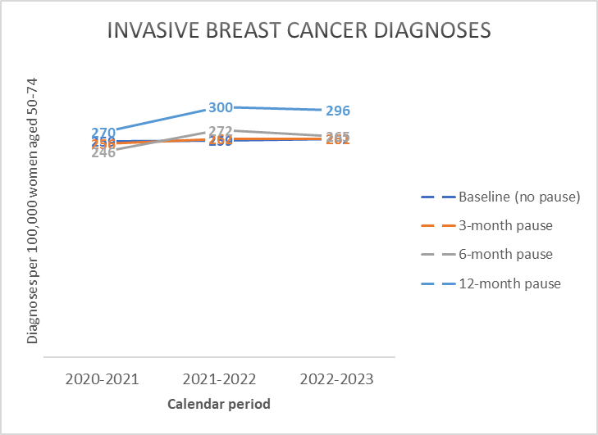

Figure 12. Estimated invasive breast cancer diagnoses per 100,000 women in the Australian population (50-74 years), for different pause scenarios.

Population rates of screen-detected invasive breast cancers among women aged 50-74 are also expected to fluctuate depending on the duration of pause, as shown in Figure 13. These outcomes are particularly sensitive to the *prioritisation module* in the simulation model.

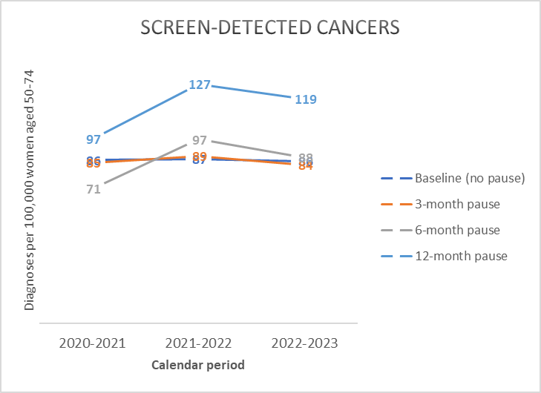

Figure 13. Screen-detected invasive breast cancers per 100,000 women in the Australian population (50-74 years), for different pause scenarios.

Population-level interval cancer rates are expected to fluctuate for different scenarios (Figure 14). These fluctuations are a result of various factors: the likelihood of an interval cancer is expected to depend on the time since the screen prior to the interval cancer reference screen, screening round, and age, all of which vary for different pause scenarios

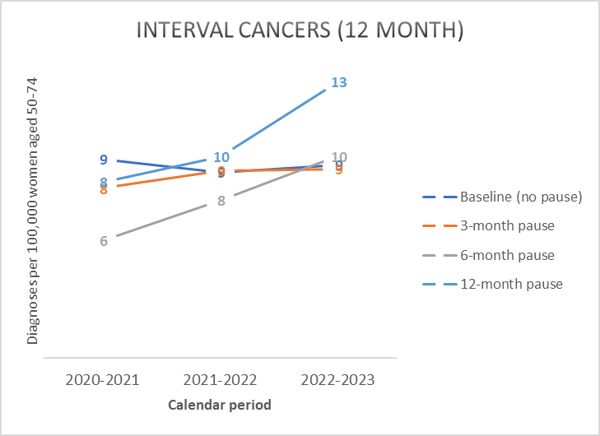

Figure 14. Interval invasive breast cancers (diagnosed within 12 months of a negative BreastScreen screen) per 100,000 women in the Australian population (50-74 years), for different pause scenarios.

## Program sensitivity

The combined effect is expected to lead to fluctuations in program sensitivity as usually reported by BreastScreen (Figure 15). As for interval cancers, these figures are driven by factors such as time since the screen prior to the interval cancer reference screen, screening round, and age, all of which vary for different pause scenarios.

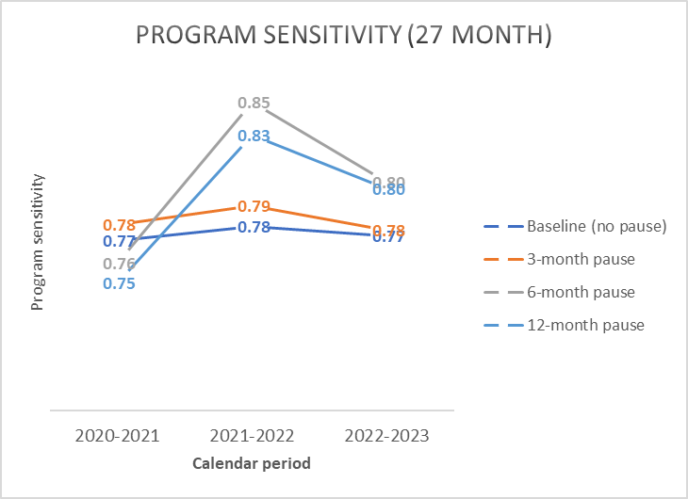

Figure 15. Estimated program sensitivity (50-74 years), for interval cancers up to 27 months following a negative screen, for different pause scenarios.

## Tumour characteristics

For population-level invasive breast cancer diagnoses among Australian women aged 50-74 years, we estimate that screening pauses would be associated with an increased proportion of large cancers and cancers with nodal involvement and, for a 12-month pause, an increase in the proportion of high-grade cancers.

### Tumour size

Over the 12 months following pause commencement (1 April 2020 – 31 March 2021), we estimate a reduction in small (≤15mm) invasive breast cancers from ranging from 54% (3-month pause) to 48% (12-month pause) (Figure 16). Note that these figures report outcomes for all women aged 50-74 (not only screening outcomes).

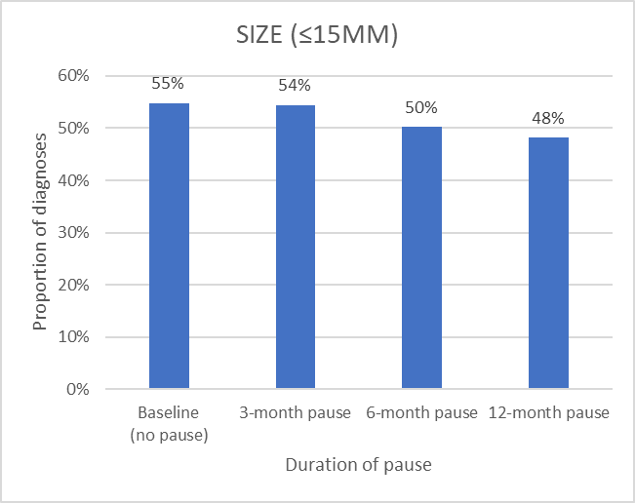

Figure 16. Estimated proportion of invasive breast cancers ≤15mm diameter at diagnosis for different pause scenarios, for cancers diagnosed in the Australian population from 1 April 2020 to 31 March 2021, women aged 50-74.

These differences are expected to attenuate over time, with only small differences across the whole period 2020-2023 (Figure 17).

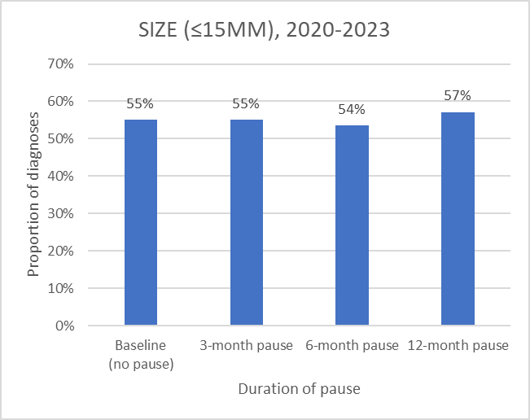

Figure 17 Estimated proportion of invasive breast cancers ≤15mm diameter at diagnosis for different pause scenarios, for cancers diagnosed in the Australian population for the four-year period 2020-2023, women aged 50-74.

### Nodal involvement

Over the 12 months following pause commencement (1 April 2020 – 31 March 2021), we estimate an increase in population-level invasive breast cancers with nodal involvement from 26% (3-month pause) to 30% (12-month pause) (Figure 18). Note that these figures report outcomes for all women aged 50-74 (not only screening outcomes).

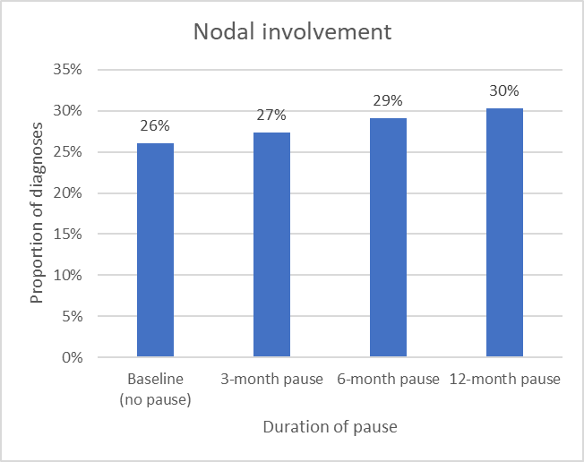

Figure 18. Estimated proportion of invasive breast cancers with nodal involvement at diagnosis for different pause scenarios, for cancers diagnosed in the Australian population from 1 April 2020 to 31 March 2021, women aged 50-74.

These differences are expected to attenuate over time, with only small differences across the whole period 2020-2023 (Figure 19).

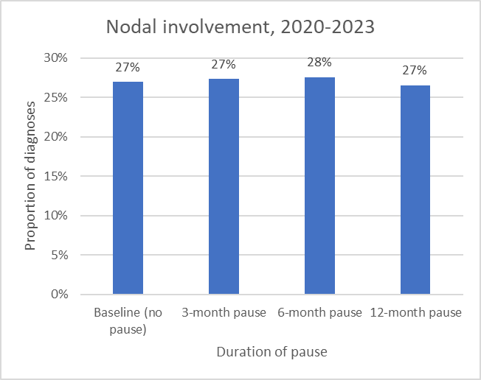

Figure 19. Estimated proportion of invasive breast cancers with nodal involvement at diagnosis for different pause scenarios, for cancers diagnosed in the Australian population for the four-year period 2020-2023, women aged 50-74.

### Grade

We estimate a shift towards higher grade cancers at a population level, most apparent for a 12-month pause (Figure 20). In the Policy1-Breast model we assume that individual tumours do not progress in grade, so these changes reflect differences in which cancers are diagnosed (at a population level) under different pause and recovery scenarios.

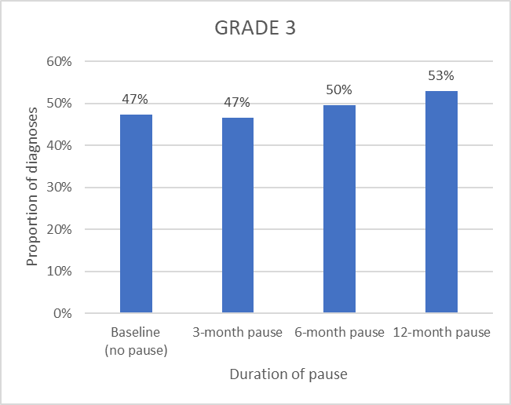

Figure 20. Estimated proportion of Grade 3 (versus Grade 1 or 2) invasive breast cancers for different pause scenarios, for cancers diagnosed in the Australian population from 1 April 2020 to 31 March 2021, women aged 50-74.

These differences are expected to attenuate over time, with only small differences across the whole period 2020-2023 (Figure 21).

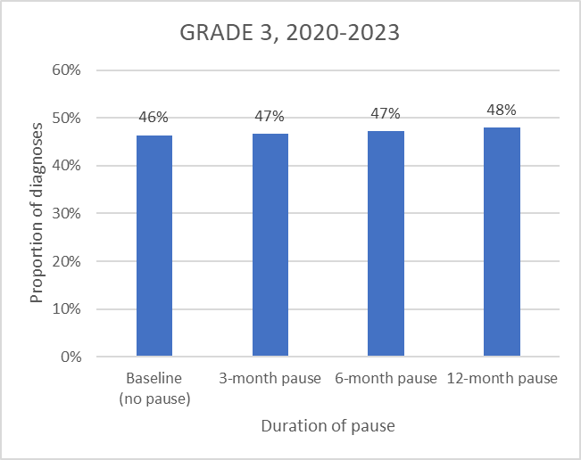

Figure 21. Estimated proportion of Grade 3 (versus Grade 1 or 2) invasive breast cancers for different pause scenarios, for cancers diagnosed in the Australian population for the four-year period 2020-2023, women aged 50-74.

## Survival

We estimate no discernible changes to population-level breast cancer mortality rates over the period 2020-2023.

For all women who would usually screen during the first year following the pause at age 50-74 we estimate no differences in five-year survival following their BAU screening date.

However, for women *directly affected* by the pause at age 50-74 who have a subsequent invasive breast cancer diagnosis by end 2023, we estimate their 5-year survival following diagnosis would reduce from 90.4% with a 3-month pause to 89.5% with a 12 month pause (equivalent to approximately one additional death within 5 years of diagnoses per 100 women diagnosed). This may be at least partially due to changes in lead time, where cancers are diagnosed later but the risk of death does not change.

For women who would usually screen during the first year following the pause at age 50-74 who have a breast cancer diagnosis by end 2023, we estimate that 5-year survival would reduce with increased screening pauses (e.g. 5-year survival following diagnosis 91.4% under business as usual compared to 89.5% with a 12 month pause) (Figure 22).

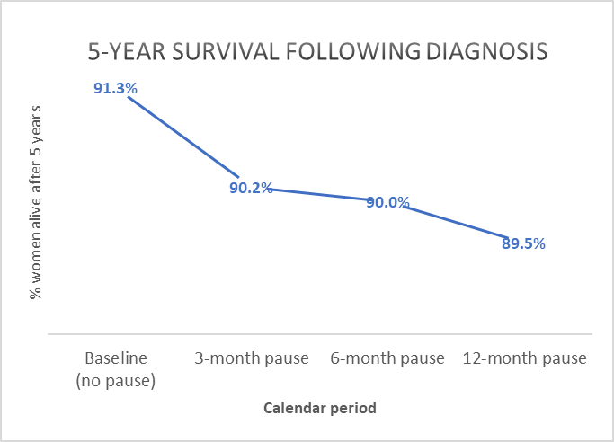

Figure 22. Estimated 5-year survival following diagnosis, for all women who would usually screen during the first year following the pause at age 50-74 and have an invasive breast cancer diagnosis by end 2023. Survival is based on outcomes as modelled up to the year 2030, so there is no censoring of outcomes

## BreastScreen recall rates and false positive rates

Recall rates are expected to fluctuate over time under various pause scenarios, as shown in Figure 23. The net effect of a pause over the whole period 2020-2023 would lead to recall rates ranging between 6.0% (3-month pause) to 6.2% (12-month pause). This variation will be due to a range of factors including the tumour size of modelled breast cancers at screening and the mix of first and subsequent round screening in each scenario.

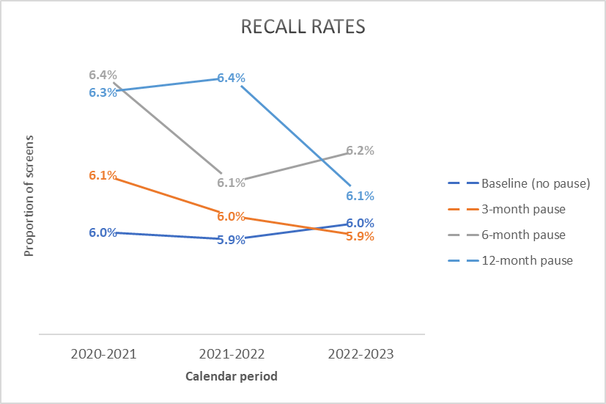

Figure 23. Recall rates for various pause scenarios (50-74 years).

False-positive recall rates are expected to fluctuate over time under various pause scenarios, as shown in Figure 23. The net effect of a pause over the whole period 2020-2023 would lead to false positive rates ranging between 5.3% (3-month pause) and 5.5% (6-month pause). These fluctuations will be due to a range of factors including the mix of first and subsequent round screening in each scenario.

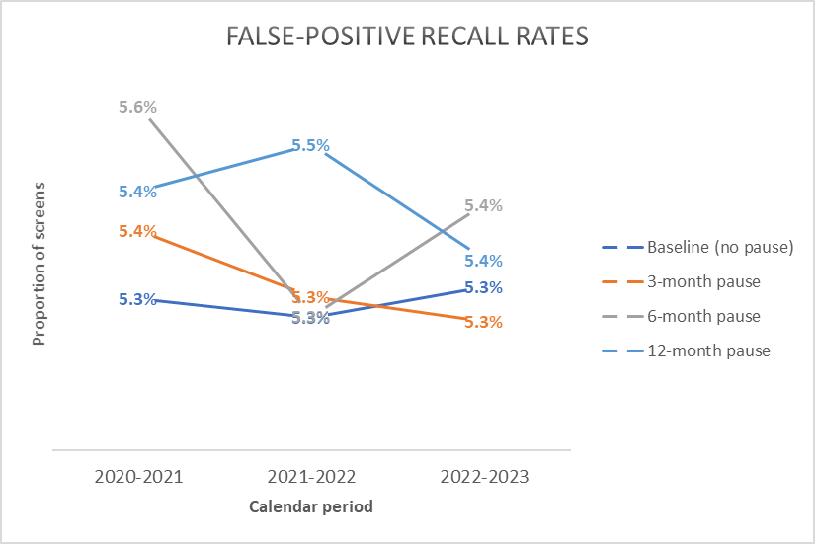

Figure . False positive recall rates for various pause scenarios (50-74 years)

# Discussion

## Overview

These high-level, national results offer some insights about the possible impact of 3, 6 and 12 month pauses in Australian breast cancer screening due to the COVID-19 pandemic. While some BreastScreen services are (as of 12 May) recommencing to various degrees and timeframes, the results indicate the expected impact of longer delays on cancer diagnoses and breast cancer mortality for women in the BreastScreen target age range of 50-74 years, and highlight the sensitivity of various aspects of BreastScreen services and population-level outcomes to pauses in screening.

Adapting our existing microsimulation model to pause and recovery scenarios including prioritisation of client groups during recovery was a complex exercise, and the estimates should be considered indicative.

## Clinical outcomes

We estimate a slight reduction in 5-year survival following diagnosis for women directly affected by a pause, but no discernible changes to population-level breast cancer mortality rates. Comparison of longer-term outcomes may reveal some mortality differences, but it is also possible that the modelled approach to prioritising women during recovery period effectively mitigated some of the impact of screening delays during the pause.

At a population level, we estimate marked fluctuations in population rates of invasive breast cancer diagnoses, with a 10% increase between 2020-2021 and 2022-2023. These variations would be expected to have a flow-on effect on the demand for treatment services.

We estimate that pauses to screening will lead to increases tumour size, nodal involvement and Grade 3 tumours among cancers diagnosed in the twelve months following pause commencement. In the Policy1-Breast model we currently assume that tumour grade does not change over time, so the slight shift towards higher-grade cancers may be due to a reduction in the diagnosis of slow-growing cancers. Only minor differences are apparent over the whole period 2020-2023, reflecting the diagnosis of lower-grade tumours later in the recovery period.

## BreastScreen program outcomes

Median screening intervals during 2020-2021 are expected to increase from 104 weeks under BAU to 130 weeks with a 12-month pause, with delays shared between directly and indirectly affected women. These figures are sensitive to modelling of capacity and uptake, and uptake is currently overestimated (Figure 5); as such, estimated screening intervals may increase with further model calibration.

The estimated fluctuations in BreastScreen recall rates and false positive recall rates during recovery are consistent with the changing profile of women screened across the recovery phase compared to BAU, and would be expected to impact on the profile and numbers of screening episodes referred for further BreastScreen assessment. These outcomes would be highly sensitive to prioritisation of screens during the recovery period.

We estimate periods of higher BreastScreen ‘program sensitivity’, especially following a longer pause. This is a function of both delays in screening and opportunities for interval cancers (which can occur only following a screening event), rather than an indicator of screening test sensitivity (which is how it is most often interpreted). This would need to be considered in the interpretation of routinely collected and reported BreastScreen data.

## Screening capacity

The assumed gradual increase in screening capacity is a simplified approach by necessity in this rapid-response modelling exercise, intended to clearly assume as a base-case that breast cancer screening cannot be switched on to full capacity after a pause.

In reality, the capacity of BreastScreen services and their clients to engage in screening under COVID-19 will depend on many factors such as the availability of personal protective equipment, specialist personnel and usual screening equipment, additional time to conduct screening to minimise risk of virus transmission, access to communities with heightened social distancing measures, and localised virus control and outbreaks. As such, the restoration of BreastScreen services would be expected to vary between jurisdictions, over calendar time, and between specific geographical areas and sub-populations.

## Options for screening recovery

There is no default way to prioritise women to available screens during the recovery period after a pause. The current evaluation assumes that women would be prioritised for available screens according to screening round, age, usual screening interval (biennial or annual), and whether their screen is due or overdue. This follows a general principle that prioritisation should aim to maximise the benefits and minimise the harms of available screens, while being feasible to implement and acceptable to clients.

This does mean that the modelled approach effectively simulated a more risk-based screening protocol than BAU during the recovery period. The resulting median time between screens is similar for directly and indirectly affected women, suggesting that the approach is reasonably equitable in terms of screening delays. It may be of interest to compare alternative scenarios with less or more targeted approaches to prioritising women during the recovery phase. It would be possible using Policy1-Breast to model options where women are prioritised according to criteria such as breast cancer risk (currently assigned within the model as lifetime risk), breast density, or age groups within 50-74 age range, or exploring optimal combinations in terms of clinical outcomes.

## Other considerations

This rapid-response report provides a first, high-level summary of selected modelled outcomes. Other modelled outcomes that may be of interest include results according to age group and screening round, interval cancers arising in different cohorts (rather than by calendar time at diagnosis) or the intensity of treatment required (e.g. surgery and adjuvant therapy rates) for different cohorts of women or for different calendar periods under various scenarios.

Modelling different levels of longer-term reduced throughput (e.g. 20%, 30%, 40%, up to 100% capacity over a 12-month period) would help indicate the impact of longer-term constraints on BreastScreen capacity, including e.g. reduced annual throughput due to short-term reductions in screening due to e.g. COVID-19 outbreaks or limited access to resources or populations. For such scenarios, the specified approach to prioritising women to available screens within constrained services would become even more important.

It may also be valuable to investigate the time required to achieve full recovery under different pause and recovery assumptions, including assumptions about when screening should be made available to women outside the target age range.

# References

1. Lew JB, St John DJB, Xu XM, et al. Long-term evaluation of benefits, harms, and cost-effectiveness of the National Bowel Cancer Screening Program in Australia: a modelling study. *Lancet Public Health*. 2017;2(7):e331-e340.
2. Lew JB, Simms K, Smith MA, et al. National Cervical Screening Program Renewal: effectiveness modelling and economic evaluation in the Australian setting (assessment report)—MSAC application number 1276. November, 2013. Available from: http://www.cancerscreening.gov.au/internet/screening/publishing.nsf/Content/E6A211A6FFC29E2CCA257CED007FB678/$File/Renewal%20Economic%20Evaluation.pdf Accessed 10 December 2018.
3. Australian Bureau of Statistics (ABS) 2019. Australian Demographic Statistics ‘Table 59. Estimated Resident Population by Single Year of Age, Australia’, time series spreadsheet, cat. no. 3101.0, viewed 28 January 2020, https://www.abs.gov.au/AUSSTATS/abs@.nsf/DetailsPage/3101.0Sep%202019?OpenDocument
4. Australian Institute of Health and Welfare (AIHW) 2019a. GRIM (General Record of Incidence of Mortality) books 2018: All causes combined. Canberra: AIHW.
5. Australian Institute of Health and Welfare (AIHW) 2019b. GRIM (General Record of Incidence of Mortality) books 2018: Breast cancer. Canberra: AIHW.