

# ACFI Monitoring report - January 2022

## Summary

* Average ACFI claims increased in January.
* The solid line in Figure 1 shows the average daily claim rate.
* The impact of the temporary increase in subsidies in the March 2019 quarter is highlighted in the dotted line, while the dashed line shows the impact of temporary funding increase from 1 March 2020 in response to the COVID-19 pandemic.
* The remainder of this report provides analysis based on the changes in claim rates without the temporary increase incorporated.

Figure 1. Average daily ACFI claim per month[1]

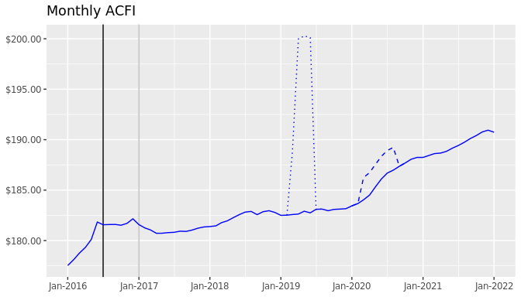

Table 1: Cumulative Daily Average ACFI Subsidies and Growth Rates by ACFI Category

| ACFI category | July 2020 to Jan 2021 | July 2021 to Jan 2022 | Nominal growth | Real growth |
| --- | --- | --- | --- | --- |
| ADL | $100.28 | $102.85 | 2.6% | 1.4% |
| BEH | $29.59 | $30.33 | 2.5% | 1.4% |
| CHC | $55.69 | $57.12 | 2.6% | 1.4% |

Figure 2. Daily Average $/Day Trend by Month – 2021/22 Dollars

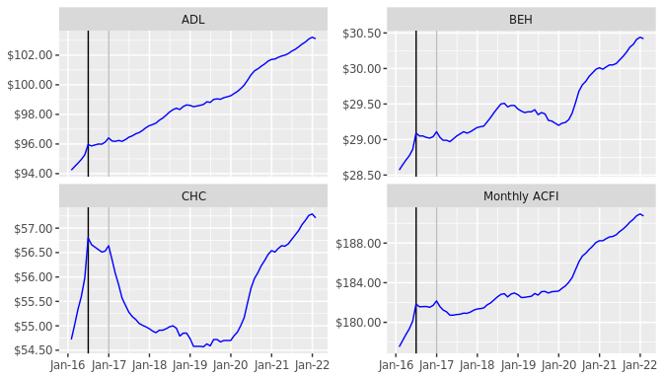

Table 2: Cumulative Daily Average ACFI Subsidies and Growth Rates by State

| State | July 2020 to Jan 2021 | July 2021 to Jan 2022 | Nominal growth | Real growth |
| --- | --- | --- | --- | --- |
| Projected National | $185.57 | $190 | 2.4% | 1.3% |
| Actual National | $185.57 | $190.30 | 2.6% | 1.4% |
| NSW | $182.16 | $187.44 | 2.9% | 1.8% |
| VIC | $190.95 | $194.92 | 2.1% | 1.0% |
| QLD | $183.35 | $189.31 | 3.3% | 2.1% |
| WA | $190.91 | $192.04 | 0.6% | -0.5% |
| SA | $184.17 | $189.15 | 2.7% | 1.6% |
| TAS | $179.35 | $186.60 | 4.0% | 2.9% |
| ACT | $181.47 | $186.67 | 2.9% | 1.7% |
| NT | $188.11 | $195.04 | 3.7% | 2.6% |

Table 3: Cumulative Daily Average ACFI Subsidies and Growth Rates by Remoteness

| Remoteness | July 2020 to Jan 2021 | July 2021 to Jan 2022 | Nominal growth | Real growth |
| --- | --- | --- | --- | --- |
| Major Cities | $188.99 | $193.65 | 2.5% | 1.3% |
| Inner Regional | $179.22 | $184.25 | 2.8% | 1.7% |
| Outer Regional | $174.27 | $178.77 | 2.6% | 1.5% |
| Remote | $150.60 | $156.92 | 4.2% | 3.1% |
| Very Remote | $158.76 | $161.69 | 1.9% | 0.7% |

Table 4: Cumulative Daily Average ACFI Subsidies and Growth Rates by Organisation Type

| Organisation Type | July 2020 to Jan 2021 | July 2021 to Jan 2022 | Nominal growth | Real growth |
| --- | --- | --- | --- | --- |
| Not-for-profit | $181.85 | $186.76 | 2.7% | 1.6% |
| For-profit | $193.47 | $198.00 | 2.3% | 1.2% |
| Government | $158.38 | $160.11 | 1.1% | -0.0% |

Table 5: Cumulative Daily Average ACFI Subsidies and Growth Rates by Provider Size[2]

| Provider Size | July 2020 to Jan 2021 | July 2021 to Jan 2022 | Nominal growth | Real growth |
| --- | --- | --- | --- | --- |
| 0-39 | $160.36 | $163.74 | 2.1% | 1.0% |
| 40-74 | $171.57 | $178.13 | 3.8% | 2.7% |
| 75-129 | $177.10 | $182.15 | 2.8% | 1.7% |
| 130-499 | $183.98 | $188.13 | 2.3% | 1.1% |
| 500-999 | $190.34 | $194.36 | 2.1% | 1.0% |
| 1000+ | $190.43 | $195.22 | 2.5% | 1.4% |

Table 6: Cumulative proportion of total days by ACFI level and ACFI category

|  | ADL | | |  | BEH | | |  | CHC | | |
| --- | --- | --- | --- | --- | --- | --- | --- | --- | --- | --- | --- |
| ACFI Level | July 2020 to Jan 2021 | July 2021 to Jan 2022 | Change ADL |  | July 2020 to Jan 2021 | July 2021 to Jan 2022 | Change BEH |  | July 2020 to Jan 2021 | July 2021 to Jan 2022 | Change CHC |
| H | 64.5% | 66.9% | 2.4% |  | 65.6% | 67.0% | 1.4% |  | 55.0% | 56.9% | 1.9% |
| M | 27.4% | 26.4% | -1.0% |  | 22.0% | 21.7% | -0.2% |  | 31.0% | 30.3% | -0.7% |
| L | 7.7% | 6.5% | -1.3% |  | 9.1% | 8.5% | -0.7% |  | 13.5% | 12.4% | -1.1% |
| N | 0.4% | 0.2% | -0.1% |  | 3.3% | 2.9% | -0.4% |  | 0.5% | 0.4% | -0.1% |

Table 7: Cumulative proportion of total days by ADL Scores and ADL Question

|  | July 2020 to Jan 2021 | | | |  | July 2021 to Jan 2022 | | | |
| --- | --- | --- | --- | --- | --- | --- | --- | --- | --- |
| ADL Question | A | B | C | D |  | A | B | C | D |
| Nutrition | 2.1% | 10.9% | 72.6% | 14.4% |  | 1.6% | 9.5% | 75.1% | 13.9% |
| Mobility | 1.2% | 1.6% | 31.1% | 66.1% |  | 0.9% | 1.3% | 29.6% | 68.3% |
| Personal Hygiene | 0.3% | 4.2% | 7.9% | 87.6% |  | 0.2% | 3.6% | 7.4% | 88.8% |
| Toileting | 1.6% | 7.9% | 15.1% | 75.4% |  | 1.2% | 6.7% | 15.2% | 76.9% |
| Incontinence | 9.2% | 1.7% | 3.3% | 85.8% |  | 7.9% | 1.4% | 3.0% | 87.7% |

Table 8: Cumulative proportion of total days by BEH scores and BEH question

|  | July 2020 to Jan 2021 | | | |  | July 2021 to Jan 2022 | | | |
| --- | --- | --- | --- | --- | --- | --- | --- | --- | --- |
| BEH Question | A | B | C | D |  | A | B | C | D |
| Cognitive skills | 6.4% | 27.0% | 39.3% | 27.2% |  | 5.9% | 26.9% | 40.1% | 27.1% |
| Wandering | 86.6% | 4.2% | 3.1% | 6.1% |  | 87.8% | 3.8% | 2.9% | 5.5% |
| Verbal | 10.7% | 11.2% | 20.3% | 57.7% |  | 9.8% | 11.2% | 20.7% | 58.2% |
| Physical | 26.3% | 16.0% | 20.5% | 37.3% |  | 25.2% | 16.3% | 21.2% | 37.4% |
| Depression | 32.8% | 29.5% | 19.3% | 18.5% |  | 32.1% | 29.4% | 19.8% | 18.7% |

Table 9: Distribution of claim days for the CHC

## July 2020 to Jan 2021

### Appraised before 1 July 2016

|  | Q12 | | | |  | | |
| --- | --- | --- | --- | --- | --- | --- | --- |
| Q11 | A | B | C | D |  | Rating | Proportion |
| A | 0.0% | 0.0% | 0.1% | 0.0% |  | Nil | 1.1% |
| B | 0.1% | 0.2% | 0.5% | 1.2% |  | Low | 6.3% |
| C | 0.2% | 0.1% | 0.5% | 1.5% |  | Med | 16.4% |
| D | 0.1% | 0.5% | 3.3% | 1.0% |  | High | 76.2% |

### Appraised between 1 July 2016 and 31 December 2016

|  | Q12 | | | |  | | |
| --- | --- | --- | --- | --- | --- | --- | --- |
| Q11 | A | B | C | D |  | Rating | Proportion |
| A | 0.0% | 0.0% | 0.0% | 0.0% |  | Nil | 0.7% |
| B | 0.0% | 0.1% | 0.2% | 0.7% |  | Low | 5.9% |
| C | 0.0% | 0.0% | 0.2% | 0.7% |  | Med | 24.7% |
| D | 0.0% | 0.2% | 0.1% | 0.7% |  | High | 68.7% |

### Appraised after 1 January 2017

|  | Q12 | | | |  | | |
| --- | --- | --- | --- | --- | --- | --- | --- |
| Q11 | A | B | C | D |  | Rating | Proportion |
| A | 0.3% | 0.1% | 0.4% | 0.2% |  | Nil | 0.4% |
| B | 7.6% | 4.8% | 27.4% | 41.6% |  | Low | 14.6% |
| C | 0.0% | 0.5% | 0.6% | 4.2% |  | Med | 32.7% |
|  |  |  |  |  |  | High | 52.3% |

## July 2021 to Jan 2022

### Appraised before 1 July 2016

|  | Q12 | | | |  | | |
| --- | --- | --- | --- | --- | --- | --- | --- |
| Q11 | A | B | C | D |  | Rating | Proportion |
| A | 0.0% | 0.0% | 0.1% | 0.0% |  | Nil | 1.0% |
| B | 0.0% | 0.1% | 0.3% | 0.8% |  | Low | 6.0% |
| C | 0.1% | 0.1% | 0.3% | 1.0% |  | Med | 15.3% |
| D | 0.1% | 0.3% | 2.1% | 0.7% |  | High | 77.7% |

### Appraised between 1 July 2016 and 31 December 2016

|  | Q12 | | | |  | | |
| --- | --- | --- | --- | --- | --- | --- | --- |
| Q11 | A | B | C | D |  | Rating | Proportion |
| A | 0.0% | 0.0% | 0.0% | 0.0% |  | Nil | 0.6% |
| B | 0.0% | 0.0% | 0.1% | 0.4% |  | Low | 5.2% |
| C | 0.0% | 0.0% | 0.1% | 0.5% |  | Med | 22.2% |
| D | 0.0% | 0.1% | 0.1% | 0.4% |  | High | 72.0% |

### Appraised after 1 January 2017

|  | Q12 | | | |  | | |
| --- | --- | --- | --- | --- | --- | --- | --- |
| Q11 | A | B | C | D |  | Rating | Proportion |
| A | 0.3% | 0.1% | 0.4% | 0.3% |  | Nil | 0.4% |
| B | 7.3% | 4.2% | 27.7% | 46.5% |  | Low | 13.0% |
| C | 0.0% | 0.5% | 0.5% | 4.5% |  | Med | 31.4% |
|  |  |  |  |  |  | High | 55.3% |

Table 10: Actual Average ACFI per day - Monthly and Cumulative

| ACFI | Jul 21 | Aug 21 | Sep 21 | Oct 21 | Nov 21 | Dec 21 |
| --- | --- | --- | --- | --- | --- | --- |
| Monthly ACFI | $189.42 | $189.74 | $190.11 | $190.40 | $190.76 | $190.94 |
| Cumulative ACFI | $189.42 | $189.58 | $189.75 | $189.92 | $190.08 | $190.23 |

| ACFI | Jan 22 | Feb 22 | Mar 22 | Apr 22 | May 22 | Jun 22 |
| --- | --- | --- | --- | --- | --- | --- |
| Monthly ACFI | $190.74 |  |  |  |  |  |
| Cumulative ACFI | $190.30 |  |  |  |  |  |

Figure 3. ACFI Category - Change in Proportion of Total Care Days Year to Date – Year on Year[3]

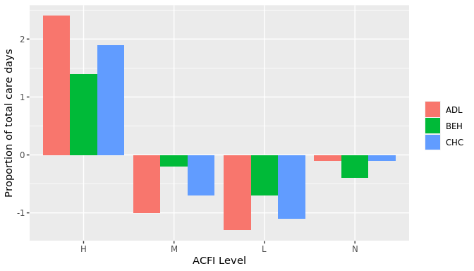

1. All $ values are based on ACFI Question Responses and calculated at 2021/22 ACFI rates.
2. Based on full time equivalent residents per year for 2020/21. Only includes providers active during July 2021.
3. Compares change in proportion of care days for start of July to end of January between 2020/21 and 2021/22.