# Health promotion resource

*“Talking poster” - Syphilis Story in Yolgnu Martha (the language of East Arnhem)*

## Talking poster script in English

This is the story of syphilis; in the circle all the family are strong and healthy. The man in the circle decides to move to another community and when he does he is tempted to want to make a relationship with a woman but he remembers the messages from the elders and says no.

The white footprints shows a health person with no syphilis and the red ones show a person with syphilis.

When he goes to the third community he makes a relationship with a woman who has syphilis that’s when his footprint changes from white to red because now he has that infection.

In the other communities he has sex with two more women and he gives them that infection. When it is time to go home he thinks he might have syphilis of other STIs so he remembers the messages of the elders and does not want to bring sickness to the community so he goes to the clinic and gets tested and treated. Then his footprints turn back to being white he is healthy and happy to go home.

Aboriginal and non-Aboriginal people have to work together to stop these sex infections.

By Terrence Guyula, Aboriginal Health Practitioner, CDC, Nhulunbuy

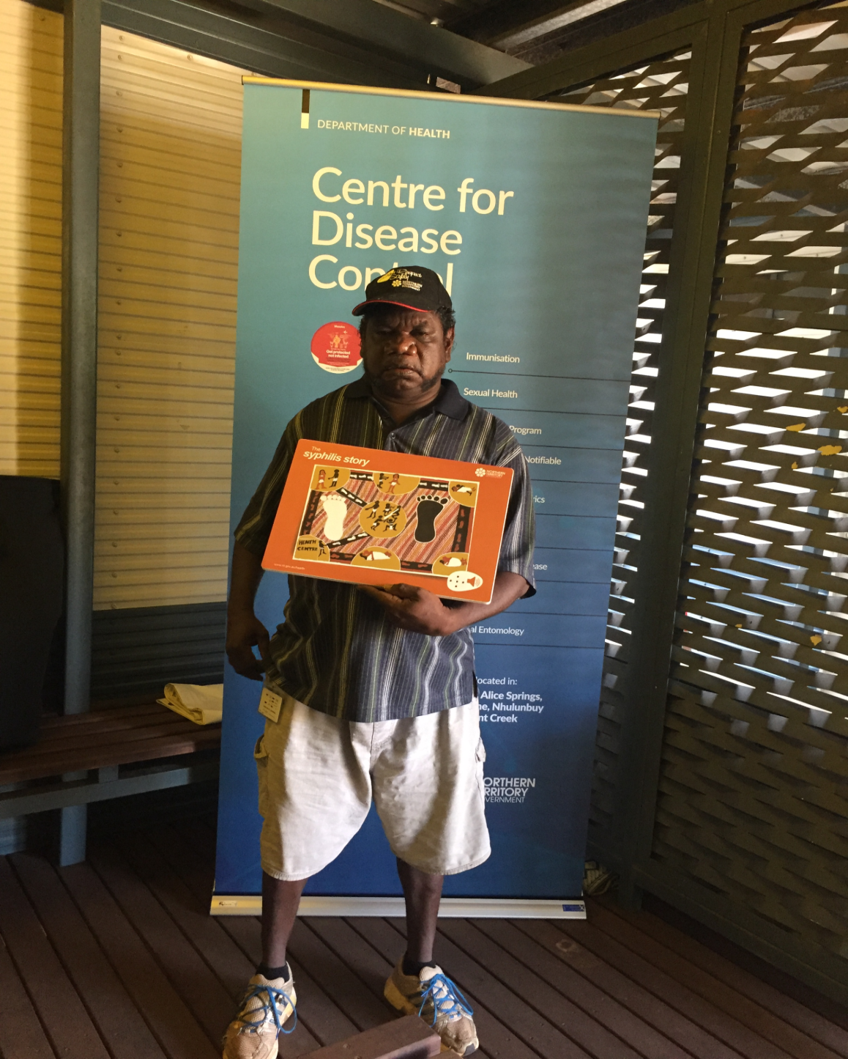

Developing the Syphilis Story in Yolgnu Matha

* Terrence Guyula, a man from Gapuwiyak in East Arnhem who works as an Indigenous Health Practitioner with the Centre for Disease Control painted the story of syphilis, using traditional artwork (men’s version).
* Terrence got the permission from his elders to this artwork, when it was complete he showed it to many Indigenous people in the region to make sure that they could understand this story, all the feedback was very positive.
* A script in English was developed (see attached) which told the story of the man who travelled from his community to six other communities.
* A company here in Darwin produces the talking posters called ‘One Talk Technology’ ( a part of Sprout Design) ph 08 89805700.
* The English script was sent to the Interpreting Service to be translated in Yolgnu Matha.
* The talking poster is on corf lute material (like the election posters on fences), they are light but durable, can be mounted with double sided tape in the men’s clinics or can be a portable educational device for small groups of men or one on one. You just push the button on the bottom right and this starts the story.
* We produced 15 x A3 talking posters and this cost approximately $5,500
* We now plan to use the original artwork but use an English translation on the poster; this allows wider distribution as it is not possible to produce in all the languages of the NT.
* Terrence also has permission from his elders to create the ‘women’s’ story which will follow the similar story line to the men story.

*For further information please contact:*

Jan Holt

Health Promotion Officer

Sexual Health and BBV Unit Darwin

PH 08 89228814

[jan.holt@nt.gov.au](mailto:jan.holt@nt.gov.au)