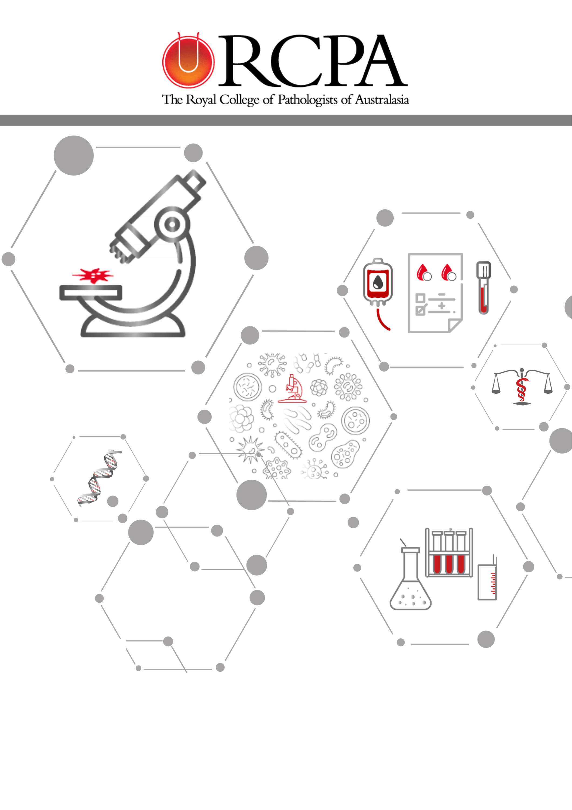

31 AUGUST 2021

FINAL REPORT

PUBLICATION OF COMMON-SENSE PATHOLOGY (CSP)

# Document Control

| **Date** | **Version** | **Status** | **Action** | **Responsible** |
| --- | --- | --- | --- | --- |
| 31Aug 2021 | V.01 | FINAL | Web accessible version created | MH |
| 14 Oct | V.02 | FINAL | With new Figure 4 | MH |

Contents

Document Control 1

1. Glossary of terms & acronyms 4

2. Executive summary 4

3. Project Statement 5

3.1 Background 5

4. Scope 6

5. Governance and Reporting 6

5.1 Governance Structure 6

5.2 Steering Committee 6

5.3 Stakeholders 7

6. Project Activities 7

6.1 Documentation summary 7

7. Project Outcomes 8

7.1 Delivery of ten editions of CSP 8

7.2 Publication of two education modules 9

8. Project Challenges 13

# Glossary of terms & acronyms

| Acronym | Detail |
| --- | --- |
| ADG | Australian Doctor Group |
| CSP | Common Sense Pathology |
| CPD | Continuing Professional Development |
| DoH | Department of Health |
| GP | General Practitioner |
| HCP | Health Care Practitioner |
| MBS | Medicare Benefits Schedule |
| RCPA | [Royal College of Pathologists of Australasia](http://www.rcpa.edu.au/) |
| RCPAQAP | [RCPA Quality Assurance Programs](http://www.rcpaqap.gov.au) |

# Executive summary

This is the Final report for the Common-Sense Pathology (CSP) 2018-2021 Project.

CSP 2018-2021 Project included the production of 10 editions of a colour supplement distributed with Australian Doctor magazine and electronically via the “How to Treat” website and e-newsletter and two education modules accredited by Royal Australian College of General Practitioners (RACGP) for Continuing Professional Development (CPD) purposes.

The Project completed the following activities:

* The Steering Committee developed the CSP topics and agreed these with the Department of Health in September 2018.
* Ten editions of CSP were produced and distributed with the Australian Doctor Magazine. Edition 7 on CODVID19 was produced in online format only and published on 10 May 2020.
* Education Module 1 and Education Module 2 are available on the Australian Doctor Group (ADG) “How to Treat” website under the CPD Modules and Webinars section. Each CSP Education Module uses content from 5 editions [Module 1 – editions 1-5, and Module 2 – editions 6-10] designed to support the upskilling of GPs. These education modules are accredited with the RACGP attracting Category 2 CPD points.

The Project encountered the following challenges:

* Aligning the CSP topics with the MBS Pathology Review was challenging in the early stages of the Project. This was resolved satisfactorily, and the CSP topics were agreed with the Department of Health.
* The edition on Recurrent Infection, initially planned as Edition 5 was delayed due to a leave of absence by the Author and was replaced with Abnormal liver function tests.
* The COVID19 pandemic, lead to numerous requests for the RCPA to produce an edition to assist GPs in their approach to treating patients. In consultation with the Steering Committee and the Department it was agreed to replace the already delayed edition on Recurrent Infection with an edition on COVID19. This edition is online only for two reasons: 1) a print version would have missed the opportunity to have the edition ready within the required timeframe and 2) the nature of the topic and the rapidly changing environment meant an online version ensured the content was as current as possible, and last-minute changes were more easily incorporated.

The Final report outlines, in more detail, how the Project delivered the contracted deliverables.

# Project Statement

## Background

The production of CSP is supported by funding from the Australian Government Department of Health and produced by the College, almost continuously since 1987.

The 2018 – 2021 publication of CSP included – a colour supplement, ten editions distributed with Australian Doctor magazine, electronically via the “How to Treat” website and e-newsletter, and two education modules accredited by RACGP for CPD purposes. The CSP topics focused on the Medicare Benefits Schedule (MBS) Review of pathology related tests.

CSP is written primarily for General Practitioners (GPs) providing education about quality use of pathology, using practical case scenarios with clear and concise information that is useful and as an important aid in determining which pathology tests are most appropriate for the diagnosis and management of different illnesses. Providing education aims to prevent unnecessary testing, which is both invasive to patients and costly to the community. Also, it assists in providing GPs with up-to-date information on the most appropriate pathology test to request, thereby reducing potential misdiagnoses through omitting to request an important pathology test. CSP provides appropriate pathology requesting information to GPs and has proven to be a highly effective tool for imparting information about pathology tests to doctors across the country.

# Scope

The purpose of publishing this series of CSP was to continue educating GPs and other practitioners about the quality requesting of pathology tests by using practical case-based scenarios with clear and concise information that assists in determining which pathology tests are needed for different clinical conditions. Also, it supports GPs with up-to-date information on the most appropriate pathology test to request.

# Governance and Reporting

## Governance Structure

## Steering Committee

The Steering Committee is responsible for co-ordination and oversight of the Project.

Steering Committee Members:

Helen Freeborn DCEO, RCPA

Vanessa White Manager, PMO RCPA

Jo Hartley Editor, ADG

Dr Steve Flecknoe-Brown Editor, RCPA

Dr Karley Heyworth GP Editor, ADG

Hannah Donovan, ADG

Karissa Kuguru, ADG

Marion Higginson, RCPA

## Stakeholders

**GPs, other medical practitioners, and medical students**: all of whom have the opportunity for enhanced education and improved medical practice by reading CSP.

**Patients**: who can avoid unnecessary tests and benefit from worthwhile tests as GPs become familiar with the guidelines provided in CSP.

**Pathologists**: who find CSP a useful tool to refer GP queries to.

**The community**: which will benefit from enhanced quality of pathology referring practices through cost savings.

# Project Activities

There were two key elements to the Project approach;

1. Coordinate the development, publication, and delivery of ten editions of CSP as follows:
2. Print format – ten editions of CSP to appear as a colour supplement in Australian Doctor magazine in line with the quarterly publication periods of March, June, September, and December 2018-2021.
3. Electronic format – publish CSP supplements aimed at GP's and other Health Care Professionals (HCPs) on the “How to Treat” website [www.howtotreat.com.au](http://www.howtotreat.com.au) and the [RCPA](https://www.rcpa.edu.au/Library/Publications/Common-Sense-Pathology) [website](https://www.rcpa.edu.au/Library/Publications/Common-Sense-Pathology). A “Pathology” category has been created on the “How to Treat” website for the pathology content created within the ten editions of the CSP supplements.
4. E-newsletter – distribute CSP supplements via E-Newsletter to GPs and HCPs, including medical students.
5. Develop and publish two education modules on the “How to Treat” website and promote the modules to support the upskilling of GPs and HCPs. Each module uses content from five editions of CSP [Module 1 – editions 1-5, and Module 2 – editions 6-10] to create an article and a series of multiple-choice questions. These modules attract Category 2 CPD points and are accredited with the RACGP.

## 6.1 Documentation summary

Edition 1 “Making sense of antibodies” by Dr Daman Langguth and Daniel Schuster - December 2018

Edition 2 “Investigating fatigue” by Prof Andrew R Lloyd - March 2019

Edition 3 “Abnormal full blood count in the asymptomatic patients” by Dr Yasmin Harvey – June 2019

Edition 4 “Investigation of common thyroid problems” by Dr Annabelle Warren and Prof Duncan Topliss – September 2019

Edition 5 – “Interpreting liver function tests” by Dr Melissa Gillett and Dr Rebecca Brereton

Edition 6 – “Investigations of secondary amenorrhea” by Dr Cherie Chiang and Dr Andra Desra

Edition 7 – “Common sense testing of COVID19” by RCPA and ADG

Edition 8 – “Tumour marker testing – a cautious approach” by Dr Jared Millican, Dr Stephen Li and Dr Mark Wong

Edition 9 – “Genetic Testing” by Dr Melody Caramins

Edition 10 – “Molecular diagnostics: the usefulness and pitfalls of PCR testing” by Dr Jenny Robson and Dr Evan Bursle

# Project Outcomes

## Delivery of ten editions of CSP

Ten editions of CSP were produced and distributed with the Australian Doctor Magazine, in print and online. Edition 7 on CODVID19 was produced in online format only.

Nine of these editions exceeded the ADG average content campaign page view average of 750 with 2,264 average CSP content page views. The RCPA content rated 202% above the ADG content per page view average.

The geographical breakdown of the print distribution of CSP across Australia was 80% metropolitan based GPs and 20% rural based GPs. The split across states and territories was:

| State | Distribution % by State |
| --- | --- |
| ACT | 2% |
| NSW | 33% |
| VIC | 27% |
| SA | 7% |
| WA | 11% |
| TAS | 2% |
| NT | 1% |
| QLD | 18% |

Online total content page views were 22,641 with an average time of 4.25 minutes spent on a page and 3.78 % newsletter click through rate which is better than the ADG average of 3.1% click through rate for content.

| **ADG Edition sent to GPs** | **“How to Treat” e-newsletter website pageviews** | **RCPA website file downloads** |
| --- | --- | --- |
| Edition 1 sent to 18,652 GPs | 1140 | 2089 |
| Edition 2 sent to 19,335 GPs | 1607 | 2449 |
| Edition 3 sent to 20,905 GPs | 2619 | 6249 |
| Edition 4 sent to 17,749 GPs | 4462 | 2806 |
| Edition 5 sent to 19,043 GPs | 5455 | 3618 |
| Edition 6 sent to 17,500 GPs | 1346 | 2847 |
| Edition 7 online version only | 2885 | 816 |
| Edition 8 sent to 17,228 GPs | 1589 | 559 |
| Edition 9 sent to 17,250 GPs | 1001 | 304 |
| Edition 10 sent to 16,991 GPs | 537 | 325 |

## Publication of two education modules

**Online Education Module 1** “Common Sense Pathology – a case-based approach for general practice” was launched on 11 May 2020 with content based on the first 5 editions.

Edition 1 “Making sense of antibodies” by Dr Daman Langguth and Daniel Schuster - December 2018

Edition 2 “Investigating fatigue” by Prof Andrew R Lloyd - March 2019

Edition 3 “Abnormal full blood count in the asymptomatic patients” by Dr Yasmin Harvey – June 2019

Edition 4 “Investigation of common thyroid problems” by Dr Annabelle Warren and Prof Duncan Topliss – September 2019

Edition 5 – “Interpreting liver function tests” by Dr Melissa Gillett and Dr Rebecca Brereton – March 2020

Education Module 1 had 893 online engagements and 420 online module completions, with a completion rate of 47%. The GP locality breakdown showed that 70% were urban/city based, 26% rural/remote and 4% hospital-based. This RCPA education content out-performed ratings of other ADG education content by 47% for engagement and 18% for completion rates.

The behavioural shift from undertaking Education Module 1 was significant. GPs improved their understanding of which pathology tests are most appropriate for the diagnosis and management of different illnesses, refer to Figure 1. GPs improved their confidence in assessing and appropriately investigating illness via requesting the most appropriate pathology test, refer to Figure 2.

Figure 1: Online Module 1 Behavioural Analysis

Shows pre-module survey and post-module survey results for GPs. Improvement in knowledge demonstrated.

Figure 1: Online Module 1 Behavioural Analysis

Figure 2: Online Module 1 Behavioural Analysis

Shows pre-module survey and post-module survey results for GPs. Improvement in knowledge demonstrated.

Figure 2: Online Module 1 Behavioural Analysis

GP feedback from Education Module 1 showed that 99% had their education needs meet either entirely 55% or partially 44% while 100% of GPs stated that the module was relevant to their practice either 89% entirely or 11% partially.

**Online Education Module 2** “Choosing and interpreting pathology testing in general practice” launched on 9 June 2021 with content based on the last set of 5 editions of CSP.

Edition 6 – “Investigations of secondary amenorrhea” by Dr Cherie Chiang and Dr Andra Desra

Edition 7 – “Common sense testing of COVID19” by RCPA and ADG

Edition 8 – “Tumour marker testing – a cautious approach” by Dr Jared Millican, Dr Stephen Li and Dr Mark Wong

Edition 9 – “Genetic Testing” by Dr Melody Caramins

Edition 10 – “Molecular diagnostics: the usefulness and pitfalls of PCR testing” by Dr Jenny Robson and Dr Evan Bursle

Education Module 2 had 259 online engagements and 90 online module completions, with a completion rate of 35%. The GP locality breakdown showed that 63% were urban/city based, 26% rural/remote and 11% hospital-based.

The behavioural shift from undertaking Education Module 2 was significant. GPs improved their understanding of which pathology tests are most appropriate for the diagnosis and management of different illnesses, refer to Figure 3. GPs improved their confidence in assessing and appropriately investigating illness via requesting the most appropriate pathology test, refer to Figure 4.

Figure 3: Online Module 2 Behavioural Analysis

Shows pre-module survey and post-module survey results for GPs. Improvement in knowledge demonstrated.

Figure 3: Online Module 2 Behavioural Analysis

Figure 4: Online Module 2 Behavioural Analysis

Shows pre-module survey and post-module survey results for GPs. 

Figure 4: Online Module 2 Behavioural Analysis

GP feedback from Education Module 2 showed that 99% had their education needs meet either entirely 81% or partially 18% while 100% of GPs stated that the module was relevant to their practice either 90% entirely or 10% partially.

The Education modules were relevant to the GPs practice, survey outcomes demonstrated significant changes in GPs understanding and their ability to request the most appropriate pathology test for assessing and appropriately investigating illness.

# Project Challenges

Responding to COVID19 pandemic related requests from GPs for information on how to treat patients was a challenge. Deciding to produce an online-only COVID19 edition ensured that the content was as current as possible, and last-minute changes were easily incorporated. Members of the RCPA Microbiology Advisory Committee were also requested to help and provide feedback on the edition during a period of high demand for their services.

Aligning the topics with the MBS Pathology Review was initially challenging as, at the time of proposing the topics, the MBS Pathology Review recommendations had not yet been finalised. The negotiations and content of the MBS Review were confidential. The Project Team was not involved in these discussions. To address this issue the proposed list of topics was circulated to the Chairs of the RCPA discipline-specific committees engaged in the MBS Pathology Review requesting input to identify whether the proposed topics had possible alignment with the MBS Pathology Review recommendations. Responses from the Chairs confirmed that every topic proposed had a possible alignment, and the Project subsequently agreed the topics with the Department of Health.