SPRC


**Structured Pathology Reporting of Cancer 2017-20**

Final Report to

Australian Government Department of Health

15 September 2020

Contents

1. Glossary of terms & acronyms 3

2. Executive summary 4

3. Project statement 6

3.1 Background 6

3.2 Project Outline 6

4. Scope 7

5. Governance 9

5.1 CanSAC 9

5.2 Project Group 9

5.3 Cancer Specific Expert Groups 10

6. Project Activities 11

6.1 SPRC Protocol Development 11

6.2 Education and Promotion 12

6.3 Facilitate local implementation 14

7. Project Outcomes 18

7.1 Knowledge Advancement 18

7.2 Metrics of success 19

8. Project Challenges 23

9. Future Directions 24

9.1 Protocol development 24

9.2 Digital implementation 24

9.3 Widespread adoption via top-down leadership 25

10. References 26

# Glossary of terms & acronyms

| ACRONYM | DETAIL |
| --- | --- |
| AIHW | Australian Institute of Health and Welfare |
| AP | Anatomical Pathology |
| ASCO | American Society of Clinical Oncology |
| CanSAC | Cancer Services Advisory Committee |
| CAP | [College of American Pathologists](http://www.cap.org/apps/cap.portal) |
| DoH | Department of Health |
| ICCR DSC | ICCR Dataset Steering Committee |
| IARC | International Agency for Research on Cancer |
| ICCR | International Collaboration on Cancer Reporting |
| IHTSDO | International Health Terminology Standards Development Organisation |
| IPaLM | International Pathology and Laboratory Medicine (IPaLM) Special Interest Group |
| FHIR | Fast Healthcare Interoperability Resources |
| FNA | Fine needle aspiration |
| LIS | Laboratory Information System |
| LOINC | Logical Observation Identifiers, Names and Codes |
| MBS | Medical Benefit Schedule |
| MoU | Memorandum of Understanding |
| NBCSP | National Bowel Cancer Screening Program |
| NCSR | National Cancer Screening Register |
| NPAAC | [National Pathology Accreditation Advisory Council, Australia](http://www.health.gov.au/npaac) |
| PITUS | Pathology Information, Terminology and Units Standardisation |
| QUPP | Quality Use of Pathology Program |
| RCPA | [Royal College of Pathologists of Australasia](http://www.rcpa.edu.au/) |
| RCPath | The Royal College of Pathologists (UK) |
| SNOMED | Systematized Nomenclature of Medicine |
| SPRC | Structured Pathology Reporting of Cancer |
| UGICR | Upper Gastrointestinal Cancer Registry |
| WHO | World Health Organization |

# Executive summary

This is the Final Report for the Structured Pathology Reporting of Cancer (SPRC) 2017-20 Project.

The Royal College of Pathologists of Australasia (RCPA) identified the need to steer improvements in pathology reporting that provide benefits in cancer management and planning services as well as improving patient outcomes.

Therefore, the Structured Pathology Reporting of Cancer (SPRC) 2017-20 Project was initiated with the principal objective to drive improvements in pathology reporting, and accomplished this via three core pursuits:

1. Delivered a comprehensive suite of up-to-date SPRC protocols.
2. Provided a series of educational webinars and promotional activities to encourage mainstream use of SPRC protocols.
3. Undertook information modelling to facilitate local implementation of SPRC.

The Project completed the following activities:

* Developed and published 32 SPRC protocols and supplementary resources. Current protocols included the most recent evidence-based information including the latest methodologies and techniques. The need to do ancillary testing such as immunohistochemistry, in situ hybridisation and molecular genetics on samples has been defined to allow for better management of Medicare Pathology services. Inclusion of molecular genetics within SPRC protocols has made the task of keeping abreast of current technologies and reporting changes in this area more achievable for pathologists.
* Designed SPRC protocols that ensure essential morphological and prognostic indicators are present in a patient’s diagnostic histopathology report. Recommendations for appropriate evidence-based ancillary testing such as molecular or immunological testing are utilised. Data obtained from the SPRC Survey, the Upper Gastrointestinal Cancer Registry (UGICR) Quality Register and SPRC website usage, confirm the majority of anatomical pathologists routinely report using SPRC Protocols.
* Delivered six webinars, published twelve newsletters and three scientific peer-reviewed journal articles. The high volume of participation in molecular SPRC webinars evidenced the value the Project has provided to the pathology community.
* Three annual surveys were developed, distributed, and reviewed between 2017-2019 which provided important data regarding the use of RCPA SPRC protocols in Australian laboratories.
* Collaborated with the PITUS and IHTSDO/SNOMED Projects to produce standardised terminology reference sets to improve data quality and standardisation.
* Advocated more appropriate utilisation of other Medicare items such a diagnostic imaging, surgery, radiotherapy and PBS items for chemotherapy and immunotherapies, by ensuring that all relevant and appropriate information is included in the patient’s cancer report on which further treatment decisions can be made. Data obtained from the pancreatic Quality Register confirms that >95% of histopathology reports contain critical SPRC protocol content.

A number of challenges were encountered during the Project 2017-20 contract period:

* Protocol development scheduling changes resulted from development and publication delays of the WHO/IARC tumour classifications and ICCR datasets. This periodically impacted the schedule of contracted new or updated SPRC protocols and the Project developed a substitute set of protocols for alternative organ systems (e.g. the Endocrine suite of reporting protocols replaced the Breast cancer suite in 2020).
* The SARS-CoV-2/COVID-19 pandemic impacted the availability of a number of local and international experts involved in the development of the ICCR gastrointestinal datasets due to disruptions caused by the pandemic. This resulted in delays to ICCR gastrointestinal dataset publications.
* Without a national requirement for a minimum standard of discrete data standardisation and software upgrade, significant progress on the implementation of structured reporting is unlikely. Implementation of levels 5-6 structured reporting promote the highest quality data standardisation, efficiency and improved reporting performance outcomes. A key barrier to higher level structured reporting is the lack of top-level policy requirements for high level structured reporting. Without a mandatory directive, widespread Level 5-6 implementation is unlikely to be realised in Australian anatomical pathology laboratories.

# Project statement

## 3.1 Background

Structured pathology reporting is an evidence-based method of reporting cancer pathology that contains standardised critical reporting details, displayed in a structured list format. Essentially it provides the critical, key information presented in a format designed for maximum accuracy and clarity.

Increasingly, international evidence reveals that the use of standardised structured pathology reporting of cancer improves the completeness and quality of pathology data provided to multidisciplinary clinical teams and healthcare professionals, with direct demonstrable benefits to patients.

In addition, anatomical pathologists must ensure that essential morphological and prognostic indicators are present in a patient’s diagnostic histopathology report. A single source for current Australian recommendations for appropriate evidence-based best practice reporting guidelines and ancillary testing was required.

SPRC protocols provide a mechanism to enable the highest standards of reporting and data quality to improve cancer management and patient outcomes for all Australians.

## 3.2 Project Outline

The RCPA identified the need to sustain improvements in pathology reporting that provide benefits in cancer management and planning services as well as improve patient outcomes.

To meet this need, the RCPA set out to develop a comprehensive suite of up-to-date SPRC protocols to expand the coverage for the majority of cancers, incorporating the latest international best practice guidelines and peer-reviewed evidence.

Promotion and education of the protocols and resources was designed to ensure maximum access and benefit to the Australian pathology community.

To facilitate local implementation, the capture of important survey data, the development of standardised internationally-agreed terminology, and the development of a clinical quality register was coordinated.

In doing so, the SPRC 2017-20 Project supported the QUPP goal of meeting the needs of pathology consumers and referrers, by providing the latest best practice reporting standards for Australian pathologists, to provide benefits in cancer management and planning services which improve patient care.

# Scope

The Aims of the SPRC 2017-20 Project were to improve the standard of cancer reporting in Australia by:

* Increasing the existing number of SPRC protocols by developing an up to date, comprehensive suite of SPRC protocols for Australian pathologists, which incorporate the latest evidence-based national and international standards;
* Encouraging the use of SPRC through promotional and educational activities; and
* Facilitating implementation of SPRC through external collaborations and disseminating the new and updated protocols to all pathologists and laboratories (public and private) in Australia.

The pathology report lays the foundation for a patient’s cancer journey and conveys information which is critical to facilitate accurate and timely treatment. Studies show the traditional narrative style of reporting, is more likely to result in the omission of essential information necessary for patient management, and that structured reporting significantly enhances the completeness and quality of data in pathology reports. The National Pathology Accreditation Advisory Council (NPAAC) has stated that “the increasing complexity of the pathology information required for personalised management of cancer patients requires that reports are clear, complete, concise, and conform to standards in order to ensure optimal patient treatment and outcomes. Standardised data elements and methods of measurement are required to ensure that all necessary information is available in the report and that each data element has been measured consistently and in conformance with agreed SPRC protocols. Standardised and complete data, aggregated at population level, is also essential for public health management.”

NPAAC also notes that “the implementation of structured reporting in Australian practice is an important step in improving cancer patient care as well as delivering the most reliable data on cancer to registries to allow planning of health resources and measurement of outcomes.” Figure 1 is a schematic, illustrating the key relationships of the SPRC Project and the pivotal role SPRC plays in the delivery of beneficial outcomes for cancer patients, quality improvements in cancer and national and international benchmarking.

*Figure 1: The role of structured pathology reporting of cancer in Australia.*

Diagram 



# 5. Governance

The governance model established under the initial funding period incorporates formalised national and international relationships. This structure provides the mechanism for communication and support, incorporating interconnectivity to international organisations such as the ICCR to support long term development and expansion. A diagram of the governance model is set out in Figure 2 below:

*Figure 2. Structured Pathology Reporting of Cancer Governance Structure*

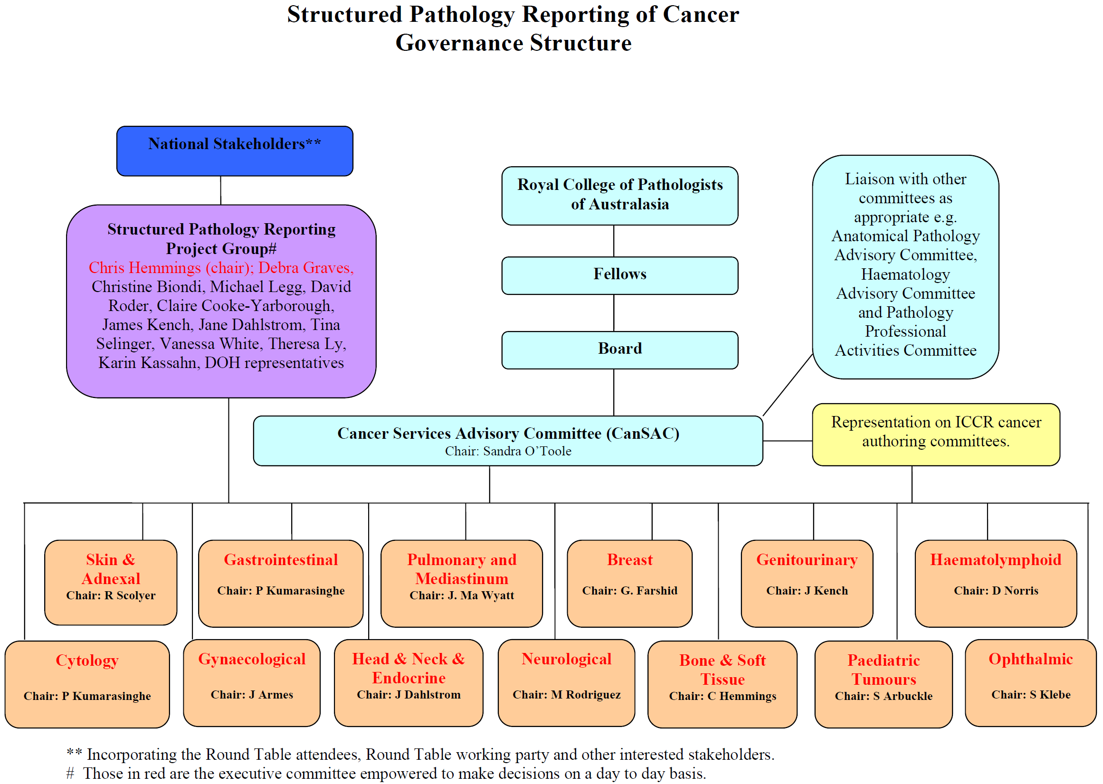

There are five critical elements to the governance model:

## 5.1 CanSAC

Cancer Services Advisory Committee (CanSAC) is a RCPA committee reporting to the RCPA Board of Directors. It was formed in 2008 to provide governance for the SPRC Project and to foster multidisciplinary communication and knowledge sharing to support cancer-related activities and organisations.

It provides leadership in the development, dissemination and preservation of a national structure for useable, evidence-based cancer pathology reporting standards and guidelines.

## 5.2 Project Group

The Project Group has representation from each of the parties to the MoU (refer below) as well as clinical involvement and RCPA Executive Team representation.

The Project group meets on a 4-6 weekly basis via teleconference to:

* To monitor project progress
* To review risks and issues
* To provide advice and direction to resolve issues and plan activities

## 5.3 Cancer Specific Expert Groups

The expert groups have been structured into groupings to align with other international bodies to facilitate communication and participation. The expert groups reflect broad anatomical structures such as Gastrointestinal rather than Colorectal. One or more ‘authorship’ groups are formed in each expert group who are responsible for the development of the cancer protocols e.g.

Diagram illustrating the four protocol authoring committees under the broad category of gastrointestinal

5.4 National Stakeholders

The SPRC Project communicates with key stakeholders from around Australasia including other cancer related organisations, laboratory systems vendors, medical colleges and IT organisations.

5.5 International collaboration

The SPRC Project has formalised collaboration internationally via the formation of the ICCR. The Chair of the SPRC Project is the RCPA representative on the ICCR Dataset Steering Committee (DSC) and the Director of the ICCR is a member of CanSAC. The ICCR connects the SPRC Project with other international bodies such as CAP and RCPath via CanSAC membership and is an integral part of the governance structure.

5.6 Memorandum of Understanding (MoU)

An MoU between the RCPA, Cancer Australia and the Cancer Institute NSW was entered into to oversee the SPRC Project in 2008. As part of the current Project contract, this MoU was renewed in May 2018. The continued participation of the parties under this MoU has facilitated communication with the wider cancer related community.

# 6. Project Activities

There were three key elements to the Project approach – development of new and updated SPRC protocols, providing educational opportunities to showcase and promote usability, and to facilitate SPRC implementation locally.

## **6.1 SPRC Protocol Development**

During the three year contract period, the Project developed 32 SPRC protocols which included pathology reporting resources in the form of comprehensive protocols, guides, proformas, typist templates and other documents, to promote and support the use of standardised structured pathology reporting. These 32 SPRC protocols reflect the growing demand for current anatomical pathology reporting recommendations and include the latest local and international morphological and molecular techniques and internationally standardised ICCR content. The SPRC protocols delivered under this Project reflected the following goals:

* Aligned information to interdependent resources such as the WHO classification of Tumours and international staging systems (e.g. Tumour Node Metastasis).
* Facilitated the flow of information through the availability of datasets for all specimens from an anatomical site. For example, the availability of a biopsy dataset as well as one for resections ensures there is comprehensive and consistent reporting of information along a patient’s cancer journey.
* Enabled pathologists who specialise in a specific area of cancer pathology, such as urology or head & neck pathology, to adopt a fully structured approach to pathology reporting rather than piecemeal implementation.

The development of the SPRC protocols in anatomical groupings aligned with the WHO/IARC tumour classifications and ICCR dataset production schedules. Specific anatomical groupings were selected which expanded the suite of SPRC protocols for Genitourinary, Head and Neck, Endocrine and Gastrointestinal.

The 32 new and updated SPRC protocols were subjected to an open consultation and/or peer review prior to publishing:

**2017-18**

* + Completed four new and four updated Genitourinary (8) SPRC protocols and published to the RCPA website with supporting documentation.

**2018-19**

* + Completed eleven new and five updated SPRC protocols: Genitourinary (4), Head & Neck (9), Liver (1), Thyroid FNA cytology (1), and Endometrial (1) SPRC protocols, and published to the RCPA website with supporting documentation. Published new HER2 testing for Breast Cancer Guidelines – Recommendations for Practice in Australasia.

**2019-20**

* + Completed eight new/updated SPRC protocols: Three new and one updated Endocrine (4) and four Gastrointestinal update (4) SPRC protocols and published to the RCPA website with supporting documentation.

## **6.2 Education and Promotion**

**Webinars**

Six educational webinars were identified by the SPRC Project Group for delivery. A number of highly respected experts in pathology were approached to present each webinar, and subsequent recordings of each webinar have been posted to the RCPA website for ongoing access to RCPA members.

The six webinars provided participants with the latest expert recommendations on the most advanced subjects in anatomical pathology included:

* + Topical issues in cervical histopathology reporting
  + Update on HER2 testing guidelines for breast cancer
  + What is new in salivary gland pathology
  + What’s new in endometrial cancer structured reporting
  + Molecular markers in lung cancer
  + HPV-related squamous cell carcinomas of the head and neck

In the three years since the first SPRC webinar took place, total webinar webpage views increased from 168 in 2016 to 259 views in 2019 (see Figure 3). This represents a 54% increase in webinar participation/usage on the RCPA website over the life of the Project.

*Figure 3. Total views of SPRC Webinar presentations on webpage*

The most popular SPRC webinar was the Molecular markers in lung cancer webinar held on 12 May 2020. A record number of 176 attendees participated, representing a more than six-fold increase as compared to the previous average webinar attendance of 27. The increased attendance at the Molecular markers in lung cancer webinar validates the importance for the SPRC Project to continue to provide up-to-date resources for routine reporting of molecular pathology. The changing field of molecular pathology is a driver for continual demand for updated SPRC protocols and is likely to continue to drive demand into the future.

Webinar webpage views reached a total of 286 views in the first six months of 2020 (see Figure 3), which includes the Molecular markers in lung cancer webinar. In addition, more page views were recorded in the first six months of 2020 alone, than in any other 12 month period of the Project (Figure 3). Increased awareness and limited access to conferences in 2020 may have contributed to the recent increased interest in the SPRC webinars.

*Figure 4. Views per SPRC Webinar presentation*

**SPRC Newsletters**

Quarterly SPRC newsletters were another tool used to promote the Project. Twelve quarterly SPRC newsletters were circulated from July 2017 - June 2020. Newsletters were electronically distributed to all RCPA AP and Haematology Fellows, Trainees, laboratories and other relevant stakeholders.

Data from the Hartz and MailChimp newsletter reports, revealed the average opening rate of the SPRC newsletter was 40%. This is substantially higher than the average rate for the Medical/Healthcare industry of 22% (sourced from MailChimp) - confirming the importance of continuing to provide the profession with timely updates regarding SPRC (Figure 5).

*Figure 5. Average SPRC Newsletter email opening rate*

**Peer-reviewed scientific publications**

Three peer-reviewed scientific journal articles were published as a result of the Project work.

Following the SPRC Project publication of the ratified Australasian HER2 testing guidelines for breast cancer, a scientific article was published in the journal Pathology titled “ASCO/CAP 2018 breast cancer HER2 testing guidelines: summary of pertinent recommendations for practice in Australia”.1 The article was produced by the authors of the SPRC HER2 testing guidelines, Professor Farshid et al, and outlined the ratified guidelines that were published on the RCPA website.

A second editorial article was published in the RCPA journal Pathology, discussing selected key issues from the second edition RCPA Endometrial protocol, addressing future challenges in pathology reporting of endometrial cancer. This publication titled ‘Highlighted issues from the second edition RCPA Endometrial Cancer Structured Reporting Protocol ‘was authored by the SPRC protocol lead authors Dr Marsali Newman and Associate Professor Kerryn Ireland-Jenkin in conjunction with the SPRC Project Manager.2

A third article titled ‘Pathological assessment of endoscopic resections of the gastrointestinal tract: a comprehensive clinicopathologic review’ was published by the SPRC Gastrointestinal Series Chair Professor Priyanthi Kumarasinghe et al in the journal Modern Pathology in June 2020.3

## **6.3 Facilitate local implementation**

The Project identified a number of goals to assess progress, and facilitate implementation of structured pathology reporting in Australia:

* Advancing the SPRC information model
* Assist sites implementing SPRC Protocols, and
* Investigate opportunities for monitoring the impact and uptake of SPRC Protocols through work undertaken by government cancer registries and funded clinical quality registries

The Project consistently progressed ways to achieve these goals such as:

* Collaborated with the RCPA PITUS 18-20 Project whereby five information terminology models for SPRC Protocols were developed to help advance electronic implementation and updating of the protocol checklists in LISs (refer SPRC Information and Terminology Models section below for more detail). An information model describes the hierarchy and inter-relation of elements in a cancer checklist and defines internationally recognised terminology such LOINC or SNOMED CT for each element and value in the checklist.
* Assisted pathology laboratories such as Sonic Healthcare to implement the RCPA Colorectal cancer SPRC protocol.
* Facilitated connections with the National Cancer Screening Registry and their National Bowel Cancer Screening Program to assist with the implementation of the SPRC protocol for Colorectal excisional biopsies (polypectomies) into the Bowel screening program. In addition, collaborations with the NSW, NT and Monash clinical registries were established.
* Implementation guides and materials were developed in the format of protocol checklists, guides, and proformas for each of the 32 protocols as well as a growing number of terminology reference sets (currently Gynaecological and Thyroid Cytology; as well as Colorectal, Gastric and Prostate Cancers) which enable implementation of the SPRC checklists using LOINC or SNOMED codes.

**Surveys**

Three annual surveys were developed, distributed, and reviewed between 2017-2019 to model important data regarding the use of RCPA SPRC protocols in Australian laboratories.

A survey to establish a baseline estimate of the use of SPRC protocols in Australian laboratories was developed and the Project conducted three surveys in 2017, 2018 and 2019. The Surveys were distributed to all RCPA Anatomical Pathology Fellows and responses were received from all states and territories in Australia, as well as New Zealand and other countries. Only results from Australian respondents have been compiled in this report.

*Table 1. Comparison of SPRC Surveys*

| **Survey parameter** | **2017** | **2018** | **2019** |
| --- | --- | --- | --- |
| Laboratory organisations represented | 68% | 63% | 78% |
| Structured reporting checklist utilised | 70.5% | 81% | 91% |
| Preference for text/narrative style | 33.3% | 30% | 9% |
| Use of RCPA SPRC protocols | 48.8% | 51% | 49% |

The survey results indicated that usage of structured pathology reporting checklists have increased by 10% (i.e. 2018 81% to 91% in 2019).

Just under half of the responders were using RCPA SPRC protocols. If there were more SPRC protocols developed and accessible to pathologists, it is likely that usage rates would increase as pathologists would be able to access all protocols via the SPRC website as opposed to having locate information requirements/templates elsewhere.

A total of 98 responses were received in 2017, 146 responses were received in 2018 and 155 responses were received in 2019. An increase in responses was observed each year between 2017-2019, with 399 responses received in total. A 58% increase in responses was observed between 2017 (n=98) to 2019 (n=155) (Figure 6).

*Figure 6. Total number of responders to SPRC survey*

Data extracted from the survey revealed in 2019 the majority of respondents (56%) conveyed that their LIS was capable of reporting at an entry level of structured pathology reporting (Level 3). 7% described their LIS as capable of reporting at the highest level (level 5-6), which represented nine major laboratories across four states. 27% of responders in 2019 indicated plans were in progress to upgrade their LIS. This was an increase of 13% when compared against 2018.

Implementation data received from the survey results highlighted the SPRC Project positively impacted sites where implementation had taken place, and one such example of this was reflected in the work the Project undertook to assist sites such as Sonic Healthcare and the National Bowel Cancer Screening Program to implement the RCPA Colorectal cancer SPRC protocol.

**SPRC Information and Terminology Models**

The SPRC Project in conjunction with the ICCR collaborated with the International Health Terminology Standards Development Organisation (IHTSDO)/SNOMED International and the International Pathology and Laboratory Medicine (IPaLM) Special Interest Group, the University of Nebraska Medical Centre as well as representatives from other Pathology Colleges around the world, to progress the international harmonisation of standardised terminology for cancer datasets.

In October 2017, this initiative became an official Project of IHTSDO/SNOMED International. The template used for harmonisation was based on the ICCR datasets, and the Project involved representatives from the USA, UK, Canada and Australia as well as many other countries around the world. The first international terminology dataset for Radical Prostatectomy tumours was published in 2019.

Additional collaboration took place with the PITUS 18-20 Project in Australia to develop RCPA SPIA information models and terminology reference sets, to facilitate FHIR translation for the following SPRC protocols:

• Polypectomy and local resections of the colorectum

• Colorectal cancer

• Cervical cancer

• Endometrial cancer

• Ovary, Fallopian tube and Peritoneum cancers

The SPRC and PITUS 18-20 Projects collaborated to develop FHIR resources matching SPRC protocols. This represents a technological advancement in data formatting for electronic health records in Australia and is one of the means by which the Project is keeping abreast of cutting edge digital technology to support pathologists to stay current with the most advanced trends, technologies and international standards.

**Quality Register**

The SPRC 2017-20 Project investigated the possibility of leveraging the work of quality registers to assess adherence to SPRC Protocol standards. During the Project period, discussions with a number of quality registers were undertaken, however, only a single collaboration was achieved with a clinical quality register for pancreatic cancer. The government-funded clinical quality register for pancreatic cancer was established by the UGICR, and a workshop to develop quality indicators for SPRC was held in December 2017. The SPRC Project proposed the inclusion of three SPRC-related clinical quality indicators, and was subsequently expanded to nine clinical quality indicators based on the SPRC pancreatic cancer protocol:

• Tumour type

• Tumour size

• Tumour grade

• Lymph node status

• Margin status

• Lymphovascular invasion

• Perineural invasion

• SPRC reporting must be used

To comply with these indicators, reports were classified as an RCPA ‘Structured’ or ‘Synoptic’ report if they included the above clinical quality indicators as microscopic elements, which must be appear as discrete headings with defined responses within the diagnostic histopathology report.

A review of 305 pancreatic register reports was completed. This data represented 73% coverage of hospitals in New South Wales and Victoria, with reports from 2016-2019 analysed. 95.7% of the reports received were classified as compliant with an RCPA SPRC protocol. The proportion of reports defined as structured has steadily increased each year from a base of 79% in 2016 to 95.7% in 2019.

*Figure 7. Proportion of reports defined as ‘Structured’*

# Project Outcomes

## **7.1 Knowledge Advancement**

SPRC protocols met acute demands for the latest Australian best practice standards and guidelines for pathology reporting.

The SPRC 2017-20 Project was successful in publishing SPRC protocols covering 19 of the top 20 most common cancers (Figure 8), with now, at least 89% of all cancers included.

*Figure 8. Top 20 most common cancers diagnosed, 2019 (sourced from Australian Institute of Health and Welfare (AIHW) Cancer in Australia 2019 report)*

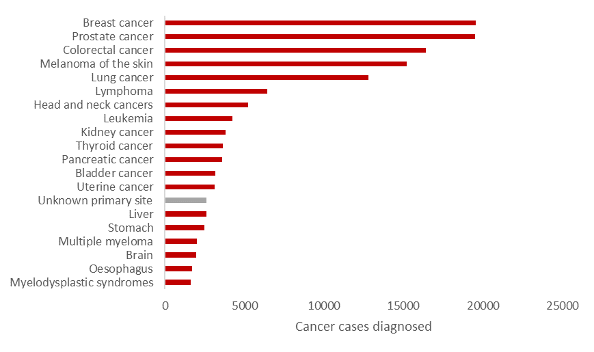

*

*Carcinomas of Unknown Primary site is the only site not currently covered by SPRC protocols in the top 20 most common cancers. This cancer type will be proposed for development in a future SPRC Project.

The SPRC 2017-20 Project has provided pathologists with best practice reporting guidelines for many critical cancers such as for prostate and other genitourinary cancers, liver cancer, head and neck and endocrine cancer, and cervical pre-neoplasia specimens.

The SPRC 2017-20 Project has supported patient safety and championed efficiencies of Medicare-funded spending by promoting the highest standards of reporting data quality to improve accuracy, completeness, and interpretability – all of which improves patient outcomes.

By ensuring that all relevant and appropriate information has been included in the patient’s cancer report on which further treatment decisions are made, the SPRC 2017-20 Project has driven more appropriate utilisation of other Medicare items such a diagnostic imaging, surgery, radiotherapy and PBS items for chemotherapy and immunotherapies,

Similarly, this Project has also enabled pathologists to ensure that essential morphological and prognostic indicators are present in a patient’s report, enabling better management of Medicare Pathology-related services.

Recommendations for appropriate evidence-based ancillary testing such as molecular or immunological testing were included. As a result, patients were less likely to receive treatments of limited benefit that may cause complications or toxicity i.e. patients are more likely to receive the correct treatment at the correct time to minimise the number of unnecessary pathology, diagnostic and monitoring tests required.

The delivery of SPRC templates, webinars, scientific publications and promotional publications has provided critical educational resources for pathology trainees and the wider pathology profession.

The SPRC Project has shown strong industry and research leadership via the publication of three peer-reviewed scientific journal articles published as a result of the SPRC 2017-20 Project. These publications were cited three times in other scientific peer-reviewed journals and accessed at least 1579 times.

SPRC protocols ensured Australian pathologists’ reporting practices were standardised with international ICCR benchmarks whilst bringing together local experts to ensure Australian demographic needs and public policy requirements were met.

The Project facilitated collaborations with experts in pathology and clinical cancer care within Australia and internationally.

SPRC specialist expert committees were consulted on various matters of cancer policy and strategy (such as for the state and national Cancer Council best practice guidelines and the National Cancer Screening Register on histopathology integration guidelines), reiterating the value these experts add to this Project.

As a result of the collaboration with the National Cancer Screening Registry National Bowel Cancer Screening Program, who built their histopathology value lists utilising the SPRC colorectal excision biopsy (polypectomy) protocol, this work is expected to have a direct impact on improving patient health outcomes in Australia.

SPRC webinars connected the pathology community in Australia with experts in challenging subject areas, bringing audiences up-to-speed with the current evidence of best practice in structured pathology reporting.

The Project facilitated knowledge sharing via collaboration with other local QUPP-funded projects such as PITUS 18-20 to complete five terminology reference sets.

Terminology reference sets matching the SPRC protocols served as a vital tool for laboratories and cancer registries to facilitate data standardisation and reduce ambiguity.

The collaboration between the SPRC 17-20 and PITUS 18-20 Projects to develop FHIR resources matching SPRC protocols, facilitated the modernisation of the data format for electronic health records in Australia. This is one of the means by which the Project is keeping abreast of cutting- edge digital technology to support pathologists stay current with the most advanced trends and international standards.

The Project supported terminology standardisation around the globe via collaborations with the international IHTSDO/SNOMED terminology community.

## **7.2 Metrics of success**

The Project evidenced increased engagement with the pathology community through increased access to the SPRC section of the RCPA website. Average unique page visits increased by 40% (12 month average to July 2020 of 1462 page visits compared with the 12 month average to July 2017 of 1047 page visits). This represents the equivalent of 1.2 times the entire anatomical pathology workforce of Australia (~1200 anatomical Fellows) accessing these resources every month.

*Figure 9. Unique pageviews* to SPRC website per month*

* Unique Pageviews is the number of sessions during which the specified page was viewed at least once. A unique pageview is counted for each page URL + page Title combination.

The Cancer Protocols webpage has seen a steady increase in average monthly page visits each year from 737 in July 2017 to 993 in July 2020, representing a 35% increase in usage over the Project contract period. This is a positive measurement of the awareness and usage of the SPRC resources and further confirms pathologists are keeping up to date with new protocols through prevalent uptake.

*Figure 10. SPRC Cancer Protocols webpage – average monthly visits*

The Australian pathology community was highly engaged in the Project’s webinar program, which on average received increasing live attendance. Increased traffic to view the recordings was observed over the three year contract period. In total the webinar recordings were viewed a total of 1156 times.

The six-fold increase in attendance to the Molecular Lung Markers webinar illustrates the increasing demand for up-to-date resources for reporting of molecular pathology in the Australian pathology community.

Anatomic pathology Fellows and Trainees were highly engaged in reading about the Project as evidenced by an average opening rate for the quarterly SPRC newsletters nearly double that of the industry average.

Annual surveys and data obtained from the UGICR clinical quality register measured the success of the Project and areas where the Project has delivered results. Data showed each year pathologists are increasingly adopting structured reporting as part of routine practice which is in excess of 91%.

*Figure 11. Proportion of reports defined as ‘Structured’*

The UGICR quality register served as a clear measure of the increased uptake of structured reporting over the three year contract period. Registry data revealed there were improvements over time in the completeness of diagnostic pancreatic reports received, with an all-time high of 95.7% compliance with SPRC protocol standards in 2019.

This improvement in completeness directly benefited patients by providing increased accuracy and safety regarding the quality of the diagnostic report data. International evidence has shown that improvements as a result of structured reporting increases patient survival as a result of enhanced access to appropriate adjuvant therapy.4

The annual surveys uncovered areas to focus efforts and were a gauge of national Level 5-6 structured reporting capability, showing that nine major laboratories across four states are capable of reporting at the highest level. 27% of responders indicated they were in the process of upgrading the LIS to be able to report at levels above Level 3.

The SPRC Project worked to assist sites such as Sonic Healthcare and the National Bowel Cancer Screening Program to implement the RCPA Colorectal cancer SPRC protocol, who value SPRC protocols as they:

* improve completeness of data
* reduce ambiguity and improve accuracy of interpretation
* reduce costs associated with checking pathology report results

Many anatomical pathology laboratories attest positive impacts to work practices as a direct result of implementing SPRC templates into their reporting workflow:

Professor Wendy Cooper of the Royal Prince Alfred Hospital Department of Tissue Pathology and Diagnostic Oncology stated:

*“Structured pathology reporting gives me confidence that I am including all relevant parameters in my pathology reports that are important for patient care. I don’t report without it! When a registrar isn’t sure how to approach reporting a specimen, I always say, ‘Have you looked at the structured pathology reporting protocols on the College website?’*”

Dr Marsali Newman of the Austin Hospital has said:

*“I rely on structured reporting systems every day when assessing complex gynaecological cancer specimens to accurately and concisely convey to the clinical team all the required data elements. When reporting cases in areas of pathology that I less commonly encounter, structured reporting systems are also invaluable to ensure I have provided relevant and up to date information required for prognosis and treatment.”*

Additional leading pathologists have described how the SPRC 2017-20 has impacted their work and benefitted the pathology community:

Professor Richard Scolyer of the Royal Prince Alfred Hospital Department of Tissue Pathology and Diagnostic Oncology stated:

*‘It is my view that the Structured Reporting Project has been of great benefit to the Australian community and has directly improved the care of cancer patients both within Australia and throughout the world. By providing benchmarks and guidelines for the pathology reporting of complex cancers, the project has ensured that patients and their treating clinicians are provided with the most relevant information about their cancer in an easy to digest format. This not only ensures that they receive optimal patient care but will inevitably lead to improved patient outcomes.’*

Associate Professor Kerryn Ireland-Jenkin of the Austin Hospital has said:

*‘The SPRC program has been a vital resource in the translation of ICCR datasets into best practice pathology reporting guidelines appropriate to the local Australasian context, and therefore has played a critical role in reducing the timeframe for implementation of international datasets into routine patient care. As an author it has been a pleasure to work with the protocol development team, and as end-user, having ready access to best practice cancer datasets has been extremely helpful in cancer reporting.’*

Professor Alfred Lam, Foundation Chair Professor and Head of Pathology at the Gold Coast University Hospital says:

*‘SPRC streamlines the basic requirements for reporting cancer for pathologists and will benefit the clinical management of patients with cancer as well as facilitating the establishment of digital platforms for storage of cancer data and cancer research.’*

# Project Challenges

A number of challenges were encountered during the Project 2017-20 contract period. These mostly related to delays in the international guidelines impacting the development of local protocols, as well as the absence of mandatory national requirements for higher level structured pathology reporting.

For the purposes of maximum efficiency and international standardisation, the SPRC Protocol schedule was structured around the publication of WHO/IARC tumour classifications and subsequent ICCR dataset publication. Consequently, this exposed the protocol schedule to delays resulting from publication setbacks for some of the WHO/IARC tumour classifications and ICCR dataset production lags. Therefore, the RCPA Protocol development schedule had to be reviewed and amended. A substitute set of protocols for alternative organ systems was organised (the Endocrine suite of reporting protocols replaced the Breast cancer suite in 2020).

The SARS-CoV-2/COVID-19 pandemic impacted the availability of a number of local and international experts involved in the development of the ICCR gastrointestinal datasets due to disruptions caused by the pandemic. This resulted in delays to ICCR gastrointestinal dataset publications and contributed to a delay for the RCPA gastrointestinal protocols which were dependent upon alignment with these international guidelines.

Australian pathology laboratories contain a broad variety of LIS. Without a national requirement for a minimum standard of discrete data standardisation and software upgrade (Level 5-6 structured reporting) (Figure 12), future advancement on the implementation of structured reporting is unlikely. Many anatomical pathology departments are still only capable of level 3 implementation – a basic text-based method of standardised reporting. Implementation of levels 5-6 structured reporting promote the highest quality data standardisation, efficiency and improved reporting performance outcomes. However, without a mandatory directive, widespread Level 5-6 implementation is currently unlikely to be realised in Australian anatomical pathology laboratories.

*Figure 12. RCPA structured pathology reporting compliance matrix*

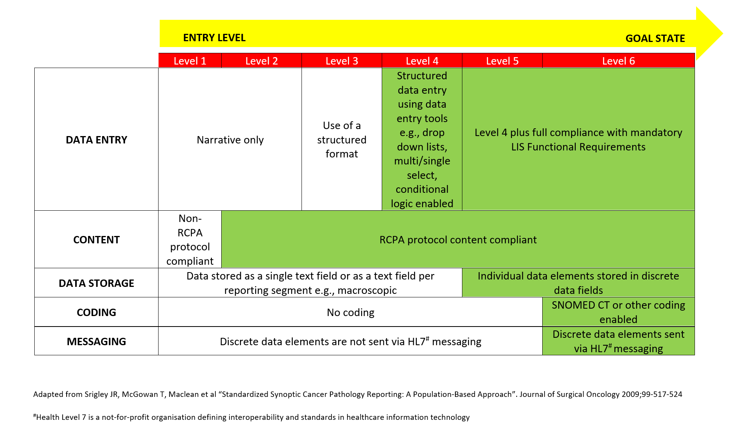

# Future Directions

## **9.1 Protocol development**

The RCPA SPRC Project has successfully published SPRC protocols covering over 89% of cancers and has been the catalyst for the formation of the International Collaboration on Cancer Reporting (ICCR). Last year marked the tenth anniversary of the SPRC initiative in Australia.

Over the last decade the Project has:

* grown significantly in popularity and use,
* is an official element of the Pathology Trainee Curriculum,
* facilitated major international collaborations,
* championed the standardisation cause on the world stage
* met the needs of Australian pathologists, aligned with local best-practice pathology, and developed local protocols which include bespoke detail useful for local implementation, local demographic needs, and local policy directions.
* provided invaluable resources for trainees and early career pathologists, providing guidance on contemporary techniques and advanced practices
* supported the development of professional practice standards that meet the evolving needs of healthcare professionals and patients in Australia and Australian pathologists are better placed to achieve the highest standards of patient care through the access to and use of SPRC protocols.

Looking to the future - many in the healthcare sector believe the remaining 11% of cancer protocols yet to be developed represent increasingly significant value to the Australian healthcare community, particularly with respect to recent developments in molecular characterisation and local stakeholder priority needs. Examples of prioritised future protocols identified for development include those for neuroendocrine tumours, cytology specimens, and carcinomas of unknown primaries. These cancers often represent entities of diagnostic difficulty and high complexity, and these unfortunately are not currently within the short-term scope of the ICCR dataset development.

Local pathology experts have identified these protocols are a significant local requirement and future development of these would align with the QUPP objective of meeting local consumer and referrer needs.

## **9.2 Digital implementation**

The greatest success has been seen when projects link the digital implementation of structured pathology reporting with accreditation or funding incentives.

Increasing evidence from large international studies demonstrates the use of standardised structured pathology reporting of cancer improves the completeness and quality of pathology data provided to multidisciplinary clinical teams and healthcare professionals, with direct demonstrable benefits to patients. Sluitjer et al (2019)4 have shown that structured pathology reporting has a positive impact on the delivery of adjuvant therapy, and data shows structured pathology reporting is significantly associated with improved overall survival in patients, even after controlling for stage, grade and neoadjuvant therapy. In addition to the nationwide structured pathology reporting projects successfully implemented in countries such as the Netherlands, United States, Norway and Canada, all have similarly utilised digital structured pathology reporting templates or software tools.

Therefore, future directions in SPRC would aim to leverage the best strategies successfully implemented internationally, maximising the potential for success in Australia.

## **9.3 Widespread adoption via top-down leadership**

The draft 4th edition NPAAC ‘Requirements for Information Communication and Reporting’, was recently circulated for public comment. If enacted, this document would mandate the use of RCPA SPRC protocols for all cancer reporting.

Until a national requirement for a minimum standard of discrete data standardisation and software upgrade for LIS (Level 5-6 structured reporting) is legislated, significant progress on the implementation of structured pathology reporting is thought to be unlikely. Widespread investment in higher level structured reporting capability by Australian pathology laboratories is not considered to be achievable without government mandates to regulate the modernisation of LIS. In the absence of mandatory structured pathology reporting, the RCPA will explore opportunities to:

* Pilot digital software tools designed to provide universal access to electronic SPRC protocols for efficient upload into any LIS.
* Pilot the use of digital structured reporting software to further assist pathologists to adopt SPRC standards and recommendations. The pilot would aim to assess usability and ability to implement SPRC within Australian laboratory settings.
* Test digital structured pathology reporting middleware to assist in enabling an efficient and flexible approach for laboratories to utilise the latest evidence-based reporting standards in a digital format. The pilot would seek to link high level ‘atomic’ data to external stakeholders such as registries, who are currently receiving pathology reporting data often in a suboptimal way, requiring manual typing and labour intensive database management. Structured ‘atomic’ pathology data allows a computer to intelligently analyse individual elements for a variety of clinical, research, and quality audit purposes.

This proposed approach has the ability to improve accuracy, reduce data input time, and reduce costs, by providing efficient digital versions of RCPA SPRC protocols that can be incorporated into any LIS, saving considerable money that would otherwise be borne by laboratories.

# References

1 Farshid G, Bilous M, Morey A, Fox S, Lakhani S, Loi S, Bell R and Spillane A (2019). ASCO/CAP 2018 breast cancer HER2 testing guidelines: summary of pertinent recommendations for practice in Australia. *Pathology* 51(4):345-348.

2 Ireland-Jenkin K, Selinger C and Newman M (2020). Highlighted issues from the second edition RCPA Endometrial Cancer Structured Reporting Protocol. *Pathology* 52(3):293-296.

3 Kumarasinghe MP, Bourke MJ, Brown I, Draganov PV, McLeod D, Streutker C, Raftopoulos S, Ushiku T and Lauwers GY (2020). Pathological assessment of endoscopic resections of the gastrointestinal tract: a comprehensive clinicopathologic review. *Mod Pathol* 33(6):986-1006.

4 Sluijter CE, van Workum F, Wiggers T, van de Water C, Visser O, van Slooten HJ, Overbeek LIH and Nagtegaal ID (2019). Improvement of Care in Patients With Colorectal Cancer: Influence of the Introduction of Standardized Structured Reporting for Pathology. *JCO Clin Cancer Inform* 3:1-12.