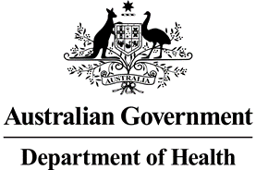

**Nurse Practitioner 10-Year Plan Steering Committee**

**Meeting Communique 29 April 2022 and 19 May 2022**

The fourth Nurse Practitioner 10-Year Plan Steering Committee (NPSC) meeting was held across two sessions on 29 April 2022 and 19 May 2022. Co-Chairs, Adjunct Professor (Practice) Alison McMillan PSM and First Assistant Secretary Matthew Williams advised committee members that the Department of Health would be working under the caretaker conventions to ensure that any Australian Public Service actions do not bind an incoming government and limit its freedom of action.

During the April meeting, the Nursing Taskforce provided the committee with an update on stakeholder engagement and consultations to date, including consultations with all state and territory Chief Nursing and Midwifery Officers. The purpose of these consultations was to understand the current successes and barriers of the nurse practitioner workforce in each jurisdiction. The committee was also provided an opportunity to discuss nurse practitioners into the future, and how the nursing and medical interface may shift over a 10-year horizon.

Both meetings focused on workshopping the aim and intended outcomes of the Nurse Practitioner 10 Year Plan (Plan). The committee also considered specific action items which would form part of the Plan.

As the development of the Plan continues, further consultation with stakeholders will be undertaken.