**MULTIJURISDICTIONAL SYPHILIS OUTBREAK   
SURVEILLANCE REPORT: MAY 2018**

**This surveillance report has been authorised by Health Departments in outbreak affected jurisdictions and the Office of Health Protection.**

The Multijurisdictional Syphilis Outbreak (MJSO) Working Group was formed by the Communicable Diseases Network of Australia (CDNA) in April 2015, in response to an ongoing outbreak of syphilis among Aboriginal and Torres Strait Islander people living largely in remote and rural areas of northern Australia. Increased notifications associated with the outbreak in northern Australia were first reported in January 2011 in northwest Queensland (Qld), followed by the Northern Territory (NT) in July 2013, and the Kimberley region of Western Australia (WA) in June 2014. In March 2017,   
South Australia (SA) declared an outbreak in the Far North and Western and Eyre regions from November 2016.

This surveillance report summarises the outbreak epidemiological data as of 31 March 2018 (current status).

**Please note:** the MJSO Surveillance Report was formerly known as the MJSO Communique. Historical epidemiological data and MJSO activities are published in earlier MJSO Communiques available at *http://www.health.gov.au/internet/main/publishing.nsf/Content/ohp-infectious-syphilis-outbreak.htm*

**Current status**

Outbreak data to 31 March 2018 are summarised in Figure 1, Table 1 and Table 2 below.

Outbreak cases are reported as either category 1 or category 2: category 1 cases include Aboriginal and Torres Strait Islander people residing in an outbreak declared regionβ at the time of diagnosis, and; category 2 cases include people who are a sexual contact of a confirmed outbreak case which includes Aboriginal and Torres Strait Islander people who do not reside in an outbreak area at the time of diagnosis and non-Indigenous people regardless of where they reside.

**Figure 1**. Epidemic curve showing category 1 infectious syphilis α outbreak cases notified in Aboriginal and Torres Strait Islander people residing in affected regionsβ of Queensland, the Northern Territory, Western Australia and   
South Australia from commencement of the outbreak in each jurisdiction to 31 March 2018ᵞ

Epidemic curve showing category 1 infectious syphilis outbreak cases notified in Aboriginal and Torres Strait Islander people residing in affected regions of Queensland, the Northern Territory, Western Australia and South Australia from commencement of the outbreak in each jurisdiction to 31 March 2018


**Table 1**.Characteristics of category 1 infectious syphilisα outbreak cases notified in Aboriginal and Torres Strait Islander people residing in affected regionsβ of Queensland, the Northern Territory, Western Australia and South Australia, to   
31 March 2018ᵞ

|  | **North Qld** (four HHSsβ) | | **NT** (seven regions β) | **WA**  (Kimberley region) | **SA**  (two regions β) |
| --- | --- | --- | --- | --- | --- |
| **Situation to-date, 31 March 2018** |  | |  |  |  |
| Outbreak commencement month/year | January 2011 | | July 2013 | June 2014 | November 2016 |
| Total number of casesα | 1082 | | 735 | 154 | 31 |
| Percent cases reported in 15-29 year age group | 67% | | 66% | 71% | 48% |
| % Male / % Female | 48% / 52% | | 45% / 55% | 37% / 63% | 39% / 61% |
| Congenital cases, confirmed (probable)« | 4 (4) | | 2 (2) | 0 (0) | 1 (0) |
| -number of deaths in congenital cases, confirmed (probable) | 3 (3) | | 0 (0) | 0 (0) | 0 (0) |
| **Last reporting months, 1 March – 31 March 2018** | |  |  |  |  |
| Number of casesα | 19 | | 13 | 6 | 2 |
| Percent cases reported in 15-29 year age group | 63% | | 77% | 100% | 0% |
| % Male / % Female | 37% / 63% | | 50% / 50% | 33% / 67% | 50% / 50% |

**Table 2.** Number of category 2 infectious syphilisα cases, to 31 March 2018ᵞ

|  | **North Qld** (four HHSsβ) | **NT** (seven regions β) | **WA**  (Kimberley region) | **SA**  (two regions β) |
| --- | --- | --- | --- | --- |
| **Situation to-date, 31 March 2018** | | | | |
| Outbreak commencement month/year | January 2011 | July 2013 | June 2014 | November 2016 |
| Aboriginal and Torres Strait Islander people§ | 11 | 2 | 0 | 0 |
| Non-Indigenous peopleµ | 16 | 3 | 0 | 0 |
| **Last reporting months, 1 -31 March 2018** | | | | |
| Aboriginal and Torres Strait Islander people§ | 0 | 0 | 0 | 0 |
| Non-Indigenous peopleµ | 1 | 0 | 0 | 0 |

**Notes:**

**α** Cases defined as per the MJSO syphilis outbreak case definition:

Nationally, an infectious syphilis outbreak case is defined as: any person who is newly diagnosed with confirmed or probable infectious syphilis according to the CDNA national surveillance case definition for infectious syphilis, **AND**, is an Aboriginal or Torres Strait Islander person who resides in any of the following outbreak declared regions as defined and documented by that jurisdiction, at or after the dates indicated: ***Qld*** - Torres and Cape Hospital and Health Service area (from 1 December 2012); Cairns and Hinterland Hospital and Health Service area (from 1 August 2013); North West Hospital and Health Service area (from 1 January 2011); Townsville Hospital and Health Service area (from 1 January 2014); ***NT*** - Alice Springs or Barkly district (from 1 July 2013); Katherine district (from 1 May 2014); East Arnhem district (from 1 November 2015); Darwin Rural and Urban (from 1 January 2017); ***WA*** - Kimberley region, Western Australia (from 1 June 2014), ***SA***  - Far North and Western and Eyre regions (from 15 November 2016) (category 1 outbreak cases) **OR**, is a sexual contact of a confirmed outbreak case (category 2 outbreak cases).

**β**Affected regions include Torres and Cape, Cairns and Hinterland, North West, and Townsville Hospital and Health Services in Queensland; Alice Springs Urban, Alice Springs Rural, Barkly, East Arnhem, Katherine, Darwin Urban and Darwin Rural regions in the Northern Territory; the Kimberley health region in Western Australia, and; Far North and Western and Eyre regions in South Australia.

« Cases defined as per the MJSO syphilis outbreak case definition: any newly diagnosed case of confirmed or probable congenital syphilis that meets the CDNA national surveillance case definition whose mother’s syphilis infection prior to or during pregnancy meets the infectious syphilis outbreak case definition.

§ Aboriginal and Torres Strait Islander people who are sexual contacts of a confirmed outbreak case and reside outside an outbreak declared region at the time of diagnosis.

µ Non-Indigenous people who are sexual contacts of a confirmed outbreak case and reside in or out of an outbreak declared region at the time of diagnosis.

**ᵞ** Please note that **all data are provisional** and subject to change due to ongoing case investigation.

**MULTIJURISDICTIONAL SYPHILIS OUTBREAK   
SURVEILLANCE REPORT: JUNE 2018**

Data as of 30 April 2018

**This surveillance report has been authorised by Health Departments in outbreak affected jurisdictions and the Office of Health Protection.**

The Multijurisdictional Syphilis Outbreak (MJSO) Working Group was formed by the Communicable Diseases Network of Australia (CDNA) in April 2015, in response to an ongoing outbreak of infectious syphilis among Aboriginal and Torres Strait Islander people living largely in remote and rural areas of northern Australia. Increased notifications associated with the outbreak in northern Australia were first reported in January 2011 in northwest Queensland (Qld), followed by the Northern Territory (NT) in July 2013, and the Kimberley region of Western Australia (WA) in June 2014. In March 2017, South Australia (SA) declared an outbreak in the Far North and Western and Eyre regions from November 2016.

This surveillance report summarises the outbreak epidemiological data as of 30 April 2018 (current status).

**Please note:** the MJSO Surveillance Report was formerly known as the MJSO Communique. Historical epidemiological data and MJSO activities are published in earlier MJSO Communiques available at *http://www.health.gov.au/internet/main/publishing.nsf/Content/ohp-infectious-syphilis-outbreak.htm*

**Current status**

Outbreak data to 30 April 2018 are summarised in Figure 1, Table 1 and Table 2 below.

Outbreak cases are reported as either category 1 or category 2: category 1 cases include Aboriginal and Torres Strait Islander people residing in an outbreak declared regionβ at the time of diagnosis, and; category 2 cases include people who are a sexual contact of a confirmed outbreak case which includes Aboriginal and Torres Strait Islander people who do not reside in an outbreak area at the time of diagnosis and non-Indigenous people regardless of where they reside.

Between 1 – 30 April 2018, there were 36 outbreak cases (category 1 and 2 cases) reported from the four outbreak affected jurisdictions: 20 in Queensland; 14 in the Northern Territory; 1 in Western Australia and; 1 in South Australia (Figure 1, Table 1 and Table 2). From the commencement of the outbreak to 30 April 2018, there were a total of 2069 outbreak cases (category 1 and 2 cases) reported across the four outbreak affected jurisdictions: 1129 in Queensland (from January 2011); 754 in the Northern Territory (from July 2013); 155 in Western Australia (from June 2014), and; 31 in South Australia (from November 2016) (Table 1 and 2).

**Figure 1**. Epidemic curve showing category 1 infectious syphilis α outbreak cases notified in Aboriginal and Torres Strait Islander people residing in affected regionsβ of Queensland, the Northern Territory, Western Australia and   
South Australia from commencement of the outbreak in each jurisdiction to 30 April 2018ᵞ

**Epidemic curve showing category 1 infectious syphilis α outbreak cases notified in Aboriginal and Torres Strait Islander people residing in affected regionsβ of Queensland, the Northern Territory, Western Australia and 
South Australia from commencement of the outbreak in each jurisdiction to 30 April 2018ᵞ
**

**Table 1**.Characteristics of category 1 infectious syphilisα outbreak cases notified in Aboriginal and Torres Strait Islander people residing in affected regionsβ of Queensland, the Northern Territory, Western Australia and South Australia, to   
30 April 2018ᵞ

|  | **North Qld** (four HHSsβ) | | **NT** (seven regions β) | **WA**  (Kimberley region) | **SA**  (two regions β) |
| --- | --- | --- | --- | --- | --- |
| **Situation to-date, 30 April 2018** |  | |  |  |  |
| Outbreak commencement month/year | January 2011 | | July 2013 | June 2014 | November 2016 |
| Total number of casesα | 1102 | | 749 | 155 | 31 |
| % 15-29 year age group | 67% | | 66% | 71% | 48% |
| % Male / % Female | 48% / 52% | | 46% / 54% | 37% / 63% | 39% / 61% |
| Congenital cases, confirmed (probable)« | 4 (4) | | 2 (2) | 0 (0) | 1 (0) |
| -number of deaths in congenital cases, confirmed (probable) | 3 (3) | | 0 (0) | 0 (0) | 0 (0) |
| **Last reporting month, 1 – 30 April 2018** | |  |  |  |  |
| Number of casesα | 20 | | 14 | 1 | 1 |
| % 15-29 year age group | 80% | | 57% | 100% | 100% |
| % Male / % Female | 45% / 55% | | 43% / 57% | 0% / 100% | 0% / 100% |

**Table 2.** Number of category 2 infectious syphilisα cases, to 30 April 2018ᵞ

|  | **North Qld** (four HHSsβ) | **NT** (seven regions β) | **WA**  (Kimberley region) | **SA**  (two regions β) |
| --- | --- | --- | --- | --- |
| **Situation to-date, 30 April 2018** | | | | |
| Outbreak commencement month/year | January 2011 | July 2013 | June 2014 | November 2016 |
| Aboriginal and Torres Strait Islander people§ | 11 | 2 | - | - |
| Non-Indigenous peopleµ | 16 | 3 | - | - |
| **Last reporting month, 1 -30 April 2018** | | | | |
| Aboriginal and Torres Strait Islander people§ | - | - | - | - |
| Non-Indigenous peopleµ | - | - | **-** | - |

**Notes:**

**α** Cases defined as per the MJSO syphilis outbreak case definition:

Nationally, an infectious syphilis outbreak case is defined as: any person who is newly diagnosed with confirmed or probable infectious syphilis according to the CDNA national surveillance case definition for infectious syphilis, **AND**, is an Aboriginal or Torres Strait Islander person who resides in any of the following outbreak declared regions as defined and documented by that jurisdiction, at or after the dates indicated: ***Qld*** - Torres and Cape Hospital and Health Service area (from 1 December 2012); Cairns and Hinterland Hospital and Health Service area (from 1 August 2013); North West Hospital and Health Service area (from 1 January 2011); Townsville Hospital and Health Service area (from 1 January 2014); ***NT*** - Alice Springs or Barkly district (from 1 July 2013); Katherine district (from 1 May 2014); East Arnhem district (from 1 November 2015); Darwin Rural and Urban (from 1 January 2017); ***WA*** - Kimberley region, Western Australia (from 1 June 2014), ***SA***  - Far North and Western and Eyre regions (from 15 November 2016) (category 1 outbreak cases) **OR**, is a sexual contact of a confirmed outbreak case (category 2 outbreak cases).

**β**Affected regions include Torres and Cape, Cairns and Hinterland, North West, and Townsville Hospital and Health Services in Queensland; Alice Springs Urban, Alice Springs Rural, Barkly, East Arnhem, Katherine, Darwin Urban and Darwin Rural regions in the Northern Territory; the Kimberley health region in Western Australia, and; Far North and Western and Eyre regions in South Australia.

« Cases defined as per the MJSO syphilis outbreak case definition: any newly diagnosed case of confirmed or probable congenital syphilis that meets the CDNA national surveillance case definition whose mother’s syphilis infection prior to or during pregnancy meets the infectious syphilis outbreak case definition.

§ Aboriginal and Torres Strait Islander people who are sexual contacts of a confirmed outbreak case and reside outside an outbreak declared region at the time of diagnosis.

µ Non-Indigenous people who are sexual contacts of a confirmed outbreak case and reside in or out of an outbreak declared region at the time of diagnosis.

**ᵞ** Please note that **all data are provisional** and subject to change due to ongoing case investigation.

**MULTIJURISDICTIONAL SYPHILIS OUTBREAK   
SURVEILLANCE REPORT: JUNE 2018**

Data as of 31 May 2018

**This surveillance report has been authorised by Health Departments in outbreak affected jurisdictions and the Office of Health Protection.**

The Multijurisdictional Syphilis Outbreak (MJSO) Working Group was formed by the Communicable Diseases Network of Australia (CDNA) in April 2015, in response to an ongoing outbreak of infectious syphilis among Aboriginal and Torres Strait Islander people living largely in remote and rural areas of northern Australia. Increased notifications associated with the outbreak in northern Australia were first reported in January 2011 in northwest Queensland (Qld), followed by the Northern Territory (NT) in July 2013, and the Kimberley region of Western Australia (WA) in June 2014. In March 2017, South Australia (SA) declared an outbreak in the Far North and Western and Eyre regions from November 2016.

This surveillance report summarises the outbreak epidemiological data as of 31 May 2018 (current status).

**Please note:** the MJSO Surveillance Report was formerly known as the MJSO Communique. Historical epidemiological data and MJSO activities are published in earlier MJSO Communiques available at *http://www.health.gov.au/internet/main/publishing.nsf/Content/ohp-infectious-syphilis-outbreak.htm*

**Current status**

Outbreak data to 31 May 2018ȶ are summarised in Figure 1, Table 1 and Table 2 below.

Outbreak cases are reported as either category 1 or category 2: category 1 cases include Aboriginal and Torres Strait Islander people residing in an outbreak declared regionβ at the time of diagnosis, and; category 2 cases include people who are a sexual contact of a confirmed outbreak case which includes Aboriginal and Torres Strait Islander people who do not reside in an outbreak area at the time of diagnosis and non-Indigenous people regardless of where they reside.

Between 1 – 31 May 2018 ȶ, there were 48 outbreak cases (category 1 and 2 cases) reported from the four outbreak affected jurisdictions: 19 in Queensland; 19 in the Northern Territory; 6 in Western Australia and; 4 in South Australia (Figure 1, Table 1 and Table 2). From the commencement of the outbreak to 31 May 2018 ȶ, there were a total of 2120 outbreak cases (category 1 and 2 cases) reported across the four outbreak affected jurisdictions: 1149 in Queensland (from January 2011); 774 in the Northern Territory (from July 2013); 162 in Western Australia (from June 2014), and; 35 in South Australia (from November 2016) (Table 1 and 2).

**Figure 1**. Epidemic curve showing category 1 infectious syphilis α outbreak cases notified in Aboriginal and Torres Strait Islander people residing in affected regionsβ of Queensland, the Northern Territory, Western Australia and South Australia from commencement of the outbreak in each jurisdiction to 31 May 2018 ȶ ᵞ

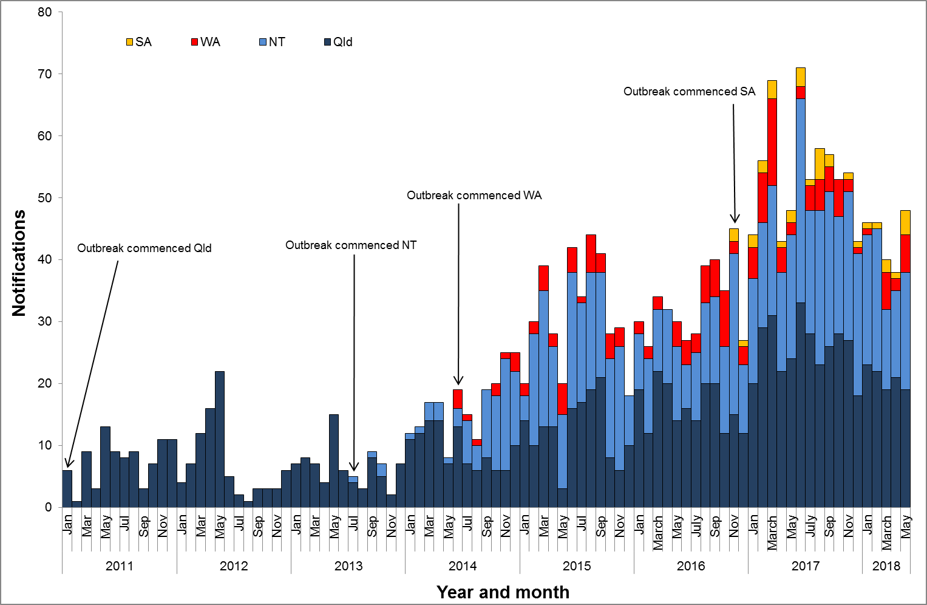

**Table 1**.Characteristics of category 1 infectious syphilisα outbreak cases notified in Aboriginal and Torres Strait Islander people residing in affected regionsβ of Queensland, the Northern Territory, Western Australia and South Australia, to   
31 May 2018 ȶ ᵞ

|  | **North Qld** (four HHSsβ) | | **NT** (seven regions β) | **WA**  (Kimberley region) | **SA**  (two regions β) |
| --- | --- | --- | --- | --- | --- |
| **Situation to-date, 31 May 2018** |  | |  |  |  |
| Outbreak commencement month/year | January 2011 | | July 2013 | June 2014 | November 2016 |
| Total number of casesα | 1123 | | 768 | 162 | 35 |
| % Male / % Female | 47% / 53% | | 45% / 55% | 36% / 64% | 43% / 57% |
| % 15-29 year age group | 67% | | 65% | 71% | 48% |
| Congenital cases, confirmed (probable)« | 4 (4) | | 2 (2) | 0 (0) | 1 (0) |
| -number of deaths in congenital cases, confirmed (probable) | 3 (3) | | 0 (0) | 0 (0) | 0 (0) |
| **Last reporting month, 1 – 31 May 2018** | |  |  |  |  |
| Number of casesα | 19 | | 19 | 6 | 4 |
| % Male / % Female | 37% / 63% | | 26% / 74% | 33% / 67% | 75% / 25% |
| % 15-29 year age group | 68% | | 42% | 67% | 25% |

**Table 2.** Number of category 2 infectious syphilisα cases, to 31 May 2018 ȶ ᵞ

|  | **North Qld** (four HHSsβ) | **NT** (seven regions β) | **WA**  (Kimberley region) | **SA**  (two regions β) |
| --- | --- | --- | --- | --- |
| **Situation to-date, 31 May 2018** | | | | |
| Outbreak commencement month/year | January 2011 | July 2013 | June 2014 | November 2016 |
| Aboriginal and Torres Strait Islander people§ | 11 | 2 | - | - |
| Non-Indigenous peopleµ | 15 | 4 | - | - |
| **Last reporting month, 1 -31 May 2018** | | | | |
| Aboriginal and Torres Strait Islander people§ | - | - | - | - |
| Non-Indigenous peopleµ | - | - | **-** | - |

**Notes:**

ȶ ‘Diagnosis date’ was used to define the period of analysis. This date represents either the onset date or where the date of onset was not known, the earliest of the specimen collection date, the notification date, or the notification receive date.

**α** Cases defined as per the MJSO syphilis outbreak case definition:

Nationally, an infectious syphilis outbreak case is defined as: any person who is newly diagnosed with confirmed or probable infectious syphilis according to the CDNA national surveillance case definition for infectious syphilis, **AND**, is an Aboriginal or Torres Strait Islander person who resides in any of the following outbreak declared regions as defined and documented by that jurisdiction, at or after the dates indicated: ***Qld*** - Torres and Cape Hospital and Health Service area (from 1 December 2012); Cairns and Hinterland Hospital and Health Service area (from 1 August 2013); North West Hospital and Health Service area (from 1 January 2011); Townsville Hospital and Health Service area (from 1 January 2014); ***NT*** - Alice Springs or Barkly district (from 1 July 2013); Katherine district (from 1 May 2014); East Arnhem district (from 1 November 2015); Darwin Rural and Urban (from 1 January 2017); ***WA*** - Kimberley region, Western Australia (from 1 June 2014), ***SA***  - Far North and Western and Eyre regions (from 15 November 2016) (category 1 outbreak cases) **OR**, is a sexual contact of a confirmed outbreak case (category 2 outbreak cases).

**β**Affected regions include Torres and Cape, Cairns and Hinterland, North West, and Townsville Hospital and Health Services in Queensland; Alice Springs Urban, Alice Springs Rural, Barkly, East Arnhem, Katherine, Darwin Urban and Darwin Rural regions in the Northern Territory; the Kimberley health region in Western Australia, and; Far North and Western and Eyre regions in South Australia.

« Cases defined as per the MJSO syphilis outbreak case definition: any newly diagnosed case of confirmed or probable congenital syphilis that meets the CDNA national surveillance case definition whose mother’s syphilis infection prior to or during pregnancy meets the infectious syphilis outbreak case definition.

§ Aboriginal and Torres Strait Islander people who are sexual contacts of a confirmed outbreak case and reside outside an outbreak declared region at the time of diagnosis.

µ Non-Indigenous people who are sexual contacts of a confirmed outbreak case and reside in or out of an outbreak declared region at the time of diagnosis.

**ᵞ** Please note that **all data are provisional** and subject to change due to ongoing case investigation.

**MULTIJURISDICTIONAL SYPHILIS OUTBREAK   
SURVEILLANCE REPORT: JULY 2018**

**This surveillance report has been authorised by Health Departments in outbreak affected jurisdictions and the Office of Health Protection.**

The Multijurisdictional Syphilis Outbreak (MJSO) Working Group was formed by the Communicable Diseases Network of Australia (CDNA) in April 2015, in response to an ongoing outbreak of infectious syphilis among Aboriginal and Torres Strait Islander people living largely in remote and rural areas of northern Australia. Increased notifications associated with the outbreak in northern Australia were first reported in January 2011 in northwest Queensland (Qld), followed by the Northern Territory (NT) in July 2013, and the Kimberley region of Western Australia (WA) in June 2014. In March 2017, South Australia (SA) declared an outbreak in the Far North and Western and Eyre regions from November 2016.

This surveillance report summarises the outbreak epidemiological data as of 30 June 2018 (current status).

**Please note:** the MJSO Surveillance Report was formerly known as the MJSO Communique. Historical epidemiological data and MJSO activities are published in earlier MJSO Communiques available at *http://www.health.gov.au/internet/main/publishing.nsf/Content/ohp-infectious-syphilis-outbreak.htm*

**Current status**

Outbreak data to 30 June 2018ȶ are summarised in Figure 1, Table 1 and Table 2 below.

Outbreak cases are reported as either category 1 or category 2: category 1 cases include Aboriginal and Torres Strait Islander people residing in an outbreak declared regionβ at the time of diagnosis, and; category 2 cases include people who are a sexual contact of a confirmed outbreak case which includes Aboriginal and Torres Strait Islander people who do not reside in an outbreak area at the time of diagnosis and non-Indigenous people regardless of where they reside.

Between 1 – 30 June 2018 ȶ, there were 54 outbreak cases (category 1 and 2 cases) reported from the four outbreak affected jurisdictions: 22 in Queensland; 26 in the Northern Territory; 3 in Western Australia and; 3 in South Australia (Figure 1, Table 1 and Table 2). From the commencement of the outbreak to 30 June 2018 ȶ, there were a total of 2175 outbreak cases (category 1 and 2 cases) reported across the four outbreak affected jurisdictions: 1170 in Queensland (from January 2011); 802 in the Northern Territory (from July 2013); 165 in Western Australia (from June 2014), and; 38 in South Australia (from November 2016) (Table 1 and 2).

**Figure 1**. Epidemic curve showing category 1 infectious syphilis α outbreak cases notified in Aboriginal and Torres Strait Islander people residing in affected regionsβ of Queensland, the Northern Territory, Western Australia and South Australia from commencement of the outbreak in each jurisdiction to 30 June 2018 ȶ ᵞ

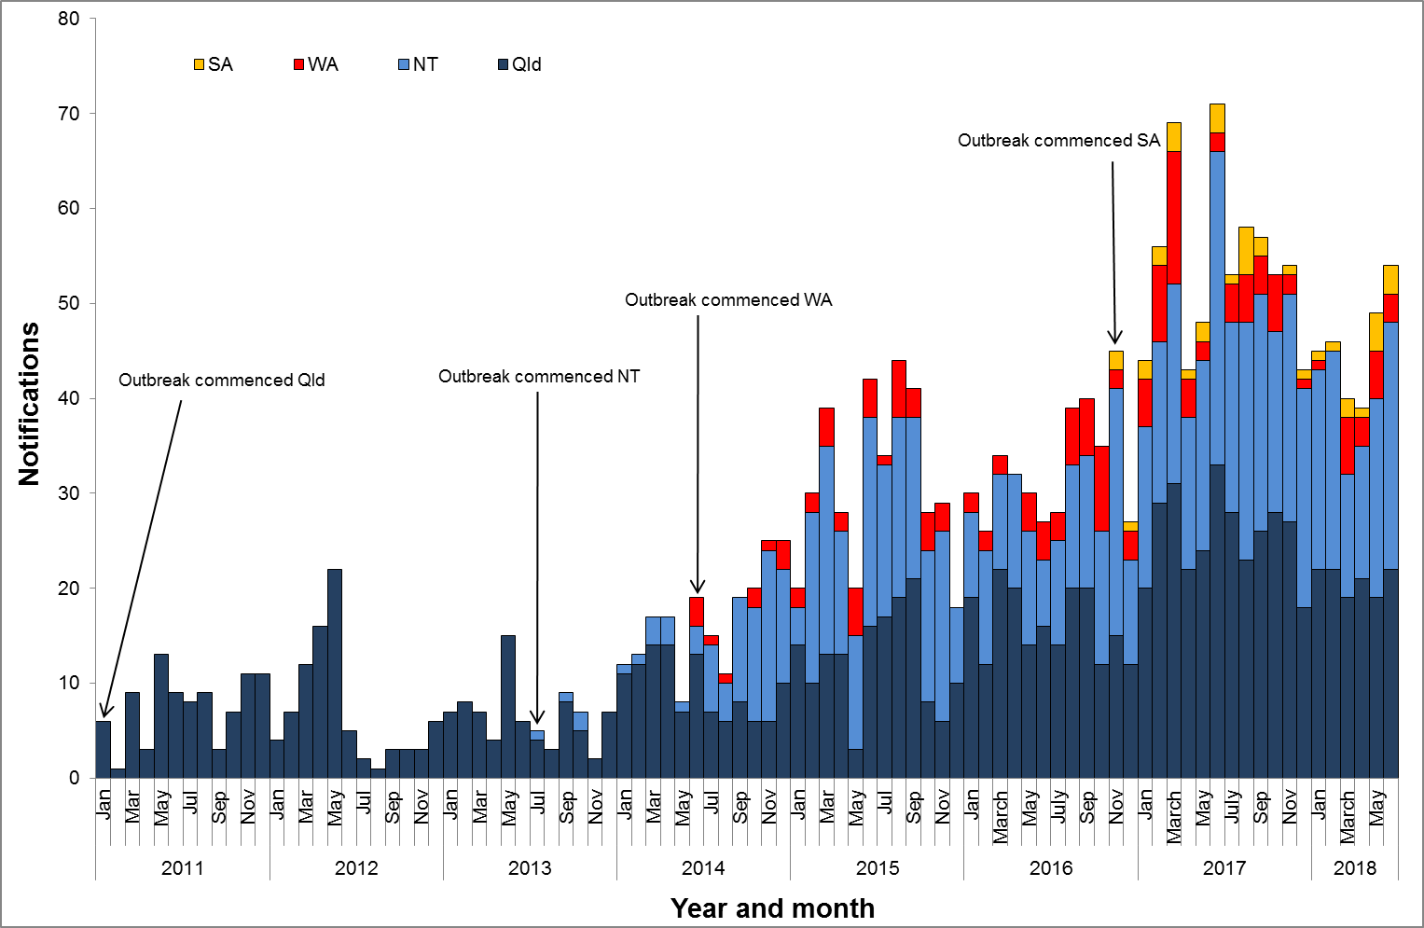

**Table 1**.Characteristics of category 1 infectious syphilisα outbreak cases notified in Aboriginal and Torres Strait Islander people residing in affected regionsβ of Queensland, the Northern Territory, Western Australia and South Australia, to   
30 June 2018 ȶ ᵞ

|  | | **North Qld** (four HHSsβ) | | **NT** (seven regions β) | **WA**  (Kimberley region) | **SA**  (two regions β) |
| --- | --- | --- | --- | --- | --- | --- |
| **Situation to-date, 30 June 2018** |  | | |  |  |  |
| Outbreak commencement month/year | | January 2011 | | July 2013 | June 2014 | November 2016 |
| Total number of casesα | | 1144 | | 796 | 165 | 38 |
| % Male / % Female | | 47% / 53% | | 46% / 54% | 36% / 64% | 45% / 55% |
| % 15-29 year age group | | 67% | | 64% | 71% | 45% |
| Congenital cases, confirmed (probable)« | | 4 (4) | | 2 (2) | 0 (0) | 1 (0) |
| -number of deaths in congenital cases, confirmed (probable) | | 3 (3) | | 0 (0) | 0 (0) | 0 (0) |
| **Last reporting month, 1 – 30 June 2018** | | |  |  |  |  |
| Number of casesα | | 22 | | 26 | 3 | 3 |
| % Male / % Female | | 32% / 68% | | 54% / 46% | 33% / 67% | 67% / 33% |
| % 15-29 year age group | | 59% | | 27% | 67% | 33% |

**Table 2.** Number of category 2 infectious syphilisα cases, to 30 June 2018 ȶ ᵞ

|  | **North Qld** (four HHSsβ) | **NT** (seven regions β) | **WA**  (Kimberley region) | **SA**  (two regions β) |
| --- | --- | --- | --- | --- |
| **Situation to-date, 30 June 2018** |  |  |  |  |
| Outbreak commencement month/year | January 2011 | July 2013 | June 2014 | November 2016 |
| Aboriginal and Torres Strait Islander people§ | 11 | 2 | - | - |
| Non-Indigenous peopleµ | 15 | 4 | - | - |
| **Last reporting month, 1 -30 June 2018** |  |  |  |  |
| Aboriginal and Torres Strait Islander people§ | - | - | - | - |
| Non-Indigenous peopleµ | - | - | **-** | - |

**Notes:**

ȶ ‘Diagnosis date’ was used to define the period of analysis. This date represents either the onset date or where the date of onset was not known, the earliest of the specimen collection date, the notification date, or the notification receive date.

**α** Cases defined as per the MJSO syphilis outbreak case definition:

Nationally, an infectious syphilis outbreak case is defined as: any person who is newly diagnosed with confirmed or probable infectious syphilis according to the CDNA national surveillance case definition for infectious syphilis, **AND**, is an Aboriginal or Torres Strait Islander person who resides in any of the following outbreak declared regions as defined and documented by that jurisdiction, at or after the dates indicated: ***Qld*** - Torres and Cape Hospital and Health Service area (from 1 December 2012); Cairns and Hinterland Hospital and Health Service area (from 1 August 2013); North West Hospital and Health Service area (from 1 January 2011); Townsville Hospital and Health Service area (from 1 January 2014); ***NT*** - Alice Springs or Barkly district (from 1 July 2013); Katherine district (from 1 May 2014); East Arnhem district (from 1 November 2015); Darwin Rural and Urban (from 1 January 2017); ***WA*** - Kimberley region, Western Australia (from 1 June 2014), ***SA***  - Far North and Western and Eyre regions (from 15 November 2016) (category 1 outbreak cases) **OR**, is a sexual contact of a confirmed outbreak case (category 2 outbreak cases).

**β**Affected regions include Torres and Cape, Cairns and Hinterland, North West, and Townsville Hospital and Health Services in Queensland; Alice Springs Urban, Alice Springs Rural, Barkly, East Arnhem, Katherine, Darwin Urban and Darwin Rural regions in the Northern Territory; the Kimberley health region in Western Australia, and; Far North and Western and Eyre regions in South Australia.

« Cases defined as per the MJSO syphilis outbreak case definition: any newly diagnosed case of confirmed or probable congenital syphilis that meets the CDNA national surveillance case definition whose mother’s syphilis infection prior to or during pregnancy meets the infectious syphilis outbreak case definition.

§ Aboriginal and Torres Strait Islander people who are sexual contacts of a confirmed outbreak case and reside outside an outbreak declared region at the time of diagnosis.

µ Non-Indigenous people who are sexual contacts of a confirmed outbreak case and reside in or out of an outbreak declared region at the time of diagnosis.

**ᵞ** Please note that **all data are provisional** and subject to change due to ongoing case investigation.

**MULTIJURISDICTIONAL SYPHILIS OUTBREAK   
SURVEILLANCE REPORT: AUGUST 2018**

**This surveillance report has been authorised by Health Departments in outbreak affected jurisdictions and the Office of Health Protection.**

The Multijurisdictional Syphilis Outbreak (MJSO) Working Group was formed by the Communicable Diseases Network of Australia (CDNA) in April 2015, in response to an ongoing outbreak of infectious syphilis among Aboriginal and Torres Strait Islander people living largely in remote and rural areas of northern Australia. Increased notifications associated with the outbreak in northern Australia were first reported in January 2011 in northwest Queensland (Qld), followed by the Northern Territory (NT) in July 2013, and the Kimberley region of Western Australia (WA) in June 2014. In March 2017, South Australia (SA) declared an outbreak in the Far North and Western and Eyre regions from November 2016.

This surveillance report summarises the outbreak epidemiological data as of 31 July 2018 (current status).

**Please note:** the MJSO Surveillance Report was formerly known as the MJSO Communique. Historical epidemiological data and MJSO activities are published in earlier MJSO Communiques available at *http://www.health.gov.au/internet/main/publishing.nsf/Content/ohp-infectious-syphilis-outbreak.htm*

**Current status**

Outbreak data to 31 July 2018ȶ are summarised in Figure 1, Table 1 and Table 2 below.

Outbreak cases are reported as either category 1 or category 2: category 1 cases include Aboriginal and Torres Strait Islander people residing in an outbreak declared regionβ at the time of diagnosis, and; category 2 cases include people who are a sexual contact of a confirmed outbreak case which includes Aboriginal and Torres Strait Islander people who do not reside in an outbreak area at the time of diagnosis and non-Indigenous people regardless of where they reside.

Between 1 – 31 July 2018 ȶ, there were 45 outbreak cases (category 1 and 2 cases) reported from the four outbreak affected jurisdictions: 11 in Queensland; 27 in the Northern Territory; 6 in Western Australia and; 1 in South Australia (Figure 1, Table 1 and Table 2). From the commencement of the outbreak to 31 July 2018 ȶ, there were a total of 2228 outbreak cases (category 1 and 2 cases) reported across the four outbreak affected jurisdictions: 1180 in Queensland (from January 2011); 829 in the Northern Territory (from July 2013); 180 in Western Australia (from June 2014), and; 39 in South Australia (from November 2016) (Table 1 and 2).

**Figure 1**. Epidemic curve showing category 1 infectious syphilis α outbreak cases notified in Aboriginal and Torres Strait Islander people residing in affected regionsβ of Queensland, the Northern Territory, Western Australia and South Australia from commencement of the outbreak in each jurisdiction to 31 July 2018 ȶ ᵞ

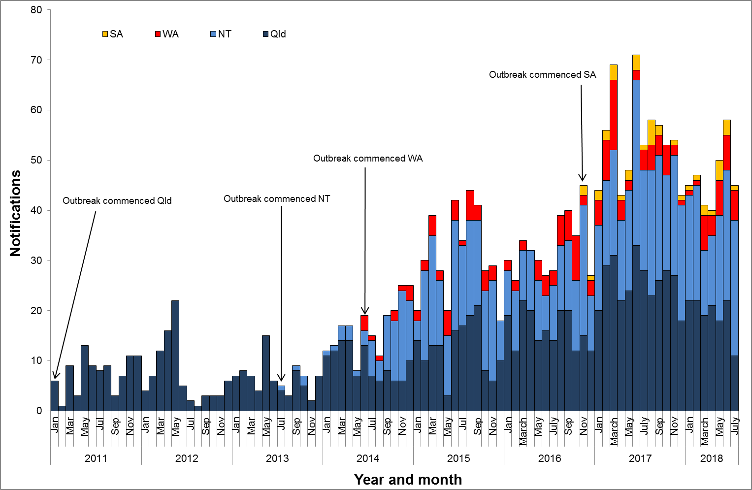

**Table 1**.Characteristics of category 1 infectious syphilisα outbreak cases notified in Aboriginal and Torres Strait Islander people residing in affected regionsβ of Queensland, the Northern Territory, Western Australia and South Australia, to   
31 July 2018 ȶ ᵞ

|  | **North Qld** (four HHSsβ) | **NT** (seven regions β) | **WA**  (two regions β) | **SA**  (two regions β) |
| --- | --- | --- | --- | --- |
| **Situation to-date, 31 July 2018** |  |  |  |  |
| Outbreak commencement month/year | January 2011 | July 2013 | June 2014 | November 2016 |
| Total number of casesα | 1154 | 823 | 180 | 39 |
| % Male / % Female | 47% / 53% | 46% / 54% | 37% / 63% | 46% / 56% |
| % 15-29 year age group | 67% | 64% | 73% | 44% |
| Congenital cases, confirmed (probable)« | 4 (4) | 2 (3) | 0 (0) | 1 (0) |
| -number of deaths in congenital cases, confirmed (probable) | 3 (3) | 0 (0) | 0 (0) | 0 (0) |
| **Last reporting month, 1 – 31 July 2018** | | | | |
| Number of casesα | 11 | 27 | 6 | 1 |
| % Male / % Female | 55% / 45% | 52% / 48% | 33% / 67% | 100% / 0% |
| % 15-29 year age group | 64% | 48% | 83% | 0% |

**Table 2.** Number of category 2 infectious syphilisα cases, to 31 July 2018 ȶ ᵞ

|  | **North Qld** (four HHSsβ) | **NT** (seven regions β) | **WA**  (Kimberley region) | **SA**  (two regions β) |
| --- | --- | --- | --- | --- |
| **Situation to-date, 31 July 2018** | | | | |
| Outbreak commencement month/year | January 2011 | July 2013 | June 2014 | November 2016 |
| Aboriginal and Torres Strait Islander people§ | 11 | 2 | - | - |
| Non-Indigenous peopleµ | 15 | 4 | - | - |
| **Last reporting month, 1 -31 July 2018** | | | | |
| Aboriginal and Torres Strait Islander people§ | - | - | - | - |
| Non-Indigenous peopleµ | - | - | **-** | - |

**Notes:**

ȶ ‘Diagnosis date’ was used to define the period of analysis. This date represents either the onset date or where the date of onset was not known, the earliest of the specimen collection date, the notification date, or the notification receive date.

**α** Cases defined as per the MJSO syphilis outbreak case definition:

Nationally, an infectious syphilis outbreak case is defined as: any person who is newly diagnosed with confirmed or probable infectious syphilis according to the CDNA national surveillance case definition for infectious syphilis, **AND**, is an Aboriginal or Torres Strait Islander person who resides in any of the following outbreak declared regions as defined and documented by that jurisdiction, at or after the dates indicated: ***Qld*** - Torres and Cape Hospital and Health Service area (from 1 December 2012); Cairns and Hinterland Hospital and Health Service area (from 1 August 2013); North West Hospital and Health Service area (from 1 January 2011); Townsville Hospital and Health Service area (from 1 January 2014); ***NT*** - Alice Springs or Barkly district (from 1 July 2013); Katherine district (from 1 May 2014); East Arnhem district (from 1 November 2015); Darwin Rural and Urban (from 1 January 2017); ***WA*** - Kimberley region (from 1 June 2014) and Pilbara region (from 1 February 2018); ***SA***  - Far North and Western and Eyre regions (from 15 November 2016) (category 1 outbreak cases) **OR**, is a sexual contact of a confirmed outbreak case (category 2 outbreak cases).

**β**Affected regions include Torres and Cape, Cairns and Hinterland, North West, and Townsville Hospital and Health Services in Queensland; Alice Springs Urban, Alice Springs Rural, Barkly, East Arnhem, Katherine, Darwin Urban and Darwin Rural regions in the Northern Territory; Kimberley and Pilbara regions in Western Australia, and; Far North and Western and Eyre regions in South Australia.

« Cases defined as per the MJSO syphilis outbreak case definition: any newly diagnosed case of confirmed or probable congenital syphilis that meets the CDNA national surveillance case definition whose mother’s syphilis infection prior to or during pregnancy meets the infectious syphilis outbreak case definition.

§ Aboriginal and Torres Strait Islander people who are sexual contacts of a confirmed outbreak case and reside outside an outbreak declared region at the time of diagnosis.

µ Non-Indigenous people who are sexual contacts of a confirmed outbreak case and reside in or out of an outbreak declared region at the time of diagnosis.

**ᵞ** Please note that **all data are provisional** and subject to change due to ongoing case investigation.

**MULTIJURISDICTIONAL SYPHILIS OUTBREAK   
SURVEILLANCE REPORT: SEPTEMBER 2018**

**This surveillance report has been authorised by Health Departments in outbreak affected jurisdictions and the Office of Health Protection.**

The Multijurisdictional Syphilis Outbreak (MJSO) Working Group was formed by the Communicable Diseases Network of Australia (CDNA) in April 2015, in response to an ongoing outbreak of infectious syphilis among Aboriginal and Torres Strait Islander people living largely in remote and rural areas of northern Australia. Increased notifications associated with the outbreak in northern Australia were first reported in January 2011 in northwest Queensland (Qld), followed by the Northern Territory (NT) in July 2013, and the Kimberley region of Western Australia (WA) in June 2014. In March 2017, South Australia (SA) declared an outbreak in the Far North and Western and Eyre regions from November 2016. In August 2018, WA declared that the outbreak had spread to the Pilbara region with the first syphilis notification in this region in February 2018.

This surveillance report summarises the outbreak epidemiological data as of 31 August 2018 (current status).

**Please note:** the MJSO Surveillance Report was formerly known as the MJSO Communique. Historical epidemiological data and MJSO activities are published in earlier MJSO Communiques available at *http://www.health.gov.au/internet/main/publishing.nsf/Content/ohp-infectious-syphilis-outbreak.htm*

**Current status**

Outbreak data to 31 August 2018ȶ are summarised in Figure 1, Table 1 and Table 2 below.

Outbreak cases are reported as either category 1 or category 2: category 1 cases include Aboriginal and Torres Strait Islander people residing in an outbreak declared regionβ at the time of diagnosis, and; category 2 cases include people who are a sexual contact of a confirmed outbreak case which includes Aboriginal and Torres Strait Islander people who do not reside in an outbreak area at the time of diagnosis and non-Indigenous people regardless of where they reside.

Between 1 – 31 August 2018 ȶ, there were 42 outbreak cases (category 1 and 2 cases) reported from the four outbreak affected jurisdictions: 11 in Queensland; 22 in the Northern Territory; 5 in Western Australia and; 4 in South Australia (Figure 1, Table 1 and Table 2). From the commencement of the outbreak to 31 August 2018 ȶ, there were a total of 2271 outbreak cases (category 1 and 2 cases) reported across the four outbreak affected jurisdictions: 1191 in Queensland (from January 2011); 851 in the Northern Territory (from July 2013); 186 in Western Australia (from June 2014), and; 43 in South Australia (from November 2016) (Table 1 and 2).

**Figure 1**. Epidemic curve showing category 1 infectious syphilis α outbreak cases notified in Aboriginal and Torres Strait Islander people residing in affected regionsβ of Queensland, the Northern Territory, Western Australia and South Australia from commencement of the outbreak in each jurisdiction to 31 August 2018 ȶ ᵞ

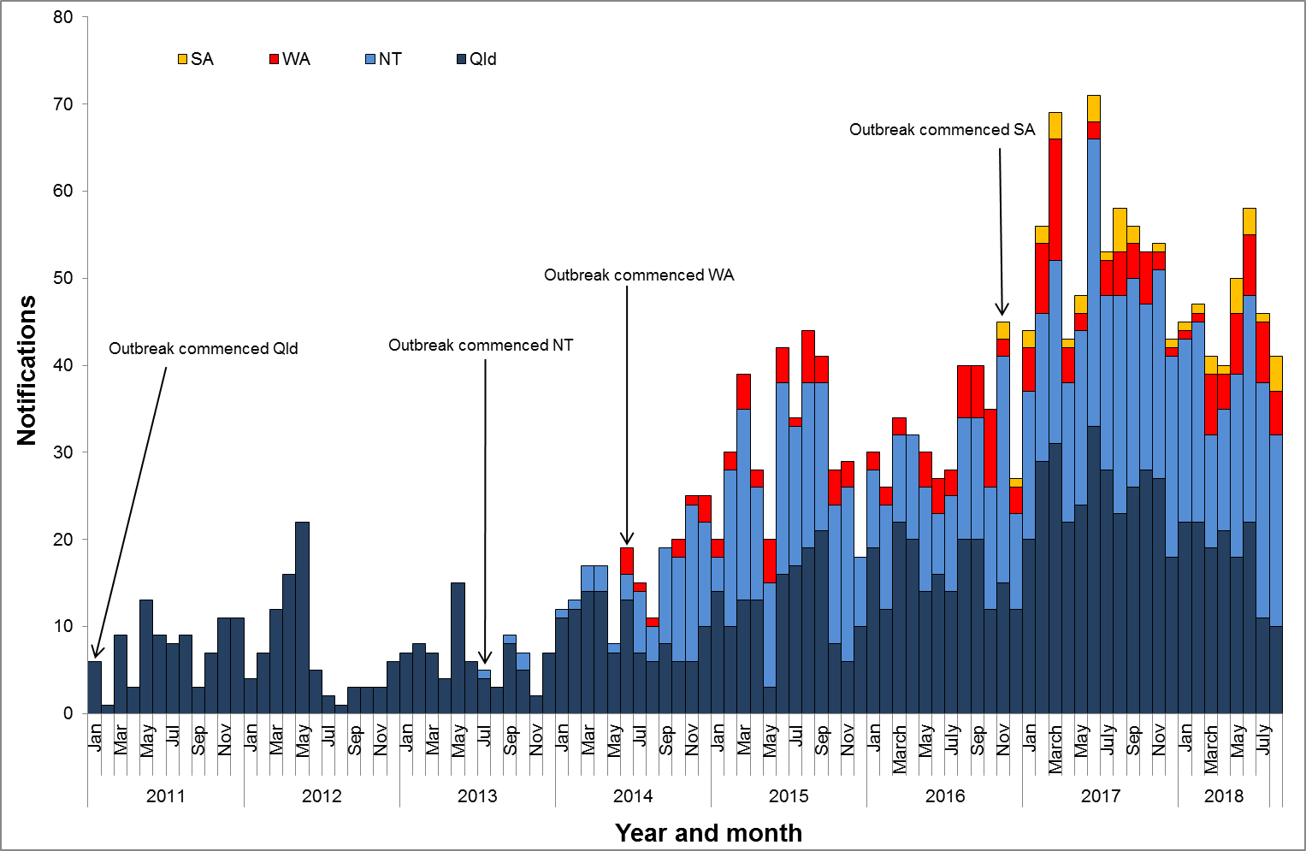

**Table 1**.Characteristics of category 1 infectious syphilisα outbreak cases notified in Aboriginal and Torres Strait Islander people residing in affected regionsβ of Queensland, the Northern Territory, Western Australia and South Australia, to   
31 August 2018 ȶ ᵞ

|  | **North Qld** (four HHSsβ) | **NT** (seven regions β) | **WA**  (two regions β) | **SA**  (two regions β) |
| --- | --- | --- | --- | --- |
| **Situation to-date, 31 August 2018** |  |  |  |  |
| Outbreak commencement month/year | January 2011 | July 2013 | June 2014 | November 2016 |
| Total number of casesα | 1164 | 845 | 186 | 43 |
| % Male / % Female | 47% / 53% | 46% / 54% | 38% / 62% | 47% / 53% |
| % 15-29 year age group | 67% | 64% | 73% | 49% |
| Congenital cases, confirmed (probable)« | 4 (4) | 2 (3) | 0 (0) | 1 (0) |
| -number of deaths in congenital cases, confirmed (probable) | 3 (3) | 0 (0) | 0 (0) | 0 (0) |
| **Last reporting month, 1 – 31 August 2018** | | | | |
| Number of casesα | 10 | 22 | 5 | 4 |
| % Male / % Female | 40% / 60% | 50% / 50% | 40% / 60% | 50% / 50% |
| % 15-29 year age group | 50% | 68% | 80% | 100% |

**Table 2.** Number of category 2 infectious syphilisα cases, to 31 August 2018 ȶ ᵞ

|  | **North Qld** (four HHSsβ) | **NT** (seven regions β) | **WA**  (two regions β) | **SA**  (two regions β) |
| --- | --- | --- | --- | --- |
| **Situation to-date, 31 August 2018** | | | | |
| Outbreak commencement month/year | January 2011 | July 2013 | June 2014 | November 2016 |
| Aboriginal and Torres Strait Islander people§ | 12 | 2 | - | - |
| Non-Indigenous peopleµ | 15 | 4 | - | - |
| **Last reporting month, 1 -31 August 2018** | | | | |
| Aboriginal and Torres Strait Islander people§ | 1 | - | - | - |
| Non-Indigenous peopleµ | - | - | **-** | - |

**Notes:**

ȶ ‘Diagnosis date’ was used to define the period of analysis. This date represents either the onset date or where the date of onset was not known, the earliest of the specimen collection date, the notification date, or the notification receive date.

**α** Cases defined as per the MJSO syphilis outbreak case definition:

Nationally, an infectious syphilis outbreak case is defined as: any person who is newly diagnosed with confirmed or probable infectious syphilis according to the CDNA national surveillance case definition for infectious syphilis, **AND**, is an Aboriginal or Torres Strait Islander person who resides in any of the following outbreak declared regions as defined and documented by that jurisdiction, at or after the dates indicated: ***Qld*** - Torres and Cape Hospital and Health Service area (from 1 December 2012); Cairns and Hinterland Hospital and Health Service area (from 1 August 2013); North West Hospital and Health Service area (from 1 January 2011); Townsville Hospital and Health Service area (from 1 January 2014); ***NT*** - Alice Springs or Barkly district (from 1 July 2013); Katherine district (from 1 May 2014); East Arnhem district (from 1 November 2015); Darwin Rural and Urban (from 1 January 2017); ***WA*** - Kimberley region (from 1 June 2014) and Pilbara region (from 1 February 2018); ***SA***  - Far North and Western and Eyre regions (from 15 November 2016) (category 1 outbreak cases) **OR**, is a sexual contact of a confirmed outbreak case (category 2 outbreak cases).

**β**Affected regions include Torres and Cape, Cairns and Hinterland, North West, and Townsville Hospital and Health Services in Queensland; Alice Springs Urban, Alice Springs Rural, Barkly, East Arnhem, Katherine, Darwin Urban and Darwin Rural regions in the Northern Territory; Kimberley and Pilbara regions in Western Australia, and; Far North and Western and Eyre regions in South Australia.

« Cases defined as per the MJSO syphilis outbreak case definition: any newly diagnosed case of confirmed or probable congenital syphilis that meets the CDNA national surveillance case definition whose mother’s syphilis infection prior to or during pregnancy meets the infectious syphilis outbreak case definition.

§ Aboriginal and Torres Strait Islander people who are sexual contacts of a confirmed outbreak case and reside outside an outbreak declared region at the time of diagnosis.

µ Non-Indigenous people who are sexual contacts of a confirmed outbreak case and reside in or out of an outbreak declared region at the time of diagnosis.

**ᵞ** Please note that **all data are provisional** and subject to change due to ongoing case investigation.

**MULTIJURISDICTIONAL SYPHILIS OUTBREAK   
SURVEILLANCE REPORT: OCTOBER 2018**

**This surveillance report has been authorised by Health Departments in outbreak affected jurisdictions and the Office of Health Protection.**

The Multijurisdictional Syphilis Outbreak (MJSO) Working Group was formed by the Communicable Diseases Network of Australia (CDNA) in April 2015, in response to an ongoing outbreak of infectious syphilis among Aboriginal and Torres Strait Islander people living largely in remote and rural areas of northern Australia. Increased notifications associated with the outbreak in northern Australia were first reported in January 2011 in northwest Queensland (Qld), followed by the Northern Territory (NT) in July 2013, and the Kimberley region of Western Australia (WA) in June 2014. In March 2017, South Australia (SA) declared an outbreak in the Far North and Western and Eyre regions from November 2016. In August 2018, WA declared that the outbreak had spread to the Pilbara region with the first syphilis notification in this region in February 2018.

This surveillance report summarises the outbreak epidemiological data as of 30 September 2018 (current status).

**Please note:** the MJSO Surveillance Report was formerly known as the MJSO Communique. Historical epidemiological data and MJSO activities are published in earlier MJSO Communiques available at *http://www.health.gov.au/internet/main/publishing.nsf/Content/ohp-infectious-syphilis-outbreak.htm*

**Current status**

Outbreak data to 30 September 2018ȶ are summarised in Figure 1, Table 1 and Table 2 below.

Outbreak cases are reported as either category 1 or category 2: category 1 cases include Aboriginal and Torres Strait Islander people residing in an outbreak declared regionβ at the time of diagnosis, and; category 2 cases include people who are a sexual contact of a confirmed outbreak case which includes Aboriginal and Torres Strait Islander people who do not reside in an outbreak area at the time of diagnosis and non-Indigenous people regardless of where they reside.

Between 1 – 30 September 2018 ȶ, there were 52 outbreak cases (category 1 and 2 cases) reported from the four outbreak affected jurisdictions: 21 in Queensland; 21 in the Northern Territory; 9 in Western Australia and; 1 in South Australia (Figure 1, Table 1 and Table 2). From the commencement of the outbreak to 30 September 2018 ȶ, there were a total of 2335 outbreak cases (category 1 and 2 cases) reported across the four outbreak affected jurisdictions: 1212 in Queensland (from January 2011); 883 in the Northern Territory (from July 2013); 196 in Western Australia (from June 2014), and; 44 in South Australia (from November 2016) (Table 1 and 2).

**Figure 1**. Epidemic curve showing category 1 infectious syphilis α outbreak cases notified in Aboriginal and Torres Strait Islander people residing in affected regionsβ of Queensland, the Northern Territory, Western Australia and South Australia from commencement of the outbreak in each jurisdiction to 30 September 2018 ȶ ᵞ

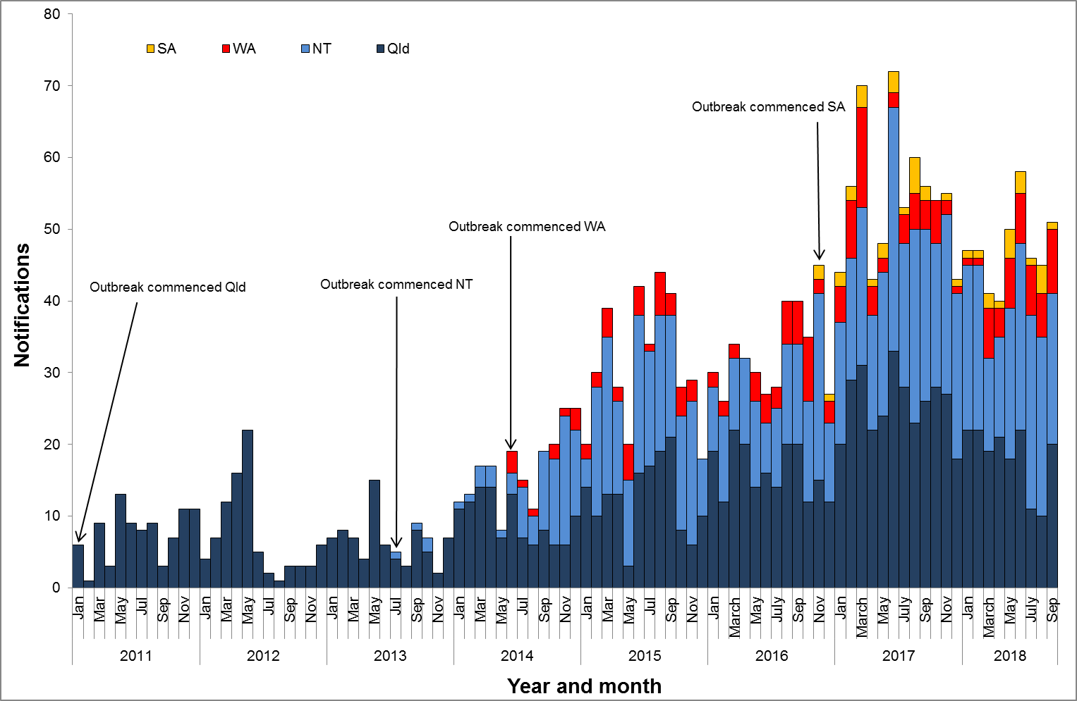

**Table 1**.Characteristics of category 1 infectious syphilisα outbreak cases notified in Aboriginal and Torres Strait Islander people residing in affected regionsβ of Queensland, the Northern Territory, Western Australia and South Australia, to   
30 September 2018 ȶ ᵞ

|  | **North Qld** (four HHSsβ) | **NT** (seven regions β) | **WA**  (two regions β) | **SA**  (two regions β) |
| --- | --- | --- | --- | --- |
| **Situation to-date, 30 September 2018** |  |  |  |  |
| Outbreak commencement month/year | January 2011 | July 2013 | June 2014 | November 2016 |
| Total number of casesα | 1184 | 877 | 196 | 44 |
| % Male / % Female | 47% / 53% | 46% / 54% | 38% / 62% | 45% / 55% |
| % 15-29 year age group | 66% | 63% | 73% | 50% |
| Congenital cases, confirmed (probable)« | 4 (5) | 2 (3) | 0 (0) | 1 (0) |
| -number of deaths in congenital cases, confirmed (probable) | 3 (4) | 0 (0) | 0 (0) | 0 (0) |
| **Last reporting month, 1 – 30 September 2018** | | | | |
| Number of casesα | 20 | 21 | 9 | 1 |
| % Male / % Female | 40% / 60% | 52% / 48% | 44% / 56% | 0% / 100% |
| % 15-29 year age group | 45% | 57% | 78% | 100% |

**Table 2.** Number of category 2 infectious syphilisα cases, to 30 September 2018 ȶ ᵞ

|  | **North Qld** (four HHSsβ) | **NT** (seven regions β) | **WA**  (two regions β) | **SA**  (two regions β) |
| --- | --- | --- | --- | --- |
| **Situation to-date, 30 September 2018** | | | | |
| Outbreak commencement month/year | January 2011 | July 2013 | June 2014 | November 2016 |
| Aboriginal and Torres Strait Islander people§ | 12 | 2 | - | - |
| Non-Indigenous peopleµ | 16 | 4 | - | - |
| **Last reporting month, 1 -30 September 2018** | | | | |
| Aboriginal and Torres Strait Islander people§ | - | - | - | - |
| Non-Indigenous peopleµ | 1 | - | **-** | - |

**Notes:**

ȶ ‘Diagnosis date’ was used to define the period of analysis. This date represents either the onset date or where the date of onset was not known, the earliest of the specimen collection date, the notification date, or the notification receive date.

**α** Cases defined as per the MJSO syphilis outbreak case definition:

Nationally, an infectious syphilis outbreak case is defined as: any person who is newly diagnosed with confirmed or probable infectious syphilis according to the CDNA national surveillance case definition for infectious syphilis, **AND**, is an Aboriginal or Torres Strait Islander person who resides in any of the following outbreak declared regions as defined and documented by that jurisdiction, at or after the dates indicated: ***Qld*** - Torres and Cape Hospital and Health Service area (from 1 December 2012); Cairns and Hinterland Hospital and Health Service area (from 1 August 2013); North West Hospital and Health Service area (from 1 January 2011); Townsville Hospital and Health Service area (from 1 January 2014); ***NT*** - Alice Springs or Barkly district (from 1 July 2013); Katherine district (from 1 May 2014); East Arnhem district (from 1 November 2015); Darwin Rural and Urban (from 1 January 2017); ***WA*** - Kimberley region (from 1 June 2014) and Pilbara region (from 1 February 2018); ***SA***  - Far North and Western and Eyre regions (from 15 November 2016) (category 1 outbreak cases) **OR**, is a sexual contact of a confirmed outbreak case (category 2 outbreak cases).

**β**Affected regions include Torres and Cape, Cairns and Hinterland, North West, and Townsville Hospital and Health Services in Queensland; Alice Springs Urban, Alice Springs Rural, Barkly, East Arnhem, Katherine, Darwin Urban and Darwin Rural regions in the Northern Territory; Kimberley and Pilbara regions in Western Australia, and; Far North and Western and Eyre regions in South Australia.

« Cases defined as per the MJSO syphilis outbreak case definition: any newly diagnosed case of confirmed or probable congenital syphilis that meets the CDNA national surveillance case definition whose mother’s syphilis infection prior to or during pregnancy meets the infectious syphilis outbreak case definition.

§ Aboriginal and Torres Strait Islander people who are sexual contacts of a confirmed outbreak case and reside outside an outbreak declared region at the time of diagnosis.

µ Non-Indigenous people who are sexual contacts of a confirmed outbreak case and reside in or out of an outbreak declared region at the time of diagnosis.

**ᵞ** Please note that **all data are provisional** and subject to change due to ongoing case investigation.

**MULTIJURISDICTIONAL SYPHILIS OUTBREAK   
SURVEILLANCE REPORT: NOVEMBER 2018**

**This surveillance report has been authorised by Health Departments in outbreak affected jurisdictions and the Office of Health Protection.**

The Multijurisdictional Syphilis Outbreak (MJSO) Working Group was formed by the Communicable Diseases Network of Australia (CDNA) in April 2015, in response to an ongoing outbreak of infectious syphilis among Aboriginal and Torres Strait Islander people living largely in remote and rural areas of northern Australia. Increased notifications associated with the outbreak in northern Australia were first reported in January 2011 in northwest Queensland (Qld), followed by the Northern Territory (NT) in July 2013, and the Kimberley region of Western Australia (WA) in June 2014. In March 2017, South Australia (SA) declared an outbreak in the Far North and Western and Eyre regions from November 2016. In August 2018, WA declared that the outbreak had spread to the Pilbara region with the first syphilis notification in this region in February 2018.

This surveillance report summarises the outbreak epidemiological data as of 31 October 2018 (current status).

**Please note:** the MJSO Surveillance Report was formerly known as the MJSO Communique. Historical epidemiological data and MJSO activities are published in earlier MJSO Communiques available at *http://www.health.gov.au/internet/main/publishing.nsf/Content/ohp-infectious-syphilis-outbreak.htm*

**Current status**

Outbreak data to 31 October 2018ȶ are summarised in Figure 1, Table 1 and Table 2 below.

Outbreak cases are reported as either category 1 or category 2: category 1 cases include Aboriginal and Torres Strait Islander people residing in an outbreak declared regionβ at the time of diagnosis, and; category 2 cases include people who are a sexual contact of a confirmed outbreak case which includes Aboriginal and Torres Strait Islander people who do not reside in an outbreak area at the time of diagnosis and non-Indigenous people regardless of where they reside.

Between 1 – 31 October 2018 ȶ, there were 61 outbreak cases (category 1 and 2 cases) reported from the four outbreak affected jurisdictions: 17 in Queensland; 29 in the Northern Territory; 11 in Western Australia and; 4 in South Australia (Figure 1, Table 1 and Table 2). From the commencement of the outbreak to 31 October 2018 ȶ, there were a total of 2378 outbreak cases (category 1 and 2 cases) reported across the four outbreak affected jurisdictions: 1220 in Queensland (from January 2011); 903 in the Northern Territory (from July 2013); 207 in Western Australia (from June 2014), and; 48 in South Australia (from November 2016) (Table 1 and 2).

**Figure 1**. Epidemic curve showing category 1 infectious syphilis α outbreak cases notified in Aboriginal and Torres Strait Islander people residing in affected regionsβ of Queensland, the Northern Territory, Western Australia and South Australia from commencement of the outbreak in each jurisdiction to 31 October 2018 ȶ ᵞ

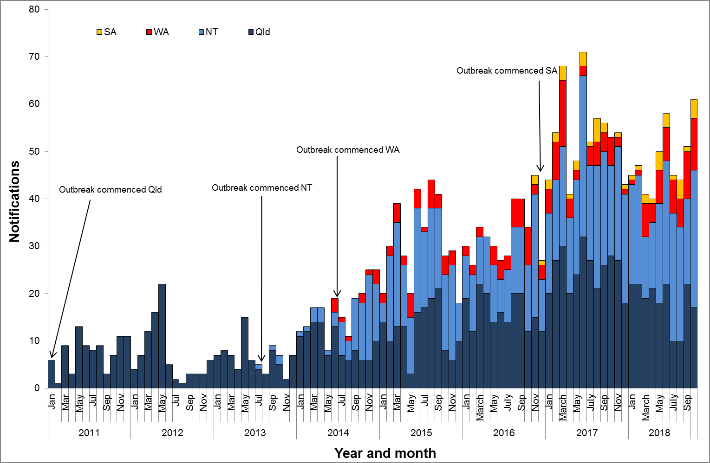

**Table 1**.Characteristics of category 1 infectious syphilisα outbreak cases notified in Aboriginal and Torres Strait Islander people residing in affected regionsβ of Queensland, the Northern Territory, Western Australia and South Australia, to   
31 October 2018 ȶ ᵞ

|  | **North Qld** (four HHSsβ) | **NT** (seven regions β) | **WA**  (two regions β) | **SA**  (two regions β) |
| --- | --- | --- | --- | --- |
| **Situation to-date, 31 October 2018** |  |  |  |  |
| Outbreak commencement month/year | January 2011 | July 2013 | June 2014 | November 2016 |
| Total number of casesα | 1193 | 896 | 207 | 48 |
| % Male / % Female | 47% / 53% | 46% / 54% | 40% / 60% | 44% / 56% |
| % 15-29 year age group | 67% | 64% | 72% | 55% |
| Congenital cases, confirmed (probable)« | 4 (5) | 2 (3) | 0 (0) | 1 (0) |
| -number of deaths in congenital cases, confirmed (probable) | 3 (4) | 0 (0) | 0 (0) | 0 (0) |
| **Last reporting month, 1 – 31 October 2018** | | | | |
| Number of casesα | 17 | 29 | 11 | 4 |
| % Male / % Female | 18% / 82% | 41% /59% | 73% / 27% | 25% / 75% |
| % 15-29 year age group | 76% | 62% | 64% | 100% |

**Table 2.** Number of category 2 infectious syphilisα cases, to 31 October 2018 ȶ ᵞ

|  | **North Qld** (four HHSsβ) | **NT** (seven regions β) | **WA**  (two regions β) | **SA**  (two regions β) |
| --- | --- | --- | --- | --- |
| **Situation to-date, 31 October 2018** | | | | |
| Outbreak commencement month/year | January 2011 | July 2013 | June 2014 | November 2016 |
| Aboriginal and Torres Strait Islander people§ | 11 | 2 | - | - |
| Non-Indigenous peopleµ | 16 | 5 | - | - |
| **Last reporting month, 1 -31 October 2018** | | | | |
| Aboriginal and Torres Strait Islander people§ | - | - | - | - |
| Non-Indigenous peopleµ | - | - | **-** | - |

**Notes:**

ȶ ‘Diagnosis date’ was used to define the period of analysis. This date represents either the onset date or where the date of onset was not known, the earliest of the specimen collection date, the notification date, or the notification receive date.

**α** Cases defined as per the MJSO syphilis outbreak case definition:

Nationally, an infectious syphilis outbreak case is defined as: any person who is newly diagnosed with confirmed or probable infectious syphilis according to the CDNA national surveillance case definition for infectious syphilis, **AND**, is an Aboriginal or Torres Strait Islander person who resides in any of the following outbreak declared regions as defined and documented by that jurisdiction, at or after the dates indicated: ***Qld*** - Torres and Cape Hospital and Health Service area (from 1 December 2012); Cairns and Hinterland Hospital and Health Service area (from 1 August 2013); North West Hospital and Health Service area (from 1 January 2011); Townsville Hospital and Health Service area (from 1 January 2014); ***NT*** - Alice Springs or Barkly district (from 1 July 2013); Katherine district (from 1 May 2014); East Arnhem district (from 1 November 2015); Darwin Rural and Urban (from 1 January 2017); ***WA*** - Kimberley region (from 1 June 2014) and Pilbara region (from 1 February 2018); ***SA***  - Far North and Western and Eyre regions (from 15 November 2016) (category 1 outbreak cases) **OR**, is a sexual contact of a confirmed outbreak case (category 2 outbreak cases).

**β**Affected regions include Torres and Cape, Cairns and Hinterland, North West, and Townsville Hospital and Health Services in Queensland; Alice Springs Urban, Alice Springs Rural, Barkly, East Arnhem, Katherine, Darwin Urban and Darwin Rural regions in the Northern Territory; Kimberley and Pilbara regions in Western Australia, and; Far North and Western and Eyre regions in South Australia.

« Cases defined as per the MJSO syphilis outbreak case definition: any newly diagnosed case of confirmed or probable congenital syphilis that meets the CDNA national surveillance case definition whose mother’s syphilis infection prior to or during pregnancy meets the infectious syphilis outbreak case definition.

§ Aboriginal and Torres Strait Islander people who are sexual contacts of a confirmed outbreak case and reside outside an outbreak declared region at the time of diagnosis.

µ Non-Indigenous people who are sexual contacts of a confirmed outbreak case and reside in or out of an outbreak declared region at the time of diagnosis.

**ᵞ** Please note that **all data are provisional** and subject to change due to ongoing case investigation.

**MULTIJURISDICTIONAL SYPHILIS OUTBREAK   
SURVEILLANCE REPORT: DECEMBER 2018**

**This surveillance report has been authorised by Health Departments in outbreak affected jurisdictions and the Office of Health Protection.**

The Multijurisdictional Syphilis Outbreak (MJSO) Working Group was formed by the Communicable Diseases Network of Australia (CDNA) in April 2015, in response to an ongoing outbreak of infectious syphilis among Aboriginal and Torres Strait Islander people living largely in remote and rural areas of northern Australia. Increased notifications associated with the outbreak in northern Australia were first reported in January 2011 in northwest Queensland (Qld), followed by the Northern Territory (NT) in July 2013, and the Kimberley region of Western Australia (WA) in June 2014. In March 2017, South Australia (SA) declared an outbreak in the Far North and Western and Eyre regions from November 2016. In August 2018, WA declared that the outbreak had spread to the Pilbara region with the first syphilis notification in this region in February 2018.

This surveillance report summarises the outbreak epidemiological data as of 30 November 2018 (current status).

**Please note:** the MJSO Surveillance Report was formerly known as the MJSO Communique. Historical epidemiological data and MJSO activities are published in earlier MJSO Communiques available at *http://www.health.gov.au/internet/main/publishing.nsf/Content/ohp-infectious-syphilis-outbreak.htm*

**Current status**

Outbreak data to 30 November 2018ȶ are summarised in Figure 1, Table 1 and Table 2 below.

Outbreak cases are reported as either category 1 or category 2: category 1 cases include Aboriginal and Torres Strait Islander people residing in an outbreak declared regionβ at the time of diagnosis, and; category 2 cases include people who are a sexual contact of a confirmed outbreak case which includes Aboriginal and Torres Strait Islander people who do not reside in an outbreak area at the time of diagnosis and non-Indigenous people regardless of where they reside.

Between 1 – 30 November 2018ȶ, there were 44 outbreak cases (category 1 and 2 cases) reported from the four outbreak affected jurisdictions: 9 in Queensland; 24 in the Northern Territory; 9 in Western Australia and; 2 in South Australia (Figure 1, Table 1 and Table 2). From the commencement of the outbreak to 30 November 2018 ȶ, there were a total of 2429 outbreak cases (category 1 and 2 cases) reported across the four outbreak affected jurisdictions: 1238 in Queensland (from January 2011); 925 in the Northern Territory (from July 2013); 216 in Western Australia (from June 2014), and; 50 in South Australia (from November 2016) (Table 1 and 2).

**Figure 1**. Epidemic curve showing category 1 infectious syphilis α outbreak cases notified in Aboriginal and Torres Strait Islander people residing in affected regionsβ of Queensland, the Northern Territory, Western Australia and South Australia from commencement of the outbreak in each jurisdiction to 30 November 2018 ȶ ᵞ

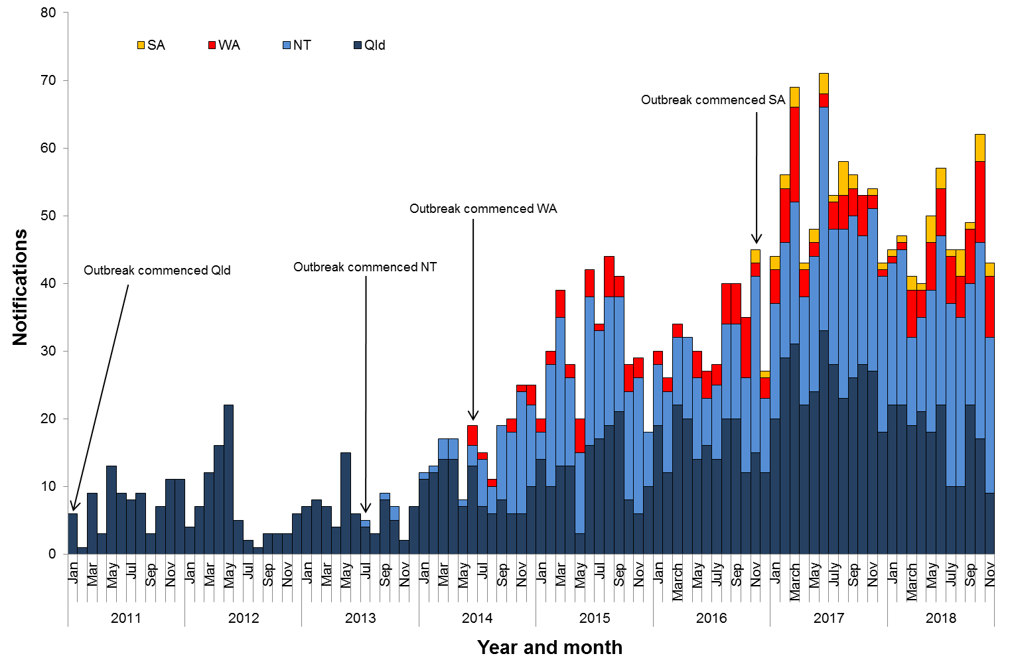

**Table 1**.Characteristics of category 1 infectious syphilisα outbreak cases notified in Aboriginal and Torres Strait Islander people residing in affected regionsβ of Queensland, the Northern Territory, Western Australia and South Australia, to   
30 November 2018 ȶ ᵞ

|  | **North Qld** (four HHSsβ) | **NT** (seven regions β) | **WA**  (two regions β) | **SA**  (two regions β) |
| --- | --- | --- | --- | --- |
| **Situation to-date, 30 November 2018** |  |  |  |  |
| Outbreak commencement month/year | January 2011 | July 2013 | June 2014 | November 2016 |
| Total number of casesα | 1211 | 917 | 216 | 50 |
| % Male / % Female | 47% / 53% | 46% / 54% | 40% / 60% | 44% / 56% |
| % 15-29 year age group | 66% | 63% | 69% | 56% |
| Congenital cases, confirmed (probable)« | 4 (5) | 2 (3) | 0 (0) | 1 (0) |
| -number of deaths in congenital cases, confirmed (probable) | 3 (4) | 0 (0) | 0 (0) | 0 (0) |
| **Last reporting month, 1 – 30 November 2018** | | | | |
| Number of casesα | 9 | 23 | 9 | 2 |
| % Male / % Female | 44% / 56% | 39% /61% | 22% / 78% | 50% / 50% |
| % 15-29 year age group | 67% | 48% | 33% | 100% |

**Table 2.** Number of category 2 infectious syphilisα cases, to 30 November 2018 ȶ ᵞ

|  | **North Qld** (four HHSsβ) | **NT** (seven regions β) | **WA**  (two regions β) | **SA**  (two regions β) |
| --- | --- | --- | --- | --- |
| **Situation to-date, 30 November 2018** | | | | |
| Outbreak commencement month/year | January 2011 | July 2013 | June 2014 | November 2016 |
| Aboriginal and Torres Strait Islander people§ | 11 | 2 | - | - |
| Non-Indigenous peopleµ | 16 | 6 | - | - |
| **Last reporting month, 1 -30 November 2018** | | | | |
| Aboriginal and Torres Strait Islander people§ | - | - | - | - |
| Non-Indigenous peopleµ | - | 1 | **-** | - |

**Notes:**

ȶ ‘Diagnosis date’ was used to define the period of analysis. This date represents either the onset date or where the date of onset was not known, the earliest of the specimen collection date, the notification date, or the notification receive date.

**α** Cases defined as per the MJSO syphilis outbreak case definition:

Nationally, an infectious syphilis outbreak case is defined as: any person who is newly diagnosed with confirmed or probable infectious syphilis according to the CDNA national surveillance case definition for infectious syphilis, **AND**, is an Aboriginal or Torres Strait Islander person who resides in any of the following outbreak declared regions as defined and documented by that jurisdiction, at or after the dates indicated: ***Qld*** - Torres and Cape Hospital and Health Service area (from 1 December 2012); Cairns and Hinterland Hospital and Health Service area (from 1 August 2013); North West Hospital and Health Service area (from 1 January 2011); Townsville Hospital and Health Service area (from 1 January 2014); ***NT*** - Alice Springs or Barkly district (from 1 July 2013); Katherine district (from 1 May 2014); East Arnhem district (from 1 November 2015); Darwin Rural and Urban (from 1 January 2017); ***WA*** - Kimberley region (from 1 June 2014) and Pilbara region (from 1 February 2018); ***SA***  - Far North and Western and Eyre regions (from 15 November 2016) (category 1 outbreak cases) **OR**, is a sexual contact of a confirmed outbreak case (category 2 outbreak cases).

**β**Affected regions include Torres and Cape, Cairns and Hinterland, North West, and Townsville Hospital and Health Services in Queensland; Alice Springs Urban, Alice Springs Rural, Barkly, East Arnhem, Katherine, Darwin Urban and Darwin Rural regions in the Northern Territory; Kimberley and Pilbara regions in Western Australia, and; Far North and Western and Eyre regions in South Australia.

« Cases defined as per the MJSO syphilis outbreak case definition: any newly diagnosed case of confirmed or probable congenital syphilis that meets the CDNA national surveillance case definition whose mother’s syphilis infection prior to or during pregnancy meets the infectious syphilis outbreak case definition.

§ Aboriginal and Torres Strait Islander people who are sexual contacts of a confirmed outbreak case and reside outside an outbreak declared region at the time of diagnosis.

µ Non-Indigenous people who are sexual contacts of a confirmed outbreak case and reside in or out of an outbreak declared region at the time of diagnosis.

**ᵞ** Please note that **all data are provisional** and subject to change due to ongoing case investigation.

**MULTIJURISDICTIONAL SYPHILIS OUTBREAK   
SURVEILLANCE REPORT: JANUARY 2019**

**This surveillance report has been authorised by Health Departments in outbreak affected jurisdictions and the Office of Health Protection.**

The Multijurisdictional Syphilis Outbreak (MJSO) Working Group was formed by the Communicable Diseases Network of Australia (CDNA) in April 2015, in response to an ongoing outbreak of infectious syphilis among Aboriginal and Torres Strait Islander people living largely in remote and rural areas of northern Australia. Increased notifications associated with the outbreak in northern Australia were first reported in January 2011 in northwest Queensland (Qld), followed by the Northern Territory (NT) in July 2013, and the Kimberley region of Western Australia (WA) in June 2014. In March 2017, South Australia (SA) declared an outbreak in the Far North and Western and Eyre regions from November 2016. In August 2018, WA declared that the outbreak had spread to the Pilbara region with the first syphilis notification in this region in February 2018. In January 2019, SA declared the outbreak had spread to Adelaide with the first notification in this region reported in February 2018.

This surveillance report summarises the outbreak epidemiological data as of 31 December 2018 (current status).

**Please note:** the MJSO Surveillance Report was formerly known as the MJSO Communique. Historical epidemiological data and MJSO activities are published in earlier MJSO Communiques available at *http://www.health.gov.au/internet/main/publishing.nsf/Content/ohp-infectious-syphilis-outbreak.htm*

**Current status**

Outbreak data to 31 December 2018ȶ are summarised in Figure 1, Table 1 and Table 2 below.

Outbreak cases are reported as either category 1 or category 2: category 1 cases include Aboriginal and Torres Strait Islander people residing in an outbreak declared regionβ at the time of diagnosis, and; category 2 cases include people who are a sexual contact of a confirmed outbreak case which includes Aboriginal and Torres Strait Islander people who do not reside in an outbreak area at the time of diagnosis and non-Indigenous people regardless of where they reside.

Between 1 – 31 December 2018ȶ, there were 42 outbreak cases (category 1 and 2 cases) reported from the four outbreak affected jurisdictions: 12 in Queensland; 16 in the Northern Territory; 13 in Western Australia and; 1 in South Australia (Figure 1, Table 1 and Table 2). From the commencement of the outbreak to 31 December 2018 ȶ, there were a total of 2493 outbreak cases (category 1 and 2 cases) reported across the four outbreak affected jurisdictions: 1253 in Queensland (from January 2011); 943 in the Northern Territory (from July 2013); 231 in Western Australia (from June 2014), and; 66 in South Australia (from November 2016) (Table 1 and 2).

**Figure 1**. Epidemic curve showing category 1 infectious syphilis α outbreak cases notified in Aboriginal and Torres Strait Islander people residing in affected regionsβ of Queensland, the Northern Territory, Western Australia and South Australia from commencement of the outbreak in each jurisdiction to 31 December 2018 ȶ ᵞ

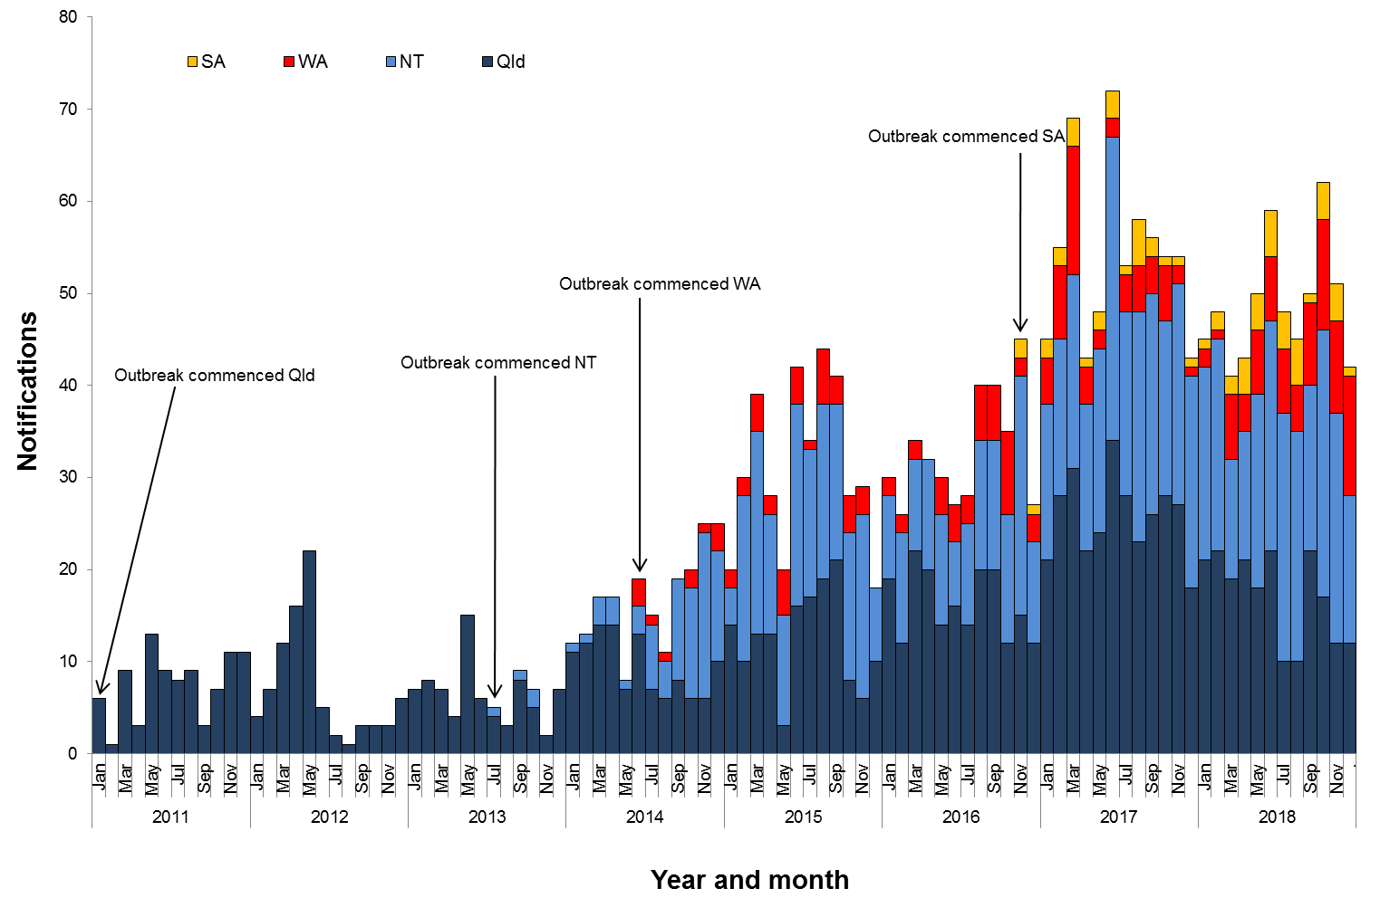

**Table 1**.Characteristics of category 1 infectious syphilisα outbreak cases notified in Aboriginal and Torres Strait Islander people residing in affected regionsβ of Queensland, the Northern Territory, Western Australia and South Australia, to   
31 December 2018 ȶ ᵞ

|  | **North Qld** (four HHSsβ) | **NT**  (seven regions β) | **WA**  (two regions β) | **SA**  (three regions β) |
| --- | --- | --- | --- | --- |
| **Situation to-date, 31 December 2018** |  |  |  |  |
| Outbreak commencement month/year | January 2011 | July 2013 | June 2014 | November 2016 |
| Total number of casesα | 1226 | 935 | 231 | 64 |
| % Male / % Female | 47% / 53% | 46% / 54% | 42% / 58% | 50% / 50% |
| % 15-29 year age group | 66% | 63% | 65% | 52% |
| Congenital cases, confirmed (probable)« | 4 (5) | 2 (3) | 0 (0) | 1 (0) |
| -number of deaths in congenital cases, confirmed (probable) | 3 (4) | 0 (0) | 0 (0) | 0 (0) |
| **Last reporting month, 1 – 31 December 2018** | | | | |
| Number of casesα | 12 | 16 | 13 | 1 |
| % Male / % Female | 58% / 42% | 44% /56% | 62% / 38% | 0% / 100% |
| % 15-29 year age group | 50% | 50% | 77% | 100% |

**Table 2.** Number of category 2 infectious syphilisα cases, to 31 December 2018 ȶ ᵞ

|  | **North Qld** (four HHSsβ) | **NT** (seven regions β) | **WA**  (two regions β) | **SA**  (three regions β) |
| --- | --- | --- | --- | --- |
| **Situation to-date, 31 December 2018** | | | | |
| Outbreak commencement month/year | January 2011 | July 2013 | June 2014 | November 2016 |
| Aboriginal and Torres Strait Islander people§ | 11 | 2 | - | - |
| Non-Indigenous peopleµ | 16 | 6 | - | 2 |
| **Last reporting month, 1 -31 December 2018** | | | | |
| Aboriginal and Torres Strait Islander people§ | - | - | - | - |
| Non-Indigenous peopleµ | - | - | **-** | - |

**Notes:**

ȶ ‘Diagnosis date’ was used to define the period of analysis. This date represents either the onset date or where the date of onset was not known, the earliest of the specimen collection date, the notification date, or the notification receive date.

**α** Cases defined as per the MJSO syphilis outbreak case definition:

Nationally, an infectious syphilis outbreak case is defined as: any person who is newly diagnosed with confirmed or probable infectious syphilis according to the CDNA national surveillance case definition for infectious syphilis, **AND**, is an Aboriginal or Torres Strait Islander person who resides in any of the following outbreak declared regions as defined and documented by that jurisdiction, at or after the dates indicated: ***Qld*** - North West Hospital and Health Service area (from 1 January 2011); Torres and Cape Hospital and Health Service area (from 1 December 2012); Cairns and Hinterland Hospital and Health Service area(from1 August 2013); Townsville Hospital and Health Service area (from 1 January 2014); ***NT*** - Alice Springs Rural and Urban or Barkly district (from 1 July 2013); Katherine district (from 1 May 2014); East Arnhem district (from 1 November 2015); Darwin Rural and Urban (from 1 January 2017); ***WA*** - Kimberley region (from 1 June 2014) and Pilbara region (from 1 February 2018); ***SA***  - Far North and Western and Eyre regions (from 15 November 2016); Adelaide (from 1 February 2018) (category 1 outbreak cases) **OR**, is a sexual contact of a confirmed outbreak case (category 2 outbreak cases).

**β**Affected regions include Torres and Cape, Cairns and Hinterland, North West, and Townsville Hospital and Health Services in Queensland; Alice Springs Urban, Alice Springs Rural, Barkly, East Arnhem, Katherine, Darwin Urban and Darwin Rural regions in the Northern Territory; Kimberley and Pilbara regions in Western Australia, and; Far North, Western and Eyre and Adelaide regions in South Australia.

« Cases defined as per the MJSO syphilis outbreak case definition: any newly diagnosed case of confirmed or probable congenital syphilis that meets the CDNA national surveillance case definition whose mother’s syphilis infection prior to or during pregnancy meets the infectious syphilis outbreak case definition.

§ Aboriginal and Torres Strait Islander people who are sexual contacts of a confirmed outbreak case and reside outside an outbreak declared region at the time of diagnosis.

µ Non-Indigenous people who are sexual contacts of a confirmed outbreak case and reside in or out of an outbreak declared region at the time of diagnosis.

**ᵞ** Please note that **all data are provisional** and subject to change due to ongoing case investigation.