# MULTIJURISDICTIONAL SYPHILIS OUTBREAK WORKING GROUP (MJSO)

**Meeting Communique, 24 March 2016** (1st communique)

**This communique has been authorised by the chair of the MJSO, Dr Nathan Ryder.**

The Multijurisdictional Syphilis Outbreak Working Group (MJSO) was formed by the Communicable Diseases Network of Australia (CDNA) in April 2015, in response to an ongoing outbreak of syphilis among Aboriginal and Torres Strait Islander people living largely in remote and rural areas of northern Australia. Increased notifications associated with the outbreak in northern Australia were first reported in January 2011 in northwest Queensland, followed by the Northern Territory (NT) in July 2013, and the Kimberley region of Western Australia (WA) in June 2014. This communique summarises the outbreak epidemiological data as of 29 February 2016 (current status), and the activities of the MJSO from 01 October 2015 -­ 29 February 2016.

**Current status**

Outbreak data to 29 February 2016 are summarised in Figure 1 and Table 1 below.

**Figure 1**. Epidemic curve showing outbreak cases of infectious syphilis[1] notified in affected regions[2] of Queensland, the Northern Territory and Western Australia, from commencement of the outbreak in each jurisdiction to 29 February 2016.

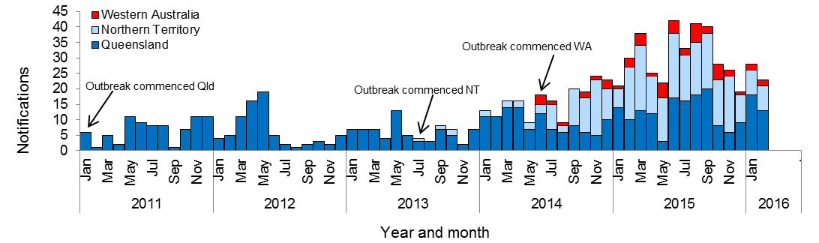

**Table 1.** Characteristics of outbreak cases of infectious syphilis notified in affected regions of Queensland, the Northern Territory and Western Australia, to 29 February 2016[3].

|  |  |  |  |
| --- | --- | --- | --- |
|  | **North Qld (four HHSsβ)** | **NT (four regions β)** | **WA (Kimberley region)** |
| Situation to-­‐date, 29 February 2016 | | | |
| Outbreak commencement month/yr | January 2011 | July 2013 | June 2014 |
| Total number of cases α | **510** | **277** | **51** |
| Percent cases reported in 15-­‐29 year age group | 72% | 79% | 80% |
| % Male / % Female | 44% / 56% | 50% / 50% | 31% /69% |
| Congenital cases, confirmed (probable) | 3 (1) | 1 (2) | 0 (0) |
| -­‐number of deaths in congenital cases | 3 | 0 | 0 |
| Last reporting month, 1-­‐29 Feb 2016 | | | |
| Number of cases α | **13** | **8** | **2** |
| Percent cases reported in 15-­‐29 year age group | 54% | 50% | 50% |
| % Male / % Female | 54% / 46% | 50% / 50% | 100% / 0% |

**Activities of the MJSO, 1 October 2015 ­ 29 February 2016:**

* updated CDNA of the current outbreak situation and MJSO activities. CDNA supported the proposal for a multijurisdictional campaign to increase community awareness of the outbreak and the need for testing (see community engagement below).
* ensured that correct information regarding the outbreak was in the public domain by submitting a paper describing the outbreak epidemiology to the journal Communicable Diseases Intelligence (CDI).
* identified the need for information sharing about health promotion initiatives and set up a platform to facilitate this.
* created a ‘Data working group’ to address epidemiological questions pertinent to the outbreak, including: what data are needed to monitor the epidemiology of the outbreak and control efforts at the local, regional and multijurisdictional levels; and how to interpret data on testing coverage and positivity to guide outbreak responses.

**Community engagement**

A sub-­group, Engaging Aboriginal and Torres Strait Islander Communities (EAC) meets monthly, and reports back to the MJSO with suggestions for improved community engagement. During this period, the EAC:

* developed a checklist for jurisdictions to use when engaging with communities
* recommended the need for infectious syphilis and antenatal testing rates to be provided to staff at the local service provider level
* submitted a proposal to the Commonwealth for funding of a multijurisdictional campaign to increase community awareness of the outbreak and the need for testing.

# MULTIJURISDICTIONAL SYPHILIS OUTBREAK WORKING GROUP (MJSO)

**Meeting Communique, 16 June 2016** (2nd communique)

**This communique has been authorised by the chair of the MJSO, Dr Nathan Ryder.**

The Multijurisdictional Syphilis Outbreak Working Group (MJSO) was formed by the Communicable Diseases Network of Australia (CDNA) in April 2015, in response to an ongoing outbreak of syphilis among Aboriginal and Torres Strait Islander people living largely in remote and rural areas of northern Australia. Increased notifications associated with the outbreak in northern Australia were first reported in January 2011 in northwest Queensland, followed by the Northern Territory (NT) in July 2013, and the Kimberley region of Western Australia (WA) in June 2014. This communique summarises the outbreak epidemiological data as of 31 May 2016 (current status), and the activities of the MJSO from 1 March - 31 May 2016.

## Current status

Outbreak data to 31 May 2016 are summarised in Figure 1 and Table 1 below.

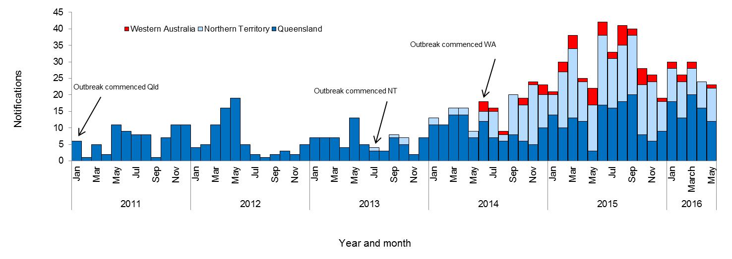**Figure 1**. Epidemic curve showing outbreak cases of infectious syphilis[4] notified in affected regions[5] of Queensland, the Northern Territory and Western Australia, from commencement of the outbreak in each jurisdiction to 31 May 2016ᵞ.

**Table 1.** Characteristics of outbreak cases of infectious syphilis notified in affected regions of Queensland, the Northern Territory and Western Australia, to 31 May 2016[6].

|  | **North Qld (four HHSsβ)** | **NT (four regions β)** | **WA (Kimberley region)** |
| --- | --- | --- | --- |
| Situation to-date, 31 May 2016 |  |  |  |
| Outbreak commencement month/yr | January 2011 | July 2013 | June 2014 |
| Total number of casesα | **598** | **309** | **54** |
| Percent cases reported in 15-29 year age group | 71% | 84% | 78% |
| % Male / % Female | 47% / 53% | 47% / 53% | 33% /67% |
| Congenital cases, confirmed (probable) | 3 (1) | 1 (2) | 0 (0) |
| -number of deaths in congenital cases | 3 | 0 | 0 |
| Last reporting month, 1-31 May 2016 |  |  |  |
| Number of casesα | **12** | **10** | **1** |
| Percent cases reported in 15-29 year age group | 75% | 100% | 0% |
| % Male / % Female | 67% / 33% | 30% / 70% | 100% / 0% |

**Activities of the MJSO, 1 March 2016 – 31 May 2016:**

* Updated CDNA of the current outbreak situation and MJSO activities;
* Developed a paper which summarises the barriers and issues identified in the outbreak response and the proposed actions to address these barriers/issues;
* Submitted various abstracts to a number of conferences;
* Disseminated information through the GP Round Table and Aboriginal and Torres Strait Islander Health Partnership Forums;
* Agreed to the development of a centralised webpage which will provide information to the public on the outbreak; and
* Consulted with the MJSO’s Data Working Group (DWG), on a regular basis, to address epidemiological questions pertinent to the outbreak, including development of indicators to measure the goals in the MJSO’s Terms of Reference.

**Community engagement**

* A sub-group, Engaging Aboriginal and Torres Strait Islander Communities (EAC) meets monthly, and reports back to the MJSO with suggestions for improved community engagement. During this period, the EAC received Commonwealth approval for funding of a multijurisdictional campaign to increase community awareness of the outbreak and the need for testing.

# MULTIJURISDICTIONAL SYPHILIS OUTBREAK WORKING GROUP (MJSO)

**Meeting Communique, 21 July 2016** (3rd communique)

**This communique has been authorised by the chair of the MJSO, Dr Nathan Ryder.**

The Multijurisdictional Syphilis Outbreak Working Group (MJSO) was formed by the Communicable Diseases Network of Australia (CDNA) in April 2015, in response to an ongoing outbreak of syphilis among Aboriginal and Torres Strait Islander people living largely in remote and rural areas of northern Australia. Increased notifications associated with the outbreak in northern Australia were first reported in January 2011 in northwest Queensland, followed by the Northern Territory (NT) in July 2013, and the Kimberley region of Western Australia (WA) in June 2014. This communique summarises the outbreak epidemiological data as of 30 June 2016 (current status), and the activities of the MJSO from 1 June – 30 June 2016.

## Current status

Outbreak data to 30 June 2016 are summarised in Figure 1 and Table 1 below.

**Figure 1**. Epidemic curve showing outbreak cases of infectious syphilis[7] notified in affected regions[8] of Queensland, the Northern Territory and Western Australia, from commencement of the outbreak in each jurisdiction to 30 June 2016ᵞ.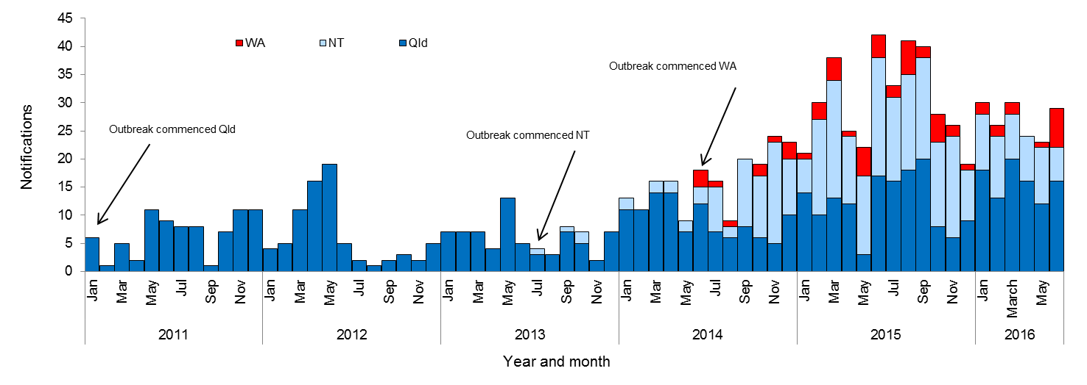

**Table 1.** Characteristics of outbreak cases of infectious syphilis notified in affected regions of Queensland, the Northern Territory and Western Australia, to 30 June 2016[9].

|  | **North Qld (four HHSsβ)** | **NT (four regions β)** | **WA (Kimberley region)** |
| --- | --- | --- | --- |
| Situation to-date, 30 June 2016 |  |  |  |
| Outbreak commencement month/yr | January 2011 | July 2013 | June 2014 |
| Total number of casesα | **618** | **316** | **61** |
| Percent cases reported in 15-29 year age group | 71% | 83% | 74% |
| % Male / % Female | 48% / 52% | 47% / 53% | 34% /66% |
| Congenital cases, confirmed (probable) | 3 (1) | 1 (2) | 0 (0) |
| -number of deaths in congenital cases | 3 | 0 | 0 |
| Last reporting month, 1-30 June 2016 |  |  |  |
| Number of casesα | **16** | **6** | **7** |
| Percent cases reported in 15-29 year age group | 63% | 50% | 0% |
| % Male / % Female | 63% / 38%^ | 50% / 50% | 43% / 57% |

**Activities of the MJSO, 01 June 2016 – 30 June 2016:**

* Finalised the development of a paper which summarises the barriers and issues identified in the outbreak response and the proposed actions to address these barriers/issues;
* Finalised the development of a paper which will update the Australian Health Protection Principal Committee on the current outbreak situation and MJSO activities; and
* Endorsed a congenital syphilis outbreak case definition, developed by the MJSO’s Data Working Group (DWG).

**Community engagement**

* During this period, the Community Awareness Campaign plan, arising from a proposal put forward by the MJSO’s Aboriginal and Torres Strait Islander Community Engagement Sub-committee (EAC), was approved by the Commonwealth. This multijurisdictional campaign will aim to increase community awareness of the outbreak and the need for testing.

# MULTIJURISDICTIONAL SYPHILIS OUTBREAK WORKING GROUP (MJSO)

**Meeting Communique, 18 August 2016** (4th communique)

**This communique has been authorised by the chair of the MJSO, Dr Nathan Ryder.**

The Multijurisdictional Syphilis Outbreak Working Group (MJSO) was formed by the Communicable Diseases Network of Australia (CDNA) in April 2015, in response to an ongoing outbreak of syphilis among Aboriginal and Torres Strait Islander people living largely in remote and rural areas of northern Australia. Increased notifications associated with the outbreak in northern Australia were first reported in January 2011 in northwest Queensland, followed by the Northern Territory (NT) in July 2013, and the Kimberley region of Western Australia (WA) in June 2014. This communique summarises the outbreak epidemiological data as of 31 July 2016 (current status), and the activities of the MJSO from 1 July – 31 July 2016.

## Current status

Outbreak data to 31 July 2016 are summarised in Figure 1 and Table 1 below.

**Figure 1**. Epidemic curve showing outbreak cases of infectious syphilis[10] notified in affected regions[11] of Queensland, the Northern Territory and Western Australia, from commencement of the outbreak in each jurisdiction to 31 July 2016ᵞ.

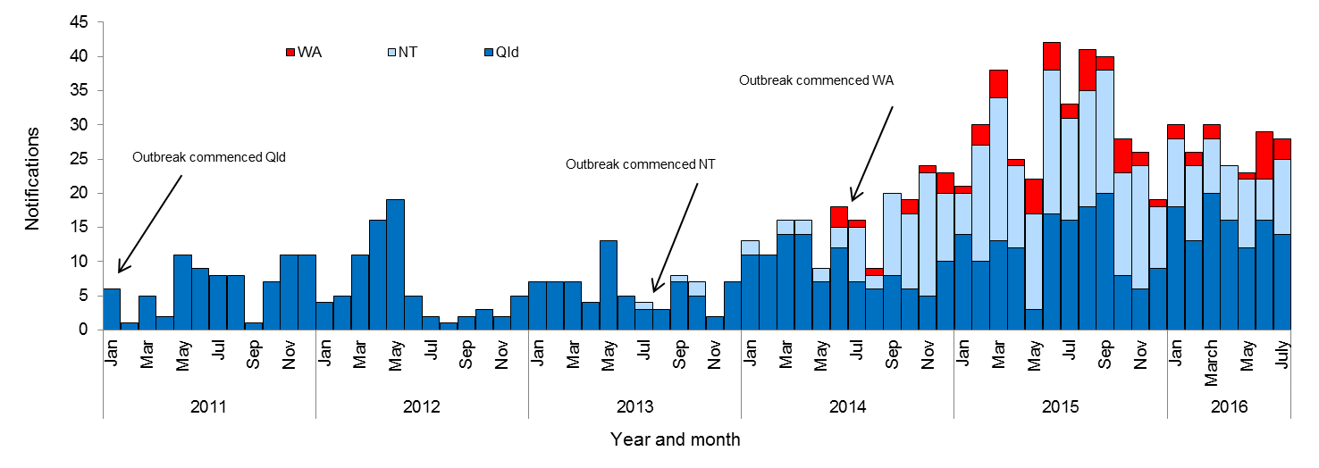

**Table 1.** Characteristics of outbreak cases of infectious syphilis notified in affected regions of Queensland, the Northern Territory and Western Australia, to 31 July 2016[12].

|  | **North Qld (four HHSsβ)** | **NT (four regions β)** | **WA (Kimberley region)** |
| --- | --- | --- | --- |
| Situation to-date, 31 July 2016 |  |  |  |
| Outbreak commencement month/yr | January 2011 | July 2013 | June 2014 |
| Total number of casesα | **633** | **328** | **64** |
| Percent cases reported in 15-29 year age group | 71% | 83% | 72% |
| % Male / % Female | 48% / 52% | 47% / 53% | 36% / 64% |
| Congenital cases, confirmed (probable) | 3 (1) | 1 (2) | 0 (0) |
| -number of deaths in congenital cases | 3 | 0 | 0 |
| Last reporting month, 1-31 July 2016 |  |  |  |
| Number of casesα | **14** | **11** | **3** |
| Percent cases reported in 15-29 year age group | 50% | 82% | 67% |
| % Male / % Female | 57% / 43% | 45% / 55% | 67% / 33% |

**Activities of the MJSO, 1 July 2016 – 31 July 2016:**

* Proposed a number of actions to address some of the barriers and issues identified in the outbreak response; and
* Provided an update to the Australian Health Protection Principal Committee on the current outbreak situation and MJSO activities.

**Community engagement**

* A sub-group, Engaging Aboriginal and Torres Strait Islander Communities (EAC) meets monthly, and reports back to the MJSO with suggestions for improved community engagement. During this period, the EAC discussed alternative testing methods to be used alongside the Commonwealth funded Community Awareness Campaign. The purpose of this approach is to increase testing among young Aboriginal and Torres Strait people.

# MULTIJURISDICTIONAL SYPHILIS OUTBREAK WORKING GROUP (MJSO)

**Meeting Communique, 15 September 2016** (5th communique)

**This communique has been authorised by the chair of the MJSO, Dr Nathan Ryder.**

The Multijurisdictional Syphilis Outbreak Working Group (MJSO) was formed by the Communicable Diseases Network of Australia (CDNA) in April 2015, in response to an ongoing outbreak of syphilis among Aboriginal and Torres Strait Islander people living largely in remote and rural areas of northern Australia. Increased notifications associated with the outbreak in northern Australia were first reported in January 2011 in northwest Queensland, followed by the Northern Territory (NT) in July 2013, and the Kimberley region of Western Australia (WA) in June 2014. This communique summarises the outbreak epidemiological data as of 31 August 2016 (current status), and the activities of the MJSO from 1 August – 31 August 2016.

## Current status

Outbreak data to 31 August 2016 are summarised in Figure 1 and Table 1 below.

**Figure 1**. Epidemic curve showing outbreak cases of infectious syphilis[13] notified in affected regions[14] of Queensland, the Northern Territory and Western Australia, from commencement of the outbreak in each jurisdiction to 31 August 2016ᵞ.

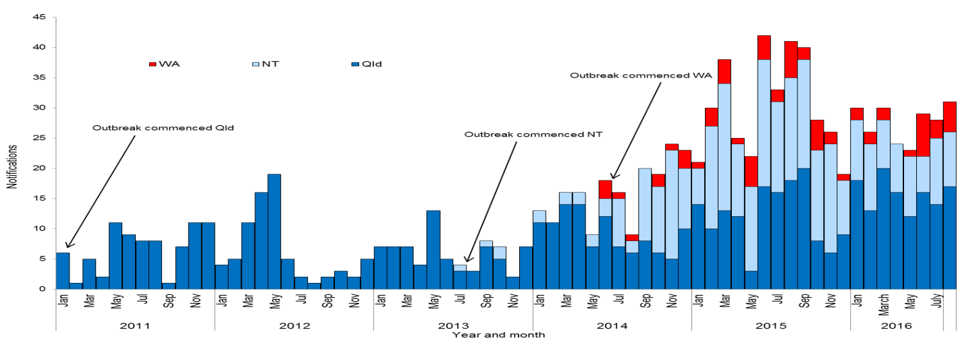

**Table 1.** Characteristics of outbreak cases of infectious syphilis notified in affected regions of Queensland, the Northern Territory and Western Australia, to 31 August 2016[15].

|  | **North Qld (four HHSsβ)** | **NT (four regions β)** | **WA (Kimberley region)** |
| --- | --- | --- | --- |
| Situation to-date, 31 August 2016 |  |  |  |
| Outbreak commencement month/yr | January 2011 | July 2013 | June 2014 |
| Total number of casesα | **653** | **342** | **69** |
| Percent cases reported in 15-29 year age group | 70% | 79% | 71% |
| % Male / % Female | 48% / 52% | 46% / 54% | 35% / 65% |
| Congenital cases, confirmed (probable) | 3 (1) | 1 (2) | 0 (0) |
| -number of deaths in congenital cases | 3 | 0 | 0 |
| Last reporting month, 1-31 August 2016 |  |  |  |
| Number of casesα | **17** | **9** | **5** |
| Percent cases reported in 15-29 year age group | 41% | 77% | 60% |
| % Male / % Female | 65% / 35% | 44% / 56% | 20% / 80% |

**Activities of the MJSO, 1 August 2016 – 31 August 2016:**

* Provided an update to CDNA on the current outbreak situation and MJSO activities;
* Agreed to streamline the MJSO reporting requirements; and
* Agreed to review the current targets outlined in the Syphilis National guidelines for public health units and adapting those as necessary to the context of the syphilis outbreak.

**Community engagement**

* A sub-group, Engaging Aboriginal and Torres Strait Islander Communities (EAC) meets monthly, and reports back to the MJSO with suggestions for improved community engagement. During this period, the EAC agreed to provide comments on the Community Awareness Campaign’s plans and materials. Given the coverage of the campaign across northern Australia, it is important that members of this group have input from their local area perspective.

# MULTIJURISDICTIONAL SYPHILIS OUTBREAK WORKING GROUP (MJSO)

**Meeting Communique, 20 October 2016** (6th communique)

**This communique has been authorised by the chair of the MJSO, Dr Nathan Ryder.**

The Multijurisdictional Syphilis Outbreak Working Group (MJSO) was formed by the Communicable Diseases Network of Australia (CDNA) in April 2015, in response to an ongoing outbreak of syphilis among Aboriginal and Torres Strait Islander people living largely in remote and rural areas of northern Australia. Increased notifications associated with the outbreak in northern Australia were first reported in January 2011 in northwest Queensland, followed by the Northern Territory (NT) in July 2013, and the Kimberley region of Western Australia (WA) in   
June 2014. This communique summarises the outbreak epidemiological data as of 30 September 2016 (current status), and the activities of the MJSO from 1 September – 30 September 2016.

## Current status

Outbreak data to 30 September 2016 are summarised in Figure 1 and Table 1 below.

**Figure 1**. Epidemic curve showing outbreak cases of infectious syphilis[16] notified in affected regions[17] of Queensland, the Northern Territory and Western Australia, from commencement of the outbreak in each jurisdiction to   
30 September 2016ᵞ.

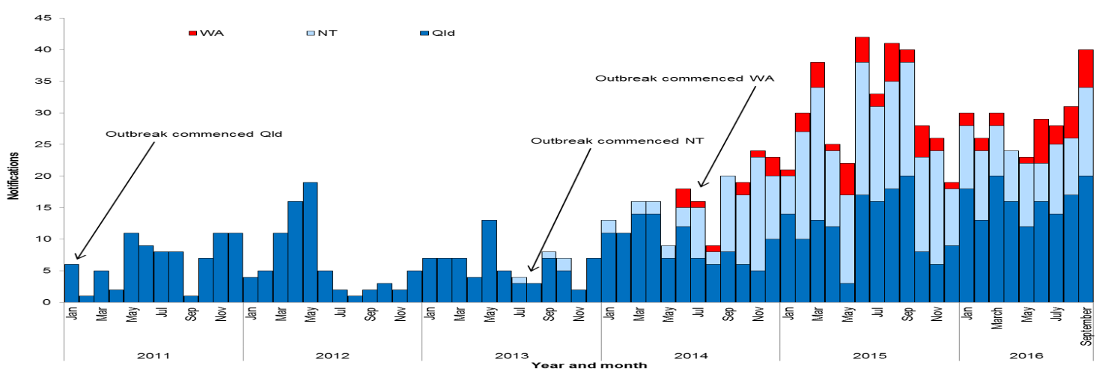

**Table 1.** Characteristics of outbreak cases of infectious syphilis notified in affected regions of Queensland, the Northern Territory and Western Australia, to 30 September 2016[18].

|  | **North Qld (four HHSsβ)** | **NT (four regions β)** | **WA (Kimberley region)** |
| --- | --- | --- | --- |
| Situation to-date, 30 September 2016 |  |  |  |
| Outbreak commencement month/yr | January 2011 | July 2013 | June 2014 |
| Total number of casesα | **681** | **361** | **75** |
| Percent cases reported in 15-29 year age group | 70% | 79% | 68% |
| % Male / % Female | 48% / 52% | 47% / 53% | 36% / 64% |
| Congenital cases, confirmed (probable) | 3 (2) | 1 (2) | 0 (0) |
| -number of deaths in congenital cases | 4 | 0 | 0 |
| Last reporting month, 1-30 September 2016 |  |  |  |
| Number of casesα | **20** | **14** | **6** |
| Percent cases reported in 15-29 year age group | 65% | 86% | 33% |
| % Male / % Female | 30% / 70% | 64% / 36% | 50% / 50% |

**Activities of the MJSO, 1 September 2016 – 30 September 2016:**

* Published a webpage on the Department of Health’s website to provide information regarding the infectious syphilis outbreak affecting Aboriginal and Torres Strait Islander people living in northern Australia;
* Sought agreement from CDNA to review the current targets outlined in the Syphilis National guidelines for public health units and adapting those as necessary to the context of the syphilis outbreak;
* Considered the possible role of the syphilis point of care tests as part of the outbreak response strategy to rapidly screen communities and provide immediate treatment to those with a positive result; and
* Explored new changes to the syphilis case definition.

**Community engagement**

* A sub-group, Engaging Aboriginal and Torres Strait Islander Communities (EAC) meets monthly, and reports back to the MJSO with suggestions for improved community engagement. During this period, the EAC shared promotional material and engagement plans aimed to encourage testing and increase awareness among Aboriginal and Torres Strait Islander communities.

# MULTIJURISDICTIONAL SYPHILIS OUTBREAK WORKING GROUP (MJSO)

**Meeting Communique, 24 November 2016** (7th communique)

**This communique has been authorised by the chair of the MJSO, Dr Nathan Ryder.**

The Multijurisdictional Syphilis Outbreak Working Group (MJSO) was formed by the Communicable Diseases Network of Australia (CDNA) in April 2015, in response to an ongoing outbreak of syphilis among Aboriginal and Torres Strait Islander people living largely in remote and rural areas of northern Australia. Increased notifications associated with the outbreak in northern Australia were first reported in January 2011 in northwest Queensland, followed by the Northern Territory (NT) in July 2013, and the Kimberley region of Western Australia (WA) in   
June 2014. This communique summarises the outbreak epidemiological data as of 31 October 2016 (current status), and the activities of the MJSO from 1 – 31 October 2016.

## Current status

Outbreak data to 31 October 2016 are summarised in Figure 1 and Table 1 below.

**Figure 1**. Epidemic curve showing outbreak cases of infectious syphilis[19] notified in affected regions[20] of Queensland, the Northern Territory and Western Australia, from commencement of the outbreak in each jurisdiction to 31 October 2016ᵞ.

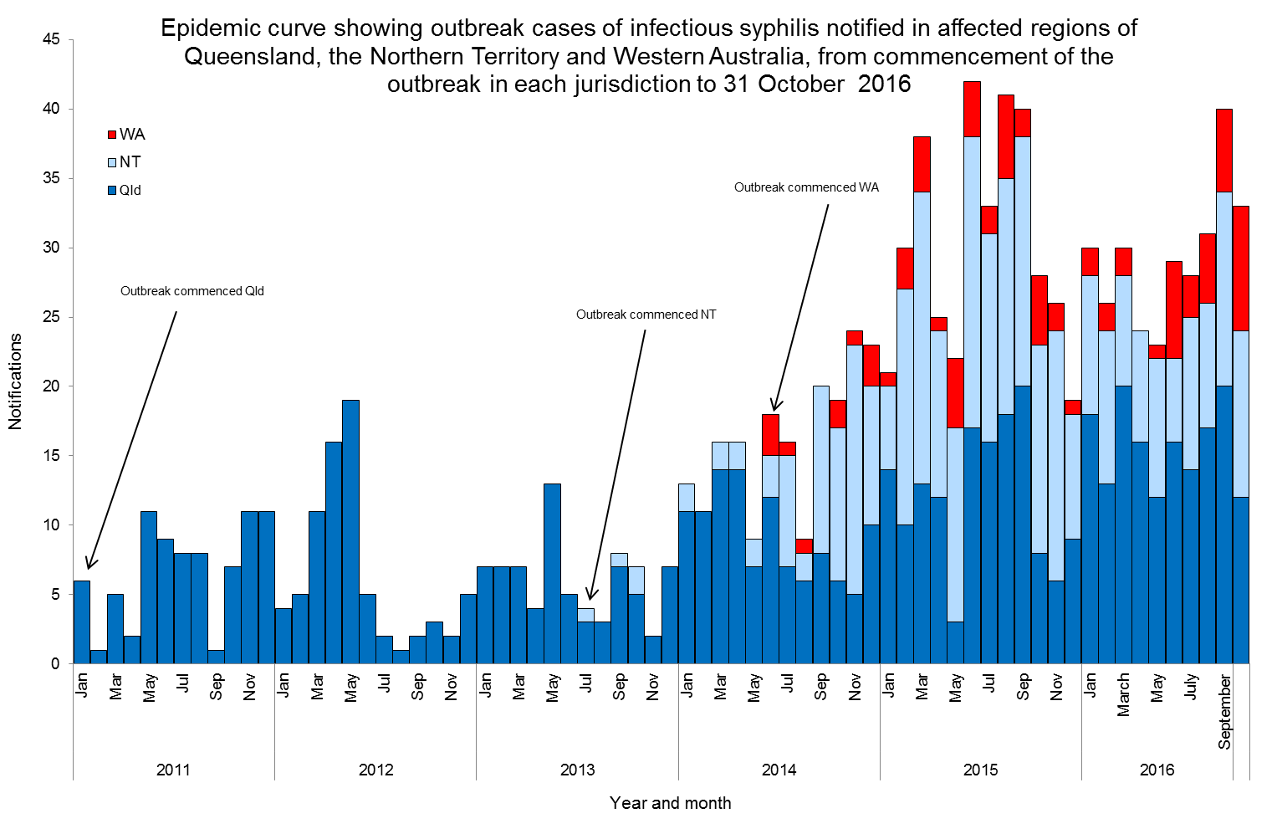

**Table 1.** Characteristics of outbreak cases of infectious syphilis notified in affected regions of Queensland, the Northern Territory and Western Australia, to 31 October 2016[21].

|  | **North Qld (four HHSsβ)** | **NT (four regions β)** | **WA (Kimberley region)** |
| --- | --- | --- | --- |
| Situation to-date, 31 October 2016 |  |  |  |
| Outbreak commencement month/yr | January 2011 | July 2013 | June 2014 |
| Total number of casesα | **693** | **372** | **84** |
| Percent cases reported in 15-29 year age group | 70% | 79% | 69% |
| % Male / % Female | 48% / 52% | 47% / 53% | 34% / 66% |
| Congenital cases, confirmed (probable) | 3 (2) | 1 (2) | 0 (0) |
| -number of deaths in congenital cases | 4 | 0 | 0 |
| Last reporting month, 1-31October 2016 |  |  |  |
| Number of casesα | **12** | **12** | **9** |
| Percent cases reported in 15-29 year age group | 75% | 92% | 66% |
| % Male / % Female | 42% / 58% | 42% / 58% | 22% / 78% |

**Activities of the MJSO, 1 October – 31 October 2016:**

* Presented epidemiological data and public health response activities at the 2016 Australasian Sexual Health Conference.
* Sought agreement from CDNA to review the current targets outlined in the Syphilis National guidelines for public health units and adapting those as necessary to the context of the syphilis outbreak.
* Considered the possible role of the syphilis point of care tests as part of the outbreak response strategy to rapidly screen communities and provide immediate treatment to those with a positive result.

**Community engagement**

* A sub-group, Engaging Aboriginal and Torres Strait Islander Communities (EAC) meets monthly, and reports back to the MJSO with suggestions for improved community engagement. During this period, the EAC shared promotional material and engagement plans aimed to encourage testing and increase awareness among Aboriginal and Torres Strait Islander communities.

# MULTIJURISDICTIONAL SYPHILIS OUTBREAK WORKING GROUP (MJSO)

**Meeting Communique, 15 December 2016** (8th communique)

**This communique has been authorised by the chair of the MJSO, Dr Nathan Ryder.**

The Multijurisdictional Syphilis Outbreak Working Group (MJSO) was formed by the Communicable Diseases Network of Australia (CDNA) in April 2015, in response to an ongoing outbreak of syphilis among Aboriginal and Torres Strait Islander people living largely in remote and rural areas of northern Australia. Increased notifications associated with the outbreak in northern Australia were first reported in January 2011 in northwest Queensland, followed by the Northern Territory (NT) in July 2013, and the Kimberley region of Western Australia (WA) in   
June 2014. This communique summarises the outbreak epidemiological data as of 30 November 2016 (current status), and the activities of the MJSO from 1 – 30 November 2016.

## Current status

Outbreak data to 30 November 2016 are summarised in Figure 1 and Table 1 below.

**Figure 1**. Epidemic curve showing outbreak cases of infectious syphilis[22] notified in affected regions[23] of Queensland, the Northern Territory and Western Australia, from commencement of the outbreak in each jurisdiction to 30 November 2016ᵞ.

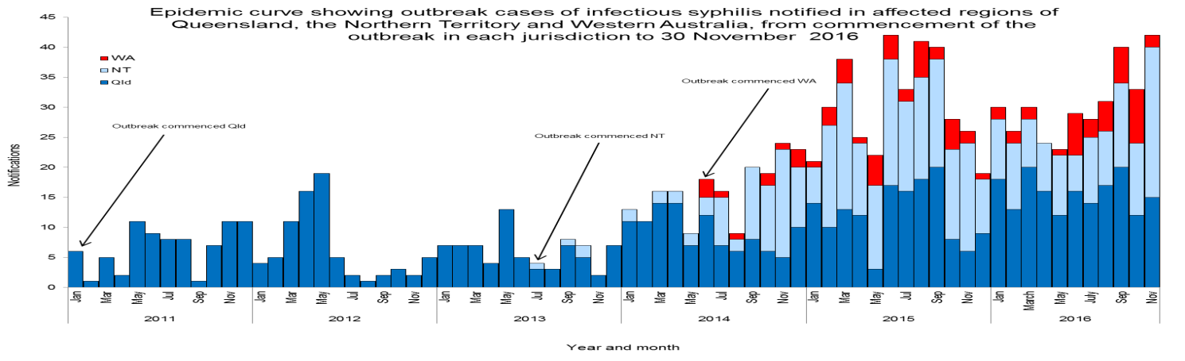

**Table 1.** Characteristics of outbreak cases of infectious syphilis notified in affected regions of Queensland, the Northern Territory and Western Australia, to 30 November 2016[24].

|  | **North Qld (four HHSsβ)** | **NT (four regions β)** | **WA (Kimberley region)** |
| --- | --- | --- | --- |
| Situation to-date, 30 November 2016 |  |  |  |
| Outbreak commencement month/yr | January 2011 | July 2013 | June 2014 |
| Total number of casesα | **709** | **397** | **86** |
| Percent cases reported in 15-29 year age group | 70% | 79% | 67% |
| % Male / % Female | 48% / 52% | 46% / 54% | 35% / 65% |
| Congenital cases, confirmed (probable) | 3 (2) | 1 (2) | 0 (0) |
| -number of deaths in congenital cases | 4 | 0 | 0 |
| Last reporting month, 1-30 November 2016 |  |  |  |
| Number of casesα | **15** | **25** | **2** |
| Percent cases reported in 15-29 year age group | 67% | 76% | 0% |
| % Male / % Female | 60% / 40% | 36% / 64% | 50% / 50% |

# MULTIJURISDICTIONAL SYPHILIS OUTBREAK WORKING GROUP (MJSO)

**Meeting Communique, 16 February 2017 (9th Communique)**

**This communique has been authorised by the chair of the MJSO, Dr Nathan Ryder.**

The Multijurisdictional Syphilis Outbreak Working Group (MJSO) was formed by the Communicable Diseases Network of Australia (CDNA) in April 2015, in response to an ongoing outbreak of syphilis among Aboriginal and Torres Strait Islander people living largely in remote and rural areas of northern Australia. Increased notifications associated with the outbreak in northern Australia were first reported in January 2011 in northwest Queensland, followed by the Northern Territory (NT) in July 2013, and the Kimberley region of Western Australia (WA) in   
June 2014. This communique summarises the outbreak epidemiological data as of 31 January 2017 (current status), and the activities of the MJSO from 1 December 2016 – 31 January 2017.

**Current status**

Outbreak data to 31 January 2017 are summarised in Figure 1 and Table 1 below.

**Figure 1**. Epidemic curve showing outbreak cases of infectious syphilisα notified in affected regionsβ of Queensland, the Northern Territory and Western Australia, from commencement of the outbreak in each jurisdiction to   
31 January 2017ᵞ.

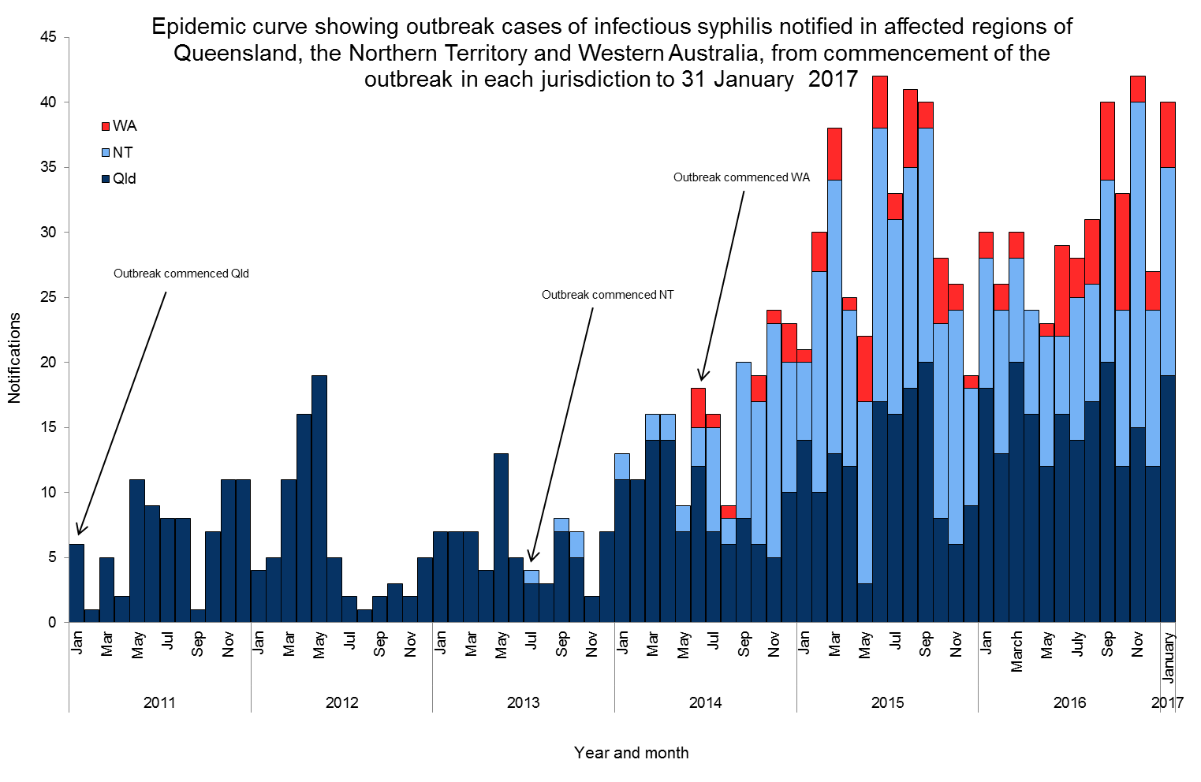

**Table 1.** Characteristics of outbreak cases of infectious syphilis notified in affected regions of Queensland, the Northern Territory and Western Australia, to 31 January 2017ᵞ.

|  | **North Qld  (four HHSsβ)** | **NT  (four regions β)** | **WA  (Kimberley region)** |
| --- | --- | --- | --- |
| Situation to-date, 31 January 2017 |  |  |  |
| Outbreak commencement month/yr | January 2011 | July 2013 | June 2014 |
| Total number of casesα | **743** | **426** | **94** |
| Percent cases reported in 15-29 year age group | 69% | 78% | 68% |
| % Male / % Female | 48% / 52% | 46% / 54% | 35% / 65% |
| Congenital cases, confirmed (probable) | 3 (2) | 1 (2) | 0 (0) |
| -number of deaths in congenital cases | 4 | 0 | 0 |
| Last reporting month, 1 December 2016 – 31 January 2017 |  |  |  |
| Number of casesα | **31** | **28** | **8** |
| Percent cases reported in 15-29 year age group | 61% | 75% | 75% |
| % Male / % Female | 52% / 48% | 43% / 57% | 37% / 63% |

**α** Cases defined as per the MJSO syphilis outbreak case definition:

Nationally, an infectious syphilis outbreak case is defined as: any person who is newly diagnosed with confirmed or probable infectious syphilis according to the CDNA national surveillance case definition for infectious syphilis, **AND**, is an Aboriginal or Torres Strait Islander person who resides in any of the following outbreak declared regions as defined and documented by that jurisdiction, at or after the dates indicated: ***Qld*** - Torres and Cape Hospital and Health Service area (from 1 December 2012); Cairns and Hinterland Hospital and Health Service area (from 1 August 2013); North West Hospital and Health Service area (from 1 January 2011); Townsville Hospital and Health Service area (from 1 January 2014); ***NT*** - Alice Springs or Barkly district (from 1 July 2013); Katherine district (from 1 May 2014); East Arnhem district (from 1 November 2015); Darwin Rural and Urban (from 1 January 2017); ***WA*** - Kimberley region, Western Australia (from 1 June 2014), **OR**, is a sexual contact of a confirmed outbreak case.

**β**Affected regions include Torres and Cape, Cairns and Hinterland, North West, and Townsville Hospital and Health Services in Queensland; Alice Springs, Barkly, East Arnhem and Katherine regions in the Northern Territory, and: the Kimberley health region in Western Australia.

**ᵞ** Please note that **all data are provisional** and subject to change due to ongoing case investigation.

**Activities of the MJSO, 1 December 2016 – 31 January 2017:**

* The Darwin Rural and Urban region of the Northern Territory was declared an outbreak region (from   
  1 January 2017);
* Proposed a number of actions aimed at addressing some of the barriers and issues identified in the outbreak response.

**Community engagement**

* A sub-group, Engaging Aboriginal and Torres Strait Islander Communities (EAC) meets monthly, and reports back to the MJSO with suggestions for improved community engagement. During this period, the EAC shared promotional material and engagement plans aimed to encourage testing and increase awareness among Aboriginal and Torres Strait Islander communities.

**MULTIJURISDICTIONAL SYPHILIS OUTBREAK WORKING GROUP (MJSO)**

**Meeting Communique, 23 March 2017 (10th Communique)**

**This communique has been authorised by the chair of the MJSO, Dr Nathan Ryder.**

The Multijurisdictional Syphilis Outbreak Working Group (MJSO) was formed by the Communicable Diseases Network of Australia (CDNA) in April 2015, in response to an ongoing outbreak of syphilis among Aboriginal and Torres Strait Islander people living largely in remote and rural areas of northern Australia. Increased notifications associated with the outbreak in northern Australia were first reported in January 2011 in northwest Queensland, followed by the Northern Territory (NT) in July 2013, and the Kimberley region of Western Australia (WA) in   
June 2014.

This communique summarises the outbreak epidemiological data as of 23 March 2017 (current status), and the activities of the MJSO from 1–28 February 2017.

**Current status**

Outbreak data to 28 February 2017 are summarised in Figure 1 and Table 1 below.

**Figure 1**. Epidemic curve showing outbreak cases of infectious syphilisα notified in affected regionsβ of Queensland, the Northern Territory, and Western Australia from commencement of the outbreak in each jurisdiction to   
28 February 2017ᵞ.

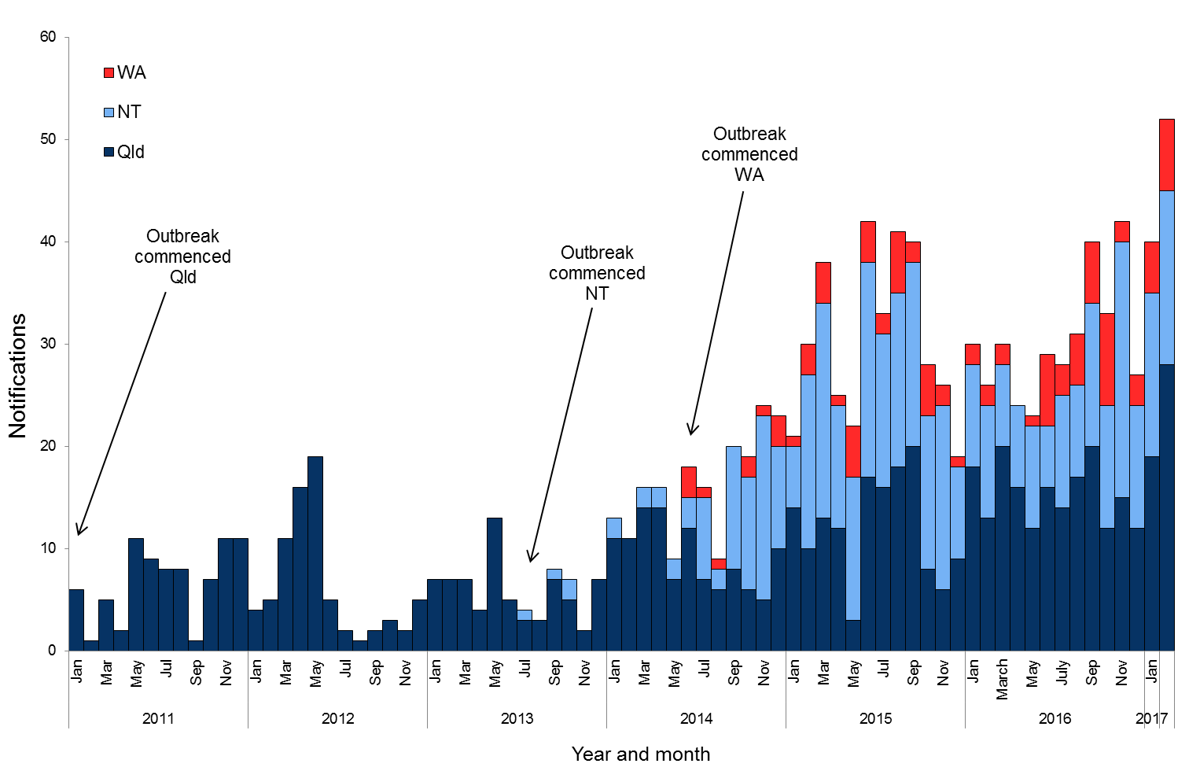

**Table 1**.Characteristics of outbreak cases of infectious syphilis notified in affected regions of Queensland, the Northern Territory and Western Australia, to 28 February 2017ᵞ.

|  | **North Qld** (four HHSsβ) | **NT** (four regions β) | **WA**  (Kimberley region) |
| --- | --- | --- | --- |
| Situation to-date, 28 February 2017 |  |  |  |
| Outbreak commencement month/year | January 2011 | July 2013 | June 2014 |
| Total number of casesα | **774** | **453** | **101** |
| Percent cases reported in 15-29 year age group | 69% | 78% | 68% |
| % Male / % Female | 48% / 52% | 45% / 55% | 35% / 65% |
| Congenital cases, confirmed (probable) | 3 (2) | 1 (2) | 0 (0) |
| -number of deaths in congenital cases | 4 | 0 | 0 |
| Last reporting month, 1–28 February 2017 |  |  |  |
| Number of casesα | **28** | **17** | **7** |
| Percent cases reported in 15-29 year age group | 61% | 76% | 58% |
| % Male / % Female | 46% / 54% | 29% / 71% | 29% / 71% |

**α** Cases defined as per the MJSO syphilis outbreak case definition:

Nationally, an infectious syphilis outbreak case is defined as: any person who is newly diagnosed with confirmed or probable infectious syphilis according to the CDNA national surveillance case definition for infectious syphilis, **AND**, is an Aboriginal or Torres Strait Islander person who resides in any of the following outbreak declared regions as defined and documented by that jurisdiction, at or after the dates indicated: ***Qld*** - Torres and Cape Hospital and Health Service area (from 1 December 2012); Cairns and Hinterland Hospital and Health Service area (from 1 August 2013); North West Hospital and Health Service area (from 1 January 2011); Townsville Hospital and Health Service area (from 1 January 2014); ***NT*** - Alice Springs or Barkly district (from 1 July 2013); Katherine district (from 1 May 2014); East Arnhem district (from 1 November 2015); Darwin Rural and Urban (from 1 January 2017); ***WA*** - Kimberley region, Western Australia (from 1 June 2014) **OR**, is a sexual contact of a confirmed outbreak case.

**β**Affected regions include Torres and Cape, Cairns and Hinterland, North West, and Townsville Hospital and Health Services in Queensland; Alice Springs, Barkly, East Arnhem and Katherine regions in the Northern Territory, and: the Kimberley health region in Western Australia.

**ᵞ** Please note that **all data are provisional** and subject to change due to ongoing case investigation.

**Activities of the MJSO, 1 February – 28 February 2017:**

* Provided an update to the CDNA and the Blood Borne Viruses and Sexually Transmissible Infections Standing Committee (BBVSS) of the Australian Health Protection Principal Committee (AHPPC) on the outbreak status and activities of the MJSO Working Group.
* Continued to discuss a number of actions aimed at addressing some of the barriers and issues identified in the outbreak response.

**Community engagement**

* The MJSO Working Group discussed the Engaging Aboriginal and Torres Strait Islander Communities (EAC) sub-group, and agreed to further consider the membership and structure of the sub-group to more effectively meet the aims of the EAC.

**MULTIJURISDICTIONAL SYPHILIS OUTBREAK WORKING GROUP (MJSO)**

**Meeting Communique, 20 April 2017 (11th Communique)**

**This communique has been authorised by the chair of the MJSO, Dr Nathan Ryder.**

The Multijurisdictional Syphilis Outbreak Working Group (MJSO) was formed by the Communicable Diseases Network of Australia (CDNA) in April 2015, in response to an ongoing outbreak of syphilis among Aboriginal and Torres Strait Islander people living largely in remote and rural areas of northern Australia. Increased notifications associated with the outbreak in northern Australia were first reported in January 2011 in northwest Queensland, followed by the Northern Territory (NT) in July 2013, and the Kimberley region of Western Australia (WA) in   
June 2014. In March 2017, South Australia (SA) declared an outbreak in the Western and Eyre regions from   
November 2016.

This communique summarises the outbreak epidemiological data as of 20 April 2017 (current status), and the activities of the MJSO from 1–31 March 2017.

**Current status**

Outbreak data to 31 March 2017 are summarised in Figure 1 and Table 1 below.

**Figure 1**. Epidemic curve showing outbreak cases of infectious syphilisα notified in affected regionsβ of Queensland, the Northern Territory, Western Australia and South Australia from commencement of the outbreak in each jurisdiction to 31 March 2017ᵞ.

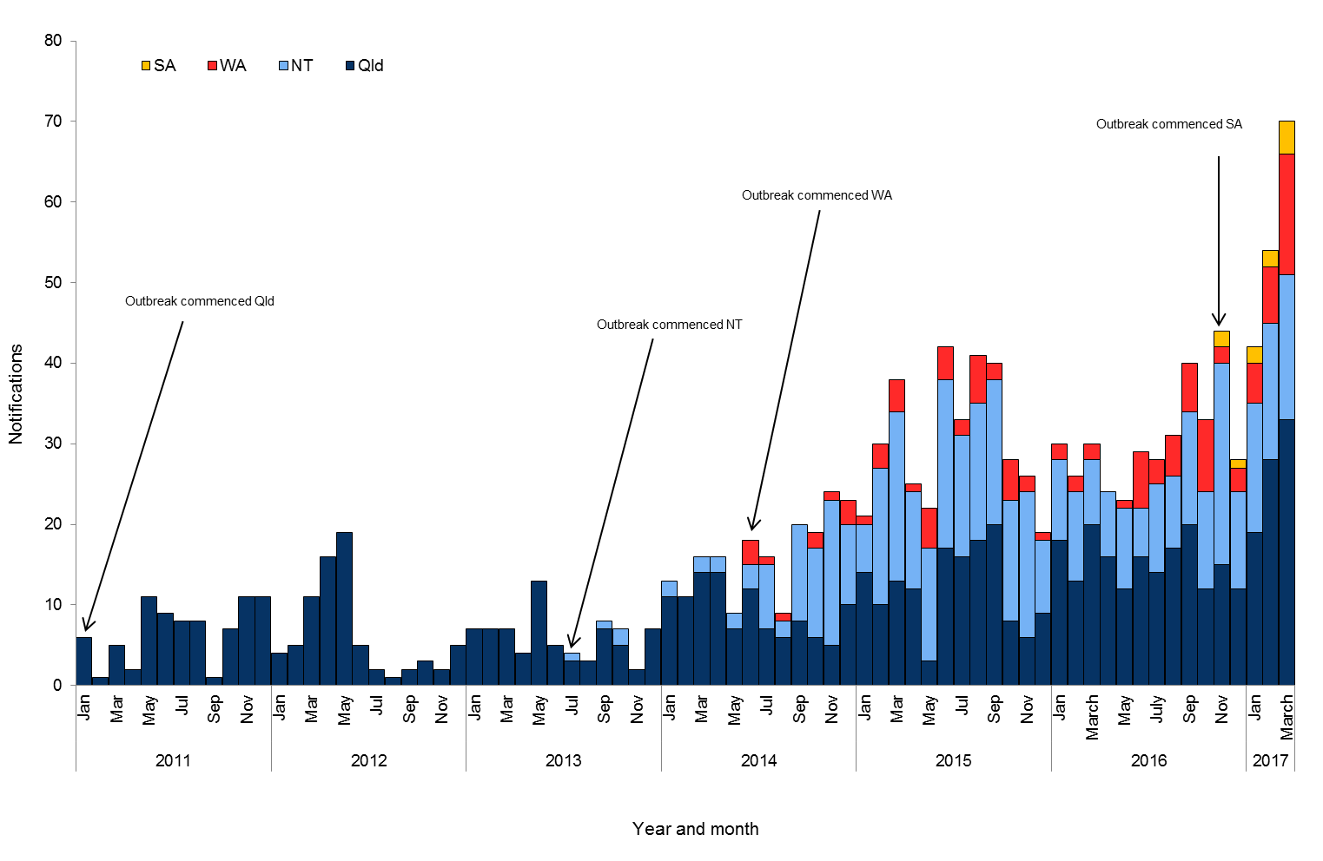

**Table 1**.Characteristics of outbreak cases of infectious syphilis notified in affected regions of Queensland, the Northern Territory, Western Australia and South Australia, to 31 March 2017ᵞ.

|  | **North Qld** (four HHSsβ) | **NT** (four regions β) | **WA**  (Kimberley region) | **SA**  (Western/Eyre regions) |
| --- | --- | --- | --- | --- |
| Situation to-date, 31 March 2017 |  |  |  |  |
| Outbreak commencement month/year | January 2011 | July 2013 | June 2014 | November 2016 |
| Total number of casesα | **808** | **471** | **116** | **11** |
| Percent cases reported in 15-29 year age group | 69% | 77% | 68% | 64% |
| % Male / % Female | 49% / 51% | 45% / 55% | 34% / 66% | 55% /45% |
| Congenital cases, confirmed (probable) | 3 (2) | 1 (2) | 0 (0) | 1 (0) |
| -number of deaths in congenital cases | 4 | 0 | 0 | 0 |
| Last reporting month, 1–31 March 2017 |  |  |  |  |
| Number of casesα | **33** | **18** | **15** | **4** |
| Percent cases reported in 15-29 year age group | 76% | 44% | 73% | 75% |
| % Male / % Female | 58% / 42% | 44% / 56% | 33% / 67% | 50% / 50% |

**α** Cases defined as per the MJSO syphilis outbreak case definition:

Nationally, an infectious syphilis outbreak case is defined as: any person who is newly diagnosed with confirmed or probable infectious syphilis according to the CDNA national surveillance case definition for infectious syphilis, **AND**, is an Aboriginal or Torres Strait Islander person who resides in any of the following outbreak declared regions as defined and documented by that jurisdiction, at or after the dates indicated: ***Qld*** - Torres and Cape Hospital and Health Service area (from 1 December 2012); Cairns and Hinterland Hospital and Health Service area (from 1 August 2013); North West Hospital and Health Service area (from 1 January 2011); Townsville Hospital and Health Service area (from 1 January 2014); ***NT*** - Alice Springs or Barkly district (from 1 July 2013); Katherine district (from 1 May 2014); East Arnhem district (from 1 November 2015); Darwin Rural and Urban (from 1 January 2017); ***WA*** - Kimberley region, Western Australia (from 1 June 2014), ***SA***  - Western and Eyre regions (from 15 November 2016) **OR**, is a sexual contact of a confirmed outbreak case.

**β**Affected regions include Torres and Cape, Cairns and Hinterland, North West, and Townsville Hospital and Health Services in Queensland; Alice Springs, Barkly,   
East Arnhem and Katherine regions in the Northern Territory; the Kimberley health region in Western Australia, and; Western and Eyre regions in South Australia.

**ᵞ** Please note that **all data are provisional** and subject to change due to ongoing case investigation.

**Activities of the MJSO, 1 – 31 March 2017:**

* Commenced a review of the 2015 National Guidelines for Syphilis in the context of the outbreak.
* Continued to discuss a number of actions aimed at addressing some of the barriers and issues identified in the outbreak response.

**MULTIJURISDICTIONAL SYPHILIS OUTBREAK WORKING GROUP (MJSO)**

**Meeting Communique, 18 May 2017 (12th Communique)**

**This communique has been authorised by the chair of the MJSO, Dr Nathan Ryder.**

The Multijurisdictional Syphilis Outbreak Working Group (MJSO) was formed by the Communicable Diseases Network of Australia (CDNA) in April 2015, in response to an ongoing outbreak of syphilis among Aboriginal and Torres Strait Islander people living largely in remote and rural areas of northern Australia. Increased notifications associated with the outbreak in northern Australia were first reported in January 2011 in northwest Queensland, followed by the Northern Territory (NT) in July 2013, and the Kimberley region of Western Australia (WA) in   
June 2014. In March 2017, South Australia (SA) declared an outbreak in the Western and Eyre regions from   
November 2016.

This communique summarises the outbreak epidemiological data as of 18 May 2017 (current status), and the activities of the MJSO from 1–30 April 2017.

**Current status**

Outbreak data to 30 April 2017 are summarised in Figure 1 and Table 1 below.

**Figure 1**. Epidemic curve showing outbreak cases of infectious syphilisα notified in affected regionsβ of Queensland,  
the Northern Territory, Western Australia and South Australia from commencement of the outbreak in each jurisdiction to 30 April 2017ᵞ.

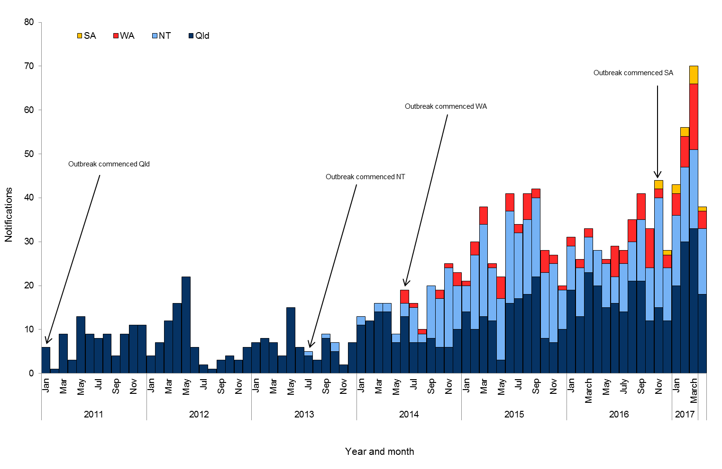

**Table 1**.Characteristics of outbreak cases of infectious syphilis notified in affected regions of Queensland, the Northern Territory, Western Australia and South Australia, to 30 April 2017ᵞ.

|  | **North Qld** (four HHSsβ) | **NT** (four regions β) | **WA**  (Kimberley region) | **SA**  (Western/Eyre regions) |
| --- | --- | --- | --- | --- |
| Situation to-date, 30 April 2017 |  |  |  |  |
| Outbreak commencement month/year | January 2011 | July 2013 | June 2014 | November 2016 |
| Total number of casesα | **826** | **491** | **121** | **12** |
| Percent cases reported in 15-29 year age group | 69% | 75% | 69% | 67% |
| % Male / % Female | 48% / 52% | 46% / 54% | 36% / 64% | 50% /50% |
| Congenital cases, confirmed (probable) | 3 (2) | 2 (2) | 0 (0) | 1 (0) |
| -number of deaths in congenital cases | 4 | 0 | 0 | 0 |
| Last reporting month, 1–30 April 2017 |  |  |  |  |
| Number of casesα | **18** | **15** | **4** | **1** |
| Percent cases reported in 15-29 year age group | 78% | 40% | 75% | 100% |
| % Male / % Female | 33% / 67% | 73% / 27% | 75% / 25% | 0% / 100% |

**α** Cases defined as per the MJSO syphilis outbreak case definition:

Nationally, an infectious syphilis outbreak case is defined as: any person who is newly diagnosed with confirmed or probable infectious syphilis according to the CDNA national surveillance case definition for infectious syphilis, **AND**, is an Aboriginal or Torres Strait Islander person who resides in any of the following outbreak declared regions as defined and documented by that jurisdiction, at or after the dates indicated: ***Qld*** - Torres and Cape Hospital and Health Service area (from 1 December 2012); Cairns and Hinterland Hospital and Health Service area (from 1 August 2013); North West Hospital and Health Service area (from 1 January 2011); Townsville Hospital and Health Service area (from 1 January 2014); ***NT*** - Alice Springs or Barkly district (from 1 July 2013); Katherine district (from 1 May 2014); East Arnhem district (from 1 November 2015); Darwin Rural and Urban (from 1 January 2017); ***WA*** - Kimberley region, Western Australia (from 1 June 2014), ***SA***  - Western and Eyre regions (from 15 November 2016) **OR**, is a sexual contact of a confirmed outbreak case.

**β**Affected regions include Torres and Cape, Cairns and Hinterland, North West, and Townsville Hospital and Health Services in Queensland; Alice Springs, Barkly,   
East Arnhem and Katherine regions in the Northern Territory; the Kimberley health region in Western Australia, and; Western and Eyre regions in South Australia.

**ᵞ** Please note that **all data are provisional** and subject to change due to ongoing case investigation.

**MULTIJURISDICTIONAL SYPHILIS OUTBREAK WORKING GROUP (MJSO)**

**Meeting Communique, 22 June 2017 (13th Communique)**

**This communique has been authorised by the chair of the MJSO, Dr Nathan Ryder.**

The Multijurisdictional Syphilis Outbreak Working Group (MJSO) was formed by the Communicable Diseases Network of Australia (CDNA) in April 2015, in response to an ongoing outbreak of syphilis among Aboriginal and Torres Strait Islander people living largely in remote and rural areas of northern Australia. Increased notifications associated with the outbreak in northern Australia were first reported in January 2011 in northwest Queensland, followed by the Northern Territory (NT) in July 2013, and the Kimberley region of Western Australia (WA) in   
June 2014. In March 2017, South Australia (SA) declared an outbreak in the Western, Eyre and Far North regions from November 2016.

This communique summarises the outbreak epidemiological data as of 22 June 2017 (current status), and the activities of the MJSO from 1–31 May 2017.

**Current status**

Outbreak data to 31 May 2017 are summarised in Figure 1 and Table 1 below.

**Figure 1**. Epidemic curve showing outbreak cases of infectious syphilisα notified in affected regionsβ of Queensland,  
the Northern Territory, Western Australia and South Australia from commencement of the outbreak in each jurisdiction to 31 May 2017ᵞ.

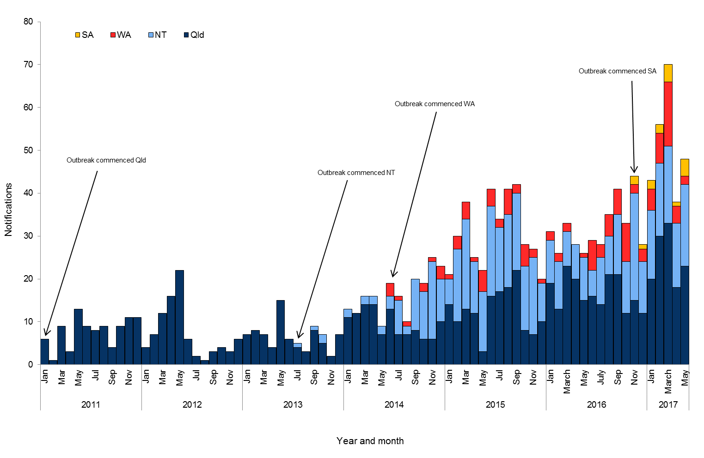

**Table 1**.Characteristics of outbreak cases of infectious syphilis notified in affected regions of Queensland, the Northern Territory, Western Australia and South Australia, to 31 May 2017ᵞ.

|  | **North Qld** (four HHSsβ) | **NT** (four regions β) | **WA**  (Kimberley region) | **SA**  (three regions β) |
| --- | --- | --- | --- | --- |
| Situation to-date, 31 May 2017 |  |  |  |  |
| Outbreak commencement month/year | January 2011 | July 2013 | June 2014 | November 2016 |
| Total number of casesα | **852** | **509** | **123** | **16** |
| Percent cases reported in 15-29 year age group | 69% | 74% | 68% | 56% |
| % Male / % Female | 48% / 52% | 46% / 54% | 36% / 64% | 50% /50% |
| Congenital cases, confirmed (probable) | 3 (2) | 2 (2) | 0 (0) | 1 (0) |
| -number of deaths in congenital cases | 4 | 0 | 0 | 0 |
| Last reporting month, 1–31 May 2017 |  |  |  |  |
| Number of casesα | **23** | **19** | **2** | **4** |
| Percent cases reported in 15-29 year age group | 65% | 53% | 50% | 25% |
| % Male / % Female | 61% / 39% | 42% / 58% | 50% / 50% | 50% / 50% |

**α** Cases defined as per the MJSO syphilis outbreak case definition:

Nationally, an infectious syphilis outbreak case is defined as: any person who is newly diagnosed with confirmed or probable infectious syphilis according to the CDNA national surveillance case definition for infectious syphilis, **AND**, is an Aboriginal or Torres Strait Islander person who resides in any of the following outbreak declared regions as defined and documented by that jurisdiction, at or after the dates indicated: ***Qld*** - Torres and Cape Hospital and Health Service area (from 1 December 2012); Cairns and Hinterland Hospital and Health Service area (from 1 August 2013); North West Hospital and Health Service area (from 1 January 2011); Townsville Hospital and Health Service area (from 1 January 2014); ***NT*** - Alice Springs or Barkly district (from 1 July 2013); Katherine district (from 1 May 2014); East Arnhem district (from 1 November 2015); Darwin Rural and Urban (from 1 January 2017); ***WA*** - Kimberley region, Western Australia (from 1 June 2014), ***SA***  - Western, Eyre and Far North regions (from 15 November 2016) **OR**, is a sexual contact of a confirmed outbreak case.

**β**Affected regions include Torres and Cape, Cairns and Hinterland, North West, and Townsville Hospital and Health Services in Queensland; Alice Springs, Barkly,   
East Arnhem and Katherine regions in the Northern Territory; the Kimberley health region in Western Australia, and; Western, Eyre and Far North regions in  
 South Australia.

**ᵞ** Please note that **all data are provisional** and subject to change due to ongoing case investigation.

**MULTIJURISDICTIONAL SYPHILIS OUTBREAK WORKING GROUP (MJSO)**

**Meeting Communique, 20 July 2017 (14th Communique)**

**This communique has been authorised by the chair of the MJSO, Dr Nathan Ryder.**

The Multijurisdictional Syphilis Outbreak Working Group (MJSO) was formed by the Communicable Diseases Network of Australia (CDNA) in April 2015, in response to an ongoing outbreak of syphilis among Aboriginal and Torres Strait Islander people living largely in remote and rural areas of northern Australia. Increased notifications associated with the outbreak in northern Australia were first reported in January 2011 in northwest Queensland, followed by the Northern Territory (NT) in July 2013, and the Kimberley region of Western Australia (WA) in   
June 2014. In March 2017, South Australia (SA) declared an outbreak in the Western, Eyre and Far North regions from November 2016.

This communique summarises the outbreak epidemiological data as of 20 July 2017 (current status).

**Current status**

Outbreak data to 30 June 2017 are summarised in Figure 1 and Table 1 below.

**Figure 1**. Epidemic curve showing outbreak cases of infectious syphilisα notified in affected regionsβ of Queensland,  
the Northern Territory, Western Australia and South Australia from commencement of the outbreak in each jurisdiction to 30 June 2017ᵞ.

Epidemic curve showing outbreak cases of infectious syphilisα notified in affected regionsβ of Queensland,
the Northern Territory, Western Australia and South Australia from commencement of the outbreak in each jurisdiction to 30 June 2017


**Table 1**.Characteristics of outbreak cases of infectious syphilis notified in affected regions of Queensland, the Northern Territory, Western Australia and South Australia, to 30 June 2017ᵞ.

|  | **North Qld** (four HHSsβ) | **NT** (four regions β) | **WA**  (Kimberley region) | **SA**  (three regions β) |
| --- | --- | --- | --- | --- |
| Situation to-date, 30 June 2017 |  |  |  |  |
| Outbreak commencement month/year | January 2011 | July 2013 | June 2014 | November 2016 |
| Total number of casesα | **887** | **542** | **124** | **22** |
| Percent cases reported in 15-29 year age group | 69% | 72% | 69% | 55% |
| % Male / % Female | 48% / 52% | 46% / 54% | 35% / 65% | 50% /50% |
| Congenital cases, confirmed (probable) | 3 (3) | 2 (2) | 0 (0) | 1 (0) |
| -number of deaths in congenital cases | 5 | 0 | 0 | 0 |
| Last reporting month, 1–30 June 2017 |  |  |  |  |
| Number of casesα | **34** | **32** | **1** | **6** |
| Percent cases reported in 15-29 year age group | 59% | 47% | 100% | 50% |
| % Male / % Female | 41% / 59% | 50% / 50% | 0% / 100% | 50% / 50% |

**α** Cases defined as per the MJSO syphilis outbreak case definition:

Nationally, an infectious syphilis outbreak case is defined as: any person who is newly diagnosed with confirmed or probable infectious syphilis according to the CDNA national surveillance case definition for infectious syphilis, **AND**, is an Aboriginal or Torres Strait Islander person who resides in any of the following outbreak declared regions as defined and documented by that jurisdiction, at or after the dates indicated: ***Qld*** - Torres and Cape Hospital and Health Service area (from 1 December 2012); Cairns and Hinterland Hospital and Health Service area (from 1 August 2013); North West Hospital and Health Service area (from 1 January 2011); Townsville Hospital and Health Service area (from 1 January 2014); ***NT*** - Alice Springs or Barkly district (from 1 July 2013); Katherine district (from 1 May 2014); East Arnhem district (from 1 November 2015); Darwin Rural and Urban (from 1 January 2017); ***WA*** - Kimberley region, Western Australia (from 1 June 2014), ***SA***  - Western, Eyre and Far North regions (from 15 November 2016) **OR**, is a sexual contact of a confirmed outbreak case.

**β**Affected regions include Torres and Cape, Cairns and Hinterland, North West, and Townsville Hospital and Health Services in Queensland; Alice Springs, Barkly,   
East Arnhem and Katherine regions in the Northern Territory; the Kimberley health region in Western Australia, and; Western, Eyre and Far North regions in  
 South Australia.

**ᵞ** Please note that **all data are provisional** and subject to change due to ongoing case investigation.

**MULTIJURISDICTIONAL SYPHILIS OUTBREAK WORKING GROUP (MJSO)**

**Meeting Communique, 17 August 2017 (15th Communique)**

**This communique has been authorised by the chair of the MJSO, Dr Nathan Ryder.**

The Multijurisdictional Syphilis Outbreak Working Group (MJSO) was formed by the Communicable Diseases Network of Australia (CDNA) in April 2015, in response to an ongoing outbreak of syphilis among Aboriginal and Torres Strait Islander people living largely in remote and rural areas of northern Australia. Increased notifications associated with the outbreak in northern Australia were first reported in January 2011 in northwest Queensland, followed by the Northern Territory (NT) in July 2013, and the Kimberley region of Western Australia (WA) in   
June 2014. In March 2017, South Australia (SA) declared an outbreak in the Western, Eyre and Far North regions from November 2016.

This communique summarises the outbreak epidemiological data as of 17 August 2017 (current status).

**Current status**

Outbreak data to 31 July 2017 are summarised in Figure 1 and Table 1 below.

**Figure 1**. Epidemic curve showing outbreak cases of infectious syphilisα notified in affected regionsβ of Queensland,  
the Northern Territory, Western Australia and South Australia from commencement of the outbreak in each jurisdiction to 31 July 2017ᵞ.

 Epidemic curve showing outbreak cases of infectious syphilisα notified in affected regionsβ of Queensland,
the Northern Territory, Western Australia and South Australia from commencement of the outbreak in each jurisdiction to 31 July 2017


**Table 1**.Characteristics of outbreak cases of infectious syphilis notified in affected regions of Queensland, the Northern Territory, Western Australia and South Australia, to 31 July 2017ᵞ.

|  | **North Qld** (four HHSsβ) | **NT** (four regions β) | **WA**  (Kimberley region) | **SA**  (three regions β) |
| --- | --- | --- | --- | --- |
| Situation to-date, 31 July 2017 |  |  |  |  |
| Outbreak commencement month/year | January 2011 | July 2013 | June 2014 | November 2016 |
| Total number of casesα | **915** | **562** | **129** | **22** |
| Percent cases reported in 15-29 year age group | 68% | 71% | 70% | 41% |
| % Male / % Female | 48% / 52% | 47% / 53% | 36% / 64% | 55% /45% |
| Congenital cases, confirmed (probable) | 3 (3) | 2 (2) | 0 (0) | 1 (0) |
| -number of deaths in congenital cases | 5 | 0 | 0 | 0 |
| Last reporting month, 1–31 July 2017 |  |  |  |  |
| Number of casesα | **27** | **20** | **5** | **1** |
| Percent cases reported in 15-29 year age group | 52% | 50% | 100% | 0% |
| % Male / % Female | 48% / 52% | 50% / 50% | 60% / 40% | 100% / 0% |

**α** Cases defined as per the MJSO syphilis outbreak case definition:

Nationally, an infectious syphilis outbreak case is defined as: any person who is newly diagnosed with confirmed or probable infectious syphilis according to the CDNA national surveillance case definition for infectious syphilis, **AND**, is an Aboriginal or Torres Strait Islander person who resides in any of the following outbreak declared regions as defined and documented by that jurisdiction, at or after the dates indicated: ***Qld*** - Torres and Cape Hospital and Health Service area (from 1 December 2012); Cairns and Hinterland Hospital and Health Service area (from 1 August 2013); North West Hospital and Health Service area (from 1 January 2011); Townsville Hospital and Health Service area (from 1 January 2014); ***NT*** - Alice Springs or Barkly district (from 1 July 2013); Katherine district (from 1 May 2014); East Arnhem district (from 1 November 2015); Darwin Rural and Urban (from 1 January 2017); ***WA*** - Kimberley region, Western Australia (from 1 June 2014), ***SA***  - Western, Eyre and Far North regions (from 15 November 2016) **OR**, is a sexual contact of a confirmed outbreak case.

**β**Affected regions include Torres and Cape, Cairns and Hinterland, North West, and Townsville Hospital and Health Services in Queensland; Alice Springs, Barkly,   
East Arnhem and Katherine regions in the Northern Territory; the Kimberley health region in Western Australia, and; Western, Eyre and Far North regions in  
 South Australia.

**ᵞ** Please note that **all data are provisional** and subject to change due to ongoing case investigation.

**MULTIJURISDICTIONAL SYPHILIS OUTBREAK WORKING GROUP (MJSO)**

**Meeting Communique, 21 September 2017 (16th Communique)**

**This communique has been authorised by the chair of the MJSO, Dr Nathan Ryder.**

The Multijurisdictional Syphilis Outbreak Working Group (MJSO) was formed by the Communicable Diseases Network of Australia (CDNA) in April 2015, in response to an ongoing outbreak of syphilis among Aboriginal and Torres Strait Islander people living largely in remote and rural areas of northern Australia. Increased notifications associated with the outbreak in northern Australia were first reported in January 2011 in northwest Queensland, followed by the Northern Territory (NT) in July 2013, and the Kimberley region of Western Australia (WA) in   
June 2014. In March 2017, South Australia (SA) declared an outbreak in the Western, Eyre and Far North regions from November 2016.

This communique summarises the outbreak epidemiological data as of 21 September 2017 (current status).

**Current status**

Outbreak data to 31 August 2017 are summarised in Figure 1 and Table 1 below.

**Figure 1**. Epidemic curve showing outbreak cases of infectious syphilisα notified in affected regionsβ of Queensland,  
the Northern Territory, Western Australia and South Australia from commencement of the outbreak in each jurisdiction to 31 August 2017ᵞ.

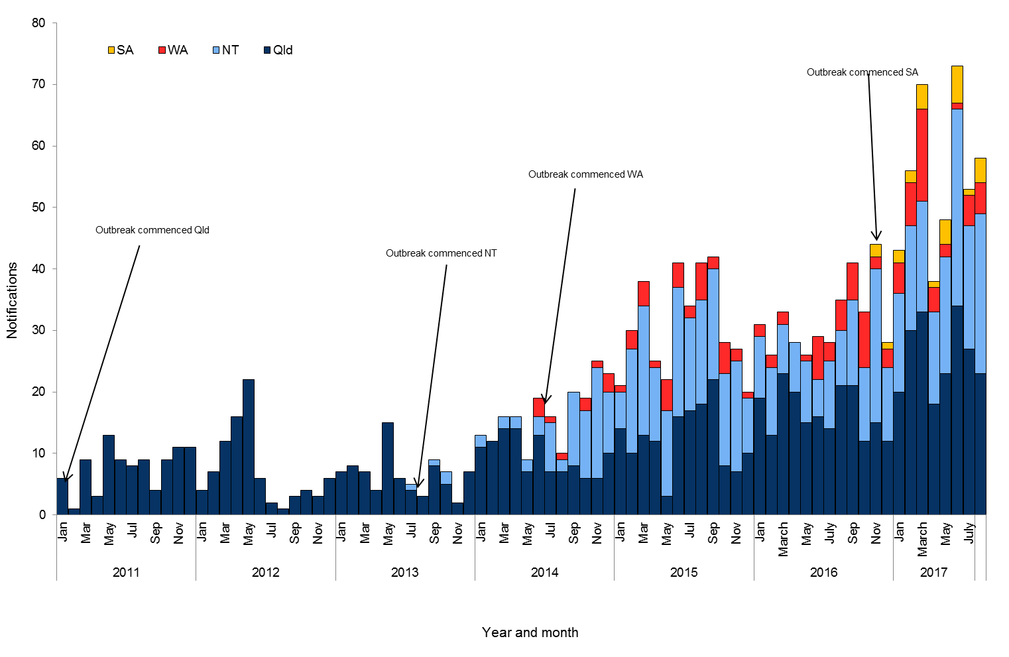

**Table 1**.Characteristics of outbreak cases of infectious syphilis notified in affected regions of Queensland, the Northern Territory, Western Australia and South Australia, to 31 August 2017ᵞ.

|  | **North Qld** (four HHSsβ) | **NT** (four regions β) | **WA**  (Kimberley region) | **SA**  (three regions β) |
| --- | --- | --- | --- | --- |
| Situation to-date, 31 August 2017 |  |  |  |  |
| Outbreak commencement month/year | January 2011 | July 2013 | June 2014 | November 2016 |
| Total number of casesα | **941** | **588** | **134** | **26** |
| Percent cases reported in 15-29 year age group | 68% | 70% | 69% | 50% |
| % Male / % Female | 49% / 51% | 47% / 53% | 37% / 63% | 54% /46% |
| Congenital cases, confirmed (probable) | 4 (3) | 2 (2) | 0 (0) | 1 (0) |
| -number of deaths in congenital cases | 5 | 0 | 0 | 0 |
| Last reporting month, 1–31 August 2017 |  |  |  |  |
| Number of casesα | **23** | **26** | **5** | **4** |
| Percent cases reported in 15-29 year age group | 56% | 50% | 40% | 25% |
| % Male / % Female | 44% / 56% | 62% / 38% | 40% / 60% | 50% / 50% |

**α** Cases defined as per the MJSO syphilis outbreak case definition:

Nationally, an infectious syphilis outbreak case is defined as: any person who is newly diagnosed with confirmed or probable infectious syphilis according to the CDNA national surveillance case definition for infectious syphilis, **AND**, is an Aboriginal or Torres Strait Islander person who resides in any of the following outbreak declared regions as defined and documented by that jurisdiction, at or after the dates indicated: ***Qld*** - Torres and Cape Hospital and Health Service area (from 1 December 2012); Cairns and Hinterland Hospital and Health Service area (from 1 August 2013); North West Hospital and Health Service area (from 1 January 2011); Townsville Hospital and Health Service area (from 1 January 2014); ***NT*** - Alice Springs or Barkly district (from 1 July 2013); Katherine district (from 1 May 2014); East Arnhem district (from 1 November 2015); Darwin Rural and Urban (from 1 January 2017); ***WA*** - Kimberley region, Western Australia (from 1 June 2014), ***SA***  - Western, Eyre and Far North regions (from 15 November 2016) **OR**, is a sexual contact of a confirmed outbreak case.

**β**Affected regions include Torres and Cape, Cairns and Hinterland, North West, and Townsville Hospital and Health Services in Queensland; Alice Springs, Barkly,   
East Arnhem and Katherine regions in the Northern Territory; the Kimberley health region in Western Australia, and; Western, Eyre and Far North regions in  
 South Australia.

**ᵞ** Please note that **all data are provisional** and subject to change due to ongoing case investigation.

**MULTIJURISDICTIONAL SYPHILIS OUTBREAK WORKING GROUP (MJSO)**

**Meeting Communique, 19 October 2017 (17th Communique)**

**This communique has been authorised by the chair of the MJSO, Dr Nathan Ryder.**

The Multijurisdictional Syphilis Outbreak Working Group (MJSO) was formed by the Communicable Diseases Network of Australia (CDNA) in April 2015, in response to an ongoing outbreak of syphilis among Aboriginal and Torres Strait Islander people living largely in remote and rural areas of northern Australia. Increased notifications associated with the outbreak in northern Australia were first reported in January 2011 in northwest Queensland, followed by the Northern Territory (NT) in July 2013, and the Kimberley region of Western Australia (WA) in   
June 2014. In March 2017, South Australia (SA) declared an outbreak in the Western, Eyre and Far North regions from November 2016.

This communique summarises the outbreak epidemiological data as of 19 October 2017 (current status).

**Current status**

Outbreak data to 30 September 2017 are summarised in Figure 1 and Table 1 below.

**Figure 1**. Epidemic curve showing outbreak cases of infectious syphilisα notified in affected regionsβ of Queensland,  
the Northern Territory, Western Australia and South Australia from commencement of the outbreak in each jurisdiction to 30 September 2017ᵞ.

Epidemic curve showing outbreak cases of infectious syphilisα notified in affected regions of Queensland,
the Northern Territory, Western Australia and South Australia from commencement of the outbreak in each jurisdiction to 30 September 2017.


**Table 1**.Characteristics of outbreak cases of infectious syphilis notified in affected regions of Queensland, the Northern Territory, Western Australia and South Australia, to 30 September 2017ᵞ.

|  | **North Qld** (four HHSsβ) | **NT** (four regions β) | **WA**  (Kimberley region) | **SA**  (three regions β) |
| --- | --- | --- | --- | --- |
| Situation to-date, 30 September 2017 |  |  |  |  |
| Outbreak commencement month/year | January 2011 | July 2013 | June 2014 | November 2016 |
| Total number of casesα | **966** | **614** | **138** | **30** |
| Percent cases reported in 15-29 year age group | 68% | 69% | 70% | 47% |
| % Male / % Female | 48% / 52% | 47% / 53% | 36% / 64% | 46% /54% |
| Congenital cases, confirmed (probable) | 4 (3) | 2 (2) | 0 (0) | 1 (0) |
| -number of deaths in congenital cases | 5 | 0 | 0 | 0 |
| Last reporting month, 1–30 September 2017 |  |  |  |  |
| Number of casesα | **26** | **24** | **4** | **4** |
| Percent cases reported in 15-29 year age group | 73% | 29% | 100% | 25% |
| % Male / % Female | 35% / 65% | 25% / 75% | 25% / 75% | 25% / 75% |

**α** Cases defined as per the MJSO syphilis outbreak case definition:

Nationally, an infectious syphilis outbreak case is defined as: any person who is newly diagnosed with confirmed or probable infectious syphilis according to the CDNA national surveillance case definition for infectious syphilis, **AND**, is an Aboriginal or Torres Strait Islander person who resides in any of the following outbreak declared regions as defined and documented by that jurisdiction, at or after the dates indicated: ***Qld*** - Torres and Cape Hospital and Health Service area (from 1 December 2012); Cairns and Hinterland Hospital and Health Service area (from 1 August 2013); North West Hospital and Health Service area (from 1 January 2011); Townsville Hospital and Health Service area (from 1 January 2014); ***NT*** - Alice Springs or Barkly district (from 1 July 2013); Katherine district (from 1 May 2014); East Arnhem district (from 1 November 2015); Darwin Rural and Urban (from 1 January 2017); ***WA*** - Kimberley region, Western Australia (from 1 June 2014), ***SA***  - Western, Eyre and Far North regions (from 15 November 2016) **OR**, is a sexual contact of a confirmed outbreak case.

**β**Affected regions include Torres and Cape, Cairns and Hinterland, North West, and Townsville Hospital and Health Services in Queensland; Alice Springs, Barkly,   
East Arnhem and Katherine regions in the Northern Territory; the Kimberley health region in Western Australia, and; Western, Eyre and Far North regions in  
 South Australia.

**ᵞ** Please note that **all data are provisional** and subject to change due to ongoing case investigation.

**MULTIJURISDICTIONAL SYPHILIS OUTBREAK WORKING GROUP (MJSO)**

**Meeting Communique, 23 November 2017 (18th Communique)**

**This communique has been authorised by the chair of the MJSO, Dr Nathan Ryder.**

The Multijurisdictional Syphilis Outbreak Working Group (MJSO) was formed by the Communicable Diseases Network of Australia (CDNA) in April 2015, in response to an ongoing outbreak of syphilis among Aboriginal and Torres Strait Islander people living largely in remote and rural areas of northern Australia. Increased notifications associated with the outbreak in northern Australia were first reported in January 2011 in northwest Queensland, followed by the Northern Territory (NT) in July 2013, and the Kimberley region of Western Australia (WA) in   
June 2014. In March 2017, South Australia (SA) declared an outbreak in the Western and Eyre and Far North regions from November 2016.

This communique summarises the outbreak epidemiological data as of 23 November 2017 (current status).

**Current status**

Outbreak data to 31 October 2017 are summarised in Figure 1 and Table 1 below.

**Figure 1**. Epidemic curve showing outbreak cases of infectious syphilisα notified in affected regionsβ of Queensland,  
the Northern Territory, Western Australia and South Australia from commencement of the outbreak in each jurisdiction to 31 October 2017ᵞ.

Epidemic curve showing outbreak cases of infectious syphilisα notified in affected regions of Queensland,
the Northern Territory, Western Australia and South Australia from commencement of the outbreak in each jurisdiction to 31 October 2017


**Table 1**.Characteristics of outbreak cases of infectious syphilis notified in affected regions of Queensland, the Northern Territory, Western Australia and South Australia, to 31 October 2017ᵞ.

|  | **North Qld** (four HHSsβ) | **NT** (four regions β) | **WA**  (Kimberley region) | **SA**  (three regions β) |
| --- | --- | --- | --- | --- |
| Situation to-date, 31 October 2017 |  |  |  |  |
| Outbreak commencement month/year | January 2011 | July 2013 | June 2014 | November 2016 |
| Total number of casesα | **994** | **634** | **141** | **30** |
| Percent cases reported in 15-29 year age group | 68% | 67% | 70% | 47% |
| % Male / % Female | 47% / 53% | 47% / 53% | 35% / 65% | 50% /50% |
| Congenital cases, confirmed (probable) | 4 (3) | 2 (2) | 0 (0) | 1 (0) |
| -number of deaths in congenital cases | 5 | 0 | 0 | 0 |
| Last reporting month, 1–31 October 2017 |  |  |  |  |
| Number of casesα | **28** | **18** | **3** | **0** |
| Percent cases reported in 15-29 year age group | 64% | 22% | 100% | - |
| % Male / % Female | 54% / 46% | 50% / 50% | 0% / 100% | - |

**α** Cases defined as per the MJSO syphilis outbreak case definition:

Nationally, an infectious syphilis outbreak case is defined as: any person who is newly diagnosed with confirmed or probable infectious syphilis according to the CDNA national surveillance case definition for infectious syphilis, **AND**, is an Aboriginal or Torres Strait Islander person who resides in any of the following outbreak declared regions as defined and documented by that jurisdiction, at or after the dates indicated: ***Qld*** - Torres and Cape Hospital and Health Service area (from 1 December 2012); Cairns and Hinterland Hospital and Health Service area (from 1 August 2013); North West Hospital and Health Service area (from 1 January 2011); Townsville Hospital and Health Service area (from 1 January 2014); ***NT*** - Alice Springs or Barkly district (from 1 July 2013); Katherine district (from 1 May 2014); East Arnhem district (from 1 November 2015); Darwin Rural and Urban (from 1 January 2017); ***WA*** - Kimberley region, Western Australia (from   
1 June 2014), ***SA***  - Far North and Western and Eyre and regions (from 15 November 2016) **OR**, is a sexual contact of a confirmed outbreak case.

**β**Affected regions include Torres and Cape, Cairns and Hinterland, North West, and Townsville Hospital and Health Services in Queensland; Alice Springs, Barkly,   
East Arnhem and Katherine regions in the Northern Territory; the Kimberley health region in Western Australia, and; Western, Eyre and Far North regions in  
 South Australia.

**ᵞ** Please note that **all data are provisional** and subject to change due to ongoing case investigation.

**MULTIJURISDICTIONAL SYPHILIS OUTBREAK WORKING GROUP (MJSO)**

**Meeting Communique, 21 December 2017 (19th Communique)**

**This communique has been authorised by the chair of the MJSO, Dr Nathan Ryder.**

The Multijurisdictional Syphilis Outbreak Working Group (MJSO) was formed by the Communicable Diseases Network of Australia (CDNA) in April 2015, in response to an ongoing outbreak of syphilis among Aboriginal and Torres Strait Islander people living largely in remote and rural areas of northern Australia. Increased notifications associated with the outbreak in northern Australia were first reported in January 2011 in northwest Queensland, followed by the Northern Territory (NT) in July 2013, and the Kimberley region of Western Australia (WA) in   
June 2014. In March 2017, South Australia (SA) declared an outbreak in the Western and Eyre and Far North regions from November 2016.

This communique summarises the outbreak epidemiological data as of 21 December 2017 (current status).

**Current status**

Outbreak data to 30 November 2017 are summarised in Figure 1 and Table 1 below.

Epidemic curve showing outbreak cases of infectious syphilis notified in affected regions of Queensland,
the Northern Territory, Western Australia and South Australia from commencement of the outbreak in each jurisdiction to 30 November 2017**Figure 1**. Epidemic curve showing outbreak cases of infectious syphilisα notified in affected regionsβ of Queensland,  
the Northern Territory, Western Australia and South Australia from commencement of the outbreak in each jurisdiction to 30 November 2017ᵞ.

**Table 1**.Characteristics of outbreak cases of infectious syphilis notified in affected regions of Queensland, the Northern Territory, Western Australia and South Australia, to 30 November 2017ᵞ.

|  | **North Qld** (four HHSsβ) | **NT** (four regions β) | **WA**  (Kimberley region) | **SA**  (three regions β) |
| --- | --- | --- | --- | --- |
| Situation to-date, 30 November 2017 |  |  |  |  |
| Outbreak commencement month/year | January 2011 | July 2013 | June 2014 | November 2016 |
| Total number of casesα | **1022** | **655** | **145** | **32** |
| Percent cases reported in 15-29 year age group | 67% | 68% | 70% | 47% |
| % Male / % Female | 48% / 52% | 47% / 53% | 36% / 64% | 47% /53% |
| Congenital cases, confirmed (probable) | 4 (3) | 2 (2) | 0 (0) | 1 (0) |
| -number of deaths in congenital cases | 5 | 0 | 0 | 0 |
| Last reporting month, 1–30 November 2017 |  |  |  |  |
| Number of casesα | **28** | **21** | **4** | **2** |
| Percent cases reported in 15-29 year age group | 61% | 81% | 75% | 50% |
| % Male / % Female | 39% / 61% | 57% / 43% | 50% / 50% | 100%/0% |

**α** Cases defined as per the MJSO syphilis outbreak case definition:

Nationally, an infectious syphilis outbreak case is defined as: any person who is newly diagnosed with confirmed or probable infectious syphilis according to the CDNA national surveillance case definition for infectious syphilis, **AND**, is an Aboriginal or Torres Strait Islander person who resides in any of the following outbreak declared regions as defined and documented by that jurisdiction, at or after the dates indicated: ***Qld*** - Torres and Cape Hospital and Health Service area (from 1 December 2012); Cairns and Hinterland Hospital and Health Service area (from 1 August 2013); North West Hospital and Health Service area (from 1 January 2011); Townsville Hospital and Health Service area (from 1 January 2014); ***NT*** - Alice Springs or Barkly district (from 1 July 2013); Katherine district (from 1 May 2014); East Arnhem district (from 1 November 2015); Darwin Rural and Urban (from 1 January 2017); ***WA*** - Kimberley region, Western Australia (from   
1 June 2014), ***SA***  - Far North and Western and Eyre and regions (from 15 November 2016) **OR**, is a sexual contact of a confirmed outbreak case.

**β**Affected regions include Torres and Cape, Cairns and Hinterland, North West, and Townsville Hospital and Health Services in Queensland; Alice Springs, Barkly,   
East Arnhem and Katherine regions in the Northern Territory; the Kimberley health region in Western Australia, and; Western, Eyre and Far North regions in  
 South Australia.

**ᵞ** Please note that **all data are provisional** and subject to change due to ongoing case investigation.

**MULTIJURISDICTIONAL SYPHILIS OUTBREAK WORKING GROUP (MJSO)**

**Meeting Communique, 22 February 2018**

**This communique has been authorised by the chair of the MJSO, Dr Nathan Ryder.**

The Multijurisdictional Syphilis Outbreak Working Group (MJSO) was formed by the Communicable Diseases Network of Australia (CDNA) in April 2015, in response to an ongoing outbreak of syphilis among Aboriginal and Torres Strait Islander people living largely in remote and rural areas of northern Australia. Increased notifications associated with the outbreak in northern Australia were first reported in January 2011 in northwest Queensland, followed by the Northern Territory (NT) in July 2013, and the Kimberley region of Western Australia (WA) in   
June 2014. In March 2017, South Australia (SA) declared an outbreak in the Western and Eyre and Far North regions from November 2016.

This communique summarises the outbreak epidemiological data as of 22 February 2018 (current status).

**Current status**

Outbreak data to 31 January 2018 are summarised in Figure 1 and Table 1 below.

**Figure 1**. Epidemic curve showing outbreak cases of infectious syphilisα notified in affected regionsβ of Queensland,  
the Northern Territory, Western Australia and South Australia from commencement of the outbreak in each jurisdiction to 31 January 2018ᵞ.

Epidemic curve showing outbreak cases of infectious syphilisα notified in affected regions of Queensland,
the Northern Territory, Western Australia and South Australia from commencement of the outbreak in each jurisdiction to 31 January 2018


**Table 1**.Characteristics of outbreak cases of infectious syphilis notified in affected regions of Queensland, the Northern Territory, Western Australia and South Australia, to 31 January 2018ᵞ.

|  | **North Qld** (four HHSsβ) | | **NT** (four regions β) | **WA**  (Kimberley region) | **SA**  (three regions β) |
| --- | --- | --- | --- | --- | --- |
| Situation to-date, 31 January 2018 |  | |  |  |  |
| Outbreak commencement month/year | January 2011 | | July 2013 | June 2014 | November 2016 |
| Total number of casesα | **1066** | | **704** | **148** | **34** |
| Percent cases reported in 15-29 year age group | 67% | | 66% | 70% | 47% |
| % Male / % Female | 48% / 52% | | 47% / 53% | 37% / 63% | 44% /56% |
| Congenital cases, confirmed (probable) | 4 (4) | | 2 (2) | 0 (0) | 1 (0) |
| -number of deaths in congenital cases | 6 | | 0 | 0 | 0 |
| Last reporting months, 1 December 2017 – 31 January 2018 | | | | | |
| Number of casesα | **43** | **46** | | **2** | **2** |
| Percent cases reported in 15-29 year age group | 58% | 46% | | 100% | 50% |
| % Male / % Female | 37% / 63% | 41% / 59% | | 50% / 50% | 0% / 100% |

**α** Cases defined as per the MJSO syphilis outbreak case definition:

Nationally, an infectious syphilis outbreak case is defined as: any person who is newly diagnosed with confirmed or probable infectious syphilis according to the CDNA national surveillance case definition for infectious syphilis, **AND**, is an Aboriginal or Torres Strait Islander person who resides in any of the following outbreak declared regions as defined and documented by that jurisdiction, at or after the dates indicated: ***Qld*** - Torres and Cape Hospital and Health Service area (from 1 December 2012); Cairns and Hinterland Hospital and Health Service area (from 1 August 2013); North West Hospital and Health Service area (from 1 January 2011); Townsville Hospital and Health Service area (from 1 January 2014); ***NT*** - Alice Springs or Barkly district (from 1 July 2013); Katherine district (from 1 May 2014); East Arnhem district (from 1 November 2015); Darwin Rural and Urban (from 1 January 2017); ***WA*** - Kimberley region, Western Australia (from   
1 June 2014), ***SA***  - Far North and Western and Eyre and regions (from 15 November 2016) **OR**, is a sexual contact of a confirmed outbreak case.

**β**Affected regions include Torres and Cape, Cairns and Hinterland, North West, and Townsville Hospital and Health Services in Queensland; Alice Springs, Barkly,   
East Arnhem and Katherine regions in the Northern Territory; the Kimberley health region in Western Australia, and; Western, Eyre and Far North regions in  
 South Australia.

**ᵞ** Please note that **all data are provisional** and subject to change due to ongoing case investigation.

1. Cases defined as per the MJSO syphilis outbreak case definition: Nationally, an infectious syphilis outbreak case is defined as: any person who is newly diagnosed with confirmed or probable infectious syphilis according to the CDNA national surveillance case definition for infectious syphilis, AND, is an Aboriginal or Torres Strait Islander person who resides in any of the following outbreak declared regions as defined and documented by that jurisdiction, at or after the dates indicated: Qld -­‐ Torres and Cape Hospital and Health Service area (from 1 December 2012); Cairns and Hinterland Hospital and Health Service area (from 1 August 2013); North West Hospital and Health Service area (from 1 January 2011); Townsville Hospital and Health Service area (from 1 January 2014); NT -­‐ Alice Springs or Barkly district (from 1 July 2013); Katherine district (from 1 May 2014); East Arnhem district (from 1 November 2015); WA -­‐ Kimberley region, Western Australia (from 1 June 2014), OR, is a sexual contact of a confirmed outbreak case.
2. Affected regions include Torres and Cape, Cairns and Hinterland, North West, and Townsville Hospital and Health Services in Queensland; Alice Springs, Barkly, East Arnhem and Katherine regions in the Northern Territory, and: the Kimberley health region in Western Australia.
3. **Please note that all data are provisional and subject to change due to ongoing case investigation.**
4. Cases defined as per the MJSO syphilis outbreak case definition: Nationally, an infectious syphilis outbreak case is defined as: any person who is newly diagnosed with confirmed or probable infectious syphilis according to the CDNA national surveillance case definition for infectious syphilis, AND, is an Aboriginal or Torres Strait Islander person who resides in any of the following outbreak declared regions as defined and documented by that jurisdiction, at or after the dates indicated: Qld -­‐ Torres and Cape Hospital and Health Service area (from 1 December 2012); Cairns and Hinterland Hospital and Health Service area (from 1 August 2013); North West Hospital and Health Service area (from 1 January 2011); Townsville Hospital and Health Service area (from 1 January 2014); NT -­‐ Alice Springs or Barkly district (from 1 July 2013); Katherine district (from 1 May 2014); East Arnhem district (from 1 November 2015); WA -­‐ Kimberley region, Western Australia (from 1 June 2014), OR, is a sexual contact of a confirmed outbreak case.
5. Affected regions include Torres and Cape, Cairns and Hinterland, North West, and Townsville Hospital and Health Services in Queensland; Alice Springs, Barkly, East Arnhem and Katherine regions in the Northern Territory, and: the Kimberley health region in Western Australia.
6. **Please note that all data are provisional and subject to change due to ongoing case investigation**.
7. Cases defined as per the MJSO syphilis outbreak case definition: Nationally, an infectious syphilis outbreak case is defined as: any person who is newly diagnosed with confirmed or probable infectious syphilis according to the CDNA national surveillance case definition for infectious syphilis, AND, is an Aboriginal or Torres Strait Islander person who resides in any of the following outbreak declared regions as defined and documented by that jurisdiction, at or after the dates indicated: Qld -­‐ Torres and Cape Hospital and Health Service area (from 1 December 2012); Cairns and Hinterland Hospital and Health Service area (from 1 August 2013); North West Hospital and Health Service area (from 1 January 2011); Townsville Hospital and Health Service area (from 1 January 2014); NT -­‐ Alice Springs or Barkly district (from 1 July 2013); Katherine district (from 1 May 2014); East Arnhem district (from 1 November 2015); WA -­‐ Kimberley region, Western Australia (from 1 June 2014), OR, is a sexual contact of a confirmed outbreak case.
8. Affected regions include Torres and Cape, Cairns and Hinterland, North West, and Townsville Hospital and Health Services in Queensland; Alice Springs, Barkly, East Arnhem and Katherine regions in the Northern Territory, and: the Kimberley health region in Western Australia.
9. **Please note that all data are provisional and subject to change due to ongoing case investigation.**
10. Cases defined as per the MJSO syphilis outbreak case definition: Nationally, an infectious syphilis outbreak case is defined as: any person who is newly diagnosed with confirmed or probable infectious syphilis according to the CDNA national surveillance case definition for infectious syphilis, AND, is an Aboriginal or Torres Strait Islander person who resides in any of the following outbreak declared regions as defined and documented by that jurisdiction, at or after the dates indicated: Qld -­‐ Torres and Cape Hospital and Health Service area (from 1 December 2012); Cairns and Hinterland Hospital and Health Service area (from 1 August 2013); North West Hospital and Health Service area (from 1 January 2011); Townsville Hospital and Health Service area (from 1 January 2014); NT -­‐ Alice Springs or Barkly district (from 1 July 2013); Katherine district (from 1 May 2014); East Arnhem district (from 1 November 2015); WA -­‐ Kimberley region, Western Australia (from 1 June 2014), OR, is a sexual contact of a confirmed outbreak case.
11. Affected regions include Torres and Cape, Cairns and Hinterland, North West, and Townsville Hospital and Health Services in Queensland; Alice Springs, Barkly, East Arnhem and Katherine regions in the Northern Territory, and: the Kimberley health region in Western Australia.
12. **Please note that all data are provisional and subject to change due to ongoing case investigation.**
13. Cases defined as per the MJSO syphilis outbreak case definition: Nationally, an infectious syphilis outbreak case is defined as: any person who is newly diagnosed with confirmed or probable infectious syphilis according to the CDNA national surveillance case definition for infectious syphilis, AND, is an Aboriginal or Torres Strait Islander person who resides in any of the following outbreak declared regions as defined and documented by that jurisdiction, at or after the dates indicated: Qld -­‐ Torres and Cape Hospital and Health Service area (from 1 December 2012); Cairns and Hinterland Hospital and Health Service area (from 1 August 2013); North West Hospital and Health Service area (from 1 January 2011); Townsville Hospital and Health Service area (from 1 January 2014); NT -­‐ Alice Springs or Barkly district (from 1 July 2013); Katherine district (from 1 May 2014); East Arnhem district (from 1 November 2015); WA -­‐ Kimberley region, Western Australia (from 1 June 2014), OR, is a sexual contact of a confirmed outbreak case.
14. Affected regions include Torres and Cape, Cairns and Hinterland, North West, and Townsville Hospital and Health Services in Queensland; Alice Springs, Barkly, East Arnhem and Katherine regions in the Northern Territory, and: the Kimberley health region in Western Australia.
15. **Please note that all data are provisional and subject to change due to ongoing case investigation.**
16. Cases defined as per the MJSO syphilis outbreak case definition: Nationally, an infectious syphilis outbreak case is defined as: any person who is newly diagnosed with confirmed or probable infectious syphilis according to the CDNA national surveillance case definition for infectious syphilis, AND, is an Aboriginal or Torres Strait Islander person who resides in any of the following outbreak declared regions as defined and documented by that jurisdiction, at or after the dates indicated: Qld -­‐ Torres and Cape Hospital and Health Service area (from 1 December 2012); Cairns and Hinterland Hospital and Health Service area (from 1 August 2013); North West Hospital and Health Service area (from 1 January 2011); Townsville Hospital and Health Service area (from 1 January 2014); NT -­‐ Alice Springs or Barkly district (from 1 July 2013); Katherine district (from 1 May 2014); East Arnhem district (from 1 November 2015); WA -­‐ Kimberley region, Western Australia (from 1 June 2014), OR, is a sexual contact of a confirmed outbreak case.
17. Affected regions include Torres and Cape, Cairns and Hinterland, North West, and Townsville Hospital and Health Services in Queensland; Alice Springs, Barkly, East Arnhem and Katherine regions in the Northern Territory, and: the Kimberley health region in Western Australia.
18. **Please note that all data are provisional and subject to change due to ongoing case investigation.**
19. Cases defined as per the MJSO syphilis outbreak case definition: Nationally, an infectious syphilis outbreak case is defined as: any person who is newly diagnosed with confirmed or probable infectious syphilis according to the CDNA national surveillance case definition for infectious syphilis, AND, is an Aboriginal or Torres Strait Islander person who resides in any of the following outbreak declared regions as defined and documented by that jurisdiction, at or after the dates indicated: Qld -­‐ Torres and Cape Hospital and Health Service area (from 1 December 2012); Cairns and Hinterland Hospital and Health Service area (from 1 August 2013); North West Hospital and Health Service area (from 1 January 2011); Townsville Hospital and Health Service area (from 1 January 2014); NT -­‐ Alice Springs or Barkly district (from 1 July 2013); Katherine district (from 1 May 2014); East Arnhem district (from 1 November 2015); WA -­‐ Kimberley region, Western Australia (from 1 June 2014), OR, is a sexual contact of a confirmed outbreak case.
20. Affected regions include Torres and Cape, Cairns and Hinterland, North West, and Townsville Hospital and Health Services in Queensland; Alice Springs, Barkly, East Arnhem and Katherine regions in the Northern Territory, and: the Kimberley health region in Western Australia.
21. **Please note that all data are provisional and subject to change due to ongoing case investigation.**
22. Cases defined as per the MJSO syphilis outbreak case definition: Nationally, an infectious syphilis outbreak case is defined as: any person who is newly diagnosed with confirmed or probable infectious syphilis according to the CDNA national surveillance case definition for infectious syphilis, AND, is an Aboriginal or Torres Strait Islander person who resides in any of the following outbreak declared regions as defined and documented by that jurisdiction, at or after the dates indicated: Qld -­‐ Torres and Cape Hospital and Health Service area (from 1 December 2012); Cairns and Hinterland Hospital and Health Service area (from 1 August 2013); North West Hospital and Health Service area (from 1 January 2011); Townsville Hospital and Health Service area (from 1 January 2014); NT -­‐ Alice Springs or Barkly district (from 1 July 2013); Katherine district (from 1 May 2014); East Arnhem district (from 1 November 2015); WA -­‐ Kimberley region, Western Australia (from 1 June 2014), OR, is a sexual contact of a confirmed outbreak case.
23. Affected regions include Torres and Cape, Cairns and Hinterland, North West, and Townsville Hospital and Health Services in Queensland; Alice Springs, Barkly, East Arnhem and Katherine regions in the Northern Territory, and: the Kimberley health region in Western Australia.
24. **Please note that all data are provisional and subject to change due to ongoing case investigation.**