**Fifth National Hepatitis C Strategy 2018–2022**

This page is intentionally blank.

Contents

1 Introduction 1

2 Guiding principles 3

3 Snapshot of hepatitis C in Australia 4

4 About this strategy 5

5 Measuring progress 7

6 Priority populations and settings 9

7 Priority areas for action 13

8 Implementing this strategy 20

Appendix A References 21

This page is intentionally blank

# 1 Introduction

Hepatitis C has been a significant public health issue in Australia for several decades. This period has been characterised by a growing number of people living with hepatitis C, a rising burden of liver disease and liver cancer and premature deaths attributed to long-term infection with this blood borne virus (BBV). However, Australia has the essential tools to achieve elimination of hepatitis C as a public health threat, including direct-acting antiviral (DAA) treatment, which can cure hepatitis C, and effective prevention measures. Over the life of this strategy, effort is required to scale up the response to hepatitis C and capitalise on this opportunity.

The advent of new DAA treatments is the most significant advance in clinical management of hepatitis C in decades and has brought with it an unprecedented opportunity to change the course of the epidemic. In 2016 the Australian Government made a major investment in DAA treatment and initiated changes to prescribing rules to support the broadest possible access to these medicines. These DAA treatments provide a cure for well over 90 per cent of people treated. Realising the potential of the new DAA cures is an important part of our national response to hepatitis C and key to the success of this strategy.

Figure 1: Blood Borne Viruses and Sexually Transmissible Infections Standing Committee (BBVSS)

Peak organisations

Hepatitis Australia

Australian Injecting and Illicit Drug Users League (AIVL)

Scarlet Alliance, Australian Sex Workers Association

Australasian Society for HIV, Viral Hepatitis and Sexual Health Medicine (ASHM)

Australian Federation of AIDS Organisations (AFAO)

Australian Indigenous Doctors’ Association (AIDA)

National Association of People with HIV Australia (NAPWHA)

State and Territory Governments

ACT Health

NSW Ministry of Health

NT Department of Health

Queensland Health

SA Department for Health and Wellbeing

Tasmanian Department of Health and Human Services

Victorian Department of Health and Human Services

WA Department of Health

Australian Government Department of Health

*BBVSS is a key advisory body reporting to the Australian Health Ministers’ Advisory Council through the Australian Health Protection Principal Committee on strategic policy, programs, social issues and activities related to HIV, viral hepatitis and sexually transmissible infections (STI).*

In addition to broad access to DAAs, there is a need to strengthen efforts to address the lack of reduction in hepatitis C incidence, the increasing rates of receptive needle and syringe sharing and continued mortality and morbidity experienced by people living with hepatitis C. There is also a need to address the consistently high prevalence of hepatitis C in priority populations, including in Aboriginal and Torres Strait Islander people. Addressing the barriers to reducing the ongoing transmission of hepatitis C, increasing early diagnosis and ensuring equitable access to quality treatment and care across Australia, are essential elements in the response.

Meeting international hepatitis C obligations and targets is a critical part of Australia’s response. In 2016, the Australian Government endorsed the World Health Organization (WHO) Global Health Sector Strategy on Viral Hepatitis 2016–2021, which set the overarching goal of elimination of viral hepatitis as a major public health threat by 2030. As a result of the national investment in DAA treatment, by the end of 2016 Australia was one of a handful of countries worldwide on track to reach the elimination goal by 2030.[1]

Since the First National Hepatitis C Strategy in 1999, Australia’s response to hepatitis C has been underpinned by a strong partnership approach between Australian, state and territory governments, people living with and affected by viral hepatitis, community organisations, researchers and health professionals.

The Australian Government acknowledges the pivotal role of the national community and health peak organisations and other organisations representing the interests of the affected communities and the clinical workforce over the course of the previous strategies. These organisations, particularly Hepatitis Australia and the Australian Injecting and Illicit Drug Users League (AIVL), along with the Australasian Society for HIV, Viral Hepatitis and Sexual Health Medicine (ASHM) and Scarlet Alliance, Australian Sex Workers Association, have played a critical role in the success of Australia’s response to hepatitis C. Other key organisations which have a central role in Australia’s response to hepatitis C include the Gastroenterological Society of Australia, the Australian Liver Association, the Australasian Society for Infectious Diseases and the Australasian Hepatology Association.

This strong foundation, and the commitment and work of all partners, means that Australia remains well placed to build on the successes under the Fourth National Hepatitis C Strategy 2014–2017, realise gains for all priority populations, and work towards becoming one of the first countries in the world to eliminate hepatitis C as a public health threat by 2030.

*Gratitude is expressed to those who participated in the stakeholder consultations and contributed to the strategy development process—in particular, the members and organisations represented on the Blood Borne Viruses and Sexually Transmissible Infections Standing Committee (see Figure 1).*

# 2 Guiding principles

The Fifth National Hepatitis C Strategy 2018–2022 includes guiding principles to support a high-quality, evidence-based and equitable response to hepatitis C. These are included in each of the blood borne viruses (BBV) and sexually transmissible infections (STI) strategies and are drawn from Australia’s efforts over time to respond to the challenges, threats and impacts of HIV, viral hepatitis and STI. Perhaps most critical is the ongoing and meaningful participation of people living with hepatitis C and affected communities in all aspects of the response. This is central to the partnership approach and is key to the success of this strategy.

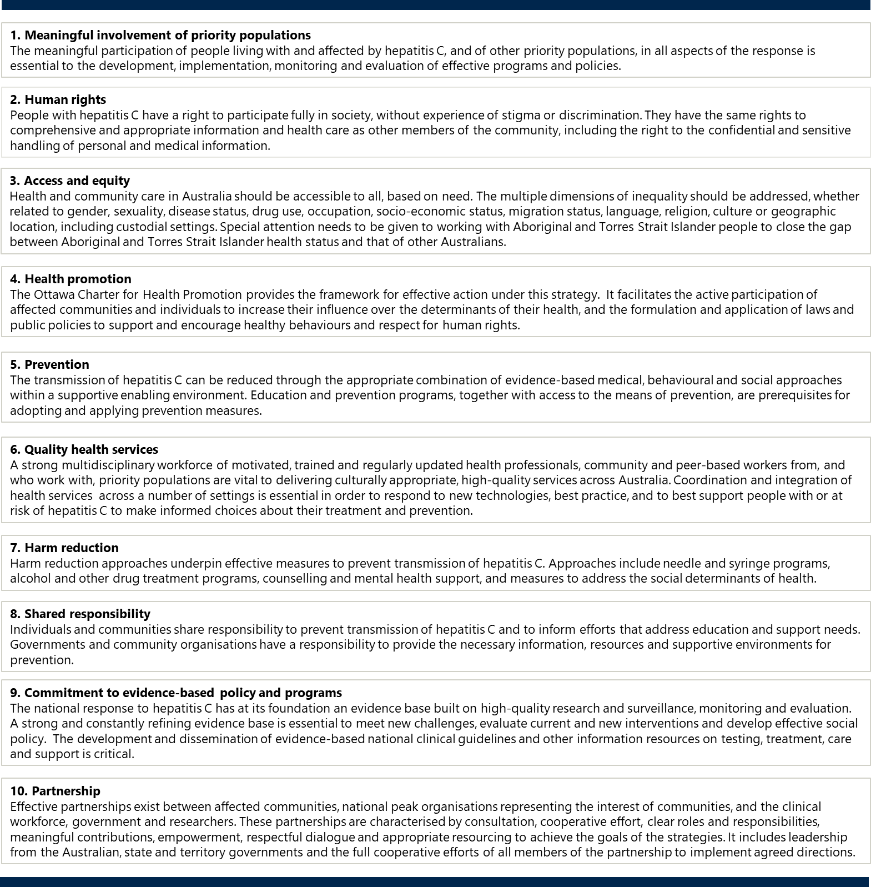

# 3 Snapshot of hepatitis C in Australia[2],[3],[4],[5]

Figure 2: Snapshot of hepatitis C in Australia

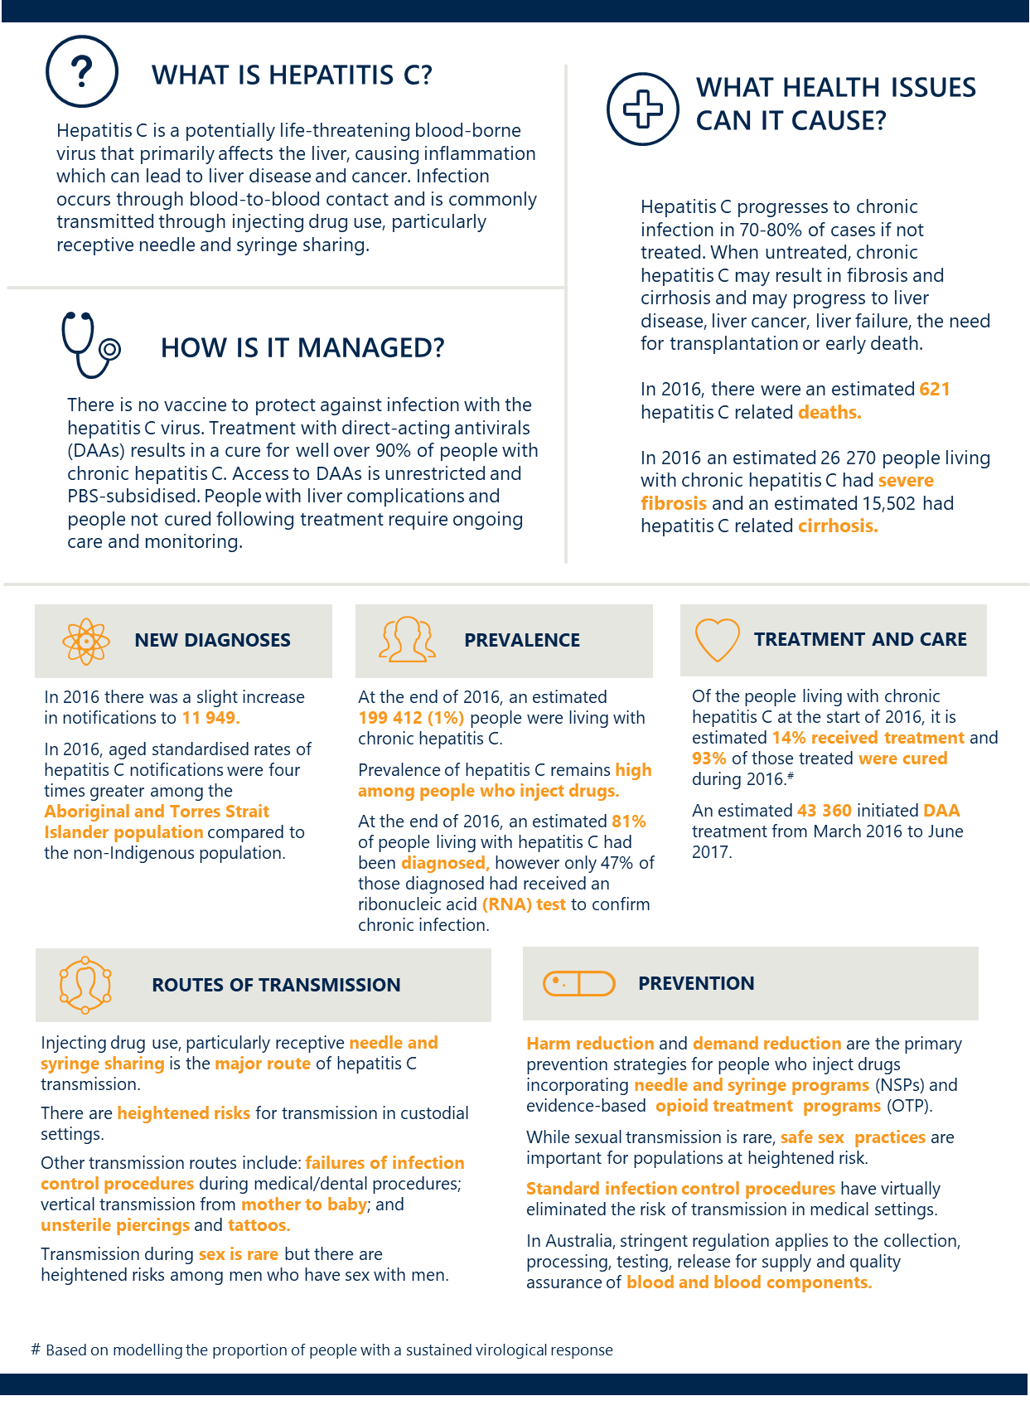

# 4 About this strategy

The Fifth National Hepatitis C Strategy sets the direction for Australia’s continuing response to hepatitis C for 2018 to 2022. It builds on achievements and lessons learned from previous strategies. It is one of five national strategies that, together, outline a framework for a high-quality and coordinated national response to BBV and STI in Australia. These five strategies are:

1. Third National Hepatitis B Strategy 2018–2022
2. Fifth National Hepatitis C Strategy 2018–2022 (this strategy)
3. Eighth National HIV Strategy 2018–2022
4. Fourth National Sexually Transmissible Infections Strategy 2018–2022
5. Fifth National Aboriginal and Torres Strait Islander Blood Borne Viruses and Sexually Transmissible Infections Strategy 2018–2022.

Each strategy has a specific focus but shares some structural elements, including guiding principles, goals, targets, priority areas (see Section 5, ‘Measuring progress’), and defined priority populations. Also, all five national BBV and STI strategies have key priority areas for action, including education and prevention, testing, treatment and management, equitable access and coordination of care, workforce, improving data and surveillance, and stigma and discrimination.

The Fifth National Hepatitis C Strategy aims to provide a framework for the efforts of all partners in the response to hepatitis C, guide resourcing decisions and monitor progress. It is informed by progress made under the Fourth National Hepatitis C Strategy 2014–2017;the effectiveness of current and past responses to hepatitis C in Australia and internationally; the identification of gaps and opportunities; and consultation with governments, community organisations, researchers, health professionals and other stakeholders across the country. This strategy is also informed by, and responds to, a range of surveillance data on hepatitis C in Australia and its impact on priority populations; and research providing evidence for new and emerging issues.

This strategy complements other jurisdictional, national and international policy documents that contribute to the hepatitis C response and supports the achievement of existing commitments. These include:

* state and territory viral hepatitis strategies
* National Drug Strategy 2017–2026
* National Strategic Framework for Aboriginal and Torres Strait Health Plan 2013–2023
* Aged Care Diversity Framework
* World Health Organization (WHO)Global Health Sector Strategy on Viral Hepatitis 2016–2021.

This strategy also supports progress towards Sustainable Development Goal 3 (‘Ensure healthy lives and promote well-being for all at all ages’) of the United Nations2030 Agenda for Sustainable Development*.*

This strategy acknowledges that some states and territories have set or may set different targets to drive progress and that the goals and targets of this strategy are intended to facilitate jurisdictional efforts. Wherever possible, jurisdictions are encouraged to match or exceed the targets of this strategy.

Further detail on the implementation of this strategy, including the associated action plan, is provided in Section 8, ‘Implementing this strategy’.

**PROGRESS UNDER THE FOURTH NATIONAL HEPATITIS C STRATEGY 2014–2017**

Progress under the Fourth National Hepatitis C Strategy 2014–2017 provides context for the achievements in Australia to date (see Figure 3). These achievements reflect the joint efforts of governments, community organisations, affected communities, researchers and health professionals through the partnership approach.

Figure 3: Key achievements under the Fourth National Hepatitis C Strategy 2014–20172,[6],[7],[8],[9]

|  |  |
| --- | --- |
| Image only | The treatment targets of the Fourth Strategy were exceeded. An estimated 43 360 people initiated treatment from the time of the Pharmaceutical Benefits Scheme listing in March 2016 to mid-2017 |
| Image only | An estimated 69 per cent of the 14 020 people living with cirrhosis in 2015 had initiated treatment by mid-2017 |
| Image only | Two prisons in Queensland and one in the Australian Capital Territory report achieving 80%–90% treatment uptake among inmates. Three prisons in New South Wales report having eliminated hepatitis C |
| Image only | The proportion of individuals prescribed direct-acting antiviral (DAA) treatment by GPs increased from 8% in March 2016 to 39% in June 2017, with a total of 22 per cent of individuals prescribed DAA treatment by GPs during this period |

Progress under the previous strategy has been notable in some areas. However, in others, there remain challenges to overcome.

In 2016, Australia was one of the first countries in the world to subsidise DAA treatment without any restrictions related to stage of liver disease or drug or alcohol use. Subsidisation was coupled with changed provisions allowing non-specialist and primary care prescribing of hepatitis C treatment to facilitate the broadest possible rollout of the cures which lay the foundation for the elimination of hepatitis C as a public health threat by 2030.

The following summarises progress in relation to the specific targets set under the previous strategy:

* Between March 2016, when the DAAs were subsidised, and mid-2017, 19 per cent (43 360) of the estimated 227 310 people living with hepatitis C initiated DAA treatment.2 Prior to this, in the interferon treatment era, annual subsidised treatment uptake had never exceeded 2 per cent of the prevalent population per annum.[10] This is significantly greater than the previous target of a 50 per cent increase in the number of people receiving antiviral treatment.
* Treatment uptake among people who inject drugs also improved, with the proportion of respondents to the 2016 Australian Needle and Syringe Program (NSP) Survey who reported treatment in the previous 12 months increasing to 22 per cent in 2016 from a base of 1 to 3 per cent in previous years.5
* Australia fell short of achieving a 50 per cent reduction in incidence.3 Hepatitis C incidence is difficult to measure accurately due to delays in diagnosis associated with the lack of defining symptoms at the time of infection and in the early stages of hepatitis C liver disease. However, trends in notifications among people under 25 years of age, who are likely to have acquired hepatitis C more recently, were stable from 2012 to 2016 (15–16 per 100 000 population).3

Receptive needle and syringe sharing, which is the main driver of new cases of hepatitis C, increased from 16 per cent in 2012 to 19 per cent in 2016 according to the Australian NSP Survey.5 This indicates that new cases of hepatitis C may continue to occur and that a focus on this particular risk exposure will be integral to reducing the incidence and prevalence of hepatitis C in Australia.

Based on the limited data available on Aboriginal and Torres Strait Islander status, the hepatitis C notification rate in the Aboriginal and Torres Strait Islander population in 2016 was 3.8 times higher compared to the non‑Indigenous population.11 This has increased from 2012 to 2016 (from 138 to 173 per 100 000 population) compared with a more stable notification rate in the non-Indigenous population over the same period.11 Also of great concern is the much higher notification rate among Aboriginal and Torres Strait Islander people under 25 years of age when compared with the non-Indigenous population (89 versus 14 per 100 000 population).[11] Aboriginal and Torres Strait Islander respondents to the 2016 Australian NSP survey were almost twice as likely to report receptive needle and syringe sharing as non-Indigenous respondents.5

While the impact of DAAs on reducing hepatitis C incidence is yet to be fully realised, the limited progress in reducing hepatitis C incidence suggests that a revitalised response is needed to engage priority populations in education and awareness of hepatitis C and its exposure risks and to support early testing, treatment and retention in ongoing care.

# 5 Measuring progress

This strategy has overarching goals, targets and priority areas which will guide the national response to hepatitis C for 2018–2022. Indicators and associated data sources for measuring progress towards each target are included in the Surveillance and Monitoring Plan for the five national BBS and STI strategies.

|  |
| --- |
| **Goals** |

* **Make significant progress towards eliminating hepatitis C as a public health threat**
* **Reduce mortality and morbidity related to hepatitis C**
* **Eliminate the negative impact of stigma, discrimination, and legal and human rights issues on people’s health**
* **Minimise the personal and social impact of hepatitis C**

|  |
| --- |
| **Targets** |

By the end of 2022:

Reduce the number of newly acquired hepatitis C infections, with a focus on priority populations,[12] by 60 per cent[13]

Increase the proportion of people living with hepatitis C who are diagnosed to 90 per cent

Increase the cumulative proportion of people living with chronic hepatitis C who have initiated direct-acting antiviral treatment to 65 per centb

Reduce hepatitis C attributable mortality overall by 65 per centb

Reduce by 50 per cent the reported experience of stigma among people living with hepatitis C, and the expression of stigma, in respect to hepatitis C status[14]

|  |
| --- |
| **Priority areas[15]** |

Improve knowledge and awareness of hepatitis C in the general community and priority populations, to support prevention of transmission and engagement in testing and treatment

Improve equitable access to successful preventative measures for all priority populations, with a focus on sterile injecting equipment through needle and syringe programs (NSPs)

Implement approaches that maximise the number of people living with hepatitis C who are diagnosed, and support the completion of confirmatory testing[16] and treatment for priority populations

Support health professionals to provide current, innovative and effective patient testing, and care for people living with hepatitis C

Continue to strengthen connections between priority populations, the healthcare workforce, and community organisations to facilitate coordination of care

Ensure equitable access to treatment and care for all priority populations, including people in custodial settings and people reinfected after cure

Implement a range of initiatives to address stigma and discrimination and minimise their impact on the health of people at risk of or living with hepatitis C

Continue to work towards addressing the legal, regulatory and policy barriers which affect priority populations and influence their health-seeking behaviours

Facilitate a highly skilled multidisciplinary workforce that is respectful of and responsive to the needs of people at risk of or living with hepatitis C

Continue to build a strong evidence base for responding to hepatitis C in Australia, informed by high‑quality, timely data and surveillance systems that underpin evidence-based local and national responses

# 6 Priority populations and settings

Hepatitis C disproportionately impacts on a number of key populations. This strategy identifies priority populations and settings (see Figure 4) and acknowledges that many individuals may identify with multiple priority populations and settings. This results in a diverse variety of intersecting characteristics and risk factors unique to each individual. In accordance with the guiding principle of access and equity, the unique challenges and experiences within all priority populations need to be considered in the response. This includes, but is not limited to, all gender expressions and experiences, disabilities, cultural and ethnic identities, different geographic settings, sexual orientations and religious affiliations.

While women, sex workers, gay men and other men who have sex with men (MSM) and people with HIV are not represented as distinct priority populations (see Figure 4), they are represented within many of the priority populations. It is important that the unique challenges and experiences of these groups in relation to hepatitis C are addressed in the response:

* Women with hepatitis C have a number of specialised needs related to their reproductive and sexual health and need accurate information to assist them to make informed decisions about their healthcare needs.[17],[18]
* Sex workers have a potentially increased risk of hepatitis C. There is a lack of high-quality data in relation to sex workers and hepatitis C which needs to be addressed in order to fully understand the burden of illness on this population. Sex workers face unique challenges, including structural barriers, widespread stigma and discrimination and lack of consistent anti-discrimination protections. This increases their vulnerability and prevents equitable access to services. Tailored approaches are required for sex workers who inject or have injected drugs, street-based sex workers, sex workers from culturally and linguistically diverse (CALD) backgrounds, and Aboriginal and Torres Strait Islander sex workers.
* Hepatitis C infection is a major cause of death amongst people with HIV.[19] HIV and hepatitis C co‑infected individuals have a reduced chance of spontaneous clearance of hepatitis C and increased risk of liver disease, cirrhosis and liver cancer compared with people without HIV.[20] Lack of condom use with casual partners was the key risk factor influencing transmission of hepatitis C among gay men and MSM, which emphasises the need for alignment and cross-education between hepatitis C and HIV prevention strategies.[21]

Figure 4: Priority populations for the Fifth National Hepatitis C Strategy 2018–2022

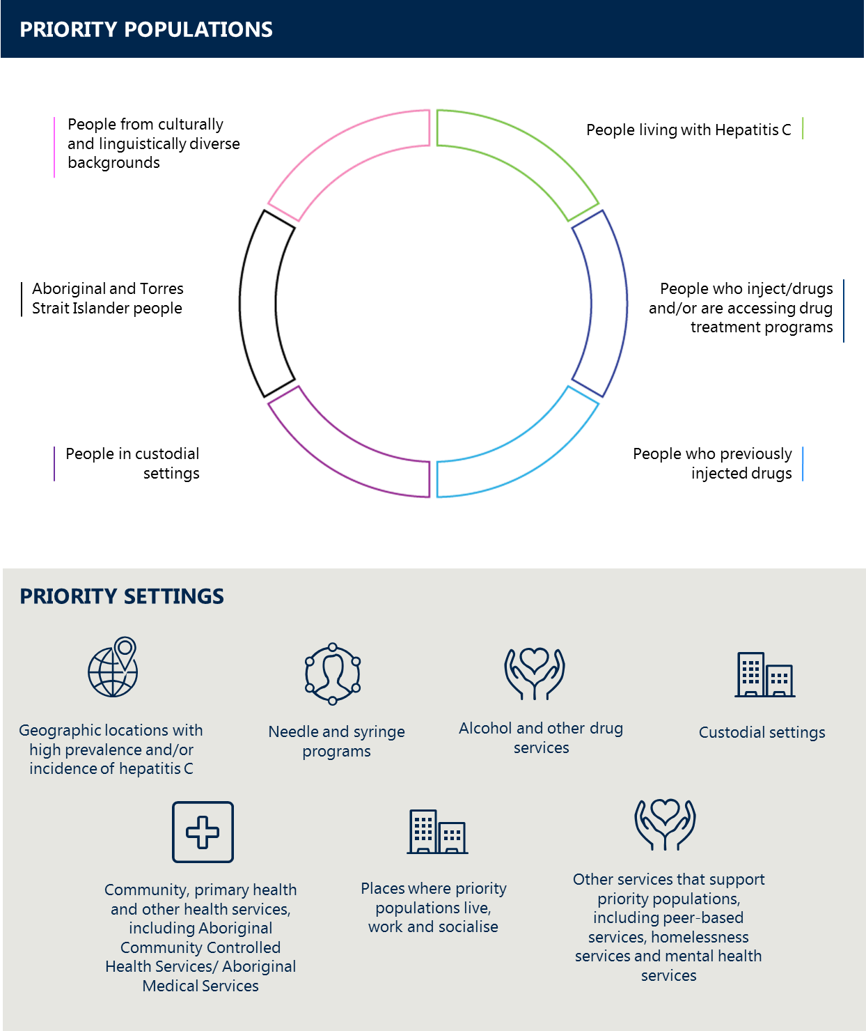

**NOTE: The graphic is not intended to reflect equal priority or prevalence among populations**

*People living with hepatitis C*

People living with hepatitis C includes individuals who are fully diagnosed, partially diagnosed (no RNA test) and not yet diagnosed. All people with risk factors for hepatitis C should be offered testing and, if found to be living with hepatitis C, offered DAA treatments. Successful treatment is associated with multiple clinical benefits, including improvement in quality of life, loss of infectivity, regression of cirrhosis, lower risk of liver failure and hepatocellular carcinoma, and reduction in mortality.10

Key sub-populations include:[22]

* + people who currently inject drugs
  + people who are accessing drug treatment programs
  + people who previously injected drugs and no longer do so
  + Aboriginal and Torres Strait Islander people
  + people in, or previously in, custodial settings
  + people born in countries with a high prevalence of hepatitis C
  + refugees and humanitarian entrants
  + people living with medically acquired hepatitis C
  + people living with hepatitis C who have a hepatitis B co-infection and/or HIV co-infection
  + children born to mothers with hepatitis C
  + gay men and other MSM with or without HIV co-infection
  + sex workers
  + people who have received tattoos and body piercings in unsterile conditions.

*People who inject drugs and/or are accessing drug treatment programs*

Receptive needle and syringe sharing is the primary cause of transmission in Australia. Therefore, education and prevention activities primarily target people who inject drugs, to reduce their own risk of acquiring hepatitis C and reduce the risk of transmission to others. People who inject drugs and/or are accessing drug treatment programs are also one of the key populations for hepatitis C testing and treatment programs.

Through analysis of surveillance data, key sub-populations have been identified as either having an increased risk of exposure to hepatitis C or having been historically affected by hepatitis C. Tailored approaches to education, awareness, prevention, testing and treatment that are socially and culturally appropriate will be needed for these groups. Key sub-populations include:

* + Aboriginal and Torres Strait Islander people
  + people in custodial settings
  + people from CALD backgrounds
  + sex workers
  + gay men and MSM with or without HIV co-infection
  + new initiates and people at risk of injecting, particularly young people.

*People who previously injected drugs*

People who previously injected drugs account for a high proportion of the hepatitis C prevalent population.[23] It is estimated that approximately two-thirds of people who have acquired hepatitis C through injecting drug use no longer inject drugs and therefore may not be identified by a health service or other provider as requiring access to hepatitis C testing and treatment.18 Different approaches to those used for other priority populations may be needed to reach and engage this important priority population.

*People in custodial settings*

People in custodial settings are at heightened risk of hepatitis C transmission due to the high hepatitis C prevalence among prison entrants4 and limitations on the delivery of evidence-based harm reduction and demand reduction programs such as provision of sterile needles and syringes, sterile tattooing and body piercings, and evidence-based opioid treatment programs (OTP). Current approaches to hepatitis C in these settings focus primarily on treatment. Opportunities for greater harm reduction and demand reduction services need to be explored.

*Aboriginal and Torres Strait Islander peoples*

Lack of access to testing and treatment, over-representation in custodial settings[24] and complex social and medical factors mean that Aboriginal and Torres Strait Islander people are more frequently exposed to environments and situations where there is an increased risk of exposure to hepatitis C. They are therefore disproportionately impacted compared with the non-Indigenous population.11 The development of enhanced programs to close this gap is facilitated by culturally appropriate education, prevention, testing, treatment and care programs being delivered through Aboriginal Community Controlled Health Services (ACCHS), Aboriginal Medical Services and mainstream services.

*People from culturally and linguistically diverse backgrounds*

People from CALD backgrounds include people born in countries with high hepatitis C prevalence, refugees and humanitarian entrants. Medical and dental procedures, transfusion of unscreened blood and blood products or occupational exposure are more common means of transmission of hepatitis C in some regions of the world when compared with Australia. Although country-dependent, injecting drug use through receptive needle and syringe sharing also remains a significant exposure risk internationally. People from CALD backgrounds who are at risk of or living with hepatitis C require culturally appropriate services and carefully adapted messaging to assist them to engage in testing, treatment and care for hepatitis C.

*Priority settings in which priority populations may be reached*

Service providers and other organisations that support priority populations are priority settings due to the contact they have with priority populations and the potential this offers for health promotion and connecting people to hepatitis C services.

The priority settings for delivery of education and prevention, testing, treatment and care services include:

* all primary healthcare services / general practice
* ACCHS and Aboriginal Medical Services
* NSPs
* alcohol and other drug services (AOD)
* custodial settings
* BBV / sexual health services
* geographical areas of higher hepatitis C prevalence
* regional, rural and remote areas with reduced access to relevant health and community services
* other medical and non-medical services that support priority populations such as hepatitis organisations, peer-based organisations, welfare services, educational institutions, youth centres, Aboriginal and Torres Strait Islander organisations, homelessness services, and mental health services (including forensic mental health facilities).

Peers play a vital role in support, education and health promotion across these settings.

# 7 Priority areas for action

*This strategy includes a set of priority areas for action designed to support the achievement of the goal and targets. Each priority area for action relates to one or more of the targets. It is the interaction of these actions as a whole that is essential to the achievement of this strategy.*

Australia’s strong enabling environment has supported the achievements made under the previous hepatitis C strategies and is vital in the implementation of the Fifth National Hepatitis C Strategy 2018–2022.

The priority areas for action build on the achievements and lessons learned in the response to hepatitis C since the first national strategy was released in 1999. This strategy is designed to address a number of key challenges and opportunities while recognising the need for flexibility to respond to other issues as they arise.

**EDUCATION AND PREVENTION**

*Improve knowledge and awareness of hepatitis C in the general community and priority populations, to support prevention of transmission and engagement in testing and treatment*

*Improve equitable access to successful preventative measures for all priority populations, with a focus on sterile injecting equipment through NSPs*

The transmission of hepatitis C can be prevented through targeted education, health promotion and evidence‑based harm reduction (for example, NSPs) and demand reduction strategies, such as drug treatment programs.

A person with hepatitis C may be unaware that they have the virus because obvious symptoms both at the time of transmission and in the early stages of liver disease are uncommon. This often leads to a substantial delay in diagnosis. During this time, further inadvertent transmissions can occur. It is crucial that priority populations have an understanding of hepatitis C transmission routes and risks.

The vast majority of new cases of hepatitis C in Australia occur among people who inject drugs, with receptive sharing of contaminated needles and syringes the predominant cause of these new infections.3 Therefore, prevention efforts are largely focused on addressing the risks associated with injecting drug use, including via peer education; and equitable access to prevention tools, such as sterile needles and syringes.

Prior infection with hepatitis C does not offer immunity, and reinfection following a cure can occur. It is therefore important that health promotion, education, regular testing and access to the means of prevention continue for people with ongoing risk of reinfection.

NSPs are a key tool in the prevention effort in Australia and play a valuable role in providing sterile injecting equipment. NSPs also play a key role in client education. They also refer clients to, and in some locations provide, hepatitis C testing and treatment services. NSPs are very cost-effective compared with other public health interventions. Past modelling over a 10-year period estimated that over 96 000 new hepatitis C infections were averted and, for every one dollar invested in NSPs, more than four dollars were returned (additional to the investment) in direct healthcare cost savings.[25] Evidence also supports the use of evidence-based OTP to assist in reducing or ceasing injecting drug use, in addition to NSPs, to reduce hepatitis C transmission.[26]

Custodial settings in Australia do not currently provide access to sterile needles and syringes or sterile tattooing and body piercing equipment. However, international research suggests that introduction of NSPs into Australian custodial settings would significantly impact on transmission of hepatitis C.[27],[28] There are also gaps in access to drug treatment programs in these settings.

There are also opportunities to improve access to NSPs in the general community. Options include needle dispensing machines or supply through other services open after hours, as these have shown strong utilisation by people who inject drugs.[29] NSP coverage in regional, rural and remote areas and within Aboriginal and Torres Strait Islander communities also needs to be established or enhanced.

Peers are credible, trusted sources of information and can assist in engaging hard-to-reach populations. A peer-based approach can be particularly useful in engaging people who inject drugs as well as young people at risk of injecting. Legal barriers to the peer distribution of sterile injecting equipment remain in the majority of jurisdictions, making it difficult to formalise this approach.

New curative DAA treatments provide the opportunity for ‘treatment as prevention of onward transmission’, as it has the potential to reduce overall hepatitis C incidence as the population of people living with hepatitis C diminishes.[30] Research on this approach among people who inject drugs and their networks is continuing and will inform the development of models of care for this high-risk priority population.

Sufficient safety information on the impact of these new hepatitis C treatments on pregnant women and their babies is not yet available.[31] Prevention of mother-to-child transmission should continue to focus on adequate physical prevention measures while supporting research on the safety of DAA treatment during pregnancy.

**Key areas for action**

1. Implement a national hepatitis C public education initiative which incorporates a focus on transmission routes, risks and evidence-based prevention strategies
2. Scale up access to tailored information, education and prevention programs (including peer-based programs, in-language and low literacy resources) targeting each priority population across priority settings, to improve hepatitis C‑related health literacy, promote transmission risk mitigation, and support engagement in testing and treatment
3. Facilitate the sharing of successful prevention approaches and initiatives and support the adaptation of successful approaches to other priority populations and settings, including custodial settings
4. Increase the availability and distribution of sterile injecting equipment and information on safer injecting among people who inject drugs across all priority settings, including facilitation of peer-based harm reduction initiatives, education and equipment distribution
5. Support an increase in the provision of and equitable access to evidence-based OTP in priority populations and priority settings and address key barriers to access

**TESTING, TREATMENT AND MANAGEMENT**

*Implement approaches that maximise the number of people living with hepatitis C who are diagnosed; and support the completion of confirmatory testing[32] and treatment for priority populations*

*Support health professionals to provide current, innovative and effective testing and care for people living with hepatitis C*

Regular testing of hepatitis C among priority populations and in priority settings enables not only early diagnosis but also access to curative treatment and education to prevent transmission. At the end of 2016 an estimated 19 per cent of people living with hepatitis C (~38 000 people) were undiagnosed.3

Australia has a National Hepatitis C Testing Policy[33] that includes details on indications for testing, diagnostic strategies and quality assurance. The principles of quality testing in Australia include that informed consent is required at all times, including in custodial settings; and that testing is voluntary, accessible, non‑discriminatory, confidential and of clear benefit to the individual being tested.

Gaps in application of recommended testing procedures are evident and suggest that a significant proportion of people who have been exposed to hepatitis C have been lost to follow-up. Of those estimated to have previously had an initial antibody test for hepatitis C at the end of 2016 (~161 500 people), less than half were estimated to have had a follow-up hepatitis C RNA test (~75 900 people) to confirm if they have evidence of infection.3

Finding everyone who is currently undiagnosed, partially diagnosed (no confirmatory RNA test) and/or not engaged in active management of their hepatitis C infection is essential in improving treatment uptake. A range of approaches are needed to support this, including a national hepatitis C public awareness initiative; tailored priority population education and testing programs, including linkages via peer educators; and active case-finding strategies. Consideration also needs to be given to improving the uptake of recommended testing procedures, including supporting follow‑up HCV RNA testing.

Efforts to increase testing for all people at risk of hepatitis C must be based on the principles of voluntary testing, informed consent and confidentiality which have underpinned the improvements in testing coverage achieved in Australia to date.

The role of peers in treatment promotion and support will be important to enhance engagement in testing and treatment and improve outcomes for otherwise hard-to-reach populations. NSPs, AOD and other services that target priority and vulnerable populations can also play an important role in reaching individuals in need of testing and treatment services who may not be engaged with primary healthcare services.

Testing services that provide culturally appropriate testing, tailored to the needs of specific groups, in a non‑stigmatising and non-discriminatory environment are more likely to be utilised by people who inject drugs and other priority populations. Engagement with priority populations may be improved through the use of rapid testing and point-of-care (POC) technologies when available.

Maintaining appropriate treatment uptake levels over the life of this strategy is critical in supporting the longer-term goal of eliminating hepatitis C as a public health threat by 2030.The prescribing arrangements for the new DAAs are expanded beyond specialists to include general practitioners (GPs) and authorised nurse practitioners. The transition of hepatitis C treatment to primary care settings has begun but is yet to be firmly established. In some jurisdictions specialist hepatitis C nurses are providing valuable services outside of hospitals to assist GPs with finding and testing people living with hepatitis C in community-based settings. It will be essential to build on this positive trend over the life of this strategy, particularly to support equitable access across locations and settings.

A range of supports are required to assist GPs, nurses and other health professionals working in primary care to take a central role in hepatitis C testing and treatment. This includes consideration of training, arrangements to initiate hepatitis C treatment, collaborations with peer-led and targeted treatment promotion strategies, supporting options for case finding and liver health assessments, strong links with specialist liver services, digital health initiatives and the role of Primary Health Networks. To assist prescribers, an Australian expert panel has developed a consensus statement to guide best-practice hepatitis C DAA treatment.[34]

The management of hepatitis C and its complications goes beyond DAA treatment. Access to specialist care is critical for the management of people living with hepatitis C who have more complex needs, such as those with liver cirrhosis or other major comorbidities and/or co-infections. Ongoing management of people with cirrhosis is vital due to the risk of developing hepatocellular carcinoma even if they are cured of hepatitis C.[35] In addition, the small proportion of people who are not cured following treatment require regular liver health assessments and need to be considered as candidates for new treatments. Innovative programs and solutions to provide specialist support, particularly in rural and remote areas, are important to facilitate the delivery of care in these locations. Specialist advice regarding the management of people living with hepatitis C who have co-infections with hepatitis B and/or HIV is also important.

**Key areas for action**

1. Incorporate information on new cures and how to access testing and treatment into the national hepatitis C public education initiative
2. Explore the use of rapid testing and point-of-care (POC) technologies where appropriate to improve access to testing and engagement with priority populations
3. Further develop and deliver evidence-based risk assessment and testing approaches for key priority populations which provide strong linkage to treatment
4. Identify opportunities to improve the application of recommended testing procedures for hepatitis C by clinicians, including the feasibility of automatic HCV RNA testing for priority populations
5. Support best-practice case finding, treatment and management for hepatitis C in all primary care settings
6. Develop and integrate peer-based support models that include people with lived experience of hepatitis C as peer navigators in diagnosis, treatment and care for all priority populations

**EQUITABLE ACCESS AND COORDINATION OF CARE**

*Continue to strengthen connections between priority populations, the healthcare workforce and community organisations to facilitate coordination of care*

*Ensure equitable access to treatment and care for all priority populations, including people in custodial settings and people reinfected after cure*

Innovative, multidisciplinary models of care for hepatitis C treatment and management are important, especially outside of metropolitan settings where access to some services can be limited. Approaches need to address the specific barriers and meet the needs of priority populations, including in regional, rural and remote communities, and to take into account the range of healthcare settings commonly used by priority populations.

To effectively reach priority populations, it is necessary to connect the healthcare workforce with other organisations that support and provide services to these priority populations. This includes strengthening the referrals and coordination between the healthcare workforce and hepatitis C community organisations, peer‑based organisations, AOD, ACCHS and mental health services. Collaborations between service providers and community organisations can support awareness-raising, health literacy, and establishment and maintenance of connection to care for priority populations.

Addressing hepatitis C in custodial settings and during the transition of people back into the community are key priorities. While the provision of medical services in custodial settings is generally the responsibility of state and territory governments, hepatitis C medicines are also available under the Highly Specialised Drugs (HSD) Program available to patients in prisons who meet certain eligibility requirements. The potential to enable authorised nurse practitioners to prescribe hepatitis C medicines under the HSD Program could be explored as a way of facilitating greater uptake of these medicines in custodial settings.

Nurse-led treatment programs have been successful in custodial settings in scaling up treatment and reducing hepatitis C prevalence,[36] and they are currently implemented in specific prisons in some jurisdictions.6,7,[37] Specialist hepatitis C nurses manage inmate engagement with the health service, with the prescriber maintaining oversight of the treatment process. This approach could also be considered in other settings where there is a high concentration of people living with hepatitis C.

Case management during the post-release transition period also offers benefits in supporting treatment adherence and follow-up testing and preventing hepatitis C reinfection. Post-release transition programs can be enhanced through collaborations with alcohol and other drug services, peer-based services and organisations and other services that engage with prisoners post-release.

While most people living with hepatitis C are able to be treated in primary care settings, approaches need to include engagement with specialist services, particularly for people with liver cirrhosis and other complex comorbidities and co-infections and people who have not been cured following treatment. Models of care need to provide increased options for assessment of liver disease outside of specialist settings, including access to and knowledge of the non-invasive diagnostic tools for assessing liver disease severity.

Key areas for action

1. Support models of care that provide effective testing, treatment and management of people living with hepatitis C in primary health settings, including links and referral pathways to specialist and multidisciplinary services
2. Identify opportunities to improve patient management systems to better support the primary care workforce to promptly identify and provide treatment and care for people living with hepatitis C
3. Improve the coordination of hepatitis C treatment services and other service providers, including general practice, Aboriginal and Torres Strait Islander health services, AOD, NSPs, sexual health services, peer-based services and mental health services to better link people at risk of or living with hepatitis C to prevention, testing, and relevant follow-up and management
4. Enhance partnerships between jurisdictional health and justice systems and facilitate knowledge sharing across jurisdictions regarding prevention, testing, treatment and support services for inmates and those recently released
5. Identify and trial opportunities to increase access to prevention, testing and treatment in custodial settings
6. Establish and support nurse-led and other treatment programs in custodial settings, review prescribing arrangements for authorised nurse practitioners in these settings, and develop systems for active case management of people released from prison upon re-entry into the community
7. Explore the inclusion of hepatitis C related key performance indicators, aligned to the targets of this strategy, for organisations central to the delivery of hepatitis C programs or services, including Primary Health Networks and custodial facilities

**ADDRESSING STIGMA AND CREATING AN ENABLING ENVIRONMENT**

*Implement a range of initiatives to address stigma and discrimination and minimise their impact on the health of people at risk of or living with hepatitis C*

*Continue to work towards addressing the legal, regulatory and policy barriers which affect priority populations and influence their health-seeking behaviours*

An enabling legal and policy environment that addresses criminalisation, stigma and discrimination, and human rights issues will help to increase access to services and improve the health and wellbeing of people living with hepatitis C. Access to health prevention information and health services is improved where supporting and enabling environments are created free from stigma and discrimination and legal barriers to health promotion activities.

Discrimination and stigma associated with hepatitis C is a key issue to address, as it can have a significant impact on health outcomes, relationships and employment prospects and can lead to social isolation and poor mental health. Fear of stigma and discrimination and of being judged can prevent people from attending health services to discuss their risk of hepatitis C, requesting a hepatitis C test, and taking up and continuing care. It also may deter people from seeking support from their family and friends.

The close connection between hepatitis C and injecting drug use, and disapproval of injecting drug use and fear of the contagion, drives much of the hepatitis C related stigma.[38] In a 2016 online survey completed by 123 people, more than half (56 per cent) reported experiencing stigma within the previous 12 months related to their hepatitis C status and two-thirds (65 per cent) reported some instances of being treated negatively by health workers[39]—findings that are supported by international research.[40],[41] While this is a small sample and further data is needed, it does suggest that additional effort to eliminate the negative effects of stigma is needed.

The stigma and discrimination experienced by people living with hepatitis C can also be influenced by individual characteristics and the stigma and discrimination associated with those characteristics. These include sexual orientation, gender identity, cultural background, migrant or refugee status, disability, people with HIV and being a sex worker. Strategies to address stigma and discrimination must acknowledge and account for intersecting stigmas.

Everyone working with people at risk of, or living with, hepatitis C requires an understanding of the impact of stigma and discrimination on access to healthcare services. Education in relation to stigma in healthcare settings is considered an integral part of training programs for staff of all specialist, primary healthcare and community-based service providers.

Australia’s strong support for an enabling policy and legal environment for people who inject drugs is demonstrated by the funding of NSP services in the community. The absence of this same evidence-based harm reduction service in custodial settings is a policy gap in the hepatitis C prevention effort. The increased possibility of contact with exposure risks for hepatitis C in custodial settings needs to be addressed by a comprehensive suite of evidence-based harm reduction programs. Aspects of social disadvantage are compounded in custodial settings.

Australia has publicly funded NSPs in the community since the 1980s, many years ahead of some other countries. Peer-based approaches, including sharing of sterile injecting equipment to prevent transmissions, are particularly important for highly marginalised individuals who are often less likely to engage with a NSP service on their own. Peer distribution of sterile injecting equipment within an injecting network has been demonstrated to prevent acquisition of a BBV, despite this being outlawed in some jurisdictions.[42]

**Key areas for action**

1. Incorporate messaging to counteract stigma into the national hepatitis C public education initiative
2. Monitor laws, policies, stigma and discrimination which impact on health-seeking behaviour among priority populations and their access to testing and services; and work to ameliorate legal, regulatory and policy barriers to an appropriate and evidence-based response
3. Review and address institutional, regulatory and system policies which create barriers to equality of prevention, testing, treatment, care and support for people living with hepatitis C and priority populations
4. Implement initiatives in the community and healthcare settings aimed at minimising stigma and discrimination against people living with hepatitis C, people who inject drugs and other priority populations

**WORKFORCE**

*Facilitate a highly skilled multidisciplinary workforce that is respectful of and responsive to the needs of people at risk of or living with hepatitis C*

The provision of best-practice hepatitis C prevention, testing, treatment and care is founded on a highly skilled workforce that is respectful of and responsive to the needs of people at risk of or living with hepatitis C. A strong multidisciplinary workforce of trained and motivated health professionals, community health workers and peer workers who work with priority populations is vital to the delivery of culturally appropriate and high-quality services for vulnerable and marginalised populations, including those who may not readily access hepatitis C treatment services.

Identifying opportunities for workforce capacity building, knowledge sharing and upskilling is critical for improved service delivery. The prescribing arrangements for the new DAAs represent a significant practice change for primary care settings. This requires education and other support for the primary care workforce. Embedding these changes into routine practice may be assisted through support for early detection and treatment of hepatitis C and involvement in BBV training.

The continued availability of evidence-based, responsive and accessible national clinical guidelines and tools has an essential role in supporting the provision of effective hepatitis C prevention and care. Guidelines must be coupled with education and training to support implementation and build workforce capacity and capability.

Issues in relation to recruitment and retention of staff need to be addressed, particularly in rural and remote areas, to ensure that the required expertise, capability and capacity exists in all areas. Innovative models of care adapted to local contexts can assist in addressing such challenges by appropriately utilising the skills of the broader clinical and community health workforce, including nursing professionals, pharmacists, Aboriginal and Torres Strait Islander Health Workers, community health workers and peer workers. Aboriginal and Torres Strait Islander Health Workers and jurisdictional Aboriginal health councils need to be supported to engage in hepatitis C prevention and care. Opportunities to facilitate the provision of more nurse-led services should be a particular focus, including required education, professional development and specialisation opportunities.

**Key areas for action**

1. Implement targeted initiatives to facilitate a highly skilled clinical and community sector workforce, including the use of online learning, web-based resources, mobile applications and face-to-face learning opportunities
2. Continue to prioritise education and resources to support GPs and other prescribers in prescribing DAAs, managing patient care, and utilising available multidisciplinary referral pathways
3. Support community organisations, the healthcare workforce and peer workers to increase their engagement with priority populations to improve health literacy and connection to care
4. Facilitate and support the involvement of the primary care workforce in the early detection and treatment of hepatitis C, including access to remote support for those new to treating hepatitis C, upskilling and training, and other approaches
5. Support the continued provision, dissemination and maintenance of evidence-based, responsive and accessible national clinical guidelines and other information resources on testing, treatment, care and support for people living with hepatitis C that are adapted to the needs of the workforce
6. Continue to explore and share experiences of innovative models of care for hepatitis C prevention and management, particularly models for rural and remote areas and areas of workforce shortage

**DATA, SURVEILLANCE, RESEARCH AND EVALUATION**

*Continue to build a strong evidence base for responding to hepatitis C in Australia, informed by high‑quality, timely data and surveillance systems that underpin evidence-based local and national responses*

Continuous improvement of data collections and systems is important to support a comprehensive understanding of the burden of BBV and STI in Australia and to monitor the impacts of interventions. However, this must be appropriately targeted to ensure its effective utility and balanced to avoid unnecessary burden for health services and frontline staff.

There is a need to improve the timeliness and consistency of data collections across Australia to better support their completeness and comparability. Opportunities to improve the granularity of data need to be explored to better understand the true incidence and prevalence of hepatitis C and identify trends and issues of concern in relation to specific priority and sub-populations and other demographics. Data on Aboriginal and Torres Strait Islander status and country of birth are important in informing the national response to hepatitis C for Aboriginal and Torres Strait Islander people and people from CALD backgrounds, respectively. A lack of high-quality data on the prevalence of hepatitis C among sex workers was identified by the previous strategy and still exists. Collection and analysis of this data on a national level remains fragmented, and it is an important focus in the implementation of this strategy.

Other areas for attention include the collection of data on stigma and discrimination and gender and sexuality, and opportunities for greater involvement of community and peer-based organisations in surveillance given their strong knowledge of priority populations. Collection and analysis of data would also support a greater understanding of the burden and impact of hepatitis C in aged care settings in Australia and any challenges which could be addressed by future strategies. It is currently not possible to analyse data on the incidence of hepatitis C reinfections at a national level. Enabling and exploring data linkages would allow for this data to be collected and appropriate actions developed to minimise reinfection in priority populations in the future.

Research guides the development, implementation and evaluation of policies and programs at all levels of the national response to hepatitis C. Social, behavioural, epidemiological, clinical and basic research is important in developing a strong evidence base for managing and preventing BBV and STI in the community. Research is needed to more fully understand the impact of hepatitis C in priority populations and communities. It must be linked to the needs of affected communities, particularly people who inject or have injected drugs.

Partnerships between research institutes, health professionals, community-based organisations and peer‑based organisations are valuable, as community-based organisations are often the first to identify changes in behaviours, social interactions and demographics of priority populations due to their direct contact with affected communities.

**Key areas for action**

1. Identify opportunities to improve the timeliness and consistency of data collections
2. Implement initiatives to improve data completeness of Aboriginal and Torres Strait Islander status and country of birth in clinical and pathology settings; and for collecting data on the impact of hepatitis C on sex workers in Australia
3. Investigate opportunities to better measure incidence and prevalence of hepatitis C in the community, including linkage of data on the incidence of reinfection
4. Identify gaps in surveillance data for measuring and monitoring the implementation of this strategy and prioritise these for action
5. Improve surveillance of issues that impact people living with hepatitis C, including stigma and discrimination and quality of life measures
6. Promote a balance of social, behavioural, epidemiological and clinical research to better inform all aspects of the response
7. Ensure current and future programs and activities are evaluated to ensure linkage and alignment to the priority areas of this strategy

# 8 Implementing this strategy

**Leadership, partnership and connections to community**

Australia’s response to hepatitis C is built on a model of partnership between government, community‑based organisations, researchers, health professionals and priority populations. The partnership approach depends on clear leadership roles and accountabilities for all involved.

The Australian Government is committed to providing strong national leadership by working across portfolios and jurisdictions to achieve the goals of this strategy. The Australian Government Department of Health leads the coordination of the national response to hepatitis C under the National Hepatitis C Strategy. However, the success of this strategy is contingent on productive partnerships between Australian, state and territory governments and partners, including peak organisations representing communities, health professionals, researchers and others. In the case of research on BBV and STI, it is imperative that this is conducted in partnership with communities and aligned with the priorities of the national strategies.

National community and health peak organisations, and other organisations, representing priority populations and the clinical workforce remain at the forefront of the response to hepatitis C in Australia. Organisations including Hepatitis Australia and the Australian Injecting and Illicit Drug Users League, along with the Australasian Society for HIV, Viral Hepatitis and Sexual Health Medicine; Scarlet Alliance, Australian Sex Workers Association; the Gastroenterological Society of Australia; Australian Liver Association; Australasian Society for Infectious Diseases; and the Australasian Hepatology Association, and the relationship these organisations have with their members, have a critical role to play in the implementation of this strategy.

**Action plan**

The National BBV and STI Strategies Action Plan 2018–2022 provides the detail of specific actions for governments and partners. The action plan outlines the roles and responsibilities of governments and partners and the time frames for implementation of the actions. Indicators for measuring the progress towards achievement of the strategies’ targets will also be developed. The action plan will be reviewed as required during the lifetime of the strategies.

The five national BBV and STI strategies share a number of key actions related to areas such as workforce, improving data and surveillance, education programs, and stigma and discrimination. The action plan will focus on encouraging connections between existing programs and policies, and build on previously successful approaches, to minimise duplication of effort. It will also look for opportunities to learn from and adapt responses used for other diseases where relevant.

**Governance, reporting and evaluation**

The five national BBV and STI strategies are endorsed by Australia’s Health Ministers and governed through relevant committees of the Australian Health Ministers’ Advisory Council (AHMAC). The Blood Borne Viruses and Sexually Transmissible Infections Standing Committee (BBVSS) coordinates implementation efforts across jurisdictions and reports to the Australian Health Protection Principal Committee (AHPPC) on progress in the implementation of the national strategies. BBVSS and the Communicable Diseases Network Australia (CDNA) will jointly monitor progress towards the targets of each strategy and identify emerging issues and opportunities for action.

**Surveillance and monitoring plan**

The National BBV and STI Surveillance and Monitoring Plan 2018–2022 supports the five national BBV and STI strategies and informs and monitors progress on achieving the goals and targets of each strategy. A subcommittee of the CDNA is responsible for overseeing the Surveillance and Monitoring Plan and reporting on progress to the CDNA and BBVSS.

Appendix A References

1. Scott, N. E., S. McBryde, A. Thompson, J. S. Doyle, and M. E. Hellard. (2016). ‘Treatment scale-up to achieve global hepatitis C virus incidence and mortality elimination targets: a cost-effectiveness model.’ Gut, **77**(8):1507–1515.
2. The Kirby Institute. (2017). Monitoring hepatitis C treatment uptake in Australia, Issue 8. Accessed 20 February 2018 at: <https://kirby.unsw.edu.au/sites/default/files/kirby/report/Monitoring-hep-C-treatment-uptake-in-Australia_Iss8-DEC17.pdf>
3. The Kirby Institute. (2017). HIV, viral hepatitis and sexually transmissible infections in Australia, Annual Surveillance Report 2017. University of New South Wales (UNSW): Sydney.
4. The Kirby Institute. (2017). National Prison Entrants’ Bloodborne virus and risk behaviour survey report, 2004, 2007, 2010, 2013 and 2016. UNSW Sydney: Sydney.
5. The Kirby Institute. (2017). Australian Needle Syringe Program Survey National Data Report 2012-2016: Prevalence of HIV, hepatitis C and injecting and sexual behaviour among NSP attendees. UNSW Sydney: Sydney.
6. ACT Government. (2017). World Hepatitis Day 2017: Effective treatment reducing Hepatitis C rates in AMC. Accessed 27 February 2017 at: <https://www.cmtedd.act.gov.au/open_government/inform/act_government_media_releases/rattenbury/2017/world-hepatitis-day-2017-effective-treatment-reducing-hepatitis-c-rates-in-amc>
7. Russell, D. B., P. Fox, H. Cabatingan *et al.* (2017). A regional prison cleared of hepatitis C in less than 12 months. Keynote presentation at the Australian Viral Hepatitis Elimination Conference 2017, 10 August 2017.
8. The Kirby Institute. (2016). National Blood-borne viruses and Sexually Transmissible Infections—Surveillance and Monitoring Report, 2016. UNSW Sydney: Sydney.
9. Bartlett, S. R., P. Fox, H. Cabatingan *et al.* (2018). ‘Demonstration of near-elimination of hepatitis C virus among a prison population: the Lotus Glen Correction Centre hepatitis C treatment project.’ Clinical Infectious Diseases, Early Manuscript.
10. The Kirby Institute. (2004–2017). HIV, viral hepatitis and sexually transmissible infections in Australia, Annual Surveillance Reports 2004-2014. UNSW Sydney: Sydney.
11. The Kirby Institute. (2017). Bloodborne viral and sexually transmissible infections in Aboriginal and Torres Strait Islander people, Annual Surveillance Report 2017. UNSW Sydney: Sydney.
12. This includes the priority populations, as described in Section 6 below. Specific targets for Aboriginal and Torres Strait Islander people are included in theFifth National Aboriginal and Torres Strait Islander Blood Borne Viruses and Sexually Transmissible Infections Strategy 2018–2022.
13. Compared with / based on 2016 data.
14. Baseline to be determined.
15. Links to Section 7, ‘Priority areas for action’. Priority population and priority settings are described in Section 6, ‘Priority populations and settings’.
16. Refers to the utilisation of an RNA confirmation test in accordance with testing protocols.
17. Gifford, S. M., M. L. O’Brien, G. Bammer, C. Banwell, and M. Stoove. (2003). ‘Australian women’s experiences of living with hepatitis C virus: results from a cross-sectional survey.’ Journal of Gastroenterology and Hepatology, **18**(7):841–850.
18. Hepatitis Australia. (2015). Women and Hepatitis C. Accessed 9 April 2018 at: <https://www.hepatitisaustralia.com/living-with-hepatitis-c/women-and-hepatitis-c>.
19. Wansom, T., O. Falade-Nwulia, C. G. Sutcliffe *et al.* (2017). ‘Barriers to Hepatitis C Virus (HEPATITIS C) Treatment Initiation in Patients With Human Immunodeficiency Virus/HEPATITIS C Coinfection: Lessons From the Interferon Era.’ Open Forum Infectious Diseases, **4**(1):ofx024.
20. Wyles, D.L., M. S. Sulkowski, and D. Dieterich. (2016). ‘Management of Hepatitis C/HIV Coinfection in the Era of Highly Effective Hepatitis C Virus Direct-Acting Antiviral Therapy.’ Clinical Infectious Diseases, **63**(Supp. 1):S3–S11.
21. Scott, N., M. Stoové, D. P. Wilson *et al.* (2018). ‘Eliminating hepatitis C virus as a public health threat among HIV-positive men who have sex with men: a multi-modelling approach to understand differences in sexual risk behaviour.’ Journal of the International AIDS Society, **21**(1):10.1002/jia2.25059.
22. World Health Organization. (2017). Hepatitis C Fact Sheet. Published October 2017. Accessed 15 March 2018 at: <http://www.who.int/mediacentre/factsheets/fs164/en/>
23. Dore, G. (2017). Hepatitis C: The treatment landscape in 2017—on the road to HCV elimination? Presented at the 2017 Australasian Viral Hepatitis Elimination Conference, 10 August 2017.
24. Australian Institute of Health and Welfare (AIHW). (2015). The health of Australia’s prisoners 2015. AIHW: Canberra.
25. Department of Health. (2009). Return on investment 2: evaluating the cost-effectiveness of needle and syringe programs in Australia. Accessed 27 February 2018 at: <http://www.health.gov.au/internet/main/publishing.nsf/content/A407CF4FECBDC715CA257BF0001F98B2/%24File/return2.pdf>
26. Turner, K., S. Hutchinson, P. Vickerman *et al.* (2011). ‘The impact of needle and syringe provision and opiate substitution therapy on the incidence of hepatitis C virus in injecting drug users: pooling of UK evidence.’ Addiction, **106**(11):1978–1988.
27. Australasian Society for HIV, Viral Hepatitis and Sexual Health Medicine (ASHM). (2016). Prisons Could Unlock Hepatitis C Free Future [press release], 8 September 2016. Accessed 23 February at: <http://www.ashm.org.au/news/prisons-could-unlock-hepatitis-c-free-future/>
28. Stoové, M., C. J. Treloar, L. Maher, H. Tyrell, and J. Wallace. (2015). ‘Salvaging a prison needle and syringe program trial in Australia requires leadership and respect for evidence.’ Medical Journal of Australia, **203**(8):319–320.
29. Islam, M. M., and K. M. Conigrave. (2007). ‘Assessing the role of syringe dispensing machines and mobile van outlets in reaching hard-to-reach and high-risk groups of injecting drug users (IDUs): a review.’ Harm Reduction Journal, **4**:14.
30. Hellard, M. D., A. Rolls, R. Sacks-Davis *et* al. (2014) ‘The impact of injecting networks on hepatitis C transmission and treatment in people who inject drugs.’ Hepatology, 60(6):1861–1870.
31. Spera, A. M., R. K. Eldin, G. Tosone, and R. Orlando. (2016). ‘Antiviral therapy for hepatitis C: has anything changed for pregnant/lactating women?’ World Journal of Hepatology, **8**(12):557–565.
32. Refers to the utilisation of an RNA confirmation test in accordance with testing protocols.
33. ASHM. (2016). National Hepatitis C Testing Policy. Accessed 27 February 2018 at: <http://testingportal.ashm.org.au/images/HCV/HCV_TESTING_POLICY_Mar_2017.pdf>
34. Gastroenterological Society of Australia. (2017). Hepatitis C Treatment. Accessed 27 February 2018 at: <http://www.gesa.org.au/resources/hepatitis-c-treatment/>
35. Baumert, T. F., F. Jühling, A. Ono, and Y. Hoshida. (2017). ‘Hepatitis C-related hepatocellular carcinoma in the era of new generation antivirals.’ BMC Medicine, **15**(52):1–10.
36. Lloyd, A. R., J. Clegg, J. Lange *et al.* (2013). ‘Safety and effectiveness of a nurse-led outreach program for assessment and treatment of chronic hepatitis C in the custodial setting.’ Clinical Infectious Diseases, **56**(9):1078–1084.
37. Department of Health and Human Services Victoria. (2016). ‘Highlight: Prison Programs.’ In: Victorian hepatitis C strategy 2016–2020, p. 15.
38. Richmond, J. A., T. L. Dunning, and O. V Desmond. (2007). ‘Health professionals’ attitudes toward caring for people with hepatitis C.’ Journal of Viral Hepatitis, **14**(9):624–632.
39. Cama, E., L. Brener, M. Hopwood, J. de Wit, and C. Treloar. (2017). Stigma Indicators Monitoring Project—Final Report. Centre for Social Research in Health (CSRH), UNSW: Sydney.
40. Marinho, R. T, and D. P. Barreira. (2013). ‘Hepatitis C, stigma and cure.’ World Journal of Gastroenterology, **19**(4):6703–6709.
41. Butt, G. (2008). ‘Stigma in the context of hepatitis C: concept analysis.’ Journal of Advanced Nursing, **62**(6):712–724.
42. Treloar, C. (2016). Peer distribution of sterile injecting equipment: UNSW and Monash research supports recent change of laws in three Australian jurisdictions. CSRH, UNSW: Sydney.