**Eighth National HIV Strategy 2018–2022**

This page is intentionally blank.

Contents

1 Introduction 2

2 Guiding principles 2

3 Snapshot of HIV in Australia 2

4 About this strategy 2

5 Measuring progress 2

6 Priority populations and settings 2

7 Priority areas for action 2

8 Implementing this strategy 2

Appendix A References 2

This page is intentionally blank

# Introduction

Since the first cases of AIDS and the discovery of HIV 35 years ago, Australia has made a concerted and sustained effort to respond to the virus. Australia’s domestic response to HIV is regarded internationally as a world-leading model of best practice. Australia has a national HIV incidence lower than many other comparable high-income countries.[1]

Despite Australia’s success, there is a need to bolster and realign efforts in response to the changes of HIV incidence within priority populations and the changing contribution of risk exposures. Gay men and other men who have sex with men (MSM) continue to bear a high burden of HIV in Australia, and our response needs to maintain a strong focus on this priority population. However, achieving and maintaining low rates of HIV in other populations is also of critical importance. This includes responding to increases in HIV transmission among Aboriginal and Torres Strait Islander people and among heterosexuals. Protecting Australia’s achievements in the virtual elimination of HIV among sex workers, mother to child transmission and in people whoinject drugs[2] is also essential.Ensuring all people with HIV and those at risk are linked to quality prevention, testing, treatment, care and support services is a priority for Australia, as is addressing HIV-related stigma and discrimination.

Figure 1: Blood Borne Viruses and Sexually Transmissible Infections Standing Committee (BBVSS)

Peak organisations

Australian Federation of AIDS Organisations (AFAO)

Australian Indigenous Doctors’ Association (AIDA)

Australian Injecting and Illicit Drug Users League (AIVL)

Australasian Society for HIV, Viral Hepatitis and Sexual Health Medicine (ASHM)

Hepatitis Australia

National Association of People with HIV Australia (NAPWHA)

Scarlet Alliance, Australian Sex Workers Association

State and territory governments

ACT Health

NSW Ministry of Health

NT Department of Health

Queensland Health

SA Department for Health and Wellbeing

Tasmanian Department of Health and Human Services

Victorian Department of Health and Human Services

WA Department of Health

Australian Government Department of Health

*BBVSS is a key advisory body reporting to the Australian Health Ministers’ Advisory Council through the Australian Health Protection Principal Committee on strategic policy, programs, social issues and activities related to HIV, viral hepatitis and sexually transmissible infections (STI).*

Australia’s response to HIV needs to capitalise on the promise offered by new technologies and advancements. Medical advances in the treatment of HIV include the availability of more potent, convenient and well-tolerated antiretroviral treatments that allow people with HIV to begin treatment immediately and improve both short- and long-term health outcomes. Research to date has found that people with HIV who take antiretroviral treatment daily as prescribed and achieve and maintain sustained viral suppression[3] have effectively no risk of sexually transmitting the virus to a HIV-negative partner.[4],[5],[6],[7] This is known as undetectable equals untransmittable (U=U) and Treatment as Prevention (TasP).

Australia has made significant steps towards providing equitable access to pre-exposure prophylaxis for people at medium and high risk. This, combined with high rates of testing and treatment, has the potential to considerably advance our response to HIV.

Meeting and exceeding international HIV obligations and targets is a critical part of Australia’s response. Internationally, Australia supports the 2016 United Nations Political Declaration on HIV and AIDS: On the Fast-Track to Accelerating the Fight against HIV and to Ending the AIDS Epidemic by 2030,[8] which provides a global framework for action on HIV. The declaration endorses the UNAIDS 90–90–90 HIV treatment targets.[9] The aim of these targets is that, by 2020, 90 per cent of all people with HIV will know their HIV status, 90 per cent of all people with diagnosed HIV infection will receive sustained antiretroviral therapy (treatment coverage) and 90 per cent of all people receiving antiretroviral therapy will have viral suppression. Australia is on track to achieving these targets ahead of 2020, and sights are now set on achieving the UNAIDS Fast-Track 95–95–95 global targets to end the HIV epidemic.[10]

However, we need to do more than achieve these international targets if we are to reach our goal of virtual elimination of HIV transmission, achieve longer and healthier lives for people with HIV and eliminate stigma and discrimination. A concerted effort is needed by all Australian governments, clinicians, researchers, community and professional organisations, and individuals, to support action in key areas and accelerate an effective and equitable response to HIV. The meaningful involvement of people with HIV and all priority populations is critical to ensuring our efforts are inclusive, responsive and connected to the needs and concerns of these communities.

Since the first national HIV strategy in 1989, Australia’s response has been underpinned by a partnership approach between the Australian Government, state and territory governments, people with and affected by HIV, community organisations, researchers and clinicians.

The Australian Government acknowledges the significant contribution of people with HIV and the national community and health peak organisations, and other organisations, representing communities and the clinical workforce over the course of the previous HIV strategies. These organisations, including the Australian Federation of AIDS Organisations; the National Association of People with HIV Australia; the Australian Injecting and Illicit Drug Users League; Scarlet Alliance, Australian Sex Workers’ Association; and the Australasian Society for HIV, Viral Hepatitis and Sexual Health Medicine have played a critical role in the success of Australia’s response to HIV. This strong foundation and the commitment and work of all partners means that Australia remains well placed to build on the successes of theSeventh National HIV Strategy 2014–2017,realise gains for all priority populations,and achieve the goal of becoming one of the first countries to virtually eliminate new HIV transmissions.

*Gratitude is expressed to those who participated in the stakeholder consultations and contributed to the strategy development process—in particular, the members and organisations represented on the Blood Borne Viruses and Sexually Transmissible Infections Standing Committee (see Figure 1).*

# Guiding principles[11]

The Eighth National HIV Strategy 2018–2022 includes guiding principles to support a high-quality, evidence-based and equitable response to HIV. These are included in each of the blood borne viruses (BBV) and sexually transmissible infections (STI) strategies and are drawn from Australia’s efforts over time to respond to the challenges, threats and impacts of HIV, viral hepatitis and STI. Perhaps most critical is the ongoing and meaningful participation of people with HIV and affected communities in all aspects of the response. This is central to the partnership approach and is key to the success of this strategy.

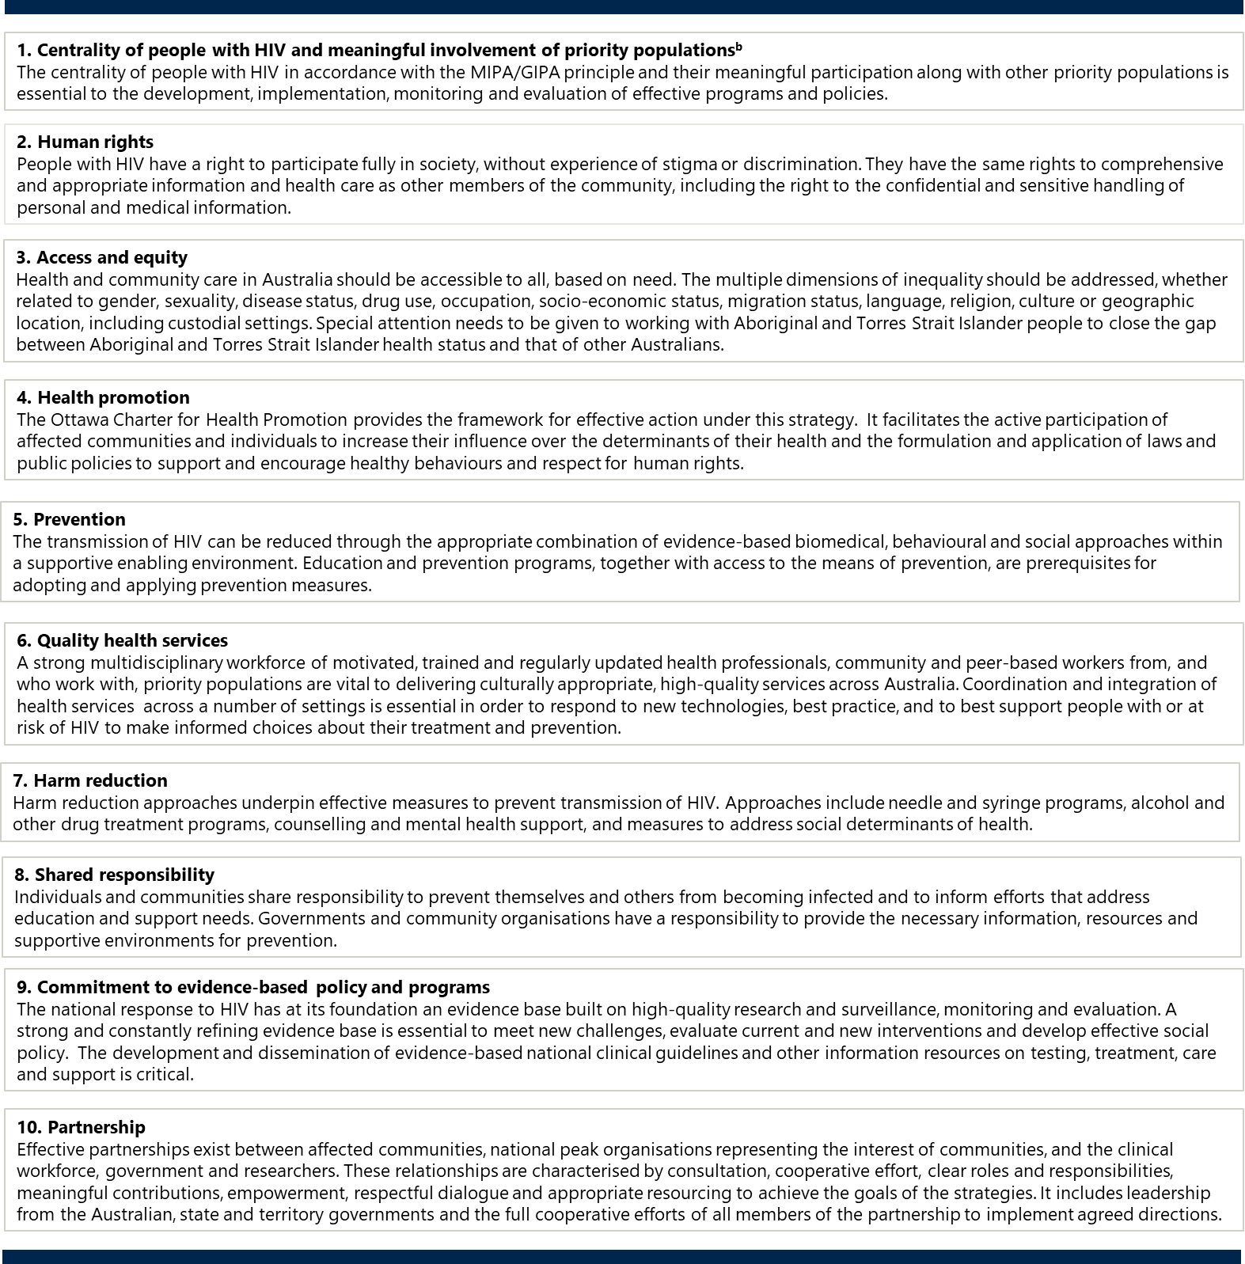

# 3 Snapshot of HIV in Australia2,3,4,5,6,[12],[13],[14]

**Figure 2: Snapshot of HIV in Australia**

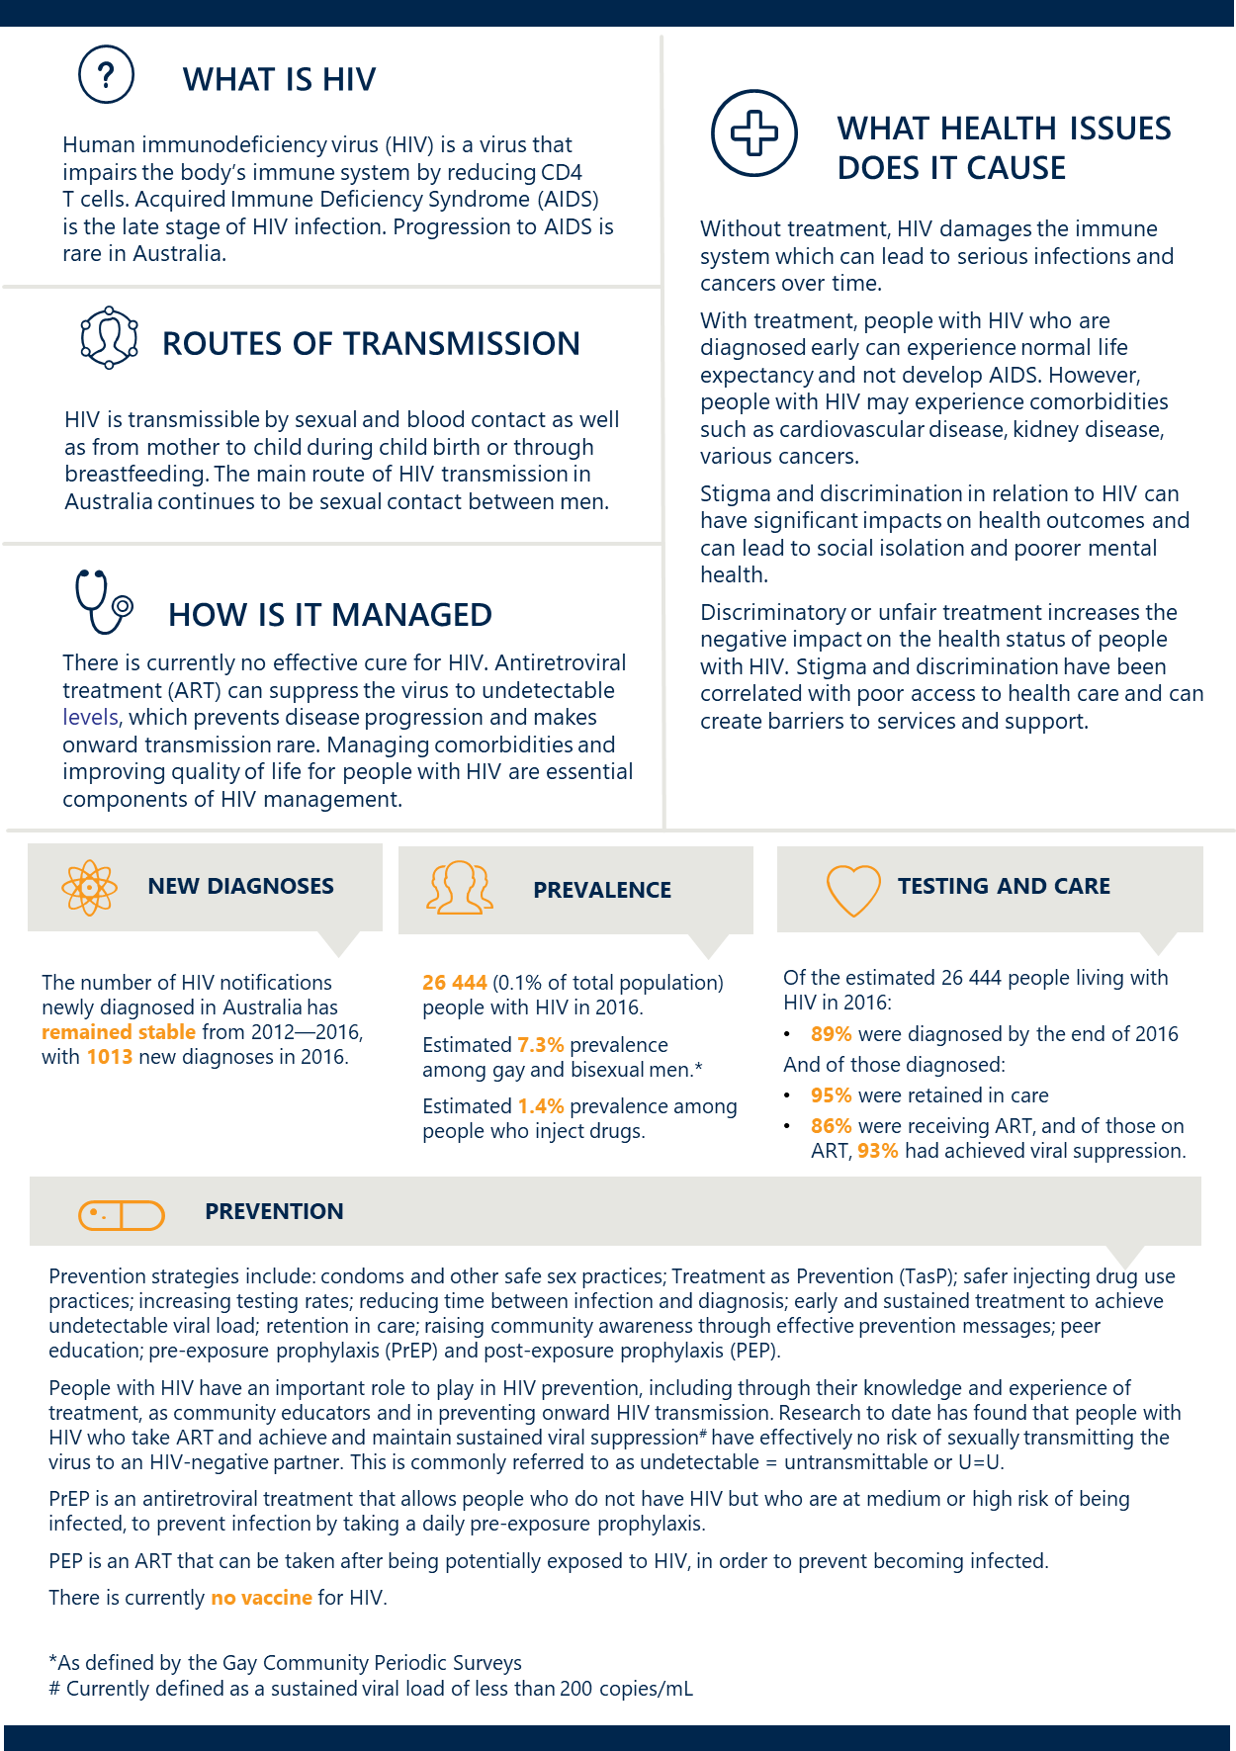

# About this strategy

TheEighth National HIV Strategy sets the direction for Australia’s continuing response to HIV for 2018 to 2022. It builds on achievements and lessons learned from previous strategies. It is one of five national strategies that, together, outline a framework for a high-quality and coordinated national response to BBV and STI in Australia. These five strategies are:

1. Third National Hepatitis B Strategy 2018–2022
2. Fifth National Hepatitis C Strategy2018–2022
3. Eighth National HIV Strategy 2018–2022 (this strategy)
4. Fourth National Sexually Transmissible Infections Strategy 2018–2022
5. Fifth National Aboriginal and Torres Strait Islander Blood Borne Viruses and Sexually Transmissible Infections Strategy 2018–2022.

Each strategy has a specific focus but shares some structural elements, including guiding principles, goals, targets, priority areas (see Section 5, ‘Measuring progress’) and defined priority populations. Also, all five national BBV and STI strategies have key priority areas for action, including education and prevention, testing, treatment and management, equitable access and coordination of care, workforce, improving data and surveillance, and stigma and discrimination.

The Eighth National HIV Strategy aims to provide a framework for the efforts of all partners in the response to HIV, guide resourcing decisions and monitor progress. It is informed by progress made under the Seventh National HIV Strategy 2014–2017;the effectiveness of current and past responses to HIV in Australia and internationally; the identification of gaps and opportunities; and consultation with governments, community organisations, researchers, health professionals and other stakeholders across the country. This strategy is also informed by, and responds to, a range of surveillance data and research on HIV in Australia and its impact on priority populations.

This strategy complements other jurisdictional, national and international policy documents that contribute to the HIV response and supports the achievement of existing commitments. These include:

* state and territory HIV strategies
* Australian Health Ministers AIDS 2014 Legacy Statement
* National Strategic Framework for Aboriginal and Torres Strait Health Plan 2013–2023
* National Drug Strategy 2017–2026
* Action Plan: Enhanced response to addressing sexually transmissible infections (and blood borne viruses) in Indigenous populations
* Aged Care Diversity Framework
* World Health Organization (WHO)Global Health Sector Strategy on HIV 2016–2021
* 2016 United Nations Political Declaration on HIV and AIDS: On the Fast-Track to Accelerating the Fight against HIV and to Ending the AIDS Epidemic by 2030
* Regional Action Plan on the Triple Elimination of Mother-to-Child Transmission of HIV, Hepatitis B and Syphilis*.*

This strategy also supports progress towards Sustainable Development Goal 3 (‘Ensure healthy lives and promote well-being for all at all ages’) of the United Nations 2030 Agenda for Sustainable Development.

This strategy acknowledges that some states and territories have set or may set different targets to drive progress and that the goals and targets of this strategy are intended to facilitate jurisdictional efforts. Wherever possible, jurisdictions are encouraged to match or exceed the targets of this strategy.

Further detail on the implementation of this strategy, including the associated action plan, is provided in Section 8, ‘Implementing this strategy’.

**PROGRESS UNDER THE SEVENTH NATIONAL HIV STRATEGY 2014–2017**

Progress under the Seventh National HIV Strategy 2014–2017 provides a context for the achievements in Australia to date (see Figure 3). These achievements reflect the joint efforts of governments, community organisations, affected communities, researchers and clinicians through the partnership approach.

Figure 3: Key achievements under the Seventh National HIV Strategy 2014–20172

|  |  |
| --- | --- |
|  | Highly successful needle and syringe programs coupled with services provided by peer-based organisations have ensured low prevalence amongst people who inject drugs |
|  | Continued health promotion and prevention efforts of peer-based sex worker organisations have sustained the low prevalence of HIV among sex workers |
|  | High quality antenatal care has sustained the virtual elimination of mother-to-child transmission |
|  | Community mobilisation and community-led education programs among gay men have continued to contribute to the stabilisation in HIV notifications from 2012 to 2016 |
|  | A broad community and clinical effort to expand testing coverage, including through making testing easier and more accessible, has increased testing rates for gay and bisexual men[15] |
|  | By the end of 2017, approximately 15 351 people who are at higher risk of acquiring HIV were enrolled in pre-exposure prophylaxis (PrEP) trials conducted by states and territories, and this has continued to grow. The impact of these trials on national HIV transmission rates is expected to be observed over the coming years. |
|  | An increase in treatment uptake, with an estimated 86% of people diagnosed with HIV receiving antiretroviral therapy and 93% of people on ART having a suppressed viral load in 2016 |

While progress under the Seventh National HIV Strategy 2014–2017 has been notable in some areas, there are challenges remaining that need to be overcome.

Overall, Australia’s HIV prevalence among the general population remains one of the lowest among developed countries. There are approximately 26 000 people estimated to currently be living with HIV.2 The number of new HIV cases diagnosed each year has remained stable at around 1000 people over the past five years.2

Australia has made significant gains in a number of areas. It has sustained the virtual elimination of mother to child HIV transmission and low rates of HIV amongst sex workers and people who inject drugs; it has significantly increased treatment uptake by people diagnosed with HIV; and it has effectively maintained prevention programs for priority populations.

The following summarises progress in relation to the specific targets set under the previous strategy:

* Australia has sustained the virtual elimination of HIV among sex workers, among people who inject drugs and mother-to‑child transmission in line with the targets of the previous strategy. This has been partly a result of the maintenance of effective prevention programs targeting sex workers and people who inject drugs, which was also a target of the previous strategy.
* Treatment coverage of people with HIV was 86 per cent in 2016.2 It is likely that in the near future Australia will achieve the target of 90 per cent of people diagnosed with HIV being on treatment, which was a target of the previous strategy and is also an agreed UNAIDS target.
* Sexual transmission (both male-to-male and heterosexual) remained static between 2012 and 2016, and the target of a 50 per cent reduction in sexual transmission of HIV by 2015 was not achieved.2
* The rate of newly diagnosed HIV among Aboriginal and Torres Strait Islander people increased by 30 per cent between 2012 and 2016. Rates of diagnoses more than doubled in the period since 2008 (from 19 in 2008 to 46 in 2016).[16] The previous strategy’s target of sustaining low general population rates of HIV in Aboriginal and Torres Strait Islander people and communities was not achieved. This is of great concern.

Gay men and other MSM continue to be the most commonly reported population group exposed to HIV. Nationally, 70 per cent (712) of cases in 2016 were attributed to this priority population.2 There are also increasing rates of transmission among gay men and other MSM from Asia2—an issue that requires specific attention.

Further detail about the epidemiology of HIV in specific priority populations is provided in Section 6, ‘Priority populations’.

During the period of the previous strategy, work commenced on the development of an indicator to measure progress in achieving the objective of eliminating the ‘negative impact of stigma, discrimination, and legal and human rights issues on people’s health’. This indicator will be used to measure progress under this strategy.

The limited progress demonstrated against some targets of the previous national strategy, including an increase in rates of HIV among Aboriginal and Torres Strait Islander people and the stabilisation of sexual transmission, indicate that a revitalised response to these challenges is needed.

# Measuring progress

This strategy has overarching goals, targets and priority areas which will guide the national response to HIV for 2018–2022. Indicators and associated data sources for measuring progress towards each target are included in the Surveillance and Monitoring Plan for the five national BBV and STI strategies.

|  |
| --- |
| **Goals** |
| * **Virtually eliminate HIV transmission in Australia within the life of this strategy** * **Sustain the virtual elimination of HIV transmission among people who inject drugs,  among sex workers and from mother to child** * **Reduce mortality and morbidity related to HIV** * **Eliminate the negative impact of stigma, discrimination, and legal and  human rights issues on people’s health** * **Minimise the personal and social impact of HIV** |
| **Targets** |
| By the end of 2022:  Increase the proportion of people with HIV (in all priority populations) who are diagnosed to 95 per cent  Increase the proportion of people diagnosed with HIV on treatment to 95 per cent  Increase the proportion of those on treatment with an undetectable viral load to 95 per cent  Reduce the incidence of HIV transmissions in men who have sex with men[17]  Reduce the incidence of HIV transmission in other priority populationsd  Sustain the virtual elimination of HIV among sex workers, among people who inject drugs and from  mother to child through the maintenance of effective prevention programs  Increase the proportion of eligible people who are on PrEP, in combination with STI prevention and testing to 75 per cent  75 per cent of people with HIV report good quality of life  Reduce by 75 per cent the reported experience of stigma among people with HIV, and expression of stigma, in relation to HIV status[18] |
| **Priority areas[19]** | |

Maintain focus on health promotion, prevention and peer education to improve knowledge and awareness of HIV in priority populations and reduce risk behaviours associated with the transmission of HIV

Ensure priority populations have access to the means of prevention

Increase knowledge of, and access to, treatment as prevention for individuals with HIV

Increase knowledge of treatment as prevention for individuals at risk of HIV

Improve the frequency, regularity and targeting of access to testing for priority populations and decrease rate of late diagnoses

Improve early uptake and sustained treatment to improve quality of life for people with HIV and prevent transmission

Ensure health care and support services are accessible, coordinated and skilled to meet the range of needs of people with HIV, particularly as they age

Ensure people with HIV are engaged in the development, delivery and evaluation of the services they use

Facilitate a highly skilled, multidisciplinary workforce that is respectful of and responsive to the needs of people with HIV and other priority populations

Implement a range of initiatives to address stigma and discrimination and minimise the impact on people’s health-seeking behaviour and health outcomes

Continue to work towards addressing the legal, regulatory and policy barriers which affect priority populations and influence their health-seeking behaviours

Strengthen and enhance partnerships and connections to priority populations, including the meaningful engagement and participation of people with HIV

Continue to build a strong evidence base for responding to HIV in Australia, informed by high-quality, timely data and surveillance systems

# Priority populations and settings

***In our response to HIV it is important to prioritise emerging populations at elevated risk and vulnerability as well as those populations that are impacted historically and are at continued risk.***

HIV disproportionately impacts a number of key populations. This strategy identifies priority populations and settings (see Figure 4) and acknowledges that many individuals may identify with multiple priority populations and settings. This results in a diverse variety of intersecting characteristics and risk factors unique to each individual. In accordance with the guiding principle of access and equity, the unique challenges and experiences within all priority populations need to be considered in the response. This includes, but is not limited to, all gender expressions and experiences, disabilities, cultural and ethnic identities, different geographic settings, sexual orientations and religious affiliations.

While women are not represented here as a distinct priority population, women are recognised across most other priority populations. Women, both those with HIV and those at risk of HIV, have unique challenges and experiences that are not easily addressed solely on the basis of risk. It is important to apply a gender lens to all aspects of the HIV response to ensure women’s needs are considered and addressed.

**Figure 4: Priority populations for the Eighth National HIV Strategy 2018–2022**

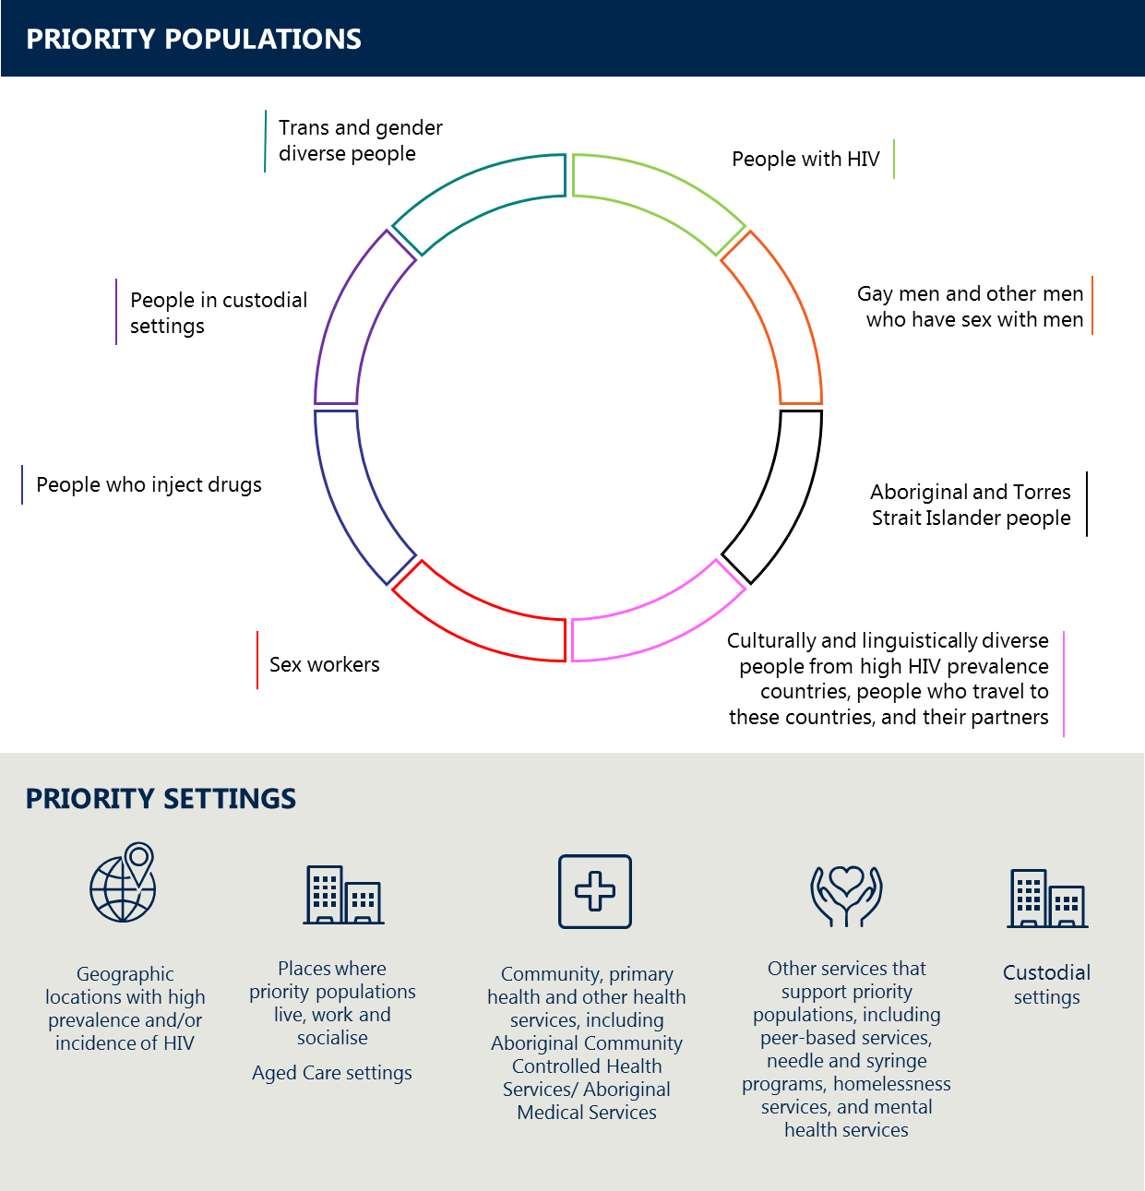

**NOTE: The graphic is not intended to reflect equal priority or prevalence among populations**

*People with HIV*

In Australia, accessible and effective antiretroviral treatment has significantly improved the lives of people with HIV. Early detection, treatment adherence and a focus on retention in care supports the achievement of an undetectable viral load. An undetectable viral load improves health outcomes and quality of life and, if sustained,[20] results in there being effectively no risk of onward transmission of HIV through sexual contact. Despite the availability of effective antiretroviral treatments, people with HIV also experience comorbidities and other health issues associated with HIV infection.

Poorer mental health outcomes in people with HIV have been linked to stigma, discrimination and the lack of an enabling environment.[21],[22],[23],53,54 Due to shared modes of transmission and other risk factors, people with HIV are also more likely to self-report key comorbidities and drug use; have high rates of certain STI; and have co-infection with syphilis, hepatitis B and hepatitis C when compared with people from a similar demographic who do not have HIV.[24],[25],[26],[27],[28],[29]

The proportion of people with HIV in older age groups is growing, and this has important implications for the healthcare system and aged care services.[30],[31] Like the general ageing population, people with HIV will experience health conditions more common with age. However, they are also more likely to experience complex age-related comorbidities and chronic illnesses—for example, cardiovascular disease[32]—than age-matched populations.

In relation to mother-to-child transmission, among 223 women with HIV who gave birth in the five-year period from 2012 to 2016, the transmission rate to newborns was 2 per cent compared with 39 per cent in the period from 1985 to 1991 and 28 per cent from 1992 to 1996.2 There were no cases notified in 2016.2 It is important that high-quality antenatal care and education is provided to all women in order to sustain this achievement.[33]

The meaningful participation of people with HIV in the development, implementation, monitoring and evaluation of HIV programs and policies is central to the partnership approach and the success of this strategy.

Within the population of people with HIV, tailored approaches are needed, including for people with comorbidities, older people, people with complex needs, Aboriginal and Torres Strait Islander people, women with HIV, people from culturally and linguistically diverse (CALD) backgrounds and people who are ineligible for subsidised health care and medicines.

*Gay men and other men who have sex with men*

HIV in Australia remains concentrated among gay men and other MSM (70 per cent of new notifications in 2016).2 However, over the past five years, HIV testing among gay and bisexual men has continued to increase, with the proportion having a repeat HIV test within six months of a previous test at 43 participating sexual health clinics increasing from 37 per cent in 2012 to 50 per cent in 2016.2 Increases in HIV testing also occurred in gay and bisexual men attending high-caseload general practice clinics—from 22 per cent in 2013 to 33 per cent in 2016.2

Alongside TasP, the listing of PrEP on the Pharmaceutical Benefits Scheme (PBS) provides an opportunity to significantly reduce HIV transmission among gay men and other MSM. However, consistent condom use with casual partners has been declining over the past five years.2 It is therefore important that the increased availability of PrEP is accompanied by STI prevention education, regular and comprehensive HIV and STI testing, and ongoing commitment to partner notification after STI diagnosis. Addressing the challenges in access to PrEP and other preventative treatments for those individuals not eligible for Medicare is also important.

As noted earlier, the increasing rates of transmission among gay men and other MSM from Asia2 is an issue that requires specific attention in the response.

*Aboriginal and Torres Strait Islander people*

Within the priority population of Aboriginal and Torres Strait Islander people, gay men and other MSM remain the group at greatest risk of HIV. However, in the period from 2012 to 2016, Aboriginal and Torres Strait Islander people were more likely to acquire HIV from heterosexual contact (20 per cent of new notifications) and needle and syringe sharing (14 per cent) when compared with non-Indigenous populations—at 15 per cent and 3 per cent respectively.13 The higher prevalence of other STI also contributes to the increased risk of HIV transmission.[34],[35]

While the prevalence of HIV remains low among Aboriginal and Torres Strait Islander people, new notifications of HIV in Aboriginal and Torres Strait Islander people have steadily increased since 2007. Notification rates are over two times higher than the Australian-born non-Indigenous population (6.4 per 100 000 versus 2.9 per 100 000).13 There has been a 52 per cent increase in the number of new notifications in men since 2012, while the number of new notifications in women has remained fairly stable over this period.

In 2016, rates of receptive needle and syringe sharing were greater amongst Aboriginal and Torres Strait Islander respondents to the Australian Needle and Syringe Program Survey when compared with the non-Indigenous population.[36] Between 2007 and 2011, there were higher levels of condomless anal intercourse among Aboriginal and Torres Strait Islander gay and bisexual men when compared with non-Indigenous gay and bisexual men.[37]

Within this population, tailored, culturally inclusive and safe approaches are needed for people from remote, regional and urban areas; women; people who are highly mobile; people who inject drugs; people with complex needs; and people in custodial settings.

Epidemiology, policy context and priority areas for action in relation to HIV in Aboriginal and Torres Strait Islander people are more specifically addressed in the Fifth National Aboriginal and Torres Strait Islander Blood Borne Viruses and Sexually Transmissible Infections Strategy 2018–2022.

*Culturally and linguistically diverse people from high HIV prevalence countries, people who travel to high-prevalence countries, and their partners*

New HIV diagnoses have increased for people from high HIV prevalence countries and their partners—they accounted for over one-third of the cases of heterosexual transmission of HIV in 2016in Australia.2

In 2016, the Australian national notification rate was 4.2 per 100 000 population, while the rate in people born in Australia was slightly less, at 3.4 per 100 000.2 This compares with a notification rate of 17.3 per 100 000 for people born in the Americas (North and South America); 17.1 per 100 000 for people born in South-East Asia; and 10.9 per 100 000 for those born in sub-Saharan Africa. From 2012 to 2016, the highest proportion of late diagnoses was in people born in Central America, Sub-Saharan Africa and South-East Asia.2

Of the women who reported heterosexual sex as their risk exposure, 28 per cent were born in a high-prevalence country and 4 per cent had sex with a person from a high-prevalence country.2

Tailored approaches that effectively address cultural, language and gender issues across all aspects of the response to HIV are needed for several sub-populations, including gay men and other MSM, people who inject drugs, international students, people who are ineligible for subsidised health care, refugees, humanitarian entrants and women. Specific messaging for people who travel to high-prevalence countries about the risks of HIV and prevention strategies is also important.

*Sex workers*

Sex workers are a priority population due to the potential higher exposure risk associated with sex work. Continued prevention efforts led by sex workers and their organisations ensure that HIV prevalence among Australian sex workers remains among the lowest in the world.

Sex workers experience barriers to accessing health services including stigma and discrimination. They also face a range of regulatory and legal issues including criminalisation, licensing, registration and mandatory testing in some jurisdictions.[38] These barriers create a complex system of impediments to evidence-based prevention, access to testing and healthcare services. They can result in increased risk of BBVs and STIs, loss of livelihood, and risk to personal and physical safety. Evidence that has emerged since the previous strategy definitively shows that decriminalisation of sex work is linked to the reduction of HIV risk and rates.[39]

Within this population, tailored approaches are needed for sub-populations of sex workers, including street-based sex workers, sex workers who work in isolation, sex workers in rural and remote areas, migrant and CALD sex workers, Aboriginal and Torres Strait Islander sex workers, male sex workers, trans and gender-diverse sex workers, sex workers with HIV, people with complex needs and people from other priority populations. Tailored approaches that address stigma and discrimination and the regulatory and legal barriers experienced by sex workers are required.

*People who inject drugs*

Australia’s highly successful needle and syringe programs coupled with services provided by peer-based organisations have maintained low HIV infection rates among people who inject drugs. However, this population remains a priority due to the potential risks associated with receptive needle and syringe sharing.

Between 2012 and 2016, the proportion of people who injected drugs and attended needle and syringe programs reporting receptive needle and syringe sharing in the last month increased from 16 per cent to 19 per cent.29 These rates were similar in men and women. Rates of HIV are influenced by the availability of injecting equipment. Access to injecting equipment in rural, regional and remote Australia requires particular consideration within this context.

Within this population of people who inject drugs, tailored approaches are needed for people with complex needs and people from other priority populations, particularly Aboriginal and Torres Strait Islander people, gay men and other MSM. People experiencing mental illness or homelessness are also important sub‑populations identified as being at higher risk, and they need to be specifically considered in the response.2,16,17,[40],[41] Aboriginal and Torres Strait Islander people are more likely to acquire HIV from and participate in receptive needle and syringe sharing when compared with the non-Indigenous population. This indicates that an individual approach targeting promotion of and access to sterile injecting equipment is needed for this population. This is further explored and defined in the Fifth National Aboriginal and Torres Strait Islander Blood Borne Viruses and Sexually Transmissible Infections Strategy.

There are also broader issues in relation to non-injecting drug use that may also require attention. This includes recreational drug use among MSM, particularly when used to enhance sexual experiences.[42] Numerous studies have found that HIV and other STI are more likely to occur in gay men and other MSM who use recreational drugs than those who do not, although the causal nature of this requires further investigation.[43]

*People in custodial settings*

People in custodial settings are at risk of HIV transmission through shared use of injecting equipment, unsafe tattooing and condomless sex. The *National Prison Entrants’ Bloodborne Virus and Risk Behaviour Survey Report*, which provides data on the prevalence of HIV and other BBV and STI among Australian prison entrants, found no new cases of HIV among the 431 people entering into custodial settings who were voluntarily screened (out of a possible 862) in 2016.38 In addition, the prevalence of HIV among people entering custodial settings has remained low over the past five years.38 However, the risk of transmission in the context of undiagnosed HIV or detectable viral load is significant given the nature of risk exposures occurring in custodial settings.[44],[45],[46]

Barriers to HIV prevention include a lack of access to sterile injecting equipment, sterile tattooing equipment, PrEP, post-exposure prophylaxis (PEP), TasP, health promotion and condoms; and high levels of stigma and discrimination, which also impact on access to HIV prevention, testing and treatment. Limited data are available on discharges from custodial settings. While data on the percentage tested for BBV and STI on leaving the prison system are available, the results of these tests are not available.[47] This highlights a significant gap in our understanding of HIV and other BBV and STI in custodial settings. Care coordination / through-care for men and women living with HIV, ensuring continuity of access to medication, and engagement with medical care and community supports are crucial to reduce transmission risk after release from custody.

Effective HIV prevention, testing and treatment for this population requires a strong, whole-of-government partnership approach involving those concerned with juvenile detention centres as well as adult prisons.

*Trans and gender-diverse people*

HIV prevalence among trans and gender-diverse people is unknown in Australia due to a paucity of data. However, international studies in low- and high-income countries have found that HIV prevalence among trans and gender-diverse people is many times that of the general population.[48],[49] Many trans and gender-diverse people are already part of existing priority populations, such as trans MSM, trans men, trans women and non-binary sex workers, people who inject drugs, and others, and they may share some of the same risk exposures of other priority populations. However, trans and gender-diverse people may also have specific sexual health needs and barriers to prevention, treatment and care that need to be taken into consideration in the response to HIV.

Increased community engagement with trans and gender-diverse people, alongside improved data and research, is needed to better understand how HIV impacts this population. Inclusion of trans and gender-diverse people in the HIV response is a priority for all stakeholders.

Improved access to HIV prevention, testing and treatment will require improving the levels of literacy about gender diversity in the broader health workforce. Healthcare settings will require support to provide appropriate and sensitive sexual health care to trans and gender-diverse people.

Within this population, tailored approaches are needed for Aboriginal and Torres Strait Islander people, including Sistagirls/Sistergirls, Brotherboys and other two-spirit people.

# Priority areas for action

*This strategy includes a set of priority areas for action designed to support the achievement of the goals and targets. Each priority area for action relates to one or more of the targets. It is the interaction of these actions as a whole which is essential to the achievement of the strategy.*

Australia’s response to HIV builds on the achievements and lessons learned over the past 30 years and is shaped by a number of key challenges and opportunities. Some of these have been around for some time and others are new and reflect ongoing changes in the epidemiology of HIV, biomedical prevention technologies and other aspects of the response.

Some of the key challenges and opportunities include the high numbers of late diagnoses in particular population groups; access to preventative measures and diagnostic technologies, including PrEP, PEP, TasP, HIV rapid testing and needle and syringe programs; maintaining and improving the gains made in treatment coverage; and improving the quality of life for people with HIV. This strategy is designed to address these while recognising the need to maintain key aspects of the response that remain pivotal to its success and respond flexibility to other issues as they arise.

**EDUCATION AND PREVENTION**

*Maintain focus on health promotion, prevention and peer education to improve knowledge and awareness of HIV in priority populations and reduce risk behaviours associated with HIV transmission*

*Ensure priority populations have access to the means of prevention*

*Increase knowledge of, and access to, treatment as prevention for individuals with HIV*

*Increase knowledge of treatment as prevention for those individual at risk of HIV*

|  |
| --- |
| Effective HIV prevention relies upon ready access to the means of prevention, including HIV treatment, PEP, PrEP, condoms and sterile injecting equipment, together with a strong enabling environment to support access and use. This needs to be combined with sustained, community-led prevention education programs for people at risk of HIV to improve health literacy and empower priority populations.  It is important that priority populations are provided with tailored education, including correct and consistent condom use, safe sex practices, community mobilisation, peer education and outreach, health promotion, capacity development, harm reduction approaches, needle and syringe programs, increased testing (including making it easier for people to ask for and to be offered testing), and promotion of early HIV treatment.  Prevention approaches that have worked well in Australia’s response to date, including peer and community-led prevention and education for people with HIV, gay men and other MSM, sex workers and people who inject drugs, need to be strengthened and considered for other priority populations. Collaboration with priority populations and community-led programming are important to ensure that initiatives are appropriately targeted, culturally sensitive, gender sensitive, age appropriate and tailored to local contexts.  TasP plays a central role in HIV prevention. Education for health professionals and people at risk of or with HIV should outline the benefits of having an undetectable viral load, including through its role as a prevention method and in improving the health and wellbeing of people with HIV. Raising awareness of the significance of having an undetectable viral load may also assist in addressing HIV-related stigma, such as alleviating fear of infection, and support greater efforts in critical aspects of the HIV response, including the importance of regular testing and early treatment.  Another significant development in HIV prevention is the subsidisation of PrEP through the PBS as of 1 April 2018for people at medium and high risk of HIV[50]. Current evidence demonstrates that, for gay men and other MSM, PrEP makes a significant impact on HIV transmissions if implemented rapidly alongside high rates of HIV testing and treatment.[51],[52] Early evidence from Australian PrEP access trials indicates that PrEP, combined with high rates of testing and treatment and TaSP, can lead to a reduction in rates of HIV transmission.[53]  To reap the full benefits of PrEP in appropriate priority populations, it is essential to address the remaining barriers to access, including a lack of awareness in relevant priority populations and not having a general practitioner or other clinician who is familiar with PrEP. PrEP needs to be combined with regular testing for STI, timely treatment and prevention education (particularly in relation to the importance of condom use for STI prevention), along with current clinical guidelines to support provider decision-making. STI surveillance and monitoring is an important part of PrEP implementation to measure any changes in disease prevalence.  It is important to also recognise the role of PEP in the prevention ‘toolbox’ for individuals who have been exposed (or suspect they have been exposed) to HIV, including in both non-occupational and occupational settings.[54],[55] Continued awareness and accessibility to this medication for the purposes of PEP is essential.  A combination prevention approach comprising multiple methods and interventions is critical for achieving effective prevention and for meeting the specific needs of priority populations and individuals.  Key areas for action   1. Maintain and implement targeted programs, including community-led and peer-based approaches, which improve HIV-related knowledge, reinforce prevention and promote safe behaviours in priority populations 2. Promote the availability and effectiveness of PEP and PrEP and facilitate rapid, widespread and equitable access to PEP and PrEP across the country 3. Ensure clinical prevention approaches are delivered in combination with education on STI prevention and regular STI testing 4. Increase the knowledge and awareness of HIV among general practitioners / primary care professionals in relation to the suite of available prevention methods, including TasP, PEP and PrEP; how to support priority populations; and the availability and effectiveness of HIV treatment, with a particular focus in areas of high need 5. Support and prioritise TasP by increasing awareness of HIV treatment; promoting the benefits of having an undetectable viral load; and supporting access, uptake and adherence to antiretroviral treatment immediately after diagnosis 6. Ensure the wide distribution and availability of sterile injecting equipment and safer injecting education among people who inject drugs, including a focus on priority populations and people living in regional, rural and remote areas 7. Improve surveillance and research on priority populations, including through improved data collections and greater granularity of epidemiological data, and use these data to inform approaches |

**TESTING, TREATMENT AND MANAGEMENT**

*Improve the frequency, regularity and targeting of testing for priority populations and decrease rates of late diagnosis*

*Improve early uptake of sustained treatment to improve quality of life for people with HIV and prevent transmission*

Regular frequent testing in accordance with risk enables people to know their status and adopt safe behaviours. It also supports early treatment commencement and adherence. Successful long-term treatment adherence, connection to care, effective management of comorbidities and side effects, connection to peers, an enabling environment and building resilience to challenge stigma are all important in securing an improved quality of life for people with HIV.

While HIV testing rates have increased in Australia, the proportion of new HIV cases diagnosed late has remained stable, and some priority populations are over-represented in late diagnosis data. These include people born in high-prevalence countries, heterosexual people, Aboriginal and Torres Strait Islander people, and women. In particular, of women reporting heterosexual sex as an exposure risk from 2012 to 2016, the groups with the highest proportion of late diagnoses were those in the age groups of 30 to 39 years and 50 years and older and those born in South-East Asia and sub-Saharan Africa.2 People who are diagnosed with HIV late are more likely to experience comorbidities, and having untreated HIV increases the risk of onward HIV transmission.

Efforts to increase the frequency of testing for all people at risk of HIV must be based on the principles of voluntary testing, informed consent and confidentiality which have underpinned the improvements in testing coverage achieved in Australia to date. Continued efforts to expand testing coverage are important. They need to be supported through improved ability to recognise risk factors and by ensuring a mix of testing options, such as rapid testing in community and after-hours clinics, are available. Efforts to expand testing coverage must also be supported by improved community education, availability and accessibility of testing services and initiatives to build linkages between peer educators and testing services.

Testing options that support early diagnosis need to be linked to the provision of early treatment and care. Timely patient follow-up is needed to minimise the time between diagnosis and commencement of treatment, support patient adherence to treatment, and support the achievement and maintenance of sustained viral suppression. This is important for all priority populations and is already recognised as an integral component of antenatal care in order to prevent mother-to-child transmission of HIV.

The achievement of the 95–95–95 targets relies on rapid, affordable and continued access to antiretroviral therapy for all people with HIV and their ongoing clinical management in community-based settings by well-trained and accredited prescribers. Increasingly, new HIV diagnoses are being made in general practice settings.[56] General practitioners may require additional support and training to be able to provide appropriate ongoing care to their patients.

Key areas for action

1. Expand the use and accessibility of a range of HIV and STI testing technologies and options and tailor testing approaches to the needs of priority populations and sub-populations, particularly where there is a need to improve early diagnosis
2. Improve the knowledge and awareness of health professionals and community-based health workers of indications for HIV testing, including, for health professionals, the investigation of non-specific symptoms without identifiable risk factors
3. Ensure that people diagnosed with HIV are promptly linked to treatment, ongoing care and peer support using approaches that address the specific barriers experienced by priority populations and sub-populations across priority settings
4. Promote the use of evidence-based clinical guidelines and resources
5. Investigate a sustainable model for access to treatment for people with HIV who are ineligible for Medicare

**EQUITABLE ACCESS TO AND COORDINATION OF CARE**

*Ensure healthcare and support services are accessible, coordinated and skilled to meet the range of needs of people with HIV, particularly as they age*

*Ensure people with HIV are engaged in the development, delivery and evaluation of the services they use*

Healthcare and support services need to be coordinated and staff must be appropriately skilled to meet the range of needs of people with HIV across the continuum of their care. People with HIV have a unique knowledge of their own treatment and management and need to be actively engaged as equal participants in the planning and delivery of their own care.

The provision of care requires a team-based, multidisciplinary approach tailored to the needs of the individual. Clear protocols and pathways are essential to ensure that comprehensive care and support is delivered in a cohesive way across a range of medical and community-based settings.

Models and approaches need to facilitate early referral to treatment services, retain newly diagnosed patients in care, and maintain (or re-establish) links to services for people with HIV. Approaches need to be culturally acceptable; address the specific barriers experienced by priority populations, including those in regional, rural and remote communities and with gender and cultural diversity; and take into account the range of healthcare and other settings commonly used by priority populations to maximise their engagement.

The ageing population of people with HIV in Australia is a key issue to be considered in the response. Effective treatment has greatly improved life expectancy and quality of life for people with HIV, with approximately 40 per cent of people with HIV now aged over 50. This proportion is expected to continue to increase. Older people with HIV in Australia are likely to require special care and support, including access to high-quality aged care services, the management of comorbidities, assistance with treatment adherence, and other issues related to ageing.18,19 Stigma and discrimination is a central concern for many people ageing with HIV who may require health and social services outside of their regular HIV care and support providers with whom they have an established relationship.44

There are additional sub-populations in the community, such as people experiencing homelessness or mental health issues that require more intensive support and coordination, including through outreach and district nursing services.

Key areas for action

1. Improve the integration of care provided to people with HIV, including by general practitioners, sexual health physicians, psychosocial support services, community pharmacies, community-based nursing, other health services and specialists, and aged care services, particularly in rural and remote locations
2. Identify, implement and evaluate models of care that meet the needs of people with HIV who are ageing and ensure quality of care across services
3. Increase capacity for HIV treatment and care in those health services providing culturally appropriate care to Aboriginal and Torres Strait Islander people and culturally and linguistically diverse populations
4. Increase HIV awareness, capability and collaboration of service providers to support people with HIV, including in settings such as drug and alcohol, mental health, aged care, disability, housing, employment, child and family, and justice and corrective services

**WORKFORCE**

*Facilitate a highly skilled multidisciplinary workforce* *that is respectful of and responsive to the needs of people with HIV and other priority populations*

A strong multidisciplinary workforce of motivated and trained health professionals and community health, aged care, and peer-based workers who are from, and who work with, priority populations is vital to delivering best-practice, culturally appropriate, high-quality services across Australia.

Primary health services, including general practice, Aboriginal Community Controlled Health Services (ACCHS) and Aboriginal Medical Services (AMS), remain priority settings for the delivery of prevention, testing and treatment services for HIV, in collaboration with specialist care as necessary. Sexual health clinics and peer-based organisations involved in health service delivery play an important role in providing culturally and age-appropriate services to priority populations and people who are not accessing mainstream primary health services. Other health services, including specialist, antenatal, alcohol and other drug and mental health services and treatment programs and needle and syringe programs, are also important settings in the response to HIV.

Evidence-based, responsive and accessible clinical guidelines and tools play an essential role in supporting the provision of effective HIV prevention and care in Australia. These guidelines must be updated at regular intervals and coupled with education and training to build workforce capacity and capability. This is particularly important in supporting the management of patients with complex needs in community-based settings.

Specific education, professional development and specialisation opportunities need to be made available to support the development of essential knowledge and skills across the workforce. Hybrid approaches of online learning, web-based resources and mobile applications, as well as face-to-face learning opportunities, should be tailored to specific workforce needs and locations (including urban, regional, rural and remote). Comprehensive guidance for the workforce that supports professionals in providing advice to patients, including on legal and policy issues in relation to HIV transmission and undetectable viral load, would better support people with HIV to make informed decisions about prevention and treatment adherence. Education to reduce and address stigma and discrimination should be included in training programs for staff of all specialist, primary healthcare and community service providers.

Issues in relation to recruitment and retention of staff need to be addressed, particularly in rural and remote areas, to ensure that the required expertise, capability and capacity exists in all areas. Innovative models adapted to local contexts can assist in addressing such challenges by utilising the skills of other appropriately trained health professionals. Shared care models involving general practitioners, medical specialists, nursing professionals, Aboriginal and Torres Strait Islander Health Workers, community-based workers, and other health professionals will assist in decreasing the burden on sexual health services. Less experienced diagnosing clinicians need strong links with specialist providers in providing an HIV diagnosis and enabling treatment, ongoing care and other support services in the community.

As the accessibility of PrEP is increased, prescribers need to be more closely linked to HIV services and sexual health services and/or able to provide those services in primary healthcare settings. PrEP-related education for primary care should be informed by caseload, the priority populations being cared for and the past community experiences of accessing such services. Enhanced roles for nursing professionals that facilitate access to preventive measures, including PrEP, early treatment and monitoring for priority populations, should be further explored and developed.

Key areas for action

1. Continue to regularly update, maintain, and make accessible evidence-based clinical guidelines, tools and support for prevention, testing and management of HIV and related comorbidities
2. Ensure that access to PrEP, TasP and other prevention methods are supported by consistent and targeted information and messaging for health professionals
3. Continue to explore and share experiences of innovative multidisciplinary models of care for HIV prevention and management, particularly models for rural and remote areas and areas of workforce shortage
4. Develop knowledge and awareness of HIV across the multidisciplinary workforce to facilitate the delivery of appropriate services and address the ongoing care and support needs of people with HIV
5. Support the capacity and role of community organisations to provide education, prevention, support and advocacy services to priority populations

**ADDRESSING STIGMA AND CREATING AN ENABLING ENVIRONMENT**

*Implement a range of initiatives to address stigma and discrimination and minimise the impact on people’s health-seeking behaviour and health outcomes*

*Continue to work towards addressing the legal, regulatory and policy barriers which affect priority populations and influence their health-seeking behaviours*

*Strengthen and enhance partnerships and connections to priority populations, including the meaningful engagement and participation of people with HIV*

Stigma is widely recognised as one of the most significant barriers to an effective HIV response. It can have a significant impact on health outcomes as well as relationships and employment prospects and can lead to social isolation and mental ill health. The experience and anticipation of discriminatory or unfair treatment increases the negative impact on the health status of people with HIV and can reduce access to care. Stigma and discrimination have been correlated with poor access to health care, and they create barriers to services and support.

While stigma and discrimination have reduced somewhat over the last 30 years, it continues to be reported by people with HIV and by lesbian, gay, bisexual, trans and gender-diverse, and/or intersex populations, sex workers, people who use drugs, Aboriginal and Torres Strait Islander people and CALD populations. In a 2016 online survey completed by 181 people with HIV, nearly three-quarters of respondents (74 per cent) reported stigma related to their HIV status and approximately half of respondents (52 per cent) reported experiencing negative or different treatment by health workers.[57]

The stigma and discrimination experienced by people with HIV and other priority populations can also be influenced by intersecting characteristics and the stigma and discrimination associated with those. This includes sexual orientation, gender and gender identity, cultural background, migrant or refugee status, disability, or being a sex worker or person in a custodial setting. Strategies to address stigma and discrimination must acknowledge and account for this.

There is an ongoing need for Australian governments to continue to review and work towards removing barriers to access to HIV prevention, management, care and support; promote and protect the human rights of people with HIV and people among affected communities; and break down the stigma and discrimination associated with HIV.

Increased efforts are needed to address stigma and support people with HIV and priority populations to challenge stigma and build resilience. The meaningful involvement of people with HIV and affected communities in all aspects of the HIV response play an important role in addressing stigma and discrimination. It enables individuals and communities to draw on their lived experiences and be meaningfully involved in the design, implementation and evaluation of HIV interventions.

Efforts are also needed to increase the awareness of health professionals and community health workers, particularly those on the front line of HIV diagnosis and treatment, in relation to stigma and discrimination. This is an important part of training programs for staff of all specialist, primary healthcare and community-based service providers. The training needs to highlight the essential role they play in removing stigma and discrimination as a barrier for priority populations in accessing prevention, testing, treatment, care and support. It is important to ensure that healthcare professionals are well-informed about how to most effectively engage with and support priority populations is important, and this must be underpinned by comprehensive and transparent health service quality standards, including standards that address privacy, confidentiality and patient rights.

Overall Australia has a strong enabling environment, including regulation of needle and syringe programs and strong anti-discrimination legislation for some populations. However there are some key legal, regulatory, policy, social, cultural and economic barriers that impact on HIV prevention and access to HIV services. These barriers include the cost of services; challenges with service delivery in regional and remote areas; language and cultural barriers; a lack of culturally appropriate health services; and laws and regulations in relation to sex work, drug use, peer distribution of injecting equipment, and non-disclosure, exposure and transmission of HIV.31 Studies have found that the removal of such barriers, and reduction in stigma and discrimination, increased the rates of testing and treatment and contributed to a decrease in the incidence and prevalence of various BBV and STI.31,[58] Approaches to addressing barriers in Australia need to be informed by the national and international evidence base in relation to the impact on HIV transmission and public health outcomes, and they need to be considered in the Australian context.

The implementation of this strategy rests within the health sector. However, many of the barriers to access and equitable treatment of affected individuals and communities fall outside of the responsibility of the health system—for example, criminalisation impacts on priority populations by perpetuating isolation and marginalisation and limiting their ability to seek information, support and health care. It is important that effective and meaningful dialogue is maintained across sectors and jurisdictions to support knowledge translation (for example, current HIV-related clinical evidence) and to discuss the potential impacts of any wider decisions on the health of priority populations.

Key areas for action

1. Implement initiatives to reduce stigma and discrimination across priority settings, including education which incorporates messaging to counteract stigma
2. Implement initiatives that assist people with, and at risk of, HIV to challenge stigma and build resilience
3. Maintain and develop peer support models appropriate for priority populations and maintain support for people with HIV as peer navigators in diagnosis, treatment and care
4. Monitor laws, policies, stigma and discrimination which impact on health-seeking behaviour among priority populations and their access to testing and services; and work to ameliorate legal, regulatory and policy barriers to an appropriate and evidence-based response
5. Review and address institutional, regulatory and system policies which create barriers to equality of prevention, testing, treatment and care and support for people with HIV and affected communities
6. Engage in dialogue with other government sectors to promote the use of up-to-date HIV-related science to improve policies affecting people with HIV and to discuss the impacts of wider public policy decisions on the health of priority populations

**DATA, SURVEILLANCE, RESEARCH AND EVALUATION**

* + *Continue to build a strong evidence base for responding to HIV in Australia that is informed by high-quality, timely data and surveillance systems*

Continuous improvement of data collections and systems is important to support a comprehensive understanding of HIV in Australia. However, this must be appropriately targeted to avoid unnecessary burden for health services and frontline staff and to ensure effective patient privacy and confidentiality.

Opportunities to improve the level of detail in collected data to better identify trends and issues of concern in relation to specific priority and sub-populations, including trans and gender-diverse people and women, need to be explored. Improvements in the reporting of Aboriginal and Torres Strait Islander status in clinical and pathology settings also need to be implemented. There is a need for data on stigma and discrimination, both in relation to HIV itself and in relation to a variety of other factors, with a focus on gender and sexuality and sex work, and on the quality of life for people with HIV. There is also a need to improve the timeliness and consistency of data collection across Australia to better support completeness and comparability. Potential areas for greater involvement of community and peer-based organisations in surveillance also need to be identified, given their strong knowledge of priority populations.

Rates of HIV drug resistance require ongoing monitoring. While cases of treatment failure are rare in Australia, active and accurate monitoring is required to detect any increase. This is important, as drug resistance can result in adverse health outcomes and transmission of drug-resistant HIV.

Social, behavioural, epidemiological, clinical and basic research is essential in developing a strong evidence base for managing and preventing HIV in the community. This research identifies and examines key changes in the epidemiology and behaviours of priority populations; emerging issues and concerns; and influences on people’s decisions in regard to risk taking and seeking testing, care and treatment. It also assists to inform targeted responses in priority populations and settings. Partnerships between research institutes, clinicians and community and peer‑based organisations are valuable, as community and peer-based organisations (and clinicians) are often the first to identify changes in behaviours, social interactions and demographics of priority populations.[59],[60] Maintaining a strong research agenda and program that informs and responds to the priority actions of the strategy ensures that implementation is supported by a strong, relevant evidence base.

The National BBV and STI Surveillance and Monitoring Plan 2018–2022 will be developed to measure and monitor the implementation of this strategy through the identification and development of indicators to measure progress towards achieving the strategy’s targets. The evaluation of existing HIV activities and programs, and development of new ones, will aim to maximise their alignment with the priority areas for action set out in this strategy.

Key areas for action

1. Identify gaps in surveillance data for measuring and monitoring the implementation of this strategy and prioritise these for action
2. Identify opportunities to improve the timeliness and consistency of data collection
3. Improve surveillance of issues impacting on people with HIV, including morbidity and mortality, stigma and discrimination, quality of life measures, the availability of new biomedical interventions and HIV drug resistance
4. Build on the existing strong evidence base to effectively inform the implementation of the priority actions of this strategy
5. Ensure current and future programs and activities are evaluated to ensure linkage and alignment to the priority areas of this strategy
6. Explore opportunities for assessing the impact of legislation and regulation on barriers to equal access to health care

# Implementing this strategy

**Leadership, partnership and connections to community**

Australia’s response to HIV is built on a model of partnership between government, community-based organisations, researchers, health professionals and priority populations. The partnership approach depends on clear leadership roles and accountability for all involved.

The Australian Government is committed to providing strong national leadership by working across portfolios and jurisdictions to achieve the goals of this strategy. The Australian Government Department of Health leads the coordination of the national response to HIV under the National HIV Strategy. However, the success of this strategy is contingent on productive partnerships between Australian, state and territory governments and partners, including peak bodies representing communities, health professionals, researchers and others. In the case of research on BBV and STI, it is imperative that this is conducted in partnership with communities and aligned with the priorities of the five national strategies.

National community and health peak organisations, and other organisations, representing communities and the clinical workforce remain at the forefront of the HIV response in Australia. Organisations including the Australian Federation of AIDS Organisations; the National Association of People with HIV Australia; the Australian Injecting and Illicit Drug Users League; Scarlet Alliance, Australian Sex Workers’ Association; and the Australasian Society for HIV, Viral Hepatitis and Sexual Health Medicine, and the relationship these organisations have with their members, have a critical role to play in the implementation of this strategy.

**Action plan**

The National BBV and STI Strategies Action Plan 2018–2022 provides the detail of specific actions for governments and partners. The action plan outlines the roles and responsibilities of governments and partners and the time frames for implementation of the actions. Indicators for measuring the progress towards achievement of the strategies’ targets will also be developed. The action plan will be reviewed as required during the lifetime of the strategies.

The five national BBV and STI strategies share a number of key actions related to areas such as workforce, improving data and surveillance, education programs, and stigma and discrimination. The action plan will focus on encouraging connections between existing programs and policies, and adapting lessons from previously successful approaches, to minimise duplication of effort. It will also look for opportunities to learn from and adapt responses used for other diseases where relevant.

**Governance, reporting and evaluation**

The five national BBV and STI strategies are endorsed by Australia’s Health Ministers and governed through relevant committees of the Australian Health Ministers’ Advisory Council (AHMAC). The Blood Borne Viruses and Sexually Transmissible Infections Standing Committee (BBVSS) coordinates implementation efforts across jurisdictions and reports to the Australian Health Protection Principal Committee (AHPPC) on progress in the implementation of the national strategies. BBVSS and the Communicable Diseases Network Australia (CDNA) will jointly monitor progress towards the targets of each strategy and identify emerging issues and opportunities for action.

**Surveillance and monitoring plan**

The National BBV and STI Surveillance and Monitoring Plan 2018–2022 supports the five national BBV and STI strategies and informs and monitors progress on achieving the goals and targets of each strategy. A subcommittee of the CDNA is responsible for overseeing the surveillance and monitoring plan and reporting on progress to the CDNA and BBVSS.

1. References

1. The Kirby Institute. (2000–2017). HIV, viral hepatitis and sexually transmissible infections in Australia, Annual Surveillance Reports 2007–2017. University of New South Wales (UNSW) Sydney: Sydney.
2. The Kirby Institute. (2017). HIV, viral hepatitis and sexually transmissible infections in Australia, Annual Surveillance Report 2017. UNSW Sydney: Sydney.
3. Currently defined as a sustained viral load of less than 200 copies/mL.
4. Rodger, A. (2016). Association between sexual activity without condoms and risk of HIV transmission in serodifferent couples when the HIV-positive partner is using suppressive antiretroviral therapy: the PARTNER study*.* 21st International AIDS Conference, Durban, abstract TUAC0206.
5. Rodger, A., T. Bruun, V. Cambiano *et al*. (2014). HIV transmission risk through condomless sex if HIV+ partner on suppressive ART: PARTNER study*.*21st Conference on Retroviruses and Opportunistic Infections, Boston, abstract 153LB.
6. The Kirby Institute. (2017). Promising news for HIV treatment as prevention: study finds HIV transmission rare in couples when an HIV positive partner is receiving treatment. Accessed 29 November 2017 at: <https://kirby.unsw.edu.au/news/promising-news-hiv-treatment-prevention-study-finds-hiv-transmission-rare-couples-when-hiv>
7. HIV Prevention Trials Network. (2017). HIV Prevention Trial (HPTN 052) Releases New Findings: Early initiation of ART leads to 96% reduction in HIV transmission according to study conducted by HIV Prevention Trials Network [press release]. Accessed 29 November 2017 at: <https://hptn.org/sites/default/files/inline-files/HPTN052PressReleaseIASJul2011final.pdf>
8. United Nations. (2016). United Nations Political Declaration on HIV and AIDS: On the Fast-Track to Accelerating the Fight against HIV and to Ending the AIDS Epidemic by 2030. Accessed 10 April 2017 at:

   <http://www.unaids.org/sites/default/files/media_asset/2016-political-declaration-HIV-AIDS_en.pdf>
9. Joint United Nations Programme on HIV/AIDS (UNAIDS). (2014).90–90–90—An ambitious treatment target to help end the AIDS epidemic. Accessed 10 April 2018at:<http://www.unaids.org/sites/default/files/media_asset/90-90-90_en.pdf>
10. UNAIDS. (2014). Fast-Track: Ending the AIDS epidemic by 2030. Accessed 10 April 2018 at: [www.unaids.org/sites/default/files/media_asset/JC2686_WAD2014report_en.pdfwww.unaids.org/sites/default/files/media_asset/JC2686_WAD2014report_en.pdf](http://www.unaids.org/sites/default/files/media_asset/JC2686_WAD2014report_en.pdf)
11. The MIPA/GIPA Principle (Greater Involvement of PLHIV)is from the Paris AIDS Summit Declaration in 1994, endorsed by Australia and 42 other countries. Available at: <http://data.unaids.org/pub/briefingnote/2007/jc1299_policy_brief_gipa.pdf>
12. Vanable, P. A., M. P. Carey, D. C. Blair, and R. A. Littlewood. (2006). ‘Impact of HIV-related stigma on health behaviors and psychological adjustment among HIV-positive men and women.’ AIDS and Behavior, **10**(5):473–482.
13. Mahajan, A. P., J. N. Sayles, V. A. Patel *et al*. (2008). ‘Stigma in the HIV/AIDS epidemic: a review of the literature and recommendations for the way forward.’ AIDS **22**(Suppl 2):S67–S79.
14. Logie, C., and T. M. Gadalla. (2009). ‘Meta-analysis of health and demographic correlates of stigma towards people living with HIV.’ AIDS Care, **21**(6):742–753.
15. Where the term ‘gay and bisexual men’ is used in the document, this is a reflection of the methodology utilised for the dataset described—notably, the data collected by the Australian Collaboration for Coordinated Enhanced Sentinel Surveillance (ACCESS). For the purposes of this strategy, the terminology used elsewhere is ‘gay men and other men who have sex with men (MSM)’.
16. The Kirby Institute. (2017). Bloodborne viral and sexually transmissible infections in Aboriginal and Torres Strait Islander people, Annual Surveillance Report 2017. UNSW Sydney: Sydney.
17. Compared with 2016 data.
18. Compared with 2018 data.
19. Links to Section 7, ‘Priority areas for action’. Priority population and priority settings are described in Section 6, ‘Priority populations and settings’.
20. Currently defined as a sustained viral load of less than 200 copies/mL.
21. Rueda, S., S. Mitra, and S. Chen. (2016). ‘Examining the associations between HIV-related stigma and health outcomes in people living with HIV/AIDS: a series of meta-analyses.’ BMJ Open, **6**(7):e011453.
22. Bird, S. T., L. M. Bogart, and D. L. Delahanty. (2004). ‘Health-related correlates of perceived discrimination in HIV care.’ AIDS Patient Care and STDs, **18**(1):19–26.
23. Brandt, R. (2009). ‘The mental health of people living with HIV/AIDS in Africa: a systematic review.’ African Journal of AIDS Research, **8**:123–133.
24. Hughes, E., S. Bassi, S. Gilbody, M. Bland, and F. Martin. (2016). ‘Prevalence of HIV, hepatitis B, and hepatitis C in people with severe mental illness: a systematic review and meta-analysis.’ Lancet Psychiatry, **3**:40–48.
25. Lyons, A., M. Pitts, J. Grierson, R. Thorpe, and J. Power. (2010). ‘Ageing with HIV: health and psychosocial well-being of older gay men.’ AIDS Care, **22**(10):1236–1244.
26. Petoumenos, K., R. Huang, J. Hoy *et al*. (2017). ‘Prevalence of self-reported comorbidities in HIV positive and HIV negative men who have sex with men over 55 years—The Australian Positive & Peers Longevity Evaluation Study (APPLES).’ PLoS ONE, **12**(9).
27. Spinner, C.D., C. Boesecke, C. Jordan *et al*. (2018). ‘Prevalence of asymptomatic sexually transmitted infections in HIV-positive men who have sex with men in Germany: results of a multicentre cross-sectional study.’ Infection, DOI: [10.1007/s15010-018-1124-6](https://doi.org/10.1007/s15010-018-1124-6).
28. Lee, E., L. Mao, T. Lea, T. McKenzie, C. Batrouney, B. Allan, M. West, G. Prestage, I. Zablotska, J. de Wit, and M. Holt. (2017). Gay Community Periodic Survey: Melbourne 2017. Centre for Social Research in Health, UNSW Australia: Sydney.
29. Nicola, M., N. M. Zetola, and J. D. Klausner. (2007). ‘Syphilis and HIV Infection: An Update.’ Clinical Infectious Diseases, **44**:1222–1228.
30. UNSW. (2010). Mapping HIV outcomes: geographical and clinical forecasts of numbers of people living with HIV in Australia. UNSW Sydney: Sydney.
31. Bretana, N. A., M. G. Law, R. Guy, and R. T. Gray. (2017). A growing ageing population of people living with diagnosed HIV in Australia. A poster presented at the 2017 HIV and AIDS Conference, Canberra.
32. Lang, S., F. Boccara, M. Mary-Krause, and A. Cohen, A. (2015). ‘Epidemiology of Cardiovascular Disease in HIV infected versus uninfected individuals in developed countries.’ Archives of Cardiovascular Disease, **108**:206–215.
33. Australasian Society for HIV, Viral Hepatitis and Sexual Health Medicine (ASHM). (2018). ‘Antenatal Testing.’ In: Guide to Australian HIV laws and policies for healthcare professionals. Accessed 23 February 2018 at: <http://hivlegal.ashm.org.au/index.php/guide-to-australian-hiv-laws-and-policies-for-healthcare-professionals/antenatal-testing>
34. Ward, J., L. Crooks, and D. Russell. (2016). High level summit on rising HIV, sexually transmissible infections (STI) and viral hepatitis in Aboriginal and Torres Strait Islander communities, Final Report—April 2016. Accessed 20 February 2018 at: [www.ashm.org.au](http://www.ashm.org.au/)
35. South Australian Health & Medical Research Institute. (2017). HIV and Aboriginal & Torres Strait Islander communities in 2017. Accessed 20 February 2018 at: <https://www.sahmri.org/m/downloads/SAHMRI_booklet_HIV_and_ATSI_Communities_in_2016_FINAL_electronic_version.pdf>
36. The Kirby Institute. (2017). Australian Needle and Syringe Program Survey National Data Report 2012–2016. UNSW Sydney: Sydney.
37. Lea, T. M., L. Costello, G. Mao *et al*. (2013). ‘Elevated reporting of unprotected anal intercourse and injecting drug use but no difference in HIV prevalence among Indigenous Australian men who have sex with men compared with their Anglo-Australian Peers.’ Sexual Health, **10**(2):146–155.
38. ASHM. (2018). Guide to Australian HIV laws and policies for healthcare professionals. Accessed 23 February 2018 at: [http://hivlegal.ashm.org.au/index.php/guide-to-australian-hiv-laws-and-policies-for-healthcare-professionals](http://hivlegal.ashm.org.au/index.php/guide-to-australian-hiv-laws-and-policies-for-healthcare-professionals/antenatal-testing).
39. Shannon, K., S. A. Strathdee, S. M. Goldenberg *et al*. (2015). ‘Global epidemiology of HIV among female sex workers: influence of structural determinants.’ The Lancet, **385**(9962):55–71.
40. Buckingham, E., E. Schrage, and F. Cournos. (2013). ‘Why the treatment of mental disorders is an important component of HIV prevention among people who inject drugs.’ Advance in Preventive Medicine, **2013**:1–9.
41. Topp, L., J. Iversen, E. Baldry, and L. Maher. (2012). ‘Housing instability among people who inject drugs: results from the Australian Needle and Syringe Program Survey.’ Journal of Urban Health: Bulletin of the New York Academy of Medicine, **90**(4):699–716.
42. The Kirby Institute. (2016). Following lives undergoing change: gay community life, drug use, and taking care of ourselves and each other 2014–15. Accessed 28 February 2018 at: <https://kirby.unsw.edu.au/sites/default/files/kirby/news/Flux%20Annual%20Report.pdf>.
43. Race, K., T. Lea, D. Murphy, and K. Pienaar. (2017). ‘The future of drugs: recreational drug use and sexual health among gay and other men who have sex with men.’ Sexual Health, **14**:42–50.
44. The Kirby Institute. (2017). National Prison Entrants’ Bloodborne virus and risk behaviour survey report, 2004, 2007, 2010, 2013 and 2016. UNSW Sydney: Sydney.
45. Dolan, K, B. Moazen, A. Noori, S. Rahimzadeh, F. Farzadfar, and F. Hariga. (2015). ‘People who inject drugs in prison: HIV prevalence, transmission and prevention.’ International Journal of Drug Policy, **26**:S12–S15.
46. Hellard, M. E., and C. K. Aitken. (2004). ‘HIV in prison: what are the risks and what can be done?’ Sexual Health, **1**:107–113.
47. Australian Institute of Health and Welfare (AIHW). (2015). The health of Australia’s prisoners, 2015. AIHW: Canberra.
48. Bara, S. D., T. Poteat, S. Strömdahl *et al*. (2013). ‘Worldwide burden of HIV in transgender women: a systematic review and meta-analysis.’ The Lancet: Infectious Disease, **13**(4):214–222.
49. Grant, J. M., L. Mottet, J. Tanis *et al*. (2011). Injustice at every turn: A report of the National Transgender Discrimination Survey. The National Gay and Lesbian Task Force and the National Center for Transgender Equality: Washington.
50. As defined in the PrEP guidelines published by the Australasian Society for HIV, Viral Hepatitis and Sexual Health Medicine. Available at: http://viruseradication.com/journal-details/Australasian_Society_for_HIV,_Viral_Hepatitis_and_Sexual_Health_Medicine_HIV_pre-exposure_prophylaxis:_clinical_guidelines/
51. Grant, R. M., J. R. Lama, P. L. Anderson *et al.* (2010).‘Pre-exposure chemoprophylaxis for HIV prevention in men who have sex with men.’ New England Journal of Medicine, **363**:2587–2599.
52. McCormack, S., D. T Dunn, M. Desai *et al.* (2016). ‘Pre-exposure prophylaxis to prevent the acquisition of HIV-1 infection (PROUD): effectiveness results from the pilot phase of a pragmatic open-label randomised trial.’ Lancet, **387**:53–60.
53. NSW Health. (2017). NSW HIV Strategy 2016–2020—Quarter 4 and Annual 2017 Data Report. Accessed 26 March 2018 at: <http://www.health.nsw.gov.au/endinghiv/Publications/q4-2017-and-annual-hiv-data-report.pdf>.
54. Hamlyn, E., and P. Easterbrook. (2007). ‘Occupational exposure to HIV and the use of post-exposure prophylaxis.’ Occupational Medicine, **57**(5):329–336.
55. ASHM. (2016). National guidelines for post-exposure prophylaxis after non-occupational and occupational exposure to HIV. Accessed 26 March 2018 at: <http://www.ashm.org.au/resources/PEP_GUIDELINES_2016.FINAL_ONLINE_VERSION.pdf>
56. ASHM. (2018). Making a New HIV Diagnosis. Accessed 28 February 2018 at: <http://www.ashm.org.au/HIV/prevention-testing-and-diagnosis/making-new-diagnosis/>.
57. Centre for Social Research in Health. (2017). Stigma Indicators Monitoring Project Final Report. University of New South Wales: Sydney.
58. Ritter, A., and J. Cameron. (2005). ‘A systematic review of harm reduction.’ Drug Policy Modelling Project Monograph, **6**.
59. World Health Organization. (2013). Chapter Three—Community-led services. In: Implementing comprehensive HIV/STI programmes with sex workers: practical approaches from collaborative interventions. Accessed 4 April 2018 at:<http://www.who.int/hiv/pub/sti/sex_worker_implementation/en/>
60. UNAIDS and Stop Aids Alliance. (2015). Communities deliver: the critical role of communities in reaching the global targets to end the AIDS epidemic. Accessed 4 April 2018 at: <http://www.unaids.org/sites/default/files/media_asset/UNAIDS_JC2725_CommunitiesDeliver_en.pdf>.

    53 Power, J., G. Brown, A. Lyons, R. Thorpe, G. W. Dowsett, and J. Lucke. (2017). ‘HIV Futures 8: protocol for a repeated cross-sectional and longitudinal survey of people living with HIV in Australia.’ Frontiers in Public Health, **5**(50).

    54 Lyons, A., and W. A. Heywood, A national survey of HIV and Mental Health. Australian Research Centre in Sex, Health and Society. Accessed 27 March 2018 at: <https://www.latrobe.edu.au/__data/assets/pdf_file/0010/764137/Healthy-Minds-briefing-paper.pdf>