6 steps to approve a vaccine
17 June 2022
 | In Australia, the Therapeutic Goods Administration (TGA) approves all vaccines before they can be used.
The TGA is a group of independent medical experts.
This means they make their own decisions using the scientific information they have.
The TGA makes sure the medicines we use in Australia:
- are safe
- work well.
6 | The TGA always follow the same 6 steps to approve a vaccine in Australia.

Step 1 – Before making an application to have a vaccine approved
1 | There are many companies around the world that make vaccines.  Companies must apply to the TGA for their vaccine to be approved.
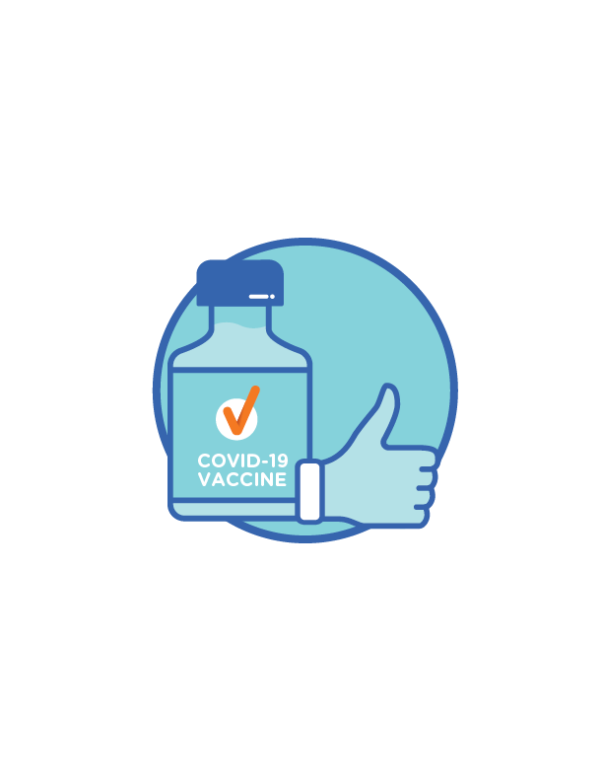 | Before a company can send the TGA an application, the company must tell the TGA:  - about the vaccine they want to be approved
- why people need the vaccine
- what clinical trials they have run.

 | A clinical trial is research to test if a vaccine:  - is safe  - works well.
The company must also tell the TGA how they will make sure in the future their vaccine:
- is safe
- works well.
If the TGA decides the company made the vaccine in the right way, they will tell them to apply.

Step 2 – The application to have a vaccine approved
2 | The company must send an application to the TGA for their vaccine to be approved.
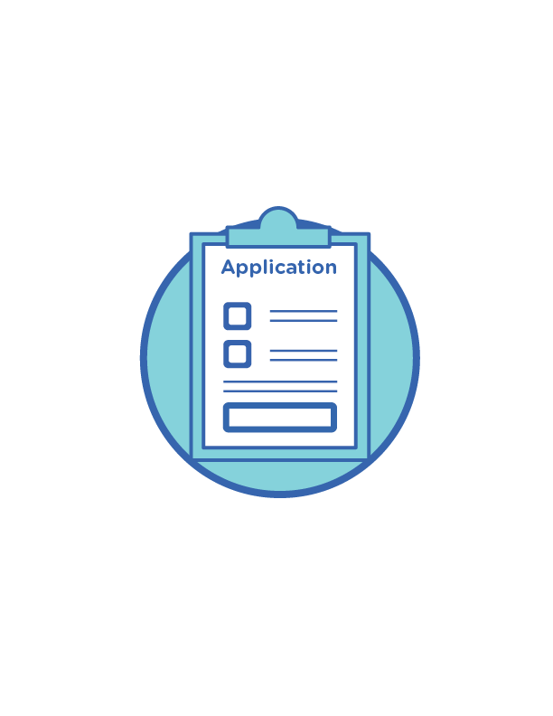 | When they apply, the company must tell the TGA:  - how the clinical trials show the vaccine is safe and works well  - how the ingredients in the vaccine are safe.
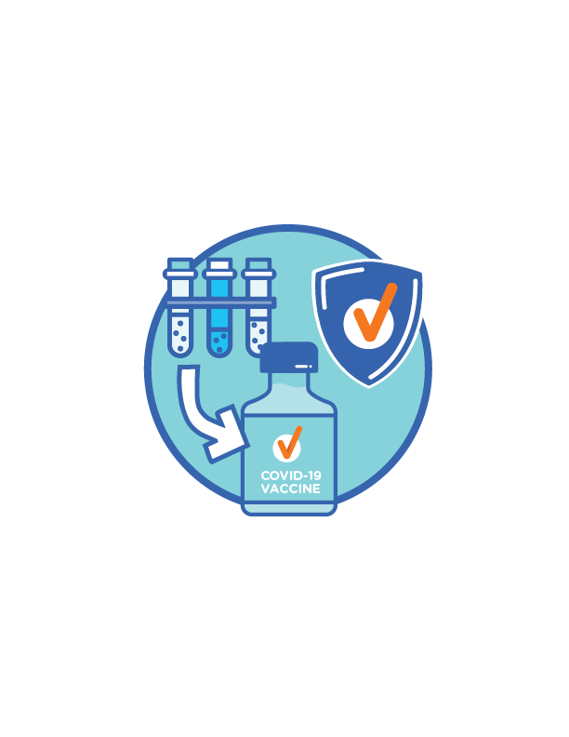 | The company must also tell the TGA:  - how they will make the vaccine  - if there are any risks for people who have the vaccine.

Step 3 – Looking at the application
The TGA will carefully look at the:
- vaccine to make sure it is safe
- information the company provided.
The TGA will:
- work with other experts to make sure the vaccine is safe

 | - look at every ingredient in the vaccine to make sure it is safe.
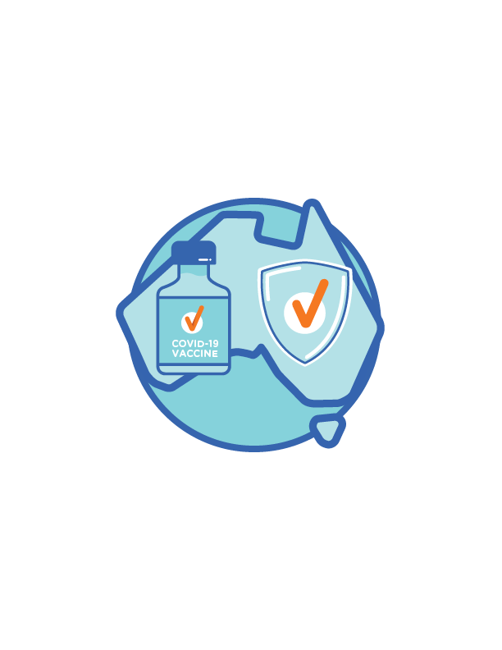 | The TGA will also:  - look at the clinical trials to make sure the vaccine is safe for everyone in Australia
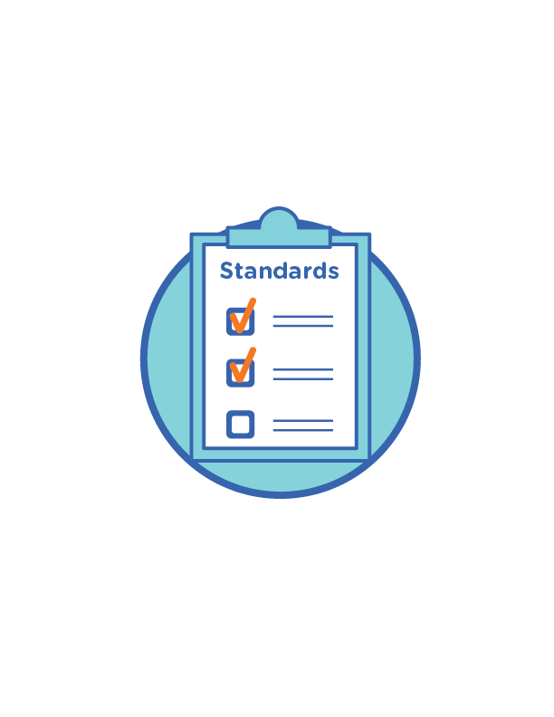 | - make sure the vaccine meets Australian standards
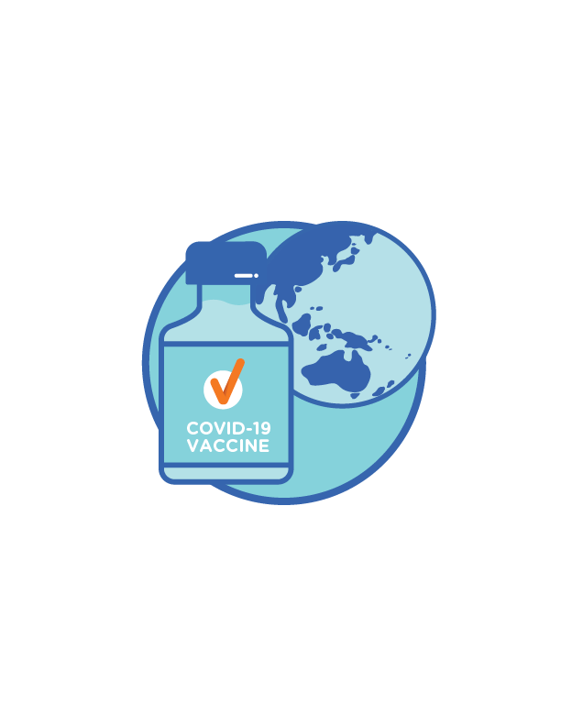 | - look at how other countries around the world have used the vaccine.
 | The TGA might also ask the company more questions if they need to.

Step 4 – Making the decision
4 | The TGA decides if they will approve the vaccine.
 | If the TGA approves the vaccine, they will approve it for 2 years.  After 2 years, the company can ask the TGA to approve the vaccine for up to 6 more years.

Step 5 – Registering the vaccine
5 | After the TGA approves the vaccine, they will add it to the Australian Register of Therapeutic Goods (the Register).
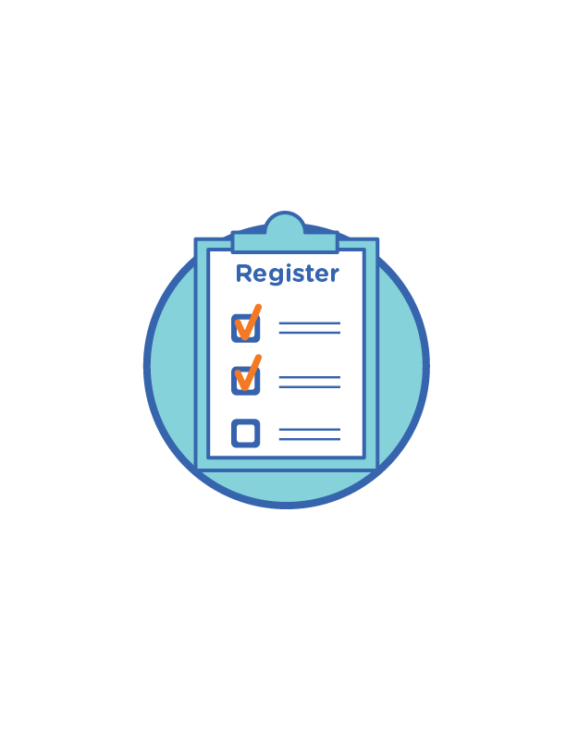 | The Register is a record of all the vaccines the TGA has approved in Australia.  The record includes:  - the name of the company  - the name of the vaccine  - what ingredients are in the vaccine  - information for people who get the vaccine.
 | After the vaccine is added to the Register, the company can start to send out the vaccine.

Step 6 – Keeping track of the vaccine
6 | The TGA will keep checking the vaccine as more people get it.
This is to make sure it:
- is still safe
- still works well.
If there are any problems, the TGA can:
- look into the problem with the vaccine
- give people new information about how safe the vaccine is
- take away the approval, if needed.

More information
 | You can visit the Department of Health website at www.health.gov.au/covid19-vaccines-languages for more information about the vaccine in your language.
 | You can call the National Coronavirus Helpline on 1800 020 080. Select option 8 for free interpreting services.

