

Plain Language Summary

National Guidelines to improve coordination of treatment and supports for people with severe and complex mental illness

Australian Government Department of Health – March 2022

# Contents

Contents 1

List of Figures 2

Glossary and Abbreviations 3

Plain language summary 5

Why do we need national Guidelines? 5

What does severe and complex mental illness mean? 5

What do the Guidelines do? 5

How can the Guidelines help? 5

Guiding principles 6

Care Coordination 7

What is care coordination? 8

How does care coordination help? 8

How to make coordination safe 8

What about my rights? 9

What needs to happen in good care coordination? 10

Recommendations to improve care coordination 11

Recommendation 1. Clarify the function and role of each stakeholder 12

What does this mean? 12

Recommendation 2. Ensure there is a care coordinator to navigate and coordinate support for consumers 13

What does this mean? 13

Recommendation 3. Ensure multiagency care planning is consumer-led and recovery oriented 14

What does this mean? 14

Recommendation 4.Develop and implement practices that support communication and information sharing 16

What does this mean? 16

Recommendation 5. Establish and support safe transitions of care 18

What does this mean? 18

Recommendation 6. Ensure Aboriginal and Torres Strait Islander services are involved and available 20

What does this mean? 20

Recommendation 7. Promote and strengthen innovative leadership 22

What does this mean? 22

Recommendation 8. Ensure workforces are equipped to deliver effective coordination 23

What does this mean? 23

Recommendation 9. Commit to improve and increase the use of data and technology in care coordination 25

What does this mean? 25

Specific Populations 26

Life stages and transitions 27

Aboriginal and Torres Strait Islander 27

Culturally and linguistically diverse 27

LGBTQIA+ 27

People living with a disability 27

People living in rural, regional and remote communities 28

Acknowledgments 29

# List of Figures

Figure 1 Six guiding principles for the Guidelines 6

Figure 2 Some of the services a consumer, carer and community may use 9

Figure 3 What happens in good care coordination 10

# Glossary and Abbreviations

**Access:** The ability of any person to obtain required or available services when needed within an appropriate time frame.

**ACCHOS:** Aboriginal Community Controlled Health Organisation and/or Service.

**AMS:** Aboriginal Medical Service.

**CALD:** Culturally and Linguistically Diverse.

**Care coordination:** The process of working with and for the consumer, carer and community to help them plan their care and access a range of different health and social care services and sectors.

**Carer:** Refers to persons that provide care and support to a person with severe and complex mental illness. Carers can be formal or informal and include family, friends or community members. The role of carer can vary over time depending on the needs of the person and the carer.

**Consumer:** A person who has or has had a personal lived experience of severe and complex mental illness and who is accessing or has previously accessed mental health and social care services.

**Consumer-led:** Coordination of supports is directed by the person with severe and complex mental illness. They have a right to make their own decisions. These decisions should be respected and supported by carers, communities, services, sectors and professionals.

**Communities:** Refers to any persons involved in the consumers life. This includes families, friends, aunties, uncles, cousins, teachers, colleagues and neighbours.

**Cultural safety:** Determined by Aboriginal and Torres Strait Islander individuals, families and communities. Ensuring respect for cultural and social differences in the provision of health and social care services.

**Culturally safe:** Practices that include ongoing critical reflection of health practitioner knowledge, skills, attitudes, practicing behaviours and power differentials in delivering competent, appropriate, safe, accessibly and responsive care that is free from racism.

**Information sharing:** Refers to the sharing of appropriate clinical and nonclinical information between professionals, services, consumers, carers and communities.

**Kinship:** The kinship is based on direct blood lines through family such as grandparents, parents and child(ren); AND/OR there is also traditional kinship systems which include nations and clan groups who have ties across extended families, such as grandparents (and their siblings), aunties, uncles, cousins, parents (siblings) and child(ren).

**Leadership teams:** Refers to persons who lead services and workers to adapt and improve the way services are developed and delivered to consumers, carers and communities.

**LGBTQIA+:** Refers collectively to people who identify as lesbian, gay, bisexual, transgender, intersexed, Genderqueer, Queer, Agender, Asexual, bodily diverse, gender fluid, queer, pansexual, sister-girls, brother-boys and other sexually and gender diverse populations.

**MOU:** Memorandum of Understanding.

**Multiagency:** Refers to a number of different services working together with and for the consumer, carer and community.

**NDIS:** National Disability Insurance Scheme.

**Organisation:** Group of people with a particular purpose such as a business or government department.

**Peer worker:** Refers to a person employed specifically from either their personal lived experiences of mental illness and recovery, or their lived experience of supporting family or friends with mental illness, along with their professional experience, training, strengths and abilities.

**Person-centred:** Involving the person, their carer and community in planning, designing and delivering of services.

**Recovery oriented:** Refers to the practice of supporting people to recognise and own their recovery journey. People should be supported to define their goals and desires.

**Sectors:** Refers to different departments and services of care, including health, psychosocial, housing, justice, education and employment.

**Services:** Refers to a person, business or organisation who carries out actions or work that help people with severe and complex mental illness, their carer/s and communities.

**Severe and complex mental illness:** Encompasses severity (reflected through diagnosis and episodic nature of illness), persistence (reflected through duration of illness or service needs) and complexity (reflected by impact to daily living, comorbidities and/or trauma).

**Shared decision-making:** Involves collaboration and discussion between the person, their carer, community and the service provider. The person should be supported to make decisions, exercise their legal capacity, make day-to-day choices and draw upon their personal strengths and support networks to reach the most appropriate decision for that person.

**Social and emotional wellbeing:** A whole-of-life view that is multidimensional and intrinsically connected to all aspects of living, including family and kinship, culture and spirituality, connection, sense of belonging, reciprocity and the land.

**Trauma-informed care:** Practices that understand and recognise the widespread impact of trauma for people with severe and complex mental illness, carers, communities, workers and others. Practices that respond by integrating trauma-informed knowledge and principles into policies, procedures and practices.

# Plain language summary

This plain language summary is designed to inform the reader about the National Guidelines to improve the coordination of treatment and supports for people with severe and complex mental illness (the Guidelines).

## Why do we need national Guidelines?

Services work hard to support people with severe and complex mental illness (mental illness). Sometimes this is not enough. Some people do not receive the support and coordination that they need. Action 9 of the Fifth National Mental Health and Suicide Prevention Plan recognises the need for better coordination to help people access and receive the support they need.

## What does severe and complex mental illness mean?

The meaning of severe and complex mental illness is different for different people. The definition used in this document may not represent everyone’s experiences and recovery journey. In these Guidelines, severe and complex mental illness includes:

* Severity (which means how many episodes a person may experience or how a person’s mental illness may impact their life).
* Persistence (which means how long a person has been living with a mental illness).
* Complexity (which means other challenges a person may be experiencing at the same time, such as homelessness, trauma or substance use).

Social and emotional wellbeing needs to be included for Aboriginal and Torres Strait Islander people. This means acknowledging the whole-of-life view when providing support.

Throughout the Guidelines, people with severe and complex mental illness may be referred to as consumers. We understand that not everyone will see themselves as a consumer. In this document a consumer is a person who is using a service to help their recovery journey.

## What do the Guidelines do?

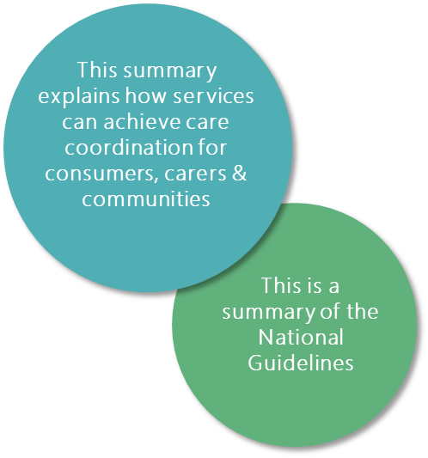The Guidelines have been created to improve the coordination of treatment and supports for people living with severe and complex mental illness. There are nine recommendations that help services:

* Work with the person living with a mental illness.
* Work with the carers and communities of a person living with mental illness.
* Work with other services to meet the needs of the person living with mental illness.

## How can the Guidelines help?

When supports are coordinated, it can help people feel good about their health and wellbeing. It can also help carers and communities understand how they can support a person living with a mental illness.

# Guiding principles

The Guidelines are supported by six principles (see Figure 1). These principles help to keep the focus on the person and what the person needs in their recovery.

* Consumer-led Coordination of supports is directed by the consumer. The consumer has the right to make their own decisions. These decisions should be respected and supported.
* Co-design Coordination of supports are designed, delivered and monitored with services, consumers, carers and communities. Consumers, carers and communities have an active role in all processes that affect them.
* Information sharing and communication Services should share relevant information with consumer consent and involvement. Services should also seek to include the carers and communities with the consent of the consumer. Communication should be trauma-informed and culturally safe.
* Collaboration Services should communicate, share decisions and trust each other. It should be clear what service is responsible for what when coordinating care.
* Comprehensive and recovery oriented Services should meet the person’s health care, social and other support needs.
* Continuity of care Support is consistent and delivered on time.

Figure 1 Six guiding principles for the Guidelines

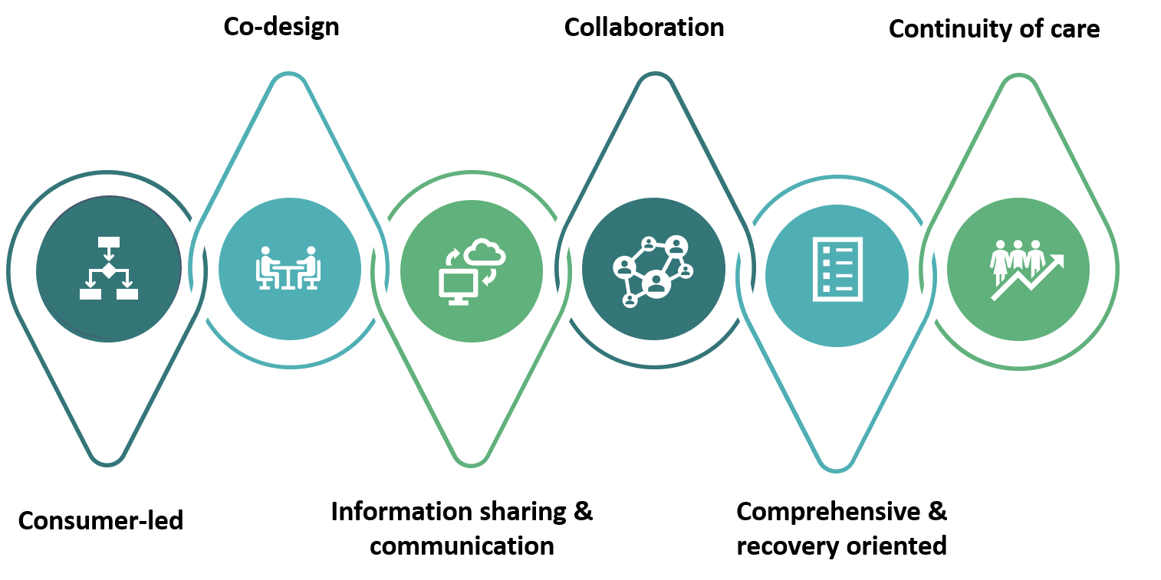



Care coordination is…

Providing a person with all the right supports they need and want at the right time.

Care Coordination

## What is care coordination?

Care coordination brings people, services and communities together. It helps people receive the care they need to reach good mental health and wellbeing.

Care coordination is about the person and reflects the person’s needs and goals. Good coordination includes:

* Whole of person The person’s physical, mental, emotional and social health and wellbeing.
* Timely and targeted care The right supports at the right time.
* Consumers, carers and communities Coordination is designed with and for the consumer.
* Navigation and leadership Support when accessing and coordinating care.
* Culturally safe Access to supports that are safe and supported.
* Information and data sharing Always includes the consumer and their consent.

## How does care coordination help?

People with a mental illness may need help from different health and social care services. Figure 2 below shows some of the services a person may choose to access.

This means that people are given care that is not just about their mental health. It means care is also about their physical, emotional and social wellbeing.

Good care coordination makes experiences better for consumers, carers and communities. When there is good coordination there is better quality of care given from services and workers. This means consumers may have a higher quality of life. It also means consumers, carers and communities can feel confident they are getting the right care and services.

Good care coordination also helps services. It means less hospital visits and ensures referrals to the right services. This means that people can use the right services at the right time.

## How to make coordination safe

In Australia, there are lots of different cultures, beliefs and values. This means that people can have different views on what is important to their mental health and wellbeing. Services need to work with and for people. Services also need to work together for each consumer. This makes sure supports are about the person and what they need. When this happens, consumers, carers and communities can trust that they will receive the best care and support.

Services need to work with lots of other health and social care services to meet the physical, emotional and social wellbeing of each person. They also need to work with different communities so that services reflect and support the different cultures, beliefs and values. This includes working with:

* Aboriginal and Torres Strait Islander communities.
* Culturally and linguistically diverse communities.
* LGTBQIA+ communities.
* People living with a disability.

Figure 2 Some of the services a consumer, carer and community may use

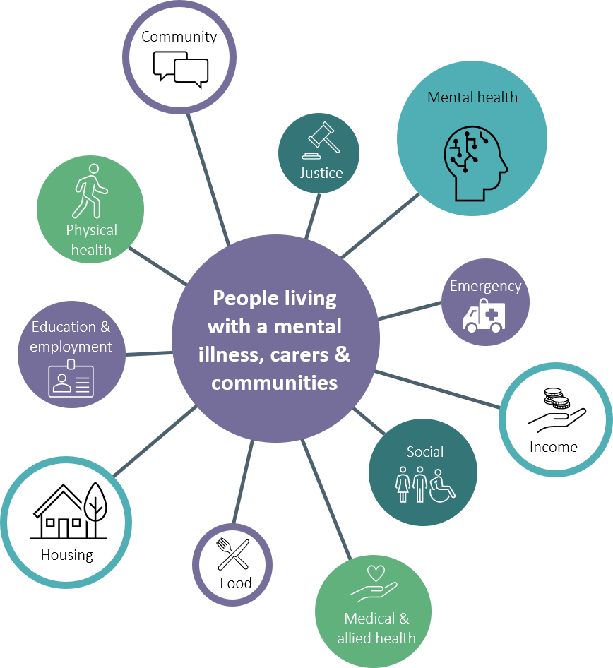

## What about my rights?

Consumers, carers and communities have many rights when accessing and receiving support. Some key rights include:

* The right to receive timely and appropriate treatment, care and support.
* The right to their privacy and confidentiality.
* The right to be an active participant in decision-making.
* The right to have their lived experiences taken into account.
* The right to have families, carers and support persons involved to the extent requested by the consumer.
* The right to have kinship family involved to the extent requested by the consumer.
* The right to be advised by the treating clinicians or services of events affecting the consumer.

The Mental Health Statement of Rights and Responsibilities provides more details for consumers, carers, communities, services and workers.

## What needs to happen in good care coordination?

There are certain activities that services should do when working with and for consumers. These are shown in Figure 3 and include:

* Engage Whether a person engages with a service for the first time or tenth time, services must have a no wrong door policy.
* Consent Consumer consent is essential. Consumers should have enough information to make an informed decision. Services must tell consumers what information is recorded and check if they can share this with other services. Consent needs to be reassessed regularly.
* Assess Services should work with the consumer, carer and community to understand and assess their physical, mental, emotional and social needs. Care plans should be consumer-led and co-designed to meet these needs. Wherever possible, the persons carer and community should be included.
* Plan Supports should be provided according to the consumers care plan. There should be no duplication of services. There should be clear pathways to help people access services.
* Action Services should carry out their agreed roles and responsibilities in the care plan.
* Reassess Services should check in with the consumer regularly. This is to make sure consumer’s expectations, needs and goals are met. Care plans and actions should change if needed.

Figure 3 What happens in good care coordination

Figure 3 is a diagram of what happens in good care coordination 




The recommendations…

This is what services need to be doing to support consumers and carers to get the supports they want and need at the right time.

Recommendations to improve care coordination

## Recommendation 1. Clarify the function and role of each stakeholder

1.1 Ensure that all functions, roles and responsibilities are designed and developed with and for the consumers, carers and communities and are clear, transparent and understood.

1.2 Clearly outline the requirements and expectations of each role for all stakeholders to understand, including consumers, carers and communities.

### What does this mean?

People with a mental illness often need help and support from lots of people and services. Everyone involved needs to know what they have to do to best help someone with a mental illness, including the person’s carer and community.

Everyone needs to know what they need to do to best help someone with a mental illness.

#### Recommendation 1.1

Everyone will help in a different way. The role of governments is to make sure the services available are designed to meet the needs of people with a mental illness.

Services have a role to work with the consumer. They also have a role to work with other services to meet the person’s needs. The care coordinator is there to help the person develop their care plan. They support the person to access services and reach their goals. Consumers, carers and communities are key stakeholders. The consumer’s role is an active participant and decision-maker in their mental wellbeing and recovery journey.

#### Recommendation 1.2

Services need to be clear about:

* What they will achieve.
* How they will work with the consumer, carer and community to coordinate care.
* How they will work with other services.
* The skills and experiences required.

For example, a community mental health service will provide care to consumers experiencing homelessness. They will partner with the local hospital, housing department and other services. The mental health service will communicate how they can help. For example, how they can connect them to accommodation support. If there are gaps in service delivery, the service will connect them with the appropriate services.

All services should understand the role of other services. Services should work with each other to support consumers. Consumers, carers and communities should feel confident about who is involved and how care will be coordinated. This means they know which service provides what. It also means there are no gaps in their care.

## Recommendation 2. Ensure there is a care coordinator to navigate and coordinate support for consumers

2.1 With consumer consent, engage a care coordinator to identify needs and support the coordination and navigation of services and sectors.

2.2 Provide care coordinators with appropriate support, resources and authority to oversee and ensure the multiagency care plan is being implemented.

### What does this mean?

Everyone should have navigation and care planning support if they want it. Consumers may need support from more than one service. Having one person a consumer can turn to for help means they can get the support they need.

The care coordinator can help a person take charge of their health and wellbeing and achieve their goals.

#### Recommendation 2.1

All people with a severe and complex mental illness should have access to a care coordinator. Consumers under a mental health order should have a care coordinator.

The care coordinator can help the consumer, their carer and community by:

* Helping to make a plan of care.
* Connecting them with the services they want and need.
* Involving the consumers, carers and community.
* Helping the consumer access NDIS supports if they are eligible and want it.
* Supporting the consumer, carer and community when moving from one service to another.
* Advocating with and for the consumer.
* Acting in their best interest to ensure their health, safety and welfare.
* Building relationships with other services that may support the consumer.

There should be trust between the care coordinator and the consumer, carer and community.

#### Recommendation 2.2

Care coordinators need skills and knowledge of the local services available. With the persons consent, they should have access to the care plan. The care coordinator can make sure the plan is being carried out and everyone involved is doing their job.

There needs to be enough support to help care coordinators do their job. Funding and item numbers may be needed.

## Recommendation 3. Ensure multiagency care planning is consumer-led and recovery oriented

3.1 Establish processes to develop multiagency care plans with and for the consumer.

3.2 Services, sectors, carers and communities should collaborate and work alongside each other according to an agreed single multiagency care plan for the consumer’s needs.

3.3 Ensure the consumer is an involved decision-maker and participant in their multiagency care plan.

### What does this mean?

One person cannot give someone living with a mental illness everything they need. It is a team effort. Services must come together with the consumer, carer and community and work with them to create a care plan. This means that each service involved agrees to help the consumer in a specific way. Each service has a responsibility to make sure they do what they agree to.

Services must come together with the consumer and work with them to create a care plan.

#### Recommendation 3.1

There should be steps that services take to participate with consumers in a single care plan. The way this happens will look different for each service. The steps taken by services should be planned and developed with the consumer. This should happen regardless of the consumer’s gender, race, sexuality or ethnicity.

The steps should allow the service to engage with other services to support the person and their needs. Services should also follow agreed steps if the person is experiencing acute crisis situations.

#### Recommendation 3.2

The care plan must reflect the person’s needs, goals and life. Take into consideration kinship responsibilities for Aboriginal and Torres Strait Islander people. This means that the care plan will help the person in their current situation. It will also help them move towards their future goals and wishes. Care plans should be reviewed regularly and updated at times agreed by the consumer and everyone else involved, including kinship families. When developing a plan, services should work with the consumer to understand:

* The person’s goals, beliefs, preferences and culturally safe supports.
* The person’s physical, mental health, emotional wellbeing and social care needs.
* How everyone will be involved in the person’s care plan and the key contacts.
* Who the lead coordinator or person will be and how they will provide support.
* Safety and crisis planning.

#### Recommendation 3.3

Care planning must be person-centred and consumer-led. Meetings should be a joint effort with the consumer, carer and community to ensure full participation. Meetings should be at times the person and their nominated supports can be there. All communication must be honest, open and respectful. The consumer, carer and other nominated supports must be included in all communications.

Consumer’s should feel safe and supported to speak about any concerns they may have. Services must be safe places for this to happen.

## Recommendation 4. Develop and implement practices that support communication and information sharing

4.1 Develop information sharing protocols that are underpinned by principles of informed consent and confidentiality.

4.2 Develop information sharing protocols in collaboration with health and social care services and sectors, and across states and territories.

4.3 Ensure all professionals have access to education and resources on how to gain and document informed consent, the legislation in each state and territory and how to communicate information.

4.4 Ensure consumers, carers and communities have access to education and resources on consent and information sharing processes.

### What does this mean?

A person may access many services at one time. When this happens information may need to be shared with other services. This means there must be informed consent.

Information sharing that is trauma-informed can improve service quality. This means services need to know what information should and should not be shared.

When information sharing is done well, it can create a culturally safe environment and improve service satisfaction and health outcomes.

#### Recommendation 4.1

Gaining a person’s consent to share information must underpin any information sharing protocol developed. This means that the steps services follow to share information happen with the person’s consent.

Information sharing, without a person’s consent should only occur in some situations. For example, if the person disclosing the information believes, on reasonable grounds, that the person is at risk of harm to themselves or others.

#### Recommendation 4.2

##### Between services and sectors

Services should create steps for information sharing with other services. These should follow the state and territory laws. This will mean the persons information is safe. The steps should also be designed with consumers, carers and communities.

The steps should support services to share information in certain situations, while recognising the consumer’s right to confidentiality and privacy.

The steps should include (but not be limited to):

* An understanding of why information may need to be shared.
* How to gain informed consent.
* What information needs to be shared between services.
* How information will be safely shared and stored.
* Safe ways to communicate and help consumers, carers and communities understand.

The steps should be regularly reviewed in collaboration with consumers, carers and communities. An electronic platform can support information sharing (see Recommendation 9).

##### Across states and territories

To ensure continuity of care across states and territories when a person is under an involuntary mental health order, information sharing should be supported. States and territories should take two primary steps:

* Adopt a mutual recognition principle within mental health legislation. This means each state or territory legally recognises mental health orders from another state or territory.
* Develop a Memorandum of Understanding. This means a formal agreement about how information will be shared between services in different states and territories.

#### Recommendation 4.3

Services working with consumers should have regular training to support good information sharing (e.g. once per year). Where possible, consumers, carers and communities should be included to provide training. They may share their experiences as part of training professionals.

The training should be specific to the state or territory and include all parts of information sharing (see Recommendation 4.2).

#### Recommendation 4.4

Consumers, carers and communities have a right to access education and resources. This helps to understand and provide informed consent. Open communication is also needed between consumers, carers, communities and services. Service improvements include but not limited to:

* Communication about what information needs to be shared with who, when and how.
* Communication about why information may need to be shared.
* Provision of resources for example web-based or pamphlets.
* Access to translators if needed.

The resources must be culturally appropriate, easy to understand and easily available. They should also be available in different indigenous and international languages. Resources should be co-designed with consumers, carers and communities.

## Recommendation 5. Establish and support safe transitions of care

5.1 Improve or develop formal pathways with shared agreements between health and social care services and sectors.

5.2 Clearly define and clarify the roles and responsibilities of those involved in the transition of care.

5.3 Identify a coordinator to support the consumer and assist in ensuring safe and effective transitions.

### What does this mean?

The most vulnerable period for people with a mental illness is when they are transitioning through care episodes and/or settings. This includes from child and young adult services to adult and older adult services. Transitions may also be from inpatient services to community-based services or between community-based services. Another important transition is from a service back into the care of the person’s carer or community.

The constant in the transitions through care episodes or settings is the consumer, their carer and communities.

The transition should therefore be well coordinated to ensure the persons safety. This also means the person’s recovery goals are met, and they do not fall through the gaps.

#### Recommendation 5.1

Formal pathways and shared agreements between services should be developed or improved. The agreement should have clear steps, so people can have a safe transition. The agreement should include:

* Clear roles and responsibilities.
* How information will be shared (in line with Recommendation 4).
* The use of warm referrals where possible— in person or over the phone.
* Culturally safe transitions.
* Flexible service delivery for all people.
* Follow up and evaluation processes.
* Local step-up/step-down pathways.

With the persons consent, the original service should maintain contact with the person and the receiving service for a period of time after transition. When all parties agree that the transition has been completed, the original service can stop contact.

Both the original and receiving service should undertake monitoring and evaluation. Consumer, carer and community experiences should be used to improve future transitions.

#### Recommendation 5.2

Planning for a transition should begin as early as possible. The consumer should be involved in decisions throughout the transition. If the person chooses to have their carer or community involved, then they should also be included.

The roles and responsibilities of each service and professional in the transition should be defined. This should be outlined in the multiagency care plan to ensure a level of accountability.

This should include:

* An agreement to engage and support the consumer, carer and communities.
* What supports each service will provide and when they will provide them.

If a person is transitioning back into the care of a carer or their community then it is important that the service engages with them in advance. For Aboriginal and Torres Strait Islander consumers, this must include their kinship family. As long as this is the consumer’s choice, communication with the consumer and their carer or community needs to be clear. This includes discharge processes with a simple summary of the discharge papers, follow up appointments and any next steps. This will make sure there is continuity of care.

Consideration for the diverse needs of any consumer, carer or community in the transition process must be respected. For more information see Specific Populations.

#### Recommendation 5.3

A care coordinator responsible for ensuring a safe transition should be identified. If a care coordinator is not available, a key person should instead be named to support the consumer, their carer and community throughout the transition. The care coordinator and key person should have the authority to ensure that all services are engaged and able to provide the support needed (see Recommendation 2).



## Recommendation 6. Ensure Aboriginal and Torres Strait Islander services are involved and available

6.1 Ensure Aboriginal and Torres Strait Islander services, professionals and social and emotional wellbeing teams are embedded across government and non-government health and social care services and sectors.

6.2 Develop strong culturally safe partnerships that enable coordination with health and social care services and sectors, as well as communities, to meet the social and emotional wellbeing needs of Aboriginal and Torres Strait Islander consumers.

6.3 Continually consider and assess the social and emotional wellbeing and needs of each individual, offering access to culturally safe treatment and supports that include the kinship family.

### What does this mean?

Social and emotional wellbeing is central to the health of Aboriginal and Torres Strait Islander people. It is about the physical, emotional and cultural wellbeing of the person and their community. Services need to understand the importance of this holistic approach. Services must work to foster the traditions of Aboriginal and Torres Strait Islander communities.

Social and emotional wellbeing is central to health. It is about the physical, emotional and cultural wellbeing of the individual and their community.

#### Recommendation 6.1

Governments need to invest in strengthening Aboriginal and Torres Strait Islander services, professionals and social and emotional wellbeing teams. This will support Aboriginal and Torres Strait Islander consumers, carers, families and kinship.

Services that do not have Aboriginal and Torres Strait Islander professionals or teams need to partner with other Aboriginal and Torres Strait Islander professionals or community-controlled services. This will mean that if an Aboriginal and Torres Strait Islander consumer wants to connect with an Aboriginal and Torres Strait Islander professional, they can.

#### Recommendation 6.2

Services should be partnering with Aboriginal Community Controlled Health Organisations and/or Services (ACCHOS) and Aboriginal Medical Services (AMS).

ACCHOS and AMS should be involved in the development and delivery of training for staff. This will support services and staff to provide the best care for Aboriginal and Torres Strait Islander people.

#### Recommendation 6.3

Services need to learn about Aboriginal and Torres Strait Islander social and emotional wellbeing. This will help services to provide care that empowers Aboriginal and Torres Strait Islander people.

Aboriginal and Torres Strait Islander consumers should be active participants and involved decision-makers. If the consumer wants, Aboriginal and Torres Strait Islander communities and kinship families should also be involved. Services should offer consumers access to culturally safe services such as:

* Elders.
* Traditional healers.
* Cultural healers.
* Interpreters.



## Recommendation 7. Promote and strengthen innovative leadership

7.1 Develop and support internal system and organisational leadership to facilitate effective communication and care coordination.

7.2 Support consumers, carers and communities to develop independent life and leadership skills that will assist in their recovery journey.

7.3 Establish, build and maintain trusting relationships and partnerships with other services, professionals, carers and communities.

### What does this mean?

Leaders keep services focused on the consumer and their needs. This means that services are person-centred and designed with the consumer. Leaders can influence the attitudes of services and change how services are delivered to consumers, carers and communities.

Leaders keep services focused on the consumer and their need.

#### Recommendation 7.1

Services should have effective leaders. Leaders should be open to change, strong and brave. Leadership can inspire changes within the services. These changes can shape the development of future services and how they are delivered. This will mean that consumers, carers and communities can access and receive coordinated care that meets their individual needs.

There should be leadership teams (groups of leaders) that work together to improve the way services meet consumer needs. Leadership teams should include peer workers, consumers, carers and community members. This will help services understand the consumer, carer and community perspective.

#### Recommendation 7.2

Consumers, carers and communities should be shown how to develop their own leadership and self-advocacy skills. Each service will have different ways of doing this. For example, involving Elders, mentors, peer workers or life coaches. This will mean that consumers, carers and communities will be able to take control of their own health and wellbeing.

Consumers, carers and communities should be supported to engage and actively participate in the learning of new skills. These skills should help the consumer understand how they can take control of their health and wellbeing journey. It should help carers understand how they can access services and advocate with the consumer on their recovery journey. This may include using technology, understanding their diagnosis and communication skills.

#### Recommendation 7.3

Leaders should build strong relationships with other health and social care services. Regular contact needs to be maintained.

Leaders need to help workers to understand what other services are available and how this can help coordinate care for the consumer. Leaders make sure that nobody gets left behind.

## Recommendation 8. Ensure workforces are equipped to deliver effective coordination

8.1 Ensure services and sectors are trained to provided culturally safe and effective coordination.

8.2 Ensure peer workers are treated as valued members of the workforce.

8.3 Build the capacity and confidence of consumers, carers and communities to engage in their own health and wellbeing journey.

### What does this mean?

People living with a mental illness need workers who know how to coordinate care. Workers must have the skills to coordinate care in culturally safe and supported ways. This will mean they can give continuous care that is recovery oriented, trauma-informed and culturally competent.

People living with severe and complex mental illness need workers who know how to coordinate care.

#### Recommendation 8.1

Services should be set-up to receive regular training that helps them understand how to coordinate care. Governments need to commit to investing in this.

Training should be designed to help services and workers to understand:

* Discrimination and barriers consumers, carers and communities may face when accessing support.
* Current services available.
* How to provide and maintain culturally competent coordination.
* What is needed to access services including housing, psychosocial, community services and mental health and alcohol and other substance use services.
* The importance of peers in supporting and coordinating care for consumers, carers and communities.
* The importance of helping consumers, carers and communities coordinate their own care.

#### Recommendation 8.2

Peer workers are valuable and equal members of the workforce. They should have access to training that supports them to provide care coordination and deliver trauma-informed care. Training should be developed and delivered by peer workers. This will mean that training will be relevant to the unique challenges and experiences of peer workers.

Peer workers could also lead or participate in the training of other workers. This may include sharing their experiences or learnings of coordinating care. Peer workers must feel safe and supported to share and participate. This will help services and other workers understand some of the challenges people with a mental illness may face and ways to provide support.

#### Recommendation 8.3

There must be a commitment to help consumers, carers and communities take control of their own health and wellbeing. Services should work with consumers, carers and communities to help them build confidence in engaging in their own health and wellbeing journey.

This requires services to value the autonomy and perspectives of consumers, carers and communities and ensure their choices are respected and acted on.

Feedback from consumers, carers and communities needs to be valued. Robust feedback processes and evaluation activities which includes partnerships with consumers, carers and communities are embedded in services.



## Recommendation 9. Commit to improve and increase the use of data and technology in care coordination

9.1 Ensure electronic information sharing platforms are compatible across government and non-government services and sectors.

9.2 Collaborate with consumers, carers and communities in the development and implementation of electronic platforms.

9.3 Ensure consumers have the opportunity and choice to use digital technology (i.e. telehealth) to supplement face-to-face contact for remote monitoring and consultations.

### What does this mean?

To improve care coordination, an information sharing platform is needed. This platform should allow services to access information about a consumer that supports them in providing care.

Timely communication of data and information can improve multiagency care planning and outcomes for people.

With a person’s consent to share information, services can know who is involved. This can help to keep the person safe. Transitions will be safer if everyone knows who is doing what.

#### Recommendation 9.1

There should be a dedicated information sharing platform. The platform should have the following goals:

* To assist the workforce to share information in a timely manner.
* To enable consumers to access their own information and data.
* To support self-care. Appointment reminders, medication and information should be included.
* To be transparent about what information is and is not shared.
* To be support by government information sharing and confidentiality laws.
* To allow multiagency care planning.
* To have regular workforce training to support safe practices.
* To have evaluation and feedback processes.

#### Recommendation 9.2

Consumers, carers and communities should be included to develop or improve technology used. Time and resources by Commonwealth, states and territories are needed to develop, implement, maintain and evaluate electronic tools.

#### Recommendation 9.3

People have a right to choose how they would like to access a service. Digital technology for communication and coordination such as telehealth and internet-based support services should be available for consumers and used when it is appropriate.

These services can increase access for those in rural, regional and remote areas. Information sharing platforms are useful to assist in coordinating access. Digital communication with consumers should not replace face-to-face support.



Key considerations….

Sometimes services need to think about the needs of different groups of people. This may include people from different cultures, people with different beliefs and people with different abilities.

Specific Populations

## Life stages and transitions

* Identify the person’s life stage or transition point. This may be the stage between adolescent to adulthood, entering old age or release from prison. Understand that this can impact their ability to access services that support their mental health and wellbeing.
* Work together with other services to support the person as they move between life stages and events. For example, from adolescence to adulthood.
* The consumers physical health should always be assessed. A person’s care plan should include their physical health.
* Consider the social factors influencing the consumer in care planning. This includes housing, finances and education.
* Carers and communities should be active participants in the coordination of care for the person they support.

## Aboriginal and Torres Strait Islander

* Service participation in cultural safety and cultural competency training to support good communication when engaging with Aboriginal and Torres Strait Islander communities or services.
* Engage Aboriginal and Torres Strait Islander community-controlled services, Elders and communities when coordinating the consumer’s supports.
* Services and workforces build their cultural awareness and sensitivity that involves an understanding of kinship and cultural differences of Aboriginal and Torres Strait Islander communities across Australia.
* A social and emotional wellbeing approach should be offered and provided in care coordination.
* Services and environments have culturally safe resources that have been developed with Aboriginal and Torres Strait Islander people and communities.
* Aboriginal and Torres Strait Islander people are included in all decision-making ‘nothing about us without us.’

## Culturally and linguistically diverse

* Services should develop partnerships with local culturally and linguistically diverse services where appropriate.
* The consumers family and community should be involved in care coordination and planning, with the consumers consent.
* Consumers, carers and their community should have a culturally safe and appropriate environment when accessing services. They should have access to resources in their language.
* Services should be aware of the diverse backgrounds, values and beliefs.

## LGBTQIA+

* Services promote trusting, safe and confidential relationships and environments.
* Services are aware and sensitive of the cultures, needs and diversity of the LGBTQIA+ community.
* Services should partner with LGBTQIA+ services where appropriate.

## People living with a disability

* Services should be prepared and willing to adapt their approach. This includes accommodating any physical support needs.
* Services offer interpreters, or the persons preferred communication system should be made available. This includes in person, telephone and digital.
* Services work to maximise involvement of the person, their carer and community when planning and coordinating care (with the consumers consent).

## People living in rural, regional and remote communities

* Local partnerships between health and social services should be developed to form an integrated network of support.
* E-health interventions should be promoted and offered to consumers where appropriate but should not replace face-to-face services.
* Additional support to carers and communities should be offered.
* Services should develop trusting relationships at all levels to promote and maintain confidentiality.



# Acknowledgments

The Department would like to express appreciation to the Action 9 Working Group, membership of which included:

* Mark Roddam: Chair, Mental Health Principal Committee representative, Australian Government Department of Health.
* Daya Henkel: National Mental Health Consumer Carer Forum, Consumer representative
* Hayley Solich: National Mental Health Consumer Carer Forum, Carer representative
* Dr Vanessa Lee: Aboriginal and Torres Strait Islander Mental Health Project Reference Group
* Professor Tim Carey: Aboriginal and Torres Strait Islander Mental Health Project Reference Group
* Glen James: Primary Health Networks representative
* Australian Capital Territory, ACT Health
* New South Wales, NSW Ministry of Health
* Queensland, Queensland Health
* South Australia, Department of Health
* Tasmania, Department of Health
* Victoria, Department of Health and Human Services
* Western Australia, Mental Health Commission
* Senior Officials Working Group, Mental Health Interface Sub-Working Group representative
* Local Hospital Network representative

The Department would like to express appreciation to the key stakeholders and all other individuals who have contributed information, expertise and ideas to this important document. These include:

* Agency for Clinical innovation
* Attorney-General’s Department, South Australia
* Austin Health, Victoria
* Australian Government, Department of Health
* Australian Capital Territory, ACT Health
* Brisbane North Primary Health Network
* Child and Adolescent Mental Health Services, North West Tasmania
* Child and Family Mental Health Services, New South Wales
* Community Mental Health Australia
* Consumers Health Forum of Australia
* Consumers of Mental Health Western Australia
* Department of Attorney-General and Justice, Northern Territory
* Department of Communities and Justice, New South Wales
* Department of Education, Northern Territory
* Department of Education, South Australia
* Directions Australian Capital Territory
* Equity Rights Alliance
* Flourish Tasmania
* Forensic Mental Health Services, New South Wales
* Gold Coast Primary Health Network
* Justice and Community Safety, Australian Capital Territory
* Lived Experience Australia
* Mental Health Australia
* Mental Health Commission, Western Australia
* Mental Health Community Coalition, Australian Capital Territory
* Mental Health Coordinating Council, New South Wales
* Mental Health Council, Tasmania
* Mental Health Families and Friends
* Mental Health Victoria
* Mental Illness Fellowship Australia
* Mind
* National Disability Insurance Agency
* National Indigenous Australians Agency
* National Mental Health Commission
* National Mental Health Consumer and Carer Forum
* New South Wales, Ministry of Health
* Northern Territory Government, Department of Health
* Northern Territory Primary Health Network
* Office of Chief Psychiatrist, South Australia
* Office of Chief Psychiatrist, Western Australia
* One Door Mental Health
* Orygen Australia
* Phoenix Australia
* Queensland Aboriginal and Islander Health Council
* Queensland Alliance for Mental Health
* Queensland Government, Department of Health
* Queensland Government, Department of Housing
* Royal Australian and New Zealand College of Psychiatrists
* Selectability
* South Australia Department of Health
* Tasmanian Government, Department of Health
* Tasmanian Health Service
* University of Sydney
* Victorian Government, Department of Health and Human Services
* Western Australia Association for Mental Health
* Western Australia Mental Health Commission
* Western Victoria Primary Health Network