**MULTIJURISDICTIONAL SYPHILIS OUTBREAK   
SURVEILLANCE REPORT: February 2021**

**This surveillance report has been authorised by Health Departments in outbreak affected jurisdictions and the Australian Government Department of Health.**

The Multijurisdictional Syphilis Outbreak (MJSO) Working Group was formed by the Communicable Diseases Network of Australia (CDNA) in April 2015, in response to an ongoing outbreak of infectious syphilis among Aboriginal and Torres Strait Islander people living largely in remote and rural areas of northern Australia. Increased notifications associated with the outbreak in northern Australia were first reported in January 2011 in northwest Queensland (Qld), followed by the Northern Territory (NT) in July 2013, and the Kimberley region of Western Australia (WA) in June 2014. In March 2017, South Australia (SA) declared an outbreak in the Far North and Western and Eyre regions from November 2016. In August 2018, WA declared that the outbreak had spread to the Pilbara region with the first syphilis notification in this region in February 2018. In January 2019, SA declared the outbreak had spread to Adelaide with the first notification in this region reported in February 2018. In May 2019, WA declared the outbreak had spread to the Goldfields region with the first notification in this region reported in January 2019. In September 2019, Queensland declared the outbreak had spread to Central Queensland with the first notification in this region reported in June 2017.

**Please note:**

On 19 November 2020, the MJSO Working Group endorsed the extension of the ‘target age group’ from 15-29 years to 15-34 years. This change came into effect from the February 2021 Surveillance Report (noting there were no reports produced between November 2020 and January 2021).

The MJSO Surveillance Report was formerly known as the MJSO Communique. Historical epidemiological data and MJSO activities are published in earlier [MJSO Communiques](https://www1.health.gov.au/internet/main/publishing.nsf/Content/ohp-infectious-syphilis-outbreak.htm).

**Current status**

Outbreak data to 31 January 2021ȶ are summarised in Figure 1, Table 1 and Table 2 below.

Outbreak cases are reported as either category 1 or category 2: category 1 cases include Aboriginal and Torres Strait Islander people residing in an outbreak declared regionβ at the time of diagnosis, and; category 2 cases include people who are a sexual contact of a confirmed outbreak case which includes Aboriginal and Torres Strait Islander people who do not reside in an outbreak area at the time of diagnosis and non-Indigenous people regardless of where they reside.

Between 1 – 31 January 2021, there were 42 outbreak cases (category 1 and 2 cases) reported from the four outbreak affected jurisdictions: 4 in Qld; 23 in WA; 15 in the NT, and; 0 in SA (Figure 1, Table 1 and Table 2). From the commencement of the outbreak to 31 January 2021ȶ, there were 4,017 outbreak cases (category 1 and 2 cases) reported across the four outbreak affected jurisdictions: 1,697 in Qld (from January 2011); 1,532 in the NT (from July 2013); 657 in WA (from June 2014), and; 131 in SA (from November 2016) (Table 1 and 2).

**Figure 1**. Epidemic curve showing category 1 infectious syphilisα outbreak cases notified in Aboriginal and Torres Strait Islander people residing in affected regionsβ of Qld, the NT, WA and SA from commencement of the outbreak in each jurisdiction to 31 January 2021ȶ ᵞ

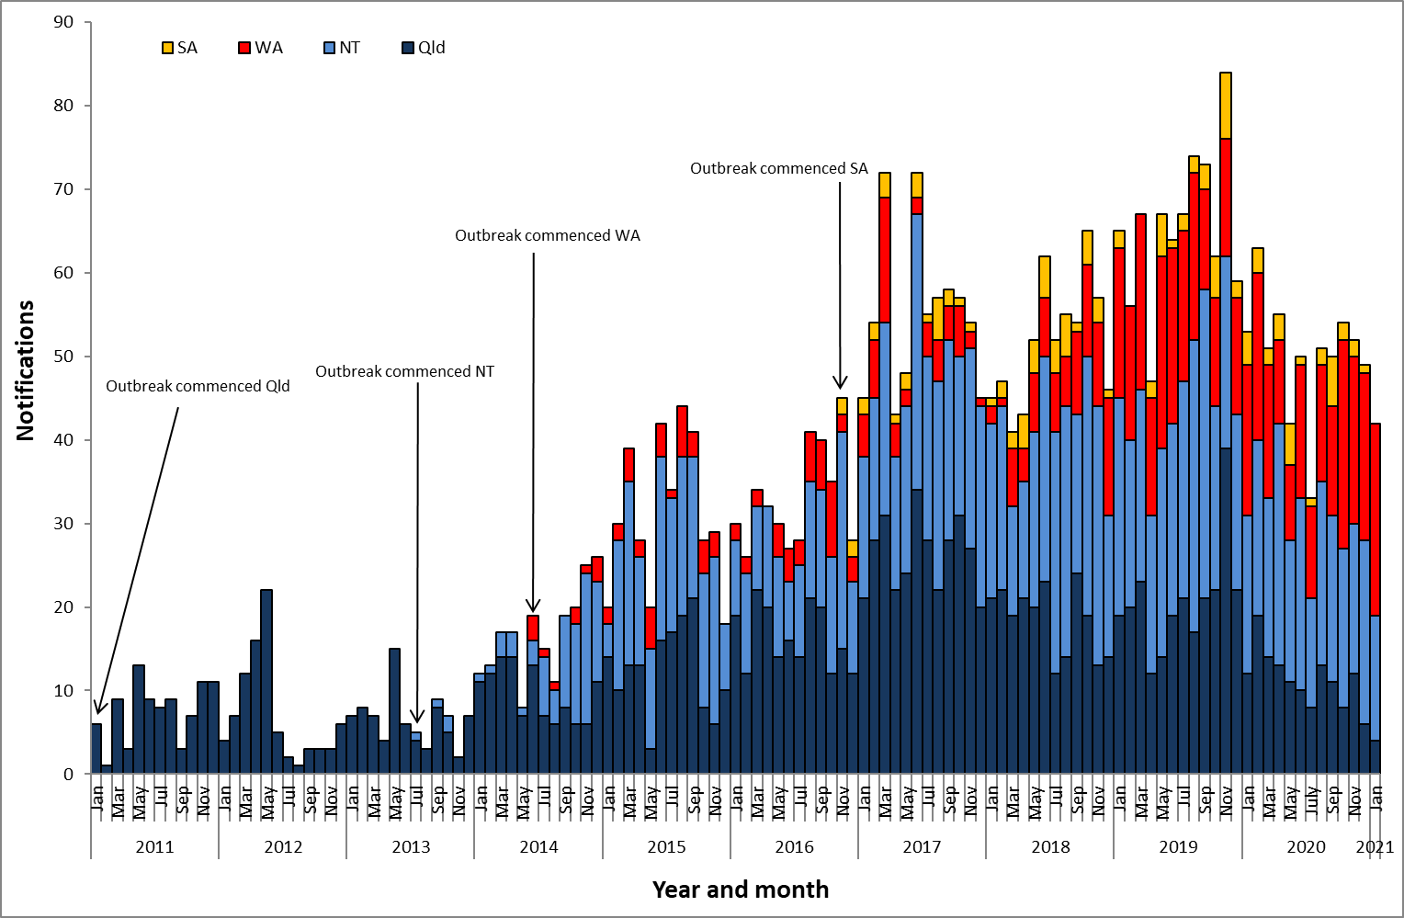

**Table 1**.Characteristics of category 1 infectious syphilisα outbreak cases notified in Aboriginal and Torres Strait Islander people residing in affected regionsβ of Qld, the NT, WA and SA, to 31 January 2021 ȶ ᵞ

|  | **North Qld** (five HHSsβ) | **NT**  (seven regions β) | **WA**  (three regions β) | **SA**  (three regions β) |
| --- | --- | --- | --- | --- |
| **Situation to-date, 31 January 2021** |  |  |  |  |
| Outbreak commencement month/year | January 2011 | July 2013 | June 2014 | November 2016 |
| Total number of casesα | 1,640 | 1,515 | 653 | 127 |
| % Male / % Female | 46% / 54% | 46% / 54% | 44% / 56% | 51% / 49% |
| % 15-34 year age group | 77% | 72% | 48% | 63% |
| Congenital cases, confirmed (probable)« | 4 (5) | 3 (6) | 0 (1) | 3 (0) |
| -number of deaths in congenital cases, confirmed (probable) | 3 (4) | 0 (0) | 0 (0) | 0 (0) |
| **Last reporting month, 1 – 31 January 2021** | | | | |
| Number of casesα | 4 | 15 | 23 | 0 |
| % Male / % Female | 50% | 47% / 53% | 57% / 43% | - |
| % 15-34 year age group | 50% / 50% | 73% | 48% | - |

**Table 2.** Number of category 2 infectious syphilisα cases, to 31 January 2021 ȶ ᵞ

|  | **North Qld** (five HHSsβ) | **NT** (seven regions β) | **WA**  (three regions β) | **SA**  (three regions β) |
| --- | --- | --- | --- | --- |
| **Situation to-date, 31 January 2021** | | | | |
| Outbreak commencement month/year | January 2011 | July 2013 | June 2014 | November 2016 |
| Aboriginal and Torres Strait Islander people§ | 14 | 4 | 4 | 4 |
| Non-Indigenous peopleµ | 43 | 13 | - | - |
| **Last reporting month, 1 – 31 January 2021** | | | | |
| Aboriginal and Torres Strait Islander people§ | - | - | - | - |
| Non-Indigenous peopleµ | - | - | - | - |

**Notes:**

ȶ ‘Diagnosis date’ was used to define the period of analysis. This date represents either the onset date or where the date of onset was not known, the earliest of the specimen collection date, the notification date, or the notification receive date.

**α** Cases defined as per the MJSO syphilis outbreak case definition:

Nationally, an infectious syphilis outbreak case is defined as: any person who is newly diagnosed with confirmed or probable infectious syphilis according to the CDNA national surveillance case definition for infectious syphilis, **AND**, is an Aboriginal or Torres Strait Islander person who resides in any of the following outbreak declared regions as defined and documented by that jurisdiction, at or after the dates indicated: ***Qld*** - North West Hospital and Health Service area (from 1 January 2011); Torres and Cape Hospital and Health Service area (from 1 December 2012); Cairns and Hinterland Hospital and Health Service area (from 1 August 2013); Townsville Hospital and Health Service area (from 1 January 2014); Central Queensland Hospital and Health Service area (from 1 June 2017) ***NT*** - Alice Springs Rural and Urban or Barkly district (from 1 July 2013); Katherine district (from 1 May 2014); East Arnhem district (from 1 November 2015); Darwin Rural and Urban (from 1 January 2017); ***WA*** - Kimberley region (from 1 June 2014); Pilbara region (from 1 February 2018); Goldfields region (from 1 January 2019); ***SA***  - Far North and Western and Eyre regions (from 15 November 2016); Adelaide (from 1 February 2018) (category 1 outbreak cases) **OR**, is a sexual contact of a confirmed outbreak case (category 2 outbreak cases).

**β**Affected regions include Torres and Cape, Cairns and Hinterland, North West, Townsville and Central Queensland Hospital and Health Services in Queensland; Alice Springs Urban, Alice Springs Rural, Barkly, East Arnhem, Katherine, Darwin Urban and Darwin Rural regions in the Northern Territory; Kimberley, Pilbara and Goldfield regions in Western Australia, and; Far North, Western and Eyre and Adelaide regions in South Australia.

« Cases defined as per the MJSO syphilis outbreak case definition: any newly diagnosed case of confirmed or probable congenital syphilis that meets the CDNA national surveillance case definition whose mother’s syphilis infection prior to or during pregnancy meets the infectious syphilis outbreak case definition.

§ Aboriginal and Torres Strait Islander people who are sexual contacts of a confirmed outbreak case and reside outside an outbreak declared region at the time of diagnosis.

µ Non-Indigenous people who are sexual contacts of a confirmed outbreak case and reside in or out of an outbreak declared region at the time of diagnosis.

**ᵞ** Please note that **all data are provisional** and subject to change due to ongoing case investigation.