Medical Research Future Fund MRFF Webinar 12 April 2022
Dr Masha Somi, CEO of the Health and Medical Research Office
Ms Sue MacLeman, Chair of MTPConnect Board

1. The Medical Research Future Fund (MRFF) Update
2. MRFF activities – Grants awarded and expenses
3. 2nd MRFF 10-year Investment Plan (2nd Plan)
4. Activities under the MRFF’s Medical Research Commercialisation initiative
5. MTPConnect
6. Australia’s MTP sector
7. MRFF programs operated by MTPConnect
8. MRFF’s Medical Research Commercialisation initiative
9. Early Stage Translation and Commercialisation Support
10. BioMedTech Incubator Grant Opportunity
11. Biomedical Translation Fund
12. Medical Research Future Fund Program Update
13. MRFF Gender Data Report
14. New Grant Opportunities
15. MRFF Accelerator Grants

# MRFF grants awarded and MRFF budget and expenses

* $2 billion across a total of 742 grants already funded (as at 6 April 2022).
* Funds are available in future years for allocation to priorities.

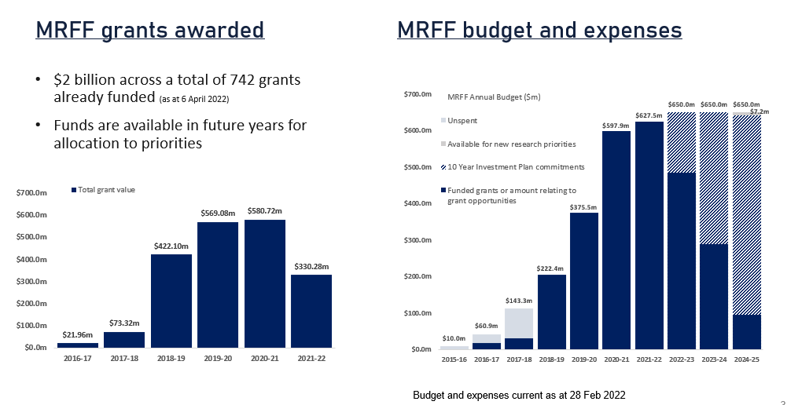

# 2nd MRFF 10-year Investment Plan

* **$6.3 billion over 10 years** (2022-23 to 2031-32).
* Retains and carries forward all funding allocated from existing 1st 10-year Investment Plan (2018-19 to 2027-28).
* Retains the current **4 funding themes** and **20 initiatives**.
* The new 10-year Investment Plan is available at <https://www.health.gov.au/campaigns/mrff>.

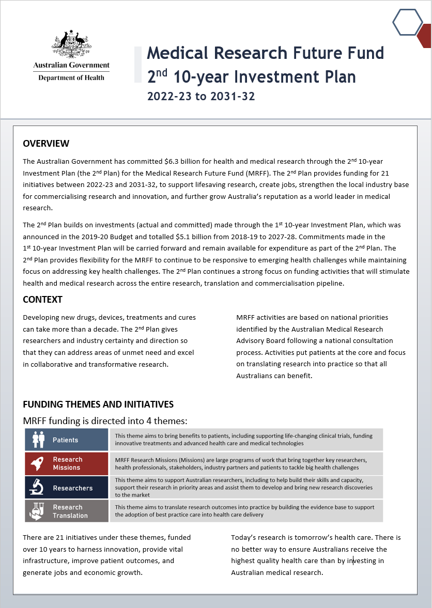

# Update to 10-year Investment Plan (2nd Plan)

* Includes one new initiative and an **additional $3.1 billion** funding:
* **$384.2** million for a new MRFF initiative:
* supporting early to mid-career researchers to enable them to work on greatest health challenges
* **$1.2 billion** for enhancing and expanding existing MRFF initiatives:
* Clinical Trials Activity initiative
* Preventive and Public Health Research initiative
* Primary Health Care Research initiative
* Medical Research Commercialisation initiative
* **$1.5 billion** for extending existing MRFF initiatives from 2028-29 to 2031-32:
* $944 million for extension:
  + - * Emerging Priorities and Consumer Driven Research initiative
      * Global Health initiative
      * Frontier Health and Medical Research initiative
      * Clinician Researchers initiative
      * Rapid Applied Research Translation initiative
      * National Critical Research Infrastructure initiative
      * Research Data Infrastructure initiative
* $590.8 million for extending existing MRFF Missions that demonstrate outcomes, or creating new Missions to address emerging priorities.



* The 2nd Plan includes a section on Alignment with the MRFF Strategy and Priorities.
* This is a high-level overview of how the MRFF initiatives:
* align with and contribute to the strategic objectives of the current 2021-26 Strategy.
* align with the current 2020-22 Priorities (and also the new draft Priorities).

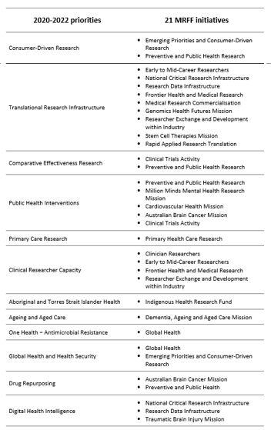

* The 2nd Plan includes snapshots of descriptions for each **MRFF funding theme**, including:
* funding allocated to date (2016-17 to 2021-22)
* funding allocated from 2022-23 to 2031-32
* total funding from inception of the MRFF through to 2031-32.

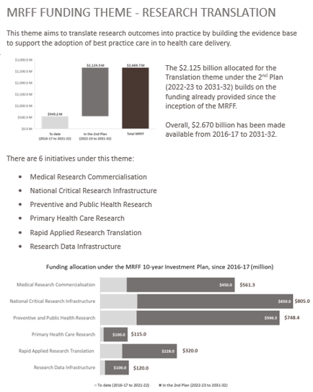

* The 2nd Plan includes snapshots of descriptions for each **MRFF funding initiative:**
* funding allocated to date (2016-17 to 2021-22)
* funding allocated from 2022-23 to 2031-32
* total funding from inception of the MRFF through to 2031-32
* objectives of each initiative
* grant activities supported to date (as of 21 January 2022) from each initiative

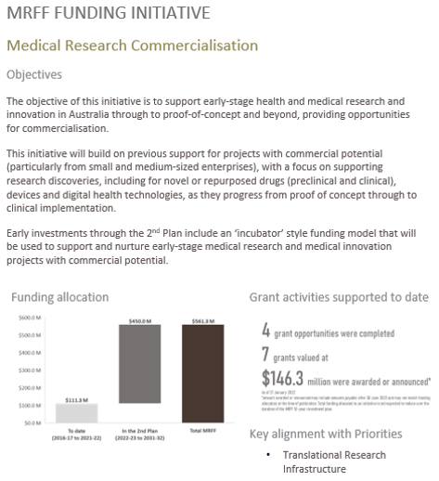

# 2nd Plan: Snapshots of Updates – Patients

| **Theme: Patients** | **Changes to initiative’s focus** |
| --- | --- |
| **Clinical Trials Activity:**   * $750m over 10 years * Increase: $62.6m pa to $75m pa from 2022-23 to 2027-28 * Continuation: 4 years extension 2028-29 to 2031-32 ($300m) | * Expanded focus through a new stream, **effective health interventions**, to enable funding of research projects focused on any disease or condition that meets the objective specified in each grant opportunity (focus in 1st 10-year Plan was on rare cancers, rare diseases, and unmet needs). |
| **Emerging Priorities and Consumer-Driven Research:**   * $613m over 10 years * Increase: Nil * Continuation: 4 years extension 2028-29 to 2031-32 ($240m) | * Nil |
| **Global Health:**   * $30m over 10 years * Increase: Nil * Continuation: 4 years extension 2028-29 to 2031-32 ($12m) | * Nil |

# 2nd Plan: Snapshots of Updates – Research Missions

* Current Missions will continue to be implemented in alignment with Missions’ Roadmaps and Implementation Plans.
* **$590.8 million** has been earmarked in the 2nd Plan for extending existing MRFF Missions that demonstrates outcomes, or creating new Missions to address emerging priorities.

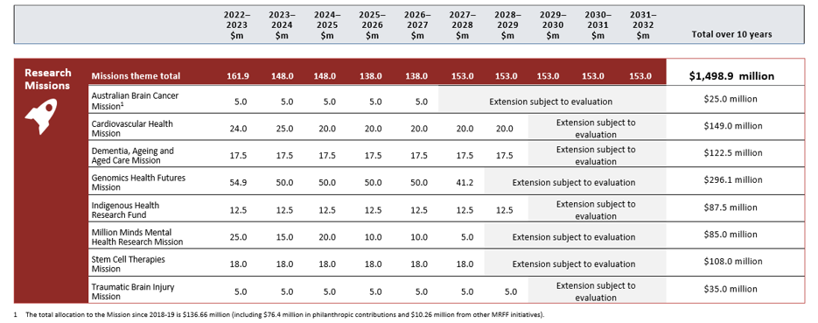

# **2nd Plan: Snapshots of Updates – Researchers**

| **Theme: Researchers** | **Changes to initiative’s focus** |
| --- | --- |
| **Clinician Researchers:**   * 200m over 10 years * Increase: Nil * Continuation: 4 years extension 2028-29 to 2031-32 ($80m) | * Nil |
| **Early to Mid-Career Researchers**:   * $384.2m over 10 years * New initiative | * Dedicated funding stream to support early to mid-career researchers (EMCRs). * **$84 million** for **early career researchers** to develop and test the feasibility of novel solutions to challenging health issues. * **New incubator model** for early-stage small-scale research projects. * **$206 million** for **mid-career researchers** to allow large interdisciplinary teams to devise and implement research to improve health care/health system effectiveness. * **New accelerator model** for large-scale programs of work. * **$95 million** for **accelerated research translation** to allow EMCRs to lead co-funded projects that accelerate translation of research outcomes. * A **targeted call for research** model for research-industry collaboration and translation into practice. |
| **Frontier Health and Medical Research:**   * $700m over 10 years * Increase: Nil * Continuation: 4 years extension 2028-29 to 2031-32 ($280m) | * Nil |
| **Researcher Exchange and Development within Industry:**   * $4m over 1 year * Increase: Nil * Continuation: No | * Nil |

# 2nd Plan: Snapshots of Updates – Research Translation

| **Theme: Research Translation** | **Changes to initiative’s focus** |
| --- | --- |
| **Medical Research Commercialisation**:   * $450m over 10 years * Increase: $35m pa to $45m pa * Continuation: 4 years extension 2028-29 to 2031-32 ($180m) | * Building on supporting projects with **commercial potential** (particularly from small and medium-sized enterprises), with a focus on supporting **research discoveries**, including for novel or repurposed drugs (preclinical and clinical), devices and digital health technologies, as they progress **from** **proof of concept through to clinical implementation**. * Includes **‘incubator’ style** funding model for early-stage medical research and medical innovation projects with commercial potential. |
| **National Critical Research Infrastructure**:   * $650m over 10 years * Increase: Nil * Continuation: 4 years extension ($50m pa) 2028-29 to 2031-32 ($200m) | * Focussed on: * innovation enablers * digitisation of health care * co-investment partnerships * mRNA technology enablers. |
| **Preventive and Public Health Research**:   * $596.5m over 10 years. * Increase: $274.9m from 2022-23 to 2027-28 (year-on-year increases are variable) * Continuation: 4 years extension 2028-29 to 2031-32 ($203m) | * Building on earlier focus to support: * Consumer Led Research, $100 million over 10 years * Health Technology Assessment, $100 million over 10 years * Maternal Health and Early Childhood, $75 million over 10 years * Promoting Healthy Lifestyles, $75 million over 10 years * Chronic Respiratory Conditions, $65 million over 5 years.   *NB: Funding for Targeted Translation Research Accelerator continues ($125m over 10 years).* |
| **Primary Health Care Research:**   * $100m over 10 years * Increase: $5m pa to $10m pa * Continuation: 4 years extension 2028-29 to 2031-32 ($40m) | * Expanded focus on supporting projects that **enhance equity of access to high quality primary health care through digital health innovation** and that help patients to monitor and control their own health care, support continuity of care and enable health care providers and patients to communicate in innovative and timely ways. * Funding decisions will be driven by **meaningful engagement with end users**, such as patients, clinicians and health service providers, to address specific needs of Australian populations, including those in rural or remote locations. |
| **Rapid Applied Research Translation:**   * $228m over 10 years * Increase: Nil * Continuation: 4 years extension 2028-29 to 2031-32 ($92m) | * Nil |
| **Research Data Infrastructure:**   * $100m over 10 years * Increase: Nil * Continuation: 4 years extension 2028-29 to 2031-32 ($40m) | * Nil |

# MRFF’s Medical Research Commercialisation Initiative

* Activities:
* **BioMedTech Horizons**
* **Biomedical Translation Bridge**
* **Early Stage Translation and Commercialisation Support**
* **BioMedTech Incubator**
* Some activities are operated by MTPconnect.

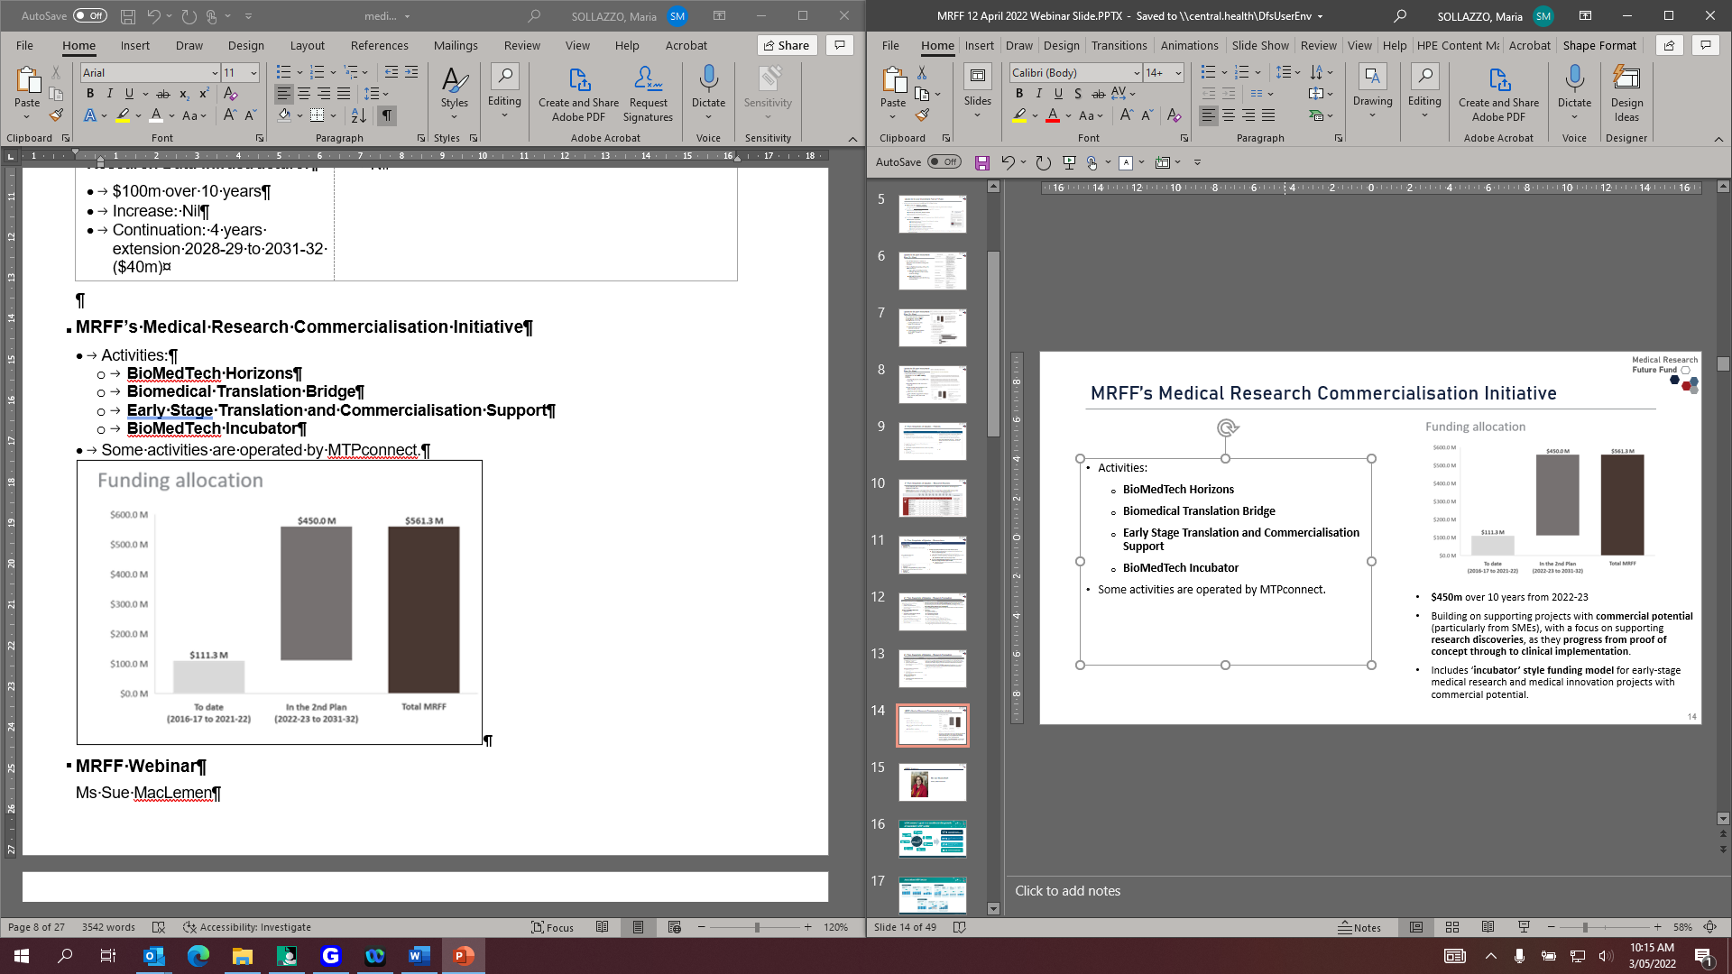

# MRFF Webinar

Ms Sue MacLemen, Chair, MTPConnect

This is a picture of Ms Sue MacLemen
Chair, MTPConnect


## MTPConnect’s goal is to accelerate the growth of Australia’s MTP sector

1. Increasing collaboration and commercialisation across the sector.
2. Improved management and workforce skills.
3. Optimising the regulatory environment.
4. Improved access to global supply chains and international markets.

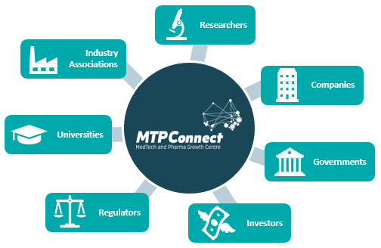

# Australian MTP Sector

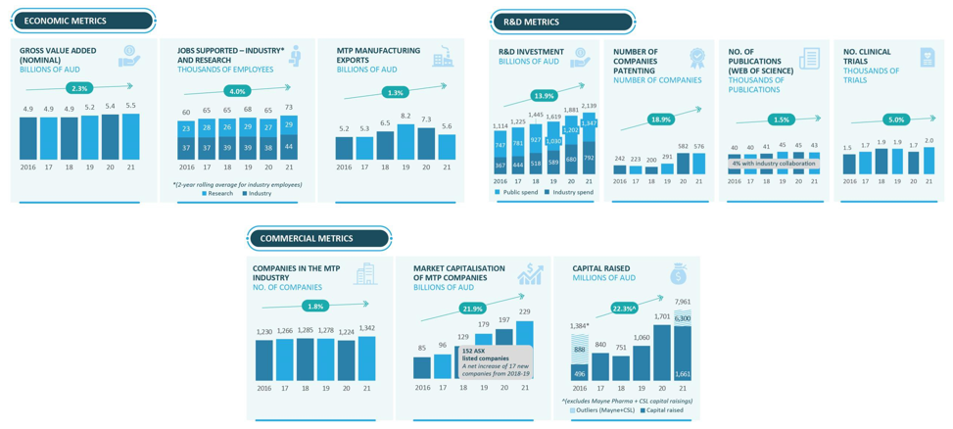

# MTPConnect Programs Overview @$182M

* Department of Industry, Science, Energy and Resources
* Industry Growth Centres.
* Growth Centre Project Fund: $15.6 million; 40 projects.
* Department of Health - Medical Research Future Fund
* Biomedical Translation Bridge Program: $22.3 million; 21 projects.
* BioMedTech Horizons Program: $45 million; 46 projects.
* REDI Developing Australian’s MTP Sector Workforce: $32 million; 13 training partners; 31 training programs.
* Targeted Translation Research Accelerator: $47 million; 7 research projects; 2 research centres.
* Clinical Translation and Commercialisation Medtech: $19.75 million; Round 1 – now open.

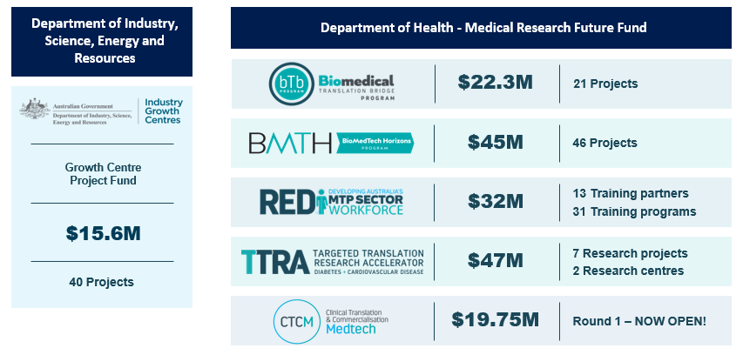

# BioMedTech Horizons Program (BMTH)

* The BioMedTech Horizons program (BMTH) is a $45 million MRFF initiative focused on supporting proof-of-concept to commercial development of biomedical and medical technology.
* Four funding rounds - funded 46 projects.
* Investments from the program are $40 million in funding has been distributed direct to projects and this has leveraged a further $49 million in cash and in kind.
* Projects have addressed many technical and clinical domains including precision medicine, 3D printing, cardiovascular health, orthopedics, emergency medicine, ophthalmology, implantable medical devices, digitally enabled devices, wearable devices, oncology, neonatal and pediatric devices and devices aimed at supporting blind people and restoring vision.

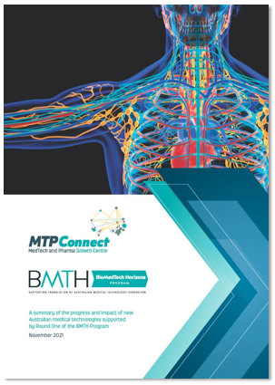

# BioMedTech Horizons Program 1.0 - Impact

* The first BMTH funding round concluded activities on 29 October 2021.
* Of the 11 projects identified and funded as part of BMTH1, nine successfully completed their program of works resulting in clear advancement of their devices toward achieving their research and commercialisation objectives.

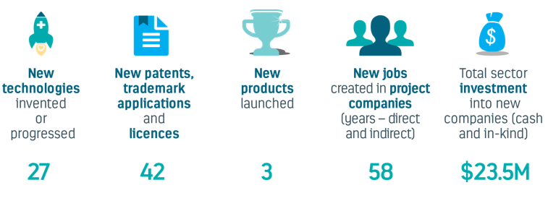

# BMTH Program Success: WearOptimo

**In 2018, WearOptimo was awarded funding in Round One to help create a microwearable**

**platform and again for Round Two in 2019 to develop a cardiac microwearable sensor.**

* March 2021, secured a $30 million partnership deal to manufacture its microwearable sensor at an advanced technology facility in Brisbane – for worldwide distribution. Partnership between the QLD Government, ANU and the Australian National Fabrication Facility.
* March 2022, announced a multi-million-dollar investment agreement with Australian-owned Aspen Medical, cementing a strategic partnership to accelerate the development of its microwearable sensor that detects and alerts an individual to dehydration risk – while refining and testing it across industries like the military, mining, and resource sectors.



# Biomedical Translation Bridge Program (BTB)

The Biomedical Translation Bridge program is a $22.3 million MRFF initiative that provides up to $1 million in matched funding to nurture the translation of new therapies, technologies and medical devices through to the proof of concept stage.

Delivered through mentoring and commercialisation advice by BTB partners and partner programs, the BTB program aims to:

* De-risk and develop ventures so that they can attract further funding opportunities
* Nurture and mentor the next generation of health and medical research innovators in Australia
* Develop ventures to become attractive to Biomedical Translation Fund (BTF)
* Assist in the development of ventures that aim to ultimately result in preventative interventions, cures and
* Treatments for diseases that address health problems of national significance.

BTB Program - Funding:
- Three funding rounds
- R3 funding in 2020 was for COVID-19 research projects that had to be completed within 12-months
- 20 projects currently funded by the BTB program

# BTB Program Success: The University of Melbourne

The patient isolation hood is an Australian developed technology protecting HCWs from COVID-19 and reducing viral levels in the immediate surroundings. It provides for better patient respiratory treatment, reducing the need for invasive ventilation.

* The University of Melbourne’s patient isolation hood – now named **“McMonty” by Medihood** – has seen clinical trials conducted in Intensive Care Units (ICUs) at Western Health’s Footscray and Sunshine hospitals.
* The hoods have been successfully deployed in rural areas of Australia, particularly those without specialised facilities and negative pressure rooms. They have also been deployed internationally in Papua New Guinea and the Republic of Nauru.
* A collaboration between the University of Melbourne, Western Health and local manufacturer Evan Evans saw the product in market within 12-months and, to date, 1,000 devices and additional consumables have been sold.

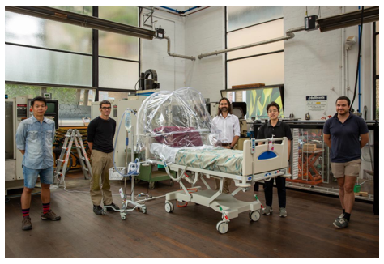

# Clinical Translation & Commercialisation – Medtech (CTCM)

**The Clinical Translation and Commercialisation - Medtech (CTCM) program is offered under the 2020 Early Stage Translation and Commercialisation Support Grant of the Medical Research Future Fund’s Medical Research Commercialisation Initiative.**

* The $19.75 million program will identify and nurture high-quality medical device projects that have commercial potential and support their translation through early clinical trials.
* The program opened in December 2021, is focused on SMEs and aims to boost commercialisation of home- grown medical products.

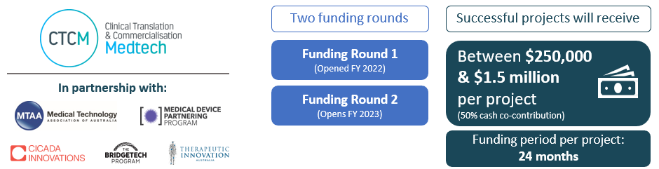

# REDI Initiative

* Developing future workforce capabilities in the MTP sector.

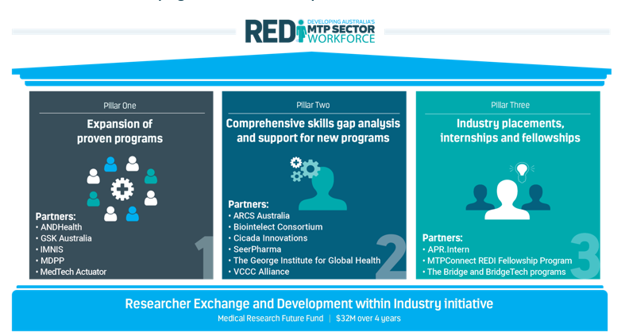

# REDI Skills Gap Analysis

* Skills gap analysis has provided us with a skills development blueprint for an industry-ready, fit for purpose MTP workforce.

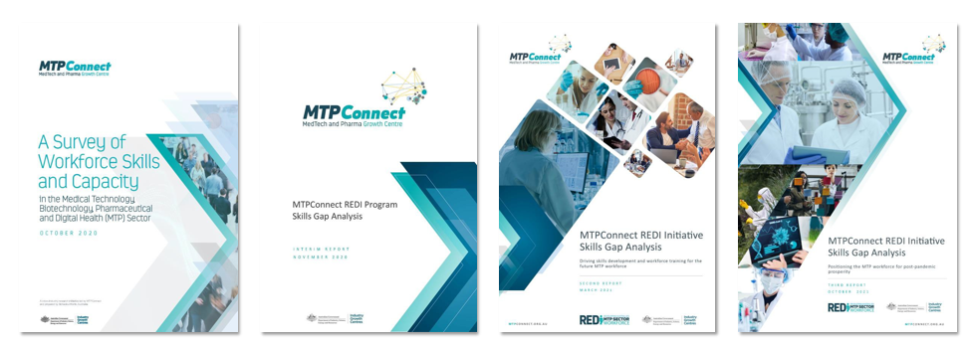

# REDI Success: The REDI Fellowship Program

* The REDI Fellowship program provides companies in the medical technology, biotechnology and pharmaceuticals (MTP) sector with up to $250,000 per annum to bring researchers, clinicians and MTP professionals in-house for up to 12-months to work on priority medical research projects.
* Intended to accelerate relationships, drive projects towards commercial outcomes and provide high- level commercial and entrepreneurial experience for the Fellow.
* To date, 14 fellowships have been awarded, working with major Australian and international companies including Cochlear, Telix Pharmaceuticals, Stryker, Pharmaxis, Paige and Synopsis.
* Successful applicants from the November 2021 round are now being finalised, after which all funds in the current budget will be committed and the program will be paused.

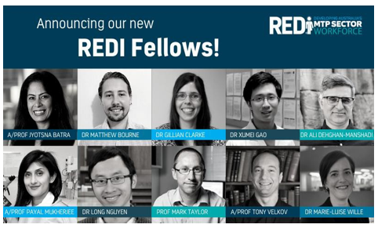

# TTRA Diabetes & Cardiovascular Disease Research Accelerator

The $47 million MRFF-funded TTRA program:

* has established two **Research Centres** for diabetes and cardiovascular disease
* is providing direct **Research Project** funding support across Australia,

to enable research translation, commercialisation and implementation through to clinical impact.

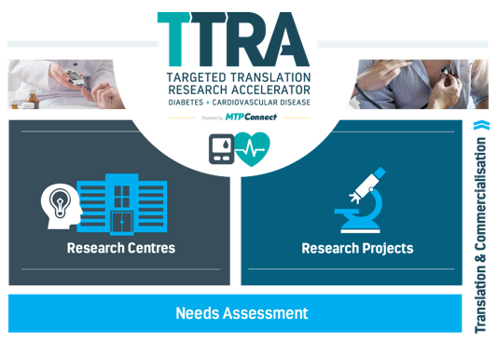

Image explaining each Pillar of the TTRA Program. Research Centres (Pillar 1). Centre #1: Diabetes Complications. Centre #2: Cardiovascular Disease Complications. Research Projects (Pillar 2). Round 1: 7 Projects $5.2m. Round 2: Needs assessment Round 3: Needs assessment


# TTRA Success Story: Research Centres

*“A new approach to boosting the translation and commercialisation of Australian research to do more to help people with cardiovascular disease and diabetes.”*

* In January 2022, two new national Research Centres, the Australian Centre for Accelerating Diabetes Innovations (ACADI) and the Australian Stroke & Heart Research Accelerator (ASHRA) were established under the TTRA initiative.
* Each Research Centre has been awarded $10 million over four years and attracted substantial co- contributions from academic and industry partners totalling $34.3 million.
* Collectively the two new Research Centres will initially progress **31 research projects** addressing diabetic kidney disease, peripheral neuropathy and diabetic foot syndrome, and short-term complications of hypoglycaemia, hyperglycaemic hyperosmolar syndrome (HHS) and ketoacidosis, coronary artery disease, cardiomyopathy and heart failure, and transient ischaemic attack (TIA) / stroke.



# Contact us for further information

* Phone: +61 3 9070 8298
* Email: [info@mtpconnect.org.au](mailto:info@mtpconnect.org.au)
* Head Office: Level 1, Suite 1.01, 250 Bay Street Brighton, VIC 3186 Australia



# MRFF’s Early Stage Translation and Commercialisation Support

**The 2020 Early Stage Translation and Commercialisation Support Grant Opportunity:**

* Competitive grant round.
* **$79 million over three years from 2020-21** to support early stage Australian medical research and medical innovation projects with commercial potential.
* Successful projects will be required to partner with Australian small to medium-sized enterprises (SMEs), including to provide them with specialist support and expertise with the aim to de-risk project outputs and progress towards commercialisation.
* **Four grants of $19.75 million each** awarded to:
* MRCF Pty Ltd (Brandon BioCatalyst) to support 20-25 preclinical medical research or medical innovation projects with commercial potential
* MRCF Pty Ltd (Brandon BioCatalyst) to support at least 11 early clinical development of novel drugs, or novel uses for existing drugs, with commercial potential
* MTPConnect to support early clinical development of medical devices with commercial potential
* ANDHealth Limited to support up to 25 SMEs in early stage development of digital health technologies with commercial potential.
* **ANDHealth Limited** has selected and announced five SMEs as the first cohorts under its MRFF-funded program to share in $3.75 million of project funding:
* **Cardihab** – Digital Cardiac Rehabilitation providing care to patients at a time and place that works for them
* **Gheorg** – The friendly robot helping children with anxiety; an AI enhanced first responder for children with mental health issues and expert guide for parents
* **Perx Health** – A motivation and engagement platform changing the way people and companies create habits for managing medical conditions
* **Sound Scouts** – Free online hearing test app for kids. Fun, clinically proven technology enabling hearing to be checked efficiently and reliably
* **VaxApp** – An immunisation management platform that enables healthcare providers to deliver and monitor vaccination and rapid antigen testing programs.
* **MCRF Pty Ltd (Brandon BioCatalyst)** has completed its first round of expression of interests (EOIs).
* **MTPConnect’s** first round of EOIs has opened.

# MRFF’s BioMedTech Incubator

* Funds a suitable organisation that can identify and select a number of Australian small and medium enterprises (SMEs) undertaking early-stage medical research and innovation projects with commercial potential.
* The successful organisation will partner with the SMEs to progress and nurture their medical research and innovation projects by:
* supporting novel or repurposed drugs (pre-clinical and clinical), medical devices and digital health technologies
* providing access to capital (project funding of up to $5 million over 5 years) and industry knowledge to support transition of discoveries through to commercialisation
* nurture and mentor the next generation of health and medical research innovators.
* **$50 million** available over **two years from 2022-23.**
* Applications close **25 August 2022 at 5:00pm.**
* GrantConnect: GO ID GO5322.

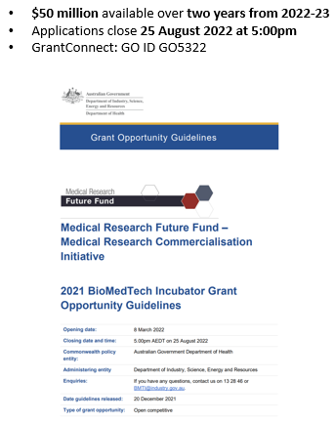

# Biomedical Translation Fund (BTF)

* The BTF **complements the MRFF in supporting the translation and commercialisation** of medical research and medical innovation, in particular the **‘second valley of death’ along the research pipeline**, by
* investing in their promising biomedical discoveries (therapeutic, medical or pharmaceutical) and assist in commercialisation
* encouraging development of these companies by addressing capital and management constraints.
* Three licensed private fund managers:
* Brandon Capital Partners
* OneVentures Management
* BioScience Managers.
* Program delivery by AusIndustry: <https://business.gov.au/Grants-and-Programs/Biomedical-Translation-Fund>.

Image of funding available. $501.25 million is available. $250 million from Commonwealth funding, and $251 million from private sector capital.

$287.8 million committed in 25 investee companies as of 4 March 2022.

# BTF Success Stories

* **$6.5 million to Avita Medical Ltd**
* commercialisation of the **RECELL®** system that produces a suspension of Spray-On Skin™ Cells using a small sample of the patient’s own skin for the treatment of acute burns, prepared and applied at the point of care in as little as 30 minutes.
* RECELL® sales were projected at US$28-30 million for 2020-21.
* **$19 million to BiVACOR Pty Ltd**
* development of a rotary total artificial heart device, designed to take over complete function in the case of heart failure.
* designed to be a long-term device to completely replace a natural heart.
* **27.4 million to Global Kinetics Corporation**
* accelerating the development and commercialisation of the **PKG® System**, which includes a wrist-worn device that records Parkinson’s symptoms and provides clinical reports to assist with planning routine care for Parkinson’s patients.

# MRFF Program Updates and News

# MRFF Gender Data Report

* Report now available on the MRFF webpage at: <https://www.health.gov.au/resources/publications/medical-research-future-fund-grant-opportunity-gender-data-report-22-march-2022>.
* Analysis based on approximately 76% of MRFF completed competitive grant opportunities as of 30 June 2021 consisting of:
* 60 competitive grant opportunities
* 56 grant opportunities administered by NHMRC
* 4 grant opportunities administered by BGH (Business Grants Hub)
* Data from almost 15,000 Chief Investigators (CIs) or equivalent, who self-identified or were identified by the department as a woman or man.

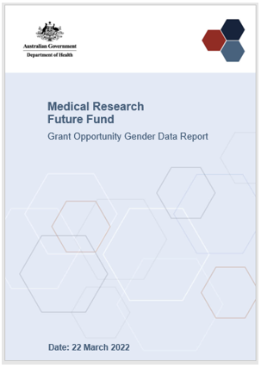

* Overall, more men applied for MRFF grants as a Chief Investigator (CI) or as the Chief Investigator ‘A’ (CIA) compared with women.
* Funded rates for women and men CIs were relatively comparable across the range of factors assessed in this report.

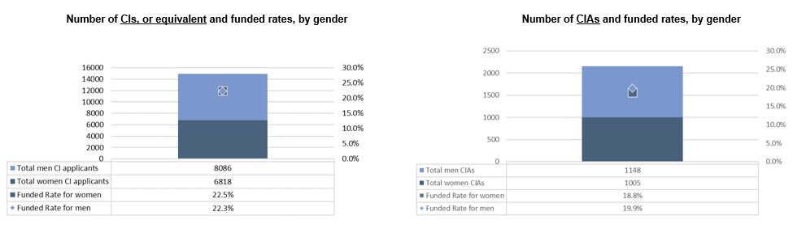

* More women applied for grants in the Health Services Research and Public Health Broad Research Areas compared with men.
* **Women CIs had better or equal funded rates in applications than men across the broad research areas, other than in Basic Science.**
* For CIA data only:
* **Women had greater funded rates than men for Health Services Research and Public Health applications.**
* Men had greater funded rates than women for Clinical Medicine and Science applications.
* **Funded rates for Basic Science applications were approximately equal** for men and women CIAs.

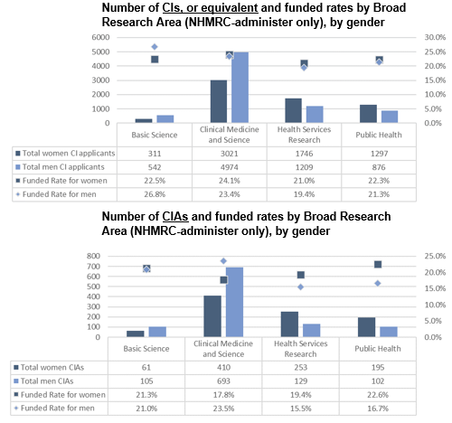

* The funded rates for women CIs tended to be equal to or higher than for men CIs across many MRFF initiatives.

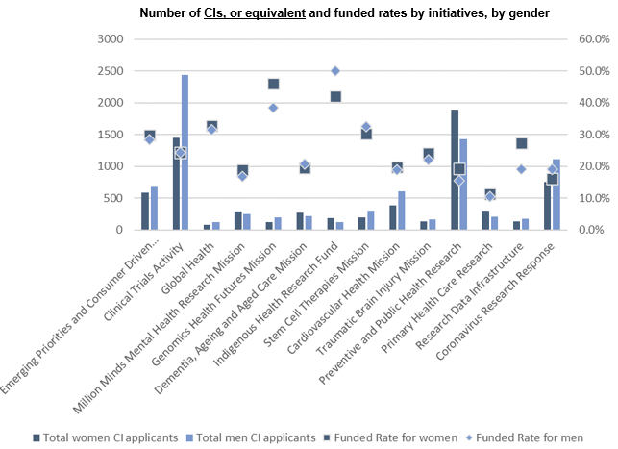

* The funded rates for women CIAs are more variable, with higher funded rates for women across half of the MRFF initiatives.

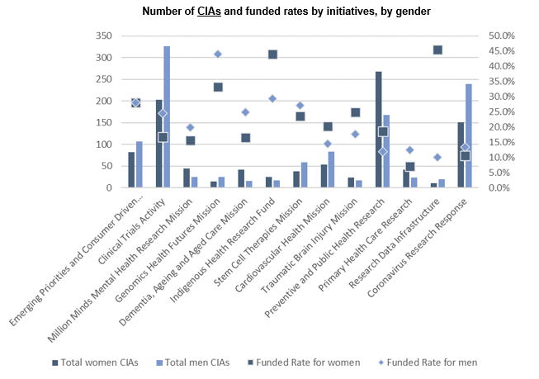

* There are variable outcomes by grant sizes (funding requests).
* Some general trends observed:
* Funded rates for women CIs are slightly higher than for men for grant sizes $2 million and above, but are about equal or less than for men for smaller grant sizes.
* Funded rates for women CIAs are lower than for men for all grant sizes, except for grants between $1 million to less than $2 million.

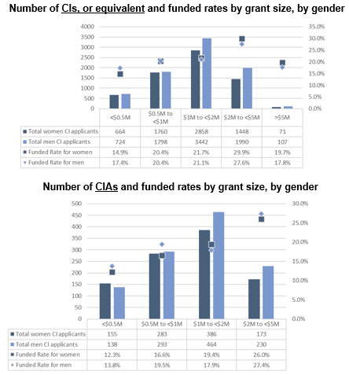

# Sharing stories of the brilliant women leading MRFF projects

* Read about the brilliant female Chief Investigators leading MRFF projects at: <https://www.health.gov.au/resources/publications/the-brilliant-women-leading-mrff-projects>.

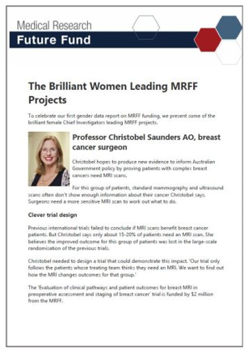

# $301 million in 13 Grant Opportunities announced in December 2021

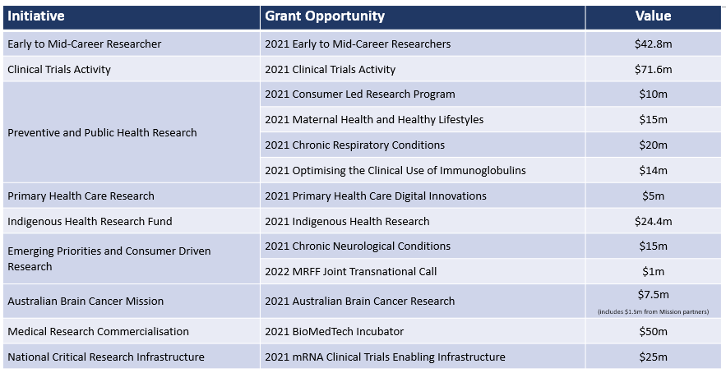

# $268.1 million in 17 New Grant Opportunities in 2022-23 Budget

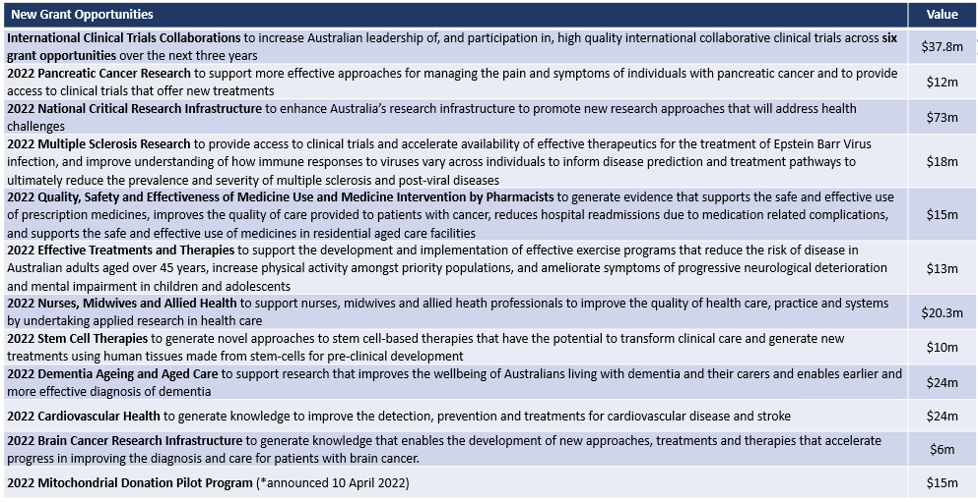

# MRFF Accelerator Grants

* Large scale (up to $5 million) and long-term (up to 5 years) funding to support interdisciplinary research to drive implementation of substantial improvements to health care and/or health system effectiveness.
* These grants:
* focus on a specific ‘big question’
* integrate collaborative work programs under strong governance structure
* facilitate high quality interdisciplinary research that addresses needs of communities and health consumers
* aim to embed sustainable, systemic improvements to policy and/or practice within health care and/of health system.
* Grant applications are assessed using selection criteria defined in the grant opportunity guidelines by independent Grant Assessment Committees set up by the grant administration hubs (NHMRC or Business Grants Hub).
* More information: <https://www.health.gov.au/resources/publications/mrff-accelerator-grants>.

# Keep connected…

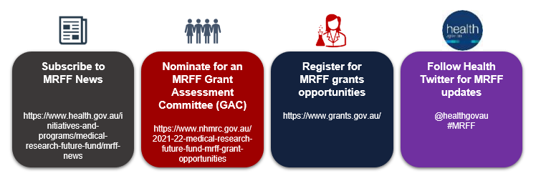

**Thank you for your time**

**Questions?**