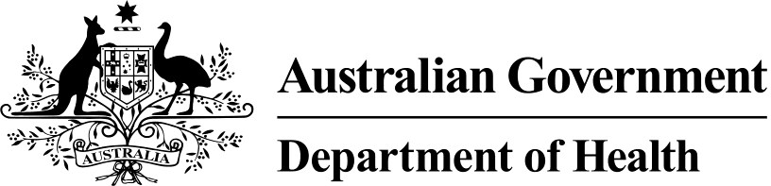

FOLLOW-UP HEALTH SERVICES PROVIDED BY A PRACTICE NURSE OR ABORIGINAL AND TORRES STRAIT ISLANDER HEALTH PRACTITIONER FOR AN INDIGENOUS PERSON WHO HAS RECEIVED A HEALTH ASSESSMENT (MBS ITEM 10987)

Fact Sheet

*This fact sheet must be read in conjunction with the item descriptors and explanatory notes for item 10987 (as set out in the Medicare Benefits Schedule).*

MBS Item 10987 allows Indigenous people who have received any MBS health assessment item to access Medicare rebates for follow up services provided by a practice nurse or Aboriginal and Torres Strait Islander health practitioner. A maximum of 10 services per patient is available in a calendar year.

# Components of the follow-up item

The MBS follow-up service item may be used to provide:

* examinations/interventions as indicated by the health assessment;
* education regarding medication compliance and associated monitoring;
* checks on clinical progress and service access;
* education, monitoring and counselling activities and lifestyle advice;
* taking a medical history; and
* prevention advice for chronic conditions, and associated follow up.

# Eligible practitioners

The MBS follow up item is provided by a practice nurse or Aboriginal and Torres Strait Islander health practitioner, on behalf of a GP. Where an exemption under subsection 19(2) of the Health Insurance Act 1973 has been granted to an Aboriginal Community Controlled Health Organisation or a State/Territory Government Health Clinic, MBS item 10987 may be claimed for services provided by a practice nurse Aboriginal and Torres Strait Islander health practitioner on behalf of a GP.

# Restrictions on providing the MBS follow-up item

The MBS follow-up item may only be provided if:

* the service is provided on behalf of and under the supervision of a GP;
* the person receiving the service is not an admitted patient of a hospital;
* the service is consistent with the needs identified through the health assessment;
* a claim has been made to the Department of Human Services (Medicare) for a patient in respect of any MBS health assessment item in the last three years; and
* the GP under whose supervision the follow-up services to a health assessment are provided retains responsibility for the health, safety and clinical outcomes of the person.

Supervision of the practice nurse or Aboriginal and Torres Strait Islander health practitioner at a distance is recognised as an acceptable form of supervision.

# MBS Item 10987 can be claimed in conjunction with:

* the MBS bulk billing incentive items 10990 and 10991, so long as the follow-up is provided to a Commonwealth concession card holder, or person under the age of 16, and the service is bulk billed;
* MBS allied health items for people receiving Indigenous health assessments (items 81300 to 81360);
* the MBS chronic condition disease management allied health services (items 10950 to 10970) for a person who has a chronic condition and has a GP Management Plan (item 721) and Team Care Arrangements (item 723);
* the MBS practice nurse and Aboriginal and Torres Strait Islander health practitioner chronic disease monitoring and support item (item 10997) for people with a chronic disease care plan; and
* the MBS Aboriginal and Torres Strait Islander health practitioner items for immunisation and wound management (items 10988 and 10989).

# Guidelines and Resources

For more detailed information about MBS item descriptors and explanatory notes visit the Department of Health website at [www.mbsonline.gov.au](http://www.mbsonline.gov.au/)

Further information, including referral forms, is available on the Department of Health website at <http://www.health.gov.au/mbsprimarycareitems>