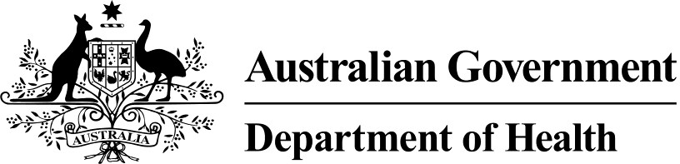

MEDICARE HEALTH ASSESSMENT FOR ABORIGINAL AND TORRES STRAIT ISLANDER PEOPLE

(MBS ITEM 715)

*This fact sheet must be read in conjunction with the item descriptors and explanatory notes for item 715 (as set out in the Medicare Benefits Schedule).*

The aim of this MBS health assessment item is to help ensure that Aboriginal and Torres Strait Islander people receive primary health care matched to their needs, by encouraging early detection, diagnosis and intervention for common and treatable conditions that cause morbidity and early mortality.

For the purpose of this item, a person is an Aboriginal or Torres Strait Islander person if they, or their parent or carer, identify them as being of Aboriginal or Torres Strait Islander descent.

The MBS health assessment for Aboriginal and Torres Strait Islander people covers the full age spectrum, and should be used for health assessments for the following age groups:

* Aboriginal and Torres Strait Islander children who are less than 15 years old
* Aboriginal and Torres Strait Islander adults who are aged fifteen years and over but under the age of 55 years
* Aboriginal and Torres Strait Islander older people who are aged 55 years and over

# Components of the Health Assessment

The health assessment includes an assessment of the patient’s health, including their physical, psychological and social wellbeing. It also assesses what preventive health care, education and other assistance should be offered to the patient to improve their health and wellbeing. It complements existing services already undertaken by a range of health care providers. This health assessment must include:

* information collection, including taking a patient history and undertaking examinations and investigations as required;
* making an overall assessment of the patient;
* recommending appropriate interventions;
* providing advice and information to the patient;
* keeping a record of the health assessment, and offering the patient a written report about the health assessment, with recommendations about matters covered by the health assessment; and
* offering the patient’s carer (if any, and if the medical practitioner considers it appropriate and the patient agrees) a copy of the report or extracts of the report relevant to the carer.

As part of a health assessment, a medical practitioner may develop a simple strategy for the good health of the patient. The strategy should identify any services the patient needs and the actions the patient, or parent or carer, should take. It should be developed in collaboration with the patient, or parent or carer, and documented in the written report on the assessment

that is offered to the patient, and/or patient’s carer.

# Eligible practitioners

This MBS health assessment item may only be claimed by a medical practitioner (including a general practitioner but not including a specialist or consultant physician).

The medical practitioner may only undertake the health assessment, after the patient, their parent or carer, has been given an explanation about what is involved and has given their consent.

A practice nurse or Aboriginal and Torres Strait Islander health practitioner can assist the medical practitioner in the information collection stage of the health assessment and with providing patients with information about recommended interventions at the direction of the medical practitioner.

# Restrictions on providing the MBS Health Assessment for Aboriginal and Torres Strait Islander People

This health assessment is an annual service. The minimum time allowed between services is nine (9) months. This allows flexibility for very remote communities, where medical practitioner visits may be less frequent and may make it more difficult to follow a consistent schedule of health assessments.

MBS Item 715 does not apply for services that are provided by any other Commonwealth or State funded services. However, where an exemption under subsection 19(2) of the Health Insurance Act 1973 has been granted to an Aboriginal Community Controlled Health Service or State/Territory Government health clinic, MBS item 715 can be claimed for services provided by medical practitioners salaried by or contracted to, the service or health clinic so long as all requirements of the item are met.

Medical practitioners should not conduct a separate consultation in conjunction with a health assessment unless it is clinically necessary (ie. the patient has an acute problem that needs to be managed separately from the assessment).

This MBS health assessment item is not available to people who are in-patients of a hospital or care recipients in a residential aged care facility.

# Guidelines and Resources

Medical practitioners are encouraged to utilise relevant guidelines and resources, such as:

* Information about MBS primary care items at <http://www.health.gov.au/mbsprimarycareitems>
* The Department of Human Services (Medicare) provider enquiry line on 132 150.
* Item descriptors and explanatory notes at [www.mbsonline.gov.au.](http://www.mbsonline.gov.au/)
* The health assessment proformas available at the [MBS Primary Care Items webpage](http://www.health.gov.au/internet/main/publishing.nsf/Content/mbsprimarycare_ATSI_mbsha_resource_kit)