**The Way Back Support Services | Interim Evaluation Short Report**

Beyond Blue

24 November 2021

*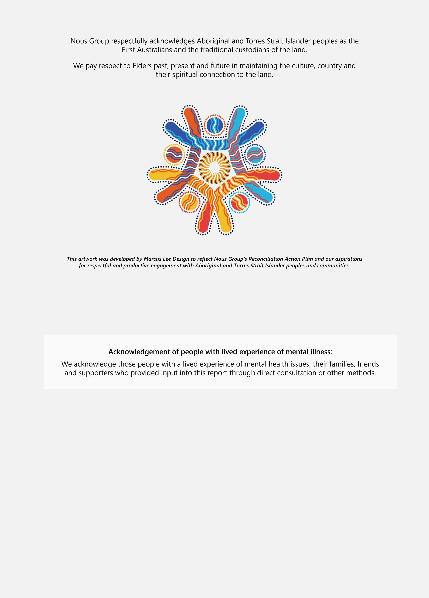***Disclaimer:**

Nous Group (**Nous**) has prepared this report for the benefit of the Beyond Blue (the **Client**).

The report should not be used or relied upon for any purpose other than as an expression of the conclusions and recommendations of Nous to the Client as to the matters within the scope of the report. Nous and its officers and employees expressly disclaim any liability to any person other than the Client who relies or purports to rely on the report for any other purpose. Nous has prepared the report with care and diligence. The conclusions and recommendations given by Nous in the report are given in good faith and in the reasonable belief that they are correct and not misleading. The report has been prepared by Nous based on information provided by the Client and by other persons. Nous has relied on that information and has not independently verified or audited that information.

© Nous Group

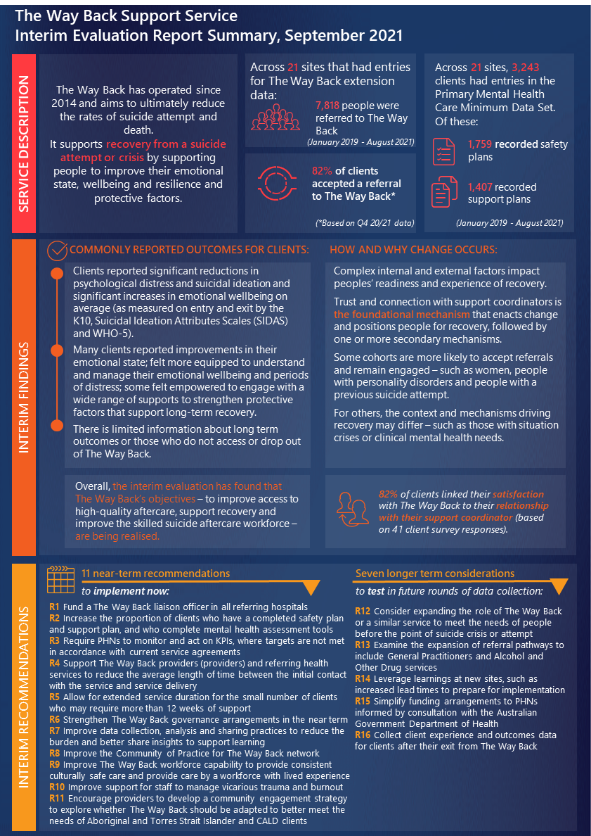

# Executive summary

## Background and context

### There is a pressing need for services in Australia that help to prevent suicide re-attempts.

Over 3,000 people die by suicide in Australia each year – an average of nine per day.[1] Suicide rates in Australia continue to increase.[2] For every death, there are approximately 26 suicide attempts.[3] Suicide can affect anyone, but some people are more at risk due to where they live, gender, age, cultural identity, gender identity and sexual orientation.[4]

### Governments continue to invest to improve prevent suicides and suicide re-attempts.

The *Fifth National Mental Health and Suicide Prevention Plan 2017-2022* (the Fifth National Plan) made suicide prevention a priority and included a priority for Aboriginal and Torres Strait Islander people. It recognised that preventing re-attempts is essential to reduce suicide rates, given a previous attempt is the strongest predictor of a subsequent death by suicide.[5] It emphasised that consistent, timely and culturally safe follow-up support is critical.

Since then, major inquiries have recognised the importance of assertive aftercare in suicide prevention. The Productivity Commission Inquiry into Mental Health (the Productivity Commission Inquiry) and the Royal Commission into Victoria’s Mental Health System (the Royal Commission) called for universal aftercare. In its 2021 Budget, the Australian Government committed to ‘*provide aftercare services for all Australians discharged from hospital following a suicide attempt and trials for aftercare services for anyone experiencing suicidal crisis, but who do not attend a hospital*.[6]

COVID-19 has exacerbated demand for suicide prevention services. This increase in demand came when the system was already under substantial stress and failing to meet needs, including for the ‘missing middle’.[7]

### The Way Back Support Service is a substantial effort and investment into follow-up support.

The Way Back Support Service (The Way Back) represents a substantial effort to address some of the key unmet needs and gaps in the system. It makes assertive follow-up support available to people immediately after a suicide attempt or suicidal crisis who have presented to a hospital emergency department (ED) or community mental health service.[8] The Way Back was initially trialled at three sites in 2014, and has since been expanded to 31 sites nationally (as of September 2021).

Figure 1 summarises The Way Back’s core service model. There is some flexibility for variations to respond to local need (examples of variations are peer support and Aboriginal and Torres Strait Islander specific referral pathways).

Figure 1 | The Way Back service model[9]

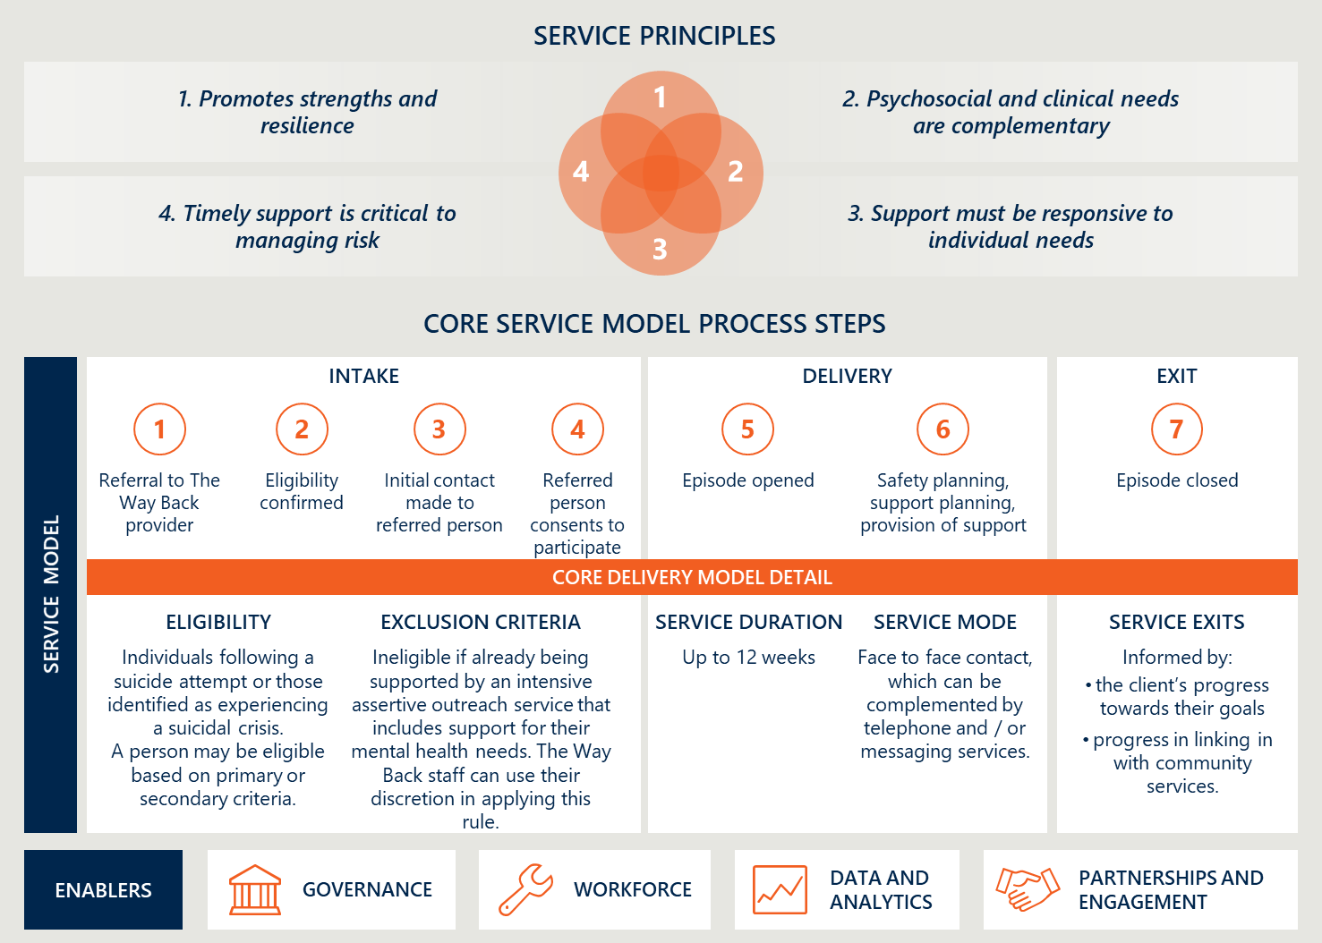

### Many organisations and governments are involved in governing The Way Back.

The governance for The Way Back reflects the highly complex funding arrangements and complex policy and operational landscape for suicide aftercare services (see Full Report, section 3.1.5). The roles of stakeholders in the commissioning and delivery of The Way Back are summarised in Figure 2.

Figure 2 | The Way Back governance arrangements [10]

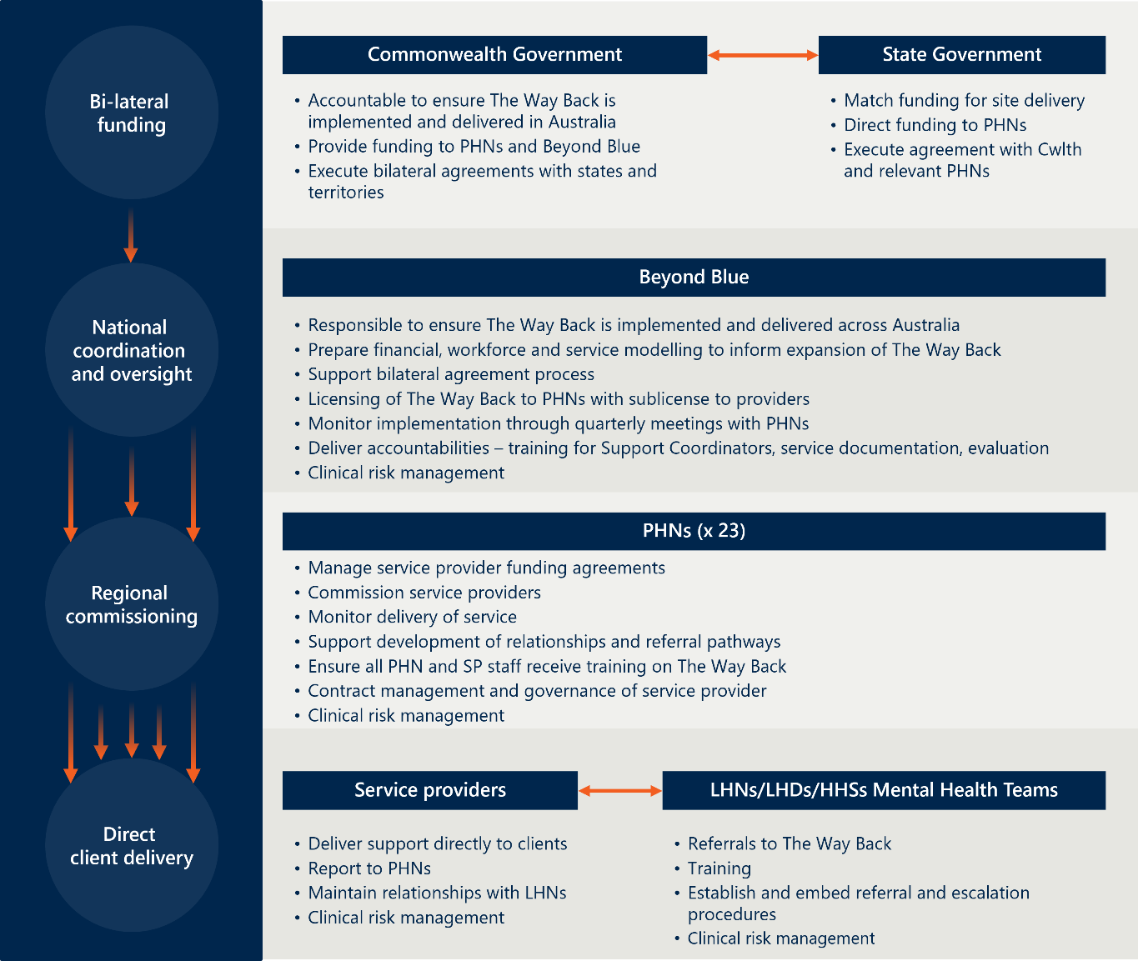

### An evaluation of The Way Back will help to build the evidence base on what works.

Beyond Blue engaged Nous Group (Nous) to evaluate The Way Back from June 2020 to November 2022. The evaluation will assist Beyond Blue, Primary Health Networks (PHNS) and The Way Back service providers (providers) to: be accountable for implementation; understand outcomes for clients; and influence evidence-based policy and service design (such as by identifying the essential elements of successful aftercare).

The evaluation draws multiple data sources, including: consultation with clients, providers, PHNs, Beyond Blue and referring health services at eight sites (‘deep dive sites’); surveys of clients and providers and quarterly reports at 21 sites; and data from the Primary Mental Health Care Minimum Data Set (PMHC MDS) and The Way Back extension (referred to as ‘the PMHC MDS’ in this report) for 21 sites. Bellberry Human Research Ethics Committee (HREC) has ethical oversight of the evaluation.

The Way Back has 31 sites operational as of September 2021, all having commenced operation at different times. This is expected to increase to 40 by June 2022. Twenty-five sites are in-scope for this report.[11]

## Purpose of this report

### This Interim Evaluation Report provides findings on design, implementation and delivery.

It also provides early insights on outcomes (including what is changing, for whom and why). It will be used to inform ongoing improvements to The Way Back and provides additional evidence on the elements of successful aftercare services. This report uses data from September 2018 to August 2021 (time periods vary by data source).

There are limitations to the data:

* *There are significant limitations in the quality of service use and outcomes data.* This means insights from PMHC MDS and quarterly reports are under representative of service activity and/or based on low quality/incomplete data for some sites. As part of PHN’s commissioning role, they are accountable for ensuring service providers upload accurate and complete data into the PMHC MDS. Beyond Blue have invested efforts to work alongside PHNs and service providers to improve the quality and completeness of this data set. However, Beyond Blue do not yet have access to the PMHC MDS. This Interim Evaluation Report makes recommendations for suggested (significant) improvements to data collection practices to support greater completeness, accuracy and value from the data. Key limitations to the PMHC MDS and quarterly reports include:
  + The PMHC MDS data is under representative of service activity. Twenty-one sites (out of a possible 31) report data into the PMHC MDS as of September 2021. The data was not complete or accurate for all sites and some only started reporting data into it recently.[12] Sites that have been operational since early 2019 may have more data available and potentially more established data collection practices than those that became operational in early 2021.
  + There is limited availability of quantitative outcomes data. A small proportion of episodes recorded in the PMHC MDS had completed outcome measures recorded at beginning and end – enabling measurement of change in outcomes over time.[13] Descriptive analysis of these episodes indicates the sample of clients with matched pairs is roughly representative of the broader PMHC MDS sample.
  + There is limited data on the outcomes for those who choose not to engage with The Way Back, or who disengage early, and on the outcomes for families and carers.[14]
* *The evaluation is unable to report on the experiences of Aboriginal and Torres Strait Islander clients*. The evaluation can report PMHC MDS data disaggregated by Aboriginality (i.e. provide insights on service use). Due to outstanding ethics approval from the Australian Institute of Aboriginal and Torres Strait Islander Studies (AIATSIS) HREC at the time of data collection in mid-2021, the evaluation could not seek to actively survey or interview Aboriginal and Torres Strait Islander clients to understand their experiences of The Way Back. AIATSIS HREC granted full ethics approval in October 2021 so the Final Evaluation Report will include further insights on the experiences of Aboriginal and Torres Strait Islander clients.
* *The insights are based on qualitative input from a small sample of The Way Back clients.* A small sample of clients responded to the online survey and participated in interviews. There is potentially a positive bias among people who volunteer to be interview participants or respond to surveys.
* *There is very limited data available from support persons’.* The two support persons’ survey responses were excluded from analysis. Nous and Beyond Blue will look to increase responses in subsequent data collection. [15]

### Summary of key interim findings

**There are positive signs that The Way Back’s desired short-term intent is largely being achieved.** The interim evaluation found that The Way Back’s objectives are being realised – to improve access to high-quality aftercare, support recovery and increase the capacity of a skilled aftercare workforce.

**Many clients experienced improvements in short-term intended outcomes and noted The Way Back had significantly contributed to their early recovery**. For clients with pre- and post- assessments, there were significant reductions in psychological distress and suicidal ideation, and significant increases in emotional wellbeing on average (as measured on entry and exit by the Kessler Psychological Distress Scale (K10), World Health Organisation- Five Well-Being Index (WHO-5) and the Suicidal Ideation Attributes Scale (SIDAS)). On the K10 this represents a large improvement from an average score that indicates a severe likelihood of mental disorder, to an average end score that represents a high, but less severe, likelihood of mental disorder.

**The trust and rapport with support coordinators is a key driving mechanism of change.** The lack of a waitlist and the provision of psychosocial support are fundamental and welcome changes to how people experience mental health services. Many clients reported that they felt ‘seen and heard’, and supported to identify their own strengths to help recovery –many noted this was a departure from their experiences accessing clinical mental health services.

**This Interim Evaluation Report builds the evidence on the role of follow-up support**. It provides further evidence on the elements of successful aftercare and what early recovery looks like, including for different cohorts – such as how improvements in a sense of belonging and connectedness can reduce feelings of hopelessness and suicidal ideation. The evaluation itself has been an important mechanism to give clients the opportunity to say what services matter to them, what motivates them and what shapes their response when they access support. Whilst evidence shows these factors may indirectly deter a reattempt, it was out of scope for this evaluation to assess the extent to which The Way Back results in reduced reattempts over time.[16]

**In quarter four (FY20/21), the uptake rates vary significantly across 21 sites from ~41 to 100 per cent**. On average, 82 per cent of clients consented to a referral to The Way Back[17]. Longer term data from the dashboard and the PMHC-MDS indicates a much lower uptake of 41 per cent on average, however, this is likely due to incomplete or inconsistent PMHC-MDS data collection. The Productivity Commission reported around half of the people offered follow up care, attend the service.[18] There were some differences in referring practices (based on quarterly reports and consultations with referring providers). Providers indicated some cohorts were less likely to take up a referral. Further contributing to this may be the delay in implementation of The Way Back sites because of the prolonged bilateral agreement process. This delay meant that 14 of the 21 sites were only operational for a short period before Q4 2020-21. However, this alone does not sufficiently explain the variability in uptake; the drivers of both high and low uptake rates require further investigation.

**Many sites are not meeting key performance indicators (KPIs)**.[19] None of the 21 sites for which there is KPI data met all six KPIs. Six sites met five of the six KPIs. [20]Two sites only met one KPI and two sites met no KPIs (based on data from Q4 20/21). The reasons behind why KPIs were not met requires further investigation. It appears that there is work required by Beyond Blue, PHNs and providers to increase compliance against KPIs as a priority. [21]

**There are significant challenges with the complex governance and funding arrangements**. There is a lack of clarity in, and exercising of, accountability and authority, for example, to hold providers or PHNs to account when KPIs are not met. Given the multiple funding streams PHNs receive (Australian Government, state and territory governments and Beyond Blue), it is not clear in practice who should hold them to account for performance monitoring and management. It will be critical to learn from the significant issues in the governance, funding and data collection arrangements to both improve delivery of The Way Back and inform decisions about future aftercare services in Australia.

**The Way Back is driving integration of clinical and non-clinical services at many sites**. The hospital liaison officer role present at some sites assists with identification of eligible clients and is a critical enabler of inbound referrals and integration, as are the relationships between providers, PHNs and referring health services.

**Clients would like support from services like The Way Back to be available for people before they reach crisis point.** Many clients and providers engaged in interviews for this evaluation commented they would have found it beneficial to engage in The Way Back before their suicidal ideation reached a point of crisis or a suicide attempt. This suggests, anecdotally, people may benefit from the person-centred care The Way Back offers earlier on in their progression to a suicidal crisis.

#### What is being delivered under The Way Back, where how and why?

##### As of September 2021, The Way Back is being delivered at 31 sites across six jurisdictions.

In theory, The Way Back service model was designed with an emphasis on meeting the need for timely support after an attempt or crisis, given the evidence on how critical *immediate* follow-up is.[22] In practice, The Way Back is delivered at many sites with an emphasis on meeting the need for assertive outreach and ongoing coordination to psychosocial and clinical supports (as reported by The Way Back staff in consultations). Staff were less likely to emphasise the need for immediate engagement, supported by performance against the KPI for *Initial contact with Referred Person,* with 15 out of 21 sites meeting this KPI (in Q4 20/21).

As of September 2021, Beyond Blue has partnered with 23 PHNs, seven state and territory governments and the Australian Government Department of Health to deliver The Way Back. $82.3 million of funding had been budgeted for the national expansion of The Way Back under the 2018 Commonwealth budget measure, including contributions from the Australian Government, states and territories, and Beyond Blue.[23] This funding measure has allowed for a rapid expansion in scale of The Way Back from six sites in June 2020 to 31 sites by September 2021.

3,243 clients engaged with The Way Back between January 2019 and August 2021 according to the PMHC-MDS.[24] Most (76 per cent) clients were referred via public hospitals or public mental health services.[25] The remainder were referred from EDs (15 per cent), community services (3 per cent) or not stated (6 per cent). Forty two per cent of clients in the PMHC MDS completed their episode of care as planned, while a further 24 per cent of episodes remain open at the time of analysis.

#### How well is The Way Back being delivered?

**Eighty-two per cent of people offered a referral to The Way Back in Q4 (FY20/21) consent to it, with variation across sites.** This is similar to that of the initial service uptake rates reported for suicide aftercare services in the Hunter Evaluation (81 per cent). Further exploration of this lower engagement rate is needed. There is large variation in uptake across sites (~41 to 100 per cent). The drivers of variations in uptake rates require further exploration.

**Some cohorts were less likely to take up a referral**. This includes people requiring intensive clinical support, those who self-identify as being ‘not ready’ for recovery, those well-connected to supports and people who have previously had negative experiences with community/psychosocial services (based on consultations with providers).

**Over half of the clients were referred to The Way Back because of a suicide attempt.** Fifty-six per cent clients who consented to a referral to The Way Back (1,804 clients) were referred based on primary eligibility criteria (a suicide attempt) and 30 per cent were referred based on the secondary eligibility criteria (a suicidal crisis) (967 clients)[26]. The remaining 14 per cent did not have their eligibility criteria recorded.

PMHC-MDS analysis shows clients aged over 65 years, those referred after a suicidal crisis (as opposed to an attempt) and those with a safety plan were more likely to remain engaged.[27] More than half (54 per cent) of clients exit prior to nine weeks. Clients who have completed a safety plan or support plan were more likely to remain engaged for 12 weeks.27[28] Clients who did not disclose their sexual orientation or transgender status were more likely to leave the service prior to nine weeks. Many clients in interviews indicated trust/rapport with their support coordinator was key to engagement.

**The demographics of The Way Back clients largely reflect the profile of people who attempt suicide.**[29] Two thirds of clients identified as female (58 per cent or 1,869 clients) and the vast majority were born in Australia (89 per cent or 2,867 clients). Nine per cent identified as Aboriginal or Torres Strait Islander (290 clients).

**Many clients do not have a completed safety or support plan,** despite it being a ‘mandatory’ part of the service model – with 1,759 safety plans and 1,407 support plans completed for a sample of 3,243 clients recorded in the PMHC-MDS.[30] Between 20[31] and 40[32] per cent of clients do not have either a support or safety plan developed. The true proportion of completed safety and support plans may be higher. Regardless, this warrants further investigation.[33] How

**On average, The Way Back provides one-two recommendations to other services throughout a client’s service episode, of which 40 per cent are commenced.** Recommendations to psychiatric or other mental health services were the most common (18 per cent of all episodes). Of these, 50 per cent of clients commenced these services while 16 per cent were waitlisted.[34] Recommendations to community support groups (14 per cent), GPs (12 per cent) and other community health services (10 per cent) were also common, though uptake varies.

**The needs of Aboriginal and Torres Strait Islander and culturally and linguistically diverse (CALD) people are not well understood.** Providers in consultations suggested limited relationships with other local Aboriginal and Torres Strait Islander or CALD services may impact awareness of The Way Back. They also reported the need for a more Aboriginal and Torres Strait Islander and CALD support coordinators.

**Governance arrangements are complex, problematic and appear to be ineffective.** There is significant lack of clarity and alignment of accountability, authority and control across funding, service provision, commissioning, regulation and performance management. Beyond Blue’s networks and reputation is a strength in implementation, given their role requires influencing (as they have limited authority, beyond the enforcement of contractual obligations, to hold PHNs and providers to account in fulfilling their obligations under current governance arrangements).

#### What is changing, for whom, in The Way Back?

**Many clients attain positive short-term changes in expected service outcomes and goals** during their service period. Figure 3 shows average changes in mental health measures between episode start and end for clients with two valid scores at the 21 sites in the PMHC MDS between January 2019 and August 2021.

Figure 3 | Changes in outcomes measures for clients with a valid score in the PMHC MDS at episode start and end

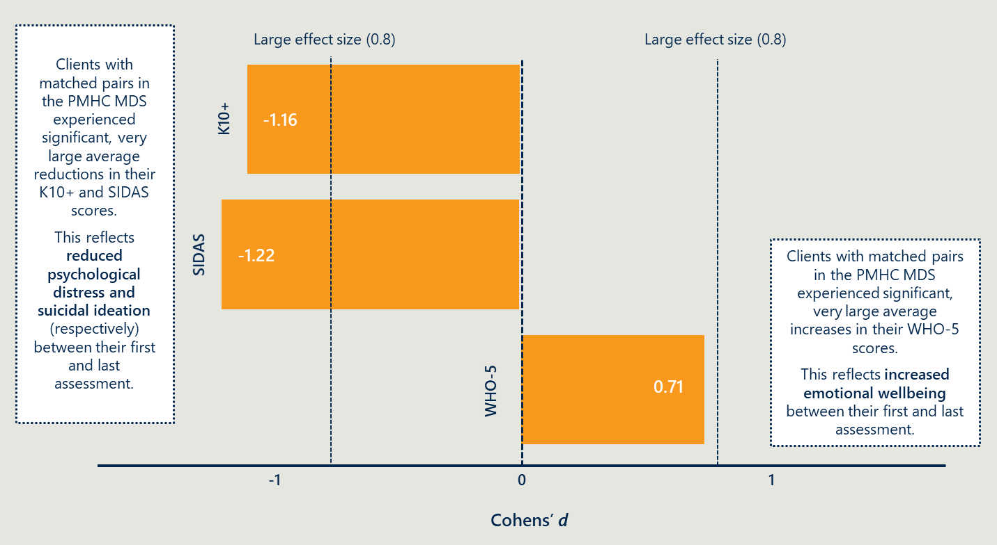

**Some cohorts experienced a larger average change in outcomes than others.** For example, clients who identify as Aboriginal and Torres Strait Islander experienced larger improvements in outcomes than those who did not identify as Aboriginal and/or Torres Strait Islander, and clients who were unemployed experienced smaller improvements than those who were employed.[35]

**There were no significant differences in client outcomes between sites.**[36] Some clients in interviews reported that variations to the service model at some sites were helpful to their recovery, such as peer support model. However, analysis of outcomes data did not find any significant difference between individual sites.

#### Why and how does change occur in The Way Back, in which circumstances?

Trust in and rapport with the support coordinator seems to be the foundational mechanism that facilitates ongoing engagement with The Way Back, as reported by all providers and nearly all clients in surveys and interviews. This is supported by the SAX Institute Evidence Check, which noted a strong patient-rated patient/provider therapeutic alliance is associated with better outcomes.[37]

There are four subsequent mechanisms of change that enact reasoning/behaviour changes for recovery:

* The client gains the hope and motivation required for recovery.
* The client engages in appropriate supports.
* The client builds their own capacity to manage emotional distress.
* The client develops protective factors that enable them to manage and sustain their recovery.

These mechanisms seem to vary across cohorts more so than between sites.

## Summary of interim recommendations

### The evaluation identified 17 interim recommendations to improve The Way Back.

The interim recommendations are in Table 1. They aim to help ensure The Way Back can best meet the needs of clients through high quality, accessible and evidence-based service provision and to simplify governance, funding and data use arrangements.

Nearer-term actions aim to improve how The Way Back is delivered, noting some actions may commence in the near term but take longer to complete. Some longer-term considerations would result in significant change and require more consideration and/or further exploration.

In addition to the recommendations specific to The Way Back, this evaluation is a significant addition to the Australian evidence base about the critical elements of successful aftercare services more generally. With the Australian Government federal budget commitment in 2020-21 of $158.6 million for universal aftercare, it would be remiss to not learn from The Way Back in designing future services.[38] This is particularly pertinent for governance, funding and accountability arrangements, given the opportunity to simplify them – ultimately, to support providers to enable the best outcomes for individuals, families and communities.

Table 1 | Summary of interim near-term recommendations and longer-term considerations

|  |  |  |
| --- | --- | --- |
| Nearer-term actions to support continual improvement | | Lead responsibility |
| 1 | Fund a The Way Back liaison officer role with sufficient FTE in all referring hospitals to make initial contact with clients while they are in the ED or in-patient unit. | Australian and jurisdictional governments |
| 2 | Increase the proportion of clients who have a completed safety plan and support plan, and who complete mental health assessment tools. The first two are especially important given this KPI is not being met and the importance of these plans in recovery and risk reduction. The mental health assessment tools are critical for understanding service effectiveness. | Providers (may require some support from PHNs) |
| 3 | Require PHNs to monitor and act on KPIs, where targets are not met in accordance with service agreements. | Beyond Blue and Australian Government |
| 4 | Support providers and referring health services to reduce the average length of time between the initial contact with the service and service delivery.[39] | Beyond Blue, PHNs and providers |
| 5 | Allow for extended service duration for the small number of clients who may require more than 12 weeks of support. It is not suggested this become the standard offering for all clients but rather the small number who may benefit from it. | Australian, state and territory governments, Beyond Blue (funding); providers (delivery) |
| 6 | Strengthen The Way Back governance arrangements in the near term to ensure roles, responsibilities and accountabilities are clear and broadly understood. | Australian, state and territory governments and Beyond Blue |
| 7 | Improve data collection, analysis and sharing to reduce the burden and better share insights to support learning. | Beyond Blue (design), PHNs (contracts), Australian Government (PMHC MDS data changes) |
| 8 | Improve existing Community of Practice to better share good practice, problem solve and identify ways to upskill providers, including involvement of broader The Way Back network (e.g. PHNs, referring health services). | Beyond Blue, Australian, state and territory governments, PHNs, LHDs |
| 9 | Improve The Way Back workforce capability to provide consistent culturally safe care and provide care including from a workforce with lived experience. | Providers (who may require support from PHNs) |
| 10 | Improve support for The Way Back staff to better manage vicarious trauma and burnout. | Providers and PHNs |
| 11 | Encourage providers to develop a community engagement strategy to understand how to best meet the needs of Aboriginal and Torres Strait Islander clients, and clients from CALD backgrounds. | Beyond Blue, PHNs, providers |
| Longer-term considerations that require further consideration | |  |
| 12 | Consider expanding the role of The Way Back or a similar service to help meet the needs of people *before they are at the point of severe crisis (i.e. a suicide attempt or suicidal crisis).* Given its significance, this longer-term consideration requires further exploration through subsequent rounds of data collection and consultation with Beyond Blue, PHNs and governments. | Australian Government and Beyond Blue |
| 13 | Examine the expansion of referral pathways to include inbound referral pathways to allow referrals from GPs, Ambulance, and alcohol and other drugs (AOD) services. This may include clients with a mental health plan or presenting with suicidality prior to the point of crisis or attempt. | Beyond Blue, Australian Government, PHNs and providers |
| 14 | Improve the implementation of The Way Back at future sites. This includes by lengthening the lead times between funding confirmation and expected service delivery, and more widely and clearly communicating The Way Back purpose, benefits and inbound referral processes to referring services. | Australian Government (as funders), Beyond Blue (as owners of the service model) |
| 15 | Simplify funding arrangements to PHNs from governments, informed by consultation with the Australian Government Department of Health. | Australian Government and Beyond Blue |
| 16 | Collect client experience and outcome measures at six- and 12-month points post service exit to better understand medium-term outcomes. | Providers and Beyond Blue |

The interim evaluation identified several areas that require further exploration in the remainder of the evaluation. These include, but are not limited to:

* The reasons for highly variable data collection, input and reporting through the PMHC MDS.
* The drivers of the highly variable initial uptake rate of The Way Back across deep dive sites, including the characteristics of people who do not engage with The Way Back and why at deep dive sites.
* The drivers for why clients choose to disengage prior to 12 weeks, including why some cohorts were more likely to complete their service episode than others.
* The reasons behind the significant variation in sites achieving KPIs and those not. In particular, the reasons for the low proportion of clients with a safety plan and a support plan.
* The extent to which outcomes vary across sites with different levels of integration.
* The extent to which The Way Back is a culturally safe service that meets the needs of Aboriginal and Torres Strait Islander clients and clients from CALD backgrounds.
* The reasons for lower reach into some cohorts, such as veterans and older people (people aged over 65 years).
* Further examination of the quarterly reporting data and comparison to the PMHC MDS.
* Further examination of the experiences of support persons of The Way Back clients, including families and carers.
* Further refining Context-Mechanism-Outcome hypotheses through consultation with clients and analysis of other data sources.

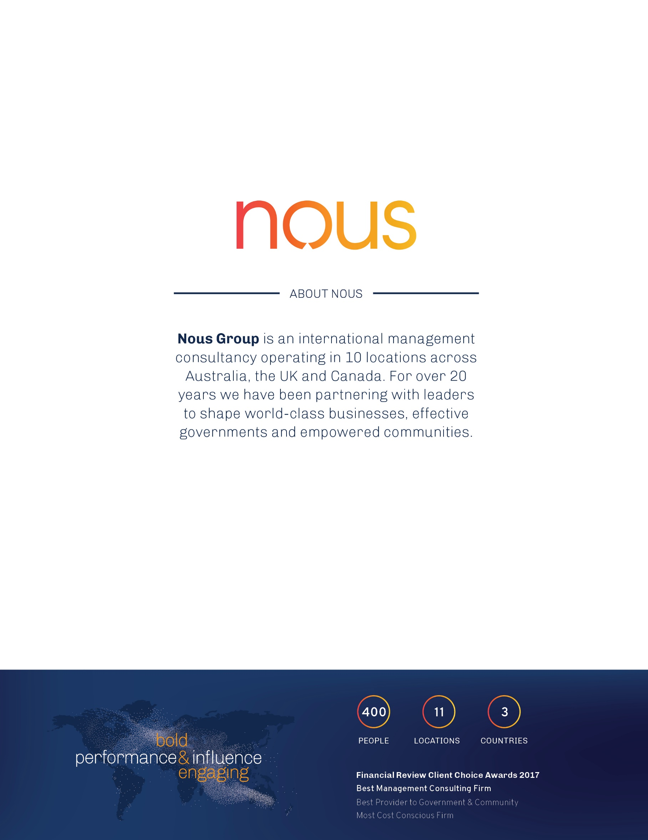

1. Australian Bureau of Statistics. (2021). Causes of Death, Australia. Based on 2020 data.
2. Australian Bureau of Statistics (ABS). (2019). *Causes of death, Australia,* 2018. Cat. no. 3303.0
3. Productivity Commission. (2019). *Productivity Commission Draft Report - Mental Health,* vol.2, p.848.
4. COAG Health Council. (2017). *The Fifth National Mental health and Suicide Prevention Plan*. Canberra: The Australian Government. pp.23
5. COAG Health Council. (2017); Department of Health and Ageing. (2007). Living is for everyone: A framework for the prevention of suicide in Australia, Canberra: The Australian Government; Department of Health and Human Services. (2016). Victorian suicide prevention framework 2016–25, Victoria: Victorian State Government; Christiansen, E., & Jensen, B. (2007). Risk of repetition of suicide attempt, suicide or all deaths after an episode of attempted suicide: a register-based survival analysis. Australian and New Zealand Journal of Psychiatry, 41(3), pp. 257-265.
6. Department of Health (2021). Budget 2021-22: Generational change and record investment in the health of Australians.
7. As defined by the Inquiry those “several hundred thousand people who have symptoms that are too complex to be adequately treated by a GP and the limited MBS-rebated individual sessions with psychologists. But their condition also does not reach the threshold for access to State or Territory funded specialised mental health services. Alternative services, such as private psychiatrists or private hospitals, may be inaccessible due to long waiting lists or very high out-of-pocket costs”.
8. This report uses ‘follow-up support’ as the term to describe what The Way Back does, given that clients could enter the service under one of the two criteria described. Nous notes that most clients access The Way Back after a suicide attempt and so the service is part of and will have lessons for, the emerging field of ‘aftercare’.
9. Depiction based on information captured in Beyond Blue’s ‘The Way Back Support Service – Service Delivery Model’, March 2020.
10. Depiction based on information captured in Beyond Blue, ‘The Way Back Support Service – Service Delivery Model’, March 2020. Number of PHNs is representative of all 31 operational sites, noting some PHNs have more than 1 site in their region.
11. Sites were excluded from this evaluation for a range of reasons, including some that are Victorian HOPE sites and covered by a different evaluation and some that were excluded from the ethics application. A small number of additional sites are likely to be included in the final evaluation report following a variation in our ethics application.
12. HOPE sites do not report into the PMHC MDS and some sites (Hobart, Launceston and Broken Hill) had only recently commenced operations as at September 2021.
13. 19 per cent of episodes have a matched pair recorded for the K10+ (n=591), 14 per cent for the WHO-5 (n=437) and 14 per cent for the SIDAS (n=451).
14. There are a variety of reasons why clients who chose not to engage with The Way Back or had unplanned early exits from the service. The evaluation understands that these include those who: did not take up the referral, did not provide consent to be a part of the evaluation, were difficult to reach for during recruitment for evaluation interviews and surveys.
15. Service providers do not collect the required contact details or consents for support persons to be contacted directly by the evaluators. This impacted our ability to get responses from support workers to the survey.
16. Fisher, L., Overholser, J., Ridley, J., Braden, A., Rosoff, C. (2015). From the outside looking in: sense of belonging, depression and suicide risk. *Psychiatry*, 78(1), pp. 29-41.
17. Figure is indicative based on analysis of Q4 FY20/21 quarterly report.
18. Productivity Commission. 2020. Productivity Commission Inquiry Report: Volume 2. No 95, 30 June 2020.
19. The quality of data collection affected some sites’ ability to accurately report against KPIs. A grace period of 120 days is provided on achievement of the Total Annual New Client KPI. Six sites are within the grace period of 120 days.
20. The delay in implementation of The Way Back sites because of the prolonged bilateral agreement process may have contributed to a slower start on KPI numbers. This delay meant that 14 of the 21 sites were only operational for a short period before Q4 2020-21.
21. The reader should note that there is a grace period of 120 days outlined in The Way Back Service Agreements for the Total Annual New Client KPI, but none of the others. There are six sites that qualify for the grace period, but removing them does not significantly change the distribution of KPIs being met. Beyond Blue also noted that in practice, many PHNs apply this grace period to more KPIs. Similarly, it did not substantially change the distribution of KPIs being met.
22. The SAX Institute for the Minister of Health NSW, ‘Evidence Check - Suicide aftercare services’, October 2019. and Beyond Blue, ‘The Way Back Support Service - Service delivery Model’, March 2020.
23. Nous has not yet obtained access to expenditure data and will include this in a final report if and when we do get access. Please also note that an additional $2m of funding was provided by the Paul Ramsey Foundation for improvements to The Way Back’s data collection and management processes (December 2018- June 2022)
24. The PMHC-MDS data may be under representative of true service use. Only 21 (of the 25 in-scope sites) have entered data into the PMHC MDS (the four remaining in-scope sites are not yet operational). Six of the 21 sites have limited episodes recorded (≤ 40 episodes between 2018-2021). A further six have ≤ 100 records over that period. Nine sites have data recorded from 2021 onwards.
25. based on PMHC MDS data for 21 sites between January 2019 and August 2021.
26. Also note that some sites only accept referrals based on the primary eligibility criteria.
27. Note that this correlation reflects a bidirectional relationship. That is, clients who remain engaged in the service for longer were more likely to have had time to complete a safety plan.
28. 40 per cent of all unique episodes do not have either a support or safety plan.
29. AIHW, 2021, ‘Intentional self-harm hospitalisations by states & territories’, Available from: www.aihw.gov.au/suicide-self-harm-monitoring/data/intentional-self-harm-hospitalisations/intentional-self-harm-hospitalisations-by-states.
30. Based on PMHC MDS data for 21 sites for January 2019 to August 2021, 36 per cent of service episodes have both a support and safety plan, 17 per cent only have a safety plan and seven per cent have a support plan but no safety plan.
31. Based on analysis of Q4 20/21 quarterly reports. It is unclear what proportion of clients have both a safety and support plan.
32. Based on PMHC MDS data for 21 sites for January 2019 to August 2021. There are limitations in the quality of the PMHC-MDS.
33. For the purposes of the PMHC MDS, a unique Episode of Care (referred to as service episodes in this report) is defined as a more or less continuous period of contact between a client and a PHN-commissioned provider organisation/clinician that starts at the point of first contact and concludes at discharge. Further information available online at: [docs.pmhc-mds.com/projects/data-specification-wayback/en/v3/data-specification/key-concepts.html#episode](https://docs.pmhc-mds.com/projects/data-specification-wayback/en/v3/data-specification/key-concepts.html#episode)
34. The outcome of the referral for the remaining percentage of clients is not known (e.g. not stated/adequately described)
35. Note that this analysis distinguishes between clients who are unemployed and clients who are ‘not in the labour force’. There was no statistically significant difference between clients who were not in the labour force and those who were employed.
36. The PMHC MDS data is not able to identify which individual clients accessed peer support services at the Murrumbidgee site. The regression modelling uses a flag for Murrumbidgee as a ‘peer support site’ and compares differences in outcomes between all people who accessed The Way Back at Murrumbidgee and those at other sites.
37. The SAX Institute for the Minister of Health NSW, ‘Evidence Check - Suicide aftercare services’, October 2019. P 28
38. Australian Government National Mental Health Commission. 2021. 2021-22 Federal Budget: Inclusions for Suicide Prevention.
39.