**The Brilliant Women Leading MRFF Projects**

## To celebrate our first gender data report on MRFF funding, we present some of the brilliant female Chief Investigators leading MRFF projects.

**photo of Professor Christobel Saunders
Professor Christobel Saunders AO, breast cancer surgeon**

### Christobel hopes to produce new evidence to inform Australian Government policy by proving patients with complex breast cancers need MRI scans.

For this group of patients, standard mammography and ultrasound scans often don’t show enough information about their cancer Christobel says. Surgeons need a more sensitive MRI scan to work out what to do.

**Clever trial design**

Previous international trials failed to conclude if MRI scans benefit breast cancer patients. But Christobel says only about 15-20% of patients need an MRI scan. She believes the improved outcome for this group of patients was lost in the large-scale randomisation of the previous trials.

Christobel needed to design a trial that could demonstrate this impact. ‘Our trial only follows the patients whose treating team thinks they need an MRI. We want to find out how the MRI changes outcomes for that group.’

The ‘Evaluation of clinical pathways and patient outcomes for breast MRI in preoperative assessment and staging of breast cancer’ trial is funded by $2 million from the MRFF.

**Co-designing the trial with patients**

Breast cancer patient advocates helped design the trial. They wanted to record patient outcomes to help patients make informed joint decisions with their doctors.

To collect this data the team worked with Breast Cancer Trials to set up the first-ever electronic patient recorded outcomes system. Simple questions are sent to patients to answer on their phones. Now this system is being used in other breast cancer studies.

Christobel says, ‘a lot of the ways we practice patient centred cancer research and treatment today were driven by breast cancer patient advocates, so it’s been a great field to go into.’

**Research outcomes will inform policy**

Interim subsidies for [two new services](http://www.mbsonline.gov.au/internet/mbsonline/publishing.nsf/Content/Factsheet-MRIBreastCa) for breast cancer MRI scans were made available from 1 November 2019. Christobel hopes her trial will provide evidence on the benefits and effectiveness of these services for further consideration by the independent expert committee, the Medical Services Advisory Committee (MSAC).

The trial examines how the MRI scan changes the management of each patient’s treatment and if the change is appropriate. For example, if the team conclude from the MRI scan that the cancer is so big a mastectomy is the best option, does the pathology report confirm this decision?

The trial will also consider the economic benefits of MRI scans, such as reduced reoperation rates.

Christobel plans to start analysing data from the 400 women participating in the MRI scan trial in September 2022.

**How Christobel shaped her career**

Christobel was ‘hooked on research’ as a trainee surgeon at the Royal Marsden Hospital and Institute for Cancer Research.

‘There were all these really clever scientists. I was very intimidated. Then I began to bring clinical questions from the patient bedside to my colleagues. They helped answer those questions.

‘That really started me on collaborative, transformational research from bedside to lab and back again.’

Christobel feels proud that she, in turn, mentors trainees. They form a network of breast cancer researchers spread around the world.

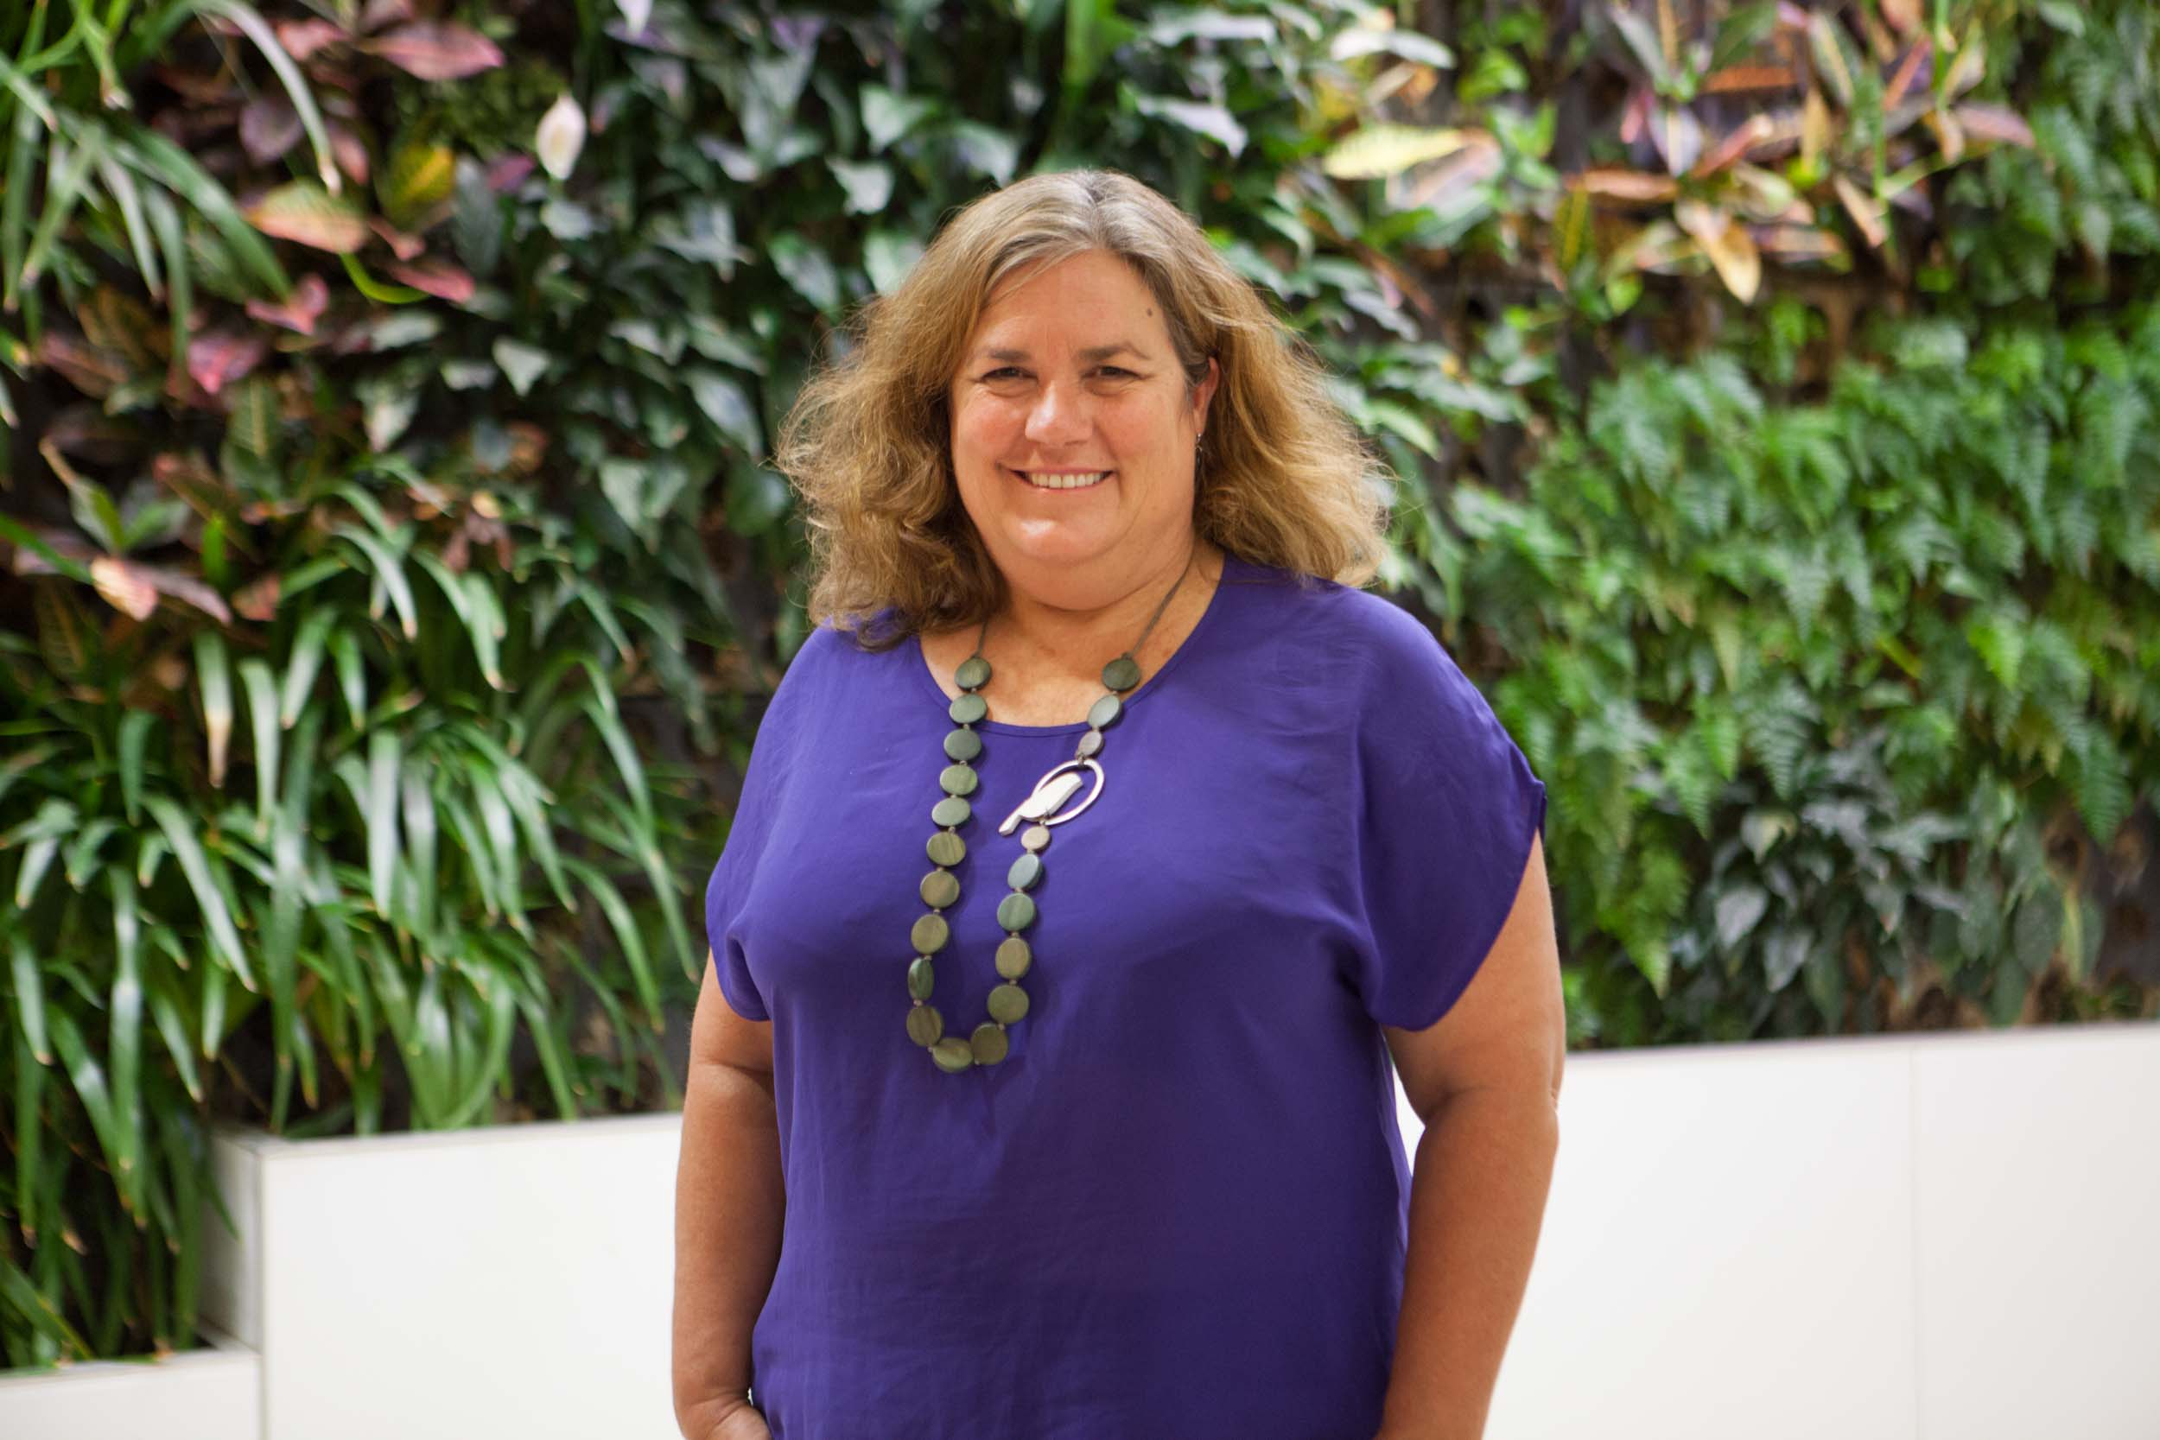**Professor Catherine Chamberlain: midwife and epidemiologist**

Cath is helping Aboriginal and Torres Strait Islander parents heal intergenerational trauma by nurturing their babies.

**Childbirth is a time of natural healing**

Having a baby is a special time. It can also trigger painful childhood memories for Aboriginal and Torres Strait Islander parents with intergenerational complex trauma.

Cath is trialling a program to enable maternity services to support these parents. If it is successful, it will be a world first.

‘A lot of effort is spent on intervention programs to address things like smoking and diabetes during pregnancy in indigenous communities worldwide, but very few have been effective.’

Cath’s program aims to harness ‘the love that children bring into the world as the healing salve for complex trauma.’

**Addressing the effects of complex post-traumatic stress disorder**

Cath believes the failure of previous interventions may be due to not addressing parents’ experiences of intergenerational and complex post-traumatic stress disorder (complex PTSD) which stems from violence associated with colonisation.

Complex PTSD is recognised as a severe form of PTSD by the World Health Organisation. It is caused by inescapable, repetitive, and violent events such as slavery, genocidal campaigns, and childhood sexual and physical abuse.

Symptoms include severe problems in expressing emotions, feeling defeated and worthless, and difficulties in sustaining relationships. They impair personal, family, social, educational, and occupational areas of functioning. When a whole community suffers these symptoms, the effects are magnified.

**Breaking the intergenerational trauma cycle**

‘Healing the Past by Nurturing the Future’ aims to assess and support Aboriginal and Torres Strait Islander parents experiencing complex PTSD and help parents break the trauma cycle for the next generation.

The program was co-designed with Aboriginal and Torres Strait Islander communities, elders, and organisations in 3 states. Now with $1.5 million funding from the MRFF and Ian Potter Foundation funding, it is being trialled and evaluated in Gippsland, Victoria.

**How Cath shaped her career**

Cath managed maternity services in remote Aboriginal communities and worked in war zones in Africa. Yet her expertise as a midwife did not prepare her for how the trauma she experienced as a child and in war zones would be triggered by becoming a parent. She suffered severe mental illness which took six months to recover from.

Cath wondered why she had not been aware of the mental health risk of past traumatic events when becoming a parent. Eventually this led her to develop the ideas in ‘Healing the Past by Nurturing the Future’.

As an early to mid-career researcher, Cath received an NHMRC fellowship and funding from the Lowitja Institute and NHMRC to co-design the project, and had two unsuccessful MRFF applications before the current project was successful.

Now the team are submitting proposals with key partners like the National Aboriginal Community Controlled Health Organisation so that learnings from ‘Healing the Past by Nurturing the Future’, can be rolled out nationally.

‘It feels like a snowball in a way. It’s taken off with legs of its own and I'm just trying to keep up!’

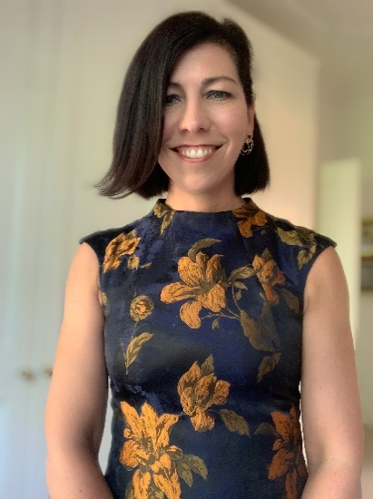**Professor Felicity Baker: music therapist**

Felicity is harnessing machine learning to help carers use music more mindfully to regulate and calm people with dementia.

**Music Attunement**

Felicity is developing a mobile eHealth application drawing on a lifetime of research showing how music therapy calms people with dementia experiencing states of agitation. It also creates moments of connection and joy between carers and their loved ones or aged care residents.

This project builds on Felicity’s Homeside study, funded in the UK, Australia, Germany, Norway and Poland, which involves providing guidance and demonstration about how carers can use music to support completing everyday tasks like showering.

‘If a person with dementia is confused and lacks connection to the here and now they can become agitated when being undressed and getting ready for a shower. To help orient the person, we teach the carer to sing orienting songs to them like “I’m Gonna Wash that Man Right Outa my Hair”.

‘The carer connects with the agitated person by singing in a staccato rhythm that matches their agitated movements, such as pacing or tapping.

‘Then the carer gradually slows down their singing to a more melodic and gentler legato pace. This pulls the person experiencing agitation into a calmer state.’

**Helping carers enjoy caring and be more resilient**

When people with dementia respond to music ‘they come to life in a different way. Carers often tell us, “I haven’t seen that spark in a long time,”’ Felicity says. This experience helps carers ‘see the person behind the dementia.’

Using music to create happy, less stressful experiences with their loved one or aged care resident helps carers too. ‘That positive feedback helps carers sustain the energy to complete challenging personal care tasks and gives them joy.’

**Using machine learning to scale up music therapy**

But carers can’t be attentive all the time. Family carers need to cook dinner or hang out the washing. Professional carers have other residents to look after.

Felicity’s multi-disciplinary team is developing a mobile eHealth application carers can use when they can’t be physically present.

Personal and environmental sensors will monitor the person’s level of agitation. Machine algorithms will be developed for the project to learn how to interpret changes to a person’s level of agitation, then match music to the level of high arousal and agitation, then adapt the music to calm the person down.

The Music Attuned Technology Care eHealth solution is funded by $2 million from the MRFF.

**How Felicity shaped her career**

Felicity emerged from an Arts background to lead large Science Technology Engineering and Mathematics (STEM) teams. She says this is due to her ability to come up with a creative idea to solve clinical problems.

‘As a neurorehabilitation music therapist, I helped multi-disciplinary teams with problems they couldn’t solve.

Today there is a broad recognition of the neuroscience behind music therapy. Highly qualified STEM experts seek me out as a collaborator!’

