Specialist Dementia Care Program (SDCP)

Information Booklet

# What is the Specialist Dementia Care Program?

The Australian Government’s Specialist Dementia Care Program (SDCP) provides transitional support and care for people living with very severe behavioural and psychological symptoms of dementia.

The SDCP offers temporary care with a goal to stabilise and reduce a person’s behavioural symptoms with a supported transition into a less intensive care setting.

## What are the key features of the SDCP?

* A living environment that is a small unit (typically 9 beds),   
  cottage-like and dementia-friendly.
* Care delivered by a team of highly trained dementia support staff, with oversight and regular visits by a clinical team such as   
  psycho-geriatricians, geriatricians and medical specialists.

Person-centred and goal-oriented care that builds on the strengths and capabilities of each individual and is tailored to the unique circumstances, background, cultural sensitivities and preferences of each person, their family and carers.

## What is the eligibility criteria?

A person is eligible if they have:

* a diagnosis of dementia
* very severe behavioural or psychological symptoms of dementia, which many include but are not limited to:
  + aggression
  + severe agitation, or
  + vocalisation
* trialled less intensive behaviour support strategies which have been unsuccessful, and
* has had an Aged Care Assessment Team (ACAT) assessment.

## Who does the eligibility assessment?

Eligibility assessments for the program are undertaken by Dementia Support Australia (DSA).

Anyone can make a referral to DSA for assessment, provided there is either family or guardian written consent and supporting documentation provided by the treating clinician.

More information on the SDCP referral and assessment process is available by contacting DSA on **1800 699 799** or via their website at [**www.dementia.com.au.**](http://www.dementia.com.au/)

## If a person is assessed as eligible, does that mean they are entitled to a place in an SDCP unit straight away?

No. A person can be considered eligible for the program, however, the person must also be considered suitable for their preferred unit. Behaviours and needs of existing residents must be considered when bringing in someone new. Units may also be at capacity and therefore unable to take a new resident.

## Is a place in a SDCP unit permanent?

**No. The SDCP is designed to offer temporary, transitional care to stabilise and reduce behavioural and psychological symptoms with the aim of enabling a person to transition to a less intensive care setting.

“The SDCP unit had the same carers every day who created a rapport with the residents. The residents were treated as family. They knew how to relate to dementia residents.”

- family member

## How long can a person stay in an SDCP unit?

There is no set timeframe for a person to stay in an SDCP unit. However, a person’s stay in an SDCP unit is likely to be around   
12 months. The SDCP is not designed to accommodate people   
on a permanent basis.

## Is there support when it is time for a person to be transitioned in and out of the SDCP?

Yes, there is support for a person to transition into and out of the   
SDCP. No one will be left without care.

A person will have security of tenure at the SDCP unit for the duration of their stay. This is formalised through the resident agreement that will be signed when transferring into the SDCP unit.

More information on length of stay and security of tenure can be accessed at: [www.health.gov.au/specialist-dementia-care-program-fees-and-security-of-tenure.](http://www.health.gov.au/specialist-dementia-care-program-fees-and-security-of-tenure)

Planning for transition out starts at placement and involves the SDCP provider, resident, their family and carers. The SDCP provider assists the resident to find a suitable place and supports the new care staff to understand behaviour triggers and successful care approaches.

## Can a person be re-admitted to an SDCP unit?

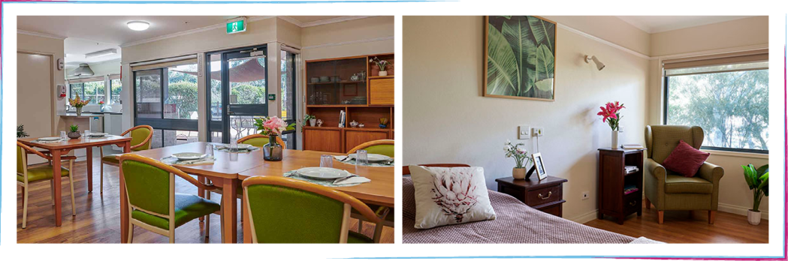Yes. A person can be re-admitted into an SDCP unit if their transition out is unsuccessful. One bed in the unit is funded for this purpose. Re-admission is based on availability.

## Can an SDCP unit make a decision to move a person to a different model of care?

Yes. There are circumstances where it may be required for the provider of the SDCP unit to move a person out of the program.  
A resident’s circumstances can change to a point where an alternative model of care is more appropriate. An increase of behaviours where a person needs more acute care, or a decline in other health conditions, are two examples where an alternate model of care will be needed.

## Can a transition based program like the SDCP be disruptive to a person’s care needs?

Yes. It can be. Moving a person to a different model of care can be disruptive and frustrating at times for both residents and carers. However, it is important to remember the ultimate goal is to ensure the model of care provided meets the needs of the resident.

The SDCP is designed to be a transitional based program.

## Should I research a wide-range of models of care?

Yes. The SDCP is a program that caters towards specific needs.  
Researching models of care provided in your state or territory   
is encouraged. You should work towards the most appropriate, accessible care for you and your loved one.

## Where are the units located?

Information on SDCP unit locations across Australia can be found on the Department of Health’s website at [www.health.gov.au/specialist- dementia-care-program](https://www.health.gov.au/specialist-dementia-care-program).

## Can a person be considered for an SDCP unit outside the state or territory in which they reside?

Yes. The SDCP is a borderless program. It is important however to consider whether a significant move from an existing location will be the right move for the resident and their carer.

## How much will a place in an SDCP cost?

The fee structure for the SDCP is the same as mainstream residential aged care. If you are currently in another residential aged care facility and have paid a refundable accommodation deposit it will be refunded or transferred when you leave the residential aged care facility to enter the SDCP unit.

It is important to visit the Australian Government My Aged Care website at [www.myagedcare.gov.au/aged-care-home-costs-and-fees](http://www.myagedcare.gov.au/aged-care-home-costs-and-fees) for more information on aged care fees.

## Raising your concerns

If you are unhappy with any aspect of care you receive, you can:

* speak to your provider directly about your concerns, or
* **make a complaint through the Aged Care Quality and Safety Commission (ACQSC), call **1800 951 822** or visit [www.agedcarequality.gov.au.](http://www.agedcarequality.gov.au/)

“The doctors, geriatrician, carers and nurses are of the highest quality and their training has contributed to John* knowing he is in a safe environment, cared for by the same staff on a daily basis, who know him and know how to treat people with behaviour problems due to dementia.”

- family member

*name has been changed

## Where can I find more information about the SDCP?

You can find more information about the SDCP on the Department of Health website [www.health.gov.au/specialist-dementia-care-program](http://www.health.gov.au/specialist-dementia-care-program) or make contact with SDCP providers and discuss any referral or admission enquiries directly.

## Where can I go for further information and support?

Detailed information on the SDCP and other behavioural programs including Dementia Behaviour Management Advisory Service (DBMAS) and Severe Behaviour Response Teams (SBRT), can be found at [www.dementia.com.au/services/needs-based-assessment- program](http://www.dementia.com.au/services/needs-based-assessment-%20program).

You can also call Dementia Support Australia on **1800 699 799**.

If you are a carer and in need of additional support, please contact:

Carer Gateway on **1800 422 737** or [www.carergateway.gov.au](http://www.carergateway.gov.au/)

Dementia Australia on 1800 100 500 or [www.dementia.org.au](http://www.dementia.org.au/), or

Older Persons Advocacy Network (OPAN) on **1800 700 600** or [www.opan.org.au.](http://www.opan.org.au.)

Translations and accessibility **131 450** for Translating and Interpreting Service (TIS), ask for your language to connect.

call **1300 010 877** for Auslan Connections,

email [interpreter.bookings@deafservices.org.au,](mailto:interpreter.bookings@deafservices.org.au)

fax **07 3892 8511** or SMS **0407 647 591**.

