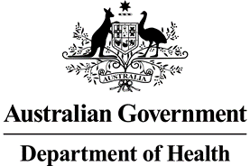

Nurse Practitioner 10 Year Plan Steering Committee Meeting Communique 3 March 2022

The third Nurse Practitioner 10 Year Plan Steering Committee meeting was held on 3 March 2022. The focus of the meeting was aimed at identifying an agreed purpose and developing a logic model for the Nurse Practitioner 10 Year Plan. Summaries and findings from the public consultation, Yarning circles and consumer focus groups were also discussed.

The Committee provided insight and feedback around potential areas of action and key focus points to consider during the development of the Plan. The Chief Nursing and Midwifery Officer, Adjunct Professor (Practice) Alison McMillan PSM noted the importance of remaining consumer focused and ensuring longevity of the Plan.

Work is underway to draft the Plan and an implementation, monitoring and evaluation framework, with further internal and external consultation anticipated.

Results from the public consultation can be found on the Department of Health’s [Consultation Hub.](https://consultations.health.gov.au/health-workforce/nurse-practitioner-10-year-plan-survey/)