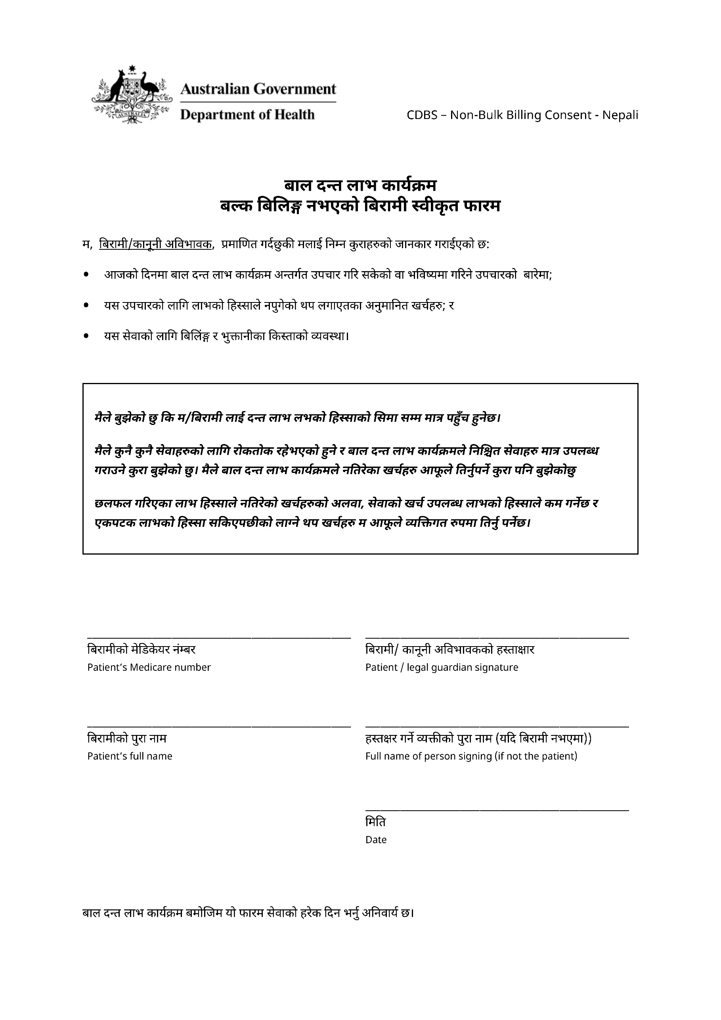

CHILD DENTAL BENEFITS SCHEDULE

NON-BULK BILLING PATIENT CONSENT FORM

I, the patient / legal guardian, certify that I have been informed of:

* the treatment that has been or will be provided on this day under the Child Dental Benefits Schedule*;*
* the likely cost of this treatment, including any out‑of‑pocket costs; and
* the billing and payment arrangements for the services.

***I understand that I / the patient will only have access to dental benefits of up to the benefit cap.***

***I understand that benefits for some services may have restrictions and that the Child Dental Benefits Schedule covers a limited range of services. I understand I will need to personally meet the costs of any services not covered by the Child Dental Benefits Schedule.***

***In addition to the out-of-pocket costs discussed, I understand that the cost of services will reduce the available benefit cap and that I will need to personally meet the costs of any additional services once benefits are exhausted*.**

___________________________ ___________________________

Patient’s Medicare number Patient / legal guardian signature

___________________________ ___________________________

Patient’s full name Full name of person signing   
(if not the patient)

___________________________

Date

This form must be completed on each day of service provision under the Child Dental Benefits Schedule.