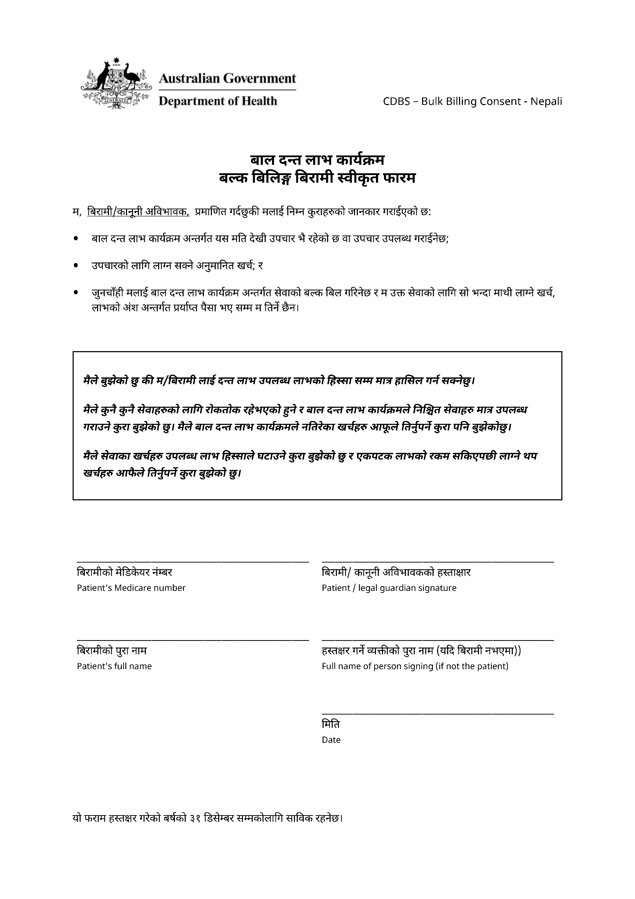

CHILD DENTAL BENEFITS SCHEDULE

BULK BILLING PATIENT CONSENT FORM

I, the patient / legal guardian, certify that I have been informed:

* of the treatment that has been or will be provided from this date under theChild Dental Benefits Schedule*;*
* of the likely cost of this treatment; and
* that I will be bulk billed for services under the Child Dental Benefits Schedule and I will not pay out‑of‑pocket costs for these services, subject to sufficient funds being available under the benefit cap.

***I understand that I / the patient will only have access to dental benefits of up to the benefit cap.***

***I understand that benefits for some services may have restrictions and that Child Dental Benefits Schedule covers a limited range of services. I understand I will need to personally meet the costs of any services not covered by the Child Dental Benefits Schedule.***

***I understand that the cost of services will reduce the available benefit cap and that I will need to personally meet the costs of any additional services once benefits are exhausted.***

___________________________ ___________________________

Patient’s Medicare number Patient / legal guardian signature

___________________________ ___________________________

Patient’s full name Full name of person signing   
(if not the patient)

___________________________

Date

This form is valid up to 31 December of the calendar year for which it is signed.