Review of the RPGP and GPPTSP: Evaluation Report

Department of Health

11 September 2017

This page is intentionally blank.

© Nous Group

Contents

Executive Summary 1

Key facts and figures 5

Key findings 6

1 Overview of rural workforce programs 9

1.1 Rural Procedural Grants Program (RPGP) 9

1.2 General Practitioner Procedural Training Support Program (GPPTSP) 12

1.3 Rural workforce retention and upskilling program mapping 16

1.3.1 Commonwealth programs 16

1.3.2 Jurisdictional programs 17

2 Rural GPs value the subsidies but the policy outcomes are less clear 20

2.1 RPGP and GPPTSP have subsidised rural GPs to access procedural skills training since their inception 20

2.2 Recent reviews suggest that skills maintenance and upskilling are being achieved through the RPGP and GPPTSP 22

2.3 Data available from the current review confirms stakeholder support 24

2.4 The administrative simplicity of both programs is a key strength 24

3 The context for change and reform of the RPGP and GPPTSP is multifaceted 27

3.1 Supporting rural health workforce is a key feature of Commonwealth policy 27

3.2 Rural workforce initiatives have continued to expand 28

3.3 Patterns of rural hospital practice and general practice are changing 29

3.4 Health needs of rural communities are paramount 30

3.5 Broader considerations of the policy context 32

3.5.1 Principles of efficient Government policy 32

3.5.2 Strategic consideration: Evidence suggests that financial incentives are only one aspect of successful retention programs 33

4 Overview of options for reform 36

4.1 Options for reform: RPGP 36

4.1.1 Option A: Maintain and refine the RPGP as an uncapped program that is better targeted to policy objectives 37

4.1.2 Option B: Integrate the RPGP into the General Practice Rural Incentives Program (GPRIP) 52

4.1.3 Option C: Cap the RPGP with a focus on community need, and centralise the program administration 55

4.2 Options for reform: GPPTSP 65

4.2.1 Option D: Retarget the GPPTSP funds into other health workforce programs 65

4.2.2 Option D1: Integrate GPPTSP funds into the Health Workforce Scholarship Program 70

4.2.3 Option D2: Integrate funds into Australian General Practice Training program to expand the AGPT to support VRGPs for advanced skills training 73

4.3 Options for reform: Combining RPGP and GPPTSP 76

4.3.1 Option E: Amalgamate the RPGP and GPPTSP to form a separate capped and more broadly based grants program 76

4.3.2 Option E1: Amalgamate the RPGP and the GPPTSP to form a combined VRGP procedural skills maintenance and upskilling program 76

4.3.3 Option E2: Amalgamate the RPGP and GPPTSP to develop a new rural VRGP advanced skills program 78

4.4 Summary of benefits, considerations and risks for the Options for Reform 81

Appendix A Methodology 86

Appendix B Summary of the literature review 90

Appendix C Summary of the data analysis 104

Appendix D Summary of the stakeholder consultation outcomes 121

Appendix E Consultation participants 136

Appendix F Commonwealth and jurisdictional workforce programs 143

Appendix G References 151

# Executive Summary

The Department of Health (DoH) engaged Nous Group (Nous) to conduct a review of the Rural Procedural Grants Program (RPGP) and the General Practitioner Procedural Training Support Program (GPPTSP). Nous employed a multi-modal methodology, triangulating the findings from three research streams including: a literature review (including national program mapping), data analysis and intensive stakeholder consultation (see Appendix A). Nous analysed the available data in collaboration with the National Centre for Social and Economic Modelling (NATSEM) research team from the University of Canberra. Analysis of the findings and evidence informed Nous’ development of evidence-based options for reform for both programs to be considered by the DoH.

The policy objective of both the RPGP and the GPPTSP is to encourage the retention of GPs with procedural skills in the rural and remote regions of Australia. Vocationally registered GPs (VRGPs) with procedural skills in surgery, anaesthetics, obstetrics and emergency medicine form a critical component of health service delivery in rural and remote areas, where access to specialist care is limited by geography and a sparse population base.

Both programs are part of the capped health workforce program portfolio. The RPGP provides an income supplement to encourage GPs to maintain their procedural skills, while the GPPTSP provides financial support to undertake additional certification to gain procedural skills in obstetrics and associated anaesthetics. While skills maintenance is a mandatory part of continuing professional development and College fellowship, the entitlement to a subsidy is seen by rural procedural GPs as important recognition of the value of their skills, as well as providing financial recompense towards the costs of travel, accommodation and absence from their practice.

The RPGP is a demand driven, uncapped entitlement program that provides VRGPs and locums with access to grants to attend relevant training, for maintenance and enhancement of procedural skills. From the RPGP’s inception in 2004 to December 2016, 45,819 grants totalling $174 million53 have been provided to more than 4,000 GPs across Australia.51 Between FY2009-10 to FY2016-17, the most accessed training was in emergency medicine (2,458 grants) followed by anaesthetics (1,261 grants).51 The GPPTSP has provided a total of 237 grants for advanced skills development in obstetrics and anaesthetics since grant inception to 2015, at a total cost of $9.1 million.15, 108 Taken together, the two programs expended in the vicinity of $21 million in FY 2015-16, with the larger program, the RPGP, regularly over-running its budget allocation in more recent years, due to the uncapped number of GPs eligible for the entitlement.

These two programs form part of a matrix of individual programs, funded at both Commonwealth and state/territory levels, that aim to encourage GPs to work and stay in rural and regional areas. There is no alignment of such programs between the Commonwealth and the states/territories, with each independently administering its own programs to ensure the rural workforce is able to maintain its skills. In the complex and changing world of health service delivery, rural procedural GPs often work in close collaboration with state/territory funded local hospitals, providing critical resources in the running of surgical, obstetric and emergency rosters.

The Nous Group (Nous) was engaged to undertake an independent evidence-based review of these two programs. Nous’ review drew together a review of relevant literature, analysis of available data, including MBS and program data, as well as an extensive consultation process. The Review aimed to determine whether the programs deliver the best value for money in terms of:

* Maintaining or increasing access by the community to highly skilled rural health professionals
* Increasing the sustainability of the rural health services and the health workforce
* Continuing to align with government rural workforce development priorities
* Determining if the programs most effectively meet the policy objectives and integrate with other programs with similar policy aims.

The key findings of the review are highlighted in Table 1.

Not surprisingly, the review found overwhelming support for the subsidies from rural procedural GPs and their associated organisations. Data analysis showed that rural GPs who received grant funding through either program continued to provide MBS billed, procedural health services.

On the vexed question of whether the subsidies actually encourage the retention of procedural GPs in rural and remote areas, the evidence is less clear cut. Evidence from recent studies indicates that there are a broad range of factors that influence a GP to remain in a rural or remote setting, including partner/spousal support and locum availability. The relatively small subsidy provided by these two programs is unlikely to represent a major incentive to remain in rural practice.

While the evidence is less than conclusive, it indicates that continuation of a subsidy program, albeit with some modifications, will assist in the retention of highly skilled GP proceduralists in rural and remote regions. Overall, the evidence suggests that there is an opportunity to better meet community needs as the skills demanded by rural communities extend beyond the scope of procedural areas.

Nous considered whether modifications to the current programs would improve the value for money they provide for taxpayers. Concerns that arose in the course of the Review primarily revolved around how well the programs are targeted towards the needs of the rural and remote communities they are intended to benefit.

Nous proposes a range of options to ensure the programs are better targeted to need, and represent value to taxpayers. Figure 1 summarises the options for reform of the RPGP and GPPTSP for consideration by the DoH.

Figure 1: Summary of the Options for Reform

Figure that summaries the Option for Reform

**Option A: Maintain and refine the RPGP as an uncapped program that is better targeted to policy objectives**

This option continues the RPGP as an ‘entitlement’ program with uncapped expenditure ensuring that every rural procedural GP is able to access a subsidy so long as they undertake a course certified by one of the Colleges. However it changes the eligibility for the subsidy by targeting rural proceduralists using the Modified Monash categorisation of rurality – effectively restricting eligibility more tightly than under the current categorisation of rurality.

Modelling indicates that the change to MMM 3-7 will significantly reduce the numbers of rural proceduralists eligible for a subsidy. This would allow the introduction of a scaled payment, so that proceduralists in MMM 6 and 7, for example, could receive a higher subsidy that recognises their higher costs of travel.

This option also tightens aspects of the program, including its policy objective, risk management controls and eligibility. GPs accessing similar specific support for the costs associated with procedural upskilling through state-based programs or other Commonwealth programs would be excluded. An advantage of this option is that it maintains the relatively simple administration processes of the current RPGP program.

**Option B: Integrate the RPGP into the General Practice Rural Incentives Program (GPRIP)**

The General Practice Rural Incentives Program (GPRIP) provides income supplementation to GPs practicing in rural areas to improve rural workforce retention. Option B proposes that the RPGP should be integrated into the GPRIP as an uncapped entitlement program providing additional support (unrelated to specific participation in upskilling courses) to better streamline administration and monitor workforce retention.

Integration of the RPGP with GPRIP could strengthen the measure of RPGP impact on retention policy objectives given that the GPRIP considers rural service or practice as part of the eligibility criteria for payment. Integrated administration could better facilitate data collection and monitoring of workforce retention, particularly in instances where the GPs continue to apply for the GPRIP payment in the following year.

The uncapped nature of GPRIP cautions against adoption of this option, as there would be few controls on expenditure. This option also removes the direct link between undertaking upskilling and financial assistance.

**Option C: Cap the RPGP with a focus on community need, and centralise the program administration**

The recognition that there is a finite funding pool for the RPGP requires the introduction of a more competitive process, with relative priority being determined from among the applicants. While eligibility and tightening will be modified under this option as proposed in Option A (including the use of the MMM classification), this option uses two criteria to determine the relative priority of applicants:

* Relative community need.
* Access of the applicant to other (state or Commonwealth based) subsidies for skills maintenance.

This option will require different program administration arrangements to the current program, as it is no longer entitlement based. Eligibility for a grant would need to be determined up-front, potentially on an annual basis, and a decision-maker would need to be put in place to assess the relative merit of applications.

Nous proposes that under this option a program administrator be put in place either through a competitive tender process or by amalgamation with the Health Workforce Scholarships Program (HWSP), with a specific procedural VRGP funding stream established as a quarantined fund separate from HWSP funding. While this additional administrative process will increase the costs of administration, it will also ensure the program is appropriately targeted and provides better value for money. The advantage of this variation is that it would reduce the number of separate programs and provide economies of scale in administration.

**Option D: Retarget the GPPTSP funds into other health workforce programs**

Analysis of the outcomes of the GPPTSP against its policy objectives indicates that the demand for the program, as an encouragement for VRGPs to gain advanced skills in obstetrics and associated anaesthetics, is limited. This reduction in demand reflects evidence that there is a saturation of demand for GP obstetricians.

Increasingly the GPPTSP funding has been diverted to registrars rather than to fellows who were the original policy target. The AGPT program already provides registrars with access to these advanced skills and the review sees no reason to pay some registrars an income supplement for this advanced skills training, beyond the arrangements in the AGPT program.

The review proposes that the GPPTSP be abolished as a separate program and the funding reallocated to areas of high workforce need in rural and remote areas. Registrars would access the existing AGPT program without additional income supplementation.

There are several options for the reallocation of the funding, including allocating all the GPPTSP funding to the HWSP, with a separate funding stream for fellows to gain advanced skills in obstetrics, until demand indicates this is no longer required. The funds can then be applied to more broadly based upskilling for fellows in areas of community need, such as mental health.

**Option E: Amalgamate the RPGP and GPPTSP to form a separate capped and more broadly based grants program**

In line with the desire to reduce the number of separate grants programs, a single capped program that combines the intent of the two existing programs would streamline administration and clarify policy intent. There are two potential policy objectives that could be met by this amalgamation. The first is to combine the funds into a pool that is specifically for procedural skills, with some funding reallocated elsewhere for broader community need, given the reduction in demand for the GPPTSP component.

The second is to create a new Rural GPs Advanced Skills Program, which would continue to meet the demand for subsidies for rural procedural GP skills maintenance and upskilling, but would also provide subsidies to encourage rural GPs to gain advanced skills in other areas of community need, such as mental health or palliative or aged care. This would provide a response in line with the extensive feedback received during this review on the need for GPS to acquire advanced skills in these areas, particularly in mental health.

Key facts and figures

Figure 2: Facts and Figures for the RPGP

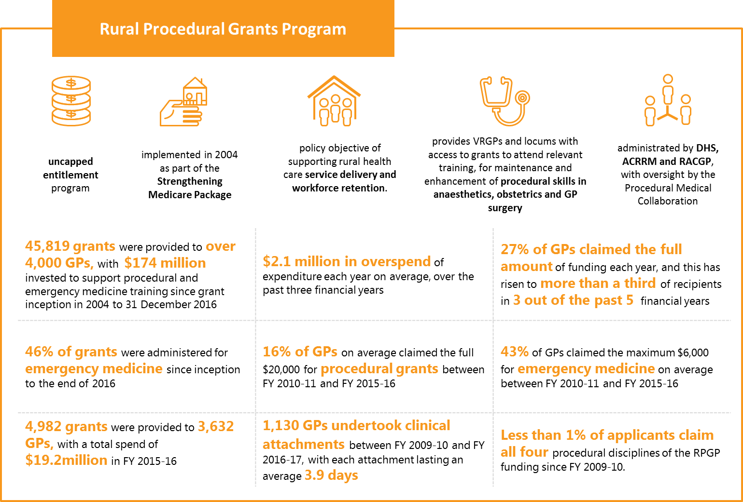

Figure 3: Facts and Figures for the GPPTSP

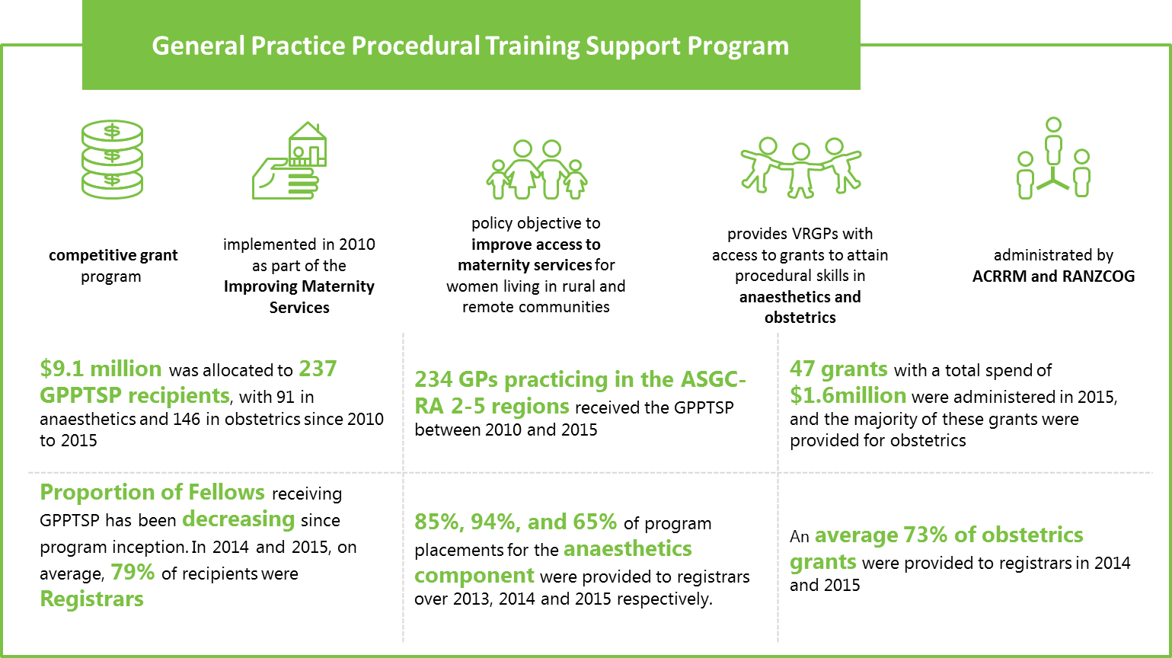

Key findings

The table below summarises the key findings of this Review.

Table 1: Key findings from the Review

|  |  |
| --- | --- |
|  | Key findings |
| 1 | * + - * 1. **Financial subsidies provided through RPGP and GPPTSP are strongly supported by recipients and Colleges** * Vast majority of stakeholders felt that the RPGP and GPPTSP enable VRGPs to maintain and upskill in the specific procedural skills supporting through the grants#. * 60% of RPGP recipients and 35% of GPPTSP recipients who responded to the online survey* reported that the financial support provided through the grant influenced their decision to remain practicing in a rural or remote area “to a great extent”.   + - * 1. *#Access to quantitative data to objectively measure the policy impact of the program was limited for this Review (see 5).*         2. *\*Note that the qualitative survey results were drawn from current members of ACRRM (71%), RACGP (13%), RANZCOG (4%), and ACEM (1%).* |
| 2 | **Of the 108 rural health workforce programs nationally (Commonwealth and jurisdictional), 64 target retention and upskilling and are potentially available to the same cohort of doctors**  The RPGP and GPPTSP build on, and add to, the suite of **108** rural health workforce programs available nationally (Commonwealth and jurisdictions); however they do not integrate effectively.  **64/108 programs** target workforce retention or upskilling, and were identified as relevant for rural GPs, specialists or GP registrars.   * + - **29/64** programs were associated with GP workforce retention     - **35/64** related to maintaining skills and upskilling GPs (12 Commonwealth; 23 jurisdictional)       * + **13/23** jurisdictional programs support specific skills training in procedural obstetrics, anaesthetics, emergency medicine and surgery.         + **7/13** jurisdictional programs in key procedural skills (in addition to the RPGP and GPPTSP) across Qld, Vic, NSW and WA were targeted at registered GPs or proceduralists. |
| 3 | * + - * 1. **Program outcomes are suggestive, but not definitive, of impact on policy objectives**   The data suggests a correlation between RPGP recipients and rural workforce retention.  Retention of the FY2002-05 cohort of GPs grants was higher than those that did not receive a grant.  GPPTSP may have contributed to improving access to maternity services in rural locations, given that 161 GPs have completed obstetrics and anaesthetics training. |
| 4 | **Policy objectives for the RPGP and GPPTSP are unclear and can be misinterpreted**  The original and intended policy objectives for RPGP and GPPTSP evolved or were diluted over time, not clear, and misunderstood or misinterpreted.  GPPTSP program guidelines indicate eligibility for registrars which misaligns with the original intent of the program to be targeted for VRGPs. |
| 5 | **Program design and eligibility is based on health workforce demand, rather than access to services or community need for procedural skills**   * The scope of rural practice to meet community needs is broad and includes procedural and non-procedural skills including mental health, palliative care, chronic disease management and paediatrics. * The skills that are most commonly acquired and those that are most commonly practised in rural communities are mental health, emergency medicine and chronic disease management. * Consultations from the Review have emphasised that community need should be the first determinant of program eligibility. * Peak bodies and grant recipients surveyed identified both emergency medicine and mental health as areas of greatest need in rural communities. * Stakeholders asserted that the rural and remote GPs need to be prepared to provide emergency services. |
| 6 | **Issues were identified with the cost and mode of some training programs**  Some training providers designed and priced courses to meet the RPGP eligibility criteria.  The Procedural Medical Collaboration group debated whether online programs should be eligible for the RPGP, given the funds are intended to pay for the travel and associated costs of leaving their practice.  Approximately 20% of survey respondents attended a RPGP-supported course that had 10-20% online components, <5% of respondents identified attending a RPGP supported course that was entirely online. |
| 7 | **There is developing market saturation of procedural anaesthetics and obstetrics trained GPs**  Stakeholder consultations indicated a decline in GPPTSP demand. This may be attributed to the saturation of training recipients, VRGPs may acquire their training as a registrar as part of the AGPT.  Proportion of non-registrars receiving the GPPTSP grant has been decreasing. An average of 79% of grants were provided to registrars in 2014 and 2015. |
| 8 | * + - * 1. **The need for workforce support in rural areas continues, and patterns of rural medicine practice are changing (growth of specialists may reduce the need for GP proceduralists)**   The maldistribution of Australia’s health care workforce favouring metropolitan areas continues, with rural gaps in procedural GPs.  The absolute number of rural proceduralists has not changed significantly in almost 15 years, while the number of GPs practicing in rural and remote areas has roughly doubled.  There is a shift in patterns of traditional rural general practice, including the growing tendency towards specialisation and sub-specialisation for new graduates.  MABEL data shows the number of patients seen per week by GP proceduralists in private practices has been falling from 111 in 2011 to 94 in 2015, as have the hours worked, from 46 to 43 hours per week.  The Medical Colleges are refining their training programs to better suit rural practice. The growing cohort of graduating specialist Fellows could reduce the requirements for procedural GPs. |
| 9 | **MMM classification system provides more granular understanding of remoteness compared to ASGC-RA**  The MMM uses seven remoteness classifications based on road distance to the nearest town of a set population and town size.  Newly developed programs are implementing the MMM classification system, including GPRIP.  Financial assistance is more important for VRGPs located in more remote areas to cover high travel costs to attend training. |

|  |
| --- |
| * + - * 1. **A number of broader strategic considerations for the DoH were identified** |
| **Financial incentives are only one aspect of successful attraction and retention programs**   * Holistic, multifaceted and integrated initiatives and programs achieve better rural retention results than stand-alone programs. * Recent MABEL data highlighted that 65% of GPs would not consider relocating to rural areas, regardless of the amount of financial incentive provided.   **Government reform advocates rationalising grant programs to ensure incentives provide value for money**   * Program mapping found potential duplication in the health workforce programs aimed at upskilling and retaining rural GPs. * Recommendations from the Mason Review, and successive governments have prompted consolidation and rationalisation grant programs, with efficiencies gained directed to go to frontline services.   **Evaluation and monitoring framework to support continual program improvements could be strengthened**   * Limited systematic monitoring and centralised data collection mechanisms for the RPGP and GPPTSP limit formative and summative evaluation measures. |

# Overview of rural workforce programs

RPGP and the GPPTSP are provided under the Commonwealth Health Workforce Program, to strengthen the capacity of the rural health workforce to deliver high quality health care to Australians across the country.56 Funded by the DoH, the RPGP and GPPTSP aim to incentivise and support rural VRGPs to undertake training to attain, maintain and upskill their procedural skills, and provide rural communities with access to procedural services.

Across Australia, the RPGP and GPPTSP are part of a larger suite of Commonwealth and jurisdictional rural workforce programs, incentives and/or initiatives aimed to improve access to quality health services and extend capability of the rural health workforce. The two programs contribute to the objective through offering income supplementation to assist rural GPs to maintain and upskill their procedural skills per College recertification and AHPRA requirements for Continuous Professional Development (CPD). This is in the context of an evolving medical education market where courses targeting specific needs are now well developed and costs of education are rising, and therefore such programs are becoming increasingly relevant considering the influence they have on GP purchasing power and capacity to train, among others.

The sections of the report detailed below provide background on the two programs under review and maps these programs with other relevant national and jurisdictional level GP programs, focused on rural workforce upskilling and retention.

## Rural Procedural Grants Program (RPGP)

Overview

The RPGP provides rural, VRGPs and locum GPs with a grant subsidy to partially offset the costs of attending approved training programs to maintain and enhance their procedural and emergency medicine skills, relevant to their location and community need. It is a demand driven, uncapped entitlement program. It was first implemented in 2004 as part of the Strengthening Medicare Package, with the policy objective of supporting rural health care service delivery and workforce retention.55

The DoH indicates that ‘the underlying program theory assumes:

* financial incentives will encourage and support rural GPs to undertake relevant training;
* GPs who complete training will have increased skills, an expanded scope of practice, and increased job satisfaction – all of which will contribute to rural workforce retention; and
* improved and/or increased access to relevant procedural services in regional, rural and remote communities, providing access to high quality and safe health service provision close to home, will prevent the need for travel/disruption to access services.’44

The RPGP has two components:

1. **Procedural Medicine** across three disciplines (anaesthetics, obstetrics, and surgery), where recipients are eligible for up to $20,000 per financial year for 10 days of training at $2,000 per day.
2. **Emergency Medicine**, where recipients are eligible for up to $6,000 per financial year for 3 days of training at $2,000 per day.

Figure 4 overleaf illustrates the program logic for the RPGP.13, 44, 55, 125

From the RPGP’s inception in FY2004-05 to 31 December 2016, 45,819 grants totalling $174 million53 have been provided to more than 4,000 GPs across Australia.51 In FY2015-16 alone, the RPGP provided 4,982 grants52 to 3,634 college registered GPs52 with a total spend of $19.2 million.52 In this year, the most accessed training was in emergency medicine (2,475 grants) followed by anaesthetics (1,266 grants).51 In addition, analysis of DoH RPGP data revealed that 1,130 GPs undertook clinical attachments between FY2009-10 to FY2016-17, 51 with each attachment lasting for an average 3.91 days. 51 The RPGP has over-run its budget allocation for the past three financial years (FY2013-14 to FY2015-16) by an average $2.1 million.41

Eligibility

A GP’s eligibility to participate in the program is assessed by the Australian College of Rural and Remote Medicine (ACRRM) and the Royal Australian College of General Practitioners (RACGP). To receive grants under RPGP, GPs must initially register for the program with either of the GP colleges. To be eligible for payment under the RPGP, applicants need to be:

* A currently practising GP with general registration and Fellowship with either the ACRRM or the RACGP (vocational registration).
* Delivering either unsupervised anaesthetics, obstetrics and/or surgery in Australian Standard Geographical Classification – Remoteness Areas (ASGC-RA) 1-5[1], or unsupervised emergency medicine in 24-hour triaging accident and emergency facilities in ASGC-RA 2-5.

Administration

The RPGP is jointly administered by ACRRM, RACGP and the Department of Human Services (DHS). An advisory group, the Procedural Medicine Collaboration, has been established to provide advice on the administration of the program with membership from the GP Colleges, the DoH and DHS. The DoH and the DHS attends as an observer. The Collaboration meets regularly and takes decisions on application eligibility and provision of the grants. The Procedural Medical Collaboration applies the eligibility criteria and also prioritises eligible GPs who have required clinical privileges and participate regularly in on-call rosters.

Upon entry into RPGP, doctors can then claim payment for procedural and emergency medicine activities they subsequently attend. The activities/training must be minimum six hours duration and relevant to the discipline in which they have been registered in the program.44

The DHS then administers the funds through an automated system directly to successful applicants.

Figure 4: RPGP program logic

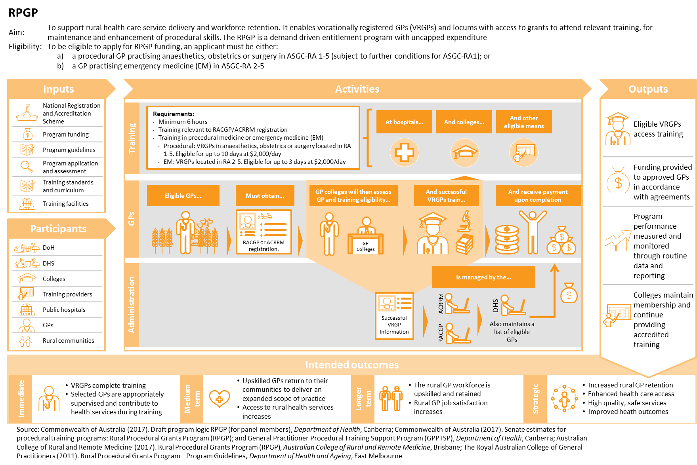

## General Practitioner Procedural Training Support Program (GPPTSP)

Overview

The GPPTSP is a competitive grant implemented in 2010 as part of the Improving Maternity Services in Australia package. Its objective is to improve access to maternity services for women living in rural and remote communities by supporting GPs to attain procedural skills in anaesthetics and obstetrics.55

The DoH stipulates that the underlying logic to the program is that:

* ‘financial incentives will encourage and support rural GPs to undertake the relevant training;
* GPs who complete this training will have increased skills, an expanded scope of practice, and increased job satisfaction – all of which will contribute to rural workforce retention; and
* improved and/or increased access to anaesthetic and obstetric services in regional, rural and remote communities allows women in these regions to access safe, quality maternity services close to their home preventing the need for them to travel.’43

The GPPTSP has two components:

1. **Anaesthetics** which provides $40,000 per recipient to complete the Advanced Rural Skills Training in Anaesthesia with six months to secure an accredited training post, and two years to complete the Advanced Rural Skills Training in Anaesthesia from commencement of training. $35,000 is provided to the recipient upon acceptance into the accredited training post, and $5,000 upon successful completion of the program.12
2. **Obstetrics** which provides $40,000 per recipient to complete the Diploma of the Royal Australian and New Zealand College of Obstetrics and Gynaecology (DRANZCOG) Advanced Training. Recipients are expected to have completed the training application process within six months from notification and successfully completed the DRANZCOG Advanced Diploma within 2 years of commencing the training.[2] $35,000 is provided to the recipient upon acceptance into the accredited training post, and $5,000 upon successful completion.106

Figure 5 overleaf illustrates the program logic for the GPPTSP.12, 43, 55, 106

Since the GPPTSP’s inception in 2010 to 2015, $9.1 million was provided to 237 GPPTSP recipients across Australia, with 91 in anaesthetics and 146 in obstetrics.10, 11, 103, 104, 105 In 2015-16, the GPPTSP provided 43 grants with a total spend of $1.6 million, and the majority of these grants were provided for obstetrics (26 grants). 10, 11, 103, 104, 105 These trends are further discussed in Section 2.

Eligibility

A GP’s eligibility to obtain GPPTSP funding is determined by ACRRM and the Royal Australian and New Zealand College of Obstetrics and Gynaecology (RANZCOG). As evident below, the application guidelines for each component are slightly different.

To apply for the *anaesthetics* component, the applicant must be:

* A GP per ACRRM’s eligibility criteria outlined in Table 2 below.
* Physically located in an ASGC-RA 2-5 location for their principle location of clinical practice or current training post.12

To apply for the *obstetrics* component, the applicant must be:

* A GP per RANZCOG’s eligibility criteria outlined in Table 3 below, or GP Locum.
* Physically located in an ASGC-RA 2-5 location for their principle location of clinical practice or current training post.106

Table 2: Eligibility Criteria of the GPPTSP Anaesthetics component12

|  |  |
| --- | --- |
| Item | GP Description |
| A | A practitioner who is vocationally registered under section 3F of the Health Insurance Act 1973. |
| B - | A practitioner who:   1. is a Fellow of the RACGP 2. participates in the quality assurance and continuing medical education program of the RACGP 3. meets the RACGP requirements for quality assurance and continuing education. |
| C | A practitioner in relation to whom a determination is in force under regulation 6DA of the Health Insurance Regulations 1975 recognising that he or she meets the fellowship standards of ACRRM. |
| D | An eligible non-vocationally recognised medical practitioner as defined in rule 3(3) of the Health Insurance (General Medical Services Table) Regulations 2009. |
| E | A practitioner who is undertaking a placement in general practice as part of the Remote Vocational Training Scheme administered by Remote Vocational Training Scheme Limited. |
| F | A practitioner who is undertaking a placement in general practice that is approved by the RACGP or ACRRM:   1. as part of a training program for general practice leading to the award of Fellowship of the RACGP 2. as part of another training program recognised by the RACGP as being of an equivalent standard 3. as part of a training program leading to the award of Fellowship of ACRRM. |

Table 3: Eligibility Criteria of the GPPTSP Obstetrics component106

|  |  |
| --- | --- |
| Item | GP Description |
| A | A practitioner who is vocationally registered under section 3F of the Health Insurance Act 1973. |
| B | A practitioner who:   1. is a Fellow of the RACGP or ACRRM 2. participates in the quality assurance and continuing medical education program of the RACGP or ACRRM 3. meets the RACGP or ACRRM requirements for quality assurance and continuing. |
| C | A practitioner in relation to whom a determination is in force under regulation 6DA of the Health Insurance Regulations 1975 recognising that he or she meets the fellowship standards of ACRRM. |
| D | An eligible non-vocationally recognised medical practitioner as defined in rule 3(3) of the Health Insurance (General Medical Services Table) Regulations 2009. |
| E | A practitioner who is undertaking a placement in general practice as part of the Remote Vocational Training Scheme administered by Remote Vocational Training Scheme Limited. |
| F | A practitioner who is undertaking a placement in general practice that is approved by the RACGP or ACRRM:   1. as part of a training program for general practice leading to the award of Fellowship of the RACGP 2. as part of another training program recognised by the RACGP as being of an equivalent standard 3. as part of a training program leading to the award of Fellowship of ACRRM. |

When selecting successful applicants, GPs are ranked in order of ASGC-RA classification of the VRGP’s practice or registrar’s training post, followed by the need for anaesthetic or obstetric skills in the GP’s geographic area of practice.12, 106

Administration

The GPPTSP is administered by ACRRM and RANZCOG. Each year, ACRRM administers approximately 15 grants for the anaesthetics component,12 while RANZCOG administers approximately 35 grants for the obstetrics component.103 The successful applicant is expected to complete the training application process within six months, and complete the advanced training within two years of training commencement. However, the Review also recognises that there may be case by case exceptions, whereby successful RANZCOG recipients could be eligible for an extension of time under special circumstances. Failure to meet these expectations may result in a request for refund.12, 106

Figure 5: GPPTSP program logic

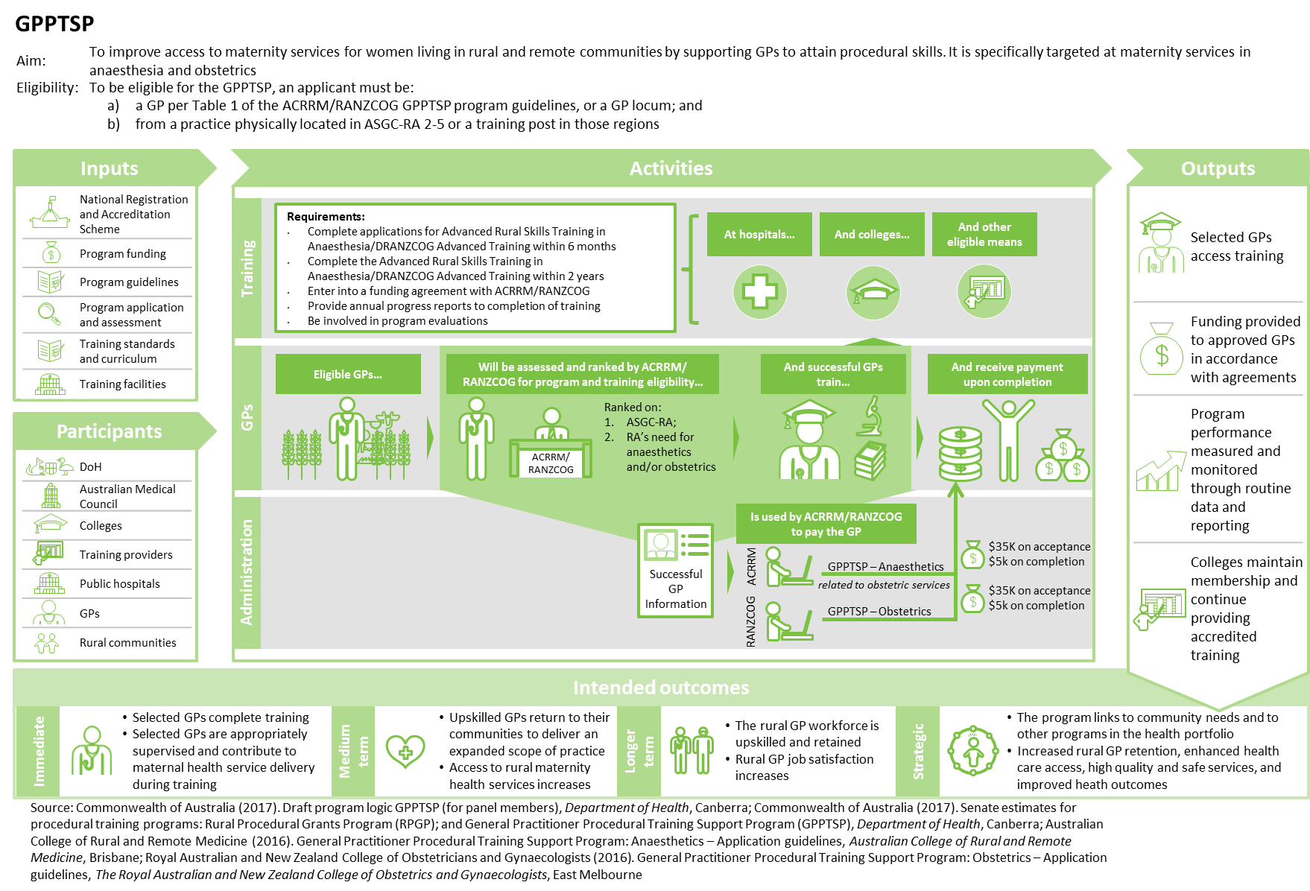

## Rural workforce retention and upskilling program mapping

As part of this Review, the RPGP and GPPTSP were mapped with other relevant national and jurisdictional level GP programs focused on rural workforce upskilling and retention. The Literature Review and Stakeholder Consultation research streams identified relevant rural workforce programs. In addition to state-based awards, the Review identified 108 programs designed to support the health care workforce in rural communities provided by either the Commonwealth or other jurisdictions.[3]

Of these, 25 Commonwealth programs and 39 jurisdictional programs (64 in total, including RPGP and GPPTSP) were identified as relevant for the mapping analysis exercise using the following criteria, whether the programs:

* were current
* relevant for rural GPs or specialists or GP registrars
* target rural workforce retention or upskilling.

A complete list of programs included in the mapping analysis is presented in Appendix F.*[4]* These programs were categorised by whether their primary purpose was to encourage retention (e.g. through remuneration, locum placements or other quality of life benefits) or to encourage upskilling (e.g. through scholarships or subsidised training). When considering the program objective of the 64 programs, 35 of these relevant rural workforce programs related to upskilling, whilst 29 related to GP retention.

### Commonwealth programs

Of the 25 relevant Commonwealth programs, 12 were aimed at upskilling and 13 were aimed at GP retention. The balance between upskilling and retention programs indicate an even focus in the types of Commonwealth programs provided to support the priority areas of need for rural practice. There is a logical connection between both upskilling and retention programs where a program aimed at one outcome can certainly influence the other. Figure 6 illustrates the rural Commonwealth programs supporting general practitioners, noting both the RPGP and GPPTSP are included.

Figure 6: Map of rural Commonwealth programs supporting GPs

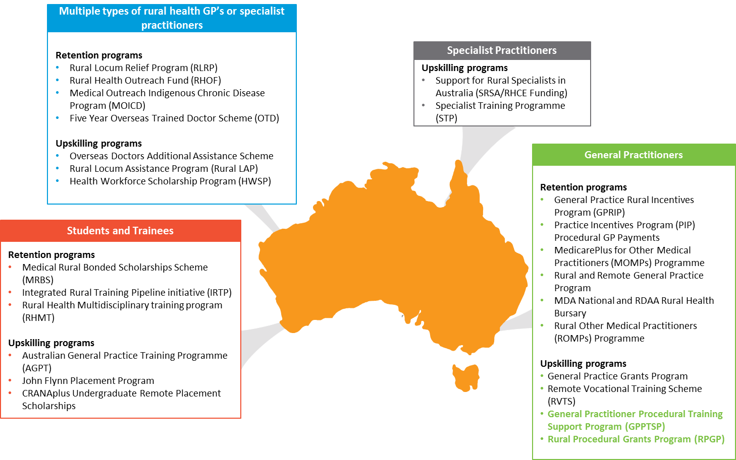

In addition to the RPGP and GPPTSP, five other Commonwealth funded rural health workforce programs were identified as providing support and coordination for training in the procedural areas of obstetrics, anaesthetics, emergency medicine and surgery. These programs include:

* Australian General Practice Training (AGPT) Program
* Remote Vocational Training Scheme (RVTS)
* Practice Incentives Program (PIP) Procedural GP Payments
* Specialist Training Program (STP)
* Health Workforce Scholarship Scheme.

The impending development of the National Rural Generalist Pathway/s is also noted as an important and relevant program, once developed and launched across the states and territories (see below for further discussion on the Generalist Pathways).42 Over the next few years, introduction of new formalised training programs conducted by the colleges could also impact the standard and quality of training courses in the procedural areas of obstetrics, anaesthetics, emergency medicine and surgery.

Section B.3.1 provides more detail on the analysis of Commonwealth funded rural health workforce program in relation to the RPGP and GPPTSP.

### Jurisdictional programs

Some jurisdictions provided training programs in the procedural skill areas covered by the RPGP and the GPPTSP. Of the 39 identified jurisdictional programs, 16 programs were aimed at GP retention and 23 were aimed at upskilling GPs in each jurisdiction. Figure 7 illustrates the rural jurisdictional programs supporting GPs for each state and territory.

Figure 7: Map of rural jurisdictional programs supporting GPs

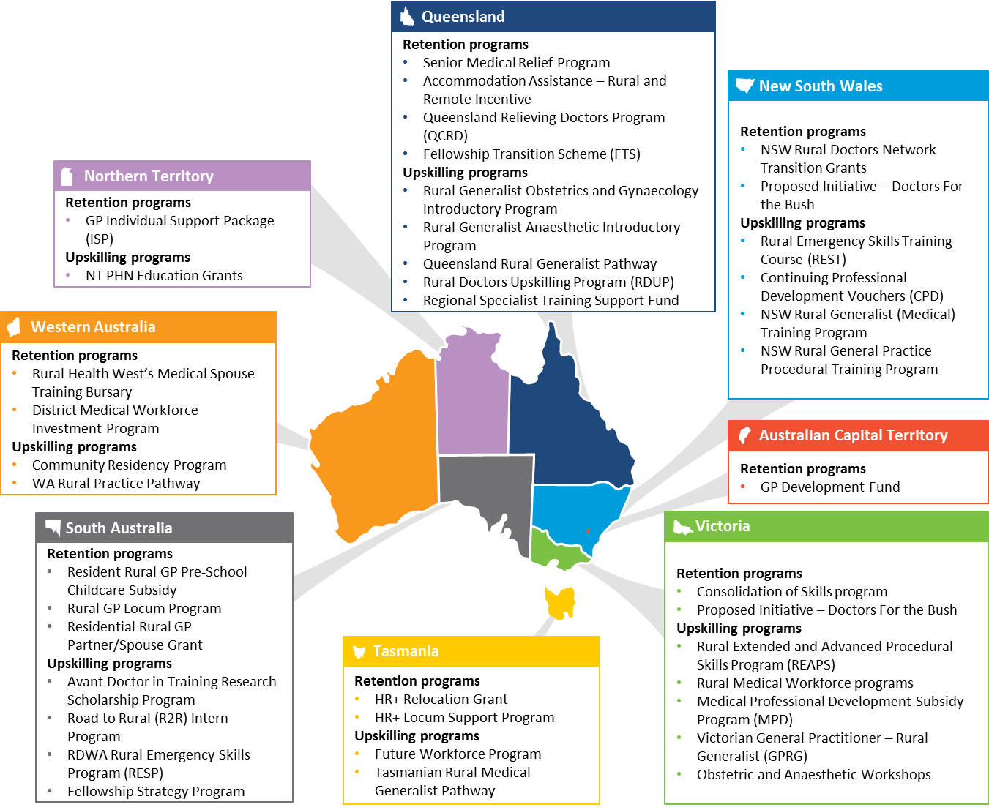

Of the 23 upskilling programs provided across the jurisdictions, 13 were identified as supporting specific skills training in the procedural areas of obstetrics, anaesthetics, emergency medicine and surgery. Further review of these programs revealed that seven programs (in addition to the RPGP and GPPTSP) across four states were targeted for registered GPs or proceduralists. Table 4 overleaf illustrates which jurisdictional programs provide support for training in the four procedural skill areas. Other programs, including the jurisdictional Rural Generalist Pathway programs (in Queensland, New South Wales, Victoria, Tasmania and Western Australia), were targeted at medical students, trainees and registrars. Although not considered as part of the Review’s mapping exercise, the Review recognises that the Rural Generalist Pathway programs are important training initiatives for junior doctor, particularly in developing advanced skills. The Review took into consideration the anecdotal evidence from stakeholder consultations, which suggested that registrars accessed both the Rural Generalist Pathway and the GPPTSP.

Table 4: Comparison of relevant jurisdictional programs that provide rural GPs with training in the four procedural skill areas

|  |  |  |  |  |
| --- | --- | --- | --- | --- |
|  | **Obstetrics** | **Anaesthetics** | **Emergency Medicine** | **Surgery** |
| **RPGP** (Commonwealth) | ✓ | ✓ | ✓ | ✓ |
| **GPPTSP** (Commonwealth) | ✓ | ✓ |  |  |
| **Rural Emergency Skills Training** (**REST) Course (cross-jurisdictional)** |  |  | ✓ |  |
| **NSW Rural General Practice Procedural Training Program** (New South Wales) | ✓ | ✓ | ✓ | ✓ |
| **Consolidation of Skills Program** (Victoria) | ✓ | ✓ | ✓ | ✓ |
| **Medical Professional Development Subsidy Program** (Victoria) |  |  | ✓ | ✓ |
| **Rural Extended and Advanced Procedural Skills (REAPS) program** (Victoria) | ✓ | ✓ | ✓ | ✓ |
| **Rural Doctors Upskilling Program** (Queensland) – *in development* | ✓ | ✓ | ✓ | ✓ |
| **District Medical Workforce Investment Program (Western Australia)** |  |  | ✓ |  |

The program mapping identified similar rural health workforce programs across all states and territories. As evident in Table 4, Queensland, New South Wales, Victoria and Western Australia have introduced rural health workforce programs that specifically cover and provide support for the same procedural skills areas of focus as the RPGP and GPPTSP. This is not surprising, since the state-run rural hospitals rely on this workforce to staff rosters or provide other workforce requirements.

Section B.3.1 provides more detail on the analysis of jurisdictional funded rural health workforce programs in relation to the RPGP and GPPTSP.

# Rural GPs value the subsidies but the policy outcomes are less clear

This section highlights the successful implementation of, and stakeholder support for, the RPGP and GPPTSP programs to date. While previous reviews indicate effectiveness of the programs in providing funding support to rural GPs to upskill and maintain procedural skills, impact on the higher order policy objectives is not easily obtained. The stated policy objectives are:

* RPGP: to support rural health care service delivery and workforce retention.
* GPPTSP: to improve access to maternity services for women living in rural and remote communities by supporting GPs to attain procedural skills.55

Demonstrating impact on the policy intent of the programs is of concern and the data and evidence gathered during this Review indicate a range of opportunities for reform of both the RPGP and GPPTSP (outlined in Section 4). The case for reform is supported by shifts in the policy context and health care landscape since the inception of the programs, as discussed in Section 3.

## RPGP and GPPTSP have subsidised rural GPs to access procedural skills training since their inception

Both the RPGP and GPPTSP represent Commonwealth policy responses to well documented gaps and needs in the rural health workforce to deliver quality health services to rural communities. For more than a decade the RPGP has supported rural GPs to complete training to maintain procedural skills. The GPPTSP has funded GPs to obtain advanced obstetric skills for the past several years. The ongoing existence of the programs acknowledges the importance of upskilling rural GPs, and maintaining rural GP procedural skills, especially in rural and remote areas.

RPGP was developed in 2004 in response to evidence of decline in rural medical workforce capability and numbers. Significant numbers of practitioners were leaving rural practice and the pipeline of newly trained health professionals had dried up. The RPGP was initially tied to the procedural disciplines of anaesthetics, obstetrics and GP surgery and later extended to emergency medicine capability for rural general practice. The latter now dominates the grants system, with emergency medicine alone contributing to 46% of RPGP grants administered between FY2004-05 to FY2016-17.53 The policy objective of the RPGP is to ‘support rural health care service delivery and workforce retention’.55

Since 2004, the RPGP has supported more than 4,000 GPs51 with $174 million53 invested to support procedural and emergency medicine skills training. As evident in Figure 8, the number of grant recipients per financial year has increased steadily in recent years.

Figure 8: Number of RPGP grant recipients per financial year from FY2004-05 to 2015-16 by college

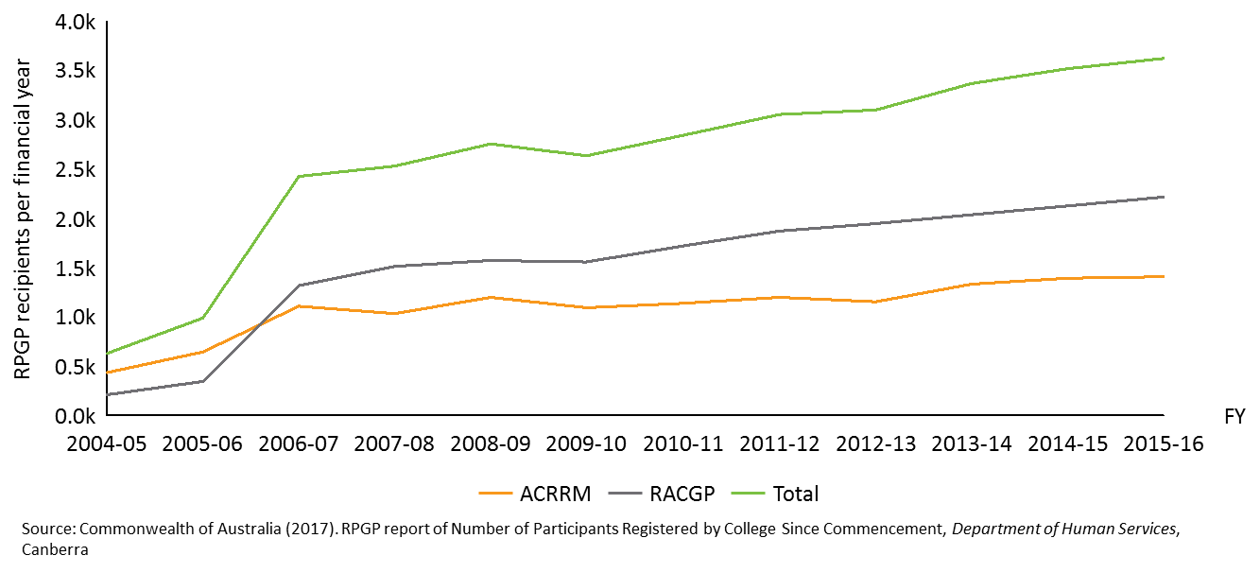

The GPPTSP commenced in 2010 as a discrete rural medical workforce intervention to support rural obstetrics care from procedural GPs (in both obstetrics and obstetrically-oriented anaesthetics). The policy objective of GPPTSP is stated to ‘improve access to maternity services for women living in rural and remote communities by supporting GPs to attain procedural skills’.55

The GPPTSP has supported 237 GPs from 2010 to 2015 and provided $9.1million of funding to support maternal health through advanced procedural skills training in anaesthetics and obstetrics over the period.15, 108 Despite being a capped program, grant recipient numbers have fluctuated across the years since program inception as evident in Figure 9, from a high of 50 in 2014 to a low of 31 in 2011.15, 108 As a competitive grant program, the GPPTSP was designed to provide financial support to selected GPs (as opposed to the RPGP which was designed as an entitlement program), as shown in Table 5.

Figure 9: Number of GPPTSP grant recipients per financial year from 2010 to 2015 by college

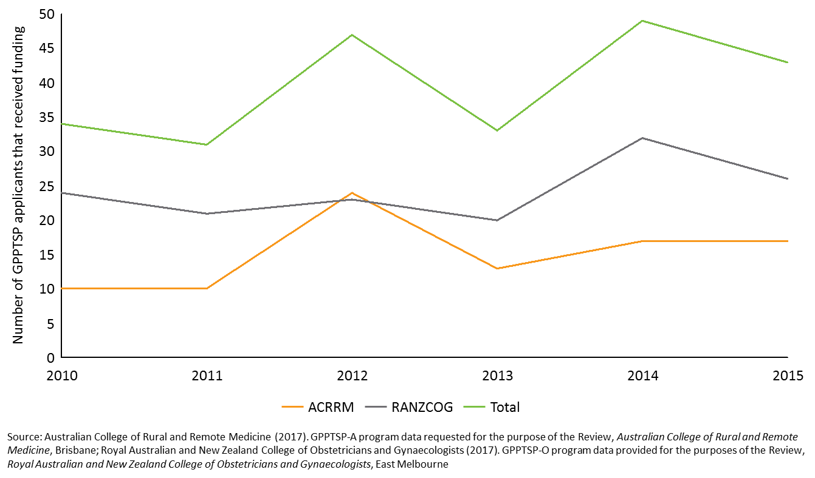

Table 5: Summary of Commonwealth support through RPGP and GPPTSP

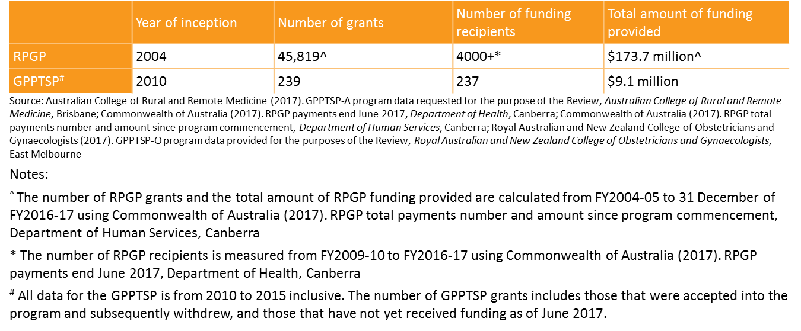

## Recent reviews suggest that skills maintenance and upskilling are being achieved through the RPGP and GPPTSP

In 2008, a review of the effectiveness of the Training for Rural and Remote Procedural GPs Program (former RPGP) in achieving its program objectives of workforce skills maintenance and upskilling was conducted. The review highlighted that there was an overall high level of awareness of the program, reflected through 70% of eligible GPs having registered for the RPGP, and the high level of uptake was consistent throughout each of the procedural disciplines. One-in-eight (12.5%) surveyed GPs also highlighted that their skills had been maintained as a result of attending training courses through the subsidised program.4

Since the Review above, the RPGP program feedback remains highly positive with key reasons for undertaking the program being financial compensation for professional development, updating skills, the low administration costs as a portion of grant expenditure, relieving costs of training and being subsidised to maintain professional competency through skills maintenance.22 This Review further explored recipient feedback through an online survey as discussed in Appendix D.

A recent 2016 survey by the ACRRM and RACGP Procedural Medicine Collaboration assessed whether the financial incentives provided through the RPGP achieved its intended program outcomes.1 This study found that:

* 80% of RACGP respondents reported the program influenced them to stay longer in a rural practice.
* 69% of ACRRM respondents reported the program influenced their intent to continue working in a rural practice.
* Only 8% of RPGP recipients undertook training in three or more procedural skills, considering the level of commitment required for the programs.1

The RPGP was also found to be more effective across the states and territories with organised procedural VRGP training programs such as Queensland.1 At the same time, the current Review found that the states and territories with more established rural health workforce programs, such as Queensland, Victoria and New South Wales (see Section 1.3.2) accessed a larger number of grants, as reflected in Figure 10 below.

Figure 10: State Distribution of RPGP grants between FY2009-10 to FY2016-17

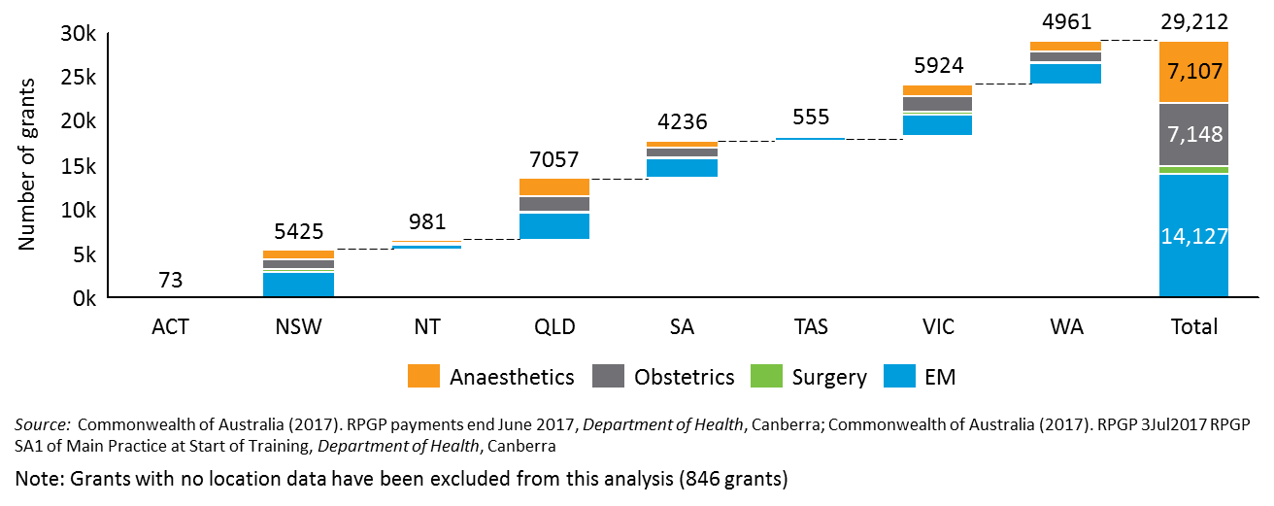

The GPPTSP has also received positive feedback, and was seen as a key mechanism to improving qualifications in maternity care with many respondents commenting that they would not have been able to undertake the training without the financial support.63 A review of the Maternity Services Budget Package (2009-10) highlighted that the GPPTSP was successful in improving access to maternity services closer to home, with many GPs continuing to practice their learnt skills, and most stating their intent to continue providing services to rural communities for over 10 years.63 Forty two grants were provided in 2013-14 with 26 in obstetrics and 15 in anaesthetics, however most of the benefit has filtered towards inner and outer regional locations.15, 108

## Data available from the current review confirms stakeholder support

The stakeholder consultation interviews and surveys in the current Review confirmed the widespread support for the programs (more detail is provided in Appendix D). The majority of interview consultations with stakeholders confirmed the perceived value of the RPGP for recipients in supporting the cost of procedural skill training and maintenance. The survey of peak bodies indicated that:

* 77% of respondents who had an understanding of the RPGP reported that the specific financial support provided through the grant encouraged rural GPs to maintain their procedural skills and remain practicing in a rural or remote area to a great extent.



*Many rural and remote communities rely entirely on procedurally skilled rural GPs. There is no specialist cover for those communities. GPs undertake routine office based general practice much of the time, but use their procedural skills for uncommon but critical interventions at times.*

* Survey respondent
* 67% of respondents who had an understanding of the GPPTSP reported that the specific financial support provided through the grant encouraged rural GPs to develop their procedural skills and remain practicing in a rural or remote area to a great extent.
* 75% of respondents who had an understanding of both the RPGP and GPPTSP reported that the RPGP encouraged rural GPs to develop/maintain their procedural skills and remain practicing in a rural or remote area to a great extent, however only 39% of respondents felt that GPPTSP did this to a great extent.

The survey of program recipients[5] indicated that:

* 82% reported procedural skills target critical community health needs in rural and remote areas.
* 50% reported the GPPTSP was very important in enabling procedural upskilling.
* 60% reported the RPGP influenced their decision to remain practising in rural areas to a great extent, with 28% reporting the program had some extent of influence.
* 35% reported the GPPTSP influenced their decision to remain practising in rural areas to a great extent, with 28% reporting the program had some extent of influence.

## The administrative simplicity of both programs is a key strength

The application processes for the RPGP and GPPTSP are captured in the program logics from Figure 4 and Figure 5. The administrative responsibilities of each stakeholder are outlined in Figure 11 below.

Figure 11: Administrative responsibilities of key stakeholders for the RPGP/GPPTSP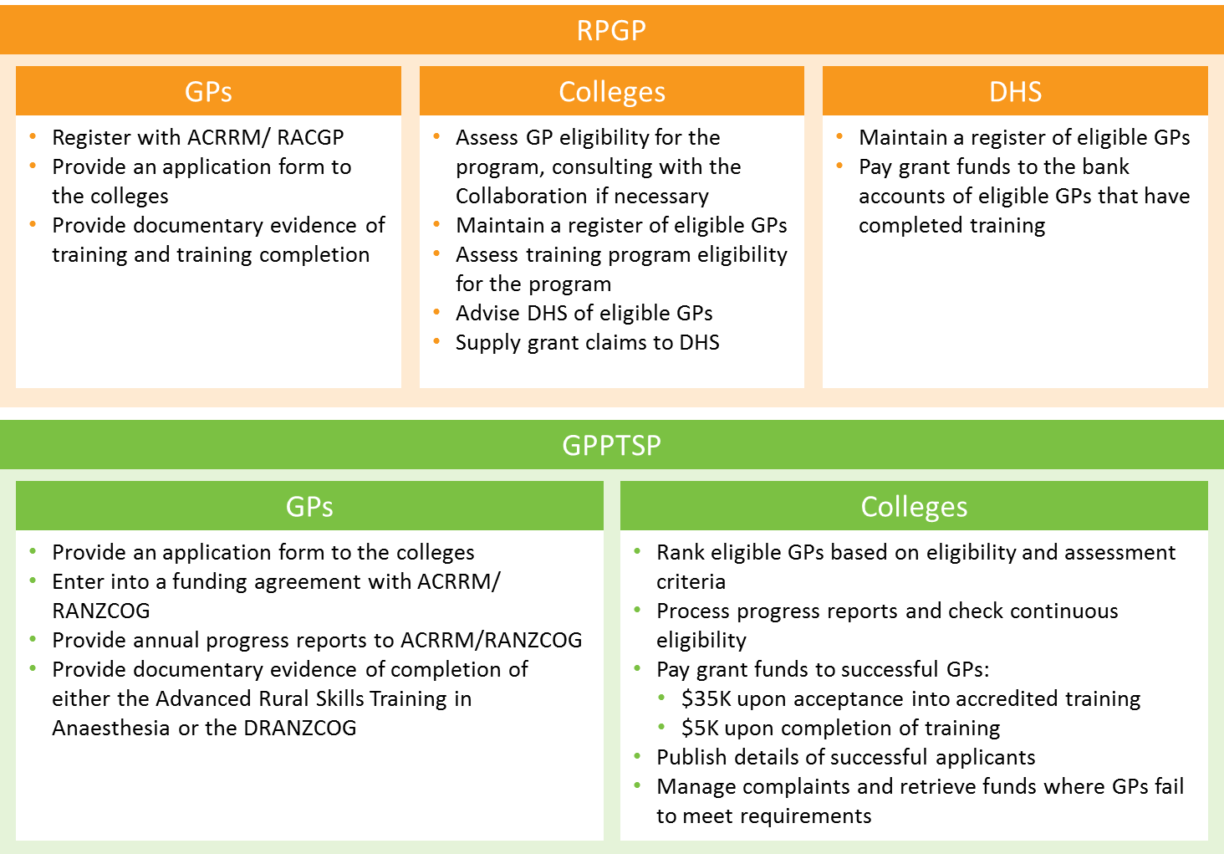

Source: Commonwealth of Australia (2017). Draft program logic GPPTSP (for panel members), *Department of Health*, Canberra; Commonwealth of Australia (2017). Draft program logic RPGP (for panel members), *Department of Health*, Canberra; The Royal Australian College of General Practitioners (2011). Rural Procedural Grants Program – Program Guidelines, *Department of Health and Ageing*, East Melbourne; Australian College of Rural and Remote Medicine (2016). General Practitioner Procedural Training Support Program: Anaesthetics – Application guidelines, *Australian College of Rural and Remote Medicine*, Brisbane; Royal Australian and New Zealand College of Obstetricians and Gynaecologists (2016). General Practitioner Procedural Training Support Program: Obstetrics – Application guidelines, *Royal Australian and New Zealand College of Obstetrics and Gynaecologists*, East Melbourne

The Review has identified that the administration processes for both the RPGP and the GPPTSP are simple, and this is a key strength for the programs. Qualitative evidence from stakeholder consultations has highlighted that 86% percent of RPGP grant recipients, and 70% of GPPTSP recipients responding to the survey felt that the administration of the two programs was efficient, or highly efficient.

*There is strength in the simplicity of the program’s administrative process. Increasing the complexity of the program’s eligibility will increase the administrative burden.*

* Stakeholder interview



The current administrative costs for the RPGP are relatively low with the colleges employing a combined 4.6 full-time equivalent (FTE) staff for grant administration and DHS employing less than one FTE for grant processing through their highly automated system. ACRRM employs 2.1 FTE,14 whilst RACGP employ 2.5 FTE.127 Based on the available RPGP college data, the administrative cost per grant has decreased to approximately $100 in FY2015-16, representing a reduction in the cost per additional grant of $12.25.17, 52, 128 Time taken to process a grant has decreased from 2.28 hours per grant to 1.66 hours between FY 2009-10 and FY2015-16.14, 127 However, the Review recognises that these estimates do not take into account the significant effort (and cost) that went into DHS automated system design and establishment.

Specific to the RPGP, an ACRRM/RACGP Procedural Medicine Collaboration report revealed that, while administration costs have been increasing in absolute terms, the joint administration costs of the RPGP as a percentage of total grant expenditure has been falling from a high of 6.8% in FY2004-05 to 2.9% in FY2014-15.1 This is due to the increasing volume of grants resulting in economies of scale. The Review also recognises that this low percentage has been made possible through the availability of the DHS’s highly automated payment processing infrastructure which alleviates the administrative burden of undertaking this process from the colleges. No information was available to the review on the investment in the DHS automated system, however, it is likely to have added substantially to the overall costs of administration.

A review by the Allen Consulting Group found that the ease, timeliness and generally strong governance processes in place for the RPGP were strongly endorsed by the GPs. However, issues are still present such as the lack of transparency in training course details as there is currently no central information source.4

Since GPPTSP inception in 2010, ACRRM and RANZCOG have spent a combined average of $112,400 per year on grant administration, representing an average of 6.64% allocated grant funding. Overall GPPTSP administrative spend has fluctuated, though these fluctuations are largely driven by RANZCOG’s marketing, recruitment and IT spend in 2010 and 2015. ACRRM and RANZCOG jointly employ approximately 1.17 FTE for the GPPTSP, with a grant processing time of 31.4 hours per grant as of 2015 compared to 41.3 hours in 2010[6]. However this should be viewed in context of the general decline in the proportion of budgeted funds for the GPPTSP distributed for GP training from 58.6% in 2010 to 44.4% as of 2015, including carry forward income from prior financial years and committed funds not yet paid.15, 108

# The context for change and reform of the RPGP and GPPTSP is multifaceted

This section sets out the main contextual factors for the two workforce programs under review. Since the RPGP and GPPTSP inception in 2004 and 2010 respectively, there have been changes to the policy context and heath care landscape. Some of these changes were quite specific, while others were more general and/or of a larger scale.

## Supporting rural health workforce is a key feature of Commonwealth policy

Supporting rural health service delivery has been a feature of the Commonwealth investment in workforce for many years. The DoH expenditure on health workforce programs has grown from $286 million p.a. in 2004-05, to $1.8 billion in 2016-17.77 This investment has largely been in education, particularly in universities and postgraduate vocational training. Smaller discrete programs have been aimed at rural health workforce, including retention of health workforce resources in rural areas.

In the past, expenditure on the health workforce programs has generally grown in an accretive manner, as newly developed programs have been continuously added to the existing body of Commonwealth commitments, to respond to particular national health workforce imperatives. This is evident from the Commonwealth program mapping outlined in Section 1.3. More recently, the Commonwealth have worked towards addressing this challenge through decreasing the number of existing grant programs by abolishing, merging and consolidating existing programs.

Analysis of recent MABEL data further highlights the imperative for rural health workforce support through the emergence of the following trends:

* The number of hours worked increase with rurality. On average, procedural GPs in MMM7 worked 46.3 hours per week in 2015 in comparison to those in MMM1 who only worked 39.9 hours. This difference may reflect the expected greater population dispersion in MMM7.
* The number of days on call increase significantly with rurality, with procedural GPs in MMM7 on-call for practice approximately one-in-4.7 days per year in 2015, and on-call for hospital work approximately one-in-2.4 days per year.
* The number of patients who received care was almost 2.5 times as great by procedural GPs in MMM7 compared to those in MMM1, with 40.7 patients per week seen on average compared to 16.5 patients.21

The two programs under review are relatively small in size and commitment in the broader scheme of the Commonwealth’s overall investment in the health workforce. The amounts for RPGP and GPPTSP grant expenditure were $19.2 million53 and $1.7 million10, 11, 103, 104, 105 respectively in 2015-16**.** The current Commonwealth Health Portfolio budget places workforce programs in Outcome 2 with a budgeted expenditure of $1.3 billion, most of which is invested in the training pipeline.48 Delivery arms in Program 2.3 include:

* Increasing the capacity and effectiveness of training and education for the future health workforce (mainly through support for the medical training pipeline e.g. AGPT and STP).
* Redesigning the supply of and support for health professionals in rural, regional and remote Australia (specific programs aimed at the rural health professional training).
* Improving access to health services for rural Australia (various initiatives).

An important focus for the DoH will be ensuring ongoing rural health workforce programs, including the RPGP and GPPTSP or their reformed versions, are effectively meeting their objectives and contributing to the Portfolio Outcomes.

## Rural workforce initiatives have continued to expand

There have been significant changes in the health care environment for rural health services in the last decade covering the lifespan of the RPGP and GPPTSP. These influence both recruitment and retention for rural practice.

Over the last few decades, there has been an expansion of rural workforce incentives to better target and achieve national health workforce imperatives (see program mapping in Section 1.3). This Review identified 108 programs designed to support the health care workforce in rural communities, provided by either the Commonwealth or other jurisdictions through the program mapping exercise. The Review also found that there were no formalised mechanisms in place to ensure that health care professionals were not applying for multiple grants to cover the costs of the same training course and ensure that government funding were used for its intended purpose (see Section 4.1.1 for further discussion).

In addition to the expansion of rural workforce programs across Australia, there have also been more specific changes to universities and postgraduate vocational training. Some of these changes are detailed below:

* Rural Clinical Schools have developed, based on the understanding that doctors trained in rural settings and who come from rural areas are more likely to return to practice in rural settings.
* Recent announcements from the DoH supporting Regional Training Hubs complements the support of those in rural practice with skills training that is in complementary regional health care settings.
* Australia is very reliant on International Medical Graduates (IMGs) and in many ways they are critical providers of rural health services, covering a substantial deficit in the rural healthcare workforce. Rural generalists are particularly reliant on IMGs to provide locum relief support to attend continuous professional development training courses and/or take recreational leave.
* Recent policy announcement from the DoH (via Dr Gillespie, Assistant Minister for Health) supporting the development of the National Rural Generalist workforce is relevant in that it supports a formal pipeline of appropriately skilled proceduralist GPs. This hospital-based model of the rural generalist pathway is well developed in Queensland. It is unclear at this point how that support will translate into the different Australian states which each have their own differing medical workforce arrangements.
* The Medical Colleges are refining their training programs to better suit rural practice:
  + - RACGP has about 35,000 members (representing 80% of practising GPs in Australia), of which 7400 are members of the Rural Faculty and are in regional, rural or remote areas. RACGP supports the Fellowship in Advanced Rural General Practice (FARGP) qualification as an enhanced qualification for rural practice.
    - ACRRM has continued to develop, noting its strong presence in Queensland and the concurrent development of the Rural Generalist approach, with a strong focus on procedural practice. Stakeholder consultations have identified that roughly 10% of Australian rural GPs are ACRRM Fellows.
    - The medical colleges cover 90% of rural practicing GPs so roughly 10% of rural GPs in Australia are unaccounted for by colleges as ACRRM or RACGP Fellows.
    - Data indicates that there were fewer than 70 proceduralists in operative surgery across the ASGC-RA2-5 in 2015.71 This number is likely to decline with retirements as there is no clear pipeline for training new GP surgeons.
    - Australasian College for Emergency Medicine (ACEM) is developing formal training standards for GPs delivering emergency care in rural settings. A continuum is noted between the emergency management skills required for all GPs compared with the skills required for formal Emergency Department doctors. ACEM’s focus is on the latter.
    - Australian and New Zealand College of Anaesthetists (ANZCA) is developing a formal GP anaesthetics training program. This will influence both training and standards for rural anaesthesia delivered by GPs well within the next decade.
    - Several specialist colleges are graduating specialist Fellows in numbers that are predominantly practising in major cities and increasingly in secondary centres.66 In fact, between 2008 and 2012, the increase in the number of specialists was 67% compared to the growth in general practitioners of 33%.69 This could lead to a reduction in the demand for procedural GPs and hence the need for generalist procedural training over time.

## Patterns of rural hospital practice and general practice are changing

The States and Territories, which operate the public hospital system in Australia, are generally consolidating services in regional hubs. This has had the effect of limiting services in small hospitals near these regional referral hospitals, especially in reducing or removing procedural general practice in obstetrics and surgery, and the MBS claims data reflects this as only 20% of GP procedural obstetrics services were provided in MMM4-7. 49 That is, there has been a change in how people access services. One rule of thumb considering acceptable travel time suggests it is reasonable to consolidate hospital services within one hour’s travel time from a large centre, and it becomes progressively more challenging with longer travel times. Using this approach would need different application in the various states and territories. For example:

* The travel distances in Queensland and Western Australia are qualitatively different to Victoria and Tasmania. There are a number of towns in these states that are several hours from major facilities or regional centres.
* South Australia has a widely dispersed and relatively low density rural population. Over time the number of hospitals offering procedural GP services has significantly reduced with flow-on impacts on requirements for procedural GPs.
* NSW has developed a network of regional referral hospitals with flow-on affects in nearby smaller hospitals that traditionally offered procedural GP services.
* Tasmania has consolidated its hospitals offering surgery and obstetrics care, as has Victoria.

Overall these changes suggest there may be a reduced need for procedural GPs to provide services. In support of this, MABEL data has highlighted that the number of patients seen per week by GP proceduralists in private practices has been falling from 2011-15, from 111 to 94, as have the hours worked, from 46 hours to 43 hours per week.21 An alternate view could consider the importance of work-life balance for health professionals and an assessment of the number of practitioners in each discipline required for a viable and appropriate on-call roster, at a local hospital facility level, irrespective of service volume. As an example, past common practice of individuals being accredited in multiple disciplines is declining (for very good reasons), but it does create other difficulties for maintenance of provision of a broad discipline of services.

The case of emergency medicine skills is somewhat different, in that the capability to deliver safe and effective first line care (in a team environment with nursing and ambulance officer-trained personnel) is ubiquitous for rural hospital services.

The continuing development of complementary service delivery mechanisms is also influencing service needs, especially in more remote settings. Two examples include the telehealth systems and air retrieval. Related to this change in the role of many rural hospitals, is the nature of rural general practice, given that an increasing proportion of rural-based practitioners are not aligned with a hospital. This can be very disruptive for service provision at a local level.

Introduction of the Rural Generalist Pathway in some jurisdictions has influenced the quality, recruitment and retention for rural general practice. One component of the pathways includes placements in rural hospitals. Through the Review, it became evident that the well-established Queensland Rural Generalist Pathway provided good evidence of success in producing an increasing number of rural practitioners, however the breakdown between services provided from hospitals and primary care facilities by those that completed the Pathway program was not available.

## Health needs of rural communities are paramount

There is a strong and sensible argument that an assessment of community health needs in rural Australia should drive the Commonwealth investment in education and training for practitioners in all health disciplines. Examples of emerging rural community needs through the literature review, that were confirmed by stakeholder consultations include, but are not limited to:

* An epidemic of rural mental health illness (including suicide) and drug and alcohol related health problems. 6, 76, 126, 115, 138
* A deficit in palliative care and aged care service arrangements, with particular challenges relating to rural health service delivery. 6, 76, 126, 115, 138

Prioritising community health needs as the driver for targeted investment would position procedural skills training and upskilling in competition with clinical skills which are at the cognitive, psychosocial end of the medical practice spectrum. Emergency medicine skills would arguably stand alone as the procedural skills under this rationale.

According to a survey conducted by the RACGP, emergency medicine, mental health and chronic disease management were the most commonly acquired and practised advanced skills in rural areas, as evident in Table 6.126 However, after the top three skills, discrepancies begin to emerge. The online survey conducted as part of this Review has also yielded similar results, as seen in Section 4.1.3. Overall, the evidence suggests that there is an opportunity to better meet community needs as the skills demanded by rural communities extend beyond the scope of procedural areas.

Table 6: Most commonly acquired and practised skills by rural GPs

|  |  |  |  |  |
| --- | --- | --- | --- | --- |
| **Rank** | **Most commonly acquired skills** | **%** | **Most commonly practised skills** | **%** |
| **1** | Emergency medicine |  | Mental health |  |
| **2** | Mental health |  | Emergency medicine |  |
| **3** | Chronic disease management |  | Chronic disease management |  |
| **4** | Obstetrics |  | Paediatrics |  |
| **5** | Paediatrics |  | Aged care |  |
| **6** | Small town rural general practice |  | Small town rural general practice |  |
| **7** | Aboriginal & Torres Strait Islander health |  | Aboriginal & Torres Strait Islander health |  |
| **8** | Palliative care |  | Palliative care |  |
| **9** | Aged care |  | Internal medicine |  |
| **10** | Internal medicine |  | Obstetrics |  |

Source: Appropriated from Table 3 in The Royal Australian College of General Practitioners (2014). New approaches to integrated rural training for medical practitioners, *The Royal Australian College of General Practitioners*, East Melbourne

Stakeholder consultations in this Review highlighted the need to have more support and training for GPs in rural areas to address mental health issues, which can be challenging to manage well, and can involve mental health first aid and linking with other social services. GPs in rural and remote areas are often the principal point of contact to provide continuing care in communities. Good mental health care is difficult to provide and essential in rural communities, however Review consultations suggested that mental health skills and training are not always valued as highly, nor sought after as regularly by GPs compared with procedural skills training.

The Health Workforce Australia (HWA), in its assessment of possible responses to impending and current health workforce shortages, emphasised ‘reform and innovation to increase the productivity of the future workforce’, particularly aimed at the makeup and skills of the clinical team and its management of chronic conditions.77 This represented a predominant community health needs approach to workforce planning.

Further evidence from the stakeholder consultations found that respondents generally did not oppose support for training beyond procedural skills, however unsurprisingly, they did not want to dilute the current investment in procedural skills. Taking this approach, many stakeholders argued that any extension of the scope of grant programs would need to be accompanied by an increase in funding from the Commonwealth.

Advice from the DoH confirms a limited funding pool available as the Health Workforce Program is fully allocated, if not over committed. Moreover, the regular budget over-run of the RPGP is an increasing cause for concern. Hence, an extension of the scope of the existing programs with an accompanying need for additional funding was not considered a viable way forward. Ways in which the program budget can be restrained will facilitate greater fiscal control while also increasing the scope of the grants.

## Broader considerations of the policy context

### Principles of efficient Government policy

Successive governments have advocated rationalising grant programs and streamlining their administration. Similarly, recommendations from the Mason Review77and the National Commission of Audit report in 201435 propose to continue the consolidation of grant programs to ensure that the financial incentives provide value for money and reduce potential red tape. The current Review acknowledges the 2009-10 Budget’s health workforce investment26 to streamline training and scholarship programs, and the work the DoH has done to consolidate and rationalise grant programs within the broader Health Workforce Program to ensure that community needs are met, with efficiencies gained directed to go to frontline services. There is opportunity to continue this work with the RPGP and GPPTSP.

A key finding of the National Commission of Audit report (Recommendation 49) was that the Commonwealth should simplify its grants administration. This recommendation stated that:

‘The Commonwealth spent about $22 billion on around 500 grants programmes in 2012-13. The Commission recommends significant changes be made to the administration of the Commonwealth's grant programmes including by:

1. establishing a central register within the Department of Finance of all grants programmes with complete transparency on all grants awarded;
2. reducing red tape for grant recipients by applying contemporary risk-based approaches to grant management;
3. decreasing the number of existing grant programmes by abolishing, merging or consolidating existing grants programmes;
4. addressing the proliferation of new grant programmes by introducing a rigorous grant assessment process at the approval stage; and
5. ensuring all grants have measurable outcomes which are regularly assessed.’ 35

The principle recommendation is to roll programs together (or remove them) wherever possible, in order to simplify administration, leading to lower cost and greater transparency. The review of RPGP and GPPTSP presents an opportunity to apply this approach by consolidating existing Commonwealth workforce programs.

The Australian Government’s policy on outsourcing, competitive tendering and procurement could also be relevant to this Review. There may be benefit to having the professional standards setting and program administration required for the RPGP and GPPTSP performed by alternative bodies to the medical colleges. The medical colleges are the appropriate bodies to set professional standards of practice, and are also appropriate to assess course content for its applicability to practice. In relation to administration of the two grants, a number of alternatives could be considered (see Section 4).

At a national level, there is also recognition of the challenges to implementing policy as Commonwealth and States having responsibilities in the same areas. Hospital care in the Australian health system is the direct responsibility of the states, noting that the Commonwealth provides funding through the national health care agreement to support around 42% of the national efficient price of the cost of hospitals. Part of the confusion may be that General Practice is funded by the Commonwealth through the Medical Benefits Schedule, and procedural GP grants can be seen as an extension of this practice. However, the important principle of subsidiarity suggests this support could be provided by the states as part of the jurisdictional hospital systems. Note that this Review did not find any significant support for this point of view, but recognises that the DoH has a leadership role to work collaboratively with the states to ensure that the provisions of grants are complementary.

### Strategic consideration: Evidence suggests that financial incentives are only one aspect of successful retention programs

In light of the Mason Review77 and successive governments’ ongoing policy reforms, there has been considerable consolidation of grant programs. However, there is evidence to support further refinement, and including the RPGP and GPPTSP in a broader review and holistic redesign of health workforce programs. This Review also recognises the DoH is in the process of developing a Commonwealth Health Workforce Strategy which will require approval of Health Ministers. The Strategy will provide the basis for Commonwealth investment over the coming years, to enable appropriate access to the health workforce to all Australian communities.  The development of the Strategy will include a review of the current programs and measures, utilising workforce data with an evidence-based approach to develop a suite of targeted priorities. The Commonwealth will consult and engage with relevant professional stakeholders, and state and territory jurisdictions.

Independent of the context of the Commonwealth Health Workforce Strategy, this Review found further evidence to support the benefit of a holistic redesign of the RPGP and GPPTSP. A redesign of this nature is aligned with government policy to rationalise, consolidate and streamline existing grants programs where possible,and may be an appropriate response to the expanding number of Commonwealth and jurisdictional workforce programs. It would also be aligned with WHO global policy recommendations on program design, and may provide opportunity to consider non-financial incentives as part of a package to achieve rural workforce retention. A strategic review and redesign could provide opportunity to apply appropriate best practice components of program design, identified through the literature review of existing international and domestic programs.

As noted earlier, the number of rural workforce initiatives targeted at retention and upskilling has continued to expand. In addition to the state based awards, the Review has found 29 programs across the Commonwealth and jurisdictions associated with GP workforce retention and 36 programs focused on professional development opportunities to maintain skills and upskill GPs (see Section 1.3 for full map). Through the stakeholder consultations and program mapping, it was evident that there was some degree of duplication and overlap between different programs.

In accordance with the WHO’s global policy recommendations, the best results are achieved by implementing a combination of initiatives across the following categories: education, regulation, financial incentives, and support for personal and professional development.144 Whilst financial incentives do influence a health care professional’s decision to remain in rural areas (see Figure 12), evidence from the literature review indicated that a suite of programs were more effective in rural workforce attraction and retention.

Figure 12: Rank of order of effectiveness of strategies to retain GPs in rural areas, according to peak body survey respondents

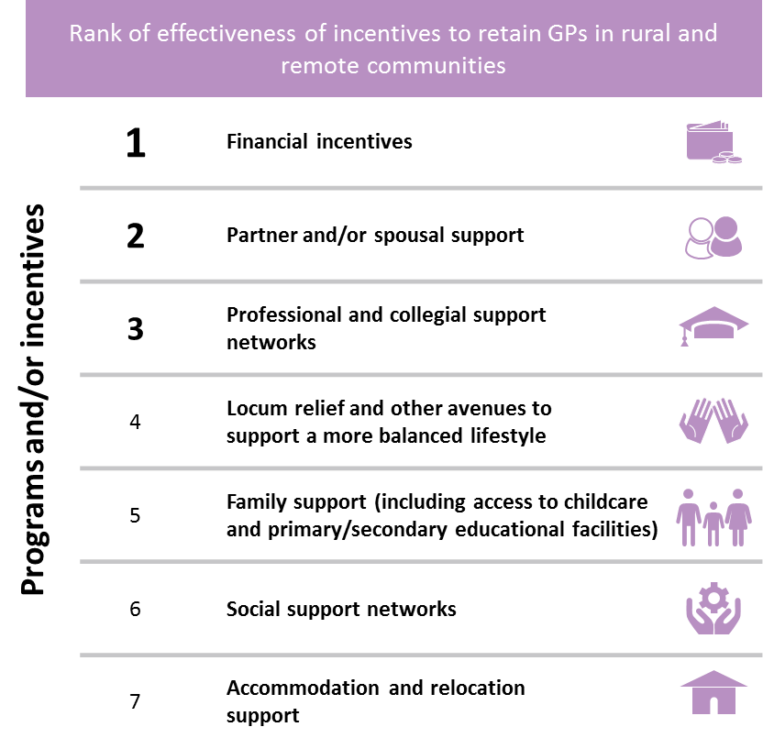

Through the Review, it became evident that financial incentives alone were not sufficient to meet the needs of rural GPs and improve workforce retention over the long term. Although a vast majority of rural health workforce programs are financial incentives, it is the whole rural experience that influences a GP’s decision to move to and remain practicing in rural areas. This would include both the remunerative and non-remunerative benefits that encompass the personal, professional, social, and cultural benefits.64



*Money or equivalent financial support is important particularly in attracting, but in terms of staying it (presuming with a good income) is all about the other things in life.*

* Survey respondent

However, a recent MABEL study highlighted that 65% of GPs would not consider relocating regardless of the amount of financial incentive provided.81 In the recent MABEL report, the rural GPs showcased a preference for locum relief support over retention payments and payments for skills development for their retention, and this was particularly true for retaining GPs in the ‘least attractive’ rural locations, i.e. those with smaller populations, longer work hours, higher on-call commitments and limited social interactions. 81

As evident from the program mapping (see Section 1.3), the DoH has provided a suite of rural workforce programs to attract and retain rural and remote GPs. In light of the Commonwealth Health Workforce Strategy, there could be opportunity to further review and redesign the suite of health workforce programs, integrating both financial and non-financial incentives, to better support rural practice and workforce retention objectives. This could be through designing a holistic package, tailored appropriately.

The Canadian Enrichment Program provides an example of a successful program that better targeted the needs of the regional community and improved rural workforce retention. The program provided individual GPs with the opportunity to self-select a training or upskilling program, with the support of their regional health districts (see below). 66

|  |  |
| --- | --- |
|  | **Case Study: Canadian Enrichment Program (EP)** |
| Similar to Australia, the Alberta Government in Canada introduced the Rural Physicians Action Plan (RPAP) in 1991 to address challenges associated with recruitment and retention of rural physicians.One of the RPAP initiatives introduced was the EPbased on the understanding that specialist skills training and upskilling is an important requirement in rural practice.  **Introduction of the Enrichment Program**  The EP is a self-selected training program that enables professional development, with durations between two weeks to one year, and includes a pool of $80,000 annually prorated. Trainers are compensated and locums are arranged during the program. All eligible physicians must be working in an established rural practice and will require written support from the regional or zone medical director.  **Outcomes of the Enrichment Program**  The self-selected training programs reviewed in the case controlled study included, but was not limited to, obstetrics, emergency medicine and epidural anaesthesia. Evidence found that the rural physicians who participated in the enrichment training were approximately 30% more likely to remain in rural training practice five years later, compared to colleagues who did not participate in the EP. All rural EP participants continued to use their enriched skills at end of five years, despite most training sessions being five weeks long. All physicians desired for the program to continue, with many preferring an increase in funding. | |

The Review identified a range of best practice components to increase the likelihood of meeting policy objectives of rural workforce retention, and meeting rural community health need. Further considerations for holistic redesign of the rural component of health workforce programs could include the following:

* Mechanisms to enable ongoing collaboration with the jurisdictions.
* Assessment frameworks to determine community need.
* Evaluation frameworks to assess programs against policy objectives.
* Risk management and quality assurance mechanisms.

# Overview of options for reform

In light of the changing context outlined in Section 3, successive governments’ ongoing policy reforms to consolidate grant programs,35 and evidence gathered in this Review (summarised in Appendices B, C and D), this Review has found that the design and implementation of the RPGP and GPPTSP could be adjusted to better meet strategic rural health workforce outcomes, and the intended policy objectives.

This section outlines several options for reform of the RPGP and GPPTSP for consideration by the DoH. These are summarised in Figure 13 below.

Figure 13: Options for reform summary

Figure 13: Options for reform summary

## Options for reform: RPGP

This Review has analysed evidence from three research streams to inform how the RPGP could better deliver the policy objectives of skilled workforce retention in rural areas and increased access to quality procedural GP services. The research stream findings are summarised in Appendices B, C and D.

Nous has developed three options for reform of the RPGP through synthesis of the Review findings. The following options are presented for consideration by the DoH:

* **Option A:** Maintain and refine the RPGP as an uncapped program that is better targeted to policy objectives.
* **Option B:** Integrate the RPGP into the General Practice Rural Incentives Program (GPRIP).
* **Option C:** Cap the RPGP with a focus on community need, and centralise the program administration.

None of the reform options for the RPGP remove grants for procedural training. Options A and B maintain the current entitlement features of the RPGP while, Option C maintains funding within a capped budget for a sustainable and fiscally responsible approach to future spending.

These options are supported by evidence in this Review and have been designed with consideration of the original reform options outlined in the RFQ for this evaluation. Options A, B and C for reform of RPGP are detailed in the sections below with supporting evidence and consideration of the challenges and benefits of the proposed options.

### Option A: Maintain and refine the RPGP as an uncapped program that is better targeted to policy objectives

Option A proposes that the RPGP should remain a separate entitlement program, with improvements to better target the policy objectives while keeping the administration of the grants simple. Option A proposes that the colleges (ACRRM and RACGP) continue their current program administrator role for the RPGP, and the DoH implement all or a selection of, the proposed improvements. Option A includes a set of five improvements (see Figure 14) that the DoH could choose to take forward in their entirety, or as discrete program adjustments.

The overarching policy objective of the RPGP is to support quality, rural health care service delivery and promote GP retention in rural and remote areas. Option A is based on a number of assumptions in order to design a better targeted RPGP program. The assumptions reflect evidence from the Review, and principles of good government, health policy and planning, including:

* Policy objectives should be clear to support targeted, outcome-oriented and compliant implementation, and objectives should be communicated to all stakeholders.
* Locations with higher remoteness have greater difficulty delivering health services and retaining health professionals.
* Government funded programs should have appropriate risk management controls to support efficient and responsible administration.
* Procedural skills training programs eligible for RPGP funding should be relevant and high quality.
* Robust evaluation frameworks support ongoing monitoring, improvements and evidence based policy and program design e.g. Workforce retention programs should be designed to measure and achieve retention outcomes.

Figure 14: Five improvements in Option A

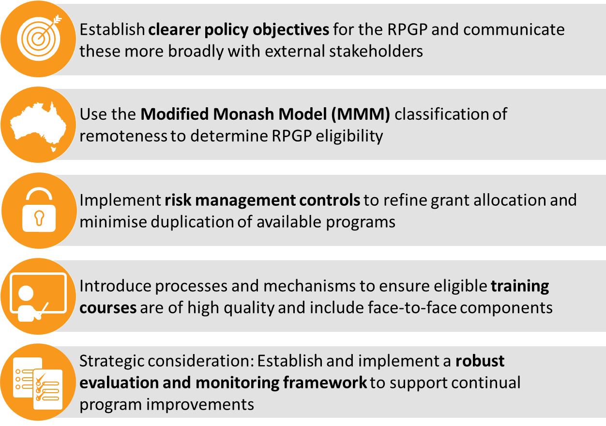

#### Establish clearer policy objectives for the RPGP and communicate these broadly with external stakeholders

Through the Review it became evident that the RPGP policy objectives are too general and unclear. Although the DoH, DHS and administrating colleges have an understanding of policy objectives and purpose (see Figure 15), qualitative evidence from stakeholder consultations suggest that the specific policy objectives were misunderstood, misinterpreted, or not clear beyond the DoH. Since inception in 2004, the DoH’s intended target cohort of VRGPs has gradually been diluted. The policy objectives were not clearly documented or communicated to other external stakeholders. There is a need to refocus the intent of the program to appropriately target the intended cohort and meet the future needs in the health workforce.

Figure 15: Policy objectives of the RPGP

Figure 15: Policy objectives of the RPGP 

Source: Commonwealth of Australia (2017). Senate estimates for procedural training programs: Rural Procedural Grants Program (RPGP); and General Practitioner Procedural Training Support Program (GPPTSP), *Department of Health*, Canberra

As Health Workforce Australia has alluded to in the *Australia’s Future Health Workforce: Doctors*, there is opportunity for further coordination across the medical training pipeline, particularly between governments, universities, medical colleges and the various employers of doctors. Ensuring that the decisions across these various entities are strategically aligned and integrated is essential.36 Greater collaboration and alignment within Commonwealth and between jurisdictions is required to better ensure effectiveness and minimise duplication of purpose between programs.

The financial support provided by the RPGP is not intended as reimbursement for course attendance, but rather, these funds should be treated as a subsidy for attending training courses that many of the procedural GPs may have attended as part of achieving their CPD requirements. Currently, the financial support provided through these grants is used by recipients to cover a number of costs as reported through stakeholder consultations. These include; the cost of course attendance, travel, accommodation, loss of income and costs of running a business (if practice is independently owned) and locum support (direct payment to locums and support to identify and coordinate locum cover). Although the RPGP grants were provided to GPs to cover some of the various costs associated with attending a training course, it was not intended to cover *all* the associated costs.

Establishing clearer policy objectives that better articulate the intention of the program and how the current programs differ from, and integrate with, other Commonwealth and jurisdictional programs would better ensure that the grants achieve its intended purpose. A portion of the administration of the RPGP is outsourced to ACRRM and RACGP to assess GP eligibility and training course appropriateness (with the DHS facilitating and processing payment), creating distance between the implementation and the original policy intent. The outsourcing of the administration coupled with unclear policy objectives may have contributed to the gradual shift of the RPGP away from its original policy objectives. Establishing and documenting clearer policy directions from the DoH would better guide the RPGP program administrators to realign and better target the financial support provided through this grant.

One key policy objective of the RPGP is rural workforce retention of procedural GPs. This could be construed as support for particular individuals to stay in their training practice for many years. While the Review found a correlation between GPs retained and receipt of a RPGP grant in the provision of MBS billed health services (see Figure 16), an explicit causal relationship between the two variables is not confirmed.

Figure 16: Retention of the FY2002-05 cohort of RPGP recipients providing MBS billed health services

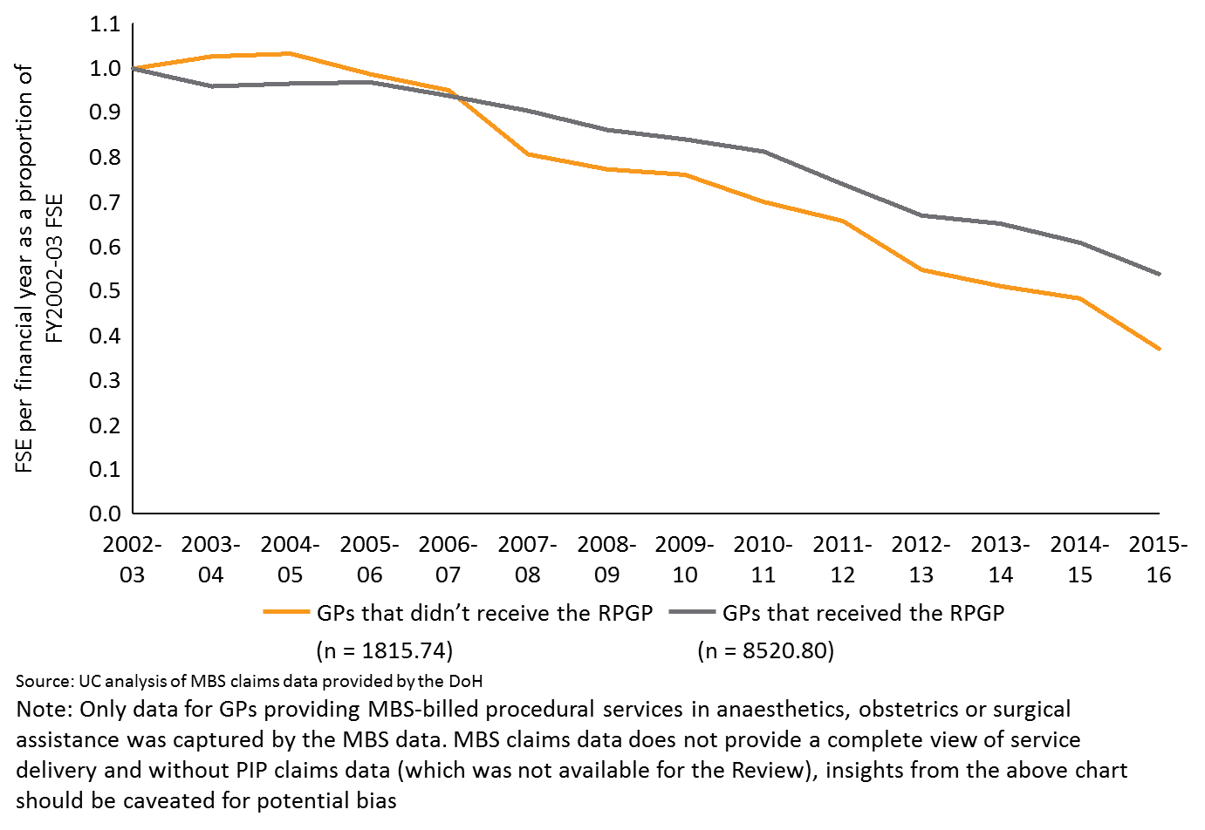

An alternative interpretation of the retention policy objective could be to aim for continuing access of health services to meet community need*,* with less emphasis on individuals staying for long periods in rural settings but greater focus on continuity of service provision back to the community. This alternative is supported by quantitative evidence, in that those who receive the RPGP are more likely to continue to provide procedural services as evidenced in Figure 17. An additional policy objective could be support to improve areas of relative service deficit in community settings through a community needs focused approach. While these differing policy objectives all lead to improvements in rural health services delivery, they could well lead to different expenditure program design. Some of these pathways may also require an increased granularity of policy design by supporting particular towns and hospitals on the basis of service need.

Figure 17: Proportion of total health services provided by RPGP and GPPTSP recipients by MMM

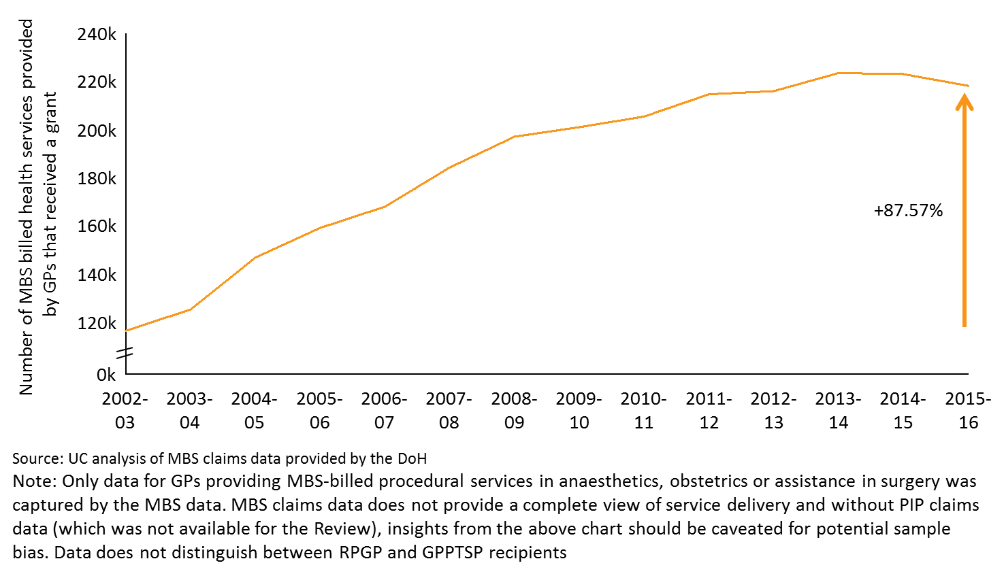

#### Use the Modified Monash Model (MMM) classification of remoteness to determine RPGP eligibility

The DoH is increasingly using the MMM for remoteness classification across programs. Qualitative evidence from a number of stakeholders in this Review raised some particular concerns with the use of the current ASGC-RA classification system. In particular, the system does not allow for a granular understanding of the location of grant recipients. Consequently there is inadequate oversight of financial allocation according to targeted geographical areas and limitations to understanding and planning where grants are awarded, based on community need.



*I’m aware of some GPs who live close to metropolitan cities who receive RPGP funding. They view the RPGP funding as a bonus, rather than an incentive.*

* Stakeholder interview

Grant expenditure has steadily risen since program inception and more than half of the grants have been awarded to recipients in the less remote MMM3-5 areas as outlined in Figure 18 (noting that per capita, more grants have been distributed to GPs living in MMM6-7). Arguably the program objectives would be better realised through providing grant funding to those living in more remote rural areas (i.e. higher MMM classifications).

Additionally, a number of stakeholders expressed the opinion that VRGPs living in ASGC-RA2 are close enough to a regional or city centre that they do not need to be financially incentivised to remain practicing in their location. Evidence from the Mason Review also indicated that by using the ASGC-RA model, proportions of government incentives were allocated to health workers in inner regional Australia (ASGC-RA2), a cohort that would have stayed in the region regardless of government funding,77 inferring that the RPGP would not make a difference to the retention of GPs in ASGC-RA2.

Figure 18: Distribution of RPGP funding by ASGC-RA by discipline, and per capita

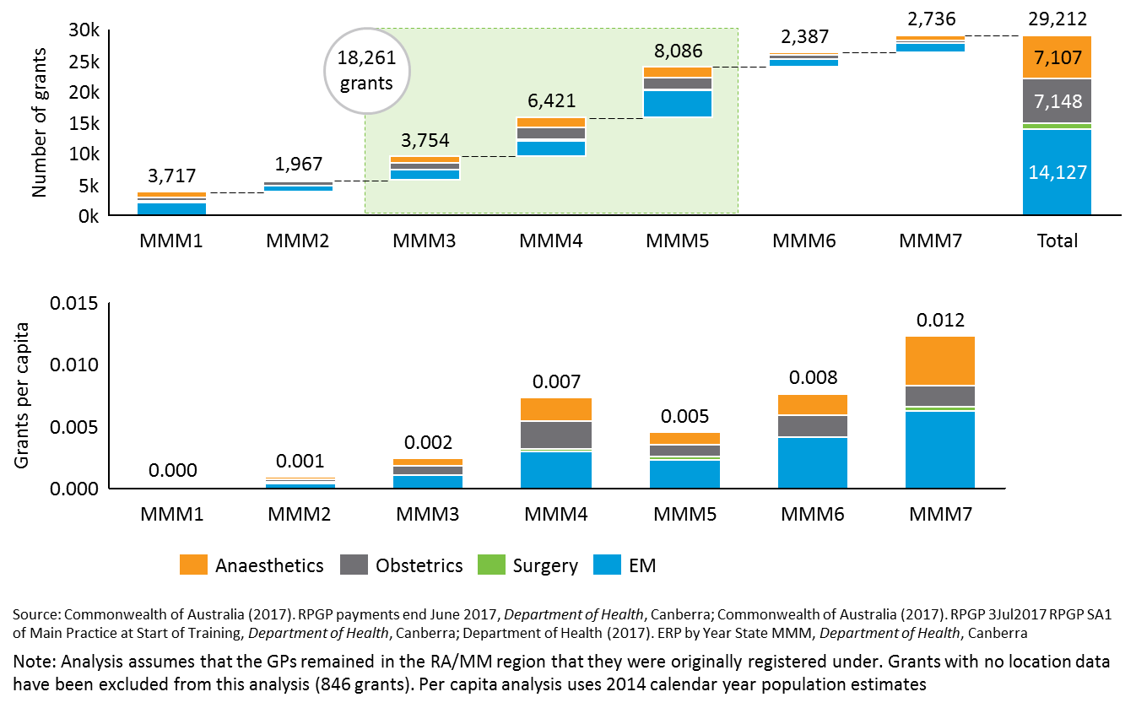

The MMM uses seven remoteness classifications based on road distance to the nearest town of a set population and town size, which allows for a more granular understanding of the location of VRGPs who apply to the RPGP. This in turn will allow the DoH to more effectively apply retention strategies to VRGPs living in specific rural communities. The application of the MMM to the RPGP will provide a number of benefits, as outlined in Figure 19.

Figure 19: Benefits of applying the MMM classification system to the RPGP

Figure 19: Benefits of applying the MMM classification system to the RPGP 

The MMM has recently applied to the GPRIP with beneficial results, as outlined below (as described in stakeholder consultations).

|  |  |
| --- | --- |
|  | **Case study: The General Practice Rural Incentives Program (GPRIP)** |
| TheGPRIP incentivises medical professionals to continue to work in regional and remote areas by providing scaled payments to professionals practicing in the most remote areas, with payments increasing each year until a maximum threshold is capped after five years of service.70  Recent changes to the GPRIP provide an encouraging case study for the application of the new MMM. Based on the ABS remoteness classification of the ASGC-RA, the MMM further takes into account the difference between rural locations in term of population size. The shift from ASGC-RA 2-5 to MMM3-7 in 1 July 2015 refocussed the program’s target cohort, which reduced the number of GPs eligible for the program.  Some stakeholders stated there has been an overall reduction in total grant expenditure and the funding is better targeted to regions that experience difficulty sourcing and retaining general practitioner services. | |

Using the MMM for the RPGP will change recipient eligibility based on geographic location. Nous proposes GPs practicing in the **MMM3-7 regions should be eligible for the RPGP**. These proposed MMM categorises of 3-7 also align to the eligible locations under the newly developed Health Workforce Scholarship Program and the GPRIP, which have presented beneficial results (as mentioned above).

The DoH has developed a map of the RPGP payments made in 2016, translating the ASGC-RA classification to the MMM classification system. The map suggests that RPGP grants were being provided to GPs practicing in major and regional cities (see Figure 21), though this may be reflective of payments made to VRGPs with city-based practices offering rural relief work.

If the RPGP’s classification system transfers to MMM, a number of currently eligible VRGPs residing in ASGC-RA 2-3 regions will no longer be eligible for the RPGP. This is evident through comparing Figure 21 and Figure 22, and a significant number of regions currently classified as ASGC-RA 2 (coded in purple), such as Torquay in Victoria, have been reclassified as MMM2 (also coded in purple) in the MMM map. This suggests that VRGPs in these regions would no longer be eligible for the RPGP under the proposed MMM3-7 classifications.

Analysis of RPGP data provided by the DoH found a total of 25,495 grants were allocated to GPs practicing in RA2-5 between FY2009-10 and FY2016-17.49, 51 When mapped across to the MMM classification system, only 23,384 of these grants would have been distributed under the proposed MMM3-7 classifications.49, 51 This indicates that 2,111 grant applications (not individual GPs) would not be eligible to receive funding under the new MMM classification system, with an equivalent of $23.5 million that could be retargeted to VRGPs in more remote areas.49, 51 This is particularly relevant considering the high proportion of procedural anaesthetics, obstetrics, surgery and emergency medicine provided by VRGPs in MMM4-7 regions as per Figure 20.

Figure 20: Distribution of RPGP grants (2009 to 2017) by RA and MMM

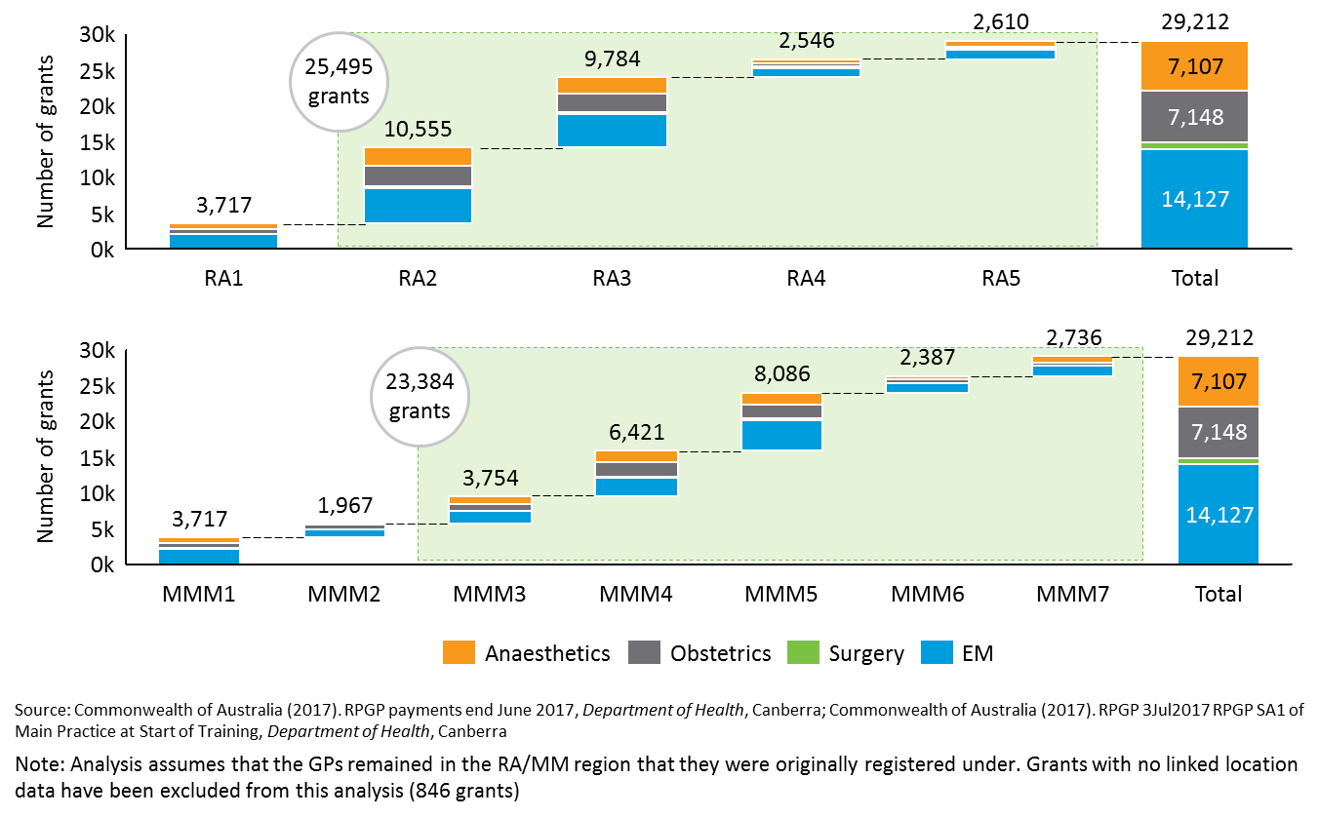

The Review also recognises that some unsupervised VRGPs within the ASGC-RA1 applying for the anaesthetics, obstetrics and/or surgery component would no longer be eligible under the proposed MMM3-7 categories (e.g. Queanbeyan). In circumstances such as this example, the DoH or RPGP program administrators could continue to assess the eligibility of these VRGPs under a case-by-case basis.

Additionally, a number of stakeholders suggested that the financial assistance is more important for VRGPs located in more remote areas, as they have higher travel costs associated with attending training. The review considers that the funds saved through adopting MMM3-7 could be redirected towards **scaled payments** for the financial support provided through the RPGP, whereby VRGPs in the more remote locations (e.g. MMM7) can access a larger amount of grant funding.

Nous recognises that the DoH is currently revising the District of Workforce Shortage (DWS) model of geographic classification, which is a potential alternative to the MMM. The core purpose of the model is to operate as a workforce modelling tool, as opposed to a tool that will allow the DoH to better understand and prioritise community need. Consequently, Nous determines that the MMM is a more suitable classification system for the RPGP.

Figure 21: DoH developed map: RPGP payment across Australia under the ASGC-RA remote classification system

Figure 21: DoH developed map: RPGP payment across Australia under the ASGC-RA remote classification system


Figure 22: DoH developed map: RPGP payment across Australia under the MMM remote classification system

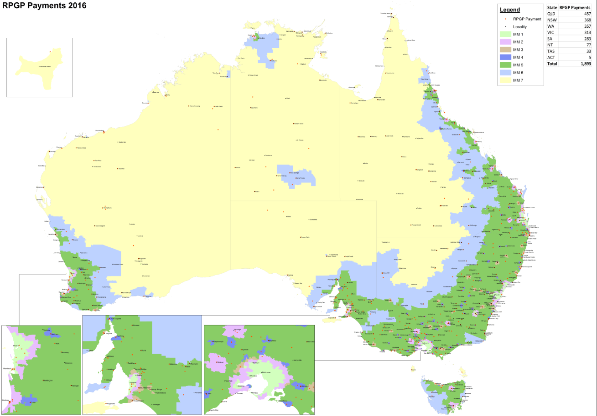

#### Implement risk management controls to refine grant allocation and minimise duplication of available programs

Grants available through the RPGP are currently uncapped and all eligible VRGPs who are RPGP-registered and who attend approved training courses are provided with RPGP grants. While this is aligned with the program’s intent to act as an entitlement program, the DoH could implement risk management controls to further refine the allocation of grants, and reduce the risk of duplicate applications to multiple programs. Both of these issues are explained in more detail below.

##### i) Strengthen data collection, sharing and analysis to refine the allocation of grants

According to the RPGP program guidelines, VRGPs are eligible for $2,000 per day for a maximum of 10 days per financial year for courses in surgery, anaesthetics and obstetrics and $2,000 per day for a maximum of 3 days per financial year for courses in emergency medicine.125 This therefore results in a maximum grant threshold of $20,000 for the procedural component and $6,000 for the emergency medicine component, or a total of $26,000 per financial year for each eligible VRGP.

Ensuring that GPs do not receive funding exceeding this amount requires strong data collection and control processes. However the stakeholder consultations highlighted that the program administrators, i.e. ACRRM and RACGP, currently do not appear to share information on grant applicants and therefore rely on DHS to pick up any applicants who have applied for a grant for the same course through the separate colleges.[7]

Therefore, although the current process using the DHS does appear to pick up anomalies, future program administration could implement checks and balances to further minimise the risk of over allocation of grants. This could be achieved through more methodical and robust data collection processes and better data sharing. The type of data that could be collected is outlined in Section 4.1.1.5.

##### ii) Exclude (or de-prioritise) VRGPs who receive state-based support for procedural skills maintenance

Training and upskilling grants are also available to VRGPs through state-funded programs, although this differs by jurisdiction, as outlined in Section 1. There is currently no level playing field across Australia for access to financial support for procedural skills maintenance for rural GPs.

In recognition of these different practices, it would be feasible for the RPGP administration process to exclude or deprioritise VRGP applicants who receive other financial support, above a defined threshold, from state or territories that is specifically aimed at procedural skills maintenance. This could contain the program expenditure and potentially reduce funding duplication as state employed GPs may have access to multiple programs to support their continual professional development, whilst non-state employed GPs may have a smaller range of programs available to support their skills maintenance. The appropriate threshold should be determined by the DoH, and would require analysis to determine a practical and meaningful level.

The Colleges, as the current RPGP program administrators, would need to develop mechanisms to differentiate these VRGPs. This should be undertaken in collaboration with the state, PHNs, RWAs and local hospitals or health services to guide decision making on eligibility of applicants. One mechanism could include a tick box on the application form to increase awareness, and discourage applicants who are receiving support from other state and/or territory programs (see below).

Exclusion or de-prioritisation of VRGPs who receive state-based support for procedural skills maintenance will likely mean some current recipients will no longer be eligible for the grants. This means that states including Queensland, New South Wales and Victoria that have rural health workforce programs focused on providing support for the same procedural skills areas as the RPGP, may no longer receive RPGP grants to the same extent as they have done in the previous rounds (as seen in the mapping of Section 1.3). Such changes could also add additional complexity and burden to existing program administration and governance arrangements, particularly when establishing continual collaboration forums to guide decision making on eligible applicants.

Complexities may also arise when assessing part-time GPs and/or VMOs for the grants, considering their part-time/fee for service status and access to different arrangements, including part-time salaries and other benefits. Further guidelines should therefore be implemented to assess their eligibility, and approaches used through previous scholarship guidelines may provide a useful reference point. The Review has noted that taking an accumulated funding approach has worked reasonably well for former DoH scholarships initiatives, e.g. if the VMO receives in excess of $10,000 in grants funding outside the scholarship, they are ineligible. The intention of this approach would ensure that those who do not receive substantial financial support from states and territories are not excluded from accessing the grant.

As flagged above, defining an exclusion threshold from other state or territory sources would assist in implementing this criterion. This would mean that some GPs will no longer be eligible for RPGP grants, if they receive more than an agreed amount of financial support from other sources. This threshold amount should be considered by the DoH. The threshold needs to ensure that those who do not receive substantial financial support from states and territories are not excluded from accessing the grant.

##### iii) Amend the RPGP application form to reduce duplicate program funding applications

Adjustments could be implemented to limit intentional or unintentional application to multiple government programs. The ability to apply for support for the same training course is not considered an effective use of government resources, and has the potential to continue the growing trend of increasing total grant expenditure, particularly given the growing uptake of the programs as seen through Figure 8.

While there is no solid evidence of significant numbers of duplicate applications for funding, the Review found that there were no reported mechanisms in place to prevent this from occurring. It was evident through stakeholder consultations that the intended purpose of the funding is unclear – some thought it was to cover the cost of the course only, while others thought it was to cover any costs, such as travel costs, locum relief, loss of income etc. The RPGP guidelines outline that the funding can be used for costs associated with attending training, including course costs, locum relief and travel expenses.

Appendix B.3.1 provides an overview of the various federal, jurisdictional and other grant programs that provide funding for training that is also covered by the RPGP. For example, there are a number of grants available to cover the cost of locum relief as highlighted in Figure 23.[8] There is no current mechanism in place to hinder a locum from receiving funding via all four of these support programs: a GP could provide funding from RPGP to a locum while they attend training, and the locum could concurrently be receiving funding from the Rural Locum Relief Program (paid via the MBS). A GP could also apply for funding from the RPGP and a jurisdictional grant for the same course and use the funds to cover different costs e.g. locum cover and travel.

A few stakeholders identified that funding overlap could occur when a GP receives a RPGP grant, while concurrently receiving their salary via CPD allocated days in their employment contracts, as is the case for many recipients. Regardless of whether this is considered to be an overlap in funding support, it would be complex to monitor, and the Review found limited evidence to suggest that a significant proportion of RPGP recipients fall in this category.

Figure 23: Grants available for locum relief in Australia[9]

Figure 23: Grants available for locum relief in Australia

Stronger controls, IT systems and communication mechanisms could be implemented that enable better coordination between the RPGP program administrators, the state health departments and other stakeholders administering grants to prevent payment duplications. However, Nous acknowledges the administrative complexity of this coordination through the need to perform data matching and frequent liaisons with the jurisdictions and their programs. This may therefore be difficult to justify given the relatively small scale of the RPGP relative to the total health spend.

Recognising the above mentioned implementation challenges, an alternative could be to include a tick box in the RPGP application form to encourage applicant awareness, and discourage application for multiple grants or programs for the same purpose, for example:



The DoH could also amend the eligibility criteria in the application form to state that an applicant is ineligible if they are already receiving funding to attend the same training course from another funding provider. Please note that the DoH may need to stipulate some exceptions to this rule for specific circumstances. While recognising that the RPGP program administrators may not have the technical capabilities to check if the applicant has applied for funding from another source, the process of having to state in the application form that they are not applying for funding can act as an effective deterrent, and raise awareness of the potential for duplicate applications.

##### iv) Create a requirement for support from the local hospital CEO and/or director of medical services (DMS)

The current RPGP application forms for both colleges include a documentation requirement that the Area Health Service or hospital credentialing committee recognises the applicant as a current unsupervised provider of procedural or emergency medicine services.125 Additionally, applicants could be routinely required to provide a letter or signature of written support from the local director of medical services (DMS) or health service CEO to confirm that the procedural GP applicant is practising in an RPGP-eligible region, and that the training being sought reflects a need in the local community. As an example, the Canadian Enrichment Program, implemented as part of the Rural Physicians Action Plan in Alberta, includes a request for written support by the regional medical director to ensure that privileges and support is provided after training completion (see Section 3.5.2 for the case study).

#### Introduce processes and mechanisms to ensure eligible training courses are of high quality and include face-to-face components

Evidence suggests that establishing clearer eligibility requirements and implementing quality review and controls would ensure a level of consistency in the types and quality of courses that are approved for grant funding. Quality assurance processes would also better ensure that all training courses approved under the RPGP meet policy objectives and are of an equally high standard and quality reducing variation in care quality, promoting safety and consistent delivery across colleges and throughout Australia.

Stakeholder consultations suggested that some training providers designed and priced courses to meet the RPGP eligibility criteria. Stakeholders raised concerns that the cost of training courses seem to closely align with the amount of financial support provided through these grants. Introducing quality assurance and control processes for training courses could help improve practices. Whilst the introduction of these processes may create further administrative burden on the RPGP program administrators, such changes would ensure that the RPGP grants are better targeted and focused on achieving the intended policy objectives.



*While we have respect for what the program wants to achieve, there have been concerns around the quality of some of the training groups*

* Stakeholder interview

The DoH recognises the importance of in situ training for procedural upskilling, acknowledging the need for procedural GPs to regularly practice to maintain these skills and at appropriate high volumes. Although a majority of stakeholders generally agreed that face-to-face training experience is important and of higher quality than online training, particularly for procedural skills training, the Review found a range of diverse opinions on whether RPGP courses should include online components.

A majority of stakeholders recognised the significant advancements in technology that have enabled online health services and courses (e.g. telehealth, online simulations and videoconferencing), however procedural skills training in particular, may require face-to-face supervision, shadowing or instruction with hands-on practice and assessment. Some stakeholders suggested that face-to-face training could be supplemented with online components for pre- and post- training materials or assessment. The Review recognised that some of the accredited RPGP courses do currently include an online component. Approximately 20% of RPGP recipients who responded to the online survey, reported that they attended a RPGP-supported course that had 10-20% online components (see Section D.4.4 for more detail). A few stakeholders stated that pure online courses should be a component of the RPGP. These stakeholders argued that online courses could be eligible for the RPGP, as long as they are quality assured and include an assessment component.

A decision on whether or not online courses should be eligible for the RPGP needs to be founded on the purpose and policy objective of the program. The RPGP does not seek to determine appropriate training for procedural upskilling. The financial support provided through the RPGP is “designed to assist with the cost of attending training, including course costs, locum relief and travel expenses" (p.2).28 Pure online courses (i.e. courses consisting of 100% online delivery) do not involve these costs and hence should not be eligible for the RPGP. Completion of pure online courses would not require financial support for travel and locum relief. It is essential to the nature of the grant that training courses eligible for RPGP continue to be based on face-to-face training.

#### Strategic consideration: Establish and implement a robust evaluation and monitoring framework to support continual program improvements

Ideally, a robust evaluation framework for summative (outcomes-focused) and formative (implementation-focused) measures could be established for the RPGP. However the relative effort and cost of establishing ongoing monitoring and evaluation should reflect the program size and expenditure. If the upcoming Commonwealth Health Workforce Strategy development (see Section 3.5.2) encompasses the RPGP, a comprehensive evaluation framework could be considered at that time.

Through the Review, it became evident that the RPGP has limited systematic evaluation monitoring or centralised data collection mechanisms to allow ongoing review and improvements. Access to quantitative and qualitative data to objectively measure the policy impact of the program was limited for this Review, although the consultation research stream gathered relevant information from stakeholders who were able to anecdotally refer to the program’s success or otherwise. Consequently it is not possible to conclusively determine if the program is meeting its policy objective of supporting rural health care service delivery and workforce retention, outside the data analysis included in this report.

There are a number of benefits to setting up comprehensive evaluation frameworks (for both formative and summative evaluation). Comprehensive evaluation frameworks:

|  | Allow the program impact to be confirmed and quantified and to objectively advocate the program’s success. |
| --- | --- |
|  | Provide a basis to test assumptions and develop opportunities to recognise areas for improvement. |
|  | Contribute to program transparency and accountability. |
|  | Allow like programs to learn from others’ experiences and build on knowledge. |
|  | Create a robust basis for raising funds and influencing policy. |

Summative evaluation for the RPGP would require data to be collected and analysed in a way that allows timely reporting on the objectives and impact of the program, and the degree to which the program meets the policy objectives (e.g. retention and service delivery outcomes). For example:

* Number or proportions of VRGP grant recipients who remained in practice in MMM3-7 locations for 1 year / 2 years / 5 years.
* Trends in service delivery of RPGP procedures in locations where grants were awarded.

Further, the DoH could also stipulate the specific data fields that should ideally be collected to allow for longitudinal analysis of the program’s effectiveness. A high level overview of the suggested data fields is provided in Figure 24. The data fields provided as examples in Figure 24 will allow for a formative evaluation – e.g. how much money was paid to whom.

Figure 24: Overview of data fields to allow for formative evaluation

Figure 24: Overview of data fields to allow for formative evaluation

While a summative evaluation would be of great benefit to understanding the impact of the program (e.g. has RPGP resulted in increased workforce retention and better service delivery in rural areas?), the difficulty in objectively measuring this is recognised, particularly given the small scale of the grant relative to the Commonwealth Health Portfolio budget. For example, to objectively measure workforce retention, a control group would need to be established to compare the retention statistics between those who received a RPGP grant versus those who did not. This would be a great administrative burden and cost for the DoH and administrator of the RPGP.

In the event that the RPGP remains a standalone program (under Option A), formative evaluation may be a sufficient avenue.

Additionally, a centralised database could improve transparency and better enable data access to readily evaluate programs for continuous improvement. The database would enable DoH, DHS, colleges and other external agencies to input and extract data as required, share knowledge and overtime, reduce the time impost required to extract and analyse data for reporting purposes. Although the initial uptake may increase the administrative burden for DHS, particularly regarding additional privacy requirements and variable access permissions, over the long term it would enable a centralised and automated system.

### Option B: Integrate the RPGP into the General Practice Rural Incentives Program (GPRIP)

Option B proposes that the RPGP should be integrated into the GPRIP as an uncapped entitlement program to better streamline program administration and monitor workforce retention. As mentioned in Section 4.1.1.2, the GPRIP aims to encourage medical practitioners to remain practicing in regional and remote locations by providing scaled payments to professionals practicing in the most remote areas.39 Similar to the RPGP, the GPRIP aims to provide financial support to GPs practicing in rural areas to improve rural workforce retention. However, the GPRIP is focused on providing financial incentive payments based on service provision, MMM region and duration of active service.

Aligned with recommendations from successive governments’ and ongoing policy reforms to consolidate grant programs,(see Section 3.5),35 Option B proposes that the *program administration* of the RPGP should be consolidated with the existing GPRIP, with a *separate funding stream maintained to focus on procedural skills* in rural and remote areas. Maintaining a separate funding stream would ensure that focus is not diffused from procedural skills that were deemed as integral in rural areas. There is opportunity for the DoH to integrate the RPGP into the GPRIP and extend the GPRIP assessment criteria to provide additional incentive payments for VRGPs who are identified as procedural GPs.

Option B is designed as an extension to Option A, in that, all or some of the improvements outlined in Option A are relevant and should be taken on to refine the RPGP, in addition to pursuing Option B. For example, further consideration under this integrated RPGP and GPRIP option would be needed to establish clearer RPGP policy objectives (an improvement in Option A), especially as the purpose of the financial support provided through the RPGP and GPRIP are different. The RPGP provides a subsidy for procedural GPs to attend training courses for skills maintenance, while the GPRIP acts solely as an income supplementation. Further assessment of GPRIP against key elements of the RPGP can be found in Table 7 (in Section 4.1.3.4).

Recognising the GPRIP has two different administration processes, the Review explores the integration of RPGP with both payment systems under Option B:

* **GPRIP - Central Payment System (CPS).** The CPS is an automated payment system developed by the DHS.39
* **GPRIP - Flexible Payment System (FPS).** The FPS is used for those providing non-Medicare services or those undertaking training through AGPT or the ACCRM Independent Pathway. 39 The DoH could integrate the program administration of the RPGP into the FPS which is currently delivered by the state and territory RWAs. Nous appreciates that the current arrangement could change with the introduction of the Rural Health Workforce Support Activity.54

Benefits

The benefits for integrating the RPGP program administration with the GPRIP are outlined below, with several elements aligned with recommended improvements outlined for Option A:

* The GPRIP implements the MMM remoteness classification to determine eligibility of applicants. More specifically, applicants within classification MMM3-7 would be eligible for the GPRIP. This is aligned with the recommended MMM categories for the RPGP as mentioned in Section 4.1.1.2. Implementing the MMM classification system will better target the rural and remote VRGPs and reduce the current overspend on total grant expenditure.
* Integration of the RPGP with GPRIP could strengthen the measure of RPGP impact on retention policy objectives given that the GPRIP considers tenure of rural service or practice as part of the criteria for scaled payment. Integrated program administration could better facilitate data collection and monitoring of workforce retention, particularly in instances where the GPs continue to apply for the GPRIP payment in the following year (strengthened outcome or summative evaluation).
* Integration with the GPRIP CPS or FPS would ensure that there is one centralised program administrator of the GPRIP and RPGP grants. This would help to streamline administration processes and possibly improve transparency and oversight of the grants awarded.
* The new proposed GPRIP-FPS program administrator *(to be determined)* will have methodologies in place to develop a health workforce needs assessment and retention strategies, in collaboration with PHNs and state peak bodies.54 At the same time, the administrator would also be responsible for reporting against performance indicators, including the number of grant recipients to leave rural work within 12 months of receiving the grant.54 By integrating the RPGP program administration into this process, the financial support for procedural skills training can better target workforce needs and report against agreed performance indicators (strengthened outcome or summative evaluation).
* The GPRIP-CPS payment administration processes leverage the MBS billing system to automate the GPRIP payments and minimise ongoing administration costs. There is opportunity to introduce an additional field into the automated system to easily identify the procedural GPs to provide additional financial incentive payments. Payment through DHS’ automated system could streamline the administrative processes.

Considerations

To ensure that the financial support for procedural skills is targeted at the relevant individuals, there are a number of considerations for the DoH. These include the following:

* The purpose, structure and systems of the GPRIP and RPGP are different and there would be work required to establish smooth operational guidelines and models to oversee the administration of both streams within the one program.
* Mechanisms would need to be implemented to ensure separate funding streams for the RPGP component are maintained. The separate funding stream would enable the procedural grants to be administered under a different funding model to the scaled payments provided under the GPRIP-FPS (i.e. procedural grants could be administered based on the number of days of course attendance). This would also ensure that the grant funding is not diffused and focus is not diverted from the procedural skills. Further consideration under this alternative would be the possibility of implementing a scaled approach for the RPGP against MMM regions.
* The eligibility of the separate procedural grants funding stream should be restricted to VRGPs who practice procedural and emergency medicine skills in rural or remote regions and meet community need. This would better align the RPGP funding to its original policy objectives.
* If Option B is chosen for RPGP, Option D for the GPPTSP should also be implemented.

Risks

There are a number of risks associated with Option B that the DoH should consider when assessing feasibility of the reform options. These include:

* Continued overspend in the total grant expenditure as both GPRIP and RPGP are uncapped entitlement programs. Under the GPRIP, GPs practicing in rural areas are eligible for payments once they meet certain criteria. However, as the GPRIP program implements the MMM classification system, the administration of funds are better targeted. This would also apply to the RPGP under Option B. While this will provide some reduction in overspend, the uncapped nature of the programs will not fully address the current RPGP overspend.
* Substantial cost of changing the GPRIP’s program administration infrastructure to incorporate RPGP. Currently, the GPRIP–CPS is automated as it leverages the MBS billing system to minimise ongoing payment processing costs. However, despite the RPGP’s simple administrative processes, integration of the RPGP into the GPRIP may be complex and relatively more expensive.
* Retargeting of eligible RPGP grant recipients, if the MMM remoteness classification system is implemented. Should the DoH choose to restrict grant recipients to the proposed MMM3-7 remote regions, there would likely be some current RPGP recipients who will no longer be eligible for the grant.

### Option C: Cap the RPGP with a focus on community need, and centralise the program administration

Option C proposes moving towards a capped program where community needs are targeted, and a competitive assessment is introduced to identify priority applicants within the capped budget. Given the additional administration (assessment and prioritisation) this path would generate, a centralised program administrator would be most efficient. Option C therefore proposes that the RPGP could be integrated with the Health Workforce Scholarship Program (Option C1) or go to the market for tender (Option C2).

As with Option B, Option C is designed as an extension to Option A, in that, all or some of the improvements outlined in Option A are relevant and should be taken on to refine the RPGP, in addition to pursuing changes outlined in Option C below.

#### Introduce a financial cap on total program budget allocation and expenditure

Currently, the RPGP is an uncapped entitlement program, awarded based on demand by eligible VRGPs applying for the grants. Through the Review, it was found that expenditure on the RPGP exceeded the budgeted amounts for the past three financial years (FY2013-14 to FY2015-16), resulting in $2.1 million in overspend each year on average.41

Option C proposes the program could be reformed as a capped and more tightly targeted program, providing taxpayers with better value for money. Introduction of a total program expenditure cap would enable greater oversight into grant expenditure and contain budget overflows. This would also further improve forecasting for future program planning. The introduction of a program expenditure cap would also require the implementation of more competitive application processes to prioritise applicants who cannot access training support from other avenues and communities who require access to these procedural services (detailed in Section 4.1.3.3). In these ways, it will provide greater value for the funds available. Eligibility for a grant would need to be determined up-front, potentially on an annual basis, and a decision-maker would need to be put in place to assess the relative merit of applications.

In addition to limiting the funding pool, value for money could be improved by reducing the maximum claimable RPGP amount for each VRGP from its current limit of $26,000 per applicant (for all RPGP procedural and emergency elements at $20,000 and $6000 respectively). Payments data from the DoH between FY2009-10 to FY2016-17 highlights that the average GP claimed $7,614 within a financial year, which is less than half of the theoretical maximum funding of $26,000 per financial year available through the RPGP (see Figure 25).51 DHS data between FY2004-05 to FY2015-16 also highlighted that on average, 27% of VRGPs claimed the full amount of funding each year (though in three of the past five years this has risen to more than a third of recipients),50, 52 and the cohort claiming RPGP funding for all four procedural disciplines was a minority (less than 1%).51 This therefore suggests an opportunity to limit the total claimable funds per individual at a lower level without major disruption to the workforce need.

Further breakdown into the procedural and emergency medicine components of the RPGP indicate uptake of the emergency medicine grants is higher, with an average of 43% RPGP recipients claiming the maximum $6,000 and 16% of recipients claiming the full $20,000 available for procedural skills as seen in Figure 25.50, 52 This translates to the average GP claiming $10,889 for the procedural component and $4,602 for the emergency medicine component.51 DoH transactional data between FY2009-10 to FY2016-17 further highlights that less than 1% of GPs accessed funding for all four components of the RPGP,51 though this is expected given the training background for GPs differs and a minority would seek training across all anaesthetics, surgery and obstetrics skills in the one year. Potential reduction of the maximum claimable amount by an individual VRGP could therefore be considered to the procedural (non-emergency) component, and this aligns with the high importance placed on emergency medicine by GPs in rural communities as highlighted in Section 4.1.3.2.

Figure 25: Average claim value against the proportion of claimants receiving maximum funding

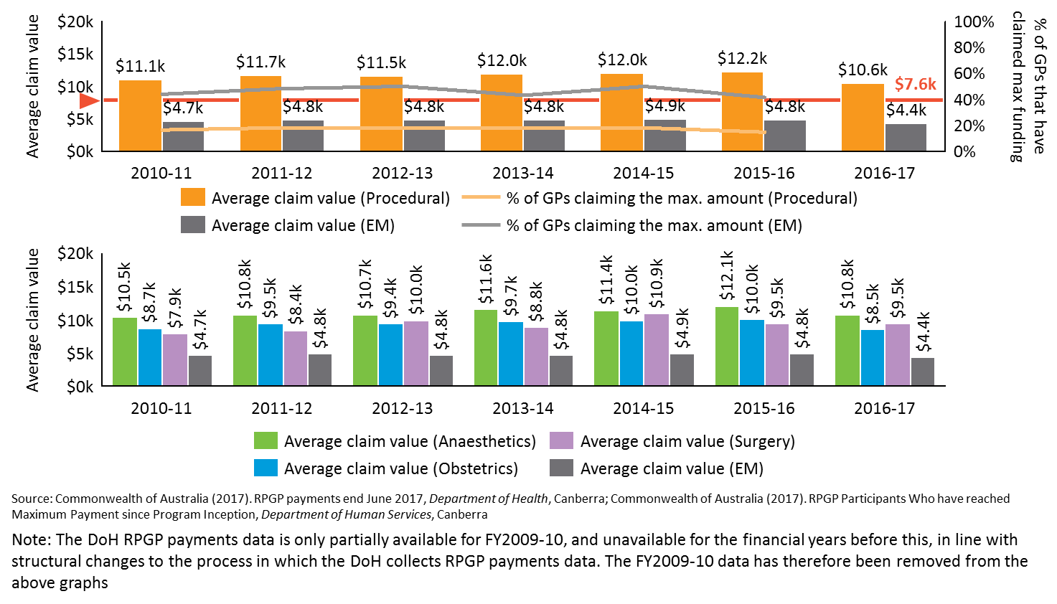

#### Community need could be the first determinant of eligibility

One of the policy objectives of the RPGP is to support rural health service delivery, which is defined by community need. As previously mentioned, the RPGP is an entitlement program, awarded based on demand by GPs applying for the grants – there is no strategic oversight as to whether there is a community need for the procedural skills the VRGP seeks support to attain. This increases the risk of gaps in service provision and overall community need in rural areas not being met.

The first factor in determining whether a GP is eligible for the RPGP grant could be whether there is a community need for the skill they are seeking training in. This will ensure that the RPGP grants are more aligned to the policy objective to improve health care delivery in rural areas. For example, Bourke needs anaesthetics, Leongatha needs obstetrics. Determining health *workforce* need will also in many cases mean liaison with state health services and local hospitals, as procedural GPs form an important component of their workforce.

The majority of stakeholders expressed the opinion that the RACGP and ACRRM are both effective program administrators of the RPGP. However, determinations of community need are not part of their current remit as partial administrators nor their primary purpose. Stakeholders expressed a range of opinions as to which agency is best placed to determine community need. Rural Workforce Agencies (RWAs) and Primary Health Networks (PHNs) were the two bodies most frequently referenced. The strengths and weaknesses of each body in determining community need, as expressed during stakeholder consultations, are outlined in Figure 26.

Figure 26: Stakeholder consultations identified possible strengths and weaknesses of each body in determining community need

Figure 26: Stakeholder consultations identified possible strengths and weaknesses of each body in determining community need

Nous contends that RWAs are best placed to determine community need in conjunction with other advisory bodies. From 1 July 2017, the Commonwealth has charged the RWAs to conduct health workforce needs assessments. As per the contract, the RWAs are expected to convene a steering group that includes representatives from PHNs, regional training hubs, state health services, rural clinical schools and state-based Aboriginal controlled community organisations. The purpose of the steering group is to ensure that all of the bodies’ experience and expertise in different community groups are factored into decision making.

It is important to emphasise that *community need* should be the first determinant of RPGP eligibility, rather than *health workforce needs.* A limitation of the RWA performing this role, is its emphasis on health workforce needs as opposed to community need, however as the recently appointed administrator of the Health Workforce Scholarship Program, RWAs will have mechanisms in place to support community need determination. While both are interlinked, it is expected that the steering group will ensure community need is the primary consideration for the purposes of determining RPGP eligibility and that community need is determined at a sub-jurisdictional level. Using a body already established will be an efficient way to determine community need as part of the RPGP eligibility. When the PHNs are better established, the DoH could review and evaluate the current arrangements to determine whether RWAs are still best placed to determine community need.

The Review’s consultation stream investigated whether other community health needs were important in rural areas, outside the procedural skills covered by the RPGP. Figure 27 shows the perceived community health needs by online survey participants.

Figure 27: Ranking of the greatest needs in the community of the online survey respondents

Figure 27: Ranking of the greatest needs in the community of the online survey respondents

*Note the procedural skills areas covered under the RPGP and GPPTSP are highlighted in **purple**.

While mental health, aged care and palliative care were highlighted as areas of rural community need by survey respondents and many interviewees, the Review also identified other programs, for example the Health Workforce Scholarships Program, NSW’s Rural General Practice Procedural Training Program and Queensland’s Rural Doctors Upskilling Program, as available to support training in these disciplines.

#### Implement a competitive prioritisation framework for the RPGP

Option C would incorporate a competitive application process to improve targeting to policy objectives, provide greater oversight into grant expenditure and contain budget overspends. As a competitive grant program, the DoH will need to consider implementing an assessment framework to prioritise and rank the eligible applications.

Option A outlines a range of improvements that the DoH could consider for prioritising, or assessing, eligible applicants, and these are relevant for Option C. An assessment framework could prioritise:

* More remote regions, according to the MMM remote classification system (see Section 4.1.1.2 for more detail).
* Or restrict eligibility to VRGPs who do not receive state-based support for procedural skills maintenance (see Section 4.1.1.3 for more detail).
* Applicants who have received support from the local hospital CEO and/or director of medical services (DMS) (see Section 4.1.1.3 for more detail).

#### Integrate program administration into the Health Workforce Scholarship Program or determine through a tender process

The recommendations from the Mason Review77 and successive governments’ ongoing reforms have consolidated grant programs to ensure that incentives provide value for money and reduce potential red tape, as mentioned in Section 3.5.35 In line with these actions for streamlining, the Review has considered other existing programs for potential integration of the RPGP program administration.

In considering which other existing Commonwealth programs would be most appropriate for administration integration, a number of variables were considered, as seen in Table 7. Weighing up evidence drawn from the Review, Nous proposes two possible routes that the DoH could consider to determine the centralised RPGP program administration under Option C:

* Health Workforce Scholarship Program (HWSP), or
* A competitive tender process.

As evident in Table 7, the HWSP features were most aligned with the RPGP compared to two other key program alternatives,[10] including:

* Policy objectives aimed to improve rural health care service delivery and rural workforce retention.
* Targeting post-graduate rural health professionals, that is, inclusive of VRGPs.
* Prioritisation based on community need.
* Focus on training outcomes for the targeted cohort.
* Implementation of the MMM classification.

The following sections outline the rationale, benefits and considerations for centralising the program administration with either the HWSP or using an open tender process to determine the best administrator of a capped, community focused and competitive RPGP under Option C.

Table 7: Assessment of existing programs against key elements of the RPGP

|  |  |  |  |
| --- | --- | --- | --- |
| Other existing Commonwealth Programs | Health Workforce Scholarship Program (HWSP) | General Practice Rural Incentives Program* (GPRIP) | Practice Incentives Program (PIP) Procedural GP Payments |
| **Do the policy objectives align with RPGP?** | 🗸 | 🗸 | 🗸 |
| **Does the program include VRGPs?** | 🗸 |  |  |
| **Does the program conduct a community need analysis?** | 🗸 |  |  |
| **Does the program have a return of service obligation?** | 🗸  [return of service] | 🗸  [continuation of payment is suggestive of retention] |  |
| **Does the program evaluate workforce retention outcomes?** | 🗸 |  |  |
| **Does the program focus on training outcomes for the targeted cohort?** | 🗸 |  |  |
| **Does the program use the MMM classification?** | 🗸 | 🗸 |  |
| **Does the program currently maintain low administrative costs?** | 🗸 | 🗸 | 🗸 |

* Integration of the RPGP into the GPRIP is considered in Option B (see Section 4.1.2 for more detail)

#### Option C1: Centralise RPGP administration with the Health Workforce Scholarship Program

The Review acknowledges the recent work done by the DoH to introduce a HWSP from 2017-2020 that streamlines a number of smaller health workforce programs.45 Similar to the RPGP, the HWSP provides financial support to postgraduate health practitioners and rural professionals to participate in training programs for skills development and upskilling. However, the HWSP allows the professional to upskill in areas beyond procedural skills, with focus on the broader fields of medicine, allied health and nursing. The Review recognises that the DoH has recently announced that the HWSP would be administered by the consortium of RWA’s, led by Health Workforce Queensland.46

##### Rationale

The RPGP could be an additional funding stream for procedural training of VRGPs within the HWSP. The DoH could draw from the same administrative mechanism as the HWSP to streamline administrative burden, and better target grants for procedural training to policy objectives. Both RPGP and HWSP have similar policy objectives that aim to improve rural health care service access and delivery, and rural workforce retention.

##### Benefits

The benefits for integrating the RPGP program administration with the HWSP are outlined as follows:

* The HWSP administrator (RWAs) will have methodologies in place to determine the community needs and skills shortages in the eligible MMM regions, which will be drawn from evidence based local needs assessment by PHNs, LHNs, as well as state and local governments. In addition, as part of the RWA’s commitment to the Rural Health Workforce Support Activity, the agency will be able to draw community need insights from their stakeholder needs analysis group.54 By integrating the RPGP administration into this process, the financial support for procedural skills training can better target community and workforce needs.
* The HWSP administrator will also have methodologies in place for reporting, monitoring and evaluating program outcomes against workforce and community need outcomes. This application could be broadened to include RPGP to better enable the evaluation and demonstration of benefit of program outcomes to support continual improvements.
* Integration with the HWSP would result in one centralised program administrator of the HWSP, John Flynn Placement program and the RPGP. This would help to streamline administration processes as well as improve transparency of Commonwealth grants awarded (aligned with consolidation goals of successive governments and the Mason Review recommendations).
* The RWAs have a case management strategy for the HWSP, and have continual and ongoing interaction with grant recipients and beyond the program which may provide opportunity to examine retention.
* The HWSP implements the MMM remoteness classification to determine eligibility of applicants. More specifically, applicants within classification MMM3-7 would be eligible for the HWSP.46 This is aligned with the recommended changes for RPGP in Option A as mentioned in Section 4.1.1.2. MMM classification system (MMM3-7) will better target rural and remote VRGPs and contain the program expenditure.

##### Considerations

To ensure that the financial support for procedural skills is targeted at the relevant individuals, there are a number of considerations for the DoH. These include:

* Mechanisms to ensure separate funding streams for the RPGP component are maintained. The separate ‘RPGP’ funding stream within the HWSP would enable procedural grant recipients to receive the same amount of financial support as the current RPGP grant, which is greater than the proposed grant amount for the HWSP (a maximum of $10,000 per year for a maximum of two years to undertake further postgraduate study, or a one-off bursary payment to cover training fees).45 Setting specific limits for the procedural skills grants would ensure that the funding is not lost or diffused and the focus is not diverted from the procedural skills.
* Eligibility of the separate procedural grants funding stream should be restricted to VRGPs to align with the original intent of the RPGP policy objectives.
* Amount of financial support provided under the procedural grant should not decrease to the HWSP amount of $10,000 per year for a maximum of two years. Unless other decisions are made to scale the payments (as discussed in Option A above), recipients would continue to receive the same amount of financial support as the current RPGP grant: $2,000 per day for a maximum of 10 days per financial year for courses in surgery, anaesthetics and obstetrics and $2,000 per day for a maximum of 3 days per financial year for courses in emergency medicine.44
* Applicant assessment and prioritisation will result in new program procedures. There would need to be new processes in place to assess and prioritise applicants based on community need, potentially on an annual basis. Clear and measureable selection criteria would need to be introduced to standardise and ensure quality control of the assessment.
* Extending the HWSP’s return of service obligation to the RPGP component. The HWSP implements a return to service obligation to enable ongoing continuity of care and service delivery for rural areas and improve workforce retention, which could be extended to the RPGP component. The Review found that RWAs are investing in software to track the return of service obligations after training completion as part of their John Flynn Placement program. This software could also be used for the RPGP to monitor and improve the rural workforce retention outcomes and better ensure continuity of procedural service provision in rural communities. Leveraging the HWSP mechanisms for return of service obligations and continuity of care provisions for the RPGP would better determine impact on the policy objectives. Although some consultations suggested introducing a return of service obligation as a requirement of the RPGP, the Review recognises that international and domestic evidence indicate the return of service obligation, or bonded component, were successful in retaining GPs in rural or remote areas only for the nominated service obligation period.78, 115 Nous also recognises the potential risk and administrative burden of bonded schemes, whereby substantial costs are associated with grant recovery when people do not fulfil their return of service obligations. Therefore, the return of service obligation component of the HSWP may not be appropriate for the RPGP given the large cost required to monitor, relative to the grant amount.
* If Option C1 is chosen for RPGP, Option D for the GPPTSP should also be implemented.

##### Risks

There are a number of risks associated with Option C that the DoH should consider when assessing feasibility of the reform options. These include:

* Increased complexity and cost for implementation and greater disruption to the continuity of the RPGP program. Resources and effort would be required to redesign the governance and program administration systems and processes. The cost of changing the HWSP systems and processes could be substantial, given the relative size of the $11.3 million per annum HWSP budget.45
* Increased workload and resourcing for the program administrator to assess and prioritise applicants for a capped and refined RPGP. As mentioned in Section 2.4, the current RPGP administrative costs are relatively low with ACRRM and RACGP employing a combined 4.6 FTE staff for grant administration and the DHS employing less than 1 FTE. ACRRM and RACGP have also reduced the time taken to process a grant, which has decreased from 2.28 hours per grant to 1.66 hours.[11] Note that this does not take into account the significant effort (and cost) that went into DHS system design and establishment initially. A few stakeholders have raised concerns that integrating program administration of the RPGP with other programs could increase administrative costs substantially.
* Challenges associated with aligning the funding arrangements across the two separate funding streams. Implementing a separate funding stream targeted at VRGPs skills maintenance could be challenging due to the different funding cycles between the RPGP and HWSP. HWSP has a three year funding cycle, whilst RPGP’s funding cycle is within a year.

#### Option C2: Determine RPGP program administrators through a tender process

Many stakeholders expressed the view that ACRRM and RACGP are both effective program administrators of the RPGP, however there is limited data available on administration effectiveness beyond the cost of administration. A range of possible program administrators could be considered including the RWAs, PHNs, RTOs, or continuing under the current college administration.

Nous proposes that if Option C1 (centralisation through the HWSP) is not chosen, the most appropriate approach to determine the administrator for the refined RPGP program would be to approach the market under tender. Aligned with the tendering process in the Parliament of Australia’s Contracting out of Government Services Report,24 assessment of the appropriate administrators could consider following:

* mechanisms to enable ongoing collaboration with key stakeholders
* assessment frameworks to determine community need
* identification process under the MMM classification system
* evaluation frameworks to assess program outcomes
* risk management and quality assurance mechanisms.

Regardless of the program administrator, there is a need for continual collaboration between the administrator and professional colleges. This could be in the form of the current ACRRM and RACGP Procedural Medicine Collaboration, or a newly developed joint college forum that will have an independent, advisory role and provide governance over the selection and approval of quality training courses and professional standards for RPGP eligibility.

##### Benefits

A key benefit of an open tender process for program administration of the capped and refined RPGP is that the successful tenderer can be tasked to implement the proposed improvements to the RPGP criteria (outlined in Option A, plus those in Option C). Aligned with the broader benefits of Options C, other benefits include:

* Implementing program improvements as detailed in Option A to better target and achieve the policy objectives.
* Capping the total RPGP expenditure to stop current overspend and ensure other DoH Health Workforce programs are supported.
* Assessing community needs to prioritise rural applicants who seek to undertake procedural skill training in areas that address service delivery gaps in their community, thus better targeting policy outcomes.

##### Considerations

In addition to considering the appropriate program administrators and the aforementioned improvements, implementing new program procedures for applicant assessment and prioritisation would also need to be considered:

* New processes would be required to assess and prioritise applicants based on rural community need. Clear selection criteria for grant recipients would also need to be introduced to standardise and ensure quality control of the assessment.
* Recent tendering processes for similar programs e.g. HSWP should be considered and whether RPGP is different enough to warrant its own tendering process.
* If Option C2 is chosen for RPGP, Option D for the GPPTSP should also be implemented.

##### Risks

There are a number of risks that the DoH should consider when assessing the tender approach to determine the program administrator for the refined RPGP. These include:

* Increased workload and resourcing for the administrator to assess and prioritise applicants in the capped and refined RPGP, as mentioned in Option C1.
* Increased complexity, cost to implement and cause greater disruption to the continuity of the RPGP program. There would be additional complexity in the open tender process as the DoH would be required to assess and select the successful applicant before a design and change management action plan is used to implement the change.
* Cost of going to tender may not be either commiserate with the expenditure of the RPGP funds, or deemed a responsible use of government resources, especially given similar recent processes for other scholarship and grant programs.
* If Option C1 is chosen for RPGP, Option D for the GPPTSP should also be implemented.

## Options for reform: GPPTSP

In light of the changing context outlined in Section 3, recommendations from the Mason Review77 and successive governments’ consolidation of grant programs, and the evidence gathered in this Review, the design and implementation of the GPPTSP should be revised. This Review has analysed data and evidence from the three research streams to inform how changes could be made.

Since 2010, a total of 237 GPPTSP grants were administered. The grants have supported 161 grant recipients to attain advanced procedural skills in anaesthetics and obstetrics, with a further 76 recipients of first round funding expected to complete their advanced training in the near future (as at 2015). This suggests that the GPPTSP could be contributing to improving access to maternity services in rural locations, given that 161 GPPTSP recipients have completed their college accredited advanced obstetrics and anaesthetics qualification. These advanced skills are still required in rural communities.

Although most stakeholders had an understanding of the RPGP, there were a smaller proportion of stakeholders that understood, and were aware of, the relatively smaller GPPTSP. Since its inception, the proportion of Fellows claiming the GPPTSP grants is decreasing, whilst the proportion of registrars claiming the grants is increasing. This decline in Fellows claiming grants could be attributed to the market saturation of GPPTSP training recipients, whereby fewer VRGPs require the advanced training in obstetrics and anaesthetics as they have access to advanced skills training through their AGPT program.

If realigned to GPPTSP’s original intent of targeting VRGPs, with current projections to continue, the grant expenditure for Fellows would be too low to justify a standalone program. As a result, under Option D, this Review proposes that the GPPTSP should not be maintained as a standalone program, but rather integrated with existing rural workforce programs, or reallocated to better target community needs.

Through synthesis of the Review findings, Option D proposes that the GPPTSP is ceased in its current form as a separate program, and funding should be retargeted to more broadly based areas of rural and remote workforce need. The following alternatives within Option D for GPPTSP funding reallocations are presented for consideration:

* **Option D1:** Integrate GPPTSP funds into the Health Workforce Scholarship Program
* **Option D2:** Integrate funds into Australian General Practice Training program to expand the AGPT to support VRGPs for advanced skills training

Note that Option E (see Section 4.3) provides an alternative option for reform for the GPPTSP by consolidating the RPGP and GPPTSP to form a separate, integrated program.

These options are supported by evidence in this Review and have been designed with consideration of the original reform options outlined by the RFQ. Option D, D1 and D2 are detailed in the sections below with supporting evidence and analyses of the challenges and benefits of the proposed options. Further detail on the research findings are summarised in Appendices B, C and D.

### Option D: Retarget the GPPTSP funds into other health workforce programs

According to the Senate Estimates for the GPPTSP, the policy objective of the program is to *‘improve access to maternity services for women living in rural and remote communities by supporting GPs to attain procedural skills in anaesthetics and obstetrics’.*55 As further discussed below, the Review has surfaced evidence that the GPPTSP is no longer achieving the intended policy outcomes. Option D proposes to cease the GPPTSP as a standalone program and retarget the funds into other existing rural health workforce programs and/or initiatives.

One of the key policy objectives of the broader Health Workforce programs is to ensure rural communities have access to high quality health care service delivery. As mentioned above, the decline in VRGPs claiming the GPPTSP grants represents a dwindling workforce need for the GPPTSP funds for the intended target cohort (VRGPs).This gives good rationale to repurpose and redirect the program funds to address gaps in rural service provision and to ensure that overall community need in rural areas are being met. There is opportunity under Option D to reallocate GPPTSP funds to community needs.

#### Remove the current GPPTSP as a separate Health Workforce program

Outlined below are the Review findings in support of removing the current GPPTSP as a separate program. The following sections describe how refocused eligibility criteria will better target VRGPs, and a retargeting of funds to broadly based programs will impact community need.

##### i) Prevalence of registrars receiving grants

A high proportion of GPPTSP funding is administered to registrars. In 2014 and 2015, 79% of recipients were registrars, which is misaligned with the original program intent, aimed at VRGPs. Data shows that registrars comprised an average of 61% of anaesthetics grants and 73% of obstetrics grants in any given year[12](Table 8). Figure 28 further provides evidence that a majority of GPPTSP grants provided to registrars were provided to those with training posts in ASGC-RA2-3. There is potential program duplication here, as registrars already have access to multiple programs to support their training, such as the Australian General Practice Training (AGPT) program. Evidence from stakeholder consultations and the literature review also supports this, noting the similarity in eligibility criteria to other programs targeting registrars.

Table 8: Proportion and number of placements given to registrars

|  |  |  |  |  |  |  |
| --- | --- | --- | --- | --- | --- | --- |
|  | GPPTSP-A | | | GPPTSP-O | | |
| **Year** | Registrars | Fellows | Not Identified | Registrars | Fellows | Not identified |
| **2010** | 30.00% (3) | 50.00% (5) | 20.00% (2) | Not available | Not available | 100.00% (31) |
| **2011** | 40.00% (4) | 40.00% (4) | 20.00% (2) | Not available | Not available | 100.00% (26) |
| **2012** | 54.17% (13) | 41.67% (10) | 4.16% (1) | Not available | Not available | 100.00% (40) |
| **2013** | 84.62% (11) | 7.69% (1) | 7.69% (1) | Not available | Not available | 100.00% (26) |
| **2014** | 94.12% (16) | 5.88% (1) | 0.00% (0) | 75.76% (25) | 24.24% (8) | 0.00% (0) |
| **2015** | 64.71% (11) | 29.41% (5) | 5.88% (1) | 70.97% (22) | 29.03% (9) | 0.00% (0) |
| AVERAGE | 61.27% (10) | 29.11% (4) | 9.62% (1) | 73.36% (24) | 26.64% (9) | 66.67% (21) |

Source: Australian College of Rural and Remote Medicine (2017). GPPTSP-A program data requested for the purpose of the Review, *Australian College of Rural and Remote Medicine*, Brisbane; Royal Australian and New Zealand College of Obstetricians and Gynaecologists (2017). GPPTSP-O program data provided for the purposes of the Review, *Royal Australian and New Zealand College of Obstetricians and Gynaecologists*, East Melbourne

Note: Analysis of registrar by ASGC – RA is found below in Figure 28

Figure 28: Distribution of registrars by RA between 2014 and 2015

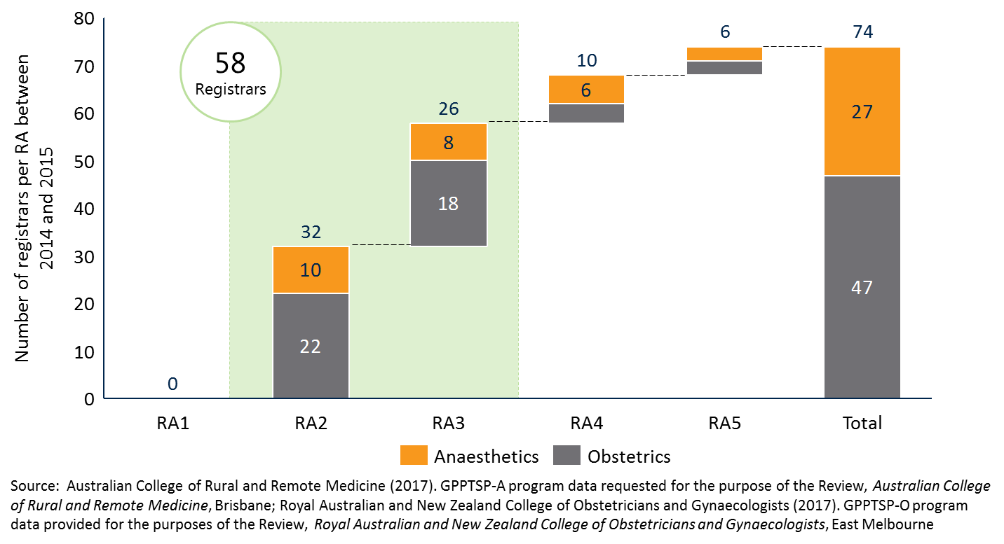

The Review also found that the policy objectives of improving access to maternity services, and ensuring obstetrics and anaesthetics services are provided back to rural communities, were not necessarily fulfilled. Although the program guidelines stipulate that eligible applicants will be prioritised based on the degree of remoteness followed by the ‘need for obstetrics or anaesthetic skills in the GP’s geographic area of practice’, registrars who receive the grant may not end up practicing in the same location as their training post at the time of GPPTSP application. While some evidence suggests that those who conducted training in rural regions are likely to return to their training post location following training completion,81 this is not a guaranteed outcome. As a high proportion of GPPTSP grants are distributed to registrars, there is an increased risk of continual gaps in service provision for procedural anaesthetics and obstetrics services, with overall community need in rural areas not being met.

##### ii) Low demand for the program from Fellows

Whilst the GPPTSP was relatively successful in achieving the policy intent of targeting VRGPs to upskill in advanced obstetrics and anaesthetics skills when first designed and implemented, data analysis also suggests that the demand from Fellows to undertake the GPPTSP is decreasing. Program data from ACRRM indicates that 85%, 94%, and 65% of program placements for the anaesthetics component were provided to registrars over 2013, 2014 and 2015 respectively.[13] Data received from RANZCOG has highlighted a similar trend, with relatively high registrar proportions of grant recipients with an average 73% of grants being provided between 2014 and 2015.

Data analysis also found that there was a decreasing proportion of overall budgeted funds distributed each year through the GPPTSP, as illustrated in Figure 29. The trend reflects the decreasing demand for advanced procedural obstetrics skills as evidenced through the declining proportion of grants distributed through the GPPTSP-O. This gives rise to opportunity to retarget funds towards other existing rural health workforce programs and/or initiatives that address rural community needs

Figure 29: GPPTSP funding dollars and the proportion of budgeted funding distributed

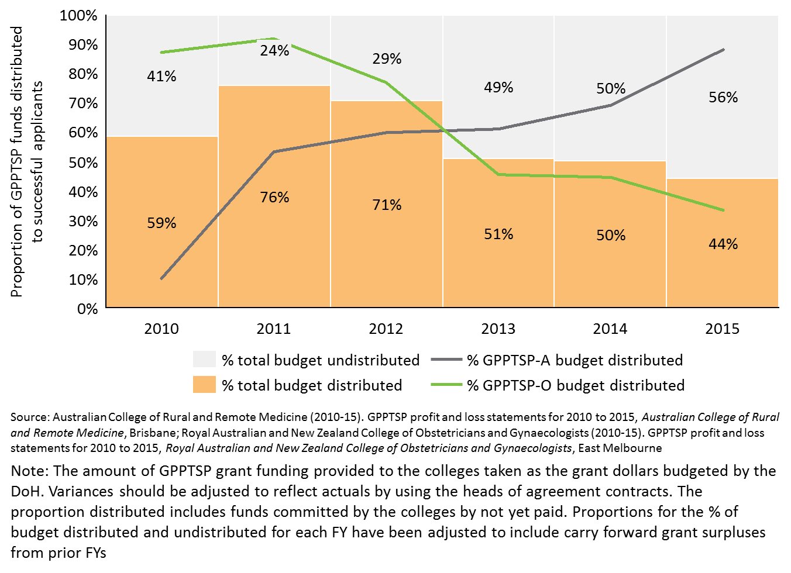

One likely reason for this decline is the saturation of the training recipient market, whereby fewer VRGPs require the advanced training in obstetrics and anaesthetics as they have already been trained as a registrar as part of the AGPT program. A key stakeholder noted that there may also be market saturation for GP obstetricians, driven in part by the challenging insurance requirements but also by the declining number of rural hospitals accredited for obstetrics. Evidence from the stakeholder consultations alternatively poses that the decline in program demand may be attributed to the difficulty VRGPs face in finding training positions and the limited financial support for VRGPs to meet the ongoing practice costs and training.

##### iii) Negligible total program expenditure relative to the overall health budget

The funds currently administered for the GPPTSP are of negligible size relative to the overall health workforce budget and hardly justify separate program administration. Between 2010 and 2015, $9.1 million was administered through the GPPTSP program, of which $5.5 million went to upskilling in obstetrics skills through RANZCOG.10, 11, 104, 105, 106

##### iv) GPPTSP program guidelines were misaligned with policy intent for obstetrics services

Similar to the RPGP (see Section 4.1), it became evident that the GPPTSP policy objectives are unclear. Qualitative evidence from stakeholder consultations suggest that the specific policy objectives were misunderstood, misinterpreted, or not clear beyond the DoH. Current GPPTSP program guidelines stipulate that registrars are also eligible to apply for the grant, which differs from the DoH’s original intent for the GPPTSP. Realigning the intent of program to better target the policy objectives will better meet rural community needs.

The Review also found misalignment between the GPPTSP’s policy objective and the program requirements. Stakeholder consultations have identified that applicants were not aware that the GPPTSP anaesthetics component was tied to the expectation to support obstetric services upon returning to their primary area of practice. A factor contributing to this confusion could be the application guidelines not explicitly detailing that the GPPTSP anaesthetics component is intended to support obstetric services, not purely to ‘*increase availability of anaesthetic services in [rural and remote] areas*’.12 Reflecting this, many GPPTSP recipients have used the grants to attend training courses that do not directly relate back to maternity services or align with the original policy intent.

In consideration of the prevalence of registrars receiving grants, the low demand for the program from Fellows, the negligible total program expenditure relative to the overall health budget and the misaligned policy objectives, there is evidence to suggest that the DoH could remove the GPPTSP grant and redirect funding to areas of greater need.

#### Refocus eligibility criteria to better target established VRGPs, with registrars using the existing AGPT program

Retargeting the GPPTSP program within existing rural health workforce programs provides an opportunity to realign the GPPTSP to the original policy intent by better targeting the VRGPs. A consideration under this option could be to restrict GPPTSP funding provision to VRGPs who are practicing in rural areas and desire to further upskill in the advanced skills of procedural obstetrics and anaesthetics. Registrars can use the existing AGPT program to access training support to upskill in advanced skills. This would create a level playing field for all rural registrars and prevent duplication of program funding applications by registrars who can access financial support to gain advanced skills through the AGPT and reduce competition for trainee posts between the AGPT and GPPTSP applicants.

The Review also recognises the additional challenges associated with retargeting registrars to use the existing AGPT program as this might increase the competition to secure training posts to fulfil program requirements. Many stakeholders have identified the ongoing challenge of securing a training post in competition with the increasing pipeline of medical specialists, particularly once the applicant has been notified as the successful recipient of the grant.

#### Reallocate resources to more broadly based areas of rural community or workforce need

Option D proposes that once the GPPTSP is discontinued as a standalone program, the remaining GPPTSP funds could be retargeted within existing rural health workforce programs and/or initiatives. There is opportunity for the DoH to distribute a proportion of funds to a range of different programs. This could include initiatives broader than the rural workforce programs noted (e.g. Practice Incentives Program - Procedural GP Payments).

In considering which other existing Commonwealth programs would be most appropriate for integration with the GPPTSP, a number of variables were considered, as seen in Table 9.[14] Given the policy objective and the target cohort of program applicants, Nous proposes two Commonwealth Rural Health Workforce programs that the DoH could consider for reallocation of GPPTSP funds:

* + Health Workforce Scholarship Program (HWSP), or
  + Australian General Practice Training (AGPT) program.

The following sections outline the rationale for integrating GPPTSP with the programs listed above and explore the benefits and considerations for implementation.

Table 9: Assessment of programs against key elements of the GPPTSP

|  |  |  |  |
| --- | --- | --- | --- |
| Other existing Commonwealth Programs | Health Workforce Scholarship Program (HWSP) | Australian General Practice Training (AGPT) program | Rural Locum Assistance Program (RLAP) |
| **Do the policy objectives align with GPPTSP?** | 🗸 | 🗸 | 🗸 |
| **Does the program target VRGPs?** | 🗸 |  |  |
| **Does the program conduct a community need analysis?** | 🗸 |  |  |
| **Does the program have a return of service obligation?** | 🗸  [return of service] |  |  |
| **Does the program evaluate workforce retention outcomes?** | 🗸 |  |  |
| **Does the program focus on training outcomes for the targeted cohort?** | 🗸 | 🗸  [qualification as Fellows on completion] |  |
| **Does the program use the MMM classification?** | 🗸 |  | 🗸 |
| **Does the program currently maintain low administrative costs?** | 🗸 | 🗸 |  |

### Option D1: Integrate GPPTSP funds into the Health Workforce Scholarship Program

As mentioned in Section 4.1.3, the HWSP provides financial support to postgraduate health practitioners and rural professionals to participate in training programs for skills development and upskilling. However, the HWSP allows the professional to upskill in disciplines broader than procedural anaesthetics and obstetrics, with a focus on medicine, allied health and nursing. Option D1 proposes to retarget the GPPTSP funds into the HWSP.

When integrating funds into the HWSP, the DoH could consider introducing a *separate funding stream* aimed at supporting VRGPs to attain advanced procedural anaesthetics and obstetrics skills to improve access to maternity services in rural and remote areas. As a majority of stakeholders agreed that procedural skills in anaesthetics and obstetrics were integral in rural communities, maintaining a separate funding stream could ensure that focus and funding is not diffused from these procedural skills.

Without a separate funding stream within the HWSP, the funds previously aimed to increase the number of rural Fellows with advanced obstetrics skills would be more broadly available to upskill Fellows, based on community need. While this remains an option, the Review considers that it is reasonable to ensure that the original policy intent is protected while demand is still apparent. Over time, dependent on demand, the funds would appropriately be absorbed into broader community need.

The HWSP implements the MMM remoteness classification to determine the eligibility of applicants, as opposed to the GPPTSP which relies on the less granular ASGC-RA model. The MMM facilitates better targeting of grant recipients as it further takes into account the difference between rural locations in term of population size, as highlighted in Section 4.1.1.2. Specifically, the HWSP limits grant eligibility to those located in MMM3-7 to reflect the prioritisation of GPs in further remote areas, and using this criterion for the GPPTSP will result in more resources being provided for VRGPs in further remote regions as illustrated in Figure 30. Between 2010 and 2016, a total of 234 grants were provided to GPs in ASGC-RA 2-5. If eligibility was limited to GPs practising in MMM3-7, 186 GPs would have received grants. This indicates that 48 of the current GP recipients would not have received the grant, with $1.9 million available to be redistributed to VRGPs in more rural locations.

Figure 30: GPPTSP grant distribution by ASGC-RA against MMM

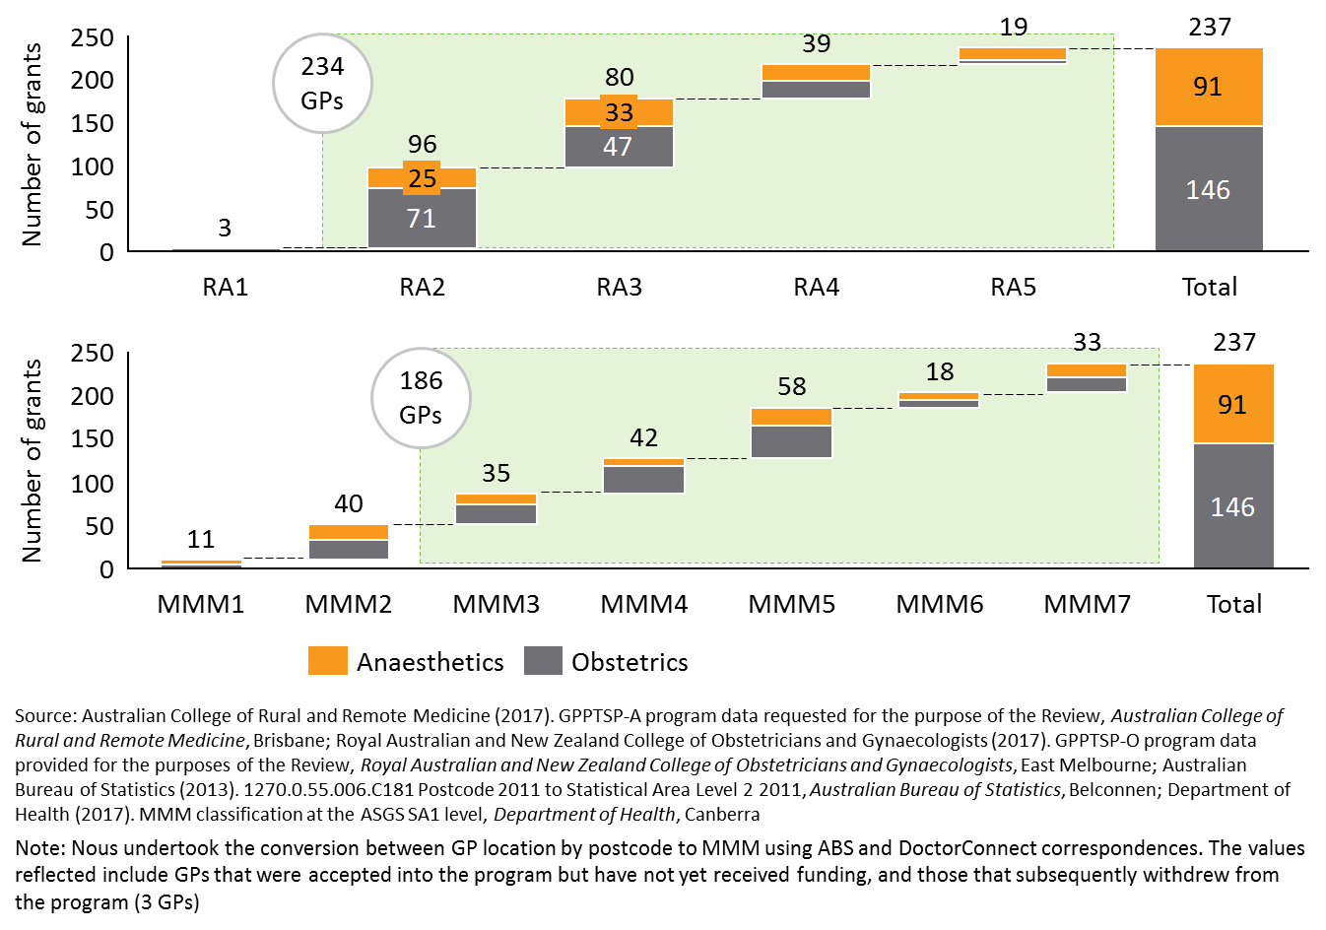

Rationale

The GPPTSP is focused on supporting postgraduate GPs to obtain skills in procedural anaesthetics and obstetrics to improve service provision in rural and remote areas, which has notable similarities with the policy objective of the HWSP.

Benefits

Benefits of integrating the GPPTSP funds and program administration with the HWSP include the following:

* A separate funding stream aimed at supporting VRGPs to attain advanced procedural anaesthetics and obstetrics skills to improve access to maternity services in rural and remote areas will ensure better targeting of the intended GPPTSP policy objectives.
* Applying the MMM classification will result in a reduction in eligible recipients, thereby making available funds to support scaled payments for those in more remote locations.
* Similar to the benefits outlined in integrating the RPGP to the HWSP in Option C1, RWAs, as the HWSP program administrators, have:
  + - methodologies in place to determine the community needs and skills shortages in the eligible MMM regions, which will align with other local needs assessment by PHNs, LHNs, and state and local governments
    - infrastructure, through stakeholder needs analysis group to draw community needs assessment
    - methodologies in place for reporting, monitoring and evaluating program outcomes against workforce and community needs outcomes
    - a case management strategy to meet workforce needs, using continual and ongoing interaction with grant recipients beyond the program, and in doing so, can develop mechanisms for succession planning to better target community needs.
* By integrating the GPPTSP with the HWSP, the financial support for developing procedural anaesthetics and obstetrics skills can better target and prioritise applicants who are practicing in rural areas that require such skills, and enable better assessment of program outcomes to support continual program improvement. These approaches will better target the intended policy objectives of the original GPPTSP.
* Integration with the HWSP would result in one centralised administrator of the HWSP, John Flynn Placement program and the GPPTSP. This would help to consolidate program administration processes as well as improve transparency and oversight of Commonwealth grants awarded.

Considerations

Implementing Option D1 should take on board a number of considerations including those outlined below:

* A key decision will be whether a separate funding stream for advanced procedural anaesthetics and obstetrics skills to improve access to maternity services in rural and remote areas is maintained, or whether the funds are allocated more broadly under Option D2.
* Mechanisms would need to be in place to ensure a separate funding stream for the GPPTSP component is maintained. To align with the original policy intent for the GPPTSP, a separate GPPTSP funding stream could be developed, with access only available to VRGPs in established rural practices who wish to upskill in advanced obstetrics skills. The separate funding stream would enable procedural grant recipients to receive the same amount of financial support as the current GPPTSP grant, which is greater than the proposed grant amount for the HWSP (a maximum of $10,000 per year for a maximum of two years to undertake further postgraduate study, or a one-off bursary payment to cover training fees).Setting specific limits for the procedural skills grants would ensure that the funding is not lost or diffused and the focus is not diverted from procedural skills.
* As mentioned in Option C1, there may be opportunity to extend the HWSP’s return of service obligation to GPPTSP component as well. There could be opportunity to leverage the RWA’s software to track the return of service obligations under the John Flynn Placement program. However, the Review recognises that evidence indicates the return of service obligation, or bonded component, were only successful in retaining GPs in rural or remote areas for the duration of the nominated service obligation period.78, 115 Therefore, the return of service obligation may not be appropriate given the large cost required to monitor, relative to the grant amount.
* Further consideration under Option D1 could be given to reduce the scholarship numbers and retargeting the funds to under one or more of the following options:
  + - increase the amount of financial support provided through each scholarship to support advanced training
    - increase the amount of financial support provided to the sole practice owners
    - increase the amount of financial support provided to those from more remote locations (via scaled payments).

By integrating the proportion of GPPTSP funds currently received by registrars into the HWSP for Fellows, there is opportunity to increase the amount of funds provided to individual VRGPs to cover training fees or undertake further study.

* While the GPPTSP funds would be reallocated to the HWSP, registrars would be directed to the AGPT for training support.

Risks

There are a number of risks associated with Option D1 that the DoH should consider when assessing feasibility of the reform options. These include:

* Increased administrative burden, complexity and cost for the RWA’s to assess and prioritise applicants in the separate funding steam, given the relative size of HWSP compared against the GPPTSP (as alluded in Option C1). As mentioned in Section 2.4, the GPPTSP administrating colleges currently assess and process grants independently and expend a combined average of 6.6% of distributed grant funding on administration each year.7109 The cost of implementing the changes to the HWSP systems and processes could be substantial, given the relative size of the $11.3 million per annum HWSP.45
* Challenges associated with aligning the funding arrangements across the two separate funding streams. Implementing a separate funding stream targeted at VRGPs skills maintenance could be challenging due to the different funding cycles between the GPPTSP and HWSP. HWSP has a three year funding cycle, whilst the GPPTSP funding cycle is within two years[15].

### Option D2: Integrate funds into Australian General Practice Training program to expand the AGPT to support VRGPs for advanced skills training

The AGPT program offers training positions under the Rural or General Pathway and provides vocational training opportunities for medical graduates who are specialising in general practice and working towards their Fellowship. The AGPT aims to ensure that ‘at least 50% of training on the AGPT Program is delivered in rural and remote areas, to meet community need’.60

Option D2 proposes to expand and broaden scope of the AGPT to include administration of funds targeted at Fellows, who have completed training in obstetrics and anaesthetics, to receive further advanced skills training. This means that there would be a *separate funding stream* aimed at supporting VRGPs to attain advanced procedural anaesthetics and obstetrics skills to improve access to maternity services in rural and remote areas.

Integrating GPPTSP funds into the AGPT would indicate that the nine regional training organisations (RTOs) will become responsible for administering and prioritising the GPPTSP funds.

Similar to the policy objective of the AGPT, the GPPTSP is focused on upskilling GPs to develop their medical skills in anaesthetics and obstetrics to improve service provision in rural and remote areas. Given the AGPT currently allocates 1,500 training posts per year to registrars60 and GPPTSP has a ‘high’ proportion of registrars receiving the grants, there is opportunity to streamline administration processes and integrate the programs.

Benefits

The benefits of Option D2 are outlined below:

* Integrating GPPTSP funds into the AGPT would reduce overlap and potential program duplication as registrars will no longer be able to access financial support to upskill in advanced skills through both the AGPT and GPPTSP, allowing the AGPT to be focused on targeting registrars. The discrete, separate funding stream would provide the financial support for VRGPs to attain advanced skills in procedural anaesthetics and obstetrics.
* The AGPT administrators and the RTOs have good oversight of the local community needs in their regions. The nine streamlined training organisation ensures a better geographical distribution and limits overlap of organisation coverage. This suggests that these bodies could be better placed to prioritise applicants and/or posts to those who practice in rural areas that have a prominent need for obstetric and anaesthetic services.
* The RTOs also have well-established infrastructure to assess, prioritise and select applicants for the GPPTSP funds, as the AGPT program requires the application of similar processes to prioritise and select students for the training pathways. The GPPTSP administration process could be considered as an extension of the current AGPT program.
* Stakeholder consultations have indicated that previously, when AGPT was administered under the General Practice Education and Training Ltd (GPET), the AGPT included provisions that enabled the training providers to liaise with former AGPT registrars (for up to 5 years after their Fellowship) to help them access advanced skills training. This indicates that historically the RTOs would have the mechanisms in place to assist VRGPs to obtain advance skills.
* Integration with the AGPT would result in administration through a central program under the nine RTOs distributed in the eleven AGPT training regions. This could help to streamline processes as well as improve transparency of Commonwealth grants awarded. This would also enable the program administrator to have greater oversight of the training posts available and the training pipeline.
* Amalgamation could better facilitate data collection and monitoring of workforce retention as RTOs would have the existing infrastructure and relationships with the Fellows and Colleges to enable these continuous improvement processes for the AGPT.

Considerations

A range of considerations for Option D2 have been noted including the following:

* As the AGPT is currently targeted at registrars, there may be a need to reconsider the current program administration processes. As the original intent for the GPPTSP was to prioritise VRGPs, policy change would be required to ensure that the RTOs can also administer specific training courses for VRGPs in established rural practice. Although these changes are feasible, this would slightly increase the administrative burden on the RTOs given GPPTSP’s small administration costs. The DoH could consider extending their current AGPT contract with the RTOs to include another schedule for arrangements with VRGPs.
* Further changes under the integration of the GPPTSP with the AGPT would include a redesign of the program guidelines, with regular processes in place to review and update the guidelines, as required.
* GPPTSP funding should not be retargeted to the AGPT training posts or positions, as this might create further competition between providers for the same trainee/ GP or training location. The fund should be used to subsidise advanced procedural training in obstetrics and anaesthetics. Different from the GPPTSP where financial support is provided to the individual GP to upskill in procedural obstetrics and anaesthetics skills, the AGPT program provides funding for training positions. The Review found evidence of similar challenges in securing training posts and training programs under both the AGPT program and GPPTSP. However, this could be mitigated by restricting the GPPTSP grants to VRGPs (as discussed below). Further consideration under this alternative would be to provide additional guidelines and/or principles to the hospitals to better guide the prioritisation of the training posts to reduce competition. However, this may be extensive and difficult to establish.
* Mechanisms would need to be in place to ensure a separate funding stream for the GPPTSP component is maintained. To realign with the original policy intent, integrating program administration could provide the opportunity to better align the GPPTSP to the original policy objectives by better targeting VRGPs. The separate GPPTSP funding stream could be restricted to VRGPs who are practicing in rural areas and desire to upskill in procedural obstetrics and anaesthetics. This would reduce the duplication of program funding application by registrars who could also access financial support to upskill in advance skills through the general AGPT and reduce competition for trainee posts between the AGPT and GPPTSP applicants.
* Both the GPPTSP and AGPT (Rural Pathway) are currently administered under the ASGC-RA remote classifications system, which is less targeted than the newly introduced MMM classification. The integration of administration functions between the two programs could provide an opportunity to refocus and realign the classification system under the MMM to also account for town size. This would mean that eligible VRGPs would have a principle location of clinical practice located between the MMM 3 – 7 regions.

Risks

As evidenced in Option D1, there are a number of risks associated with Option D2 that the DoH should consider when assessing feasibility of the options. These include:

* Increased administrative burden, complexity and cost for the RTOs to assess and prioritise applicants in the separate funding steam, given the relative size of AGPT compared against the GPPTSP.
* Challenges associated with aligning the funding arrangements across the two separate funding streams. Implementing a separate funding stream targeted at VRGPs skills maintenance could be challenging due to the different funding approaches between the GPPTSP and AGPT.

## Options for reform: Combining RPGP and GPPTSP

Option E looks at ways in which the two programs under review could be capped and amalgamated to form a single program. Option E1 explores a single program focused on procedural skills training and maintenance for VRGPs. Option E2 explores a single program focused on advanced skills training including procedural skills and skills determined by community need (e.g. mental health or palliative care). Option E draws on the supporting evidence and analyses presented in previous Options for Reform.

### Option E: Amalgamate the RPGP and GPPTSP to form a separate capped and more broadly based grants program

As discussed in Sections 1, the policy objectives of the RPGP and the GPPTSP are similar in that both programs aim to improve rural health care service delivery though procedural skills training and rural workforce retention. Amalgamation of the RPGP and GPPTSP provides an opportunity for the DoH to improve value for money by amending the program design and consolidating the funding to better target the VRGPs cohort, with streamlined program administration and a focus on upskilling and/or maintaining procedural skills or advanced skills more broadly.

Nous has developed two alternatives under Option E through synthesis of the Review findings. The following options are presented for consideration by the DoH:

* **Option E1**: Amalgamate the RPGP and the GPPTSP to form a combined VRGP procedural skills maintenance and upskilling program.
* **Option E2:** Amalgamate the RPGP and the GPPTSP to develop a new VRGP advanced skills training program based on community need (beyond procedural skills).

As with Option B and C, Option E is designed as an extension to Option A, in that, all or some of the improvements outlined in Option A are relevant and should be taken on to refine the RPGP component of the separate combined grants program within Option E.

Options E1 and E2 are detailed in the sections below with supporting evidence and analyses of the challenges and benefits of the proposed options. Further detail on the research findings are summarised in Appendices B, C and D.

### Option E1: Amalgamate the RPGP and the GPPTSP to form a combined VRGP procedural skills maintenance and upskilling program

The similar RPGP and GPPTSP policy objectives provide an opportunity to consolidate two VRGP programs targeted at maintenance and upskilling in procedural skills. However, as mentioned in Section 1, the financial support provided through the RPGP and GPPTSP are intended for different purposes. The RPGP is provided as a subsidy for VRGPs to attend a range of training courses (e.g. conferences, hospital training, and simulations) as part of achieving their CPD requirements and maintaining their procedural skills. In contrast, the GPPTSP is intended to support VRGP upskilling in the advanced skills of anaesthetics and obstetrics through the *ARSTA/DRANZCOG Advanced.* A clear integrated policy objective and purpose would need to be established for the newly VRGP procedural skills program that is communicated broadly to key stakeholders.

Given the analysis of the GPPTSP presented in Option D, the quantum of funds to be redirected from the GPPTSP into the combined pool should be limited to only a portion of the current funding available for the GPPTSP. The remainder could be allocated as per the Option D alternatives.

The key features and benefits of Option E1 include:

* **Introduce a financial cap on total program expenditure** to prevent and limit overspend (as described in the RPGP options for reform in Section 4.1.1.5) and provide greater oversight over the use of program funds. As previously mentioned, the current RPGP is an entitlement program without capped total program expenditure. By limiting the funding pool, it would also make grants under both programs more competitive and ensure that other health workforce programs are supported.
* **Redesign the RPGP component as a competitive program,** as per Option C, the RPGP component of the amalgamated program under Option E1 would no longer be an entitlement program.
* **Focus on the VRGPs cohort.** Both the RPGP and GPPTSP were intended to provide financial support to VRGPs who were practicing in rural and remote areas. Integrating the programs could better target the intended cohort (i.e. non-registrars), particularly in the case of the GPPTSP where the majority of recipients are registrars. Registrars who wish to upskill in procedural obstetrics and anaesthetics can be catered for by the AGPT program as part of their advanced skills training and Generalist Pathway on their rural hospital-based doctors. This would also reduce competition for training posts between AGPT recipients and the original GPPTSP recipients.

Additionally, if Option E1 is selected, the features of the amalgamated program will be dependent on its agreed purpose. There are two alternatives. The new program could be: i) a training incentive for procedural skills maintenance and upskilling, or ii) a subsidy for procedural skills maintenance and development. Table 10 provides an overview under two possible purposes of the proposed features, funding model, benefits, considerations and risks for the DoH to consider.

Table 10: Overview of Option E1 alternatives

|  |  |  |
| --- | --- | --- |
| Option E1: Amalgamate the RPGP and the GPPTSP to form a combined VRGP procedural skills maintenance and upskilling program | | |
| Purpose: | 1. Training incentive for procedural skills maintenance and upskilling | 1. Subsidy for procedural skills maintenance and development |
| Features | **New program** **is focused on** supporting two mutually exclusive purposes - essentially maintaining the current purposes of the RPGP and GPPTSP.   * **Provide opportunities for focused maternity and obstetrics advanced skills**. This could be through a quota of GPPTSP recipients per year to prevent GPPTSP recipients from being lost in the amalgamation with the RPGP. | **New program is focused on** providing financial subsidy to maintain and upskill in procedural skill**,** not aimed at skill qualifications.  **Remove advanced training requirements** currently explicit under the GPPTSP. This could decrease the number of VRGPs qualified in advanced procedural anaesthetics and obstetrics skills in future. |
| Funding model | **Two separate funding streams;** one for procedural skills maintenance (RPGP), and one for obstetrics and obstetric-related anaesthetics upskilling (GPPTSP).  The maximum amount per recipient would remain limited as per current arrangements.   * Specific proportions of the combined funding budget are allocated for procedural skill training subsidy and advanced obstetrics upskilling. | **One combined funding stream with capped funding amount.**  The maximum amount per recipient would need to be determined from the one funding pool. |
| Administration | The new program could be administered through:  Current arrangements (DHS, ACCRM, RACGP and RANZCOG), or  Determined through competitive tender process | The administers of the new program could be determined through a competitive tendering process. |

Benefits

In addition to the benefits outlined above, further benefits of Option E1 include the following:

* Program administration and governance arrangements would not change substantially as the two procedural programs are closely aligned. This indicates that changes would be easier to implement compared to other options.
* Under the redesign as a training incentive for procedural skills maintenance and upskilling, the separate funding streams enable targeting of specific policy objectives under each stream and better tailored for different training courses conducted over different durations.
* Under the redesign as a subsidy for procedural skills maintenance and development, one centralised program administrator may streamline administration and potentially realise efficiency gains and cost synergies through removing duplicate activities.

Considerations

A range of considerations for Option E1 have been noted including the following:

* Although programs were initially created in response to immediate needs in rural and remote communities, there have been significant changes in the health care environment for rural health services. GPPTSP funds could be retargeted to other rural workforce incentives as there is a gradual decline in program demand from VRGPs.
* There is opportunity to better target rural grant recipients for both programs by implementing the MMM classification system (as detailed further in 4.1.1.2).

Risks

There are a number of risks associated with Option E1 that the DoH should consider. These include:

* Combined funding streams could diffuse focus from the original objectives of improving access to procedural services (RPGP) and maternity services (GPPTSP).
* Risk that the GPPTSP recipients could be lost. Large total program expenditure of the RPGP could dilute focus from the GPPTSP.
* Implementation costs may be high, given the infrastructure of both programs would need to be re-designed. In the context of the broader health portfolio and budget, costs to implement a change may not be economically beneficial or justifiable.

### Option E2: Amalgamate the RPGP and GPPTSP to develop a new rural VRGP advanced skills program

Option E2 proposes to redesign the amalgamated program as a grant program to support VRGPs to maintain and upskill in a broader range of advanced skills, including but not limited to procedural skills. Similar to Option E1, the combined program is proposed to have a financial cap on total program expenditure, with the RPGP component redesigned as a competitive program and refocused on the VRGP cohort. However, Option E2 proposes to broaden the scope of eligible training disciplines to reflect broader community needs including mental health and palliative care as well as procedural skills.

The key features of Option E2 include:

* **Focus on supporting two mutually exclusive purposes** to: a) maintain and upskill in procedural skills and b) better address community needs through other workforce programs.
* **Provide opportunities for focused procedural skills training and development**. This could be through a proportion of quarantined funds to prevent procedural skills training and maintenance from being lost in the amalgamation with community need.
* **Repurpose the combined GPPTSP funds as a financial subsidy** to support training and development in skills required in rural communities. Evidence from stakeholder consultations and the literature review indicated that GP training in the areas of mental health and/or paediatrics could be beneficial in improving rural health care service delivery (see Section 3.5).
* **Two separate funding streams.** One for procedural skills maintenance and upskilling (originally the RPGP component), and one for community needs (originally the GPPTSP component).
* **Prioritise eligible applicants based on rural community needs**, as discussed in Option C in the redesign of the RPGP. This would mean that community need for the skill the GP is seeking training in would be the first determinant of eligibility. This will ensure that the grants are more aligned to the policy objective to improve health care delivery in rural areas.

Nous proposes two options for administration of the newly developed advanced skills program. This includes:

* **Integrating program administration with the HWSP**. Similar to the RPGP and GPPTSP policy objectives, the HWSP provides financial support to postgraduate health practitioners and rural professionals to participate in training programs for skills development and upskilling. As mentioned in Option C and D, there could be opportunity to streamline administration and leverage the mechanisms from the consortium of RWAs who administrator the HWSP.
* **Determining the administrator through a tender process**. An alternative approach is to determine the most appropriate administrator through a tender process. A range of possible administrators could be considered including the RWAs, PHNs, RTOs, or continuing under the current college administration. Nous proposes that approaching the market to determine the administrator for the integrated program would be most appropriate.

Benefits

Benefits for Option E2 include:

* Stronger focus on addressing rural community needs through allocating a proportion of the available funds to skills seen as necessary by rural communities. As detailed in Section 4.1.3.2, the community needs assessment could be determined by RWAs or PHNs. Should the DoH consider integrating administration into the HWSP, there would be methodologies in place to determine community need.
* Assessment of community need also allows prioritisation of applicants who seek to undertake training that addresses service delivery gaps in their community.
* Separate funding streams enable targeting of specific policy objectives and purposes under each stream. This would also enable the development of more tailored training courses conducted over different durations.
* Changes are easier to implement as there is close alignment between the administration and governance arrangements for the two programs (as described in Option E1).
* Limits to the current RPGP overspend and ensures that other health workforce programs are supported through the introduction of a financial cap on total program expenditure (as described in Option C and Option E1). By limiting the funding pool, it would also make grants under both programs more competitive.
* Better targets the intended cohort (i.e. non-registrars), particularly in the case of the GPPTSP where the majority of recipients are registrars (as described in Option E1).

Considerations

There are a range of specific considerations required for an integrated program with skills extending beyond procedural skills. These include the following:

* Mechanisms in place to ensure separate funding streams for the procedural skills and the community need component are maintained (as mentioned in Option C and D).
* Expanded scope of advanced skills could contribute to potential program duplication with HWSP and other grant programs that target similar areas of community needs, such as mental health and palliative care. The Review recognises that the HWSP is broader than VRGPs, including nursing and allied health.
* GPPTSP funds could be reallocated to other rural workforce incentives as there is a gradual decline in program demand from VRGPs evident from the changes in the health care environment for rural health services (as described in Option E1).
* There is opportunity to better target VRGPs through implementing the MMM classification system (as detailed further in 4.1.1.2).

Risks

There are risks associated with Option E2 that the DoH should consider. These include:

* High implementation costs, given the infrastructure of both programs would need to be re-designed and repurposed.
* Large amounts of focus on community need (e.g. mental health), with focus diffused from the original policy objectives of improving access to procedural services (RPGP). As mentioned in Section 3.4, stakeholders generally did not oppose support for training beyond procedural skills, but did not want to dilute the current investment in procedural skills.

## Summary of benefits, considerations and risks for the Options for Reform

This section provides a summary of each Option for Reform, highlighting the key features, benefits, considerations and potential risks from a policy perspective.

|  |  |  |
| --- | --- | --- |
| **Option A: Maintain and refine the RPGP as an uncapped program that is better targeted to policy objectives**  **Key features:**  Propose a set of improvements that the DoH could choose to take forward in their entirety, or as discrete program adjustments.  Improvements include: establishing clearer policy objectives; using the MMM remoteness classification system; implementing risk management controls; introducing processes and mechanisms to ensure quality of eligible training courses; and, implementing a robust evaluation and monitoring framework.  Continue to have the colleges (ACRRM and RACGP) administer the RPGP. | | |
| **Benefits** | **Considerations** | **Risks** |
| Clearer policy objectives will better target, and positively impact, the rural community health needs  MMM classification system (MMM3-7) will better target rural and remote VRGPs and reduce current overspend  Quality of eligible training programs will be enhanced  Risk management controls will minimise duplication of available programs and better target eligible recipients  Exclusion of VRGPs who receive state-based support for procedural skills maintenance will reduce the current overspend  Minimal changes to administration and a relatively simple transition from current state | Although Option A set out five improvements that the DoH could choose to take forward as discrete program adjustments, ideally the improvement should be taken in their entirety.  Should the DoH choose to take forward Option A for the RPGP, Option D would be selected for the GPPTSP. | Continued overspend of total grant expenditure, with implications for expenditure of the capped Health Workforce Programs  Implementation of MMM and exclusion of VRGPs who receive state-based support for procedural skills maintenance will likely mean some current recipients will no longer be eligible  Refining training program criteria will mean pure online programs will not be eligible  No community needs assessment or evaluation is performed |

|  |  |  |
| --- | --- | --- |
| **Option B: Integrate the RPGP into the General Practice Rural Incentives Program (GPRIP)**  **Key features**  Integrate with the GPRIP as an uncapped entitlement program to better streamline administration and monitor workforce retention.  Designed as an extension to Option A, in that, all or some of the improvements outlined in Option A are relevant and should be taken on in addition to pursuing Option B.  Consolidate program administration of the RPGP with the existing GPRIP, with a separate funding stream maintained to focus on procedural skills in rural and remote areas. | | |
| **Benefits** | **Considerations** | **Risks** |
| MMM classification system (MMM3-7) will better target rural and remote VRGPs and reduce current overspend  Applying the GPRIP criteria (scaled payments for tenure up to 5 years) will strengthen the evaluation of RPGP’s impact on workforce retention  Streamlined and consolidated administration of two existing DoH programs will increase transparency and oversight  Automated payments using the GPRIP MBS billing system will minimise ongoing administration costs | Should the DoH choose to take forward Option B for the RPGP, Option D would be selected for the GPPTSP  Mechanisms to ensure separate funding streams for the RPGP component  Alignment of purpose, structure, and systems of the GPRIP and RPGP | Continued overspend in the total grant expenditure as both programs are uncapped  Cost of changing the infrastructure administering the grants could be substantial  Implementation of MMM will likely mean some current recipients will no longer be eligible |

|  |  |  |
| --- | --- | --- |
| **Option C: Cap the RPGP with a focus on community need, and centralise the program administration**  **Key features**  Designed as an extension to Option A, in that, all or some of the improvements outlined in Option A are relevant and should be taken on in addition to pursuing Option C.  Redesign the RPGP as a capped program where community needs are the first determinant of eligibility.  Introduce a competitive assessment to identify priority applicants within the capped budget.  Integrate program administration with the Health Workforce Scholarship Program (Option C1) or go to the market for tender (Option C2). | | |
| **Benefits** | **Considerations** | **Risks** |
| Implementing program improvements as detailed in Option A will better target policy objectives  Capping the program will stop current overspend and ensure other workforce programs are supported  Assessment of community need allows prioritisation of applicants who seek to undertake training that addresses service delivery gaps in their community  MMM classification system (MMM3-7) will better target rural and remote VRGPs and contain the program expenditure  Option C1 (integrate administration with HWSP) will streamline and consolidate administration of two existing DoH programs  Option C1 will leverage from the existing HWSP evaluation methodology for community needs  Option C2 (open tender for administrator) will ensure that the successful tenderer can implement the proposed changes to the RPGP criteria | Should the DoH choose to take forward Option C for the RPGP, Option D would be selected for the GPPTSP  Applicant assessment and prioritisation will result in new program procedures  Under Option C1, the HWSP’s return of service obligation may not be appropriate given the large cost required to monitor, relative to the grant amount  Continual collaboration between the administrator and professional colleges as independent advisors would need to be ensured | Implementation of MMM and exclusion of VRGPs who receive state-based support for procedural skills maintenance will likely mean some current recipients will no longer be eligible  Applicant assessment and prioritisation for the capped and refined RPGP will increase workload and resourcing for the administrator  Centralising (C1) or tendering (C2) administration could be difficult, costly to implement and cause disruption to the continuity of the program  In Option C1, the cost of changing the HWSP systems and processes could be substantial, given the relative size of the $11.3 million per annum HWSP  In Option C1, a separate funding stream targeted at VRGPs skills maintenance could be challenging due to different funding cycles between the RPGP and HWSP |

|  |  |  |
| --- | --- | --- |
| **Option D: Retarget the GPPTSP funds into other health workforce programs**  **Key features**  Cease the GPPTSP as a standalone program and retarget the funds into other existing rural health workforce programs and/or initiatives.  Refocus eligibility criteria to better target established VRGPs, with registrars using the existing AGPT program.  Integrate GPPTSP funds into the Health Workforce Scholarship Program (Option D1) or the Australian General Practice Training program (Option D2). | | |
| **Benefits** | **Considerations** | **Risks** |
| GPPTSP funds will better target the policy objectives of meeting rural community needs  A separate GPPTSP funding stream specifically targeted to VRGPs will better reach the intended cohort (i.e. non-registrars)  Streamlined and consolidated administration of two existing DoH programs will increase transparency and oversight  Option D1 (Integrate funds into HWSP) will leverage from the existing HWSP evaluation methodology for community needs  Option D2 (Integrate funds into AGPT) will leverage from the existing AGPT program assessment methodology to meet workforce needs | Should the DoH choose to take forward Option D for the GPPTSP, Option A or B or C should be selected for the RPGP  Ensure the GPPTSP funds are not provided for training or advanced skills training posts / positions, but to subsidise advanced procedural training in obstetrics and anaesthetics  Under Option D1, the HWSP’s return of service obligation may not be appropriate given the large cost required to monitor, relative to the grant amount  Under Option D1, there is opportunity to reduce scholarship numbers and retarget the funds to these options:   * + increase the amount of financial support provided through each scholarship to support advanced training   + increase the amount of financial support provided to the sole practice owners   + increase the amount of financial support provided to those from more remote locations (via scaled payments)   Under Option D2, changes to policy and program guidelines would be required for integration of the GPPTSP with the AGPT | Administrative burden and complexity could be substantial, given the relative size of the HWSP and AGPT compared against the GPPTSP  A separate funding stream targeted at VRGPs skills maintenance could be challenging due to different funding cycles between the GPPTSP and HWSP or AGPT |

|  |  |  |
| --- | --- | --- |
| **Option E: Amalgamate the RPGP and GPPTSP to form a separate capped and more broadly based grants program**  **Key features**  Designed as an extension to Option A, in that, all or some of the improvements outlined in Option A are relevant and should be taken on in addition to pursuing Option E.  Amalgamate the RPGP and GPPTSP to consolidate funding to form a separate capped program that targets the VRGPs cohort, streamlines administration and focuses on upskilling and/or maintaining procedural skills (Option E1) or advanced skills (Option E2) more broadly. | | |
| **Benefits** | **Considerations** | **Risks** |
| Implementing program improvements (as detailed in Option A) will better target policy objectives  Close alignment of the administration and governance arrangements for the two programs will not substantially change  Capping the program will stop current overspend and ensure other workforce programs are supported  Refocusing the target cohort to VRGPs will better reach the intended cohort (i.e. non-registrars)  In Option E1 (amalgamate to form a training incentive for procedural skills) and Option E2 (amalgamate to develop a rural VRGP advanced skills program), separate funding streams will enable specific focus on procedural areas under each stream and better tailored for different training courses conducted over different durations  In Option E1 (amalgamate to form a subsidy for procedural skills), a centralised administrator could streamline administration and potentially realise efficiency gains and cost synergies  In Option E2, assessment of community need allows prioritisation of applicants who seek to undertake training that addresses service delivery gaps in their community | GPPTSP funds could be reallocated to other rural workforce incentives as there is a gradual decline in program demand from VRGPs  Under Option E2, the expanded scope of advanced skills could lead to potential duplication with HWSP and other grant programs that target similar areas of community needs (e.g. mental health and palliative care) | Implementation costs may be high, given the re-design of both programs  Under Option E1, combined funding streams could diffuse focus from the original policy objectives of improving access to procedural services (RPGP) and maternity services (GPPTSP)  Under Option E1, large total program expenditure of the RPGP could diffuse focus from the GPPTSP  Under Option E2, extensive focus on community need (e.g. mental health), could diffuse focus from the original policy objectives of improving access to procedural services |

1. Methodology

Nous designed a mixed methods research approach to draw insights from a range of different data sources to develop evaluation findings and options for reform. The Review draws on insights gained from three research streams:

* Stream 1 | Literature Review
* Stream 2 | Data Analysis
* Stream 3 | Stakeholder Consultation.

To ensure efficient and effective research, Nous structured the project methodology to address key lines of enquiry (KLE) as agreed with the DoH (see Figure 31 below).

Figure 31: Key lines of enquiry for the project

Figure 31: Key lines of enquiry for the project

Figure 32 illustrates Nous’ methodology for each of the three research streams and how the results were triangulated to identify findings and options for reform in the Final Evaluation Report.

Figure 32: Nous' methodology across three research streams

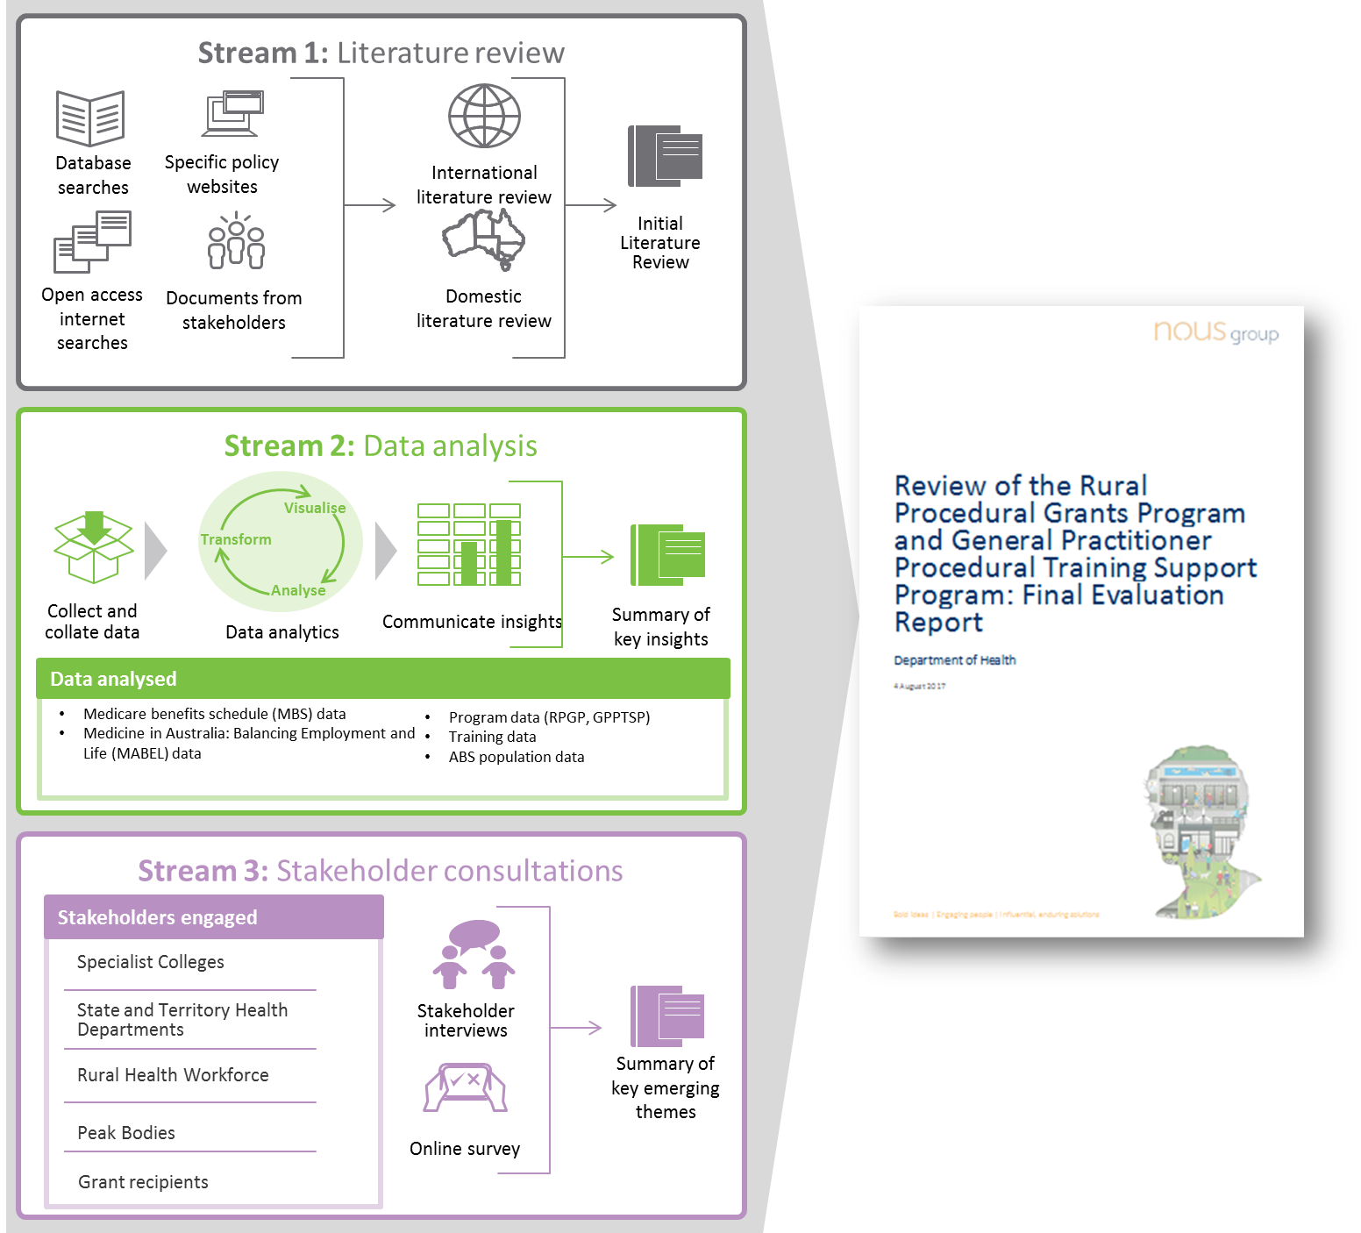

* 1. Stream 1 | Literature Review

Nous developed a Literature Review Strategy with a clear search methodology and inclusion/exclusion criteria for the Literature Review that was agreed with the DoH. The Literature Review investigated both domestic and international rural health workforce initiatives and incentives, particularly those regarding rural workforce retention, education and training. The review included a domestic mapping of programs in Australia, at both Commonwealth and state/territory levels, and an international review of workforce retention programs in comparable countries.

Nous undertook a structured approach to identifying and prioritising peer-reviewed and grey literature found in databases, specific websites and open access internet searches for further in-depth review, as illustrated through Figure 33. Supporting documents provided by government departments, specialist colleges, and other relevant stakeholders were also included in the review. The prioritisation process and collection of key or supporting documentation resulted in more than 130 items for in-depth analysis. Appendix B provides a summary of the Literature Review findings.

Figure 33: Literature prioritisation

Figure 33: Literature prioritisation

* 1. Stream 2 | Data Analysis

Nous developed a Data Analysis Strategy to outline how quantitative analysis of specific datasets would provide evidence to support the Review findings. Nous analysed the available data in collaboration with the National Centre for Social and Economic Modelling (NATSEM) research team from the University of Canberra to assess the efficiency, effectiveness and appropriateness of the RPGP and GPPTSP. The approach and methodology for the data analysis was developed using the KLOEs outlined in Figure 31, and were agreed with the DoH. Key trends on the distribution of the GP workforce, spatial patterns of health care utilisation, and details of current activity in relation to the programs were assessed.

A range of data sources were used for quantitative analysis including:

* RPGP and GPPTSP data from the Department of Human Service and colleges
* Training data from the colleges
* ABS population data
* Medicare benefits schedule (MBS) data
* Medicine in Australia: Balancing Employment and Life (MABEL) data.

Appendix C provides a summary of findings from the data analysis research stream.

* 1. Stream 3 | Stakeholder Consultation

A detailed Stakeholder Engagement Plan was developed and agreed in consultation with the DoH, to identify key stakeholders, the key objectives and lines of enquiry, and the methods of engagement: consultation interviews and online surveys.

The consultations provided an important opportunity for many stakeholders to share their experiences, express their opinions, and be heard throughout the Review. The purpose of the stakeholder engagement was to obtain a deeper understanding of the RPGP and GPPTSP in terms of:

* Implementation, achievement of objectives and value for money.
* How these training programs relate to rural workforce needs and rural population and community priorities and needs.

Nous designed interview guides which were shared with stakeholders prior to the consultation following approval from the DoH. Whilst the interview guide provided direction in the consultations and ensured all aspects were covered, in practice, the interview was semi-structured to allow the stakeholder to lead the conversation based on their specific areas of interest and expertise. Nous conducted a range of face-to-face consultations and teleconferences.

Nous also designed and distributed two online surveys tailored for GPs receiving the RPGP and/or the GPPTSP and the peak bodies to ensure that all stakeholders have been given the opportunity to contribute.

Appendix E provides the full list of stakeholders who were engaged as part of this Review via the consultation interviews and/or the online survey.

Overall, the stakeholder consultation provided rich qualitative insight to inform how the programs under review could be better designed, delivered and integrated from a range of different stakeholders. Appendix D provides a summary of findings from the Stakeholder Consultation research stream.

1. Summary of the literature review

Nous conducted the Literature Review according to the Literature Review Strategy endorsed by the DoH. Domestic and international literature from a range of sources was included in the literature review. Literature was sourced from:

* Priority papers identified from specific databases and open access internet searches.
* Supporting documents provided by government departments and relevant stakeholders.
* Relevant policy and strategy documents from specific websites noted in the Literature Review Strategy.

The documents were analysed and summaries were tabulated in a document register. The evidence identified through the Literature Review was synthesised in the Final Literature Review report, and case studies of successful programs were also included such as the Queensland Rural Generalist Pathway (QRGP) Program and the Canadian Enrichment Program (EP). The document register and Final Literature Review report were provided to the DoH as separate documents. This Appendix provides a summary of the Literature Review findings, plus additional analysis completed on documentation obtained through the above sources, subsequent to the completion of the Literature Review research stream. This section is structured under the Review’s key lines of enquiry. Further detailed from the Literature Review can be found in the Initial Literature Review report.

* 1. Overall summary of findings from the literature review

The findings from the Literature Review have been summarised in Table 11 below, with links to the supporting evidence.

|  |  |  |
| --- | --- | --- |
|  | Findings and evidence summary | Associated references in Appendix G |
| 1 | Recruitment and retention challenges in the rural health workforce | |
|  | The maldistribution of Australia’s health care workforce, particularly procedural GPs, contributes to the development of a ‘health gradient’, with community health standards deteriorating with increasing degrees of community remoteness. This is despite the overall Australian health workforce doubling in recent years and the rate of growth being twice that of the population at one point. The lack of health professionals and specialists has therefore resulted in an estimated $3billion shortfall in rural health service provision to bring rural communities up to the general health standard. | 9, 25, 29, 30, 31, 37, 40, 56, 73, 74, 77, 100, 113, 140 |
|  | International medical graduates (IMGs) provide major relief to rural workforce shortages and currently represent an estimated 51% of rural GPs. They provide a valuable buffer for peaks in demand and have been associated with longer retention compared to the Australian medical graduates, however they are still a short-term solution in large part and have associated challenges. As attraction and recruitment of rural and remote practitioners is a common challenge across Australia, reliance on IMGs will likely continue until workforce dynamics change dramatically. | 19, 28, 36, 80, 81, 118, 139 |
|  | The absolute number of rural proceduralists has not changed significantly in almost 15 years, while the number of GPs practicing in rural and remote areas has roughly doubled. This reflects a shift in patterns of traditional rural general practice, including the growing tendency towards specialisation and sub-specialisation for new graduates. | 1, 18, 31, 36, 37, 70, 79, 83, 99, 114 |
|  | Retention of the rural medical workforce is five times cheaper than recruitment, and allows effective workforce planning. There has been strong investment in attraction and recruitment efforts to date. | 9, 70, 118 |
|  | Workforce programs with objectives to improve long term retention have not clearly demonstrated impact (RPGP and GPPTSP are examples). Direct financial incentives (income supplements) aimed at retention have relatively little impact on outcomes given the personal, social, cultural and professional factors that influence GP decisions to practice in rural and remote areas. | 9, 77, 81, 111 |
|  | There is some evidence to indicate that two to five years is an appropriate retention timeframe for primary health care retention (doctors, nurses, mental health workers), with further evidence suggesting procedural GPs are more likely to remain in the rural workforce than non-procedural GPs. | 1, 19, 116, 119 |
| 2 | GP skills maintenance and upskilling to meet rural community health needs | |
|  | It is critical for rural GPs to maintain and further develop their skills. The range of skills required for effective rural practice is broad, and includes procedural and non-procedural skills in areas such as palliative care, mental health, chronic disease management and paediatrics. In rural areas, limited support services places more weight on the skills of the GP. | 8, 76, 115, 126, 138 |
|  | Evidence suggests there may be misalignment between the skills that are most commonly acquired and those that are most commonly practised in rural communities. For example, while most GPs that obtain training continue to practise their acquired skills following their return to their primary area of practice, there is a notable drop-out rate for those who trained in anaesthetics and obstetrics. | 126 |
| 3 | Global, national and state rural health workforce policy | |
|  | WHO has developed guidance on rural health service provision, pointing towards the need for a multifaceted set of interventions across education, regulation, financial incentives and support for personal and professional development. Internationally, many other countries have introduced rural workforce strategies to tackle similar problems to Australia. | 84, 85, 112, 124, 131, 132, 141, 145 |
|  | Multifaceted and integrated initiatives and programs achieve better rural retention results than stand-alone programs, or a combination of seemingly complementary programs. | 144 |
|  | There is a long standing government commitment at Commonwealth and jurisdictional levels to improve the rural health workforce, with numerous strategies developed. The monitoring and evaluation of policy implementation has been limited. | 2, 3, 25, 27, 29, 33, 42, 58, 59, 86, 87, 89, 90, 91, 92, 94, 95, 96, 97, 120, 121, 122, 123, 134, 135, 136, 142, 143 |
|  | The overall strength of evidence for upskilling, training and retention program evaluation is limited. Evidence notes a need for Australian training providers to report on, and be accountable for, their rural workforce outcomes through the introduction of measures such as the rural retention rate. | 69 |
| 4 | Rural health care workforce programs across Australia | |
|  | Initial mapping suggests over 100 rural workforce retention or upskilling programs are currently in place in Australia, either through the Commonwealth or the jurisdictional governments. Approximately two-thirds are aimed at GPs or trainees. | *Insights drawn from Nous’ preliminary analysis of available Commonwealth and jurisdictional-level rural health care workforce programs. Please see* ***Appendix F*** *for the full list of relevant programs* |
|  | While the RPGP and GPPTSP are the only Commonwealth programs of their type, there is overlap with a number of programs available in some (but not all) jurisdictions. |
|  | Australian programs aimed at upskilling are mostly designed as distinct to programs aimed at retention. However both types of programs are intended to support supply of a skilled workforce to rural areas. |
| 5 | Learnings from other comparable rural workforce programs and initiatives | |
|  | There is some evidence from previous reviews that the RPGP is meeting its stated objectives for skills maintenance (70% of eligible GPs at the time of review accessed this funding stream for professional development), and the program has strong support from RPGP recipients. | 1, 4, 22 |
|  | The GPPTSP is supporting approximately 50 GPs a year in both obstetrics and anaesthetics advanced skills, and the program has strong professional buy-in. | 34, 63 |
|  | Well established evidence indicates holistic approaches that address social drivers of retention increase attraction, recruitment and retention of rural GPs. It is often the overall ‘package’ which will determine decisions to take up a rural position and remain there. | 5, 20, 63, 64, 76, 77, 81, 93, 111, 130, 137 |
|  | Rural-origin GPs are more likely to practice in, and return to, rural settings. | 77, 80, 81, 82, 98, 124 |
|  | There is good evidence on the benefits of medical schools offering undergraduate and postgraduate placements training, in a rural setting, on rural workforce retention. | 18, 29, 40, 64, 77, 81, 82, 98, 133, 134, 137 |
|  | It is possible that the targeting of incentives may not be weighted to the most rural and remote locations. The Enrichment Program in Canada requires written support from the regional or zone medical director, which can be used as additional documentation to ensure that the GP applicants work in rural/remote practice. | 66 |
|  | Bonded programs (scholarships, medical placements) have not been effective beyond the nominated obligation period in Australia. Strategies need to be contextually relevant e.g. in 'hostile' environments the average length of retention may be shorter and emphasis should be placed on optimising tenure and ensuring that replacements exist. | 36, 78, 115, 117, 126 |
|  | The Queensland Rural Generalist Pathway provides good evidence of success, producing an increasing number of rural practitioners, and key features include:  Clear vocational pathway to general practice.  Advanced training skills in Indigenous health, mental health, paediatrics, obstetrics, gynaecology, surgery, adult internal medicine, anaesthetics or emergency medicine.  Rural placements in rural hospitals.  Likely Fellowship of the Australian College of Rural and Remote Medicine (FACRRM) and/or Fellowship of the Royal Australian College of General Practitioners (FRACGP) plus Fellowship in Advanced Rural General Practice (FARGP). | 9, 41, 65, 69, 88, 110 |

* 1. Are the intended program outcomes being achieved?
     1. Do the programs meet the stated policy objectives?

As discussed in Sections 1.1and 1.2, the policy objectives of the RPGP and the GPPTSP are to improve rural health care service delivery and workforce retention, and maternity services upskilling respectively. These have been detailed further in Figure 34.

Figure 34: Policy objectives of the RPGP/GPPTSP

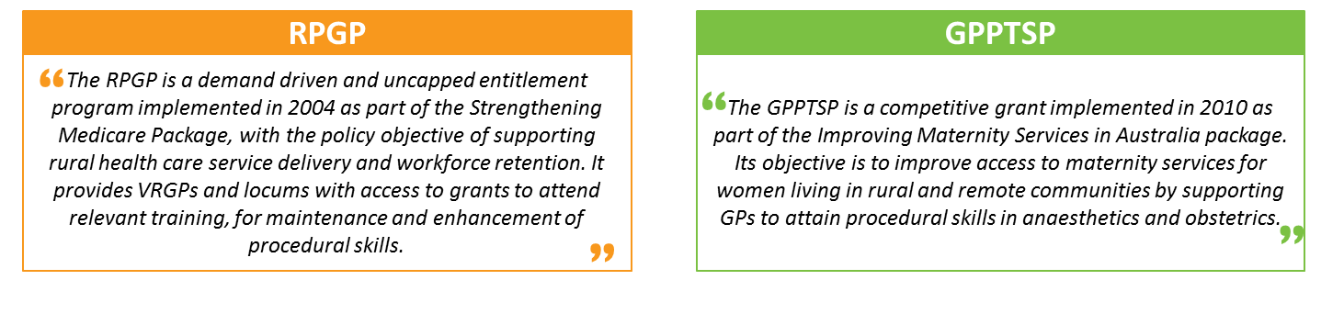

Source: Commonwealth of Australia (2017). Senate estimates for procedural training programs: Rural Procedural Grants Program (RPGP) and General Practitioner Procedural Training Support Program (GPPTSP), *Department of Health*, Canberra

Previous reviews of the RPGP and GPPTSP have highlighted their relative success at achieving skills maintenance and retention (see Section 2). However, both have heavily relied on the responses from surveys and consultations with rural GPs, many of which may have been grant recipients, and successful retention has been identified by the percentage of GPs self-reporting their intent to stay in rural areas long term. It is therefore difficult to determine the individual success of each program at achieving large scale objectives such as improved health service delivery and workforce retention, particularly in context of ongoing health workforce maldistribution and the health gradient evident in rural communities. This is also in context of other studies such as the Mason Review, which have highlighted that while financial support provided through incentives appear to support GPs, to maintain and retain advanced skills to meet continual professional development (CPD) requirements, the financial support itself may not necessarily provide incentive to upskill or retain GPs in rural areas.

Questions also arise regarding the clarity of the policy objectives themselves. While they are clearly defined per the documentation for Senate estimates,55 as noted in Figure 34, they are less so in the publically available program guidelines. For the RPGP in particular, the policy objective is currently stated as to provide financial assistance to access activities that assist GPs to maintain or update their skills. Given this objective, with no clear mention of rural health service delivery or retention, one could infer that that achievement of objectives merely requires funding expenditure, which the RPGP has clearly achieved to date. Further, while the RPGP program guidelines state that funds can be used to cover the costs of training including course costs, locum relief and travel expenses, there is no such mention in the GPPTSP program guidelines.

However, the limitations of individual grants to achieve these large scale objectives have been documented globally. The WHO is explicit in their position that a combination of initiatives around education, regulation, financial incentives and personal and professional support is necessary for greater achievement of results (discussed further in Appendix B.4.1).

|  |  |
| --- | --- |
|  | Conclusion |
| * Previous reviews found that the RPGP and the GPPTSP have been relatively successful in achieving skills maintenance and retention, though these conclusions have been heavily reliant on survey responses and consultations with rural GPs who may have been grant recipients. * The policy objectives currently lack clarity and consistency of documentation, which complicates the evaluation of program success. * Individual grants have had limited success across the world at achieving improved health service delivery and workforce retention, and a combination or portfolio of initiatives addressing social drivers is necessary. | |

* 1. Is the design of the RPGP and GPPTSP appropriate?
     1. Does the RPGP/GPPTSP build on, duplicate, or integrate with other rural health workforce programs run by the Commonwealth or other jurisdictions?

As described in Section 1.3, the Literature Review identified 108 programs and incentives across Australia designed to support primary health care in rural and remote communities. Of these, 25 Commonwealth programs and 39 jurisdictional programs were found to be current, relevant for rural GPs, specialists and GP registrars, and targeted towards rural workforce retention or upskilling (see Appendix F for further detail on the relevant programs).*[16]*

With the growing awareness of the maldistribution of the health workforce across metropolitan and rural areas, the Commonwealth and jurisdictions have continued to introduce new rural workforce initiatives focused on improving access to, and quality of, health care services in rural and remote areas. However, these programs do not seem to integrate with other programs, but rather work in silos.

##### Commonwealth rural workforce programs

The Literature Review found limited evidence of duplication between the RPGP/GPPTSP and other rural workforce programs run by the Commonwealth. In addition to the RPGP and GPPTSP, there were four other ongoing Commonwealth funded programs that provided support for training in the procedural areas of obstetrics, anaesthetics, emergency medicine and surgery. However, further examination of these four programs in terms of their relevance to rural GPs revealed that:

* Although the **Australian General Practice Training (AGPT) Program** offers training positions under the Rural or General Pathway, the program provides vocational training opportunities for medical graduates who are specialising in general practice and working towards their Fellowship. As the two programs under review are intended for established GPs, there appears to be no duplication. However, stakeholders have suggested that a significant proportion of GPPTSP recipients appear to be GP registrars/doctors in training.
* The **Remote Vocational Training Scheme (RVTS)** offers an alternative pathway for remote GP registrars working towards their Fellowship by providing training opportunities via distance education and remote supervision. This gives the registrars opportunities to practice in remote locations while training. Similar to the AGPT, as the RVTS is targeted at GP registrars, there appears to be no duplication with the RPGP and GPPTSP.
* Different from the RPGP and GPPTSP, where financial support is provided directly to the GP, the **Practice Incentives Program (PIP) Procedural GP Payments** provide funds to anaesthetics, surgery and/or obstetric practices. This is intended for the practices to purchase new equipment, upgrade facilities or increase remuneration for GPs working at the practice to better enhance primary health care outcomes.
* While the **Specialist Training Program (STP)** provides placement and specialist training opportunities for registrars and trainees within rural clinics (who may or may not continue to practice rurally), it does not provide any specialist training or placement opportunities to those currently practicing as GPs in rural areas. Therefore, the program provides no specific upskilling benefit to GPs themselves and is not a significant motivator of retention for this group.

Financial support provided through the RPGP grant is “designed to assist with the cost of attending training, including course costs, locum relief and travel expenses".[17] Although the RPGP covers the cost for locum support, both the **Rural Locum Assistance Program (Rural LAP)** and **the Rural Locum Relief Program (RLRP)** provide financial assistance to further assist GPs to source locum support and incentivise other doctors to work in rural and remote areas to provide relief to GPs. Depending on the difference in cost to relieve procedural GPs compared against GPs, there appears to be overlap between the RPGP and RLRP and Rural LAP.

There is potential for future overlap with the introduction of the **Health Workforce Scholarship Program (HWSP)** from 2017-2020.45 The newly developed program will streamline a number of smaller health workforce programs and aim to increase the capacity, skills and scope of practice of health professionals in medicine, nursing and allied health to better assist communities in rural and remote areas. Similar to the RPGP and GPPTSP, the program will provide financial support to rural professionals to participate in training programs for skills development and upskilling. However, in contrast to the two programs under review, the HWSP will:

* Target postgraduate health practitioners and rural professionals in the field of medicine, nursing or allied health.
* Aim to support training courses that could include, but not are limited to, the procedural skills areas of obstetrics, anaesthetics, emergency medicine and surgery.
* Provide at most $10,000 per year for a maximum of two years to undertake further postgraduate study, or a one-off bursary payment to cover training fees.

##### Jurisdictional rural workforce programs

The Review also analysed the jurisdictional rural health workforce programs against the four procedural skills areas relevant to the RPGP and GPPTSP (see below in Table 12). Through the comparison it became evident that seven out of 39 programs exhibited some degree of overlap, of which four demonstrated obvious overlap in terms of skill focus with the RPGP and the GPPTSP (10% of all relevant jurisdictional programs examined). These programs include the NSW Rural General Practice Procedural Training Program (New South Wales), REAPS program (Victoria), the Consolidation of Skills Program (Victoria) and the newly developed Rural Doctors Upskilling Program (Queensland). As the programs under review are intended for GPs, jurisdictional Rural Generalist Pathway programs were excluded from further analysis because of their focus on medical students and trainees.

It is apparent that GPs in New South Wales and Victoria would have greater opportunities to access multiple sources of funding when maintaining or developing skills in the four procedural areas, particularly in emergency medicine and surgery. This may be appropriate given the demand for emergency services in rural areas, with more than 60% of GPs indicating it to be a relevant skill for rural practice.126 Although there is an overlap with a number of programs available in some jurisdictions, the RPGP and GPPTSP serve an important role in providing rural GPs with opportunities to pursue proceduralist training and upskilling in procedural areas outside New South Wales, Victoria and Queensland and across Australia as a whole.

Table 12: Comparison of relevant jurisdictional programs that provide rural GPs with training in the four procedural skills areas

|  |  |  |  |  |
| --- | --- | --- | --- | --- |
|  | Obstetrics | Anaesthetics | Emergency Medicine | Surgery |
| **RPGP** (Commonwealth) | ✓ | ✓ | ✓ | ✓ |
| **GPPTSP** (Commonwealth) | ✓ | ✓ |  |  |
| **Rural Emergency Skills Training** (**REST) Course (cross-jurisdictional)** |  |  | ✓ |  |
| **NSW Rural General Practice Procedural Training Program** (New South Wales) | ✓ | ✓ | ✓ | ✓ |
| **Consolidation of Skills Program** (Victoria) | ✓ | ✓ | ✓ | ✓ |
| **Medical Professional Development Subsidy Program** (Victoria) |  |  | ✓ | ✓ |
| **Rural Extended and Advanced Procedural Skills (REAPS) program** (Victoria) | ✓ | ✓ | ✓ | ✓ |
| **Rural Doctors Upskilling Program** (Queensland) – *in development* | ✓ | ✓ | ✓ | ✓ |
| **District Medical Workforce Investment Program** (Western Australia) |  |  | ✓ |  |

The Review also appreciates the impending development of the National Rural Generalist Pathway Program,42 which could create further overlap when it is developed and launched across the states and territories.

|  |  |
| --- | --- |
|  | Conclusion |
| * The RPGP and GPPTSP build on, and add to, the suite of rural health workforce programs available, however they do not integrate effectively. The iterative, ad hoc program development, lack of alignment with global evaluation strategies and the unclear links to stated policy objectives (see Section B.2.1) provides evidence that the current programs under review do not integrate with other Commonwealth and jurisdictional rural workforce retention and upskilling programs. That said there was no evidence to suggest that the RPGP and GPPTSP directly conflicted with other existing programs. * Currently, there is no duplication at the Commonwealth level, however there is potential for future overlap with the introduction of the Health Workforce Scholarship grants for 2017-2020. * At a jurisdictional level, there is duplication in procedural skill training support with other rural workforce programs providing training support for the four procedural skills areas in NSW, Victoria and Queensland. * There seems to be duplication in the financial support provided to locums at a national and jurisdictional level. Although the RPGP grant can be used towards costs for locum support, locums are also supported through the DoH’s RLRP and Rural LAP, as well as jurisdictional programs such as Queensland’s Relieving Doctors Program and South Australia’s Rural GP Locum Program. | |

* + 1. Is the amount of money appropriate, given the broader context of other incentives, initiatives and programs?

The Commonwealth and jurisdictional program mapping (see Section 1.3) provides evidence for different levels of financial support provided through rural workforce retention and upskilling programs across jurisdictions. For example, Queensland and Victoria have a broader range of programs supporting the rural health workforce, whilst the Northern Territory and Western Australia have minimal programs other than the RPGP and GPPTSP.

Although the GPPTSP may contribute to the increase in service delivery in rural and regional Australia,77 there is a suggestion by RANZCOG through their Funding Proposal (2014) that the $40,000 p.a. provided through the GPPTSP is not sufficient. They proposed the financial support provided was insufficient to cover the costs of recruiting locum staff, ongoing costs of running their practice and travelling to the training sites for the duration of their training, which is usually between 6 and 12 months.102 However, there was limited evidence to further substantiate this view.

As previously mentioned in Section 1, the RPGP grant administers $2,000 a day for up to 10 days training for procedural GPs, or for up to three days training for GPs providing hospital-based emergency services. The Literature Review has found limited evidence to determine whether this amount is appropriate, given the broader context of Commonwealth and jurisdictional programs and incentives available.

Considering the procedural overlap of the two programs however, this does mean that a GP wanting to study anaesthetics or obstetrics could theoretically receive a maximum of $60,000 by studying for either the Advanced Rural Skills Training in Anaesthesia or the DRANZCOG Advanced. Further, with no mechanisms in place to prevent a GP from applying to more than one grant at a time for the same training program, this implies that a GP could theoretically receive up to $160,000 depending on their state of residence by applying to the various jurisdictional grants programs available.

Further evidence is provided in Section D.4.2 through the stakeholder consultation.

|  |  |
| --- | --- |
|  | Conclusion |
| There is no substantive evidence to indicate whether the financial support provided through the RPGP and/or GPPTSP is appropriate, given the broader support available through other incentives, initiatives and programs. | |

* + 1. Does the literature identify comparable programs elsewhere, what are the similarities and differences, and how do they relate to the Australian experience?

While Australia faces unique geographic and access challenges in its rural health service delivery, the literature has identified comparable rural health programs in Canada, the US and Japan. These include Jichi Medical University’s bonded medical training program in Japan78 and the EP implemented as part of Alberta’s Rural Physician Action Plan in Canada,66 both of which are detailed in the literature review report. Both of these programs target retention of rural GPs, and the EP in particular applies to the disciplines of obstetrics, emergency medicine and epidural anaesthesia among others.

Differences in effectiveness do exist however, depending on the country in which the program was applied. Compulsory return of service requirements provides a useful case study, as they have not been effective beyond the nominated obligation period in Australia.115 However in Japan, JMU’s program which has a return of service timeframe far longer than those in Australia has led to 50% of graduates remaining in rural areas after completing their obligatory services.78

Strategies therefore must be contextually relevant, for example in 'hostile' environments with longer working hours, frequent on-call requirements and difficulty in sourcing locum relief, the average length of retention may be shorter and emphasis should be placed on optimising tenure and ensuring that replacements exist.81

|  |  |
| --- | --- |
|  | Conclusion |
| Successful and comparable international programs have been identified, however the Australian rural environment is unique and diverse, and direct and effective application is unlikely without evidence-based review and tailoring for the Australian experience. | |

* 1. How could outcomes be further improved?
     1. How can the RPGP/GPPTSP draw from the learnings of other comparable rural workforce policy, programs and initiatives?

Financial incentives have been the centrepiece of the government’s health workforce strategy to date.77 While they are welcomed by rural GPs, many domestic studies have revealed that financial incentives alone are not sufficient to meet the needs of GPs, with a recent study highlighting that 65% of GPs would not consider relocating regardless of the amount of financial incentive provided.81 While still important, it is the total rural work experience including non-remunerative benefits, i.e. the personal, professional, social, and cultural benefits, which inform a GP’s decision making around recruitment and retention.64

In line with these findings, the WHO has developed global policy recommendations to increase access to health workers in remote and rural areas through improved attraction, recruitment, retention, education and professional development opportunities. The WHO outline that better results are achieved by implementing holistic programs that combine initiatives across the following categories: education, regulation, financial incentives, and support for personal and professional development. Specifically, in terms of sustainable financial incentives, WHO recommend measures beyond income supplementation, such as hardship allowances, housing grants, support for transportation and paid holiday time.144 Other examples include cheaper car loans and access to better schools for the children of rural GPs. Scholarships and education subsidies are classified as regulatory interventions, and the WHO recommends they have compulsory service requirements in rural and remote areas.5

There is also strong evidence from domestic and international literature that GPs of rural origin are more likely to pursue a long-term career in rural health.77, 79, 82 Figure 35 quantifies the increase in rural retention rates reported through analysis of MABEL survey results.81 The literature explains this correlation through the GP’s connection with the rural community developed through the extended periods of time spent there. In principle, this will ensure a baseload number of procedural GPs are maintained in rural areas to achieve a minimum level of rural health care service delivery.

However GPs of rural origin are not by themselves sufficient to service rural health needs. Statistics show that this cohort only makes up 37% of Australian-trained medical graduates (AMGs) working as rural GPs.80 Therefore, GPs of metropolitan backgrounds with vocational training experience in rural areas could be targeted in principle through mandatory return of service requirements. Similar to rural-origin GPs, the literature highlights that this cohort has a higher likelihood of returning to the region which they trained for a period of at least five years, as shown in Figure 35. This is attributed to the awareness of the rural health situation through early exposure in their medical career.77

Figure 35: MABEL statistics from survey responses

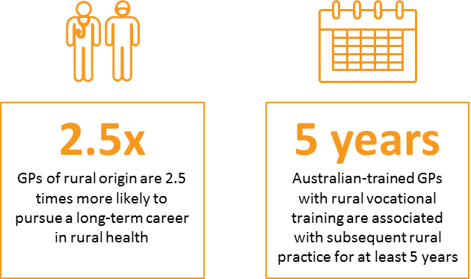

The Rural Clinical Schools (RCS) Program and the Australian General Practice Training (AGPT) Program are successful examples of implementing similar provisions (although they focus on undergraduate medical students). Both programs currently have a minimum quota for placements: the RCS requires 25% of students to undertake at least 12 months of clinical training in rural communities, and the AGPT requires that at least 50% of training placements are conducted in rural areas.82 Some of the specialist Colleges also reported they were exploring opportunities to ensure more trainees and registrars undertake their training in rural areas.

Successful programs at the jurisdictional and international level have also implemented mechanisms for continuous monitoring and program-level evaluation to generate accountability and facilitate modelling. For example, the NSW Ministry of Health publishes a progress report providing evidence of building and retaining an effective, well-trained workforce. One key performance indicator is the introduction of five new Rural Generalist Medical Training positions every year, for four years.92 Other countries have also implemented rigorous program-level evaluation on workforce and community impact, using mechanisms such as a rural retention rate to measure performance.69

|  |  |
| --- | --- |
|  | Conclusion |
| * Complementary programs and incentives should be purposefully designed to be holistic and address social drivers that influence rural retention. Well established evidence indicates holistic approaches that address social drivers of retention, increases attraction and retention of rural GPs. It is often the overall ‘package’ which will determine decisions to take up a rural position and remain there. * Multifaceted retention strategies should be designed where modifiable factors are addressed directly (e.g. types of training to be provided), while less modifiable factors are financially compensated for (hardships related to remoteness, etc.). * Mechanisms for monitoring and evaluation of policy effectiveness should be established and maintained for current and future programs. | |

* + 1. Are the needs of communities addressed by the focus of these programs or should a range of alternative skills and procedural training be considered?

Health professionals with a wide scope of practice are necessary to service the broad spectrum of community health demands, and procedural GPs have played an integral part in delivering care, especially in rural areas. To provide rural communities with access to quality health care, the rural health workforce must maintain their skills and upskill appropriately. Ongoing support is also necessary at each stage of the training process.

According to a survey conducted by the RACGP, emergency medicine, mental health and chronic disease management are the most commonly acquired and practised advanced skills in rural areas, as evident through Table 13. However, after the top three skills, discrepancies begin to emerge. Overall, the skills demanded by rural communities can be said to extend well beyond the scope of the current procedural emphasis of the RPGP and GPPTSP and an opportunity emerges to better meet community needs. However, no evidence was found beyond this paper, and therefore further research will be necessary to understand whether the RPGP and GPPTSP meet rural community health needs.

Table 13: Most commonly acquired and practised skills

|  |  |  |  |  |
| --- | --- | --- | --- | --- |
| Rank | Most commonly acquired skills | % | Most commonly practised skills | % |
| **1** | Emergency medicine |  | Mental health |  |
| **2** | Mental health |  | Emergency medicine |  |
| **3** | Chronic disease management |  | Chronic disease management |  |
| **4** | Obstetrics |  | Paediatrics |  |
| **5** | Paediatrics |  | Aged care |  |
| **6** | Small town rural general practice |  | Small town rural general practice |  |
| **7** | Aboriginal & Torres Strait Islander health |  | Aboriginal & Torres Strait Islander health |  |
| **8** | Palliative care |  | Palliative care |  |
| **9** | Aged care |  | Internal medicine |  |
| **10** | Internal medicine |  | Obstetrics |  |

Source: Appropriated from Table 3 of The Royal Australian College of General Practitioners (2014). New approaches to integrated rural training for medical practitioners, *The Royal Australian College of General Practitioners*, East Melbourne[18]

|  |  |
| --- | --- |
|  | Conclusion |
| * One paper cites emergency medicine, mental health and chronic disease management as the top three most commonly acquired and practiced skills. * There is limited evidence from the published and grey literature to suggest that the needs of communities are addressed by the focus of the RPGP/GPPTSP, or whether a range of alternative skills and procedural training be considered. | |

* + 1. Could better outcomes be achieved within the same total program expenditure by adjusting the level of individual grants to participating doctors?

As previously mentioned in Section B.3.2, there is limited evidence from the Literature Review to determine whether the financial support provided through RPGP and GPPTSP are appropriate. There was no evidence identified from the literature review as to whether better outcomes could be achieved within the same total program expenditure with adjustment to the level of individual grants to participating doctors. RANZCOG suggested an increase of the current grant amount of $40,000 p.a. and decrease the number of grants administered to better incentivise the intended group of VRGPs from ACRRM or RACGP who practice in rural and remote areas.102 However, there was limited evidence to further support this proposal.

|  |  |
| --- | --- |
|  | Conclusion |
| There is limited evidence from the literature to suggest that better outcomes could be achieved within the same total program expenditure by adjusting the level of individual grants to participating GPs. | |

* + 1. Are the administration and governance arrangements the most efficient and appropriate to the streamlined implementation of these programs?

The application processes for the RPGP and GPPTSP are captured in the program logics from Figure 4 and Figure 5. The administrative responsibilities of each stakeholder are outlined in Figure 36.

Figure 36: Administrative responsibilities of key stakeholders for the RPGP/GPPTSP



Source: (1) Commonwealth of Australia (2017). Draft program logic GPPTSP (for panel members), *Department of Health*, Canberra; (2) Commonwealth of Australia (2017). Draft program logic RPGP (for panel members), *Department of Health*, Canberra; (3) The Royal Australian College of General Practitioners (2011). Rural Procedural Grants Program – Program Guidelines, *Department of Health and Ageing*, East Melbourne; (4) Australian College of Rural and Remote Medicine (2016). General Practitioner Procedural Training Support Program: Anaesthetics – Application guidelines, *Australian College of Rural and Remote Medicine*, Brisbane; (5) Royal Australian and New Zealand College of Obstetricians and Gynaecologists (2016). General Practitioner Procedural Training Support Program: Obstetrics – Application guidelines, *Royal Australian and New Zealand College of Obstetrics and Gynaecologists*, East Melbourne.

The Literature Review indicates that the RPGP’s simple and efficient administration is a key strength. An ACRRM/RACGP Procedural Medicine Collaboration report revealed that, while administration costs have been increasing in absolute terms, the joint administration costs of the RPGP as a percentage of total grant expenditure has been falling from a high of 6.8% in FY2004-05 to 2.9% in FY2014-15.1

This finding was supported by a review by the Allen Consulting Group, articulating that the ease, timeliness and generally strong governance processes in place for the RPGP were well endorsed by the GPs. However, issues are still present such as the lack of transparency in training course details as there is currently no central information source.4

|  |  |
| --- | --- |
|  | Conclusion |
| * The current administration process for the RPGP is low cost, and administration expenses have decreased as a portion of total grant expenditure to less than 3% (note: this does not take into consideration original DHS investment and infrastructure costs). * There is limited evidence from the published and grey literature on the administration and governance arrangements for the GPPTSP and whether they are the most efficient and appropriate to the streamlined implementation of the programs. | |

1. Summary of the data analysis

Throughout the Review, Nous collected and received data from the DoH, DHS, ACRRM, RACGP, RANZCOG, the Australian Bureau of Statistics, and the Centre for Research Excellence in Medical Workforce Dynamics for the RPGP and the GPPTSP. Specifically, the data included:

* Program data for both programs
* MBS data
* MABEL data
* ABS population data

Using these sources, Nous and the University of Canberra NATSEM team conducted analyses to quantitatively assess RPGP and GPPTSP outcomes against the agreed key lines of enquiry, in addition to developing useful insights for the purpose of informing the options for reform.

This Appendix provides a summary of the data analysis findings, drawing together insights from the various analyses performed to date. This section is structured under the Review’s key lines of enquiry.

* 1. Overall summary of findings from the data analysis

The findings from the data analysis have been summarised in Table 14 below.

Table 14: Summary of findings

| 1 | The RPGP and the GPPTSP are, to an extent, achieving their policy objectives |
| --- | --- |
|  | Retention of the FY2002-03 cohort of GPs that received the RPGP or the GPPTSP was higher than those that did not receive a grant.  GPs that received the RPGP or the GPPTSP are continuing to provide MBS billed procedural services with service delivery by grant recipients increasing by 87.57% comparing FY2002-03 services to FY2015-16 (noting a slight decrease over the past two financial years).  The GPPTSP has supported GPs to obtain procedural skills in anaesthetics and obstetrics. 161 GPs have been supported as of FY2015-16 to complete the advanced training.  A majority of those receiving GPPTSP funding are registrars and therefore the original intent of supporting VRGPs to provide maternity services in rural areas has been diluted. |
| 2 | **Specific community benefit from either program is difficult to demonstrate, however broad benefits are achieved** |
|  | 1,130 GPs undertook clinical attachments for an average 3.9 days using the RPGP between FY2009-10 and FY2016-17.  GP recipients appear to continue practice in their procedural discipline following training, given that the number of MBS claims by RPGP recipients did not fall between FY2002-03 to FY2015-16.  161 GPs completed the GPPTSP programs (76 in anaesthetics and 85 in obstetrics), which indicates that the communities in which the applicants returned to following their training now have access to these advanced skills from highly qualified GPs. However, the proportion of grants provided to registrars is significant, and given this, the sustainable community benefit is uncertain.  The majority of GPPTSP grants are allocated to GPs in MMM2-5, with some grants provided in more remote regions. |
| **3** | **There is opportunity to improve the program design of both the RPGP and the GPPTSP to better achieve policy objectives** |
|  | Overall, the proportion of budgeted GPPTSP funds allocated inclusive of carry forward surpluses from previous financial years and commitments not yet paid, have been decreasing since FY2011-12. However, ACCRM is increasing the proportion of budgeted funds allocated, while this proportion has been decreasing for RANZCOG.  Increasing the maximum funding per grant for the GPPTSP while maintaining the same overall budget may improve grant uptake by VRGPs to realign program outcomes with those originally intended. |
| **4** | **Quantitative evidence shows that both programs are administratively simple, though their overall cost effectiveness is not known** |
|  | The RPGP is administratively simple. While absolute administration costs have steadily risen, the administration cost per grant and the marginal administration cost per additional grant have fallen. The Review acknowledges that the original infrastructure investment to facilitate grant payments by the DHS was significant and has contributed to the ongoing administrative simplicity and low cost of the RPGP.  Direct causality between the RPGP program and improved health workforce retention could not be established. However given the higher retention rate of GPs that received the grant compared to those that did not, the grants are correlated with rural retention.  The GPPTSP is administratively simple, with fluctuations in costs possibly driven by changes in expenditure on recruitment, IT and marketing by RANZCOG. Overall administration expenditure per grant, the marginal cost of processing an additional grant, and the time taken to process a grant have all fallen since grant inception.  Provided administration costs for both programs remain constant, improvements to efficiency are likely to be small. |

* 1. Are the intended program outcomes being achieved?

The policy objectives of the RPGP and the GPPTSP are reproduced in Figure 37. While they have some overlap through the procedural anaesthetics and obstetrics focus, achievement of these objectives has been assessed independently for each program.

Figure 37: Policy objectives of the RPGP/GPPTSP



Source: Commonwealth of Australia (2017). Senate estimates for procedural training programs: Rural Procedural Grants Program (RPGP) and General Practitioner Procedural Training Support Program (GPPTSP), *Department of Health*, Canberra

Analysis of whether the two programs have successfully met their stated program objectives has been undertaken based on data available for the Review. The analysis is presented in the sections below.

* + 1. Do the programs meet the stated policy objectives?

RPGP policy objective – health workforce retention

According to data from the DoH, between FY2009-10 to FY2016-17:

* 1,082 GPs received RPGP funding under the procedural component
* 2,452 GPs received RPGP funding under the emergency medicine component.51

Analysis of rural GP retention was partially possible through analysing MBS claims data. Retention was assessed through the proxy of changes to the full-time service equivalents (FSE) in a MMM between financial years for GPs that did and did not receive grant funding through the RPGP between FY2002-05, benchmarked against FY2002-03 FSE levels as shown in Figure 38 below. [19] MBS claims data was available for the Review. This data has been used as a representative sample for GPs providing services for anaesthetics, obstetrics and surgery, and analysis is therefore limited to services billed privately (through the MBS and private health insurance). There is a risk of sample bias with this approach but this is not thought to be material.

Figure 38: Retention (measured by the proxy of changes in full-time service equivalents [FSE]) of the FY2002-05 cohort of RPGP recipients providing MBS billed health services



The above analysis suggests that for GPs providing MBS billed procedural health services through the MBS, there is a correlation between the longevity of stay in a MMM region and receipt of RPGP grant funding. However, it is difficult to determine causality regarding whether these GPs stayed in their MMM regions for longer as a result of obtaining an RPGP grant.

Breaking down the above analyses by MMM, evidence suggests a trend for GPs receiving a grant in more remote regions remaining in rural practice longer. This correlation is represented through the decline in total FSE from FY2002-03 to FY2015-16, benchmarked against FY2002-03 FSE, between the MMM regions analysed in Figure 39 and Figure 40. Retention in MMM2 is less for those receiving a grant, and a potential reason for this could be that MMM2 is mainly large cities, and these services are staffed by specialist anaesthetists and obstetricians so there is likely less need for GP proceduralists.

Figure 39: Retention of the FY2002-05 cohort of RPGP grant recipients in MMM1-3 providing MBS billed health services

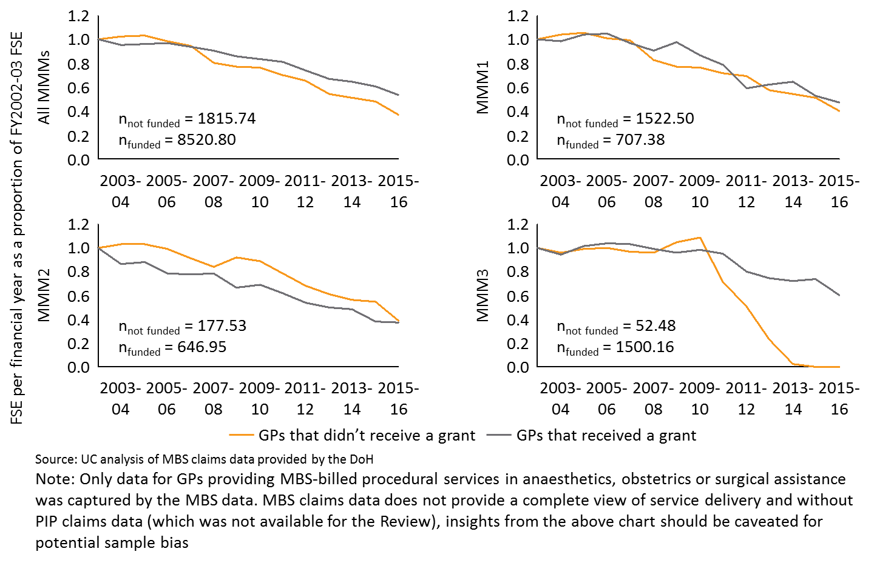

Figure 40: Retention of the FY2002-05 cohort of RPGP grant recipients in MMM4-7 providing MBS billed health services

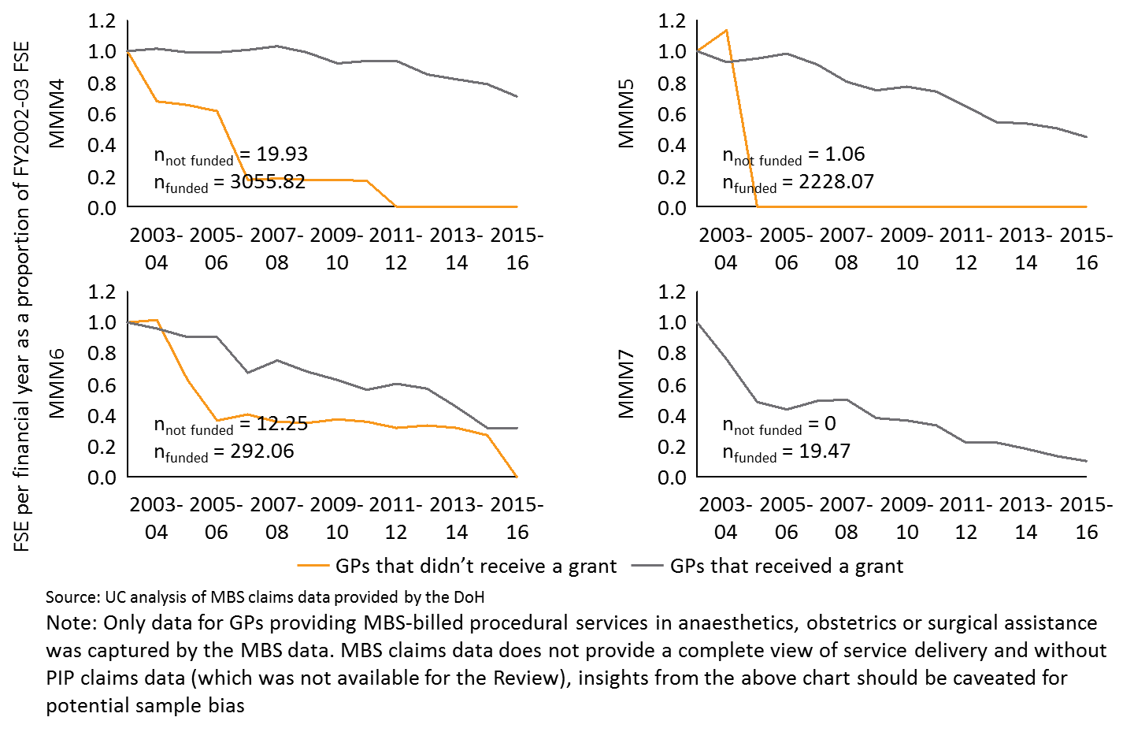

RPGP policy objective – health care service delivery

The RPGP aims to improve health care service delivery through retention of VRGPs receiving a grant. Analysis of MBS claims data, illustrated in Figure 41, tracks the absolute number of MBS billed procedural health services provided by RPGP or GPPTSP grant recipients, both inside and outside of hospitals. The analysis highlights that since FY2002-03, the absolute number of health services delivered by GPs that received either the RPGP or the GPPTSP has increased by 87.57% and from FY2004-05, service delivery has increased by 48.78%. Considering the relatively small number of grant recipients per year under the GPPTSP compared to the RPGP as shown in Table 5, it can be assumed that the majority of the health services depicted in the below chart are provided by RPGP recipients. Under this assumption, there are grounds to suggest RPGP recipients continue to provide MBS billed procedural services, and therefore the program is at least partially meeting its policy objective of sustaining service delivery.

Figure 41: Total MBS billed procedural health services provided by grant recipients by MMM



GPPTSP policy objective – supporting GPs to obtain procedural skills in anaesthetics and obstetrics

According to progress and selection report data from ACRRM10, 11 and RANZCOG103, 104, 105, between FY2010-11 to FY2015-16:

* 91 GPs received funding for the anaesthetics component (GPPTSP-A), of which 76 received full payment, and 15 received the first instalment[20].
* 146 GPs received funding for the obstetrics component (GPPTSP-O), of which 85 received full payment, and 61 received the first instalment[21].

Using the above figures, the GPPTSP supported 237 GPs to undertake advanced training in anaesthetics and obstetrics, of which 161 GPs had completed their training and a further 76 GPs were expected to complete their advanced training in the near future, as of FY2015-16. Therefore, if the current policy objective is taken as stated, i.e. to support GPs to obtain procedural skills in anaesthetics and obstetrics, the GPPTSP has met one of its policy objectives.

GPPTSP policy objective – improve access to maternity services for rural communities

College data tabulated in Table 15 highlights that a high majority of grant recipients were registrars, and the portion of grants claimed by VRGPs has fallen since inception, with the exception of 2015. Further, analysis in Figure 42 highlights that 78% of grants allocated to registrars were to those with training posts in ASGC-RA2-3 between 2014 and 2015. Therefore, although the program has been successful at increasing the absolute number of individuals completing advanced training, the program has arguably not facilitated access to maternity services in rural communities as registrars cannot yet undertake unsupervised procedures and given the high proportion of grants in less rural locations. It could be that future access to maternity services may improve when the registrars undertaking advanced training through the GPPTSP obtain VRGP status.

Table 15: Proportion and number of placements given to registrars

|  |  |  |  |  |  |  |
| --- | --- | --- | --- | --- | --- | --- |
|  | GPPTSP-A | | | GPPTSP-O | | |
| **Year** | Registrars | Fellows | Not Identified | Registrars | Fellows | Not identified |
| **2010** | 30.00% (3) | 50.00% (5) | 20.00% (2) | Not available | Not available | 100.00% (31) |
| **2011** | 40.00% (4) | 40.00% (4) | 20.00% (2) | Not available | Not available | 100.00% (26) |
| **2012** | 54.17% (13) | 41.67% (10) | 4.16% (1) | Not available | Not available | 100.00% (40) |
| **2013** | 84.62% (11) | 7.69% (1) | 7.69% (1) | Not available | Not available | 100.00% (26) |
| **2014** | 94.12% (16) | 5.88% (1) | 0.00% (0) | 75.76% (25) | 24.24% (8) | 0.00% (0) |
| **2015** | 64.71% (11) | 29.41% (5) | 5.88% (1) | 70.97% (22) | 29.03% (9) | 0.00% (0) |
| **AVERAGE** | 61.27% (10) | 29.11% (4) | 9.62% (1) | 73.36% (24) | 26.64% (9) | 66.67% (21) |

Source: Australian College of Rural and Remote Medicine (2017). GPPTSP-A program data requested for the purpose of the Review, *Australian College of Rural and Remote Medicine*, Brisbane; Royal Australian and New Zealand College of Obstetricians and Gynaecologists (2017). GPPTSP-O program data provided for the purposes of the Review, *Royal Australian and New Zealand College of Obstetricians and Gynaecologists*, East Melbourne

Note: Analysis of registrar by ASGC – RA is found below in Figure 4

Figure 42: Distribution of registrars by RA between FY2013-14 to FY2015-16



|  |  |
| --- | --- |
|  | Conclusion |
| * Retention of the FY2002-05 cohort of GPs that received the RPGP or the GPPTSP was higher than those that did not receive a grant * GPs that received the RPGP or the GPPTSP are continuing to provide procedural services, with service delivery by this cohort inside and outside of hospitals increasing by 87.57% from FY2002-03 to FY2015-16 despite a slight decrease over the past two financial years. * The GPPTSP has supported GPs to obtain procedural skills in anaesthetics and obstetrics. 161 GPs have been supported as of 2015 to complete the advanced training. * A majority of those receiving GPPTSP funding are registrars and therefore the original intent of supporting VRGPs to provide maternity services in rural areas has been diluted. | |

* + 1. Is there evidence that communities benefit from these programs?

The analysis detailed below has assessed whether each program delivers community benefits beyond those directly targeted through their policy objectives. Quantitative analysis of program outcomes against policy objectives has been undertaken in Section C.2.1.

RPGP

Analysis of DoH RPGP data51 reveals that 1,130 GPs undertook clinical attachments between FY2009-10 to FY2016-17 with each attachment lasting for an average 3.91 days.[22] The data also highlights that 5,068 clinical attachments were undertaken as part of the RPGP between FY2009-10 to FY2016-17, and the average GP undertook 4.48 clinical attachments.51

One community benefit comes from GPs providing health services related to the discipline in which they trained under the RPGP. The charts in Figure 43 highlight that for all MMM regions, the number of MBS claims by RPGP recipients has generally increased from the years prior to RPGP implementation.

Figure 43: MBS claims by RPGP recipients by MMM

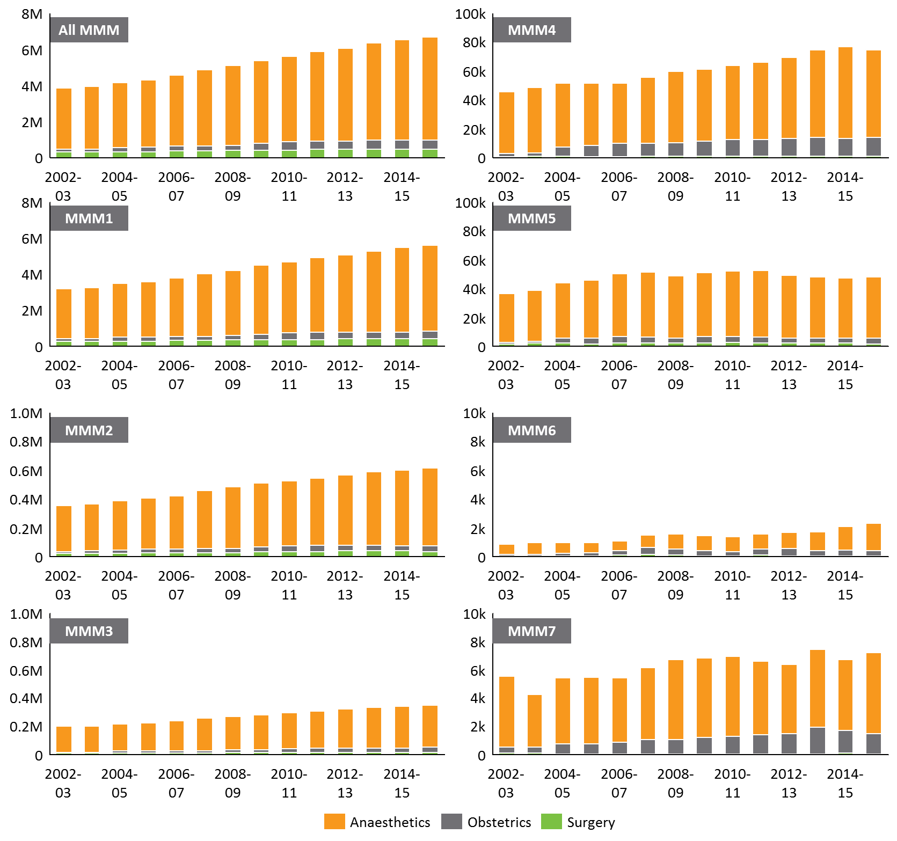

*Source: UC analysis of MBS claims data provided by the DoH for RPGP program recipients*

GPPTSP

GPPTSP recipients must complete the Advanced Rural Skills Training in Anaesthesia or the DRANZCOG Advanced depending on the component in which the applicant applied (see Section 1.2). Both are accredited by medical colleges (ANZCA, RACGP and ACRRM for the former, and RANZCOG for the latter). Assessment of the number of training completions provides a view of the number of newly college-accredited GPs with advanced skills in anaesthetics and obstetrics. 161 GPs completed the program, with 76 in anaesthetics and 85 in obstetrics, which suggests the communities these GPs serve now have access to these advanced skills from highly qualified GPs. Figure 44 further highlights that this benefit across communities in all MMM regions. However, as mentioned in Appendix C.2.1, the proportion of grants provided to registrars is significant, and so the immediate community benefit is uncertain as retention data is not available for that cohort.

Figure 44: Distribution of GPPTSP grants by MMM and per capita

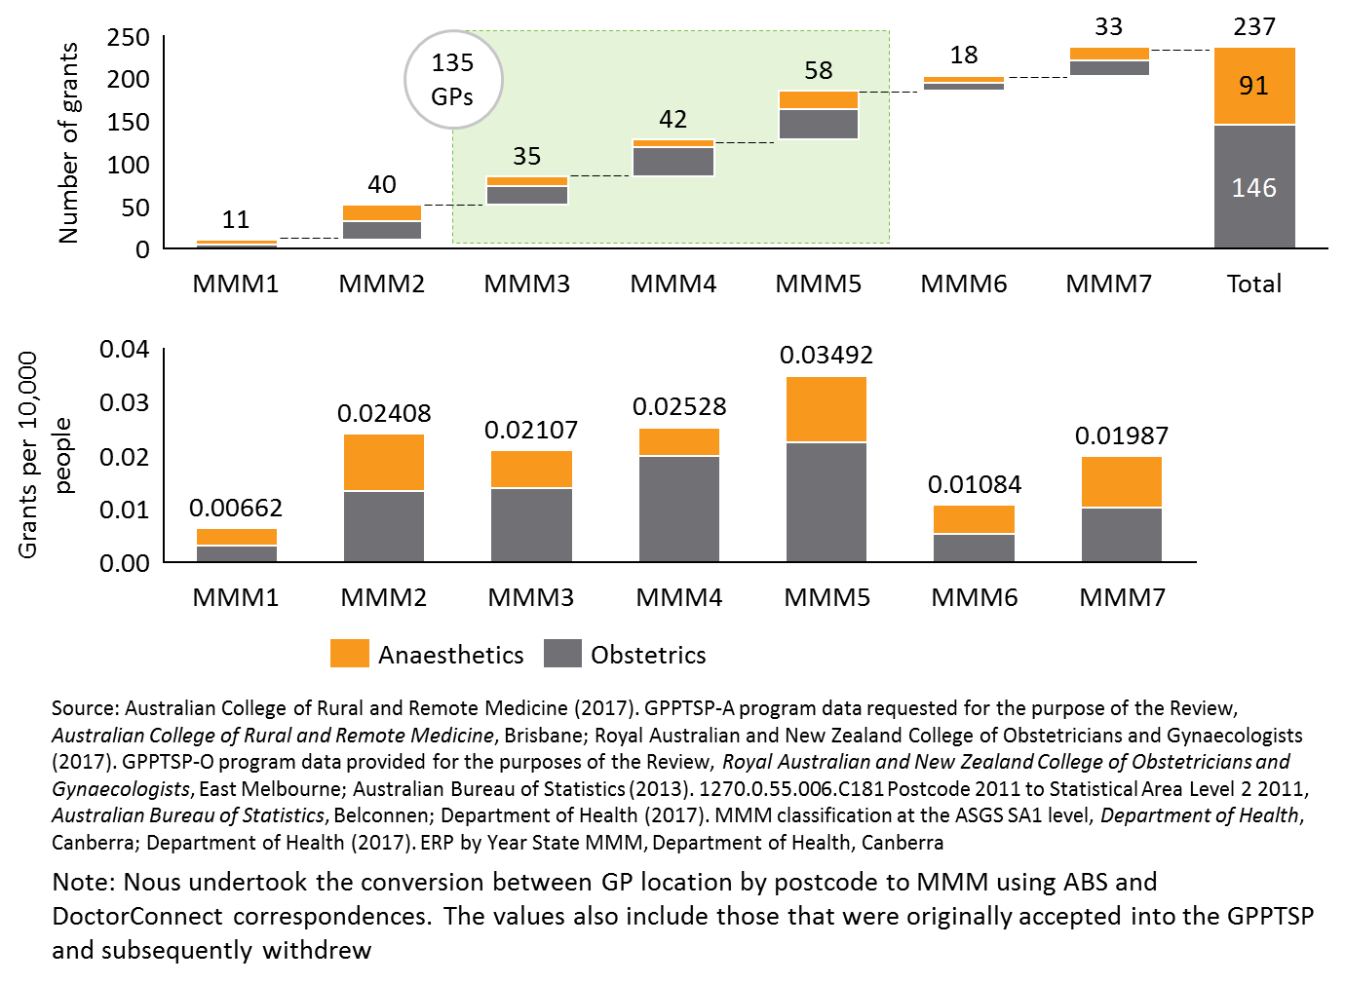

|  |  |
| --- | --- |
|  | Conclusion |
| * While difficult to quantify specific community benefits from both programs, rural communities may receive broad benefits. For the RPGP, these include continued health service delivery by GPs upon return to their primary area of practice. Under the GPPTSP, communities – including those very remote locations – appear to have benefited from access to GPs trained in advanced procedural anaesthetics and obstetrics. | |

* 1. Is the design of the RPGP and GPPTSP appropriate?

In relation to the design of the programs, quantitative analysis investigated the specific questions assigned through the key lines of enquiry. The findings are detailed in the respective sections below.

* + 1. Is the amount of money appropriate, given the broader context of other incentives, initiatives and programs?

|  |  |
| --- | --- |
|  | Conclusion |
| * There was no quantitative evidence to determine whether the amount of money provided through the grants was appropriate, given the broader context of other incentives, initiatives and programs. * No comparable program data was available for analysis. Payments data for each GP were provided for this project, however associated data in relation to the actual costs of attending training were not available. | |

* 1. How could outcomes be further improved?

The following subsections detail evidence from quantitative analysis for whether the programs outcomes could be improved through a change of design.

* + 1. Are the needs of communities addressed by the focus of these programs or should a range of alternative skills and procedural training be considered?

|  |  |
| --- | --- |
|  | Conclusion |
| * Quantitative data to assess whether the needs of communities were addressed by the focus of these programs or whether a range of alternative skills and procedural training should be considered were not available for this Review. | |

* + 1. Could better outcomes be achieved within the same total program expenditure by adjusting the level of individual grants to participating doctors?

**RPGP**

Using the program data provided, Nous analysed the average grant funding received by each grant recipient over the period in which the data is available. While it is noted that the RPGP is currently an entitlement program, this analysis provides a useful view for the purposes of adopting a capped funding model. Figure 45 reveals that since inception till December 2016, the average grant claimant claimed $7,614 per financial year,51 which is less than half the theoretical maximum of $26,000 available to VRGPs by undertaking a procedural and an emergency medicine component under the RPGP (as somewhat expected considering GPs may not be skilled in all four areas to warrant upskilling). Combining this with the finding that on average, only 27% of GPs claim the full amount of funding in any given year (though in three of the past five financial years this has risen more than a third of recipients)50, 52 provides evidence that if an individual cap were to be introduced, the cap could be set lower than the current $26,000 maximum. This is unlikely to materially influence the achievement of program outcomes, as only a minor proportion of GPs claim the full amount available.

Breaking the numbers down further into the procedural and emergency medicine components, Figure 45 shows that uptake of the emergency medicine component is higher, with an average 43% of GPs claiming the maximum $6,000 compared to the procedural component where only 15% of GPs claimed the full $20,000.50, 52 By dollars, DoH data indicates that the average GP claimed $10,889 for the procedural component and for emergency medicine, the average GP claimed $4,602.51. As such, while the average amount claimed for both components of the RPGP are less than the maximum claimable amount, any changes considered to the maximum claimable amount by a GP within the financial year need only be made to the procedural component.

Figure 45: Average claim value against the proportion of claimants receiving maximum funding



GPPTSP

Since program inception, the GPPTSP has provided $40,000 to each GP that has successfully completed their advanced training in the Advanced Rural Skills Training in Anaesthesia or the DRANZCOG Advanced. This funding amount alone may be insufficient as a salary substitute for the time taken by VRGPs to complete the advanced training. This may be a reason for the low grant uptake from VRGPs, evidenced through Table 15, and the decreasing overall proportion of budgeted GPPTSP funds distributed each year (as shown in Figure 46), particularly for the GPPTSP-O. Other possible reasons may be the insufficient number of grants, the reducing pool of GPs demanding advanced procedural training in obstetrics, or the increasing penetration of specialists into regional hospitals causing consolidation of smaller units, however the data is inconclusive on causality. While the proportion of grant funding distributed by RANZCOG has dropped from 87.3% in 2010 to 33.3% in 2015, ACRRM has increased its distribution ratio over the same period from 10.0% to 88.1%.

Figure 46: GPPTSP funding dollars and the proportion of budgeted funding distributed



|  |  |
| --- | --- |
|  | Conclusion |
| * Any proposed changes to the individual grant caps for the RPGP need only be made to the procedural component, not the emergency medicine component, as the average claim amounts were less than the current maximum amount available to GPs. Such a change would have minimal impact. * Unlike the RPGP which has experienced an overspend for the past three financial years, the GPPTSP has seen an overall decrease in the proportion of budgeted funds distributed. | |

* + 1. Are the administration and governance arrangements the most efficient and appropriate to the streamlined implementation of these programs?

RPGP

For the RPGP, it is important to note that the resourcing provided by DHS is likely to be small considering their highly automated process that relies on College data, with less than 1 FTE utilised to administer claims and data on the initial cost of establishing the system could not be obtained. Administration costs consumed by the DHS are therefore not included in this analysis.

Using administration expense data from the ACRRM/RACGP Collaboration Report highlights that absolute administrative expenditure has been increasing, from $290,000 in FY2004-05 to $546,000 in FY2014-15. However, this is in the context of increasing grants being administered, and weighting this College component of administrative cost increase to the total grants funding, as of FY2014-15, combined administration expenses for ACRRM and RACGP were at 3% of total grant expenditure, down from 7% in FY2004-05 as shown in Figure 47. Further, the administration dollars spent per grant has also fallen during this period from $307 per grant to $113 per grant; a decrease of more than half. From this perspective, it can be said that the colleges are jointly become achieving economies of scale.

Figure 47: RPGP administration cost for ACRRM/RACGP as a percentage of grants expenditure

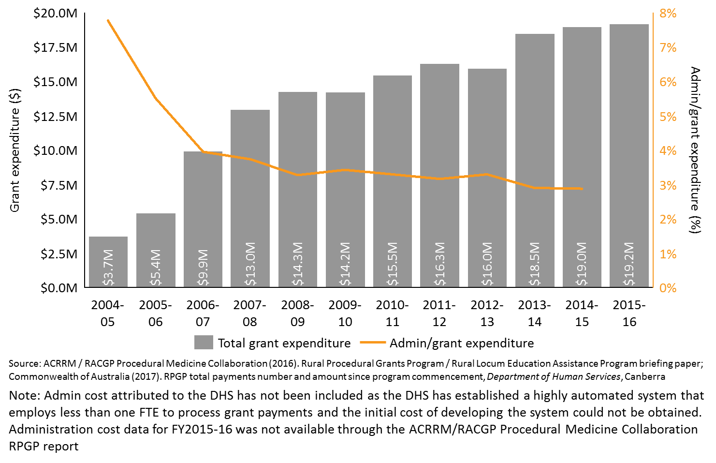

Further, between FY2009-10 to FY2015-16, administrative cost per grant appears to improve. The administrative cost per grant has decreased from $113.59 per grant to $101.33 over the timeframe, and the time taken to process a grant has decreased from 2.28 hours per grant to 1.66 hours.[23] Importantly, the original infrastructure investment to facilitate grant payments by the DHS was not considered in these estimates, however it is acknowledged as a critical investment and sunk cost.

As retention analysis was only possible by assessing changes in FSE in each MMM between financial years for the FY2002-03 cohort of GPs, determination of causality and direct comparison with administrative processes and expenditure was not possible. However, as detailed in Section C.2.1, evidence does show that those that received a grant were retained for longer than those that did not. Therefore, if this trend could be assumed to hold true for all GP cohorts, and considering the current entitlement structure of the RPGP, the administration process can to some extent be said to be effective.

GPPTSP

Analysing administration expense data from ACRRM and RANZCOG’s profit and loss (P&L) statements for the GPPTSP, overall administrative spend has fluctuated between $156,600 and $81,800 between 2010 to 2015. The fluctuations could be explained by episodic expenditure by RANZCOG for marketing, recruitment and IT related to the GPPTSP-O. Overall however, the administrative costs as a percentage of total grant expenditure has remained relatively constant and low as shown in Figure 48, and has averaged 6.6% of distributed funds over the years.

Breaking down the administrative expenditure by college, it is evident that RANZCOG has been able to achieve greater economies of scale through the lower ratio of administration dollars to grant expenditure, and this is reasonable considering RANZCOG processes approximately double the number of grants compared to ACRRM.

Figure 48: GPPTSP administration costs ACRRM/RANZCOG as a percentage of grants expenditure

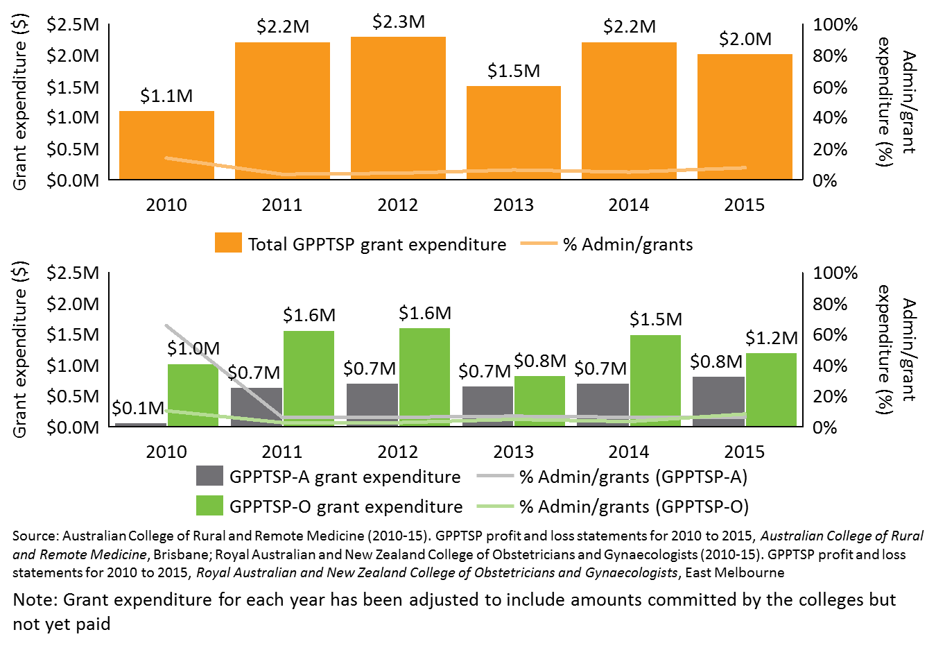

The expense data also shows that there has been a general decline in the marginal administration dollars consumed per additional grant processed by both colleges. Between 2010 to 2015, the overall cost of processing an additional grant has reduced by $769 and as of 2015, the administration cost consumed per grant was $2,301 (compared to $3,070 per grant in 2015).

The time taken to process a grant also shows improvement. ACRRM employs 0.4FTE for the GPPTSP as of 2015, and this translates to ACRRM staff requiring the equivalent of 36 hours per year to process one grant. This is in contrast to 2010 where it took 72 hours per grant, reflecting a halving of the time taken. As of August 2017, RANZCOG employed 0.77 FTE for GPPTSP administration translating to 29.5 hours spent processing each grant in 2015, which marks improvement from 33.8 hours in 2010.[24]

Assessment of training completions indicates that in each year a number of applicants withdraw from the program following original acceptance. On average, 10.5% of those accepted into the anaesthetics component withdraw, while 20.6% of those accepted into obstetrics withdraw, which accumulates to 51 out of the original 286 not completing their training, as illustrated in Figure 49. Consultations suggest that the majority of these withdrawals were due to the inability to secure placements to undertake training, while four received first round funding of $35,000 and subsequently withdrew. While this does not necessarily mean that the grants are being provided to the wrong individuals, it does suggest that timing and allocation of grants could be improved. There is therefore scope for increased rigour in the assessment process, however, the potential savings are not likely to be material (estimated to be $140,000).

Figure 49: Proportion of GPPTSP program withdrawals by discipline

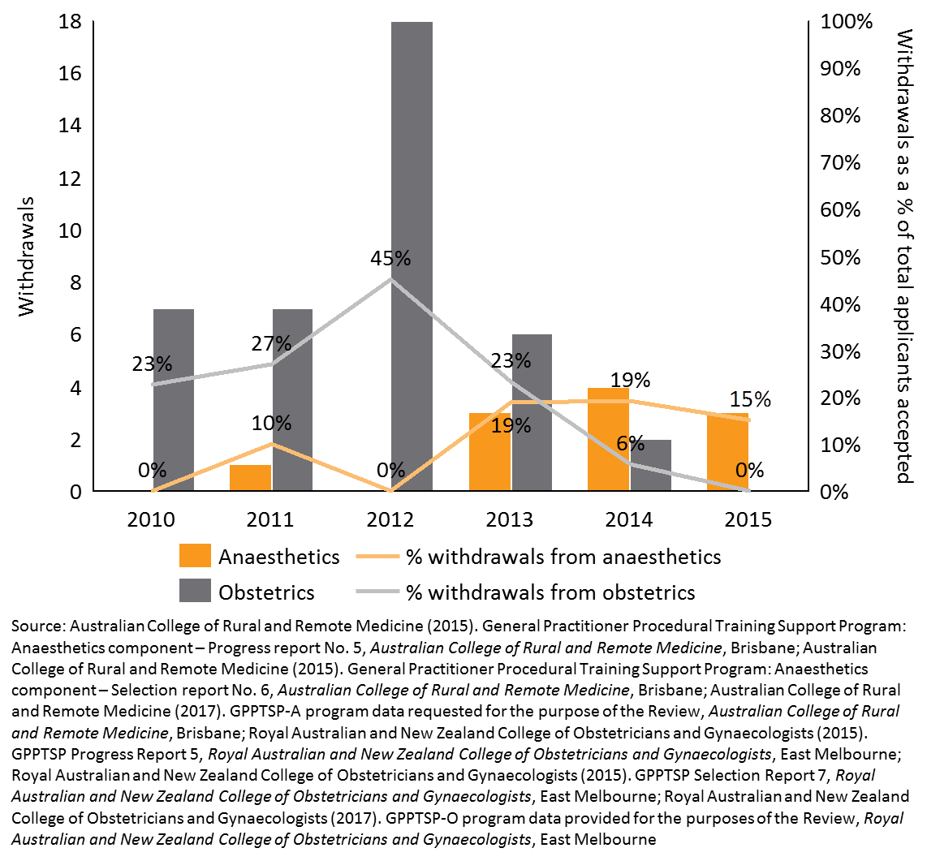

|  |  |
| --- | --- |
|  | Conclusion |
| * The RPGP is administratively simple, with low admin costs to total grant expenditure. While the absolute administrative expenditure has increased, the marginal cost of processing an additional grant and the time taken to process each grant have both reduced. * ACRRM and RANZCOG are administering the GPPTSP at reasonable administrative cost considering the relative size of each individual grant, the recipient prioritisation assessment by the colleges, and the direct College processing of grant funds. * Provided administration costs for both programs remain constant, improvements to efficiency through productivity will be small. | |

1. Summary of the stakeholder consultation outcomes
   1. Introduction

Between May 2017 and June 2017, Nous conducted interviews with approximately 65 stakeholders. This included jurisdictional and federal health department representatives, specialist medical colleges, program administrators, peak bodies and broader government departments.

Nous also released two surveys which were available over May and June 2017. One survey was provided to both RPGP and GPPTSP grant recipients. An overview of the respondents is as follows:

* 283 survey respondents (include completed and partials).
* 75% of respondents were male and 24% female (1 % prefer not to say).
* 37% of respondents from Queensland, 20% from NSW, 13% from WA, 10% from SA, 12% from Victoria, 10% from SA, 6 % from NT and 2% from Tas.
* 71% of respondents from ACRRM, 13 % from RACGP, 4% from RANZCOG, 1% from ACEM.
* 52 % of respondents were from ACRRM and receiving RPGP grant funding, compared to the 9.5% receiving both RPGP and GPPTSPs and 3.9% receiving funding from GPPTSP.
* 27.2% of respondents were from QLD ACRRM, and 14.5% from NSW ACRRM.

The second survey was provided to a number of peak body organisations and Primary Health Networks, Rural Training Organisations and Rural Multidisciplinary Health Training Hubs. There were 74 survey respondents, of which 31% responded as representatives of the organisation and 69% responded as individuals.

This Appendix provides a summary of the Stakeholder Consultation findings, drawing together insights from the consultation interviews and the online survey. This section is structured under the Review’s key lines of enquiry.

* 1. Overall summary of findings from the stakeholder consultations

|  |  |
| --- | --- |
| 1 | **Procedural skills are vital in rural areas** |
|  | Through the stakeholder consultation process, it became evident that the vast majority of stakeholders agreed that procedural skills were vital in rural areas. The RPGP and GPPTSP provide subsidies to enable rural GPs to maintain and upskill in procedures that GPs are expected to provide over large geographical areas. It became evident that most stakeholders were more familiar with the RPGP, rather than the GPPTSP. The programs were also greatly supported in jurisdictions that had a limited number of other rural workforce retention programs and/or initiatives available, such as Northern Territory and Western Australia. |
| 2 | **The program objectives and purpose of the grant amount is unclear** |
|  | Beyond the DoH and the Colleges administering the programs, other external stakeholders had limited detailed knowledge of the programs’ specific purposes and policy objectives. Stakeholders were unclear whether the programs target key rural service delivery needs, as they do not directly respond to the needs of the community. Stakeholders were also unsure whether the purpose of the funding was to cover the cost of the course only, or if it was intended to cover other costs such as travel and accommodation costs and locum relief. Through the consultations and survey responses, stakeholders also identified a number of broader community needs in rural areas beyond procedural skills. Of these, mental health was identified as one of the greatest needs in the rural and remote communities. |
| 3 | **The grants influence some GPs’ decision to remain in rural areas** |
|  | While a large number of grant recipients stated that the grants influenced their decision to remain practicing in rural areas, it was not possible to objectively determine whether these programs alone improve rural health workforce retention. Stakeholders highlighted the importance of financial incentives and support for spouses or partners in encouraging health care professionals to remain practicing in rural areas, along with the importance of professional networks and locum relief. |
| 4 | **There were mixed opinions as to whether the amount of grant funding is appropriate** |
|  | There were mixed opinions on whether the amount of funding provided by the two grants was appropriate, given the context of other rural workforce upskilling and retention programs and incentives funded by the Commonwealth and jurisdictions. A number of stakeholders raised the concern that the cost of training courses seemed to be aligned with the amount of financial assistance provided through these grants. However, it was also raised that the financial support provided through these grants should be treated as a subsidy for attending training courses, rather than a reimbursement for all associated costs. |
| 5 | **Stakeholders stated that GPs do “double dip” and receive funding from multiple sources for the same training** |
|  | Stakeholders understood that there are some GPs who “double dip” or receive funding from different sources for the same training and there are no mechanisms to prevent this from occurring. The RPGP grants can be used for such a broad purpose (e.g. cost of the course, travel costs, locum relief, loss of income etc) and therefore the purpose of the grant double dips with other programs. The purpose of the GPPTSP is also closely aligned to other jurisdictional programs and a GP can receive funding for the same training from multiple sources. The eligibility criteria of the RPGP and GPPTSP also duplicate with other programs. |
| 6 | **The majority of stakeholders reported current administrative and governance arrangements as effective** |
|  | Stakeholders stated that overall the current administrative and governance arrangements are effective. There were some issues raised that could be addressed. These include:   * ensuring the purpose of the grants is clear * reducing inequity across regions * putting in place risk management processes * streamlining the administration process to have one program administrator * finding hospital placements for the GPPTSP. |

* 1. Are the intended program outcomes being achieved?
     1. Do the programs meet the stated policy objectives?

As discussed in Section 1, the policy objectives of the RPGP and the GPPTSP are to improve rural health care service delivery in the procedural skills areas and increase rural workforce retention. The extent to which these objectives have been achieved are outlined below.

Improve rural health care service delivery and access to procedural services

Qualitative evidence from the vast majority of stakeholders agreed that procedural skills were vital in rural areas. The RPGP and GPPTSP enable rural GPs to maintain and upskill in procedures that GPs are expected to provide over large geographical areas, with limited support from other health care professionals. Some stakeholders asserted that GPs would not remain in a rural area (or at least, continue to practice the procedural skills) if they were not confident in their ability and skills to effectively deliver the procedural services. The RPGP and GPPTSP provide GPs with the opportunity to ensure they maintain their confidence to conduct the required procedures. On the other hand, other stakeholders identified the RPGP as a market response, whereby programs were tailored to match the demand of the GPs. While there was a lot of support expressed for the programs in consultations, stakeholders could not identify quantitative or objective evidence to demonstrate that the programs are improving service delivery.



*Procedural skills are very important for quality and access to safe care in rural and remote communities. Maintaining these services in the face of relentless subspecialisation and ongoing misdistribution of medial workforce is extremely challenging.*

* Survey respondent

The level of support provided to the RPGP and GPPTSP differed across the states and territories. A number of stakeholders argued that the financial assistance provided through these grants was more important in jurisdictions that have a limited number of other rural workforce retention programs and/or initiatives available, such as Northern Territory and Western Australia. In these contexts, stakeholders said that the RPGP and GPPTSP are used as recruitment and attraction tools to incentivise procedural GPs to move to rural and remote areas. Some stakeholders also stated that the funding could be better targeted through implementing the MMM classification system to better target the program to recipients who would be of most benefit. One key stakeholder group evidenced that the General Practice Rural Incentives Program (GPRIP) had recently transferred to the MMM, which resulted in a better focus on recipients and decreased expenditure. Stakeholders raised concerns that the integration or removal of such grants would greatly impact the continuity of services provided in the rural communities.

Of the four procedural skills covered through the RPGP and GPPTSP, both interviewees and survey respondents recognised the critical importance of emergency medicine training. Stakeholders asserted that rural and remote GPs always need to be prepared for emergency situations, particularly those who are situated a large distance away from a regional hospital. Other stakeholders have raised concerns that rural health care service delivery should better encompass community need beyond procedural areas, including mental health, aged care, Aboriginal and Torres Strait Islander health, internal medicine and palliative care (discussed further in Appendix D.5.1).

Regardless, the financial assistance provided through the RPGP and GPPTSP were viewed to strongly target the most critical workforce needs of rural or remote communities by the GPs who are currently receiving the grants, as evidenced from the survey results in Figure 50. Both the RPGP and GPPTSP were well supported by the GPs who are currently receiving the grants. A number of stakeholders who were interviewed asserted that more people attend the procedural training courses as a result of the grant. This was further emphasised by the fact that more than 72% of RPGP recipients who responded to the survey stated that the grant ensured their Continuing Professional Development (CPD) requirements were met “to a great extent”.

Figure 50: Grant recipient responses to survey question ‘To what extent does the financial assistance provided through the grants target the most critical workforce needs of rural or remote communities?’

Figure 50: Grant recipient responses to survey question ‘To what extent does the financial assistance provided through the grants target the most critical workforce needs of rural or remote communities?’

A small number of stakeholders also raised concerns about the introduction of corporate GP practices in rural and remote areas. They argued that these practices provide services between 9am-5pm and leave after hour service provision to other GPs, which is not making a positive impact on service delivery or the workforce. Stakeholders stated that this emerging trend places greater strain on the existing rural health care workforce and after-hours service provision.

Improve rural health workforce retention

Overall, there is limited objective evidence to determine whether the programs increase workforce retention as there are no current processes or frameworks in place to collect outcomes-based data and objectively determine if workforce retention is different between recipients and non-recipients of the grants. However similar to previous reviews on the RPGP and GPPTSP (see Section B.2.1), personal opinions obtained through Nous’ online survey revealed that:

* **60%** of RPGP recipients reported that the financial support provided through the grant *influenced their decision to remain practicing* in a rural or remote area “to a great extent”.
* **77%** of peak bodies who have an understanding of, or any involvement in, the RPGP reported that *the grant encouraged rural GPs to maintain their procedural skills and remain practicing* in a rural or remote area “to a great extent”.
* **35%** of GPPTSP recipients reported that *the financial support provided through the grant influenced their decision* to remain practicing in a rural or remote area “to a great extent”.
* **67%** of peak bodies who have an understanding of, or any involvement in, the GPPTSP reported that *the grant encouraged rural GPs to develop their procedural skills and remain practicing* in a rural or remote area “to a great extent”.
* **75%** of peak bodies who have an understanding of, or any involvement in, the RPGP and GPPTSP reported that *the RPGP encouraged rural GPs to develop their procedural skills and remain practicing* in a rural or remote area “to a great extent”. However, only **39%** of these respondents reported that GPPTSP did this “to a great extent”.



*Being recognised and remunerated for ongoing training and upskilling makes it worthwhile. If the grant ceases, I might consider leaving.*

* Survey respondent

While there is limited objective data available to determine if the grants have increased rural workforce retention, qualitative evidence, particularly from grant recipients, evidenced that the program does have an influence on GPs’ decision (or intent) to remain practicing in a rural area. Some stakeholders said that workforce retention could be increased through implementing a return of service obligation, where recipients are expected to remain in the rural community for a specified period of time.

|  |  |
| --- | --- |
|  | Conclusion |
| * The majority of stakeholders agreed that procedural skills are vital in rural and remote areas. * It is unclear if the programs are continuing to target the key rural service delivery needs. Stakeholders highlighted the importance of maintaining and upskilling skills in emergency medicine, but also the importance of upskilling GPs in mental health. * The programs are also greatly supported in jurisdictions that have a limited number of other rural workforce retention programs and/or initiatives available, such as Northern Territory and Western Australia. * Many stakeholders argued that the MMM would better target the program and ensure the right people are accessing the grants. * While there are limited mechanisms in place for objective data collection to determine whether the RPGP and GPPTSP improve rural health workforce retention, 60% of RPGP grant recipients and 35% of GPPTP grant recipients stated it influenced their decision to remain practicing in a rural area to a great extent. * Some stakeholders stated that a return of service obligation could increase retention in rural areas. | |

* + 1. Is there evidence that communities benefit from these programs?

Throughout consultations, stakeholders asserted that these programs were integral to ensuring that rural GPs are trained and confident in providing procedural services back to their communities. A few stakeholders raised concerns with attributing the impact of a single health workforce grant to broader objectives, such as health service delivery and retention. Further qualitative evidence on communities that benefit from these programs has been outlined in Section D.3.1.

* + 1. What other financial and non-financial programs incentivise GPs to remain in rural and remote communities?

Whilst the RPGP and GPPTSP were identified as important programs that provided subsidies to support rural GPs upskill and maintain their advanced procedural skills, stakeholders have raised a number of effective workforce retention strategies beyond financial incentives.



*Money or equivalent financial support is important particularly in attracting, but in terms of staying it (presuming with a good income) is all about the other things in life.*

* Survey respondent

Figure 51 provides an overview of the survey responses and the ranking of the effectiveness of each retention strategy. These responses suggested that financial incentives, support for spouses or partners and professional networks were seen as the most important incentives to encourage health care professionals to remain practicing in rural areas. In addition to these incentives, interviewed stakeholders raised the benefits of working in multidisciplinary primary health care teams and the opportunity to broaden their scope of practice.

Figure 51: Rank of order of effectiveness of strategies to retain GPs in rural areas, according to peak body survey respondents

Figure 51: Rank of order of effectiveness of strategies to retain GPs in rural areas, according to peak body survey respondents

As the current rural procedural GPs begin to retire in the coming years, a number of stakeholders recognised the need to change the design and delivery of health care services. They raised concerns that the future generation of doctors appeared to be less focused on financial incentives and have greater desire for a more balanced lifestyle. In light of these impending changes, one stakeholder raised concerns that rural locum support should not be used as a long term solution to relieving GPs for training and recreational purposes, as it is an expensive option.

|  |  |
| --- | --- |
|  | Conclusion |
| * Stakeholders identified a range of programs beyond financial incentives that were effective in incentivising GPs to remain in rural and remote communities. * Stakeholders highlighted the importance of financial incentives, support for spouses or partners and professional networks in encouraging health care professionals to remain practicing in rural areas. | |

* 1. Is the design of the RPGP and GPPTSP appropriate?
     1. Does the RPGP/GPPTSP build on, duplicate, or integrate with other rural health workforce programs run by the Commonwealth or other jurisdictions?

Throughout consultations, stakeholders raised a number of programs that provide funding for the same or similar purposes to the RPGP and GPPTSP. All of these programs have been captured in the literature review findings in Appendix B. The stakeholder consultations were particularly important to recognise similar programs administered by the jurisdictions. Stakeholder consultations confirmed the literature review findings that the RPGP and GPPTSP have similar eligibility criteria to other programs and that duplication exists between them. There are also no mechanisms in place to ensure that GPs are not applying for multiple grants to cover the costs of the same training course. No stakeholder was able to deny that “double dipping” was occurring and many were confident that it is occurring.



*There are currently no mechanisms in place to reduce double dipping – but, does it matter? As the scheme currently stands, it is easy to do.*

* Stakeholder interviews

Through the consultations, a number of stakeholders raised concerns that the impending development and introduction of the National Rural Generalist Pathway could impact the current programs under review. Stakeholders emphasised the need for the National Pathway to be flexible enough to contextualise and be applicable to the local jurisdictional need.

|  |  |
| --- | --- |
|  | Conclusion |
| * Considering the broad purpose of the RPGP grant, (e.g. it can be used to cover the cost of the course, travel costs, locum relief or loss of income) the RPGP duplicates with other programs. * The eligibility criteria of the RPGP and GPPTSP also duplicates with other programs. * Stakeholders understood that there are some GPs who “double dip” or receive funding from different sources for the same training. | |

* + 1. Is the amount of money appropriate, given the broader context of other incentives, initiatives and programs?

As mentioned in Section D.3.1, it was evident that the RPGP and GPPTSP grants are strongly supported by procedural GPs. The financial support provided through the RPGP grants was used to cover a number of costs associated with training. These include the cost of course attendance, travel, accommodation, locum support, loss of income and costs of running an independently ownedpractice*.* Stakeholders also recognised that locum relief coverage was provided through the MBS under the Rural Locum Relief Program (RLRP), and may not need to be a cost covered under the grants. The online survey also revealed that more than 23% of RPGP recipients reported that locum/other doctors were not required to fulfil their role while they attended a training course, with a further 17.5% reported as ‘rarely’ arranged and 27.4% as ‘sometimes’ arranged.

Some stakeholders argued that the value associated with these grants is considered a nominal figure to subsidise the training courses that many of the procedural GPs may have had to attend as part of meeting their CPD requirements. However, others understood that the grant was not supposed to act as a reimbursement for all associated costs. A number of stakeholders argued that the financial assistance is more important for GPs located in remote areas, as they have higher travel costs associated with attending training.

There were varying opinions as to whether the amount of financial support provided through the grant is appropriate. Some suggested the amount to be comprehensive, whilst others suggested the amount should be increased to better align to the level of financial burden associated with attending training when living in rural areas. Some stakeholders also raised concerns that the cost of training courses has increased to now be directly aligned to the amount of financial assistance provided through the grant.



*The price of attending the courses has increased, unsurprisingly to be aligned to the exact amount of the RPGP grant.*

- Stakeholder interview

Through the stakeholder consultations, a range of suggested changes to the funding amounts were provided. The proposed changes are listed below:

* **Financial support provided to the GPs could be assessed via a sliding scale**, whereby GPs can access a larger amount of money if they have travelled from a more remote location. This could be to attend more days of training (to make the travel time more worthwhile) or to cover the additional travel costs.
* **Financial support provided through the grants could be re-indexed** to have a renewed flat rate, as both grants have not been indexed since program commencement. The amount of financial assistance required for GP procedural skill training may no longer align with the new associated financial pressures.
* **Programs could introduce different tiers of funding depending on how long the GPs have been an accredited** **Fellow** and/or practiced in rural or remote areas. For example in NSW, there are two tiers of funding – for those practicing for less than five years and those practicing for more than five years. This was intended to better incentivise the more experienced GPs to leave their practice to upskill.
* **Payments could be graded according to length and cost of travel** on a receipt basis and be capped. For example, the Medical Professional Development Subsidy program asks people to provide evidence of travel for reimbursement, but is currently capped. However, this would increase the cost of administration for the two programs.
* **Financial payments of the GPPTSP could be administered in a weighted and staggered approach**, rather than the current two-phased approach with more than 85% payment upfront*.*

Through this Review it was also evident that needs in rural and remote areas are broader than procedural services. While there are broader community needs (see Section D.5.1), many emphasised that funding should not be drawn from the existing RPGP and GPPTSP grants. These stakeholders acknowledged that scope of the current grants should not be broadened at the risk of diffusing funding or diluting focus from the procedural skills that are essential in rural communities.

|  |  |
| --- | --- |
|  | Conclusion |
| * There were mixed opinions as to whether the amount of funding provided by the two grants was appropriate, given the context of other rural workforce upskilling and retention programs and incentives available in the states and territories. * Many stakeholders raised the concern that the cost of training courses seem to closely align with the amount of financial assistance provided through these grants. * There were mixed opinions as to whether the grants are intended to be a reimbursement for training, or whether they are treated as a subsidy for attending training courses that the procedural GPs would have otherwise attended as part of achieving their CPD requirements. | |

* + 1. Does the literature identify comparable programs elsewhere, what are the similarities and differences, and how do they relate to the Australian experience?

The key comparable programs are outlined in the Literature Review section in Appendix B. However the key countries that stakeholders referenced that the Australian context could learn from were Canada, New Zealand and the United Kingdom.

* + 1. Should online courses be eligible as a RPGP training courses?

Qualitative evidence from many stakeholders suggested that the nature of procedural services makes it essential to have face-to-face training to maintain and upskill in procedural areas. The key reasons stakeholders stated face-to-face training sessions were valuable was:

* Great opportunity for GPs to participate in medical simulations.
* More opportunities to develop professional relationships with regional providers that assist safer care by improving mutual understanding and ability to seek advice.
* More professional networking opportunities.
* Greater exposure to the group dynamics of a medical team.

Given the financial support provided through the RPGP was designed to assist with the cost of attending training, including course costs, locum relief and travel expenses, some stakeholders argue that online courses should not be eligible for the RPGP.



*For procedural skills there is an important need to be able to have ‘hands-on’ training. Although these skills may not be needed every day, when they are, one needs to be competent in their use.*

* Survey respondent

Other stakeholders expressed a diverse range of opinions as to whether RPGP courses could include online components (as opposed to the whole course being provided online). A number of stakeholders recognised the significant advancements in technology that have enabled not only the ability to train or learn online (e.g. online simulations and videoconferencing), but also the ability to deliver health services online through avenues such as telehealth. Many stakeholders agreed that online courses could be a component of the RPGP, under the condition that courses are quality assured and include a supervisory and assessment component. Others felt that any aspect of procedural training online would diminish course quality, lose networking benefits with peers and be highly dependent on internet access and satellite coverage.

A small number of stakeholders have also suggested that face-to-face training courses could be supplemented with online components for pre- and post- training course materials. However, the Review appreciates that some of the current RPGP accredited courses have an online component. According to the online survey provided to grant recipients, approximately 20% of respondents attended a RPGP-supported course that had 10-20% online components, whilst approximately 35% of respondents had attended a course with no online components. Very few (<5% of survey respondents) identified attending a RPGP supported course that was held entirely online.

|  |  |
| --- | --- |
|  | Conclusion |
| * Stakeholders expressed mixed views as to whether it would be suitable for online courses to be eligible for the RPGP. The majority thought it was not aligned to the intentions of the program. * Many argued that it would be suitable for courses to be approved if only some components were online and the course also included an assessment component and was quality assured. | |

* 1. How could outcomes be further improved?
     1. Are the needs of communities addressed by the focus of these programs or should a range of alternative skills and procedural training be considered?

Stakeholders argued that demand for the RPGP and GPPTSP are not determined by community need, but rather, the need of the individual GPs. Some stakeholders referred to the programs as a market response, whereby the programs were tailored to match the demand needs of the GPs which were only indirectly linked to community needs. Through the consultations, it became evident that a majority of stakeholders supported the idea that community need should be the first determinant of programs. Stakeholders noted that some jurisdictions conduct their own community needs assessment, including Western Australia and New South Wales.



*The [training] programs are designed as a market response. Funding is provided to the practitioner, with GPs choosing to participate in the programs that meet their education needs.*

* Stakeholder interview

When the broader needs of rural and remote communities were explored, a large number of stakeholders identified a range of alternative skills required that were beyond procedural areas. These included mental health, palliative care, aged care, paediatrics, Aboriginal and Torres Strait Islander health, chronic disease, alcohol and other drugs and internal medicine. Figure 52 details the ranking of the greatest needs in rural and remote communities based on survey responses. Outside of the procedural skills areas, survey respondents raised the importance of mental health training for those practicing in rural and remote areas as a vital area to develop. This was further emphasised by stakeholder consultations, which highlighted the need to have more support and training for GPs in rural areas to address mental health issues, as they are often the principal point of contact to provide continuing care in communities.



*The distance from a tertiary hospital makes provision of emergency and obstetric services vital to minimise avoidable life loss.*

* Survey respondent

Of the four procedural skills areas covered across the RPGP and GPPTSP, a large number of interviewed and surveyed stakeholders raised the importance of access to, and provision of, emergency medicine and obstetrics services in the rural and remote areas of Australia. These rankings were more prominent for those who had an understanding of the RPGP. Both consultations and the online survey revealed that stakeholders asserted that rural and remote GPs always needed to be prepared to provide emergency and obstetric services, particularly when practicing in areas that are away from regional hospitals. Evidence from the online survey results (see Figure 52) also suggested that there was a diminishing requirement for GP training in surgery. One key stakeholder further asserted that there was no significant pipeline for training GP surgeons in Australia.

Figure 52: Ranking of the greatest needs in the community of the online survey respondents

Figure 52: Ranking of the greatest needs in the community of the online survey respondents 

*\*Note the procedural skills areas covered under the RPGP and GPPTSP are highlighted in purple.*

|  |  |
| --- | --- |
|  | Conclusion |
| * Many stakeholders argued that the programs are not designed to meet the needs of communities, but rather, the programs are a market response to the demand need of the GPs. * Stakeholders identified a number of broader community needs that are required in rural areas beyond procedural skills. Of these, mental health training for GPs was identified as the greatest need in rural and remote communities. | |

* + 1. Could better outcomes be achieved within the same total program expenditure by adjusting the level of individual grants to participating doctors?

The RPGP aspires to increase rural workforce retention and improve delivery of health services in rural areas. As the RPGP expenditure is uncapped, lowering the amount of each individual grant so that more VRGPs could receive the grant would not have a significant impact on total grant expenditure. While stakeholders expressed various opinions about whether the amount of each individual grant should be increased, evidence obtained through stakeholder consultations demonstrated no causal link between increasing the financial amount of individual grants and it resulting in either an increase in rural workforce retention, or improved rural health service delivery.

|  |  |
| --- | --- |
|  | Conclusion |
| * There was no causal link evidenced through stakeholder consultations that adjusting the level of individual grants would result in better program outcomes. | |

* + 1. Are the administration and governance arrangements the most efficient and appropriate to the streamlined implementation of these programs?

Overall stakeholders were positive towards the administrative and governance arrangements of the RPGP (see Figure 53). Stakeholders stated that the application process for both VRGPs and training providers was efficient. The administration process is straightforward due to the broad eligibility criteria and lack of cap funding. If a cap were to be put in place, there would need to be stricter criteria applied and deeper analysis to determine which VRGP would be eligible over the other. However another stakeholder argued that low administration costs are less important than ensuring funding is correctly and fairly allocated. Overall administration costs are very low (approximately 3% of the budget for FY2014-15), as described in Section 2.



*There is strength in the simplicity of the program’s administrative process. Increasing the complexity of the program’s eligibility will increase the administrative burden.*

* Stakeholder interview

Figure 53: Grant recipient responses to survey question ‘How efficient is the current administrative process of the grants?’

Figure 53: Grant recipient responses to survey question ‘How efficient is the current administrative process of the grants?’

The Collaboration, which consists of representatives from RACGP, ACRRM and DHS, is an effective governance model. The process for determining contested applications is also effective – the Collaboration uses precedent and refers to past decisions when determining application outcomes to ensure a level of consistency in decision making. Some stakeholders also stated that the Colleges are suitable bodies to govern the RPGP because they have strong relationships with hospitals, doctors and understand the broader health system.

Stakeholders also provided some opportunities to improve the administration and governance process. These include:

* While there are benefits to administering the programs nationally, there are issues as to whether it results in equity across different locations, as each state (and region) has different requirements.



*A disadvantage of the RPGP is that it is overseen by both ACRRM and RACGP – it’s essentially doubling up. They could have one joint administration*

* Survey respondent
* The overall purpose of the RPGP grant funding is unclear and should be more clearly articulated.
* Administration of the GPPTSP could be improved by assisting GPs to find placements in hospitals. At present some GPs are awarded the GPPTSP grant but are unable to find a hospital placement and therefore must forfeit their grant.
* There is a lack of process in place to manage risk.
* Administration could be simplified by streamlining administration to only one College.
* GPs would appreciate if the RACGP had an online application portal to increase the efficient application process.

|  |  |
| --- | --- |
|  | Conclusion |
| * Overall the current administrative and governance arrangements are effective. * There are some issues that could be addressed, including ensuring the purpose of the RPGP grant is clear, reducing inequity across regions, putting in place risk management processes, streamlining the administration process to have one program administrator and finding hospital placements for the GPPTSP grant recipients. | |

1. Consultation participants

The following section provides the list of individuals and organisations who were engaged in the interviews and survey consultations as part of this Review.

|  |  |  |  |  |  |
| --- | --- | --- | --- | --- | --- |
|  | | Stakeholders consulted in interviews | | | |
|  | Stakeholder | | Interview method | | Date | |
| Colleges | | | | | | |
| **1** | **Australian College of Rural and Remote Medicine (ACRRM)**   * Marita Cowie, CEO | | Face to face | | 5 May | |
| **2** | **Royal Australian College of General Practitioners (RACGP)**   * James Flynn, Head of Rural Faculty, General Practitioners | | Face to face | | 10 May | |
| **3** | **The Royal Australian and New Zealand College of Obstetricians and Gynaecologists (RANZCOG)**   * Alana Killen, CEO | | Face to face | | 29 May | |
| **4** | **Australasian College for Emergency Medicine (ACEM)**   * Dr Niall Small, Queensland representative, Council of Advocacy, Practice and Partnerships * Prof Sally McCarthy, New South Wales representative, Council of Advocacy, Practice and Partnerships | | Teleconference | | 16 May | |
| **5** | **Australian & New Zealand College of Anaesthetists (ANZCA)**   * Olly Jones, General Manager, Education * Paula Stephenson, General Manager, Training Assessment * Jo anne Chapman, General Manager, Policy, Safety and Quality | | Face to face | | 23 May | |
| **6** | **Royal Australasian College of Surgeons (RACS)**   * John Biviano, Acting CEO * Assoc Prof Stephen Tobin, Dean of Education | | Face to face | | 16 May | |
| Key Government Agencies | | | | | | |
| **7** | **Commonwealth Department of Health**   * David Hallinan, First Assistant Secretary, Health Workforce Division | | Face to face | | 24 May | |
| **8** | **Commonwealth Department of Health**   * Fay Holden, Assistant Secretary, Health Training Branch * David Meredyth, Director, Regional Training Education Reform Section * Teresa Couacaud, Assistant Director, Postgraduate Training Section, Health Training Branch | | Face to face | | 30 June | |
| **9** | **Commonwealth Department of Health**   * David Hallinan, First Assistant Secretary, Health Workforce Division * Dr Andrew Singer, Principal Medical Adviser, Health Services * Dr Susan Wearne, Senior Medical Adviser, Health Workforce Division * Elizabeth Murray, Director, Rural Distribution Section * Lisa La Rance, Assistant Secretary, Rural Access Branch | | Face to face | | 24 May | |
| **10** | **Commonwealth Department of Health**   * Elizabeth Murray, Director, Rural Distribution Section * Lauren Quaglio, Program Manager, Health Workforce Scholarship Program | | Teleconference | | 28 June | |
| **11** | **Commonwealth Department of Health**   * Rebecca Richardson, Director, GP Training Analysis, Health Workforce Division * Louise Morgan, Director, GP Selection and Education Section | | Teleconference | | 10 July | |
| **12** | **Commonwealth Department of Human Services**   * Annette Shaw, Director * Kate Stih, Assistant Director * Dyani Sherer, Senior Program Officer | | Face to face | | 12 May | |
| **13** | **Australian Capital Territory Health Directorate**   * Jennie Gordon, Director, Workforce Policy and Planning * Shamgya Deo, Workforce Policy and Planning Officer * Prof Amanda Barnard, Associate Dean, Rural Clinical School, Australian National University * Dr Jeffery Fletcher, General Paediatrics, Paediatric Outpatient Department | | Teleconference | | 12 May | |
| **14** | **Department of Health and Human Services, Victoria**   * Tarah Tsakonas, Senior Policy Advisor * Margaret Milne, Senior Policy Advisor, Medical Workforce | | Teleconference | | 16 May | |
| **15** | **Department of Health, Northern Territory**   * Dr Hugh Heggie, Chief Health Officer, Office of the Chief Health Officer * Dr Sally Banfield, Acting Director of Medical Services, Primary Health Care | | Teleconference | | 8 May | |
| **16** | **New South Wales Ministry of Health**   * Dr Linda MacPherson, Medical Adviser, Workforce Planning and Development | | Face to face | | 11 May | |
| **17** | **Department of Health, Western Australia**   * Dr Paul Myhill, Medical Adviser, Office of the Chief Medical Officer | | Teleconference | | 7 Jun | |
| **18** | **Department of Health, Queensland**   * Rachel Hoffman, Manager of the Office of the Chief Medical Officer, Chief Medical Officer and Health care Regulation Branch * James McNulty, Principal Workforce Planning Officer, Resident Medical Workforce Campaign Team, Office of the Principal Medical Officer (OPMO), Health Service and Clinical Innovation Division * Megan Crawford, Director, Office of the Principal Medical Officer * Cheryl Ball, Principal Policy Officer | | Teleconference | | 8 May | |
| **19** | **Department of Health, South Australia**   * Dr Jayaraman Thiagarajan, Acting Chief Medical Adviser, Country Health SA Local Health Network | | Teleconference | | 8 May | |
| **20** | **Department of Health and Human Services, Tasmania**   * Dr Allison Turnock, Director, Rural Pathways | | Teleconference | | 8 May | |
| Peak bodies and influencers | | | | | | |
| **21** | **NSW Rural Doctors Network**   * Dr Rose Ellis, Director Governance & Health Service Development * Arna Wotherspoon, Conference Manager | | Teleconference | 31 May | | |
| **22** | **Rural Workforce Agency Queensland**   * Assoc Prof Chris Mitchell, CEO | | Teleconference | 19 May | | |
| **23** | **Rural Workforce Agency Victoria**   * Megan Cahill, CEO | | Teleconference | 19 May | | |
| **24** | **Rural Health West**   * Kelli Porter, General Manager, Workforce * Leesa Thomas, Manager, Continuing Professional Development | | Teleconference | 8 May | | |
| **25** | **Rural Doctors Association of Australia**   * Peta Rutherford, CEO | | Face to face | 8 May | | |
| **26** | **Rural Doctors Association of Australia**   * Dr Paul Mara, former President | | Teleconference | 1 May | | |
| **27** | **National Rural Health Alliance**   * David Butt, CEO * Alexis Mohay, Director of Policy | | Teleconference | 29 May | | |
| **28** | **Rural Clinical School, Flinders University**   * Prof Jennene Greenhill, Associate Dean | | Teleconference | 24 May | | |
| **29** | **Royal Flying Doctor Service**   * Martin Laverty, CEO | | Teleconference | 19 May | | |
| **30** | **Rural Clinical School, University of Queensland**   * Assoc Prof Bruce Chater, Chair | | Face to face | 5 May | | |
| **31** | **Independent Expert Panel, Primary Health Care Advisory Group**   * Dr Steve Hambleton, Chair | | Teleconference | 29 May | | |
| **32** | **Independent Expert Panel, Primary Health Care Advisory Group**   * Prof John Humphries, Member | | Teleconference | 10 May | | |
| **33** | **Medicare Benefits Schedule Review Taskforce**   * Prof Bruce Robinson, Chair | | Teleconference | 4 May | | |
| **34** | **Australian Medical Association**   * Warwick Hough, Director, Workplace Relations, Legal Services and General Practice | | Face to face | 17 May | | |
| **35** | **Australian Medical Association**   * Dr David Rivett, Chair, Rural Medical Committee | | Teleconference | 2 June | | |
| **36** | **WONCA Conference, Cairns**   * ACRRM Quality and Safety in Practice Committee * Dr Ewen McPhee, President, RDAA * James Flynn, RACGP * Dr Rob Stable, Chair of Rural Workforce Queensland * Dr Sue Harrison, procedural GP anaesthetics and ED * Dr John Hall, procedural GP Obstetrics * Dr Peter Rishbeith, procedural GP Murray Bridge SA | | Face to face | 28 - 30 April | | |
| **Total number of stakeholders engaged** | | | | **Approx.65** | | |

|  |  |  |
| --- | --- | --- |
|  | Additional stakeholders consulted through the online survey | |
| Stakeholder | | | |
| Colleges | | | |
| * The Royal Australasian College of Physicians (RACP) * The Royal Australian & New Zealand College of Psychiatrists (RANZCP) * Council of Presidents of Medical Colleges | | | |
| Primary Health Network | | | |
| * Western Australia Primary Health Alliance * Primary Health Network Country South Australia * Primary Health Network Western Queensland * Primary Health Network Northern Queensland | | * Health Network Northern Territory * Western Victoria Primary Health Network * Western Health Alliance Ltd | |
| **Rural Multidisciplinary Health Training Hub** | | | |
| * University of Adelaide * Australian National University (ANU) * Deakin University * Flinders University * Flinders NT Rural Clinical School (Charles Darwin University) * Griffith Unviersity * James Cook University * University of Melbourne * Monash University | | * University of Newcastle * University of NSW * UNDA Fremantle * UNDA Sydney * University of Queensland * University of Sydney * University of Tasmania * University of Western Australia * Western Sydney University * University of Wollongong | |
| **Registered Training Organisations (RTOs)** | | | |
| * GP Synergy (Western NSW, Lower Eastern NSW, North Eastern NSW) * Northern Territory General Practice Education (NT) * Generalist Medical Training (North Western QLD) * General Practice Training Queensland (South Eastern QLD) * GPEx (SA) * General Practice Training Tasmania (Tasmania) * Eastern Victoria GP Training (Eastern Victoria) * Murray City Country Coast GP Training (Western Victoria) * Western Australian General Practice Education and Training (WA) | | | |
| **Other peak bodies and influencers** | | | |
| * Rural Health Workforce Australia * National Aboriginal Community Controlled Health Organisation (NACCHO) * The Aboriginal Health & Medical Research Council of New South Wales (AH&MRC) * The Aboriginal Health Council of Western Australia (AHCWA) * Aboriginal Health Council South Australia (AHCSA) * Aboriginal Medical Services Alliance Northern Territory (AMSANT) * Queensland Aboriginal and Islander Health Council (QAIHC) * Victorian Aboriginal Community Controlled Health Organisation (VACCHO) * Tasmanian Aboriginal Centre (TAC) * Australian Capital Territory Winnunga Nimmityjah Aboriginal Health Service (AHS) * National Indigenous Doctors Association (AIDA) * CRANAplus * Consumer Health Forum * Palliative Care Australia * Council on the Ageing * Mental Health First Aid Australia * General Practice Registrars Australia * Australian Rural Health Education Network * Health Consumers of Rural and Remote Australia Inc * Our Watch | | | |

1. Commonwealth and jurisdictional workforce programs

This section provides an overview of the Commonwealth and jurisdictional rural workforce programs previously mentioned in Section 1.

* 1. Commonwealth Program List

The table below provides a brief description of each relevant Commonwealth program categorised by target group.

|  |  |  |
| --- | --- | --- |
| Program Name | Primary Purpose | Description |
| General Practitioners | | |
| **General Practice Rural Incentives Program (GPRIP)** | Retention | The GPRIP provides yearly bonuses of between $4,500-$60,000 to GPs who provide primary care services in rural and remote locations, and meet the continuous service requirements. Incentive payments to medical practitioners are scaled according to practice location, practice time and clinical workload. |
| **MedicarePlus for Other Medical Practitioners (MOMPs) Program** | Retention | The MOMPs program provides access to the A1 Medicare rebate for general practice services provided in Areas of Workforce Shortage (AOWS) by eligible pre 1996 non-vocationally registered medical practitioners. |
| **Rural and Remote General Practice Program (RRGPP)** | Retention | The program provides funding to Rural Workforce Agencies in each state and the Northern Territory to provide a range of activities and support to improve the recruitment and retention of GPs to rural and remote areas. |
| **Rural Other Medical Practitioners (ROMPs) Program** | Retention | The ROMPS program provides access to the A1 Medicare rebate to post-1996 non-vocationally recognised medical practitioners providing general practice services in eligible rural and remote areas. Normally non-vocationally recognised medical practitioners would access the lower A2 Medicare rebate. |
| **MDA National and RDAA Rural Health Bursary** | Retention | The bursary is open to Aboriginal and/or Torres Strait Islander doctors who are based either in urban, rural or remote locations. The bursary covers the cost of travel, accommodation and/or other expenses in undertaking the clinical placement or research (or similar activity) attendance at RDAA and ACRRM's Rural Medicine. |
| **Practice Incentives Program (PIP) Procedural GP Payments** | Retention | The PIP consists of 11 individual incentives that are categorised as practice payments, service incentive payments or rural loading programs. One such incentive includes the PIP Procedural GP Payment, which is aimed to encourage GPs in rural and remote areas to maintain local access to surgical, anaesthetic and obstetric services. The payment is provided to the accredited practices providing anaesthetics, surgery and/or obstetric services in rural and remote Australia to purchase new equipment, upgrade facilities or increase remuneration for GPs working at the practice to improve capacity and enhance primary health outcomes. There are four tiers of procedural payments, which are dependent on the number of procedural services provided in the rural community per procedural GP during the six month reference period. |
| **Rural Procedural Grants Program (RPGP)** | Upskilling | The RPGP commenced in 2004 (and was formerly known as the Training for Rural and Remote Procedural GPs Program). It supports VRGPs in rural and remote areas to attend relevant training, which is focussed on both skills maintenance and upskilling in the areas of anaesthetics, obstetrics and/or emergency medicine. |
| **General Practitioner Procedural Training Support Program (GPPTSP)** | Upskilling | The GPPTSP aims to improve access to obstetric and anaesthetics services for people living in rural and remote communities. The program supports rural GPs to attain procedural skills by providing funding to enable GPs to gain the Advanced Rural Skills and Advanced Specialised Training in Anaesthesia or the DRANZCOG Advanced. |
| **Remote Vocational Training Scheme (RVTS)** | Upskilling | The RVTS program is designed to accommodate the circumstances of remote practice and provide the best possible educational experience for rural GPs. Training is provided via distance education and supervision is facilitated remotely. Program delivery is flexible and designed to meet a participant’s individual needs. Delivered through weekly webinars, an intensive 5 day face to face workshop, clinical teaching visits and remote supervision arrangements. |
| **General Practice Grants Program** | Upskilling | The grants of up to $300,000 will help deliver improved rural health services through additional infrastructure, increased levels of teaching and training, and more opportunities to inform rural communities about healthy living. Replaces the RRTIG program. |
| Multiple types of rural health GPs or specialist practitioners | | |
| **Rural Locum Relief Program (RLRP)** | Retention | Rural Locum Relief Program allows doctors who are permanent residents or Australian citizens to access a Medicare provider number to work in rural and remote areas while they are working towards GP Fellowship. This enables Overseas Trained Doctors and Australian Trained Doctors without Fellowship to provide General Practitioner services in rural and remote areas for which Medicare rebates are available. |
| **Rural Health Outreach Fund (RHOF)** | Retention | The Rural Health Outreach Fund (RHOF) consolidates the activities of five existing programs, and will provide a larger, flexible funding pool for initiatives aimed at improving access to medical specialists, GPs, allied and other health professionals in rural, regional and remote areas of Australia. |
| **Medical Outreach Indigenous Chronic Disease Program (MOICD)** | Retention | The program provides funding to support GPs, specialists and allied health Outreach Services that focus on the prevention, detection and management of chronic disease in Aboriginal and Torres Strait Islander people across Australia. |
| **Five Year Overseas Trained Doctor Scheme** | Retention | The 5 Year Overseas Trained Doctor Scheme was developed to address long-term rural medical workforce shortages. It allows a reduction in the 10 Year Moratorium (temporary prohibition of activity) for Overseas Trained Doctors in exchange for 5 years of rural practice, encouraging them to work in remote or difficult-to-recruit locations. |
| **Overseas Doctors Additional Assistance Scheme** | Upskilling | The Additional Assistance Scheme provides education assistance for eligible Overseas Trained Doctors who are seeking Fellowship with the Royal Australian College of General Practitioners (RACGP) or the Australian College of Rural and Remote Medicine (ACRRM). |
| **Rural Locum Assistance Program (Rural LAP)** | Upskilling | Rural LAP enables provides up to $6,000 of income support to eligible health professionals to allow them to source a locum practitioner to facilitate continuing professional development or to take leave for recreation purposes. |
| **Health Workforce Scholarship Program** | Upskilling | As part of the Health Workforce Program, the Health Workforce Scholarship Program Grant is a restricted, competitive grant. It will run from 2017 up to 30 June 2020 and aims to increase the capacity, skills and scope of practice of health professionals in medicine, nursing and allied health to assist communities that need the services most. A total of $33.6 mil will be allocated over the three years by a single program administrator, through either a scholarship for at most $10,000 per year for a maximum of two years to undertake further postgraduate study, or a one-off bursary payment to cover training fees |
| Students and Trainees | | |
| **Medical Rural Bonded Scholarships (MRBS) Scheme** | Retention | Provides 100 Commonwealth Supported Places (CSP) each year, valued at over $26,000 a year, to first year Australian medical students. Students accepting the MRBS commit to working for six continuous years in a rural or remote area of Australia less any credit obtained through Scaling, after completing their medical training as a specialist. |
| **Rural Health Multidisciplinary Training Program (RHMT)** | Retention | An initiative by the Federal Government where up to $94 million in funding will be invested towards developing 30 regional medical training hubs to ensure that Medical students can study rurally, train rurally and continue to practice rurally. |
| **Integrated Rural Training Pipeline Initiative (IRTP)** | Retention | Aimed at increasing the number of allied health trainees and specialists in rural and regional areas. The objective set by the Commonwealth requires that trainees funded under the IRTP complete a target of 75% of their Fellowship training (66% minimum) in a rural or regional area. |
| **Australian General Practice Training (AGPT) Program** | Upskilling | Provides vocational training for medical graduates wishing to specialise in general practice. The two endpoints of the AGPT program are the Fellowship of the Australian College of Rural and Remote Medicine (FACRRM) and the Fellowship of the Royal Australia College of General Practitioners (FRACGP). |
| **John Flynn Placement Program** | Upskilling | The John Flynn Placement Program (JFPP) introduces medical students to life as a rural doctor by offering them the opportunity to spend eight weeks over four years in one small rural or remote community. Students work closely with rural health professionals and are linked to a local person or organisation in the community to assist with social and cultural experiences. |
| **CRANAplus Undergraduate Remote Placement Scholarships** | Upskilling | The scholarships offer up to $1,000 of financial assistance to support undergraduate students who are interested in working remotely, giving them the opportunity to experience a remote health setting first hand. |
| Specialist Practitioners | | |
| **Support for Rural Specialists in Australia (SRSA/RHCE Funding Round 1)** | Upskilling | Provides funding to rural specialist practitioners in an area of need position to pursue further education either in their area of practice or another specialist area of need. |
| **Specialist Training Program** | Upskilling | The Specialist Training Program (STP) provides support to enable specialist registrars and trainees to rotate through an expanded range of settings beyond traditional public teaching hospitals, in pursuit of becoming a fellow of a recognised specialist medical college. From 1 January 2010 the STP became the single Commonwealth grants support program for specialist training. |

* 1. Jurisdictional Program List

The table below provides a brief description of each relevant jurisdictional program categorised by state.

|  |  |  |
| --- | --- | --- |
| Program Name | Primary Purpose | Description |
| **New South Wales** | | |
| **NSW Rural Doctors Network Transition Grants** | Retention | Grants of up to $5,000 are available to eligible GPs transitioning to rural NSW communities that are in need of general practice services. |
| **Doctors For the Bush –** *proposed initiative* | Retention | A partnership of Charles Sturt University (NSW) and La Trobe University (VIC) are seeking approval for a new rurally-based medical school (and a broader educational model) with a specific remit to address medical rural workforce shortages (particularly rural GPs). |
| **Rural Emergency Skills Training Course (REST)** | Upskilling | The REST course enables rural GPs to enhance their emergency medicine skills, trains urban GPs for rural locum work by broadening their clinical skills and offers essential emergency medicine skills training. |
| **Continuing Professional Development Vouchers (CPD)** | Upskilling | GPs new to general practice in rural communities may apply for funding that covers the full cost registration fees for themselves, their partner/spouse and their family to attend an RDN conference. |
| **NSW Rural Generalist (Medical) Training Program** | Upskilling | The program provides junior doctors wishing to pursue a career as a rural GP with the opportunity to provide primary care in a community general practice setting as well as advanced services and/or procedural skills within a rural hospital. |
| **NSW Rural General Practice Procedural Training Program (GPPTP)** | Upskilling | The GPPTP provides 15 full time equivalent supernumery training posts across rural NSW every year. The program provides opportunities for GPs and registrars to acquire additional procedural skills to meet rural communities health needs including emergency medicine, anaesthetics, obstetrics, surgery and mental health. |
| **Australian Capital Territory** | | |
| **GP Development Fund** | Retention | The GP Development Fund is a four year bi-annual grants pool managed by ACT Health totalling $4 million for general practices that commit to supporting the attraction, retention and development of the general practice workforce. |
| **Victoria** | | |
| **Consolidation of Skills Program (CSP)** | Retention | The CSP aims to ensure that rural GPs, rural GP registrars and rural salaried medical officers who have undertaken procedural skills training are able to consolidate the skills learnt, and to practise independently following training with up to $25,000 of salary support to pursue specialist placements in anaesthetics, obstetrics, emergency and/or surgery. |
| **Doctors For the Bush –** *proposed initiative* | Retention | A partnership of Charles Sturt University (NSW) and La Trobe University (VIC) are seeking approval for a new rurally-based medical school (and a broader educational model) with a specific remit to address medical rural workforce shortages (particularly rural GPs). |
| **Rural Extended and Advanced Procedural Skills Program (REAPS)** | Upskilling | The REAPS aim to ensure that rural and regional doctors (GPs) have access to the non-procedural extended and advanced procedural skills training required to meet the medical service needs of the communities in which they practice. The procedural skills posts are inclusive of areas in anaesthetics, obstetrics, emergency, paediatrics and surgery. Funding is available to practicing GPs, GP registrars, international medical graduates (IMGs) and Australian trainees to undertake procedural and non-procedural training posts in a health service, general practice, community settings or Aboriginal health setting. |
| **Rural Medical Workforce programs** | Upskilling | Provides training and skills maintenance pathways to doctors with advanced procedural or speciality skills who will (or currently) work as GPs to meet the needs of communities in regional and rural Victoria. |
| **Medical Professional Development Subsidy Program (MPD)** | Upskilling | Provides funding to assist medical practitioners or GP registrars enrolled in the AGPT currently practising in general practice in rural and regional Victoria, and interns who are required to complete a minimum of 13 weeks in a Victorian rural community placement. |
| **Victorian General Practitioner – Rural Generalist (GPRG)** | Upskilling | The GP-RG program training pathway, administered by RWAV, spans the five years from internship to postgraduate year 5, and upon completion, trainees are eligible for fellowship with FACRRM and equipped with the skills to be a rural GP. |
| **Obstetric and Anaesthetic Workshops** | Upskilling | The Victorian Department of Health funds the delivery of state-wide obstetrics and anaesthetic workshops for rurally based DRANZCOG Advanced trainees and GP Anaesthetist trainees in Victoria. |
| **Queensland** | | |
| **Senior Medical Relief Program** | Retention | Administered by Queensland Country Practice (QCP) and provides short and medium term placement services for experienced senior medical officers across Queensland to relieve their colleagues. |
| **Accommodation Assistance – Rural and Remote Incentive** | Retention | The incentive Provides $82.50 per week accommodation assistance to eligible QLD Health employees appointed or transferred to eligible rural locations for up to 17 months. |
| **Queensland Relieving Doctors Program (QCRD)** | Retention | The QCRD provides relief to over 100 rural medical practitioners throughout Queensland, with particular focus on solo medical practitioners in public and (uniquely) private general practice. The program draws from a pool of junior medical staff employed in Queensland’s public hospital system to provide services that attract Medicare benefit as locum placements. |
| **Fellowship Transition Scheme (FTS) -** *in development* | Retention | A structured pilot program of supported placements for new Fellows in regional, rural and remote settings. The program will be facilitated by an initial placement in a metropolitan setting, followed by regional and /or rural placement with access to formalised peer networks and ongoing training and education opportunities. |
| **Queensland Rural Generalist Pathway** | Upskilling | The pathways is designed to be completed at the end of the postgraduate year, the program gives eligible medical graduates in Queensland Advanced Training (12-24 month duration) and a pathway to vocational employment in: Indigenous health, mental health, paediatrics, obstetrics and gynaecology, surgery, adult internal medicine, anaesthetics or emergency medicine within rural communities. |
| **Rural Generalist Obstetrics and Gynaecology Introductory Program** | Upskilling | An intensive five day program designed to prepare, support and build a rural Generalist trainee's/rural registrar's skills and confidence to undertake obstetrics and gynaecology advanced skills training. |
| **Rural Generalist Anaesthetic Introductory Program** | Upskilling | This intensive five day program is designed to prepare, support and build a Rural Generalist Trainee's/rural registrar's skills and confidence to undertake anaesthetic advanced skills training in Queensland. |
| **Rural Doctors Upskilling Program (RDUP) -** *to be piloted in 2017* | Upskilling | Supports the development and maintenance of skilled GP workforce to meet medical service needs of regional, rural and remote communities. Funding provided to the GPs will support their upskilling requirements. The program includes both procedural skills and non-procedural specialist areas including paediatrics, dermatology, mental health and emergency medicine. |
| **Regional Specialist Training Support Fund** *- in development* | Upskilling | Provides non-recurrent funding allocation to subsidise the cost of training/supervision resources or opportunities, to specialists and registrars employed by hospitals and health service facilities in rural and remote areas. |
| **South Australia** | | |
| **Resident Rural GP Pre-School Childcare Subsidy** | Retention | Subsidises the cost of childcare for GPs who are the primary carers of pre-school aged children and who cannot work without placing children in paid childcare at a rate of $2 per hour. |
| **Rural GP Locum Program** | Retention | The RDWA’s GP Locum Program provides or subsidises the cost of locum doctors who deliver medical services while the resident GP is on leave. The Program comprises of the GP locum placements, GP procedural locum placements and subsidy for privately arranged locum placements. |
| **Residential Rural GP Partner/Spouse Grant** | Retention | RDWA finances up to $3,000 to support partners and spouses of rural GPs to develop career or business opportunities, or to assist in study, professional development or personal development. |
| **Avant Doctor in Training Research Scholarship Program** | Upskilling | Provides four scholarships between $25,000-50,000 and six grants of $12,5000 for research in the fields of obstetrics, gynaecology, anaesthesia, general practice and paediatrics. |
| **Road to Rural (R2R) Intern Program** | Upskilling | Sponsored by the RDWA, this program provides the opportunity for medical interns to have the opportunity to undertake a ten week placement in a rural practice. |
| **RDWA Rural Emergency Skills Program (RESP)** | Upskilling | A two day program free to rural GPs which provides capability development in emergency medicine. |
| **Fellowship Strategy Program** | Upskilling | The RDWA provides the opportunity for resident GPs on their Fellowship pathway to have an individual learning plan developed in conjunction with a medical educator. |
| **Western Australia** | | |
| **Rural Health West’s Medical Spouse Training Bursary** | Retention | Bursaries are available up to a maximum of $1,000 per applicant for Spouses of Rural GPs to reimburse costs associated with study, for example tuition fees, purchase of books, equipment and course materials. |
| **District Medical Workforce Investment Program** | Retention | The program was introduced as part of the $565 million broader Southern Inland Health Initiative reforms. Funded by Royalties for Regions and managed by WA Country Health Service, the program aims to improve 24 hour emergency cover and increase primary health care, as well as delivery of Aboriginal health care services. |
| **Community Residency Program** | Upskilling | The WA Country Health Service co-ordinates supervised training placements for rural resident doctors; providing community facing time in outreach clinics, outpatient services, specialist community clinics, hospital GP clinics, Aboriginal Medical Services, Royal Flying Doctor Service, Hospital in the Home (HITH) and/or transitional care services. |
| **WA Rural Practice Pathway** | Upskilling | Provides placement and career development opportunities for GPs and medical students; implementing initiatives to expand the rural medical workforce. |
| **Northern Territory** | | |
| **GP Individual Support Package (ISP)** | Retention | Funding is provided by NT PHN to assist with reimbursement of costs associated with relocation, salary subsidy during orientation activities arranged by NT PHN, up-skilling courses and rental assistance. |
| **NT PHN Education Grants** | Upskilling | NT PHN provides the opportunity for NT GPs, GP registrars and specialist practitioners to attend relevant education and training programs that meet their continuing professional development needs, as well as supporting the needs of the local community. |
| **Tasmania** | | |
| **HR+ Relocation Grant** | Retention | HR+ offers a relocation grant of $10,000 to GPs moving to take up employment in Tasmania in ASGC - RA3 locations and above. |
| **HR+ Locum Support Program** | Retention | All rural general practices in ASGC - RA3 locations and above are eligible to apply for a HR+ locum subsidy (up to 21 days) when they have directly incurred the cost of employing a locum to cover their permanent GPs when they take leave from the practice. |
| **Future Workforce Program** | Upskilling | Provides professional development workshops and networking events to medical, nursing and allied health service students looking to pursue a career in rural/regional Tasmania. |
| **Tasmanian Rural Medical Generalist Pathway** | Upskilling | The TRMGP provides visible access to rotations, skills and training required to be a Tasmanian Rural Medical Generalist in regional, rural and remote areas of the state. The Rural Medical Generalist are trained in a broad scope of practice, including community general practice, emergency medicine and an advanced skill in an area of paediatrics, palliative care and anaesthetics. |

1. References
2. ACRRM / RACGP Procedural Medicine Collaboration (2016). Rural Procedural Grants Program / Rural Locum Education Assistance Program, briefing paper, accessed at <http://www.acrrm.org.au/docs/default-source/documents/the-college-at-work/rural-procedural-grants-program-briefing-paper.pdf?sfvrsn=4>
3. ACT Government (2011). ACT Health Primary Health Care Strategy, *ACT Health*, Canberra, accessed at <http://www.health.act.gov.au/sites/default/files/Policy_and_Plan/Primary%20Health%20Care%20Strategy%202011-2014.pdf>
4. ACT Government (2013). ACT Health Workforce Plan: 2013-2018, *ACT Health*, Canberra, accessed at <http://www.health.act.gov.au/workforceplan>
5. Allen Consulting Group (2008). Review of the Training for Rural and Remote Procedural GPs Program final report, *Allen Consulting Group*, Sydney
6. Araujo, E.C. & Maeda, A. (2013). How to recruit and retain health workers in rural and remote areas in developing countries: A guide note, *The International Bank for Reconstruction and Development / The World Bank*, Washington D.C., accessed at <http://documents.worldbank.org/curated/en/273821468154769065/pdf/785060WP0HRHDC00Box377346B00PUBLIC0.pdf>
7. Australian Bureau of Statistics (2013). 1270.0.55.006.C181 Postcode 2011 to Statistical Area Level 2 2011, *Australian Bureau of Statistics*, Belconnen, accessed at <http://www.abs.gov.au/AUSSTATS/abs@.nsf/DetailsPage/1270.0.55.006July%202011?OpenDocument>
8. Australian College of Rural and Remote Medicine (2010-15). GPPTSP profit and loss statements for 2010 to 2015, *Australian College of Rural and Remote Medicine*, Brisbane
9. Australian College of Rural and Remote Medicine (2013). Cairns Consensus Statement on Rural Generalist Medicine, accessed at <http://www.nsdm.no/filarkiv/File/konferanser/Cairns-Consensus-Statement-fd.pdf>
10. Australian College of Rural and Remote Medicine (2014). The rural way: Implementation of a national rural generalist pathway, *Australian College of Rural and Remote Medicine*, Brisbane, accessed at <http://www.acrrm.org.au/docs/default-source/documents/the-college-at-work/the-rural-way.pdf?sfvrsn=2>
11. Australian College of Rural and Remote Medicine (2015). General Practitioner Procedural Training Support Program: Anaesthetics component – Progress report No. 5, *Australian College of Rural and Remote Medicine*, Brisbane
12. Australian College of Rural and Remote Medicine (2015). General Practitioner Procedural Training Support Program: Anaesthetics component – Selection report No. 6, *Australian College of Rural and Remote Medicine*, Brisbane
13. Australian College of Rural and Remote Medicine (2016). General Practitioner Procedural Training Support Program: Anaesthetics – Application guidelines, *Australian College of Rural and Remote Medicine*, Brisbane, accessed at <http://www.acrrm.org.au/docs/default-source/documents/continuing-development/gpptsp-guidelinesA5CFD9633324.pdf?sfvrsn=0>
14. Australian College of Rural and Remote Medicine (2017). Data on the full-time equivalent staff employed for RPGP administration, *Australian College of Rural and Remote Medicine*, Brisbane
15. Australian College of Rural and Remote Medicine (2017). Data on the full-time equivalent staff employed for GPPTSP administration, *Australian College of Rural and Remote Medicine*, Brisbane
16. Australian College of Rural and Remote Medicine (2017). GPPTSP-A program data requested for the purpose of the Review, *Australian College of Rural and Remote Medicine*, Brisbane
17. Australian College of Rural and Remote Medicine (2017). Rural Procedural Grants Program (RPGP), *Australian College of Rural and Remote Medicine*, Brisbane, accessed at <http://www.acrrm.org.au/continuing-development/assistance-and-grants/rpgp>
18. Australian College of Rural and Remote Medicine (FY2004-16). RPGP profit and loss statements for FY2004-05 to FY2015-16, *Australian College of Rural and Remote Medicine*, Brisbane
19. Australian Medical Association (2012). Regional and rural workforce initiatives - 2012, *Australian Medical Association*, Kingston, accessed at <https://ama.com.au/position-statement/regional-and-rural-workforce-initiatives-2012>
20. Bailey, B.E.S., Wharton R.G. & Holman C.D.J. (2016). Glass half full: Survival analysis of new rural doctor retention in Western Australia, *The Australian Journal of Rural Health*, 24(4), pp. 258-264
21. Campbell, A.M., Brown, J., Simon, D.R., Young, S., Kinsman, L. (2014). Leading the rebirth of the rural obstetrician, *The Medical Journal of Australia*, 201(11), pp. 667-670, accessed at <https://www.mja.com.au/journal/2014/201/11/leading-rebirth-rural-obstetrician>
22. Centre for Research Excellence in Medical Workforce Dynamics (2017). Analysis of selected MABEL survey results, *Centre for Research Excellence in Medical Workforce Dynamics*, Parkville
23. Chater, A.B. (2014). Supporting rural procedural practice, *World Organization of Family Doctors*, Bangkok.
24. Clinical Oncology Society of Australia (2011). Submission to the Senate Community Affairs Committees regarding the factors affecting the supply of health services and medical professionals in rural areas, *Cancer Council Australia*, Sydney, accessed at <https://www.cosa.org.au/media/1079/cosa_submission_cca_supply-of-health-services-in-rural-areas_dec2011.pdf>
25. Commonwealth of Australia (1998). Contracting out of Government Services Second Report, *Parliament of Australia,* Canberra, accessed at: <http://www.aph.gov.au/Parliamentary_Business/Committees/Senate/Finance_and_Public_Administration/Completed_inquiries/1996-99/contracting/report/c02>
26. Commonwealth of Australia (2005). Australia’s health workforce, *Productivity Commission*, Canberra, accessed at <http://www.pc.gov.au/inquiries/completed/health-workforce/report/healthworkforce.pdf>
27. Commonwealth of Australia (2009). Investing in the Health Workforce – Backing Our Doctors, Nurses and Midwives, *Department of Health*, Canberra, accessed at <https://nationaldrugstrategy.gov.au/internet/budget/publishing.nsf/Content/budget2009-hmedia03.htm>
28. Commonwealth of Australia (2011). National Strategic Framework for Rural and Remote Health, *Department of Health*, Canberra, accessed at <http://www.health.gov.au/internet/main/publishing.nsf/Content/national-strategic-framework-rural-remote-health>
29. Commonwealth of Australia (2011). Rural Health Workforce Strategy: Rural Procedural Grants Program Guidelines, *Department of Health and Ageing*, Canberra,  accessed at <http://www.racgp.org.au/download/Documents/Rural/rpgpguidelines-enrolment.pdf>
30. Commonwealth of Australia (2012). Australia's health workforce series: Doctors in focus, Health Workforce Australia, South Australia, accessed at <http://pandora.nla.gov.au/pan/133228/20130418-0001/www.hwa.gov.au/sites/uploads/australias_health_workforce_series_doctors_in_focus_20120322.pdf>
31. Commonwealth of Australia (2012). Health workforce 2025: Doctors, nurses and midwives volume 1, Health Workforce Australia, South Australia, accessed at <http://pandora.nla.gov.au/pan/133228/20150419-0017/www.hwa.gov.au/sites/uploads/FinalReport_Volume1_FINAL-20120424.pdf>
32. Commonwealth of Australia (2012). Senate Committee report into the factors affecting the supply of health services and medical professionals in rural areas, *Community Affairs References Committee*, Canberra.
33. Commonwealth of Australia (2013). National Primary Health Care Strategic Framework, *Department of Health*, Canberra, accessed at <http://www.health.gov.au/internet/main/publishing.nsf/Content/nphc-strategic-framework>
34. Commonwealth of Australia (2013). National Rural and Remote Health Workforce Innovation and Reform Strategy, *Health Workforce Australia*, South Australia, accessed at <http://pandora.nla.gov.au/pan/133228/20150419-0017/www.hwa.gov.au/sites/uploads/HWA13WIR013_Rural-and-Remote-Workforce-Innovation-and-Reform-Strategy_v4-1.pdf>
35. Commonwealth of Australia (2014). 2013-14 Department of Health Annual Report Outcome 12: Health Workforce Capacity, *Department of Health*, Canberra, accessed at <http://www.health.gov.au/internet/main/publishing.nsf/Content/annual-report-1314-toc~13-14-2~13-14-2-1~13-14-2-1-12>
36. Commonwealth of Australia (2014). Approach to government and new fiscal rules, *National Commission of Audit*, Canberra, accessed at <http://www.ncoa.gov.au/report/phase-one/recommendations.html>
37. Commonwealth of Australia (2014). Australia’s Future Health Workforce: Doctors, *Health Workforce Australia*, Canberra, accessed at <http://www.health.gov.au/internet/main/publishing.nsf/Content/F3F2910B39DF55FDCA257D94007862F9/$File/AFHW%20-%20Doctors%20report.pdf>
38. Commonwealth of Australia (2016). Australia's Future Health Workforce - Anaesthesia, *Department of Health*, Canberra, accessed at <http://www.health.gov.au/internet/main/publishing.nsf/Content/B10EC836A6CBDB91CA257FFC001897A1/$File/Anaesthesia%20Report%20Updated.pdf>
39. Commonwealth of Australia (2016). Coalition Government announces regional training hub funding round, *Department of Health*, Canberra, accessed at <http://www.health.gov.au/internet/ministers/publishing.nsf/Content/health-mediarel-yr2016-gillespie005.htm>
40. Commonwealth of Australia (2016). General Practice Rural Incentives Program – Program Guidelines, *Department of Health*, Canberra, accessed at <http://www.health.gov.au/internet/main/publishing.nsf/content/D113A406C101D076CA257FA4000CD890/$File/GPRIP%20Program%20Guidelines.pdf>
41. Commonwealth of Australia (2016). General practice statistics, *Department of Health*, Canberra, accessed at <http://www.health.gov.au/internet/main/publishing.nsf/content/General+Practice+Statistics-1>
42. Commonwealth of Australia (2017). 2016-17 Budget expenditure of Rural Procedural Grants Program (RPGP) provided by the Department of Health, *Department of Health*, Canberra
43. Commonwealth of Australia (2017). Australia's First National Rural Health Commissioner: The Champion of Regional and Rural Health Reform, *Department of Health*, Canberra, accessed at <http://www.health.gov.au/internet/ministers/publishing.nsf/Content/health-mediarel-yr2017-gillespie005.htm>
44. Commonwealth of Australia (2017). Draft program logic GPPTSP (for panel members), *Department of Health*, Canberra
45. Commonwealth of Australia (2017). Draft program logic RPGP (for panel members), *Department of Health*, Canberra
46. Commonwealth of Australia (2017). GP procedural obstetrics provided by the DoH, *Department of Health*, Canberra
47. Commonwealth of Australia (2017). Health Workforce Scholarship Program Grant Opportunity - GO81, *Department of Health*, Canberra
48. Commonwealth of Australia (2017). Health Workforce Scholarship Program, *Department of Health*, Canberra, accessed at <http://www.health.gov.au/internet/main/publishing.nsf/Content/health-workforce-scholarship-program>
49. Commonwealth of Australia (2017). Portfolio Budget Statements 2017-18 – Health portfolio, *Department of Health*, Canberra
50. Commonwealth of Australia (2017). RPGP 3Jul2017 RPGP SA1 of Main Practice at Start of Training, *Department of Health*, Canberra
51. Commonwealth of Australia (2017). RPGP Participants Who have reached Maximum Payment since Program Inception sourced from Department of Health, *Department of Human Services*, Canberra
52. Commonwealth of Australia (2017). RPGP payments end June 2017, *Department of Health*, Canberra
53. Commonwealth of Australia (2017). RPGP report of Number of Participants Registered by College Since Commencement sourced from Department of Health, *Department of Human Services*, Canberra
54. Commonwealth of Australia (2017). RPGP total payments number and amount since program commencement sourced from Department of Health, *Department of Human Services*, Canberra
55. Commonwealth of Australia (2017). Rural health workforce support - Grant opportunity guidelines, *Department of Health*, Canberra
56. Commonwealth of Australia (2017). Senate estimates for procedural training programs: Rural Procedural Grants Program (RPGP); and General Practitioner Procedural Training Support Program (GPPTSP), *Department of Health*, Canberra
57. Commonwealth of Australia (n.d.). Health Workforce Programs, *Department of Health*, Canberra, accessed at <<http://www.health.gov.au/internet/main/publishing.nsf/Content/work-prog>>
58. Council of Australian Governments (2006). Expanding Settings for Medical Specialist Training Appendix D: Extract from COAG Communique July 2006 (Health Workforce), accessed at <http://www.health.gov.au/internet/publications/publishing.nsf/Content/work-edu-spectr-mstsc-rept-toc~work-edu-spectr-mstsc-rept-app-d>
59. Council of Australian Governments (2007). COAG Meeting Communique 20 December, *Council of Australian Governments*, accessed at <https://www.coag.gov.au/meeting-outcomes/coag-meeting-communiqu%C3%A9-20-december-2007>
60. Council of Australian Governments (2008). National partnership agreement on hospital and health workforce reform, *Council of Australian Governments*, Canberra, accessed at <http://www.federalfinancialrelations.gov.au/content/npa/health/_archive/healthcare_national-agreement.pdf>
61. Department of Health (2017). Australian General Practice Training handbook, *Department of Health*, Canberra
62. Department of Health (2017). ERP by Year State MMM, Department of Health, Canberra
63. Department of Health (2017). MMM classification at the ASGS SA1 level, *Department of Health*, Canberra
64. Department of Health and Ageing (2013). Improving Maternity Services Budget Package final evaluation report, *Healthcare Management Advisors Pty Ltd*, Adelaide
65. Dolea, C., Stormont, L. & Braichet, J.M. (2010). Evaluated strategies to increase attraction and retention of health workers in remote and rural areas, *Bulletin of the World Health Organization*, 88(5), pp. 379-385
66. Ernst and Young (2013). Evaluation and Investigative Study of the Queensland Rural Generalist Program commissioned by Queensland Department of Health, *The State of Queensland (Queensland Health)*, Queensland, accessed at <https://www.health.qld.gov.au/ruralgeneralist/content/background>
67. Gorsche, R.G. & Woloschuk, W. (2012). Rural physicians’ skills enrichment program: A cohort control study of retention in Alberta, *The Australian Rural Journal of Health*, 20(5), pp. 254-258
68. Grobler, L., Marais B.J. & Mabunda, S. (2015). Interventions for increasing the proportion of health professionals practising in rural and other underserved areas, *Cochrane Database of Systematic Reviews*, accessed at <http://onlinelibrary.wiley.com/doi/10.1002/14651858.CD005314.pub3/full>
69. Gupta, T. S., Manahan, D., Lennox, D., Taylor, N., Stewart, R., & Bond, D. (2016). Queensland Rural Generalist Pathway: Impacts on rural medical workforce, 13th National Rural Health Conference, accessed at <http://www.ruralhealth.org.au/13nrhc/images/paper_Sen%20Gupta%2C%20Tarun.pdf>
70. Gupta, T.S. & Hays, R. (2016). Training for general practice: How Australia’s programs compare to other country, *Australian Family Physicians*, 45(1), pp. 18-21, accessed at <http://www.racgp.org.au/afp/2016/januaryfebruary/training-for-general-practice-how-australia%E2%80%99s-programs-compare-to-other-countries/>
71. Hambleton, S., Humphreys, J. & Mara, P. (2015). Independent Expert Panel: Report on the public consultation and advice to Government on the redesign of the General Practice Rural Incentives Program, *Department of Health*, Canberra, accessed at <http://www.health.gov.au/internet/main/publishing.nsf/content/B15D1329DC10C5E4CA257FA60078A6C3/$File/Independent%20Expert%20Panel%20Report.pdf>
72. Health Workforce Queensland (2016). Medical Practice in Remote, Rural and Regional Queensland: Minimum Data Set Report at 30 November 2015, *Health Workforce Queensland*, Brisbane, accessed at <https://www.healthworkforce.com.au/media/healthworkforce/2015_hwq_minimum_data_set_report.pdf>
73. Human Services & Deloitte (2016). Rural and Regional Health System Design, Service and Infrastructure Plan - Consultation Report, Deloitte Consulting Pty Ltd, accessed at <https://www2.health.vic.gov.au/hospitals-and-health-services/rural-health/rural-system_design>
74. Humphreys, J.S & Gregory, G. (2012). Celebrating another decade of progress in rural health: What is the current state of play?, *The Australian Journal of Rural Health*, 20(3), pp. 156–163
75. Hyett, N., Kenny, A., Dickson-Swift, V., Farmer, J. & Boxall, A.M. (2014). How can rural health be improved through community participation?, *Deeble Institute for Health Policy Research*, Deakin West
76. Joint Consultative Committee on Anaesthesia (2010). Curriculum statement in anaesthesia for advanced rural skills and advanced specialised training, *Joint Consultative Committee on Anaesthesia*, South Melbourne, accessed at <https://www.acrrm.org.au/docs/default-source/documents/training-towards-fellowship/anaesthesia_curriculum-statement_2011_jcca.pdf?sfvrsn=0>
77. Larkins, S. & Evans, R. (2014). Greater support for generalism in rural and regional Australia, *Australian Family Physician*, 43(7), accessed at <http://www.racgp.org.au/afp/2014/july/generalism-in-rural-australia/>
78. Mason, J. (2013). Review of Australian Government Health Workforce Programs, *Department of Health*, Canberra, accessed at <https://www.health.gov.au/internet/main/publishing.nsf/Content/D26858F4B68834EACA257BF0001A8DDC/$File/Review%20of%20Health%20Workforce%20programs.pdf>
79. Matsumoto, M., Inoue, K., Kajii, E. & Takeuchi, K. (2010). Retention of physicians in rural Japan: Concerted efforts of the government, prefectures, municipalities and medical schools, *The International Electronic Journal of Rural and Remote Health Research, Education, Practice and Policy*, 10(1432), accessed at <http://www.rrh.org.au/articles/subviewnew.asp?ArticleID=1432>
80. May, J., Walker, J., McGrail, M. & Rolley, F. (2016). It’s more than money: policy options to secure medical specialist workforce for regional centres, *Australian Health Review*.
81. McGrail, M.R. & Russell, D.J. (2016). Australia’s rural medical workforce: Supply from its medical schools against career stage, gender and rural-origin, *The Australian Journal of Rural Health*
82. McGrail, M.R., O'Sullivan, B., Russell, D. & Scott, A. (2017). Solving Australia's rural medical workforce shortage, *Centre for Research Excellence in Medical Workforce Dynamics*, accessed at <http://mabel.org.au/__data/assets/pdf_file/0010/2294578/MABEL-policy-brief-no-3.pdf>
83. McGrail, M.R., Russell, D.J. & Campbell, D.G. (2016). Vocational training of general practitioners in rural locations is critical for the Australian rural medical workforce, *Medical Journal of Australia*, 205(5), pp. 216-221, accessed at <https://www.mja.com.au/journal/2016/205/5/vocational-training-general-practitioners-rural-locations-critical-australian>
84. McKenzie, A., Beaton, N., Hollins, J., Jukka, C. & Hollins, A. (2013). Advanced rural skills training: Are recently qualified GPs using their procedural skills?, *The International Electronic Journal of Rural and Remote Health Research, Education, Practice and Policy*, 13(2159), accessed at <http://www.rrh.org.au/articles/subviewnew.asp?ArticleID=2159>
85. Ministry of Health, Labour and Welfare (2011). Medical services in remote areas, *Ministry of Health, Labour and Welfare*, Tokyo, accessed at <http://www.mhlw.go.jp/english/wp/wp-hw5/dl/23010214e.pdf>
86. NHS Education for Scotland (2017). GP fellowships, *NHS Education for* Scotland, accessed at <http://www.nes.scot.nhs.uk/education-and-training/by-discipline/medicine/general-practice/gp-fellowships.aspx>
87. Northern Territory Government (2008). Strategic workforce plan 2008-2011: Working together to strengthen our workforce, *Department of Health and Families*, Northern Territory, accessed at <http://digitallibrary.health.nt.gov.au/prodjspui/handle/10137/343>
88. Northern Territory Government (2014). Northern Territory Health Strategic Plan 2014-2017, *Department of Health*, Northern Territory, accessed at <http://digitallibrary.health.nt.gov.au/prodjspui/handle/10137/618>
89. Nova Public Policy Pty Ltd. (2010). Review of the Queensland Health Rural Generalist Pathway (RGP). model to examine whether there is the potential to expand the model nationally, *Nova Public Policy Pty Ltd*, accessed at <https://www.health.qld.gov.au/__data/assets/pdf_file/0031/155857/nova_rgp_evl_jun2010.pdf>
90. NSW Government (2012). Health Professionals Workforce Plan 2012-2022, *NSW Ministry of Health*, Sydney, accessed at <http://www.health.nsw.gov.au/workforce/hpwp/Publications/health-professionals-workforce-plan.pdf>
91. NSW Government (2014). NSW Health Plan: Towards 2021, *NSW Ministry of Health*, Sydney, accessed at <http://www.health.nsw.gov.au/statehealthplan/Publications/NSW-state-health-plan-towards-2021.pdf>
92. NSW Government (2014). NSW Rural Health Plan: Towards 2021, *NSW Ministry of Health*, Sydney, accessed at <http://www.health.nsw.gov.au/rural/Publications/rural-health-plan.pdf>
93. NSW Government (2015). NSW Rural Health Plan: Progress Report 2015, *NSW Ministry of Health*, Sydney, accessed at http://www.health.nsw.gov.au/rural/Publications/rural-health-progress-2015.pdf
94. Peterson, C. & Willis, E. (2011). Recruitment and retention of rural GPs: The role of skill substitution and home and work balance, *The Australian Sociological Association*, accessed at <https://www.tasa.org.au/wp-content/uploads/2011/05/Peterson-Chris-Session-75-PDF.pdf>
95. Queensland Government (2013). Rural and Remote Health Service Planning Process, *The State of Queensland (Queensland Health)*, Brisbane, accessed at <https://publications.qld.gov.au/dataset/rural-and-remote-health-service-planning/resource/4ab3807c-489f-4ea8-9afa-fb895fb9b975>
96. Queensland Government (2014). Queensland Rural and Remote Health Service Framework, *The State of Queensland (Queensland Health)*, Brisbane, accessed at <https://publications.qld.gov.au/dataset/rural-and-remote-health-service-planning/resource/0d627e3a-1a38-443a-80e5-6b60fd837b8f>
97. Queensland Government (2016). QLD Department of Health Strategic Plan 2016-2020, *The State of Queensland (Queensland Health)*, Brisbane, accessed at <https://publications.qld.gov.au/dataset/rural-and-remote-health-service-planning/resource/8ae52ca8-6e0c-4e1e-ba4a-8b5d8e972038>
98. Queensland Government (2017). Medical Practitioner Workforce Plan for Queensland, *The State of Queensland (Queensland Health)*, Brisbane, accessed at <https://www.health.qld.gov.au/system-governance/strategic-direction/plans/medical-practitioner-workforce-plan-for-queensland>
99. Ranmuthugala, G. (2016). Rural recruitment and training promotes rural practice by GPs, but is it strong enough to retain them?, *Medical Journal Australia*, accessed at <https://www.mja.com.au/system/files/issues/205_05/10.5694mja16.00783.pdf>
100. Robinson, M., Slaney, G.M., Jones, G.I. & Robinson, J.B. (2010). GP Proceduralists: 'The hidden heart' of rural and regional health in Australia
101. Rollins, A. (2016). Concerns persist over rural health fix, *Australian Medical Association*, accessed at <https://ama.com.au/ausmed/concerns-persist-over-rural-health-fix>
102. Royal Australian and New Zealand College of Obstetricians and Gynaecologists (n.d.). GP Procedural Training Support Program, *Royal Australian and New Zealand College of Obstetricians and Gynaecologists*, Melbourne accessed at <https://www.ranzcog.edu.au/Training/Certificate-Diploma/GP-Procedural-Training-Support-Program>
103. Royal Australian and New Zealand College of Obstetricians and Gynaecologists (2014). GP Procedural Training Support Program Funding Proposal, *Royal Australian and New Zealand College of Obstetricians and Gynaecologists*, East Melbourne
104. Royal Australian and New Zealand College of Obstetricians and Gynaecologists (2016). GPPTSP Progress Report 6, *Royal Australian and New Zealand College of Obstetricians and Gynaecologists*, East Melbourne
105. Royal Australian and New Zealand College of Obstetricians and Gynaecologists (2015). GPPTSP Progress Report 5, *Royal Australian and New Zealand College of Obstetricians and Gynaecologists*, East Melbourne
106. Royal Australian and New Zealand College of Obstetricians and Gynaecologists (2015). GPPTSP Selection Report 7, *Royal Australian and New Zealand College of Obstetricians and Gynaecologists*, East Melbourne
107. Royal Australian and New Zealand College of Obstetricians and Gynaecologists (2016). General Practitioner Procedural Training Support Program: Obstetrics – Application guidelines, *Royal Australian and New Zealand College of Obstetrics and Gynaecologists*, East Melbourne, accessed at <https://www.ranzcog.edu.au/RANZCOG_SITE/media/RANZCOG-MEDIA/Training%20and%20Assessment/Certificate%20and%20Diploma/GPPTSP-Application-guidelines-July-2016.pdf>
108. Royal Australian and New Zealand College of Obstetricians and Gynaecologists (2017). Data on the full-time equivalent staff employed for GPPTSP administration, *Royal Australian and New Zealand College of Obstetricians and Gynaecologists*, East Melbourne
109. Royal Australian and New Zealand College of Obstetricians and Gynaecologists (2017). GPPTSP-O program data provided for the purposes of the Review, *Royal Australian and New Zealand College of Obstetricians and Gynaecologists*, East Melbourne
110. Royal Australian and New Zealand College of Obstetricians and Gynaecologists (2010-15). GPPTSP profit and loss statements for 2010 to 2015, *Royal Australian and New Zealand College of Obstetricians and Gynaecologists*, East Melbourne
111. Royal Doctors Association of Australia (2013). A national rural generalist training program: A lifeline for country medicine, position paper, Royal Doctors Association of Australia, accessed at <http://www.rdaa.com.au/sites/default/files/public/National%2520Rural%2520Generalist%2520Training%2520Program%2520%289.1.14%29_20140110091820.pdf>
112. Rural Health Information Hub (2017). Recruitment and retention for rural health facilities, *Rural Health Information Hub*, accessed at <https://www.ruralhealthinfo.org/topics/rural-health-recruitment-retention>
113. Rural Health Information Hub (2017). State rural health plans, *Rural Health Information Hub*, accessed at <https://www.ruralhealthinfo.org/resources/lists/rural-health-plan>
114. Rural Health West (2013). Critical success factors for recruiting and retaining health professionals to primary health care in rural and remote locations, *Rural Health West*, Western Australia, accessed at <http://www.ruralhealthwest.com.au/docs/default-source/marketing/publications/rhw_uwa_cucrh-contemporary-review-of-the-literature-f-lr.pdf?sfvrsn=2>
115. Rural Health Workforce Australia (2016). Medical practice in rural and remote Australia: Combined Rural Workforce Agencies National Minimum Data Set report as at 30th November 2015, *Rural Health Workforce Australia*, Melbourne, accessed at <https://www.rwav.com.au/wp-content/uploads/2015-National-MDS-Report-30-November-2015.pdf>
116. Russell, D.J. (2014). The patterns, determinants and measurement of rural and remote primary health care workforce turnover and retention, *Monash University*, Clayton, <http://arrow.monash.edu.au/vital/access/manager/Repository/monash:131128;jsessionid=D0EF74FB7DD0327ECB43B8BBE557E8B9?exact=sm_subject%3A%22Health+manpower%22>
117. Russell, D.J., Humphreys, J.S., McGrail, M.R., Cameron, W.I. & Williams, P.J. (2013). The value of survival analyses for evidence-based rural medical workforce planning, Human Resources for Health, 11(65), accessed at <https://human-resources-health.biomedcentral.com/articles/10.1186/1478-4491-11-65>
118. Russell, D.J., McGrail, M.R. & Humphreys, J.S. (2017). Determinants of rural Australian primary health care worker retention: A synthesis of key evidence and implications for policymaking, *The Australian Journal of Rural Health*, 25(1), pp. 5-14
119. Russell, D.J., McGrail, M.R., Humphreys, J.S. & Wakerman, J. (2011). What factors contribute most to the retention of general practitioners in rural and remote areas?, *Australian Journal of Primary Heath*, 18(4), pp. 289-294, accessed at <http://www.publish.csiro.au/py/PY11049>
120. Russell, D.J., Wakerman, J. & Humphreys, J.S. (2013). What is a reasonable length of employment for health workers in Australian rural and remote primary healthcare services?, *Australian Health Review*, 37, pp. 256-261.
121. South Australian Government (2007). South Australia’s Health Care Plan 2007-2016, *South Australia Health*, accessed at: <http://www.sahealth.sa.gov.au/wps/wcm/connect/public+content/sa+health+internet/health+reform/south+australias+health+care+plan>
122. South Australian Government (2015). Country Health SA Local Health Network Strategic Plan 2015-2020, *Country Health SA Local Health Network*, accessed at: <https://www.sahealth.sa.gov.au/wps/wcm/connect/public+content/sa+health+internet/resources/country+health+sa+strategic+plan+2015-2020>
123. Tasmanian Government (2013). Strategic Framework for Health Workforce 2013–2018, *Tasmanian Department of Health and Human Services*, Hobart, accessed at <https://www.dhhs.tas.gov.au/__data/assets/pdf_file/0003/149169/SCWR_StrategicWorkforceFramework_CAPABLE_20131217.pdf>
124. Tasmanian Government (2015). One State, One Health System, Better Outcomes - White Paper June 2015, *Tasmanian Department of Health and Human Services*, accessed at <http://www.onehealthsystem.tas.gov.au/wp-content/uploads/2015/07/OHS-White-Paper-Final-Release-vf4-Press.pdf>
125. The Robert Graham Center (2009). Specialty and geographic distribution of the physician workforce: what influences medical student & resident choices?, *Robert Graham Center*, accessed at <http://www.graham-center.org/dam/rgc/documents/publications-reports/monographs-books/Specialty-geography-compressed.pdf>
126. The Royal Australian College of General Practitioners (2011). Rural Procedural Grants Program – Program Guidelines, *Department of Health and Ageing*, East Melbourne, accessed at <http://www.racgp.org.au/download/Documents/Rural/rpgpguidelines-enrolment.pdf>
127. The Royal Australian College of General Practitioners (2014). New approaches to integrated rural training for medical practitioners, *The Royal Australian College of General Practitioners*, East Melbourne, accessed at <http://www.racgp.org.au/download/Documents/Rural/nrffinalreport.pdf>
128. The Royal Australian College of General Practitioners (2017). Data on the full-time equivalent staff employed for RPGP administration, *The Royal Australian College of General Practitioners*, East Melbourne
129. The Royal Australian College of General Practitioners (FY2009-16). RPGP profit and loss statements for FY2009-10 to FY2015-16, *The Royal Australian College of General Practitioners*, East Melbourne
130. The Royal Australian College of General Practitioners (n.d). Rural Procedural Grants Program, *Royal Australian College of General Practitioners*, East Melbourne, accessed at <http://www.racgp.org.au/education/rural-programs/training-grants/rural-procedural-grants-program-(rpgp)/>
131. Toguri, C., Jong, M. & Roger, J. (2012). Needs of specialists in rural and remote Canada, *Canadian Journal of Rural Medicine*, 17(2), pp. 56-62.
132. United Nations (2015). Millennium Development Goals - Goal 5: Improve maternal health, *United Nations*, accessed at <http://www.un.org/millenniumgoals/maternal.shtml>
133. United Nations (2017). Sustainable Development Goals - Goal 3: Ensure healthy lives and promote well-being for all at all ages, *United Nations*, accessed at <http://www.un.org/sustainabledevelopment/health/>
134. Verma, P., Ford, J.A., Stuart, A., Howe, A., Everington, S. & Steel, N. (2016). A systematic review of strategies to recruit and retain primary care doctors. *BMC Health Services Research*, 16(126).
135. Victorian Department of Health and Human Services & Deloitte (2016). Rural and Regional Health System Design, Service and Infrastructure Plan - Discussion Paper, *Deloitte Consulting Pty Ltd*, accessed at <https://www2.health.vic.gov.au/hospitals-and-health-services/rural-health/rural-system_design>
136. Victorian Government (2014). People in Health: Developing Victoria's health workforce, *Victorian Department of Health and Human Services*, Melbourne, accessed at <https://www2.health.vic.gov.au/health-workforce/strategy-and-planning/workforce-strategy/people-in-health>
137. Victorian Government (2016). Health 2040: Advancing health, access and care, *Victorian Department of Health and Human Services*, Melbourne, accessed at <https://www2.health.vic.gov.au/about/health-strategies/health-reform>
138. Viscomi, M., Larkins, S. & Gupta, T.S. (2013). Recruitment and retention of general practitioners in rural Canada and Australia: A review of the literature, *Canadian Journal of Rural Medicine*, 18(1), pp. 13-23.
139. Wakerman, J. (2015). Rural and remote health: A progress report, *The Medical Journal of Australia*, 202(9), pp. 461-462, accessed at <https://www.mja.com.au/journal/2015/202/9/rural-and-remote-health-progress-report>
140. Wakerman, J., Humphreys, J.S, Bourke, L., Dunbar, T., Jones, M., Carey, T.A., Guthridge, S., Russell, D.J., Lyle, D., Zhao, Y. & Murakami-Gold, L. (2016). Assessing the Impact and Cost of Short-Term Health Workforce in Remote Indigenous Communities in Australia: A Mixed Methods Study Protocol, *JMIR Research Protocols*, 5(4)
141. Ware, V. (2013). *Closing the gap:* *Improving the accessibility of health services in urban and regional settings for Indigenous people,* Australian Institute of Health and Welfare, Canberra, accessed at <http://www.aihw.gov.au/uploadedFiles/ClosingTheGap/Content/Publications/2013/ctgc-rs27.pdf>
142. Welsh Assembly Government (2009). Rural health plan: Improving integrated service delivery across Wales, *Welsh Assembly Government*, accessed at <http://www.weds.wales.nhs.uk/sitesplus/documents/1076/Ruralhealthplan.pdf>
143. Western Australian Government (2015). Better health, better care, better value: WA Health Reform Program 2015–2020, *Western Australian Department of Health*, accessed at <http://ww2.health.wa.gov.au/~/media/Files/Corporate/general%20documents/Health%20Service%20Boards/Better-Health-Better-Care-Better-Value-WA-Health-Reform-Program.ashx>
144. Western Australian Government (2016). WA Health Workforce Retention Framework 2012-2015, *Western Australian Department of Health*, accessed at <http://www.health.wa.gov.au/circularsnew/attachments/715.pdf>
145. World Health Organization (2010). Increasing access to health workers in remote and rural areas through improved retention, global policy recommendations, *WHO Press*, Geneva, accessed at <http://www.searo.who.int/nepal/mediacentre/2010_increasing_access_to_health_workers_in_remote_and_rural_areas.pdf>
146. World Health Organization / Ministry of Health, Labour and Welfare (2012). Health service delivery profile, *World Health Organisation / Ministry of Health, Labour and Welfare*, Tokyo, accessed at <http://www.wpro.who.int/health_services/service_delivery_profile_japan.pdf>

1. GPs in ASGC-RA 1 must meet the additional criteria of providing routine general anaesthetics, major regional block (epidural/spinal) anaesthetics, obstetrics or surgical cover including being regularly part of the on-call roster
2. The Review acknowledges that RANZCOG could consider, on a case by case basis, whether recipients are eligible for an extension of time in the support provided under the Program.
3. Note the mapping of rural workforce retention and upskilling programs were conducted between April and June 2017. Therefore, newly developed programs introduced after June 2017, and not raised in stakeholder consultations, may not have be included for analysis in the current Review.
4. A complete description of the program mapping methodology is found in the Initial Literature Review Report.
5. Note that from the survey of program recipients, 71% of respondents from ACRRM, 13 % from RACGP, 4% from RANZCOG and 1% from ACEM.
6. Assumes a 37.5 hour week for 48 weeks and a fixed FTE from 2010 to 2015
7. The Review recognises that the DHS’s grant processing system validates whether multiple claims were made for the same course code through different colleges
8. Appendix F provides more detail on the relevant jurisdictional locum programs
9. Note the mapping of rural workforce retention and upskilling programs were conducted between April and June 2017. Therefore, newly developed programs introduced after June 2017 and not raised in stakeholder consultations, or changes made to existing programs after this date, may not have been included for analysis in the current Review.
10. Further detail of programs can be found in Appendix F.
11. Assumes no changes to FTE from FY2010-11 to FY2015-16 and a 37.5 hour work week for 48 weeks
12. Registrar data from RANZCOG was only available from FY2014-15
13. Some grant recipients did not have data on their registrar/fellow status attached
14. Further detail of programs can be found in Appendix F.
15. The Review acknowledges that RANZCOG could consider, on a case by case basis, whether recipients are eligible for an extension of time in the support provided under the Program.
16. A complete description of the program mapping methodology is found in Initial Literature Review Report.
17. Commonwealth of Australia (2011), p. 2.
18. Royal Australian College of General Practitioners (2014), p. 145
19. Cohort analysis was also conducted on the FY2005-06, FY2008-09, FY2011-12 and FY2014-15 cohorts of GPs that did and did not receive training. As the sample size diminished with more recent cohorts, with FY2011-12 onwards showcasing zero FSE for GPs without training, only analysis of the FY2002-03 cohort was progressed for the purpose of this analysis
20. One GP received the first instalment, however did not complete the program
21. Three GPs received the first instalment, however did not complete the program. Two GPs have also been accepted into the GPPTSP but are yet to receive grant funding
22. Assumes the number of paid days is synonymous with the total days of training
23. Assumes no changes to FTE from FY2010-11 to FY2015-16 and a 37.5 hour work week for 48 weeks
24. Assumes no changes to FTE from FY2010-11 to FY2015-16 and a 37.5 hour work week for 48 weeks