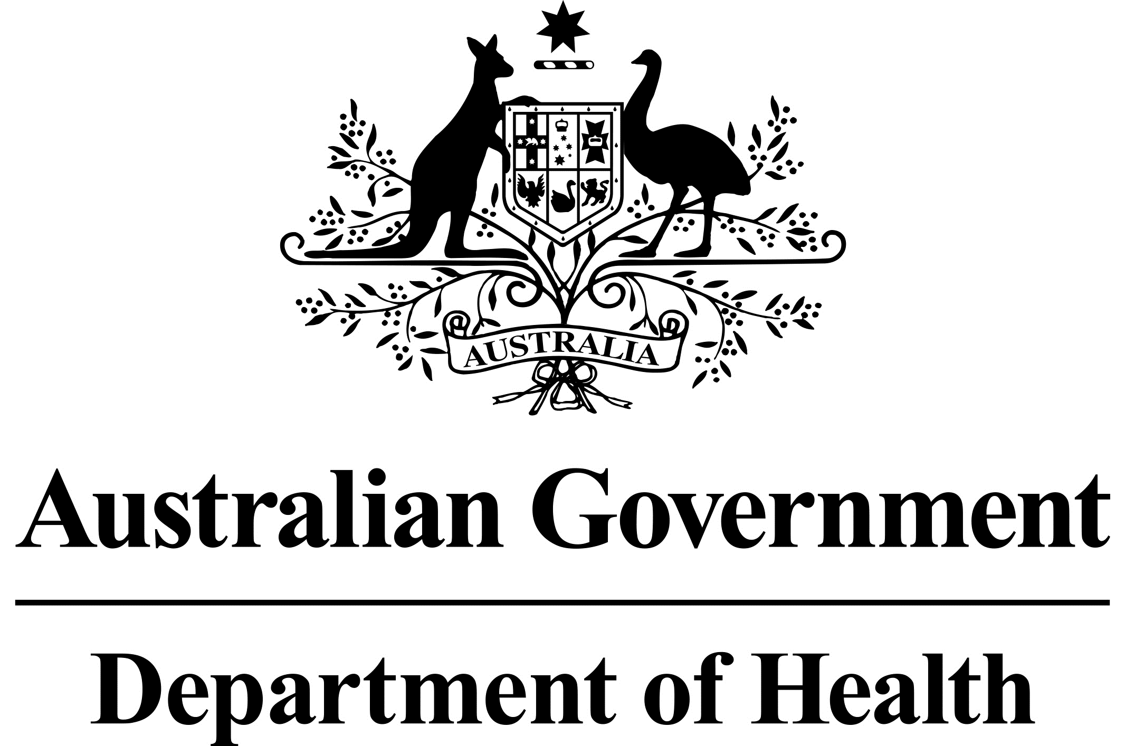

Primary care Rural Innovative Multidisciplinary Models (PRIMM) -Round 2

Grant GO5102

# FEEDBACK FOR APPLICANTS

## OVERVIEW

The Primary care Rural Innovative Multidisciplinary Models (PRIMM) grant opportunity is provided through the Health Workforce Program of the Australian Government Department of Health. The Office of the National Rural Health Commissioner is overseeing this grant opportunity.

The purpose of the PRIMM grant opportunity is to enable the design of community‑supported, locally designed rural multidisciplinary models of primary care.

This feedback is provided to all applicants in relation to PRIMM grant Round 2 held from 27 September 2021 to 5 November 2021.

The objectives of the PRIMM grant opportunity are for grant recipients to:

* Develop local, integrated, multidisciplinary models of primary care through a co‑design process, which includes engagement with local rural and remote communities, health services and training providers to address local health, service and/or workforce needs.
* Formalise processes/pathways that integrate and enhance service integration and delivery across sub‑regions and improve access, appropriateness, and availability of local health services.
* Create innovative models of care that include structured and supported processes for professional development, and service and learning opportunities for students, early career and senior health professionals and staff. These processes should be designed with local regional training providers and link with health needs and service gaps.

The intended outcomes of the PRIMM grant opportunity are for grant recipients to:

* Develop a ‘trial-ready’ multidisciplinary primary care model that will address specific population health needs and/or health workforce issues of communities or a sub-region.
* Develop a flexible methodology for the engagement of communities in co-designing solutions to address population health, service and/or workforce needs.
* Document and share findings and lessons learned from the design and co-design process with other rural and remote communities across Australia, to empower them to design their own primary healthcare solutions.

## OUTCOME OF APPLICATIONS

There was significant interest in the PRIMM grant Round 2, with 25 applications received of which two were successful for funding through an open competitive grant process.

## ASSESSMENT OF APPLICATIONS

Applications were assessed on their merits and comparatively against other applications based on:

* the overall objective/s to be achieved in providing the grant
* the extent to which the evidence in the application, including attachments clearly described the intended activities to be undertaken to meet the outcomes/objectives of the program
* the extent to which the geographic location of the application aligned with identified priorities, noting priority was given for Modified Monash (MM) MM4-7 locations
* the relative value of the grant sought.

## ASSESSMENT FEEDBACK

Common elements of high-quality applications are tabled in the assessment feedback below, including examples of how the applications met selection criteria.

Strong applications provided a clear and concise project description with qualitative and quantitative data which identified the target communities and populations with an identified health and/or service need, the activities to be conducted and the location or coverage area of the project (for example by naming the towns and their Modified Monash Model (MMM) classifications). In addition, these applications were able to demonstrate a strong multidisciplinary workforce and service model focus within the primary care setting and clearly articulated governance arrangements and project planning.

### Criterion 1: How will your grant activity align with program objectives and outcomes?

Describe your project and demonstrate how your proposal aligns with the program and grant opportunity objectives and outcomes at Section 3.1. Your response should be limited to 5000 characters (approximately 750 words). A good response should reflect the common elements and examples as tabled below:

| Sub-criteria | Common elements and examples |
| --- | --- |
| A clear description of the proposed project | Strong responses:   * Provided a strong and succinct project description using qualitative and quantitative data that identified the health issues of the communities and/or sub-regions in the proposal and compared it to relevant state or national data. * Clearly articulated the methodology for co‑designing a multidisciplinary health workforce employment model in the area. * Discussed local challenges in recruiting and retaining an appropriately qualified workforce. * Described barriers faced by the community to accessing primary health services, for example the only service available to community X is in town Y two hours’ drive away. |
| A clear problem definition describing the specific local population health needs and primary health care access barriers faced by the communities or sub-region covered by your proposal, with data and evidence to support the claim. | Strong responses:   * Demonstrated the need for the project in the community including clearly describing: * the current services available to the community * known health service gaps and needs of the community * relevant changes in demographics in the community (for example, increasing aging population requiring different model of care). * Described existing or past work that could be enhanced in the community. * Described how the project would link into existing broader initiatives and reforms at local, state, or national level. |
| Names of the communities, townships/localities the project covers (identifying the Modified Monash Model classification) and a clear intent to co-design the model of multidisciplinary healthcare with community members. | Strong responses:   * Named the communities or sub-regions covered by the proposal, including their MM classification.   Clearly articulated the methodology to be used for co‑designing a multidisciplinary health workforce/ service model in the area. |
| A case for why the project is needed, including local service gaps, and a description of how this project will be integrated with sub regional networks of services who collaborate to assist the formation of regionally collaborative, multidisciplinary teams through relevant activities, services, and reforms underway. You should use quantitative and qualitative evidence or data in your response to support your claims. | Strong responses:   * Described what the project aims to achieve for the communities involved. For example, a multi-disciplinary model of care that supports GPs and allied health professionals to work together to manage chronic disease and prevent hospitalisations, resulting in better health outcomes for patients. |

### Criterion 2: Community and stakeholder engagement

Describe how you will co-design a solution to the identified issues in Criterion 1 with the communities or sub-region and local stakeholders, including local health service providers. Your response should be limited to 5000 characters. A good response should reflect the common elements and examples as tabled below:

| Sub-criteria | Common elements and examples: |
| --- | --- |
| Details on the arrangements your organisation or consortium will use to work with the communities or sub-region, Aboriginal and Torres Strait Islander people/leaders/elders, under-represented populations (i.e. CALD, Aboriginal and Torres Strait Islander peoples) patients/consumers/carers, health professionals and other service providers in the region to develop a model that has community and sector support. | Strong responses:   * Provided specific information on how co-design would work in the community and with stakeholders. This may have included:   + how co-design participants would be engaged and trained   + how specific vulnerable population groups would be included in co-design and governance of the program (for example, through an advisory committee or targeted workshops). * Described a multi-faceted and ongoing codesign process to develop a model of care to ensure the community and stakeholders were genuinely engaged.   High quality applications also described existing arrangements working with other health service providers in the region and highlighted formalising and strengthening these arrangements with grant funding using the experience of the consortium. For example, shared recruitment strategies with the Local Health District, Primary Health Networks (PHNs), allied health providers and National Disability Insurance Scheme (NDIS) providers. Methods also highlighted employment strategies to reduce hospital admissions where possible. |
| Details of any consultation your organisation or consortium has undertaken on your proposal in the communities or sub-region. | Strong responses:   * Described the services and activities the lead organisation was currently providing or undertaking in the communities involved. * Where a consortium was proposed, services and activities for each member organisation were described clearly. * Demonstrated the lead organisation and any partner organisations together had a breadth of service experience within the communities.   High quality applications may have also described clearly how each consortia member/partner had contributed to servicing multiple communities in rural and remote locations and could build on this experience. For example, PHN stakeholder engagement, population health analysis and workforce recruitment strategies; universities in the state or region that had assisted with research and evaluation of other projects or models; and what level of available local GPs, rural generalists, specialists, nurses, allied health practitioners, Aboriginal Health practitioners and workers and support staff for their clinical expertise could be mobilised to service communities within a defined region. Letters of support from local services and community organisations were also helpful. |
| Details of how you will obtain and maintain community and sector support for your model, overcoming practical or perceived risks and barriers. | Strong responses:   * Named known issues or barriers to support within the communities and proposed specific measures to address these. For example, in communities where English is a second, third or fourth language, an organisation might hire project workers who speak the local language. * Ensured that community engagement and co-design was focussed on delivering comprehensive multidisciplinary primary health care, including integration with secondary and tertiary care. |

### Criterion 3: Outline your organisation’s capacity and performance

Demonstrate your organisation or consortium’s capacity to deliver the proposed project. Your response should be limited to 3500 characters (approximately 525 words). A good response should reflect common elements and examples as tabled below:

| Sub-criteria | Common elements and examples: |
| --- | --- |
| Details on your organisation or consortium’s capability and capacity to undertake this activity, including links and engagement that you have within the communities or sub-region. | Strong responses:   * Provided examples of current or previous engagement with the communities identified for the project. * Specified that key roles would be based in the communities that were the subject of the application. |
| Your organisation or consortium’s existing service footprint within the region. | Strong responses:   * Provided examples of current or previous projects the consortium or a group of members of the consortium had delivered together to demonstrate they had successfully worked together previously. * Examples of functional and current collaboration across local rural networks, as well as strong links with stakeholders delivering across allied health, nursing, and specialist services. |
| Organisational and staff capacity to manage this project including information on past experience. | Strong responses:   * Listed past successful grants and the outcomes of the past grants. * Outlined the staff members who would be working on the project, their roles, relevant expertise, and experience. |
| The governance and management structure. Where applicable, applicants should detail the governance arrangements for consortium arrangements. | Strong responses:   * Provided an existing or proposed project governance structure and associated plan, which may have included committee leadership and staff and stakeholder membership on the committee, and when and how often they would meet to ensure oversight of project outcomes. These included representation of key consumer, community, or population groups in the project governance structure. * Sought to have project governance arrangements established at the onset of funding which provided confidence that project planning and milestones would be managed appropriately. |
| Your application should indicate you have support from the local service and training providers including but not limited to, Primary Health Networks, Rural Workforce Agencies, the Local Health Networks (or equivalent), local Aboriginal Medical Services, Aboriginal Community Controlled Health Services and University Departments of Rural Health and other training providers. | Strong responses:   * Provided letters of support from relevant rural and remote stakeholders for the project, for example local GP clinics, local council (in addition to organisations as part of a consortia). |

### Criterion 4: Project plan (timelines, performance and use of grant funds)

Demonstrate how you will undertake the proposed activity, and how it is an efficient and economical use of grant funds. Your response should be limited to 3500 characters. A good response should reflect common elements and examples as tabled below:

| Sub-criteria | Common elements and examples: |
| --- | --- |
| A description of how the project will be implemented and managed (including the budget) within the grant period. | Strong responses:   * Described each stage of project implementation in addition to providing detail in the attached activity work plan. * Aligned with the project and activities described in other criteria. |
| The deliverables to be achieved, and how they link to grant outcomes. | Strong responses:   * Provided well defined deliverables (outputs) with a strong description of what is to be achieved (outcomes). |
| How you will measure outcomes and progress towards achieving the grant objectives. | Strong responses:   * Described how project progress towards outcomes would be measured and tracked. For example, monthly steering committee meetings and tracking deliverables in the activity work plan. |
| In addition to responding to the above criteria, the applicant must complete and attach the following documents to support their claims:   * Indicative Budget * Risk Management Plan * Activity Work-plan. | A good Indicative Budget:   * Provided a well-defined budget including administration costs, staffing requirements, and consultation costs. * Provided a brief rationale for the costs. * Was $400,000 (GST exclusive) or below as detailed in the Guidelines. * Considered eligible expenditure items as detailed in the Guidelines. * Excluded expenditure not eligible under this grant funding for example capital expenditure or expenditure to subsidise rental costs.   A good Risk Management plan:   * Demonstrated a sound knowledge of risk management principles. * Clearly articulated specific risks to their specific proposed project, e.g. community engagement. * Provided practical measures and controls to mitigate risks associated with the proposed project.   A good Activity Work plan:   * Presented activities in a logical sequence with reasonable timeframes. * Aligned with the project and activities described in other criteria. * Aligned with the outcomes and deliverables described in Criterion 4. * Had sufficient level of detail on deliverables, expectations and how planned activities will meet the goals of the described project. |