FAQs – Aged care workforce bonus payment

4 March 2022

Contents

General questions 3

What is the aged care workforce bonus payment grant opportunity? 3

Where can I get more information on the aged care workforce bonus payment? 3

Eligibility questions 3

Who is eligible to apply for funding under the grant opportunity? 3

Am I eligible to receive a bonus payment from my employer? 3

Who is not eligible to receive a bonus payment? 4

What other commonwealth programs are excluded? 5

When are the census dates? 5

How much is the bonus payment? 5

How are the bonus payments calculated? 5

Application questions 6

What do I need to do to apply for this payment? 6

What is a staffing profile spreadsheet? 6

What amount should I enter in the ‘financials’ tab in the application form for the question: “Provide a breakdown of the requested grant funding for each previously selected service area/s”? 7

What if I have more than 120 service locations to apply for? 7

What do I do to ensure my attachment is not larger than 2MB? 7

What do I enter as the project/activity details in section of the application? 7

When can I submit my application? 8

What is the process to receive the payment? 8

When do I receive the second payment? 8

What evidence is required to support my application? 9

Payment questions 9

What if the total of the bonuses that I pay to workers for the second instalment is more than the second payment I received? 9

What if workers are on leave within 4 weeks of the census dates? 9

A worker leaves after the census date and before the worker is paid? 9

What if a worker is on unpaid leave? 9

What if a worker is on unpaid leave because of COVID? 9

What if a worker has a claim for worker’s compensation? 10

What if a worker commences work after the census date/s? 10

What if a worker works less hours between the first and second census periods? 10

What if I don’t spend all the grant funding? 10

Are payments taxable? 10

Does the provider have to pay compulsory superannuation on the payment? 10

Does the provider need to pay payroll tax for the bonus payments? 11

Miscellaneous questions 11

Where can I find my approved provider ID number and service ID? 11

Where do I find my organisations ID? 11

If you have a problem with your payment? 11

How will payments be monitored? 12

# General questions

## What is the aged care workforce bonus payment grant opportunity?

On 1 February 2022, as part of the Australian Government’s commitment to the ongoing COVID-19 response, the Government announced it will provide $210 million to support the aged care workforce, in recognition of their dedication in continuing to care for older Australians during the COVID pandemic.

A bonus payment of up to $800 will be paid to care and support workers in Government-subsidised home care packages and to direct care workers, food service workers and cleaners in Government-subsidised residential care. The bonus payment will be paid in two instalments.

## Where can I get more information on the aged care workforce bonus payment?

For grant application questions and general enquiries contact the Department of Health by:

* Phone: (02) 6289 5600, or
* Email: [Grant.ATM@health.gov.au](mailto:Grant.ATM@health.gov.au) with a copy to [ACWBP@health.gov.au](mailto:ACWBP@health.gov.au).
* Enquiries from aged care workers can be emailed to [ACWBP.enquiries@health.gov.au](mailto:ACWBP.enquiries@heath.gov.au).

# Eligibility questions

## Who is eligible to apply for funding under the grant opportunity?

To be eligible to apply you must be:

* Australian Government funded:
* approved residential aged care providers.
* approved home care package providers.
* state/local government approved residential aged care and/or home care package providers.
* multipurpose service providers.
* providers delivering aged care services under the Commonwealth National Aboriginal and Torres Strait Islander Flexible Aged Care Program.
  + - * agencies or brokers employing eligible staff who are contracted to provide services for the above organisations.
      * Self-employed persons providing services for the above organisations.

An individual aged care worker, other than a self-employed person, cannot apply for this grant round. Providers are required to apply for grant funds on behalf of their workers. Agencies apply for grant funds on behalf of their workers.

## Am I eligible to receive a bonus payment from my employer?

The following workers employed by at least one of the responses above, are eligible for the aged care workforce bonus payment:

* residential aged care workers, including clinical and personal care workers, allied health workers, food services and cleaning services.[1]
* home care workers delivering home care under an approved home care package, including clinical support, personal care (showering, dressing etc.), cleaning and support with household tasks, meal preparation, social support, shopping services, community access, transport, allied health and respite services.

Table of aged care worker/s eligible for a bonus payment:

| Residential | Home |
| --- | --- |
| allied health A  cleaning services  enrolled nurses  food services  lifestyle coordinator B  nurse practitioners  personal care C  registered nurses | allied health A  ancillary care D  enrolled nurses  nurse practitioners  personal care C  registered nurses  respite services |

1. allied health includes audiologists, chiropractors, diabetes educators, dietitians, exercise physiologists, mental health worker, occupational therapists, osteopaths, physiotherapists, podiatrists and speech pathologists
2. lifestyle coordinators may be eligible to receive a bonus payment if the work that they do can be described as direct care or having direct client contact. Providers should assess their eligibility on a case by case basis.
3. personal care includes dressing, assistance with meals, grooming, hygiene, medication, movement, showering, similar activities and wound management.
4. ancillary care includes cleaning/support, community access, home support services, meal preparation, shopping, social support and transport

## Who is not eligible to receive a bonus payment?

The following workers are not eligible for the aged care workforce bonus payment. These include, but are not limited to, the following:

* full time and part time eligible aged care workers that take unpaid leave for the entire assessment period
* workers that do not provide direct care, food or cleaning services in residential care
* workers that do not provide care and support services in home care packages
* workers employed by aged care services that are not Government approved and subsidised
* administration workers
* gardeners

If there are other workers’ roles not included in this document, please contact the department at [ACWBP@health.gov.au](mailto:ACWBP@health.gov.au) for clarification.

## What other commonwealth programs are excluded?

The following commonwealth programs are not eligible to apply for the aged care workforce bonus payment grant round:

* Commonwealth Home Support Program (CHSP) Services
* NDIS services
* Short term restorative care
* Transition care
* Veterans Home Care Services

## When are the census dates?

The census dates for this grant round are:

* 28 February 2022 for payment 1, and
* 28 April 2022 for payment 2.

## How much is the bonus payment?

Eligible workers employed on a census date are entitled to a payment of up to $800, depending on how many census dates they were employed on, the type of aged care being provided and hours worked.

The bonus payment amounts are:

| Tiers | Most hours worked in a single week of the 4 weeks prior to the census date/s. | Bonus payment for residential care workers | Bonus payment for home care package workers |
| --- | --- | --- | --- |
| Tier 3 | Over 30 hours | $800 | $600 |
| Tier 2 | Over 15 hours and up to 30 hours | $640 | $480 |
| Tier 1 | Between 3 hours and up to 15 hours | $400 | $300 |

## How are the bonus payments calculated?

The bonus payments are paid in two instalments.

* For a person employed as at the first census date, the first instalment is calculated on the most number of hours worked in a single week by an employee, of the four weeks prior to the first census date 28 February 2022.

Example 1: Mary who works in residential aged care, has worked the following hours.

| Week | Date/s worked | Hours |
| --- | --- | --- |
| One | 1 Feb to 7 Feb | 15 hours |
| Two | 8 Feb to 14 Feb | 22 hours |
| **Three** | **15 Feb to 21 Feb** | **32 hours** |
| Four | 22 Feb to 28 Feb | 15 hours |

In week three, Mary worked a total of 32 hours for that week. Therefore, Mary is entitled to a tier 3 payment of $800. As the bonus payment is paid in two instalments, Mary would receive a first instalment of $400.

* For a person employed as at the second census date, the second instalment is at least equal to the first instalment, or if it results in a higher payment (or there was no first instalment), is calculated on the most number of hours worked in single a week by an employee, of the four weeks prior to the second census date of 28 April 2022.

Example 2: Mary, from example 1, worked the following hours.

|  |  |  |
| --- | --- | --- |
| Week | Date/s worked | Hours |
| One | 1 Apr to 7 April | 15 hours |
| Two | 8 Apr to 14 Apr | 22 hours |
| Three | 15 Apr to 21 Apr | 22 hours |
| Four | 22 Apr to 28 Apr | 15 hours |

Even though Mary’s weekly hours in the four weeks leading up to the census date would otherwise result in a lower bonus instalment, she is entitled to the second half of the original bonus.

She would receive a second instalment of $400.

Example 3:

If Mary’s hours were reversed so that her maximum weekly hours for the first census date was 22 and the maximum weekly hours for the second census date was 32, then she would have received $320 for the first instalment and $400 for the second.

# Application questions

## What do I need to do to apply for this payment?

Individual staff, other than a self-employed person, do not apply for this payment. Providers/agencies/brokers submit an application on behalf of their workers. Subject to approval, funds will be distributed to the provider/agency/broker who will make payments to eligible employees.

If you are an employer wanting to submit an application, please complete the on-line application form located on the GrantConnect website at <https://www.grants.gov.au/> and attach a completed staffing profile spreadsheet.

## What is a staffing profile spreadsheet?

An excel document that needs to be completed and attached with the application. It details the eligible workers working for the employer on the census date and the maximum weekly hours worked in the previous four weeks.

It is completed by the approved provider for its workers and by agencies for their workers providing services to the approved provider.

The spreadsheet requires you to identify staff by worker type and tier (the most hours worked in a single week prior to the census date). The spreadsheet will calculate the payment amounts to be entered into the application form - ‘attachments’ section.

Each spreadsheet can include information for up to 20 facilities. Applicants can upload up to 6 attachments, up to 2MB each, in the form allowing for up to 120 service locations.

A copy of the staffing profile spreadsheet will be available on the website soon.

## What amount should I enter in the ‘financials’ tab in the application form for the question: “Provide a breakdown of the requested grant funding for each previously selected service area/s”?

The total bonus amount applied for in this application form must equal the 'total application amount' of all of the services combined in the ‘staffing profile spreadsheet’ attachment.

If there is more than one attachment provided, the total amount of funding requested in the application must equal the 'total application amount' in all of the 'staffing profiles spreadsheets' submitted.

## What if I have more than 120 service locations to apply for?

Please email the department at [ACWBP@health.gov.au](mailto:ACWBP@health.gov.au). In the subject line, type:

“Assistance required – more than 120 services”. Include a name and contact number, and a staff member will call you to discuss solutions.

## What do I do to ensure my attachment is not larger than 2MB?

We recommend not to copy and paste data into the spreadsheet. This may include unseen characters and add size to the file.

We suggest you monitor the attachment size as you are entering the data, to ensure the file size does not exceed 2MB.

If you require assistance, contact the department at [ACWBP@health.gov.au](mailto:ACWBP@health.gov.au). In the subject line, type:

“Assistance required – file size exceeds 2MB”. Include a name and contact number, and a staff member will call you to discuss solutions.

## What do I enter as the project/activity details in section of the application?

There are two questions that need text entered to progress the application.

These are:

1. Provide a short title of your Application for this Project/Activity.

Enter the following in the text box: Aged Care Workforce Bonus Payment

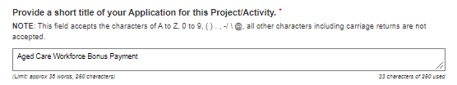

1. *Provide a brief description of your project or the services to be delivered and how it will contribute to the objectives outlined in the Grant Opportunity Guidelines.*

Enter the following in the text box: Aged Care Workforce Bonus Payment

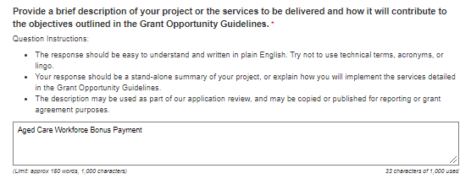

1. *In which service area/s is the Applicant proposing to deliver the Project/Activity?*
2. Select the only option available in the ‘Service Area Type’ drop down values of ‘Australia 2016’.
3. Then select the ‘Australia’ checkbox that becomes available.

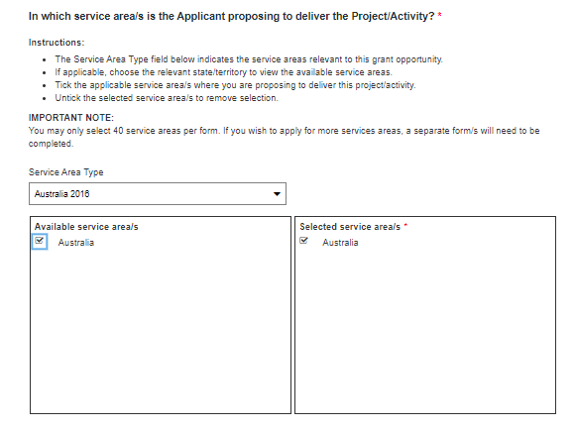

## When can I submit my application?

Applications for the aged care workforce bonus payment open from 1 March 2022 and closes at 2pm on 15 April 2022.

Please keep the original email generated by the online application form as this will include a link and submission reference number for your own records.

## What is the process to receive the payment?

Once an employer submits the application, this department will process/assess the request for funding. Subject to approval, the department will send an agreement to the approved grant recipient, which needs to be signed and returned.

Once the signed agreement is received, the department will release the first payment.

The payment to workers must be made within two pay cycles from when the employer receives the funds. However, employers are encouraged to make the bonus payment/s to workers as soon as they lodge their application.

## When do I receive the second payment?

A second payment equal to the first payment will automatically be made to providers/agencies in May 2022.

If the total of the second instalment of bonuses paid to workers is greater than the first instalment, then the employer can lodge a variation for the additional funds. If the amount is less, the employer can retain the surplus funds to be spent on COVID related expenses.

To request a variation, providers/agencies can email [ACWR@health.gov.au](mailto:ACWR@health.gov.au).

## What evidence is required to support my application?

No evidence is required at the time of submission of the application.

You will need to keep records that you have used to determine the grant application amount and evidence related to this claim. You will also be required to maintain evidence that the payments have been provided to the eligible worker.

Applications may be audited at a later date and in the event of this, you will be required to provide evidence.

# Payment questions

## What if the total of the bonuses that I pay to workers for the second instalment is more than the second payment I received?

If the total of the second instalment of bonuses paid to workers is greater than the first instalment, then the employer can lodge a variation for the additional funds. If the amount is less, the employer can retain the surplus funds to be spent on COVID related expenses.

To request a variation, providers/agencies can email [ACWR@health.gov.au](mailto:ACWR@health.gov.au).

## What if workers are on leave within 4 weeks of the census dates?

Eligible fulltime and part time aged care workers that are on paid leave are eligible for a bonus payment.

The amount of the bonus payment for workers on leave is based on the hours they would ordinarily have worked.

## A worker leaves after the census date and before the worker is paid?

If a worker’s bonus payment entitlement has been included in the application for grant funding, the worker is entitled to receive the payment, even if the worker has left employment.

## What if a worker is on unpaid leave?

If a worker is on unpaid leave, they are not eligible for a bonus payment, unless the worker is on unpaid leave due to a COVID related absence, including caring for a dependent with COVID or the worker needs to isolate as required under state/territory health orders. Please see question below for the exception.

## What if a worker is on unpaid leave because of COVID?

If a worker is on unpaid leave because they are isolating or tested positive for COVID-19, they will be entitled for a bonus payment, based on a week’s working hours that they would normally do.

## What if a worker has a claim for worker’s compensation?

If a worker is currently on worker’s compensation[2], further consideration must be provided to the department, including:

* reasons for compensation.
* duration of cover.
* Any other information relevant to the compensation claim.

For all situations, please refer the enquiry to the department at [ACWBP@health.gov.au](mailto:ACWBP@health.gov.au).

## What if a worker commences work after the census date/s?

If a worker starts employment after the census date/s, they will not be eligible for the bonus.

Example 4:

Chris commences with an approved aged care provider on 2 March 2022. Chris would not be eligible for payment 1. However, if Chris continues to work until 28 April 2022 (the second census date) Chris would be eligible for the second payment.

## What if a worker works less hours between the first and second census periods?

If a worker works less hours in the four weeks before the second census date, compared to the first census date, the worker is to be paid the same amount as their first payment.

Example 5:

Jenny works in residential care and received a first instalment of $400 because the most hours she worked in a week prior to the census date was 34 hours.

In the four weeks prior to the second census date of 28 April 2022 the most hours Jenny worked in a week was 16 hours.

Jenny is entitled to receive the same instalment of $400.

## What if I don’t spend all the grant funding?

The grant application requires you to make a true and correct statement of your staffing levels as at date of application and pay your workers. If there is surplus funding remaining from the payments, e.g. if the second instalment of bonuses that you pay is less than the automatic second payment that you received, you can retain the funds for COVID-19 related expenses.

## Are payments taxable?

Yes, the bonus payment is income and subject to income tax in the hands of workers. This is consistent with other COVID-19 measures, such as the JobKeeper payment.

For more information relating to individual tax matters, please visit the ATO website at <https://www.ato.gov.au/>.

## Does the provider have to pay compulsory superannuation on the payment?

No, the bonus payments are exempt from the superannuation guarantee.

## Does the provider need to pay payroll tax for the bonus payments?

The grant may be subject to payroll tax in the relevant jurisdiction/s. We ask employers to contact their relevant state or territory revenue office, to confirm if they are required to pay payroll tax.

# Miscellaneous questions

## Where can I find my approved provider ID number and service ID?

Your approved provider/service ID number is located on your Services Australia payment statement in the top left-hand corner. The example below is from a residential payment statement. Homecare statements will have a similar format.

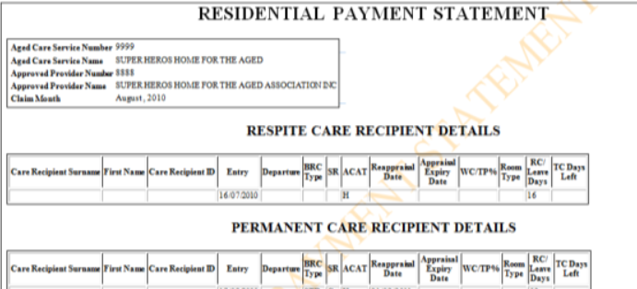

## Where do I find my organisations ID?

Your organisation’s ID can be found on a current grant agreement with the department.

The ID number is located in the top right hand corner on the grant details page of your (usually on page 4). and in the format of a combination of numbers, hyphens and letters.

For example: 1-AAAAAA (where “1” represents a number and “A” represents a letter or number).

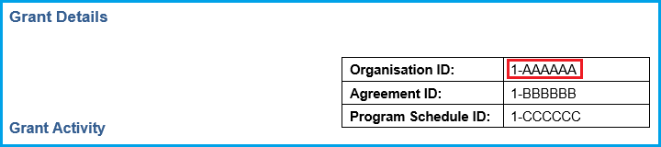

## If you have a problem with your payment?

If there is a concern with your bonus payment you received, if you think it is wrong, or you have not received a payment and believe that you should, it is ok to ask.

**Step 1: talk to your employer**

It is important that you talk to your employer first. In most cases, they can resolve the query quickly because they have the information.

If you are not sure how to talk to your employer, it may help to:

* write an email or letter to your employer to explain the problem (this also means you have a written record)
* focus on the facts
* ask for help from a friend or family member
* If needed, you can use the Translating and Interpreting Service or the National Relay Service.

If you feel you cannot talk to your employer, go to step 2 below.

**Step 2: contact us**

Contact us if your employer was not able to help, or you feel you cannot talk to your employer.

* complete the enquiry form with as much information you can provide. If available, provide supporting material, for example: pay slips.
* In the form, tell us if we can contact your employer.
* Send the completed form and attachments to [ACWRP.enquiries@health.gov.au](mailto:ACWRP.enquiries@health.gov.au).

If we can help you, we will contact your employer on your behalf, with your consent, to investigate the situation.

* Review the information received from your employer and respond to them.
* Let you know the outcome (depending on when they respond).
* If there is an error by your employer, we will provide a response how to resolve the enquiry.
* If the evidence shows wrongdoing by your employer, we may take audit action. If this happens, we may not tell you about the outcome.

If we are not able to help you, we will advise you in writing.

## How will payments be monitored?

This program will be subject to an active audit program which will be a combination of random and targeted audits. Targeted audits will be based on, but not limited to:

* Analysis of complaints or feedback.
* Examination of data held by the department, cross-referenced with application data.
* Any other information or anomalies that emerge.

This will ensure the workers receives their entitled payment.

1. cleaning services includes worker/s who provide laundry, room cleaning, and general cleaning services in a residential care facility.
2. The client does not need to be identified by name. The information can be provided to the department as a general enquiry.