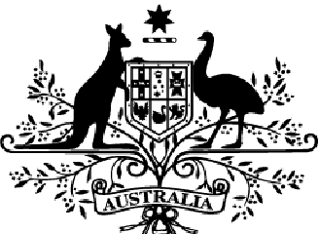

Australian Government

Operation COVID Shield

COVID-19 Vaccine Roll-out

**18 March 2022**

## 1

**Total vaccine doses**

55,508,022 total vaccine doses administered nationally as at 17 March

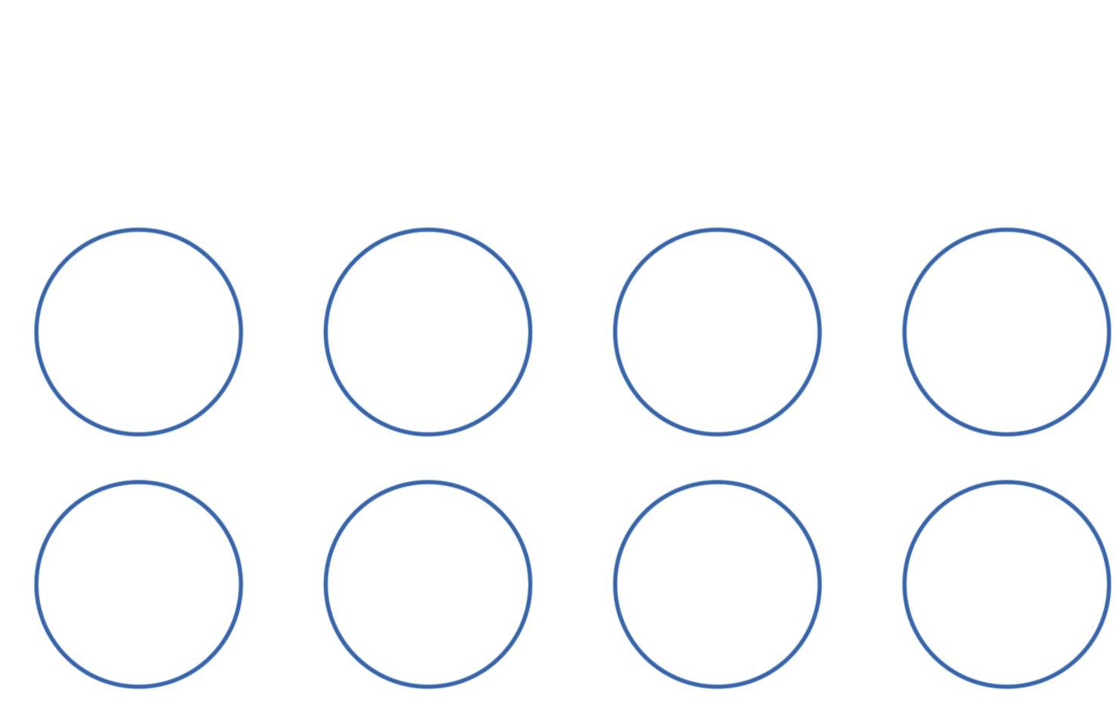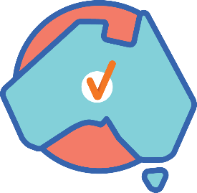

**Data as at: 17 Mar 2022**

**+**92,821 recorded in the last 24 hours

**NSW VIC QLD WA**

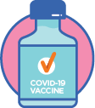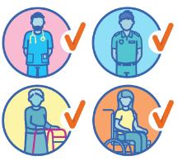

19,923,628

dose

>95%

of people over the age of 16 have had at least one dose

19,562,389

people are fully vaccinated

94.9%

of people over the age of 16 are fully vaccinated

12,402,691

people over the age of 16 who have received more than two doses

people have had at least one

**17,275,711 14,646,824 10,525,198 6,038,505**

(+26,401 daily increase)

(+21,619 daily increase)

(+16,650 daily increase)

(+14,354 daily increase)

**TAS SA ACT NT**

**1,240,154**

**3,815,495**

**1,425,372 540,763**

(+2,288 daily increase)

(+7,109 daily increase)

(+2,993 daily increase)

(+1,407 daily increase)

*Administration state breakdown indicates state in which a vaccine was administered

**Overall dose count includes instances of more than two doses per person in a small number of cases.

#### Source: Australian Immunisation Register



## 2

**Booster Vaccinations**



177,862

Indigenous people who have

received more than two doses

49.6%

of eligible population (358,485)

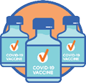

12,402,691 total people who

have received more than two doses nationally

+50,019 recorded in the last 24 hours 66.1% of people who are eligible (18,773,507) have received more than two doses

**Data as at: 17 Mar 2022**

*People may belong to multiple groups and could be represented in the above breakdowns multiple times. # NDIS participants data as at 16 March 2022.

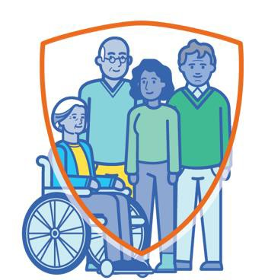

85.6%

of eligible population

(23,000)

of eligible population (236,000)

who have received more than two doses#

70.4%

166,277 20,070

**NDIS participants NDIS residents**

160,876

Aged Care Residents who have received more than two doses##

92.7%

of eligible population (173,466)

|  |  |  |
| --- | --- | --- |
| **QLD** | **People** | **% of Eligible** |
| **Cumulative** | 2,139,853 | 61.0% |
| **Daily increase** | 8,648 |

|  |  |  |
| --- | --- | --- |
| **ACT** | **People** | **% of Eligible** |
| **Cumulative** | 251,196 | 73.2% |
| **Daily increase** | 602 |

|  |  |  |
| --- | --- | --- |
| **WA** | **People** | **% of Eligible** |
| **Cumulative** | 1,484,039 | 84.8% |
| **Daily increase** | 7,973 |

|  |  |  |
| --- | --- | --- |
| **NT** | **People** | **% of Eligible** |
| **Cumulative** | 103,768 | 65.6% |
| **Daily increase** | 743 |

## Aged Care Residents data as at 17 March 2022.

#### Source: Australian Immunisation Register

**91,819**

doses administered to persons residing in other territories or with missing residential information



|  |  |  |
| --- | --- | --- |
| **NSW** | **People** | **% of Eligible** |
| **Cumulative** | 3,810,304 | 62.0% |
| **Daily increase** | 14,487 |

|  |  |  |
| --- | --- | --- |
| **SA** | **People** | **% of Eligible** |
| **Cumulative** | 876,797 | 70.0% |
| **Daily increase** | 3,452 |

|  |  |  |
| --- | --- | --- |
| **VIC** | **People** | **% of Eligible** |
| **Cumulative** | 3,367,920 | 67.3% |
| **Daily increase** | 11,791 |

|  |  |  |
| --- | --- | --- |
| **TAS** | **People** | **% of Eligible** |
| **Cumulative** | 276,995 | 68.2% |
| **Daily increase** | 1,666 |

## 3

**Vaccinations by residential location**

**Data as at: 17 Mar 2022**

|  |  |  |  |  |  |  |  |  |  |
| --- | --- | --- | --- | --- | --- | --- | --- | --- | --- |
|  |  |  |  |  |  |  |  |  |  |
|  |  |  |  |  |  |  |  |  |  |
|  |  |  |  |  |  |  |  |  | 80% |
|  |  |  |  |  |  |  |  |  | 70% |
|  |  |  |  |  |  |  |  |  |  |
|  |  |  |  |  |  |  |  |  |  |
|  |  |  |  |  |  |  |  |  |  |
|  |  |  |  |  |  |  |  |  |  |
|  |  |  |  |  |  |  |  |  |  |
|  |  |  |  |  |  |  |  |  |  |

|  |  |  |  |  |  |  |  |  |  |
| --- | --- | --- | --- | --- | --- | --- | --- | --- | --- |
|  |  |  |  |  |  |  |  |  |  |
|  |  |  |  |  |  |  |  |  |  |
|  |  |  |  |  |  |  |  |  | 80% |
|  |  |  |  |  |  |  |  |  | 70% |
|  |  |  |  |  |  |  |  |  |  |
|  |  |  |  |  |  |  |  |  |  |
|  |  |  |  |  |  |  |  |  |  |
|  |  |  |  |  |  |  |  |  |  |
|  |  |  |  |  |  |  |  |  |  |
|  |  |  |  |  |  |  |  |  |  |

First doses

|  |  |  |  |  |  |
| --- | --- | --- | --- | --- | --- |
| 4 8  Age Today weeks weeks  ago ago | | | |  | |
| 16+ | >95% | >95% | >95% |  | **WA**   * 95% 1st dose * 95% 2nd dose |
| 50+  70+ | >95% | >95% | >95% |
| >95% | >95% | >95% |
| Fully vaccinated | | | | |
| 4 8  Age Today weeks weeks  ago ago | | | |  |
| 16+ | 94.9% | 94.4% | 93.3% |
| 50+  70+ | >95% | >95% | >95% |  | |
| >95% | >95% | >95% |

|  |  |  |  |  |  |  |  |  |  |
| --- | --- | --- | --- | --- | --- | --- | --- | --- | --- |
|  |  |  |  |  |  |  |  |  |  |
|  |  |  |  |  |  |  |  |  |  |
|  |  |  |  |  |  |  |  |  | 80% |
|  |  |  |  |  |  |  |  |  | 70% |
|  |  |  |  |  |  |  |  |  |  |
|  |  |  |  |  |  |  |  |  |  |
|  |  |  |  |  |  |  |  |  |  |
|  |  |  |  |  |  |  |  |  |  |
|  |  |  |  |  |  |  |  |  |  |
|  |  |  |  |  |  |  |  |  |  |

**NT**

91.6% 1st dose

88.9% 2nd dose

**QLD**

93.2% 1st dose

91.4% 2nd dose

|  |  |  |  |  |  |  |  |  |  |
| --- | --- | --- | --- | --- | --- | --- | --- | --- | --- |
|  |  |  |  |  |  |  |  |  |  |
|  |  |  |  |  |  |  |  |  |  |
|  |  |  |  |  |  |  |  |  | 80% |
|  |  |  |  |  |  |  |  |  | 70% |
|  |  |  |  |  |  |  |  |  |  |
|  |  |  |  |  |  |  |  |  |  |
|  |  |  |  |  |  |  |  |  |  |
|  |  |  |  |  |  |  |  |  |  |
|  |  |  |  |  |  |  |  |  |  |
|  |  |  |  |  |  |  |  |  |  |

**ACT**

* 95% 1st dose
* 95% 2nd dose

|  |  |  |  |  |  |  |  |  |  |
| --- | --- | --- | --- | --- | --- | --- | --- | --- | --- |
|  |  |  |  |  |  |  |  |  |  |
|  |  |  |  |  |  |  |  |  |  |
|  |  |  |  |  |  |  |  |  | 80% |
|  |  |  |  |  |  |  |  |  | 70% |
|  |  |  |  |  |  |  |  |  |  |
|  |  |  |  |  |  |  |  |  |  |
|  |  |  |  |  |  |  |  |  |  |
|  |  |  |  |  |  |  |  |  |  |
|  |  |  |  |  |  |  |  |  |  |
|  |  |  |  |  |  |  |  |  |  |

**NSW**

* + 95% 1st dose

94.5% 2nd dose

*Residential state may differ from the state in which a vaccine was administered

**SA**

95.0% 1st dose

92.6% 2nd dose

**VIC**

|  |  |  |  |  |  |  |  |  |  |
| --- | --- | --- | --- | --- | --- | --- | --- | --- | --- |
|  |  |  |  |  |  |  |  |  |  |
|  |  |  |  |  |  |  |  |  |  |
|  |  |  |  |  |  |  |  |  | 80% |
|  |  |  |  |  |  |  |  |  | 70% |
|  |  |  |  |  |  |  |  |  |  |
|  |  |  |  |  |  |  |  |  |  |
|  |  |  |  |  |  |  |  |  |  |
|  |  |  |  |  |  |  |  |  |  |
|  |  |  |  |  |  |  |  |  |  |
|  |  |  |  |  |  |  |  |  |  |

* + 95% 1st dose

93.6% 2nd dose

**TAS**

|  |  |  |  |  |  |  |  |  |  |
| --- | --- | --- | --- | --- | --- | --- | --- | --- | --- |
|  |  |  |  |  |  |  |  |  |  |
|  |  |  |  |  |  |  |  |  |  |
|  |  |  |  |  |  |  |  |  | 80% |
|  |  |  |  |  |  |  |  |  | 70% |
|  |  |  |  |  |  |  |  |  |  |
|  |  |  |  |  |  |  |  |  |  |
|  |  |  |  |  |  |  |  |  |  |
|  |  |  |  |  |  |  |  |  |  |
|  |  |  |  |  |  |  |  |  |  |
|  |  |  |  |  |  |  |  |  |  |

* + 95% 1st dose

|  |  |  |  |  |  |  |  |  |  |
| --- | --- | --- | --- | --- | --- | --- | --- | --- | --- |
|  |  |  |  |  |  |  |  |  |  |
|  |  |  |  |  |  |  |  |  |  |
|  |  |  |  |  |  |  |  |  | 80% |
|  |  |  |  |  |  |  |  |  | 70% |
|  |  |  |  |  |  |  |  |  |  |
|  |  |  |  |  |  |  |  |  |  |
|  |  |  |  |  |  |  |  |  |  |
|  |  |  |  |  |  |  |  |  |  |
|  |  |  |  |  |  |  |  |  |  |
|  |  |  |  |  |  |  |  |  |  |

* + 95% 2nd dose





## 4



|  |  |  |
| --- | --- | --- |
| **WA** | **Jurisdictions** | **Commonwealth** |
| **Cumulative** | 2,408,043 | 3,630,462 |
| **Daily increase** | 3,412 | 10,942 |

|  |  |  |
| --- | --- | --- |
| **NT** | **Jurisdictions** | **Commonwealth** |
| **Cumulative** | 316,951 | 223,812 |
| **Daily increase** | 724 | 683 |

**Commonwealth and Jurisdiction vaccine doses administered**

|  |  |  |
| --- | --- | --- |
| **NSW** | **Jurisdictions** | **Commonwealth** |
| **Cumulative** | 5,002,549 | 12,273,162 |
| **Daily increase** | 3,664 | 22,737 |

|  |  |  |
| --- | --- | --- |
| **TAS** | **Jurisdictions** | **Commonwealth** |
| **Cumulative** | 598,116 | 642,038 |
| **Daily increase** | 493 | 1,795 |

|  |  |  |
| --- | --- | --- |
| **QLD** | **Jurisdictions** | **Commonwealth** |
| **Cumulative** | 3,759,098 | 6,766,100 |
| **Daily increase** | 3,504 | 13,146 |

|  |  |  |
| --- | --- | --- |
| **ACT** | **Jurisdictions** | **Commonwealth** |
| **Cumulative** | 730,672 | 694,700 |
| **Daily increase** | 2,027 | 966 |

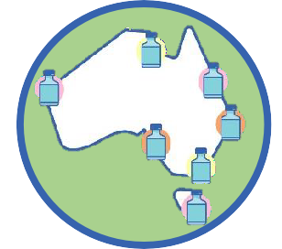

20,468,530

doses administered by state and territory facilities

+ 21,157

recorded in the last 24 hours



55,508,022 total vaccine doses administered nationally as at 17 March

**+** 92,821 recorded in the last 24 hours

**Data as at: 17 Mar 2022**



35,039,492

doses administered by

commonwealth facilities

+ 71,664

recorded in the last 24 hours

33,778,567 total vaccine doses administered in primary care settings 1,260,925 total vaccine doses administered in aged care and disability settings

|  |  |  |
| --- | --- | --- |
| **VIC** | **Jurisdictions** | **Commonwealth** |
| **Cumulative** | 5,916,835 | 8,729,989 |
| **Daily increase** | 4,525 | 17,094 |

|  |  |  |
| --- | --- | --- |
| **SA** | **Jurisdictions** | **Commonwealth** |
| **Cumulative** | 1,736,266 | 2,079,229 |
| **Daily increase** | 2,808 | 4,301 |

#### Source: Australian Immunisation Register

## 5

**Vaccine milestone charts**

**Data as at: 17 Mar 2022**

2,500,000

2,000,000

1,500,000

1,000,000

500,000

0

Doses Administered by Week

#### 7,000,000

#### 6,000,000

#### 5,000,000

#### 4,000,000

#### 3,000,000

#### 2,000,000

#### 1,000,000

80%

0%

7

Doses by administration month and vaccine type

AZ - Vaxzevria Pfizer Moderna Novavax

Feb Mar Apr May Jun Jul Aug Sep Oct Nov Dec Jan Feb Mar

5 days

7 days

10 days

Doses Reported

22-Feb-21

1-Mar-21

8-Mar-21

15-Mar-21

22-Mar-21

29-Mar-21

5-Apr-21

12-Apr-21

19-Apr-21

26-Apr-21

3-May-21

10-May-21

17-May-21

24-May-21

31-May-21

7-Jun-21

14-Jun-21

21-Jun-21

28-Jun-21

5-Jul-21

12-Jul-21

19-Jul-21

26-Jul-21

2-Aug-21

9-Aug-21

16-Aug-21

23-Aug-21

30-Aug-21

6-Sep-21

13-Sep-21

20-Sep-21

27-Sep-21

4-Oct-21

11-Oct-21

18-Oct-21

25-Oct-21

1-Nov-21

8-Nov-21

15-Nov-21

22-Nov-21

29-Nov-21

6-Dec-21

13-Dec-21

20-Dec-21

27-Dec-21

3-Jan-22

10-Jan-22

17-Jan-22

24-Jan-22

31-Jan-22

7-Feb-22

14-Feb-22

21-Feb-22

28-Feb-22

7-Mar-22

**Eligible population percentage coverage**

14 days

|  |  |  |  |  |
| --- | --- | --- | --- | --- |
| 393,501 | | |  |  |
| 573,951 | | |  |
| 848,782 | | |  |
| 1,094,60 | | | 8 |
|  |  |  |
|  | | | | |
|  |  |  |  |  |

28 days

*Sourced from the Australian Immunisation Register.

2,497,263

1st dose: >95.0%

2nd dose: 94.9%

*Each square represents 1% of the national population. Squares are filled as milestones are achieved.



## 6

**Doses by age and sex**

|  |  |  |  |  |
| --- | --- | --- | --- | --- |
|  | **16+** | **50+** | **12-15** | **5-11** |
| Dose 1 | **96.62%** (19,923,628 doses  / 20,619,959 people) | **>99%** (8,804,608 doses /  8,749,703 people) | **84.92%** (1,056,410 doses /  1,243,990 people) | **51.50%** (1,172,444 doses /  2,276,638 people) |
| Dose 2 | **94.87%** (19,562,389 doses  / 20,619,959 people) | **>99%** (8,689,101 doses /  8,749,703 people) | **79.48%** (988,740 doses /  1,243,990 people) | **13.26%** (301,833 doses /  2,276,638 people) |

First and second doses by age and sex

**Data as at: 17 Mar 2022**

##### Dose 1 Dose 2 Population

Dose 1 Dose 2

Female

>99%

Male

>99%

>99%

>99%

>99%

>99%

>99% >99%

>99% >99%

>99% >99%

>99% >99%

98.2% >99%

93.5% 95.9%

99.0% >99%

91.7% 93.2%

98.5% >99%

96.5% 97.0%

93.1% 93.8%

89.8% 91.2%

89.7% 88.2%

94.0% 91.3%

85.7% 84.2%

##### 95+

##### 90-94

##### 85-89

##### 80-84

##### 75-79

##### 70-74

##### 65-69

##### 60-64

Age

##### 55-59

##### 50-54

##### 45-49

##### 40-44

##### 35-39

##### 30-34

##### 25-29

##### 20-24

##### 16-19

##### 12-15

##### 59,555 (>99%)

##### 173,763 (>99%)

##### 338,954 (>99%)

##### 557,546 (>99%)

##### 842,052 (>99%)

##### 1,110,781 (>99%)

##### 1,256,790 (>99%)

##### 1,423,024 (>99%)

##### 1,474,430 (94.8%)

##### 1,567,713 (>99%)

##### 1,551,694 (92.5%)

##### 1,607,035 (>99%)

##### 1,779,823 (97.0%)

##### 1,805,997 (93.9%)

##### 1,736,851 (91.1%)

##### 1,529,339 (89.3%)

##### 1,108,281 (92.7%)

##### 1,056,410 (84.9%)

##### 56,134 (>99%)

##### 167,879 (>99%)

##### 331,476 (>99%)

##### 549,628 (>99%)

##### 832,908 (>99%)

##### 1,099,013 (>99%)

##### 1,241,608 (98.7%)

##### 1,405,563 (97.8%)

##### 1,456,386 (93.6%)

##### 1,548,506 (99.0%)

##### 1,530,492 (91.3%)

##### 1,579,969 (97.5%)

##### 1,744,639 (95.1%)

##### 1,761,231 (91.6%)

##### 1,687,258 (88.5%)

##### 1,488,127 (86.9%)

##### 1,081,572 (90.4%)

##### 988,740 (79.5%)

##### 1m 0.8m

##### 0.6m

##### 0.4m

##### 0.2m

##### 0m 0.2m

##### 0.4m

##### 0.6m

##### 0.8m 1m

Population (percentages are first dose)

|  |  |  |  |  |  |  |  |  |  |
| --- | --- | --- | --- | --- | --- | --- | --- | --- | --- |
|  | **AUS** | **ACT** | **NSW** | **NT** | **QLD** | **SA** | **TAS** DOH ( | Australia**V**n**IC**Immunisation | Regist**W**er**A**), ABS (Population) |
| **16 and over - dose 1** | 19,923,628 | 351,321 | 6,299,542 | 174,483 | 3,834,843 | 1,367,936 | 442,730 | 5,140,020 | 2,079,856 |
| **16 and over - dose 2** | 19,562,389 | 345,912 | 6,203,966 | 169,486 | 3,760,267 | 1,333,933 | 432,787 | 5,063,340 | 2,036,698 |
| **16 and over - population** | 20,619,959* | 344,037 | 6,565,651 | 190,571 | 4,112,707 | 1,440,400 | 440,172 | 5,407,574 | 2,114,978 |
| **16 and over % with dose 1** | 96.62% | >99% | 95.95% | 91.56% | 93.24% | 94.97% | >99% | 95.05% | 98.34% |
| **16 and over % with dose 2** | 94.87% | >99% | 94.49% | 88.94% | 91.43% | 92.61% | 98.32% | 93.63% | 96.30% |
| **5 to 11 - dose 1** | 1,172,444 | 31,498 | 348,853 | 12,957 | 206,193 | 83,078 | 28,198 | 320,660 | 133,852 |
| **5 to 11 - dose 2** | 301,833 | 10,707 | 98,509 | 2,946 | 57,892 | 20,066 | 9,570 | 74,972 | 25,869 |
| **5 to 11 - population** | 2,276,638 | 39,789 | 716,460 | 24,750 | 478,731 | 148,816 | 45,033 | 578,499 | 244,154 |
| **5 to 11 % with dose 1** | 51.50% | 79.16% | 48.69% | 52.35% | 43.07% | 55.83% | 62.62% | 55.43% | 54.82% |
| **5 to 11 % with dose 2** | 13.26% | 26.91% | 13.75% | 11.90% | 12.09% | 13.48% | 21.25% | 12.96% | 10.60% |
| **12 to 15 - dose 1** | 1,056,410 | 20,074 | 326,125 | 10,918 | 207,789 | 68,473 | 22,916 | 276,239 | 114,800 |
| **12 to 15 - dose 2** | 988,740 | 19,193 | 309,054 | 9,703 | 192,543 | 63,955 | 21,576 | 261,672 | 103,202 |
| **12 to 15 - population** | 1,243,990 | 19,693 | 390,330 | 13,060 | 270,146 | 82,747 | 26,308 | 308,611 | 132,869 |
| **12 to 15 % with dose 1** | 84.92% | >99% | 83.55% | 83.60% | 76.92% | 82.75% | 87.11% | 89.51% | 86.40% |
| **12 to 15 % with dose 2** | 79.48% | 97.46% | 79.18% | 74.30% | 71.27% | 77.29% | 82.01% | 84.79% | 77.67% |

*National population will not equal sum of listed jurisdictions due to a small number of people counted in national population residing in some 'other' territories. Sum of state doses will not add to national total as some records

are unable to be geocoded to a State or Territory.

##### Doses sourced from Australian Immunisation Register, population from ABS ERP June 2020



## 7

**Vaccinations by location**

**Data as at: 17 Mar 2022**

**Cumulative total doses administered vs eligible state populations* First and Second Doses by residential location**

400.0

0% 10% 20% 30% 40% 50% 60% 70% 80% 90% 100%

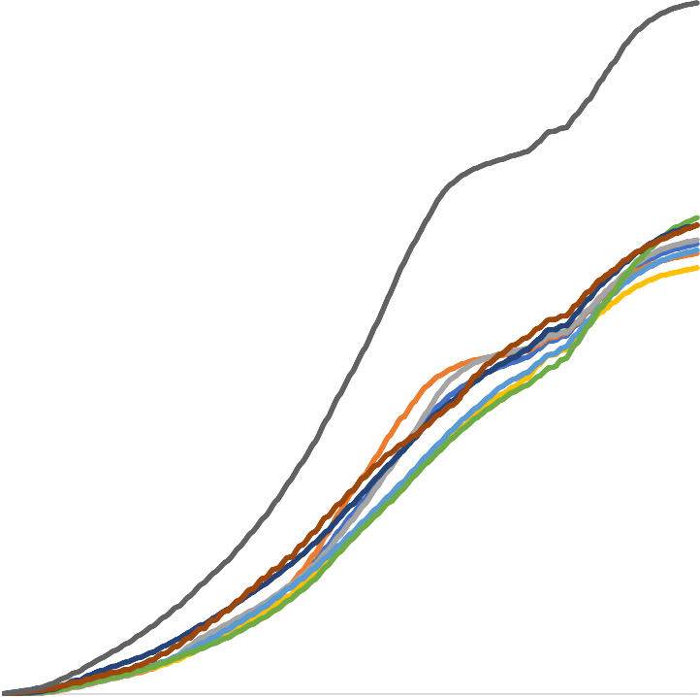

WA = 261.5

NSW=241.9

QLD = 234.0

TAS =257.5

ACT= 379.5

|  |
| --- |
| NT =257.3 |
| VIC =249.3 |
| AUS = 247.1 |
| SA =243.7 |

350.0

300.0

250.0

200.0

150.0

100.0

50.0

0.0

21/02/2021

13/03/2021

2/04/2021

22/04/2021

12/05/2021

1/06/2021

21/06/2021

11/07/2021

31/07/2021

20/08/2021

9/09/2021

29/09/2021

19/10/2021

8/11/2021

28/11/2021

18/12/2021

7/01/2022

27/01/2022

16/02/2022

8/03/2022

National Total Australian Capital Territory

Tasmania Western Australia New South Wales

Victoria South Australia Queensland Northern Territory

### 94.9%

### >95%

### >95%

### >95%

### 94.5%

### 93.6%

### 92.6%

### 91.4%

### 88.9%

### >95%

### >95%

### >95%

### >95%

### >95%

### >95%

### 95.0%

### 93.2%

### 91.6%



#### *Not an indication of percentage vaccinated, numbers will exceed 100 due to multiple doses required per person of the population. All doses are included for those aged 12 and above, and are based on vaccination provider location.

## 8

**Aboriginal and Torres Strait Islander peoples Number of people vaccinated**



434,708

people over the age of 16 have had at least one dose

83.8%

of people over the age of 16 have had at least one dose

|  |  |  |  |  |  |  |  |
| --- | --- | --- | --- | --- | --- | --- | --- |
| 177 Ab  0# | original  50 | commu  27 | nity cont  44 | rolled he  12 | alth se  3 | rvices (A  21 | CCHS)  20 |
| ACT | NSW | NT | QLD | SA | TAS | VIC | WA |

**Data as at: 15 Mar 2022**

**Updated weekly**

|  |  |  |  |  |
| --- | --- | --- | --- | --- |
| Medicare Address State## | Individuals Dose 1 | Individuals Dose 1 % | Individuals Dose 2 | Individuals Dose 2 % |
| Australian Capital Territory | 4,837 | 91.3% | 4,713 | 88.9% |
| New South Wales | 134,608 | 86.6% | 131,283 | 84.5% |
| Northern Territory | 42,154 | 89.1% | 39,604 | 83.7% |
| Queensland | 114,770 | 80.9% | 108,282 | 76.3% |
| South Australia | 19,708 | 79.3% | 18,053 | 72.7% |
| Tasmania | 13,965 | 88.4% | 13,474 | 85.3% |
| Victoria | 35,197 | 89.5% | 34,308 | 87.3% |
| Western Australia | 52,750 | 84.0% | 47,087 | 75.0% |
| Unknown/Other Territories | 16,719 | 64.7% | 14,783 | 57.3% |
| **Totals** | **434,708** | **83.8%** | **411,587** | **79.4%** |



411,587

people over the age of 16 are fully vaccinated

79.4%

of people over the age of 16 are fully vaccinated

#### Source: Australian Immunisation Register



People aged 12 – 15 years

48,327 41,857

68.1% 59.0%

At least one dose Fully vaccinated

*Identifying as Aboriginal and Torres Strait Islander is optional and the estimated population may be under reported.

**Includes all Aboriginal and Torres Strait Islander peoples who have received a vaccination, not limited to those administered in an ACCHS setting

#ACCHS in the ACT are currently operating as a Commonwealth Vaccine Clinics so not included to avoid double counting

##The above table includes all identified Aboriginal and Torres Strait Islander people who are aged 16 and above by their state of residence.

## 9

**Aboriginal and Torres Strait Islander peoples Number of people vaccinated by age**

**Data as at: 15 Mar 2022**

**Updated weekly**

#### 70+

#### 60-69

#### 50-59

#### 40-49

#### 30-39

#### 20-29

#### 16-19

#### 12-15

#### 5-11

#### 0 20,000 40,000 60,000 80,000 100,000 120,000 140,000 160,000

### Individuals Dose 1 Only Individuals Fully Vaccinated Individuals Remaining (AIR)

Doses sourced from Australian Immunisation Register, population from ABS ERP June 2020

Source: Australian Immunisation Register

## 10

**Commonwealth primary care**

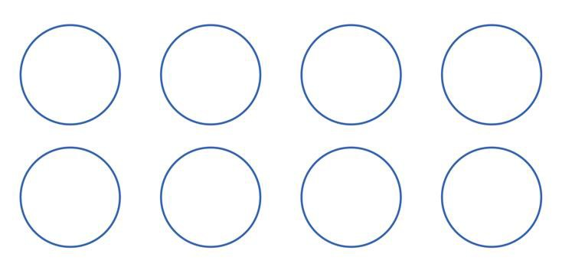

Primary care vaccine administration sites

**Data as at: 17 Mar 2022**

33,778,567 total vaccine doses administered primary care settings as at 17 March

**+** 71,058 recorded in the last 24 hours

|  |  |  |  |
| --- | --- | --- | --- |
| 5,788 | 128 | 177 | 3,585 |
| GPs | CVCs | ACCHS | Pharmacies |

**Primary care vaccinations by provider type**

|  |  |  |  |
| --- | --- | --- | --- |
|  | **Doses administered** | **Daily increase** | **7 day increase** |
| **General Practice\***  includes other  Commonwealth | 27,424,656 | 46,983 | 272,391 |
| **Pharmacy** | 6,353,911 | 24,075 | 141,367 |

**NSW**

**11,729,827**

|  |  |  |
| --- | --- | --- |
| **VIC** | **QLD** | **WA** |
| **8,426,339** | **6,495,687** | **3,504,915** |
| (+16,999 daily | (+12,971 daily | (+10,522 daily |
| increase) | increase) | increase) |
| **SA** | **ACT** | **NT** |
| **2,003,062** | **532,248** | **203,060** |
| (+4,273 daily | (+851 daily | (+642 daily |
| increase) | increase) | increase) |

(+22,293 daily increase)

**TAS**

**622,809**

(+1,778 daily increase)

**260,620**

doses administered to persons residing in other territories or with missing residential information



*General practice includes Commonwealth Vaccination Clinics, Aboriginal Community Health Centres, Royal Flying Doctor Service and other Commonwealth vaccination facilities Source: Australian Immunisation Register

## 11

**Commonwealth aged care and disability doses administered**

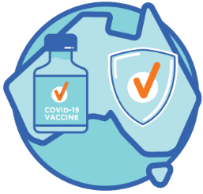

1,260,925

(+ 606 last 24 hours)

Total vaccine doses administered in aged care and disability facilities as at 17 March

**Data as at: 17 Mar 2022**

**Number of doses administered as part of the Commonwealth aged and disability care rollout**

**NSW VIC QLD WA**

**557,944 234,852 199,374 104,757**

(+241 daily

increase)

(+15 daily increase)

(+89 daily

increase)

(+189 daily increase)

**TAS SA ACT NT**

**22,449 83,916 16,549 7,406**

(+4 daily increase)

(+3 daily increase)

(+20 daily increase)

(+4 daily increase)

doses administered to persons

*Sourced from the Australian Immunisation Register. Includes all persons vaccinated at participating residential aged care, disability and related industry settings.

**33,678**

residing in other territories or with missing residential information

**State level breakdown indicates the residential location and may not align to the state in which the vaccination occurred.

#### Source: Australian Immunisation Register



## 12

**National Disability Insurance Scheme (NDIS) reported vaccinations**

**Data as at: 17 March 2022 Updated weekly**

**NDIS participant vaccinations**

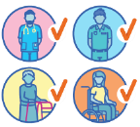

254,080

NDIS participants over the

age of 16 have had at least one dose

86.6%

of people over the age of 16 have had at least one dose



248,346

NDIS participants over the

age of 16

are fully vaccinated

84.7%

of people over the age of 16 are fully vaccinated

|  |  |  |  |  |
| --- | --- | --- | --- | --- |
|  | **People aged 16+ with at least one dose** | **People aged 16+ fully vaccinated** | **% People aged 16+ with at least one dose** | **% People aged 16+ fully vaccinated** |
| **ACT** | 4,816 | 4,745 | **88.8%** | **87.5%** |
| **NSW** | 78,269 | 76,929 | **87.2%** | **85.7%** |
| **NT** | 2,203 | 2,114 | **77.2%** | **74.1%** |
| **QLD** | 49,949 | 48,746 | **84.9%** | **82.9%** |
| **SA** | 20,683 | 20,050 | **84.3%** | **81.7%** |
| **TAS** | 6,366 | 6,176 | **86.6%** | **84.0%** |
| **VIC** | 67,692 | 66,368 | **87.9%** | **86.2%** |
| **WA** | 24,102 | 23,218 | **87.6%** | **84.3%** |
| **National** | **254,080** | **248,346** | **86.6%** | **84.7%** |

Source: Linkage between National Disability Insurance Agency data and the Australian Immunisation Register. Total NDIS participant numbers as at 28th February. Australian Immunisation Register data as at 16 March. Includes all participants regardless of residence type.



People aged 12 – 15 years

42,518 39,493

76.9% 71.4%

At least one Fully dose vaccinated

## 13

**National Disability Insurance Scheme (NDIS) reported vaccinations**

|  |  |  |  |  |  |
| --- | --- | --- | --- | --- | --- |
| **NATIONAL** | **Total people with at least**  **one dose** | **People fully vaccinated** | **Total number of individuals**  **in cohort** | **% People with at least one**  **dose** | **% People fully vaccinated** |
| **NDIS participants living in disability accommodation** | 20,594 | 20,201 | 23,352 | **88.2%** | **86.5%** |

**NDIS**

|  |  |  |  |  |
| --- | --- | --- | --- | --- |
|  | **NDIS workers with at least one dose** | **NDIS workers fully vaccinated** | **% NDIS workers with at least one dose** | **% NDIS workers fully vaccinated** |
| **NSW** | 120,409 | 117,272 | **98.1%** | **95.5%** |
| **VIC** | 116,047 | 109,512 | **98.3%** | **92.7%** |
| **QLD** | 69,192 | 68,334 | **97.4%** | **96.2%** |
| **WA** | 32,695 | 30,144 | **98.5%** | **90.8%** |
| **SA** | 35,081 | 31,596 | **98.2%** | **88.4%** |
| **TAS** | 10,794 | 10,495 | **99.7%** | **96.9%** |
| **ACT** | 3,550 | 3,519 | **99.6%** | **98.8%** |
| **NT** | 3,477 | 3,353 | **99.7%** | **96.1%** |
| **TOTAL** | **391,245** | **374,225** | **98.1%** | **93.9%** |

**Data as at: 17 March 2022**

**Updated Weekly**

**workforce vaccinations**

#### 100%

#### 90%

#### 80%

#### 70%

#### 60%

#### 50%

#### 40%

#### 30%

#### 20%

#### 10%

#### 0%

**NDIS participants in disability and aged care accommodation**

#### ACT NSW NT QLD SA TAS VIC WA National

#### Fully vaccinated One dose only Not vaccinated

Source: the NDIS Commission has established a requirement for registered NDIS providers who provide intensive disability support services to report on the vaccination status of workers they employ, or otherwise engage, to deliver NDIS-funded supports and services, and who are required to be vaccinated in accordance with in-force state and territory public health orders. The statistics reflect data reported to the NDIS Commission by registered NDIS providers and should be considered indicative and subject to change

Source: Linkage between National Disability Insurance Agency data and the Australian Immunisation Register. Includes participants residing in disability accommodation only.

Source: Total NDIS participant numbers as at 28th February. Participant data as at 16 March. Australian Immunisation Register data as at 16 March. Worker data as at 17 March.

Note: Some registered NDIS providers are yet to report on the vaccination status of their workforce. The NDIS Commission is working with those providers around reporting requirements.

Remaining workers not included include those exempt from vaccination requirements, workers whose vaccination status is not yet verified by the provider (such as workers on leave) and provider reporting anomalies.



## 14

**Residential aged care vaccination rollout**

Residential aged care facilities status

Commonwealth facilities visited (2,537 planned sites)

100%

173,424

People fully vaccinated

175,751

People with at least one dose

**Data as at: 17 Mar 2022**

**Updated weekly**

#### 100%

#### 90%

#### 80%

#### 70%

#### 60%

#### 50%

#### 40%

#### 30%

#### 20%

#### 10%

#### 0%

**Aged care resident vaccinations**

#### NSW VIC QLD SA WA TAS NT ACT Total

#### Fully vaccinated One dose only Not vaccinated

|  |  |  |  |  |
| --- | --- | --- | --- | --- |
|  | **Aged care** | **worker vac** | **cinations** |  |
| **Jurisdictions** | **Total workers with at least one dose** | **Workers fully vaccinated** | **% Workers with at least one dose** | **% Workers fully vaccinated** |
| **NSW** | 78,141 | 78,131 | **96.7%** | **96.7%** |
| **VIC** | 66,947 | 66,946 | **97.3%** | **97.3%** |
| **QLD** | 48,022 | 48,015 | **97.8%** | **97.8%** |
| **SA** | 26,506 | 26,479 | **97.7%** | **97.6%** |
| **WA** | 23,931 | 23,926 | **99.7%** | **99.6%** |
| **TAS** | 7,773 | 7,773 | **100.0%** | **100.0%** |
| **NT** | 833 | 833 | **100.0%** | **100.0%** |
| **ACT** | 3,061 | 3,061 | **100.0%** | **100.0%** |
| **Total** | **255,214** | **255,164** | **97.6%** | **97.6%** |

#### Source: My Aged Care Portal vaccination progress

#### *Status updates are provided by facilities at least once per week. Reporting is updated Monday to Friday to encompass different facility updates being made on different days. Data is sourced directly from Aged Care Service Providers and is not drawn or closely aligned with data from AIR due to inconsistencies and potential lags in uploading of records.

## 15

**Jurisdiction administered**

Total vaccine doses administered in State and Territory clinics as at 17 March

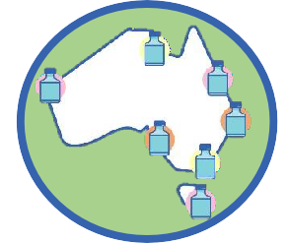

### ACT NSW

**Data as at: 17 Mar 2022**

20,468,530 total vaccine doses administered in State and Territory clinics as at 17 March

**+** 21,157 recorded in the last 24 hours

**+** 157,351 recorded in the last 7 days

### NT QLD SA TAS

**NSW**

**5,002,549**

(+3,664 daily increase)

**VIC**

**5,916,835**

(+4,525 daily increase)

**QLD**

**3,759,098**

(+3,504 daily increase)

**WA**

**2,408,043**

(+3,412 daily increase)

### VIC

### WA

### 0

### 2,000,000 4,000,000 6,000,000 8,000,000

**TAS**

**598,116**

(+493 daily increase)

**SA**

**1,736,266**

(+2,808 daily increase)

**ACT**

**730,672**

(+2,027 daily increase)

**NT**

**316,951**

(+724 daily increase)

## AZ - Vaxzevria Pfizer Moderna

*Sourced from the Australian Immunisation Register. Numbers are calculated as difference in daily cumulative reported numbers to allow for historical corrections.

#### Source: Australian Immunisation Register



## 16

**Cumulative doses administered by channel**

**Data as at: 17 Mar 2022**

60,000,000

58,000,000

56,000,000

54,000,000

52,000,000

50,000,000

48,000,000

46,000,000

44,000,000

Cumulative doses administered

42,000,000

40,000,000

38,000,000

36,000,000

34,000,000

32,000,000

30,000,000

28,000,000

26,000,000

24,000,000

22,000,000

20,000,000

18,000,000

16,000,000

14,000,000

12,000,000

10,000,000

8,000,000

6,000,000

4,000,000

2,000,000

0

## 54,147,015

## 55,508,022

Feb-21 Mar-21 Apr-21 May-21 Jun-21 Jul-21 Aug-21 Sep-21 Oct-21 Nov-21 Dec-21 Jan-22 Feb-22 Mar-22

49,926,171

42,723,536

39,294,041

35,715,731

**Primary Care Aged Care**

**Jurisdiction**

19,697,498

12,317,727

7,750,006

4,288,050

2,234,844

32,782

683,073

28,091,630

#### Source: Australian Immunisation Register

## 17

**Doses at equivalent stages of rollout (Day 388)**

The x-axis is truncated at the length of Australia's vaccination program. Countries with intermittent reporting have had their doses per 100 imputed to Australia's current stage of rollout. Israel excluded as it is beyond scale of the graph

**Data as at: 17 Mar 2022**

Cumulative doses administered (17 Mar): **55,508,022**



##### 200

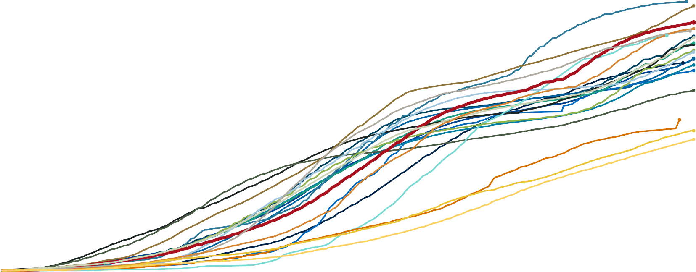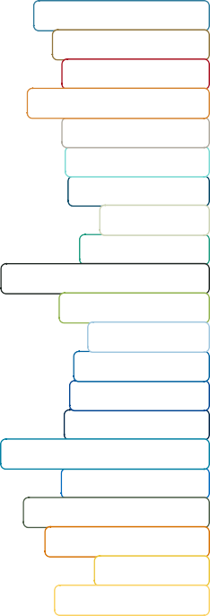

South Korea: 234.0

Singapore: 230.4

Australia: 216.0

New Zealand: 210.5

Malaysia: 208.5

Vietnam: 204.5

Belgium: 203.9

Italy: 202.6

France: 198.1

United Kingdom: 196.9

Germany: 191.7

Japan: 190.1

Canada: 184.9

Sweden: 183.9

Thailand: 180.8

European Union: 178.8

Sri Lanka: 174.1

United States: 157.0

Philippines: 131.2

India: 121.7

Indonesia: 114.2

##### 150

Total Vaccinations Per Hundred

##### 100

##### 50

##### 0

##### 0 25 50 75 100 125 150 175 200 225 250 275 300 325 350 375 388

Days since first vaccination

##### Note: From 11 January 2022, data for Australia includes all doses administered to people 5 and over. Prior to 11 January, data was for 12 and over.

##### Source: Department of Health (Australia), Our World in Data (international)

##### Latest data: 17 March

## 18

**International data – COVID-19**

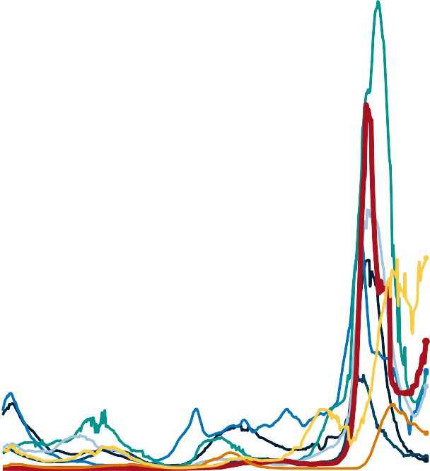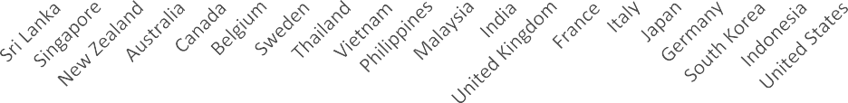

6,927

**Data as at: 17 Mar 2022**

New daily cases per million in 2021, Australia and G7 countries

Smoothed - 7 day average

COVID-19 deaths in past 7 days - Australia and select countries

##### 4,000

Cases per million people

##### Germany: 2,450

##### 2,000

##### Australia: 1,479

##### United Kingdom: 1,135

1,835

1,840

##### France: 1,111

1,396

##### Italy: 956

1,095

##### Japan: 412

55

60

70

142

160

179

244

483

521

553

602

673

767

840

957

##### 0

##### Jan 2021

##### Jul

##### Jan 2022

##### Canada: 134

##### United States: 96

##### Jul

##### Source: OWID

|  |  |  |  |
| --- | --- | --- | --- |
|  |  |  |  |

##### Source: OWID

##### Data downloaded: 18 Mar 2022 08:10

##### Latest data: 16 Mar 2022

##### Data downloaded: 18 Mar 2022 08:10

##### Latest data: 16 Mar 2022



## 19

### 697,633

20



**Concessional rapid antigen test program**

**5,612 pharmacies** have delivered over **23.5 million rapid antigen tests** to more than **3.8m eligible concession card holders** under the Government’s concessional rapid antigen test program.

### 1,203,201

### 1,389,689

### 1,696,616

### 2,013,936

### 2,251,112

### 2,412,455

### 2,764,577

### 3,125,020

### 3,568,464

### 4,127,556

### 4,729,711

**Cumulative number of tests provided to Community under Commonwealth Program**

### 5,056,689

### 5,253,144

### 5,767,296

### 6,286,311

### 6,824,253

### 7,430,788

### 8,038,893

### 8,368,200

### 8,553,768

### 9,064,919

### 9,578,001

### 10,064,619

### 10,546,870

### 10,989,630

### 11,225,497

### 11,371,049

### 11,767,681

### 12,145,821

### 12,546,354

### 12,968,790

### 13,342,797

### 13,536,679

### 13,664,095

### 14,075,899

### 15,297,567

### 16,205,769

### 17,053,178

### 17,819,729

### 18,199,099

### 18,421,866

### 18,997,866

### 19,582,827

### 20,160,964

### 20,752,491

### 21,290,730

**Data as at 18 Mar 2022**

### 21,568,631

### 21,743,671

### 22,124,290

### 22,613,236

### 23,068,819

### 23,514,625

Pandemic Response Payments



COVID Disaster Payment:

5.89 million claims received - 2.19 million individuals paid a total of $12.59 billion.

$200 Income Support Payment:

353,000 claims received - 183,000 individuals paid a total of $268.9 million.

Pandemic Leave Disaster Payment: 1,350,000 claims received - 848,000 individuals paid a total of $953.4 million.

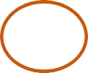

**Data as at midnight: 13 Mar 2022 Updated weekly**

|  |  |  |
| --- | --- | --- |
| 2.38 million  People have received at least one COVID  Disaster Payment (including ISP200)  $13.81 billion  Paid Out as at 13 Mar 2022  7.12 million  Claims granted across  three different payments |  | |
|  | 92%  of Claims Received Digitally |

COVID-19 DISASTER PAYMENTS

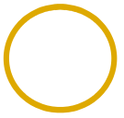

THREE PAYMENTS AVAILABLE

COVID Disaster Payment

**assisting during a lockdown event in a Commonwealth hotspot.**

Income Support Payment

$200

**for income support recipients who lost at least 8 hours of work.**

Pandemic Leave Disaster Payment

**for those who have to self-isolate, quarantine or care.**

For more information visit:

**servicesaustralia.gov.au**



Northern Territory

Lockdown (#3) from 16 Nov to 22 Nov

*Claiming period ended 27 Dec*

7,500 people have received at least one COVID Disaster Payment.

$6.9m paid out as at 13 Mar 2022.

Nil paid in initial payments in the week ending 13 Mar 2022.

Cumulative payments made by Territory since activation on 25 Aug 2021.

$6.9m $6.9m $6.9m $6.9m

**$6.9m**

13 Feb 20 Feb 27 Feb 6 Mar 13 Mar



Victoria

Lockdown (#6) from 6 Aug to 28 Oct

*Claiming period ended 9 Dec*

745,000 people have received at least one COVID Disaster Payment.

$4.45b paid out as at 13 Mar 2022.

$2,000 paid in initial and reoccuring payments in the week ending

13 Mar 2022.

Cumulative payments made by State since activation on 8 Jun 2021.

$4.45b $4.45b $4.45b $4.45b **$4.45b**

13 Feb 20 Feb 27 Feb 6 Mar 13 Mar



New South Wales

Lockdown from 24 Jun to 10 Oct

*Claiming period ended 27 Nov*

1.08m people have received at least one COVID Disaster Payment.

$7.48b paid out as at 13 Mar 2022.

$2,000 paid in initial and reoccuring payments in the week ending

13 Mar 2022.

Cumulative payments made by State since activation on 1 Jul 2021.

$7.48b $7.48b $7.48b $7.48b **$7.48b**

13 Feb 20 Feb 27 Feb 6 Mar 13 Mar



Australian Capital Territory

Lockdown from 12 Aug to 14 Oct

*Claiming period ended 25 Nov*

65,000 people have received at least one COVID Disaster Payment.

$344.7m paid out as at 13 Mar 2022.

$1,000 paid in initial and reoccuring payments in the week ending

13 Mar 2022.

Cumulative payments made by Territory since activation on 20 Aug 2021.

$344.7m $344.7m $344.7m $344.7m **$344.7m**

13 Feb 20 Feb 27 Feb 6 Mar 13 Mar

# Source: Services Australia 21

Pandemic Response Payments (continued)

**Data as at midnight: 13 Mar 2022 Updated weekly**

COVID-19 DISASTER PAYMENTS



Tasmania

Lockdown from 15 Oct to 18 Oct

*Claiming period ended 12 Nov*

6,900 people have received at least one COVID Disaster Payment.

$3.6m paid out as at 13 Mar 2022.

Nil paid in initial and reoccuring payments in the week ending 13 Mar 2022.

Cumulative payments made by State since activation on 22 Oct 2021.

$3.6m $3.6m $3.6m $3.6m **$3.6m**

13 Feb 20 Feb 27 Feb 6 Mar 13 Mar



Queensland

Lockdown from 31 Jul to 11 Aug

*Claiming period ended 28 Aug*

196,000 people have received at least one COVID Disaster Payment.

$252.6m paid out as at 13 Mar 2022.

Nil paid in initial and reoccuring payments in the week ending 13 Mar 2022.

Cumulative payments made by State since activation on 7 Aug 2021.

$252.6m $252.6m $252.6m $252.6m **$252.6m**

13 Feb 20 Feb 27 Feb 6 Mar 13 Mar



South Australia

Lockdown from 21 to 27 Jul

*Claiming period ended 17 Aug*

86,000 people have received at least one COVID Disaster Payment.

$48.2m paid out as at 13 Mar 2022.

Nil paid in initial and reoccuring payments in the week ending 13 Mar 2022.

Cumulative payments made by State since activation on 28 Jul 2021.

$48.2m $48.2m $48.2m $48.2m **$48.2m**

13 Feb 20 Feb 27 Feb 6 Mar 13 Mar

Source: Services Australia 22