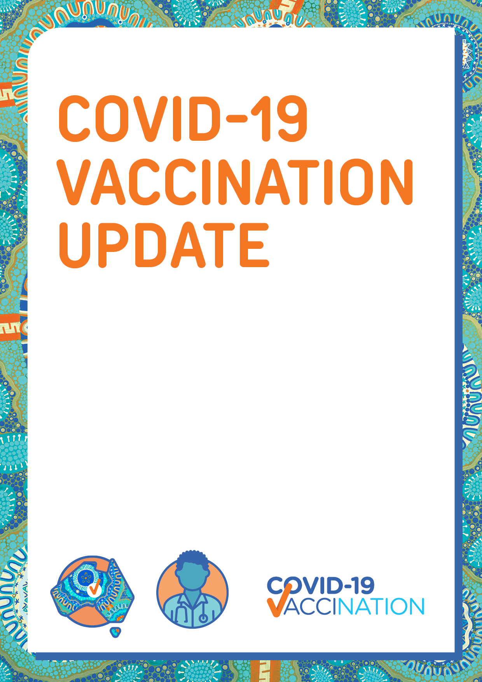Everyone aged 5 and over can now have a COVID-19 vaccine

To find out how you can book your appointment, ask the clinic, or visit **health.gov.au/covid19-vaccines.**