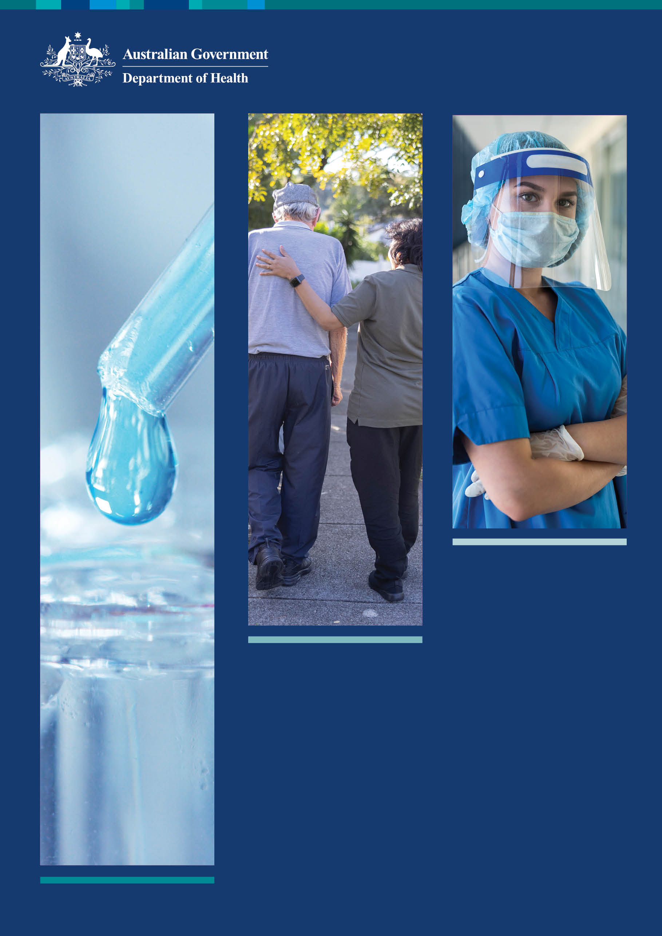Delivering the Long Term   
National Health Plan  
for the next decade

# Contents

Contents 2

Minister’s foreword 3

Guaranteeing Medicare and improving access to medicines 6

Supporting our hospitals 11

Prioritising preventive health, mental health and sport 15

Life saving and job creating medical research 20

Ageing and Aged Care 22

Australia’s world leading management of the COVID-19 pandemic 24

# Minister’s foreword

Our goal is very simple – to deliver the world’s best health system that works for all Australians.

It is the core of the Australian Government’s *Long Term National Health Plan* (the Plan). It is underpinned by our brilliant Australian researchers and medical technology sector, with our clinicians being at the forefront of adopting the latest breakthroughs in treatments and medicines, which is benefiting patients with the best possible health outcomes. It is a health system that is resilient, mobile, equitable, accessible and sustainable, and that is key to our healthy and strong nation. This has become even more evident over the past two years as we confronted the COVID-19 pandemic, and natural disasters including bushfires and floods.

We are living through the worst global pandemic in 100 years. Our response to the COVID-19 pandemic has been world-leading. Australia has had one of the lowest death rates and highest vaccination rates of any country. Our economic recovery has been one of the strongest in the world. This is thanks to our National Plan and the rigorous actions of our world-class team of virologists, epidemiologists, pathologists, nurses, doctors, hospitals, pharmacists and aged care workers.

While the pandemic has certainly had an impact on the health system in nearly all areas, the Australian Government’s focus has not waivered, and the implementation of the Plan is on schedule and already delivering results.

Through the 2022–23 Budget, our Government has delivered an investment in health of $537 billion over the next four years, up $34 billion compared to the 2021–22 Budget, as part of our commitment to the Plan, including:

* $7.3 billion increase in Medicare funding
* $9.8 billion increase in hospital funding
* $10.1 billion increase in Aged Care funding, and
* Permanent telehealth – fundamentally changing how Australians access health care and improving access for millions of people.

The Plan aims to improve the health and raise the living standard of all Australians by addressing four pillars of health care:

* Guaranteeing Medicare and improving access to medicines through the Pharmaceutical Benefits Scheme (PBS)
* Supporting our public and private hospitals, including improvements to private health insurance
* Prioritising mental health and preventive health
* Investing in health and medical research.

The comprehensive body of work undertaken over the past three years in these areas has helped to guarantee the continued growth in capabilities and to focus on the ongoing priority areas including:

* The Primary Health Care 10 Year Plan
* The 10 Year Stronger Rural Health Strategy, commenced in 2018–19
* The Mental Health and Suicide Prevention Plan
* The National Aboriginal and Torres Strait Islander Health Plan 2021–2031
* Medical Research Future Fund 10 Year Investment Plan, *and*
* *The 5-Year, 5-Pillar Aged Care reform agenda.*

As Australians begin to emerge from two years of COVID-19, we look to the future, while acknowledging the continued cost of the pandemic and the necessity of all levels of government to contribute towards a healthier and happier Australia. More funding, more research, more life-saving treatments and more beds means that Australians can live with the confidence that their health needs will be met now and into the future, no matter who they are or where they live.

**The Hon. Greg Hunt MP**

**Minister for Health and Aged Care**

The Australian Government, working with consumers and the health sector, is making our health system better at preventing and treating disease, better at promoting health and better at providing affordable and accessible services.

Budget 2022–23 continues critical investment in our health system and the *Long Term National Health Plan*. The Plan is well under way in delivering and improving Australia’s world-leading health system and health outcomes for all Australians.

# Guaranteeing Medicare and improving access to medicines

Continued modernisation and investment into Medicare underpins the success of the Australian health care system. Its role in providing accessible and affordable health care to all Australians, regardless of their circumstances, cannot be overstated. The Government continues to work with general practitioners (GPs), specialists, allied health professionals and consumers to provide the most needed treatments, while keeping patient out-of-pocket costs low.

In 2012–13, $19.5 billion was provided for Medicare, supporting Australians to access care, diagnostics and treatment. Over the past decade, our investment has grown by 61% to $31.4 billion in 2022–23, and will reach a record $133.1 billion over four years to 2025–26.

Our promise to the Australian people is that Medicare and affordable access to breakthrough new medicines are guaranteed. Our goal is to make primary health care more patient focused, more accessible, and better able to provide preventive health and support the management of chronic conditions.

Our Government has committed more than $525 billion in Guaranteeing Medicare and improving access to medicines since 2012–13.

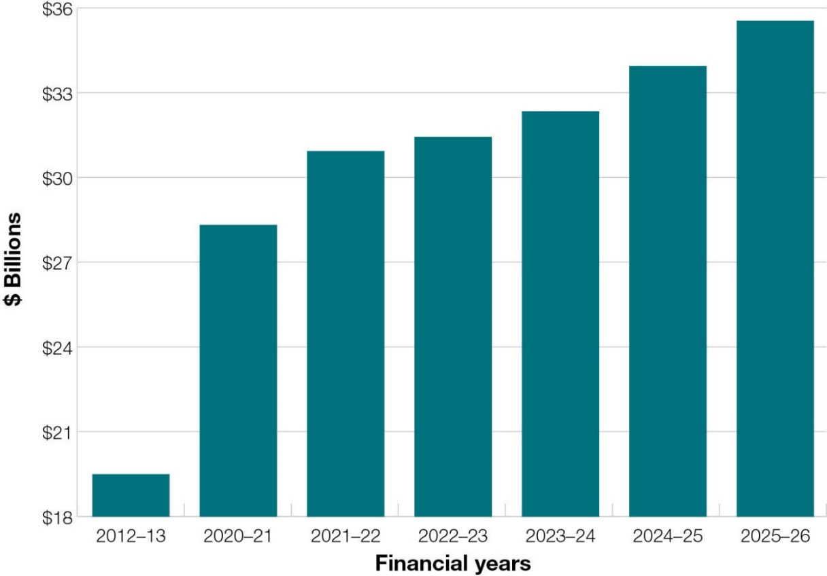

## Primary Health Care 10 Year Plan

Primary health care is the frontline and first point of contact with the health care system for most Australians. It is a key part of keeping people healthy and well in the Australian community, wherever they may live and through all stages of life.

The Australian Government continues to drive improvements for patients across primary health care, including better access and better outcomes, through its *Primary Health Care 10 Year Plan.*

The Government has worked in partnership with the primary care sector to co-design the *Primary Health Care 10 Year Plan* to provide a framework for primary care reform over the next decade. The ambition of the plan is to continue to modernise the delivery of primary health care with patients at the centre.

The Government began developing the *Primary Health Care 10 Year Plan* in 2020. Since then, we have invested almost $1.1 billion in the *Primary Health Care 10 Year Plan* to date, with an additional investment of $632.8 million announced in the 2022–23 Budget. This is on top of the Australian Government’s commitment to primary care in response to the COVID-19 pandemic, of nearly $4 billion, which includes $884.2 million in the 2022–23 Budget.

The introduction of telehealth through Medicare, following the outbreak of the COVID-19 pandemic in 2020, is the most fundamental change to health care since Medicare’s inception. It has improved access to all types of health care and removed the obstacle of distance and remoteness for many Australians to reach the care they need, when they need it, throughout the pandemic. Since 2020, more than 100 million telehealth sessions have been provided.

Making universal telehealth a permanent fixture of the Australian health system is a structural, landmark reform that will now play a permanent part in the health of all Australians.

**From October to December 2021, 88.4% of GP services provided to Australians were bulk-billed and incurred no co-payment.**

### Key Primary Care Initiatives

* Over $5 billion in spending on COVID-19-related Medicare Benefits Schedule (MBS) telehealth items since March 2020 and $106 million in the 2021–22 MYEFO to make telehealth a permanent feature of the MBS
* $678.8 million in new investments since 2014–15 including $288.9 million since 2019–20 to reform the Practice Incentive Program (PIP), including $201.5 million to establish the PIP Quality Improvement Incentive, $22.6 million to reform the Indigenous Health Incentive, $42.8 million to double the Aged Care Access Incentive, and $149 million in additional PIP supports during the COVID-19 pandemic
* $254.4 million to improve infrastructure in Aboriginal Community Controlled Health Services, and improve healthy birthweight outcomes for Aboriginal and Torres Strait Islander people, announced with the release of the Closing the Gap Implementation Plan in July 2021
* $16.4 million to support the one in nine Australian women living with endometriosis, through the establishment of new endometriosis and pelvic pain clinics in general practice

## *10 Year Stronger Rural Health Strategy*

The Australian Government is continuing its focus on suppling a quality health workforce distributed across the country according to community need. These investments are driven by the *10 Year Stronger Rural Health Strategy*.

The *10 Year Stronger Rural Health Strategy* was unveiled in 2018–19 and the Morrison-Joyce Government originally invested $550 million in the Strategy. We are building on this investment with $296.5 million in the 2022–23 Budget.

The Australian Government is improving access to critical and life-saving diagnostic imaging in regional and rural areas by expanding access to Medicare-funded Magnetic Resonance Imaging (MRI) services.

Removing the current MRI equipment eligibility requirements for MMM 2–7 areas from 1 November 2022 will increase access to subsidised, clinically-necessary MRI services at any comprehensive diagnostic imaging facility that meets quality and safety requirements. It will help reduce the pressure on out-of-pocket costs to consumers and reduce the need to travel for these diagnostic scans.

One of the critical goals of the Strategy is to deliver 3,000 extra doctors and 3,000 extra nurses by 2028, by building a sustainable, high-quality health workforce. In the first two years of the Strategy the Government has delivered an additional, more 700 full time equivalent (FTE) doctors and more than 700 FTE nurses. Our Government is continuing to deliver on this with an investment of $152.8 million to build training and education opportunities in rural regions.

In the 2022–23 Budget, the Australian Government will commit to an historic 10 Year Strategic Partnership with the Royal Flying Doctor Service, and will provide $56.8 million for aeromedical services which ensure people in rural and remote Australia can access emergency evacuation services and outreach health services, through the Royal Flying Doctors Service, CareFlight, and Little Wings. The Royal Flying Doctor Service provides primary care and emergency response to approximately 6.5 million square kilometres, or 85% of Australia.

$17.2 million will go to supporting outreach health and medical services to regional, rural and remote areas of Queensland for Heart of Australia, which provides cardiology, endocrinology, sleep medicine, psychiatry, geriatric medicine, immunology, general medicine, neurology, gastroenterology and gynaecology services.

## Pharmaceutical Benefits Scheme (PBS)

The PBS underpins the strength of the Australian health system. Millions of Australians benefit every year from access to subsidised life-saving medicines that would otherwise be unaffordable. The Government guarantees the funding of these essential medicines.

As a significant cost-of-living measure, the Australian Government is investing $525.3 million over four years to lower the PBS safety net thresholds from 1 July 2022 by the equivalent of 12 fully priced scripts for concession card holders and the equivalent of approximately two fully priced scripts for non-concessional patients.

This will mean concessional patients will be able to access PBS medicines free of charge after reaching the reduced threshold of $244.80 in a year, roughly the equivalent of 36 concessional scripts. The threshold for general patients will reduce to $1,457.10 per year, after reaching this level they will pay only the concessional co-payment of $6.80 per PBS script for the balance of the year.

This will provide concessional and general patients with earlier access to free or significantly cheaper PBS medicines. This continues to drive more affordable and accessible medicines for all Australians through the PBS.

Since 2013, the Australian Government has approved more than 2,800 new or amended listings on the PBS. This represents an average of around 30 listings or amendments per month, at an overall cost of $15 billion since 2013. This record investment has tangible and life-changing benefits for so many Australians.

In the 2022–23, we are adding $2.4 billion of new listings to the PBS, including:

New listings from April 2022 –

* Trikafta®, the combination product of elexacaftor/tezacaftor/ivacaftor and ivacaftor for the treatment of cystic fibrosis, helping an average of 1,900 patients reduce their out-of-pocket costs from around $250,000 a year.

New listings from May 2022 –

* Ofev® (nintedanib) for use in the treatment of progressive fibrosing interstitial lung disease, which will save more than 1,400 Australian patients $40,000 a year.
* Zolgensma® (onasemnogene abeparvovec) for the treatment of spinal muscular atrophy, which will save an average of 20 patients each year more than $2.5 million per treatment.
* Trodelvy® (sacituzumab govitecan) for the treatment of triple negative breast cancer, which will save an average of 580 patients each year $80,000 per course of treatment.

Last year saw the landmark strategic agreements with the medicines industry through Medicines Australia and the Generic Biosimilar Medicines Association, which brought a comprehensive package of reforms to continue to deliver life-saving medicines to Australian patients. Since the Agreement came into effect, the Australian Government has:

* legislated almost $2 billion in savings to be invested in new PBS listings through the New Medicines Funding Guarantee
* bolstered Australia’s medicines supply and protected Australian patients, pharmacists and prescribers from the impact of increasing global medicine shortages, and
* led significant reform in processes that will mean Australia’s assessment of new health technologies keeps pace with rapid advances and a shifting landscape.

No matter how common or rare the illness, the PBS continues to deliver affordable treatment options for more patients every year. The Australian Government is committed to expanding the scheme in line with the principles of a robust Health Technology Assessment framework moving forward through our *Long Term National Health Plan*.

## National Aboriginal and Torres Strait Islander Health Plan 2021–2031

Health care for Aboriginal and Torres Strait Islander people continues to remain a fundamental focus of the *Long Term National Health Plan*. Released on 15 December 2021, the *National Aboriginal and Torres Strait Islander Health Plan* sets the national policy framework for Aboriginal and Torres Strait Islander health over the next 10 years.

Endorsed by the Commonwealth and all states and territories, it is the first national health document to address the health targets and priority reforms of the *National Agreement on Closing the Gap*.

The Australian Government is committed to delivering on critical commitments under the *Long Term National Health Plan* for Aboriginal and Torres Strait Islander people. These include:

* Ending avoidable blindness in Indigenous communities by 2025
* Ending avoidable Indigenous deafness, and
* Eradicating rheumatic heart disease by 2030.

The *National Aboriginal and Torres Strait Islander Health Plan* takes a holistic and preventive approach, recognising the influence of social factors, and the strengths of culture as a protective influence on physical, social and emotional wellbeing.

The Australian Government is accountable for implementing this Plan at a national level, through a partnership approach that embraces the leadership of Aboriginal and Torres Strait Islander organisations – including Aboriginal Community Controlled Health Services – and communities.

The Australian Government will also be responsible for supporting mainstream service providers, organisations and regulators to deliver better health services for Aboriginal and Torres Strait Islander people. This will help drive the systemic and structural change needed to realise the Plan’s vision.

We continue to see growing investment in the health and wellbeing of our First Nations people. In 2012–13, $730 million a year was provided for Aboriginal and Torres Strait Islander health through the Indigenous Australians’ Health Programme (IAHP). This has grown to an investment of $4.6 billion over four years from 2021–22 to 2024–25. This is in addition to $781 million announced in the 2021–22 Budget and more than $133.5 million in the 2022–23 Budget.

The next steps will include working in partnership with Aboriginal and Torres Strait Islander experts to develop implementation, governance and accountability arrangements as the Australian Government recommits to equity in standard and access of health care for all Australians. These commitments will provide the funding and planning necessary to improve health, wellbeing and ageing outcomes for Aboriginal and Torres Strait Islander people.

# Supporting our hospitals

All Australians have the right to free and world-class treatment in our public hospital system. In cooperation with the states and territories, the Australian Government is committed to improving quality standards, supporting our workforce and providing health care options and outcomes for patients.

Signed by the Australian Government in partnership with all the state and territory governments, the *2020–25 Addendum to National Health Reform Agreement* (the NHRA) aims to improve health outcomes for all Australians and ensure our health system is sustainable into the future, guaranteeing quality healthcare for the next generation.

The NHRA commits to improving health outcomes for Australians through better coordination and connection of care in the community, while ensuring the future sustainability of Australia’s health system. It is the key mechanism for the transparency, governance and financing of Australia’s public hospital system.

## Record increases in hospital funding

Through the NHRA, the Australian Government contributes funds to the states and territories for public hospital services. This includes services delivered through emergency departments, hospitals and community-based care settings.

The Australian Government’s funding contribution for public hospital services in all states and territories under the NHRA has grown by 90% from $13.3 billion in 2012–13 to $28.1 billion in 2022–23.

This funding is projected to continue to grow under the new 2020–25 NHRA to $142 billion between 2020–21 and 2024–25. This funding includes the Commonwealth’s contribution through the *National Partnership on COVID-19 Response*, which as of March 2022 has provided the states and territories with $9.9 billion to support the public health system to respond to the COVID-19 pandemic.

## Stability and sustainability through the minimum hospital funding guarantee

In addition to the dedicated funding for COVID-19, the Australian Government has also provided state and territory governments with a minimum funding guarantee for hospital funding during the pandemic. This guarantee means that even where they have performed fewer patient services due to COVID-19, they have funding certainty. So far, the Government has paid out $754.6 million to the states and territories under the guarantee. In addition, the *National Partnership on COVID-19 Response* funds catch-up elective surgery that had to be deferred on a 50:50 cost share basis with the jurisdictions.

## Long term reforms across hospitals and health systems

The NHRA sets a pathway for long-term reform of our health system. It introduced several long-term health reforms, and opportunities for states and territories to trial new funding models and models of care.

The reforms will give local health services the flexibility to try new solutions to address barriers to best practice care and improve patients’ experiences and outcomes. This will ensure health services best suit the needs of their local communities.

To help advance these reforms, the Government has provided the states and territories with $100 million through a dedicated Health Innovation Fund, to support trials aimed at improving health outcomes for Australians and ensuring the sustainability of the health system.

How the government is supporting hospital reform

The *Community Health in a Virtual Environment* (Co-HIVE), being trialled in Western Australia, will develop and pilot a Mental Health Model for Co-HIVE where mental health consumers can be diagnosed, treated, and monitored virtually by clinicians either on-site or in the community.

In Tasmania, the *Rapid access specialist in-reach service trial* will provide primary care professionals with fast access to staff specialists, predominantly general physicians, to support early care for people with chronic and complex health care needs, particularly during early acute exacerbations of chronic conditions. The service in the ‘Western Corridor’ will support the patients to receive their care in the community before their condition deteriorates to the point they require lengthy or repeated periods in emergency departments or be admitted to hospital.

New South Wales is trialling a *rural and regional clinical data sharing system* which will develop and implement a Health Information Exchange (HIE) data hub and repository to enable real, or near real time, data transfer between primary, secondary and tertiary settings at pilot sites in regional and rural areas. Real time health data exchange will improve patient health outcomes.

## Supporting our hospitals through the Community Health and Hospitals Program (CHHP)

The $1.25 billion CHHP, announced in 2019, is delivering local health and hospital services in every state and territory to improve health outcomes through:

* Specialist hospital services such as cancer treatment, rural health and hospital infrastructure
  + The Australian Government contributed $100 million to build a Comprehensive Children’s Cancer Centre at Sydney Children’s Hospital Randwick. This centre will provide children diagnosed with cancer with access to both cancer and other disease experts alongside their clinical doctors.
  + The Centre will combine the scientific excellence of the 300-staff Children’s Cancer Institute at UNSW Sydney with the clinical leadership of the 150-staff Kids Cancer Centre at Sydney Children’s Hospital Randwick.
* Drug and alcohol treatment
  + Through the CHHP, funding has been provided to establish and deliver drug and alcohol rehabilitation services and facilities in each jurisdiction, with the aim of increasing access to community-based rehabilitation services and facilities.
  + For example, $9 million was provided to establish an Indigenous women’s drug and alcohol residential rehabilitation service on the NSW Central Coast; a further $9 million was provided to deliver alcohol and other drug services in Cairns, Queensland.
* Preventive, primary and chronic disease management
  + The Australian Government contributed $65 million to establish Australia’s first dedicated Cystic Fibrosis Specialist Service at Westmead Hospital, Sydney. The 16-bed inpatient unit will provide specialised treatment with state-of-the-art equipment and will integrate admitted services with ambulatory care, clinical research and diagnostic facilities.
* Mental health
  + Through the CHHP the Government has contributed funding for residential eating disorder facilities in Victoria ($13 million), ACT ($13.5 million), NSW ($13 million) and Tasmania ($10 million). Funding will support the establishment of community-based residential eating disorder treatment centres which provide wraparound support and specialist care through the delivery of evidence-based programs.

The CHHP adds to the record investment the Government is providing for hospital services, supporting the commitment to ensuring access to health care for Australian communities, when and where people need it.

CHHP funds 92 projects and services across all states and territories to support patient care, while reducing pressure on community and hospital services. It better equips the health and hospitals system to meet on-ground needs and close gaps in service delivery, improving access to hospital and community health services.

The program will continue to deliver the program objectives through improved access to hospital and community health services by working in partnership with delivery organisations, which include state and territory governments, Primary Health Networks (PHNs) and non-government organisations.

## Keeping Private Health Insurance affordable for Australians

Almost 55%, or 14 million Australians, choose to take out Private Health Insurance (PHI) cover, guaranteeing them greater choice when they require health and hospital treatment. This number has grown by more than 760,000 in the past six years, and around 300,000 since January 2021.

The 2022 premium change, a 2.7% change, is the lowest in more than 21 years and the eighth successive decline in premium changes since 2012–13.

The Australian Government’s landmark reforms to private health insurance have placed significant downward pressure on premium changes for consumers, helping keep PHI more affordable.

In the 2021–22 Budget, our commitment of $22 million over four years to improve the Prostheses List (PL) was the largest PL reform in decades, and over time PL benefits will better align with the price paid in the public hospital system.

# Prioritising preventive health, mental health and sport

## Mental Health and Suicide Prevention Plan

In 2022–23, the Australian Government is continuing its significant investment in mental health — reaching an estimated record $6.8 billion. This is more than double the $3.3 billion that was spent on mental health in 2012–13.

The *Mental Health and Suicide Prevention Plan* is helping develop a mental health system based around the needs of the person, that improves access to services, focuses on prevention and early intervention and supports vulnerable Australians, across five key pillars (below). The Australian Government directed more than $2.3 billion funding to these pillars in 2021–22, driving new initiatives, delivering effective and accessible services and establishing infrastructure to help all Australians improve their mental health.

The 2022–23 Budget invests an additional $648.6 million, as Stage 2 of the *Mental Health and Suicide Prevention Plan*. Funding has been committed across the following five pillars –

* Prevention and early intervention ($86.2 million)
* Suicide prevention ($46.7 million)
* Treatment ($391.7 million)
* Supporting Australia’s vulnerable ($34.9 million)
* Workforce and governance ($89.2 million).

This funding will deliver new programs and initiatives for the mental health workforce, enhancing care for young people, and to continue the Government’s commitment to work towards zero suicides.

We’re providing an additional $63.6 million over four years to support Lifeline to continue providing digital mental health services, including their telephone counselling service, which has been vitally important during the COVID-19 pandemic.

The implementation of the *10 Year National Mental Health Workforce Strategy* will receive $60.7 million worth of funding, which will help grow and upskill the mental health workforce.

* $18.3 million to develop and pilot the National Mental Health Pathways to Practice Program.
* $6 million to enhance existing workforce capabilities, including a free national support line for GPs to access clinical advice and support from psychiatrists.

We continue to focus on improving mental health and suicide prevention services for young Australians, since 75% of mental ill-health begins before a person is 24 years old.

* $206.5 million for the Early Psychosis Youth (EPYS) Program to ensure continuity of care for vulnerable Australian experiencing, or at risk of, psychosis, and expanding the network through two new hub sites in Tasmania and the ACT. This builds on more than $215.8 million invested in headspace for the EPYS since 2018.
* $47.8 million to ensure young Australians can continue to access critical mental health services as they recover from the impact of the COVID-19 pandemic, including
  + $35.1 million to enhance the capacity of new and existing headspace services to provide critical mental health services to young Australians, particularly in rural and remote Australia
  + $1.8 million for development of the Raising Healthy Minds app, improving mental health literacy of Australian parents and carers.

Our investment in mental health also addresses mental health for specific groups, including:

* $24.3 million to support critical new treatment services and existing services for Australians with an eating disorder
* $8.6 million to establish the *National Closing the Gap Social and Emotional Wellbeing (Mental Health) Policy Partnership* to maintain momentum in reducing the devastating impact of mental ill-health and suicide on Aboriginal and Torres Strait Islander people, families and communities, and
* $17.8 million to deliver targeted evidence-based mental health support to culturally and linguistically diverse (CALD) communities in Australia.

These investments continue to grow a strong, innovative and accessible mental health and suicide prevention sector, building on significant initiatives the Australian Government has already delivered:

* a new National Mental Health and Suicide Prevention Agreement in partnership with states and territories to improve the mental health of all Australians through enhanced and sustainable mental health and suicide prevention services
* improved affordability of care through 78 new mental health service sites (headspace, adult hubs, pop up clinics) since 2018–19 including:
  + 45 headspace services; 8 Head to Health Adult Mental Health Centres; and 25 Australian Government-funded Head to Health Pop up clinics.
* more than $1.3 billion to respond to the mental health impacts of the COVID-19 pandemic including the doubling of Better Access Medicare subsidised psychological therapy sessions to 20 per patient per year
* the world’s first *National Children’s Mental Health and Wellbeing Strategy* that considers mental health and wellbeing outcomes for children from birth to 12 years, and
* the establishment of Australia’s first National Suicide Prevention Office to oversee a coordinated national approach to suicide prevention, to help deliver on the Australian Government’s target of zero suicides.

## Preventive Health

The Australian Government is committed to improving Australia’s health system, moving beyond the current focus on the treatment of illness and disease, shifting focus to prevention – from illness to wellness, and from healthcare to health.

Preventive health is critically important to make Australia healthier and reverse the rising incidence of preventable chronic conditions, to strengthen our response to infectious diseases, and to help children with chronic conditions transition to adulthood and lead their best lives.

Released in December 2021, the *National Preventive Health Strategy 2021–2030* is key to achieving a healthier Australia by 2030 through more physical activity, better nutrition, and reducing the use alcohol and other harmful drugs. The Strategy’s key aims include for all Australians to have the best start in life, to live in good health and wellbeing for as long as possible, for health equity to be achieved for priority populations, and for investment in prevention to increase.

Cancer screening is a life saving preventive health program, it increases the likelihood of detecting cancer early, enabling better outcomes from treatments. Our Government is supporting Australians refocusing on regular health check-ups and screening for breast, cervical and bowel cancer, with an investment in 2022–23 of more than $55.7 million across these national programs.

The Australian Government is aware that during the COVID-19 pandemic many regular health and screening checks didn’t occur as appointments were cancelled due to lockdowns or patients avoiding potential exposure. This means that for two years fewer than usual cancer and other preventable illness checks were done.

The Australian Government is investing more than $9.7 million to increase the capacity for BreastScreen Australia to catch up on more than 100,000 of cancer screening mammograms which were missed during the COVID-19 pandemic.

The Australian Government is investing to deliver improvements in health outcomes for women and girls, in line with the *National Women’s Health Strategy 2020–30*. Between 2021–22 and 2022–23, our Government has committed more than $333 million with a focus on endometriosis, mental health, sexual, maternal and reproductive health and women’s safety.

* $58 million to address endometriosis which affects one in nine Australian women, supporting a suite of measures including – the establishment of endometriosis and pelvic pain GP clinics in primary health settings, creating the EndoZone digital platform, promotion of the *Australian Clinical Practice Guideline for the Diagnosis and Management of Endometriosis* and investment into the National Endometriosis Clinical and Scientific Trials Network
* $142.6 million to improve health outcomes for women and girls who have experienced intimate partner violence and/or sexual violence including:
  + $48.7 million for a nation-wide program helping people who have experienced family, domestic and sexual violence to navigate the health system, and
  + $25 million to support the Illawarra Women’s Centre to establish a women’s trauma recovery centre.

## Addressing alcohol and other drug use

The Australian Government is continuing to invest in building safe and healthy communities by reducing the impact of drug and alcohol use.

This includes $343.6 million over four years for ongoing support for the *National Ice Action Strategy* and delivery of critical drug and alcohol treatment services, prevention programs and research activities.

We are also directly helping to save lives through investing $19.6 million for the national rollout of the Take Home Naloxone program, making the opioid overdose-reversing medication available at no cost and without a prescription in all Australian states and territories.

The national rollouts build upon the Take Home Naloxone pilot program, run in New South Wales, South Australia and Western Australia since 1 December 2019. The pilot program has found access to naloxone has helped, on average, to reverse the effects of opioid overdose at least three times a day since it was introduced, saving up to 1,650 Australian lives.

## Sport

Sport will be a significant focus for all Australians over the coming *‘green and gold decade’* as together we race towards the Olympic and Paralympic Games in Brisbane in 2032.

In the coming years we will play host to a series of international showcase sporting events unparalleled in our history and unlike any other nation on earth.

* 2022 Women’s Basketball World Cup
* 2022 UCI Road World Championships
* 2022 Powerchair Football World Cup
* 2022 Virtus Oceania Asia Games
* 2023 FIFA Women’s World Cup
* 2023 World Transplant Games
* 2023 World Athletics Cross Country Championships
* 2027 Netball World Cup
* 2032 Olympic and Paralympic Games in Brisbane

High quality bids are also under way for hosting rights to the 2027 Rugby World Cup and 2029 Women’s Rugby World Cup.

Along with the incredible prestige which comes from hosting, and the opportunity for Australians to see top-flight sport on home soil, these major events will leave a legacy of increased community participation and physical activity, including in schools.

Major investments in sport include:

* $10.7 million to maximise social, economic and sporting outcomes from the green and gold decade of major sporting events, and leveraging significant legacy initiatives.
  + $2.6 million for the 2022 FIBA Women’s Basketball World Cup
  + $4.4 million for the 2022 ICC T20 Men’s World Cup
  + $3.1 million for the 2023 FIFA Women’s Football World Cup
  + $400,000 for the 2023 World Transplant Games
* $79.6 million to address physical inactivity in children and young people by investing in the continuation of the Sporting Schools program for an additional two years.
* $19.7 million to enable Sport Integrity Australia to enable to continue and expand its existing functions and continue the operation of the Australian Sport Drug Testing Laboratory.
* $10.3 million to promote and create leadership, safety, and long-term employment opportunities for women and girls in sport to increase workforce diversity across the sector and reduce female underrepresentation in sport:
  + $6.3 million to fund an expanded Women Coaches Program to identify, develop and empower more than 200 women coaches per year from grassroots to elite, and
  + $4.1 million for Community Sport Leaders, to implement women’s leadership programs at the community level.

# Life saving and job creating medical research

The future success of Australia’s health system depends on cutting edge health and medical research. Today’s research is tomorrow’s health care. Whether through vaccines, treatments, medical training, or technologies, increasing Australia’s capacity to deal with current and emerging health issues is an essential step in the *Long Term National Health Plan*.

Record investment in this area has led to resounding breakthroughs and promising results. This investment is being provided through three funding sources:

* $3.7 billion for the National Health and Medical Research Council (NHMRC)
* $2.6 billion for the Medical Research Future Fund (MRFF)
* $500 million for the Biomedical Translation Fund (BTF)

In total, the Australian Government’s investment in health and medical research will reach $6.8 billion over the next four years, with $1.54 billion in 2022–23 alone. That is an incredible 224% increase on health and medical research funding provided in 2012–13 of $689 million.

At the heart of this is the $20 billion Medical Research Future Fund (MRFF) which has allowed our Government to provide more than $1.95 billion in grants and support for medical research, through 147 funding rounds.

In line with the refreshed *Medical Research Future Fund 10 Year Investment Plan*, released in the 2022–23 Budget, the 2022–23 annual MRFF disbursement will reach a record high $650 million and will continue at that level of annual investment into the future.

In conjunction with ongoing funding through the National Health and Medical Research Council, researchers have never been more supported to improve the lives of everyday Australians.

Australia’s brightest minds are able to access funding that allows researchers and entrepreneurs to turn their vision into a reality, improving the health of Australians individually and the nation itself as a hub of medical research, clinical trials, collaboration, investment and commercialisation

## How the government is supporting medical research

* The MRFF has provided almost $60 million to the Zero Childhood Cancer National Precision Medicine Program to improve health outcomes through genomic biomarker–driven matching of patients to optimal treatments and novel therapeutic clinical trials.
* Understanding the genomic drivers of paediatric cancer, and tailoring this information to Australian children, adolescents and young adults with cancer, has the potential to improve the understanding of individual tumours’ genetics and their responsiveness to treatment.
* Supporting great Australian ideas progress to market, like Anatomics and its novel StarPore technology. StarPore is a porous high-density polyethylene implant material for customized craniofacial surgical implant, which has special properties to avoid cracking when bent. Anatomics is now manufacturing in Melbourne and exporting to the United States; they are also looking for new markets in Europe, Asia and the Middle East.
* The MRFF funds clinical trials that offer hope to patients with devastating diseases. $2.5 million has been awarded to the University of Queensland for a clinical trial that aims to improve health outcomes for patients with Ataxia-telangiectasia (A-T) — a devastating rare genetic disease with no known treatment. Children with A-T lose mobility very quickly, are much more likely to develop cancer and have a much shorter life expectancy than average.
* Research using stem cells offers new opportunities to understand COVID-19 in people. Early in the pandemic, clinicians identified that COVID-19 can damage the heart. MRFF funding has supported laboratory-grown miniature human heart organoids to find out how COVID-19 is damaging the heart. This led to the discovery that a patient’s own immune system can overreact to the infection, releasing inflammatory substances that damage the organs in the body, including the heart.

# Ageing and Aged Care

The Australian Government is undertaking the largest reform of aged care in Australia’s history, in response to the findings and recommendations of the Royal Commission into Aged Care Quality and Safety.

Our Government launched what is now a $18.8 billion once-in-a-generation reform program to put *respect, care, and dignity* of senior Australians at the core of our aged care system, including an investment of $522 million in Budget 2022–23. This plan aims to deliver on this by improving quality, safety and choice in aged care.

Since 2012–13, when the investment in aged care was $13.3 billion, spending in aged care has grown by 161%, to reach a record $34.7 billion in 2025–26.

The Australian Government has completed the first year of the five-year reform program delivering immediate improvements and setting strong foundations for the changes to come, across five key reform pillars:

1. Home Care
2. Residential aged care services and sustainability
3. Residential aged care quality and safety
4. Workforce
5. Governance

Our reforms recognise that most senior Australians want to remain in their home and independent for as long as possible. So we have invested $7.7 billion in Home Care. By the end of 2021, over 50,000 people received a Home Care Package for the first time, growing the number of people with access to a Home Care Package to 217,724.

Another 40,000 Home Care Packages will be made available through 2022. The investment and increased number of packages has also reduced waiting times by 25% in the year to September 2021 and those with high priority needs receive a package within a month and 98% of people assessed are offered support services. Importantly, significant work is under way to redesign the new at-home support program which will better meet the individual needs of senior Australians, with a particular focus on assisting those with dementia to live at home.

The Government will drive improvements for aged care residents through a new funding model, the Australian National Aged Care Classification (AN-ACC). This new model will improve transparency over the way funding is allocated among residential aged care providers, providing a fairer, more equitable system for distributing funding to better support rural, regional, remote Indigenous and homeless services.

In line with the recommendation from the Royal Commission, from 1 July 2021 a new Government Basic Daily Fee supplement of $10 per resident per day has been provided. Once the new AN-ACC funding model commences in October 2022, these payments will be rolled into AN-ACC funding on an ongoing basis. This results in new investment into residential aged care of $3.2 billion.

The Government will also invest $3.9 billion over the next four years to increase the quality of frontline care delivered to senior Australians accessing residential aged care each year. Mandatory care time standards and reporting will also be introduced to drive improved quality of care.

The Government will strengthen the independent aged care regulator, the Aged Care Quality and Safety Commission, to guarantee necessary changes are implemented by increasing its resourcing to extend reach and empower its responses to compliance, expanding its scope of work. Senior Australians living in residential aged care facilities (RACFs) now have greater protections through the Serious Incident Reporting Scheme, electronic medication charts, improved quality indicators, and restrictive practices can only be used as a last resort.

The aged care workforce is central to the quality of aged care in Australia. The Government is releasing its *Aged Care Workforce Plan* and investing $652.1 million over four years to grow and upskill the aged care workforce to drive improvements to the safety and quality of care experienced by senior Australians.

More than 15,000 additional low fee and free training places will be made available in aged care courses from 1 January 2023 with a $48.5 million investment over two years as part of the JobTrainer Aged Care Boost.

The Government will deliver 33,800 additional training places for personal care workers (PCWs) to attain a Certificate III in Individual Support (Ageing). This will enable existing and new PCWs in the aged care workforce to gain formal qualifications. The Government will expand the Indigenous workforce by recruiting staff with aged care skills and qualifications to provide face to face support, assisting First Nations people to better navigate and access aged care services.

The Government has also committed to strengthen and improve governance arrangements, which include introducing a new consumer-focused *Aged Care Act*, establishing a National Aged Care Advisory Council, Council of Elders and an Inspector-General of Aged Care.

The Government has also committed to strengthen and improve governance arrangements, which include introducing a new consumer-focused *Aged Care Act*, establishing a National Aged Care Advisory Council, Council of Elders and an Inspector-General of Aged Care.

# Australia’s world leading management of the COVID-19 pandemic

The COVID-19 pandemic presented Australians with a health challenge unlike any other in more than 100 years. For more than two years now, Australians have worked together, supported each other, and helped keep each other safe.

The COVID-19 pandemic was unexpected, but not unplanned for. Our health systems, our trusted clinicians and health experts, and our dedicated workforce, all stepped up to the challenge and their hard work has saved lives and protected lives.

While the pandemic is not over, we can look back and see exactly why our experience has been the envy of the world. We have experienced far fewer Australians lost to the virus, relatively fewer infections than comparable nations around the world, and a stronger economy already on the path to recovery.

The impact of the COVID-19 pandemic on global supply chains demonstrated the value of developing Australia’s sovereign capability to provide vital health equipment and vaccines.

Since the outbreak of the pandemic, our Government has created the Australian Manufacturing Fund for PPE, to assist in local innovative companies to manufacture essential medical supplies including PPE.

Australia is also well on the path toward strong vaccine manufacturing capabilities, with an agreement to deliver a $1 billion high-tech vaccine manufacturing facility with Seqirus for pandemic influenza vaccines and life-saving antivenoms.

Australia will also establish mRNA vaccine manufacturing facility with Moderna to produce respiratory mRNA vaccines for potential future pandemics and seasonal health issues, in Victoria.

The 2022–23 Budget commitment to continue efforts to manage the pandemic and protect Australians brings the Australian Government’s overall investment in response to the COVID-19 pandemic to $45 billion.

The largest proportion of this funding is supporting state and territory frontline health and hospital systems to respond to the ongoing challenge, with $9.9 billion provided through the standing *National Partnership on COVID-19 Response*.

Significant investment has been made in COVID-19 testing, with the Australian Government underwriting the cost of COVID-19 Polymerase Chain Reaction (PCR) and Rapid Antigen Testing (RAT). As of 25 March 2022, the Commonwealth has funded over $2.5 billion for MBS PCR tests and has provided $1.6 billion in funding for point of care and self-test RATs in vulnerable populations.

More than $1 billion has secured the necessary stockpile of personal protective equipment (PPE) for the National Medical Stockpile – facemasks, face shields, gloves, gowns and goggles to assist in outbreak management, particularly at RACFs and other frontline health service sites.

Vaccination against COVID-19 remains the most effective way to prevent the worst impacts of the virus – severe disease, hospitalisation and death.

To date, more than 56 million COVID-19 vaccine doses have been administered around Australia and more than 95% of our population over the age of 16 (almost 19.5 million) are fully vaccinated.

The Australian Government has invested more than $1 billion to date to ensure access to safe and effective vaccines for all eligible people.

Our Government has ensured Australians suffering from COVID-19 can access medications to reduce the worst effects of the disease and speed their recovery.

Supplies of sotrovimab (XEVUDY®), RONAPREVE®, PAXLOVID®, and molnupiravir (Lagevrio®), EVUSHELD®, and remdesivir (VEKLURY®) have been added to the National Medical Stockpile (NMS) and are already being distributed to help with COVID-19 treatment, and prophylaxis prevention in severely immunocompromised people.

The Morrison-Joyce Government listed molnupiravir (Lagevrio®) on the PBS from 1 March 2022 as a treatment for mild to moderate COVID-19.

Protecting vulnerable Australians from the COVID-19 pandemic remains a critical priority for the Australian Government.

The Australian Government has also invested over $2.6 billion to continue the significant support for our aged care system to address COVID-19. This includes over $600 million in retention bonuses for aged care workers throughout the pandemic.

Australia has been changed by the pandemic, but many of the ways we have adapted will benefit us long into the future. Our Government has brought about the delivery of permanent telehealth across Australia, revolutionising the way Australians access health care.

Health.gov.au

March 2022