


HEALTH COUNCIL
COAG

Australian National Breastfeeding Strategy
2019 and beyond

© COAG Health Council 2019

The Australian National Breastfeeding Strategy: 2019 and Beyond was prepared under the auspices of the COAG Health Council.

The Strategy may be downloaded from the COAG Health Council website or the Department of Health website.

Copies can be obtained from:

Preventive Policy Section Preventive Health Policy Branch
Population Health and Sport Division Department of Health
GPO Box 9848, CANBERRA ACT 2601
Inquiries about the content of the Strategy should be directed to preventive.policy@health.gov.au. Print ISBN: 978-1-76007-398-5
Online ISBN: 978-1-76007-399-2

TABLE OF CONTENTS

Acknowledgements 7
Abbreviations 8
About the Australian National Breastfeeding Strategy 9
Promoting a healthy start in the first 1000 days 9
Empowering mothers to breastfeed 9
Aim of the Strategy 10
Audience 12
Time frame 12
Implementation partners 12
Governance 12
The Strategy in context 13
Australian National Breastfeeding Strategy 2010–2015 13
Complementary strategies 13
International policies 14
International human rights frameworks 16
National child and youth health policies/frameworks 17
National dietary guidelines 17
National workplace relations and parental leave policies 18
Workplace relations policies 18
Flexible working arrangements 18
Parental leave 18
Paid parental leave 19
Australian Government Paid Parental Leave scheme 19
National Quality Framework for Early Childhood Education and Care 19
World Breastfeeding Trends Initiative Australia—Report Card 2018 19
The case for breastfeeding 21
Not breastfeeding increases risks of illness for both mother and child 22
Children 22
Mothers 23
Breastfeeding influences the development of the infant microbiome 23
Breastfeeding reduces health costs 23
Breastfeeding benefits society and the environment 24
Priority populations 25
Australia’s mothers and babies 25
Priority populations for the Strategy 25
Aboriginal and/or Torres Strait Islander communities 26
Culturally and linguistically diverse communities 27
Other priority population groups 27
The Strategy 28
Vision 28
Objectives 28
Principles 29
Priority areas for the Strategy 29
Barriers to breastfeeding 29
Breastfeeding as a public health issue 30
Priority and action areas 30
Priority 1—Structural enablers 32
  - Action area—Community education and awareness 32
What has been achieved 32
What needs more attention 33
What the evidence is 33
  - Action area—Prevent inappropriate marketing of breastmilk substitutes 34
What has been achieved 34
What needs more attention 35
What the evidence is 36
  - Action area—Policy coordination, monitoring, research and evaluation 36
What has been achieved 36
What needs more attention 37
What the evidence is 37
  - Action area—Dietary guidelines and growth charts 38
What has been achieved 38
What needs more attention 39
What the evidence is 39
Priority 2—Settings that enable breastfeeding 40
  - Action area—Baby Friendly Health Initiative 40
What has been achieved 40
What needs more attention 41
What the evidence is 41
  - Action area—Health professionals’ education and training 41
What has been achieved 41
What needs more attention 42
What the evidence is 42
  - Action area—Breastfeeding-friendly environments 43
What has been achieved 43
What needs more attention 43
What the evidence is 44
  - Action area—Milk banks 45
What has been achieved 45
What needs more attention 45
What the evidence is 45
Priority 3—Individual enablers 47
  - Action area—Universal breastfeeding education, support and information services 47
What has been achieved 47
What needs more attention 48
What the evidence is 49
  - Action area—Breastfeeding support for priority groups 50
What has been achieved 51
What needs more attention 52
What the evidence is 52
Monitoring and evaluation framework 55
Purpose 55
Principles and approach 55
Governance and coordination 55
Australian Health Ministers’ Advisory Council and Health Services Principal Committee 55
Australian Government Department of Health 55
National Breastfeeding Advisory Committee 56
Monitoring strategy performance and progress 56
Monitoring Australia’s performance on breastfeeding 56
National Breastfeeding Report Card 56
Global benchmarking 57
Monitoring progress on strategy implementation 57
Approach to evaluation 58
Objective of evaluation 58
Time frame for evaluation 58
Strategy logic 58
Key evaluation questions 60
Evaluation questions for each priority and action area 62
Evaluation data sources 65
Establishing an initial baseline 66
Conducting planned evaluations 66
Ethical considerations 66
Use and dissemination 66
Achieving progress 68
Next steps 68
Measures of success 68
Appendix A Related policy and strategy documents 69
Appendix B National Breastfeeding Report Card 70
Appendix C National Breastfeeding Strategy Annual Monitoring Report Template 72
Appendix D Breastfeeding data collected, by jurisdiction—snapshot of current indicators 73
Appendix E Proposed list of indicators—long-term outcomes 76
References 78

ACKNOWLEDGEMENTS
The Australian National Breastfeeding Strategy: 2019 and Beyond (the Strategy) provides an enduring policy framework for all Australian governments to provide a supportive and enabling environment for breastfeeding.
The Department of Health would like to acknowledge the contributions of a range of stakeholders in the development of the Strategy, including:
- all state and territory governments, through:
  - the former Standing Committee on Child and Youth Health (of the former Community Care and Population Health Principal Committee of the AHMAC)
  - the Breastfeeding Jurisdictional Senior Officials Group
  - the National Aboriginal and Torres Strait Islander Health Standing Committee of the Health Services Principal Committee of the AHMAC
- the Breastfeeding Expert Reference Group, comprising representatives from:
  - Academy of Breastfeeding Medicine
  - Australasian Association of Parenting and Child Health
  - Australian Breastfeeding Association
  - ACT Department of Health
  - Australian College of Midwives
  - Australian Healthcare and Hospitals Association
  - Australian Institute of Health and Welfare
  - Australian Private Hospitals Association
  - Childbirth and Parenting Educators of Australia
  - Dietitians Association of Australia
  - Lactation Consultants of Australia and New Zealand
  - Maternal, Child and Family Health Nurses Australia
  - Murdoch Children’s Research Institute
  - National Allergy Strategy
  - National Health and Medical Research Council
  - Public Health Association of Australia
  - Queensland Department of Health
  - Royal Australasian College of Physicians
  - Royal Australian College of General Practitioners
  - Royal Australian and New Zealand College of Obstetricians and Gynaecologists
  - Telethon Kids Institute
  - University of Queensland
  - Women’s Healthcare Australasia
- the many individuals, communities and organisations across Australia that participated in the stakeholder consultation workshops in 2017 and the online consultations in 2018.

ABBREVIATIONS

ABA | Australian Breastfeeding Association
AHMAC | Australian Health Ministers’ Advisory Council
AIHW | Australian Institute of Health and Welfare
ANIFS | Australian National Infant Feeding Survey
ASCIA | Australasian Society of Clinical Immunology and Allergy
BFHI | Baby Friendly Hospital Initiative / Baby Friendly Health Initiative
CHC | COAG Health Council
COAG | Council of Australian Governments
FSANZ | Food Standards Australia New Zealand
MAIF Agreement | Marketing in Australia of Infant Formulas: Manufacturers and Importers
 | Agreement
NEC | Necrotising enterocolitis
NICUs | Neonatal intensive care units
NHMRC | National Health and Medical Research Council
OECD | Organisation for Economic Co-operation and Development
PPD | Postpartum depression
PPL | Paid Parental Leave
7 Point Plan | 7 Point Plan for the Protection, Promotion and Support of Breastfeeding
 | in Community Health Services
Strategy | Australian National Breastfeeding Strategy: 2019 and Beyond
Ten Steps | WHO/UNICEF Ten Steps to Successful Breastfeeding
2010–2015 Strategy | Australian National Breastfeeding Strategy 2010–2015
UK | United Kingdom
UNICEF | United Nations International Children’s Fund
USA | United States of America
WBTi | World Breastfeeding Trends Initiative
WHO | World Health Organization
WHO Code | International Code of Marketing of Breast-milk Substitutes

ABOUT THE AUSTRALIAN NATIONAL BREASTFEEDING STRATEGY

Promoting a healthy start in the first 1000 days

Australia’s future depends on the health and wellbeing of the next generation. Investment in Australia’s children, particularly in the early years, can have a significant impact on their future development, health, learning and wellbeing.
Positive early experiences provide a foundation for sturdy brain architecture and a broad range of skills and learning capacities. Health in the earliest years—beginning with the future mother’s health before she becomes pregnant—lays the groundwork for a lifetime of wellbeing and the development of a skilled workforce and a more productive society.1
The first 1000 days (the period from conception to the end of the child’s second year) is the period with the greatest potential to affect health and wellbeing over the life course.2 The Developmental Origins of Health and Disease hypothesis maintains that environmental exposures such as stress or under-nutrition during critical periods of development can have long-term effects on health and wellbeing by ‘programming’ organs, tissues, or body system structures or functions.2
Nutrition in the first 1000 days is one of the most significant factors that influence child health and development.3 4 5 The nutritional status of the mother and/or child is a critical factor in ‘programming’ the child for healthy development and positive long-term health and wellbeing outcomes.2 Excessive and rapid weight gain in infancy has been linked to obesity in later life as well as a number of risk factors for cardiovascular disease.6 7
‘Human breastmilk is therefore not only a perfectly adapted nutritional supply for the infant, but probably the most specific personalised medicine that he or she is likely to receive, given at a time when gene expression is being fine-tuned for life. This is an opportunity for health imprinting that should not be missed.’42

One of the most highly effective preventive measures a mother can take to protect the health of her infant and herself is to breastfeed.8 Exclusive breastfeeding has been shown to at least modestly protect against excessive early infant gain and later obesity—an effect that may result from differences in composition of weight gain between breastfed and formula-fed infants.2

Empowering mothers to breastfeed
A healthy start to life relies on safe, supportive environments and on stable, responsive relationships with caregivers.1 Mothers, fathers/partners and caregivers need better support, including support for infant and young child feeding, to raise healthy and thriving children.
Most women understand the importance of breastfeeding and want to breastfeed, but they need high-quality accessible support to overcome societal, family and health service barriers.73
A mother’s decision about whether to breastfeed is influenced by:
- Societal pressures—Social norms and attitudes that do not value or support breastfeeding include:
- negative attitudes to breastfeeding in public49 9
- media portrayal of the breast as sexual, and lack of visibility of breastfeeding images in the media9
- perception that formula-fed babies are more content and settled, need to feed less often and will sleep better at night and that formula feeding is normal, problem-free and something that others, particularly the father, can join in with.9

- Societal attitudes to mothering—The experience of mothering in modern Western culture is inherently different from that seen in previous generations or in other cultures. Typically, mothers are isolated and do not have a support system in place. Unsurprisingly, many new mothers feel overwhelmed by this change in circumstance.9
- Access to breastfeeding education and professional lactation support—Although most mothers can physically lactate, mothers who do not receive proper breastfeeding education and lactation support may produce insufficient milk to nourish their infant or may experience painful breast infections.49
- Employment arrangements or workplace settings—Some workplaces deny mothers the physical space necessary to pump and store their milk and fail to provide convenient or flexible breaks to express milk by pump.49
- Her partner—Breastfeeding is an intimate experience shared between a mother and her infant, leaving some partners feeling excluded. This can be ameliorated by reframing breastfeeding as a joint effort, providing non-breastfeeding parents with better education about the benefits of breastfeeding, and highlighting opportunities for non-breastfeeding parents to participate in other supportive activities while breastfeeding occurs.49
- Her mother—Infant and young child feeding decisions are significantly affected by familial patterns and traditions. Mothers value acceptance and encouragement from their own mothers.9
- Religious and cultural beliefs—Cultural beliefs and normative behaviour have a very powerful impact on human behavior, particularly in relation to nutrition.9
- Mental health barriers—Women with depression in pregnancy or in the first weeks postpartum are less likely to initiate breastfeeding and more likely to breastfeed for shorter durations.49 Identifying and treating mothers with depression may encourage breastfeeding. They may need extra support from family members and health care professionals to meet their breastfeeding goals.49
Although mothers are primarily responsible for breastfeeding infants and young children, without a network that encourages, supports and recognises the importance of breastfeeding, their journey will be much more difficult. An approach that considers and targets the wider influences on the mother and the structural barriers to infant and young child feeding is needed.10
The Australian National Breastfeeding Strategy: 2019 and Beyond (the Strategy) is intended to support and value mothers as the usual caregivers and food providers for infants and young children but also recognises the pivotal role of fathers, partners and other family members. The Strategy seeks to build a society in which systems and settings support and value breastfeeding as the normal way to feed infants and young children.

Aim of the Strategy
The Strategy aims to support all mothers, fathers/partners and babies in Australia by providing support for mothers to breastfeed their infants. As carers, mothers and fathers/partners make decisions (including decisions about infant and young child feeding) that can influence short- and long-term health outcomes for themselves and their children.
The Strategy provides a framework for integrated, coordinated action to shape and inform Commonwealth, state, territory and local government policies and programs as they support mothers, fathers/partners and their babies throughout their breastfeeding journeys. It sets out a vision, objectives, principles, priority areas and action areas to provide a supportive and enabling environment for breastfeeding. These are shown in the Strategy overview at Figure 1.

Figure 1: Overview—Australian National Breastfeeding Strategy: 2019 and Beyond
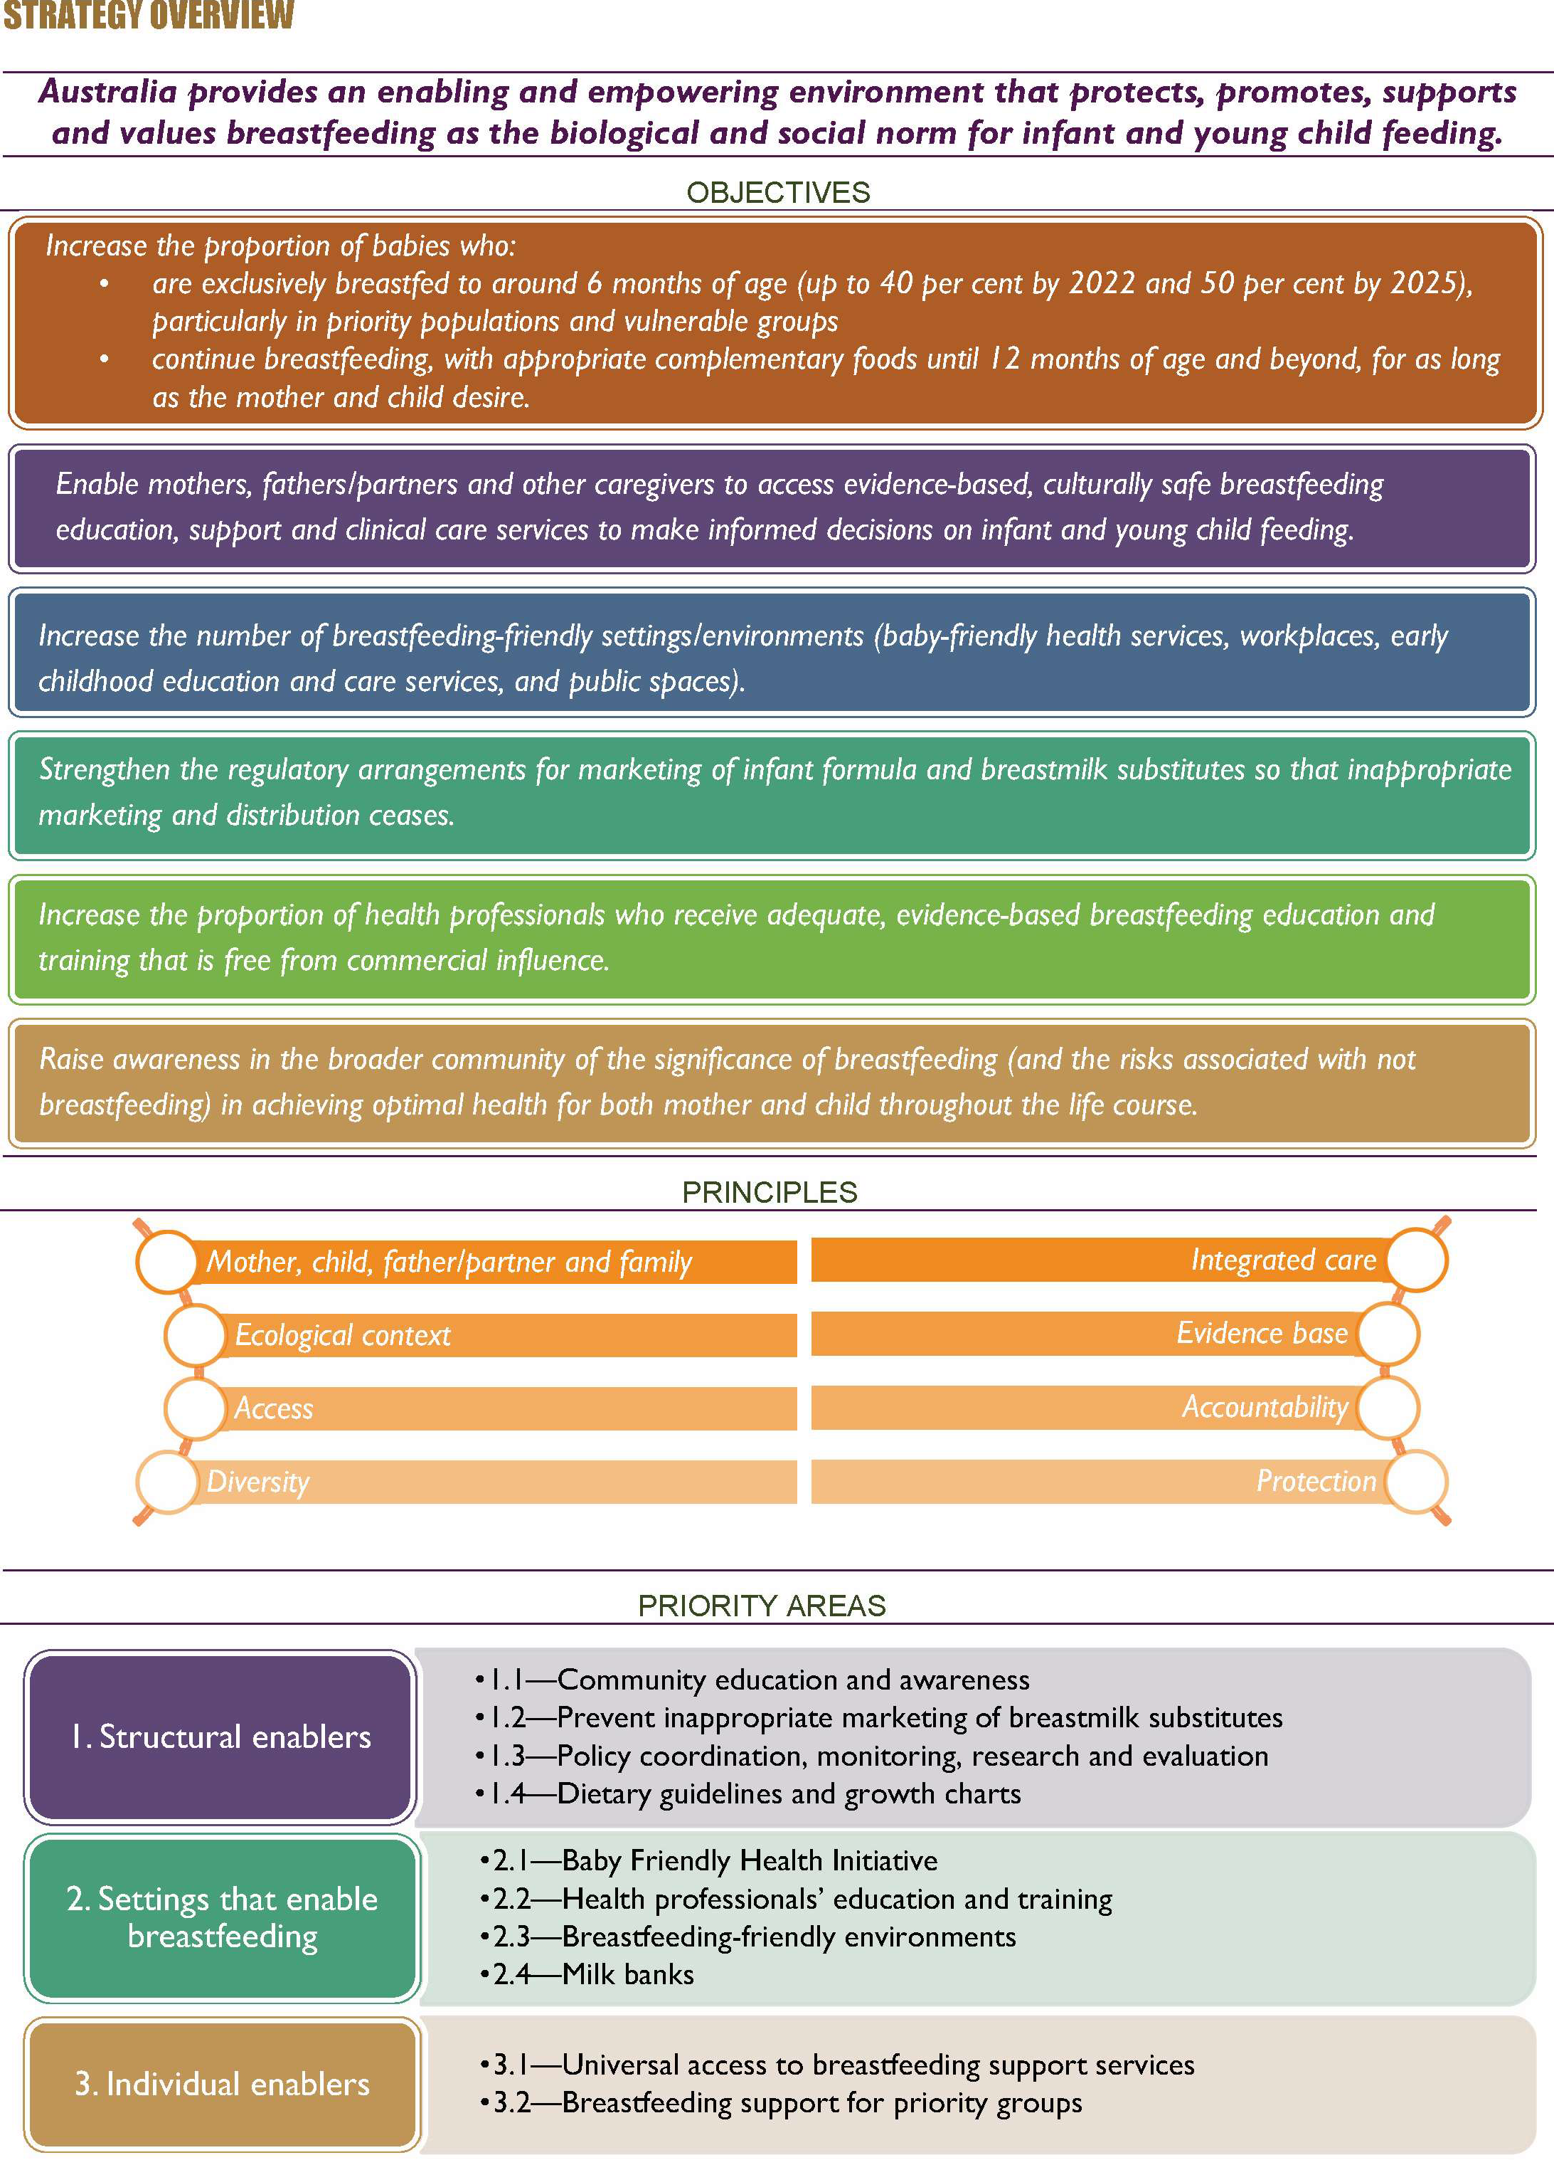

Audience
The Strategy is designed to be used as a resource across governments at all levels, policymakers, stakeholder organisations, the public and private health sectors, industry, researchers and academics, families and communities as a tool to protect, promote and support breastfeeding. The Strategy provides guidance on evidence-based approaches to protect, promote, support and monitor breastfeeding.

Time frame
The Strategy is enduring, with no end date; however, periodic reviews of the evidence underpinning the key priority and action areas will be undertaken every five years by the Australian Government Department of Health. The Department of Health will review the Strategy every two years and evaluate it every five years.

Implementation partners
The Strategy has been developed in collaboration with all states and territories and a reference group of breastfeeding experts. National stakeholder consultation workshops in April 2017, an evidence check (Review of Effective Strategies to Promote Breastfeeding66) and an online public consultation process in May–June 2018 have informed the Strategy.

The implementation of the Strategy will require collaboration and coordination of a wide range of stakeholders. Collaboration by the following organisations and individuals across the priority areas will be necessary to facilitate the delivery of the proposed actions:
- mothers, fathers/partners and their families
- the health sector
- employers
- businesses or enterprises providing breastfeeding and lactation support and aids
- early childhood education and care services
- peak bodies, non-government organisations and professional associations
- researchers
- all levels of government.

Governance
The Department of Health will establish a national breastfeeding advisory committee and will be responsible for overseeing the implementation, monitoring and evaluation of the Strategy. The department will prepare annual reports to Australian Health Ministers through the Council of Australian Governments (COAG) Health Council (CHC) and to the public. National policy coordination is necessary because the Strategy covers a wide range of priorities, actions and settings across the breastfeeding continuum in all jurisdictions.

THE STRATEGY IN CONTEXT

Australian National Breastfeeding Strategy 2010–2015

The Strategy seeks to build on the lessons learned from the Australian National Breastfeeding Strategy 2010–2015 (the 2010–2015 Strategy). The 2010–2015 Strategy was developed in response to a recommendation of the House of Representatives Standing Committee on Health and Ageing in The Best Start: Report on the Inquiry into the Health Benefits of Breastfeeding.11
The 2010–2015 Strategy provided a framework for priorities and actions for governments at all levels to protect, promote, support and monitor breastfeeding throughout Australia.12 Australian Health Ministers endorsed the 2010–2015 Strategy and the accompanying implementation plan in 2009 and 2010 respectively.13
The implementation plan identified activities under 10 action areas:
- monitoring and surveillance
- health professionals’ education and training
- dietary guidelines and growth charts
- breastfeeding-friendly environments (including workplaces and childcare settings)
- support for breastfeeding in health care settings / the Baby Friendly Health Initiative (BFHI)
- Australia’s response to the World Health Organization (WHO) International Code of Marketing of Breast-milk Substitutes and related World Health Assembly resolutions
- exploring the evidence, quality assurance, cost-effectiveness and regulatory issues associated with the establishment and operation of milk banks
- breastfeeding support for priority groups
- continuity of care, referral pathways and support networks
- education and awareness, including antenatal education.
Four implementation progress reports for the 2010–2015 Strategy were submitted to Health Ministers. The final progress report was provided to the Australian Health Ministers’ Advisory Council (AHMAC) in 2016 to summarise progress against the implementation plan14 and areas for further work. The final progress report noted that, while progress had been made across all action areas, Australia still did not have a sustainable dataset on breastfeeding that could be used to report on national breastfeeding rates.

Complementary strategies
The Strategy aligns with existing international, national and jurisdictional policies, strategies and frameworks and shares many of their underlying principles (Figure 2).
This section discusses the key international and domestic policies, which focus on international human rights frameworks, Australia’s child and youth health policies, and other domestic policies that have the potential to influence breastfeeding. A list of complementary strategies is provided in Appendix A.

Figure 2: Overview of the strategic policy context for infant and young child feeding

National dietary guidelines

National child and youth health policies

National workplace relations and parental leave policies

National Quality Framework for Early Childhood Education and Care

International policies
Australian National Breastfeeding Strategy: 2019 and Beyond

International human rights frameworks

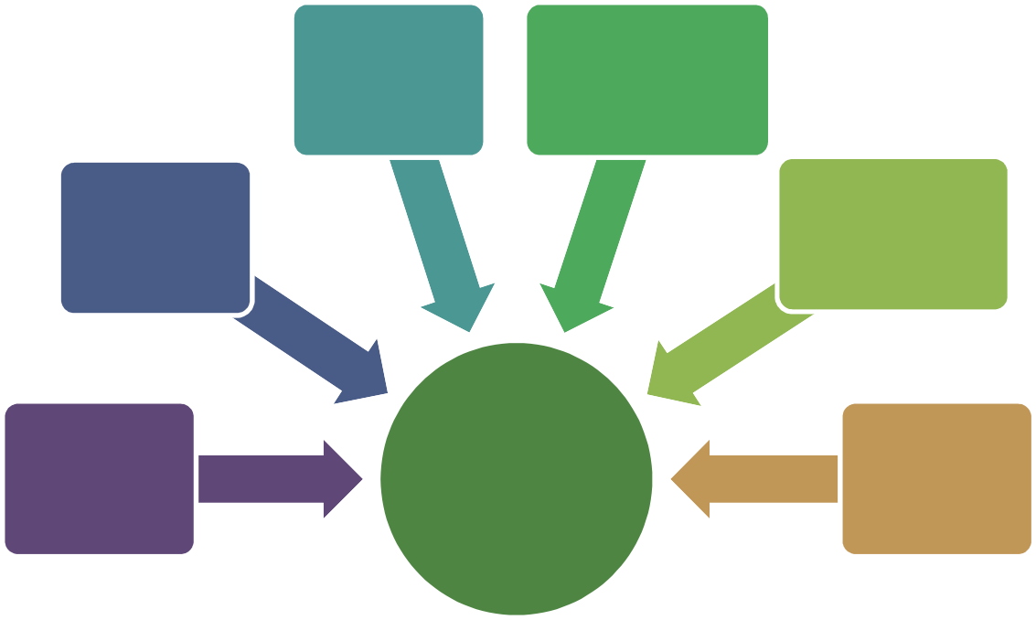
International policies
The Strategy seeks to achieve the WHO global nutrition target of increasing the rate of exclusive breastfeeding in the first six months up to at least 50 per cent by 2025,15 with an interim target of 40 per cent by 2022. The WHO / United Nations International Children’s Fund (UNICEF) Global Strategy for Infant and Young Child Feeding recommends breastfeeding as an unequalled way of providing infants with the nutrients they need for healthy growth and development.16 Virtually all mothers can physiologically breastfeed, provided they have accurate information and support within their families and communities and from the health care system.16
The WHO Global Action Plan for the Prevention and Control of Noncommunicable Diseases 2013– 2020 also supports breastfeeding promotion as part of a life course approach to prevention of
non-communicable diseases.17 This is because breastfeeding helps to reduce the risk of developing conditions such as obesity and non-communicable diseases later in life.17
As a global public health recommendation, the WHO recommends16 that infants:
- receive immediate and uninterrupted skin-to-skin contact and start breastfeeding within the first hour after birth
- be exclusively breastfed for the first six months
- be introduced to nutritionally adequate and safe complementary foods at around six months, particularly iron-rich foods, while continuing to breastfeed for up to two years or beyond.
Exclusive breastfeeding means that the infant receives breast milk (including mother’s own expressed breast milk) and allows the infant to receive oral rehydration solution, drops, syrups (vitamins, minerals, medicines), but nothing else.18
Paraphrased from World Health Organization (2008)
Indicators for Assessing Infant and Young Child Practices

Exclusive breastfeeding for the first six months provides the nurturing, nutrients, bioactive factors, anti-infective factors and energy needed for physical and neurological growth and development. Beyond six months, breastfeeding continues to provide energy and high-quality nutrients that,

jointly with safe and adequate complementary feeding, help to prevent hunger, under-nutrition and obesity.19 Continuing breastfeeding in the second year of a child’s life can provide a substantial proportion of a child’s nutrition, including more than a third of energy needs, key fatty acids, vitamin A, calcium and riboflavin.47
The WHO and UNICEF Baby-Friendly Hospital Initiative focuses on protecting, promoting and supporting breastfeeding in facilities providing maternity and newborn services by implementing the Ten Steps to Successful Breastfeeding (the Ten Steps),19 shown in Figure 3.

Figure 3: Ten Steps to Successful Breastfeeding20
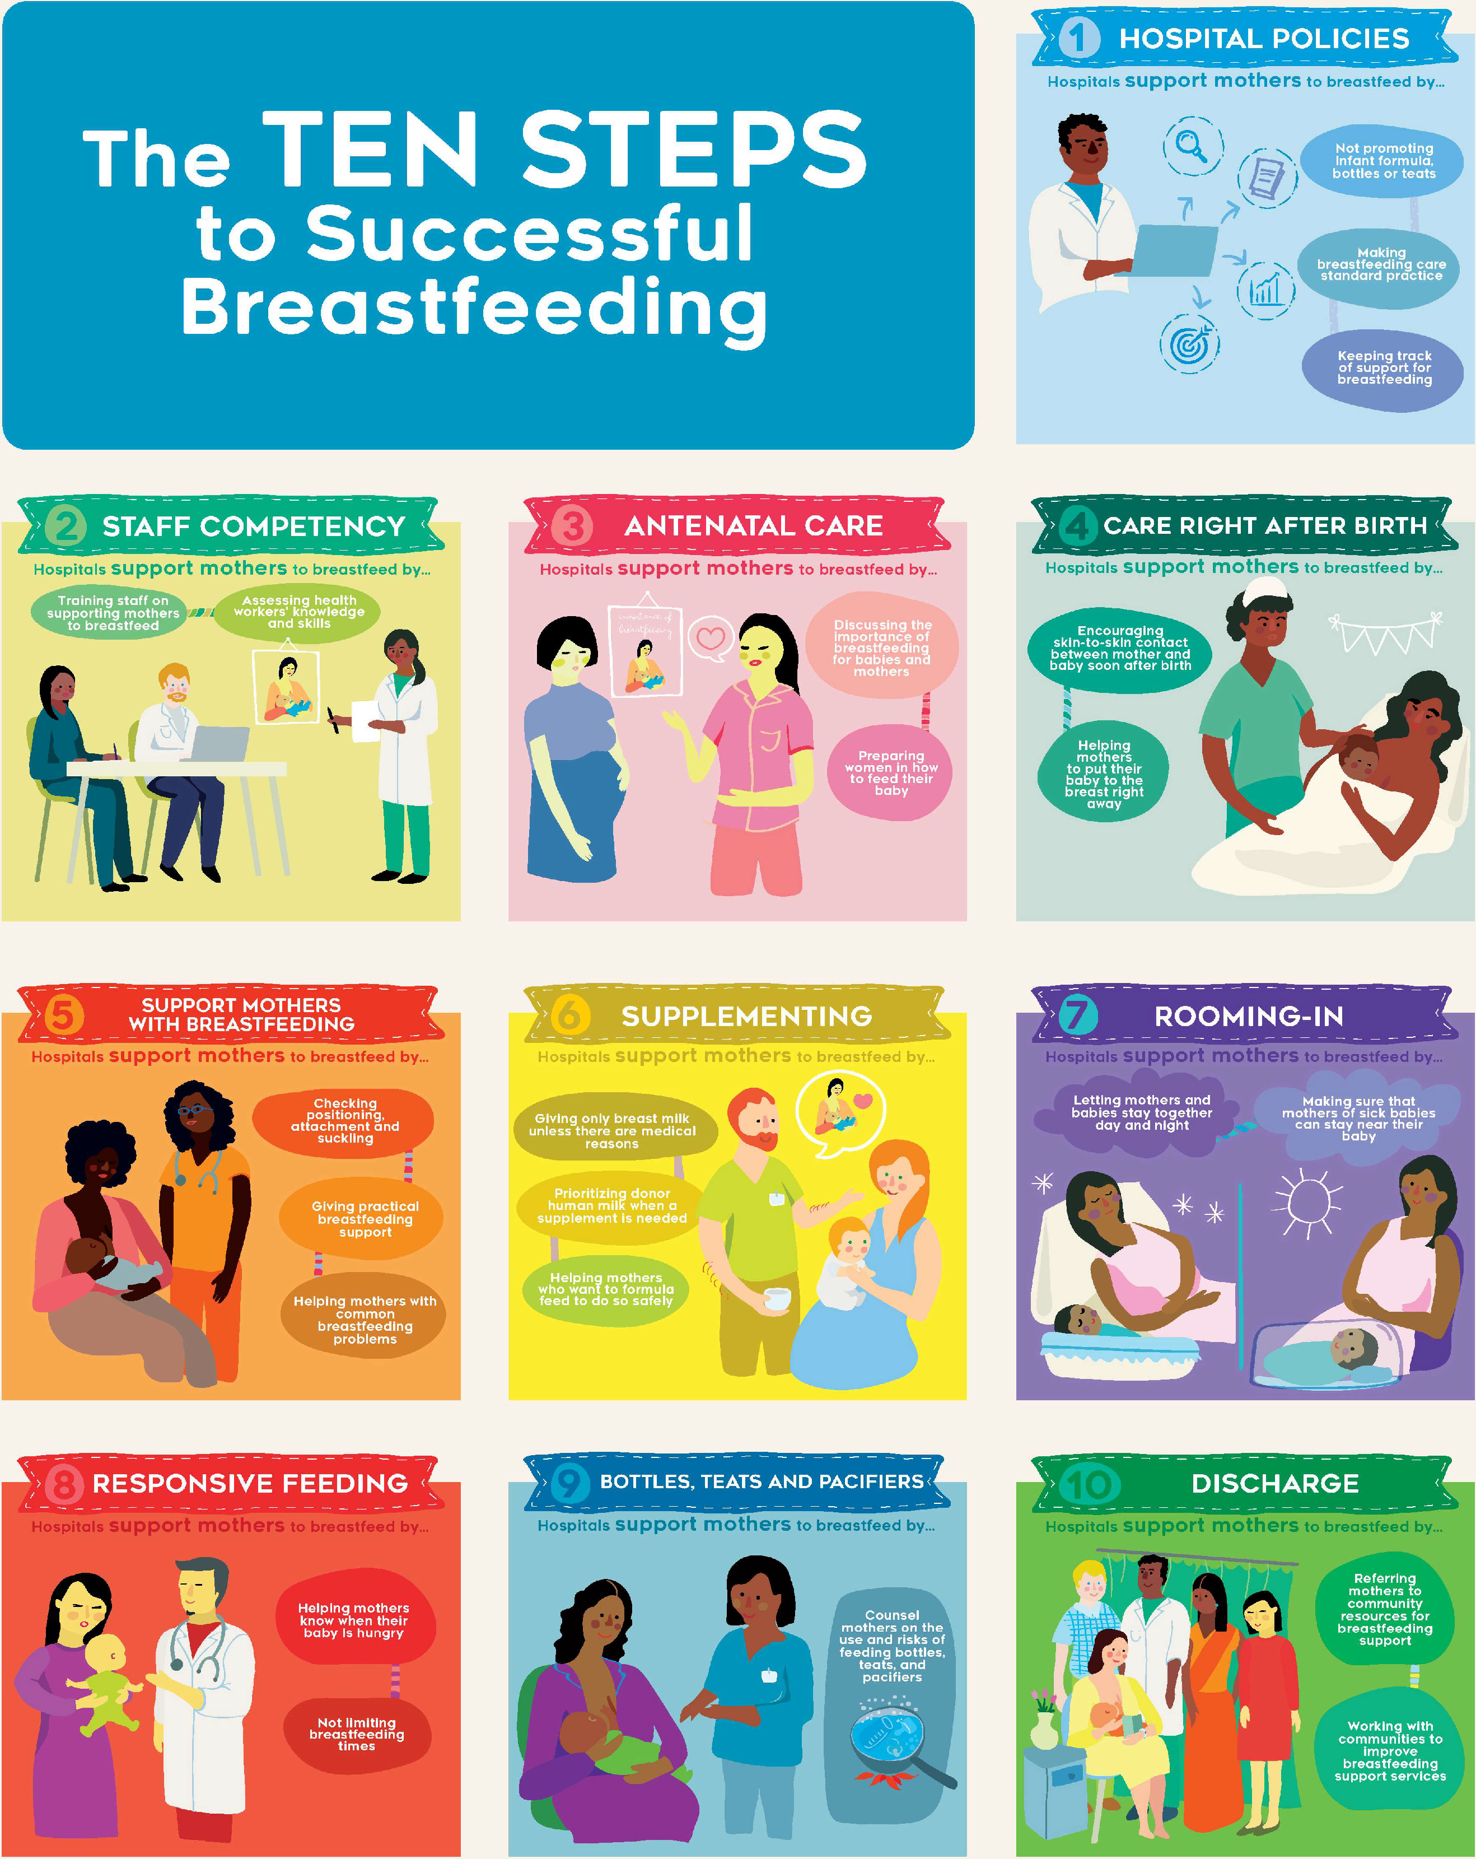

The WHO International Code of Marketing of Breast-milk Substitutes (WHO Code) is a set of recommendations to regulate the marketing of breastmilk substitutes, feeding bottles and teats.21 The WHO Code aims to stop the aggressive and inappropriate marketing of breastmilk substitutes.
The WHO Code advocates that babies be breastfed. If babies are not breastfed, for whatever reason, the WHO Code also advocates feeding them safely on the best nutritional alternative. Breastmilk substitutes should be available when needed, but they should not be promoted.21
Since 1981, there have been a number of World Health Assembly (WHA) resolutions that refer to the marketing and distribution of breastmilk substitutes and clarify or extend issues covered in the WHO Code.21
Breastfeeding also contributes to the achievement of the United Nations Sustainable Development Goals (Figure 4), particularly the goals on (1) poverty, (2) hunger, (3) health, (4) education,
- employment, (10) equality and (12) sustainable consumption.22
Figure 4: United Nations Sustainable Development Goals
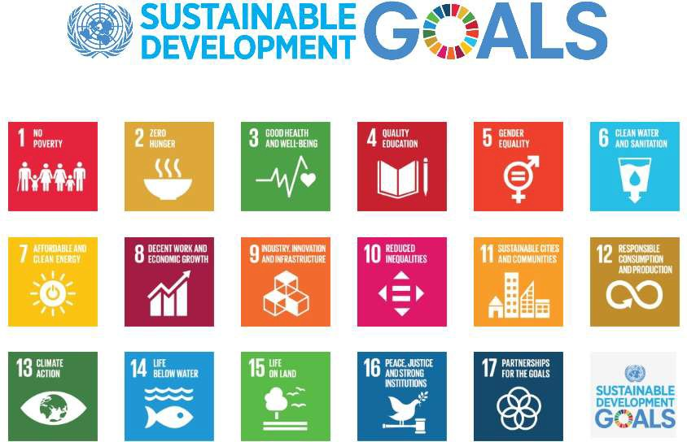

International human rights frameworks
The WHO and UNICEF Global Strategy for Infant and Young Child Feeding is based on respect, protection, facilitation and fulfilment of accepted human rights principles.16 Nutrition is a crucial, universally recognised component of the child’s right to the highest attainable standard of health as stated in the United Nations Convention on the Rights of the Child.23
Article 12 of the United Nations Convention on the Elimination of All Forms of Discrimination Against Women requires that women have equal access to health services in relation to pregnancy and postnatal care and that mothers have the right to make decisions about their own lives and their children’s (including infant and young child feeding decisions).24
In 2016 the Office of the UN High Commissioner on Human Rights released a joint statement urging member states to do more to support and protect breastfeeding and to end inappropriate marketing of breastmilk substitutes. The joint statement recognises that breastfeeding is a human rights issue for both the child and the mother.

‘Women have the right to accurate, unbiased information needed to make an informed choice about breastfeeding. They also have the right to good quality health services, including comprehensive sexual, reproductive and maternal health services. And they have the right to adequate maternity protection in the workplace and to a friendly environment and appropriate conditions in public spaces for breastfeeding which are crucial to ensure successful breastfeeding practices.’25

National child and youth health policies/frameworks
The CHC has endorsed a number of frameworks that aim to improve the health and wellbeing of children, young people and their families in Australia:
- The Healthy, Safe and Thriving: National Strategic Framework for Child and Youth Health (endorsed in 2015) is the overarching policy that draws together three separate Australian child and youth health frameworks (listed below). This framework identifies the key strategic priorities for child and youth health in Australia for the 10 years to 2025. It was developed as an evidence-based and measurable set of national priorities in continuing and emerging health issues for children and young people.26 Under Strategic Priority One, which aims to equip children and young people with the foundations for a healthy life, one of the actions to achieve optimal health is to increase breastfeeding rates.
- The National Framework for Universal Child and Family Health Services outlines the core services that should be available to all Australian children (from birth to 8 years) and their families, regardless of where they live, and how and where they access their health care.
- The National Framework for Child and Family Health Services—Secondary and Tertiary Services is a resource to guide local planning and implementation of secondary and tertiary child and family health services, in partnership with the broader health system and the education and social service sectors.
- The National Framework for Health Services for Aboriginal and Torres Strait Islander Children and Families articulates a vision and principles for the delivery of child and family health services to Aboriginal and Torres Strait Islander children and families across Australia.

National dietary guidelines
The National Health and Medical Research Council (NHMRC) Infant Feeding Guidelines recommend that infants be exclusively breastfed until around 6 months of age, when complementary foods are introduced, and that breastfeeding continue until 12 months of age and beyond, for as long as the mother and child desire.27 While breastfeeding is recommended for the first 6–12 months and beyond, any breastfeeding is beneficial to the infant and mother.27 Any breastfeeding and prolonged breastfeeding are both associated with the lowest risk of childhood obesity and in later life.27
The Eat for Health: Australian Dietary Guidelines give advice on the types and amounts of foods, food groups and dietary patterns that promote health and wellbeing and reduce the risk of diet- related conditions and chronic conditions. Guideline 4 is ‘Encourage, support and promote breastfeeding’.28 The Eat for Health website also provides specific healthy eating advice for pregnant and lactating women.28

National workplace relations and parental leave policies

Workplace relations policies
The Sex Discrimination Act 1984 (Cth) makes it unlawful to discriminate against women who are breastfeeding, including those who need to take short breaks at work to express milk.29
The Fair Work Act 2009 (Cth) does not contain specific provisions that relate to breastfeeding breaks or breastfeeding in the workplace.30
According to the Fair Work Ombudsman:31
- A best practice employer can support employees who are breastfeeding by making sure they have suitable facilities available—examples are a private room for breastfeeding, somewhere where the employee can store a breast pump, and a fridge where they can store breastmilk.
- Employees should also be given appropriate breaks so that they can breastfeed or express.
- Breastfeeding is a protected ground of discrimination. Making an employee feel uncomfortable about breastfeeding, or not providing adequate facilities or breaks, may constitute discrimination. It may also not meet the duties set out in work health and safety laws.

Flexible working arrangements
- Under the National Employment Standards in the Fair Work Act 2009, employees with 12 months’ service have a right to request flexible working arrangements in a range of
circumstances, including when an employee is the parent, or has the responsibility for the care, of a child who is school aged or younger. An employer may only refuse a request on reasonable business grounds.
- All modern awards contain provisions that supplement the right to request flexible working arrangements in the National Employment Standards. An employer who receives a request for flexible working arrangements from an employee whose terms and conditions are set by a modern award must discuss the request with the employee and genuinely try to reach an agreement on a change in working arrangements that will reasonably accommodate the employee’s circumstances.

Parental leave
Parental leave allows employees to take time away from work for the birth or adoption of a child. The term ‘parental leave’ encompasses several types of complementary entitlements,32 including:
- employer-funded paid parental leave, including paid maternity and paternity leave
- government-funded Parental Leave Pay
- unpaid parental leave
- adoption leave
- the right to return to work.
Workplace parental leave policies at individual workplaces may provide some or all of these entitlements. There are certain legal minimum entitlements that all workplaces must provide.
Under the National Employment Standards, eligible employees are entitled to 12 months of unpaid parental leave, the right to request an additional 12 months of leave,33 and a guaranteed right to return to their pre-parental-leave position. If that position no longer exists, the employee must be offered an available position—the nearest in status and pay to their pre-parental-leave position— for which the employee is qualified and suited.34
Employees are eligible to take unpaid parental leave if they have worked for their current employer for at least 12 months before the date or expected date of birth. For casual employees to be eligible for unpaid parental leave, they need to:

- have been employed by their current employer on a regular and systematic basis for a sequence of periods of employment during a period of at least 12 months
- have had a reasonable expectation of continuing work with the employer on a regular and systematic basis had it not been for the birth, expected birth or adoption of a child.

Paid parental leave
Paid parental leave includes both employer-funded and government-funded parental leave schemes.32
Many employers provide paid parental leave to their employees. This may be through a contract of employment, an enterprise agreement or a workplace policy.32
The Australian Government’s Paid Parental Leave (PPL) scheme is not intended to replace existing entitlements to employer-funded paid parental leave. Having an existing entitlement to employer- funded paid parental leave does not affect an employee’s potential eligibility for the Australian Government’s PPL scheme. If an employer currently provides paid parental leave through an industrial agreement, they cannot withdraw the entitlement for the life of the agreement.32

Australian Government Paid Parental Leave scheme
The PPL scheme is an entitlement for working parents of children born or adopted from 1 January 2011. The scheme provides government-funded Parental Leave Pay based on the National Minimum Wage for a maximum period of 18 weeks.32
Dad and Partner Pay is a payment for working fathers or partners who are on leave to care for a child born or adopted from 1 January 2013. An eligible working father or partner will receive up to two weeks of government-funded pay based on the National Minimum Wage.32

National Quality Framework for Early Childhood Education and Care
The National Quality Framework for Early Childhood Education and Care (the NQF) provides a national approach to regulation, assessment and quality improvement of early childhood education and care and outside school hours care services across Australia.35 The NQF includes the National Quality Standard (NQS), which sets a national benchmark for the quality of education and care services. The NQS covers seven quality areas that are important to outcomes for children.
Quality Area 2 is ‘Children’s Health and Safety’.
Element 2.1.3 of Quality Area 2 is ‘Healthy Lifestyle—Healthy eating and physical activity are promoted and appropriate for each child’. Services are encouraged to:
- support families’ choices regarding infant feeding, including breastfeeding and bottle feeding
- support families who choose to breastfeed their child while they are at the service.

World Breastfeeding Trends Initiative Australia—Report Card 2018
The World Breastfeeding Trends Initiative (WBTi) assessment tool was developed by the International Baby Food Action Network to assess a country’s progress in implementing the WHO/UNICEF Global Strategy for Infant and Young Child Feeding.36
The WBTi assessment results in a report card on each country’s national practices, policy and program indicators.37 As at October 2018, 97 countries, including Australia, have completed a WBTi report.
Figure 5 summarises Australia’s performance against each of the WBTi indicators.

Figure 5: WBTi Australia: Report Card 201838
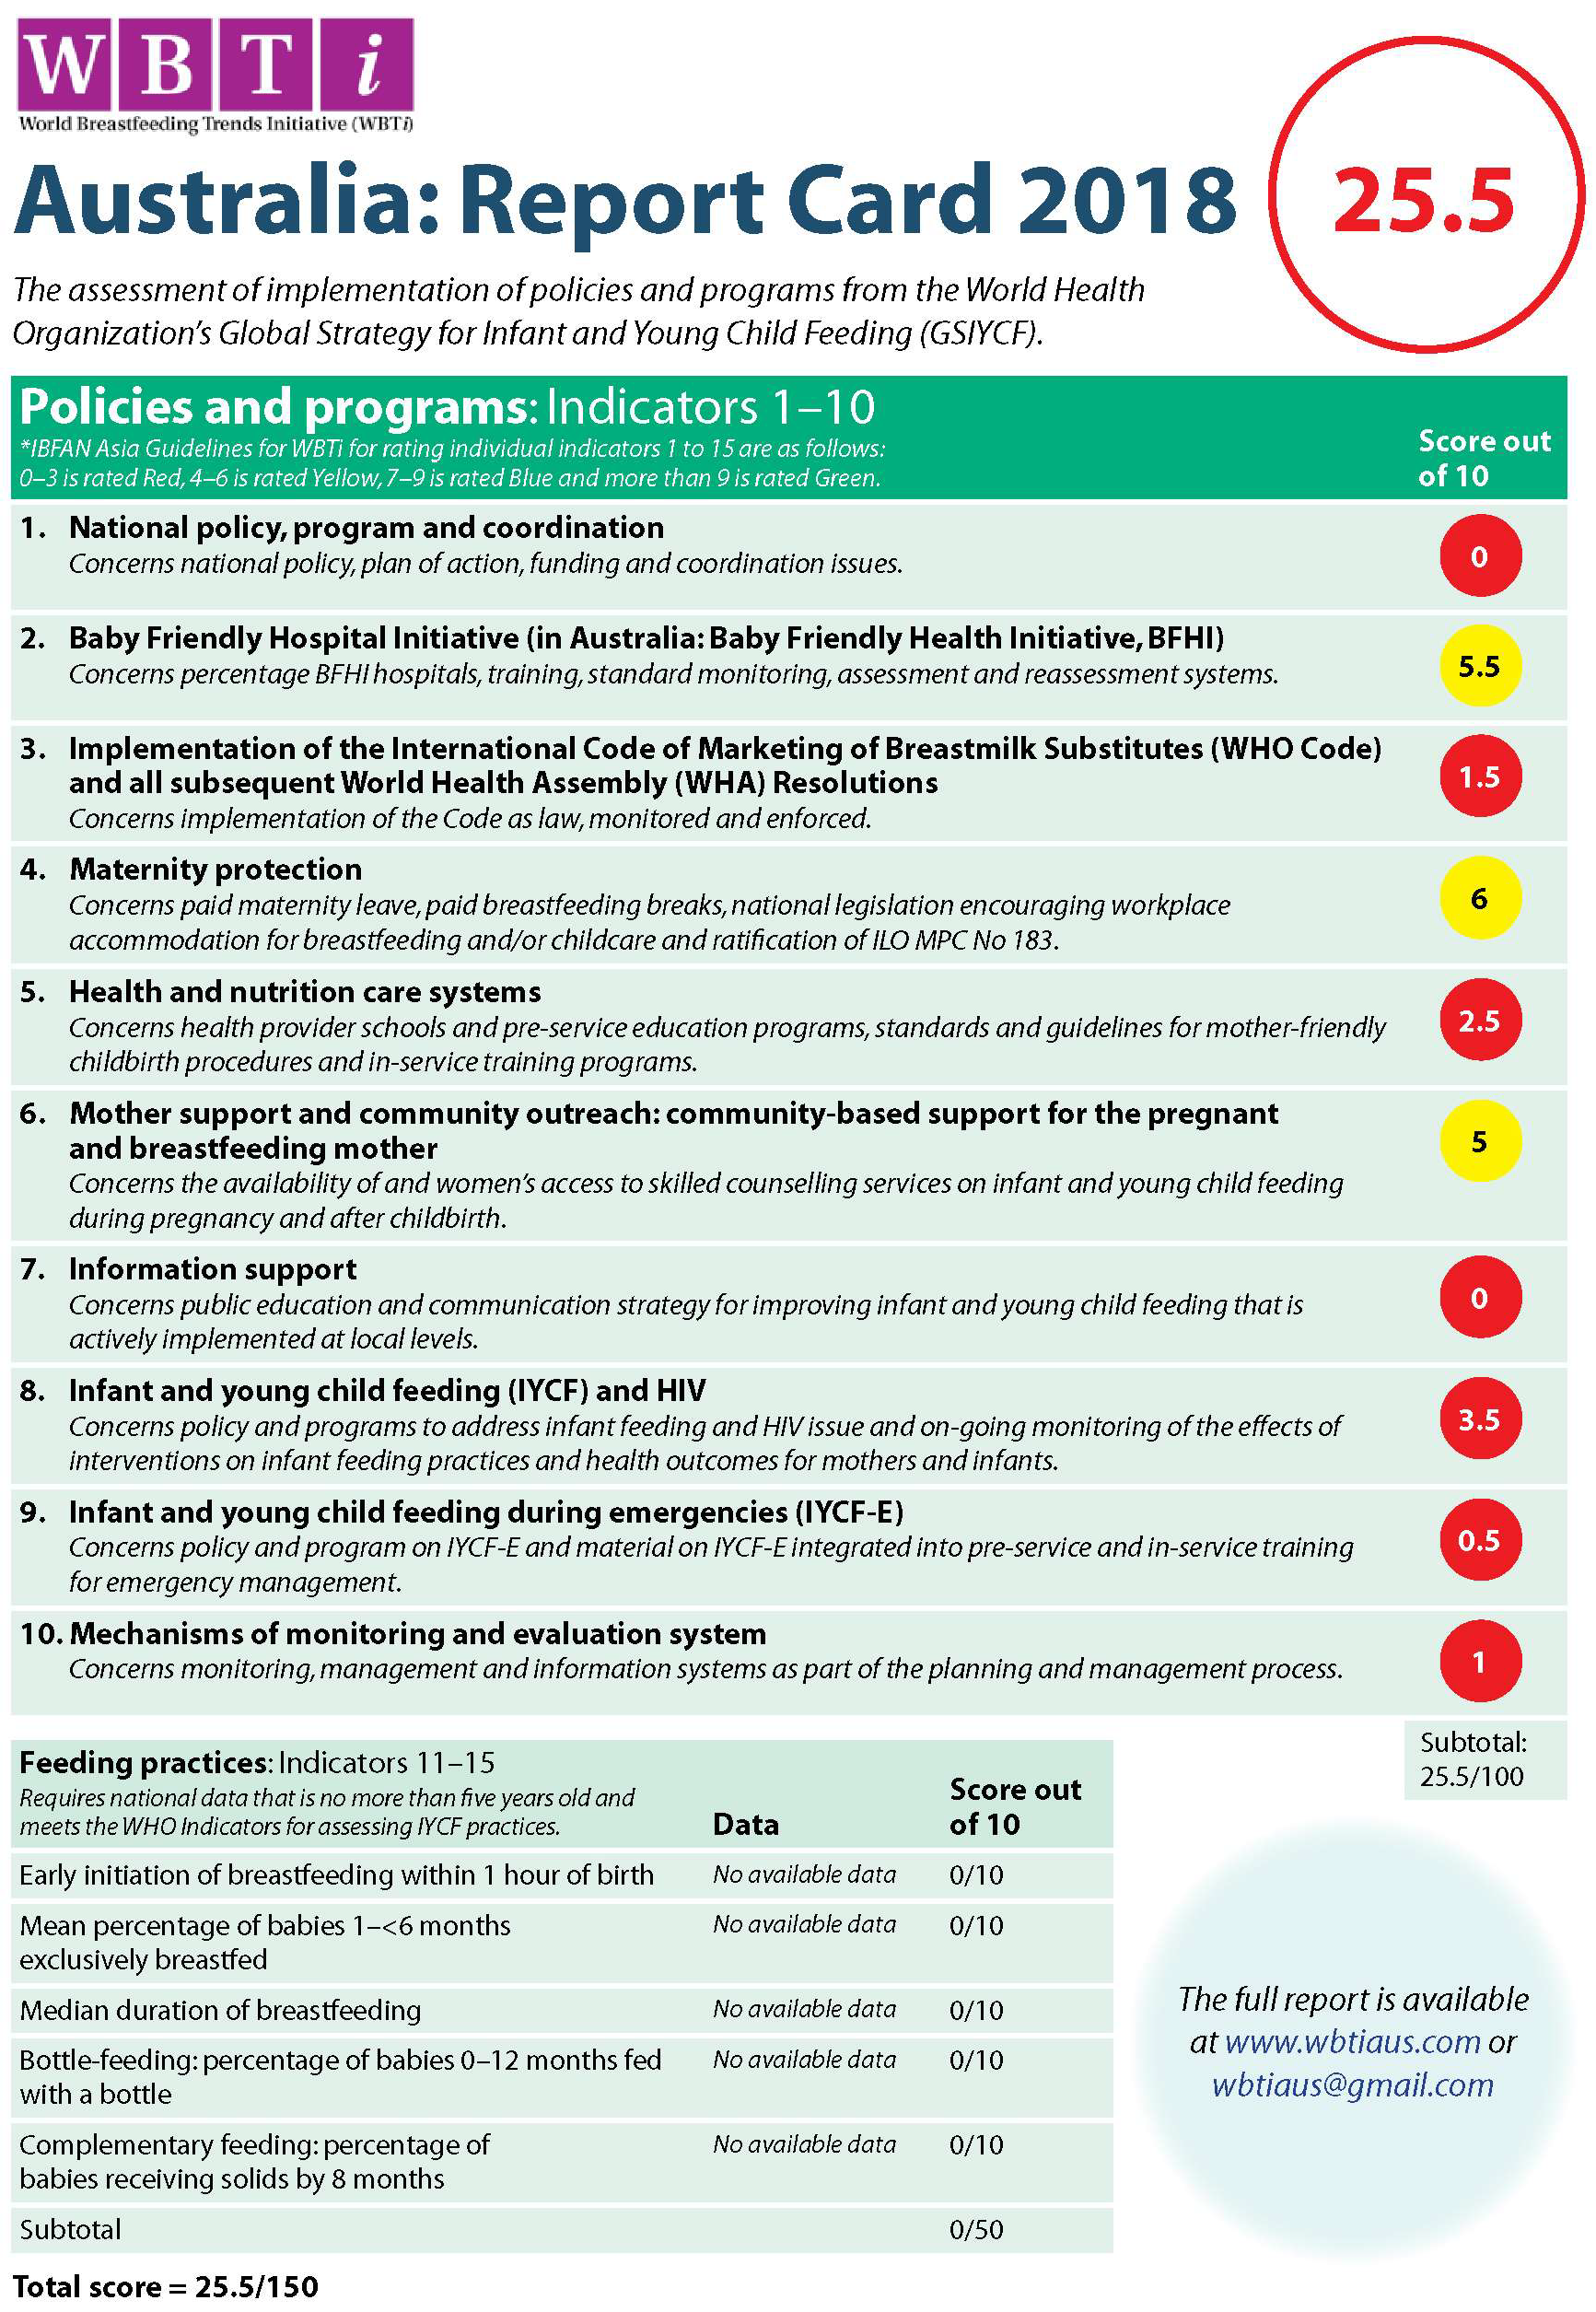

THE CASE FOR BREASTFEEDING
The 2010 Australian National Infant Feeding Survey (ANIFS) found that breastfeeding was initiated for 96 per cent of children aged 0–2 years. Around 69 per cent of infants at 4 months of age and 60 per cent at 6 months of age were still receiving some breastmilk. Around 39 per cent were exclusively breastfed to 3 months and only 15 per cent were exclusively breastfed to 5 months.39

Figure 6: Proportion of children exclusively breastfed and proportion of children breastfed at each month of age (per cent), Australia, 2010
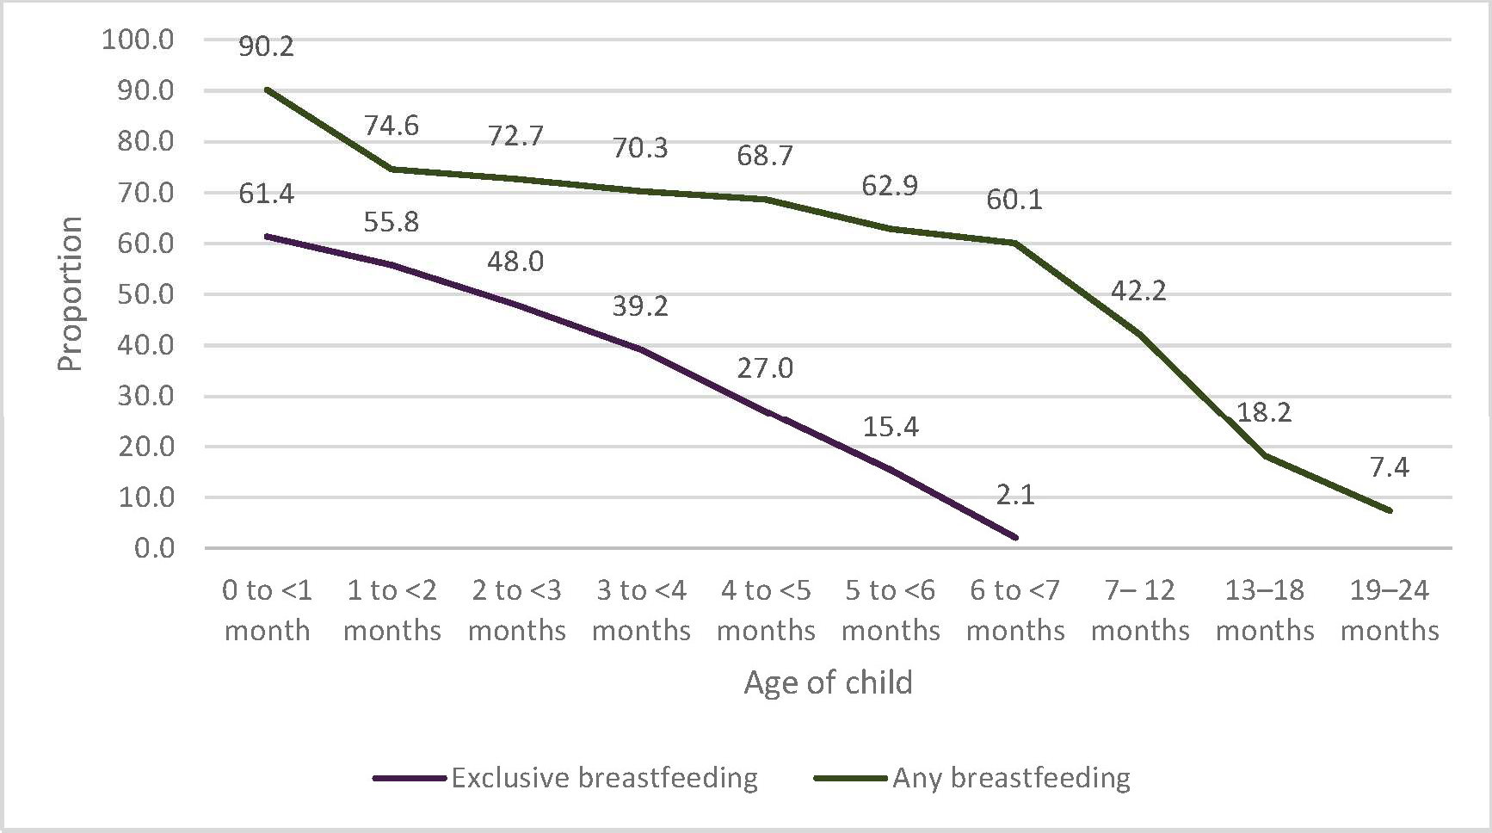
The Australian Bureau of Statistics also collected information on breastfeeding as part of the 2014–15 National Health Survey.40 The survey found:
- Ninety-two per cent of children aged 0–3 years in 2014–15 had received breastmilk at some stage.
- Of children aged 2–24 months, around three-quarters (72.6 per cent) were exclusively breastfed to at least 2 months of age.
- Of children aged 4–24 months, around two-thirds (61.6 per cent) were exclusively breastfed to at least 4 months of age.
- Of children aged 6–24 months, around one-quarter (24.7 per cent) had been exclusively breastfed to at least 6 months of age.
- Of all children aged 25–47 months, most (88 per cent) had been introduced to some type of food (soft, semi-solid or solid) by the age of 6 months. Around one-third (35.1 per cent) had been introduced to some type of food when aged 0–4 months and around half (53.7 per cent) when aged 5–6 months.
While the breastfeeding initiation rate is high, not all infants may be fully breastfeeding at the breast from birth. A study of healthy term infants in Melbourne found that only 47 per cent of infants had been fed directly at the breast from birth, with the rest having received expressed breastmilk and/or formula.41 Breastfeeding solely at the breast in the early postpartum period has been found to be associated with longer duration of breastfeeding in some studies and to have the reverse effect in others.41 Nevertheless, the first 24–48 hours is a critical period in which to set the course for successful breastfeeding.41 If the first feed is successful and pleasant for mothers, this is a key marker for continued breastfeeding. When mothers feel awkward and incompetent in the first two days, they are much less confident and more likely to cease breastfeeding early.

Increasing rates of breastfeeding in Australia in line with WHO and NHMRC recommendations will improve the health and wellbeing of infants, young children, mothers and families and may also benefit society as a whole.42 43 44
‘One of the most highly effective preventive measures a mother can take to protect the health of her infant and herself is to breastfeed’.45

In 2017 the medical journal The Lancet published a major series of studies on breastfeeding epidemiology and intervention approaches. The authors of one of the review studies published in The Lancet estimate that worldwide about 40 per cent of infants aged 0–6 months are exclusively breastfed. Scaling up breastfeeding to a near universal level could prevent annually over 820 000 deaths of children aged under 5 years and 20 000 deaths of women from breast cancer.42 Most of the latter were in high-income countries such as Australia.

Not breastfeeding increases risks of illness for both mother and child
Findings from epidemiology and biology studies substantiate the fact that not breastfeeding a child has major long-term effects on the child’s health, nutrition and development and also on the mother’s health. Possibly no other health behavior can produce such different outcomes for the two individuals involved: the mother and the child.42
Breastfeeding is an important first step to improved short-term and long-term physical and mental health outcomes for both babies and mothers and facilitates bonding between mother and child.

Children
Infants who are not breastfed are at increased risk of the following:
- Sudden infant death syndrome (SIDS)—Breastfeeding is an independently protective factor, with infants who have received no breastmilk being at highest risk (when other risk factors are adjusted).42 51
- Respiratory and gastrointestinal infections—For term babies, not breastfeeding increases the risk of illnesses such as pneumonia, diarrhoea and vomiting.42 51 Preterm infants are also at increased risk of necrotising enterocolitis (NEC).42 51
- Acute ear infection—The risk of acute ear infection (otitis media) is 100 per cent higher among exclusively formula-fed infants than among those who are exclusively breastfed during the first six months.42 51
- Asthma—Infants who are not breastfeed may experience higher rates of asthma and childhood wheeze.42 51
- Type 1 and type 2 diabetes—Formula-fed infants are more likely to develop type 1 and type 2 diabetes later in life and have also been shown to have higher serum insulin concentrations in adulthood.42 46 51
- Overweight and obesity—Longer periods of breastfeeding are associated with a reduction in overweight and obesity.42 51 In a large study among low-income children in the United States, those who were breastfed for at least 12 months were 28 per cent less likely to be overweight at 4 years of age than those who were never breastfed.47
- Leukaemia—Based on current meta-analyses, 14 per cent to 19 per cent of all childhood leukaemia cases may be prevented by breastfeeding for six months or more.48 51
Breastfeeding provides much more than just good nutrition for the developing infant. It provides direct skin-to-skin contact between mother and child, encourages early mother–child social exchanges, and calms the infant by triggering their natural sucking reflex.49 Emerging research also

suggests that exposure to bioactive hormones through breastmilk may shape infant temperament.49

Mothers
Breastfeeding also contributes to better health for mothers. In particular, breastfeeding reduces the risk of chronic diseases.
Mothers who breastfeed experience:
- longer periods of amenorrhea, leading to greater spacing between pregnancies42 48 50
- reduced risk of invasive breast cancer42 51
- reduced risk of ovarian cancer42 51
- reduced risk of hyperlipidemia,53 hypertension52 53 and cardiovascular disease54 53
- lower postpartum weight retention55 56
- reduced risk of type 2 diabetes57 53
- reduced maternal depression.42
Breastfeeding is associated with increased maternal sensitivity, reduced reactivity to stress, enhanced slow-wave sleep and reduced risk of postpartum depression.49

Breastfeeding influences the development of the infant microbiome
Breastfeeding influences the proper priming and development of the infant’s microbiome (or the collection of microorganisms living in or on the human body58), which is integral to immune and metabolic health. A mother’s breastmilk transmits probiotics and prebiotics, including elements of the mother’s own microbiome and immune responses, to the infant.
A longitudinal study of 107 healthy mother–infant pairs found that 30 per cent of the beneficial bacteria in an infant’s intestinal tract come directly from the mother’s milk and an additional 10 per cent come from skin on the mother’s breast.59
The development of the infant’s microbiome is disrupted by several practices, including Caesarean section, perinatal antibiotics, and formula feeding and these practices have been linked to increased risks of metabolic and immune diseases.58

Introduction of formula or complementary foods early in the postnatal period affects the colonisation and proliferation of the neonatal intestinal microbiota and may reduce the benefits of exclusive breastfeeding. Formula feeding has been associated with increased bacterial diversity and can alter the structures and relative abundances of the bacterial communities normally found in a breastfed infant’s gut.58

Breastfeeding reduces health costs
Breastfeeding contributes substantial savings in health costs and reduced burden of disease:
- Research in 2002 estimated that Australian hospital costs of premature weaning for four conditions (gastrointestinal illness, respiratory illness, eczema and NEC) was of the order of
$60 million to $120 million per annum.60
- A UNICEF UK report authored by Renfrew and colleagues found that even modest increases in breastfeeding rates in the UK were associated with substantial economic and health benefits.61
- A USA study showed that, if 90 per cent of mothers could exclusively breastfeed for six months, the USA would save $13 billion per year and prevent more than 911 deaths, nearly all of which would be of infants.62

Breastfeeding benefits society and the environment
Breastfeeding also has many benefits and implications beyond health. Early childhood experiences and caregiving practices, including breastfeeding, are critical to optimal human development. A parenting orientation that emphasises comforting touch, breastfeeding and responsiveness to the child’s needs is associated with positive socio-moral development.63
Breastfeeding is a sensible and cost-effective investment in society because it enhances human capital. It is associated with higher intelligence, higher school achievement and higher adult earnings.42

‘If breastfeeding did not already exist, someone who invented it today would deserve a dual Nobel Prize in medicine and economics ...
Breastfeeding is a child’s first inoculation against death, disease, and poverty, but also their most enduring investment in physical, cognitive, and social capacity.’43

Breastfeeding also has benefits for the environment. Breastmilk is an environmentally friendly product, as it does not waste scarce resources or create pollution. There are no packages involved and no transportation is needed to deliver the product, as opposed to infant formulas and other substitutes for human milk, which require packaging and transport.45 Feeding babies with non- human milk is associated with a range of poorer outcomes for mothers and babies and, more widely, is detrimental economically and ecologically.
Breastfeeding provides a dependable method of infant feeding in rural and remote locations with limited or sporadic access to alternative infant feeding options. It also provides a safe and reliable method of infant feeding in emergencies, providing a consistent source of adequate nutrition and protection against infections.64

PRIORITY POPULATIONS

Australia’s mothers and babies
Every year in Australia over 300 000 babies are born. In 2016, more women gave birth and more babies were born (an increase of 12 per cent since 2006).65 Women are giving birth later—the average age of all women who gave birth in 2016 was 30.5 years, compared with 29.8 years in 2006. Most mothers live in major cities and were born in Australia.
One-quarter (26 per cent) of mothers who gave birth in 2016 were born in a main non-English- speaking country1 (compared with 17 per cent in 2006). Around 4.4 per cent of all mothers who gave birth in 2016 identified as Aboriginal and/or Torres Strait Islander.
Almost half (45 per cent) of mothers were overweight or obese, and one in three mothers had caesarean births.
Figure 7: Key facts about Australia’s mothers and babies65
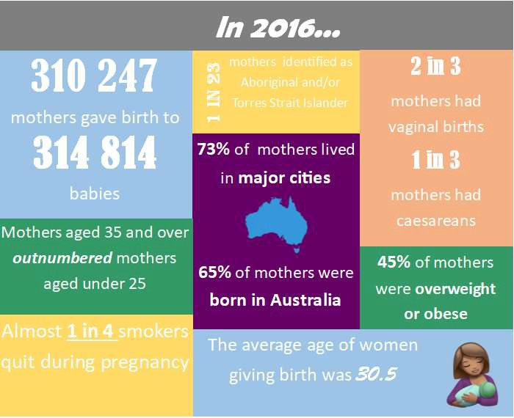

Priority populations for the Strategy
Priority populations are those that have the highest risk of not meeting optimal breastfeeding recommendations in comparison with the general population. These population groups often encounter a greater burden of mortality, morbidity and health care costs due to social and other barriers, the risk of which may be reduced, for both mother and child, when optimal breastfeeding outcomes are reached. Influencing breastfeeding outcomes for these groups may require

1 According to the Australian Institute of Health and Welfare, a ‘main non-English-speaking country’ is a country where a language other than English is likely to be spoken. This includes all countries other than Australia, Canada, the Republic of Ireland, New Zealand, South Africa, the United Kingdom and the United States of America.

improved access or more intensive, additional or specialised support.66 However, there are greater gains to be realised from improving breastfeeding rates for these groups.

Figure 8: Priority populations for the Australian National Breastfeeding Strategy

Aboriginal | Culturally and | Low socio- | Mothers | Young | Daily | Obese | Caesarean
and Torres Strait Islander | linguistically diverse* | economic background or low education level | of preterm infants | mothers (aged under 25 years) | smokers | mothers | birth or obstetric or childbirth complications
* This includes migrants, refugees, asylum seekers and their children.

Aboriginal and/or Torres Strait Islander communities
Infants with Aboriginal and/or Torres Strait Islander parents are generally less likely to be breastfed.
The 2010 ANIFS found the rates of exclusive breastfeeding between Indigenous and
non-Indigenous children aged less than 1 month to be 59 per cent and 61 per cent respectively.39 This rate declines as the infants’ age increases for both Indigenous and non-Indigenous infants, but the decline is steeper for Indigenous infants (see Figure 9).

Figure 9: Duration of exclusive breastfeeding (to each month of age), by Indigenous status, 201067
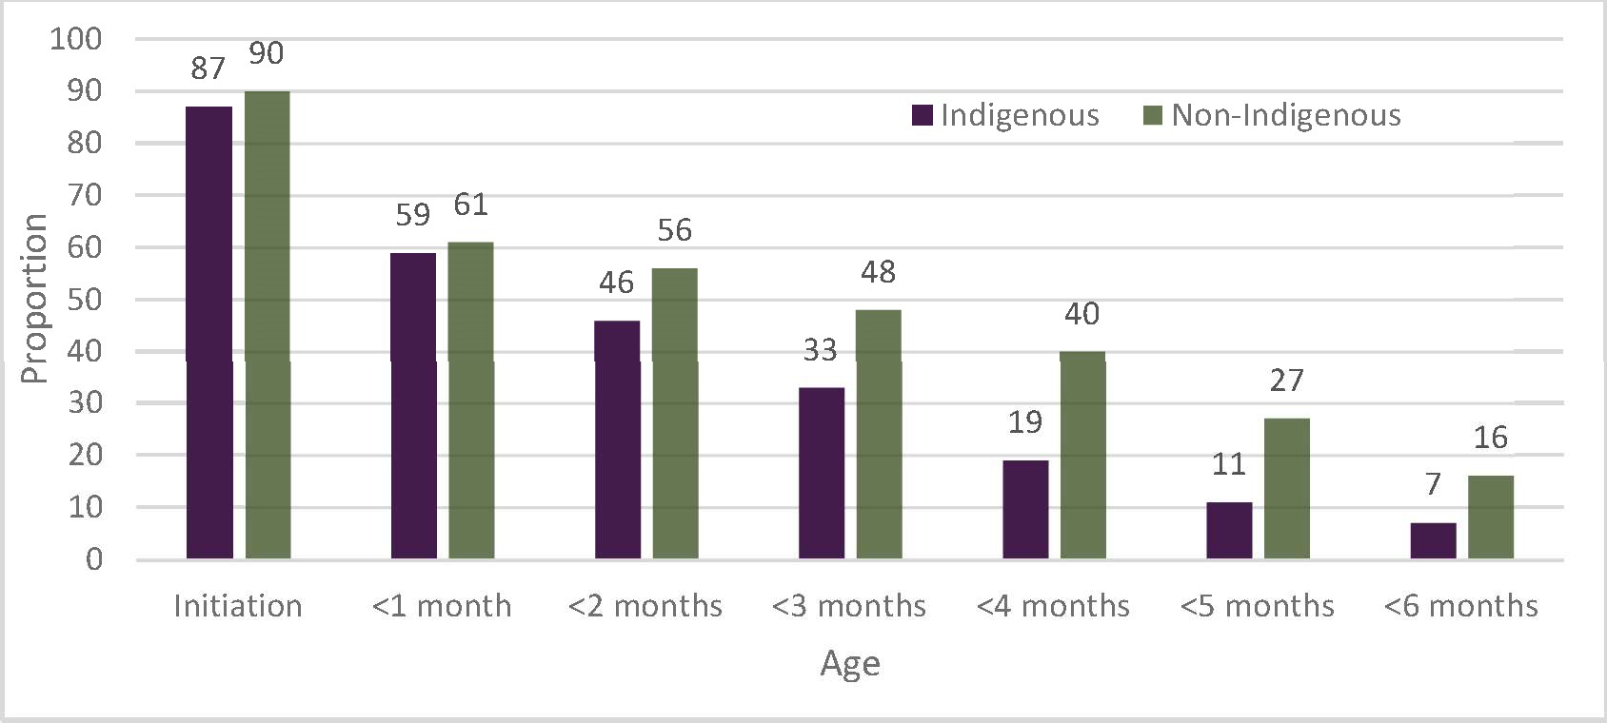
The 2014–15 National Aboriginal and Torres Strait Islander Social Survey (NATSISS) shows that 80 per cent of Indigenous children aged 0–3 years had been breastfed.67 The NATSISS also shows the disparity between Indigenous and non-Indigenous breastfeeding rates as follows:
- Indigenous infants aged 0–2 years were 1.2 times as likely as non-Indigenous infants to have never been breastfed (18 per cent compared with 14 per cent).
- Of those children aged 0–2 years who had been breastfed, Indigenous infants were more likely than non-Indigenous infants to have been breastfed for less than one month (15 per cent compared with 10 per cent).
- By the recommended age of up to 6 months, only 7 per cent of Indigenous infants were exclusively breastfed compared with 16 per cent of non-Indigenous infants.
- Indigenous infants were less likely than non-Indigenous infants to have been breastfed for 12 months or more (4 per cent compared with 12 per cent).67
A small study in rural New South Wales found that Aboriginal women value trust and knowledge passed on to them from extended family members and women within their community.68 Another study in an urban area in Queensland found that individual circumstances strongly influence infant feeding strategies and that community strengths are underused in supporting breastfeeding mothers.69

Breastfeeding interventions for Aboriginal and Torres Strait Islander people highlight the need to integrate culturally sensitive interaction and communication with programs to address multiple health and social issues that are barriers to optimal infant and young child feeding. However, the effectiveness of breastfeeding interventions for Indigenous populations in Australia and worldwide is under-researched.66
There is evidence of the effectiveness of culturally appropriate Indigenous health programs in Australia delivered within holistic primary health care services controlled by Indigenous organisations. Multiple opportunities to provide mothers and communities with consistent breastfeeding promotion, education and support also occur when maternity care and maternal and child health services:
- follow a model of continuity of woman-centred care from pregnancy through to preschool age
- are delivered by Indigenous community controlled organisations and Indigenous health professionals and other staff, including Indigenous health and childcare workers.

Culturally and linguistically diverse communities
The 2010 ANIFS reported similar rates of breastfeeding initiation between mothers born overseas and Australian-born mothers (89.1 per cent and 90.8 per cent respectively). The exclusive breastfeeding rate drops to 58.1 per cent for infants aged less than 1 month whose mothers were born overseas compared with 62.5 per cent for those whose mothers were born in Australia.39
A meta-ethnographic study of migrant and refugee women in high-income countries found that most mothers viewed breastfeeding as beneficial and as the natural way to feed an infant.70 Despite a generally positive view of breastfeeding, the findings suggest that migrant and refugee women can struggle to continue breastfeeding while managing life with a new infant in a new country. Some new mothers lacked family support while others found the support offered by family members led to conflict and tension, increasing the likelihood that the new mother would cease breastfeeding. Migrant women who valued, but did not have access to, traditional postpartum practices were more likely to cease breastfeeding.70

Other priority population groups
According to the 2010 ANIFS, population groups that are less likely to breastfeed are mothers who are young, are disadvantaged, have low education levels, are daily smokers, had pre-pregnancy obesity and had an elective or emergency caesarean birth:39
- Mothers aged under 25 years are less likely to exclusively breastfeed to 4 months than older mothers (35+ years of age). They are also more likely to introduce infant formula at comparatively younger infant ages than older mothers.
- Mothers with low socio-economic status had lower initiation and exclusive breastfeeding rates than mothers with higher socio-economic status.
- Higher proportions of children of less-educated mothers were introduced to infant formula at younger ages than children of more-educated mothers.
- The lowest rate of breastfeeding initiation was observed in mothers who smoked daily (81 per cent) compared with those who do not smoke at all (91 per cent).
- Breastfeeding rates were significantly lower among mothers who were obese than among those whose weights fell within the normal Body Mass Index (BMI) range.
- Women who experienced a planned or elective caesarean had lower initiation rates (86.9 per cent and 82 per cent) and shorter durations of breastfeeding.
Mothers of preterm infants are also less likely to successfully reach their breastfeeding goals due to the additional challenges faced by preterm infants. This population group is at higher risk of poorer short- and long-term health and developmental outcomes associated with not breastfeeding, highlighting the importance of additional tailored support during this period.71

THE STRATEGY

Vision
Australia provides an enabling and empowering environment that protects, promotes, supports and values breastfeeding as the biological and social norm for infant and young child feeding.

Objectives
- Increase the proportion of babies who:
  - are exclusively breastfed to around 6 months of age (up to 40 per cent by 2022 and up to 50 per cent by 2025), particularly those from priority populations and vulnerable groups
  - continue breastfeeding with appropriate complementary foods until 12 months of age and beyond for as long as the mother and child desire.
- Enable mothers, fathers/partners, and other caregivers to access evidence-based, culturally safe breastfeeding education, support and clinical care services to make informed decisions on infant and young child feeding.
- Increase the number of breastfeeding-friendly settings/environments (baby-friendly health services, workplaces, early childhood education and care services, and public spaces).
- Strengthen the regulatory arrangements for marketing of infant formula and breastmilk substitutes so that inappropriate marketing and distribution ceases.
- Increase the proportion of health professionals who receive adequate, evidence-based breastfeeding education and training that is free from commercial influence.
- Raise awareness in the broader community of the significance of breastfeeding (and the risks associated with not breastfeeding) in achieving optimal health for both mother and child throughout the life course.

Principles

  - Mother, child, father/partner and family
- Focus on the mother and child as the centre of all breastfeeding
activities.
- Recognise that the father/partner and other family members support women to achieve their breastfeeding goals.

2. Ecological context
- Acknowledge that breastfeeding is influenced by a range of family, social, cultural, economic and environmental factors and is a public health issue, not an individual woman’s issue.
- Invest in integrated, multi-level strategies to protect, promote and support breastfeeding.

3. Access
  - Invest in universal services provided by skilled health professionals and
peer support counsellors throughout the maternity continuum and early childhood.

4. Diversity
- Recognise the diversity of Australian families through targeted breastfeeding protection, promotion and support activities that are sensitive and responsive to health literacy, individual circumstances and culture.
    - Ensure that services and health professionals work in partnership with
- Integrated women and their families to provide holistic and evidence-based care. care • Ensure that continuity of care at key transition points is seamless from
the perspective of mothers and their families and referring services.
  - Invest in research on lactation, breastfeeding and human milk that is free

- Evidence base

- Accountability

- Protection
from bias and conflicts of interest.
- Provide evidence-based information, education and support to mothers, fathers/partners and families.
- Establish a national breastfeeding advisory committee to oversee implementation, monitoring and evaluation of the Strategy.
- Ensure that the national breastfeeding advisory committee consults and engages with key government and non-government stakeholders to track progress and optimise outcomes.
- Ensure that governments and health care and education institutions protect the community from false and misleading marketing and advertising of breastmilk substitutes that fall within the WHO Code and subsequent WHA resolutions.
- Prevent health institutions (including health professionals and health workers) from accepting sponsorship of health professional education, conferences and travel by infant formula and baby food manufacturers.

Priority areas for the Strategy

Barriers to breastfeeding
Women are aware of the benefits of breastfeeding but face societal and cultural barriers to breastfeeding.
According to the ANIFS, the most common reasons for not continuing breastfeeding in the first six months were ‘not enough breast milk for child’ (56.3 per cent), ‘child was not attaching properly’ (25.2 per cent), ‘baby was unsettled’ (24.2 per cent) and ‘breastfeeding was too painful’ (18.4 per cent).39 The most common reasons for not breastfeeding were ‘previously unsuccessful experience

with breastfeeding’ (37.9 per cent), ‘so my partner can share feeding’ (28.5 per cent) and ‘infant formula as good as breast milk (26 per cent)’.39
Research shows that the majority of mothers should be able to produce breastmilk for their infant, although some will experience impediments or have contraindications for breastfeeding. For example, infants with galactosaemia (infants who lack the enzymes needed to digest lactose and galactose in milk) need specialist formulas. The most common but relatively rare condition (affecting around one in 1000 mothers) is insufficient glandular development, which leads to low milk production despite frequent feeds after birth. Other disorders, such as gestational diabetes and polycystic ovary syndrome, may require more support in helping mothers achieve a full milk supply.9

Breastfeeding as a public health issue
Breastfeeding is not only an individual woman’s issue but must also be considered a public health issue that requires investment at a societal level. Focusing solely on solving individual issues will not lead to the cultural changes needed to normalise breastfeeding. Evidence has shown that countries that have adopted a multi-component public health strategy to increase breastfeeding levels have had significant success.72
‘The success or failure of breastfeeding should not be seen solely as the responsibility of the woman. Her ability to breastfeed is very much shaped by the support and the environment in which she lives. There is a broader responsibility of governments and society to support women through policies and programmes in the community.’73
A. Brown (2016) quoting Dr Nigel Rollins of the WHO, 2016

The authors of The Lancet’s Breastfeeding Series did a systematic review of available studies to identify the determinants of breastfeeding and reviewed and revised previous conceptual frameworks. The conceptual model at Figure 10 describes the determinants that operate at multiple levels and affect breastfeeding decisions and behaviours over time.74

Figure 10: The components of an enabling environment for breastfeeding—a conceptual model
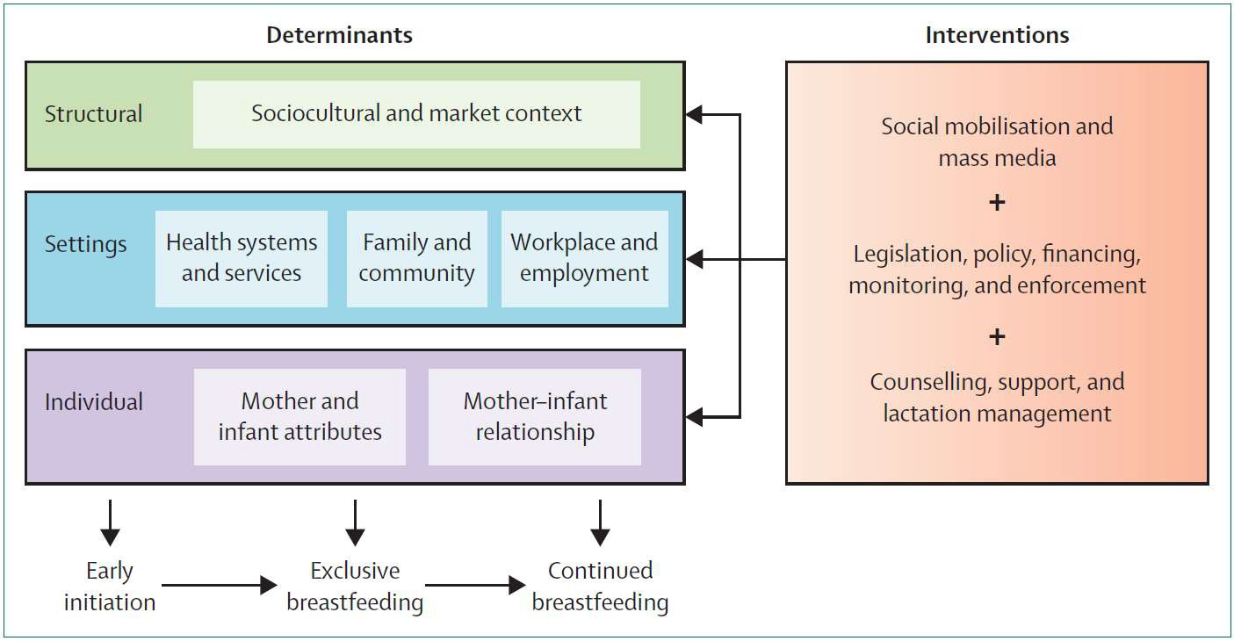

Priority and action areas
Priority areas for the Strategy (at Figure 11) have been based on the action areas identified in the 2010–2015 Strategy and on The Lancet’s conceptual model.

Three priority areas are the focus of the Strategy. These are structural enablers; settings that enable breastfeeding; and individual enablers. The actions under each priority area highlight the key areas of intervention so that breastfeeding is normalised.
Figure 11: Priority and action areas for the Australian National Breastfeeding Strategy: 2019 and Beyond
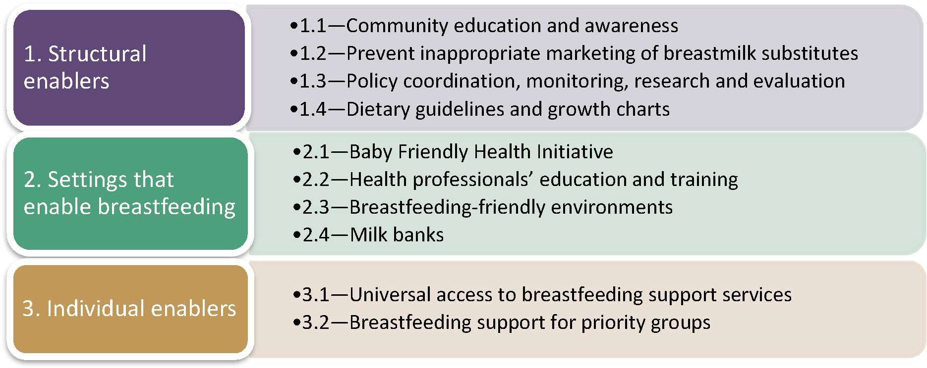

PRIORITY 1—STRUCTURAL ENABLERS

Action area—Community education and awareness
Action
Detail
Responsibility
Explore the • Review the findings of the 2009 Woolcott Commonwealth merits of a Research report Exploratory Research Regarding coordination with national social Infant Feeding Attitudes and Behaviours to identify input from states and marketing the merits and potential scope of a national social territories
campaign marketing campaign.
Develop and implement a national public health campaign on breastfeeding
•
•
The proposed public health campaign would identify the problems/issues, target audiences, key messages, attitudes and behaviours to be changed, communication platforms and budget.
The campaign needs to be well funded and sustained long enough to effect attitudinal and behavioural change.
Commonwealth coordination with input from states and territories
Promote • Increase positive breastfeeding media stories Commonwealth positive through social media platforms. coordination with

breastfeeding
  - Appoint breastfeeding champions.
input from states and

media stories territories
•
Support breastfeeding education in schools and communities
•
•
Review the national Health and Physical Education curriculum to identify the feasibility of introducing breastfeeding education.
Consider the inclusion of information on breastfeeding on government-funded websites.
Provide funding for breastfeeding education/information in local communities where there are high proportions of new families and/or priority groups. Highlight the community’s role in protecting, promoting and supporting breastfeeding.
Commonwealth coordination with input from states and territories
Australian Curriculum, Assessment and Reporting Authority
Local, state and territory governments

What has been achieved
    - The Australian Government has funded websites with trusted information on parenting, including breastfeeding, such as the Pregnancy, Birth and Baby and the Raising Children Network websites.
    - In 2009 the Department of Health commissioned research to explore attitudes and behaviours regarding infant feeding. The research report recommended that social marketing activities be implemented to normalise breastfeeding, increase commitment to breastfeeding, dispel myths associated with breastfeeding and promote the benefits of breastfeeding.75
    - The Australian Government and all state and territory governments have introduced laws to protect mothers from discrimination and harassment because of breastfeeding.76 This means that it is illegal to discriminate against a woman because she is breastfeeding.

What needs more attention
    - Mass media influences community attitudes towards parenting, child care and infant feeding. Breastfeeding is often portrayed as being problematic or difficult and formula milk and bottle- feeding as normal.72
    - The final progress report on the 2010–2015 Strategy noted that the merits of a national education campaign on breastfeeding have not yet been explored, as this has not been a priority for the Australian Government.14
    - Although breastfeeding in public is protected in Australia, many mothers perceive or experience a cultural environment that is unsupportive of this. A national education campaign on breastfeeding should include a focus on obtaining support for breastfeeding in public.

What the evidence is
    - While there is some evidence that public awareness of breastfeeding can be modified by social marketing campaigns, it can be costly to sustain these interventions long enough to change behaviour. Mass media or social marketing campaigns can be effective in raising awareness but need to be sustained long enough to effect behaviour change.72
    - A major UK evidence review in 200977 recommended public health interventions for breastfeeding promotion, including national media campaigns and celebrity endorsements promoting breastfeeding. The review also recommended the inclusion of breastfeeding education in the national curriculum for primary and secondary schools, parenting programs and child development courses targeting pupils with low academic attainment.
    - There is a need to investigate the cost-effectiveness of ongoing large-scale media and social media campaigns, social marketing and counter-marketing on changing behaviour in high- income countries. There is also a need to investigate the effectiveness and cost-effectiveness of sustained school-based social marketing or health education programs.

Action area—Prevent inappropriate marketing of breastmilk substitutes

Action
Detail
Responsibility

Review regulatory arrangements for restricting the marketing of breastmilk substitutes
Commission an independent review to determine:
  - the effectiveness of the Marketing in Australia of Infant Formulas: Manufacturers and Importers Agreement (MAIF Agreement) in restricting inappropriate marketing of breastmilk substitutes
  - the feasibility of including all manufacturers of infant and follow-up formula in the scope of the MAIF Agreement and all retailers (supermarkets, pharmacies etc.) in the scope of the agreement
  - the transparency of the complaints process and outcomes from MAIF Complaints Committee meetings.

Commonwealth

•
Raise awareness of the MAIF
Agreement in •
the community
Provide information on the complaints process and encourage the community to report inappropriate advertising and promotion of breastmilk substitutes. Actively seek out and promote membership of the MAIF Agreement to manufacturers and importers of breastmilk substitutes.
Commonwealth

What has been achieved
Australia has several mechanisms in place to implement the WHO Code:
    - The Marketing in Australia of Infant Formulas: Manufacturers and Importers Agreement (the MAIF Agreement) is a voluntary, self-regulatory code of conduct between the manufacturers and importers of infant formula in Australia.
    - In 1992, when the MAIF Agreement was first signed, there were six signatories. As at
13 December 2018, there are 15 signatories (members) of the MAIF Agreement, including all of Australia’s major manufacturers and importers of infant formula.78
    - In 2017 the Australian Government Department of Health commissioned an independent review of the MAIF complaints-handling process. An outcome of this review was the decision by the Minister for Health to transfer responsibility for the oversight and management of the MAIF complaints-handling process to the Department of Health.
    - The Department of Health has now established a new MAIF Complaints Committee comprising three members.
    - The Department of Health monitors compliance with the MAIF Agreement. The department receives complaints from the public and provides these to the MAIF Complaints Committee (previously the MAIF Complaints Tribunal).
    - The potential for reputational damage is currently the only external consequence for a breach of the MAIF Agreement, and a number of stakeholders consider this insufficient. However, signatories to the MAIF Agreement consulted as part of the 2017 review of the MAIF complaints-handling process have indicated that there can be significant internal sanctions for companies found to be in breach of the MAIF Agreement and that any change in company practice carries significant weight within the industry.78

    - The Infant Nutrition Council (INC) has reported that signatories also lodge complaints against one another through an internal complaints process managed by the INC, which mediates and resolves these complaints internally or with the assistance of external facilitation.
    - Breaches of the MAIF Agreement are also published in the annual report of the MAIF Complaints Committee (previously the MAIF Complaints Tribunal).
    - The Food Standards Australia New Zealand (FSANZ) Code includes mandatory labelling and composition provisions for infant formula, consistent with the WHO Code. Under Standard
2.9.1 of the Australia New Zealand Food Standards Code, labels of infant formula products must contain a statement that a doctor or health worker be consulted before deciding to use the product.27 Standard 2.9.1 is currently under review.79
    - The NHMRC Infant Feeding Guidelines 2012: Information for Health Workers also includes guidance for health workers on interpreting the WHO Code in Australia.27 These guidelines state that ‘health workers have a responsibility to promote breastfeeding first but, where it is needed, to educate and support parents about formula feeding and to respect a mother’s informed decision not to breastfeed’.27
    - Australian studies have shown that, while there has been a reduction in the marketing of infant formula, there has been an increase in toddler milk and other baby food advertising.80 Research suggests that Australian consumers fail to distinguish between advertising for infant formula and for toddler milk.81 Some have argued that toddler milk advertisements are functioning as de facto infant formula advertisements and that this is likely to reduce breastfeeding rates.

What needs more attention
    - According to the WBTi Australia report,38 the MAIF Agreement only partially implements the WHO Code. It is limited to the marketing of infant formula for infants up to 12 months of age, therefore allowing advertising of toddler formula and commercial baby food. The WHO contends that, because continued breastfeeding to 2 years and beyond saves lives and promotes the health of both the mother and the baby, it is important that the protection provided under the WHO Code be extended to include follow-up formula: ‘Follow-up formula has been shown to replace the intake of breastmilk and therefore acts as a breastmilk substitute. Classification of follow-up formulas for children 6–36 months as breastmilk substitutes is fully consistent with the Code and other WHO policies and recommendations’.47
    - The MAIF Agreement does not apply to retailers and distributors, such as supermarkets and pharmacies, and not all manufacturers and importers are signatories. Respondents to the online public consultation process expressed similar views to those presented in the WBTi Australia report (outlined in the previous point).89
    - The 2017 MAIF complaints-handling review suggested that, to increase the awareness and visibility of the MAIF Agreement and complaints-handling process, the Department of Health should proactively and formally reach out to new market entrants and existing non-signatories informing them of the MAIF Agreement and its importance.78
    - Stakeholder consultation conducted as part of the 2017 review of the MAIF complaints- handling process suggested that governance, interpretation and monitoring of the MAIF Agreement lacks transparency and there are no effective penalties for breaches.78
    - The WBTi Australia report found that, contrary to the recommendation of the WHO/UNICEF
Global Strategy for Infant and Young Child Feeding to introduce complementary foods from
6 months, Australian food standards permit the labelling of commercial complementary baby foods as suitable for children from 4 months of age:38
      - In 2014, FSANZ undertook a review of minimum age labelling of foods for infants (Proposal P274), which concluded that no amendments would be made to the minimum

age on infant food labels in Standard 2.9.2—Foods for Infants, of the Australia New Zealand Food Standards Code.82
      - The aim of this proposal was to consider whether the minimum age on infant food labels should align with Australian (and later New Zealand) infant feeding guidelines that advise introducing infants to complementary food (solids) at ‘around 6 months’.
      - The proposal commenced in 2003, was adjourned in 2008, made recommendations in 2013 and was finalised in 2014, with a decision to retain the current minimum age of 4 months on infant food labels. FSANZ concluded that ‘there is a window from 4 to <7 months for introducing solid food which carries a low risk of adverse health outcomes’.79

What the evidence is
    - A WHO systematic review of evidence on the potential harm to children of the marketing of breastmilk substitutes found widespread violations of the WHO Code (500 violations in 46 countries) contributing to suboptimal breastfeeding practices.83 The systematic review also found evidence that the WHO Code, when fully incorporated into legislation, can be effective in restricting the marketing of breastmilk substitutes.83
    - Legislation to restrict marketing of breastmilk substitutes is necessary but not sufficient; equally important are other measures such as implementing regulations, effective enforcement and public monitoring of compliance.84

Action area—Policy coordination, monitoring, research and evaluation

Action
Detail
Responsibility

Convene a national breastfeeding advisory committee
  - The national breastfeeding advisory committee would bring together relevant government and non- government stakeholders to implement, monitor and evaluate the Strategy.
  - The national breastfeeding advisory committee would report annually on implementation to AHMAC.

Commonwealth

Monitor and report on breastfeeding rates
- Seek agreement from all jurisdictions on national breastfeeding indicators to be collected at the local level through the Child Digital Health Record.
- Commission a baseline infant feeding survey and repeat the survey every five years.
Commonwealth and all states and territories
Conduct • Conduct a baseline evaluation in 2020. Commonwealth periodic • Conduct the first evaluation in 2025 and repeat the and all states and
territories
evaluations of
evaluation every five years thereafter.
the Strategy
Support high- quality research and knowledge translation
- Support research and translation of knowledge on breastfeeding, lactation and human milk through the Medical Research Future Fund.
Commonwealth and all states and territories

What has been achieved
    - Two national surveys that collected data on infant feeding were undertaken during the period 2010–2015. The 2010 ANIFS was the first large-scale Australian national survey of infant

feeding practices and related attitudes and behaviours. The 2011–12 Australian Health Survey (AHS), released by the Australian Bureau of Statistics in March 2013, included infant feeding data (but had fewer respondents than the ANIFS).14
    - Both the ANIFS and the AHS were based on a draft set of national breastfeeding indicators published by the Australian Institute of Health and Welfare in 2011. The Breastfeeding Jurisdictional Senior Officers Group discussed the need for further work on the draft set of indicators. Consequently, a funding bid was prepared to consult with jurisdictions on existing data collections, refine the draft breastfeeding indicators and recommend processes for routine local collection of breastfeeding data for use in both national and jurisdictional level reporting. However, the project did not receive funding.
    - In 2012, the Department of Health developed a toolkit (Evaluation Toolkit for Breastfeeding Programs and Projects) to assist jurisdictions and local health services in evaluating breastfeeding programs, including programs intended to provide support for priority groups.

What needs more attention
    - The ANIFS and the AHS only provide snapshot data, which makes it difficult to ascertain whether the overarching objective of the 2010–2015 Strategy has been met. There is currently no ongoing large-scale national data collection on infant feeding.
    - There was a lot of activity by a number of stakeholders to implement the 2010–2015 Strategy but no visible coordination or accountability to the public for these activities. The implementation plan and the progress reports were available only to state and territory government representatives. A study on the implementation of the 2010–15 Strategy recommended that Australia establish an independent breastfeeding / infant feeding committee to coordinate implementation of any future breastfeeding strategy.85 Study participants perceived the lack of committed leadership, excessive industry influence and the within-government implementation process as barriers to effective action.85
    - The evidence check for the Strategy identified areas for further research, including effectiveness of breastfeeding interventions, breastfeeding enabling policies and programs, and public awareness or social marketing approaches.66

What the evidence is
    - The extent and nature of national monitoring and evaluation of breastfeeding practices can influence public awareness and support for breastfeeding and whether it is valued at the population level as part of the food system.66

Action area—Dietary guidelines and growth charts

Action Detail Responsibility

Review and | • | Seek funding to review and update the
update dietary and infant  feeding |  | Australian dietary and infant feeding guidelines. | Commonwealth NHMRC
guidelines

Raise awareness of the dietary guidelines, infant feeding guidelines and growth charts

Provide consistent messaging on the introduction of complementary foods
- Encourage health professionals to talk to parents and families about the dietary guidelines and growth charts as part of well child health checks.
- Educate health professionals and families on interpreting growth charts.

- Work with health professional associations to ensure that consistent messages are provided on the introduction of complementary foods and allergens.
- Ensure updated infant feeding guidelines contain nationally consistent messages about the introduction of complementary foods.
Health professional associations
Commonwealth and all States and territories

Health professional associations
Commonwealth and all states and territories
NHMRC FSANZ ASCIA

What has been achieved
  - In 2012 the NHMRC released the Infant Feeding Guidelines 2012: Information for Health Workers, which provide updated advice for both health professionals and parents on breastfeeding and infant feeding. These guidelines summarise the evidence on the health benefits of breastfeeding and effective practices to support breastfeeding. The advice covers preventing or minimising common problems, the transition to solid foods, food allergies, infant formula, and interpreting the WHO Code for health workers in Australia.14
  - In 2013 the NHMRC released the Eat for Health: Australian Dietary Guidelines, which include healthy eating advice specific to pregnant and breastfeeding women (Guideline 4). These guidelines, the Australian Guide to Healthy Eating and associated resources targeted at consumers and health professionals were released as part of the Eat for Health program. In 2015 the Australian Guide to Healthy Eating was adapted for Aboriginal and Torres Strait Islander audiences.86
  - In 2012, national agreement was reached on adopting the WHO 2006 infant growth charts as the single growth standard for Australian children aged 0–2 years. The WHO growth charts are based on the growth patterns of healthy, breastfed babies. To help jurisdictions implement the new growth charts, online education and training materials are available on the Royal Children’s Hospital Melbourne website.87
  - In 2016 the Australasian Society of Clinical Immunology and Allergy (ASCIA) released the ASCIA Guidelines: Infant Feeding and Allergy Prevention. These guidelines recommend breastfeeding for at least six months and then for as long as the mother and infant wish to continue. After consultation with infant feeding stakeholders, ASCIA refined their advice to include in its key recommendations: ‘When your infant is ready, at around 6 months, but not before 4 months,

start to introduce a variety of solid foods, starting with iron rich foods, while continuing breastfeeding.’88

What needs more attention
  - The Infant Feeding Guidelines 2012: Information for Health Workers and the Eat for Health: Australian Dietary Guidelines need to be updated and promoted to health professionals and the public.
  - Stakeholder consultation on the Strategy indicated that health professionals provide inaccurate nutrition and growth advice.89 It has been suggested that education and awareness-raising programs on growth chart interpretation should be developed and implemented for families.
  - Feedback from the public consultation noted that the phrase ‘not before 4 months’ in the
ASCIA Guidelines: Infant Feeding and Allergy Prevention is confusing.89
  - There is a need to prioritise further accurate, authoritative and evidence-based messaging around the introduction of complementary foods from around 6 months. This messaging needs to continue to be free from commercial influence.

What the evidence is
  - National dietary and other guidelines or protocols, such as those on infant feeding and growth monitoring, interact with health care delivery systems and health professional education and training to strongly influence individual women’s infant and young child feeding practices.66
  - There is some debate on the effect of the use of the WHO growth charts on exclusive breastfeeding, but studies indicate the importance of appropriate education and training in this area90 and identify the need for full evaluation of the effects on breastfeeding.91

PRIORITY 2—SETTINGS THAT ENABLE BREASTFEEDING

Action area—Baby Friendly Health Initiative
Action
Detail
Responsibility
Implement the Baby • Encourage and support more maternity Friendly Health hospitals and community health services to
Initiative (BFHI) in a achieve BFHI accreditation. Commonwealth
higher proportion of and all states and
hospitals and territories
community health
services

Integrate the BFHI in national accreditation
- Work with the Australian College of Midwives and the Australian Commission on Safety and Quality in Health Care to facilitate BFHI accreditation for all maternity and newborn care facilities and community health settings.

Commonwealth

What has been achieved
  - The WHO/UNICEF BFHI (Baby-Friendly Hospital Initiative) was introduced in Australia in 1993. UNICEF passed governance of the BFHI in Australia to the Australian College of Midwives in 1995, where it remains today.
  - In 2006 the Baby Friendly Hospital Initiative was renamed the Baby Friendly Health Initiative in Australia to reflect its expansion into community health facilities.92 The BFHI provides a framework for hospitals to operate within the Ten Steps and for community facilities to operate within the 7 Point Plan for the Protection, Promotion and Support of Breastfeeding in Community Health Services (the 7 Point Plan).
  - In 2008 the 7 Point Plan, based on plans from Canada and the UK, was endorsed by the Australian College of Midwives, which awarded the first community health service accreditation in 2013.92 The seven points are:
- Point 1—Have a written breastfeeding policy that is routinely communicated to all staff and volunteers.
- Point 2—Educate all staff in the knowledge and skills necessary to implement the breastfeeding policy.
- Point 3—Inform women and their families about breastfeeding being the biologically normal way to feed a baby and about the risks associated with not breastfeeding.
- Point 4—Support mothers to establish and maintain exclusive breastfeeding for six months.
- Point 5—Encourage sustained breastfeeding beyond six months with appropriate introduction of complementary foods.
- Point 6—Provide a supportive atmosphere for breastfeeding families and for all users of the child health service.
- Point 7—Promote collaboration between staff and volunteers, breastfeeding support groups and the local community in order to protect, promote and support breastfeeding.93

  - In November 2012, the then Australian Health Ministers Council affirmed that all Australian jurisdictions support the effective, practical guidance provided by the BFHI and its Ten Steps for health services. All Australian Health Ministers encouraged all public and private hospitals to implement the Ten Steps and to work towards or to maintain their BFHI accreditation.14

What needs more attention
  - In 2017 only 22 per cent of maternity hospitals and two community health services had been designated as Baby Friendly.
  - Qualitative research has found that, while there was a positive perception of the BFHI among stakeholders, its expansion in Australia had been negatively influenced by intangible government support and suboptimal capacity building. Prioritisation, stakeholder collaboration and adequate resourcing of the BFHI are required.94

What the evidence is
  - The BFHI is a wide-ranging intervention of proven effectiveness, and its extensive implementation is highly recommended.66
  - Each step of the BFHI addresses an organisational or clinical practice within the hospital system. This includes creating organisation-wide breastfeeding policies and practices that are disseminated to all staff; individualised support that addresses pregnant, birthing and postnatal women and babies’ needs; and a seamless transition into community services.66
  - Individually, and especially in combination, the Ten Steps reduce barriers to breastfeeding and create a more enabling environment in which a mother–baby dyad can establish breastfeeding and lactation.66
  - The effectiveness of programs being implemented in some countries that expand the BFHI beyond the maternity care setting to include community health services and paediatric hospitals has not been evaluated. However, these programs rest on a combination of initiatives that have their own good evidence base.66

Action area—Health professionals’ education and training

Action
Detail
Responsibility

Provide and support access to education and training in breastfeeding for all health professionals who care for women and children
- Support the development of breastfeeding content in undergraduate and graduate education and training for health professionals.
- Consider the development of a core curriculum, skills matrix and national competency standards.
Health professional associations
Universities Commonwealth and all states and
territories

Support the | • | Promote the development of evidence-based
development of |  | breastfeeding guidelines/resources and clinical | Commonwealth
clinical care tools for |  | care tools for health professionals caring for
 |  |  | and all states and
primary health care |  | women and children.
 |  |  | territories
services

What has been achieved
  - The Department of Health has funded the Australian Breastfeeding Association (ABA) since 2008 to deliver workforce education and training to support the operation of the national toll- free Breastfeeding Helpline. This includes the Certificate IV in Breastfeeding

Education/Counselling for volunteer educators and counsellors. The ABA also delivers the Diploma of Breastfeeding Management as well as seminars and training workshops for health professionals.
  - The Department of Health provided funding to the Lactation Consultants of Australia and New Zealand (LCANZ) for sponsorship of the LCANZ 2012 Conference. Funding was provided in 2013 for bursaries or scholarships to the International Lactation Consultant Association 2013 Conference and for educational resources for lactation consultants.
  - States and territories ensure that health staff are able to participate in learning activities, including time away from normal duties. Some jurisdictions have achieved efficiencies by giving or cost-sharing access to existing resources rather than developing a duplicate program.14

What needs more attention
  - Public consultation on the Strategy identified the following issues:
    - conflicting advice from health professionals
    - negative effects of poor medical advice
    - lack of financial support for maternal and child health nurses to attend education/training
    - lack of resources for health professionals to support mothers.89
  - Respondents identified all health professionals who work with women of childbearing age, children and families as requiring education and training in breastfeeding.
  - Respondents proposed:
    - There should be a core curriculum, skills matrix and national competency standards that health professionals need to maintain through ongoing professional development.
    - Health professionals’ level of breastfeeding competency should be visible to the women consulting them, perhaps through a ‘Breastfeeding-Friendly Health Professional Accreditation Scheme’.
    - To support service delivery, a breastfeeding / infant and young child feeding research program must be implemented.

What the evidence is
  - Systematic review evidence supports the conclusion that education and training of health workers results in improved knowledge of breastfeeding.95 The type of education and training that is most effective remains unclear.
  - A cluster-randomised trial in regional Australia evaluated the effects of an intervention that trained general practice nurses in rural family doctors’ offices to deliver support for breastfeeding using motivational interviewing techniques. This intervention was found to be effective in increasing exclusive breastfeeding at 4 months.96

Action area—Breastfeeding-friendly environments

Action  Implement the Breastfeeding Friendly Workplace program in government agencies | De  • | tail  All Commonwealth, state and territory government departments must seek Breastfeeding Friendly Workplace accreditation from the ABA. | Responsibility
 |  |  | Commonwealth States and territories
Recognise employers that provide support for breastfeeding mothers | • | Recognise employers that provide support for women to breastfeed—for example, through the Workplace Gender Equality Agency’s Employer of Choice for Gender Equality citation. | Commonwealth States and territories  Employers

• | Pilot and evaluate a breastfeeding-friendly early | Commonwealth
Pilot and evaluate a | childhood education and care program that | States and
breastfeeding- | encourages centres to recognise the needs of | territories
friendly early  childhood education | breastfeeding mothers and their infants. | Early childhood education and care
and care program
 |  | providers

What has been achieved
  - The PPL scheme commenced on 1 January 2011 and provides financial support for up to 18 weeks to help eligible parents take time off work to care for a newborn or recently adopted child. From 1 January 2013, the scheme was extended to include two weeks of Dad and Partner Pay.14
  - Under the National Employment Standards in the Fair Work Act 2009, employees with 12 months’ service have a right to request flexible working arrangements in a range of circumstances, including when an employee is the parent, or has the responsibility for the care, of a child who is school aged or younger. All modern awards contain provisions that supplement the right to request flexible working arrangements provisions in the National Employment Standards to facilitate flexible working arrangements.
  - The Fair Work Ombudsman provides information on best-practice actions that employers can implement to support employees who are breastfeeding.
  - The Get Up and Grow: Healthy Eating and Physical Activity for Early Childhood resources, published in 2013 by the Department of Health, provide guidance for supporting breastfeeding and appropriate use of infant formula in early childhood education and care settings. The National Quality Framework for Early Childhood Education and Care, Quality Area 2, refers to the Get Up and Grow resources, the Eat for Health: Australian Dietary Guidelines and support for breastfeeding.14

What needs more attention
  - As part of the consultation process in the development of the Strategy, women provided examples of the challenge of balancing motherhood and returning to work. While some mothers are able to stay home for at least 12 months, others return to work early and face barriers to breastfeeding at work—negative attitudes to their needing time to express milk, no

paid lactation breaks, and pumping difficulties.89 Some women acknowledged the support provided by flexible work arrangements and the PPL scheme.
  - It was also suggested that there should be legislative support for all businesses/employers to provide flexible work practices, work breaks and facilities to enable women to combine breastfeeding and work.89
  - The International Labor Organization’s Maternity Protection Convention sets out international standards regarding maternity leave. Australia has not ratified this convention.30
  - Existing initiatives that promote breastfeeding in early childhood education and care services could be considered, such as the Munch and Move program in New South Wales and the Breastfeeding Friendly Child Care scheme piloted by the ABA, the University of New South Wales, Flinders University and the Australian National University.89

What the evidence is
  - Earnings from employment are an important financial incentive and a significant economic determinant of infant feeding practices; hence breastfeeding rates are lower among employed mothers.66 There is strong evidence from diverse countries that longer duration of paid maternity leave increases breastfeeding duration and improves maternal health.66 97
  - An evaluation of PPL in 2014 found that, while PPL appears to have had no impact on already high breastfeeding initiation rates, there was a small increase in the proportion of mothers who were still breastfeeding when their child was 6 months and older.98
  - Employment policies ensuring access to suitable and flexible hours of employment that enable longer breastfeeding and social support for breastfeeding in workplace settings are associated with improved breastfeeding practices.66
  - Evidence from the USA, Britain and Australia supports the effectiveness of specific interventions in early childhood education and care settings but provides no information on system-level strategies. There is some evidence for Australia that, in the absence of enabling policies and strategies, ensuring breastfeeding support is embedded in childcare service standards results in ad hoc support for and unequal access to breastfeeding.66

Action area—Milk banks

Action
Detail
Responsibility

Establish a human milk working group to provide advice to AHMAC on the regulation and importation of human milk
- Undertake a needs assessment to ascertain
the status of the supply of and demand (including unmet demand) for human milk and human milk products in Australia and New Zealand.
- Develop advice to AHMAC regarding the regulation and importation of human milk and human milk products; and how to consider human milk and human milk products in the context of Australian and New Zealand jurisdictional Human Tissue Acts.
- Provide advice to AHMAC on the benefits of national (Australian) standards to apply to operating human milk banks.
- Provide advice to AHMAC on the complexity of human milk, including ethical and social implications, safety and quality standards, regulation and legislation, research and therapeutic use.

Commonwealth States and territories New Zealand

What has been achieved
  - The report of the 2007 Inquiry into the Health Benefits of Breastfeeding by the House of Representatives Standing Committee on Health and Ageing recommended that ‘the Department of Health and Ageing fund a feasibility study for a network of milk banks in Australia including the development of a national regulatory and quality framework within which a network of milk banks in Australia could operate’.11
  - The implementation plan for the 2010–2015 Strategy undertook to explore the evidence, quality assurance, cost-effectiveness and regulatory issues associated with the establishment of milk banks in Australia. In 2014 the Australian Government published Donor Human Milk Banking in Australia—Issues and Background Paper, which concluded that:
- ‘the case for developing further, specific regulation of milk banks is not sufficiently strong to be pursued at this time’
- ‘decisions about establishing, managing and resourcing milk banks are a matter for consideration by local hospital networks, subject to local authorities’.99

What needs more attention
  - There are six milk banks in Australia. Access to banked milk, including for babies in neonatal intensive care units (NICUs), is restricted and is not available in all jurisdictions or regions. Australian milk banks have largely operated independently with no formal regulation and no benchmark for best practice.66
  - There is no national regulatory framework for human milk banks. There is no food standard for the processing/pasteurisation of human milk.

What the evidence is
  - There has been considerable interest and expansion in donor milk banking, including as an element of the BFHI focused specifically on NICUs. In health care settings where breastfeeding

is delayed or prevented, the use of human milk provided by the baby’s own mother or a donor and the provision of specialised lactation support are likely to be both effective and cost- effective interventions for at-risk infants and mothers. While milk banks may support breastfeeding, there are concerns that donor milk banking may compete with resources for lactation support and may reduce support for provision of the mother’s own milk or breastfeeding.66

Hospital milk banks
There is evidence supporting the use of pasteurised donor human milk for hospitalised preterm or sick infants.
A systematic review and meta-analysis in 2016, which identified 10 trials, found that the introduction of donor human milk (DHM) increased any breastfeeding on discharge by about 20 per cent.100 The authors concluded there was some evidence of both positive and negative
effects on measures of maternal breastfeeding when DHM was introduced to a neonatal unit. This may indicate that the package of interventions to support breastfeeding delivered alongside appropriate use of donor milk plays an important part in the delivery of an appropriate milk banking service.
A 2013 expert review by the Committee on Nutrition of the European Society for Paediatric Gastroenterology, Hepatology and Nutrition documented the benefits and common concerns deriving from the use of DHM in preterm infants. It identified protection against NEC as its major clinical benefit. Limited data also suggested that unfortified DHM is associated with improved feeding tolerance. This review concluded that the access to a human milk bank does not decrease breastfeeding rates at discharge and does decrease the use of formula during the first weeks of life. Fresh own mother’s milk was considered the first choice in preterm infant feeding due to the effects of processing and storage on biological components of human milk; hence the review called for strong efforts to promote lactation.101

Milk banking networks
A review of global experience in milk banking by PATH (formerly the Program for Appropriate Technology in Health) in 2013 provided guidelines to encourage the nationwide expansion of hospital milk banking for preterm and very low birthweight infants in a way that supports rather than displaces maternal breastfeeding.102
Based on this experience, an important study published in 2017 reviewed best practices and current guidelines for human milk banking.103 The review identified universal requirements for an integrated model of newborn care across all-country income settings. Crucial to success was comprehensively integrating the operation of human milk banks into newborn care strategies, neonatal unit operational structures, breastfeeding support services, and national and regional policies involving standards of practice and guidance for core functions.

PRIORITY 3—INDIVIDUAL ENABLERS

Action area—Universal breastfeeding education, support and information services

Action  Provide mothers | • | Detail  Empower mothers to reach their breastfeeding | Responsibility  Health services
with antenatal  education about the |  | goals through provision of evidence-based  information and breastfeeding education | Health professionals
significance of |  | classes.
breastfeeding for
their babies and
themselves

Provide breastfeeding education for a mother’s primary support network, including fathers/ partners and grandmothers
•
•
Encourage fathers/partners, grandmothers and other carers to attend breastfeeding education classes.
Improve access to interactive tools (phone- based applications, web-based tools etc.) that support breastfeeding.
Health services
Health professionals

Strengthen programs that provide mother-to- mother support and peer counselling
- Fund the National Breastfeeding Helpline to provide breastfeeding education and peer counselling.
- Improve access to interactive tools (phone- based applications, web-based tools etc.) that support breastfeeding.

Commonwealth and all states and territories

Enhance postnatal support for breastfeeding  Support Primary Health Networks to | •  •  •  •  • | Support the implementation of postnatal care guidelines that include sustained lactation support through the National Strategic Approach to Maternity Services.  Ensure that skilled breastfeeding support (peer or professional) is proactively offered to women who want to breastfeed.  Continue funding for perinatal mental health programs such as MumSpace.  Develop and implement strategies to address postpartum depression.  As part of broader prevention activities, support Primary Health Networks to protect, | Commonwealth and all states and territories  Health services  Commonwealth
promote |  | promote and support breastfeeding. | Primary Health
breastfeeding |  |  | Networks

What has been achieved

Antenatal education and support
The Australian Government’s Clinical Practice Guidelines: Pregnancy Care recommend that health professionals routinely offer education about breastfeeding as part of antenatal care. The

guidelines also recommend including psychological preparation for parenthood as part of antenatal care, as this has a positive effect on women’s mental health in the postnatal period.104
The Royal Hospital for Women (Sydney) was contracted by the Department of Health to update and review the resource Breastfeeding and You: A Handbook for Antenatal Educators, originally funded under the 1996–2001 breastfeeding strategy.14 The revised handbook is available online.105

Peer support
Since 2008, the Department of Health has funded the ABA to deliver the national toll-free 24-hour Breastfeeding Helpline 1800 mum 2 mum (1800 686 268), which provides breastfeeding information and peer support for mothers and their families. The Breastfeeding Helpline is staffed by trained volunteer breastfeeding counsellors. It receives over 80 000 calls per year.

What needs more attention

Antenatal and postnatal education and support
As part of the public consultation, a number of issues related to maternity services were identified, which are currently being considered in the development of the National Strategic Approach to Maternity Services. Issues raised in the public consultation89 included the following:
  - There is a need for greater continuity of midwifery care. If women have a known midwife, the education should start early in the antenatal period and be integrated throughout the pregnancy, the period immediately after birth and for the first six weeks after birth.
  - Support in the early days is necessary to establish breastfeeding, but mothers are discharged early from hospital.
  - There is a need for affordable and accessible universal postnatal support services. This includes midwifery and maternal, child and family health support. There needs to be a focus on the critical transition period from hospital to home/community.
  - There is a need for continuing support from relevant practitioners with expertise in lactation support, such as International Board Certified Lactation Consultants (IBCLCs), in the antenatal and postnatal periods, especially in rural and remote areas.

Father/partner support and family support
The attitudes and beliefs of partners, grandmothers and in-laws about breastfeeding and formula are major influences on infant feeding in the first few weeks after a baby’s birth. It could be very hard for a new mother to carry on breastfeeding if she does not get support from family.
Some respondents to the public consultation mentioned the need to involve fathers/partners. For example, one respondent said, ‘The support of my husband especially in those first few weeks where breastfeeding seemed to take up all of our time was the biggest contributing factor to our success’.89

Maternal confidence and self-efficacy
Breastfeeding is not a one-time decision made in hospital. It requires ongoing commitment that is regularly challenged and reassessed. Maternal confidence in the ability to initiate and keep breastfeeding results from a dynamic interaction between each woman’s expectations, the physical aspects of breastfeeding, her baby’s breastfeeding behaviour, sources of support and the complex social context within which breastfeeding and motherhood is embedded. Going into breastfeeding with more realistic than idealistic expectations contributes to more maternal confidence, self- efficacy and ultimately breastfeeding success.106

Perinatal mental health
The prevalence of postpartum depression (PPD) in the 1973–1978 cohort of the Australian Longitudinal Study of Women’s Health was almost 16 per cent of 5219 mothers. Breastfeeding for less than six months was one of the factors associated with PPD;107 however, findings were

inconclusive for a cause–effect relationship between breastfeeding and PPD. It is unclear whether PPD preceded or followed breastfeeding problems.
A 2015 study in the UK found that mothers who stop breastfeeding due to pain or physical difficulties are at greater risk of depressive symptoms.108 The authors concluded that specific support needs to be directed towards helping mothers experiencing pain and/or physical difficulties not only to prolong breastfeeding experience but also to support maternal wellbeing.

What the evidence is

Antenatal and postnatal education and support
There is evidence from randomised controlled trials that breastfeeding initiation rates and, in some instances, breastfeeding duration can be improved by antenatal breastfeeding education, particularly if this is interactive and takes place in small informal groups. One-to-one counselling and peer support in the antenatal period are also effective.104
Any additional education or support in the antenatal or postnatal period increases breastfeeding initiation and duration, especially if delivery includes peer counselling support and a schedule involving several contacts in the postnatal period. Antenatal and postnatal support is more effective over a longer duration than over a shorter duration and can be enhanced by technology.44

Peer support and networks
Community-based breastfeeding peer counselling support is well established as improving breastfeeding duration and exclusive breastfeeding, particularly in countries with high initiation rates and where substantial training is provided for peer counsellors.109 110
An evaluation of the National Breastfeeding Helpline found high levels of satisfaction and reports of improved breastfeeding practices. Economic evaluation provided evidence supporting the cost- effectiveness of this volunteer service from the health funder perspective. However, there was no evaluation of the sustainability of this service delivery model or of its long-term impact on the extensive organisational infrastructure on which it was built.111

Father/partner and family support
Limited systematic review and quasi-experimental evidence supports the effectiveness of interventions to improve social support for breastfeeding, such as support from male partners or female relatives such as grandmothers.66
A 2016 systematic review by Negin and colleagues investigated grandmother influence on mothers’ breastfeeding practices (in high-, middle- and low-income countries) and found there was a significant positive impact on breastfeeding when grandmothers had had their own breastfeeding experience or were more positively inclined towards breastfeeding.112
A randomised controlled trial by Maycock and colleagues involving education and support for fathers conducted in eight public maternity hospitals in Perth, Australia, found that a minimal intervention involving two-hour antenatal education session and postnatal support provided to fathers significantly increased any breastfeeding at 6 weeks. Infants with older fathers were more likely to be breastfed at 6 weeks than infants with younger fathers, as were infants with fathers with high socio-economic status compared with infants whose fathers had low socio-economic status.113

Action area—Breastfeeding support for priority groups

Action
Detail
Responsibility

Support the development of culturally safe services, programs and resources

Promote the use of interpreters and language services

Support the development of initiatives to address the risk factors and behaviours that can affect breastfeeding
- Adopt strengths-based approaches and
support services for Aboriginal and Torres Strait Islander communities.
- Work in collaboration with Aboriginal Community Controlled Health Organisations (ACCHOs), community services and other stakeholders to inform the delivery of culturally safe and responsive care.
- Work with mainstream health care services to provide culturally safe and responsive care.
- Develop and deliver culturally safe education programs for culturally and linguistically diverse populations (including migrants, refugees and asylum seekers) that need additional support for breastfeeding.
- Implement the Cultural Respect Framework for Aboriginal and Torres Strait Islander Health 2016–2026 across health services.

- Support the ability of health providers to assess the need for engaging accredited interpreters, to make necessary arrangements through an appropriate language services provider, and to work effectively with the interpreter to communicate effectively and in culturally safe ways with women with limited English proficiency.114

- Support the development of health promotion and education initiatives for mothers, fathers/partners, extended families and communities that inform them of:
- the damage that risky behaviours such as alcohol and other drug use and smoking can have on breastmilk and the health of the baby
- the effects that smoking, including passive smoking in the household, can have on the production of breastmilk and the health of the baby.
- Implement reward-based schemes to encourage smoking cessation in pregnancy (e.g. shopping vouchers redeemable for food or baby products for each week that mothers do not smoke).

States and territories Health services

Health services Health professionals

Health services Health professionals

Support the development of strategies to
- Explore interventions that combine education and counselling in supporting young women to breastfeed.
Commonwealth States and territories
Health services

Action |  | Detail  Develop targeted approaches for mothers with | Responsibility
address low
breastfeeding rates
of young women
Promote strategies | •
to facilitate |  | health or medical risk factors, those with
breastfeeding for |  | lactation difficulties and those who give birth | States and territories
mothers with |  | by caesarean section. | Health services
complicated health
issues
•

•
Provide breastfeeding and lactation support and maternal health care to families in exceptionally difficult circumstances
•
•

•
Keep mothers and babies together as much as practicable to provide the best start to breastfeeding.
Support the provision of full-time dedicated lactation support in NICUs and special care nurseries.
Design and plan maternal and newborn care that enables babies to be held skin-to-skin for the majority of the day.
Ensure skilled breastfeeding and lactation support is available to mothers, infants and young children in the child protection system, in the justice system (e.g. incarcerated mothers) and during emergencies and disasters.
Develop a national policy on infant and young child feeding in emergencies.
Commonwealth States and territories Health services Justice services
Child protection services
Emergency management services

What has been achieved
  - The final progress report on the 2010–15 Strategy identified relevant initiatives through the Australian Government’s Better Start to Life approach, including the New Directions: Mothers and Babies Services (NDMBS) program and the Australian Nurse Family Partnership Program (ANFPP).
- The NDMBS program provides Aboriginal and Torres Strait Islander children and their mothers with access to antenatal care, standard information about baby care, and practical advice and assistance with breastfeeding, nutrition and parenting.
- The ANFPP is a nurse-led home visiting program targeting mothers who are pregnant with an Aboriginal and/or Torres Strait Islander child. It aims to improve pregnancy outcomes, child health and development and parental life course.14
  - Guidance for early childhood and care settings provided through the Get Up and Grow: Healthy Eating and Physical Activity for Early Childhood resource has been adapted for Aboriginal and Torres Strait Islander people. Translated versions in nine languages are also available.
  - In the Northern Territory, the Strong Women Strong Babies Strong Culture program provides antenatal and postnatal support for Aboriginal and Torres Strait Islander women and families. In 2015–16, NSW Health, in partnership with the ABA and in collaboration with Aboriginal consultants and communities, funded community mentoring workshops and an approach to empowering Aboriginal fathers/partners to support breastfeeding.14

What needs more attention
  - High-risk groups identified in the literature include socio-economically disadvantaged or low- income mothers, young mothers, African-American mothers or indigenous mothers, and mothers or infants with medical or health conditions or family situations. This includes mothers in situations involving family law, child protection and maternal incarceration and those at risk of premature cessation of breastfeeding from health or medical risks.66 In Australia, a 2010 Physical Activity Nutrition and Obesity Research Group (PANORG) study found that factors such as early return to employment, low socio-economic status and education, and younger maternal age were associated with less successful breastfeeding.109
  - As part of consultations on the Strategy, the National Aboriginal and Torres Strait Islander Health Standing Committee noted that Aboriginal people are also represented in a number of other priority population groups, which increases their risk factors. This demonstrates the need to develop specific and culturally appropriate services and resources for Aboriginal women and their families. It is also important that the Strategy be linked with the Cultural Respect Framework for Aboriginal and Torres Strait Islander Health 2016–2026.
  - The WHO/UNICEF Global Strategy for Infant and Young Child Feeding identifies the importance of policies and strategies to address breastfeeding protection, support and promotion in exceptionally difficult circumstances, such as emergencies or mother–child exposure to HIV/AIDS. There is currently no standard practice in emergency management planning for the unique needs of children in Australia.115 The WBTi Australia report found that Australia has no comprehensive policy on infant and young child feeding that includes infant feeding in emergencies.38

What the evidence is

Indigenous peoples
  - The effectiveness of breastfeeding interventions for indigenous populations in Australia and other Organisation for Economic Co-operation and Development (OECD) countries (New Zealand, the USA and Canada) is under-researched.66 However, there is evidence of the effectiveness of culturally appropriate indigenous health programs delivered within holistic primary health care services controlled by indigenous organisations.116
  - The limited evidence from reviews of health interventions for indigenous peoples that included breastfeeding emphasised the effectiveness of individual counselling or education programs delivered by indigenous workers that covered both the prenatal and postnatal periods and were long-term and intensive. Effective strategies included combinations of group and individual sessions and home visits. Professional support was effective in increasing breastfeeding duration, and lay support was effective in promoting exclusive breastfeeding.66

Young women
  - A systematic review of interventions from high-income countries targeting breastfeeding among adolescent mothers found six studies of interventions including school-based programs, home visits and telephone support that were implemented by peer counsellors, nurse clinicians, doulas and lactation consultants.117 Only one intervention—a combination of education and counselling provided by a lactation consultant / peer counsellor team— significantly improved both initiation and duration of breastfeeding. Other results were mixed.

Health or medical risk factors for breastfeeding—mothers
  - The evidence check for the Strategy identified a number of expert protocols relevant to breastfeeding management in clinical settings published by the Academy of Breastfeeding Medicine, including clinical intervention protocols for medical situations where breastfeeding can be adversely affected.66 These situations include breastfeeding and substance use or substance use disorder, use of antidepressants in breastfeeding mothers, and blood glucose monitoring and treatment of hypoglycaemia in term and late-preterm neonates.

  - Wilkinson and colleagues examined the effects of a low-intensity postpartum weight management program including breastfeeding as one of the trial outcomes. The study found that women in the intervention group breastfed for half a month longer than those in the control group.118

Mode of delivery
  - A systematic review in 2014 evaluated evidence on the facilitation of immediate or early skin- to-skin contact following caesarean section for healthy mothers and their healthy term newborns.119 The review provided some evidence (although limited) that immediate or early skin-to-skin contact after a caesarean section may increase breastfeeding initiation, decrease time to the first breastfeed, reduce formula supplementation in hospital, increase bonding and maternal satisfaction, maintain the temperature of newborns and reduce newborn stress.
  - A 2014 study investigated the impact of early contact on breastfeeding and other maternal health outcomes for women who gave birth in Queensland. The study found that, for women who had a vaginal birth, early skin-to-skin contact and longer duration of initial contact were associated with high rates of breastfeeding initiation and breastfeeding at discharge, but not breastfeeding at 13 weeks. With longer durations of first contact, a dose–response effect was found for breastfeeding.120

Lactation difficulties
  - Breastfeeding may be associated with mild to severe physical discomfort and pain for the mother. The intensity and duration of this may be enough of a disincentive for women to stop breastfeeding.121 Such negative experiences can affect the mother–child relationship and future determination to breastfeed and can be interpreted by the mother as failure at motherhood122.
  - Nipple pain is very common in the early weeks of breastfeeding, probably because generations of women have been taught unnatural and difficult breastfeeding positions. More than half of women suffer nipple damage, but if they wish to breastfeed they need to continue removing milk every two to three hours, which can begin to seem relentless to women who are not yet accustomed to broken sleep and the sensations of lactation. Problematic breastfeeding is a challenge that can be eliminated by ceasing to lactate, and many women do that within a few weeks of giving birth.

Preterm infants
  - As part of a health technology assessment, Renfrew and colleagues found that additional lactation support is effective and cost-effective in supporting breastfeeding among mothers of babies in NICUs in Britain123.
  - A 2017 randomised controlled trial found that pacifier use improved the sucking skills of preterm infants and shortened the time to transition to full breastfeeding124.
  - A recent study found that the provision of full-time dedicated NICU lactation support was associated with improved breastfeeding outcome measures for high-risk preterm infants125.
  - Being admitted to the neonatal unit can be a marker for risk; therefore the families of those infants are often the ones needing the most support. Supporting breastfeeding is a way of supporting capacity to meet the infant’s needs more widely. Supporting breastfeeding in vulnerable families supports responsive parenting. The key evidence-based ways to support breastfeeding in NICUs are keeping mothers and babies together; designing and planning care that enables babies to be held skin-to-skin for the majority of the day; and care by the parent.
  - These actions have wider implications for infection control, admission times, mental health and lowering the risk of long-term neglect and abuse. Mothers of premature babies have extremely high rates of depression and anxiety, and breastfeeding is protective of their and their babies’ mental wellbeing. The mechanics of sucking and swallowing are not a priority in this group; the priority is increasing the amount of time newborns spend being cuddled skin-to-skin by their mothers.

Emergency situations
  - Experience from disasters and emergencies around the world demonstrates that strengthening policies on, and planning for, infant and young child feeding in emergencies will help to protect the health and feeding of all infants and young children in disasters and emergencies.66
  - In 2007 the Infant and Young Child Feeding in Emergencies Core Group (UNICEF, WHO, United Nations Human Rights Commission, World Food Programme, IBFAN-GIFA, CARE USA, Fondation Terre des hommes and Emergency Nutrition Network) published Infant and Young Child Feeding in Emergencies (Version 2.1): Operational Guidance for Emergency Relief Staff and Programme Managers. This publication provides practical guidance focusing specifically on infants and young children under 2 years of age and their caregivers, recognising their particular vulnerability in emergencies.126
  - At the Sixty-third World Health Assembly in 2010, the WHO urged member states:
‘to ensure that national and international preparedness plans and emergency responses follow the evidence-based Operational Guidance for Emergency Relief Staff and Programme Managers on infant and young child feeding in emergencies, which includes the protection, promotion and support for optimal breastfeeding, and the need to minimize the risks of artificial feeding, by ensuring that any required breast-milk substitutes are purchased, distributed and used according to strict criteria.’127

MONITORING AND EVALUATION FRAMEWORK

Purpose
The Strategy’s monitoring and evaluation framework seeks to provide an ongoing, nationally consistent and representative mechanism to:
  - monitor breastfeeding trends in Australia against agreed targets
  - monitor, report on and evaluate breastfeeding protection, promotion and support activities
  - ensure that ongoing implementation of the enduring Strategy is informed and driven forward by the best available evidence and public accountability.

Principles and approach
The monitoring and evaluation framework aligns with the Strategy’s principles:
  - Mother, child, father/partner and family—There is a need to evaluate the appropriateness and effectiveness of services provided at different stages of the breastfeeding continuum and the satisfaction of parents and families with those services.
  - Ecological context—The Strategy seeks to provide an enabling environment for breastfeeding policies and programs. Regular evaluations will determine whether the Strategy is achieving this objective. This will require cross-sectoral collaborations and partnerships that are free from commercial influence on infant and young child feeding.
  - Evidence base—Research on breastfeeding, lactation and human milk that is free of commercial influence and conflicts of interest will enable the provision of evidence-based information, education and support.
  - Accountability—The Strategy’s implementation, monitoring and evaluation will require partnerships at local, state/territory and national levels and consultation and collaboration with government and non-government stakeholders. Collaboration is necessary to establish a national breastfeeding data collection and monitoring system.

Governance and coordination
The Department of Health is responsible for providing national leadership and coordination of implementation, monitoring and evaluation under the auspices of the AHMAC.
To achieve this, the department will work with the National Breastfeeding Advisory Committee, which will include representatives from other Australian Government agencies; states and territories; health professional associations; women’s and children’s hospitals; maternal, child and family health services; breastfeeding support services; women’s organisations; researchers; consumers; and data experts.
The governance and coordination roles of key bodies are outlined below.

Australian Health Ministers’ Advisory Council and Health Services Principal Committee
The role of AHMAC and its Health Services Principal Committee is to monitor progress on Australia’s breastfeeding targets to inform national health policy, funding and actions to protect, promote and support breastfeeding.

Australian Government Department of Health
The role of the department is to coordinate and oversee implementation of the Strategy. This includes providing leadership in monitoring, surveillance and evaluation and convening the National Breastfeeding Advisory Committee.

National Breastfeeding Advisory Committee
The role of the National Breastfeeding Advisory Committee is to provide advice to the Department of Health on implementation, monitoring, surveillance, research and evaluation activities.

Monitoring strategy performance and progress

Monitoring Australia’s performance on breastfeeding
Breastfeeding practices need to be monitored across the breastfeeding continuum, which covers the antenatal period (intention to breastfeed); the birth (initiation of breastfeeding); and the period from around 6 months, when complementary foods are introduced, to around 12 months to 2 years and beyond (duration of breastfeeding).
Breastfeeding practices in Australia are captured across a range of existing and potential national data collections but not always in a way that can be easily aggregated nationally (see Appendix D). For example, not all jurisdictions collect data on the proportion of children exclusively breastfed to each month of age (0–6 months), and the definitions of ‘exclusive breastfeeding’ vary across jurisdictions.
To achieve nationally agreed definitions and reporting measures, Australia must:
  - be capable of measuring breastfeeding based on a nationally agreed indicator set
  - use pre-existing data collections as appropriate
  - enable consistent and statistically reliable reporting by state and territory, region (metro, rural, remote), socio-economic status and other demographics
  - enable reporting of trends.
Potential data sources for each stage are identified in Table 1.

Table 1: Potential sources for national data collection
Stage of the breastfeeding continuum
Intention
Potential data source
National Perinatal Data Collection Antenatal Health Record
Digital Child Health Record
Initiation National Perinatal Data Collection Digital Child Health Record
Duration
Digital Child Health Record National Health Survey
Australian National Infant Feeding Survey

National Breastfeeding Report Card
A National Breastfeeding Report Card (Appendix B) will be provided annually to AHMAC and made publicly available.
The National Breastfeeding Report Card will track Australia’s performance on primary breastfeeding indicators and on key structural determinants of an enabling breastfeeding environment, including:
  - breastfeeding and infant feeding practices
  - breastfeeding risk factors
  - enabling policies

  - breastfeeding care and support.
Progress will be tracked over time against agreed targets and will inform policy priorities and initiatives.

Table 2: National Breastfeeding Report Card

Report to | Frequency | Responsible
AHMAC | Yearly | Department of Health on behalf of all jurisdictions

Global benchmarking
Under the WBTi, the International Baby Food Action Network (IBFAN) conducts periodic assessments of countries’ policies and programs based on the WHO’s Global Strategy for Infant and Young Child Feeding. Australia’s WBTi Report Card provides an independent assessment of our performance benchmarked against that of other nations. The first WBTi assessment for Australia was released in May 2018. The next assessment is due in five years but may be scheduled earlier if adequate resources are available.

Monitoring progress on strategy implementation
The purpose of monitoring implementation of the Strategy is to systematically track implementation progress at both the level of the Strategy and the level of the planned initiatives.
Monitoring needs to involve the regular collection, collation and reporting of data and information to determine how well the Strategy is progressing and whether improvements or other changes are needed. Regular public reporting is crucial for engaging public support and interest, ensuring accountability and driving progress. Routine monitoring and reporting also provides important data and information for evaluation.
Implementing organisations will be requested to contribute data and information on their services and programs in a consistent form in order to develop a national, integrated picture of breastfeeding activities and support services.
A Strategy Annual Monitoring Report (Appendix C) will be prepared based on the compilation and analysis of aggregated data and information from partner implementing organisations working at national, jurisdictional and local levels. It will describe the progress of the Strategy overall and against each of the key initiative areas, including:
  - key inputs—resources and funding committed to initiate and progress activities
  - key activities—the level of progress in developing and implementing initiatives, including quantity, reach and coverage
  - key outputs and intermediate outcome indicators developed for specific initiatives
  - implementation issues/risks and plans.
An assessment of progress in each initiative area and an integrated perspective on the Strategy overall, using a self-assessment rating, will inform planning and priorities.
Table 3: Strategy Annual Monitoring Report

Report to | Frequency | Responsible
AHMAC | Yearly | Department of Health on behalf of all jurisdictions

Approach to evaluation

Objective of evaluation
The objective of evaluation is to assess the quality of the Strategy’s implementation, effectiveness, appropriateness and efficiency. A primary focus is to evaluate:
    - mothers’ and babies’ experiences across the breastfeeding continuum
    - the relative contributions of initiatives to provide an enabling environment for, and reduce barriers to, optimal breastfeeding practices.

Time frame for evaluation
Evaluations will be conducted every five years to inform the Strategy’s direction, priorities and resource allocations. These evaluations will draw on the theory of change derived from the Strategy logic model. Evaluation methodologies will comprise mixed-method outcomes evaluation approaches based on a before–after comparison at five-year intervals.

Strategy logic
The evidence check undertaken to establish the context of and scope for the Strategy has informed the theory of change depicted in the Strategy logic model (Figure 12).
A program logic model is a tool to help design, plan, manage, monitor and evaluate a policy or program by depicting how the policy or program is intended to work. It sets out the underlying rationale, theories and assumptions about how a set of investments and actions is intended to achieve or contribute to desired outcomes. The model provides a map that sets out a chain of if/then relationships: ‘If we do this, then it will lead to that.’
The Strategy logic model is a process and a tool for engaging stakeholders in building a shared understanding of what is intended and assessing what actually happens.

The Strategy logic model is a useful tool to:
    - identify action areas and desired or intended outcomes and design the activities and outputs required to achieve those outcomes
    - develop the monitoring and evaluation framework by helping to identify the performance measures and data that will be needed to assess the Strategy’s outcomes
    - communicate to stakeholders how the Strategy is intended to work and provide a high- level structure against which the success of the Strategy can be evaluated
    - provide a model for assessing/reviewing the Strategy to determine what needs to be retained or changed.
The Strategy logic model is not static and should be revisited over time as the Strategy is implemented.

Figure 12: Australian National Breastfeeding Strategy: 2019 and Beyond—logic model

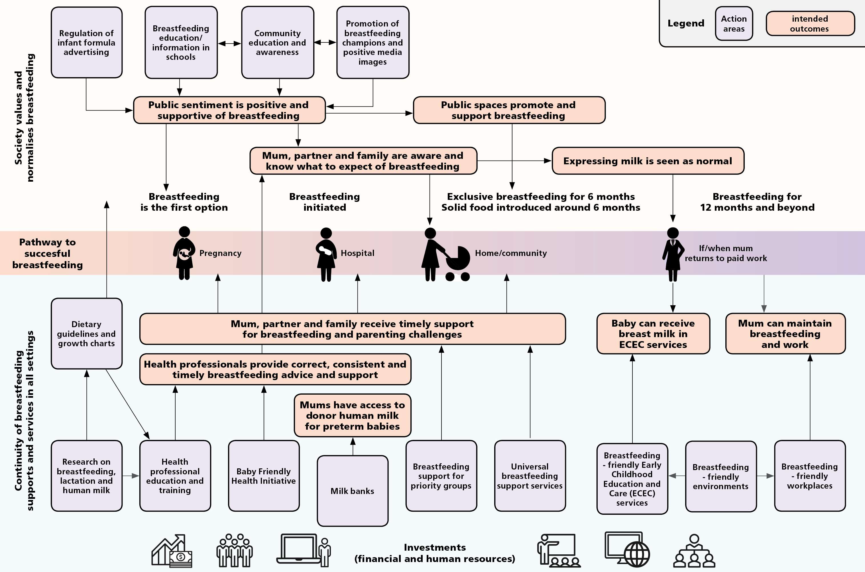

Australian National Breastfeeding Strategy: 2019 and Beyond 59 | P a g e

Key evaluation questions
The key evaluation questions reflect important areas of inquiry over the life of the enduring Strategy. These questions are indicative; some or all of them may be the focus of specific evaluations, and new or revised questions may be defined at the time of an evaluation.

Quality—How well is the Strategy being delivered?

To what extent is the Strategy being implemented as intended?

What are mothers’ experiences of, and how satisfied are they with, breastfeeding initiatives?

Effectiveness—Is the Strategy making a difference?

To what extent are the Strategy and initiatives actively supporting mothers to breastfeed at all stages of the breastfeeding continuum?

To what extent are the Strategy and initiatives supporting mothers’ aspirations and decisions to breastfeed? What are the enabling factors and barriers for mothers?

To what extent are systemic and structural changes improving the enabling environment for optimal breastfeeding?

Are there any unintended outcomes (positive and negative)?

Appropriateness—Is the Strategy addressing the need?

How well integrated are the Strategy and its initiatives with the needs of mothers and babies and with other related strategies (such as the National Strategic Approach to Maternity Services) and policies (such as the PPL scheme)?

Is there equitable access to breastfeeding initiatives and outcomes for all mothers, including populations with specific risk factors or aspects of disadvantage?

Does the Strategy continue to reflect best-practice global standards and approaches?

Efficiency—Does the Strategy make best use of available resources?

How cost-effective are the different initiatives under the Strategy and how are its economic costs and benefits distributed between sectors and between social groups?

To what extent is the Strategy relying on resourcing by mothers and other caregivers of infants and young children and by those supporting them?

Table 4: Key evaluation success criteria and data sources

Evaluation question | Key success criteria | Indicative data sources
To what extent is the Strategy | Actual achievement of planned | Initiative and strategy
being implemented as intended? | implementation | monitoring reports
 | Wide reach and coverage of | Routine data analysis
 | initiatives | and qualitative data collection
What are mothers’ experiences of, | Initiatives are high-quality | Experience/satisfaction
and how satisfied are they with, | Mothers report high | surveys
breastfeeding initiatives? | satisfaction levels and positive
 | experiences

To what extent are the Strategy and initiatives actively supporting mothers to breastfeed at all stages of the breastfeeding continuum?

To what extent are the Strategy and initiatives supporting mothers’ aspirations and decisions to breastfeed? What are the enabling factors and barriers for mothers?

To what extent are systemic and structural changes improving the enabling environment for optimal breastfeeding?

Are there any unintended outcomes (positive and negative)?
Positive breastfeeding trends
Negative trends in milk formula volume sales
Improved continuity of care across the breastfeeding continuum
More breastfeeding-friendly work, childcare and community settings
Positive public sentiment towards breastfeeding
Reduced gap between mothers’ intentions and decisions to breastfeed
Routine data collection Surveys

Experience/satisfaction surveys

Surveys

Experience/satisfaction surveys

How well integrated are the Strategy and its initiatives with the needs of mothers and babies and with other related strategies?
Maternal and child health and/or other related policies (Paid Parental Leave, Early Education and Care Quality) aim for common outcomes/objectives and outline similar actions or initiatives
Review of government policies and strategies
Is there equitable access to breastfeeding initiatives and outcomes for all mothers, including populations with specific risk factors or aspects of disadvantage?
Improved access to breastfeeding support and better outcomes for priority populations
Experience/satisfaction surveys
Routine data collection
Does the Strategy continue to reflect best-practice global standards and approaches?
Alignment with WHO guidelines and other international authorities on breastfeeding
Periodic reviews of the Strategy

Evaluation question  How cost-effective are the different | Key success criteria  Resources are focused on | Indicative data sources  Cost-effectiveness
initiatives under the Strategy? | interventions that improve | analysis
breastfeeding outcomes
To what extent is the Strategy | Initiatives support mothers’ | Experience/satisfaction
relying on resourcing by mothers | and other caregivers’ ability to | surveys
and other caregivers of infants and | work while caring for their
young children and by those  supporting them? | family

Evaluation questions for each priority and action area
The following are indicative evaluation questions for each of the priority and action areas. They may be modified or amended at the time of an evaluation.

Priority 1: Structural enablers

Table 5: Evaluation questions for Priority 1

Action area | Evaluation questions
 | Short term | Medium term | Long term
Action Area 1.1—  Community | To what extent have the community education and awareness | To what extent has the Strategy increased positive | To what extent has the Strategy increased the proportion of infants and
education and | campaigns increased | attitudes towards | young children:
awareness | knowledge and | breastfeeding | - who received any
 | awareness of | women? | breastmilk?
 | breastfeeding as the
 | normal way to feed infants and young children? | the community education and awareness | breastfed at 0–6 months?  - who receive

campaigns improved the balance of media coverage regarding breastfeeding?
To what extent have the community education programs influenced young people’s attitudes to breastfeeding?
To what extent are community and public spaces enabling/supportive of breastfeeding?
complementary foods from around 6 months and continue breastfeeding until 12 months and beyond for as long as the mother and child desire?

Action Area | To what extent has the | To what extent has | To what extent has the
1.2—Prevent | Strategy increased | the awareness | strengthening of the
inappropriate | public awareness of the | campaign on the | regulation of

Action area Evaluation questions
Short term Medium term Long term
MAIF Agreement inappropriate marketing
increased the led to cessation of
reporting of inappropriate advertising
inappropriate and promotion of infant advertising and and toddler formula and promotion of other breastmilk
formula? substitutes?

Action Area 1.3—Policy coordination, monitoring, research and evaluation
reporting breaches?
commitment to
increased public
MAIF Agreement and
substitutes
breastmilk
marketing of
To what extent has national policy coordination promoted collaboration between key stakeholders in the Commonwealth, state and territory and local governments and non- government organisations?
To what extent has national policy coordination contributed to national data collection and monitoring activities?
professional
ASCIA, health
(NHMRC, FSANZ,
stakeholders
enabled key
the Strategy
To what extent has
public?
professionals and the
awareness among health
knowledge and
growth charts increased
updated guidelines and
To what extent have the
To what extent has national policy coordination contributed to shared responsibility for the protection, promotion and support of breastfeeding between Australian Government agencies, state and territory governments and the non- government sector?
To what extent has national policy coordination, monitoring, research and evaluation increased commitment to continue funding breastfeeding protection, promotion and support activities?

growth charts
guidelines and
1.4—Dietary
Action Area

Priority 2: Settings that enable breastfeeding
foods?
complementary
introduction of
messages on the
provide consistent
associations) to

Table 6: Evaluation questions for Priority 2

Action area | Evaluation questions  Short term | Medium term Long term
Action Area 2.1— | To what extent has | To what extent has
Baby Friendly | the Strategy increased | the inclusion of the
Health Initiative | the number of baby- | BFHI in national
 | friendly health | accreditation
 | facilities? | increased the number

Action area | Evaluation questions  Short term | Medium term | Long term
 |  | of baby-friendly
 |  | health facilities?
Action Area 2.2— | To what extent have | To what extent do | To what extent are
Health | health professionals | health professionals | mothers,
professionals’ | increased their | provide evidence- | fathers/partners and
education and | knowledge and skills? | based, consistent and | families actively
training |  | timely breastfeeding | supported in all settings
 |  | advice and support | at all stages of the
 |  | across all stages of | breastfeeding
 |  | the continuum? | continuum?
Action Area 2.3— | To what extent are | To what extent do | To what extent do
Breastfeeding- | stakeholders engaged | employers implement | mothers and
friendly | in providing | breastfeeding | fathers/partners access
environments | breastfeeding-friendly | policies, lactation | increased opportunities
 | workplaces and early | breaks and | for breastfeeding-
 | childhood education | breastfeeding spaces | friendly workplaces and
 | and care settings? | for women returning | early childhood
 |  | to work? | education and care
 |  |  | services?

Priority 3: Individual enablers
banks?
expansion of milk
contributed to the
the Strategy
To what extent has
human milk banking?
for human milk and
regulatory framework
national ethics and
the development of a
the Strategy enabled
To what extent has
Milk banks
Action Area 2.4—

Table 7: Evaluation questions for Priority 3

Action area  Action Area 3.1— Universal breastfeeding | Evaluation questions Short term  To what extent has the Strategy increased funding and | Medium term Long term  To what extent are To what extent are mothers and their mothers’ infant and families aware of young child feeding
education, support and information | implementation of universal breastfeeding support | breastfeeding decisions respected by  benefits and families, health  practices and professionals, peer
services | services?  To what extent has the Strategy supported breastfeeding | associated supporters, workplaces  challenges? and early childhood To what extent do education and care  mothers and their settings?
 | education for a mother’s primary support network, | families have To what extent do realistic expectations mothers receive home about support and share
 | including fathers/partners and grandmothers? | breastfeeding? parental responsibility  for child-rearing and

Action area
Evaluation questions
Short term Medium term
Long term
infant and young child feeding?

Action Area 3.2— | To what extent has the | To what extent
Breastfeeding support for priority groups | Strategy increased funding for and implementation of breastfeeding education and support services for priority groups? | are mothers, fathers/partners and families aware of breastfeeding benefits, practices and associated challenges?
 | To what extent are the | To what extent are
 | services culturally  secure and responsive to the needs of | mothers,  fathers/partners and families aware of risk
 | Aboriginal and Torres Strait Islander people and culturally and linguistically diverse groups? | factors and behaviours that affect breastfeeding?
 | To what extent do the
 | services raise
 | awareness of the risk
 | factors and behaviours
 | that affect
 | breastfeeding?
 | To what extent do the
services provided in NICUs or special care nurseries encourage
mothers and babies to
 | be together?

Evaluation data sources
Changes in breastfeeding practices will be analysed drawing on a number of existing data sources:
- A national reporting system
  - National Perinatal Data Collection
  - Antenatal Health Record
  - National Health Survey
  - Australian National Infant Feeding Survey
  - National Aboriginal and Torres Strait Islander Social Survey
  - Child Digital Health Record
- National longitudinal studies
  - Longitudinal Study of Australian Children
  - Australian Longitudinal Study on Women’s Health
- State and territory data collections
  - State and territory based surveys
  - State and territory based administrative data collections

- Experience/ satisfaction surveys
- Milk formula product sales.

Establishing an initial baseline
It is proposed that a baseline evaluation be conducted in 2019–20. In addition to the World Breastfeeding Trends Initiative report, an estimate of national baselines/benchmarks could use data from the National Perinatal Data Collection, the 2010 National Infant Feeding Survey, the 2014–15 National Health Survey and the 2014–15 National Aboriginal and Torres Strait Islander Social Survey.

Conducting planned evaluations
It is proposed that scheduled evaluations be conducted at five-year intervals (Table 8).

Table 8: Evaluation schedule

Type of evaluation  Baseline evaluation | Timing  July 2019 – June 2020 | Internal/extern  External | al Budget/resources (if external)  TBA
Formative and summative evaluation | July 2024 – June 2025 | External | TBA
Summative evaluation | July 2029 – June 2030 | External | TBA

Ethical considerations
Each planned evaluation will need to address ethical considerations in accordance with the National Statement on Ethical Conduct in Human Research. If an evaluation involves the collection and analysis of individuals’ data, the risk of harm to participants and how it will be managed must be ascertained. Should ethics approval be required, the evaluation must be approved by an NHMRC-registered Human Research Ethics Committee.

Use and dissemination

Use of data and findings
The data and findings will be used for continuous quality improvement and to contribute to the evidence base. Public reporting of the data and findings is also crucial for engaging public support and interest, ensuring accountability and driving progress.

Reporting requirements

Table 9: Requirements for each reporting component

Report Content Timing Responsibility Recipients
National | Indicators of | Annual | Assistant | AHMAC/CHC
Breastfeeding Report Card | breastfeeding practices, |  | Secretary, Preventive Health | Public
 | structural policies |  | Policy Branch,
 | and settings that |  | Department of
 | enable |  | Health
 | breastfeeding, and
 | individual enablers

Report  Strategy Annual Monitoring Report | Content  Reports on implementation status of actions in each priority area | Timing  Annual | Responsibility  Assistant Secretary, Preventive Health Policy Branch, Department of Health | Recipients  AHMAC/CHC  Public
Baseline evaluation report | Baseline evaluation | Due 30 June  2020 | Assistant Secretary, Preventive Health Policy Branch, Department of Health | AHMAC/CHC  Public
Formative and  summative evaluations | Formative and  summative evaluation | Due 30 June  2025 | Assistant  Secretary, Preventive Health | AHMAC/CHC  Public
 |  |  | Policy Branch, Department of Health
Summative evaluation | Summative Evaluation | Due 30 June  2030 | Assistant  Secretary, Preventive Health | AHMAC/CHC  Public
 |  |  | Policy Branch, Department of Health

Evaluation findings and reports will be communicated to stakeholders and interested parties through the Australian Government Department of Health website.

ACHIEVING PROGRESS

Next steps
To ensure the effectiveness of the Strategy in fulfilling its objectives, the following actions are proposed:
- Establish a national breastfeeding advisory committee to facilitate policy coordination, to engage community and health professional partners, and to drive implementation, monitoring and evaluation of the Strategy.
- Conduct a five-yearly evaluation to assess progress made in each of the priority areas.
- Report annually on implementation progress to the AHMAC and release these reports to the public.

Measures of success
In the next five to 10 years, we expect to see:
- reliable national data on infant and young child feeding practices in Australia
- a change in community attitudes to breastfeeding—that breastfeeding is normal and supported in Australia
- more breastfeeding-friendly public spaces, workplaces and early childhood education and care services
- more health professionals providing evidence-based clinical care, advice and support to mothers
- more maternity hospitals and community health services accredited under the BFHI
- less inappropriate marketing of milk formula
- smaller markets for each milk formula product category in Australia
- more research into breastfeeding, lactation and human milk
- mothers feeling more confident about breastfeeding and supported throughout their breastfeeding journeys.

APPENDIX A RELATED POLICY AND

STRATEGY DOCUMENTS

The following list indicates some of the key documents that inform the Strategy and to which it refers:
- WHO/UNICEF Global Strategy for Infant and Young Child Feeding
- WHO Global Action Plan for the Prevention and Control of Noncommunicable Diseases 2013– 2020
- WHO International Code of Marketing of Breast-milk Substitutes
- WHO/UNICEF Baby Friendly Hospital Initiative
- Convention on the Rights of the Child
- Convention on the Elimination of All Forms of Discrimination Against Women
- Healthy, Safe and Thriving: National Strategic Framework for Child and Youth Health (2015)
- National Aboriginal and Torres Strait Islander Health Plan 2013–2023
- Cultural Respect Framework for Aboriginal and Torres Strait Islander Health 2016–2026
- National Framework for Health Services for Aboriginal and Torres Strait Islander Children and Families (2016)
- National Framework for Universal Child and Family Health Services (2011)
- National Plan to Reduce Violence against Women and their Children 2010–2022
- National Plan to Reduce Violence against Women and their Children: Third Action Plan 2016– 2019
- National Women’s Health Policy 2010–2030
- National Strategic Approach to Maternity Services (under development)
- NHMRC Infant Feeding Guidelines 2012: Information for Health Workers
- Eat for Health: Australian Dietary Guidelines
- State and territory breastfeeding strategies, policies and frameworks

APPENDIX B NATIONAL

BREASTFEEDING REPORT CARD

Criterion Measure  INFANT FEEDING PRACTICES |  | Annual target
Mothers initiating breastfeeding | Proportion of babies put to the breast within 1 hour of birth | Maintain above 95%
Children who are predominantly breastfed | Proportion of children aged 0–12 months who receive breastfeeds as the predominant source of nourishment (includes expressed breastmilk, wet- nursing and donor human milk) | Increase by x%
Children who are exclusively breastfed | Proportion of children aged 0–6 months who are fed only mother’s own expressed breastmilk, wet- nursing and donor human milk | Increase by x%
Babies starting complementary feeding at the optimal time | Proportion of children who receive nutrients containing first foods at around 6 months while breastfeeding is maintained | Increase by x%
Use of infant formula | Average sales volumes on milk formula per baby per year | Decrease by x%
AN ENABLING ENVIRONMENT
1. STRUCTURAL ENABLERS
1.1 Community education and awareness | Proportion of the community reporting positive attitudes towards breastfeeding | Increase by x%
1.2 Restriction of advertising and promotion of breastmilk substitutes | Increased public awareness of the MAIF Agreement and increased commitment to reporting breaches  Number of breaches of the MAIF Agreement MAIF Agreement complies with the WHO  International Code of Marketing of Breast-milk Substitutes  WHO monitoring frameworks applied in Australia | Increase by x%  Decrease by x%  Standards fully met  Reducing trend in WHO Code marketing breaches
1.3 Policy coordination, | Partnership and collaboration with stakeholders is | Standards fully
monitoring and research | undertaken through a national breastfeeding advisory committee  All jurisdictions collect nationally agreed breastfeeding indicators | met

Criterion Measure |  | Annual  target
All governments commit funding for the implementation, monitoring and evaluation of the Strategy
The Strategy is evaluated every 5 years and a report on progress is provided annually to AHMAC
1.4 Dietary guidelines and growth charts | National infant feeding policies and guidelines meet WHO standards | Standards fully met
2. SETTINGS THAT ENABLE BREASTFEEDING
2.1 Baby-friendly maternity hospitals and community health services | Proportion of hospitals and community health services accredited under the BFHI | Increase by x%
2.2 Health professional education and training | A breastfeeding education/training package for health professionals is rolled out nationally by 2023 | Time frame met
2.3 Breastfeeding-friendly environments | National workplace legislation and regulations meet or exceed International Labor Organization standards for protecting and supporting breastfeeding  Proportion of workplaces that are accredited as a Breastfeeding Friendly Workplace  Proportion of early childhood education and care services that have breastfeeding policies | Standards fully met  Increase by x% Increase by x%
2.4 Milk banks | A national regulatory framework for milk banks is established | Standards fully met
3. INDIVIDUAL ENABLERS
3.1 Universal breastfeeding education, information and support services | Proportion of mothers who have received 7 or more antenatal care visits  Proportion of mothers who have received support to establish breastfeeding  Proportion of mothers who have received breastfeeding support in the postnatal period  Proportion of fathers/partners who support breastfeeding | Increase by x% Increase by x% Increase by x%  Increase by x%
3.2 Breastfeeding support | Proportion of infants breastfed after caesarean | Increase by x%
for priority groups | section  Proportion of infants breastfed after preterm birth  Proportion of infants breastfed after traumatic birth  Proportion of Aboriginal and Torres Strait Islander babies who are breastfed to optimal levels  Proportion of babies from culturally and linguistically diverse groups who are breastfed to optimal levels  Proportion of babies born to women aged under 20 years who are breastfed to optimal levels | Increase by x% Increase by x% Increase by x%  Increase by x% Increase by x%

APPENDIX C NATIONAL

BREASTFEEDING STRATEGY ANNUAL MONITORING REPORT TEMPLATE

Priority area:
Action area:
Funding committed |  | Key activities
Funders | $ | Activity | Partner resources (non-  $) | Reach (coverage and recipients)
Key outputs
Progress on key indicators
Implementation issues and risks
Action planned for next 12 months
Overall progress rating
None | Little | Fair | Good | Very good

APPENDIX D BREASTFEEDING DATA COLLECTED, BY JURISDICTION— SNAPSHOT OF CURRENT INDICATORS

2011 AIHW workshop | National health sur |  | veys |  | State based data collection |  |  | Qld Point in time infant feeding  surveys
indicators | Australian Natio National Health  Infant Survey  Feeding 2011  survey 2010 |  | nal 12 | National Health Survey 2014 15 | ACT NSW  Regular Regular monitoring monitoring |  | NT  Collected but not reported |  | SA  Regular monitoring | Tas Regular monitoring | Vic Regular monitoring | WA  Regular monitoring
Proportion of children ever breastfed | ✓ | ✓ |  | ✓ | ✓ | ✓ |  | ✓ | ✓ | ✓ | ✓ | ✓
Proportion of children breastfed at each month of age, 0–24 months | - 4 months 6 months 9 months  12  months  24  months |  |  | 6 months  12  months  24  months | Discharge  Each month to 6 months  12 months | Discharge— overall rates per year |  | Each month to 6 months |  | Discharge 2 months2  4 months | Discharge 2 weeks  3 months  6 months | Discharge 0–14 days  8 weeks  4 months
 |  |  |  |  |  |  |  |  |  |  |  | 12 months
 |  |  |  |  |  |  |  |  |  |  |  | 24 months
Proportion of children exclusively breastfed to each month of age, 0–6 months | - 2 months 4 months 6 months |  |  | 2 months  4 months  6 months | Discharge  Each month to 6 months | Discharge— overall rates per year |  | ✓ |  | 4 months3 | Discharge 2 weeks  3 months  6 months | Discharge 0–14 days  8 weeks  4 months

2 Data limitation: State-based, administrative, non-representative data based on the proportion of infants who attend scheduled child health visits. The four-month data is collected retrospectively, relying on maternal recall, at the six-month scheduled child health visit.
3 Data limitation: State-based, administrative, non-representative data based on the proportion of infants who attend scheduled child health visits. The four-month data is collected retrospectively, relying on maternal recall, at the six-month scheduled child health visit.

2011 AIHW workshop indicators | National health surveys  Australian National National Health  Infant Survey  Feeding 2011 12 survey  2010 | National Health Survey 2014 15 | State based data collection  ACT NSW  Regular Regular monitoring monitoring | NT  Collected but not reported | Qld Point in time infant  feeding surveys | SA  Regular monitoring | Tas Regular monitoring | Vic Regular monitoring | WA  Regular monitoring
Proportion of children predominantly breastfed to each month of age, 0–6 months | ✓ |  |  |  | Each month to 6 months |  |  |  | Discharge 0–14 days  8 weeks  4 months
Proportion of children receiving soft/semi-solid/solid food at each month  of age, 0–12 months | - 4 months 6 months | 4 months  6 months |  |  | Each month to 6 months |  |  |  | Each month to 4 years
Proportion of children receiving non-human milk or  formula at each | ✓ |  | Discharge— overall rates per year |  | Each month to 6 months |  |  |  | Each month, to 4 years
month of age, 0–12
months

Sources
National Health Survey 2011–12: http://www.abs.gov.au/ausstats/abs@.nsf/Lookup/6664B939E49FD9C1CA257B39000F2E4B
National Health Survey 2014–15: http://www.abs.gov.au/ausstats/abs@.nsf/Lookup/by%20Subject/4364.0.55.002~2014-15~Main%20Features~Breastfeeding~10000
Australian National Infant Feeding Survey 2010: https://www.aihw.gov.au/about-our-data/our-data-collections/australian-national-infant-feeding-survey-2010
ACT: https://www.children.act.gov.au/indicators/breastfeeding
Vic: https://www.data.vic.gov.au/data/dataset/vcams-breastfeeding-rates
NSW: http://www.healthstats.nsw.gov.au/Indicator/mab_feed_cat/mab_feed_cat_lhd_trend

Qld: https://www.health.qld.gov.au/ data/assets/pdf_file/0033/465099/qld-infant-feeding-2014survey.pdf
WA: http://ww2.health.wa.gov.au/~/media/Files/Corporate/Reports%20and%20publications/Population%20surveys/Health-and-Wellbeing-of-Children-in-Western- Australia-2016-Overview-and-Trends.pdf
Tas: http://www.breastfeedingtas.org/breastfeeding_rates

APPENDIX E PROPOSED LIST OF

INDICATORS—LONG- TERM OUTCOMES
Outputs/outcomes | Measures/indicators | Data sources/methods | When/how reported | Responsible person/s (data collection)
Increased proportion of mothers who intend to breastfeed | Mother’s intention to breastfeed | National Perinatal Data Collection | Collected at birth | Midwives / other staff
Increased proportion of children who were ever breastfed | Ever received breastmilk  Currently receiving breastmilk  Not currently receiving breastmilk  Never received breastmilk  Age when child stopped receiving any breastmilk | National Health Survey | Every 3 years  Reports on children aged 0–24 months | Australian Bureau of Statistics
Increased proportion of children who are exclusively breastfed | Children aged 0–6 months who are fed only breastmilk  Children aged 0–6 months who are fed only breastmilk | Child Digital Health Record  Australian National Infant Feeding Survey | When infants present for child health checks and/or receive vaccinations at 2, 4, 6, 12  and 18 months of age  Every 5 years | Maternal, child and family health nurses and clinics  Australian Institute of Health and Welfare
Proportion of children receiving non-human milk or formula | Children aged 0–24 months who receive non-human milk or formula | Child Digital Health Record | When infants present for child health checks and/or receive vaccinations at 2, 4, 6, 12  and 18 | Maternal, child and family health nurses and clinics

Outputs/outcomes | Measures/indicators | Data sources/methods | When/how reported | Responsible person/s (data collection)
months of age
Babies receive solid foods from 6 months | Age at which child first ate soft, semi- solid or solid food (4 months or less, more than 4 months to 6 months etc.) | National Health Survey | Every 3 years  Reports on children aged 0–24 months | Australian Bureau of Statistics

REFERENCES

1 Center on the Developing Child (2010). The Foundations of Lifelong Health are Built in Early Childhood. Retrieved from https://developingchild.harvard.edu/resources/the- foundations-of-lifelong-health-are-built-in-early-childhood/
2 Moore TG, Arefadib N, Deery A & West S (2017). The First Thousand Days: An Evidence Paper. Parkville, Victoria: Centre for Community Child Health, Murdoch Children’s Research Institute.
3 Stephenson J, Heslehurst N, Hall J, Schoenaker DAJM, Hutchinson J, Cade JE, et al. (2018). Before the beginning: nutrition and lifestyle in the preconception period and its importance for future health. The Lancet. 391(10132):1830–41.
4 Fleming TP, Watkins AJ, Velazquez MA, Mathers JC, Prentice AM, Stephenson J, et al. (2018). Origins of lifetime health around the time of conception: causes and consequences. The Lancet. 391(10132):1842–52.
5 Barker M, Dombrowski SU, Colbourn T, Fall CHD, Kriznik NM, Lawrence WT, et al. (2018).
Intervention strategies to improve nutrition and health behaviours before conception. The Lancet. 391(10132):1853–64.
6 Brands B, Demmelmair H & Koletzko B (2014). How growth due to infant nutrition influences obesity and later disease risk. Acta Paediatrica. 103(6):578–85. Cited in Moore et al. 2017, The First Thousand Days: An Evidence Paper.
7 Weng SF, Redsell SA, Swift JA, Yang M & Glazebrook CP (2012). Systematic review and meta- analyses of risk factors for childhood overweight identifiable during infancy. Archives of Disease in Childhood. 97(12):1019–26. Cited in Moore et al. 2017, The First Thousand Days: An Evidence Paper.
8 US Department of Health and Human Services (2011). Executive Summary: The Surgeon General’s Call to Action to Support Breastfeeding. Retrieved from https://www.surgeongeneral.gov/library/calls/breastfeeding/executivesummary.pdf

9 Brown A (2018). Sociological and Cultural Influences upon Breastfeeding. In Family Larsson- Rosenquist Foundation (2018). Breastfeeding and Breast Milk—From Biochemistry to Impact: A Multidisciplinary Introduction. Stuttgart: Georg Thieme Verlag.
10 Brown A (2016). What do women really want? Lessons for breastfeeding promotion and education. Breastfeeding Medicine. 11(3):102–110. https://doi.org/10.1089/bfm.2015.0175
11 House of Representatives Standing Committee on Health and Ageing (2008). The Best Start: Report on the Inquiry into the Health Benefits of Breastfeeding. Retrieved from https://www.aph.gov.au/Parliamentary_Business/Committees/House_of_Representati ves_Committees?url=haa/breastfeeding/report.htm

12 Commonwealth of Australia on behalf of the Australian Health Ministers’ Conference (2009).
Australian National Breastfeeding Strategy 2010–2015. Retrieved from https://www.health.gov.au/internet/main/publishing.nsf/Content/6FD59347DD67ED 8FCA257BF0001CFD1E/$File/Breastfeeding_strat1015.pdf
13 Commonwealth of Australia on behalf of the Australian Health Ministers’ Conference (2010). 2010 Implementation plan for the Australian National Breastfeeding Strategy 2010– 2015. Retrieved from http://www.health.gov.au/internet/main/publishing.nsf/Content/D94D40B034E00B2 9CA257BF0001CAB31/$File/2010%20Implementation%20Plan%20for%20the%20Aus tralian%20National%20Breastfeeding%20Strategy%202010-2015.pdf

14 Commonwealth of Australia on behalf of the Australian Health Ministers’ Conference (2016).
Australian National Breastfeeding Strategy 2010–2015: Final Progress Report. Retrieved from

http://www.health.gov.au/internet/main/publishing.nsf/Content/D94D40B034E00B2 9CA257BF0001CAB31/$File/ANBS-2010-2015-Final-Progress-Report%20.pdf
15 World Health Organization & UNICEF (2014). Global Nutrition Targets 2025: Breastfeeding Policy Brief. Retrieved from http://apps.who.int/iris/bitstream/handle/10665/149022/WHO_NMH_NHD_14.7_eng

.pdf?ua=1
16 World Health Organization & UNICEF (2003). Global Strategy for Infant and Young Child Feeding. Retrieved from http://apps.who.int/iris/bitstream/handle/10665/42590/9241562218.pdf?sequence= 1
17 World Health Organization (2013). Global Action Plan for the Prevention and Control of Noncommunicable Diseases: 2013–2020. Retrieved from http://apps.who.int/iris/bitstream/handle/10665/94384/9789241506236_eng.pdf;jses sionid=8E3F6EFBD7DE807BB84E40D201F8EB0E?sequence=1

18 World Health Organization (2008). Indicators for Assessing Infant and Young Child Practices.
Retrieved from http://www.who.int/maternal_child_adolescent/documents/9789241596664/en/
19 World Health Organization & UNICEF (2018). Implementation Guidance: Protecting, Promoting and Supporting Breastfeeding in Facilities Providing Maternity and Newborn Services: The Revised Baby-Friendly Hospital Initiative. Retrieved from http://apps.who.int/iris/bitstream/handle/10665/272943/9789241513807- eng.pdf?ua=1
20 World Health Organization (2018). Ten Steps to Successful Breastfeeding. Retrieved from http://www.who.int/nutrition/bfhi/bfhi-poster-A2.pdf?ua=1
21 World Health Organization (2017). The International Code of Marketing of Breast-milk Substitutes: Frequently Asked Questions. Retrieved from http://www.who.int/nutrition/publications/infantfeeding/breast milk-substitutes- FAQ2017/en/
22 United Nations (2015). Sustainable Development Goals. Retrieved from https://www.un.org/sustainabledevelopment/sustainable-development-goals/
23 United Nations (1989). Convention on the Rights of the Child. Retrieved from https://www.ohchr.org/EN/ProfessionalInterest/Pages/CRC.aspx
24 United Nations (1979). Convention on the Elimination of All Forms of Discrimination Against Women. Retrieved from http://www.un.org/womenwatch/daw/cedaw/text/econvention.htm
25 United Nations (2016). Joint Statement by the UN Special Rapporteurs on the Right to Food, Right to Health, the Working Group on Discrimination Against Women in Law and in Practice, and the Committee on the Rights of the Child in Support of Increased Efforts to Promote, Support and Protect Breast-feeding. Retrieved from https://www.ohchr.org/en/NewsEvents/Pages/DisplayNews.aspx?NewsID=20871&La ngID=E
26 COAG Health Council (2015). Healthy, Safe and Thriving: National Strategic Framework for Child and Youth Health. Retrieved from http://www.coaghealthcouncil.gov.au/Portals/0/Healthy%20Safe%20and%20Thriving

%20-
%20National%20Strategic%20Framework%20for%20Child%20and%20Youth%20Hea lth.pdf
27 National Health and Medical Research Council (2012). Infant Feeding Guidelines: Information for Health Workers. Retrieved from https://nhmrc.gov.au/about- us/publications/infant-feeding-guidelines-information-health-workers#block-views- block-file-attachments-content-block-1

28 National Health and Medical Research Council (2013). Eat for Health: Australian Dietary Guidelines. Retrieved from https://www.eatforhealth.gov.au/guidelines/australian- dietary-guidelines-1-5
29 Australian Human Rights Commission. Know your rights: Sex discrimination and sexual harassment. Retrieved on 21 November 2018 from https://www.humanrights.gov.au/our-work/sex-discrimination/publications/know- your-rights-sex-discrimination-and-sexual-harassment
30 International Labor Organization. Up-to-date Conventions and Protocols not ratified by Australia. Retrieved on 20 November 2018 from https://www.ilo.org/dyn/normlex/en/f?p=1000:11210:0::NO:11210:P11210_COUNTR Y_ID:102544)
31 Fair Work Ombudsman. Returning to Work from Parental Leave: Breastfeeding in the Workplace. Retrieved on 20 November 2018 from https://www.fairwork.gov.au/leave/maternity-and-parental-leave/returning-to-work- from-parental-leave
32 Fair Work Ombudsman. Best Practice Guide: Parental Leave. Retrieved on 22 November 2018 from https://www.fairwork.gov.au/how-we-will-help/templates-and- guides/best-practice-guides/parental-leave
33 Fair Work Ombudsman. Maternity and Paternity Leave. Retrieved on 20 November 2018 from https://www.fairwork.gov.au/leave/maternity-and-parental-leave

34 Chapter 2, Part 2-2, Division 5, Fair Work Act 2009 (Commonwealth).
35 Australian Children’s Education & Care Quality Authority (2018). Guide to the National Quality Framework. Sydney: ACECQA. Retrieved on 21 November 2018 from https://www.acecqa.gov.au/sites/default/files/2018-11/Guide-to-the-NQF_0.pdf
36 International Baby Food Action Network (2018). The Guide Book: World Breastfeeding Trends Initiative (WBTi)—Galvanising Action on Breastfeeding and Infant and Young Child Feeding (IYCF). Retrieved from http://worldbreastfeedingtrends.org/uploads/WBTi- Guide-book-2018.pdf

37 World Breastfeeding Trends Initiative (2017). About World Breastfeeding Trends Initiative.
Retrieved from http://worldbreastfeedingtrends.org/about/
38 World Breastfeeding Trends Initiative Australia (2018). Australia: Report Card 2018. Retrieved from https://wbtiaus.files.wordpress.com/2018/05/wbti_report_card-australia.pdf
39 Australian Institute of Health and Welfare (2011). 2010 Australian National Infant Feeding Survey: Indicator Results. Retrieved from https://www.aihw.gov.au/getmedia/af2fe025-637e-4c09-ba03- 33e69f49aba7/13632.pdf.aspx?inline=true
40 Australian Bureau of Statistics (2017). 4362.0.55.002—Health Service Usage and Health Related Actions, Australia, 2014–15—Breastfeeding. Retrieved on 13 December 2018 from http://www.abs.gov.au/ausstats/abs@.nsf/Lookup/by%20Subject/4364.0.55.002~201 4-15~Main%20Features~Breastfeeding~10000
41 Johns HM, Forster DA, Amir LH, Moorhead AM, McEgan KM & McLachlan HL (2013). Infant feeding practices in the first 24–48 hours of life in healthy term infants. Acta Paediatrica. 102:e315–e320.
42 Victora C, Bahl R, Barros AJD, Franca GVA, Horton S, Krasevec J, Murch S, Sankar MJ, Walker N & Rollins N (2016). Breastfeeding in the 21st century: epidemiology, mechanisms and lifelong effect. The Lancet. 387(10017):475–490.
43 Hansen, K (2016). Breastfeeding: a smart investment in people and in economies. The Lancet. 387(10017):416.
44 McFadden A, Gavine A, Renfrew M, Wade A, Buchanan P, Taylor JL, Veitch E, Rennie A, Crowther SA, Neiman S & MacGillirvray S (2017). Support for healthy breastfeeding

mothers with healthy term babies. The Cochrane Database of Systematic Reviews. 2(2):CD001141. https://doi.org/10.1002/14651858.CD001141.pub5
45 US Department of Health and Human Services (2011). Executive Summary: The Surgeon General’s Call to Action to Support Breastfeeding. Retrieved from https://www.surgeongeneral.gov/library/calls/breastfeeding/executivesummary.pdf

46 Alves JG, Figueiroa JN, Meneses J & Alves GV (2012). Breastfeeding protects against type 1 diabetes mellitus: A case-sibling study. Breastfeed Med. 7(1):25–8.
47 World Health Organization & UNICEF. Information Note: Clarification on the classification of follow-up formulas for children 6–36 months as breast-milk substitutes. Retrieved on 6 December 2018 from http://apps.who.int/iris/bitstream/handle/10665/275875/WHO-NMH-NHD-18.11- eng.pdf?ua=1
48 Amitay EL & Keinan-Boker L (2015). Breastfeeding and childhood leukemia incidence: A meta-analysis and systematic review. JAMA Pediatrics. 169(6):e151025–e151025.
49 Hahn-Holbrook J. The Psychological Effects of Breastfeeding. In Family Larsson-Rosenquist Foundation (2018), Breastfeeding and Breast Milk—From Biochemistry to Impact: A Multidisciplinary Introduction. Stuttgart: Georg Thieme Verlag.
50 Kennedy K, Labbok M & Van Look P (1996). Lactational amenorrhea method for family planning. International Journal of Gynecology & Obstetrics. 54(1):55–7.
51 Stuebe A (2009). The risks of not breastfeeding for mothers and infants. Reviews in Obstetrics & Gynecology. 2(4):222–231.
52 Jonas W, Nissen E, Ransjo-Arvidson AB, Wiklund I, Henriksson P & Uvnas-Moberg K (2008). Short-and Long-Term Decrease of Blood Pressure in Women During Breastfeeding. Breastfeeding Medicine. 3(2):103–109.
53 Schwarz EB, Ray RM, Stuebe AM, Allison MA, Ness RB, Freiberg MS, et al. (2009). Duration of lactation and risk factors for maternal cardiovascular disease. Obstetrics & Gynecology. 113(5):974–82.
54 Kirkegaard H, Bliddal M, Støvring H, Rasmussen KM, Gunderson EP, Køber L & Nohr EA (2018). Breastfeeding and later maternal risk of hypertension and cardiovascular disease—The role of overall and abdominal obesity. Preventive Medicine. 114:140– 148.
55 Baker JL, Gamborg M, Heitmann BL, Lissner L, Sorensen TI & Rasmussen KM (2008).
Breastfeeding reduces postpartum weight retention. American Journal of Clinical Nutrition. 88(6):1543–51.
56 Stuebe AM, Kleinman K, Gillman MW, Rifas-Shiman SL, Gunderson EP & Rich-Edwards J (2010). Duration of lactation and maternal metabolism at 3 years postpartum.
Journal of Women’s Health. 19(5):941–50.
57 Stuebe AM, Rich-Edwards JW, Willett WC, et.al. (2005). Duration of lactation and incidence of type 2 diabetes. Journal of the American Medical Association. 294(20):2601–2610.
58 Mueller N, Backacs E, Combellick J, Grigoryan Z & Dominguez-Bello M (2015). The infant microbiome development: Mom matters. Trends in Molecular Medicine. 21(2):109– 117.
59 Pannaraj P, Li F, Cerini C, et al. (2017). Association between breast milk bacterial communities and establishment and development of the infant gut microbiome. JAMA Pediatrics. 171(7):647–654.
60 Smith J, Thompson J & Ellwood D (2002). Hospital system costs of artificial infant feeding: Estimates for the Australian Capital Territory. Australian and New Zealand Journal of Public Health. 26(6):543–551. https://doi.org/10.1111/j.1467-842X.2002.tb00364.x
61 Renfrew M, Pokhrel S, Quigley M, McCormick F, Fox-Rushby J, Dodds R, Duffy S, Trueman P & Williams A (2012). Preventing Disease and Saving Resources: The Potential Contribution of Increasing Breastfeeding Rates in the UK. Retrieved from https://www.unicef.org/Preventing_disease_saving_resources.pdf

62 Bartick M & Reinhold A (2010). The burden of suboptimal breastfeeding in the United States: A pediatric cost analysis. Pediatrics. 125(5):1048–56.
63 Narvaez D & Gleason T (2013). Developmental Optimization. In Narvaez D, Panksepp J, Schore A & Gleason T (eds), Evolution, Early Experience and Human Development: From Research to Practice and Policy (pp.307–329). New York: Oxford University Press.
64 IFE Core Group (2017). Operational Guidance on Infant Feeding in Emergencies (OG-IFE) Version 3.0. Retrieved from https://www.ennonline.net/attachments/2671/Ops- G_2017_WEB.pdf

65 Australian Institute of Health and Welfare (2018). Australia’s Mothers and Babies 2016—In Brief. Canberra: Australian Institute of Health and Welfare.
66 Smith JP, Cattaneo A, Iellamo A, Javanparas S, Atchan M, Gribble K, Hartmann B, Salmon L, Tawia S, Hull N, Linkson M, Blake M & Elliott-Rudder M (2018). Review of Effective Strategies to Promote Breastfeeding: An Evidence Check Rapid Review Brokered by the Sax Institute for the Department of Health. Retrieved from https://www.saxinstitute.org.au/wp-content/uploads/Review-of-effective-strategies- to-promote-breastfeeding.pdf
67 Australian Health Ministers’ Advisory Council (2017). Aboriginal and Torres Strait Islander Health Performance Framework 2017 Report. Canberra: AHMAC.
68 Helps C & Barclay L (2015). Aboriginal women in rural Australia: A small study of infant feeding behaviour. Women and Birth. 28(2):129–136.
69 Foley W, Schubert L & Denaro T (2013). Breastfeeding experiences of Aboriginal and Torres Strait Islander mothers in an urban setting in Brisbane. Breastfeeding Review.
21(3):53–61. https://doi.org/10.7326/L14-5001-6
70 Schmied V, Olley H, Burns E, Duff M, Dennis C & Dahlen HG (2012). Contradictions and conflict: A meta-ethnographic study of migrant women’s experiences of breastfeeding in a new country. BMC Pregnancy and Childbirth. 12(163). https://doi.org/10.1186/1471-2393-12-163

71 Geddes D, Kok C, Nancarrow K, Hepworth A & Simmer K (2018). Preterm infant feeding: A mechanistic comparison between a vacuum triggered novel teat and breastfeeding. Nutrients. 10(3):376–391.
72 Brown A (2017). Breastfeeding as a public health responsibility: A review of the evidence.
Journal of Human Nutrition and Dietetics. 30(6):759–770. https://doi.org/10.1111/jhn.12496

73 Brown A. (2016). Breastfeeding Uncovered: Who Really Decides How We Feed Our Babies? UK: Pinter and Martin Ltd.
74 Rollins N, Bhandari N, Hajeeboy N, Horton S, Lutter C, Martines J, Piwoz E, Richter L & Victora C (2016). Why invest, and what it will take to improve breastfeeding practices? The Lancet. 387(10017):491–504. https://doi.org/10.1016/S0140- 6736(15)01044-2
75 Osborne D, Economus L & Sparham L (2009). Exploratory Research Regarding Infant Feeding Attitudes and Behaviours—Research Report Prepared for the Department of Health and Ageing. Retrieved from http://www.health.gov.au/internet/main/publishing.nsf/Content/92D0C902358C8ED 8CA257BF00020A910/$File/FINAL%20Infant%20Feeding%20Report%20-

%2016.06.09.pdf
76 Australian Human Rights Commission (2014). A Quick Guide to Australian Discrimination Laws. Retrieved from https://www.humanrights.gov.au/employers/good-practice- good-business-factsheets/quick-guide-australian-discrimination-laws

77 Dyson L, Renfrew M, Mcfadden A, Mccormick F, Herbert G & Thomas J (2009). Policy and public health recommendations to promote the initiation and duration of breast- feeding in developed country settings. Public Health Nutrition. 13(1):137–144.

78 Australian Government Department of Health (2017). Independent Review of the MAIF Complaints Handling Process—Review Report. Retrieved from http://www.health.gov.au/internet/main/publishing.nsf/Content/1CA4794F9F834991 CA257BF0001A8EBB/$File/Final-MAIF-Review-Report.pdf
79 Food Standards Australia and New Zealand (2017). Reviewing Standard 2.9.1—Infant Formula. Retrieved from http://www.foodstandards.gov.au/code/infant/pages/default.aspx

80 Smith J & Blake M (2013). Infant food marketing strategies undermine effective regulation of breast-milk substitutes: Trends in print advertising in Australia, 1950–2010.
Australian and New Zealand Journal of Public Health. 37(4):337–344.
81 Berry N, Jones S & Iverson D (2011). Toddler milk advertising in Australia: Infant formula advertising in disguise? Australasian Marketing Journal. 20(1):24–27. https://doi.org/10.1016/j.ausmj.2011.10.011
82 Food Standards Australia New Zealand, Proposal P274—Review of minimum age labelling of foods for infants. Retrieved from http://www.foodstandards.gov.au/code/proposals/pages/proposalp274reviewofmini mumagelabellingoffoodsforinfants/Default.aspx
83 World Health Organization—Regional Office for the Western Pacific (2013). Informal Consultation on Reducing the Harmful Impact on Children of Marketing Foods, Beverages, Tobacco and Alcohol, Manila, Philippines, 25–26 September 2013: Meeting Report. Retrieved from http://apps.who.int/iris/handle/10665/208783

84 World Health Organization (2013). When Marketing Harms Our Children: Rapid Evidence Review and Situation Analysis. Draft 9 May 2013. Geneva, Switzerland.
85 Hull N, Schubert L & Smith JP (2017). Perspectives of key stakeholders and experts in infant feeding on the implementation of the Australian National Breastfeeding Strategy 2010–2015. Breastfeeding Review. 25(1):25–34. Retrieved from https://search.informit.com.au/fullText;dn=704809215038270;res=IELHEA
86 National Health and Medical Research Council and Department of Health (2015). Aboriginal and Torres Strait Islander Guide to Healthy Eating. Retrieved from https://www.eatforhealth.gov.au/sites/default/files/content/The%20Guidelines/final_ igthe_a3_poster_-_lr.pdf
87 The Royal Children’s Hospital Melbourne. About child growth. Retrieved from https://www.rch.org.au/childgrowth/
88 Australasian Society of Clinical Immunology and Allergy (2016). ASCIA Guidelines: Infant Feeding and Allergy Prevention. Retrieved from https://www.allergy.org.au/patients/allergy-prevention/ascia-guidelines-for-infant- feeding-and-allergy-prevention
89 Department of Health (2018). Australian National Breastfeeding Strategy: 2019 and Beyond—Report on Public Consultation. Retrieved from http://www.health.gov.au/internet/main/publishing.nsf/content/D94D40B034E00B29 CA257BF0001CAB31/$File/PDF%20Final%20Report%20on%20Public%20consultatio n%20for%20the%20ANBS%20-%20October%202018.pdf

90 Cattaneo A & Guoth-Gumberger M (2008). The new WHO Child Growth Standards: Possible effects on exclusive breastfeeding in the first six months. Breastfeeding Review.
16(3):9.
91 Binns C & Lee MK (2012). Will introducing the new WHO growth reference to Australia reduce breastfeeding rates: Why not a randomised controlled trial first? Journal of Paediatrics and Child Health. 48(4):347–49. https://doi.org/10.1111/j.1440- 1754.2011.02239.x
92 Australian College of Midwives (2018). Baby Friendly Health Initiative (BFHI) Accreditation. Retrieved from https://www.midwives.org.au/baby-friendly-health-initiative-bfhi- accreditation

93 Australian College of Midwives (2013). The Global Criteria for Baby Friendly Community Health Services in Australia Booklet 1: The Standards for implementation of the 7 Point Plan for the Protection, Promotion and Support of Breastfeeding. Retrieved from https://www.midwives.org.au/sites/default/files/uploaded-content/website- content/BFHI/booklet_1_-_handbook.pdf
94 Atchan M, Davis D & Foureur M (2018). An instrumental case study examining the introduction and dissemination of the Baby Friendly Health Initiative in Australia: Participants’ perspectives. Women and Birth. 31(3):210–219. https://doi.org/10.1016/j.wombi.2017.08.130
95 Gavine A, Macgillivray S, Renfrew M, Siebelt L, Haggi H & Mcfadden A (2016). Education and training of healthcare staff in the knowledge, attitudes and skills needed to work effectively with breastfeeding women: A systematic review. International Breastfeeding Journal. 12(1): 6. https://doi.org/10.1186/s13006-016-0097-2
96 Elliott-Rudder M, Pilotto L, McIntyre E & Ramanathan S (2014). Motivational interviewing improves exclusive breastfeeding in an Australian randomised controlled trial. Acta Paediatrica. 103(1):11–16. https://doi.org/10.1111/apa.12434
97 Chai Y, Nandi A & Heymann J (2018). Does extending the duration of legislated paid maternity leave improve breastfeeding practices? Evidence from 38 low-income and middle-income countries. BMJ Global Health. 3(5):e001032. https://doi.org/10.1136/bmjgh-2018-001032

98 Martin B, Baird M, Brady M, Broadway B, Hewitt B, Kalb G, Strazdins L, Tomaszewski W, Zadoroznyj M, Baxter J, Chen R, Foley M, McVicar D, Whitehose G & Xiang N (2014). Paid Parental Leave Evaluation: Final Report. Brisbane: Institute for Social Science Research.
99 Commonwealth of Australia (2014). Donor human milk banking in Australia—Issues and Background Paper. Retrieved from http://www.health.gov.au/internet/main/Publishing.nsf/Content/D94D40B034E00B2 9CA257BF0001CAB31/$File/Donor%20Human%20Milk%20Banking%20in%20Austral ia%20paper%20(D14-1113484).pdf
100 Williams T, Nair H, Simpson J & Embleton N (2016). Use of donor human milk and maternal breastfeeding rates: A systematic review. Journal of Human Lactation. 32(2):212–220. https://doi.org/10.1177/0890334416632203

101 Arslanoglu S, Corpeleijn W, Moro G, Braegger C, Campoy C, Colomb V, et al. (2013). Donor human milk for preterm infants: Current evidence and research directions. Journal of Pediatric Gastroenterology and Nutrition. 57(4):535–542.
102 PATH (2013). Strengthening Human Milk Banking: A Global Implementation Framework.
Version 1.1. Bill and Melinda Gates Foundation Grand Challenges Initiative. Retrieved from https://path.azureedge.net/media/documents/MCHN_strengthen_hmb_frame_Jan20 16.pdf
103 De Marchis A, Israel-Ballard K, Mansen KA & Engmann C (2017). Establishing an integrated human milk banking approach to strengthen newborn care. Journal of Perinatology. 37(5):469–474. https://doi.org/10.1038/jp.2016.198

104 Department of Health (2018). Clinical Practice Guidelines: Pregnancy Care—Linking Evidence to Recommendations. Canberra: Australian Government Department of Health.
105 Svensson J (2015). Breastfeeding and You: A Handbook for Antenatal Educators, 2nd ed.
Retrieved from https://www.health.gov.au/internet/main/publishing.nsf/Content/4EC2B100DA0B10F ECA257E4C001AA99A/$File/Breastfeeding_and_You.pdf

106 MacKean C & Spragins W (2013). The Challenges of Breastfeeding in a Complex World: A Critical Review of the Qualitative Literature on Women and their Partners’/Supporters’

Perceptions about Breastfeeding. Retrieved from https://www.albertahealthservices.ca/ps-1029951-pregnancy-2012-breastfeeding- lit-review.pdf
107 Holden L, Dobson A, Byles J, Chojenta C, Dolja-Gore X, Harris M, Hockey R, Lee C, Loxton D, McLaughlin D, Mishra G, Pachana N, Reilly N & Tooth L (2013). Mental Health: Findings from the Australian Longitudinal Study on Women’s Health—Final Report Prepared for the Australian Government Department of Health and Ageing. Retrieved from https://www.alswh.org.au/images/content/pdf/major_reports/2013_major%20report

%20H.pdf
108 Brown A, Rance J & Bennett P (2015). Understanding the relationship between breastfeeding and postnatal depression: The role of pain and physical difficulties. Journal of Advanced Nursing. 72(2):273–282. https://doi.org/10.1111/jan.12832
109 Hector D, Hebden L, Innes-Hughes C & King L (2010). Update of the Evidence Base to Support the Review of the NSW Health Breastfeeding Policy (PD2006, 012): A Rapid Appraisal. Retrieved from http://sydney.edu.au/medicine/public-health/prevention- research/news/reports/BreastfeedingRev_Jan2011.pdf
110 Trickey H, Thomson G, Grant A, Sanders J, Mann M, Murphy S & Paranjothy S (2018). A realist review of one-to-one breastfeeding peer support experiments conducted in developed country settings. Maternal & Child Nutrition. https://doi.org/10.1111/mcn.12559
111 The Allen Consulting Group (2012). National Breastfeeding Helpline Evaluation: Research Report. Retrieved from http://www.health.gov.au/internet/main/publishing.nsf/content/4E45F0F7BAD58A95 CA257C1C0019C9D7/$File/Nat%20breastfeeding%20helpline%20eval%20res%20rep

.pdf
112 Negin J, Coffman J, Vizintin P & Raynes-Greenow C (2016). The influence of grandmothers on breastfeeding rates: A systematic review (Report). BMC Pregnancy and Childbirth. 16(91):91. https://doi.org/10.1186/s12884-016-0880-5
113 Maycock B, Binns C, Dhaliwal S, Tohotoa J, Hauck Y, Burns S & Howat P (2013). Education and support for fathers improves breastfeeding rates: A randomized controlled trial. Journal of Human Lactation. 29(4):484–490. https://doi.org/10.1177/0890334413484387
114 Migrant and Refugee Women’s Health Partnership (2017). Submission to Antenatal Care Guidelines Review. Retrieved from http://culturaldiversityhealth.org.au/wp- content/uploads/2017/08/Submission-to-Antenatal-Care-Guidelines-Review-June- 2017.pdf
115 Save the Children (2013). Don’t Leave Me Alone: Protecting Children in Australian Disasters and Emergencies. Retrieved from https://resourcecentre.savethechildren.net/node/8288/pdf/301013_dont_leave_me_a lone.pdf
116 Streak Gomersall J, et al. (2017). What Indigenous Australian clients value about primary health care: A systematic review of qualitative evidence. Australian and New Zealand Journal of Public Health. 41(10). https://doi.org/10.1111/1753-6405.12687
117 Sipsma H, Jones K & Cole-Lewis H (2015). Breastfeeding among adolescent mothers: A systematic review of interventions from high-income countries. Journal of Human Lactation. 31(2):221–229. https://doi.org/10.1177/0890334414561264

118 Wilkinson S, Pligt P, Gibbons K & McIntyre H (2015). Trial for reducing weight retention in new mums: A randomised controlled trial evaluating a low intensity, postpartum weight management programme. Journal of Human Nutrition and Dietetics. 28:15– 28.

119 Stevens J, Schmied V, Burns E & Dahlen H (2014). Immediate or early skin-to-skin contact after a Caesarean section: A review of the literature. Maternal & Child Nutrition. https://doi.org/10.1111/mcn.12128
120 Redshaw M, Hennegan J & Kruske S (2014). Holding the baby: Early mother–infant contact after childbirth and outcomes. Midwifery. 30(5):e177–e187. https://doi.org/10.1016/j.midw.2014.02.003
121 Kelleher C (2006). The physical challenges of early breastfeeding. Social Science & Medicine. 63(10), 2727–2738. https://doi.org/10.1016/j.socscimed.2006.06.027

122 Brodribb W (2012). Breastfeeding Management in Australia (4th ed.). East Malvern, Vic: Australian Breastfeeding Association.
123 Renfrew MJ, Craig D, Dyson L, McCormick F, Rice S, King SE, et al. (2009). Breastfeeding promotion for infants in neonatal units: A systematic review and economic analysis. Health Technology Assessment. 13(40), 1–146, iii–iv. https://doi.org/10.3310/hta13400
124 Kaya V & Aytekin A (2017). Effects of pacifier use on transition to full breastfeeding and sucking skills in preterm infants: A randomised controlled trial. Journal of Clinical Nursing. 26(13–14:2055–2063. https://doi.org/10.1111/jocn.13617
125 Gharib S, Fletcher M, Tucker R, Vohr B & Lechner BE (2018). Effect of dedicated lactation support services on breastfeeding outcomes in extremely-low-birth-weight neonates. Journal of Human Lactation. 34(4):728–736. https://doi.org/10.1177/0890334417741304
126 IFE Core Group (2007). Infant and Young Child Feeding in Emergencies: Operational Guidance for Emergency Relief Staff and Programme Managers. Oxford: IFE Core Group. Retrieved from https://www.who.int/nutrition/publications/emergencies/operational_guidance/en/
127 WHO (2010). Sixty-Third World Health Assembly—Resolutions and Decisions Annexes.
Geneva: WHO.

