# MRFF Roll of Honour members explain why they assess our grants

People who participate in Medical Research Future Fund(MRFF) grant assessments are acknowledged and celebrated in our MRFF Roll of Honour.

The contributions of this diverse group of community members ensure the MRFF supports high impact projects that can deliver real outcomes to all Australians.

## Here are their reasons for contributing:

head shot of Patsy Yates
The MRFF targets Australia’s most urgent health priorities so it is ‘an important scheme to leverage to have the biggest impact we can’, says **Patsy Yates**, Distinguished Professor at the Queensland University of Technology (QUT).

As a Registered Nurse, Patsy understands patient experience and how to improve care and deliver it efficiently. She wants to make sure ‘grants go to programs that make a difference to the health of our communities.’

Patsy sees the MRFF ‘driving better research because it creates new collaborations’ in her role as Co-Director for QUT’s Centre for Healthcare Transformation.

**John Stubbs** was diagnosed with leukaemia 19 years ago. John’s experiences as a patient led him to become a consumer advocate. He brings the consumer’s voice to assessing MRFF grants.

‘Consumers have a good understanding of what the community needs, perhaps sometimes even more so than researchers.’

In John’s view, targeted research funded by the MRFF responds to Australians’ most urgent health needs and can be translated into patient benefits more quickly.

‘Targeted funding is really good for patient outcomes.’

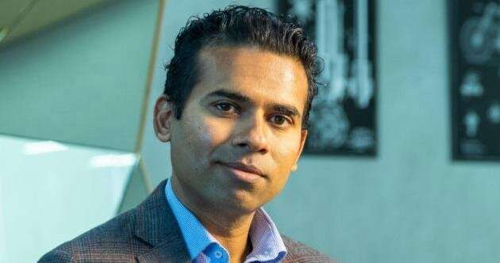**Niranjan Bidargaddi** is an expert in consulting users about the design of digital health technologies. He says including people from diverse fields and experiences in MRFF assessments increase the impact and relevance of supported projects.

‘The more we involve the community the more relevant the scheme becomes to the community and commercial developers.’ In fact, Niranjan would like MRFF panels to include even more consumers.

‘People who are at the receiving end of services know much better than providers what’s wrong with the services and products and tools that are being built’ says this Associate Professor in Digital Health at Flinders University.

**Jane Hall**, Distinguished Professor of Health Economics at the University of Technology, Sydney, is an assessor because she wants to give back to the community.

‘Those of us who benefit from receiving grants have a responsibility to undertake assessments where we can’.

Everyone involved in assessing MRFF grant applications makes a key contribution, Jane says.

‘A lot of work goes into scrutiny of the applications to ensure that the MRFF grants that are given out are going to represent value for money, contribute to what we know and improve the health system and the services that are delivered.’

Jane’s research in health economics demonstrates ‘we get terrific benefit and return on the investment in research.’

**Andrew Nash** is Chief Scientific Officer at the Australian company CSL, a global leader in biotherapies. Andrew has experience in drug discovery and development, the regulatory requirements to enable first in-human clinical trials and creating high-quality manufacturing that delivers a consistent product. He also understands his market.

‘I can bring insights into where the gaps in patient care are and the best path forward to help an early-stage discovery benefit the community and the people who supported it in the first place.’

As an assessor, Andrew wants to make sure ‘you've got the right people together in the right room addressing the right problem with the right technologies to deliver those outcomes.’

**Roy Goldie** likes ‘the collegial interactions’ and ‘full and open discussion’ between assessors. Such engagement is ‘very positive and rewarding’ for this Emeritus Professor from Flinders University.

Roy’s lifelong experience as a medical researcher in respiratory pharmacology equips him to assess proposed innovations in medical research.

If you would like to participate in MRFF grant assessments, register your interest on the [NHMRC website](https://www.nhmrc.gov.au/2020-21-medical-research-future-fund-mrff-grant-opportunities).

View the [MRFF Roll of Honour](https://www.health.gov.au/resources/publications/medical-research-future-fund-roll-of-honour).