Medical Research Future Fund
Webinar 21 July 2021
Dr Masha Somi
Chief Executive Officer
Health and Medical Research Office

# Today’s presentation

About the MRFF

How is the MRFF different?

Things to look out for as a researcher

MRFF Financial Assistance Report

Other information + stay connected

# About the MRFF

* Established under legislation (MRFF Act 2015)
* Object is to ‘improve the health and wellbeing of Australians’
* $20 billion endowment fund
* Funding is to support **medical research and medical innovation**
* Two complementary Government streams for health and medical research in Australia
  + MRFF- awards funding for **national priority areas to address unmet medical needs** with a focus on **research translation and commercialisation** to improve the health and wellbeing of Australians
  + NHMRC - awards funding through a range of **investigator-initiated schemes** to **build capacity** and **advance health and medical knowledge**
* Complements other Government support to the Sector
  + Research Block Grants to Universities, Australian Research Council, Biomedical Translation Fund, National Critical Research Infrastructure Strategy, Cooperative Research Centres, COVID-19 additional funding

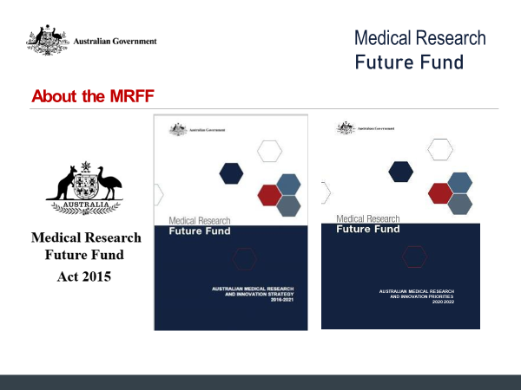

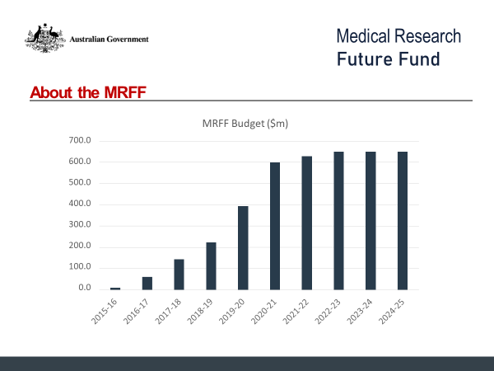

Patients: Emerging Priorities and Consumer-Driven Research ($633.0 m)
Clinical Trials Activity ($614.2 m)
Global Health ($28.4 m)
Researchers
Frontier Health and Medical Research ($570.0 m)
Clinician Researchers ($190.8 m)
Researcher Exchange and Development within  Industry ($32.0 m)
Research Translation
Preventive and Public Health Research ($260.4 m)
Primary Health Care Research ($45.0 m)
Rapid Applied Research Translation ($218.0 m)
Medical Research Commercialisation ($311.3 m)
National Critical Research Infrastructure ($605.0 m)
Research Data Infrastructure ($80.0 m)
Research Missions
Dementia, Ageing and Aged Care ($185.0 m)
Australian Brain Cancer ($49.0 m)
Cardiovascular Health ($220.0 m)
Genomics Health Futures ($500.0 m)
Indigenous Health Research Fund ($160.0 m)
Million Minds Mental Health Research ($125.0 m)
Stem Cell Therapies ($150.0 m)
Traumatic Brain Injury ($50.0 m)


# How is the MRFF different?

* Rapid and flexible disbursements to capitalise on our health and medical research strengths to respond to emerging issues (flexible)
* Focus on an area of unmet need or a technology with transformational potential (priority led)
* Bring together key researchers, health professionals, consumers, stakeholders, industry partners (outcome focused)
* Harness resources across the system (investment, leadership and collaboration)
* Use innovative research approaches (new grant models)

# How is the MRFF different – responsive to emerging issues

* 2020 and 2021 Coronavirus Research Response (incl. 2021 COVID-19 Health Impacts and Vaccination Schedules, currently open)
* 2020 Bushfire Impact Grant Opportunity
* 2020 Silicosis Research Grant Opportunity

# How is the MRFF different – addresses unmet need

* 2020 Efficient Use of Existing Medicines (to support PBAC)
* 2020 Improving Diagnosis in Low Survival Cancers (low relative survival)
* Indigenous Health Research Fund (Indigenous-led research focused on community needs)
* 2019 and 2020 Australian Brain Cancer Mission Survivorship Grant Opportunities (need identified by consumers)

# How is the MRFF different – trying new approaches

* Bringing international perspectives (reviews of MRFF Mission Roadmaps and Implementation Plans, Grant Assessment Committees)
* Evaluation and impact measurement
* Supporting early to mid-career researchers
* Consultation (AMRAB led Strategy and Priorities, MRFF Missions, Roundtables – Medicinal Cannabis, Ovarian Cancer, Early to Mid-Career Researchers)
* Engage with peaks on policies and processes (e.g. Declaration of Interests, MRFF Monitoring, Learning and Evaluation Strategy, experiences applying for and assessing MRFF grants)

# How is the MRFF different – new approaches for funding

* Different grant models (Frontiers, Incubator, Accelerator, Innovation)
* Selection Criteria focused on outcomes (Impact, Methodology, Capacity/Capability/Resources, Overall Value and Risk)
* New approaches for funding focused on improving care and outcomes (Clinician Researchers, Rapid Applied Research Translation)
* Grant Assessment Committee structures (consumers, health services, clinicians, international)

# How is the MRFF different – MRFF incubator grants

* Support early stage research projects to
  + generate new approaches for addressing a critical/intractable health issue that is of value to the community, health service providers, and health system managers
  + explore the feasibility of new approaches and their potential impact on health care practice, policy, or system effectiveness
  + establish an evidence base for further research that focuses on implementing the proposed solution
* Small scale research projects (up to $1M funding for up to 24 months)
* Multidisciplinary research (teams of diverse disciplines e.g. researchers, clinicians, health professionals)
* Several MRFF Missions first utilised this model in 2020
  + Cardiovascular Health, Stem Cell Therapies, Traumatic Brain Injury, Indigenous Health Research Fund

# Building on the strengths of the sector

* Complementing NHMRC and other funding to significantly expand support for health and medical research in Australia
* Expert advice informs priority setting (AMRAB, Council, advisory committees)
* Merit based (independent grant assessment, focus on quality of research and alignment to assessment criteria)

# Things to look out for – MRFF grant opportunities

* Each grant opportunity:
  + is different – look beyond the title to the objectives and outcomes (section 1.3), eligibility criteria (section 3) and selection criteria (section 5)
  + aligns with the Australian Medical Research and Innovation Priorities that are in force (section 1.3)
  + must meet the objective of the MRFF Initiative it sits within (e.g. primary care must be a focus of grants under the Primary Health Care Research Initiative)
  + requires researchers to identify how they will contribute to the MRFF Measures of Success (section 5 – assessment criteria 1 and 4)

# Things to look out for – MRFF program structure

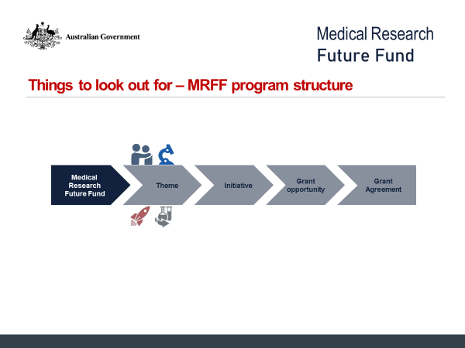

# Things to look out for – performance and evaluation

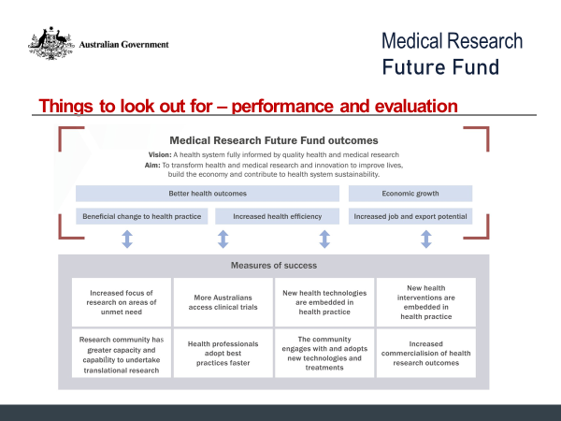

# Things to look out for – a few new things

* Innovation grants
* Accelerator grants
* Department is systematically reviewing MRFF annual progress and final reports
* Establishing ‘Eligible Organisations’ at NHMRC
* Increasing Chief Investigator limits to 15 (up from 10)
* Including ‘access clauses’ in some grant agreements

# MRFF Financial Assistance Report

* MRFF Act (section 57A):

‘The Health Minister must, as soon as practicable after the most recent Australian Medical Research and Innovation Priorities cease to be in force, prepare a report on the financial assistance provided for medical research and medical innovation from the Medical Research Future Fund Special Account during the period the Priorities were in force.’

* Two reports have been published
  + Report 1 covered the 2016-18 MRFF Priorities
  + Report 2 covered the 2018-20 MRFF Priorities

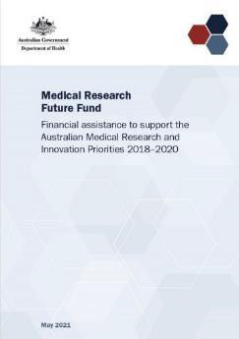

# MRFF Financial Assistance Report

Infographic illustrating:
Significant increase in funding and grants  awarded through 2018-20, compared with  2016–2018.
Around 25% of total MRFF investment  attributed to 95 successful grants in MRFF  Missions.
COVID-19 response: 49 projects  commenced under 16 grant opportunities  with a combined value of $58.1 million. 

* Success by gender and age of chief investigators

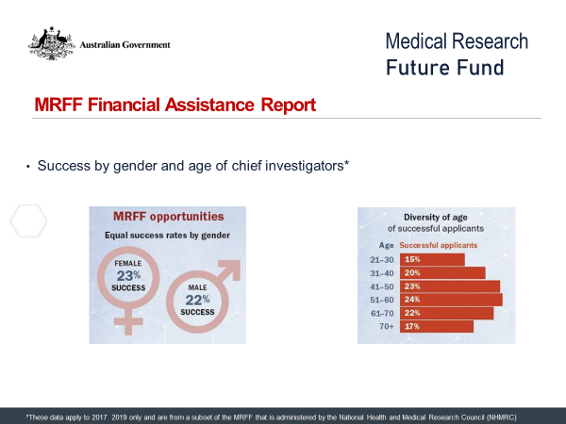

These data apply to 2017-2019 only and are from a subset of the MRFF that is administered by the National Health and Medical Research Council (NHMRC)

* MRFF opportunities fund diverse research areas

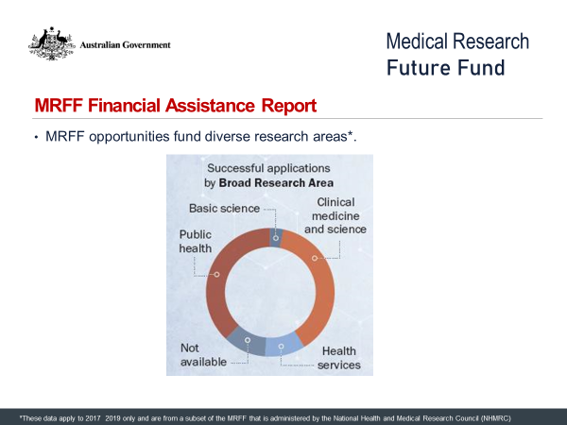

These data apply to 2017-2019 only and are from a subset of the MRFF that is administered by the National Health and Medical Research Council (NHMRC)

* A range of organisations have received MRFF grants

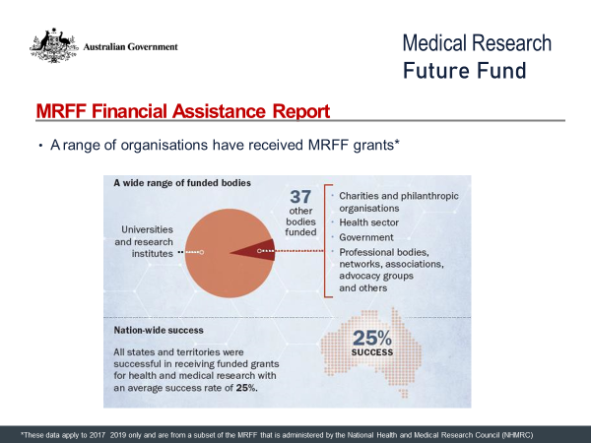

These data apply to 2017-2019 only and are from a subset of the MRFF that is administered by the National Health and Medical Research Council (NHMRC)

* Grant Assessment Committees have broad membership

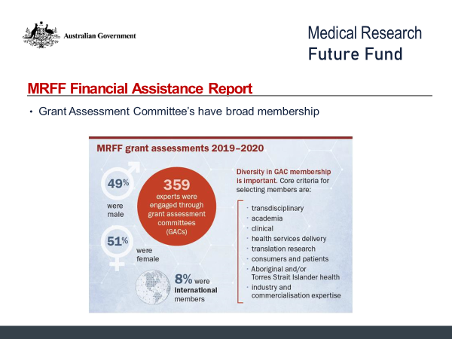

# AMRAB and the 2021-26 Strategy

* 2016-21 member terms expired late February 2021
  + Supporting Government to establish AMRAB 2021-26
* Australian Medical Research and Innovation Strategy 2016-21 expires November 2021
  + A public consultation will be required to establish the 2021-26 by November 2021

# Currently available funding opportunities

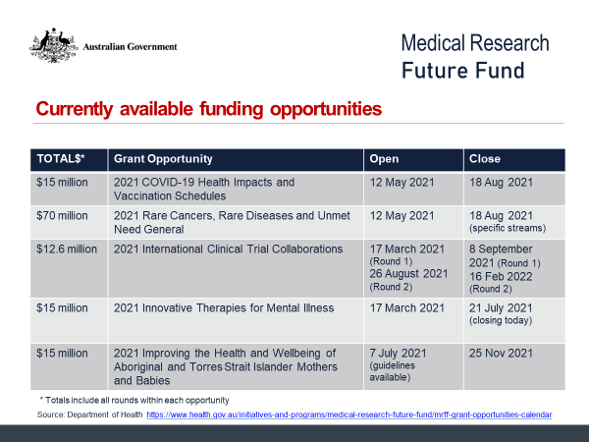

# Continuous feedback loops…we are listening and learning

* Receive feedback via AMRAB consultation processes
* Seek and receive feedback from the sector, including through structured processes
* Identify gaps in funding opportunities
* Scan the environment for emerging issues/unmet needs
* Observe which grant opportunities generate most interest

# Useful resources

* MRFF grant calendar - Medical Research Future Fund (MRFF) grant opportunities and their status:

[www.health.gov.au/initiatives-and-programs/medical-research-future-fund/mrff-grant-opportunities-](http://www.health.gov.au/initiatives-and-programs/medical-research-future-fund/mrff-grant-opportunities-%20)  [calendar](http://www.health.gov.au/initiatives-and-programs/medical-research-future-fund/mrff-grant-opportunities-calendar)

* MRFF grant recipient list – information of about funded grants:

[www.health.gov.au/resources/publications/medical-research-future-fund-mrff-grant-recipients](http://www.health.gov.au/resources/publications/medical-research-future-fund-mrff-grant-recipients)

* MRFF projects – more detailed information about some MRFF funded projects:

<https://www.health.gov.au/initiatives-and-programs/medical-research-future-fund/mrff-projects>

# Next webinar

* Expected – October 2021 [date TBC]
* Will cover:
  + MRFF Missions
  + Accelerator grants
  + Other MRFF updates
* Nominate topics by writing to [MRFF@health.gov.au](mailto:MRFF@health.gov.au)

# Keep connected…

* Subscribe to MRFF News:

<https://www.health.gov.au/using-our-websites/subscriptions/subscribe-to-mrff-newsletter>

* Nominate for an MRFF Grant Assessment Committee (GAC):

[https://www.nhmrc.gov.au/2020 21 medical research future fund mrff grant opportunities](https://www.nhmrc.gov.au/2020 21 medical research future fund mrff grant  opportunities)

* Register for MRFF grants opportunities:

https://[www.grants.gov.au/](http://www.grants.gov.au/)

* Follow Health Twitter for MRFF updates:

@healthgovau #MRFF