Medical Research Future Fund MRFF Quarterly Webinar 16 November 2021
Dr Masha Somi, CEO of the Health and Medical Research Office
Prof Ian Frazer AC, Chair of AMRAB
Prof Caroline Homer AO, Deputy Chair of AMRAB

1. Introduction
2. Australian Medical Research Advisory Board – Prof Ian Frazer and Prof Caroline Homer
3. Strategy and Priorities Consultation
4. Looking forward (next 12 months)
5. Medical Research Future Fund Update
6. Medical Research Future Fund Missions
7. Roadmaps, Implementation Plans and Grant Opportunities
8. Brain Cancer Mission
9. Million Minds Mission
10. Medical Research Future Fund Program Update
11. ANAO Audit
12. Investment Fund Legislation Amendment Bill 2021
13. Eligible Organisations
14. Accelerator grants
15. What's Next?

# Strategy 2021-2026 & related Priorities - Purpose of consultation

* Conducted public consultation to develop the 2021-26 Strategy and the related Priorities to:
* better contextualise and articulate the unique role and contributions of MRFF within the broader support system for health and medical research and strengthen MRFF’s role in supporting the translation of research into impact.
* reflect on MRFF’s current operating context, nationally and internationally, and the challenges and opportunities this poses and propose ways forward.
* Ensure an updated Strategy is:
* meeting its purpose as described in the MRFF Act
* accounting for critical current and future issues and factors (e.g. primary prevention)
* allowing the MRFF to fund research to address national health priorities
* delivering practical benefits from medical research and medical innovation to Australians.
* As the Priorities must be consistent with the Strategy, they were also revisited as part of the process.

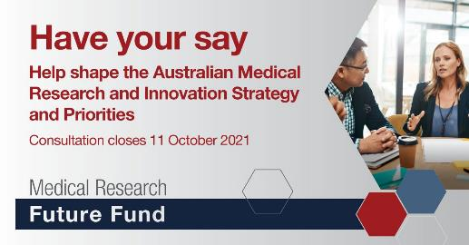

# Strategy 2021-2026 & related Priorities - Consultation Process

* The consultation process commenced on 20 September 2021 through the opening of an online consultation hub to provide opportunities for written submissions to be considered and closed 11 October 2021.
* The national consultation process included:
* Public webinar (214 attended)
* Virtual stakeholder roundtable (25 stakeholders attended)
* Online written submissions through the online consultation hub (201 submissions).
* A consultation report has also been developed by AMRAB, that incorporates the summarised feedback received through the online consultation hub and the steps AMRAB have taken to address this feedback – available on the MRFF website.

# Australian Medical Research and Innovation Strategy 2021-2026

Text box 1: Vision
A health system fully informed by quality health and medical research
Text box 2: Aim
Transform health and medical research using priority-driven investments that promote collaborative research, research innovation, research translation and impact to improve lives, whilst contributing to health system sustainability, nurturing the next generation of researchers and building the Australian economy.
Text box 3: image of the Australian Medical Research and Innovation Strategy 2021-2026

## Strategic Objectives of the MRFF

**To deliver:**

* Equitable health outcomes through research-informed preventive health and health care across the spectrum from primary to tertiary care.
* Health and economic benefits from transformative and innovative research through translation of outcomes into policy and practice, and commercialisation of new diagnostics, therapeutics, and preventive health interventions.
* A skilled and sustainable health and medical research workforce with expertise in research translation, innovation, and commercialisation.
* A health and medical research sector and health system positioned to respond to emerging and future challenges.

## Guiding principles to support the strategy

Research funded through the MRFF will address:

1. New or emerging areas of health need
2. Existing areas of unmet health need
3. Improvement in the efficiency and effectiveness of the health system
4. Social, environmental, and cultural factors that impact health and wellbeing
5. Enhancements to the translation of research outputs to deliver impact
6. Promotion of capacity and capability in the health and medical research workforce
7. Encouragement of adaptive approaches to emerging challenges

# Australian Medical Research and Innovation Priorities (draft)

* The draft version of the related Australian Medical Research and Innovation Priorities were published online on 8 November 2021.
* AMRAB developed the Priorities concurrently with the 2021-2026 Strategy, in order to align with and facilitate the achievement of the 2021-26 Strategy’s vision, aim and strategic objectives.
* These Priorities will come into force following the passage of the Investment Funds Legislation Amendment Bill 2021 (which will cause the existing 2020-22 Priorities to cease to have effect), or otherwise no later than 5 November 2022, when the 2020-22 Priorities expire.

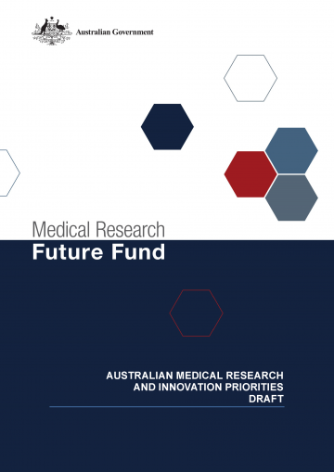

Consumer-Driven Research
Research Infrastructure and Capability
Translation and Commercialisation
Comparative Effectiveness Research
Preventive and Public Health Research
Primary Care Research
Aboriginal and Torres Strait Islander Health
Priority Populations
Antimicrobial Resistance
Global Health and Health Security
Health Impacts from Environmental Factors
Data, Digital Health and Artificial Intelligence
Health and Medical Researcher Capacity and Capability

Looking forward over the next 12 months

AMRAB will consult with the sector, including on the following areas:

* Consumer and clinician involvement in research
* Health and medical research workforce development
* Research quality

To effect this, AMRAB members are keen to attend biomedical and clinical conferences, and to visit research and health delivery organisations, on request

AMRAB will work with HMRO to assist with delivery and assessment of HMRO research programs addressing the Strategy and Priorities

AMRAB and NHMRC Council engagement

Regular engagement focussing on:

* Working together to consider alignment and complementarity
* Engagement with the community

# MRFF 10-year investment plan aligns with the Priorities and is the mechanism through which the objectives of the Strategy are met

* MRFF supported projects are
* supporting clinical trials and responding to emerging priorities
* helping researchers think big to tackle significant health challenges through investment, leadership and collaboration
* accelerating the commercialisation and implementation of medical discoveries, improving research infrastructure and supporting jobs growth in the MTP sector
* supporting Australia’s researcher capacity and skill development to continue our success as a global health and medical research leader and innovator
* Grant opportunities under the MRFF 10-year investment plan align with MRFF Priorities, and support the strategic objectives of the MRFF which focus on equitable health outcomes, research translation, research workforce, and emerging and future challenges
* Under the MRFF 10-year Investment Plan, there is flexibility and funding available to address new and emerging needs that fall under the broad objectives of each initiative

# HMRO’s role in implementing the Strategy and Priorities

* Developing funding opportunities that address the Priorities, with AMRAB’s advice
* Commissioning proposals for funding, through NHMRC and Business Grants hub
* Evaluating applications for funding, using independent and international review
* Approving proposals for funding, based on the independent reviews
* Advising the Minister of funding outcomes
* Managing funded applications, to monitor progress and risks
* Reviewing outputs of funded applications
* Reporting against the strategy and priorities to AMRAB, Government and Parliament

# MRFF program update

Since inception

2020-2021 Financial Year

# MRFF 10-year investment plan

$1.8 billion across a total of 681 grants already funded (as at 11 November 2021)

Funds are available in future years for allocation to priorities

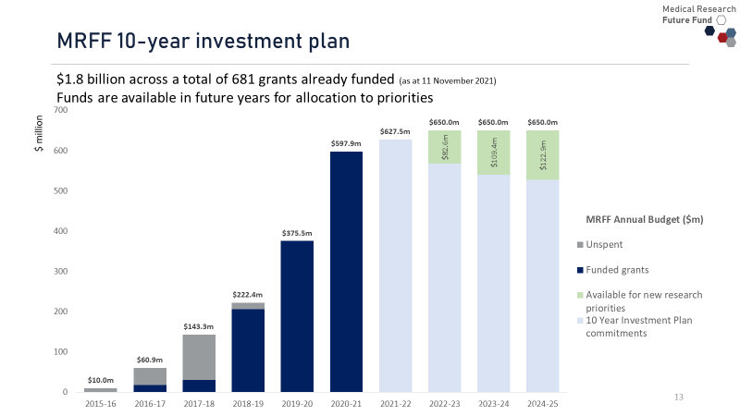

## MRFF funds are being disbursed across all states and territories, to rural and remote areas and issues, and to a range of organisations

Image of Australia
NT: 11 grants $33.3m
Qld: 84 grants $214.8m
NSW: 188 grants $523.4m
ACT: 12 grants $22.0m
Vic: 299 grants $873.5m
Tas: 11 grants $16.4m
SA: 46 grants $75.4m
WA: 29 grants $84m 

48 grants
$289 million
MRFF funding has been disbursed to a range of research projects undertaken in rural and remote areas, as well as to projects that address health topics of significance to rural and remote areas of Australia. 
Under the MRFF Act 2015, MRFF funding can be provided to: 
Universities: $1,103.2m, 546 grants
Corporations: $391.8, 44 grants
Medical Research Institutes: $247.5, 86 grants
Other entities: $107.2m, 5 grants
To date MRFF funds have been disbursed across all eligible organisation types, thus promoting a diversity of research and supporting the spectrum of organisation types within the health and medical research sector.

Note: The grant numbers and funding figures are based on the lead organisation of each MRFF-funded grant. In practice, many MRFF-funded grants are collaborative research efforts across multiple Australian locations and organisations.

## MRFF strategic priorities are directing $5 billion over 10 years across 4 themes with 20 initiatives

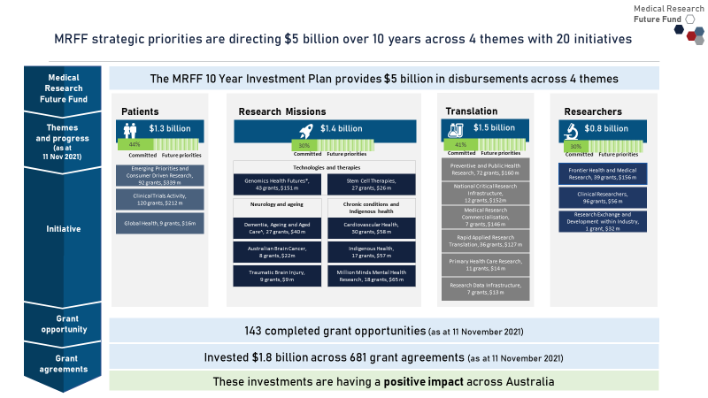

## ‘Patients’ theme supporting clinical trials and responding to emerging priorities

**Clinical trials, incl. rare cancers, rare diseases and unmet needs: $635.3 million** awarded through **247 projects** including:

* 18 bringing **large scale, multinational trials** to Australia
* 3 (valued at $125 million) for clinical trials infrastructure support to **improve access to clinical trials in rural, regional and remote** Australia.

**COVID-19 research: $96 million** disbursed from the MRFF since March 2020 has been a stimulus for growth in the research sector:

* $24+ million – **vaccine** development
* $35+ million – **therapies** and **potential treatments**
* ~$37 million – **public health activities, virus-host interactions** (diagnostics, genomics, immunity)

ZERO Childhood Cancer National Precision Medicine Program
$60 million disbursed to expand ZERO:
World-leading personalised medicine trial for <21 yr olds with high-risk cancer
Aims to identify the genetic drivers of each cancer and tailor treatments for increased survival with reduced side-effects
Early results (Oct 2020) showed 70% of children who received the recommended, personalised treatment, had a positive response (tumour stopped growing, shrank, or completely regressed)
Currently 500+ children enrolled. By end 2023, all Australian children with cancer will be able to participate.
Picture: Jack and his mum Vivian
“Because ZERO EXISTS, our Jack EXISTS, and many other children will EXIST with the right diagnosis and treatment thanks to ZERO...without the existence of our precious supporters our son would not be alive today.” (Vivian)


Merkel Cell Carcinoma (MCC) clinical trials - $3.4 million across 2 trials
Specifically exploring treatments for MCC: 
MCC is a rare, highly aggressive neuroendocrine tumour of the skin 
It affects 300 Australians/year and is one of the most lethal skin cancers
Australia (particularly Queensland) has the highest incidence of MCC worldwide
In Europe/US the leading cause is viral exposure, but in Australia it is sun-related UV exposure.

Importantly, noting the different causes of MCC, these MRFF-funded trials are being conducted in an Australian cohort, with results most likely to reflect and benefit Australian patients.

## Research Missions’ initiatives help researchers think big to tackle significant health challenges

**New technologies and therapies:** ‘Genomics Health Futures’ and ‘Stem Cell Therapies’ Missions aim to identify **novel tests, diagnostics and treatments** for Australians and **reduce unnecessary interventions and health costs**.

**Tackling chronic conditions and Indigenous health: Critical research** is being supportedthrough the ‘Indigenous Health Research Fund’, ‘Cardiovascular Health Mission’, and ‘Million Minds Mental Health Research Mission’.

**Learning about neurology and ageing: 3 Missions** focusing on the brain and ageing research and aim to:

* **support older Australians** to maintain their health and quality of life as they age, live independently for longer, and access quality care when they need it
* **double the survival rate** of Australians living with brain **cancer** over next 10 yrs
* improve patient recovery after **brain injury.**

The SuperbugAi Flagship - $3 million 
Using genomics, electronic healthcare data and AI 
This project will develop an anti-microbial resistance (AMR) tracking and response system to enable earlier detection of AMR, personalised treatments for improved patient survival, and prevention of AMR outbreaks in the healthcare system.

Brain cancer survivorship - $9.5 million for 3 projects
In 2020, 2,000 Australians were diagnosed with brain cancer. Only 22% will be alive in 5 years.
There are no known prevention measures and, for some, no effective treatments
These projects are conducting research on tailoring survivorship approaches for individual needs, and supporting access to a platform to allow patients to connect with other survivors to share experiences and support each other.

## ‘Translation’ initiatives accelerate commercialisation and implementation of medical discoveries, improve infrastructure and support a growing MTP sector

**Commercialisation of biomedical and medical technologies: Medical Research Commercialisation** initiative has awarded **$146 million** to date.

**Improving research facilities and systems:** MRFF funds have been disbursed for **research infrastructure** including:

* **facilities in rural and remote areas** so people can participate in clinical trials without the need to travel to a major city
* the creation or extension of national research data infrastructure, with a focus on **data registries, biobanks** and **data linkage platforms**.

**Contributing to jobs and growth:** MRFF funding is discovering new drugs, devices and therapeutic industries, strengthening researcher-industry collaboration, supporting more clinical trials, reinforcing the MTP sector, saving lives, and improving quality of life. These are all **key markers** of **economic wealth** and **health wealth** under the **2018 National Health and Medical Industry Growth Plan.**

McMonty Medihood - $0.6 million
Fits quickly above the head and torso of a suspected/confirmed COVID-19 patient 
Acts as a physical barrier between the patient and frontline healthcare workers
Made in Australia
Deployed to rural areas of Australia, particularly those without specialised facilities like negative pressure rooms.
Deployed internationally to support PNG and the Republic of Nauru.

MRFF funding contributes to jobs and growth in the MTP sector
In 2019, Australia’s medical technology, biotechnology and pharmaceutical (MTP) sector contributed $5.2 billion to the Australian economy. It supported approximately 68,000 jobs in research and industry and 1,278 companies

## ‘Researchers’ initiatives build skills and capacity for Australia to remain a global medical research leader and innovator

**Fostering a culture of research in clinical practice: Clinician-Researchers** initiative has awarded **$55.5 million** across **96 grants** to support research carried out by clinicians (e.g. surgeons, GPs, nurses, allied health professionals).

**Building industry skills and ties with academia: Researcher Exchange and Development within Industry** initiative is disbursing **$32 million** to develop product ideas whilst providing researchers, clinicians, MTP professionals and innovators with industry placements, mentoring, exposure to entrepreneurialism, and training in research translation and commercialisation.

**Supporting researchers to pursue revolutionary ideas: Frontier Health and Medical Research** initiative supports researchers to push the boundaries to develop new health and medical **breakthroughs** that can revolutionise health care, potentially creating new industries and having **global impact**. The 2-stage program is providing **$570 million** over **9 years**.

4D Functional Diagnosis: a new frontier in lung health for children - $29 million
Team comprised of world-leading Australian medical researchers, engineers, manufacturers and doctors 
This project delivers ground breaking lung scanners that are safe, rapid, and easy to use, enabling detailed diagnosis and treatment for patients of any age 
The scanners will fill the critical unmet need for sensitive lung health assessment for young children and could be applied to managing COVID-19
This will establish Australia at the forefront of lung science, while kick-starting a local, fast-growing, high-value, high-tech industry.

Catch them when they fall - $0.2 million
Awarded from the Clinician-Researchers initiative to Dr Fiona Shand, a clinical psychologist
Researched best evidence care after a suicide attempt
Findings have and will be used to develop and implement novel approaches to crisis care in national and state mental health strategies.

# 2020-21 Program information

Grant opportunities opened in 2020-21

| **Grant opportunities opened 2020-21** | **Total value^** |
| --- | --- |
| 36 | $812.7M |

Grant agreements executed in 2020-21

| **Grant agreements executed in 2020-21\*** | **Total value^** |
| --- | --- |
| 230 | $587.6M |

^ The value is based on the funding in the original grant opportunity guidelines. This includes round 1 of the 2020 COVID-19 Vaccine Candidate Research grant opportunity, which opened in 2019-20.

* The grant agreements could relate to grant opportunities that opened prior to 2020-21. Not all grant opportunities opened in 2020-21 have been executed.

* Grant agreements executed in 2020-21 (worth $587.6 million) are spread across all four MRFF research themes
* 81 clinical trials*, worth $168.6 million, have been supported

|  |  |
| --- | --- |
| **Grant agreements executed** | **Total value** |
| 81 | $168.6M |

*includes MRFF Clinical Trials Activity initiative and other MRFF investments on clinical trials activity

* 87 grants (worth $169.6 million*) have been executed in 2020-21 to support Missions activity

Genomics Health Futures Mission, 21 grants, $73.5M
Dementia, Ageing and Aged Care Mission, 11 grants, $17.0M
Traumatic Brain Injury Mission, 6 grants, $3.3M
Stem Cell Therapies Mission, 17 grants, $18.7M 
Cardiovascular Health Mission, 16 grants, $20.1M
Indigenous Health Research Fund, 7 grants, $7.4M
Million Minds Mental Health Research Mission, 8 grants, $27.1M
Australian Brain Cancer Mission, 1 grant, $2.6M

*Figures may not add up exactly due to rounding

# MRFF Missions Update

* MRFF Missions
* large programs of work that bring together key researchers, health professionals, stakeholders, industry partners and patients to tackle big health challenges
* tackle significant health challenges by bringing together key players:
* researchers
* health professionals
* stakeholders
* industry partners
* patients
* This joint effort supports the discovery of new knowledge, tools, techniques, treatments and approaches, supporting improved health outcomes
* Missions challenge current ways of thinking and encourage researchers to ‘research’ differently

Image of the roadmaps and implementation plans for the Genomics Health Futures Mission; the Dementia, Ageing and Aged Care Mission; the Cardiovascular Disease Health Mission; the Stem Cell Therapies Mission; and the Traumatic Brain Injury Mission
The roadmap and implementation plan for the Indigenous Health Research Fund is currently being finalised

# New Mission Grant Opportunities

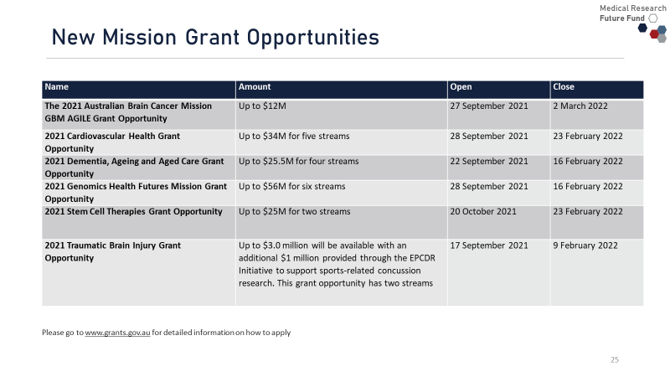

Please go to [www.grants.gov.au](http://www.grants.gov.au/) for detailed information on how to apply

# Brain Cancer Mission – new GBM Agile grant opportunity

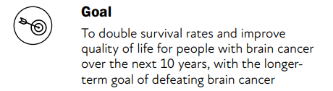

Total investment of $135.46 million achieved through an initial   
$50 million from the MRFF.

The Australian Government has committed an additional $10.26 million in MRFF funding to the Mission and brain cancer research.

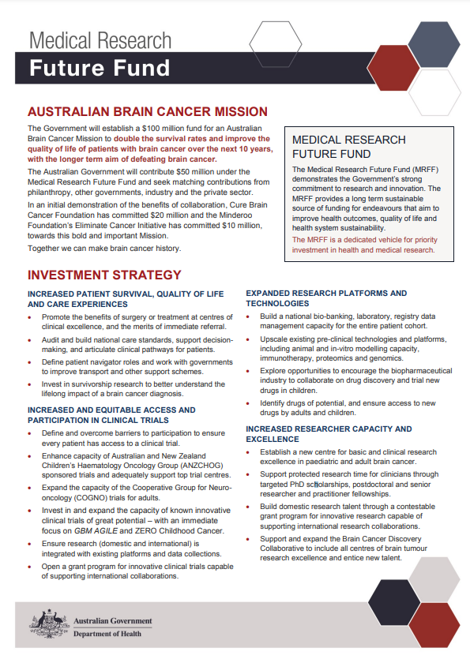

# GBM Agile Grant Opportunity

## Objective:

* improve outcomes for Australians diagnosed with brain cancer (specifically glioblastoma multiforme (GBM) by leading, co-ordinating and managing the implementation and evaluation of the Australian arm of the GBM AGILE clinical trial.

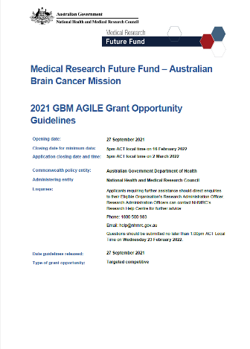

# Million Minds Mental Health Research Mission

* The Mission is an initiative of the Medical Research Future Fund and is providing $125 million over 10 years from 2018-19 to support research on new approaches to mental health prevention, detection, diagnosis, treatment and recovery.
* To date, the Mission has provided $64.81 million in funding for 18 mental health research projects.
* Investments from the Mission have been guided by the Mission’s Roadmap and the Mission’s former Expert Advisory Panel led by Professor Shitij Kapur and Professor Helen Milroy

# Review of the Million Minds Mission and EAP

The University of Technology Sydney (UTS) is undertaking a review of the Mission - final report due at the end of 2021.

As part of the evaluation process, the UTS team will approach mental health stakeholders to conduct a consultation feedback, including an online survey, regarding the Mission.

An Expert Advisory Panel (EAP) is being established

The EAP will be supported by the findings of the evaluation of the Mission that is currently underway

Applications close on **9am (AEDT) 26 November 2021.**

Information on how to apply is at: <https://www.health.gov.au/resources/publications/expression-of-interest-mrff-million-minds-mental-health-research-mission-expert-advisory-panel>

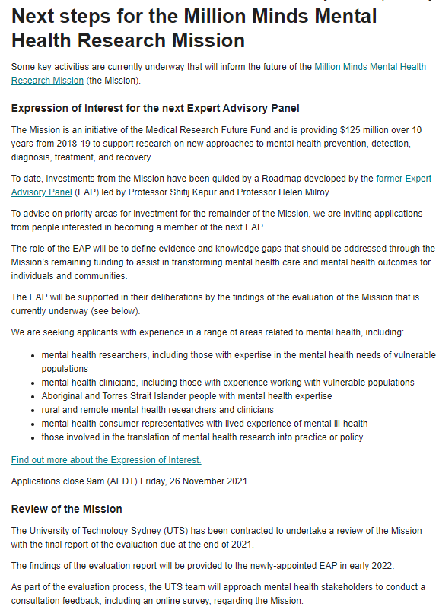

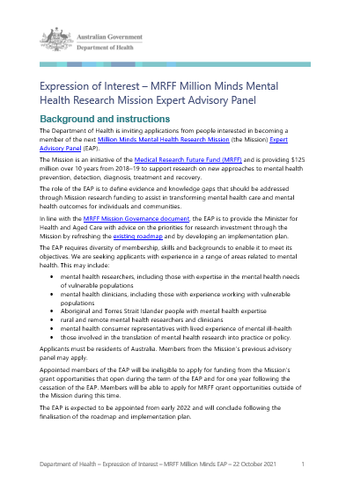

# MRFF Updates

* MRFF Performance Audit by the Australian National Audit Office
* Investment Funds Legislative Amendments Bill
* MRFF Eligible Organisations at NHMRC
* Accelerator grants
* Website updates

## MRFF Performance Audit by the Australian National Audit Office

* Concluded in August 2021
* Three key recommendations, accepted by the Department
* More information on the Department’s response can be found here: <https://www.health.gov.au/resources/publications/medical-research-future-fund-outcomes-of-performance-audit-by-the-australian-national-audit-office-anao>

## Investment Funds Legislation Amendments Bill

* Introduced in Parliament 25 August 2021
* Proposes changes to the MRFF Act
* More information can be found here: <https://www.health.gov.au/sites/default/files/documents/2021/08/proposed-changes-to-the-medical-research-future-fund-act-2015.pdf>

## MRFF Eligible Organisations (MRFF EO) at NHMRC

* Organisations can apply to NHMRC to become an MRFF Eligible Organisation.
* Separately identified in NHMRC’s grant management system from NHMRC Administering Institutions (AIs).
* Further information:
* <https://www.health.gov.au/resources/publications/mrff-eligible-organisations>
* <https://www.nhmrc.gov.au/funding/manage-your-funding/mrff-eligible-organisations>

## MRFF Accelerator Grants

* Large scale research projects (up to $5M funding for up to 5 years)
* Drive implementation of substantial improvements to health care and/or health system effectiveness
* More information: <https://www.health.gov.au/resources/publications/mrff-accelerator-grants>

**Frequent updates to the MRFF website to:**

* promote MRFF grant opportunities and outcomes
* ensure information is consistent, timely and accurate
* increase awareness and understanding of the MRFF

**Refresh undertaken to make information more user friendly and comprehensive:**

* initiative pages have been updated to make it easier for readers to find information about grant opportunities and awarded grants
* expanded grant reporting information

# Next webinar

* Expected – March 2022 [date TBC]
* Will cover:
* Accelerator grants
* Innovation grants
* Other MRFF updates
* Nominate topics by writing to [MRFF@health.gov.au](mailto:MRFF@health.gov.au)

# Keep connected…

* Subscribe to MRFF News: <https://www.health.gov.au/using-our-websites/subscriptions/subscribe-to-mrff-newsletter>
* Register to be notified of MRFF grants opportunities: https://[www.grants.gov.au/](http://www.grants.gov.au/)
* Follow Health Twitter for MRFF updates: @healthgovau #MRFF
* Invite us to give a presentation or discuss ideas: MRFF@health.gov.au

# Useful resources

* Note - Information on various on MRFF web pages have been moved around but no information has been removed.
* MRFF grant calendar - Medical Research Future Fund (MRFF) grant opportunities and their status:

[www.health.gov.au/initiatives-and-programs/medical-research-future-fund/mrff-grant-opportunities-calendar](http://www.health.gov.au/initiatives-and-programs/medical-research-future-fund/mrff-grant-opportunities-calendar)

* MRFF grant recipient list – information of about funded grants:

[www.health.gov.au/resources/publications/medical-research-future-fund-mrff-grant-recipients](http://www.health.gov.au/resources/publications/medical-research-future-fund-mrff-grant-recipients)

* MRFF projects – more detailed information about some MRFF funded projects:

<https://www.health.gov.au/initiatives-and-programs/medical-research-future-fund/mrff-projects>

* MRFF resources – constantly updated page of publications and videos about the MRFF:

<https://www.health.gov.au/initiatives-and-programs/medical-research-future-fund/mrff-resources>

* MRFF webinar – quarterly presentation to all stakeholders about the MRFF. Latest one at:

<https://www.health.gov.au/resources/videos/medical-research-future-fund-webinar-21-july-2021>

Thank you for your time

Questions?