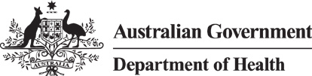



How to do a

rapid antigen test from your nose

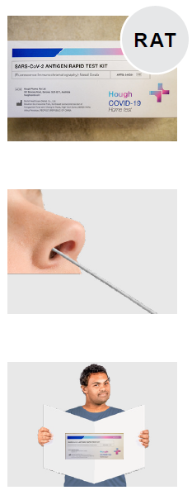Rapid antigen tests are tests that tell you if you have COVID-19.

They are called **RAT** for short.

This information is about RATs that you do from your nose.

We will tell you how to do these tests.

# Get ready to do the RAT

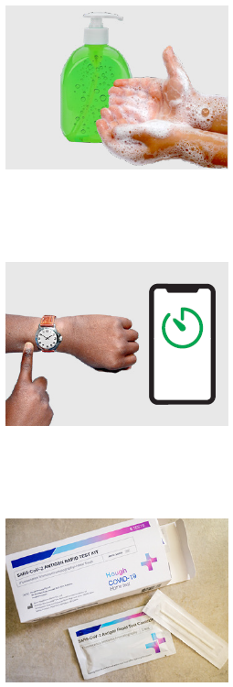Wash your hands before you do the RAT.

Get a watch or timer.

Open the RAT kit.

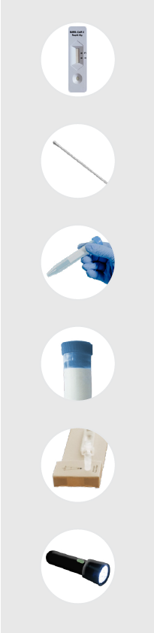In the RAT kit should be

* A strip that will show you if you have COVID-19 or not
* A long stick with 1 soft end
* A tube with liquid inside

Some RATs have the tube and liquid in different parts

* A lid for the tube
* Some kits have a stand
* Some kits come with a torch

Make sure you have the tube the right way up.

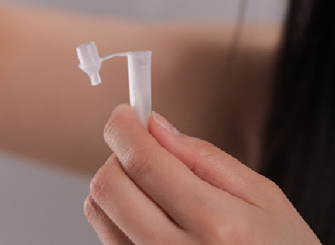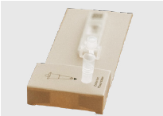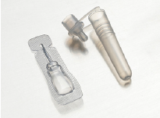

Your test kit might come with a stand to help you stand it up.

Be careful not to let the tube fall over.

Some test kits come with the tube and liquid in different parts.

You must carefully put the liquid inside the tube.

# Doing the test

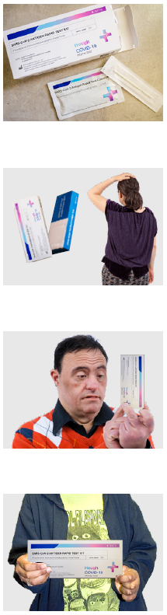Most tests work the same way.

There are some small things that can be different.

It is good to read what the box says before you do the test.

This is how you should do most tests.

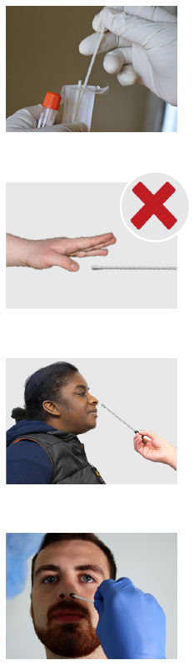Take the stick out of the packet.

Do not touch the soft part at the end of the stick.

Put the soft part of the stick up your nose.

Put it all the way up until it you feel it touch the back of your nose.

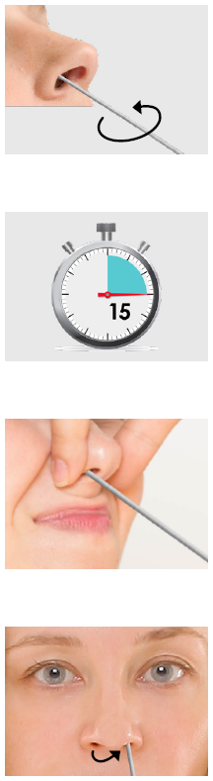Keep moving the stick around in your nose.

Count to 15 slowly.

When the stick is in your nose you can press on the side of your nose.

Use the soft end of the same stick for the other side of your nose.

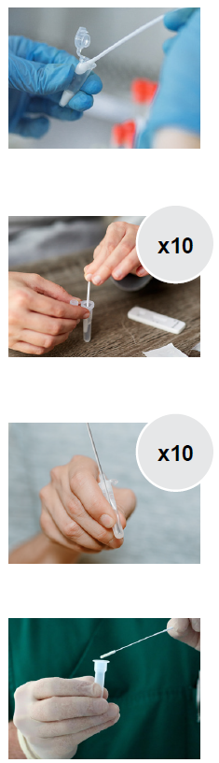When you are done put the stick into the tube.

Stir the stick in the tube 10 times.

Then gently squeeze the sides of the tube together 10 times.

Take the stick out of the tube.

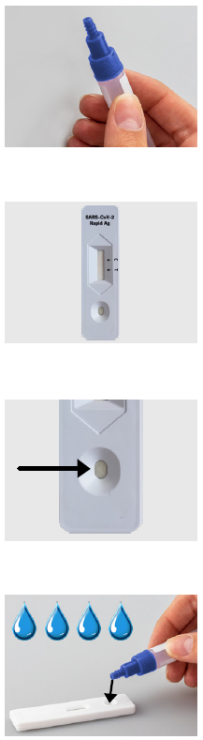Put the cap tightly on the tube.

Get the strip that will show you if you have COVID-19.

The strip has a small round circle at the bottom.

You will have to squeeze 3 or 4 drops of liquid onto the circle.

Check to see how many the box says.

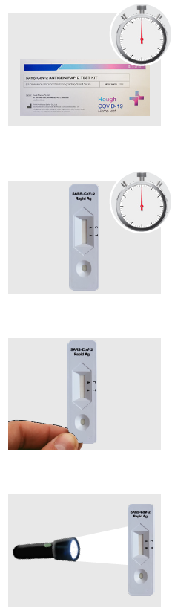Set your timer or watch.

Check what time the box says.

This can be 10, 15 or 20 minutes.

When the time is up check the strip to see what it says.

Only read the strip at that time and not later. It might be wrong then.

1 RAT kit has a torch to help you read what the strip says.

# How to read the strip

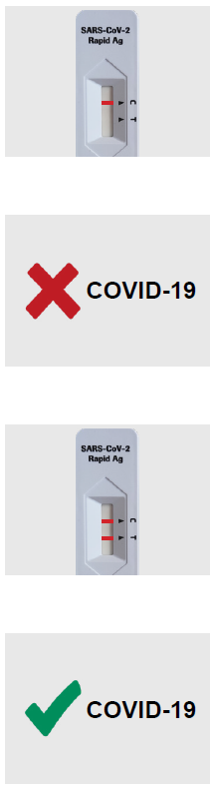When you look at the strip you might see a line next to the letter C.

This means you are negative.

You do **not** have COVID-19.

You might see a line next to the letter C **and**

a line next to the letter T.

The line might be very light

This means you are positive.

You have COVID-19.

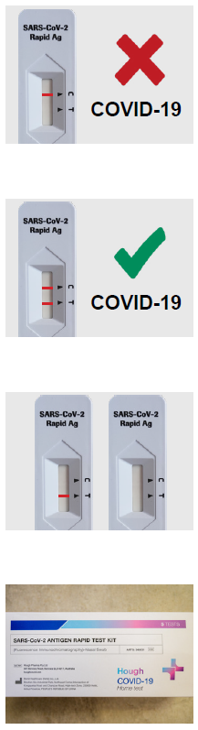If there is no line or colour next to the letter T your test is negative.

You do not have COVID-19.

If there is a line or any colour next to the letter T your test is positive.

You have COVID-19.

The line might be very light

Your test did not work if you see

* Only 1 line next to the letter T
* No lines at all

You will need to do another test.

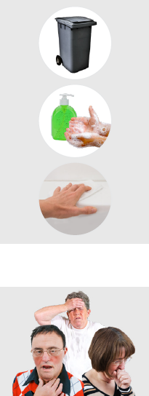When you have finished

* Put everything in the bin
* Wash your hands
* Clean where you did the RAT

If you got a negative result but still have symptoms do another test in 2 days.

Council for Intellectual Disability made this document Easy Read. CID for short. You need to ask CID if you want to use any pictures in this document.

You can contact CID at [**business@cid.org.au**.](mailto:business@cid.org.au)