Concept Paper
Concepts for a new framework for regulating aged care
February 2022

Contents
Introduction 3
Purpose of the Concept Design Paper 5
Background to Paper 1 7
The future approach to regulating aged care 12
Stage One: Concept Design of a new regulatory framework 16
Concluding remarks 21
Attachment A 22
Principles for the Aged Care Regulatory Framework 22

Introduction

Why a new framework to regulate aged care?
In response to the recommendations of the Royal Commission into Aged Care Quality and Safety (the Royal Commission), the Government is committed to a comprehensive program of reforms that will be delivered across five pillars: home care; residential aged care services and sustainability; residential aged care quality and safety; workforce; and governance. The reforms aim to strengthen and enhance the protection and rights of older Australians, and will have impacts on aged care governance, quality standards and providers.
Consistent with this reform agenda, a new, modernised aged care legislation will be introduced that is fit for purpose, delivers proportionate regulation and supports the provision of safe and quality care for senior Australians in line with the expectations of the Royal Commission. Similarly, a new Support at Home Program will be developed in consultation with senior Australians and community stakeholders. This reform will address several of the Royal Commission’s recommendations to improve the support for senior Australians to remain independent and in their own homes for longer.
These reforms require a contemporary regulatory architecture. A new regulatory framework needs to be developed in concert with the new Aged Care Act and the new Support at Home Program, that commence on 1 July 2023.

A new approach
Reforms to address the Royal Commission recommendations call for the introduction of a new approach that better aligns regulation to the proportionality of risk. A future regulatory framework also presents opportunities to address criticisms and challenges with the current system. There is scope to move beyond a one-size fits all approach to regulating approved providers, and build capability to use data and intelligence to better understand and anticipate risk and differentiate across the sector. Some progress has been made, but there is still more to do.
An improved approach to regulating aged care will go beyond compliance to foster a culture and practice of continuous improvement to deliver higher quality care that better supports the wellbeing of senior Australians. This will be achieved through a best practice and risk proportionate aged care regulatory framework, which will be built on a human rights, person centred approach. The design of this new approach will be based on a set of Principles for the Aged Care Regulatory Framework, which are detailed in Attachment A.
It is envisaged that a new regulatory framework will result in direct benefits for:
- senior Australians and their families
strengthened assurance that they are receiving high quality and safe care enabled through genuine choice of their provider
- providers and the aged care workforce
differentiated arrangements based on market segmentation, location, performance and type of services delivered
- the regulator
more efficient and targeted regulation underpinned by regulatory intelligence
This contemporary approach would fundamentally change the way the regulator interacts with the growing aged care market while maintaining and strengthening protections for senior Australians. A new regulatory model that is required to underpin the current reforms would affect all providers in the aged care market and could support mutual recognition or streamlined regulation of some providers in adjacent sectors, such as the National Disability Insurance Scheme (NDIS) and veteran’s care.

Purpose of the Concept Design Paper
This Concept Design Paper (Concept Design) seeks to provide early communication with stakeholders on concepts and ideas for a potential new model for regulating aged care. It is an important companion document to the concept paper on Support at Home and forms the first part of a staged process to work with stakeholders. It is envisaged that a comprehensive consultation process will commence in 2022. Stages of consultation will inform the detailed design of a more contemporary and fit for purpose regulatory framework and will consider the operational arrangements, transition options and an implementation plan.

Structure of this paper
This paper discusses the concepts and ideas for a potential new regulatory framework that is required to support implementation of the Government’s reforms. It introduces stakeholders to:
- concepts around regulation and regulatory frameworks
- the key challenges with existing aged care regulation and opportunities of designing a more contemporary and fit for purpose framework
- foundational concepts of a new regulatory framework, including a person-centred and risk proportionate approach
- the principles that underpin the design of the new regulatory framework.

Connection to other reforms and papers
There are other reforms that are connected and complementary to the development of a new regulatory framework.

Support at Home
A discussion paper on the new Support at Home Program has been released and is available here. The Paper provides an overview of the proposed design for the new Support at Home Program and consultation approach in 2022.
The new Support at Home Program will replace the following in-home aged care programs:
- Commonwealth Home Support Programme (CHSP)
- Home Care Packages (HCP) Program
- Short Term Restorative Care (STRC) Programme.
The proposed Support at Home program would reform the way in-home aged care is assessed, funded and regulated, to deliver benefits for aged care consumers and providers.

Regulatory Alignment
In the 2021-22 Budget the Australian Government committed to align regulation of Commonwealth funded care and supports - aged care, disability support, and veterans’ care - to improve protections and ensure consistent quality and safety for participants and consumers. A cross-agency taskforce (the Taskforce) was established in mid-2021 to progress this work.
The Taskforce published a background paper in October 2021 to support initial engagement with the care and support sector. Following this, a consultation paper was released in November 2021 to seek stakeholder views on:
- the benefits and risks of pursuing greater alignment of regulation across the care and support sectors
- the aspects of regulation that should be consistent across the care and support sectors
- options for better aligning aspects of regulation across the care and support sectors.
That consultation paper noted that stakeholder input and feedback would inform options for regulatory alignment and timeframes for implementation which would help to shape the roadmap for reform.
This Concept Design describes the aged care regulatory framework that may be used to support both the Support at Home and regulatory alignment reforms in order to introduce stakeholders to the early thinking around the high-level framework. Feedback from these parallel papers will inform the detail that sits under the regulatory framework, which will be very much driven by stakeholder feedback and further consultation.

Next steps and how to get involved
Following the distribution of this Concept Design, consultation will commence in early 2022 to inform the detailed design of the new aged care regulatory framework.
To get involved in consultations and keep up to date with the latest information on the aged care reforms and design of the future aged care regulatory framework, go to the Ageing and Aged Care Engagement Hub to:
- Sign up for future consultations
- Respond to consultation papers via a survey or written submission
- Participate in a workshop or focus group, or listen to a webinar.

Background to Paper 1

About regulation
Regulation essentially comprises the following core elements. These core elements help regulators to ensure quality and provide safeguards for users of regulated services.

Education
Issuing information and education for providers about regulatory obligations and how to comply with them, and for consumers and participants about their rights in relation to services delivered by providers. For example, websites and guidance materials.

Entry (registration, approval, agreement)
Giving approvals or registration of providers, or issuing funding agreements, and screening workers to operate in a sector.

Rules and standards
Enforcing rules, codes and standards providers and workers must meet – for example:
- codes of conduct
- quality and practice standards
- requirements for how to create individualised support strategies for people that reduce and eliminate the need for the use of practices that restrict or restrain them.

Monitoring, assessment and reporting
Overseeing the conduct of providers and workers, including through reporting by providers, and assessment of how providers are meeting the regulations – for example:
- incident reporting
- audit or assessment of the quality of services a provider delivers and their compliance with regulatory obligations
- other -activity, financial, performance.

Complaints
Managing complaints from consumers/participants and the public about providers and workers and their compliance with their obligations, as well as requirements that are placed on providers about handling complaints.

Compliance and enforcement
The oversight of provider and worker compliance to their obligations and sanctioning them if they don’t - for example:
- infringement notices
- directions to do things
- penalties
- bans.

Consumer information
Publishing information about the quality of services and performance of providers to help consumers and participants make informed choices about the services they access, including through:
- public registers of providers
- quality indicators
- star ratings.
These functions can be arranged into a regulatory framework which is a term used to describe the approach used to structure the requirements and ways in which regulation applies.
The existing aged care regulatory framework shares a number of these functions, however as identified by the Royal Commission and stakeholders, there are a number of challenges and opportunities to improve the way aged care is regulated, which has prompted reform.

Background to aged care regulatory reform
The Royal Commission made 148 recommendations about how to improve quality and safety in aged care. The Government is implementing a comprehensive program of reforms in response. The reforms will see an investment of over $17.7 billion into the sector over five years in five key areas:
- Pillar 1: Home care – supporting senior Australians who choose to remain in their own home
- Pillar 2: Residential aged care services and sustainability – improving and simplifying residential aged care services and access
- Pillar 3: Residential aged care quality and safety – improving residential aged care quality and safety
- Pillar 4: Workforce – supporting and growing a better skilled care workforce
- Pillar 5: Governance – new legislation and stronger workforce
Consistent with the reform agenda, and rather than continuing to amend legislation that was first enacted in 1997, the Government is committed to implementing new, modernised aged care legislation that is fit for purpose, delivers risk proportionate regulation and supports the provision of safe and quality care for senior Australians in line with the expectations of the Royal Commission.
The regulatory framework applied in the aged care sector needs to reflect this modernisation approach. Now is the opportune time to make it more contemporary to support the new Act and other reforms underway.
The new legislation and contemporary approach to regulation will be:
- Risk proportionate and enable regulation to be applied differently based on the risk associated with the care and services provided, as well as other market-based indicators
- Sufficiently flexible to accommodate the diverse (and growing) range of providers and consumers
- Able to help consumers to select a preferred provider
- Aligned with regulation of other areas of the care and support sector, where this is appropriate
- Clear and easily understood, minimising the burden on the sector
- Improve safety and quality outcomes for consumers through targeted regulatory effort, proportionate to risk
One of the broader reforms includes work on regulatory alignment across the care and support sector. This work is occurring in parallel and forms an important input to the future aged care roadmap for reform and the underlying detail that will define the future aged care regulatory framework.
These reforms put senior Australians and their individual needs front and centre.

What is regulatory design?
Regulation is one tool that government can use to support the implementation of policy and it is an important part of the aged care system. The genesis of this regulatory design work was the commencement of Home Care reform, however our approach to regulatory design is to apply it more broadly to all parts of regulating aged care services, including residential aged care.
The scope of regulatory design is to ensure the regulatory framework is informed by better practice and in a way that implements aged care policy, including the reforms. While the broader aged care system is out of scope of this design work, taking a system view to the design process influences the framework’s construction and ensures it works in harmony with other policy, reforms and adjacent regulatory frameworks. In turn, the design of the regulatory framework influences development and implementation of other policy across the aged care sector.

What does a contemporary regulatory scheme look like?
In designing the future aged care regulatory framework, the lessons learned from the design, implementation and experience of other contemporary schemes will be important.
Recently established schemes that use best practice and risk proportionate approaches will provide insights for designing a flexible and future proof aged care framework. While some contemporary schemes are yet to mature, other schemes have demonstrated an ability to respond to emerging risks or changing policy settings over time. These insights and lessons are captured in Figure 1 below, and can support design of a framework that will be able to adapt to future needs of senior Australians and the aged care sector.

Figure 1 – Contemporary regulatory framework architecture
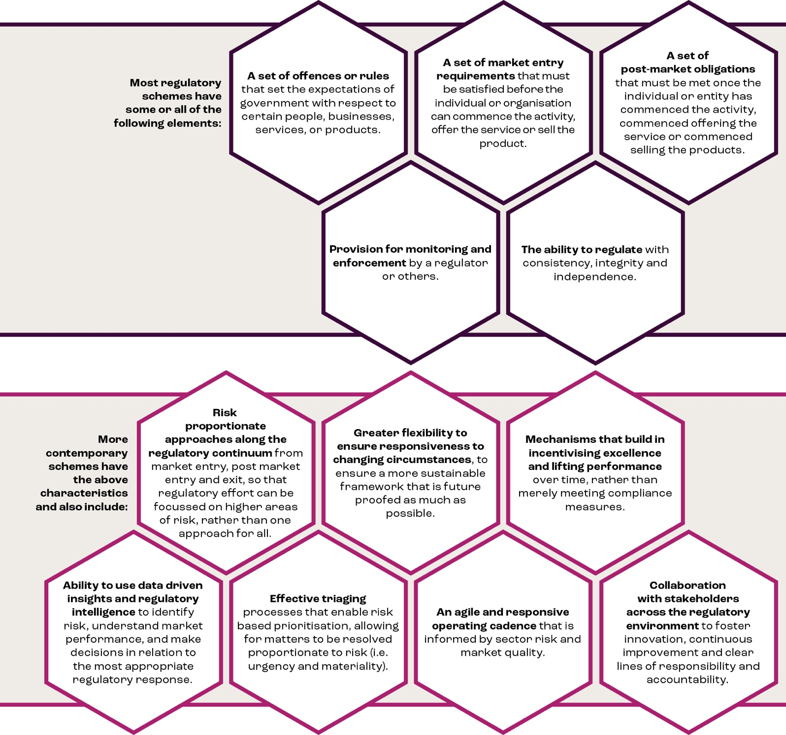Challenges and opportunities under the existing regulatory framework
While the existing aged care legislation has the above elements, the way the elements are described and framed is dated. It has presented a series of challenges with implementing fit for purpose and risk proportionate regulation as described below.
- Provider-centred regulation – Currently the objects of the Aged Care Act and the structure of the aged care legislation, as well as the narrative around the regulation, is focused on approved providers rather than safeguards for senior Australians. There is a unique opportunity to better align with a person-centred, human rights-based approach. The aged care legislation is also premised around each consumer having only one aged care provider. To support increased choice and control for consumers it is important that the regulatory framework enables a senior Australian to receive services from more than one provider and clarity about the responsibilities of each of the providers.
- Alignment – There is currently a lack of legislative alignment between aged care and other areas of the care and support sector creating unnecessary confusion and burden for regulated entities and for workers providing care and services. There is opportunity to better align the sectors, as flagged by the work underway to seek stakeholder feedback.
- Uniform approach to service types – Service offerings differ between providers and there are different risks associated with different types of care and services. For example, services such as lawn mowing present different risks compared to the provision of clinical care in a person’s home. Currently, the aged care regulatory framework does not differentiate home services providers based on the risks associated with their service offering. There is opportunity for the new regulatory framework to differentiate providers so that the level of regulation imposed is proportionate to the risk.
- Corporations as approved providers – The legislation requires all approved providers to be corporations or state/territory governments. It is recognised that some care and services need not be delivered by corporations and that in some cases delivery by individuals is appropriate. This has the potential to expand the workforce available to deliver care and services, and to reduce administrative costs to senior Australians.
- Provider responsibilities – There are currently many approved provider responsibilities, and, in some instances, responsibilities are duplicated in different areas of the law. There is an opportunity to clarify the regulatory obligations and create a stronger connection to the quality outcomes sought. This includes improving reporting responsibilities and using a ‘gather once, use often’ approach.
- Assessment against standards is the minimum requirement to ensure safety - Currently, a provider’s assessment against standards is delivered through a pass or fail status, which does not incentivise excellence or innovation. Graduated assessments allow the regulator and market to have visibility of providers that exceed the minimum requirements. This enables providers to benchmark themselves against others, and identify ways they can further build capability. There is opportunity for the new regulatory framework to support continuous improvement through graduated assessment, paired with targeted education and information.
- Legislation – Some provisions of the aged care legislation are dated and do not reflect contemporary regulatory practice. There is opportunity to improve the readability and structure of the aged care legislation particularly related to regulation.

The future approach to regulating aged care
There are benefits for everyone through the design of a new aged care regulatory framework.

How will I benefit from a new aged care regulatory framework?
Benefits of designing a more contemporary and fit for purpose approach to regulating aged care could include achieving a leading practice, future proof and risk-based framework for key beneficiary groups:

For senior Australians and their families
- is human rights and person-centred
- is principles-based and outcomes focused for safe and quality services for senior Australians
- is accessible and allows for easy understanding and transparency on what to expect from their aged care service provision and line of sight on provider compliance activity
- helps senior Australians and their families to be informed to support them to make informed choice on their preferred provider
- is sufficiently flexible to accommodate the diverse range of senior Australians and their evolving needs and expectations.

For providers and the aged care workforce
- addresses criticisms of the current framework, including that it is a one size fits all approach to providers, is not risk based, lacks capability to use data and intelligence to understand the risks in individual providers and does not differentiate risk across the sector
- will continue to be fit for purpose for future generations, irrespective of policy and funding settings
- supports and enables innovation and continuous improvement across the sector
- keeps pace with the rapidly growing size and scale of the provider and workforce market
- aligns with regulatory requirements across the care and support sectors (where appropriate), allowing mutual recognition of providers and reducing unnecessary regulatory burden for providers and workers operating across the sectors
- requires providers to only meet the obligations relevant and proportionate to the types of care and services they want to provide, ensuring 'right touch' administrative and assurance costs for providers.

For the regulator
- provides the regulator with modern regulatory tools and technology required for efficient and effective oversight of the market
- allows the regulator to focus on market segments of highest risk and remove regulatory barriers to market entry for providers of the lowest risk services
- enables the regulator to better respond to emerging risk; in individual providers, the workforce, market segments or the system, to ensure safe and quality services for senior Australians.
While the above cohorts represent the key beneficiary groups, there are benefits that other stakeholders can expect, including a range of outcomes centred on safeguarding the services provided to senior Australians.

For the Australian community
- expectations that government will support a human rights approach to an end to end system and ensure financial sustainability over the long term
- trust that the system will operate effectively, transparently and accountably
- have collective responsibilities for driving improvements in aged care

For the Government
- promote person-centred care, human rights, equity and choice
- stewardship of quality and safety throughout the system across all level of government, providers, peaks, and advocates
- setting clear expectations around the roles, responsibilities and accountabilities across the system
- ensure coherence across funding policy and regulation

For all stakeholders
- have clarity regarding their role, responsibilities, accountabilities
- have opportunities to raise views and contribute to system design and improvements
We are looking to speak with you in early 2022 about how we might best develop a future aged care regulatory framework to realise these benefits. The successful design of a contemporary and risk proportionate regulatory framework will see a shift in how aged care is regulated compared to the current aged care regulatory framework.
The table below provides an indicative future state view to give you an idea of what this might look like in practice, and how these shifts compare to what is currently in place. The changes support the overarching aims of enhancing quality and safety, building market capability and encouraging innovation and continuous improvement.
Aged Care regulatory framework - future state view
Education
From: | To:
- Known need to enhance information provision to help educate and support senior Australians to access care and engage with providers  - Limited ability to identify areas for further education for providers and workforce  - Limited integration and use of complaints and other information to support education | - Older Australians will have the right information at the right time to support them to access care, engage with providers and raise (and resolve) concerns  - Enable better information sharing across the care and support sector to inform areas for education of providers and workers  - Data and intelligence specific to registration categories and risk can better inform education for providers and senior Australians  - Education supports continuous improvement across the sector and quality care outcomes for senior Australians
Entry (registration, approval, agreement)
From: | To:
- Provider approval by care type, by a lengthy application, dictated by funding model  - One size fits all approval process, not distinguished by entity type or risk  - Barriers to market entry e.g. must be corporation  - Suitability to be approved provider is not routinely retested | - Market entry based on categories with risk proportionate requirements i.e. lower barriers to entry for providers of the lowest risk services  - Scalable to accommodate future market and consumer changes/growth  - Funding model and setting agnostic  - Period of registration aligned to risk (e.g. service category and provider profile)
Rules and standards
From: | To:
- Quality Standards are "one size fits all"  - Lack of differentiation in how requirements apply based on the risks associated with service offering  - There are numerous and duplicated approved provider responsibilities  - Lack of mechanisms to incentivise excellence  - Lack of clarity of how regulatory obligations link to outcomes sought | - Rationalised and coherent provider requirements (focused on outcomes)  - Differentiation of providers so the level of regulation imposed is proportionate to the risk  - Requirements applied specific to different types of providers and different registration categories  - Regulatory obligations have a strong connection to the quality outcomes sought
Monitoring, assessment and reporting
From: | To:
- Inflexible requirements for assessment against Quality Standards, which are based on care type (not service risk or provider profile)  - Binary assessment approach limits visibility over provider performance and identification of opportunities for continuous improvement | - Enhanced risk-based monitoring and reporting (with regulatory tools and effort appropriately focused)  - Re-assess each provider’s suitability to remain registered at regular intervals  - Report on the outcomes of monitoring activity and trends to drive improved quality and safety of care  - Graduated assessment of providers to identify excellence and innovation, to lift sector performance and quality outcomes for senior Australians
Complaints
From: | To:
- Opportunity to increase relevant information sharing between regulators  - Complaints pathway presents limitations on how information can be used in the broader regulatory context | - Strengthening the objects of the legislation to reinforce the importance of complaints, supporting senior Australians to complain and removing barriers to complaint processes  - Better integration and use of complaints and other information to inform the most appropriate actions  - Enhanced use of advocacy to support senior Australians to get the quality of care they deserve  - Sharing of relevant information between regulators particularly where it relates to complaints about breaches of the Care and Support Code of Conduct
Compliance and enforcement
From: | To:
- Complex mix of bespoke monitoring and enforcement powers and powers derived from the Regulatory Powers Act  - Wide range of actions that may be taken depending on who the issue was identified by, or to the Commission (not outcomes focused)  - No incentives for excellence | - Improved regulatory ability to flexibly respond to emerging risks (provider, market, segment or system), including through enhanced data and intelligence  - Streamlined powers and modern regulatory tools to oversight the sector and drive quality through the system  - Apply across all categories, but with market segmentation considerations
Consumer information
From: | To:
- Currently limited to information available on My Aged Care  - Limited visibility of information to allow senior Australians to make informed choices | - More meaningful and more visible to senior Australians to help make informed choices about the care they receive.  - Expanded beyond the detail available on My Aged Care to include an online platform that permits the searchability of providers relevant to categories of care  - Continue publication of certain enforcement actions and reports on monitoring activities

How do we design a new regulatory framework?
The future aged care regulatory framework will be underpinned by a person-centred approach that centres on upholding human rights and supporting the once in a generation reforms to aged care. Government is committed to genuine consultation and design of the detailed framework with stakeholders. More information on how we propose to engage with you is outlined in the Next Steps section of this document.
The proposed approach to regulatory design recognises both the significance of the task and the change for the sector. It comprises of the following stages:
- STAGE ONE - Concept Design of new regulatory model
- STAGE TWO - Development of the detail of the structural elements
- STAGE THREE - Development of structural support to operationalise the new model
- STAGE FOUR - Transition and Implementation

Stage One: Concept Design of a new regulatory framework

The foundations of the future aged care regulatory framework
The future aged care regulatory framework will be developed based on key foundations of contemporary regulation and incorporate the recommendations of the Royal Commission on how to improve the regulation of aged care as a whole. The two key foundations are designing the future framework on a person-centred and risk-proportionate approach.
The development of a new aged care regulatory framework will be underpinned by a set of principles. A summary of the 8 principles is shown in the below diagram, which are further detailed in Attachment A, Principles for the Aged Care Regulatory Framework:
- Principle 1 - The foundations of the future regulatory framework is underpinned by a human right based and person-centred approach
- Principle 2 - The regulatory framework is contemporary, responsive and future-proof in its design and delivery
- Principle 3 - Attention is prioritised to areas of the highest risk
- Principle 4 - Sustainability of the aged care system is enabled without compromise to protections and service quality
- Principle 5 - Regulatory alignment is pursued under the framework where possible
- Principle 6 - Regulation is maintained through a graduated and risk proportionate approach
- Principle 7 - Capability and design is informed by data and intelligence driven insights
- Principle 8 - System stewardship is facilitated through all roles and functions

A person-centred approach
The Government reforms take a person-centred approach. This means people:
- receive safe and quality care and services
- are empowered as partners in their care to make choices that are right for them and to inform improvements to the system
- have equitable access to care and services and get the care they need when they need it
- enjoy quality of life and have a positive experience of care
- have confidence in the aged care system
- have the freedom of choice to select providers they want to engage with
- can readily navigate the aged care system and have access to the information they need to make informed choices about providers and services, and to have any concerns addressed.
Safeguards in the aged care system are required to protect a senior person from risk of not receiving care, receiving the wrong, unsafe or poor quality care. The regulatory design approach will focus on understanding the safeguards required to ensure senior Australians are protected from risks, and then consider and design the rules, obligations and responsibilities that are needed to ensure those risks are avoided or controlled. In line with Principle 8, responsibility and accountability for protecting senior Australians lies with all participants and stakeholders. The person-centred view is shown in Figure 2 below.
Figure 2 – A person-centred system view
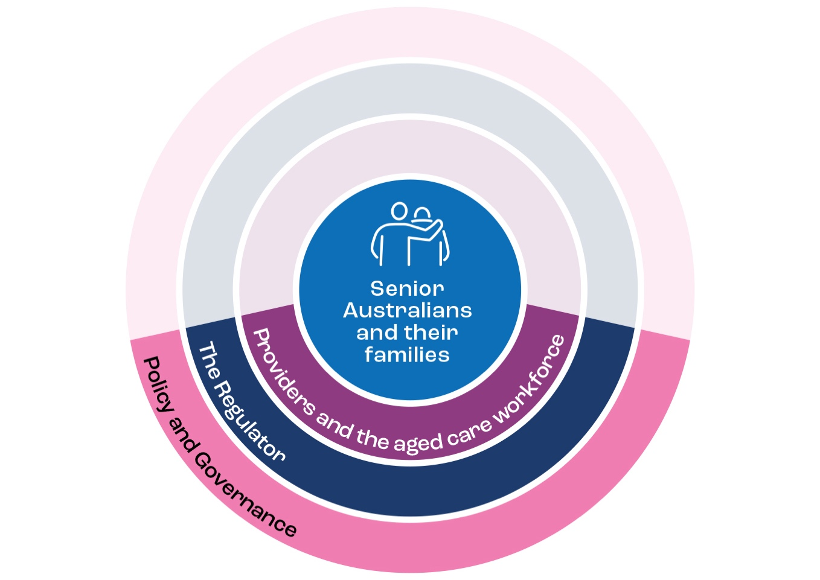

What is risk proportionate regulation and how would this look in a new framework?
Risk proportionate regulation in aged care involves regulatory activities being proportionate to the risks presented in service delivery. The level of regulatory oversight and effort, including monitoring, compliance, enforcement and penalties, are then targeted and proportionate to the harm, risk to the community, urgency and materiality of the situation.
Risk proportionate regulation considers risks from a number of sources, including:
- the risks associated with the care recipients
- the nature of the product or service provided
- the providers delivering the product or service
- how it is delivered.
Providers could be differentiated based on the care and services they provide, with capacity to differentiate providers based on market segmentation, service location, performance and/or the vulnerabilities of the consumer cohorts to which they deliver care and services.
The risk proportionate approach can be taken for regulation of aged care and is captured in Principle 6. This will be important for ensuring that the regulator directs regulatory effort most appropriately. It will also balance regulatory burden, including removing barriers to entry for providers of lowest risk services and allow providers to direct their resources towards delivering better care through innovating and continuous improvement, rather than unnecessary regulatory and administrative compliance costs.

Maintaining protections
It is important to note that a risk proportionate approach to regulating aged care does not mean there is a reduction of regulatory oversight or a lessening of protections for senior Australians. Rather, as captured in Principle 3, there is an opportunity to rebalance regulatory effort to direct it towards areas of highest risk in the sector. Figure 3 shows how the architecture of the framework focuses regulatory oversight according to the risks associated with the service being delivered.
Figure 3 – A risk proportionate approach to regulating aged care
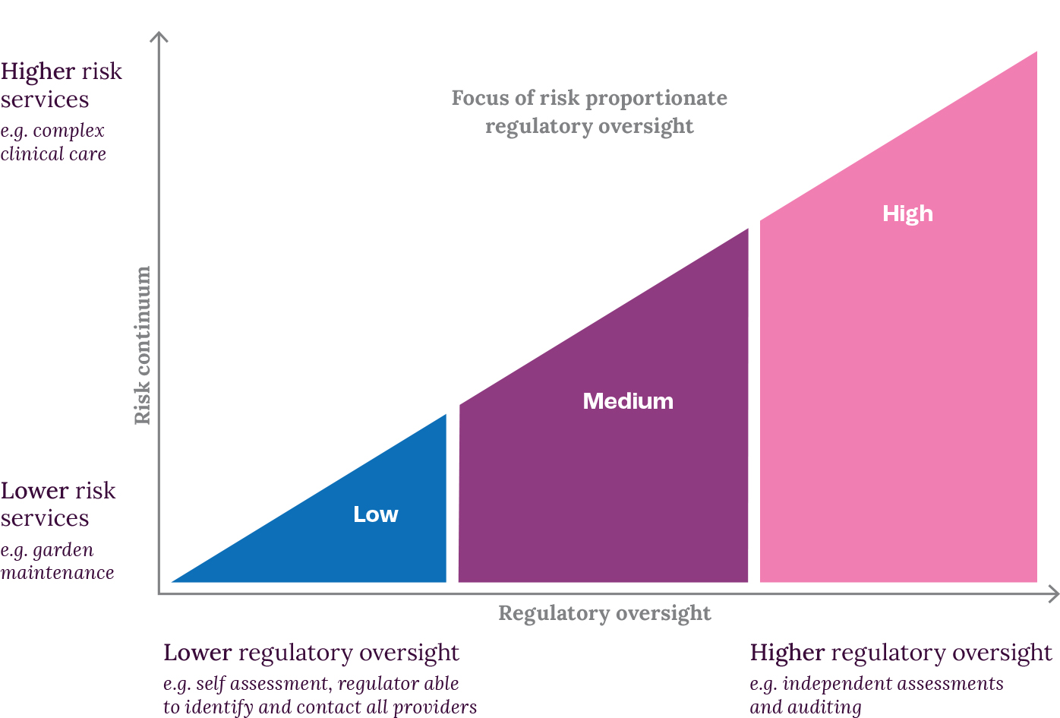

A registration model
A risk proportionate approach can be taken with a registration model. This generally involves the registration of providers that deliver care and services, with different application requirements and ongoing obligations attached to different service categories. The National Disability Insurance Scheme (NDIS) system is a current example of regulation based around a registration model that registers providers proportionate to the risk inherent with supports and services offered, and the size of the provider. The registration process, while a critical part of the regulatory framework, forms one part of the NDIS regulatory functions that works together with all other functions (i.e. complaints, behaviour support, market oversight, compliance and enforcement, investigations and worker screening).
A risk proportionate approach to aged care would consider the safeguards required for consumers, and the regulatory controls that should be in place to achieve them. This could involve establishing registration categories for market entry based on the inherent risks associated with different service categories, including risks associated with;
- the care or service provided
- care recipients
- providers
- workers and government.
Provider obligations, including compliance with the new Aged Care Act and Quality Standards, would be graduated in line with those categories.

A registration model for regulating aged care
Registration categories may feature as a central way for providers to enter the market. Providers may be subject to controls, obligations, monitoring, and enforcement activities during their tenure as a registered aged care provider. The detail of how the future registration may work will be developed in close consultation with stakeholders.
Figure 4 – An end to end concept of a registration model for regulating aged care shows what the new model could look like. This example on the following page is not representing a lifecycle or one-way process, but has been structured around three fundamental stages being considered to frame the future aged care regulatory framework:
- Market entry: the entry requirements placed on providers (including funding agreements) and the screening process of workers to operate in the aged care sector.
- Service Delivery – Controls and obligations: The safeguards applied to protect senior Australians from the risk of not receiving care, receiving the wrong, unsafe, or poor quality care. This is achieved by having fit for purpose controls and risk proportionate provider obligations in place. Activity may include re-registration or the changing of registration categories.
- Market exit: the conditions that require a provider (or registered worker) to exit the aged care sector. This may be due to compliance-based activity, lapsed registration, or the provider self-selecting out of the market.
Figure 4 – An end to end concept of a registration model for regulating aged care
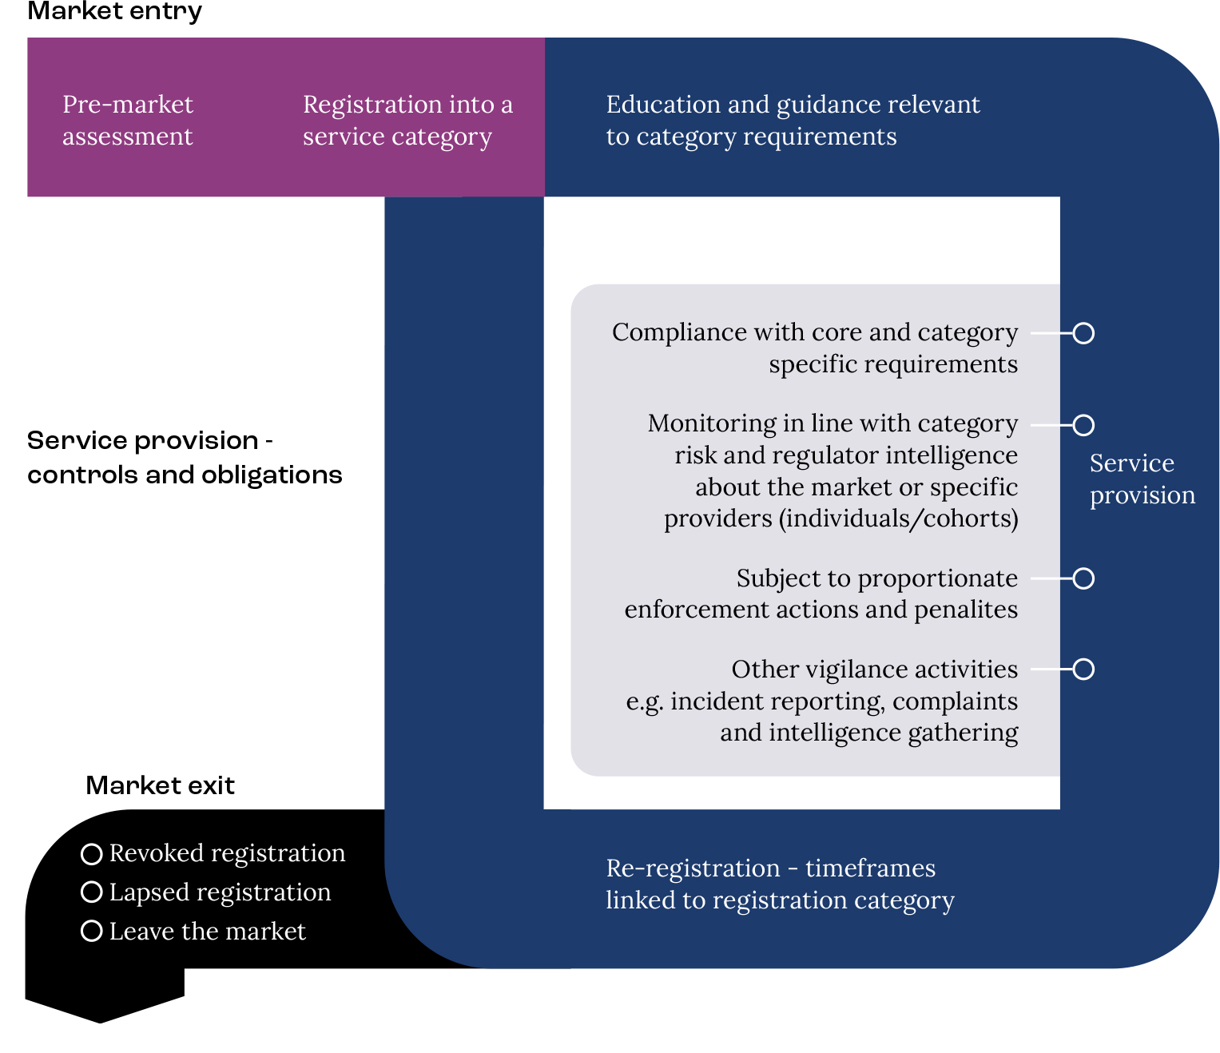

Concluding remarks
This Concept Design forms an important first part of a staged process to communicate and engage with stakeholders through a program of consultation. This paper has discussed ideas for a new approach to regulating aged care.
The regulatory design work is occurring because of the new Support at Home model however it will be built in such a way that it can be applied to all of aged care. The detailed design and how this is operationalised will need to take into account all elements of the aged care system and work in parallel to future policy design.
This Concept Design paper presents ideas only and the Department looks forward to engaging with stakeholders in early 2022 to support a detailed design process of the a new aged care regulatory framework. Parallel consultation will be happening to support the design of the Support at Home model.
To get involved in consultations and keep up to date with the latest information on the aged care reforms and design of the future aged care regulatory framework, go to the Ageing and Aged Care Engagement Hub to:
- Sign up for future consultations
- Respond to consultation papers via a survey or written submission
- Participate in a workshop or focus group, or listen to a webinar.

Attachment A

Principles for the Aged Care Regulatory Framework
The new approach to regulating aged care requires a design process based on a set of principles. The principles will underpin the design of the framework that is required to support the implementation of aged care reforms that address the Royal Commission recommendations.

Principles for the Aged Care Regulatory Framework

Principle 1) The foundations of the future regulatory framework is underpinned by a human right based and person-centred approach
There is a need for a regulatory framework to protect the health and safety of senior Australians, that:
- Is person-centred and flexible, recognising that progression through the system is not necessarily linear, and there is no typical aged care consumer
- Applies end-to-end across the whole aged care system and to all care types
- Provides equitable access to high quality, culturally safe care of their choice
- Is underpinned by legislation that is easy for consumers and providers to understand and for the regulator to administer

Principle 2) The regulatory framework is contemporary, responsive and future-proof in its design and delivery
The aged care regulatory framework should be:
- a contemporary, risk proportionate and principles based framework that protects senior Australians
- Is sufficiently flexible to be future-proof for a growing aged population and growing service market and workforce
- Is sufficiently agile to allow timely response to emerging risks
- Is evidence based and intelligence driven
- supports continuous improvement across the sector to drive quality, safety and innovation

Principle 3) Attention is prioritised to areas of the highest risk
The regulatory framework enables the regulator to direct its efforts to areas of higher risks, and have appropriate powers and flexibility to act on areas of low risk within the market/system.

Principle 4) Sustainability of the aged care system is enabled without compromise to protections and service quality
The regulatory framework should enable an efficient and effective market for the provision of quality services to senior Australians (while maintaining protections) and be financially sustainable into the future

Principle 5) Regulatory alignment is pursued under the framework where possible
The framework should strive for regulatory alignment with other care and support sectors (where it is appropriate to do so) to improve outcomes for consumers, reduce regulatory burden for the market and enhance regulator’s capability

Principle 6) Regulation is maintained through a graduated and risk proportionate approach
To be a contemporary and risk-proportionate regulatory framework there should be a graduated regulatory approach to managing risk, so that it is proportionate/commensurate to the level of risk to the consumer’s safety, based on:
- Stratification of risk across the system, through risk tiering, taking into account the inherent and combined risks of the following risk factors:
- service type delivered to the consumer
- setting in which that service is delivered
- entity/provider delivering the service (structure and behaviour)
- needs of the Consumer and their existing support structures
- workforce capability and culture
- relationship between the consumer and the service deliverer (subcontractor/workforce)
- level of harm/severity of potential consequences of the risk being realised
- applying graduated obligations on providers that are proportionate to their assessed risk, that
- enables light touch regulation for lower risk tiers
- applies additional obligations to the higher risk tiers

Principle 7) Capability and design is informed by data and intelligence driven insights
The regulatory framework should have capability to source, harness and analyse data and other intelligence, including in real time, about
- the person-centred view of pathways through the aged care sector (and other care and support sectors) and the outcomes, for policy and regulatory design and evaluation
- consumer’s and advocates’ experiences, including the ability to notify the regulator of issues, provide feedback and make complaints
- the risk factors to inform a risk proportionate monitoring and compliance strategy, including for quality outcomes for consumers and the proper use of public funding
- the existing and emerging risks in the system or specific entities
- quality providers that are able to innovate for improved outcomes and be exemplars of quality and safety

Principle 8) System stewardship is facilitated through all roles and functions
The framework should facilitate stewardship of quality and safety outcomes for consumers through the entire system, through:
- Appropriate allocation of responsibility and accountability to all participants/stakeholders in the system
- policy, culture, behaviour, and regulation
- coalitions/collaboration with all stakeholders, including consumers
- a framework that is simple to understand and navigate by consumers, advocates, providers, workforce and assessors and the wider community

Human Rights | United Nations Human rights are rights inherent to all human beings, regardless of race, sex, nationality, ethnicity, language, religion, or any other status. Human rights include the right to life and liberty, freedom from slavery and torture, freedom of opinion and expression, the right to work and education, and many more. Everyone is entitled to these rights, without discrimination.

