A new framework for regulating aged care
Australian Government Department of Health
February 2022
Contents

About this document 3
How to get involved 3
Introduction 4
Problems with the current framework 4
A new aged care framework 4
What is a regulatory framework? 5
How do we design the new framework? 6
The basis of the new framework 6
Conclusion 9

About this document
At the Department of Health, we want to update and improve aged care. We want to make sure our aged care system meets the needs of senior Australians.
This document will tell you some of our ideas about how changes to aged care regulation might help to achieve this.

How to get involved
Would you like to have your say? In 2022 we will consult a lot of people and get their ideas too.
Please go to our Engagement Hub at https://agedcareengagement.health.gov.au/ and choose ‘Sign up’.
We will often update the information on the Engagement Hub. You can check back and respond to the different surveys there.

Introduction
In 2021 a Royal Commission reported on aged care in Australia. It made many recommendations about how to improve it. You can read about these recommendations here: https://agedcare.royalcommission.gov.au/
As a result, the Government will spend $17.7 billion to reform aged care. The reforms will take place over a period of five years.
There are five key areas of reform:
- Pillar 1: Home care – supporting senior Australians who choose to remain in their own home
- Pillar 2: Residential aged care services and sustainability – improving and simplifying residential aged care services and access
- Pillar 3: Residential aged care quality and safety – improving residential aged care quality and safety
- Pillar 4: Workforce – supporting and growing a better skilled care workforce
- Pillar 5: Governance – new legislation and stronger workforce
The focus of the reforms will be on meeting the needs of senior Australians, including:
- Protecting their safety
- Protecting their rights.

Problems with the current framework
The current framework is out of date. For example:
- It focuses on service providers, rather than senior Australians themselves.
- It offers a ‘one size fits all’ approach to regulating service providers.
- It does not fit in with other care and support frameworks.
- It assesses service providers through a ‘pass’ or ‘fail’ only. This does not encourage excellence.

A new aged care framework
We will develop a new, modern framework for regulating aged care. This will include brand new laws.
Our fresh, modern approach will protect the human rights of senior Australians. Human rights include the right to life and liberty. Everyone is entitled to human rights, without discrimination.
The framework will ensure safe, high-quality care and support for senior Australians. It will:
- be accessible
- be flexible enough to suit the diverse and changing needs of senior Australians
- be clear and easy to understand
- allow senior Australians to choose their preferred service providers
- fit in with other care and support frameworks – for example, the National Disability Insurance Scheme (NDIS) and veteran care.
The framework will also cover the Support at Home Program that will start in July 2023. This new program will support senior Australians who want to stay in their own homes for longer.
The framework will be ‘future-proof’. This means it will not only be effective for now. It will also be effective for future generations.

What is a regulatory framework?
Regulation has core functions that regulators use to ensure quality and provide safeguards for users of regulated services. A regulatory framework is the term used to describe how these functions are arranged and applied in the sector. The regulatory functions are:

Education
Making information and education available:
- for providers about obligations and how to comply with them
- for consumers and people receiving care, about what they should expect from services delivered.

Entry (registration, approval, agreement)
Approving providers, providing funding, and screening workers to operate in a sector.

Rules and standards
Enforcing rules, codes and standards providers and workers must meet – for example:
- codes of conduct
- quality and practice standards
- a support strategy for an individual, to try to avoid the need for the use of practices that restrict or restrain them.

Monitoring, assessment and reporting
Using information to assess how well providers and workers are meeting the regulations – for example:
- reports about incidents
- the quality of services a provider delivers and how well they meet the rules for providing those services
- other information on activity, financial position, or performance.

Complaints
Making sure:
- complaints from consumers, families and the public about providers and workers are managed
- providers meet certain rules about how they must handle complaints.

Compliance and enforcement
The oversight of provider and worker compliance to their obligations and sanctioning them if they don’t - for example, issuing:
- infringement notices
- directions to do things
- penalties
- bans.

Consumer information
Making information available about the quality of services and how well providers comply with the rules. This helps consumers and their families make informed choices about the services they use - for example:
- public registers of providers
- quality indicators
- star ratings.

How do we design the new framework?
We will consult with a wide range of people involved in aged care. These will include senior Australians, their families and service providers.
Our approach to designing the new framework involves four stages:
- STAGE ONE – ‘concept design’ – planning the new framework
- STAGE TWO – developing details of how the new framework will operate
- STAGE THREE – developing structures to support the new framework
- STAGE FOUR – working out how to put the new framework into operation
This document sets out our early work in Stage 1.

The basis of the new framework
We will base the new framework on modern approaches to regulation. The framework will also incorporate the recommendations of the Royal Commission.
At the heart of the new framework will be several principles. These include:
- The foundation of the new framework will be a ‘person-centred approach’.
- Regulation will be ‘risk-proportionate’.
We explain both of these principles below.

A person-centred approach
A person-centred approach to aged care means that senior Australians:
- receive safe, high-quality care and services
- are partners in their own care – they make the choices that are right for them
- get the care they need when they need it
- enjoy quality of life
- have a positive experience of care
- have confidence in the aged care system
- have the freedom to choose their own service providers
- can find their way around the aged care system
- have access to the information they need to make informed choices
- can have any concerns addressed.
There will be safeguards in the new framework to protect senior Australians from:
- not receiving care
- receiving the wrong care
- receiving unsafe or poor-quality care.
A person-centred system view
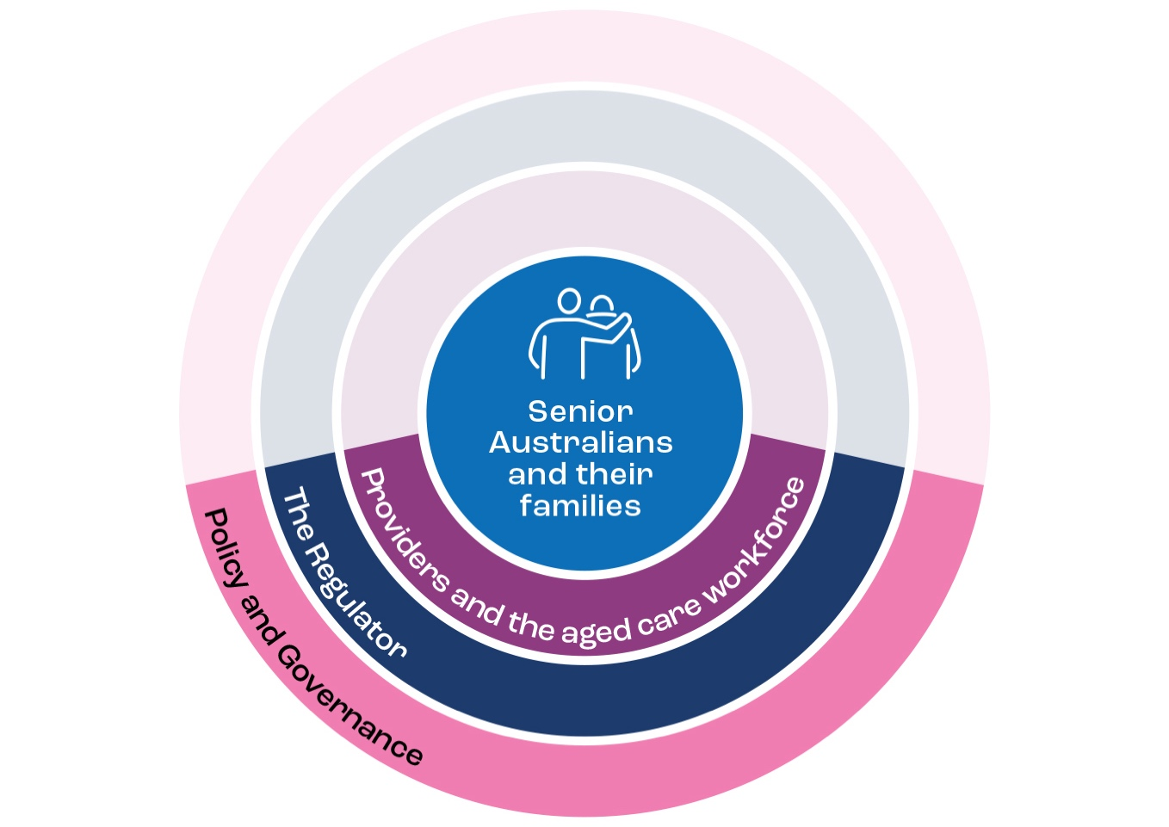

A risk-proportionate approach
A risk-proportionate approach means that regulation is in proportion with the risks involved. It responds to the risk. These risks include those associated with:
- the senior Australian who is receiving care
- the nature of the product or service
- the service provider delivering the product or service
- how the service provider delivers the product or service.
Regulatory activities include:
- educating
- monitoring
- checking compliance
- enforcement
- issuing penalties.
In risk-proportionate regulation, these activities are targeted. They consider the risk of harm, the risk to the community and the urgency of the situation.
- This removes barriers to entry into the aged care market for providers of low-risk services.
- It means service providers don’t have to deal with unnecessary administration. They can focus on delivering better care.
- The regulator will be able to focus on the highest risk parts of the sector and new risks that are emerging in the sector.
A risk-proportionate approach does not mean less protection for senior Australians. It means that regulatory activities focus on high-risk areas.
A risk proportionate approach to regulating aged care
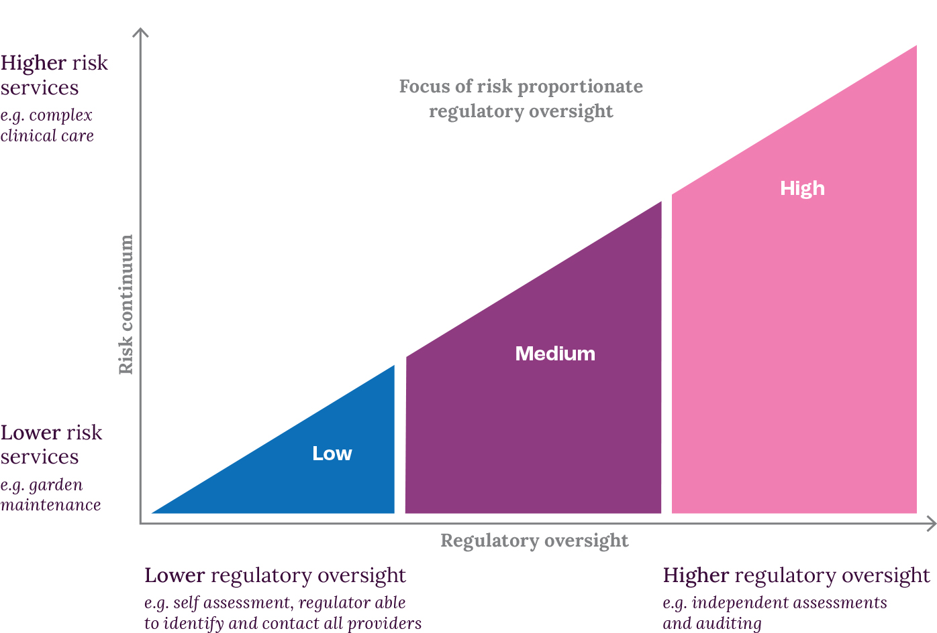

A registration model
One example of a risk-proportionate approach is a registration model. A registration model would involve:
- the registration of service providers
- different requirements attached to different types of service.
The NDIS system is an example of regulation based around a registration model.
The detail of how a future registration model may work in aged care will be developed in close consultation with stakeholders. We are considering three stages of the future aged care regulatory framework:
- Market entry: There could be different categories for service providers who want to enter the aged care market. These would be based on the risks of particular services. There would also be a screening process for those wanting to work in aged care.
- Service delivery: There would be safeguards to protect senior Australians. The rules applied to service providers and the obligations they need to meet would be based on the risks of particular services they deliver.
- Market exit: There would be conditions requiring a service provider to leave the aged care sector – for example, if they fail to follow registration requirements, or want to stop providing services.

Conclusion
This document is an important part of Stage 1 in designing the new aged care framework.
We look forward to consulting with many people who have an interest in aged care. This will help us continue our work on the new framework.
Remember, if you want to get involved:
- Please go to our Engagement Hub at https://agedcareengagement.health.gov.au/ and choose ‘Sign up’.
- We will often update the information on the Engagement Hub. You can check back and respond to the different surveys there.

