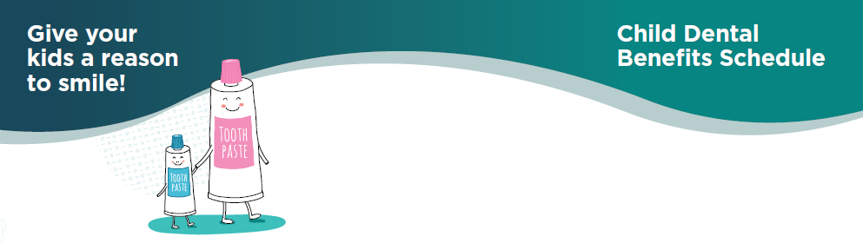

Child Dental Benefits Schedule
  - Give your kids a reason to smile!

Get up to $1,026* towards your kids dental care
Find out if your kids are eligible

The Child Dental Benefits Schedule
The Child Dental Benefits Schedule (CDBS) covers part or the full cost of some dental services for eligible children.

What is covered
Eligible children can access up to $1,026 for basic dental services over 2 calendar years.
The services covered include:
- dental check-ups
- cleaning
- x-rays
- fissure sealing
- fillings
- root canals
- extractions.
At your appointment check what each service will cost and if the CDBS covers the full cost of those services.
The CDBS does not cover:
- orthodontics
- cosmetic dental work
- any dental services in a hospital

Check if your child is eligible
You don’t need to apply or register for the CDBS. If your child is eligible, you will automatically receive a letter to let you know.
Your child is eligible when:
- they are eligible for Medicare
- they are under 18
- they receive an eligible payment at least once that year, or you receive one as their parent or guardian.
You can find a list of eligible payments when you visit servicesaustralia.gov.au and search ‘child dental benefits schedule’.
If you aren’t sure if your child can access the CDBS this year, you can either:
- check your Medicare online account through MyGov at my.gov.au
- call Medicare on 132 011.

Finding a Dentist
You can get child dental benefits for services at most dentists, whether they are public dental services provided by your State or Territory Government or private dental practices.
When you book an appointment:
- let your dentist know that you want to use the CDBS, and
- ask how much funding you have available under your CDBS cap.
Public or Private
A public dentist using the CDBS will bulk bill you and there will be no out-of-pocket expenses. Some private dentists bulk bill CDBS services.
Private dentists who do not bulk bill may charge a gap fee for services.
Ask your dentist when you book your appointment.
To find a dentist who bulk bills, use the ‘find a health service’ tool on the healthdirect website at: https://www.healthdirect.gov.au/australian-health-services.

For more information on the Child Dental Benefits Schedule:
- Visit health.gov.au/CDBS or servicesaustralia.gov.au and search for ‘child dental benefits schedule’.
- Call Services Australia on 132 011.
- Ask your dentist about the CDBS!

Amount indexed annually, this is the CDBS cap amount for 2022.

