Second report on the operation and effectiveness of COVIDSafe and the National COVIDSafe Data Store

16 May 2021 to 15 November 2021

December 2021

Title: Second report on the operation and effectiveness of COVIDSafe and the National COVIDSafe Data Store

ISBN: 978-1-76007-463-0

Online ISBN: 978-1-76007-464-7

Publications Number: DT0002432

Copyright

© 2021 Commonwealth of Australia as represented by the Department of Health

This work is copyright. You may copy, print, download, display and reproduce the whole or part of this work in unaltered form for your own personal use or, if you are part of an organisation, for internal use within your organisation, but only if you or your organisation:

1. do not use the copy or reproduction for any commercial purpose; and
2. retain this copyright notice and all disclaimer notices as part of that copy or reproduction.

Apart from rights as permitted by the *Copyright Act 1968* (Cth) or allowed by this copyright notice, all other rights are reserved, including (but not limited to) all commercial rights.

Requests and inquiries concerning reproduction and other rights to use are to be sent to the Communication Branch, Department of Health, GPO Box 9848, Canberra ACT 2601, or via e-mail to copyright@health.gov.au.

# Foreword

I present this, my second report on the operation and effectiveness of COVIDSafe and the National COVIDSafe Data Store (NCDS), to both Houses of Parliament as required under section 94ZA of the *Privacy Act 1988*. This report covers the period 16 May 2021 to 15 November 2021.

From 26 April 2020 to 15 November 2021, 7,763,991 people have registered to use the COVIDSafe app. For the period of this report, 345,663 people have registered for the COVIDSafe app.

Since its launch, 792 COVIDSafe users, who tested positive for COVID-19, have consented to upload their COVIDSafe data to the NCDS. This has resulted in more than 1.65 million digital handshakes uploaded to the NCDS, and 2,829 potential close contacts identified from more than 37,600 encounters[1].

For the period of this report, from 16 May 2021 to 15 November 2021, 13 COVIDSafe users, who tested positive for COVID-19, have consented to upload their COVIDSafe data to the NCDS. This has resulted in around 331 digital handshakes uploaded to the NCDS, and two potential close contacts identified from nine encounters.

Following a government decision to change the remit of the Digital Transformation Agency (DTA) from service delivery to managing the whole-of-government approach to data and digital policies, and IT procurement, the responsibility for the technical administration of COVIDSafe was moved to the Department of Health (the department). On 5 October 2021, the department became the National COVIDSafe Data Store administrator.

COVIDSafe remains part of the suite of tools available for Public Health Officials (PHOs) to use in contact tracing. Importantly, during this period, the Australian Government worked with jurisdictions to adjust the COVIDSafe app algorithm to better reflect the highly transmissible nature of the Delta variant of COVID-19.

Work has continued to closely monitor the effectiveness of the privacy controls, and to ensure that privacy risks are addressed.

COVIDSafe has made a positive contribution to identifying and verifying COVID-19 contacts and, in combination with other tools, plays a role in supporting contact tracing processes by jurisdictions.

# Purpose of this report

This report discusses the operation and effectiveness of COVIDSafe and the NCDS, for the period 16 May 2021 to 15 November 2021.

The report is delivered to Parliament by the Minister for Health in accordance with section 94ZA of the *Privacy Act 1988* (Act).

# Operation of the COVIDSafe app and the National COVIDSafe Data Store

Throughout this reporting period, the technical operation of the app was maintained to a high standard. The COVIDSafe app continues to successfully register handshakes between user devices, based on uploaded data. This has been evidenced through close monitoring of the operation and performance of the app’s hosting environment.

To support the ongoing operation of COVIDSafe, enhancements were made through a number of updates to the app. Further details of these enhancements are provided below.

Responsibility for the technical administration of the COVIDSafe app was transferred to the department, along with the NCDS administrator role, following a government decision to change the remit of the DTA from service delivery to managing the whole-of-government approach to data and digital policies, and IT procurement.

To ensure a seamless transfer, a notifiable instrument was enacted to allow for the DTA and the department to be joint NCDS administrators under the Act for a transition period from 27 September 2021 to 4 October 2021.

From 5 October 2021, the department has been solely responsible for the ongoing development and operation of the COVIDSafe system and ensuring the proper functioning, integrity, and security of COVIDSafe app and the NCDS. The existing privacy provisions and strong security safeguards remain enshrined in the Act, protecting the personal information of app users. Bilateral Agreements between the department and all states and territories also remain in place to support the appropriate collection, use and disclosure of COVIDSafe data.

## Algorithm change

The government has worked with states and territories through the Australian Health Protection Principal Committee (AHPPC) to adjust the COVIDSafe app algorithm to better reflect the highly transmissible nature of the Delta variant of COVID-19. Changes to the COVIDSafe Health Portal, where PHOs access COVIDSafe data for contact tracing, were deployed on 15 October 2021.

The algorithm originally identified potential close contacts based on encounters between two users within 1.5 metres of each other for 15 minutes duration or more, reflecting health advice at the time. The changes allow PHOs to view encounters for both one minute and 15 minutes, providing them greater control to identify potential close contacts of people who have been diagnosed with COVID-19.

The changes to the algorithm have not impacted the experience of COVIDSafe app users or the strict privacy provisions surrounding their data.

## Updates to the COVIDSafe app

Since my last report, four updates to the COVIDSafe app have been released. The updates have supported the ongoing operation of COVIDSafe. The table below provides a summary of each version release of the app since the last report.

### Table: COVIDSafe app release updates

| **Version** | **Release Date** | **Summary** |
| --- | --- | --- |
| Version 2.6 | 11 May 2021 | * Added guidance to explain that registration is not available to those using an international sim card. * Added security measures to prevent multiple app registrations. * Back end performance updates. |
| Version 2.7 | 6 June 2021 | * Included date and time on the home screen to clarify when statistics were updated. * Updates to allow registrations to occur from Norfolk Island. * Corrected the Norfolk Island flag in the registrations process (IOS-Apple). * Added additional detail explaining why International users are unable to register when outside Australia. |
| Version 2.8 | 1 July 2021 | * Added [cases] ‘under investigation’ statistics to the COVIDSafe app home screen. * Back end coding updates. |
| Version 2.9 | 8 November 2021 | * Improved registration process for parental consent for users under 16 years old. * Updated translations for new content. * Added ‘contact us’ link in the Privacy Policy screen. * Back end updates for Android compatibility (android only). |

# Effectiveness of the COVIDSafe app and the National COVIDSafe Data Store

Since the commencement of COVIDSafe to 15 November 2021, COVIDSafe has reported:

o 792 uploads.

o 1.654 million handshakes.

o 37,677 encounters; and

o 2,829 potential close contacts.

For the period 16 May 2021 to 15 November 2021 the figures increased from:

o 779 uploads to 792 (increase of 13)

o 1.653 million handshakes to 1.654 million (increase of 330)

o 37,668 encounters to 37,677 (increase of nine); and

o 2,827 potential close contacts to 2,829 (increase of 2).

An encounter is classified as an interaction that includes handshakes that meet the agreed parameters for access by contact tracers (i.e. within 1.5 metres for 15 minutes or more). It is too early to measure the impact of the change to the algorithm that came into effect on 15 October 2021. A more detailed breakdown of COVIDSafe activity statistics is provided at Attachment A.

Jurisdictions continue to access the Health Portal and COVIDSafe remains part of the suite of tools available for contact tracers to identify close contacts. In 2020, NSW successfully accessed the data to identify around 81 close contacts, including 17 contacts that were not identified by manual contact tracing. In one instance, their access to COVID App data revealed a previously unrecognised exposure date from a known venue, Mounties. As a result, an additional 544 contacts were identified. Of these, two were subsequently confirmed to have COVID-19.

### Chart: Weekly national COVIDSafe registrations in 2021

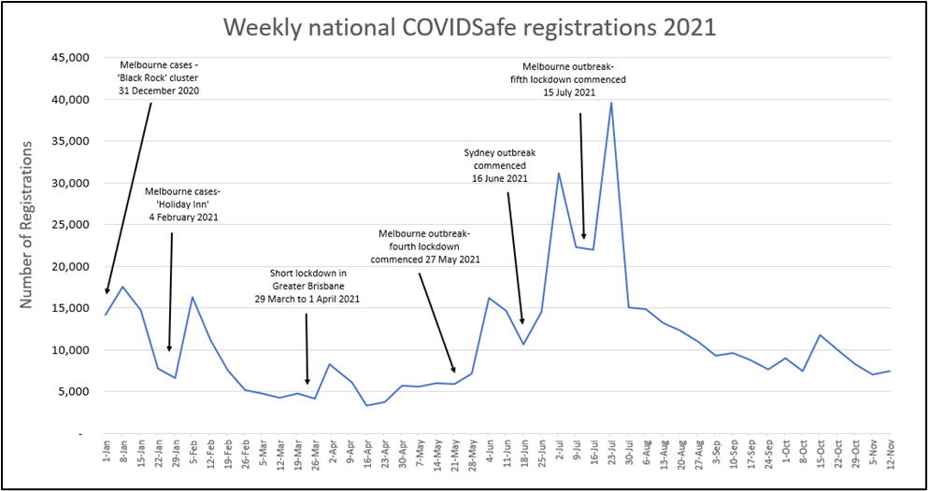

The chart shows the number of weekly national COVIDSafe app registrations from 1 January 2021 to 12 November 2021. The increase in the number of registrations appear to align with identification of positive case increases and lockdowns in jurisdictions throughout 2021.

In early 2021, weekly registrations peaked on 8 January, 5 February, and 1 April. Around these times a number of jurisdictions had small outbreaks and short lockdowns imposed.

Following the commencement of the Sydney outbreak on 16 June 2021, there was a significant increase in national registrations on COVIDSafe. In the five weeks since the start of the Sydney outbreak, there were more than twice as many registrations (25,902 registrations) of the app nationally, compared to the previous five weeks (10,894 registrations). Similarly, after fourth and fifth lockdowns commenced in Melbourne, weekly registration numbers increased.

The COVIDSafe app is supported by state and territory governments through the AHPPC, which endorsed a change to the algorithm in response to the emergence of the more transmissible Delta variant of COVID-19. This change makes the app more effective for PHOs to detect encounters and potential close contacts from uploaded data of COVID-19 positive cases.

In the period 16 May 2021 to 15 November 2021, 25 PHOs received training and access to the Health Portal. The department continues to engage and consult with state and territory officials through the Implementation Management Committee.

# Privacy

The legislated framework governing the collection, use and protection of COVIDSafe data has been pointed to by privacy experts and academics as an exemplar of privacy standards that should be followed by jurisdictions when conducting data collection for COVID related activities such as contact tracing and quarantine. The department and the DTA have worked closely to monitor the effectiveness of the privacy controls, and to ensure that privacy risks are addressed. The COVIDSafe app Privacy Policy and collection notices are also regularly reviewed and updated as necessary.

Updates have been made to the COVIDSafe app and guidance materials for PHOs to enhance the process of confirming consent has been provided for users under 16 years of age, and voluntary consent is obtained from a person acting on behalf of someone who does not have the capacity to do so. These changes further strengthen the processes and procedures for PHOs as they interact with users of COVIDSafe by providing additional guidance on how to better meet consent requirements to collect personal information under the Australian Privacy Principles.

# Conclusion

The COVIDSafe app continues to play a role, as one of the tools available, to complement the manual contact tracing processes of state and territory PHOs.

National Cabinet has agreed in the National Plan to transition Australia’s National COVID-19 Response to post vaccination settings focussed on prevention of serious illness, hospitalisation, and fatality, and the public health management of other infectious diseases. While the role of contact tracing will diminish as we transition into living with COVID-19, it is important to maintain tools such as this to assist contact tracers manage outbreaks and reduce the spread of COVID-19 where possible.

I encourage Australians to register and use the app and thank those who have participated in the important work of stopping the spread of COVID-19 in the Australian community.

# Attachment A – COVIDSafe app activity statistics

## Reporting period – cumulative from 16 May 2021 to 15 November 2021

For the purposes of this report encounters are defined as interactions that are within 1.5 metres for 15 minutes or more. Encounters of 1 minute or more in duration are not included in this report.

|  | NSW | VIC | QLD | SA | WA | TAS | NT | ACT | TOTAL |
| --- | --- | --- | --- | --- | --- | --- | --- | --- | --- |
| Uploads by COVIDSafe users who tested positive to COVID-19 | np | 12 | np | np | np | np | np | 13 | np |
| Handshakes contained in the uploads | np | 330 | np | np | np | np | np | 331 | np |
| Encounters contained in the uploads that are within 1.5 metres for 15 minutes or more | np | 9 | np | np | np | np | np | 9 | np |
| Unique potential close contacts generating the uploaded handshakes within 1.5 metres for 15 minutes or more | np | np | np | np | np | np | np | np | np |

Note: np – not published as these relate to a very small number of uploads.

## Reporting period – cumulative from 26 April 2020 to 15 November 2021

|  | NSW | VIC | QLD | SA | WA | TAS | NT | ACT | TOTAL |
| --- | --- | --- | --- | --- | --- | --- | --- | --- | --- |
| Uploads by COVIDSafe users who tested positive to COVID-19 | 125 | 661 | np | np | np | np | np | np | 792 |
| Handshakes contained in the uploads | 251,153 | 1,396,574 | 3,293 | np | 955 | 2,026 | np | np | 1,654,001 |
| Encounters contained in the uploads that are within 1.5 metres for 15 minutes or more | 10,792 | 26,414 | 190 | np | 170 | 111 | np | np | 37,677 |
| Unique potential close contacts generating the uploaded handshakes within 1.5 metres for 15 minutes or more | 1,041 | 1,733 | 34 | np | 12 | 9 | np | np | 2,829 |

Note: np – not published as these relate to a very small number of uploads.

### Key definitions

Uploads: Number of unique people who have had their data uploaded to the NCDS.

Handshake: A single Bluetooth exchange between two devices. Contact details such as date, duration, and proximity are collected around the handshake.

Encounter: An encounter is an interaction between two people who have the COVIDSafe app who have been in contact of within 1.5 metres for 15 minutes or more. The algorithm change to one minute was implemented on 15 October 2021, so resulting data has not been included in this report.

Potential Close Contact: Number of potential close contacts identified after the data of a positive case has been uploaded.

Health.gov.au

All information in this publication is correct as at December 2021

1. An encounter is classified as an interaction that includes handshakes that meet the agreed parameters for access by contact tracers (i.e. within 1.5 metres for 15 minutes or more).