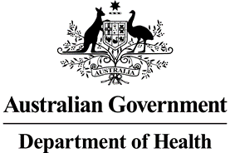

**Nurse Practitioner 10 Year Plan Steering Committee**

**Meeting Communique 12 November 2021**

The second Nurse Practitioner 10 Year Plan Steering Committee (NPSC) meeting was held on 12 November 2021. The focus of the meeting was directed to consideration of the consultation paper and survey questions that will form part of the public consultation for the Nurse Practitioner 10 Year Plan.

The first round of public consultation is intended to guide and shape the development of the Nurse Practitioner 10 Year Plan. The Committee provided insight and feedback around the key messaging of the consultation paper. The paper provides background information about the current arrangements for nurse practitioners in Australia and highlights some of the issues that have been raised by stakeholders to date. This paper, together with a survey, are available on the Department of Health’s [Consultation Hub.](https://consultations.health.gov.au/health-workforce/nurse-practitioner-10-year-plan-survey) Online submissions can be made until 20 December 2021.

The Chief Nursing and Midwifery Officer, Adjunct Professor (Practice) Alison McMillan PSM, noted that continued collaboration, strategic alignment and stakeholder contribution was essential to the development of the Nurse Practitioner 10 Year Plan.