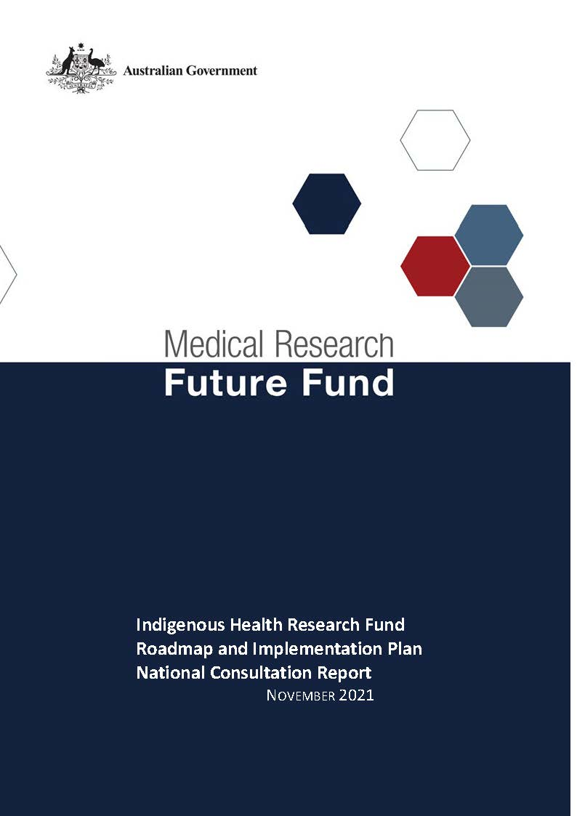

Table of Contents

Introduction 2

Community participation and submissions 3

Responses to national consultation submissions 4

# Introduction

The Medical Research Future Fund’s (MRFF) Indigenous Health Research Fund was announced as part of the 2019-20 budget. The Indigenous Health Research Fund will provide $160 million over 11 years to support research to improve the health of Aboriginal and/or Torres Strait Islander people.

An Expert Advisory Panel was established to provide advice to the Minister for Health and Aged Care on the strategic priorities for research investment through the Indigenous Health Research Fund. As per the Minister’s agreed [Governance arrangements for MRFF Missions](https://www.health.gov.au/resources/publications/mrff-mission-governance), the Expert Advisory Panel has provided advice on priorities for research investment through the Mission by developing a Roadmap and Implementation Plan.

The Roadmap is a high-level strategic document that includes the aim, vision, goal and priorities for investment for the Indigenous Health Research Fund. To support the Roadmap, the Implementation Plan outlines the priorities for investment (short, medium and long term), evaluation approaches and measures, supporting activities, and collaborative opportunities. The Roadmap and Implementation Plan will be used by the Department of Health to design and implement Indigenous Health Research Fund investments via Grant Opportunities promoted through GrantConnect ([grants.gov.au](https://www.grants.gov.au/)).

A draft Roadmap and Implementation Plan developed by the Expert Advisory Panel underwent international review on 17 March 2021; the outcome of the review is outlined in a [report endorsed by the International Review Panel](https://www.health.gov.au/initiatives-and-programs/indigenous-health-research-fund-initiative).

A national consultation to seek feedback from the community on the Indigenous Health Research Fund’s draft Roadmap and Implementation Plan was conducted over the period 14 December 2020 to 23 April 2021, during which time submissions were accepted through the Department’s [consultation hub](https://consultations.health.gov.au/health-economics-and-research-division/mrff-ihrf/).

During the consultation, the Co-Chairs of the Expert Advisory Panel hosted two webinars, on 23 and 30 March 2021. This gave an opportunity for the community to gain a greater understanding of the purpose of the Roadmap and Implementation Plan and ask questions, prior to providing written submissions to the consultation.

The following questions were provided on the consultation hub to guide submissions:

1. Are the priority areas for investment identified in the Implementation Plan the most effective way for delivering on the Indigenous Health Research Fund's goal and aims?
2. Are there existing research activities which could be utilised to contribute to the Indigenous Health Research Fund Roadmap and/or Implementation Plan aims and priority areas for investment? How can these be leveraged?
3. Are the ‘Evaluation approach and measures’ appropriate for assessing and monitoring progress towards the Indigenous Health Research Fund's goal and aims?

This report summarises the national consultation through webinar participation and written submissions.

## Community participation and submissions

49 stakeholders (from 115 registrations) attended the two webinars from across all states and territories of Australia. A diverse range of stakeholders participated including those from: research organisations (including universities and medical research institutes); Aboriginal and Torres Strait Islander health providers; advocacy groups; government agencies; and individual community members.

At the close of the consultation period, 13 written submissions were received via the consultation hub, representing research organisations (including universities and medical research institutes), Aboriginal and Torres Strait Islander health providers and advocacy groups.

The Expert Advisory Panel considered all responses from the national consultation and, where relevant, revised the Roadmap and Implementation Plan. A summary of the feedback from the submissions and the Expert Advisory Panel’s responses are outlined below.

# Responses to national consultation submissions

|  |  |  |
| --- | --- | --- |
| **Consultation Question** | **Submission Feedback / Themes** | **Action by Expert Advisory Panel (the Panel)** |
| **Are the priority areas for investment identified in the Implementation Plan the most effective way for delivering on the Indigenous Health Research Fund's goal and aims?** | * Ensure that there is investment into laboratory and discovery research as this is essential for addressing the lack of knowledge around disease mechanisms and for the development of novel therapeutic interventions. | * The Panel agreed that there will be no barrier to funding such research through the small-scale and early-stage developmental projects identified in the Implementation Plan. |
| * A decolonising approach should be taken in reviewing the Roadmap and Implementation Plan which involves more than having Aboriginal and Torres Strait Islander leadership, it involves focussing on the strengths, capacity and resilience of peoples and knowledges that have been colonised. | * The Roadmap and Implementation Plan were amended to make reference to the unique knowledge, strengths and endurance of Aboriginal and Torres Strait Islander communities. |
| * Ensure investment targets the large rural and regional populations of Australia. | * The Implementation Plan states the need to support research for such populations, with priorities that include a focus on such populations. No changes were recommended. |
| * Reference that transformative health and medical research requires long-term collaborative research. | * The Roadmap and Implementation Plan state that long-term, collaborative and sustained research efforts are needed to address the outlined challenges. * To further emphasise this, several priorities in the Implementation Plan have been amended to make clear that there needs to be investment in large-scale multidisciplinary projects and consortia. |
| * Priority areas for investment need to have a cross-cutting approach that reflect system changes, rather than a focus on a specific disease or issue. It is essential the root cause of inequity is addressed in all areas and imbedded in the priority areas. | * The Panel agreed that given that this is a stated overarching objective of the fund and are the priorities within Aim 4: ‘Address the root causes of inequality’, that no further additions were required. |
| * Ensure that the issues of data sovereignty are considered. | * The Roadmap lists Indigenous data sovereignty and governance as an enabling priority of the fund. * To further emphasise this, the Roadmap and Implementation Plan were amended to align with the National Agreement on Closing the Gap and its emphasis on Aboriginal and Torres Strait Islander Data governance. |
| * Greater clarity that the fund will facilitate truly community-led research and demonstrable involvement with, input from, co-design and true partnerships with Aboriginal and Torres Strait Islander people communities and community-controlled health services. | * The Roadmap was amended to include an additional overarching focus of facilitating involvement in, leadership of, input from and co-design with Aboriginal and Torres Strait Islander people and communities. * A number of priorities have also been amended to include a focus of the community-control health services and community involvement. * The Roadmap and Implementation Plan were amended to align with the National Agreement on Closing the Gap and its emphasis on the importance of Shared Decision Making and Building the Community Controlled Sector. |
| A number of specific areas were suggested for funding including:   * Blindness prevention * Liver disease and liver cancer * Incontinence * Social and emotional wellbeing * Mental health * Preventing spread of infectious diseases (STIs, respiratory viruses, including COVID-19) * Chronic diabetes * Enhancing Aboriginal and/or Torres Strait Islander communities response to medical emergencies, including providing first responder support * Research to identify relevant clinical imaging resources to support translational research – and build Aboriginal and Torres Strait Islander capacity in this area * Reducing pre-term births, improving food security for children, and reducing acute and chronic infections in young children. | * The Panel agreed that there will be no barrier to funding these specific areas (or others) as long as they are relevant to a grant opportunity. |
| A number of recommendations against specific aims/priority areas were suggested, such as:   * Include social and emotional wellbeing and suicide prevention for adults and older adults (Priorities 1.3 and 1.4) * Include health promotion as a focus (Priorities 2.1 and 2.2). | * The Panel agreed that some changes should be included within the Implementation Plan but noted that for the majority of recommendations, there will be no barrier to funding these specific areas (or others) as long as they are relevant to a grant opportunity. |
| **Are there existing research activities which could be utilised to contribute to the Indigenous Health Research Fund Roadmap and/or Implementation Plan aims and priority areas for investment? How can these be leveraged?** | * Partner with state, territory and local government health services as they have a role in the provision of many of public health measures. | * As partnering with and leveraging other government investment (including state government activities) is stated throughout the Implementation Plan and in the Roadmap, no further amendments were required. |
| * Build upon and collaborate with other MRFF initiatives. | * Leveraging other MRFF missions is stated throughout the Implementation Plan. * To expand on this, the Implementation Plan was amended to also state that the entire MRFF has a role to play in improving the health and wellbeing of Indigenous people. |
| * Partner with industry to maximise translational research outcomes. | * Partnering and co-investing with industry is stated in the Roadmap. * To further emphasis this, an overarching objective was added to the Implementation Plan of recognising the key role industry must play in improving Aboriginal and Torres Strait Islander peoples’ health and wellbeing. |
| **Are the ‘Evaluation approach and measures’ appropriate for assessing and monitoring progress towards the Indigenous Health Research Fund's goal and aims?** | * Local level and health services level evaluation is necessary. | * The importance of evaluation expertise at all levels has been added as an enabling priority in the Roadmap to ensure the Indigenous Health Research Fund builds on the evidence base and has an impact over time. |
| * Include the requirements of scalability and sustainability to ensure benefits reach beyond the target communities. | * The Implementation Plan states the importance of scaling and sustainability to achieve system change and transform health outcomes. * To further emphasise this, the Implementation Plan has been amended to include additional Investment priorities of large-scale collaborative and integrated research programs that support the development of real world solutions, as well as further emphasise of the importance of capacity building to ensure the sustainability of an agenda led by Aboriginal and/or Torres Strait Islander people. |
| * Strengthen the collaboration element of the evaluation framework by including explicit reference to co-design and partnership with Aboriginal and/or Torres Strait Islander people for priority activities. | * The Roadmap and Implementation Plan have been amended to include that an overall focus is to facilitate involvement in, leadership of, input from and co-design with Aboriginal and Torres Strait Islander people and communities. |